Mapping of Anopheles species vector mosquitoes breeding habitats and the longitudinal trends of malaria Pf prevalence in association with climate and environmental determinants using Remote Sensing and GIS

Abstract
Malaria is a major public health problem in the Eastern, and North-Eastern region including Assam. The present study area is Kokrajhar district of Assam state is known as an endemic district for several decades, with an increasing number of malaria incidence and fatalities reported for the past 25 years, and it is known as the hotspot malaria endemic region in the state. The presence of Plasmodium falciparum and Plasmodium vivax, both of which pose considerable public health risks of malaria transmission. The problem is being exacerbated by the district's landscape nature, which includes lush forests, wetlands, and agricultural fields, provides a potential breeding sources with conducive environment for mosquitos fecundity, especially, the existence of dense vegetation, wet irrigation agriculture crop lands, elevation, soil moistures, water features, land use/land covers, water pools, rivers and streams etc., This district has suitable climate condition with high temperatures, precipitation and high humidity which are supporting malaria transmission throughout the year. A significant correlation was obtained with the Normalized Difference Vegetation Index (NDVI). The Normalized Difference Water Index (NDWI), Normalised Soil Moisture Index (NSMI), Principal Component Analysis (PCA) and Land Surface Temperature (LST) are analysed to assess the potential malaria vectors breeding grounds, such as; agricultural crop lands (current fallow lands) 77 %, perennial water features 11.32 %, wet irrigation crop lands 11.54 %, health vegetation with holding high water contents < 1%, accordingly, calculate the area suitable for malaria vector breeding is 22.86 % of the total area support for the breeding vector mosquitoes in the summer season, and during the monsoon and winter accounted into > 90% of the area favourable for Anopheles genus vector mosquito breeding, and are having significant spatial association with malaria Pf prevalence in the hyper endemic region.

Key words: malaria endemic, Anopheles mosquitoes, vector breeding habitats, climate factors and malaria transmission, environmental determinants, Remote Sensing and GIS

1. Introduction
The symptoms of malaria include fever, chills, fatigue, headache, nausea, and vomiting, which can lead to severe complications such as organ failure, anaemia, and lead to fatal if untreated. Malaria is preventable and curable; however, it is a major public health problem, especially developing countries in the tropical and subtropical regions. In India, malaria is a major public health concern, and very particularly, in the Eastern and North Eastern regions of India (NVBDCP, New Delhi, 2024). Malaria continues to be a major health challenge across tropical and subtropical world due to regional climate changes are making conducive environment for both vector fecundity and parasite development, and disease transmissions (Longo-Pendy, N. M, et al., 2024, Tyagi BK., et al., 1995). Kokrajhar district has consistently reported a high number of malaria cases, with a significant increase in recent years which is going to be a great threatening to the district has experienced malaria-related fatalities, and hence, known for malaria endemic for several decades, with an increasing number of cases and fatalities reported in recent years with a high incidence of malaria 1991 cases with 2 fatal cases are registered (NVBDCP, 2024).
Environmental factors, such as, temperature, rainfall, relative humidity, vegetation, water features, elevation, soil moisture, land use and land cover categories are playing important role in the presents of malaria vector mosquitoes (Palaniyandi M., 2021a, and 2021b, Jacob, B.G, et al., 2021, Haileselassie, W, et al., 2021, McFeeters, S.K. 2013), and are determining the transmission dynamics of malaria (Palaniyandi M. 2021, Kibret et al., 2019, Handique, B. K., et al., 2016). Temperature plays a central role in the survival and development of both the Anopheles species (An. baimaii and An. Minimus) vectormosquitoes and the malaria parasites namely; Plasmodium falciparum, Plasmodium vivax, Plasmodium malariae, Plasmodium ovale, and Plasmodium knowlesi. Malaria transmission is highly active in the region where the temperature ranges between 20°C and 30°C, and precipitation is also significantly influences malaria transmission by making more vector breeding sites. The surface water bodies are positively associated with long durational periods of precipitation, as the result, having more water bodies and creating conducting environmental conditions for mosquito breeding. The regions where it has high humidity levels provides suitable environment for the survival of both larvae and adult vector mosquitoes (Palaniyandi M, 2025, 2021a, 2021b, and 2014, Longo-Pendy et al., 2024, Diouf, I, et al., 2020, Guofa Zhou., et al., 2007). Landscapes with high elevation regulate malaria transmission, as cooler temperatures at higher altitudes reduce mosquito survival. A water bodies surrounded by the vegetation provides shaded areas that upkeep mosquito population’s density due to favourable microclimatic ecological condition (Afrane, Y. A., et al., 2005), land-use / land cover changes, urbanization, and deforestation can create new breeding sites and alter transmission dynamics (Palaniyandi M, 2021a and 2021b, and 2012, Longo-Pendy, N M, et al., 2024).
The study area has the unique ecological settings of varied landscape topography, ranging from the highlands to the lowland plains (Tran A, et al., 2008, Thomson, M.C., et al., 1996), with significant rainfall patterns, various ecosystems, including forested areas, wetlands, and agricultural lands, each of which can contribute differently to the breeding habitats of Anopheles species mosquitoes (Liu J, Chen XP, (1996). These factors, combined with the seasonal shifts in temperature and rainfall, make the environment vulnerable to malaria outbreaks (Dabaro, D, et al.,2021) particularly as environmental changes continue to influence the distribution and prevalence of the disease (Indra Baruah, et al., 2007). The complexity of these environmental interactions underscores the need for targeted interventions that address the specific climatic and topographical factors contributing to malaria transmission in the region. Several studies have explored the relationship between environmental factors and malaria transmission, but there remains a significant gap in terms of localized, detailed investigations. The multiple ecosystems would provide a more comprehensive understanding of environmental impacts on malaria (Ghosh, Sujit K. 2024, and Kibret et al., 2019). Additionally, the study was investigated deeply into specific environmental parameters like vegetation cover that significantly affect Anopheles species malaria vector mosquitoes breeding sites (Palaniyandi, M, 2016, and Rogers DJ, et al., 2002).

Despite efforts to eradicate malaria, the Kokrajhar district of Assam, India, has struggled to manage the disease in recent years, and the situation there is quite worrisome. The number of malaria cases has significantly increased, with 1,991 instances reported as of November 20, 2024, a sharp rise from the 256 cases reported in 2023. Unfortunately, two people including a small child have already died as a result of this outbreak. All year long, the district's environment is conducive to the spread of malaria, and the area's woods produce distinct dynamics for the spread of malaria in forested and non-forested areas. Certain parts of the district have been shown to have higher incidences of malaria, and there is a clear relationship between these two (Liu J, Chen XP, (1996). This study aims to inform evidence-based policy decisions to eradicate malaria in Kokrajhar by identifying the factors that contribute to its persistence using remote sensing and GIS.
Materials and Methods
2. Study Area
Kokrajhar district is characterized by diverse geo-environmental conditions, including varying topography, climate, and land use, which play a significant role in influencing malaria transmission dynamics. It is located in the Bodoland Territorial Area Districts (BTAD) of Assam, India. The district is situated in the Northern part of the state and is surrounded by the Bhutan hills in the north, the Chirang district in the east, the Bongaigaon district in the south, and the Dhubri district in the west. Kokrajhar district is a unique and diverse region, with a rich cultural heritage and a strong economy based on agriculture and natural resources. Kokrajhar district is located between 26°15'N and 26°45'N latitude and 89°45'E and 90°15'E longitude, it has geographical area 3,169 Sq. Km (Fig.1). The temperature in Kokrajhar district experienced extreme climate temperature ranging from 10°C to 30°C during the winter and summer months, respectively. The district receives an average annual rainfall of around 2,500 mm, with the majority of the rainfall occurring during the monsoon season (June to September) and relative humidity in the district is high, ranging from 60% to 80% during the monsoon season.

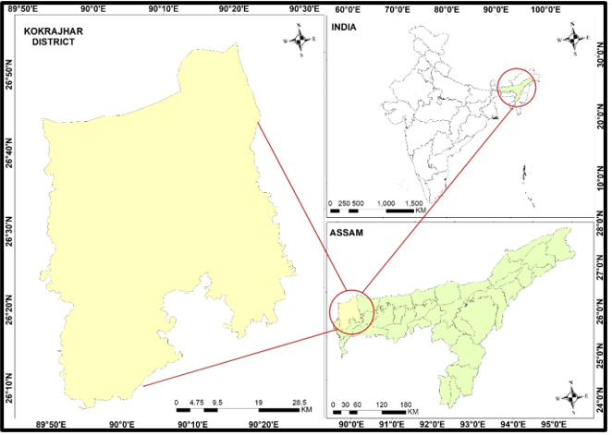
Fig 1: Study area map of Kokrajhar district of Assam
3. Objectives
The research project consists of three-fold objectives.
- To mapping the spatial distribution, and temporal changes of malaria infection in Kokrajhar district, Assam (2020-2024).
- To analyse the climate determinants in association with malaria infection in Kokrajhar district of Assam (2020-2024).
- To mapping the Mapping of Anopheles species vector mosquitoes breeding habitats in the hyper endemic malaria region in Kokrajhar district, Assam.

Landsat TM8 OLI/TIRS (operational land imagery/thermal remote sensor) data for the year 2020 was downloaded from the USGS earth explorer open source and was imported to the Quantum GIS (QGIS) 3.4 for the image analysis of Normalized Difference Vegetation Index (NDVI), Normalized Difference Water Index (NDWI), Normalized Difference Moisture Index (NDMI), Principal Component Analysis (PCA), and Land Use/ Land Cover (LU/LC) classification. A record of monthly malaria incidence was collected from the office of the Kokrajhar District National Vector Borne Disease Control Programme, Ministry of Health and Family Welfare, Government of Assam for the period 2000-2024. Monthly rainfall and rainy days records, relative humidity (RH), monthly mean temperature were collected from two sources: Indian Meteorological Department (IMD) open source portal. Monthly malaria incidence and climatic variable records are considered for the analysis of longitudinal trend and to evaluate the spatial association and correlation between climate variable and malaria prevalence. In the present study, geospatial techniques are applied to investigate geo-environmental risk factors persuading vector mosquito breeding, density and abundance, and its association with malaria transmission. Remote sensing satellite imagery is used to map land-use /land covers, potential mosquito breeding sites including wet irrigation crop lands, and water bodies, river streams etc., assessed to study the spatial association between the geographical distribution of mosquito breeding grounds and malaria transmission. climate variables such as; temperature, rainfall, relative humidity are analysed to evaluate the correlation between the risk factors and malaria transmission. Temperature and moisture were particularly important as they affect mosquito breeding cycles, while elevation provided insights into how topography influences mosquito habitats. The integrated remote sensing and GIS provides the results of NDVI, NDWI, NDMI, LULC, and PCA.

5. Result and Discussion
The analysis of longitudinal trend of malaria prevalence Pf cases shows the steady declining trend over the period of 25 years (2000 -2024) (Fig.2) due to the intervention measures implemented in the district. Climatic variable records are considered for the analysis of longitudinal trend and to evaluate the spatial association and correlation between climate variable and malaria prevalence, and the result provides the positive relationship between malaria prevalence and the climatic factors.
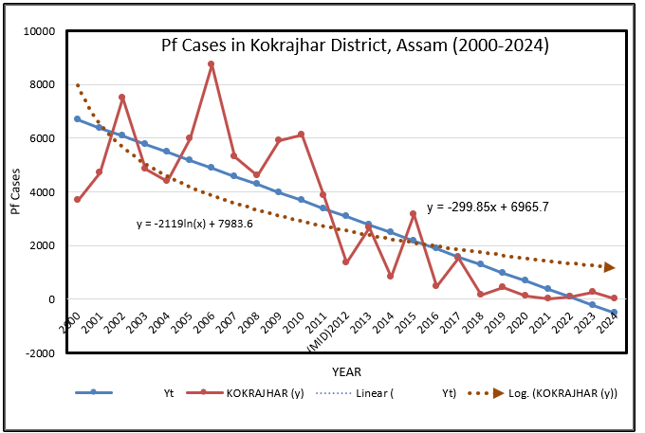
Fig.2. The longitudinal trends of malaria Pf prevalence in in Kokrajhar District, Assam (2000-2024)
Research found that malaria transmission of Plasmodium vivax requires temperature between 15.0°C and 20°C, and parasite development requires a minimum of 19.0°C temperature with 15 to 25 days to complete parasite life cycle with relative humidity between 55% and 80%, so as to complete its life cycle for the period of 6 to 10 days, and also it could be extended if the temperature remains constant between 25°C to 30°C (Palaniyandi, M, 2021).
5.1 Normalized Difference Vegetation Index (NDVI)
The NDVI map produced through the above formula provides insights into the vegetation density and vegetation health across the study area (Fig.3). In the context of malaria transmission, areas with high NDVI values ranging from 0.015-0.13 are often associated with water features, 0.18-0.27 values of agricultural crop land with water logged areas during the monsoon, 0.27- 0.36 sparse vegetation or open forest with moist environments, and the areas NDVI value 0.36 – 0.74 having dense healthy vegetation with high water content are ideal grounds for Anopheles species malaria vector mosquitoes breeding. In contradiction, the area with low NDVI values has unfavourable conditions for mosquito breeding including sandy, semi-arid, arid, and settlement. Further, the analysis shows the high vegetation growth during the rainy season, which is spatially correlated with malaria cases.

Normalized Difference Water Index

5.2 The Normalized Difference Water Index (NDWI)
The Normalized Difference Water Index (NDWI) is used to assess surface water bodies that serve as malaria vectors breeding habitats. NDWI index effectively highlights surface water features which could be used for monitoring water level in the water bodies and streams or rivers, and thus, predict malaria transmission risk in the study region. The NDWI is calculated using the given below formula;
NDWI = (Green –NIR) / (Green + NIR),
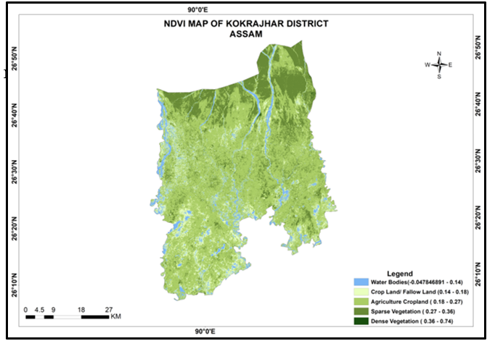
Fig.3. Normalised Difference Vegetation Index values shows the deferent vegetation covers
and water features associated with malaria vector breeding sources

Where: Green: Reflectance in the green band (Band 3 for Landsat 8), and NIR Reflectance in the near-infrared band (Band 5 for Landsat 8). The NDWI, values perfectly illustrate the presence or absence of surface water features, if the NDWI value is greater than (> 0) which indicates that the water presents in the pool, tank, lake, stream, rivers, canals, water bodies, reservoir, etc., which are ideal grounds for Anopheles species malaria vector mosquitoes throughput the year (Fig.4).

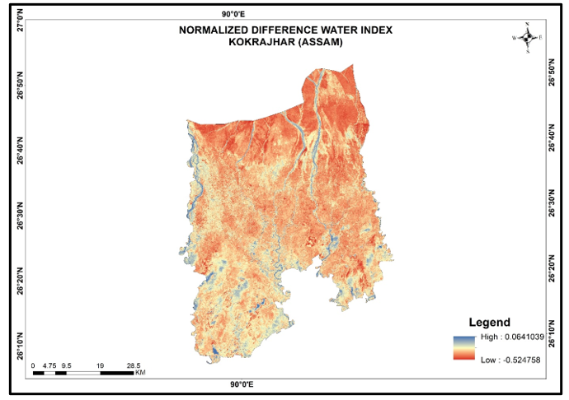
Fig.4. Normalized Difference Water Index values > 0 shows the breeding ideal grounds for malaria vector breeding grounds.

5.3. Normalized Difference Soil Moisture Index (NDMI)
Normalized Difference Soil Moisture Index (NDMI) are calculated using the given below formula.
(Short-Wave Infrared - Near-Infrared (SWIR- NIR)
-------------------------------------------------------------
(Short-Wave Infrared + Near-Infrared (SWIR+NIR)

Normalized Difference Soil Moisture Index (NDMI) analysis provides the existent of relative moisture content in the surface soil, which can influence the formation of water bodies and the availability of breeding grounds for malaria vectors. High soil moisture in a particular site, especially after rainfall, has stagnant water pools which are ideal grounds for Anopheles species (An. baimaii, An. Minimus) malaria vector mosquitoes, the primary malaria vectors.

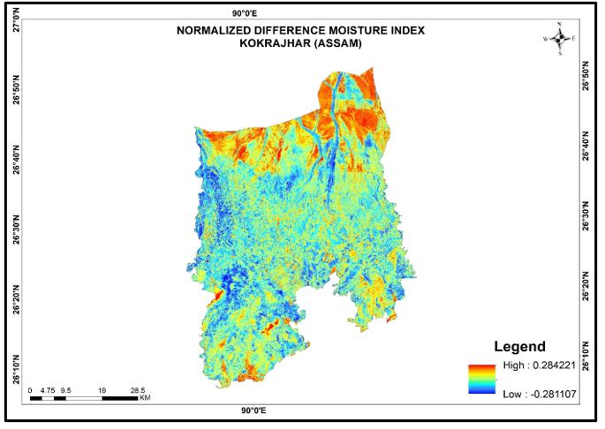
Fig.5. Normalized Difference Soil Moisture Index, lower the NDSMI value < 0 gives the area has high soil moisture with water features, light blue to dark blue colours in the study area are ideal ground grounds for Anopheles species malaria vector breeding habitats.

5.4. Principal Component Analysis (PCA)
The principal component analysis (PCA) analysis result shows the different surface features including the potential breeding grounds, such as; agricultural crop lands (current fallow lands) 77 %, perennial water features 11.32 %, wet irrigation crop lands 11.54 %, health vegetation with holding high water contents < 1%, accordingly, calculate the area suitable for malaria vector breeding is 22.86 % of the total area support for the breeding vector mosquitoes in the summer season, and during the monsoon and winter accounted into > 90% of the area favourable for Anopheles genus vector mosquito breeding (Fig. 6, Table.1,.2,.3, and.4). PCA results of Band2 blue (66%), Band3 green (67%), Band 5 Near Infra-Red 89 %, Shortwave Infrared Band6 (64%), and Thermal Infrared Band7 (73%) with correlation between Band2 and Band3 89%, Band1 and Band2 96%, Band2 and Band3 89%, and Band7 and Band6 95%, consequently the district is vulnerable for malaria transmission throughout the year, and hence, become hyper endemic zone.
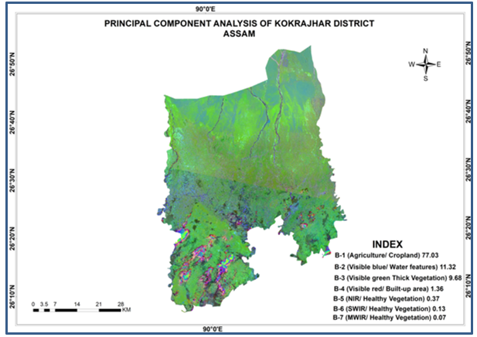
Fig.6 The principal component analysis (PCA) analysis result shows the different surface features including the potential breeding grounds

Table.1 The principal component analysis (PCA) analysis results
COVARIANCE MATRIX
Layer | Band1 | Band2 | Band3 | Band4 | Band5 | Band6 | Band7
1 | 3.682169e+05 | 3.540988e+05 | 3.376323e+05 | 3.939729e+05 | 3.100400e+05 | 4.828998e+05 | 4.518020e+05
2 | 3.540988e+05 | 3.641941e+05 | 3.608304e+05 | 4.350067e+05 | 3.035933e+05 | 5.517377e+05 | 5.218705e+05
3 | 3.376323e+05 | 3.608304e+05 | 4.451082e+05 | 5.210731e+05 | 4.164560e+05 | 6.966344e+05 | 6.441121e+05
4 | 3.939729e+05 | 4.350067e+05 | 5.210731e+05 | 6.537264e+05 | 4.182574e+05 | 9.201600e+05 | 8.663806e+05
5 | 3.100400e+05 | 3.035933e+05 | 4.164560e+05 | 4.182574e+05 | 1.308519e+06 | 1.145847e+06 | 7.137405e+05
6 | 4.828998e+05 | 5.517377e+05 | 6.966344e+05 | 9.201600e+05 | 1.145847e+06 | 2.492563e+06 | 1.955411e+06
7 | 4.518020e+05 | 5.218705e+05 | 6.441121e+05 | 8.663806e+05 | 7.137405e+05 | 1.955411e+06 | 1.692410e+06

Table 2 CORRELATION MATRIXES
Layer Band1 Band2 Band3 Band4 Band5 Band6 Band7
1 1.00000 0.96695 0.83399 0.80300 0.44666 0.50406 0.57233
2 0.96695 1.00000 0.89620 0.89152 0.43978 0.57909 0.66473
3 0.83399 0.89620 1.00000 0.96598 0.54569 0.66138 0.74212
4 0.80300 0.89152 0.96598 1.00000 0.45223 0.72085 0.82368
5 0.44666 0.43978 0.54569 0.45223 1.00000 0.63447 0.47962
6 0.50406 0.57909 0.66138 0.72085 0.63447 1.00000 0.95206
7 0.57233 0.66473 0.74212 0.82368 0.47962 0.95206 1.00000
==========================================================================

Table 3. EIGENVALUES AND EIGENVECTORS
Number of Input Layers Number of Principal Component Layers

7 7

PC Layer 1 2 3 4 5 6 7
EigenValues 5642799.99200 829190.17508 709195.72123 100223.34474 27819.80415 10183.76495 5324.52302

Eigenvectors
Input Layer
1 0.17238 -0.08029 0.46591 0.62101 0.10203 0.30474 -0.50778
2 0.18931 -0.12916 0.42874 0.36769 -0.01862 -0.42547 0.66866
3 0.23104 -0.08624 0.40076 -0.41665 -0.20547 0.67991 0.31698
4 0.29137 -0.23448 0.37907 -0.47064 -0.22214 -0.50331 -0.43848
5 0.33179 0.89676 0.16031 -0.10156 0.20507 -0.08599 -0.01667
6 0.64162 0.00458 -0.46757 0.24182 -0.55640 0.04004 -0.00395
7 0.52384 -0.33205 -0.22469 -0.12355 0.73895 0.03897 0.04493
==========================================================================

Table 4 Percentage and Accumulative Eigenvalues
PC Layer Eigen Value Eigen Values (in %) Eigen Values (Cumulative)
1 5642799.99200 77.0376 77.0376
2 829190.17508 11.3204 88.3580
3 709195.72123 9.6822 98.0402
4 100223.34474 1.3683 99.4085
5 27819.80415 0.3798 99.7883
6 10183.76495 0.1390 99.9273
7 5324.52302 0.0727 100.0000

5.5. Land Use / Land Cover Classification
Mapping of land use / land cover classification was analysed using supervised maximum likelihood image classification cluster method, and LULC categories of each class are assessed in square kilometres, such as; water features (water bodies, rivers, streams, check dams, reservoirs, pools, tanks, etc., is measured to 169 Sq. Km., Agricultural crop lands (fallow lands) is 560 Sq. Km., wet irrigation agricultural crop land is 560 Sq. Km., sparse /open vegetation cover is 910 Sq. Km., and dense vegetation is measured to 970 Sq. Km (Fig.7.), and are significantly associated with Anopheles genus malaria vector mosquitoes abundance as well as malaria prevalence over the period of 25 years (2000-2024).
5.6. Land Surface Temperature (LST)
Anopheles genus malaria vector mosquitoes breeding ground are plenty in the area where the precipitation is coexisting, and are relatively profusion, and therefore, malaria transmission is highly active in the region where the temperature ranges between 26°C and 30°C, followed by temperature ranges between 20°C - 26°C suitable for both malaria vectors and malaria transmission, and precipitation is also significantly influences making more vector breeding sites, consequently, malaria transmission is high where these weather condition is observed, and makes the region as malaria endemic nature (Fig. 8, and 9).
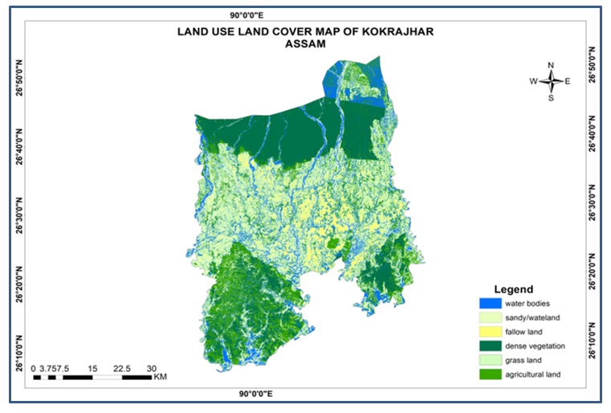Fig.7. LULC categories are significantly associated with Anopheles genus malaria vector mosquito’s abundance as well as malaria prevalence
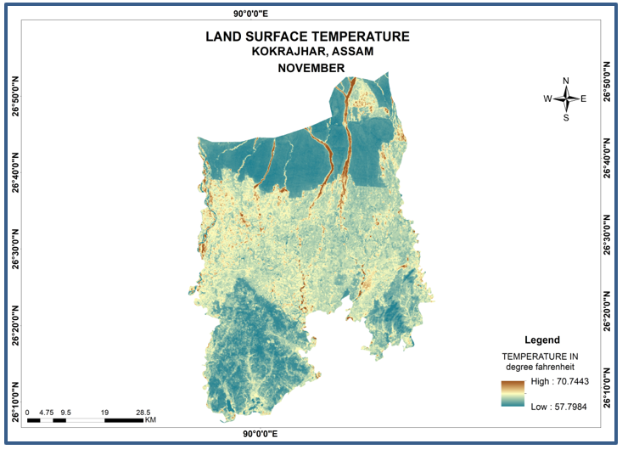
Fig.8. Land Surface Temperature (LST) for the month of November, shows the region suitable for both vector survival and malaria transmission
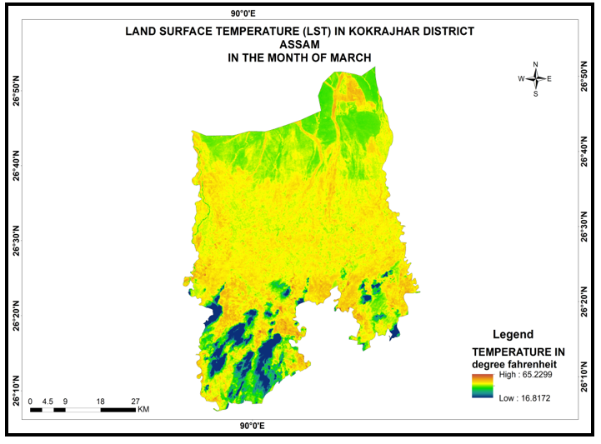

Fig.9. Land Surface Temperature (LST) for the month of March, shows the region suitable for both vector survival and malaria transmission
6. Conclusions
The integrated remote sensing, geographic information system (GIS) and global positioning system (GPS) are essentially used for the analysis the determinants of geo-environmental variables and climate factors for mapping the malaria transmission hotspot endemic region with seasonal variation. PCA identifies the similarities and difference in percentile, and provides the maximum portion of the variance of the original dataset, accordingly, calculate the area suitable for malaria vector breeding. A significant correlation was yielded for the incidence of malaria with precipitation and Normalized Difference Vegetation Index (NDVI). The Normalized Difference Water Index (NDWI) was used to assess surface water bodies that serve as malaria vectors breeding habitats. Normalized Difference Soil Moisture Index (NDMI) provides the existent of relative moisture content in the surface soil influence the water bodies and the availability of malaria vectors breeding grounds. Soil moisture and wetness of the landscape topography, predominantly humidity and water availability in the area creates a favourable environment for the increase of malaria vector breeding sources, because it affects mosquito breeding, survival, and longevity, and hence, where the active malaria transmission has occurred, and malaria hotspot endemic region are spatially associated at the significance level with environmental and climatic determinant factors. The results provide the guidelines to choose the appropriate control strategy for both vector and malaria transmission march towards the sustainable health.

COMPETING INTERESTS DISCLAIMER:
Authors have declared that they have no known competing financial interests OR non-financial interests OR personal relationships that could have appeared to influence the work reported in this paper.
Disclaimer
Author(s) hereby declare that NO generative AI technologies such as Large Language Models (ChatGPT, COPILOT, etc.) and text-to-image generators have been used during the writing or editing of this manuscript.
References
- Afrane, Y. A., Lawson, B. W., Githeko, A. K., & Yan, G. (2005). Effects of microclimatic changes caused by land use and land cover on duration of gonotrophic cycles of Anopheles gambiae (Diptera: Culicidae) in Western Kenya highlands. Journal of Medical Entomology, 42(6), 974–980. https://doi.org/10.1093/jmedent/42.6.974

- Dabaro, D., Birhanu, Z., Negash, A., Hawaria, D., & Yewhalaw, D. (2021). Effects of rainfall, temperature and topography on malaria incidence in elimination targeted district of Ethiopia. Malaria Journal, 20, 104. https://doi.org/10.1186/s12936-021-03662-7

- Ghosh, Sujit K. (2024), Forecasting Malaria in Indian States: A Time Series Approach with R Shiny Integration.‖ arXiv preprint, arXiv:2412.20121. https://arxiv.org/abs/2412.20121.

- Guofa Zhou, Stephen Munga, Noboru Minakawa, Andrew K. Githeko, and Guiyun Yan. (2007) Spatial Relationship between Adult Malaria Vector Abundance and Environmental Factors in Western Kenya Highlands, Am. J. Trop. Med. Hyg., 77(1), pp. 29-35

- Haileselassie, W., Zemene, E., Lee, M. C., Haji, J., Mekonnen, T., Ayana, M., & Sileshi, M. (2021). The effect of irrigation on malaria vector bionomics and transmission intensity in western Ethiopia. Parasites & Vectors, 14, 516. https://doi.org/10.1186/s13071-02104993-y

- Handique, B. K., Khan, S. A., Dutta, P., Nath, M. J., Qadir, A., and Raju, P. L. N. (2016). Spatial correlations of malaria incidence hotspots with environmental factors in Assam, North East India, ISPRS Ann. Photogramm. Remote Sens. Spatial Inf. Sci., III-8, 51–56, https://doi.org/10.5194/isprs-annals-III-8-51-2016

- Indra Baruah, Nani Gopal Das, Jayantee Kalita. (2007). Seasonal prevalence of malaria vectors in Sonitpur district of Assam, India, J of Vector Borne Diseases, 44(2):149-53

- Jacob, B. G., Muturi, E. J., Mwangangi, J. M., Funes, J., Caamano, E. X., Muriu, S., Shililu, J., Githure, J., & Novak, R. J. (2007). Remote and field level quantification of vegetation covariates for malaria mapping in three rice agro-village complexes in Central Kenya. Int. Journal of Health Geographics, 6, 21. https://doi.org/10.1186/1476-072X6-21

- Kibret, S., Wilson, G. G., Ryder, D., Asefa, T., Beyene, K., Getachew, A., & Zewdie, W. (2019). Environmental and meteorological factors linked to malaria transmission around large dams at three ecological settings in Ethiopia. Malaria Journal, 18(54). https://doi.org/10.1186/s12936-019-2689-y

- Liu J, Chen XP, (1996). Relationship of remote sensing Normalized Differential Vegetation Index to Anopheles density and malaria incidence rate. Biomed Envirn Sci., 19(2):130-132.

- Longo-Pendy, N. M., Sevidzem, S. L., Makanga, B. K., Nguema, M. M., Ndong-Nsomo, E. P., Abisso, R., & Tchuem-Tchuente, L. A. (2024). Assessment of environmental and spatial factors influencing the establishment of Anopheles gambiae larval habitats in the malaria endemic province of Woleu-Ntem, northern Gabon. Malaria Journal, 23(158). https://doi.org/10.1186/s12936-024-04980-5

- Mc Feeters, S. K. (2013). Using the Normalized Difference Water Index (NDWI) within a Geographic Information System to detect swimming pools for mosquito abatement: A practical approach. Remote Sensing, 5(7), 3544-3561. https://doi.org/10.3390/rs5073544

- National Vector Borne Disease Control Programme, Ministry of Health and Family Welfare, Government of India, New Delhi, 2024

- Masimalai Palaniyandi, Bidita Chakraborty, and Probhu Boro. (2025). “The Geographical Analysis of Malaria Pf Hotspot Hyper Endemic Region in Association With Environmental Determinants in Tripura, India”. Journal of Geography, Environment and Earth Science International, 29 (7):105-20. https://doi.org/10.9734/jgeesi/2025/v29i7919

- Ogunsakin, R., Babalola, B., Okpeku, M., & Adebayo, A. (2024), "GIS-Based Spatiotemporal Mapping of Malaria Prevalence and Exploration of Environmental Inequalities." Parasitology Research, vol. (123), no. 7, https://doi.org/10.1007/s00436-024- 08276-0.

- Palaniyandi, M. (2021a).The environmental risk factors significant to Anopheles species vector mosquito profusion, Plasmodium falciparum, Plasmodium vivax parasite development, and malaria transmission, using remote sensing and GIS, Ind J of Public Health Res and Development, 12(4):162-171 https://doi.org/10.37506/ijphrd.v12i4.16539

- M. Palaniyandi, P Manivel, T Sharmila, and P Thirumalai, (2021b). The use of Multispectral (MSS) and Synthetic Aperture Radar (SAR) microwave remote sensing data to study environment variables, land use / land cover changes, and recurrent weather condition for forecast malaria: A review. Applied Ecology and Environmental Sciences, 2021; 9(4): 490-501. https://doi.org/10.12691/aees-9-4-10

- M. Palaniyandi, T Marriappan, and PK Das, (2016), “Mapping of land use / land cover and mosquitogenic condition, and linking with malaria epidemic transmission, using remote sensing and GIS”, Journal of Entomol Zool Stud, 2016; 4(2): 40-47. http://dx.doi.org/10.22271/j.ento

- Palaniyandi, M, (2014). The Red and Infrared IRS WiFS Satellite Data for Mapping of Malaria and JE Vector Mosquito Breeding Habitats. J Geophys Remote Sensing 3: 126. http://dx.doi.org/10.4172/2169-0049.1000126

- M.Palaniyandi, (2012). The role of Remote Sensing and GIS for Spatial Prediction of Vector Borne Disease Transmission - A systematic review. J Vector Borne Dis., 2012; 49 (4): 197-204. PMID: 23428518. https://doi.org/10.4103/0972-9062.213498

- Rogers DJ, Sarah E. Randolph, Robert W. Snow, and Simon I. Hay. (2002). Satellite imagery in the study and forecast of malaria, Nature. 415(6872):710715 http://dx.doi.org/10.1038/415710a

- Thomson, M.C. Connor SJ, Milligan PJ, Flasse SP (1996). The ecology of malaria-as seen from earth observation satellites, Ann. Trop. Med. Parasit. 90: pp-243–264

- Tran A , Ponçon N, Toty C, Linard C, Guis H, Ferré JB, Lo Seen D, Roger F, de la Rocque S, Fontenille D, Baldet T (2008). Using remote sensing to map larval and adult populations of Anopheles hyrcanus (Diptera: Culicidae) a potential malaria vector in Southern France. Int J Health Geogr. 26,; 7:9

- Tyagi BK, Choudhary RC, Yadav SP, (1995). Epidemic malaria in Thar Desert, The Lancet, 346: 634–35.

- Wood BL, Beck LR, Washino RK, Plachick SM, Sebesta D (1991) Spectral and spatial characterization of the rice field mosquito habitat. Int J Remote Sensing 12: 621-626. 13. https://doi.org/10.1080/01431169108929676

