Nitrogen Fertilizers and Climate Change: A Comprehensive Review of Greenhouse Gas Emissions and Sustainable Management

ABSTRACT
Greenhouse gases (GHGs) such as carbon dioxide (CO₂), methane (CH₄), nitrous oxide (N₂O), water vapor, fluorinated gases and ozone play a pivotal role in global warming by trapping heat in the Earth's atmosphere. Among these, N₂O is particularly potent, with a global warming potential approximately 273 times that of CO₂ over a 100-year period. Agriculture contributes significantly to anthropogenic GHG emissions, accounting for approximately 12% globally. A substantial portion of these emissions arises from the production and application of synthetic fertilizers, which have been instrumental in boosting global food production. The manufacture of synthetic nitrogen fertilizers is energy-intensive, leading to considerable CO₂ emissions. Upon application, these fertilizers can result in N₂O emissions due to microbial processes in the soil. Studies estimate that synthetic nitrogen fertilizer use accounts for about 8.3% of farm-gate emissions. Projections suggest that, without intervention, agricultural GHG emissions could reach 8–9 gigatonnes of CO₂-equivalent per year by 2050. The impact of fertilizer application on GHG emissions is therefore a major environmental concern, demanding targeted policy and agronomic interventions. Overapplication and inefficient nitrogen use not only contribute to climate change but also pose risks to soil and water health. Addressing these challenges requires a balance between maximizing crop yields and minimizing environmental harm. Mitigation strategies include optimizing fertilizer application rates, adopting precision agriculture techniques, and integrating organic fertilizers. Such practices can reduce N₂O emissions and enhance nitrogen use efficiency. Transitioning to sustainable fertilizer management is crucial for minimizing agriculture's climate impact while ensuring food security.

Keywords: Greenhouse gases, global warming, anthropogenic, fertilizers, nitrogen use efficiency, food security

- INTRODUCTION
Greenhouse gases (GHGs) are atmospheric constituents that absorb and emit infrared radiation, leading to the greenhouse effect, which warms the Earth's surface. The primary GHGs include water vapor, carbon dioxide (CO₂), methane (CH₄), nitrous oxide (N₂O), fluorinated gases, and ozone (Filonchyk et al., 2024). While water vapor is the most abundant, CO₂, CH₄, and N₂O are significant due to their long atmospheric lifetimes and increasing concentrations resulting from human activities. CO₂ is primarily emitted through fossil fuel combustion and deforestation. CH₄ emissions arise from livestock digestion, rice cultivation, and landfills. N₂O is mainly produced through agricultural activities, especially the use of nitrogen-based fertilizers (Ma et al., 2024). Fluorinated gases, though present in smaller quantities, have high global warming potentials and are used in industrial applications. Ozone, while beneficial in the stratosphere, acts as a GHG when present at ground level.
The accumulation of these greenhouse gases in the atmosphere intensifies the natural greenhouse effect, leading to global warming and climate change (Mikhaylov et al., 2020). This enhanced warming disrupts climatic systems, contributing to rising global temperatures, altered precipitation patterns, and an increase in the frequency and intensity of extreme weather events such as droughts, floods, and hurricanes. The Intergovernmental Panel on Climate Change (IPCC) has reported that anthropogenic GHG emissions are the dominant cause of observed warming since the mid-20th century (Hegerl et al., 2019). Without significant mitigation efforts, continued emissions will drive further environmental degradation, sea level rise, loss of biodiversity, and severe socio-economic impacts worldwide.

1.1 Agriculture's Contribution to GHG Emissions
Agriculture is a significant source of GHG emissions, contributing approximately 12% of global anthropogenic emissions (Golasa et al., 2021). These emissions stem from various activities, including enteric fermentation in livestock, manure management, rice cultivation, and the use of synthetic fertilizers. The Food and Agriculture Organization (FAO) reported that in 2019, the use of synthetic nitrogen fertilizers accounted for 8.3% of farm-gate emissions. Furthermore, the Intergovernmental Panel on Climate Change (IPCC) projects that, without mitigation, agricultural emissions could reach 8–9 gigatonnes of CO₂-equivalent per year by 2050 (Prasad et al., 2020).
Agricultural GHG emissions are primarily composed of methane (CH₄) and nitrous oxide (N₂O), both of which have significantly higher global warming potentials than carbon dioxide (Rehman et al., 2020). Methane is predominantly released through enteric fermentation in ruminants and anaerobic decomposition in flooded rice paddies, while nitrous oxide arises mainly from the microbial transformation of nitrogen in soils treated with synthetic and organic fertilizers. Additionally, land-use changes associated with agricultural expansion such as deforestation and peatland drainage contribute considerable amounts of CO₂. The intensification of agricultural systems to meet rising food demands further exacerbates emissions, particularly when coupled with inefficient nutrient management practices (Purwanto & Alam, 2020). Thus, agriculture stands at a critical intersection where food security must be balanced with the urgent need to reduce its climate impact.

1.2 Role of Synthetic Fertilizers in Food Production
The advent of synthetic fertilizers has revolutionized agriculture, significantly increasing crop yields and supporting global food security. By supplying essential nutrients, particularly nitrogen, phosphorus, and potassium, synthetic fertilizers have enabled intensive farming practices to meet the demands of a growing population (Yahaya et al., 2023). However, their production and application have environmental repercussions. The manufacture of synthetic nitrogen fertilizers is energy-intensive, often relying on fossil fuels, leading to substantial CO₂ emissions. Once applied to fields, these fertilizers can undergo microbial transformations, resulting in N₂O emissions. Given N₂O's high global warming potential, its release from agricultural soils is a critical concern.

1.3 Environmental Impacts of Fertilizer Use
Excessive or inefficient fertilizer application can lead to nutrient runoff, contaminating water bodies and causing eutrophication (Tiwari & Pal, 2022). Moreover, the volatilization and leaching of nitrogen compounds contribute to air and water pollution. These environmental impacts underscore the need for sustainable fertilizer management practices. Excessive or inefficient application of fertilizers, particularly those rich in nitrogen and phosphorus, has profound environmental consequences. When these nutrients are applied beyond the absorption capacity of plants, they can leach into groundwater or run off into surface waters, leading to nutrient pollution. This influx of nutrients into aquatic systems often results in eutrophication a process characterized by excessive algal growth that depletes oxygen in the water, harming aquatic life and disrupting ecosystems. Nitrogen, due to its high solubility, is particularly prone to leaching. Phosphorus, while less mobile in soil, can attach to eroded soil particles and enter waterways, further contributing to eutrophication (Rashmi et al., 2022). Moreover, the volatilization of nitrogen compounds, such as ammonia, into the atmosphere can lead to air pollution and the formation of secondary particulate matter, which has implications for human respiratory health. These airborne nitrogen compounds can also deposit back onto land and water bodies, exacerbating nutrient loading and associated environmental issues (De Vries, 2021).
- GREENHOUSE GAS EMISSIONS AND THEIR ENVIRONMENTAL IMPACT
Fig. 1 illustrates the dynamic interactions between natural and anthropogenic sources of greenhouse gases (GHGs), the greenhouse effect, and the resultant environmental consequences on ecosystems and agriculture (Xuejun & Fusuo, 2011). Major GHGs such as water vapor (H₂O), carbon dioxide (CO₂), methane (CH₄), nitrous oxide (N₂O), and nitric oxide (NO) are released into the atmosphere from both industrial activities and agricultural landscapes, including emissions from livestock and soil management practices. The interaction between greenhouse gas (GHG) emissions, climate change, and plant physiology under changing environmental conditions. At the top, the diagram shows the ozone (O₃) formation process in the stratosphere, driven by UV radiation. Below, natural emissions and anthropogenic activities (industrial smoke, vehicles, livestock, and agricultural practices) release major greenhouse gases (H₂O, CO₂, CH₄, N₂O, O₃) into the atmosphere. These gases trap thermal infrared radiation, intensifying the greenhouse effect.
The increase in GHGs has both long-term and short-term impacts. Long-term effects include extreme climate events such as floods, droughts, and heat stress, whereas short-term effects are primarily linked to rising atmospheric CO₂. Together, these changes disrupt agricultural systems and food production. On the right side, the figure highlights the plant physiological response to elevated CO₂ and pollutants (NO, NO₂, VOCs, CO). These stressors enhance reactive oxygen species (ROS) accumulation, leading to oxidative stress. This can negatively affect photosynthesis (↓ PS) and stomatal opening (↓ SO), ultimately impairing plant growth and productivity. Antioxidant systems (AS) and signaling molecules like nitric oxide (NO) play crucial roles in mitigating ROS damage.
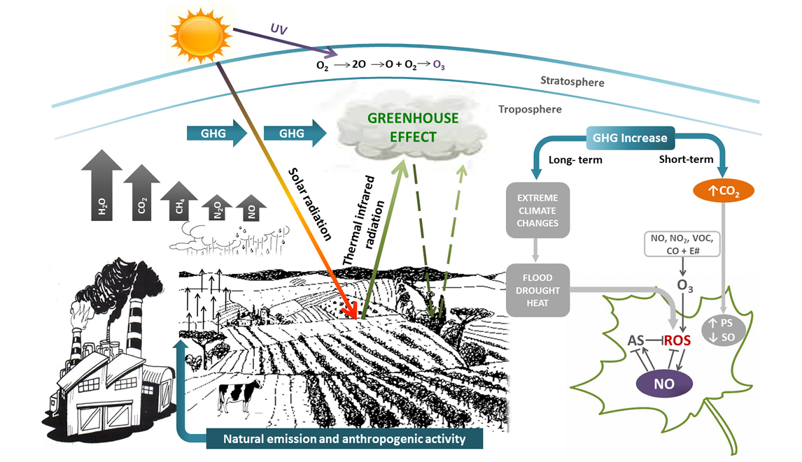
Fig. 1: Greenhouse Gas Emissions, Climate Effects, and Plant Stress Responses (Cassia et al., 2018)

2.1 Mechanism of the Greenhouse Effect
Incoming solar radiation penetrates the Earth's atmosphere, warming the surface. The Earth, in turn, emits thermal infrared radiation back into the atmosphere. However, GHGs trap some of this outgoing radiation, re-radiating it towards the Earth’s surface and intensifying the greenhouse effect. This leads to a rise in global temperatures and triggers shifts in climate patterns. The upper part of Fig. 1 depicts the formation of ozone (O₃) in the stratosphere through the photodissociation of molecular oxygen (O₂) under ultraviolet (UV) radiation. This ozone layer acts as a protective shield, absorbing harmful UV rays, but is also impacted by increased GHG emissions.

2.2 Impact on Plant Physiology
On the right side of Fig. 1, a schematic of a leaf illustrates the physiological stress induced by elevated CO₂ and ozone levels. Increased CO₂ can boost photosynthesis (PS) and stomatal opening (SO) in the short term, but elevated ozone (O₃) causes oxidative stress by generating reactive oxygen species (ROS). The presence of ROS disrupts antioxidant systems (AS) and induces nitric oxide (NO) signaling, which can compromise plant growth and resilience (Wani et al., 2021).
- TYPES OF ORGANIC FERTILIZERS AND THEIR SOURCES
Organic fertilizers play a pivotal role in sustainable agriculture by improving soil fertility and promoting healthy crop growth without the environmental downsides of synthetic fertilizers (Verma et al., 2019). These fertilizers are primarily categorized based on their source, animal-based and plant-based, and both types offer distinct nutritional benefits to plants while enhancing soil structure and microbial activity. Fig. 2 clearly depicts this classification, offering an overview of the most common organic fertilizer types derived from both animal and plant origins.
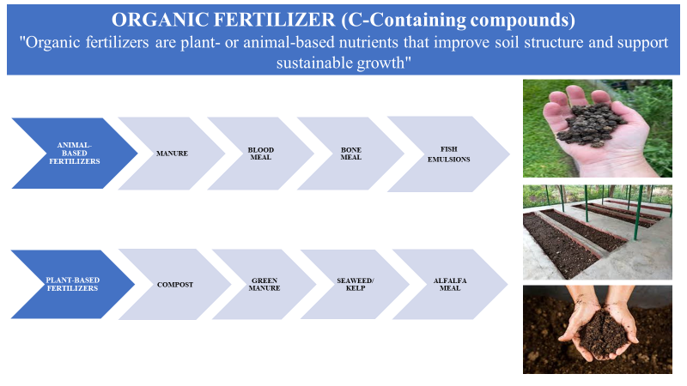
Fig. 2: Classification of Organic Fertilizers: Animal-Based and Plant-Based Types
3.1 Animal-Based Organic Fertilizers
As illustrated in Fig. 2, animal-based fertilizers include manure, blood meal, bone meal, and fish emulsions. These materials are rich in macro- and micronutrients, especially nitrogen, phosphorus, and potassium, which are crucial for vegetative and reproductive growth in crops. Manure, derived from livestock, is widely used for its balanced nutrient profile and its ability to enhance soil organic matter (Kumari et al., 2023). Blood meal is a high-nitrogen fertilizer often used for leafy vegetable crops, while bone meal is a potent source of phosphorus, beneficial for root development and flowering (Kolambage et al., 2024). Fish emulsions, obtained from processed fish waste, provide a balanced mix of nutrients and are quickly absorbed by plants, making them ideal for foliar applications.
3.2 Plant-Based Organic Fertilizers
The lower part of Fig. 2 highlights the plant-based fertilizer category, which includes compost, green manure, seaweed/kelp, and alfalfa meal. These inputs are derived from decomposed plant materials or specific crops grown and incorporated into the soil to enrich nutrient content. Compost is made from kitchen scraps, garden waste, and other biodegradable material and is known for its broad spectrum of nutrients and ability to improve soil aeration and water-holding capacity (Ayilara et al., 2020). Green manure refers to specific cover crops (like legumes) that are grown and then plowed into the soil to enhance nitrogen content and organic matter. Seaweed or kelp extracts are rich in trace elements and plant growth hormones, making them valuable for enhancing plant resistance to stress. Alfalfa meal, made from dried and ground alfalfa plants, serves as a slow-release nitrogen source and contains beneficial growth-stimulating compounds (Saju et al., 2019).
- MAJOR FERTILIZER TYPES AND THEIR NUTRIENT CHARACTERISTICS
Fertilizers are critical inputs in agriculture, essential for enhancing soil fertility and maximizing crop yield (Panhwar et al., 2019). Fig. 3 provides a structured overview of fertilizers categorized based on the primary nutrient they deliver Nitrogen (N), Phosphorus (P), or Potassium (K) and highlights their chemical forms, solubility, and agronomic suitability.
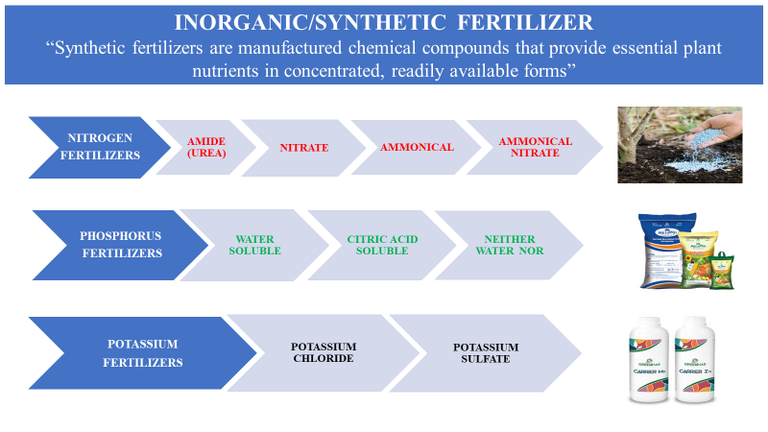
Fig. 3: Classification of Fertilizers Based on Primary Nutrients and Solubility
4.1 Nitrogen Fertilizers
Nitrogen is a vital element for vegetative growth and chlorophyll production in plants (Kumari et al., 2023). Among the various forms, urea (NH₂CONH₂) is the most commonly used synthetic organic fertilizer, containing 46% nitrogen. It has an acidic nature and is rapidly hydrolyzed in the soil to ammonium, making it suitable for a broad range of crops (Motasim et al., 2024). Nitrate-based fertilizers like calcium nitrate (Ca(NO₃)₂) with 33% nitrogen and sodium nitrate (NaNO₃) with 16% nitrogen offer quick-release nitrogen for immediate plant uptake. Potassium nitrate (KNO₃) provides both nitrogen and potassium in a readily available form. Ammonium sulfate ((NH₄)₂SO₄) is another widely used nitrogen source with 20.6% nitrogen and 23.4% sulfur; it is water-soluble and acidic, making it particularly effective for sulfur-deficient soils (Mir et al., 2021). Ammonium nitrate (NH₄NO₃) contains 34% nitrogen and is highly effective but poses an explosion risk, thus its use is restricted in sensitive regions such as Kashmir.
4.2 Phosphorus Fertilizers
Phosphorus is essential for energy transfer, root development, and flowering. Phosphatic fertilizers are classified based on their solubility. Water-soluble phosphorus fertilizers are the most efficient and include Single Super Phosphate (SSP) (16% P, 12% S), Di-Ammonium Phosphate (DAP) (18-46), Triple Super Phosphate (TSP) (48%), Double Super Phosphate (DSP) (32%), and Monoammonium Phosphate (MAP) (13-52) (Das & Mandal, 2015). These are immediately available to plants upon application. Citric acid-soluble phosphorus sources like basic slag and Thomas slag, containing 14–18% phosphorus, are less soluble and more effective in acidic soils. Neither water nor citric acid-soluble sources, such as rock phosphate (20–40%) and bone meal (15% P), are slow-release fertilizers and depend on soil microbial activity and acidity for effectiveness (Nadarajan & Sukumaran, 2021).
4.3 Potassium Fertilizers
Potassium plays a key role in regulating physiological processes, including water uptake and enzyme activation. Two main forms of potassium fertilizers are in common use. Muriate of potash (MOP or potassium chloride, KCl) contains 60% potassium and is widely used due to its high concentration. However, it may not be suitable for chloride-sensitive crops. In such cases, sulphate of potash (SOP or potassium sulfate, K₂SO₄) is preferred, containing 50% potassium along with sulfur, and being free of chloride, it is ideal for fruits, vegetables, and other sensitive crops (Nieder et al., 2018).
Mechanism of Key Greenhouse Gas Emissions from Fertilizer Application
Fertilizer application is one of the primary drivers of greenhouse gas (GHG) emissions in agriculture, particularly contributing to the release of nitrous oxide (N₂O) and methane (CH₄). These gases have significant global warming potentials 298 times for N₂O and 25 times for CH₄ relative to CO₂—making their emissions especially critical to climate change. The mechanism behind N₂O emissions begins when nitrogen fertilizers, especially synthetic ones like urea and ammonium nitrate, are applied to soil (Guo et al., 2022). Microbial processes nitrification under aerobic conditions and denitrification under anaerobic conditions convert these fertilizers into N₂O. Direct emissions occur from the fertilized soil itself, while indirect emissions result from nitrogen losses via leaching and volatilization that later transform into N₂O in adjacent environments.
CH₄ emissions, on the other hand, are predominantly associated with flooded rice paddies where anaerobic conditions prevail. Under these settings, methanogenic archaea decompose organic matter, producing methane. This CH₄ is then released into the atmosphere through ebullition (bubbling), plant-mediated transport, and diffusion. Factors such as continuous flooding, high organic input, and lack of mid-season drainage significantly elevate CH₄ emissions. Together, N₂O and CH₄ emissions from fertilizer use represent the most critical environmental challenge in rice cultivation and nitrogen-intensive cropping systems. Their release is not only a product of excessive or poorly managed fertilizer application, but also of agronomic practices that overlook water, organic matter, and soil microbial balance. Therefore, understanding these mechanisms is essential to implementing targeted mitigation strategies such as alternate wetting and drying (AWD), enhanced efficiency fertilizers (EEFs), and inhibitors like DCD or NBPT. This mechanistic understanding is the crux of this review, as it underpins both the problem of agriculture-driven climate change and the path to sustainable fertilizer use.
- MITIGATION STRATEGIES
Mitigating the environmental impacts of fertilizer use, particularly concerning greenhouse gas (GHG) emissions, is crucial for sustainable agriculture. Several strategies have been identified to address these challenges, focusing on optimizing fertilizer application, integrating nutrient management practices, and adopting innovative technologies. To address the environmental challenges posed by fertilizer use, several mitigation strategies have been proposed:
5.1 Optimized Fertilizer Application
Applying fertilizers based on precise soil testing and crop requirements enhances nutrient use efficiency and minimizes excess application (Yadav et al., 2017). This approach reduces the likelihood of nutrient runoff and leaching, which can lead to water pollution and increased GHG emissions. By aligning fertilizer application with plant needs, farmers can achieve optimal yields while mitigating environmental impacts.
5.2 Precision Agriculture
The utilization of precision agriculture technologies, such as GPS-guided equipment and remote sensing, allows for accurate fertilizer placement. These technologies enable variable rate application, ensuring that fertilizers are applied only where needed, thus reducing waste and environmental impact. Precision agriculture also facilitates real-time monitoring of soil and crop conditions, allowing for timely interventions and efficient resource use (Getahun et al., 2024).

Mechanism of Greenhouse Gas Emissions from Fertilizer Application and the Role of 4R Stewardship
Fertilizer application in agriculture plays a pivotal role in greenhouse gas (GHG) emissions, particularly through the release of nitrous oxide (N₂O) and methane (CH₄), which have global warming potentials 298 and 25 times higher than carbon dioxide (CO₂), respectively (Filonchyk et al., 2024). The emission of N₂O primarily results from two microbial soil processes: nitrification and denitrification. Nitrification occurs under aerobic conditions where ammonium (NH₄⁺) is converted into nitrate (NO₃⁻), while denitrification takes place in anaerobic environments, converting nitrate into nitrogen gas (N₂) with N₂O as an intermediate (Zhao et al., 2025). These emissions are driven by the application of nitrogen-rich fertilizers, especially urea and ammonium nitrate, and can be direct (from the soil where fertilizers are applied) or indirect (from nitrogen that leaches or volatilizes and then transforms elsewhere). Methane (CH₄) emissions are most significant in flooded rice fields, where the absence of oxygen supports the activity of methanogenic archaea. These microbes decompose organic matter and release CH₄, which escapes the soil via ebullition, diffusion, or plant-mediated transport. CH₄ emissions are intensified by continuous flooding, high organic matter input (like manure), and the absence of water management practices such as mid-season drainage.
To mitigate these emissions while maintaining crop productivity, the 4R Nutrient Stewardship approach has emerged as a critical strategy. This science-based framework promotes applying fertilizers with the Right Source, at the Right Rate, at the Right Time, and in the Right Place. Implementing 4R practices improves nutrient use efficiency (NUE) and significantly reduces nitrogen losses that lead to N₂O and CH₄ emissions. For instance, deep placement of urea, use of enhanced efficiency fertilizers (EEFs), and application of nitrification inhibitors like DCD and NBPT are proven to reduce N₂O emissions (Rose et al., 2018). In rice systems, alternate wetting and drying (AWD) disrupts the anaerobic conditions necessary for methane production, thereby lowering CH₄ emissions while conserving water. Understanding these biochemical mechanisms and integrating them with best agronomic practices lies at the heart of this review. The crux of sustainable fertilizer management is not merely in reducing emissions but in transforming fertilizer use into a climate solution—aligning food security with environmental responsibility through informed, efficient, and adaptive strategies like 4R stewardship.
5.3 Methane Emission Mitigation Strategies: Techniques and Yield Impacts
Methane (CH₄) emissions from agricultural systems, especially flooded rice fields, are a major concern for climate change. Effective mitigation strategies not only reduce emissions but also aim to sustain or improve crop yields. Various approaches such as water management, biological controls, soil amendments, and integrated methods have shown promise in reducing CH₄ emissions with varying effects on productivity. The updated Table 1 below summarizes these methods with added scientific context where data were previously missing.
Among water management practices, alternate wetting and drying (AWD) has emerged as a viable strategy in rice cultivation, reducing methane emissions by up to 49% without compromising yield. Similarly, draining and multiple drainage events enhance soil aeration, thus suppressing anaerobic methanogenesis. Biological control techniques such as Azolla (a nitrogen-fixing aquatic fern) provide partial emission reduction while offering the added benefit of nitrogen enrichment (Vijayan et al., 2024). Notably, cable bacteria improve redox conditions in waterlogged soils, enabling significant methane suppression (up to 93%) although field yield data is limited.
Biochar amendments are consistently effective across studies, reducing emissions by up to 86.4% while enhancing crop yields through improved soil structure, water retention, and nutrient availability (Tufail et al., 2022). Incorporating wood vinegar or slow-release fertilizers with biochar shows added benefits. Fertilizer-related strategies like aerobic digestion of green manure have also demonstrated emission reductions of around 60% without yield penalties. The integration of DCD (a nitrification inhibitor) with water control further supports reduced emissions, though with more modest gains (Rose et al., 2018). Integrated approaches, such as combining AWD with biochar, balance emission control and productivity, offering a sustainable path forward for methane mitigation in rice-based systems.
Table 1: Techniques for Reducing Methane Emissions in Agriculture and Their Effect on Yield (Rajendran et al., 2024)
Method | Technique | Methane Emission Reduction | Yield Impact
Water management | Optimizing drainage timing | 35%–45% | No significant change
Water management | Multiple draining | 35% | Increased
Water management | Draining | 57.8% | No change
Water management | Alternate wetting and drying (AWD) | Up to 49% | No change
Biological control | Cable bacteria application | 93% | Likely beneficial (improves redox)
Biological control | Purple nonsulfur bacteria application | 24%–28% | Increased
Biological control | Azolla application | 12.3%–25.3% | No change
Soil amendment | Biochar application | 38%–41% | Increased
Soil amendment | Biochar-based slow-release fertilizer treatment | 33.4% | Likely beneficial (better nutrient availability)
Soil amendment | Wood vinegar and biochar application | 35.3%–42.6% | Increased
Soil amendment | High-rate biochar application | 47.3%–86.4% | Increased
Fertilizer management | Aerobic pre-digestion of green manured soil | 60% | No change
Combination | Dicyandiamide (DCD) application and water control | 7%–8% | No change
Combination | AWD combined with biochar application | 18.8% | Increased

- SMART FERTILIZER APPLICATION TECHNIQUES
Modern agriculture increasingly leverages technology to optimize fertilizer use. Fig. 4 highlights advanced strategies under the umbrella of "Smart Application Methods":
- GPS-Guided Variable Rate Application: Tailors input levels to specific field zones based on soil maps, reducing over- or under-fertilization.
- Split Applications: Dividing fertilizer doses according to crop stages enhances nutrient uptake and reduces losses.
- AI-Driven Predictive Analytics: Uses real-time data and modeling to anticipate crop nutrient demands and adjust applications dynamically.
- Precise Timing with Crop Growth Stages: Synchronizing fertilizer use with critical phenological phases (e.g., tillering or flowering) maximizes efficiency.
- Deep Placement: Places nutrients near root zones to minimize volatilization and runoff.
- Soil Testing and Crop-Specific Dosing: Aligns nutrient supply with specific crop requirements based on soil health diagnostics.
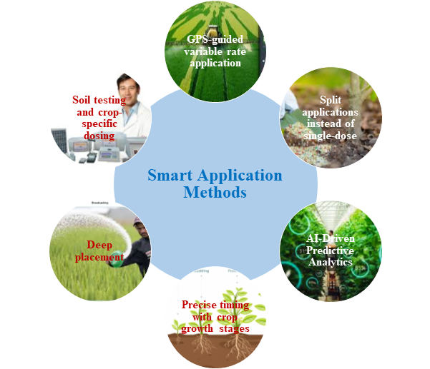
Fig. 4: Smart Fertilizer Application Methods for Precision and Sustainability

6.1 Effect of Fertilizer Management on CH₄ and N₂O Emissions
The Table 2 illustrates the impact of varying fertilizer treatments on greenhouse gas emissions and crop yield in a rice-based system. FDP (Fertilizer Deep Placement) treatments show higher CH₄ emissions compared to the control and conventional fertilizer placement methods, particularly in T₅ (32.84 kg ha⁻¹), which involved the highest nitrogen dose (120%) (Huang et al., 2024). However, T₅ also recorded the highest grain yield (4933 kg ha⁻¹), suggesting a yield-emission trade-off at elevated nutrient levels. In contrast, N₂O flux was highest under BMP (T₄: 1.010 kg ha⁻¹) and RDF (T₃: 1.004 kg ha⁻¹), indicating that balanced nutrient application following recommended guidelines can potentially raise denitrification losses if not managed with split doses or inhibitors. Treatments with lower nitrogen levels (T₇ and T₈) reduced both CH₄ and N₂O emissions, though with a corresponding reduction in grain yield (Venterea et al., 2005). These results align with research indicating that increased nitrogen fertilization enhances crop productivity but often at the cost of greater GHG emissions. Moreover, the FDP technique, while efficient in placing nutrients near the root zone, may stimulate anaerobic conditions that promote methanogenesis, especially under water-saturated paddy soils (Conrad, 1995).

Table 2. Effect of Fertilizer Management on CH₄ and N₂O Emissions and Grain Yield in Rice Cultivation
Treatments | CH₄ Emission (kg ha⁻¹) | N₂O Flux (kg ha⁻¹) | Grain Yield (kg ha⁻¹)
T₁: Control | 15.74 | 0.502 | 1970
T₂: FP with 30-18.4-36 | 19.65 | 0.857 | 2642
T₃: RDF as per AAU | 25.95 | 1.004 | 3780
T₄: BMP | 26.12 | 1.010 | 3819
T₅: FDP with 120% N + 100% PK | 32.84 | 0.733 | 4933
T₆: FDP with 100% NPK | 29.98 | 0.681 | 4451
T₇: FDP with 80% N + 100% PK | 27.14 | 0.623 | 4002
T₈: FDP with 60% N + 100% PK | 23.03 | 0.575 | 3297

Fertilizer management significantly influences CH₄ and N₂O emissions in rice cultivation. Excessive nitrogen application, particularly through fertilizer deep placement (FDP), increases CH₄ emissions by enhancing anaerobic microbial activity in flooded soils (Ahmed et al., 2023). Similarly, high nitrogen inputs can stimulate nitrification-denitrification processes, leading to elevated N₂O emissions. Optimized nutrient management, including balanced application and reduced N rates, can mitigate these emissions while sustaining crop productivity.

Table 3. Integrated Approaches for Enhanced Nutrient Management and Soil Health in Sustainable Agriculture
Approach | Practice/Technology | Scientific Basis & Benefits | Impact on Yield & Environment
Soil Management | Conservation tillage | Reduces soil erosion, enhances infiltration, and conserves organic matter (Lal, 2004) | Improves long-term productivity, reduces emissions
Soil Management | Crop rotation | Breaks pest/disease cycles; improves nutrient cycling through diverse rooting patterns | Enhances yield stability and soil fertility
Soil Management | Cover cropping | Legumes and other covers fix nitrogen and reduce erosion (Snapp et al., 2005) | Boosts soil nitrogen; prevents nutrient leaching
Soil Management | Organic amendments | Compost/manure improves microbial diversity and carbon content | Reduces reliance on chemical fertilizers
Soil Management | pH maintenance | Optimal pH (6.0–7.5) ensures nutrient availability (Brady & Weil, 2016) | Enhances uptake efficiency and reduces lock-up of nutrients
Soil Management | Organic matter monitoring | SOM >2% promotes soil aggregation and microbial activity | Increases water-holding and nutrient-retention capacity
Fertilizer Application (Smart) | GPS-guided variable rate application | Matches nutrient application to field variability (precision farming) | Reduces input waste and environmental load
Fertilizer Application (Smart) | Split applications | Timed to match crop nutrient demand phases | Enhances nitrogen use efficiency (NUE)
Fertilizer Application (Smart) | AI-driven predictive analytics | Real-time modeling for dose optimization based on crop/soil/climate interactions | Prevents under-/over-fertilization
Fertilizer Application (Smart) | Deep placement | Places nutrients near root zone; especially effective for urea and ammonium forms | Minimizes volatilization and runoff
Fertilizer Application (Smart) | Precise timing with crop growth stages | Aligns input with phenological demand (e.g., tillering, heading) | Maximizes uptake, minimizes losses
Fertilizer Application (Smart) | Soil testing and crop-specific dosing | Data-based customization of nutrient plans | Improves cost-effectiveness and productivity
Fertilizer Types | Soluble fertilizers (e.g., urea, DAP) | Rapidly available nutrients; susceptible to volatilization and leaching | High initial response, requires careful timing
Fertilizer Types | Slow-release or coated fertilizers (e.g., SCU, CRF) | Extended release matches crop demand; less leaching | Improves NUE; reduces frequency of application
Fertilizer Types | Organic fertilizers (e.g., compost, vermicompost) | Add carbon and nutrients gradually; stimulate microbial processes | Sustainable and eco-friendly; lower nutrient concentration

- CONCLUSION
The impact of fertilizer application on greenhouse gas (GHG) emissions presents a critical challenge at the intersection of agricultural productivity and environmental sustainability. This review highlights that while fertilizers, particularly synthetic nitrogen-based types, have substantially improved crop yields, they are also major contributors to methane (CH₄) and nitrous oxide (N₂O) emissions potent GHGs with high global warming potential. The emission of N₂O through soil microbial processes and CH₄ under anaerobic conditions in flooded soils underscores the importance of fertilizer management in climate change mitigation. Scientific evidence emphasizes that the method, timing, and dosage of fertilizer application significantly affect GHG emission profiles. Therefore, adopting improved agronomic practices such as precision nutrient management, site-specific dosing, integrated organic amendments, and enhanced efficiency fertilizers is essential. These strategies can not only reduce environmental pollution but also sustain long-term soil health and productivity. Furthermore, policy frameworks supporting farmer education, technology dissemination, and subsidies for sustainable inputs will be instrumental in facilitating this transition. Ultimately, reducing the climate footprint of fertilizer use demands a multidisciplinary approach that aligns environmental stewardship with food security, ensuring that agricultural systems evolve towards greater resilience and ecological balance.

DISCLAIMER (ARTIFICIAL INTELLIGENCE)
Author(s) hereby declare that NO generative AI technologies such as Large Language Models (ChatGPT, manuscript.

REFERENCES
Ahmed, Z., Gui, D., Qi, Z., Liu, J., Ali, A., Murtaza, G., ... & Ahmad, S. (2023). Greenhouse gas emissions and mitigation strategies in rice production systems. In Global agricultural production: Resilience to climate change (pp. 237-265). Cham: Springer International Publishing.
Ayilara, M. S., Olanrewaju, O. S., Babalola, O. O., & Odeyemi, O. (2020). Waste management through composting: Challenges and potentials. Sustainability, 12(11), 4456.
Cassia, R., Nocioni, M., Correa-Aragunde, N., & Lamattina, L. (2018). Climate change and the impact of greenhouse gasses: CO₂ and NO, friends and foes of plant oxidative stress. Frontiers in plant science, 9, 273.
Conrad, R. (1995). Soil microbial processes involved in production and consumption of atmospheric trace gases. In Advances in microbial ecology (pp. 207-250). Boston, MA: Springer US.
Das, D. K., & Mandal, M. (2015). Advanced technology of fertilizer uses for crop production. Fertilizer Technology I Synthesıs. Sinha, S., Pant, KK, Bajpai, S.(Eds.). Studium Press, LLC, USA, 101-150.
De Vries, W. (2021). Impacts of nitrogen emissions on ecosystems and human health: A mini review. Current Opinion in Environmental Science & Health, 21, 100249.
Filonchyk, M., Peterson, M. P., Zhang, L., Hurynovich, V., & He, Y. (2024). Greenhouse gases emissions and global climate change: Examining the influence of CO2, CH4, and N2O. Science of The Total Environment, 173359.
Getahun, S., Kefale, H., & Gelaye, Y. (2024). Application of precision agriculture technologies for sustainable crop production and environmental sustainability: A systematic review. The Scientific World Journal, 2024(1), 2126734.
Gołasa, P., Wysokiński, M., Bieńkowska-Gołasa, W., Gradziuk, P., Golonko, M., Gradziuk, B., ... & Gromada, A. (2021). Sources of greenhouse gas emissions in agriculture, with particular emphasis on emissions from energy used. Energies, 14(13), 3784.
Guo, C., Liu, X., & He, X. (2022). A global meta-analysis of crop yield and agricultural greenhouse gas emissions under nitrogen fertilizer application. Science of the Total Environment, 831, 154982.
Hegerl, G. C., Brönnimann, S., Cowan, T., Friedman, A. R., Hawkins, E., Iles, C., ... & Undorf, S. (2019). Causes of climate change over the historical record. Environmental Research Letters, 14(12), 123006.
Huang, H., Wu, Q., Liu, F., Zhang, Z., Liu, B., Zhou, G., ... & Wu, P. (2024). Influence of the depth of nitrogen-phosphorus fertilizer placement in soil on maize yielding and carbon footprint in the Loess Plateau of China. Agronomy, 14(4), 805.
Kolambage, S. H., Gajanayake, P., Kumarasingha, U., Manathunga, D., Dassanayake, R. S., Jayasinghe, R., ... & Wijethunga, A. (2024). Nitrogen-enriched liquid organic fertilizers (LOFs) production for sustainable agriculture: A review. International Journal of Recycling of Organic Waste in Agriculture, 13(4), 1-14.
Kumari, S., Kumar, R., Chouhan, S., & Chaudhary, P. L. (2023). Influence of various organic amendments on growth and yield attributes of mung bean (Vigna radiata L.). International Journal of Plant & Soil Science, 35(12), 124-30.
Ma, B., Karimi, M. S., Mohammed, K. S., Shahzadi, I., & Dai, J. (2024). Nexus between climate change, agricultural output, fertilizer use, agriculture soil emissions: Novel implications in the context of environmental management. Journal of Cleaner Production, 450, 141801.
Mikhaylov, A., Moiseev, N., Aleshin, K., & Burkhardt, T. (2020). Global climate change and greenhouse effect. Entrepreneurship and Sustainability Issues, 7(4), 2897.
Mir, I. R., Rather, B. A., Masood, A., Majid, A., Sehar, Z., Anjum, N. A., ... & Khan, N. A. (2021). Soil sulfur sources differentially enhance cadmium tolerance in Indian mustard (Brassica juncea L.). Soil Systems, 5(2), 29.
Motasim, A. M., Samsuri, A. W., Nabayi, A., Akter, A., Haque, M. A., Abdul Sukor, A. S., & Adibah, A. M. (2024). Urea application in soil: Processes, losses, and alternatives—A review. Discover Agriculture, 2(1), 42.
Nadarajan, S., & Sukumaran, S. (2021). Chemistry and toxicology behind chemical fertilizers. In Controlled Release fertilizers for sustainable agriculture (pp. 195-229). Academic press.
Nieder, R., Benbi, D. K., Reichl, F. X., Nieder, R., Benbi, D. K., & Reichl, F. X. (2018). Macro-and secondary elements and their role in human health. Soil components and human health, 257-315.
Panhwar, Q. A., Ali, A., Naher, U. A., & Memon, M. Y. (2019). Fertilizer management strategies for enhancing nutrient use efficiency and sustainable wheat production. In Organic farming (pp. 17-39). Woodhead Publishing.
Prasad, S., Yadav, K. K., Kumar, S., Pandita, P., Bhutto, J. K., Alreshidi, M. A., ... & Cabral-Pinto, M. M. (2024). Review on biofuel production: Sustainable development scenario, environment, and climate change perspectives− A sustainable approach. Journal of Environmental Chemical Engineering, 12(2), 111996.
Purwanto, B. H., & Alam, S. (2020). Impact of intensive agricultural management on carbon and nitrogen dynamics in the humid tropics. Soil Science and Plant Nutrition, 66(1), 50-59.
Rajendran, D. S., Venkatraman, S., Rahul, R., Afrrin, M., Karthik, P., & Vaidyanathan, V. K. (2024). Manifesting Sustainability Toward Food Waste into Bioenergy: Biorefinery in a Circular Economic Approach. In Circular Bioeconomy Perspectives in Sustainable Bioenergy Production (pp. 431-460). Singapore: Springer Nature Singapore.
Rashmi, I., Karthika, K. S., Roy, T., Shinoji, K. C., Kumawat, A., Kala, S., & Pal, R. (2022). Soil Erosion and sediments: a source of contamination and impact on agriculture productivity. In Agrochemicals in Soil and Environment: Impacts and Remediation (pp. 313-345). Singapore: Springer Nature Singapore.
Rehman, A., Ma, H., Irfan, M., & Ahmad, M. (2020). Does carbon dioxide, methane, nitrous oxide, and GHG emissions influence the agriculture? Evidence from China. Environmental Science and Pollution Research, 27, 28768-28779.
Rose, T. J., Wood, R. H., Rose, M. T., & Van Zwieten, L. (2018). A re-evaluation of the agronomic effectiveness of the nitrification inhibitors DCD and DMPP and the urease inhibitor NBPT. Agriculture, Ecosystems & Environment, 252, 69-73.
Saju, S. M., Thavaprakaash, N., & Amutham, G. T. (2019). Chapter-5 Use of Biostimulants in Enhancing Crop Growth. AGRONOMY, 71.
Tiwari, A. K., & Pal, D. B. (2022). Nutrients contamination and eutrophication in the river ecosystem. In Ecological significance of river ecosystems (pp. 203-216). Elsevier.
Tufail, M. A., Naeem, A., Arif, M. S., Farooq, T. H., Shahzad, S. M., Dar, A. A., ... & Shakoor, A. (2022). Unraveling the efficacy of nitrification inhibitors (DCD and DMPP) in reducing nitrogen gases emissions across agroecosystems: A three-decade global data synthesis (1993–2021). Fuel, 324, 124725.
Venterea, R. T., Burger, M., & Spokas, K. A. (2005). Nitrogen oxide and methane emissions under varying tillage and fertilizer management. Journal of environmental quality, 34(5), 1467-1477.
Verma, B. C., Pramanik, P., & Bhaduri, D. (2019). Organic fertilizers for sustainable soil and environmental management. In Nutrient dynamics for sustainable crop production (pp. 289-313). Singapore: Springer Singapore.
Vijayan, K. T. V., Deepthi, K. S., & Reshma, C. V. (2024). Exploring the Multifaceted Benefits of Azolla: A Comprehensive Review of an Aquatic Fern’s Biological and Practical Contributions. International Journal of Ecology and Environmental Sciences, 50(5), 661-672.
Wani, K. I., Naeem, M., Castroverde, C. D. M., Kalaji, H. M., Albaqami, M., & Aftab, T. (2021). Molecular mechanisms of nitric oxide (NO) signaling and reactive oxygen species (ROS) homeostasis during abiotic stresses in plants. International Journal of Molecular Sciences, 22(17), 9656.
Xuejun, L., & Fusuo, Z. (2011). Nitrogen fertilizer induced greenhouse gas emissions in China. Current Opinion in Environmental Sustainability, 3(5), 407-413.
Yadav, M. R., Kumar, R., Parihar, C. M., Yadav, R. K., Jat, S. L., Ram, H., ... & Jat, M. L. (2017). Strategies for improving nitrogen use efficiency: A review. Agricultural Reviews, 38(1), 29-40.
Yahaya, S. M., Mahmud, A. A., Abdullahi, M., & Haruna, A. (2023). Recent advances in the chemistry of nitrogen, phosphorus and potassium as fertilizers in soil: A review. Pedosphere, 33(3), 385-406.
Zhao, L., Chen, J., Shen, G., Zhou, Y., Zhang, X., Zhou, Y., ... & Ma, J. (2025). Dissimilatory Nitrate Reduction to Ammonia in the natural environment and wastewater treatment facilities: A comprehensive review. Environmental Technology & Innovation, 104011.

