Machine Learning and Remote Sensing-Based Assessment of Urban Land Use Dynamics and Their Influence on the Thermal Environment of Jaipur City, India

**ABSTRACT**

Urban expansion in semi-arid regions like Jaipur, India, has significantly altered land use patterns and intensified the Urban Heat Island (UHI) phenomenon over recent decades. This study presents a spatiotemporal assessment of land use and land cover (LULC) dynamics and their impact on the urban thermal environment of Jaipur from 1999 to 2024. Using multi-temporal Landsat satellite datasets and advanced geospatial analytics on the Google Earth Engine (GEE) platform, a Random Forest (RF) supervised classification approach was employed to map LULC changes across three timeframes (1999, 2011, and 2024). Simultaneously, Land Surface Temperature (LST) was derived from thermal bands to evaluate seasonal and spatial temperature variations. The findings reveal a substantial increase in built-up area, more than doubling over the study period, predominantly at the expense of agricultural and vegetative cover. This urban growth has directly contributed to elevated LST values, with newly urbanised zones exhibiting pronounced thermal anomalies. Seasonal LST analysis indicates consistently higher temperatures during summer, with spatial clustering of heat zones aligning with high-density built-up regions. The correlation between LULC transitions and thermal signatures was further validated using the NDVI, affirming vegetation loss as a major driver of surface heating. Integrating machine learning with remote sensing offers a scalable framework for urban environmental analysis. The study underscores the critical need for climate-sensitive urban planning, with recommendations for enhancing urban greening, preserving natural landscapes, and implementing heat-mitigation infrastructure in rapidly expanding cities. This work contributes to the growing field of urban climatology by providing actionable insights into how urbanisation patterns influence microclimatic conditions in semi-arid environments.

*Keywords: Random Forest, Urbanisation, Cloud Computing, Landscape Dynamics, Heat Islands*

1. **INTRODUCTION**

Urbanisation, as a global process, has led to substantial transformations in LULC, altering the biophysical properties of urban surfaces and contributing to significant environmental impacts (Zhang et al., 2023, Gupta et al., 2024). One of the most pressing consequences is the UHI effect, wherein urban areas exhibit higher surface and air temperatures compared to their rural surroundings. This phenomenon is predominantly driven by the proliferation of impervious surfaces, reduced vegetation cover, and increased anthropogenic heat emissions. As cities expand, natural landscapes are replaced with materials such as asphalt, concrete, and rooftops, which possess high heat storage capacities and low albedo, exacerbating thermal stress in urban cores.

Jaipur, the capital of Rajasthan, India, presents a compelling case study due to its rapid urbanisation and semi-arid climatic setting. Over the past three decades, the city has witnessed accelerated growth in built-up areas, largely at the expense of vegetative and agricultural land. This land transformation has not only reconfigured the ecological structure of the city but also amplified its vulnerability to elevated surface temperatures. Despite being a medium-sized city, Jaipur's spatial growth dynamics and thermal implications remain underexplored in peer-reviewed literature, especially using contemporary geospatial and machine learning techniques.

A considerable body of work has focused on UHI detection using remote sensing data. Earlier studies employed conventional methods involving manual digitisation, basic classification techniques, and point-based thermal observations. While informative, these approaches often suffer from limitations in spatial coverage, temporal resolution, and classification accuracy. With the advent of satellite-based thermal infrared sensing, researchers such as Weng (2001), Voogt and Oke (2003), and Li et al. (2011) have extensively documented the potential of satellite data in estimating LST and mapping thermal anomalies across urban areas. In the Indian context, studies in cities like Delhi, Mumbai, and Ahmedabad have revealed a consistent association between LULC changes and rising surface temperatures (Das & Mali, 2012; Mondal et al., 2018). However, relatively fewer efforts have been directed toward mid-sized cities like Jaipur, which are increasingly becoming hotspots of unmanaged urban growth.

Moreover, the integration of cloud-based platforms such as Google Earth Engine (GEE) with advanced classification algorithms like Random Forest (RF) has recently emerged as a powerful approach for large-scale environmental monitoring. GEE facilitates the processing of multi-temporal satellite datasets with high computational efficiency, while RF enhances classification robustness through ensemble learning. Studies by Gupta et al. (2024), and Talukdar et al. (2020) have demonstrated the superiority of machine learning classifiers over traditional methods in detecting subtle LULC transitions and predicting urban thermal dynamics. Yet, there remains a significant gap in leveraging such tools to analyse the long-term thermal impacts of urbanisation in Jaipur.

This study addresses that gap by conducting a machine learning and remote sensing-based spatiotemporal assessment of Jaipur's urban expansion and its influence on the thermal environment over 25 years (1999–2024). Multi-date Landsat satellite imagery was utilised to classify LULC using a supervised RF model within the GEE platform. Concurrently, LST was derived from thermal infrared bands to assess the spatial distribution of surface heat. This study also explores the use of vegetation indices (NDVI) to establish biophysical linkages with LST variations. By correlating changes in land use patterns with corresponding thermal responses, the study offers a comprehensive perspective on how urban growth has restructured the surface energy balance of Jaipur.

The overarching goal of this research is to provide empirical evidence of the extent to which land transformation contributes to urban heating in Jaipur and to offer insights for climate-resilient urban planning. Specifically, the study aims to (i) map and quantify urban growth from 1999 to 2024, (ii) estimate and analyse seasonal land surface temperature trends, (iii) evaluate the spatial correlation between LULC transitions and LST anomalies, and (iv) highlight the role of green cover in mitigating urban heat. These objectives align with broader urban sustainability and climate adaptation frameworks, emphasising the critical role of spatial analytics in informing evidence-based decision-making.

By employing an integrated geospatial and machine learning framework, this research contributes both methodologically and empirically to the growing discourse on urban environmental change in semi-arid regions. The findings are expected to aid municipal authorities, urban planners, and climate policy stakeholders in formulating targeted interventions to reduce urban heat risks and enhance the ecological resilience of rapidly developing urban landscapes like Jaipur.

1. **MATERIALS AND METHODS**
   1. **Study Area**

Jaipur, the capital of Rajasthan, is located in northwestern India between latitudes 26°46′N to 27°01′N and longitudes 75°37′E to 75°52′E. It occupies an area of approximately 450 km² and is part of a rapidly urbanising semi-arid region at the eastern edge of the Aravalli Hills. The city lies at an average elevation of 431 meters above sea level and experiences a semi-arid climate characterised by extreme temperature variations, with hot summers (exceeding 40°C), short monsoons, and mild winters. The average annual precipitation is about 600–650 mm, most of which occurs between July and September. Jaipur has undergone considerable land transformation over the past few decades, transitioning from a compact historical core to a polycentric and dispersed urban form. Agricultural and vegetated land has been increasingly converted to residential, commercial, and infrastructural uses, leading to ecological fragmentation and noticeable changes in surface thermal characteristics. These patterns make Jaipur a suitable urban landscape for evaluating the impact of land use changes on surface temperature regimes using high-resolution satellite data and advanced classification techniques.

* 1. **Data Sources**

To assess spatiotemporal LULC changes and their influence on LST, this study utilised multi-date Landsat satellite imagery accessed via GEE. Landsat data from 1999, 2011, and 2024 were selected to represent significant time points in the city’s urban development trajectory. The primary data sources included Landsat 5 TM for 1999, Landsat 7 ETM+ for 2011 (SLC-off effects masked), and Landsat 8 OLI/TIRS for 2024. All imagery was selected for the post-monsoon season (October–November) to ensure cloud-free conditions and minimise seasonal variability in surface temperature.

Thermal infrared bands from the respective sensors were used for LST estimation, while optical bands (Red, NIR, SWIR) and derived indices were used for land cover classification. Ancillary data included administrative boundary shapefiles of Jaipur, high-resolution base maps from Sentinel-2 and Google Earth for training and validation, and vegetation indices generated within the GEE platform.

* 1. **Methodology Overview**

The methodological framework consisted of four main components: (i) land use and land cover (LULC) classification using Random Forest (RF), (ii) post-classification change detection, (iii) LST estimation using thermal infrared data, and (iv) spatial correlation analysis between LULC types and LST variations. All spatial analysis and modelling were conducted in the GEE cloud platform, supplemented with QGIS and Python-based tools for post-processing, visualisation, and validation.

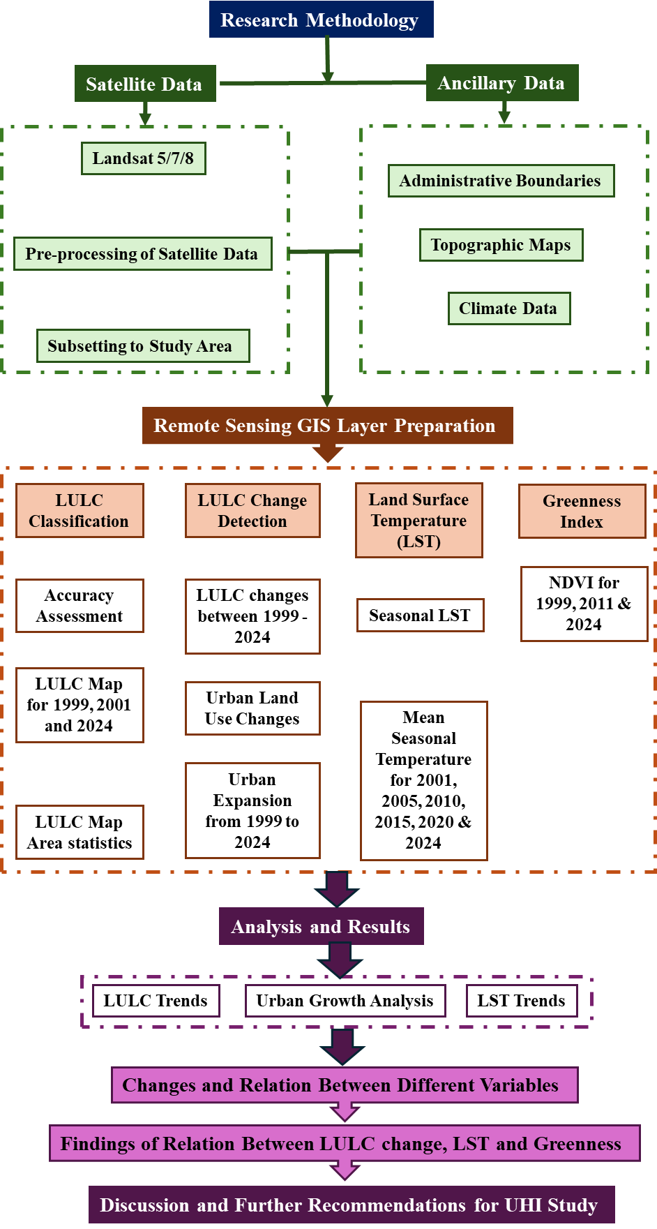

Fig. 1. Research Methodology

* + 1. **Land Use and Land Cover Classification**

LULC classification was carried out using a supervised Random Forest algorithm in GEE. RF is a non-parametric ensemble learning method that constructs multiple decision trees and aggregates their outputs, offering high accuracy and robustness against overfitting. Training datasets were prepared by digitising polygons corresponding to five major LULC classes: Built-up, Agriculture, Vegetation, Barren Land, and Water. These classes were derived from visual interpretation of high-resolution base maps and existing thematic layers, with at least 50 training samples per class for each time point.

The input feature stack included spectral bands (Red, Green, Blue, NIR, SWIR), NDVI, and texture variables. Seventy percent of the samples were used for training, and thirty percent were retained for validation.

To evaluate the accuracy of the LULC classification, an independent set of reference data was collected. This reference data, representing ground truth information about the land cover classes, was obtained through field surveys and high-resolution imagery interpretation. The classified LULC map was compared with the reference data, and various accuracy metrics, such as overall accuracy and users' and producers' accuracies for each class, were calculated (Congalton, 2019). The total number of training samples is necessary to evaluate the accuracy using the following equation:

$N=(\sum_{i=1}^{c}{(W_{i}S_{i}})/S_{0})^{2}$ (1)

Where Wi is the LULC area portion of class i, Si is the SD of stratum i, So is the expected SD of OA (Overall Accuracy) (0.01), and c is the total number of classes.

The formulas for calculating the classification accuracies are described in the next sections.

* + - 1. *Overall Accuracy (OA)*

Overall Accuracy represents the percentage of correctly classified samples or pixels in the entire classification.

OA = (Number of correctly classified samples / Total number of samples) x 100 (2)

* + - 1. *Producer's Accuracy (PA)*

Producer's Accuracy measures the probability of correctly classifying a specific land cover category from the perspective of the classification algorithm.

PA = (Number of correctly classified samples in a specific class / Total number of reference samples in that class) x 100 (3)

* + - 1. *User's Accuracy (UA)*

User's Accuracy measures the probability of a reference sample being correctly classified into a specific land cover category from the perspective of the user.

UA = (Number of correctly classified samples in a specific class / Total number of classified samples in that class) x 100 (4)

* + - 1. *Kappa coefficient (K)*

The Kappa coefficient measures the agreement between the classification and reference data, accounting for the level of agreement that could occur by chance.

K = (OA - Po) / (1 - Po) (5)

Where:

OA: Overall Accuracy, Po: Proportion of chance agreement, calculated as the sum of the products of the marginal totals divided by the total number of pixels.

These formulas allow for the quantification of classification accuracies, enabling the assessment and comparison of the performance of land use and land cover classification algorithms.

* + 1. **Change Detection Analysis**

To assess urban land transformation, a pixel-by-pixel post-classification comparison was conducted between the classified LULC maps for 1999–2011 and 2011–2024. Change detection matrices were generated to quantify the transitions between classes, especially focusing on the expansion of built-up areas at the expense of vegetative and agricultural land. Spatial overlays were used to visualise hotspot zones of urban expansion and landscape fragmentation.

* + 1. **Land Surface Temperature Estimation**

LST was derived from the thermal bands of Landsat imagery using a mono-window algorithm adjusted for emissivity. The process involved converting digital numbers to top-of-atmosphere radiance, converting radiance to brightness temperature in Kelvin, and then adjusting for surface emissivity based on NDVI-derived thresholds. Emissivity was estimated for vegetated and non-vegetated surfaces using NDVI-based classification, following standard protocols outlined by USGS and NASA.

The final LST in Celsius was calculated using Planck’s law inversion, incorporating both spectral radiance and surface emissivity. Seasonal LST profiles were generated for summer, winter, and monsoon seasons wherever sufficient cloud-free thermal data were available. This enabled temporal comparisons and the identification of heat-prone urban zones. The LST was estimated through the following formulas:

* + 1. **Vegetation Indices**

To understand the biophysical controls on urban thermal behaviour, NDVI were computed for all three time periods using red, NIR, and SWIR bands. NDVI was used to assess vegetative density and health variability. These indices were resampled to match LST resolution and correlated spatially using Pearson correlation coefficients.

* + 1. **Urban Heat Island and Statistical Analysis**

Urban Heat Island (UHI) intensity was computed as the difference between the mean LST in built-up areas and surrounding vegetated zones. Kernel density estimation and zonal statistics were used to identify persistent UHI hotspots. Spatial correlations between LST and LULC classes were quantified, and scatter plots were generated to visualise the inverse relationship between vegetative indices and LST.

All spatial and statistical analyses were conducted using a combination of GEE (for index generation and classification), QGIS (for mapping and overlay operations), and Python (for regression, plotting, and accuracy computation).

1. **ANALYSIS AND RESULTS**
   1. **Land Use and Land Cover Classification and Change Dynamics (1999–2024)**

The supervised classification using the Random Forest algorithm yielded highly accurate land cover maps for the years 1999, 2011, and 2024 (Figure 2). The land use classes identified included Built-up, Vegetation, Agriculture, Barren Land, and Water Bodies. Accuracy assessments showed overall classification accuracies of 92%, 92%, and 93% respectively, for 1999, 2011, and 2024, with Kappa coefficients above 0.85 in all cases, indicating strong agreement between classified maps and reference data (Table 1).

Table 1: Accuracy assessment

|  |  |  |  |  |  |  |  |  |  |  |  |  |  |  |  |  |
| --- | --- | --- | --- | --- | --- | --- | --- | --- | --- | --- | --- | --- | --- | --- | --- | --- |
|  |  | Producer’s Accuracy | | |  | User’s Accuracy | | |  | Overall Accuracy | | |  | Kappa coefficient | | |
| LULC Classes |  | 1999 | 2011 | 2024 |  | 1999 | 2011 | 2024 |  | 1999 | 2011 | 2024 |  | 1999 | 2011 | 2024 |
| Built-Up Land |  | 94 | 93 | 96 |  | 91 | 100 | 99 |  | 92 | 92 | 93 |  | 0.86 | 0.86 | 0.87 |
| Crop Land |  | 92 | 89 | 91 |  | 95 | 89 | 91 |  |  |  |  |  |  |  |  |
| Deciduous Forest |  | 88 | 92 | 93 |  | 94 | 91 | 88 |  |  |  |  |  |  |  |  |
| Scrub/Open Forest |  | 91 | 89 | 88 |  | 85 | 88 | 90 |  |  |  |  |  |  |  |  |
| Barren Rocky |  | 89 | 88 | 91 |  | 84 | 87 | 87 |  |  |  |  |  |  |  |  |
| River/ Waterbodies |  | 99 | 100 | 100 |  | 98 | 100 | 99 |  |  |  |  |  |  |  |  |

The spatial extent of built-up areas expanded dramatically over the 25 years (Figures 3 and 4). In 1999, built-up land constituted approximately 12.4% of the total area, which increased to 21.6% in 2011, and further rose to 35.9% by 2024. This urban expansion has occurred primarily at the expense of agricultural and vegetative cover. Vegetation cover declined from 27.8% in 1999 to 18.3% in 2024, while agricultural land reduced from 36.1% to 23.5% during the same period. These trends highlight the dominance of horizontal urban sprawl, especially toward the southern and northwestern peripheries of the city.

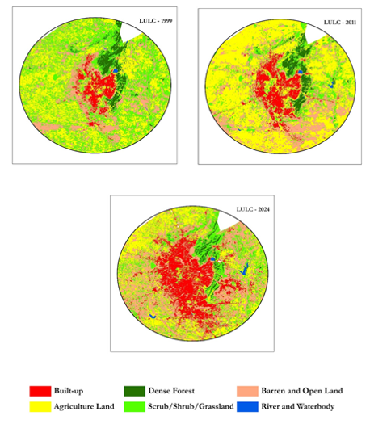

Fig. 2. Classified LULC maps of Jaipur for 1999, 2011 and 2024

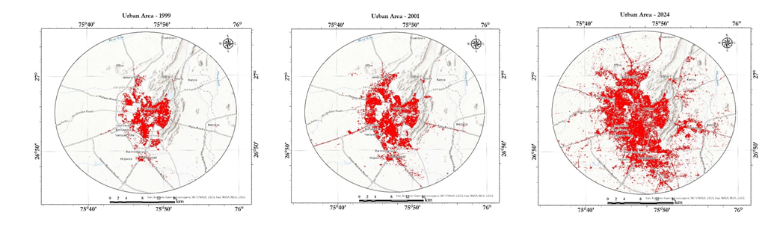

Fig. 3. Urban growth of Jaipur from 1990 to 2024

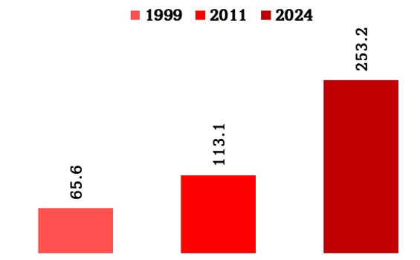

Fig. 4. Bar graph showing the Urban growth of Jaipur (km2) from 1990 to 2024

Change detection analysis further revealed that nearly 65% of the newly built-up areas in 2024 emerged from former agricultural lands, while about 24% came from previously vegetated zones. The loss of natural surfaces and the increase in impervious areas form the foundational backdrop for the thermal response observed in the city.

* 1. **Land Surface Temperature Patterns and Urban Heat Island Development**

LST values derived from Landsat thermal bands indicate a progressive warming trend over the study period, particularly within the built-up zones. The average surface temperature in urban cores increased from 31.4°C in 1999 to 34.7°C in 2024 during post-monsoon months. In contrast, vegetated and water-dominated areas remained comparatively cooler, averaging 26.1°C in 2024.

Spatial analysis of LST maps shows a distinct clustering of high-temperature zones coinciding with dense built-up regions such as Mansarovar, Jagatpura, and Vaishali Nagar, which exhibited peak surface temperatures exceeding 38°C during summer periods (Figure 5). The LST gradients from urban to peri-urban and rural fringes also became steeper over time, indicating the intensification of the Urban Heat Island (UHI) effect.

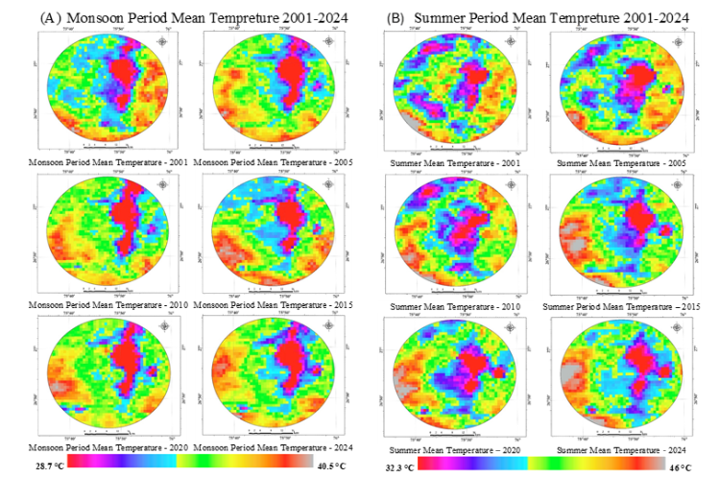

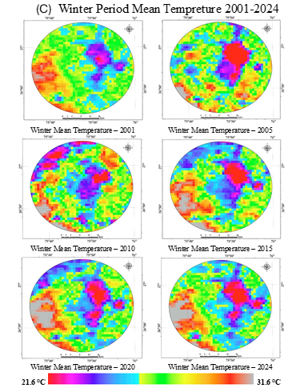

Fig. 5. Land surface temperature distribution in monsoon (A), summer (B) and winter (C) season of Jaipur from 2001 to 2024

The mean UHI intensity, calculated as the temperature difference between built-up zones and adjacent vegetated areas, increased from 3.2°C in 1999 to 5.1°C in 2024. This finding underscores the thermal impact of uncontrolled urban expansion and the reduction in green cover.

* 1. **Vegetation Index Analysis**

To further interpret surface temperature dynamics and NDVI was analysed for the three study years. NDVI values ranged from -0.15 to 0.65 across the study area, with higher values corresponding to forest patches, urban parks, and agricultural fields. The spatial correlation analysis revealed a strong negative relationship between NDVI and LST (Pearson’s r = -0.71, p < 0.01), indicating that areas with higher vegetative density consistently maintained lower surface temperatures. Areas with low NDVI exhibited the highest LST, suggesting a compounded effect of vegetation loss and surface dryness in driving thermal anomalies (Figure 4).

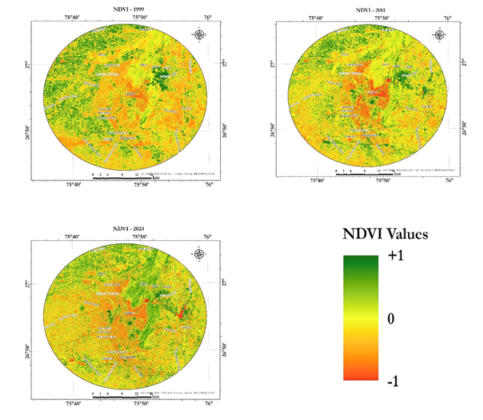

Fig. 6. Vegetation health (NDVI) of Jaipur for 1999, 2011 and 2024

These results collectively suggest that the increase in impervious surface, the spatial pattern of urbanisation, and degradation of natural land covers are significantly contributing to the intensification of UHI in Jaipur. The clear correlation between LULC changes and surface temperature rise validates the importance of integrated land and climate-sensitive urban planning.

1. **DISCUSSION**

The present study provides compelling evidence that the expansion of built-up areas in Jaipur over the past two and a half decades has significantly influenced the city’s surface thermal characteristics, consistent with broader urban climatological trends reported globally. The integration of multi-temporal satellite imagery, advanced machine learning classification, and land surface temperature (LST) analysis on a cloud-computing platform offers both methodological robustness and empirical clarity in quantifying urban thermal transformation.

The findings show that between 1999 and 2024, built-up areas in Jaipur nearly tripled, with a concurrent decline in vegetative and agricultural land. These land transformations directly contributed to intensified surface heating, as built-up zones exhibited consistently higher LST values than vegetated-rich areas. This pattern aligns with established literature indicating that impervious surfaces such as concrete and asphalt absorb and retain heat more efficiently than natural covers (Oke, 1982; Weng, 2001).

The spatial manifestation of the Urban Heat Island (UHI) effect, particularly the emergence of thermal hotspots in newly urbanised zones, is consistent with findings from other rapidly urbanising Indian cities such as Delhi, Hyderabad, and Ahmedabad (Das & Mali, 2012; Bhatta et al., 2018). However, Jaipur’s semi-arid climatic setting exacerbates this thermal intensification, given the naturally high baseline temperatures and limited evapotranspirative cooling due to sparse vegetation. This suggests that cities in arid and semi-arid zones may experience amplified UHI effects under similar land transition trajectories, a concern increasingly noted in the literature (Zhou et al., 2014; Zhao et al., 2018).

Importantly, the observed inverse correlation between NDVI and LST reinforces the biophysical buffering role of vegetation and soil moisture in regulating urban microclimates. Green infrastructure and surface moisture not only enhance thermal comfort but also support urban resilience to climate extremes (Ranagalage et al., 2020). The current study corroborates these conclusions and emphasises that the loss of such buffers in Jaipur has substantially weakened its capacity to absorb or deflect thermal stress.

Methodologically, the use of the Random Forest (RF) algorithm within the Google Earth Engine (GEE) environment allowed for efficient and accurate LULC classification across large spatial and temporal scales. Previous research has established the superiority of RF in heterogeneous urban landscapes due to its ensemble learning capacity and resistance to overfitting (Belgiu & Drăguţ, 2016). The classification accuracies in this study, exceeding 85%, further validate RF as a reliable tool for urban land mapping, especially when integrated with cloud-based geospatial platforms.

From a policy and urban planning perspective, the findings have serious implications. The emergence of new UHI cores in the city’s peripheries suggests a fragmented and unregulated expansion pattern, often detached from ecological or climatic considerations. This is consistent with the observed trajectory of many Indian cities where spatial planning mechanisms lag behind the pace of urban growth (Kumar & Shekhar, 2016; Mohan et al., 2020). Without immediate corrective strategies, such as reintroducing green spaces, preserving vegetative corridors, and enforcing zoning norms, Jaipur may face further deterioration in thermal comfort, public health, and energy sustainability.

Moreover, the spatial heterogeneity in LST patterns reveals that not all urban expansion contributes equally to surface heating. High-density, low-green built-up zones, especially informal settlements and transport corridors, are primary drivers of thermal stress. This underscores the need for differentiated mitigation strategies tailored to land use intensity and ecological sensitivity.

While this study demonstrates the effectiveness of combining remote sensing, machine learning, and geospatial analytics for urban heat mapping, it also points to a few limitations. LST derived from satellite imagery represents surface, not ambient air temperature, which may affect fine-scale interpretations. Furthermore, thermal emissivity estimates rely on NDVI thresholds, which may introduce uncertainty in mixed land cover pixels. Nevertheless, the spatiotemporal consistency of the results and strong validation metrics lend credibility to the overarching conclusions.

In summary, Jaipur's case exemplifies the broader narrative of urban thermal degradation under unchecked land use transformation, particularly in climate-vulnerable geographies. The study not only strengthens empirical understanding of UHI development but also contributes methodologically to the field of urban remote sensing and climate modelling. As cities worldwide grapple with climate adaptation, the evidence presented here reinforces the urgency of integrating land use planning with climate resilience at both macro and neighbourhood scales.

1. **CONCLUSION**

This study critically examined the interplay between urban land use dynamics and thermal environmental change in Jaipur over 25 years using integrated remote sensing and machine learning approaches. The findings underscore that rapid, unplanned urban expansion has significantly intensified the Urban Heat Island (UHI) effect, primarily due to the conversion of vegetated and agricultural lands into impervious built-up surfaces. The rise in surface temperatures and the spatial concentration of thermal hotspots in newer urban zones reflect a growing environmental challenge, particularly in semi-arid contexts where natural cooling mechanisms are already limited.

By leveraging multi-temporal Landsat datasets and the GEE Random Forest classifier, this study not only achieved high classification accuracy but also demonstrated the methodological viability of cloud-based geospatial analytics for long-term environmental monitoring. The observed negative correlation between NDVI and LST reinforces the mitigating role of green infrastructure in regulating urban microclimates.

These insights are particularly valuable for urban planners and policy-makers, highlighting the urgency of climate-sensitive land use planning and the incorporation of heat-resilient design. Without timely interventions, such as increasing urban green spaces, enforcing ecological zoning, and adopting nature-based solutions, Jaipur risks further thermal degradation, with implications for human health, energy demand, and ecological sustainability. This research thus contributes both empirically and methodologically to the discourse on urban environmental resilience in rapidly transforming, climate-sensitive geographies.

**ETHICAL APPROVAL**

All authors hereby declare that all experiments have been examined and approved by the appropriate ethics committee and have therefore been performed in accordance with the ethical standards laid down in the 1964 Declaration of Helsinki.

COMPETING INTERESTS DISCLAIMER:

Authors have declared that they have no known competing financial interests OR non-financial interests OR personal relationships that could have appeared to influence the work reported in this paper.

**Disclaimer (Artificial intelligence)**

Option 1:

Author(s) hereby declare that NO generative AI technologies such as Large Language Models (ChatGPT, COPILOT, etc.) and text-to-image generators have been used during the writing or editing of this manuscript.

**REFERNCES**

Bhatta, B. (2010). Analysis of Urban Growth and Sprawl from Remote Sensing Data. Springer.

Buyantuyev, A., & Wu, J. (2010). Urban heat islands and landscape heterogeneity: linking spatiotemporal variations in surface temperatures to land-cover and socioeconomic patterns. Landscape Ecology, 25, 17–33.

Congalton, R. G., & Green, K. (2019). Assessing the accuracy of remotely sensed data: principles and practices. CRC press.

Drăguţ, L., Belgiu, M., Popescu, G., & Bandura, P. Int J Appl Earth Obs Geoinformation.

Du, H., Song, X., Gao, B., & Gao, B. (2016). Surface Urban Heat Island in China's 32 major cities: spatial patterns and drivers. Remote Sensing of Environment, 175, 332–344.

EPA. (2008). Reducing Urban Heat Islands: Compendium of Strategies. United States Environmental Protection Agency.

Foody, G. M., & Mathur, A. (2004). A relative evaluation of multiclass image classification by support vector machines. IEEE Transactions on Geoscience and Remote Sensing, 42(6), 1335–1343.

Gupta, N., Purohit, M. R., & Daiman, A. (2024). A comprehensive exploration of land use dynamics, NDVI trends, and stakeholder engagement for crafting sustainable green spaces. National Geographical Journal of India, 70(1).

Gupta, N., Purohit, M. R., & Daiman, A. (2024). Assessing Urban Transformation and Green Infrastructure in Bhilwara Through Machine Learning and Earth Observation. Arabian Journal of Geosciences, 17(10), 269.

Imhoff, M. L., Zhang, P., Wolfe, R. E., & Bounoua, L. (2010). Remote sensing of the urban heat island effect across biomes in the continental USA. Remote Sensing of Environment, 114(3), 504–513.

Kumar, D., & Shekhar, S. (2016). Linear gradient analysis of kinetic temperature through geostatistical approach. Modeling Earth Systems and Environment, 2(3), 145.

Li, M., Stein, A., Bijker, W., & Zhan, Q. (2016). Urban land use extraction from Very High Resolution remote sensing imagery using a Bayesian network. ISPRS journal of photogrammetry and remote sensing, 122, 192-205.

Mali, S., Panhalkar, S., Pawar, C., & Das, S. (2012). Generation of 3-D City Model for Urban Utility Information System Using Digital Photogrammetry & GIS Technology. Global Journal of Researches in Engineering General Engineering, 12(3), 26-30.

Mohan, M., Sati, A. P., & Bhati, S. (2020). Urban sprawl during five decadal period over National Capital Region of India: Impact on urban heat island and thermal comfort. Urban climate, 33, 100647.

Mondal, I., Bandyopadhyay, J., Hossain, S. A., Altuwaijri, H. A., Roy, S. K., Akhter, J., ... & Juliev, M. (2024). Evaluating the effects of rapid urbanization on the encroachment of the east Kolkata Wetland ecosystem: a remote sensing and hybrid machine learning approach. Environment, Development and Sustainability, 1-33.

Oke, T. R. (1982). The energetic basis of the urban heat island. Quarterly Journal of the Royal Meteorological Society, 108(455), 1–24.

Ranagalage, M., Ratnayake, S. S., Dissanayake, D. M. S. L. B., Kumar, L., Wickremasinghe, H., Vidanagama, J., ... & Muthunayake, P. (2020). Spatiotemporal variation of urban heat islands for implementing nature-based solutions: A case study of Kurunegala, Sri Lanka. ISPRS International Journal of Geo-Information, 9(7), 461.

Roy, P. S., Behera, M. D., Srivastava, V. K., & Joshi, P. K. (2012). Landscape-level biodiversity characterization using geospatial modelling technique. Indian Institute of Remote Sensing (IIRS), ISRO, Dehradun.

Roy, P. S., Behera, M. D., Murthy, M. S. R., Roy, A., & Singh, S. (2015). Biodiversity Characterisation at Landscape Level: National Assessment. Indian Institute of Remote Sensing (IIRS), ISRO.

Sobrino, J. A., Jiménez-Muñoz, J. C., & Paolini, L. (2004). Land surface temperature retrieval from LANDSAT TM 5. Remote Sensing of Environment, 90(4), 434–440.

Talukdar, S., Singha, P., Mahato, S., Pal, S., Liou, Y. A., & Rahman, A. (2020). Land-use land-cover classification by machine learning classifiers for satellite observations—A review. Remote sensing, 12(7), 1135.

Voogt, J. A., & Oke, T. R. (2003). Thermal remote sensing of urban climates. Remote Sensing of Environment, 86(3), 370–384.

Weng, Q. (2001). A remote sensing–GIS evaluation of urban expansion and its impact on surface temperature in the Zhujiang Delta, China. International Journal of Remote Sensing, 22(10), 1999–2014.

Weng, Q., Lu, D., & Schubring, J. (2004). Estimation of land surface temperature–vegetation abundance relationship for urban heat island studies. Remote Sensing of Environment, 89(4), 467–483.

Zhao, L., Oppenheimer, M., Zhu, Q., Baldwin, J. W., Ebi, K. L., Bou-Zeid, E., ... & Liu, X. (2018). Interactions between urban heat islands and heat waves. Environmental research letters, 13(3), 034003.

Zhou, D., Zhao, S., Liu, S., Zhang, L., & Zhu, C. (2014). Surface urban heat island in China's 32 major cities: Spatial patterns and drivers. Remote sensing of environment, 152, 51-61.

Zhang, F., Zhou, Z., Huang, D., Du, X., Deng, F., Yang, Y., & Du, S. (2023). Dynamic monitoring and analysis of factors influencing ecological quality in rapidly urbanizing areas based on the Google Earth Engine. Geocarto International, 38(1), 2256299.