Derailment and Wrath of Climate in India

ABSTRACT

. India has the climate of Tropical monsoon climate due to its peculiar position in the Asian continent and the Indian Ocean. The review paper aims to discuss the impediments and indignation of the indian climate. India's climate is primarily a tropical monsoon climate characterised by distinct wet and dry seasons. This type of climate is found profusely in South and Southeast Asia. While the monsoon is the dominant feature, India's climate varies significantly across the country owing to its large size and diverse topography. In 2025, India is experiencing a stark demonstration of climate change's grip, with a year marked by record-breaking heat, water shortages and intensified extreme weather events. India is highly vulnerable to climate change, and its impacts are widespread, affecting the environment, economy, and society. The factors influencing climate change include floods, droughts, as well as cyclonic storms occurring too often and rising temperatures, while changing weather patterns. The present paper thoroughly appraises the reasons for climate change, the impact of climate change and the way forward to reduce the impact of climate change. It is suggested that India has to cope with these changes while also working for adaptation within its economic systems and infrastructure. Overall, India is facing a complex and challenging climate crisis in 2025, with a need for both short-term adaptation measures and long-term mitigation strategies to address the root causes of climate change. Action is required immediately and over time towards saving humans and biodiversity from the climate crisis.

Key Words: India, Climate Change, Causes and Impact, Way Forward, Performance Index
INTRODUCTION
“The Indian peninsula experiences a variety of climates within various states within it. India is mostly a tropical country. Its northern part is situated in the temperate belt and is separated from the rest of Asia by the Himalayan ranges, which block cold air from Central Asia. The Himalayan region, due to its fragile ecology, is extremely vulnerable to even small perturbations in climate that might not only affect the pristine ecosystems but also the socioeconomic sectors across the mountain arc” (Dad et al., 2021). “This results in the northern states of India having slightly higher temperatures than other same altitude during the winter season. On the other hand, during the summer season, due to the sun’s position, the region experiences a dry climate like that of the equatorial regions. The plains in the northern region of India are influenced by the hot wind called ‘loo’ from the Thar and Iranian deserts. This makes the temperatures comparable to the southern part of India. India's climate is primarily a tropical monsoon climate, characterised by distinct wet and dry seasons” (Unacademy). This type of climate is found mainly in South and Southeast Asia. While the monsoon is the dominant feature, India's climate varies significantly across the country owing to its large size and diverse topography.¹

NATURE AND FEATURES OF INDIAN CLIMATE
“Climate change refers to the long-term changes in temperature and weather due to human activities. Increase in average global temperature and extreme and unpredictable weather are the most common manifestations of climate change. In recent years, it has acquired the importance of a global emergency and affecting not only the well-being of humans but also the sustainability of other lifeforms” (Shivanna, 2022). “India has the climate of Tropical monsoon climate due to its peculiar position in the Asian continent and the Indian Ocean. The Indian climate is mostly characterised by wet and dry seasons. However, some locations within India, like Ladakh and the Thar desert, do not have wet seasons. The mean rainfall in each region in India varies, while Meghalaya, aka the Abode of Clouds, records one of the highest rainfall while Jaisalmer records the least. The Ganga plains and coastal regions receive rainfall during July and August. During the months of June and July, places like Goa, Patna and Hyderabad receive rainfall along with regions in the Northwest. In India, both diurnal and annual temperatures have substantial ranges. Thar experiences the highest diurnal temperatures, while the Himalayas experience the highest annual temperatures. In the Himalayas, winters are extremely cold, while summers are moderately hot” (Unacademy). India experiences a tropical monsoon climate with significant regional variations. The Himalayas, aka ‘Water Tower of Asia’ and the surrounding water bodies, play a crucial role in shaping India's climate.²

Significant temperature and rainfall differences exist across the country due to factors like latitude, altitude and proximity to the sea. The Himalayan mountain range acts as a barrier, protecting India from cold winds and influencing the monsoon patterns. Coastal areas experience a maritime climate with moderate temperatures and higher rainfall, while inland areas have a continental climate with more extreme temperatures. Temperatures range from moderate to severe, with the north experiencing cooler temperatures than the south. Temperatures rise with May being the hottest month. The SW monsoon winds bring heavy rainfall to most of the country, while northern areas receive less rainfall than southern areas. This period is generally dry and receives rainfall due to the retreating monsoon.

INFLUENCING FACTORS OF INDIAN CLIMATE (Source from Unacademy)
- The Himalayan ranges act as an interface between India and Central Asia and protect India from cold, dry winds from the Central Asian region. They also act as a stumbling block to strong monsoon winds. If not for the Himalayas, the monsoon winds would move towards China, making the northern Indian region a desert.
- Location-India has a tropical climate owing to its location between 8⁰N and 37⁰N latitude. Areas in the south of the tropic of Cancer have high solar insulation, while the northern regions receive less insulation.
- Sea-Regions in India near the coast have a relatively moderate climate. While the interior parts tend to experience more extreme climate situations. The monsoon winds bring good rainfall into the region.
- Monsoon Winds-Monsoon winds are an important part of the Indian climate characterised by sudden onset, progress, retreat and reversal of winds.
- Air circulation-The jet streams cause changes in India’s climate. The western jet stream and eastern jet stream prominently influence weather patterns in India.
- El-Nino, La Nina and ENSO
“El-Niño and La-Niña are associated with El-Niño Southern Oscillation (ENSO), an ocean-atmospheric coupled phenomenon generally observed in the tropical Pacific Ocean. ENSO occurs due to irregular sea surface temperature (SST) and wind pattern changes. The warm and cold phases of ENSO are termed El-Niño and La-Niña, respectively” (Sahu et al., 2022). “El Niño badly affects the monsoon rainfalls. Nevertheless, it is good for cyclogenesis in the Arabian Sea. El Niño also results in droughts during the season in which they take place. La Nina is good for the cyclogenesis process in the Bay of Bengal and suppresses the process in Arabian Sea. Floods are common during the time La Niña takes place. El Niño Southern Oscillation means changes in temperature in the central and Pacific Ocean. Climatic conditions as a result of the ENSO effect are similar to the El Niño effect”. ³

DERAILMENT OF CLIMATE IN INDIA
In 2025, India is experiencing a stark demonstration of climate change's grip, with a year marked by record-breaking heat, water shortages and intensified extreme weather events. February 2025 was the warmest in 125 years, but May made headlines for its extreme rainfall. Delhi received 186.4 mm of rain - the highest ever recorded in May. In 2025, India saw unusual weather patterns: January and February were very warm, while May saw extreme rainfall. There are abnormal changes in the Indian climate. The temperature is rising in the cool Himalayas, and on the contrary, low temperatures are being recorded in the generally hot areas like Central Provinces or Mid-latitudes. This has been elicited by meteorologists by considering an average temperature for the last 30 years. The Himalayas are receiving higher temperatures continuously and even rapidly. Glaciers are melting, and glacier landslides are taking place. There is a sea-change in climate and a derailing from its normalcy. Not long ago, Jaipur, capital of Rajasthan, recorded 2º °C, i.e. lower temperature than it received the average temperature of the past 30 years. Besides, it received 78 mm more rainfall.⁴

Quidditic Rainfall
“Erratic rainfall and early monsoons aren’t entirely new phenomena—they’ve been observed over many years. Nevertheless, what has changed is the intensity and concentration of rainfall in short periods. The regions like Rajasthan, Gujarat, central Maharashtra, and Karnataka have seen rainfall increase by up to 30% over the last decade compared to the previous 30-year average. This rise is not spread evenly across the season; instead, it is marked by short, intense downpours, such as those seen recently in Mumbai—an outcome of increasingly erratic monsoon behaviour” (Vishwas Chitale, Council on Energy, Environment and Water)⁵ “Warming oceans are carrying more moisture, leading to more intense and erratic rainfall. Climate change has intensified rainfall — but it's also a planning failure. We need to rethink urban design. We can’t keep building the same way in Delhi, the Himalayas, and coastal areas That approach must change" (Aarti Khosla, Climate Trends).⁶

“India spans five distinct climatic zones—tropical, arid, semi-arid, temperate and alpine—all of which are now experiencing severe disruptions due to rising temperatures. The arid and semi-arid regions are seeing erratic rainfall patterns, upending agricultural cycles. Traditional climate zones are flipping: flood-prone areas now face droughts, and vice versa” (India Today, 2025). According to the National Disaster Management Authority (NDMA), “the most affected states and union territories include Odisha, Telangana, Andhra Pradesh, Haryana, Delhi, Punjab, Rajasthan, Madhya Pradesh, Maharashtra, Gujarat, Uttar Pradesh, Bihar and Chhattisgarh”.^{7 “}The economic and social toll of these extreme conditions is enormous. The Reserve Bank of India estimates that extreme heat and humidity could lead to a 4.5% loss in GDP by 2030 due to reduced labour productivity. Changes in monsoon patterns could further reduce GDP by 2.8% by 2030, potentially lowering living standards for nearly half the population by 2050”.⁸

ANOMALOUS AND UNPRECEDENTED TEMPERATURES
The WMO report forecasts that the annually averaged global mean near-surface temperature for each year between 2025 and 2029 is predicted to be between 1.2°C and 1.9°C higher than the average. According to the Intergovernmental Panel on Climate Change (IPCC), “the UN’s climate science body, India is projected to be one of the most vulnerable regions to escalating heat waves, humid heat stress and other extreme weather events in a 1.5⁰C warmer world—threats that could bring irreversible consequences”.⁹

Today, the country has been experiencing record-breaking temperatures with early summer arriving as soon as February or March. Heat waves became more frequent, prolonged and intense. In many areas, temperatures have soared close to 50⁰C leading to increased illness and loss of life, especially among vulnerable groups such as the elderly, children, and outdoor workers. Within a week, the temperatures have skyrocketed in Rajasthan and New Delhi. In May 2025, the temperature recorded more than 50⁰C in several parts of Rajasthan. The temperature recorded at 52.9 0C in Mungeshpur in Northwest New Delhi. The IMD issued a Red Alert in North India. It is heartening to note that 16500 people got sunstroke while tens of people died in India owing to scorching and simmering temperatures. Even in the month of July 2025, New Delhi received 38⁰C temperature. In the first week of August, Tirupati received 40⁰C (The Hindu, August 2, 2025) ¹⁰.

The year 2023 is well-known for receiving abnormal temperatures around the world. Abnormal climatic conditions at the deleterious scale and state prevail in India. As May 2025 unfolded, instead of the expected peak summer heat, large parts of India experienced comparatively cooler temperatures, and a smaller number of heat wave days marked by unseasonal rains and thunderstorms. Once upon a time, 40⁰C was natural, while now the temperature is commonly around or sometimes or every now and then beyond 50⁰C. While May 2024 was marked by soaring temperatures and widespread heat waves across much of the country, May 2025 had unseasonably cool conditions, signalling a major alteration in the nation’s climatic patterns.
However, as May 2025 unfolded, instead of the expected peak summer heat, large parts of India experienced comparatively cooler temperatures marked by unseasonal rains and thunderstorms. The contrast between 2024 and 2025 highlights how climate change is not just about gradual warming but also about more frequent and intense fluctuations. While the early end of summer in 2025 offers temporary respite from heat, it is also an inkling of the complex and changing nature of India’s climate, demanding adaptive strategies across sectors. In the present summer, May and June saw relentless heat waves that pushed temperatures to record highs in many regions, exacerbating drought conditions and straining power and water resources. The intense summer heat was typical of the broader trend of rising temperatures attributed to climate change, impacting agriculture, health, and daily life for millions. However, as May 2025 unfolded, instead of the expected peak summer heat, large parts of India experienced comparatively cooler temperatures marked by unseasonal rains and thunderstorms. ¹¹

CAUSES OF DERAILMENT OF CLIMATE CHANGE IN INDIA
Changes in climate owing to pollution are the main reasons for climate derailment. If the Himalayas are melted rapidly, lower areas succumb to devastation, floods occur, and thus there may be heavy loss of property and toll. In 2025, the primary drivers of climate change in India include the emission of greenhouse gases (GHGs) from various sectors, particularly the burning of fossil fuels for energy and industrial processes, deforestation, and agricultural practices. These factors contribute to a rise in global temperatures, leading to more frequent and intense heat waves, droughts, and changes in rainfall patterns. High temperatures are recorded more than the average in the Himalayas during 2014-2024. The situation has become rather worse after 2016. The temperature was recorded at 19.99⁰C as an average, but it is higher at 0.77⁰C. The average temperature according to the World Bank Report increased on average at 0.62⁰C during 1901-2020. It varied between 0.24⁰C and 0.99⁰C. The main reasons are deforestation, rapid urbanisation, and the use of abnormal fossil fuels. “Saumya Swaminathan, environmentalist and Chairperson of MSSRF, told India Today that Urban flooding is rising due to multiple factors—partly climate change, and partly poor planning. While total rainfall did not change much over the decade, it’s now falling in fewer hours, making it harder for cities to cope”.¹²

Climate change in India is primarily caused by a combination of human activities and natural processes. The major causes include: 1. India is one of the largest emitters of greenhouse gases (GHGs), mainly carbon dioxide (CO2), due to the burning of fossil fuels for energy, transportation, and industrial activities. The increasing demand for energy, especially from coal-fired power plants, is a key driver of emissions 2. A great change in climatic conditions has been brought forth by large deforestation, often made for large-scale agriculture or for urban development. Forests are then large sinks for carbon dioxide since they absorb carbon from the atmosphere 3. Rapidly affecting industries have contributed towards emissions emanating from factories, construction, and other activities in the heavy industry sector 4. Improper waste management through the burning of biomass and waste also releases carbon dioxide and methane into the atmosphere, thus aggravating the climate.
Impact of Heat Stress
“In 2022, heat waves forced India to ban wheat exports after extreme temperatures slashed yields—highlighting the vulnerability of both the agriculture sector and global food supply chains. Agricultural scientists say heat stress has reduced rice yields by 15–20% across different varieties. To build resilience, India will need investment in cooling infrastructure, better urban design, early warning systems, and adaptive social protection. The real challenge lies in not just recognising heat as an economic threat, but also in mobilising targeted finance to tackle it and protect livelihoods. India’s challenge is unique: it must build heat resilience while sustaining economic growth to create jobs and lift millions out of poverty. The Heat Conference aims to bring together these stakeholders to address what may be India’s single greatest climate risk (Fig.1). The deliberation focused on unseasonal rainfall and the very frequent heavy rainfall occurring in the western parts of India, including the record-breaking rains in Mumbai on Monday, breaching a hundred-year record” ¹³

Fig.1. Impact of Heat Stress

IMPACT OF CLIMATE CHANGE IN INDIA
India is highly vulnerable to climate change, and its impacts are widespread, affecting the environment, economy, and society. The primary impacts are 1. The increase in average temperatures has reached an extreme event of heat in different parts of the country. It directly affects the agriculture sector, water availability, and human health because of its heat increase 2. In the monsoon pattern shifts, the delay in the timing of rainfall or randomness in rains affects the agricultural calendar, ultimately leading to crop failure. It also adds to a variety of concerns regarding the scanty availability of water 3. India is experiencing more frequent and intense weather events such as floods, cyclones, and droughts. These events cause significant damage to life, property, and infrastructure 4. The Himalayan region, which feeds many major rivers in India, is experiencing glacial melt due to rising temperatures. This impacts water availability in key areas, particularly in the Indo-Gangetic plains, ¹⁴

“India is one of the most vulnerable countries in the world to projected climate change impacts, with heat stress emerging as the single largest concern. The prospect of extreme heat and heat stress arises from the widespread, rapid changes in ocean temperatures combined with steadily rising atmospheric heat retention. The India Heat Summit 2025 is deliberating on the issue of rising temperatures and shared solutions. The summit will also advise the government on long-term measures to deal with its impact. The deliberation is also focusing on issues related to unseasonal rainfall and the very frequent heavy rainfall occurring in the western parts of India, including the record-breaking rains in Mumbai, breaching a hundred-year record” ¹⁵

Saumya Swaminathan, “environmentalist and Chairperson of MSSRF, felt that Urban flooding is rising due to multiple factors—partly climate change, and partly poor planning. While total rainfall hasn’t changed much over the decade, it’s now falling in fewer hours, making it harder for cities to cope”. ^{15 “}Climate change has intensified rainfall, but it's also a planning failure. We need to rethink urban design. We can’t keep building the same way in Delhi, the Himalayas, and coastal areas.. The regions like Rajasthan, Gujarat, central Maharashtra and Karnataka have seen rainfall increase by up to 30% over the last decade compared to the previous 30-year average. This rise isn’t spread evenly across the season; instead, it is marked by short, intense downpours, such as those seen recently in Mumbai” ¹⁶
According to the Intergovernmental Panel on Climate Change (IPCC), “the UN’s climate science body, India is projected to be one of the most vulnerable regions to escalating heat waves, humid heat stress, and other extreme weather events in a 1.5C warmer world—threats that could bring irreversible consequences. With over 90% of its workforce employed in the informal sector, in the world’s most densely populated country, India faces heightened exposure to both the physical dangers and economic risks of rising heat stress”. ^{21 “}In the north, accelerated glacial melt and glacial lake formation are intensifying flood risks. Forest fires and water scarcity are putting immense pressure on hill ecosystems in states like Uttarakhand. The arid and semi-arid regions are seeing erratic rainfall patterns, upending agricultural cycles. Traditional climate zones are flipping: flood-prone areas now face droughts, and vice versa. There is a clear spatial-temporal shift in heat wave occurrences across India, with rising trends in three major regions: north-western, central, and south-central India. The Reserve Bank of India estimates that extreme heat and humidity could lead to a 4.5% loss in GDP by 2030 due to reduced labour productivity”. ¹⁷
“Changes in monsoon patterns and rising temperatures could further reduce GDP by 2.8% by 2030, potentially lowering living standards for nearly half the population by 2050. Without effective mitigation policies, India could face annual GDP losses of 3-10% by 2100. As climate-induced extremes intensify, it’s critical to assess temperature-related risks across key sectors like energy, industry, agriculture and urban development. In May 2024, India’s power consumption surged by 15%, reaching a record peak demand of 250.07 GW, driven by extreme heat and surpassing all previous records. Rising temperatures have increased the demand for residential cooling, industrial operations and irrigation (Fig.2), making India more reliant on thermal power to meet its growing energy needs”. ¹⁸
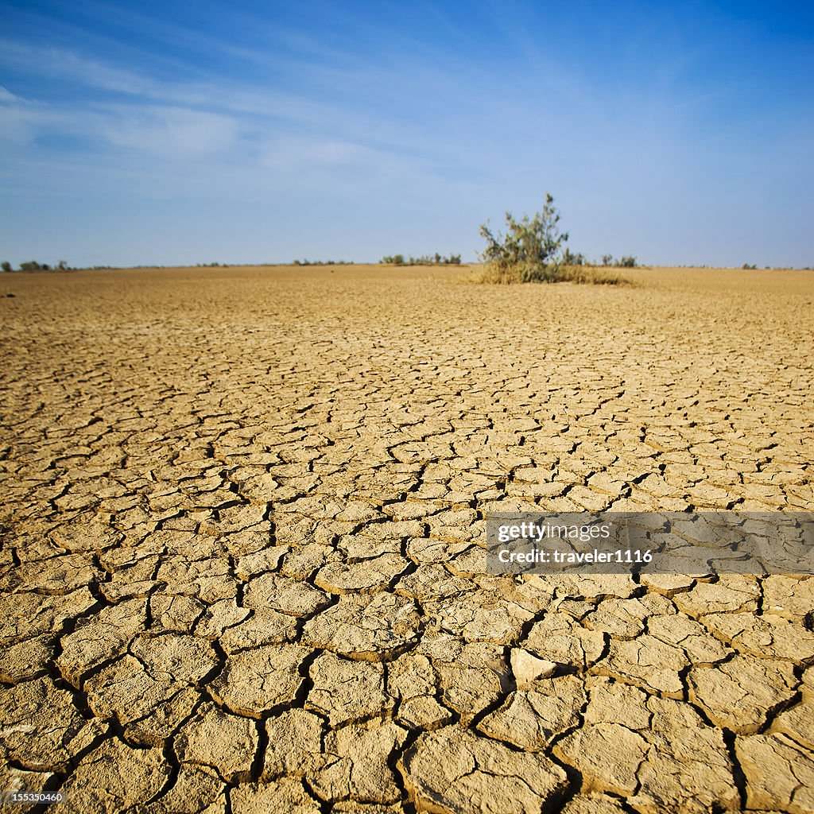
Fig.2 Exacerbating drought conditions
“Experts project a 9-10% increase in energy demand in 2025, driven in part by a sharp rise in air conditioner sales—highlighting both the rising energy demand and the growing disparity in access. From generation to transmission to distribution, high temperatures strain energy systems. Experts note that as a conductor heats up, its molecules vibrate more, increasing resistance and reducing efficiency. This became evident in 2022, when India experienced its worst electricity shortage in over six years, leading to power cuts in homes and industries. For the manufacturing sector, such supply disruptions can severely impact production timelines and raise costs. Without effective mitigation policies, India could face annual GDP losses of 3-10% by 2100”.¹⁹

This became evident in 2022, when India experienced its worst electricity shortage in over six years, leading to power cuts in homes and industries. For the manufacturing sector, such supply disruptions can severely impact production timelines and raise costs. The impact of heat stress extends far beyond the power grid. According to the World Bank, “over 34 million jobs in India could be at risk due to heat exposure. Between 2001 and 2020, India lost around 259 billion hours of labour—worth US$624 billion (INR 46 lakh crore) annually—due to extreme heat and humidity”. Moreover, landslides are occurring owing to raining cats and dogs in hilly areas, flash floods in low-lying areas, wild wildfires (Fig.3) owing to unbearable temperatures recently in India especially in Tirumala, Tirupati are the standing ovations and adduces. Astonishingly, the hazards are leading one to the other in toe. Both in June and July 2025, monsoons entered and led to torrential rains, leading to floods and cyclones. Already, the Remal Cyclone devastatingly hit several states of the 7 sisters of northeast India. These states suffered severely with oodles of property loss and human toll.²⁰

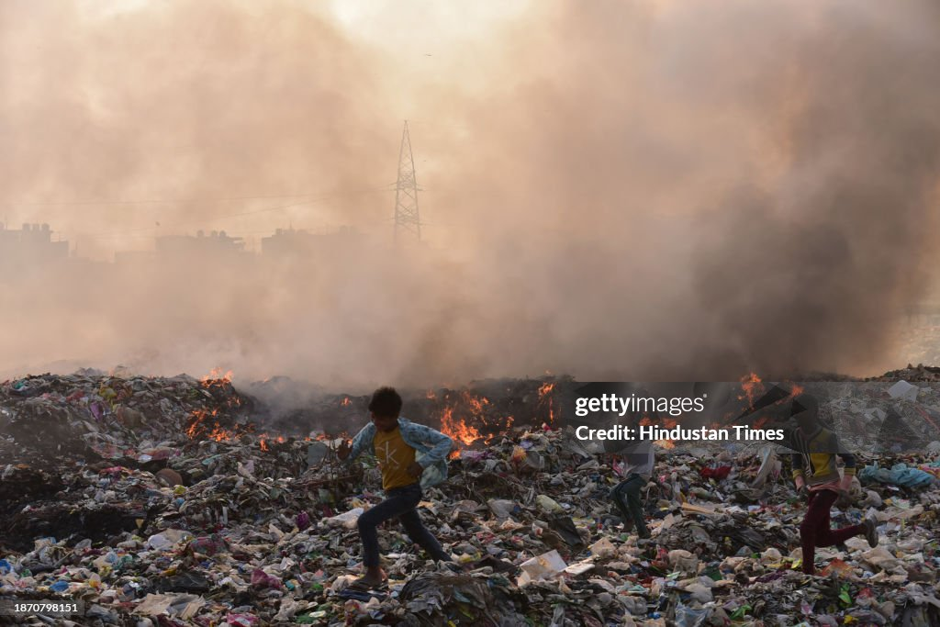
Fig.3 Forest and Waste Fires
WAY FORWARD
At present, people of the nation should learn and follow the measures taken by the Odessa Government in protecting and lessening the impact of the fury of cyclones and floods on human and property loss by pre-planned rehabilitation of people to save places and safeguarding, including the provision of basic amenities. It is more mandatory to establish cool water distribution centres, afforestation, planting of saplings abundantly and using renewable fuels, on the contrary to fossil fuels. We must emulate anti-environmental destruction plans being implemented in Thane, Maharashtra State. Primary provisions and facilities must be extended or continued to cope with the extremes of heat, rain or cool. By and large, we must take preventive and stringent measures of flood management before they turn into a great hazard by coming out from relief from the present scorching summer. It is quite difficult not to listen to any hazard of natural or man-made any more. “The cities are ill-prepared for such events, lacking resilient infrastructure for transport, public health and emergency response. According to Saumya Swaminathan, the early onset of the southwest monsoon, as seen in Mumbai, is a warning sign—and India must urgently integrate weather data with urban planning to protect vulnerable populations” (India Today, 2 Jun 2025)²¹

TACKLING CLIMATE CHANGE IN INDIA
Several important steps for climate change mitigation, adaptation, and sustainable development have been taken up by the Indian government.

National Action Plan on Climate Change (NAPCC)
India's NAPCC, launched in 2008, provides eight national missions on various aspects of comprehensive action on climate change:
- National Solar Mission: Focuses on scaling up solar power generation to promote renewable energy.
- National Mission for Enhanced Energy Efficiency: Aims to improve energy efficiency across industries.
- National Mission on Sustainable Habitat: Focuses on making urban development more climate-friendly through better waste management and transportation.
- National Water Mission: Aims to improve water-use efficiency and ensure water security.
- National Mission for Sustainable Agriculture: Focuses on climate-resilient farming practices.
- National Mission on Strategic Knowledge for Climate Change: Aims to build scientific knowledge to inform policy decisions.
- National Mission on Himalayan Ecosystems: Addresses issues related to the preservation of Himalayan ecosystems.
- National Mission for Green India: Promotes afforestation to absorb CO2.²²

INDIA’S RANK IN CLIMATE CHANGE PERFORMANCE INDEX (CCPI)
India currently ranks 10th in the Climate Change Performance Index (CCPI) 2025 Global Climate Change Performance Index. India’s performance is relatively good, with the country achieving high performance in renewable energy expansion. In order to fully meet the global climate goals, India needs to increase its efforts in carbon emissions reduction and adaptation. Despite the positive developments in renewables, India remains heavily reliant on coal. India receives a high ranking in the GHG Emissions and Energy Use categories, medium in Climate Policy, and low in Renewable Energy ²³
SUGGESTIONS AND IMPLICATIONS
For combating climate change in the first world populous country, i.e. India, the following suggestions and implications are implemented on war footing.
- Population Control is instantaneously controlled
- All vehicles running for 15 years need to be abolished.
- All vehicles should have a pollution-free certificate on the road
- Vehicle Holiday is immediately implemented in all private and government institutes once a month, if not once a week.
- Forest fires and incineration of waste must be controlled

CONCLUSION
India is mostly a tropical country. India’s northern part is situated in the temperate belt. The northern states of India have slightly higher temperatures than other same altitude during the winter season. On the other hand, during the summer season, due to the sun’s position, the region experiences a dry climate like that of the equatorial regions. India has the climate of Tropical monsoon climate due to its peculiar position in the Asian continent and the Indian Ocean. The Indian subcontinent has hot summers and moderately cold winters. In the Himalayas, winters are extremely cold, while summers are moderately hot. Overall, India is facing a complex and challenging climate crisis in 2025, with a need for both short-term adaptation measures and long-term mitigation strategies to address the root causes of climate change. Action is required immediately and over time towards saving humans and biodiversity from the climate crisis.

Disclaimer (Artificial intelligence)
Option 1:
Author(s) hereby declare that NO generative AI technologies such as Large Language Models (ChatGPT, manuscript.
Option 2:
Author(s) hereby declare that generative AI technologies such as Large Language Models, etc. have been used during the writing or editing of manuscripts. This explanation will include the name, version, model, and source of the generative AI technology and as well as all input prompts provided to the generative AI technology
Details of the AI usage are given below:
1.
2.
3.

REFERENCES
- Kari Isaksen and Kristian Stokke (2014), “Changing Climate Discourse and Politics in India: Climate Change as Challenge and Opportunity for Diplomacy and Development,” Geoforum 57, 2014: 110–119.
- Lavanya Rajamani (2009), “India and Climate Change: What India Wants, Needs, and Needs to Do”, India Review 8, No. 3 (2009): 340–374.
- S.V.Joseph and S. Sadhasivam (2024), “India as a Climate Leader in the Indo-Pacific: Challenges and Opportunities,” Journal of the Indian Ocean Region, 2024:1–23.
- MoEFCC(2024), India: Fourth Biennial Update Report to the United Nations Framework Convention on Climate Change. Ministry of Environment, Forest and Climate Change, Government of India.
- Vishwas Chitale (2025), Council on Energy, Environment and Water, Climate Resilience @ CEEW I Climate Adaptation ISB I Public policy I Climate Action
- Aarti Khosla (2025), Climate Trends, Climate Trends. Director, Carboncopy.
- National Disaster Management Authority, India (2023) Report
- Reserve Bank of India National Account Statistics 2024, Statement 1.1 and 8.10, Retrieved from https://www.mospi.gov.in/publication/national-accounts-statistics.
- Intergovernmental Panel on Climate Change (IPCC) (2025), Report on Climate Change
- The Hindu, June 5, 2025.
- Economic Survey 2024-25, Climate and Environment: Adaptation Matters https://www.indiabudget.gov.in/economicsurvey/doc/eschapter/echap10.pdf
- Saumya Swaminathan, environmentalist and Chairperson of MSSRF
- The International Conference on Thermo-Fluids and System Design (ICTFSD 2022) was held from March 22-23, 2022, organized by the Department of Mechanical Engineering at BIT Mesra,
- Jignasa Thaker and Anthony Leiserowitz, “Shifting Discourses of Climate Change in India,” Climatic Change 123, no. 2 (2014): 107–119.
- India Heat Summit 2025, India Heat Summit 2025: Rising Temperatures, Shared Solutions, March 27-28, New Delhi.
- Saumya Swaminathan, (2025) Health Impacts of Climate Change, M. S. Swaminathan Research Foundation (MSSRF), Report
- Reserve Bank of India (2025) Report
- World Bank, Economic Survey 2024-25
- The Reserve Bank of India (2025) Report
- Tropical Cyclone Remal(2024) Report on Disaster description, May 2024
- India Today, 2 Jun 2025
- Economic Survey 2023-24, Chapter 6: Climate Change and Energy Transition https://www.indiabudget.gov.in/budget2024-25/pdf
- CLIMATE CHANGE PERFORMANCE INDEX (CCPI), CAN Climate Action Network International Kaiserstr, 201 D-53113 Bonn, Germany, p.10
- Dad, J. M., Muslim, M., Rashid, I., & Reshi, Z. A. (2021). Time series analysis of climate variability and trends in Kashmir Himalaya. Ecological Indicators, 126, 107690.
- Shivanna, K. R. (2022). Climate change and its impact on biodiversity and human welfare. Proceedings of the Indian National Science Academy, 88(2), 160-171.
- Sahu, R. K., Choudhury, G., Vissa, N. K., Tyagi, B., & Nayak, S. (2022). The impact of El-Niño and La-Niña on the pre-monsoon convective systems over Eastern India. Atmosphere, 13(8), 1261.
- Unacademy. A Brief Summary on Climate of India. https://unacademy.com/content/bank-exam/study-material/general-awareness/a-brief-summary-on-climate-of-india/

