GIS and AHP-based flood susceptibility mapping: a case study of Chalakudy river Basin.

Abstract
The present study employs a GIS-AHP (Geographic Information System-Analytical Hierarchy Process) approach to assess flood susceptibility in the Chalakudy River Basin, Kerala, India. Twelve key factors influencing flooding were identified and categorized into hydrological (precipitation, river network density), morphometric (elevation, slope, distance from rivers), land cover dynamics (LULC, NDVI, NDWI, SAVI), and anthropogenic parameters (distance from roads, settlements). Using AHP, weights were assigned to these factors based on expert based judgment, and a flood susceptibility map was generated through weighted linear combination. The results classify 7.41% of the basin as highly susceptible to flooding, with validation using Sentinel-1 SAR imagery confirming the model’s accuracy. The Consistency Ratio (CR) of 4.8% ensured the reliability of the AHP-derived weights. The study highlights the interplay of natural and anthropogenic factors, such as monsoonal rainfall, terrain slope, and sedimentation, in exacerbating flood risks. While AHP-GIS proved effective for regional assessments, the study acknowledges its subjectivity and suggests integrating advanced machine learning techniques for improved precision. The findings underscore the utility of flood susceptibility maps for risk management and mitigation strategies, particularly in data-scarce regions.

Key words: Flood Susceptibility Mapping, GIS-AHP Approach, Chalakudy River Basin, Multi-Criteria Decision Analysis (MCDA), Sentinel-1 SAR Validation

Introduction

Flooding is one of the most catastrophic natural disasters globally, affecting approximately 170 million people annually and accounting for over 60% of all fatalities related to natural disasters (De Risi et al., 2019; Kazakis et al., 2015). The assessment of flood risk is complex due to the interaction of various local factors, such as rainfall, terrain, hydrographic networks, soil properties, and land use. Additionally, flood magnitudes are subject to significant variability due to climate change, land use alterations, and deforestation, all of which contribute to an increasing flood risk. Two key trends are projected to intensify future flood risk: a rise in both the frequency and severity of flooding, and heightened societal vulnerability, particularly due to urbanization and population growth in flood-prone areas, including riverbanks and coastal zones (Sofia et al., 2017). Traditional flood hazard assessments generally rely on hydrological and hydraulic models to estimate flood depth and extent. However, these models often require comprehensive observational data, which may not always be readily available (Fenicia et al., 2013). Recent advancements in Geographic Information Systems (GIS), Remote Sensing (RS), and machine learning techniques have allowed researchers to develop more robust flood risk assessment models. These models consider the interactions of multiple conditioning factors, providing more accurate and reliable predictions (Tehrany et al., 2017).

Flood susceptibility maps, which identify areas at high risk of flooding, are crucial tools for effective flood risk management and mitigation strategies. These maps are typically generated through Multi-Criteria Decision Analysis (MCDA), a method that assigns weights to various flood conditioning factors based on expert judgment (Carver, 1991). Common weighting techniques in MCDA include the Analytical Network Process (ANP) and Weighted Linear Combination (WLC) approaches (Kourgialas and Karatzas, 2011). One widely adopted MCDA approach in flood risk management is the Analytical Hierarchy Process (AHP). AHP is a multi-criteria decision-making method that deconstructs complex problems into hierarchical components, facilitating structured decision-making (Saaty,
1977). Despite its widespread use, AHP has inherent limitations, primarily due to its reliance on expert judgment for assigning numerical values, which can introduce subjectivity and result in ambiguity in decision outcomes (Li et al., 2009). This study aims to evaluate the performance of the MCDA-AHP technique for regional-scale flood susceptibility mapping, focusing on the Chalakudy River Basin. The study conceptualizes flood susceptibility as a combination of both physical-geographical factors, such as terrain, and dynamic land cover conditions.

Materials and methods Study area
The Chalakudy River Basin (Fig.1), situated between latitudes 10°09'44" and 10°22'00" North and longitudes 76°15'56" and 77°07'30" East, is the fifth longest river basin in Kerala, India, extending 145.5 km. It flows through the districts of Thrissur, Palakkad, and Ernakulam in Kerala, as well as Coimbatore in Tamil Nadu. The basin receives annual rainfall ranging from 1,800 to 3,600 mm, which is vital for its hydrological functioning. The basin's shape is roughly triangular, with the base along the eastern edge. Originating from the Anamalai hills in the Western Ghats, the river traverses the northern section of the Periyar River system.
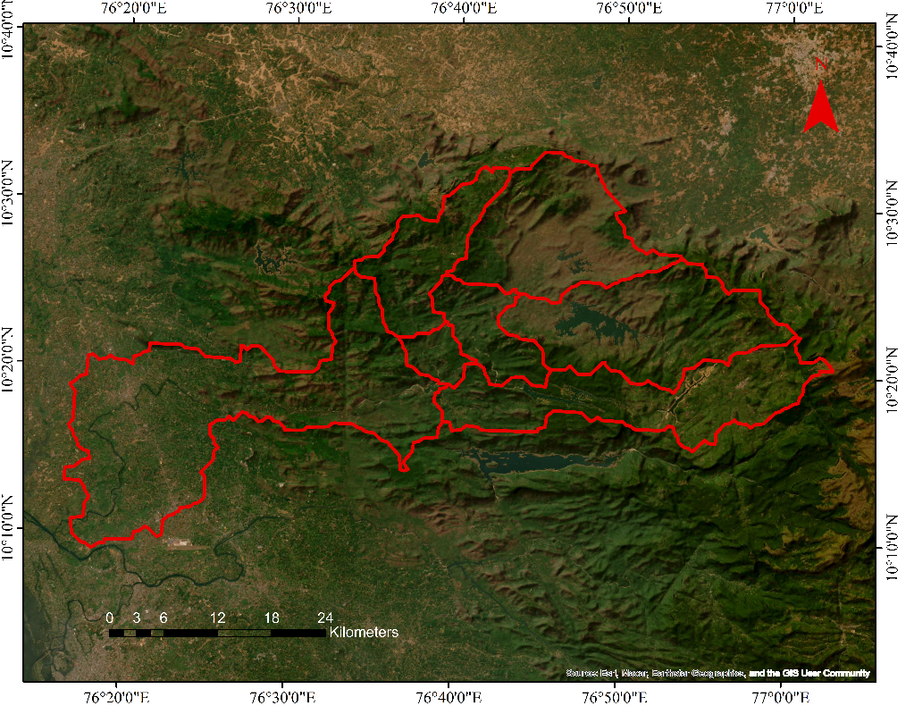

Figure 1: Study area

Flood susceptibility evaluation
It involved selecting key criteria based on several studies (Li et al., 2021; Ghorbani et al., 2017). Twelve factors were identified as significant contributors to flooding, and these were classified into four major categories based on their properties and relationships: (I) Hydrological parameters: precipitation and river network density (II) Morphometric parameters: elevation, slope and distance from rivers; (III) Land Use/Land Cover (LU/LC) dynamics: land use/land cover, soil-adjusted vegetation index (SAVI), NDWI and NDVI;
(IV) Anthropogenic interference: distance from settlements and distance from roads (Fig. 2).
Figure 2 Flowchart for Methodology
Input datasets
Hydrological parameters
Morphometric parameters
LULC dynamics
Anthropogenic parameters
- Rainfall
- Topographic wetness index
- River Network density
- Elevation
- Distance from river
- Slope
- NDVI
- SAVI
- NDWI
- LULC
- Distance from Road
- Distance from Settlement

Image processing GEE & Arc-GIS
AHP ranking and GIS mapping
Flood susceptibility Map
Validation with SAR image

Each of these criteria was carefully defined and processed into raster datasets. Their relative importance was determined through the Analytical Hierarchy Process (AHP), where factors were ranked based on expert input from professionals in soil management, water resources, meteorology, disaster management, and local administration. A final flood susceptibility map was generated using a weighted linear combination method within AHP for multi-criteria analysis.

Anthropogenic Interference
Anthropogenic interference criterion includes distance to road distance to settlement. Our study used open street map data, to automatically extract urban land or impervious surface layers [10]. Road construction results in an increased percentage of impervious surfaces, causing reduced groundwater recharge and changes in topography that in turn flow accumulation and high runoff. Flood susceptibility classes for the raster of distance to roads were defined the same as those for “distance to rivers” following the grading technique using the “Euclidean” distance tool with a vector layer in the ArcGIS software environment.
Hydrological Criterion:
Hydrological criterion comprised three parameters: precipitation, river network density, and TWI. IMD data was considered for the rainfall mapping. The values of average precipitation for 2020-2024 were collected and distributed over the study area through geostatistical interpolation, which is called krigging. The drainage network density (in km/km²) was determined and mapped using the “line density” tool of the ArcGIS software environment. It was estimated as the ratio between the total length of “river segments” to the total “drained area” or drainage basin (Dube, 2018).
Morphometric Criterion
The three relevant flood sub-criteria grouped under morphometric criterion are elevation, slope, and distance from rivers. The elevation map of the study area was estimated from a digital elevation model (DEM) with a spatial resolution of 30*30 m using Shuttle Radar Topography Mission (SRTM) DEM in the GIS software environment. A slope map was also generated from the above DEM (Renard, 1997). Another important flood evaluation criterion is “distance from rivers”, where abundant runoff causes frequent flooding. The classes for the raster of “distance from rivers” were estimated according to the natural break grading method using the “Euclidean distance” tool in the ArcGIS software environment using a map with a spatial resolution of 1:50,000.
LU/LC Dynamics
The LU/LC map for the study region was Prepared from the Landsat 8 for the year 2024 by using the GEE. In our study, the GEE platform utilized for the calculating SAVI, NDVI, NDWI (Goffi, et al., 2020).
Each criterion was categorized into five susceptibility levels based on its contribution to flooding, with the levels ranging from 1 (very low) to 5 (very high) (Table 1). The flood susceptibility for each parameter was assessed and then integrated to determine the overall flood susceptibility for the region. This process was based on a comprehensive assessment of the relevant main and sub-criteria.
Table 1: The fundamental scale of AHP (Saaty, 1980)
Intensity of Importance | Description
1 | Equal importance
3 | Moderate importance
5 | Strong importance
7 | Very strong importance
9 | Extreme importance
2, 4, 6, 8 | Intermediate values

AHP (Analytic Hierarchy Process)

It is a multi-perspective, multi-objective decision-making model that facilitates the quantitative derivation of preference scales from a set of alternatives. This approach allows users and planners to evaluate alternatives systematically. Saaty (1980) introduced the Pairwise Comparison Matrix (PCM) method for determining the weighting factors of individual criteria through a ranking scale. These rankings are estimated and assessed using a random consistency index (RI), which varies based on the number of factors or the order of the matrix. The consistency ratio (CR) is defined as the ratio of the consistency index (CI) to the random index (RI), for weight validation, the CR should be less than 0.1; if it exceeds this threshold, the comparison matrix weights must be recalculated. Researchers have employed approximation techniques to calculate the final weights and normalize the PCM. These normalized weights are then applied in flood susceptibility modeling, which integrates various criteria, including hydrological factors and morphometric attributes, to assess susceptibility levels effectively.
Table 2: Data sets used for flood susceptibility mapping
Data | Parameters | Year | Source
DEM | Elevation, Slope, Distance from the river, Topographic wetness index, River Network density | 2024 | GEE, USGS Earth Explore
Road | Distance from Road, Distance from settlement | 2024 | Open Street Map
Satellite imagery | LULC, NDVI, SAVI, NDWI | 2024 | GEE, USGS Earth Explorer
Rainfall 0.25° resolution | Rainfall | 2024 | IMD

Figure 3 Weight assignment of various parameters
Table 3: Flood Susceptibility Criteria and Sub-Criteria Ranges for Flood Susceptibility Assessment

Flood causative parameters |  |  |  | Susceptibility Class Ranges and Ratings
 |  | Unit | Very high | High | Moderate | Low | Very low
 | Hydrology parameters
1 | River network density | Km/ km2 | 0-18.3 | 18.3-44.4 | 44.4-71.9 | 71.9-105.6 | 105.6-195.22
2 | Precipitation | mm | 1378.6-1675.8 | 1675.8-1943.9 | 1943.9-2006.05 | 2006.05-2223.5 | 2223.5-2765.4
3 | TWI | Level | 0-33 | 33-100.2 | 100.2-214.7 | 214.7-415.1 | 415.1-1216.8
Morphometric parameters
5 | Elevation | m | 5-296.2 | 296.2-660.3 | 660.3-924.2 | 924.2-1261.0 | 1261.0-2326
6 | Slope | % | 0-5.8 | 5.8-13.2 | 13.2-21.3 | 21.3-30.88 | 30.88-78.76
7 | Distance from rivers | m | 0-100 | 100-200 | 200-300 | 300-400 | 400-500
 | Landcover dynamics
8 | LULC | Level | Water | Built-up | Barren/Farmland | Plantation | Forest
9 | NDVI | Range | -0.2 - 0.12 | 0.13 - 0.38 | 0.39 - 0.54 | 0.55 - 0.64 | 0.65 - 0.82
10 | NDWI | Range | -0.9 - -0.68 | -0.67 - -0.55 | -0.54 - -0.23 | -0.22 - 0.23 | 0.24 - 0.99
11 | SAVI | Range | -1.4 - -0.53 | -0.52 - 0.27 | 0.28 - 0.82 | 0.83 - 1.1 | 1.2 - 1.5
Anthropogenic parameters
13 | Distance to road | m | 0 - 746.9 | 746.9-1953.47 | 1953.47-3274.4 | 3274.4-4797.5 | 4797.5- 7325.5
14 | Distance to settlement | m | 0-184. | 184-435.8 | 435.8-755.5 | 755.5-1230.1 | 1230.1-2470.0

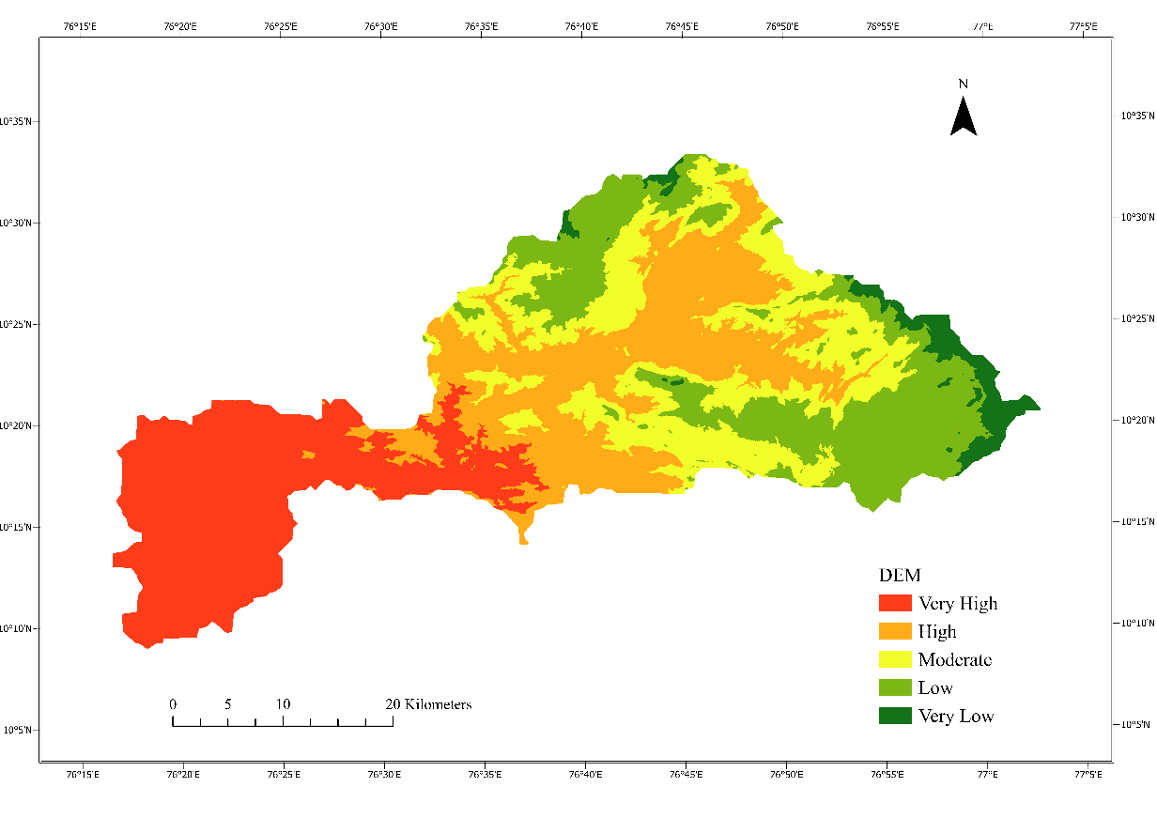

Figure 4: Elevation Map
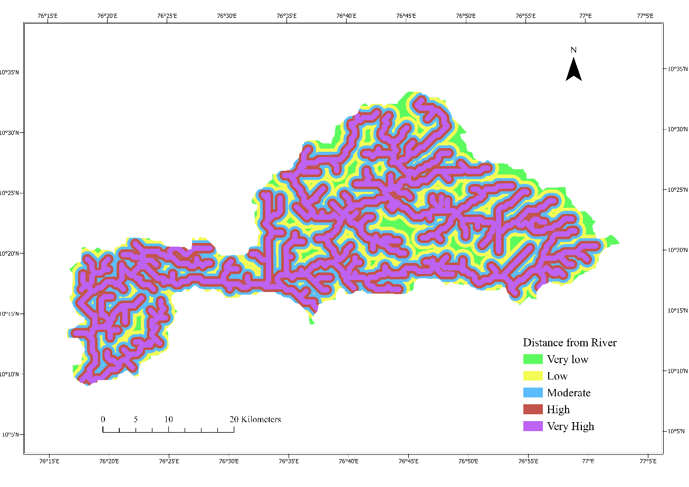
Figure 5: Distance from the river Map
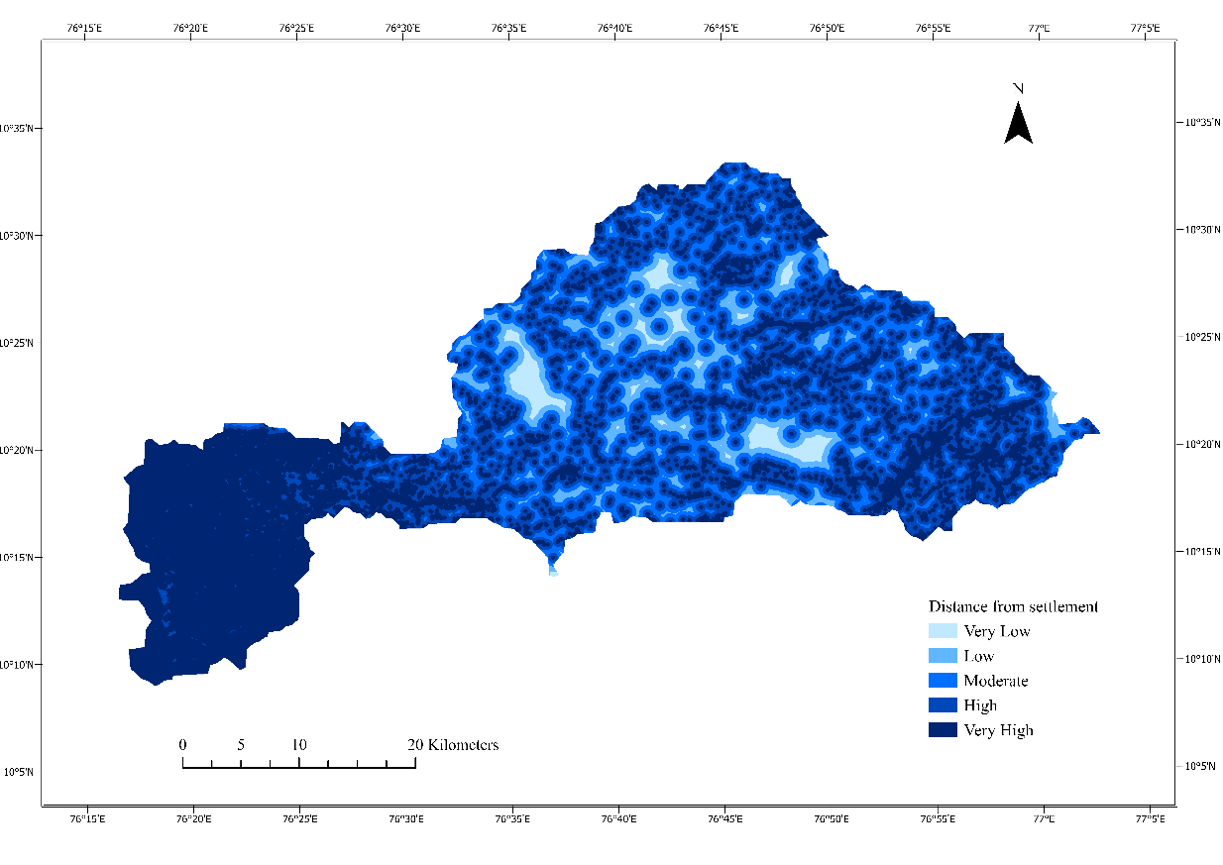
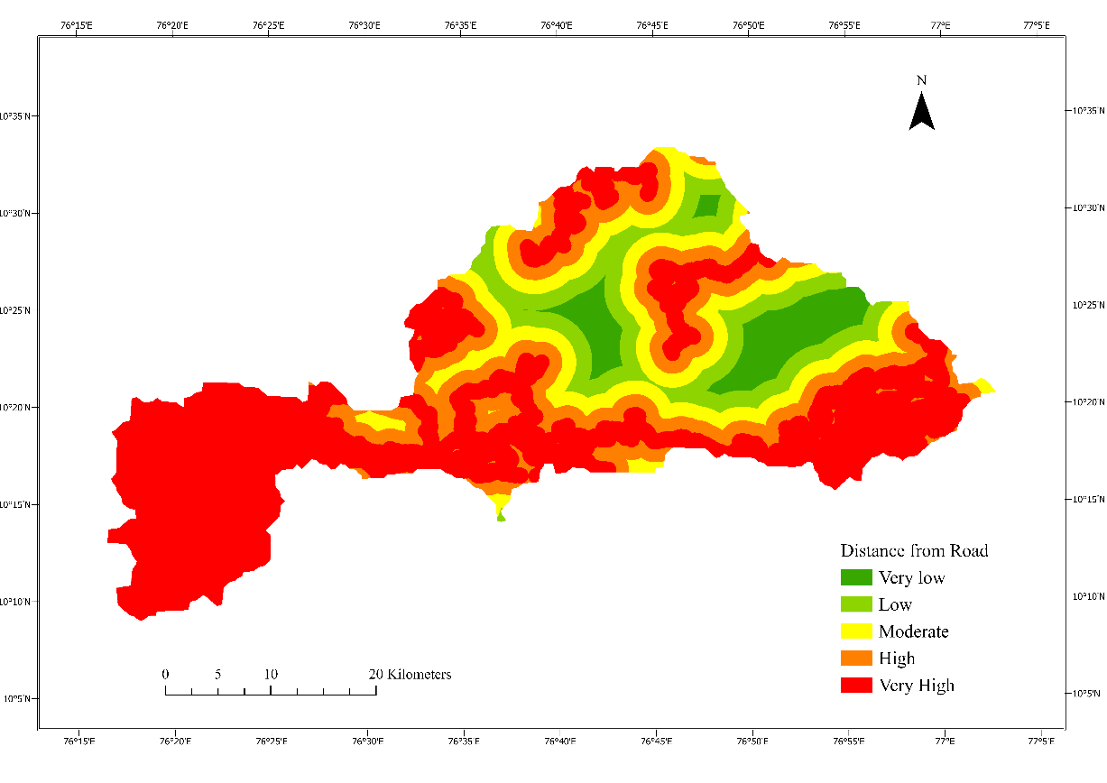
Figure 7: Distance from Settlement map
Figure 6: Distance from road Map
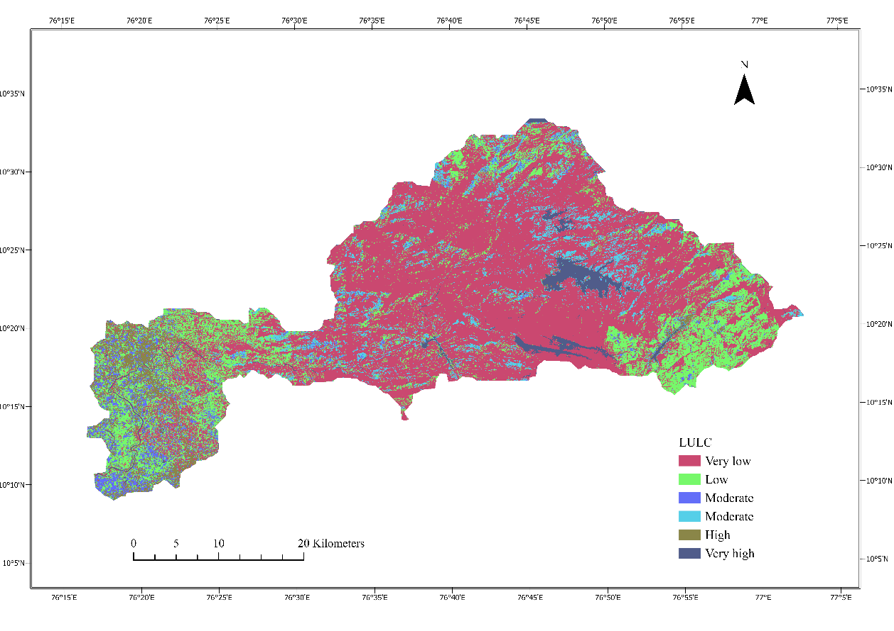
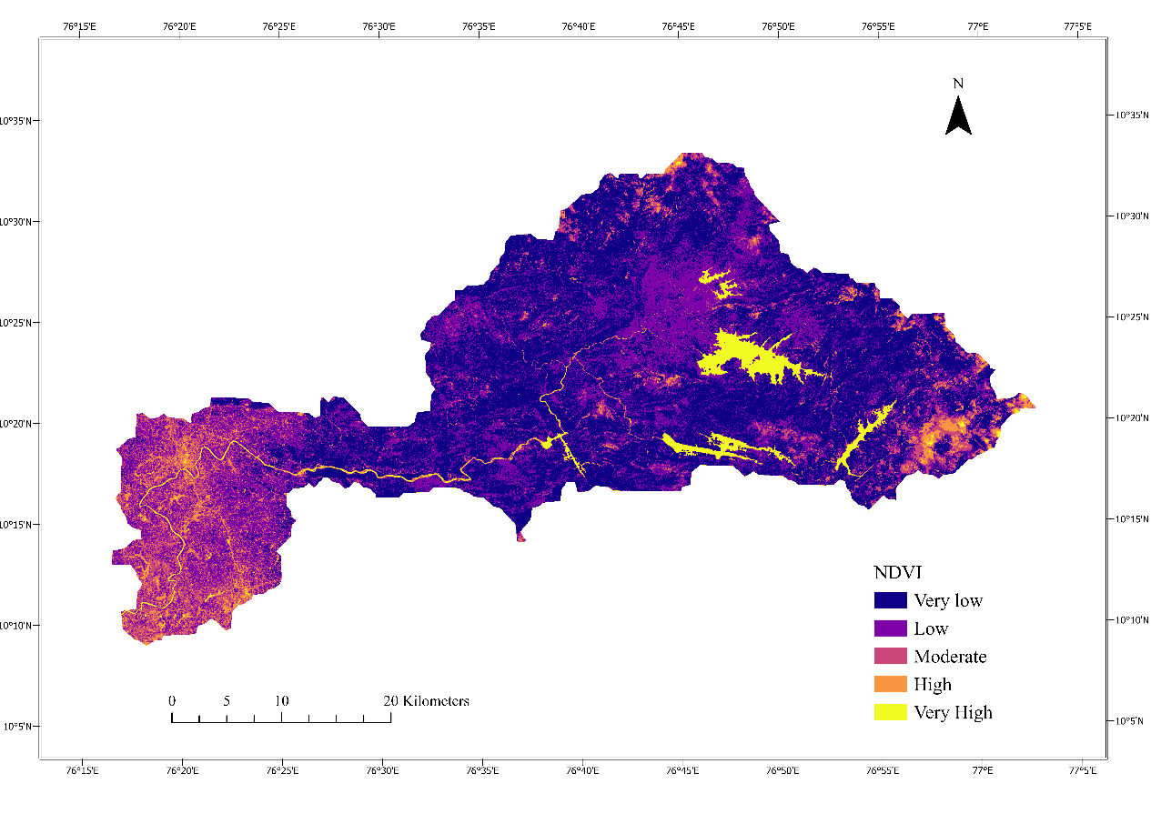
Figure 9: NDVI map
Figure 8: Land use land cover Map
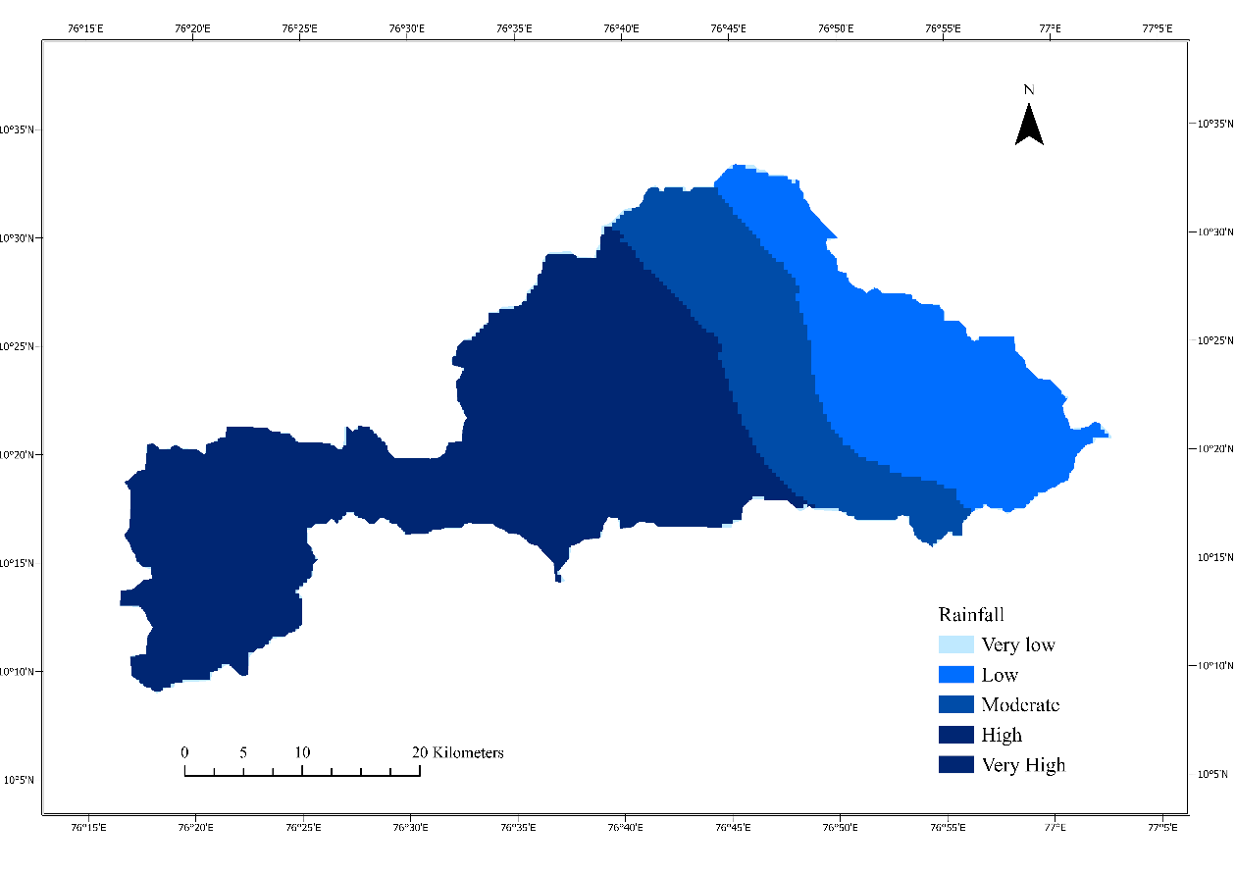
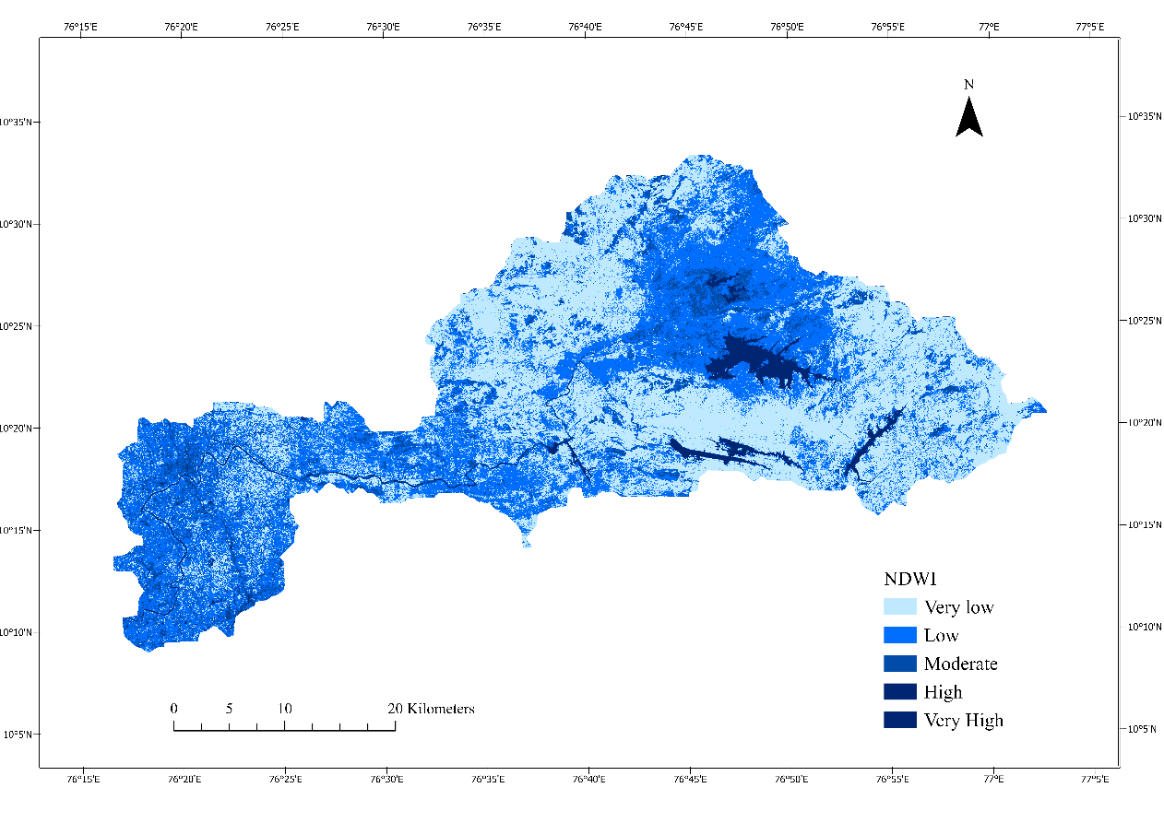
Figure 11: Rainfall Map
Figure 10: NDWI map
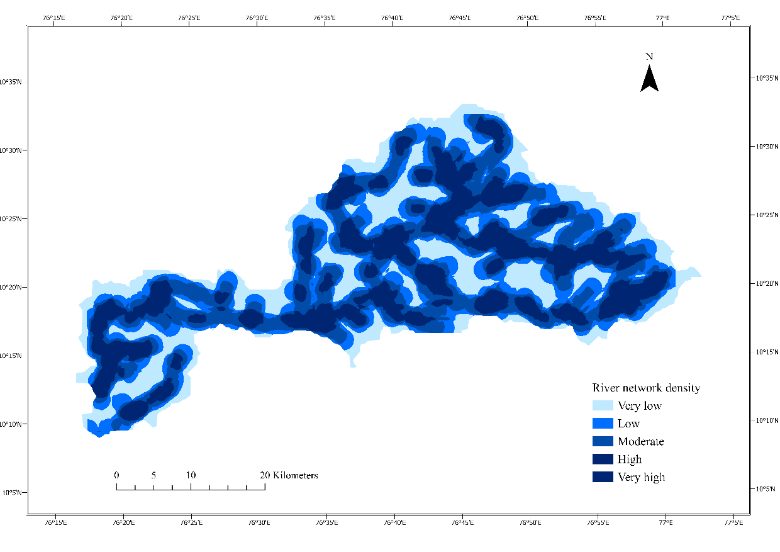
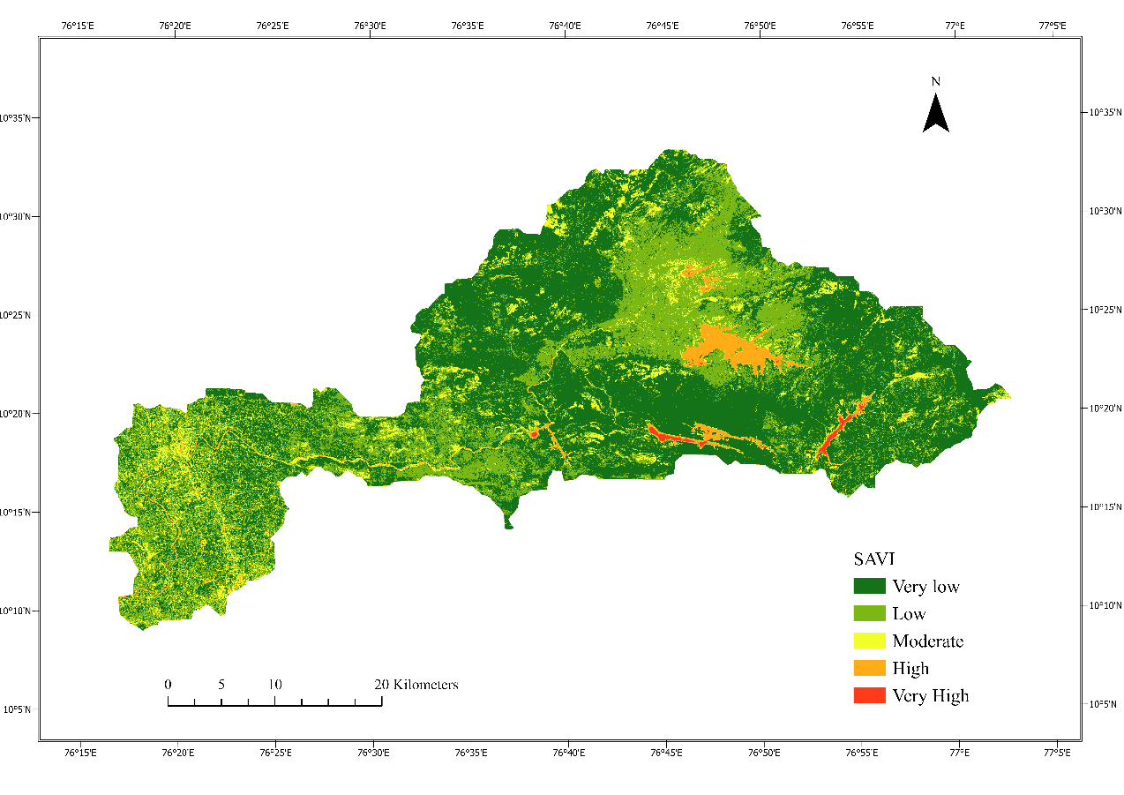
Figure 12: River Network density

Figure 13: SAVI map

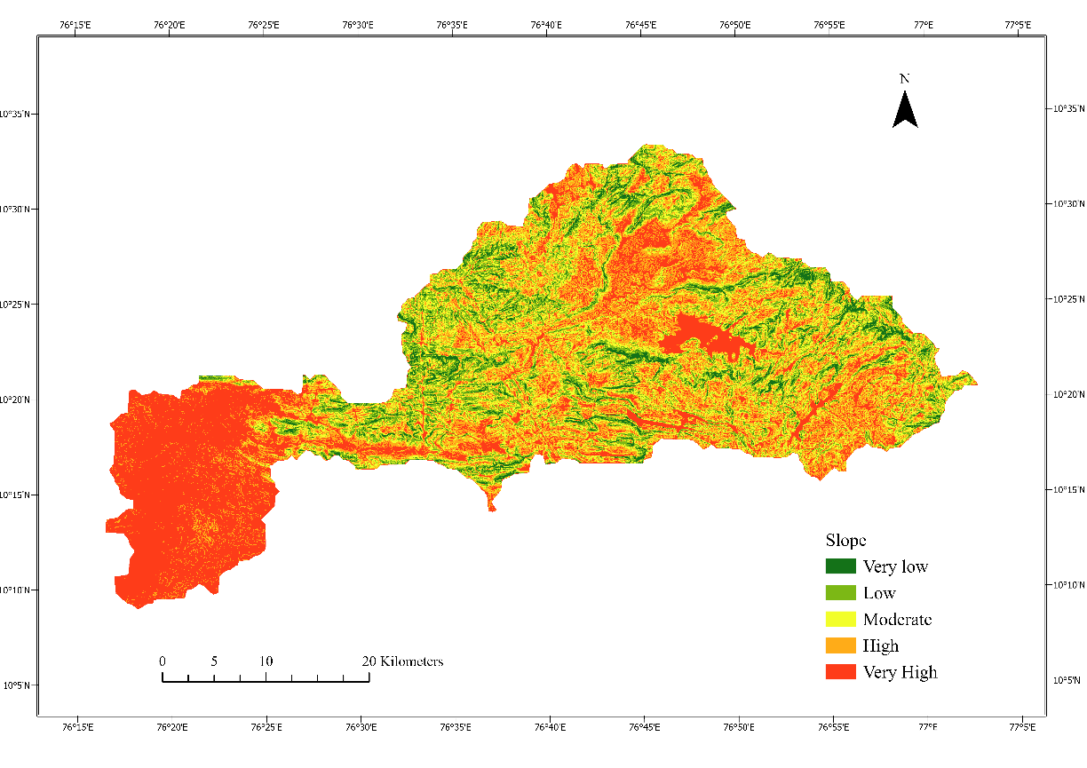
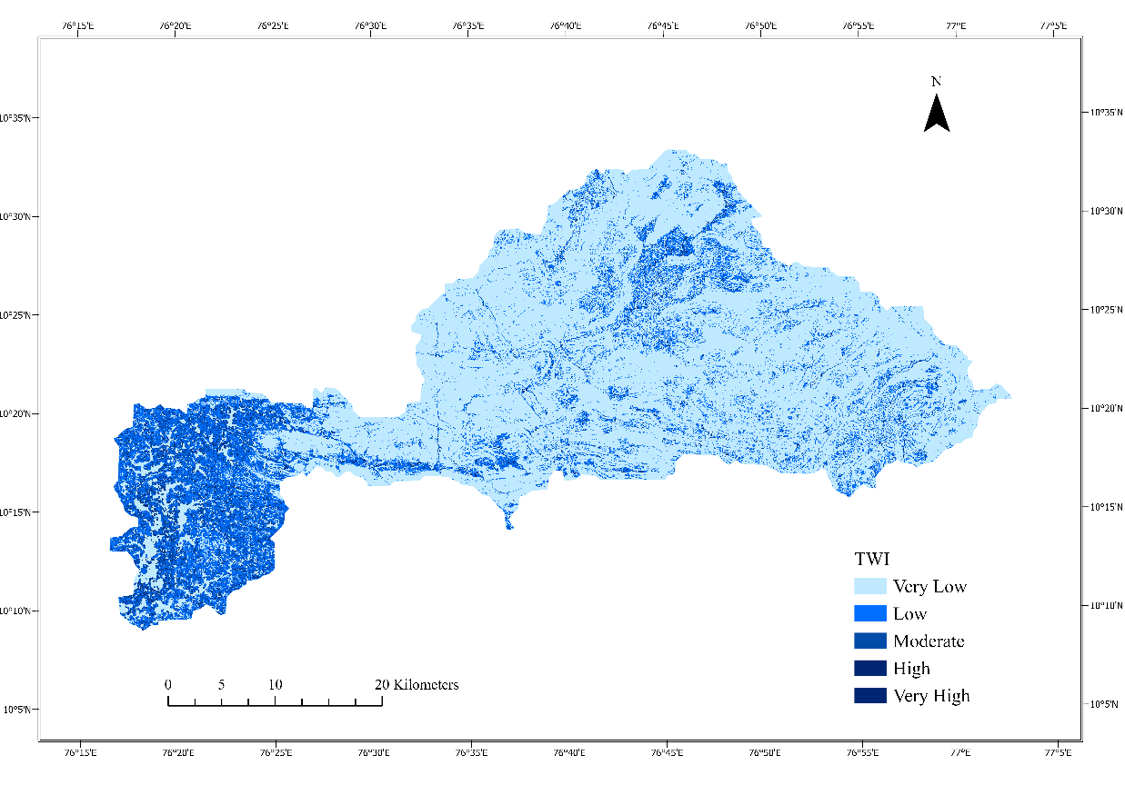
Figure 15: TWI map
Figure 14: Slope Map
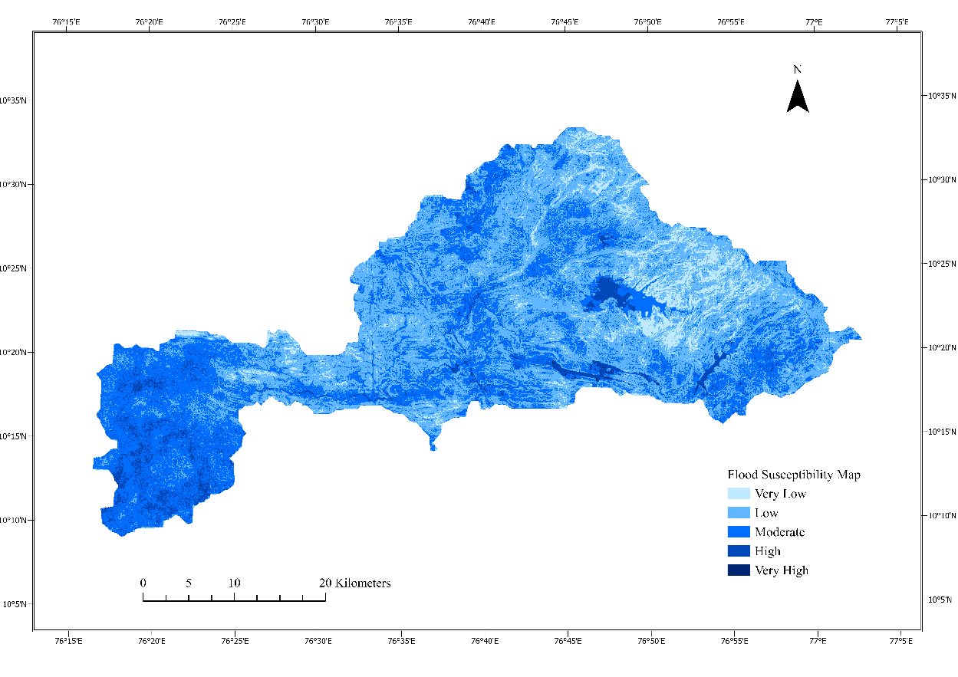
Figure 16: Flood susceptibity map
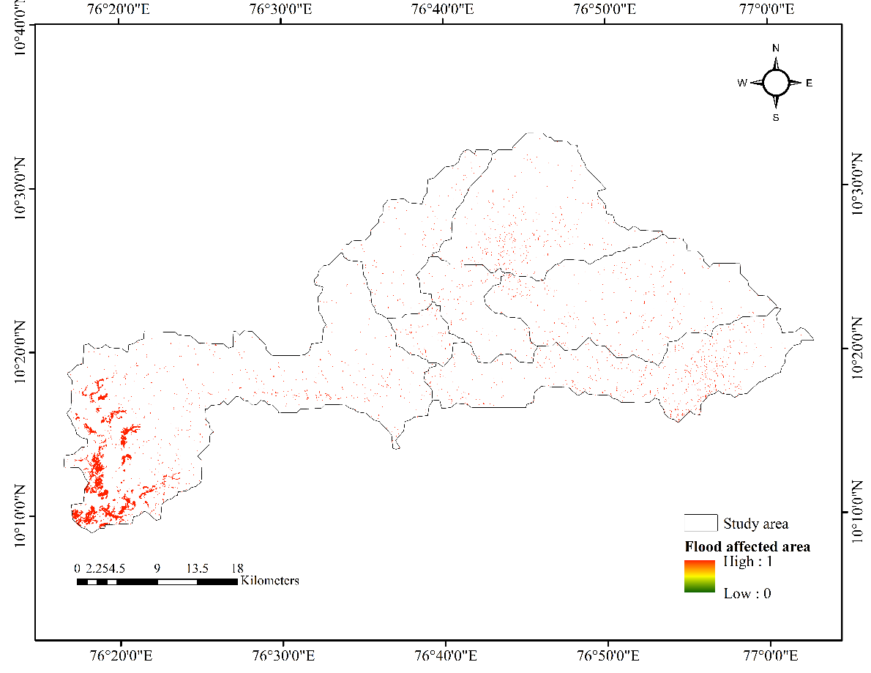
Figure 17: Validation map flood affected area of SAR data

Table 4: Area-wise Susceptibility Class Ranges

Susceptibility Class Ranges | Area (Sq. km) | Area %
Very high | 111.88 | 7.41
High | 719.86 | 47.69
Moderate | 581.63 | 38.53
Low | 94.77 | 6.28
Very low | 1.49 | 0.10

Validation of the Flood Susceptibility Map

The flood susceptibility maps were validated using pre- and post-flooding imagery from the Chalakudy River basin, captured during the events of 20th July to 05th August 2018 and 9th to 21st August 2018. The images utilized were from the Sentinel-1 C-band Synthetic Aperture Radar (SAR) Ground Range collection, with a spatial resolution of 10×10 meters. To enhance the data quality, a speckle filter was applied, followed by mosaicking of the raster image cells.
A supervised classification technique was employed to gather training data for the classification process. Representative samples of backscatter values for flood-inundated areas were extracted using the geometry tool in the Google Earth Engine (GEE) code editor. These samples were used to classify the pre- and post-flood backscatter images (VV and VH polarization) through thresholding. The extracted backscatter values were then used to create an inundated layer, from which a flooding map of the study area was derived. The final flood susceptibility map was validated by comparing it with the flooding map from SAR image of August 2018 flood.

Results and Discussions

The application of the Analytical Hierarchy Process (AHP) in conjunction with GIS for flood susceptibility mapping in the Chalakudy River Basin has yielded significant insights into the spatial distribution of flood-prone areas. The findings indicate that approximately 6.28% of the basin (comprising 1.5 km² as very high and 94.77 km² as high susceptibility) is highly vulnerable to flooding. This aligns with previous studies that have employed AHP for flood risk assessment, demonstrating its effectiveness in integrating multiple geospatial and hydrological factors (Rahmati et al., 2016; Tehrany et al., 2014). The Consistency Ratio (CR) of 4.8% falls well within the acceptable limit of <10%, as recommended by Saaty (1980), ensuring the logical consistency of the pairwise comparisons used in AHP. This strengthens the reliability of the flood susceptibility model, similar to findings by Das (2019), who emphasized that a low CR enhances the validity of AHP-derived weights in flood hazard studies.

The dominance of moderate to low susceptibility zones (581.6 km² and 719.86 km², respectively) suggests that while certain areas are less prone to flooding, localized factors such as terrain slope, drainage density, and land use still influence flood risk. This observation is consistent with research by Kourgialas & Karatzas (2011), who highlighted the role of topographic and hydrological parameters in flood susceptibility assessment.

Validation Using Sentinel-1 Radar Imagery

To validate the flood susceptibility map, radar satellite data from the Sentinel-1C platform were analyzed for pre- and post-flood conditions in August 2018. The Google Earth Engine (GEE) was employed to calculate backscatter values in VV and VH polarizations for these scenarios. Thresholding techniques were used to classify and identify flood-affected areas, resulting in a flooded area map. The analysis confirmed significant flooding along the Chalakudy River Basin during the specified period, aligning with the flood-prone zones identified in the susceptibility map.
Hydrological influences were a major determinant of flood susceptibility; however, other anthropogenic and natural factors exacerbated flood risks in the region. These included the degradation of embankments and deforestation along riverbanks, which reduced the capacity of natural barriers to mitigate floodwaters. Sedimentation was another critical issue, compounded by inadequate removal of accumulated sediment from dams and barrages. Such sedimentation reduced water-holding capacities, increasing the likelihood of overflows during heavy rainfall.
The monsoonal rainfall, characterized by its intensity and duration, played a significant role in triggering floods. Areas with high topographic slopes were particularly vulnerable, as they facilitated rapid runoff, increasing the volume of water entering the river systems. This rapid influx overwhelmed the basin’s capacity to handle excess water, further escalating flood risks.
The AHP method is a structured, multi-criteria decision-making approach that determines weights for various factors based on their relative importance. In this study, expert judgments were used to assign these weights during the initial stages. While effective and implementable, AHP is not without limitations. Its reliance on expert input introduces an
Element of subjectivity, which may lead to some uncertainty in the results. Despite this, the method proved to be particularly useful for local and regional assessments, as it allows for the integration of hydrological, hydrogeological, and morphological factors that are critical to understanding flood susceptibility.
Previous studies have demonstrated that rainfall patterns, topography, and soil properties are significant contributors to flood risks. The findings of this study corroborated these observations, emphasizing the importance of these factors in determining flood-prone areas. The method’s simplicity and adaptability make it well-suited for assessing flood risks in areas where comprehensive datasets may not be readily available (Shekar and Mathew, 2023).
While AHP demonstrated its utility in this study, the incorporation of advanced computational techniques could further improve flood susceptibility mapping. Methods such as the Naïve Bayes classifier, Alternating Decision Tree (AD Tree), Random Forest (RF), Frequency Ratio, and Support Vector Machine (SVM) models offer more sophisticated analytical capabilities. These techniques can handle larger datasets and more complex interactions between variables, leading to improved accuracy in flood risk predictions. Their integration with remote sensing and GIS platforms would enable researchers to produce more precise and reliable susceptibility maps.
The qualitative validation of the flood susceptibility map through comparison with SAR- derived flood maps from 2018 highlighted its accuracy and reliability. Regions identified as having very high or high flood susceptibility were consistent with areas that experienced significant flooding during the validation period. This alignment underscores the robustness of the AHP-GIS method and its applicability for regional flood risk assessments.
In summary, the AHP-GIS approach successfully identified flood-prone areas in the Chalakudy River Basin. Despite its limitations, the method proved effective in integrating diverse factors to produce reliable susceptibility maps. Further enhancements using modern machine learning techniques could refine these assessments, providing critical insights for flood risk management and mitigation strategies.
Conclusion
The study demonstrated the effectiveness of the GIS-AHP framework in delineating flood susceptibility zones within the Chalakudy River Basin. By integrating hydrological, morphometric, land cover, and anthropogenic parameters, the model identified 7.41% of the basin as highly susceptible to flooding, with validation using Sentinel-1 SAR imagery confirming its reliability. The Consistency Ratio of 4.8% reinforced the robustness of the AHP-derived weights, ensuring logical consistency in decision-making.
The findings highlight the combined influence of monsoonal rainfall, terrain slope, drainage density, deforestation, and anthropogenic pressures in aggravating flood risks in the region. Although AHP proved useful in integrating diverse criteria, its dependence on expert judgment introduces subjectivity. Future improvements could be achieved by incorporating advanced machine learning models such as Random Forests, SVM, or ensemble techniques to enhance predictive accuracy.
Overall, the flood susceptibility map provides a valuable decision-support tool for policymakers, planners, and disaster managers in formulating effective mitigation and adaptation strategies. By identifying priority zones for intervention, the study contributes to reducing vulnerability and enhancing resilience to future flood events in the Chalakudy River Basin.

Disclaimer (Artificial intelligence)
Option 1:
Author(s) hereby declare that NO generative AI technologies such as Large Language Models (ChatGPT, COPILOT, etc.) and text-to-image generators have been used during the writing or editing of this manuscript.
Option 2:
Author(s) hereby declare that generative AI technologies such as Large Language Models, etc. have been used during the writing or editing of manuscripts. This explanation will include the name, version, model, and source of the generative AI technology and as well as all input prompts provided to the generative AI technology
Details of the AI usage are given below:
1.
2.
3.

References

Carver, S.J., 1991. Integrating multi-criteria evaluation with geographical information systems. International Journal of Geographical Information System, 5(3), pp.321- 339.
De Risi, R., Jalayer, F., De Paola, F., Carozza, S., Yonas, N., Giugni, M. and Gasparini, P., 2020. From flood risk mapping toward reducing vulnerability: the case of Addis Ababa. Natural Hazards, 100, pp.387-415.
Dube, M., 2018. Bihar Floods: A Report on Bihar Floods 2016. Bihar Disaster Management Authority, Government of Bihar: Patna, India, p.36.
Ghorbani Nejad, S., Falah, F., Daneshfar, M., Haghizadeh, A. and Rahmati, O., 2017. Delineation of groundwater potential zones using remote sensing and GIS-based data- driven models. Geocarto international, 32(2), pp.167-187.
Goffi, A., Stroppiana, D., Brivio, P.A., Bordogna, G. and Boschetti, M., 2020. Towards an automated approach to map flooded areas from Sentinel-2 MSI data and soft integration of water spectral features. International Journal of Applied Earth Observation and Geoinformation, 84, p.101951.
Kazakis, N., Kougias, I. and Patsialis, T., 2015. Assessment of flood hazard areas at a regional scale using an index-based approach and Analytical Hierarchy Process: Application in Rhodope–Evros region, Greece. Science of the Total Environment, 538, pp.555-563.
Kourgialas, N.N. and Karatzas, G.P., 2011. Flood management and a GIS modelling method to assess flood-hazard areas—a case study. Hydrological Sciences Journal–Journal des Sciences Hydrologiques, 56(2), pp.212-225.
Li, Y., Martinis, S., Wieland, M., Schlaffer, S. and Natsuaki, R., 2019. Urban flood mapping using SAR intensity and interferometric coherence via Bayesian network fusion. Remote Sensing, 11(19), p.2231.
Li, Y., Martinis, S., Wieland, M., Schlaffer, S. and Natsuaki, R., 2019. Urban flood mapping using SAR intensity and interferometric coherence via Bayesian network fusion. Remote Sensing, 11(19), p.2231.
Renard, K.G., 1997. Predicting soil erosion by water: a guide to conservation planning with the Revised Universal Soil Loss Equation (RUSLE). US Department of Agriculture, Agricultural Research Service.
Saaty, T.L., 2008. Decision making with the analytic hierarchy process. International journal of services sciences, 1(1), pp.83-98.
Shafapour Tehrany, M., Shabani, F., Neamah Jebur, M., Hong, H., Chen, W. and Xie, X., 2017. GIS-based spatial prediction of flood prone areas using standalone frequency ratio, logistic regression, weight of evidence and their ensemble techniques. Geomatics, Natural Hazards and Risk, 8(2), pp.1538-1561.
Shekar, P.R. and Mathew, A., 2023. Flood susceptibility mapping of the Peddavagu River Basin using GIS-AHP techniques. Developments in Environmental Science, 14, pp.125-141.
Sofia, G., Roder, G., Dalla Fontana, G. and Tarolli, P., 2017. Flood dynamics in urbanised landscapes: 100 years of climate and humans’ interaction. Scientific reports, 7(1), p.40527.

