Assessment of Hydrus Model Accuracy in Simulating Soil Moisture Under Drip Irrigation for Maize

ABSTRACT
A Field experiment was conducted in a split plot design consisting of three irrigation levels (0.6 (I₁), 0.8 (I₂) and 1.0 (I₃) crop evapotranspiration (ETc) and four nitrogen levels. Nitrogen levels includes (80% (N₁), 100% (N₂), 120% (N₃) RDN and Manual application (N₄). The experiment was carried out on sandy clay loam soil during the kharif 2018, rabi 2018–19, and kharif 2019 seasons at Dr. N.T.R. College of Agricultural Engineering, Bapatla, Andhra Pradesh. The primary objective of the study was to calibrate and validate the HYDRUS-2D model for simulating soil moisture in a drip irrigated maize crop. The water flow equation used in the Hydrus-2D is in the form of the Richard's equation. The model was calibrated for hydraulic conductivity and dispersivity values for sandy clay loam soil. After calibration, model was validated with the seasonal observed data to examine its predictability. Model performance was evaluated using dimensionless statistical performance criteria, viz., coefficient of determination (R²) and Root Mean Square Error (RMSE), Relative error (%) and Model efficiency. Results of the study showed that, calibrated values of longitudinal and transverse dispersivities for sandy clay loam soil are 0.5 and 0.05 cm, respectively. The simulated and observed soil moisture content upto a depth of 100 cm in sandy clay loam soil at 50 days after sowing for 3h, 6h and 24h after irrigation at emitter, 15 cm from emitter and 30 cm from emitter clearly showed good agreement between observed and simulated values with R² in between 0.992 - 0.996. These results indicate that the HYDRUS-2D model effectively simulates soil moisture distribution in the root zone under drip irrigation and can be reliably applied to other crops and similar soil conditions.

Key words: Maize crop, Drip Irrigation, Hydrus - 2D, Calibration, Validation, Simulation on soil moisture and model efficiency

- INTRODUCTION
“Conducting field experiments in huge number of soils with different irrigation levels for developing suitable design and management option is a costly and time-consuming affair. An accurately calibrated and validated flow model can downturn the time and cost needed for understanding the water dynamics under drip irrigation system. Water transport models could simulate these distributions in the soil. These models provide an understanding of the relationship between the amount and timing of water application, the crop root uptake, yield and soil hazard and groundwater pollution” (Antonopoules, 2001). However, identification of a suitable model is very important.
“Among different available models, HYDRUS-2D has been extensively and successfully used to simulate water transport in soils even for complicated problems. Having both the flexibility to accommodate different types of boundary conditions for water flow transport calculations and the capability to simultaneously consider root uptake of water compared to other similar models” (Li et al., 2015), the HYDRUS model can simulate soil water in the fields under different water management practices.
Hence, present study has been planned at Dr NTR College of Agricultural Engineering, Bapatla to calibration and validation of hydrus-2d model for simulation of soil moisture in drip irrigated maize crop in order to increase irrigation water use efficiency.
- MATERIAL AND METHODS
2.1 Geographical Location of the Study
The field experiment was conducted during kharif 2018, rabi 2018-19 and kharif 2019 under maize crop at Dr. N. T. R. College of Agricultural Engineering, Bapatla, Bapatla district of Andhra Pradesh State, India. Geographically the experimental site is located at latitude of 16⁰ N and longitude of 88⁰ E with an altitude of 6 m above mean sea level Fig 1.
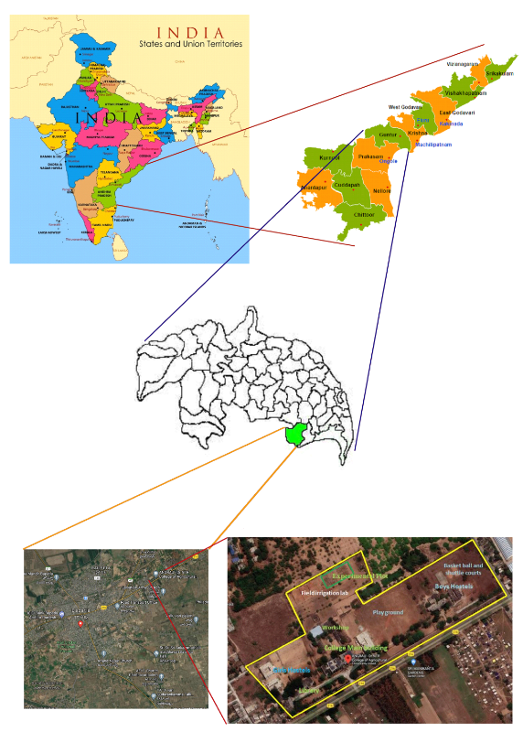
Fig. 1 Experimental location of the study area in Andhra Pradesh State, India
2.2 Meteorological Conditions of the Study Site
Bapatla is located in Southeastern part of Guntur district of Andhra Pradesh. It is very close to the coast and the town experiences hot summers and cool winters. The maximum temperature ranges between 40⁰ C to 50⁰ C in summer and the minimum temperature ranges between 18⁰ C to 25⁰ C in winter. The annual precipitation is about 700 - 1150 mm with an average of 940 mm of which 30.31 % is received during crop growing period of kharif 2018, 11% was received during crop growing period of rabi 2018-19. An amount of 48.02% is received during crop growing period of kharif 2019. The average relative humidity is 72.4 to 80.2 per cent and average wind speed is 72 to 132 km/day. Mean daily evaporation ranged between 2.4 to 4.0 mm/day during the crop growth period of the experiment.
Basic Soil Attributes of the Study Site
Soil samples were collected at every 15 cm layers from land surface till the soil depth of 90 cm using soil augur to characterize the soil. The collected soil samples were analysed in laboratory for determining the physical properties of the soil and are presented in Table 1.
Table 1. Physical properties of the experimental soil
Soil depth from surface (cm) | Mineral content (% mass) |  |  | Textural class | Hydraulic conductivity (cm/h) | Bulk density  (g/cm³) | Field capacity  (% vol) | Permanent wilting point  (% vol)
Soil depth from surface (cm) | Clay | Silt | Sand
0-15 | 35 | 10 | 55 | Sandy clay loam | 0.94 | 1.37 | 21.48 | 6.73
15-30 | 35 | 10 | 55 | Sandy clay loam | 0.50 | 1.57 | 27.17 | 9.12
30-45 | 30 | 10 | 60 | Sandy clay | 0.46 | 1.53 | 28.24 | 10.56
45-60 | 35 | 5 | 60 | Sandy clay loam | 0.96 | 1.63 | 27.69 | 10.92
60-75 | 35 | 5 | 60 | Sandy clay loam | 0.96 | 1.63 | 27.73 | 11.61
75-90 | 30 | 5 | 65 | Sandy clay loam | 0.95 | 1.67 | 26.62 | 10.75

2.3 DESIGN AND LAYOUT OF EXPERIMENT
Field experiment was conducted with DEKALB DKC 8161 variety of hybrid maize under drip irrigation in split plot design consisting of three irrigation levels as main treatment and four fertigation levels as sub treatments with three replications during kharif 2018, rabi 2018-19 and kharif 2019 at the Field irrigation lab, Dr. NTR College of Agricultural Engineering, Bapatla. Maize seed was sown in a paired row system as plant to plant and row to row spacings were 20 cm and 40 cm, respectively [(80 cm + 40 cm) × 20 cm].
Treatments are as follows:
Main plots: Irrigation levels (I)
Irrigation levels are taken as 0.6 (I₁), 0.8 (I₂) and 1.0 (I₃) of the crop evapotranspiration
Sub plots: Fertigation levels (N)
Drip fertigation with 80% of RDN (N₁), 100% of RDN (N₂), Drip fertigation with 120% of RDN (N₃) and No drip fertigation (manual application) with 100% of RDN (N₄₎
2.4 Installation of Access Tubes and Measurement of Soil Moisture Content
Soil moisture content was measured at every irrigation i.e., before starting of irrigation, immediately after irrigation, 3h after irrigation, 6h after irrigation and 24h after irrigation by using Diviner 2000 (Sentek). Diviner 2000 is a portable soil monitoring system.
Before using the diviner 2000, the sensor is normalized using a special normalization tube to set the air and water counts. This is necessary because each sensor responds slightly differently to air and water.
A total of 34 access tubes were installed in the experimental field for main and sub plots with different horizontal spacings from center of lateral pipe to a maximum of 45 cm distance at 15 cm interval. The total length of access tube is 1.5 m out of which 1.35 m was inserted below the ground and 15 cm height was left above the ground for identification. The layout of access tubes in the field was shown in Fig.2.
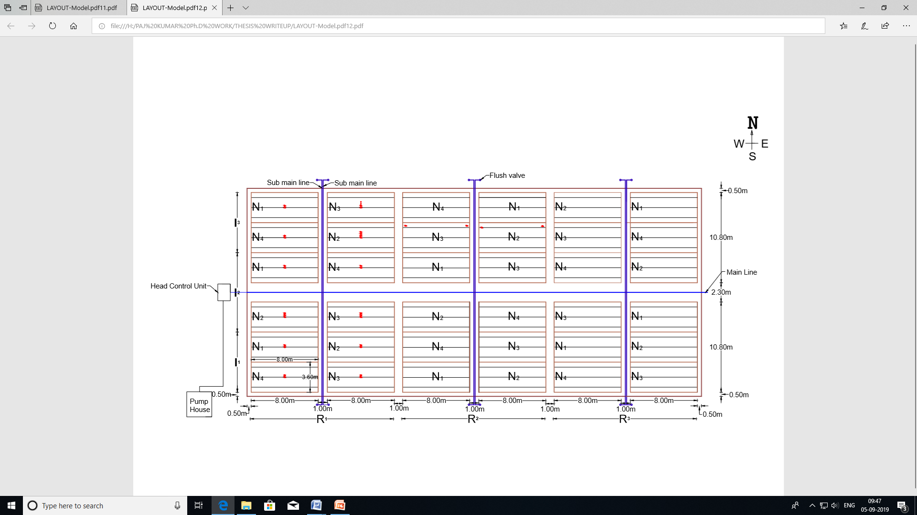
Fig. 2 The layout of access tubes in the field
2.5 Description of Hydrus 2D
Graphical User Interface of HYDRUS 2D/3D, a software package for simulating water, heat, and solute movement in two- and three-dimensional variably saturated porous media. The software package includes the computational program and the interactive graphics-based user interface. The HYDRUS 2D/3D program numerically solves the Richards equation for variably saturated water flow and convection-dispersion equations for both heat and solute transport. The flow equation incorporates a sink term to account for water uptake by roots of plant. The solute transport equations consider advective-dispersive transport in the liquid phase, as well as diffusion in the gaseous phase. The transport equations also include provisions for nonlinear non equilibrium reactions between the solid and liquid phases, linear equilibrium reactions between the liquid and gaseous phases, zero-order production, and two first-order degradation reactions. In addition, physical non equilibrium solute transport can be accounted for by assuming a two-region, dual-porosity type formulation which partitions the liquid phase into mobile and immobile regions. Attachment/detachment theory, including filtration theory, is additionally included to enable simulations of the transport of viruses, colloids, and/or bacteria.
2.6 Governing Water Flow Equation
The governing water flow equation consists two-dimensional Isothermal Darcian flow of water in a variably saturated rigid porous medium and assumes that the phase plays an unimportant role in the liquid flow process. The water flow equation used in the Hydrus-2D/3D is given by the following form of the Richard's equation:
$\frac{∂θ}{∂t}=\frac{∂}{{∂x}_{i}}\left[k\left({K_{ij}}^{A}\frac{∂h}{{∂x}_{j}}+{KA}_{iz}\right)\right]-S$ ---------------- (1)
Where,
θ = Volumetric water content [L³ L⁻³]
h = Pressure head [L]
S = Sink term [T^{-l})
X_{i} (i = 1, 2) = Spatial coordinates [L]
t = Time [T]
K_{ij}^{A} = Components of a dimensionless anisotropy tensor KA, and
K = Unsaturated hydraulic conductivity function [LT⁻¹] and is given by
K (h, x, z) = K_{s} (x, z) K_{r} (h, x, z) --------------- (2)
Where,
K_{r} = Relative hydraulic conductivity and
K_{s} = Saturated hydraulic conductivity [LT^{-l}].
The anisotropy tensor K_{ij}^{A} in (1) is used to account for an anisotropic medium.
Modified form of Richard's equation for three-dimensional axi-symmetrical flow in variably saturated, rigid, isotropic porous medium is given by

$\frac{∂θ}{∂t}=\frac{∂}{∂r}\left\{K\left(h\right)\frac{∂h}{∂r}\right\}+\frac{K\left(h\right)}{r}\frac{∂h}{∂r}$+$\frac{∂}{∂z}\left\{K\left(h\right)\left(\frac{∂h}{∂z}+1\right)\right\}$ ----------- (3)
Where,
θ = Volumetric water content, [L3 L⁻³]
h = Pressure head [L]
t = Time [T]
r = Radial coordinate [L]
z = Vertical coordinate taken positive upwards [L] and
K = Unsaturated hydraulic conductivity [LT^{-I}].
2.7 CALIBRATION AND VALIDATION OF HYDRUS-2D
Calibration is a process to establish the values of certain parameters. Model is executed by giving the nearest values of the parameters and predicted values are compared with observed values. Values of the said parameter are selected from the run when predicted and observed values are close enough. After calibration, model is validated with the seasonal observed data to examine its predictability.
Model was calibrated for hydraulic conductivity and dispersivity values for sandy clay loam soil. Based on the result of the kharif 2018, best treatment in terms of the yield and water use efficiency (I₂N₃) was selected to determine the spatial and temporal distribution of water at various growth stages. Calibration of the model was done for kharif 2018 and rabi 2018-19 using the values of water at various points, selected in the root zone with respect to the emitter. To validate the model, simulation was done for kharif 2019.
2.8 EVALUATION OF MODEL PERFORMANCE
Model performance was evaluated using dimensionless statistical performance criteria, viz., coefficient of determination (R²) and Root Mean Square Error (RMSE), Relative error (%) and Model efficiency.
2.8.1 Coefficient of Determination (R²)
$R^{2}=\frac{{\left[\sum{\left(x-\overline{x}\right)\left(y-\overline{y}\right)}\right]}^{2}}{\sum{\left(x-\overline{x}\right){\left(y-\overline{y}\right)}^{2}}}$ ---------- (4)
Where
x = Observed values
- = Mean of observed values
y = Simulated values
= Mean of simulated values
2.8.2 Root Mean Square Error (RMSE)
The model was evaluated by using root mean square error (RMSE) which quantified the differences between observed and simulated data.
$RMSE=\sqrt{\sum_{i=1}^{N}{\frac{\left(O_{i}-P_{i}\right)}{N}}}$ ---------- (5)
Where
O_{i} = Observed value
P_{i} = Predicted value
N = Number of observations
2.8.3 Relative Error (%)
The relative error in percentage was calculated by using the following formula.
$RE=\frac{|P_{i}-O_{i}|}{O_{i}}×100$ ---------- (6)
Where
P_{i} = i^{th} simulated value
O_{i}= i^{th} observed value
2.8.4 Model Efficiency
The measure of the deviation between model predictions and observed data is calculated by the following formula (Nash and Sutcliffe 1970).
$EF=1-\frac{\left[\sum_{i=1}^{n}{{〈P_{i}-O_{i}〉}^{2}}\right]}{\left[\sum_{i=1}^{n}{{〈O_{i}-\overline{O}〉}^{2}}\right]}$ ---------- (7)

- RESULTS AND DISCUSSIONS

3.1Calibration of Hydrus 2D
Hydrus-2D was calibrated for simulation of soil moisture distribution in the root zone of the maize crop for kharif 2018 with the observed soil water content in the field irrigated with 80% of crop water requirement and fertigated with 144.0 kg ha⁻¹ of nitrogen. The input parameters required by Hydrus-2D/3D were determined by field experiment and data on few parameters were estimated from the model. The model was calibrated mainly for hydraulic conductivity and dispersivity values of the sandy clay loam soil. Model performed well with the measured hydraulic conductivity values. The initial value of longitudinal dispersivity was set to be one tenth of soil depth and the initial value of transverse dispersivity was set to be one tenth of longitudinal dispersivity. Calibrated values of longitudinal and transverse dispersivities for sandy clay loam soil were 0.5 and 0.05 cm. Results of the calibration for soil water content at 50 days after sowing is presented in Figures 3 (a) to 5 (b).
Volumetric soil water content is shown on horizontal scale and depth from the soil surface on the vertical scale. These figures were drawn using the results of soil water content available in the output file of Hydrus-2D. Resulting graph shows volumetric soil water content (fraction) on Y-axis and depth on X-axis. Simulated values pertaining to 3h after irrigation, 6h after irrigation and 24 h after irrigation were exported to Microsoft Excel to plot the graph between soil water content and depth. Simulated and observed values of soil water content were used to evaluate the performance of the model.
The simulated and observed soil moisture content upto a depth of 100 cm in sandy clay loam soil at 50 days for 3h after irrigation at emitter is shown in fig 3. (a). The soil moisture content decreased with depth and observed & simulated soil moisture content exhibited similar trend. The root mean square error indicates the difference between observed and simulated water contents. It has the advantage of having the same units as measured value and therefore it can be compared with observed values. A lower value of RMSE indicates a good prediction of the model meaning a value of zero is a perfect fit. Model efficiency has been extensively used to evaluate the performance of hydrologic models, with greater values indicating better agreement. R² indicates the degree of linear correlation between the predicted and observed values, with values 0 to 1 and higher values indicating better agreement. A value closer to 1 means a better simulation quality. The scattered diagram (Fig.3. (b)) has clearly indicated that there was good agreement between observed and simulated values with R² as 0.97. Determination coefficient (R²) value explains that 97% of the variance was accounted. The relative error varied from -29.55 to 67.59 with an average relative error of 20.14. The root mean square is 0.16 and model efficiency is 0.93. Hence Hydrus model can be used to simulate the soil moisture content in the root zone during the crop growth.
The simulated and observed soil moisture content upto a depth of 100 cm in sandy clay loam soil at 50 days for 6h after irrigation at emitter is shown in fig 6 (a). The scattered diagram (Fig.6 (b)). The simulated and observed soil moisture content upto a depth of 100 cm in sandy clay loam soil at 50 days for 24h after irrigation at emitter is shown in fig 7 (a). The soil moisture content decreased with depth and simulated soil moisture content is almost equal to observed soil water content unlike the above mentioned two cases. The scattered diagram (Fig.7 (b)) has clearly indicated that there was good agreement between observed and simulated values with R² as 0.982.

The simulated and observed soil moisture content upto a depth of 100 cm in sandy clay loam soil at 50 days for 3h after irrigation at 15 cm from emitter is shown in fig 6 (a). The scattered diagram (Fig.6 (b)) has clearly indicated that there was good agreement between observed and simulated values with R² as 0.996. The simulated and observed soil moisture content upto a depth of 100 cm in sandy clay loam soil at 50 days after sowing for 6h after irrigation at 15 cm from emitter is shown in fig 7 (a). The scattered diagram (Fig.7 (b)) has clearly indicated that there was good agreement between observed and simulated values with R² as 0.999. The simulated and observed soil moisture content upto a depth of 100 cm in sandy clay loam soil at 50 days after sowing for 24h after irrigation at 15cm emitter is shown in fig 8 (a). The scattered diagram (Fig.8 (b)) has clearly indicated that there was good agreement between observed and simulated values with R² as 0.989.

Fig 3. (a) Simulated and observed soil  moisture content at 50 days after sowing  for 3h after irrigation at emitter | Fig 4 (a) Simulated and observed soil  moisture content at 50 days after sowing  for 6h after irrigation at emitter | Fig 5 (a) Simulated and observed soil  moisture content at 50 days after sowing  for 24h after irrigation at emitter
Fig 3. (b) Scattered diagram of soil  moisture content at 50 days after sowing  for 3h after irrigation at emitter | Fig 4 (b) Scattered diagram of soil  moisture content at 50 days after sowing  for 6h after irrigation at emitter | Fig 5 (b) Scattered diagram of soil  moisture content at 50 days after sowing  for 24h after irrigation at emitter

The simulated and observed soil moisture content upto a depth of 100 cm in sandy clay loam soil at 50 days after sowing for 3h after irrigation at 30 cm from emitter is shown in fig 5. (a). The soil moisture content decreased with depth and observed & simulated soil moisture content exhibited similar trend. The scattered diagram (Fig.5. (b)) has clearly indicated that there was good agreement between observed and simulated values with R² as 0.994. The relative error varied from -5.49 to 28.85 with a average relative error of 10.13. The root mean square error is 0.104 and model efficiency is 0.98.
Similarly, the simulated and observed soil moisture content upto a depth of 100 cm in sandy clay loam soil at 50 days after sowing for 6h after irrigation at 30 cm from emitter is shown in fig 5. (a). The scattered diagram (Fig.5. (b)) has clearly indicated that there was good agreement between observed and simulated values with R² as 0.987. The relative error varied from -6.49 to 28.41 with a average relative error of 14.57. The root mean square error is 0.141 and model efficiency is 0.973. There is a over estimation of SWC at 40 cm below soil surface.
The simulated and observed soil moisture content upto a depth of 100 cm in sandy clay loam soil at 50 days after sowing for 24h after irrigation at 30 cm emitter is shown in fig 5. (a). The scattered diagram (Fig.5. (b)) has clearly indicated that there was good agreement between observed and simulated values with R² as 0.996. Determination coefficient (R²) value explains that 99.6% of the variance was accounted. The relative error varied from -1.236 to 13.11 with a average relative error of 6.34. The root mean square error is 0.162 and model efficiency is 0.996. The model relatively overestimated the soil moisture content at 20 cm to 40 cm depth below the soil surface for 3 hr and 6 hr after irrigation.

Fig 6 (a) Simulated and observed soil  moisture content at 50 days after sowing  for 3h after irrigation at 15 cm from emitter | Fig 7 (a) Simulated and observed soil  moisture content at 50 days after sowing  for 6h after irrigation at 15 cm from emitter | Fig 8 (a) Simulated and observed soil  moisture content at 50 days after sowing  for 24h after irrigation at 15 cm from emitter
Fig 6 (b) Scattered diagram of soil  moisture content at 50 days after sowing  for 3h after irrigation at 15 cm from emitter | Fig 7 (b) Scattered diagram of soil  moisture content at 50 days after sowing  for 6h after irrigation at 15 cm from emitter | Fig 8 (b) Scattered diagram of soil  moisture content at 50 days after sowing  for 24h after irrigation at 15 cm from emitter

Fig 9 (a) Simulated and observed soil  moisture content at 50 days after sowing  for 3h after irrigation at 30 cm from emitter | Fig 10 (a) Simulated and observed soil  moisture content at 50 days after sowing  for 6h after irrigation at 30 cm from emitter | Fig 11 (a) Simulated and observed soil  moisture content at 50 days after sowing  for 24h after irrigation at 30 cm from emitter
Fig 9 (b) Scattered diagram of soil  moisture content at 50 days after sowing  for 3h after irrigation at 30 cm from emitter | Fig 10 (b) Scattered diagram of soil  moisture content at 50 days after sowing  for 6h after irrigation at 30 cm from emitter | Fig 11 (b) Scattered diagram of soil  moisture content at 50 days after sowing  for 24h after irrigation at 30 cm from emitter

It was observed that soil moisture content increased upto 40 cm below soil surface and then decreased. Soil moisture content was found to be higher in the top layers and gradually decreased in downward direction. The results were similar to the observations recorded by Arbat et al. (2009) who reported that “increase in moisture content was attributed to preferential flow resulted from the major soil disruption of the drip line shank during installation, saturated flow along the flexible drip line during irrigation and after shutdown or may be a combination of both effects”.
3.2 Validation of Hydrus 2D
To examine the performance of the model on seasonal basis, validation was carried out to simulate the soil water content during kharif 2019. The adjusted values of optimized parameters namely, saturated hydraulic conductivity, longitudinal and transverse dispersivities were used to validate the model using the kharif 2019 dataset. The results of simulation revealed that simulated and observed values of soil water content exhibited similar trend without much difference.
Table 2. Model evaluation parameters during validation for observed and simulated soil water content
Time after irrigation | Position
Time after irrigation | At emitter |  |  | 15 cm from emitter |  |  | 30 cm from emitter
Time after irrigation | R² | RMSE | ME | R² | RMSE | ME | R² | RMSE | ME
3 hr | 0.9981 | 0.184 | 0.97 | 0.969 | 0.158 | 0.954 | 0.998 | 0.141 | 0.96
6 hr | 0.995 | 0.158 | 0.948 | 0.999 | 0.187 | 0.955 | 0.998 | 0.158 | 0.954
24 hr | 0.988 | 0.097 | 0.98 | 0.999 | 0.135 | 0.973 | 0.998 | 0.162 | 0.935

Model validation criteria with different horizontal distances from the dripper for kharif 2019 dataset at different times after irrigation has been presented in the table 2 for observed and simulated soil water content.
- Conclusion
Conducting field experiments with different irrigation levels for developing suitable design and management option to get higher yield, higher water use efficiency for maize crop in sandy clay loam soil involve huge inputs, labour and time consuming. Hence, it is concluded that well calibrated and validated Hydrus 2D model can be effectively used to simulate the soil water dynamics under drip irrigation system to arrive the suitable design and management options.
In drip irrigated fields, soil moisture content was maintained near the field capacity in upper layers upto 40 cm even after 24h of the irrigation indicating adequate moisture availability in the active root zone of medium rooted maize crop. There was no percolation below the active root zone. Soil water content attained field capacity in upper layers 3h after irrigation and maintained well upto 6h and dropped slightly below the field capacity at 24h. Therefore, Irrigation scheduling with emitter discharge of 2.0 lph on alternate day is appropriate for maize crop in sandy clay loam soil. There is not much variation in soil water content at emitter and 15 cm from emitter. Hence, emitter to emitter spacing of 30 cm is suitable for irrigation in sandy clay loam soil.
Finally, it can be concluded that there is a little over estimation of soil water content upto 40 cm depth below soil surface and then simulated very well upon 100 cm depth below root zone. Hence, Hydrus 2D model can be applied to any crop to simulate soil water content in root zone.

Disclaimer (Artificial intelligence)
Option 1:
Author(s) hereby declare that NO generative AI technologies such as Large Language Models (ChatGPT, COPILOT, etc.) and text-to-image generators have been used during the writing or editing of this manuscript.
Option 2:
Author(s) hereby declare that generative AI technologies such as Large Language Models, etc. have been used during the writing or editing of manuscripts. This explanation will include the name, version, model, and source of the generative AI technology and as well as all input prompts provided to the generative AI technology
Details of the AI usage are given below:
1.
2.
3.

References
- Antonopoulos, V.Z. 2001. Simulation of water and nitrogen balances of irrigation and fertilized Corn-crop soil. Journal of Irrigation and Drainage Engineering. 127 (2): 77-83.
- Li, X., Haibi. Shi, H., Simunek, J., Gong, X and Peng, Z. 2015. Modeling soil water dynamics in a drip-irrigated intercropping field under plastic mulch. Irrigation Science. 33: 289-302.
- Arbat, G. P., Lamm, F. R and Kheira, A.A.A. 2009. subsurface drip irrigation emitter spacing effects on soil water redistribution, corn yield, and water productivity. ASABE Annual Meeting as Paper No. 096578.
- Iqbal, M., Kamal, M.R., Soom, M.A.M., Yamin, M., Fazly, M., Hasfalina, C.M and Muhammed, H.H. 2020. HYDRUS-1D Simulation of Nitrogen Dynamics in Rainfed Sweet Corn Production. Applied Sciences. 10 (11): 3925-3940.
- Ranjbar, A., Rahimikhoob, A., Ebrahimian, H and Varavipour, M. 2019. Simulation of nitrogen uptake and distribution under furrows and ridges during the maize growth period using HYDRUS-2D. Journal of Irrigation Science. 37: 495–509.
- Karandish, F and Simunek, J. 2017. Two-dimensional modeling of nitrogen and water dynamics for various N-managed water-saving irrigation strategies using HYDRUS. Agricultural Water Management. 193: 174–190.
- Afua, A.M and Ramanathan, S.R. 2017. Hydrus (2D/3D) simulation of water flow through sandy loam soil under potato cultivation in southern Manitoba. Journal of Canadian Systems Engineering. 59(1):9-19.
- Baoli, X., Shao, D., Tan, X., Yang, X., Gu, W and Li, H. 2017. Evaluation of soil water percolation under different irrigation practices, antecedent moisture and ground water depths in paddy fields. Agricultural water management. 192: 149-158.
- Karandish, F and Simunek, J. 2017. Two-dimensional modeling of nitrogen and water dynamics for various N-managed water-saving irrigation strategies using HYDRUS. Agricultural Water Management. 193: 174–190.
- Mante, A.A and Ranjan, R.S. 2017. HYDRUS (2D/3D) simulation of water flow through sandy loam soil under potato cultivation in southern Manitoba. Journal of Canadian Biosystems Engineering. 59: 9-19.
- Mekala, C and Nambi, M.I. 2016. Experimental and simulation studies on nitrogen Dynamics in Unsaturated and saturated soil using HYDRUS-2D. Procedia Technology. 25: 122-129.
- Shahid, I., Andrey, K.G and Khan, H.Z. 2016. Estimating Nitrogen leaching losses after compost application in furrow irrigated soils of Pakistan Hydrus-2D software. Agricultural water management. 168: 85-95.
- Li, X., Haibi. Shi, H., Simunek, J., Gong, X and Peng, Z. 2015. Modeling soil water dynamics in a drip-irrigated intercropping field under plastic mulch. Irrigation Science. 33: 289-302.
- Li, Y., Simunek, J., Zhang, Z., Jing, L and Ni, L. 2015. Evaluation of nitrogen balance in a direct seeded rice field experiment using HYDRUS-1D. Agricultural Water Management. 148: 213-222.
- Tan, X., Shao, D., Gu, W and Liu, H. 2015. Field analysis of water and nitrogen fate in lowland paddy fields under different water managements using HYDRUS 1D. Agricultural Water Management. 150: 67-

