Original Research Article
Urban Expansion and Climate Change: A Spatio-Temporal Analysis of Land Use and Land Cover Changes in Dehradun City, India

ABSTRACT
Dehradun is currently facing significant challenges as a result of increased tourism. While tourism plays a vital role in boosting the local economy, it also brings a range of environmental and infrastructural issues. The growing influx of tourists has led to environmental degradation, poor waste management, and increased pressure on the city's infrastructure. Additionally, unregulated tourism contributes to deforestation, air and water pollution, and heightens the risk of natural disasters such as flash floods and wildfires. To address these concerns, there is a pressing need to adopt sustainable tourism practices and implement stricter regulations. Such measures are essential to mitigate the negative impacts of tourism and to preserve Dehradun's natural beauty and ecological balance for future generations. The present study was conducted to analyze the impact of frequent forest fires and excessive tourism on the forest cover in the Dehradun district of Uttarakhand over a multi-decadal period. These factors have significantly contributed to forest degradation, biodiversity loss, and environmental imbalance in the region. The study also explores various preventive measures, including afforestation, community participation, and sustainable tourism practices, to protect and conserve the forest area.
Keywords: Urbanization, Tourism, Forest area, Fires, Disaster
INTRODUCTION
Amongst the states of India, Uttarakhand holds the fourth position, according to the tourist per capita, whereas in the northern region of India, Uttarakhand occupies the first position. Himachal Pradesh and Uttarakhand have considerably high tourist per capita ratios (2.86 and 3.41, respectively) compared to northern India's other states. Further, it is also observed that though both these states have similar geographies, the tourist per capita for Uttarakhand is comparatively higher. However, these tourists have limited spending, contributing minimally to the tourism economy; hence, there is a need to focus on well-paying tourists, enhancing the experience simultaneously. Uttarakhand's scenic beauty continues to attract a growing number of tourists, with a notable 30% increase in tourist footfall between 2019 and 2022. However, this rapid rise in tourism has also exposed significant vulnerabilities in the region's infrastructure. Incidents such as the Chamoli bridge collapse and frequent landslides underscore the risks posed by overcrowding, poor maintenance, and environmental degradation. Furthermore, to sharp increase in tourism in Uttarakhand has placed immense pressure on the region's fragile ecosystem. Overcrowding, littering, and unregulated construction have led to deforestation, loss of biodiversity, and pollution of water sources. Increased vehicle emissions and waste generation have further degraded air and soil quality. This environmental stress threatens the long-term sustainability of both the natural landscape and local communities. Some of the researcher i.e. Rawat and Kumar (2015), Faruk and Akpu (2022), Kaganga and Ngogo (2024), Malik et. al. (2024), Panwar et. al. (2025) also studied about the Impact of Land Use and Land Cover Changes on Ecosystem. These challenges not only threaten the safety of residents and visitors but also endanger the region’s fragile ecosystem. To ensure long-term sustainability, it is crucial to adopt responsible tourism practices and enforce stricter regulations aimed at preserving both infrastructure and the natural environment.
METHODOLOGY
The data for this study were collected from a variety of sources, including newspapers, literary works, government reports of Uttarakhand, and other relevant publications. Online searches were conducted using such as tourist arrival, reduction in forest area due to human activity, and “forest fires in Uttarakhand.” Additionally, official government websites and databases were consulted, including Tourism Statistics 2018, Census of India 2011, and ICAR NAAS 2010. Magazines such as Down to Earth were also referred to for insights into environmental and social changes in Uttarakhand.
STUDY AREA
Uttarakhand is a northern state of India, located in the western Himalayan region. It shares its borders with Himachal Pradesh to the northwest, Uttar Pradesh to the south, and the international boundary with China (Tibet) to the north, as well as Nepal to the east. Geographically, Uttarakhand lies between latitudes 28°43'N and 31°27'N and longitudes 77°34'E and 81°02'E. The state is characterized by diverse terrain, ranging from the high Himalayan peaks in the north to the foothills and plains in the south, including significant rivers such as the Ganga and Yamuna that originate in its mountainous regions. Figure 1 shows the geographical map of Uttarakhand.
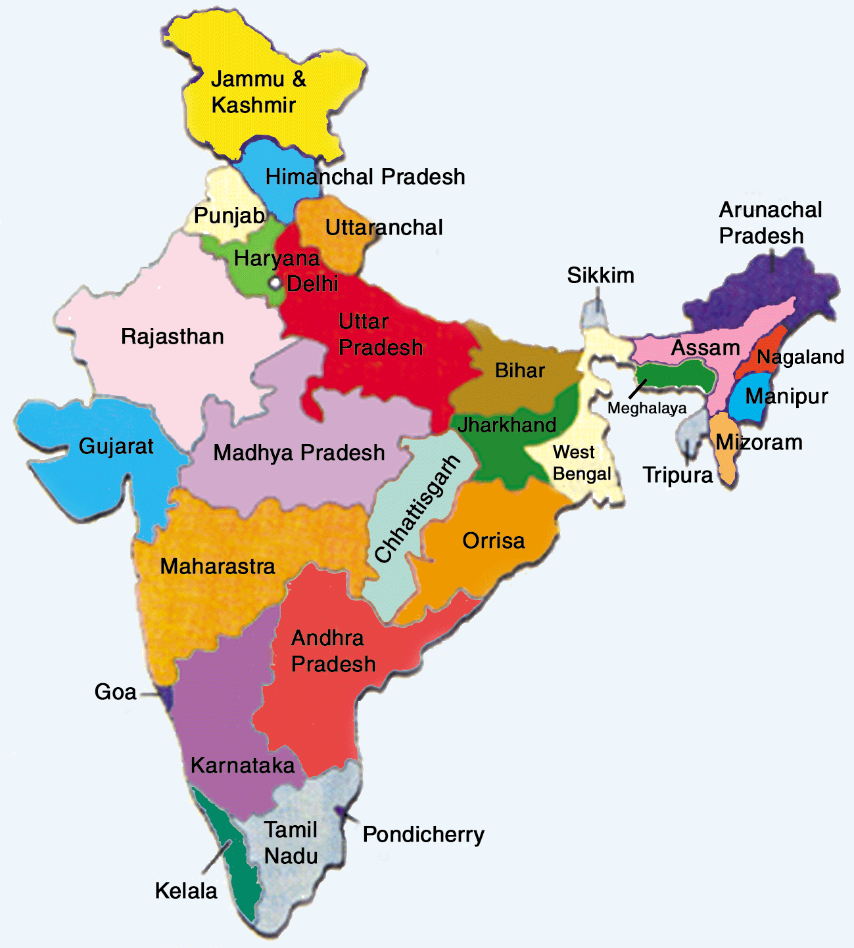 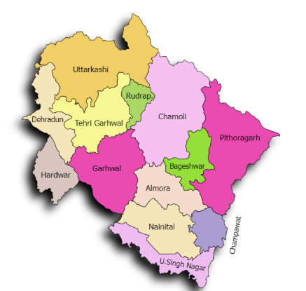Fig. 1. Geographical map of Uttarakhand
RESULT & DISCUSSION
The Uttarakhand population has recorded a consistent growth in recent years, increasing from 7.8 million in 1996 to 8.49 million in 2001, and further to 10.09 million as of 2011. An 18.8% increase during the decade, according to recent estimates. The population is expected to be 12.33 million as of 2024, a continued growth of around 2.24 million since 2011, which are also significantly affect the vegetation area. In reference to this, Uttarakhand, renowned for its picturesque hills and sacred pilgrimage sites, has experienced a significant surge in tourist footfall, with a 30% increase recorded between 2019 and 2022. While this growth reflects the state's popularity, it also raises serious concerns about its capacity to manage the rising influx. Recent disasters, such as the tragic bridge collapse in Chamoli district that resulted in the loss of ten lives, along with frequent landslides in Gangotri and Yamunotri that disrupted key pilgrimage routes, have highlighted critical gaps in infrastructure and disaster preparedness. These incidents underscore the urgent need for improved planning, infrastructure resilience, and sustainable tourism management in the region. Table 1 shows the tourist rate in Dehradun district from different states during the period of 2016 to 2017.
Table 1. Tourist Arrivals in Dehradun for different time intervals (Tourism Statistics, 2018, Census of India, 2011)
State | Population | Tourist Arrival (in lakhs) |  | Tourist per person |  | Rating
State | Population | 2016 | 2017 | 2016 | 2017 | Rating
Haryana | 25353081 | 77.14 | 62.44 | 0.30 | 0.25 | 6
Himachal Pradesh | 6864602 | 184.51 | 196.02 | 2.69 | 2.86 | 2
J & K | 12548962 | 94.78 | 133.15 | 0.76 | 1.06 | 5
Punjab | 27704236 | 393.63 | 414.02 | 1.42 | 1.49 | 3
Uttar Pradesh | 207281477 | 2148.64 | 2375.34 | 1.04 | 1.15 | 4
Uttarakhand | 10116752 | 344.94 | 344.94 | 3.03 | 3.41 | 1

Fig. 2. Tourist data coming to Uttarakhand from 2018 to 2025
Figure 2 shows the data on tourist inflow in Uttarakhand from 2018 to 2025, which shows a fluctuating yet overall rising trend. In 2018, the state welcomed 3.68 crore tourists, slightly increasing to 3.92 crore in 2019. However, due to the COVID-19 pandemic, tourist numbers drastically fell to 0.78 crore in 2020 and 1.56 crore in 2021, reflecting the impact of global travel restrictions and safety concerns. Post-pandemic, tourism rebounded strongly, with tourist numbers reaching 4.18 crore in 2022 and further rising to 4.46 crore in 2023. This positive growth continued in subsequent years, with 4.76 crore tourists in 2024 and an estimated 5.08 crore in 2025. The sharp recovery and steady growth post-2021 indicate a strong revival of the tourism sector in Uttarakhand, underscoring the state's increasing popularity as a travel destination and the effectiveness of its tourism revival strategies.
REDUCTION IN FOREST AREA
In 2020, Dehradun had approximately 124,000 hectares (kha) of natural forest, covering about 40% of its total land area. However, by 2024, the city experienced a loss of 41 hectares of natural forest. This deforestation resulted in an estimated release of 12.4 kilotons of carbon dioxide emissions, highlighting a concerning trend in environmental degradation and its impact on the region’s carbon balance.
Table 2. Reduction in Forest Area in Dehradun District, Uttarakhand due to various reasons (ICAR-NAAS, 2010)
District | Reasons
District | Water Erosion | Water Erosion (Under open forest) | Acid Soils | Acid Soils  (Under Water Erosion) | Acid Soils (Under open forest) | Mining/Industrial waste | Water logged areas
Almora | 3.62 | 0.00 | 0.00 | 0.00 | 0.00 | 100.00 | 8.00
Bageshwar | 1.93 | 2.22 | 0.00 | 0.00 | 2.02 | 0.00 | 12.00
Chamoli | 7.84 | 6.67 | 23.08 | 14.81 | 10.61 | 0.00 | 24.00
Champawat | 0.36 | 5.00 | 0.00 | 0.53 | 10.10 | 0.00 | 4.00
DehraDun | 16.16 | 5.00 | 0.00 | 10.58 | 7.58 | 0.00 | 0.00
Haridwar | 18.21 | 20.00 | 0.00 | 0.00 | 0.00 | 0.00 | 0.00
Naini Tal | 7.12 | 7.78 | 0.00 | 0.53 | 0.00 | 0.00 | 16.00
Pauri Garhwal | 12.42 | 16.67 | 46.15 | 7.94 | 17.68 | 0.00 | 0.00
Pithoragarh | 0.36 | 0.00 | 0.00 | 3.17 | 0.00 | 0.00 | 4.00
Rudraprayag | 0.12 | 8.89 | 0.00 | 0.00 | 6.06 | 0.00 | 0.00
Tehri Garhwal | 6.27 | 24.44 | 7.69 | 41.27 | 41.41 | 0.00 | 0.00
Udham Singh | 21.35 | 0.56 | 0.00 | 0.00 | 0.00 | 0.00 | 32.00
Uttarkashi | 4.22 | 2.78 | 23.08 | 21.16 | 4.55 | 0.00 | 0.00
Between 2001 and 2024, Dehradun lost approximately 684 hectares of tree cover, representing a 0.44% decline compared to the tree cover area in 2000. This loss contributed to an estimated 443 kilotons of carbon dioxide equivalent emissions. It is important to note that this figure does not account for any gains in tree cover that may have occurred during the same period.

Fig. 3. Loss in forest area during the twenty-four years
Figure 3 shows that based on the data from 2001 to 2024, Dehradun experienced a cumulative tree cover loss of 684 hectares. The annual forest loss fluctuated throughout the period, with relatively minor losses in the early 2000, such as 5 hectares in both 2001 and 2003. A noticeable surge occurred in 2012, with a loss of 80 hectares, and the most significant spike was recorded in 2017, with a drastic loss of 156 hectares. Another substantial decline occurred in 2023, with 74 hectares lost. In contrast, some years saw minimal deforestation, i.e. in 2015 (8 ha) and 2020 (6 ha). Overall, the trend reflects intermittent but impactful deforestation events over the 24 years, contributing to environmental degradation and carbon emissions in the region.
REDUCTION IN FOREST AREA DUE TO HUMAN ACTIVITIES
In Dehradun, the total forest area spans approximately 191,000 hectares (kha). Between 2000 and 2024, the region witnessed a net gain of 2.32 kha in forest area, while also experiencing a loss of 1.25 kha during the same period. Additionally, around 837 hectares of forest were classified as disturbed areas, indicating regions affected by degradation or partial deforestation. This data reflects both positive efforts in forest regeneration and ongoing challenges in forest conservation.
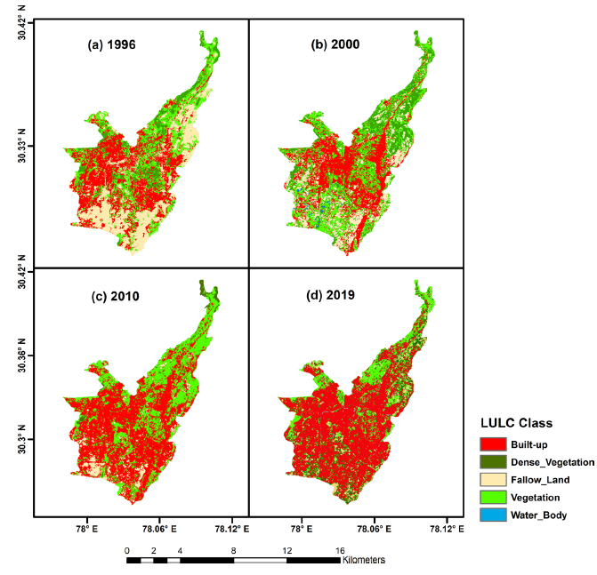
Fig. 4. Changes in the forest area from 1996 to 2019 (Mishra and Arya 2023)
REDUCTION IN FOREST AREA DUE TO FIRE ACTIVITIES
In 2025, Dehradun has reported one fire alert so far, based on the data. The number is considered normal when compared to fire activity in previous years, dating back to 2012. The highest number of fires recorded in a single year occurred in 2016, with a total of 34 alerts, indicating a peak in fire incidents during that period.
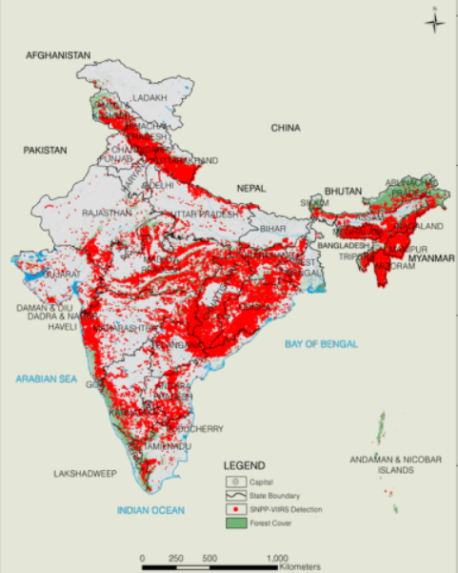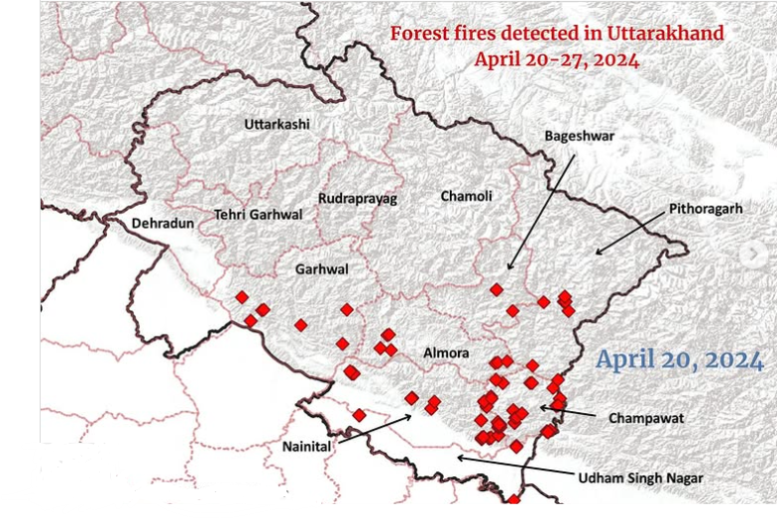
Fig. 5. Fire detected at various places in Uttarakhand during April 2024 (Forest Survey of India)
Between 2001 and 2024, Dehradun lost a total of 52 hectares of tree cover due to fires, and an additional 632 hectares from other causes such as deforestation, development, and land-use changes. The year with the highest tree cover loss caused by fires was 2012, during which 10 hectares were lost to fire-related events, accounting for approximately 13% of the total tree cover loss in that year. This highlights the impact of both natural and human-driven factors on forest degradation in the region. Figure 5 shows the forest fires detected in various places on Uttarakhand during April 2024.

Fig. 6. Loss in forest area during the twenty-four years due to fire
As shown in Figure 6, Dehradun experienced varying degrees of tree cover loss due to fire between 2001 and 2024, totaling 52 hectares over the twenty-four years. The highest annual loss occurred in 2012, with 10 hectares, accounting for the most severe fire-related deforestation in a single year during this timeframe. Other notable years include 2006 with 6 ha, 2009 with 8 ha, and 2002 and 2008 with 5 ha each. Most other years recorded minimal losses of 1 hectare or less, while 2015 saw no recorded fire-related tree cover loss. The data suggests that, while fire-related deforestation in Dehradun has generally remained low, occasional spikes highlight the need for continued monitoring and preventive measures.
Between June 21, 2021, and June 16, 2025, Dehradun recorded a total of 443 VIIRS fire alerts. These alerts are based on satellite observations indicating potential fire activity in the region. The data reflects significant fire occurrences over the four years, underlining the importance of forest fire monitoring and management. Such alerts play a crucial role in supporting timely response and mitigation efforts.
REASONS FOR THE REDUCTION IN FOREST AREA IN DEHRADUN
Dehradun, the capital of the Himalayan state of Uttarakhand, has rapidly transformed into a concrete jungle over the past two decades. Although the city was included in the list of 'Smart Cities', it continues to face significant environmental and infrastructural challenges. Once known as the land of rivers and rivulets, Dehradun now struggles with severe water pollution, as many of its rivers have deteriorated into drains filled with garbage and filth, largely due to the absence of an efficient waste management system.
- No approved master plan: The absence of an approved master plan is a major contributor to unregulated development and widespread deforestation in Dehradun. This lack of planning has led to unchecked urban expansion, threatening the region's ecological balance.
- Dying water streams: The drying of natural water streams has significantly contributed to forest loss in Dehradun. These streams, once vital for sustaining forest ecosystems, are now vanishing due to environmental degradation and human interference.
- Poor waste management: Poor waste management is a key factor contributing to the reduction of forest area in Dehradun. Unregulated dumping of solid waste and sewage into natural habitats degrades the environment, pollutes water bodies, and disrupts forest ecosystems. This negligence accelerates the loss of green cover and biodiversity.
- Expansion of agricultural land: The expansion of agricultural land is one of the primary reasons for the reduction of forest area in Dehradun. Forests are often cleared to make way for farming activities, leading to habitat loss and ecological imbalance. This conversion of land not only diminishes green cover but also affects local biodiversity and soil health.
- Urbanisation and expansion of cities: Urbanisation and the rapid expansion of cities have been major drivers of forest area reduction in Dehradun. As the city grows to accommodate rising population and infrastructure demands, large tracts of forest land are cleared. This urban sprawl leads to habitat fragmentation and a significant loss of biodiversity.
- Over-exploitation of natural resources: Over-exploitation of natural resources is a major cause of deforestation, occurring when humans extract more resources than the environment can naturally replenish. This unsustainable extraction leads to the depletion of vital resources such as timber, minerals, fossil fuels, and groundwater. Activities like mining, logging, and oil and gas extraction contribute significantly to this process. The environmental impact is severe, resulting in habitat destruction, loss of biodiversity, soil degradation, and disruption of ecological balance, ultimately threatening the sustainability of forest ecosystems.
- Shifting Cultivation: Shifting cultivation, also known as slash-and-burn agriculture, leads to deforestation as trees are cut and burned to clear land for farming. While the land is abandoned after a few years, repeated cycles degrade soil quality and hinder natural forest regeneration.
- Mining: Mining activities cause large-scale deforestation as vast areas of forest are cleared for excavation and infrastructure. It disrupts ecosystems, leads to habitat loss, and prevents forest regrowth due to soil erosion and pollution.
PROTECTIVE MEASURES TO PROTECT THE FOREST AREA IN DEHRADUN DISTRICT
To protect the forest area in Dehradun district, a combination of ecological and community-based measures is essential. Afforestation and reforestation should be prioritized to increase green cover on barren and degraded lands. Agroforestry can be promoted among farmers to integrate tree planting with agriculture, ensuring both livelihoods and forest conservation. Adopting sustainable forest management practices like selective logging and controlled grazing can help maintain forest health. Strict protection of natural forests through legal enforcement and forest reserves will preserve biodiversity. Active community involvement in forest monitoring and plantation drives enhances local stewardship. Effective policy implementation, including incentives for conservation and penalties for illegal activities, must be ensured. The use of technology such as satellite mapping and GIS tools will aid in forest monitoring and early detection of deforestation. These combined efforts can significantly contribute to preserving and expanding forest cover in Dehradun.
Conclusion
Uttarakhand, with its breathtaking landscapes and spiritual significance, continues to be a major draw for both domestic and international tourists. Its leading position in terms of tourists per capita in northern India highlights its immense potential in the tourism sector. However, this popularity has brought with it significant challenges. The rise in tourist numbers, particularly after the COVID-19 pandemic, has strained the region’s already fragile infrastructure and sensitive ecosystems. Incidents like the Chamoli bridge collapse and recurrent landslides have underscored the urgent need for better planning, infrastructure development, and disaster preparedness. At the same time, Dehradun and other regions have been witnessing a steady loss in forest cover due to various human activities such as unregulated urban expansion, agricultural encroachment, mining, poor waste management, and forest fires. These activities not only degrade the environment but also release large amounts of carbon dioxide, thereby worsening climate change impacts. Despite some gains in afforestation and forest regeneration, the ecological balance remains threatened. Therefore, sustainable and responsible tourism practices must be encouraged, focusing on quality rather than quantity of tourists. Moreover, robust forest conservation efforts, including afforestation, community involvement, technology-based monitoring, and strict policy enforcement, are essential. In essence, the future of Uttarakhand’s tourism and ecological stability lies in achieving a delicate balance between development and conservation. A holistic approach combining sustainable tourism, effective governance, and active community engagement is crucial to preserving the state’s natural wealth for future generations.

COMPETING INTERESTS DISCLAIMER:
The author has declared that no competing interests.
DISCLAIMER (ARTIFICIAL INTELLIGENCE)
Author(s) hereby declare that no generative AI technologies such as Large Language Models (ChatGPT, COPILOT, etc.) and text-to-image generators have been used during the writing or editing of this manuscript.
REFERENCES
- Mishra, A., and Singh, D. (2023). “Assessment of land use land cover dynamics and urban heat island effect of Dehradun city, North India: A remote sensing approach.” Environment, Development and Sustainability. https://doi.org/10.1007/s10668-023-03558-6
- Indian Council of Agricultural Research (ICAR) and National Academy of Agricultural Sciences (NAAS). (2010). Degraded and wastelands of India: Status and spatial distribution. New Delhi, India.
- Malik, R. (2025). “Analyzing flood patterns and impacts across various states in India: A comprehensive study.” Disaster Advances, 18(3), 31–43.
- Malik, R., Mishra, R. P., and Negi, B. S. (2024). “A study on climate change scenario in Haryana.” International Journal of Agriculture Extension and Social Development, 7(9), 299–309.
- Panwar, A., Malik, R., Aswal, A., and Manish. (2025). “Comparative analysis of ambient air pollutants across diverse locations in Dehradun district, Uttarakhand.” International Journal of Agriculture Extension and Social Development, 8(5), 94–99.
- Forest Survey of India. Forest Survey of India. Government of India.
- Tourism Statistics. (2018). Tourism statistics 2018. Ministry of Tourism, Government of India.

- Census of India. (2011). Census of India 2011. Office of the Registrar General and Census Commissioner, Government of India.

- Kaganga, L. S., & Ngogo , N. M. (2024). Impact of Land Use and Land Cover Changes on Ecosystem Services Value in Mwanza City, Tanzania. Asian Journal of Environment & Ecology, 23(5), 30–40. https://doi.org/10.9734/ajee/2024/v23i5545.

- Rawat, J. S., and Kumar, M. (2015). Monitoring land use/cover change using remote sensing and GIS techniques: A case study of Hawalbagh block, district Almora, Uttarakhand, India. The Egyptian Journal of Remote Sensing and Space Science, 18(1), 77-84.

- Faruk, B. U., and Akpu, B. (2022). Geospatial Analysis of the Spatio -Temporal Growth of Kwali Area Council, Federal Capital Territory, Abuja, 1(1), 7-14.

