Original Research Article
Assessment of Temperature and precipitation variability and its spatial distribution over Haryana,India

Abstract
The climate of Haryana is marked by significant regional variability, influenced by its diverse geographical features, including the Shivalik Hills, the Yamuna River, and the Thar Desert. This study explores the regional differences in temperature and precipitation across the state, focusing on how these geographic features shape local climatic conditions. The maximum temperatures in northern and eastern Haryana are moderated by the cooling effects of the Shivalik Hills and the Yamuna River, resulting in cooler conditions compared to the hotter, semi-arid western and southern districts. Similarly, minimum temperatures are lower in the north, with cooler rural areas such as Ambala and Hisar, while urban centers like Faridabad experience higher minimum temperatures due to the urban heat island effect. Precipitation patterns further highlight this geographic diversity, with northern and eastern districts receiving more rainfall due to orographic effects, while the western regions experience significantly lower rainfall, influenced by their proximity to the Thar Desert. This study emphasizes the complex interactions between topography, moisture availability, and regional climate systems in determining Haryana’s climate. These findings have important implications for agriculture, water resources, and climate adaptation strategies, underscoring the need for region-specific policies to address the challenges posed by the state's diverse climatic conditions.
Keywords: Climate variability, Haryana, precipitation, temperature patterns, urban heat island effect.

1. Introduction
Haryana, a state located in northern India, is marked by a climate that is both diverse and influenced by its unique geography. Characterized mainly as semi-arid, Haryana experiences scorching summers, relatively mild winters, and uneven rainfall patterns. However, the state’s climate is far from uniform, varying significantly across its 22 districts. This variation stems from the geographical contrast between the arid Thar Desert to the west and the fertile foothills of the Himalayas to the north, resulting in significant differences in temperature and precipitation. These variations have profound effects on agriculture, water resources, and the livelihoods of local communities.
The state’s climate is primarily shaped by the southwest monsoon, which brings the majority of rainfall from June to September. While this rainy season provides much-needed water to the region, its intensity and distribution differ greatly across districts. For example, areas in the southern and western parts of the state, such as Mahendragarh and Rewari, receive significantly lower rainfall, leading to water scarcity and challenges in agriculture. In contrast, districts in the northern and eastern parts, like Yamuna Nagar and Panchkula, are blessed with relatively higher rainfall. These disparities in precipitation have far-reaching implications for farming practices, as well as the availability of water for daily use (Sharma et al., 2018).
In addition to the variability in rainfall, temperature fluctuations are another important aspect of Haryana’s climate. The state experiences extreme temperature changes, with summer highs often exceeding 40°C, particularly in districts like Hisar and Bhiwani. Winters, on the other hand, can be quite cold, with temperatures dipping to as low as 2-3°C in areas like Ambala. Such marked seasonal variations in temperature can create challenges for agriculture, as different crops thrive in different temperature ranges. Moreover, the fluctuating temperatures also impact water consumption, energy demand, and the general comfort of the population.
Haryana is not only grappling with natural climate variability but also with the emerging effects of climate change. Rising temperatures and increasingly unpredictable rainfall patterns are complicating traditional agricultural practices and water resource management. The growing frequency of extreme weather events—such as droughts, floods, and unseasonal rainfall—has started to pose serious risks to the state’s agricultural productivity and, by extension, its economy. Therefore, understanding and addressing the state’s climate variability is essential for devising strategies that ensure resilience in the face of these growing challenges.

2. Methodology
2.1 Study area
Haryana is a landlocked state in northern India, nestled between 27°39'N to 30°35'N latitude and 74°28'E to 77°36'E longitude, covering an area of about 44,000 square kilometers. The landscape is largely made up of fertile plains, with four distinct regions that give it unique character: the flat Yamuna-Ghaggar plain in the center, the hilly Shivalik foothills to the northeast, the semi-arid sandy Bagar tract in the northwest, and the rocky outcrops of the Aravalli Range in the south.
The climate in Haryana is continental, with extreme variations—summers are scorching hot, often reaching temperatures between 46–50°C in May and June, while winters can be biting cold, sometimes dipping below freezing in January. The state is divided into three main climate zones: hot arid, hot semi-arid, and hot sub-humid. Most of the rainfall (over 80%) comes during the monsoon months of July to September, but the amount varies significantly across the state. In the southwest, rainfall can be less than 300 mm, while the Shivalik Hills in the northeast can receive more than 1,000 mm annually. This variability makes the region prone to both droughts and local flooding.
2.2 Data Collection
For this study, daily Temperature and rainfall data covering a 44-year period, from 1980 to 2023, was obtained from the India Meteorological Department. The data, available at a 1.0° ×1.0°, 0.25° × 0.25° resolution respectively, (Tabbussum et. al., 2014). offering insights into how the climate has behaved over time. We looked at two key temperature measures: the maximum (Tmax) and minimum (Tmin) temperatures recorded each day, as well as the total annual precipitation (rainfall) in millimeters

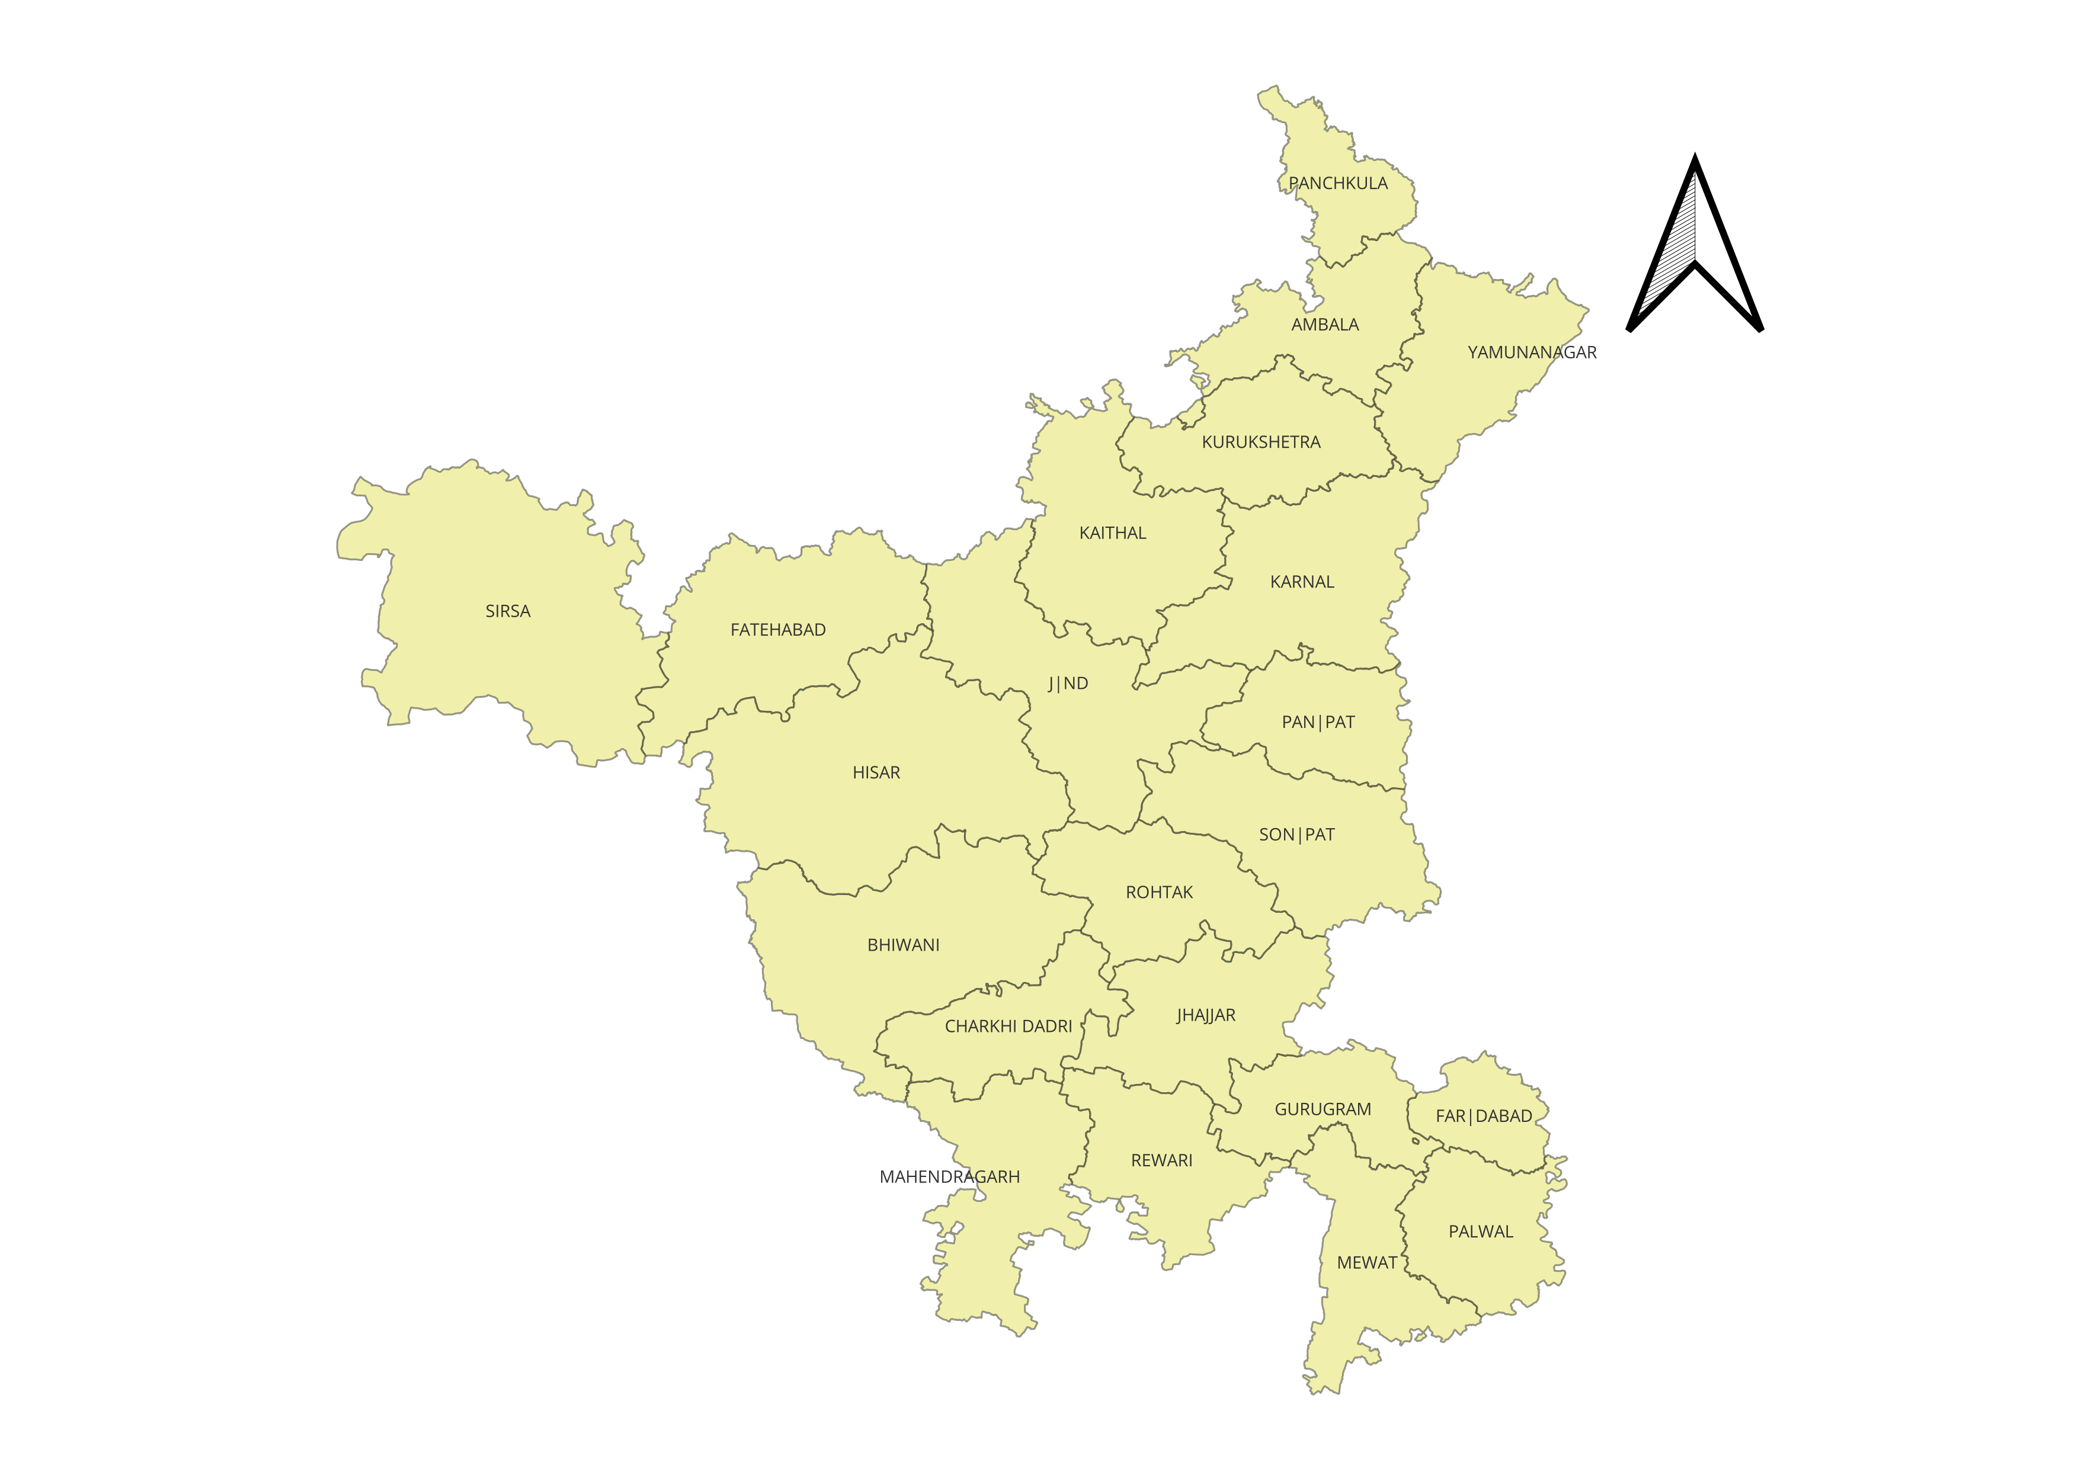
Fig. 1. Study Area
2.3 Statistical Analysis
To better understand the data, we calculated a few key statistical measures:
Mean: This gives us the average temperature and rainfall for each district.
Standard Deviation (SD): This tells us how much the data fluctuates around the average. High SD means a lot of variation, while low SD means more stability.
Coefficient of Variation (CV): By dividing the SD by the mean, we get a relative measure of variability. It’s especially useful when comparing districts with different types of data like temperature vs. precipitation. These measures helped us see where the climate is stable and where it fluctuates dramatically.
3. Results and Discussion
3.1 Temperature Patterns
Maximum temperatures: The variation in maximum temperatures across Haryana is significantly influenced by the region's geography, including factors such as proximity to rivers, mountain ranges, and urban areas. In (Fig.2) districts like Ambala (28.88°C), Panchkula (28.86°C), and Yamuna Nagar (27.08°C), temperatures tend to be relatively lower. This is largely due to the moderating effects of the Shivalik Hills and the Yamuna River, which help maintain a cooler climate compared to other parts of the state. For example, Ambala benefits from the cooling influence of the Shivalik Hills, while Yamuna Nagar, located near both the river and the hills, experiences similarly lower temperatures. In contrast, the western and southern districts of Haryana, such as Bhiwani (32.06°C), Charkhi Dadri (32.06°C), and Mahendragarh (32.06°C), experience significantly higher temperatures. These regions are situated in semi-arid areas, where the lack of nearby cooling features like rivers or mountains results in warmer temperatures during the day. Similarly, Hisar (31.43°C), Jhajjar (32.06°C), and Rewari (32.06°C) also report elevated temperatures, owing to their location in arid and semi-arid zones.
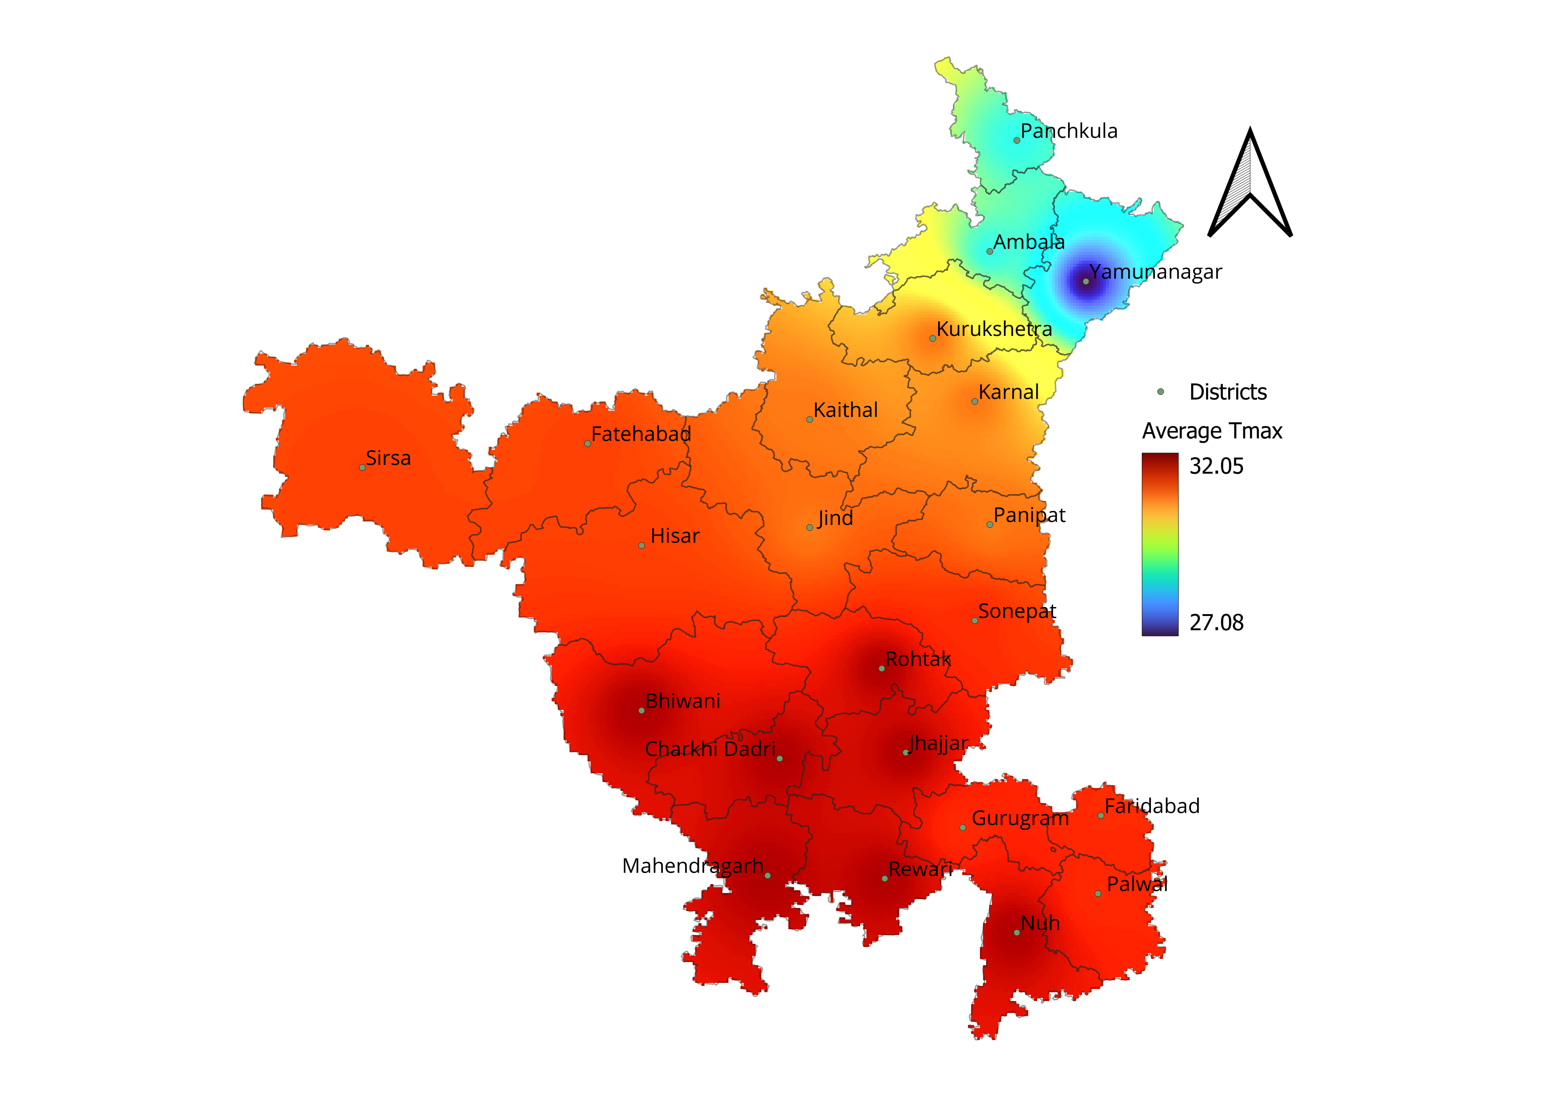
Fig. 2. Average Maximum Temperature of Haryana
Urban areas such as Faridabad (31.6°C) and Gurugram (31.6°C), located close to Delhi, experience higher temperatures as well, largely due to the urban heat island effect. The dense infrastructure and high concentration of buildings in these areas result in temperatures being higher than those in surrounding rural regions, despite these areas being somewhat cooler than Haryana’s western districts (Jain et al., 2020). Overall, the temperature patterns in Haryana are shaped by its unique geographic features, including the influence of the Shivalik Hills, the Yamuna River, and the Thar Desert, as well as the urbanization effects seen in certain districts.
Minimum Temperature: For the minimum temperature in the Fig. 3 we clearly see the Northern Haryana has the temperatures tend to be on the cooler side, with an average of around 17.73°C. Districts like Ambala (16.01°C) and Hisar (17.35°C) are the coolest, likely because of their proximity to the Shivalik hills and more rural settings. Even districts like Bhiwani (18.24°C) and Jhajjar (18.22°C) aren’t as hot as the southern parts, but they still fall on the warmer side compared to their northern counterparts.
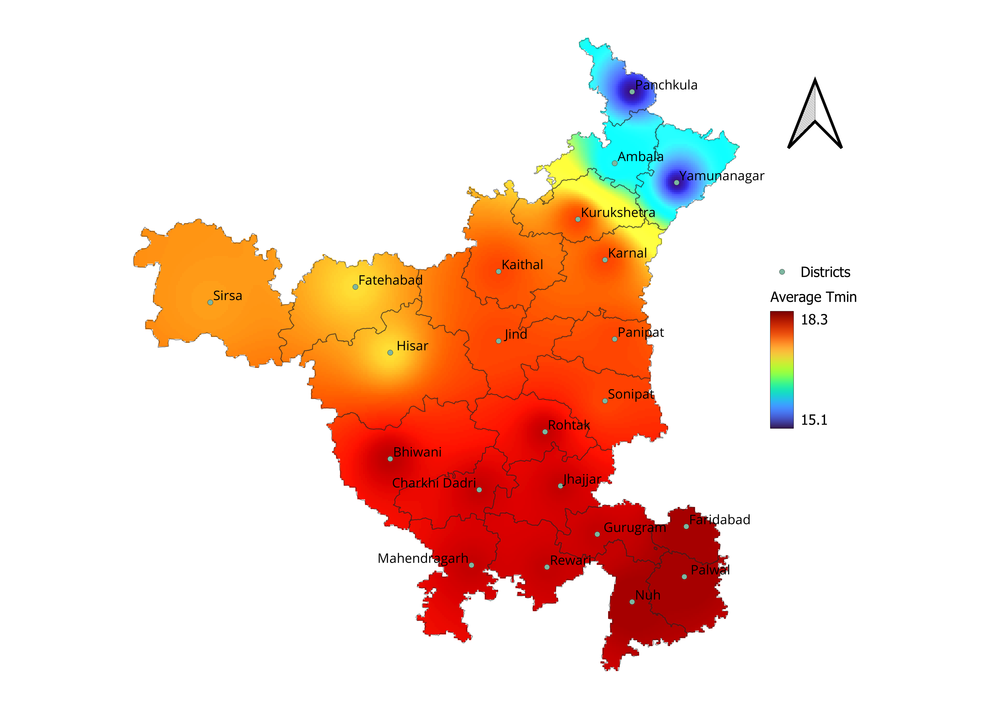
Fig. 3. Average Minimum Temperature of Haryana
In contrast, Southern Haryana is much warmer, with an average minimum temperature of about 18.01°C. Faridabad, Palwal, and Nuh all share a high of 18.37°C, making these some of the hottest districts in the state. The warmth here is mostly due to urbanization, with Faridabad being part of the National Capital Region (NCR), which leads to more heat from industries and dense populations.
Moving to Eastern Haryana, it’s a bit cooler, with an average minimum temperature of 16.05°C. The districts of Panchkula and Yamuna Nagar stand out as the coolest, both at 15.16°C. The cooler temperatures here can be explained by their location near the foothills of the Shivalik range, which offers some natural cooling, along with a relatively lower level of urban development compared to the south.
Finally, Western Haryana falls in the middle, with temperatures averaging around 17.83°C. It’s a fairly consistent region, with districts like Hisar (17.35°C) and Bhiwani (18.24°C) showing moderate temperatures. This area doesn’t get as hot as the south or as cool as the north, making it fairly balanced temperature-wise.

3.2 Precipitation Patterns
Rainfall patterns in Haryana exhibit significant regional variation, primarily influenced by geographic features, proximity to moisture-laden air masses, and the intensity of the monsoon winds. Districts such as Panchkula (1262.5 mm) and Ambala (962.2 mm) experience the highest levels of precipitation, largely due to their proximity to the Shivalik Hills. These regions benefit from orographic rainfall, a phenomenon where moist air from the southwest monsoon is forced to rise over the hills, leading to cooling and condensation that results in heavier rainfall. Similarly, Yamuna Nagar (1078.7 mm) and Karnal (704.3 mm) also record relatively high rainfall, benefiting from their location near the Yamuna River, which contributes to moisture availability and enhances precipitation during the monsoon season.
In contrast, districts located in the western and southwestern parts of the state, such as Sirsa (277.9 mm), Fatehabad (365.9 mm), and Hisar (384.6 mm), receive considerably less rainfall (Singh et.al., 2008). These areas lie in Haryana’s semi-arid zone, with limited influence from the Himalayan foothills and significant proximity to the Thar Desert. The desert’s arid conditions lead to a reduced moisture supply in these regions, resulting in lower overall precipitation. Likewise, Bhiwani (371.0 mm) and Charkhi Dadri (408.9 mm) experience moderate rainfall due to their location away from the Himalayan foothills and the lack of significant topographical features that would enhance rainfall.
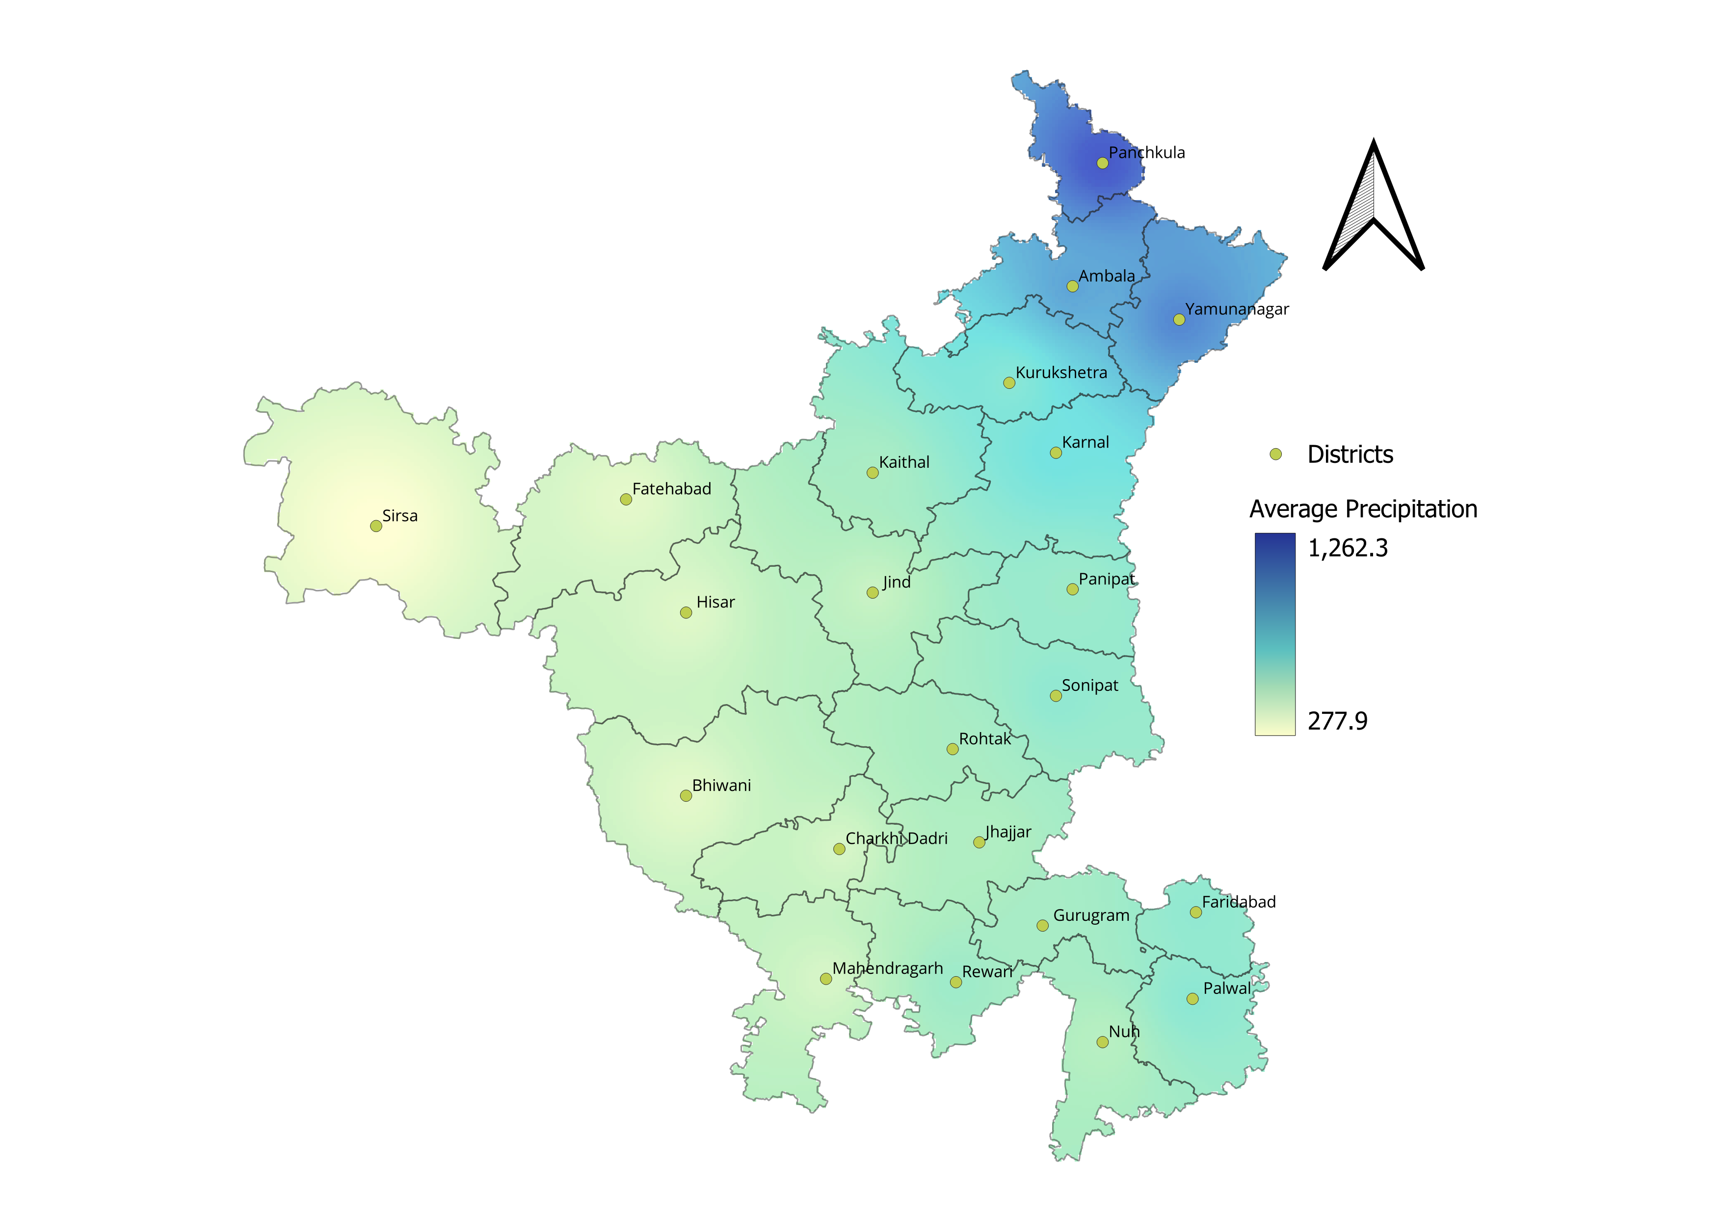
Fig.4 Average precipitation of Haryana
Moderate rainfall is also characteristic of districts such as Sonipat (614.3 mm), Rewari (572.5 mm), and Rohtak (534.2 mm), which are influenced by their proximity to Delhi and the moisture provided by the southwest monsoon winds. However, these regions lack the distinct geographical advantages, such as the Shivalik Hills or proximity to the Yamuna River, that would result in heavier rainfall. Overall, Haryana’s diverse rainfall patterns can be attributed to the interplay between its topography, the monsoon system, and its relative distance from moisture sources like the Himalayas and the Thar Desert, highlighting the state's complex climatic conditions.
Precipitation is a whole different story. The rainfall in Haryana shows a lot more variability between districts. For example, Mahendragarh gets very little rainfall, with annual totals as low as 72.9 mm, while Yamuna Nagar sees a lot more rain, with totals up to 463.5 mm. In between, districts like Rewari and Panchkula see moderate rainfall, making water availability less predictable across the state. The analysis of annual rainfall data for Haryana from 1980 to 2023 reveals considerable fluctuations in precipitation, reflecting the region's vulnerability to both periods of drought and excessive rainfall. Over this 44-year period, the average annual rainfall was 587.18 mm, with a standard deviation of 145.04 mm, suggesting a high degree of variability from year to year. Some years, such as 1988 and 1995, experienced notably high rainfall, with values of 936.5 mm and 903.3 mm, respectively. Conversely, drier years like 1987 and 2014 recorded significantly lower rainfall, with figures of 342.6 mm and 378.5 mm, underscoring the region's susceptibility to water scarcity during such periods.
Despite these fluctuations, there is no clear long-term trend in the rainfall data, with cycles of both wet and dry years persisting throughout the study period. This variability suggests that rainfall in Haryana is influenced by a combination of regional and global climatic factors, including geographical features and broader phenomena such as the Indian Monsoon and El Niño events. The alternating wet and dry periods present challenges for water resource management, agricultural productivity, and environmental sustainability, all of which are highly sensitive to these climatic extremes. (Chouhan et. al., 2024)

Temperature Variability: As we can see in the Table.1 Haryana’s climate exhibits considerable variability in both temperature and precipitation across its districts. The maximum temperatures (Tmax) mean range between 27°C and 32°C, with districts like Bhiwani, Sonipat, and Jhajjar experiencing higher Tmax values above 32°C, while regions such as Ambala and Yamuna Nagar report comparatively lower Tmax values around 27°C. The minimum temperatures (Tmin) across the state show a similar pattern of moderate variability, with values generally ranging from 15°C to 18.4°C. Districts such as Fatehabad and Rohtak display greater variation in Tmin, with coefficient of variation (CV) values between 2.6 and 2.8, signifying notable fluctuations in nighttime temperatures
Table .1. Variability of temperature and precipitation of Haryana
Districts | Tmax Mean (°C) | SD | CV | Tmin Mean (°C) | SD | CV | Precipitation  Mean (mm) | SD | CV
Ambala | 28.9 | 0.6 | 2.0 | 16.0 | 0.5 | 3.0 | 962.2 | 370.2 | 38.5
Bhiwani | 32.1 | 0.6 | 1.9 | 18.2 | 0.5 | 2.7 | 371.0 | 157.4 | 42.4
Charkhi-Dadri | 32.1 | 0.6 | 1.9 | 18.2 | 0.5 | 2.6 | 408.9 | 197.1 | 48.2
Faridabad | 31.6 | 0.5 | 1.7 | 18.4 | 0.4 | 2.4 | 609.4 | 219.2 | 36.0
Fatehabad | 31.4 | 0.6 | 2.0 | 17.4 | 0.5 | 2.8 | 365.9 | 168.9 | 46.1
Gurugram | 31.6 | 0.5 | 1.7 | 18.2 | 0.5 | 2.6 | 542.2 | 183.7 | 33.9
Hisar | 31.4 | 0.6 | 2.0 | 17.4 | 0.5 | 2.8 | 384.6 | 142.4 | 37.0
Jhajjar | 32.1 | 0.6 | 1.9 | 18.2 | 0.5 | 2.6 | 512.5 | 216.5 | 42.3
Jind | 31.1 | 0.6 | 1.9 | 17.8 | 0.5 | 2.8 | 443.3 | 180.5 | 40.7
Kaithal | 31.1 | 0.6 | 1.9 | 17.8 | 0.5 | 2.8 | 533.5 | 207.1 | 38.8
Karnal | 31.1 | 0.6 | 1.9 | 17.8 | 0.5 | 2.8 | 704.3 | 229.0 | 32.5
Kurukshetra | 31.1 | 0.6 | 1.9 | 17.8 | 0.5 | 2.8 | 640.4 | 277.3 | 43.3
Mahendragarh | 32.1 | 0.6 | 1.9 | 18.2 | 0.5 | 2.6 | 407.0 | 196.9 | 48.4
Nuh | 32.1 | 0.6 | 1.9 | 18.4 | 0.4 | 2.4 | 491.2 | 164.8 | 33.6
Palwal | 31.6 | 0.5 | 1.7 | 18.4 | 0.4 | 2.4 | 627.3 | 192.9 | 30.8
Panchkula | 28.9 | 0.6 | 2.0 | 15.2 | 0.5 | 3.2 | 1262.5 | 351.0 | 27.8
Panipat | 31.1 | 0.6 | 1.9 | 17.8 | 0.5 | 2.8 | 573.9 | 203.4 | 35.4
Rewari | 32.1 | 0.6 | 1.9 | 18.2 | 0.5 | 2.6 | 572.5 | 191.0 | 33.4
Rohtak | 32.1 | 0.6 | 1.9 | 18.2 | 0.5 | 2.6 | 534.2 | 200.6 | 37.6
Sirsa | 31.4 | 0.6 | 2.0 | 17.5 | 0.5 | 3.1 | 277.9 | 102.1 | 36.8
Sonipat | 31.6 | 0.5 | 1.7 | 17.8 | 0.5 | 2.8 | 614.3 | 195.2 | 31.8
Yamuna Nagar | 27.1 | 0.6 | 2.2 | 15.2 | 0.5 | 3.2 | 1078.7 | 313.3 | 29.0

Rainfall Variability: In Table 1 Precipitation patterns across Haryana demonstrate substantial disparities, with some districts receiving more than 1000 mm of rainfall, like Panchkula and Yamuna Nagar, while others, such as Sirsa and Fatehabad, experience much lower rainfall levels, frequently below 400 mm. The coefficient of variation for precipitation ranges from 27.8% to 48.4%, indicating a high degree of regional variability and unpredictability in rainfall distribution
4. Conclusion
The climate of Haryana is characterized by considerable regional variation, primarily influenced by the state's diverse geography. Maximum temperatures across Haryana are notably shaped by geographic features such as the proximity to the Shivalik Hills, the Yamuna River, and the Thar Desert. The northern and eastern regions of the state, including districts like Ambala and Panchkula, experience relatively lower temperatures, attributed to the moderating effects of the Shivalik Hills and the Yamuna River. These natural features provide cooling influences that mitigate the temperature extremes. On the other hand, the western and southern regions, including Bhiwani and Hisar, experience higher temperatures, owing to their semi-arid and arid conditions, where the absence of nearby cooling features leads to greater warmth.
Similarly, the minimum temperature patterns demonstrate a clear geographical divide. Northern and eastern Haryana, particularly in rural districts such as Ambala and Hisar, tend to have cooler minimum temperatures, which can be attributed to their elevation and proximity to the Shivalik range. In contrast, the southern regions, particularly urban areas like Faridabad, experience warmer minimum temperatures due to the urban heat island effect, where dense infrastructure and high population density lead to increased heat retention. Western Haryana, including districts like Hisar and Bhiwani, experiences moderate minimum temperatures, positioned between the cooler northern regions and the hotter southern areas.
Precipitation patterns across the state also exhibit significant variability, with the highest rainfall recorded in the northern and eastern districts such as Panchkula and Yamuna Nagar. These regions benefit from orographic rainfall, where moisture-laden monsoon winds are forced to rise over the Shivalik Hills, leading to increased condensation and precipitation. Conversely, the western and southwestern districts, including Sirsa and Fatehabad, receive much lower rainfall due to their proximity to the Thar Desert, which limits moisture availability. The varying precipitation levels in Haryana can be attributed to the interaction between the monsoon system, regional topography, and the state's distance from moisture sources such as the Himalayas and the Thar Desert.

Disclaimer (Artificial intelligence)
Option 1:
Author(s) hereby declare that NO generative AI technologies such as Large Language Models (ChatGPT, COPILOT, etc.) and text-to-image generators have been used during the writing or editing of this manuscript.
Option 2:
Author(s) hereby declare that generative AI technologies such as Large Language Models, etc. have been used during the writing or editing of manuscripts. This explanation will include the name, version, model, and source of the generative AI technology and as well as all input prompts provided to the generative AI technology
Details of the AI usage are given below:
1.
2.
3.

6. References
Asefi-Najafabady S, Vandecar KL, Seimon A, et al (2018) Climate change, population, and poverty: vulnerability and exposure to heat stress in countries bordering the Great Lakes of Africa. Clim Change 148:561–573.
Azhar G, Saha S, Ganguly P, et al (2017) Heat wave vulnerability mapping for India. Int J Environ Res Public Health 14.
Chauhan, A. S., Singh, S., Singh, R. K., Maurya, R. K. S., & Danodia, A. (2023). Spatio-temporal analysis of rainfall in relation to monsoon teleconnections and agriculture at regional scale in Haryana, India. Regional Environmental Change, 30(55), 116781–116803.
Chauhan, A. S., Rani, A., Dahiya, P., Maurya, R. K. S., & Danodia, A. (2024). Understanding the influence of teleconnections on Indian summer monsoon rainfall and agricultural productivity: A case study of Haryana, India (1980–2023). Journal of Water and Climate Change, 15(12), 5793–5816
India Meteorological Department. (2023). Southwest Monsoon Season Report 2023, Haryana.
Jain, S., Sannigrahi, S., Sen, S., Bhatt, S., Chakraborti, S., & Rahmat, S. (2020). Urban heat island intensity and its mitigation strategies in the fast-growing urban area. Journal of Urban Management, 9(1), 54-66.
Kumar, P., & Kumari, P. (2024). A study on climate change scenario in Haryana: Trends, impacts, and adaptation strategies. International Journal for Multidisciplinary Research, 6(4), 1-7.
Kumar, V., Niwas, R., & Kh, M. L. (2024). Influence of climatic variability on rainfall of western region of Haryana. International Journal of Research in Agronomy, 7(7), 585–588.
D. Pai, M. Rajeevan, O. Sreejith, B. Mukhopadhyay, and N. Satbha, (2014). “Development of a new high spatial resolution (0.25° × 0.25°) long period (1901-2010) daily gridded rainfall data set over India and its comparison with existing data sets over the region”, MAUSAM, vol. 65, no. 1, pp. 1–18,
Rahul, Mishra, R. P., & Negi, B. S. (2024). A study on climate change scenario in Haryana. International Journal of Agriculture Extension and Social Development, 7(9), 299-309.
Rohini, P., Rajeevan, M., and Srivastava, A. K., (2016). On the Variability and Increasing Trends of Heat Waves over India. Scientific Reports 6: pp 26153.
Sharma, C. S., Panda, S. N., Pradhan, R. P., Singh, A., & Kawamura, A. (2016). Precipitation and temperature changes in eastern India by multiple trend detection methods. Atmospheric Research, 180, 211-225
Sharma, V., & Kumar, R. (2018). Agricultural challenges in Haryana arising from monsoon variability. Agricultural Sciences Journal, 9(3), 105-112.
Singh, A., Kumar, R., & Sharma, P. (2023). Assessment of climate variability impacts on agriculture in Haryana. Research Square.
Singh, D., Singh, S. (2008). Climate of Haryana and its Variability. Encyclopedia of Haryana. 14.
Tabbussum, R., Bhowmik, R. D., & Mujumdar, P. (2025). Association of climate variability modes with concurrent droughts and heatwaves in India. Journal of Hydrology X, 26, 100196

