**Revitalizing Soil Health through Regenerative Agriculture: History, Principles, Practices and Challenges**

## Abstract

Soil health is the foundation of sustainable agricultural systems, influencing crop productivity, water dynamics, carbon sequestration and ecosystem stability. However, modern industrial agriculture has led to widespread soil degradation, erosion, loss of organic matter and declining microbial diversity. Regenerative agriculture (RA) is a holistic farming approach designed to restore soil health, enhance biodiversity and improve ecosystem resilience. As conventional agricultural practices have led to widespread soil degradation, climate change and biodiversity loss, RA offers a nature-based solution to mitigate these impacts while ensuring long-term food security. RA prioritizes key principles such as minimal soil disturbance, cover cropping, crop diversification, composting, rotational grazing and reduced synthetic inputs, all of which contribute to carbon sequestration, water conservation and soil fertility improvement. Despite its numerous benefits, the large-scale adoption of RA faces challenges, including economic barriers, knowledge gaps and policy constraints. Transitioning to RA often involves short-term yield declines and financial burdens, while the lack of standardized certification limits market access. However, research indicates that RA can significantly enhance soil organic matter, increase drought resilience and improve farm profitability over time. Future efforts should focus on research funding, policy incentives and farmer education programs to accelerate RA adoption. By integrating science-backed regenerative practices into agricultural systems, RA has the potential to combat climate change, restore degraded lands and create a more resilient and sustainable food system for future generations. This review explores the key principles, techniques, benefits, challenges and future directions of RA in revitalizing soil health and ensuring long-term agricultural sustainability.

**Keywords**: Regenerative Agriculture, Soil Health, No-Tillage, Carbon Sequestration, Water Conservation.

## 1. Introduction

Soil is often referred to as the “Skin of the Earth”, covering the planet and supporting plant life, water filtration, carbon storage and biodiversity. However, unsustainable land use, climate change and industrial agriculture have led to a global soil crisis. According to the Food and Agriculture Organization (FAO), approximately 33% of the world's soils are degraded, with nearly 24 billion tons of fertile soil lost annually due to erosion (Schreefel *et al*., 2020). If these trends continue, 90% of soils may become degraded by 2050, jeopardizing global food security and ecosystem stability (Jayasinghe *et al*., 2023).

Soil degradation occurs due to erosion, loss of organic matter, compaction, salinization, acidification, and chemical contamination. These issues are largely driven by modern intensive agriculture, deforestation, urbanization and industrial pollution (Newton *et al*., 2020). The consequences are severe, including declining agricultural productivity, increased desertification, water storage issues, loss of biodiversity and a significant contribution to climate change. As soils lose their organic matter, they also lose their ability to retain nutrients, leading to declining crop yields. Farmers then become increasingly dependent on chemical fertilizers, which further deplete natural soil ecosystems (Giller *et al*., 2021). The loss of soil microbial diversity due to pesticide and herbicide use further compounds the problem, as beneficial microbes are responsible for nutrient cycling, organic matter decomposition, and plant resilience (Jayasinghe *et al*., 2023). Erosion is another major concern, as it removes the nutrient-rich topsoil essential for plant growth. This process, accelerated by deforestation, overgrazing and intensive plowing, leads to desertification, where once-fertile lands turn barren (LaCanne and Lundgren, 2018). Nearly 500 million people worldwide are affected by desertification, particularly in arid and semi-arid regions where agriculture is a primary livelihood. Degraded soils also lose their ability to absorb and store water, making regions more susceptible to drought and flooding (Schreefel *et al*., 2020). This instability in water cycles has contributed to crop failures, food shortages and economic instability, especially in regions already experiencing climate change-induced droughts (Newton *et al*., 2020).

Another major concern is the impact of industrial agriculture on soil health. The shift toward monocropping-growing the same crop year after year on the same land-has severely depleted soil nutrients, leading to an overreliance on synthetic fertilizers (Khangura *et al*., 2023). The excessive use of chemical pesticides and herbicides has also reduced soil biodiversity, harming beneficial organisms such as earthworms, nitrogen-fixing bacteria and mycorrhizal fungi (Jayasinghe *et al*., 2023). Additionally, conventional tillage practices disturb soil aggregates, leading to compaction, poor aeration and increased susceptibility to erosion (Fig. 1) (Newton *et al*., 2020).

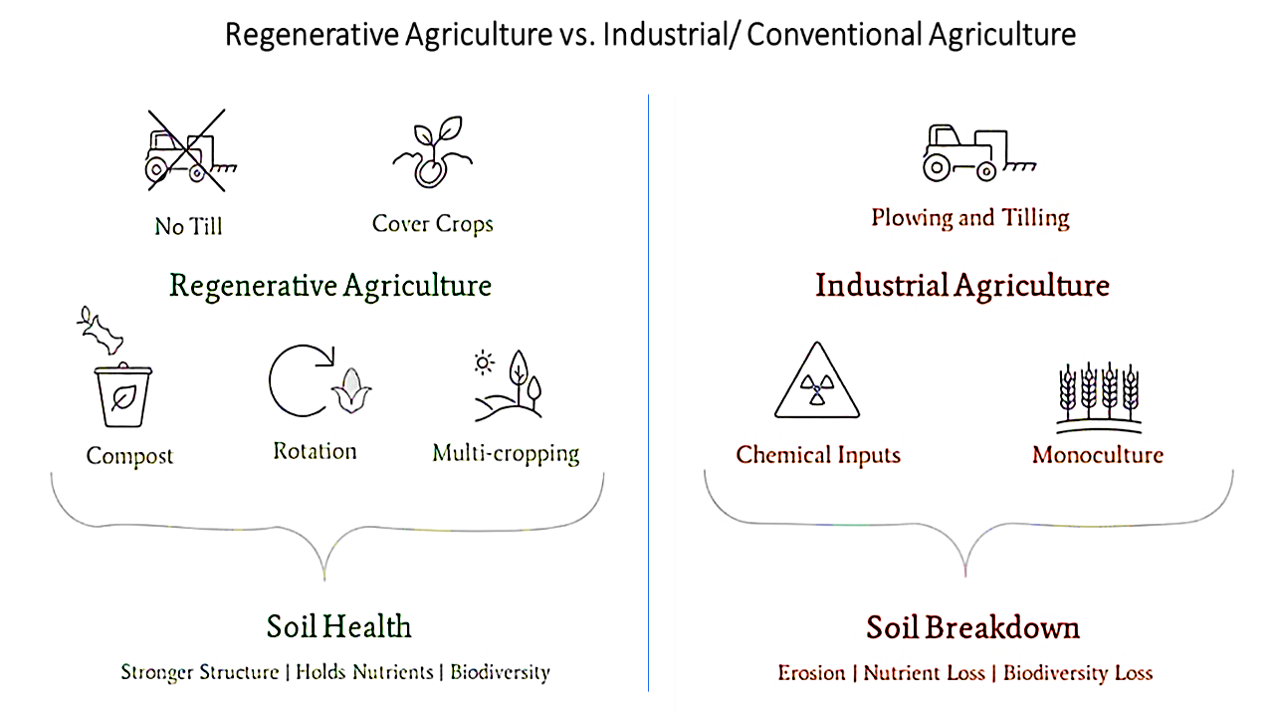

**Fig. 1 Depicting Regenerative Agriculture vs. Industrial/ Conventional Agriculture**

(Source: Adapted and modified from Kim *et al*., 2022)

Given the alarming rate of soil degradation, sustainable and regenerative agricultural practices are needed to restore soil health and ensure long-term food security. Regenerative agriculture (RA) provides a nature-based solution to reverse soil damage, improve soil function and increase farm resilience. Unlike conventional methods, which rely on chemical inputs to maintain yields, RA prioritizes restoring soil organic matter, enhancing microbial life and increasing soil structure stability (Schreefel *et al*., 2020). These practices contribute to water conservation, erosion prevention, carbon sequestration, and climate change mitigation. RA promotes cover cropping, crop rotations, no-till farming, compost application, agroforestry and holistic grazing systems, all of which work together to regenerate soil ecosystems (Newton *et al*., 2020). By improving soil carbon sequestration, RA helps mitigate climate change by pulling atmospheric carbon dioxide (CO₂) into the soil (Rhodes, 2017). Research indicates that increasing soil organic matter by just 1% can sequester an additional 3 tons of carbon per hectare annually, significantly reducing greenhouse gas emissions (LaCanne and Lundgren, 2018). Moreover, RA reduces reliance on synthetic inputs, helping farmers save on costs while maintaining or even increasing long-term crop productivity (Jayasinghe *et al*., 2023). The ability of RA to restore soil fertility, increase drought resilience and reduce erosion makes it one of the most effective solutions for degraded lands (Schreefel *et al*., 2020).

## Conservation Agriculture vs. Regenerative Agriculture

Conservation Agriculture (CA) is a sustainable farming approach aimed at conserving soil and water resources while maintaining crop productivity. It is built on three core principles: minimum mechanical soil disturbance, permanent soil cover through crop residues or cover crops, and crop diversification via rotations or intercropping (FAO, 2016). These practices reduce soil erosion, improve water infiltration, and enhance soil structure and fertility over time (Derpsch *et al*., 2010; Friedrich *et al*., 2012). CA is primarily preventive in nature, designed to halt further degradation and enhance resilience to climate stress. It is widely promoted in both rainfed and irrigated systems for its role in reducing production costs and improving soil moisture retention, especially under dryland conditions (Thierfelder and Wall, 2009).

On the other hand, Regenerative Agriculture (RA) builds upon CA but adopts a more holistic and proactive ecological approach, aiming not just to conserve but to restore soil biology, increase biodiversity, and enhance ecosystem services (LaCanne and Lundgren, 2018). It focuses on rebuilding soil organic matter, increasing biodiversity, and actively sequestering atmospheric carbon through ecological processes such as compost application, agroforestry, rotational grazing, and integration of perennial crops (Lal, 2020; Schreefel *et al*., 2020). RA adopts a holistic, systems-based approach that emphasizes soil biology, ecosystem regeneration, and farmer empowerment through traditional and indigenous knowledge. Unlike CA, which often emphasizes maintaining current soil conditions, RA is restorative, with the goal of healing degraded lands and creating resilient, self-sustaining farm ecosystems (LaCanne and Lundgren, 2018; Giller *et al*., 2021).

## 2. History of Regenerative Agriculture

Regenerative agriculture (RA) is a concept rooted in the broader sustainability movement but has evolved as a distinct agricultural paradigm over the decades. Several historical events shaped the need for regenerative farming (Heckman *et al*., 2009):

**Early Foundations (Pre-1940s)**

* **1905** – *Franklin Hiram King*, in his book *Farmers of Forty Centuries*, documented sustainable agricultural practices in East Asia, emphasizing organic matter recycling and soil fertility (King, 1911).
* **1924** – *Rudolf Steiner* introduced *biodynamic agriculture*, blending spiritual and ecological farming practices to enhance soil vitality and farm health (Steiner, 2013).
* **1930s** – The *Dust Bowl* in the USA (1930–1936), caused by intensive tillage and monoculture, led to catastrophic soil erosion. In response, the *Soil Conservation Service* was established in 1935 to promote erosion-control techniques (Heckman *et al*., 2006).
* **1940** – *Lord Northbourne* published *Look to the Land*, introducing the concept of “organic farming” and describing the farm as a living organism - a precursor to modern regenerative concepts (Northbourne, 1940; Paull, 2011).
* **1943** – *Lady Eve Balfour* launched the *Haughley Experiment* and published *The Living Soil*, advocating for holistic soil management and comparing organic vs. chemical farming systems (Balfour, 1943).
* **1940s** – *Masanobu Fukuoka* began promoting *natural farming* in Japan, a no-till, no-fertilizer, no-pesticide method focusing on natural soil regeneration (Fukuoka, 1978).

**Mid-Century Influences (1950s–1970s)**

* **1950s–1970s** – The *Green Revolution* increased yields through synthetic inputs and mechanization but caused soil degradation, biodiversity loss, and dependency on chemicals (LaCanne and Lundgren, 2018).
* **1960s–1970s** – Rise of *organic agriculture* driven by environmental and soil health concerns, with *J.I. Rodale* and *Albert Howard* promoting composting, cover cropping, and ecological balance (Rodale, 1983).

**Emergence of Regenerative Agriculture (1980s–1990s)**

* **Early 1980s** – *Robert Rodale* coined the term “Regenerative Agriculture,” advocating for practices that restore soil health, biodiversity, and community well-being, going beyond mere sustainability (Rhodes, 2017).
* RA Principles by Rodale (1983):
  1. Composting and green manure
  2. Crop-livestock integration
  3. Integrated pest management (IPM)
  4. Polyculture and crop diversification
* **1980s–1990s** – Limited policy support for RA; research and funding were largely directed toward organic and conservation agriculture (Kamenetzky and Maybury, 1989).

**Resurgence and Expansion (2000s–2010s)**

* **2000s** – Renewed interest in RA driven by climate change, declining soil fertility, and ecological crises (Pearson, 2007).
* **2011 onwards** – *Regenerative agriculture* recognized by global bodies for its potential in carbon sequestration and climate resilience (IPCC, 2021).
* **2017** – *Regenerative Organic Certification (ROC)* was introduced by Rodale Institute, Patagonia, and Dr. Bronner’s to formalize RA standards (Regenerative Organic Alliance, 2018).
* **Late 2010s** – Corporations like General Mills, Danone, and Patagonia began adopting RA principles in their supply chains (Giller *et al*., 2021).
* Consumers increasingly favoured regeneratively grown food, linking soil health with nutrition and sustainability (Poore and Nemecek, 2018).

**Recent Developments (2020s–Present)**

* **2020 onwards** – Regenerative agriculture is widely recognized as a climate-smart strategy. NGOs, corporations, governments, and farmers are collaboratively advancing regenerative farming through funding, training, and policy.
* Emphasis has shifted to outcome-based models that measure carbon sequestration, biodiversity, and water retention as indicators of regenerative success.

## 3. Principles of Soil Health in Regenerative Agriculture

RA is built upon key soil-regenerative principles (Fig. 2) that improve soil structure, organic matter content, and biological diversity:

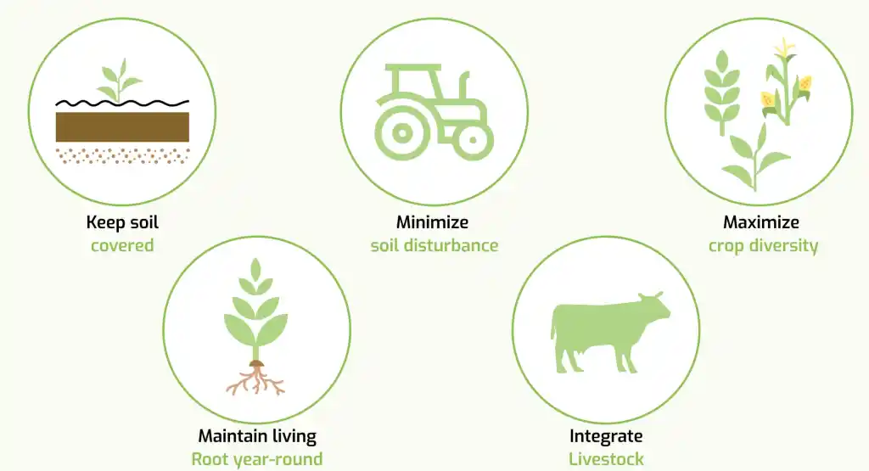

**Fig. 2 Principles of Soil Health in Regenerative Agriculture (Source: Geopard Tech, 2024)**

### 3.1. Minimizing Soil Disturbance

Conventional tillage disrupts soil aggregates and reduces microbial populations, making soil prone to erosion and compaction (Newton *et al*., 2020). Frequent tillage also disrupts fungal networks, such as mycorrhizal fungi, which play a crucial role in nutrient exchange between soil and plants (Rhodes, 2017).

Regenerative agriculture emphasizes no-till to preserve soil integrity and microbial life. By reducing mechanical soil disturbance, farmers can maintain soil structure, increase organic matter retention, and promote soil biodiversity (Shah *et al*., 2017). No-till farming helps improve water retention, allowing soil to absorb and store moisture more effectively, which enhances crop resilience during drought periods (Newton *et al*., 2020). Additionally, reducing tillage decreases carbon loss from soil, helping with carbon sequestration and climate change mitigation (Elevitch *et al*., 2018).

### 3.2. Maintaining Permanent Soil Cover

Bare soil is highly susceptible to erosion, moisture loss and temperature fluctuations (Beman *et al*., 2011). When soil is left exposed, it becomes vulnerable to wind and water erosion, leading to the loss of essential nutrients and organic matter. Additionally, direct exposure to sunlight increases soil temperature fluctuations, which can negatively impact microbial activity and root health (Klopfenstein *et al*., 1997).

Regenerative agriculture promotes cover cropping and mulching as effective strategies to protect the soil, increase organic matter, and foster microbial diversity (LaCanne and Lundgren, 2018). Cover crops, such as legumes, grasses and clovers, help stabilize the soil, prevent erosion, and improve soil fertility by fixing nitrogen and adding organic matter. Mulching, on the other hand, provides a protective barrier that reduces evaporation, conserves moisture, and suppresses weed growth. By keeping the soil covered year-round, farmers can enhance soil structure, support beneficial soil microbes and create a more resilient farming system (Elevitch *et al*., 2018). This practice also reduces reliance on synthetic fertilizers and herbicides, contributing to a more sustainable and ecologically balanced agricultural system. Maintaining permanent soil cover is essential for long-term soil health, improved water retention, and increased climate resilience.

### 3.3. Enhancing Crop Biodiversity and Microbial Activity

Enhancing crop biodiversity is crucial for improving soil health, pest resistance, and ecosystem stability. Diverse cropping systems reduce soil nutrient depletion, enhance microbial diversity, and promote natural pest control. Instead of monocropping, regenerative agriculture encourages polycultures, intercropping and crop rotations, which improve nutrient cycling and resilience to climate stress (Rhodes, 2014).

RA emphasizes crop diversity through cover cropping, companion planting, and agroforestry systems, which create a balanced farm ecosystem (Khangura *et al*., 2023). Legumes, for example, fix nitrogen in the soil, while deep-rooted crops enhance carbon sequestration and water retention (Jayasinghe *et al*., 2023). These practices reduce dependency on chemical inputs, making farming systems more sustainable, productive, and climate-resilient.

### 3.4. Keeping Living Roots in the Soil Year-Round

Keeping living roots in the soil year-round is a key principle of regenerative agriculture, as roots help stabilize soil, support mycorrhizal fungi and enhance soil carbon storage (Schreefel *et al*., 2020). Continuous root presence prevents soil erosion, improves nutrient availability and fosters beneficial microbial activity (Coccina *et al*., 2019).

Regenerative agriculture promotes the use of cover crops and perennial crops, which maintain soil structure, enhance fertility and improve moisture retention (Newton *et al*., 2020). These crops provide a constant supply of organic matter, support soil microbial communities and reduce the need for synthetic fertilizers. By ensuring that roots remain in the soil throughout the year, regenerative farming builds long-term soil health, increases resilience to drought, and enhances carbon sequestration, contributing to a more sustainable and productive agricultural system (Ryan *et al*., 2012).

### 3.5. Integrating Livestock for Natural Fertilization

Integrating livestock for natural fertilization is a key regenerative agriculture practice, as well-managed grazing adds organic matter, stimulates plant growth and enhances soil microbial diversity (Rhodes, 2017). Livestock contribute to soil aeration and nutrient cycling by trampling plant residues and returning organic material to the soil (Giller *et al*., 2021). Manure serves as a natural fertilizer, supplying essential nutrients that improve soil fertility and structure, reducing reliance on synthetic fertilizers (LaCanne and Lundgren, 2018). Properly managed rotational grazing prevents overgrazing, allowing pastures to regenerate while enhancing biodiversity and soil health. By integrating livestock into cropping systems, regenerative agriculture improves soil organic matter, boosts microbial activity and enhances ecosystem sustainability, creating a self-sustaining and resilient farming system.

These principles work synergistically to revitalize soil function, making agricultural systems more resilient to climate change and environmental stressors (Giller *et al*., 2021).

## 4. Key Practices in Regenerative Agriculture (RA)

Regenerative agriculture (RA) is a sustainable approach that focuses on restoring soil health, enhancing biodiversity, and increasing ecosystem resilience. By integrating ecological principles with modern farming practices, RA promotes soil conservation, mitigates climate change, and supports long-term agricultural productivity. The conceptual framework of regenerative agriculture is illustrated in Fig. 3.

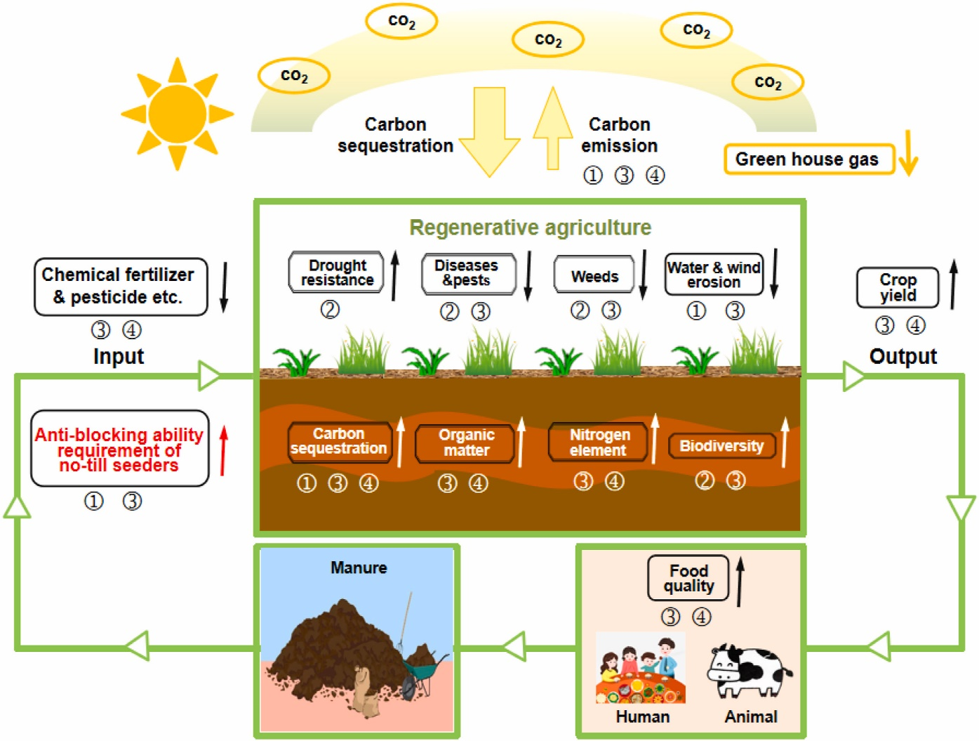

**Fig. 3** Conceptual framework of regenerative agriculture (RA), adapted from Wang *et al*. (2025). The framework illustrates the influence of four key RA practices: ① – no-till seeding, ② – crop rotation, ③ – ground cover (i.e., cover crops or residue mulching), and ④ – holistic grazing. The arrows indicate the direction of significant effects, where upward arrows (↑) represent positive impacts and downward arrows (↓) represent negative impacts of these practices (①–④) on the agroecosystem indicators shown in the surrounding boxes.

### 4.1. No Tillage / Minimum Tillage

Reducing or eliminating tillage helps preserve soil structure, prevent erosion, and improve soil carbon sequestration. No-till farming enhances soil microbial activity and increases organic matter, leading to improved soil fertility (Dalal *et al*., 1995; Derpsch *et al*., 2010)​. Research indicates that combining no-till with stubble retention increases soil organic carbon (SOC) by 2-5% over 19 years, compared to only 1.5% in conventional tillage systems (Somasundaram *et al*., 2017; Wang, Fu, Zhang, & Huang, 2021) ​. Long-term studies show that zero-tillage enhances carbon storage in tropical agriculture, providing greater climate change mitigation benefits (Cooper *et al*., 2021)​. The ability of no-till seeders is key to achieving effective no-till seeding technology (NST) for regenerative agriculture (RA) (He *et al*., 2018). To guide seeders and avoid stubble, automatic navigation methods have been developed, including touch-type sensors, machine vision systems, and GNSS-based positioning (Wang *et al*., 2020; Zhang and Guo, 2024). Recent studies have focused on crop stubble detection, target path tracking, path planning, and navigation control (Perez-Ruiz *et al*., 2012). A high-pressure air shooting (HPAS) device was also proposed for no-till seeding (Wang *et al*., 2020). Unlike conventional sowing with furrow openers and seed covering, HPAS enables sowing without seedbed preparation or covering (Wang *et al*., 2021). This integration reduces blockage, saves energy, and improves crop establishment under RA systems.

### 4.2. Stubble Retention

Stubble retention prevents wind erosion, improves soil moisture retention, and enhances nutrient cycling. Retaining crop residues returns nutrients to the soil, reduces water runoff and increases soil organic matter​. In sandy soils, stubble retention can reduce carbon loss by 3% at a 1m depth, significantly improving soil stability​. Studies confirm that combining no-till with stubble retention improves soil aggregate formation and microbial activity (Wakelin *et al*., 2007; Kassam *et al*., 2009)​.

### 4.3. Diverse Crop Rotations

Crop rotation disrupts pest and disease cycles, reducing the need for chemical inputs (Blair and Crocker, 2000)​. Legume-based crop rotations enhance nitrogen fixation, increase soil carbon levels, and improve soil structure (Lopez-Bellido *et al*., 2020)​. A global meta-analysis showed that crop rotation, combined with no-till, significantly enhances soil carbon sequestration​ (Zhao *et al*., 2022).

### 4.4. Multispecies Cover Crops

Cover cropping protects soil from erosion, improves water infiltration, and enhances microbial activity. Multi-species cover crops increase soil organic matter, biological nitrogen fixation and beneficial microbial diversity (Kim *et al*., 2020)​. Long-term studies reveal that cover crops combined with no tillage can reduce greenhouse gas emissions by 10%​. Cover crops also contribute to carbon sequestration, with fine-textured soils benefiting the most from increased soil carbon storage​.

### 4.5. Intercropping

Intercropping improves nutrient balance and maximizes land use efficiency, leading to higher soil fertility and reduced erosion (Giller *et al*., 2021)​. This practice enhances microbial diversity, reduces pest outbreaks and improves overall crop resilience​. Research shows that intercropping systems contribute to greater carbon sequestration and improved water-use efficiency​.

### 4.6. Rotational Grazing

Properly managed rotational grazing prevents overgrazing, maintains pasture productivity, and increases soil organic carbon levels​.Manure from livestock enhances nutrient cycling, promotes microbial growth and improves soil structure (Rhodes, 2017) ​.Rotational grazing has been shown to increase carbon stocks by 25% compared to conventional grazing systems (Planisich *et al*., 2020)​.

### 4.7. Reducing Synthetic Inputs

Reducing chemical inputs minimizes soil and water contamination, leading to healthier soil microbiomes and improved crop resilience​. A shift from synthetic fertilizers to biological nutrient cycling reduces input costs and enhances long-term soil health​. Studies indicate that reduced pesticide use in RA systems leads to greater beneficial insect populations and pollinator activity​ (Campbell *et al*., 2017).

### 4.8. Composting and Use of Bio stimulants

Composting enriches soil organic matter, improves microbial biodiversity and enhances water retention (Rouphael *et al*., 2020)​.Biochar application boosts soil aeration, retains moisture and supports beneficial microbes (Rhodes, 2017) ​.Biostimulants, including microbial inoculants and organic amendments, improve plant growth and increase soil resilience against environmental stresses​ (Yakhin *et al*., 2017)​.

## 5. Benefits of Regenerative Agriculture for Soil Health

Regenerative agriculture (RA) is a sustainable farming approach that prioritizes soil restoration, biodiversity, and long-term ecosystem resilience. By focusing on soil health, RA delivers substantial environmental, agronomic and socioeconomic benefits (Lal, 2020; Vamshi *et al*., 2024)

### 5.1. Environmental Benefits

* Enhanced Soil Organic Matter (SOM): RA practices such as composting, biochar application and no tillage significantly increase SOM, leading to improved soil fertility, microbial diversity, and nutrient cycling (Khangura *et al*., 2023)
* Improved Water Retention: Organic matter-rich soils enhance water infiltration and retention, reducing surface runoff and increasing drought resilience (Jayasinghe *et al*., 2023). Studies show that regenerative farms exhibit up to 30% higher water infiltration rates than conventionally managed soils (Giller *et al*., 2021)
* Carbon Sequestration: No-till farming, agroforestry, and cover cropping enhance soil carbon sequestration, mitigating climate change impacts by drawing CO₂ from the atmosphere and storing it in the soil (Newton *et al*., 2020). RA systems can sequester up to 2.5 metric tons of CO2 per hectare annually (Lal, 2020)
* Erosion Control: Cover crops and mulching reduce soil erosion by protecting the soil surface from wind and water runoff, thereby preserving topsoil quality and reducing nutrient loss (Rhodes, 2017)

### 5.2. Agronomic and Productivity Benefits

* Higher Yield Stability: RA improves soil structure and moisture availability, ensuring stable crop yields even under extreme weather conditions (Rhodes, 2017). Studies indicate that RA-based systems can outperform conventional farming during droughts by maintaining higher soil moisture levels (Jayasinghe *et al*., 2023)
* Reduced Input Costs: By minimizing reliance on synthetic fertilizers and pesticides, RA lowers production costs while maintaining or even improving yields. A meta-analysis of RA practices found that farms saved up to 30% on input costs while maintaining competitive yields (Newton *et al*., 2020)
* Stronger Plant Immunity: Healthy soils enriched with organic matter support diverse microbial communities that enhance plant immunity and suppress pathogens, reducing the need for chemical disease management (Giller *et al*., 2021)

### 5.3. Socioeconomic Benefits

* Increased Farm Profitability: Farmers practicing RA experience long-term profitability through reduced input costs and enhanced soil productivity. Some studies suggest a 15-20% increase in net farm income due to improved resource efficiency and premium pricing for regeneratively grown produce (Jayasinghe *et al*., 2023)
* Community Engagement and Knowledge Sharing: Regenerative farms promote local food systems, strengthen farmer cooperatives, and facilitate peer-to-peer learning, creating resilient rural communities (Rhodes, 2017)
* Healthier Food Systems: Nutrient-dense crops grown under RA practices provide better food quality while reducing chemical residues in food products, enhancing consumer health (Newton *et al*., 2020)

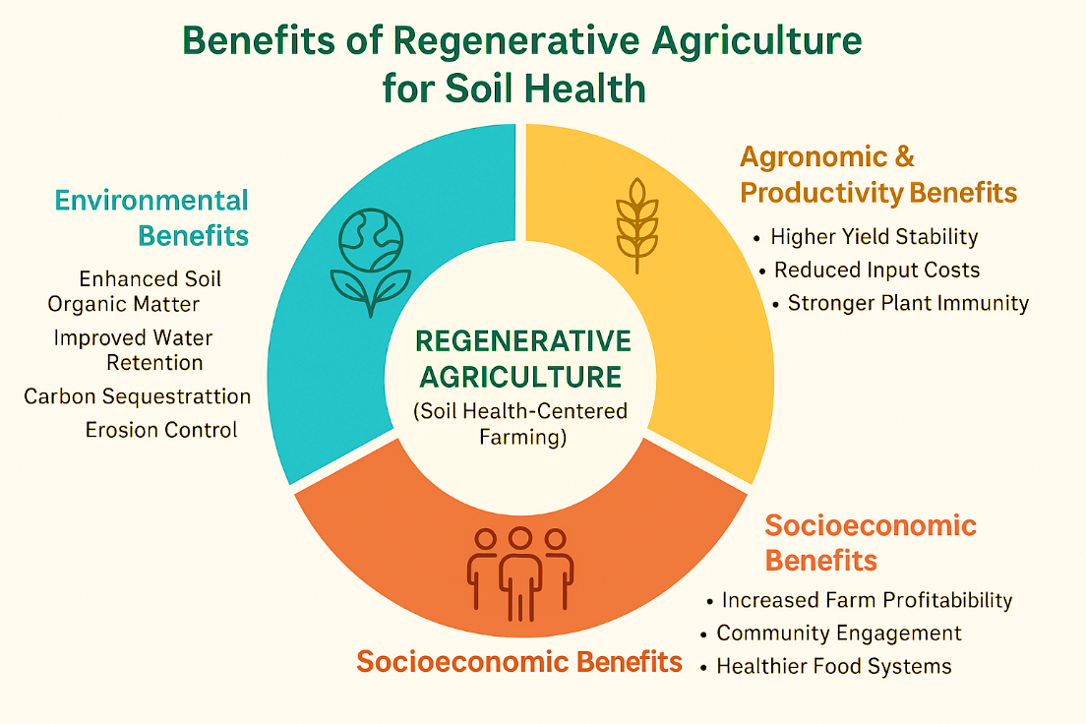

**Fig. 4 Regenerative agriculture benefits**

(Source: Adapted and modified from Kim *et al*., 2022)

## 6. Challenges and Future Directions of Regenerative Agriculture

Regenerative agriculture (RA) holds great potential for restoring soil health, improving biodiversity, and mitigating climate change, yet its widespread adoption faces several challenges. One of the primary barriers is the economic and transition costs, as farmers often experience short-term yield declines before the benefits of improved soil health become evident (Somasundaram *et al*., 2017)​. Additionally, the lack of financial incentives and policy support favors conventional farming, making it difficult for farmers to invest in regenerative practices (Rhodes, 2017)​. Knowledge gaps also hinder adoption, as there is limited long-term empirical research on RA’s scalability, carbon sequestration potential, and economic feasibility (Giller *et al*., 2021)​. Many farmers lack access to site-specific recommendations and technical training, which are necessary to transition from input-dependent conventional systems to biologically driven regenerative practices (Shalloo *et al*., 2004)​. Furthermore, market and policy barriers such as the absence of standardized RA certification systems prevent farmers from accessing premium markets, while corporate greenwashing undermines consumer trust in RA-labeled products (Jayasinghe *et al*., 2023)​. Farmers' dependence on agrochemicals, combined with deeply entrenched industrial farming models, creates additional resistance to change (Schreefel *et al*., 2020)​.

To overcome these barriers, future efforts should focus on strengthening research and development, particularly through long-term field trials that quantify the economic and environmental benefits of RA (Giller *et al*., 2021)​. Additionally, governments should introduce subsidies, tax breaks, and grant programs to support farmers during the transition period (Newton *et al*., 2020)​. Establishing carbon credit markets and incentivizing regenerative agriculture certification programs could further enhance farmer participation and provide additional revenue streams (Jayasinghe *et al*., 2023)​. Policy integration is also crucial, as RA should be incorporated into national sustainability frameworks, climate action plans, and food security strategies (Schreefel *et al*., 2020)​. Moreover, investing in farmer education and knowledge-sharing networks through digital advisory services, peer-to-peer learning, and capacity-building programs will play a key role in ensuring successful RA adoption (Giller *et al*., 2021)​. Addressing these challenges through collaborative efforts between governments, researchers, businesses, and farming communities will be essential in unlocking the full potential of regenerative agriculture and securing its place as a sustainable solution for global food systems.

## Conclusion

Soil degradation is one of the most pressing challenges in global agriculture, but regenerative agriculture provides a viable solution to restoring soil health. By adopting practices such as no-till farming, cover cropping, crop rotations, composting and rotational grazing, RA improves soil fertility, water retention, and carbon sequestration. Despite its benefits, challenges like economic barriers, policy gaps and knowledge limitations hinder widespread adoption. To accelerate RA implementation, financial incentives, research support and farmer training programs are essential. As the demand for sustainable food systems grows, regenerative agriculture stands as a pioneering approach to ensure healthy soils, productive farms, and resilient ecosystems for future generations.

**Disclaimer (Artificial intelligence)**

Option 1:

Author(s) hereby declare that NO generative AI technologies such as Large Language Models (ChatGPT, COPILOT, etc.) and text-to-image generators have been used during the writing or editing of this manuscript.

Option 2:

Author(s) hereby declare that generative AI technologies such as Large Language Models, etc. have been used during the writing or editing of manuscripts. This explanation will include the name, version, model, and source of the generative AI technology and as well as all input prompts provided to the generative AI technology

Details of the AI usage are given below:

1.

2.

3.

## References

Balfour, E. B. (1943). *The Living Soil*. London: Faber & Faber. 248-pp

Beman, J. M., Chow, C. E., King, A. L., Feng, Y., Fuhrman, J. A., Andersson, A., ... & Hutchins, D. A. (2011). Global declines in oceanic nitrification rates as a consequence of ocean acidification. *Proceedings of the National Academy of Sciences*, *108*(1), 208-213. <https://doi.org/10.1073/pnas.1011053108>

Blair, N., & Crocker, G. J. (2000). Crop rotation effects on soil carbon and physical fertility of two Australian soils. *Soil Research*, *38*(1), 71-84. <https://doi.org/10.1071/SR99064>

Campbell, B. M., Beare, D. J., Bennett, E. M., Hall-Spencer, J. M., Ingram, J. S., Jaramillo, F., ... & Shindell, D. (2017). Agriculture production as a major driver of the Earth system exceeding planetary boundaries. *Ecology and society*, *22*(4). <https://www.jstor.org/stable/26798991>

Coccina, A., Cavagnaro, T. R., Pellegrino, E., Ercoli, L., McLaughlin, M. J., & Watts-Williams, S. J. (2019). The mycorrhizal pathway of zinc uptake contributes to zinc accumulation in barley and wheat grain. *BMC Plant Biology*, *19*, 1-14. <https://doi.org/10.1186/s12870-019-1741-y>

Cooper, H. V., Sjögersten, S., Lark, R. M., Girkin, N. T., Vane, C. H., Calonego, J. C., ... & Mooney, S. J. (2021). Long‐term zero‐tillage enhances the protection of soil carbon in tropical agriculture. *European journal of soil science*, *72*(6), 2477-2492. <https://doi.org/10.1111/ejss.13111>

Dalal, R. C., Strong, W. M., Weston, E. J., Cooper, J. E., Lehane, K. J., King, A. J., & Chicken, C. J. (1995). Sustaining productivity of a Vertisol at Warra, Queensland, with fertilisers, no-tillage, or legumes. 1. Organic matter status. *Australian Journal of Experimental Agriculture*, *35*(7), 903-913. <https://doi.org/10.1071/EA9950903>

Derpsch, R., Friedrich, T., Kassam, A., & Li, H. (2010). Current status of adoption of no-till farming in the world and some of its main benefits. *International journal of agricultural and biological engineering*, *3*(1), 1-25. <https://doi.org/10.3965/j.issn.1934-6344.2010.01.0-0>

Elevitch, C. R., Mazaroli, D. N., & Ragone, D. (2018). Agroforestry standards for regenerative agriculture. *Sustainability*, *10*(9), 3337. <https://doi.org/10.3390/su10093337>

FAO. (2016). *Conservation Agriculture*. Food and Agriculture Organization of the United Nations. Retrieved from http://www.fao.org/conservation-agriculture

Friedrich, T., Derpsch, R., & Kassam, A. (2012). Overview of the global spread of conservation agriculture. *Field Actions Science Reports*, *Special Issue 6*, 1–7. <https://journals.openedition.org/factsreports/1941>

Fukuoka, M. (1978). *The One-Straw Revolution: An Introduction to Natural Farming*. Rodale Press.

Geopard Tech. (2022). *Benefits of crop rotation and no-till practices* [Infographic]. Retrieved from <https://i0.wp.com/geopard.tech/wp-content/uploads/2022/08/83.2-min.jpg?resize=1024%2C555&ssl=1>

Giller, K. E., Hijbeek, R., Andersson, J. A., & Sumberg, J. (2021). Regenerative agriculture: an agronomic perspective. *Outlook on agriculture*, *50*(1), 13-25. <https://doi.org/10.1177/0030727021998063>

He, H.W. Li, H.T. Chen, C.Y. Lu, Q.J. Wang. Research progress of conservation tillage technology and machine. *Transactions of the Chinese Society for Agricultural Machinery*, 49 (4) (2018), pp. 1-19, [10.6041/j.issn.1000-1298.2018.04.001](https://doi.org/10.6041/j.issn.1000-1298.2018.04.001)

Heckman, J. (2006). A history of organic farming: Transitions from Sir Albert Howard's War in the Soil to USDA National Organic Program. *Renewable Agriculture and Food Systems*, *21*(3), 143-150. <https://doi.org/10.1079/RAF2005126>

Heckman, J. R., Weil, R., & Magdoff, F. (2009). Practical steps to soil fertility for organic agriculture. *Organic farming: the ecological system*, *54*, 137-172. <https://doi.org/10.2134/agronmonogr54.c7>

Howard, A., & Moubry, J. M. (1940). *The book of the quarter: An agricultural testament*. African Affairs, *39*(157), 367–375. <https://doi.org/10.1093/oxfordjournals.afraf.a101058>

IPCC. 2021. Climate Change 2021: The Physical Science Basis; Contribution of Working Group I to the Sixth Assessment Report of the Intergovernmental Panel on Climate Change; Masson-Delmotte, V.; Zhai, P.; Pirani, A.; Connors, S.L.; Péan, C.; Berger, S.; Caud, N.; Chen, Y.; Goldfarb, L.; Gomis, M.I. *et al*., Eds.; Cambridge University Press: Cambridge, UK.

J.F. Wang, B.W. Chen, Y. Jiang, M. Zhu, J.F. Xia. Design and experiment on machine for rice straw full quantity deep buried into field. *Nongye Jixie Xuebao/Transactions of the Chinese Society of Agricultural Machinery*, *51*(1). <https://doi.org/10.106041/j.issn.1000-1298.2020.01.009>

Jayasinghe, S. L., Thomas, D. T., Anderson, J. P., Chen, C., & Macdonald, B. C. (2023). Global application of regenerative agriculture: a review of definitions and assessment approaches. *Sustainability*, *15*(22), 15941. <https://doi.org/10.3390/su152215941>

Kamenetzky, M., & Maybury, R. H. (1989). Agriculture in harmony with nature. *Science and Public Policy*, 16(2), 73-82. <https://doi.org/10.1093/spp/16.2.73>

Kassam, A., Friedrich, T., Shaxson, F., & Pretty, J. (2009). The spread of Conservation Agriculture: justification, sustainability and uptake. *International Journal of Agricultural Sustainability*, *7*(4), 292–320. <https://doi.org/10.3763/ijas.2009.0477>

Khangura, R., Ferris, D., Wagg, C., & Bowyer, J. (2023). Regenerative agriculture—a literature review on the practices and mechanisms used to improve soil health. *Sustainability*, *15*(3), 2338. <https://doi.org/10.3390/su15032338>

Kim, H.; Fischhoff, M. and Litchfield, A. 2022. What is regenerative agriculture? *Network for Business Sustainability*. Available at: <https://nbs.net/how-does-regenerative-agriculture-work>.

Kim, N., Zabaloy, M. C., Guan, K., & Villamil, M. B. (2020). Do cover crops benefit soil microbiome? A meta-analysis of current research. *Soil biology and Biochemistry*, *142*, 107701. <https://doi.org/10.1016/j.soilbio.2019.107701>

King, F. H. (2004). *Farmers of forty centuries: Organic farming in China, Korea, and Japan*. Courier Corporation.

Klopfenstein, N. B., Rietveld, W. J., Carman, R. C., Clason, T. R., Sharrow, S. H., Garrett, G., & Anderson, B. (1997). Silvopasture: an agroforestry practice. <https://digitalcommons.unl.edu/agroforestnotes/6?utm_source=digitalcommons.unl.edu%2Fagroforestnotes%2F6&utm_medium=PDF&utm_campaign=PDFCoverPages>

LaCanne, C. E., & Lundgren, J. G. (2018). Regenerative agriculture: merging farming and natural resource conservation profitably. *PeerJ*, *6*, e4428. <http://dx.doi.org/10.7717/peerj.4428>

Lal, R. (2020). Regenerative agriculture for food and climate. *Journal of soil and water conservation*, *75*(5), 123A-124A. <https://doi.org/10.2489/jswc.2020.0620A>

López‐Bellido, L., López‐Bellido, R., Fernández‐García, P., Muñoz‐Romero, V., & Lopez‐Bellido, F. J. (2020). Carbon storage in a rainfed Mediterranean vertisol: Effects of tillage and crop rotation in a long‐term experiment. *European Journal of Soil Science*, *71*(3), 472-483. <https://doi.org/10.1111/ejss.12883>

Newton, P., Civita, N., Frankel-Goldwater, L., Bartel, K., & Johns, C. (2020). What is regenerative agriculture? A review of scholar and practitioner definitions based on processes and outcomes. *Frontiers in Sustainable Food Systems*, *4*, 577723. <https://doi.org/10.3389/fsufs.2020.577723>

Northbourne, W. (1940). *Look to the Land*. Dent. London

Paull, J. (2011). The making of an agricultural classic: *Farmers of Forty Centuries or Permanent Agriculture in China, Korea and Japan*, 1911–2011. Agricultural Sciences, *2*(3), 175–180. https://doi.org/10.4236/as.2011.23024

Pearson, C. J. (2007). Regenerative, semiclosed systems: a priority for twenty-first-century agriculture. *Bioscience*, *57*(5), 409-418. <https://doi.org/10.1641/B570506>

Perez-Ruiz, M., Slaughter, D. C., Gliever, C., & Upadhyaya, S. K. (2012). Tractor-based Real-time Kinematic-Global Positioning System (RTK-GPS) guidance system for geospatial mapping of row crop transplant. *Biosystems engineering*, *111*(1), 64-71. <https://doi.org/10.1016/j.biosystemseng.2011.10.009>

Planisich, A., Utsumi, S. A., Larripa, M., & Galli, J. R. (2021). Grazing of cover crops in integrated crop-livestock systems. *Animal*, *15*(1), 100054. <https://doi.org/10.1016/j.animal.2020.100054>

Poore, J., & Nemecek, T. (2018). Reducing food’s environmental impacts through producers and consumers. *Science*, *360*(6392), 987-992. <https://doi.org/10.1126/science.aaq0216>

Regenerative Organic Alliance. (2018). Framework for regenerative organic certification. Available online: <https://regenorganic.org/wp-content/uploads/2018/03/ROC-Framework-Pilot-Ready-March-2018.pdf>

Rhodes, C. J. (2017). The imperative for regenerative agriculture. *Science progress*, *100*(1), 80-129. <https://doi.org/10.3184/003685017X14876775256165>

Rodale, R. (1983). Breaking new ground: The search for a sustainable agriculture. *Futurist*, *17*(1), 15-20. EJ275343

Rodale, R. (1983). *Regenerative Agriculture: A Definition*. Rodale Institute.

Rouphael, Y., & Colla, G. (2020). Biostimulants in agriculture. *Frontiers in plant science*, *11*, 40. https://doi.org/10.3389/fpls.2020.00040

Ryan, M. H., & Kirkegaard, J. A. (2012). The agronomic relevance of arbuscular mycorrhizas in the fertility of Australian extensive cropping systems. *Agriculture, Ecosystems & Environment*, *163*, 37-53. <https://doi.org/10.1016/j.agee.2012.03.011>

Schreefel, L., Schulte, R. P., De Boer, I. J. M., Schrijver, A. P., & Van Zanten, H. H. E. (2020). Regenerative agriculture–the soil is the base. *Global Food Security*, *26*, 100404. <https://doi.org/10.1016/j.gfs.2020.100404>

Shah, A. N., Tanveer, M., Shahzad, B., Yang, G., Fahad, S., Ali, S., ... & Souliyanonh, B. (2017). Soil compaction effects on soil health and cropproductivity: an overview. *Environmental Science and Pollution Research*, *24*, 10056-10067. <https://doi.org/10.1007/s11356-017-8421-y>

Shalloo, L., Dillon, P., Rath, M., & Wallace, M. (2004). Description and validation of the Moorepark dairy system model. *Journal of Dairy science*, *87*(6), 1945-1959. <https://doi.org/10.3168/jds.S0022-0302(04)73353-6>

Somasundaram, J., Reeves, S., Wang, W., Heenan, M., & Dalal, R. (2017). Impact of 47 years of no tillage and stubble retention on soil aggregation and carbon distribution in a vertisol. *Land Degradation & Development*, *28*(5), 1589-1602. <https://doi.org/10.1002/ldr.2689>

Steiner, R. (2013). *Agriculture Course: The Birth of the Biodynamic Method*. Rudolf Steiner Press.

Vamshi, M., Jagadeesan, R., Lamani, H. D., Rout, S., VijayKumar, R., Jagadesh, M., & Sachan, K. (2024). The Revolutionary Impact of Regenerative Agriculture on Ecosystem Restoration and Land Vitality: A Review. *Journal of Geography, Environment and Earth Science International*, 28(4), 1–14. <https://doi.org/10.9734/jgeesi/2024/v28i4760>

Wakelin, S. A., Colloff, M. J., Harvey, P. R., Marschner, P., Gregg, A. L., & Rogers, S. L. (2007). The effects of stubble retention and nitrogen application on soil microbial community structure and functional gene abundance under irrigated maize. *FEMS microbiology ecology*, *59*(3), 661-670. <https://doi.org/10.1111/j.1574-6941.2006.00235.x>

Wang, X., Fu, Z., Zhang, Q., & Huang, Y. (2021). Short-term subsoiling effects with different wing mounting heights before winter wheat on soil properties and wheat growth in Northwest China. *Soil and Tillage Research*, *213*, 105151. <https://doi.org/10.1016/j.still.2021.105151>

Wang, X., Zhou, H., Zhou, H., & Ji, J. (2025). Research progress and development in anti-blocking methods for no-till seeders in regenerative agriculture. *Biosystems Engineering*, *257*, 104215. <https://doi.org/10.1016/j.biosystemseng.2025.104215>

Wang, Y., Li, H., Hu, H., He, J., Wang, Q., Lu, C., Liu, P., He, D., & Lin, X. (2021). DEM–CFD coupling simulation and optimization of a self-suction wheat shooting device. *Powder Technology, 393*, 494–509. <https://doi.org/10.1016/j.powtec.2021.08.013>

Yakhin, O. I., Lubyanov, A. A., Yakhin, I. A., & Brown, P. H. (2017). Biostimulants in plant science: a global perspective. *Frontiers in plant science*, *7*, 2049. <https://doi.org/10.3389/fpls.2016.02049>

Yingbo Wang, Hongwen Li, Hongnan Hu, Jin He, Qingjie Wang, Caiyun Lu, Peng Liu, Dong He, Xin Lin,DEM – CFD coupling simulation and optimization of a self-suction wheat shooting device, Powder Technology, Volume 393, 2021, Pages 494-509, <https://doi.org/10.1016/j.powtec.2021.08.013>.

Zhang, Z., Guo, Q., He, J., Zhao, M., Xing, Z., Zeng, C., ... & Wang, Q. (2024). Design and Experiment of Side-Shift Stubble Avoidance System for No-Till Wheat Seeder Based on Deviation-Perception Fusion Technology. *Agriculture*, *13*(1), 180. <https://doi.org/10.6041/j.issn.1000-1298.2024.03.004>

Zhao, J., Chen, J., Beillouin, D., Lambers, H., Yang, Y., Smith, P., ... & Zang, H. (2022). Global systematic review with meta-analysis reveals yield advantage of legume-based rotations and its drivers. *Nature Communications*, *13*(1), 4926. <https://doi.org/10.1038/s41467-022-32464-0>