Effects of Garcinia manni oliv. biflavonoids on a model of aluminum chloride AlCl3-induced Alzheimer’s disease in drosophila

Abstract: Alzheimer's disease (AD) is a neurodegenerative disorder characterized by progressive memory loss, cognitive decline, and loss of autonomy.
This study aimed to evaluate the therapeutic effects of five biflavonoids extracted from the leaves and stems of Garcinia manni on proteins and events involved in AD development following aluminum chloride (AlCl3) exposure in a drosophila model.
Molecular docking studies conducted using Molegro Virtual Docker identified biflavonoids OBIII and DS03 based on their favorable docking scores in regards to molecular targets such as catalase, SOD, nitric oxide synthase, amyloid beta protein, and acetylcholinesterase. Drosophila were exposed to AlCl3 at concentrations of 5, 10, and 20 mM, with 5 mM inducing AD-like symptoms after seven days. Following three days of exposure to this concentration via diet, flies were treated with biflavonoids or baicalin at concentrations of 650 and 6500 µM for four days.
Compared to untreated intoxicated flies, experimental groups exhibited significant improvements (p < 0.001) in locomotion and short-term memory. To further investigate the curative effects of the two biflavonoids, seven groups of 50 flies each were established for testing at the aforementioned concentrations. Spectrophotometric assays of oxidative stress and inflammation markers revealed a significant decrease (p < 0.001) in malondialdehyde (MDA) and nitric oxide (NO) production, alongside with increased activity of catalase and superoxide dismutase in biflavonoid-treated groups.
All together, these findings position these compounds as promising therapeutic candidates for AD treatment.
Keywords: Alzheimer's disease, Garcinia manni, biflavonoids, Aluminum chloride, molecular docking, drosophila.
1. Introduction:
Alzheimer's disease (AD) is a central nervous system disorder that primarily affects the cerebral cortex, a particular region involved in memory, learning, thinking, and planning (Eratne et al., 2018). The main neuropathological characteristics include the presence of extracellular senile plaques composed of amyloid beta (Aβ) peptides and neurofibrillary tangles associated with the hyperphosphorylation of tau protein at the intracellular level (Villemagne et al., 2013). The disease progresses towards a gradual deterioration of intellectual capabilities (Chowdhury & Vijaykumar, 2025). In 2017, the World Health Organization (WHO) estimated that 47 million people worldwide were affected by dementia, with 10 million new cases reported each year. This number is projected to reach 82 million by 2030 and 152 million by 2050 in the absence of effective treatments and early diagnosis.
In Africa, the prevalence of AD is challenging to estimate accurately due to the lack of reliable data and specific research on the subject in many countries across the continent. However, according to WHO, the prevalence of AD and other forms of dementia in sub-Saharan Africa was estimated to be approximately 2.4% (Guerchet et al., 2016). This figure may vary from country to country based on factors such as population age, lifestyle habits, genetic factors, and access to healthcare.
In Cameroon, due to a lack of specific data and in-depth research on this topic, the prevalence of the disease is not clearly established, although it is believed to be increasing significantly due to an aging population and changes in lifestyle. A study conducted in Douala (country’s economic capital) estimated the prevalence of degenerative dementia at 2.07% (Njamnshi et al., 2008). Although this study does not focus exclusively on AD, it provides insights into dementia in general.
Among existing animal models such as mice and albino rats, Drosophila, due to their short life cycle, allows for accelerated observation of the effects of aging on neurodegeneration (Bouleau & Tricoire, 2015). Furthermore, they share many genes and biological pathways with humans, making them a relevant model for studying neurodegenerative processes (Bouleau & Tricoire, 2015). Additionally, free radicals are naturally produced by the body, and their production can be increased by factors such as stress, exposure to environmental toxins, and diet (Chen et al., 2025). Oxidative stress is considered a key factor in the development of AD as it can damage brain cells and contribute to the formation of amyloid plaques and neuronal degeneration (Aycan et al., 2025).
The pathophysiological process of AD involves the formation of amyloid plaques and neurofibrillary tangles, as well as oxidative stress, which contribute to neuron loss and deterioration of cognitive functions, particularly short-term memory (Jack et al., 2013). These mechanisms interact in complex ways to lead to the onset and progression of the disease. Current management of AD focuses on pharmacological treatments (acetylcholinesterase inhibitors, NMDA antagonists) and non-pharmacological therapies (cognitive and occupational therapy). However, these approaches have limitations such as side effects, limited efficacy, and minimal impact on disease progression (Lee et al., 2023). In this context, the search for new treatments for AD has become a priority for researchers worldwide (Drachman, 2003). It has been demonstrated that Ginkgo biloba extract reduces memory problems in several studies, both in rats and mice (Xie et al., 2022); experiments on the phagocytosis of amyloid β have shown that pre-treatments with extracts of Khaya grandifoliola can repair the phagocytic activity of THP-1 cells, which was impaired after inflammasome activation (Owona et al., 2025). This clearly demonstrates the strong potential of medicinal plants for the treatment of AD.
Biflavonoids are compounds found in various plants, including Garcinia manni oliv. They are complex molecules composed of two flavonoids linked by a covalent bond. Biflavonoids, with their multi-target action on amyloid β, tau, inflammation, and oxidative stress, could offer a promising alternative by protecting neurons and improving cognition (Thapa & Chi, 2015).
In this study, we investigated the effects of biflavonoids isolated from Garcinia manni on a model of AD induced in Drosophila by AlCl₃. To do so, an integrated approach combining computational simulations and in vivo experiments was adopted.

2. Material and Methods
This study was conducted between June and December 2024, in the laboratory of Pharmacology and Toxicology, University of Yaoundé 1, Cameroon.
2.1. Animal Material
For the accomplishment of this work, we used drosophila melanogaster wild type obtained from Prof Charles Wondji (CRID- Yaoundé), which were given to us for carrying out the in vivo tests.
2.2. Plant Material
Extraction and Isolation biflavonoids
The different drugs used in this study were obtained from Dr Messi’s laboratory (Organic Chemistry Laboratory, University of Yaounde 1). In brief, dried and powdered root bark of Ochna schweinfurthiana (200 g) was extracted with MeOH (3 × 3 L) at room tem perature (RT) to yield a crude extract (47 g) after evaporation under vacuum. The extract (MeOH, 80 g) was subjected to column chromatography over silica gel eluting with gradients of CH2Cl2/MeOH to generate 10 fractions of 100 mL each. These fractions were combined based on their thin-layer chromatography (TLC) profiles into four major fractions: A (0.11 g, 1–10); B (0.30 g, 11–30); C (0.23 g, 31–60); and D (0.89 g, 61–90). Fractions A (CH2Cl2; 100%); B (CH2Cl2/MeOH; 50:1); and C (CH2Cl2/MeOH; 40:1) contained mostly lipids. Fraction D (CH2Cl2/MeOH 30:1) was purified by silica gel column chromatography with a gradient of CH2Cl2/MeOH (20:1) followed by a Sephadex LH20 column in acetone to generate different biflavonoids (Table 1).

2.3. Reagents
The following reagents were used: Agar, glucose, nipagin, propionic acid, aluminum chloride (AlCl₃), white vinegar, yeast (saccharomyces cerevisiae), distilled water, corn flour (white maize variety), sodium soda (NaOH), adrenaline, sodium carbonate, monosodium carbonate, hydrogen peroxide, potassium dichromate, potassium dichromate, glacial acetic acid, sodium chloride (NaCl), potassium chloride (KCl), sodium hydrogenophosphate (NaH₂PO₄), sodium carbonate (CO₃NaH), magnesium chloride (MgCl₂), calcium chloride (CaCl₂), trichloroacetic acid (TCA), thiobarbituric acid (TBA), phosphoric acid, naphtylethylenediamine (NED), sulfanilamide anhydrous, sodium nitrite (NaNO₂), bovine albumin serum (BSA), copper sulfate hydrate (CuSO₄, 5H₂O), sodium , potassium tartrate and sodium hydroxide.
2.4. Equipment
Eppendorf refrigerated centrifuge 5804R; water bath (UNITRONIC 320 OR); Optical microscope (OLYMPUS AXIOVERT 40C); Spectrophotometer (SHIMADZU UV-120-01 and GENESYS); Vortex (Karl Hecht KG VM4); pH meter; Magnetic shaker; Precision balance; Case (HP-AD070); Dissection kit; Racks; Beaker; Flask; Glass tube; Freezer; Refrigerator; Camera; Stopwatch; T-Maze.
2.5. Preparation of the Drosophila culture medium
To prepare the culture medium, we started by weighing 4 g of agar, 5 g of glucose, 7 g of corn flour and 5 g of yeast. Then we added 200 ml of distilled water to the mixture and stirred vigorously for 2 minutes. The mixture was then placed in a hot water bath, where it was stirred for 10 minutes to ensure perfect homogeneity. After removing the mixture from the water bath, we continued to stir constantly for 30 minutes to allow a gradual cooling. We then incorporated 1.5 mL of propionic acid and 1 mL of nipagin. Once the mixture was cooled, it was transferred to culture tubes, filling them up to 10 cm. To facilitate the transfer of drosophila, we anaesthetized the insects by dipping the tubes in ice for a short time, which helped preventing them from flying when changing the tube. This method has allowed a smooth and stress-free transfer for drosophila.
2.5. Molecular Docking study
Molecular docking is a molecular modelling technique used to predict the preferred orientation of a ligand when it binds to a target protein, forming a stable complex (Bitencourt-Ferreira & de Azevedo, 2019). Docking with Molegro Virtual Docker (MVD) started by importing the molecular structures of the ligand and receptor into the software. Thereafter, the receptors were prepared by adding hydrogens and assigning appropriate charges. We then used the cavity detector to identify potential binding sites on each target protein. Next, the Docking Wizard was configured to set the search space and search algorithm parameters. Docking simulation was then run to explore the different possible ligand conformations in the active site of the protein. After the simulation was completed, the Pose Organizer was used to inspect and analyze the results, visualizing the ligand-receptor interactions and fine-tuning the found poses.

2.6. Determination of the toxic concentration of aluminum chloride
The test for AlCl₃ toxicity in drosophila consisted of exposing different groups of drosophila to increasing concentrations of AlCl₃ in their diets for seven days as reported by (Abolaji et al., 2020). We prepared aluminum chloride (AlCl₃) solutions at concentrations of 5 mM, 10 mM and 20 mM by diluting them in an appropriate medium, then divided the Drosophila (at a rate of 30 Drosophila per group) into four distinct groups (I, II, III, IV) placed in separate culture tubes. To each group, we added the corresponding concentration of AlCl₃ to their standard diet and observed the flies regularly to note any changes in their behavior and survival. The results obtained were then compared between the different groups to assess the effect of AlCl₃ on the Drosophila, allowing us to determine whether this effect was toxic and whether it was dose-dependent.
2.7. Search for non-toxic concentrations of the tested compounds
The search for non-toxic concentrations of bioactive compounds OBIII, DS03 and baicalin aims to assess their impact on the viability of drosophila in order to determine whether these substances have an effect on insect survival and whether this effect is dose-dependent. To see if the bioactive compounds tested did not kill fruit flies, we conducted a study by separating flies into seven distinct groups (I, II, III, IV, V, VI, VII). Each group was placed in appropriate culture tubes. We prepared a standard feed for each group, adding specific concentrations (650 and 6500 μM) of baicalin for groups II and III, groups IV and V contained 650 and 6500 μM of biflavonoids OBIII respectively, the same for groups VI and VII with biflavonoids DS03. Drosophila were observed for one week to note their survival rate during the experiment. Finally, we compared the survival rates between the different groups to assess the effectiveness of baicalin and biflavonoids as potential treatment options.
2.8. Negative Geotaxis Assay
This test is used to assess the fly’s behavioral response to terrestrial gravity as described by (Abolaji et al., 2020). In this assay, drosophila were placed in a vertical tube and their behavior was observed when they were confronted with gravity. Normally, drosophila tend to move up the tube due to their instinct for exploration and foraging. However, under stress or exposure to specific compounds, their ability to climb may be impaired, which is manifested by a decrease in the number of insects reaching the top of the tube. By measuring the distance travelled or the percentage of drosophila that have reached the top of the tube, we could assess the impact of various factors on their locomotor behavior and well-being. This impact was calculated as follows:
performance Index (PI) = [1/2 (N_{T}+N_{H}-N_{B}) /N_{T}] × 100
NH = Number of drosophila that crossed the 6cm line.
NB= Number of drosophila that did not cross the 6cm line.
NT = Number of drosophila present in the tube.
Procedure
Intoxication and treatment of drosophila
We first established six groups of Drosophila melanogaster, each receiving a specific treatment to evaluate the impact of biflavonoids on the levels of behavioral parameters (mobility and short-term memory) in case of aluminum chloride (AlCl₃) exposure. The first group received normal feeding, while the second was exposed to 5 mM AlCl₃ for 7 days. The third group received a normal diet enriched with 5 mM of AlCl₃ for the first 3 days and then 6500 μM of baicalin (used here as reference drug) for the last 4 days. The fourth group was treated with 5 mM AlCl₃ (for 3 days) and 650 μM OBIII (for 4 days), the fifth group received 5 mM AlCl₃ (for 3 days) with 6500 μM OBIII, and finally the sixth group had a normal feeding with 5 mM AlCl₃ and 650 μM DS03. Each treatment aimed to analyze the effects of different compounds in the presence of aluminum chloride poisoning.
Analysis of the mobility of drosophila
Each group of drosophila was pre-fixed under light ice anesthesia and placed separately in vertical glass columns labelled (15 cm long, 1.5 cm diameter). After a recovery period (about 20 minutes), the flies were tapped against the back of the spine. After 6 seconds, the number of flies that reached the 6 cm mark on the column and the number of flies remaining below this mark were recorded. Data were expressed as a percentage of flies that escaped beyond the 6 cm bar in 6 seconds. The scores for each group were the average of three trials for each treated and control group.
II.9. Short-term memory test
This short-term memory test on drosophila is based on olfactory conditioning (Owald & Waddell, 2015). This test assesses the ability of drosophila to form and retain short-term memories associated with specific olfactory stimuli (White vinegar). The experimental protocol began with the selection of drosophila flies aged 3 to 5 days, which were divided into eight groups (T0 to T7). During olfactory conditioning, each group was exposed to a neutral odor for 20 minutes, followed by exposure to white vinegar for 10 minutes. This procedure was repeated several times to reinforce the association between the smell test and the experiment. After this phase, the fruit flies were placed in a neutral environment for 30 minutes before being exposed to the smell test again, their behavioral responses being recorded at 5 second intervals using a tracking device. Finally, the results were analyzed to assess drosophila short-term memory based on their choice in the maze, and the responses of different groups were compared to determine their ability to form and retain short-term olfactory memories.
M_{stm} = N_{wv}/ N_{T}
N_{stm}: Short-term memory.
N_{wv}: Number of fruit flies that chose the side of the maze exposed to the smell of white vinegar.
N_{T}: Total number of drosophila.

Finally, the brain from each fly were cut-off and use for preparing the homogenates used in the following experiments.

II.10. Determination of superoxide dismutase activity
The oxidation of adrenaline to adrenochrome in a medium is inhibited in the presence of superoxide dismutase (Baumber & Ball, 2005). The variation in absorbance, which is proportional to the SOD activity, is recorded between 20 and 80 seconds at 480 nm. The protocol involved mixing precise volumes of homogenate, carbonate buffer and adrenaline in test tubes. After homogenization, the absorbance of test tubes was measured at 480 nm at 20 and 80 seconds, using the reactive blank as a reference.
II.11. Catalase Assay
Hydrogen peroxide is broken down in the presence of catalase. The residue binds to potassium dichromate to form an unstable blue-green precipitate of perchloric acid that will be decomposed by heat and form a green complex (Sinha, 1972). The protocol involved mixing specific volumes of distilled water, homogenate, phosphate buffer, hydrogen peroxide and potassium dichromate/glacial acetic acid in test tubes. The tubes were then incubated for 1 minute at room temperature before adding potassium dichromate/glacial acetic acid. The tubes were then sealed with glass beads and the solutions were heated to 100°C for 10 minutes. After cooling, the absorbance of the samples was read at 570 nm using an Urit-810 spectrophotometer, using the reactive blank as a reference.
II.12. Dosage of malondialdehyde
The malondialdehyde (MDA) formed during lipid peroxidation reacts with thiobarbituric acid in hot acidic medium to give a pink complex that has a maximum absorption at 530 nm. The intensity of the staining is proportional to the amount of MDA present in the medium (Wilbur et al., 1949). The colorimetric assay of MDA was carried out according to the protocol described in Table 7. The protocol involved mixing precise volumes of Tris-HCl buffer, homogenate, trichloroacetic acid (TCA) and thiobarbituric acid (TBA) in test tubes. The tubes were then capped with glass beads, heated to 90°C for 10 minutes in a water bath, cooled with tap water and centrifuged at 3,000 rpm at room temperature for 15 minutes. The supernatant was then collected and its absorbance was read at 530 nm using a spectrophotometer, with the reagent blank as a reference.
II.13. Nitrite assay
In the presence of 4-aminobenzenesulphonamide (sulphanilamide) and N-(1-naphthyl)diamino-1,2-ethane dichloride (N-1-naphthylethylenediamine) in an acid medium, the nitrites undergo a diazotization reaction. (Fermor et al., 2001). The product is proportional to the amount of nitrite present in the sample. The determination of nitric oxide (NO) was carried out by the Griess colorimetric method, based on the reaction of nitrites with the Griess reagent to form a colored product. The protocol consisted of preparing a series of sodium nitrite (NaNO₂) standards at known concentrations, as well as samples to be analyzed. Griess reagent was then added to each tube, followed by incubation for 10 minutes at room temperature. The absorbance of the solutions was then read at 546 nm using a spectrophotometer. A calibration curve was established by plotting the absorbance of the standard tubes as a function of the concentration of NaNO₂. The concentration of nitrite in each sample was then determined from this calibration line.
II.14. Protein assay
In basic medium, sodium and potassium tartrate forms with the copper ions a soluble complex. The addition of a protein displaces the copper bound to the tartrate to form a violet-colored protein copper complex. The intensity of the staining is proportional to the amount of protein present in the solution (Gornall et al., 1949). Total protein was determined using the Biuret method. A series of tubes containing solutions of bovine serum albumin (BSA) at known concentrations were prepared, along with the samples to be analyzed. Biuret reagent was then added to each tube, followed by a 30-minute incubation at room temperature, protected from light. The absorbance of the solutions was then read at 540 nm using a spectrophotometer. A calibration curve was established by plotting the absorbance of the standard tubes against the quantity of protein.

II.15. Statistical analysis
The assays were performed in triple, the data were entered into the Excel 2016 spreadsheet and analyzed using GraphPad Prism version 8.0.1 software. The results are expressed as a mean standard deviation. The statistical analysis was performed by ANOVA test at a factor followed by the post test of Turkey for a threshold of significance P<0.05. Linear correlation was performed using the non-parametric Spearman test.

3. Results
3.1. Interactions between biflavonoids and proteins involved in Alzheimer’s disease
Tables 2 to 6 present the molecular interactions between biflavonoids (DS03, OBIII, DR05, OB6B and DS1) and baicalin with key proteins involved in AD. The analysis focused on the interaction of these molecules with catalase (Table 2), superoxide dismutase (SOD) (Table 3), nitrite oxide synthase (Table 4), human amyloid beta protein (Table 5) and human acetylcholine esterase (Table 6). The results show that biflavonoids generally exhibit better affinity and more favorable binding energies than baicalin, suggesting a higher potential for interaction with these proteins. These likely interactions are illustrated in figures 5. Table 2 illustrates that all the Molecular Docking results show varied scores for several complexes, with DS03 showing a score of -120.039 Kcal/mol and a key interaction with Val (448), while OBIII shows a score of -83.525 Kcal/mol with three notable hydrogen bonds, notably with His and Arg. Other complexes such as DR05 and 1DGF OB6B showed competitive scores and a wealth of interactions, while DS1 stood out with its exceptional score of -154.745 Kcal/mol and a large number of interactions. The results of molecular docking with SOD (Table 3) reveal promising compounds, with particular attention paid to DS03, which displays the best score of -106.044 Kcal/mol and a ReRank Score of -83.5244 Kcal/mol. This ligand stood out with three significant hydrogen bonds with Arg (141), Asn (51) and Val (7), as well as six steric interactions, including three with Lys (9) and one with Cys (55), highlighting its high affinity. OBIII followed with a score of -89.9878 Kcal/mol and a ReRank Score of -67.4299 Kcal/mol, exhibiting a hydrogen bond with Ala (87) and four steric interactions. Other compounds such as DR05 and 2SOD OB6B also showed competitive scores, respectively -118.08 Kcal/mol and -115.952 Kcal/mol, but without hydrogen bonds for DR05. Table 4 shows that all the biflavonoids obtained very good scores with NO synthase, with DS1 emerging as the best candidate with a score of -107.909 Kcal/mol and a ReRank Score of -76.7297 Kcal/mol. This ligand establishes four hydrogen bonds, notably with Arg (260) and Ser (256), and has seven steric interactions, reinforcing its affinity. 2NOS OB6B followed with a score of -94.9262 Kcal/mol and a ReRank Score of -64.517 Kcal/mol, displaying nine bonds, including several with Gln (257) and Tyr (341), as well as two steric interactions. DR05, although it has a competitive score of -86.1789 Kcal/mol, shows one hydrogen interaction with Arg (375) and a single steric interaction. The ligands DS03 and OBIII have respective scores of -81.8817 Kcal/mol and -65.4659 Kcal/mol, but their potential is less marked compared with the best compounds. Table 5 shows the interactions with amyloid beta protein, from which it emerges that DS1 ranks first with a score of -485.774 Kcal/mol and a ReRank Score of -343.838 Kcal/mol, thanks to its 16 hydrogen bonds and 65 steric interactions. It is followed by DR05, which has a score of -427.056 Kcal/mol and a ReRank Score of -220.501 Kcal/mol, with a single hydrogen bond and 19 steric interactions. OB6B also stands out with a score of -419.841 Kcal/mol and 27 hydrogen bonds, in addition to 43 steric interactions. Although DS03 and OBIII have lower scores, they do not reach the same potential as the first three. Table 6 shows the results of the molecular docking scores with acetylcholine esterase, revealing varied interactions between the ligands and the protein. DS03 had a MollDock Score of -42.5411 Kcal/mol with 7 hydrogen bonds and 18 steric interactions, while OBIII had a score of -4.41982 Kcal/mol with 3 hydrogen bonds and 27 steric interactions. DR05 stood out with a score of -108.954 Kcal/mol, comprising 5 hydrogen bonds and 21 steric interactions. OB6B followed with a score of -99.261 Kcal/mol, displaying 6 hydrogen bonds and 19 steric interactions. Finally, DS1 obtained a score of -157.127 Kcal/mol, with the highest number of hydrogen bonds (10) and 21 steric interactions. The baicalin ligand had a score of -117.849 Kcal/mol, but no details were given on the types of interactions.
3.2. In vivo experiments
3.2.1. Concentration of AlCl3 inducing AD-like symptoms in Drosophila as a function of age.
The results of our study on the effect of aluminum chloride (AlCl3) in inducing symptoms of AD in Drosophila are illustrated by the three graphs in Figure 1 A. It’s showing the significant impact of different concentrations of AlCl3 on Drosophila aged between 3 and 5 days. This figure shows that the 5mM concentration of AlCl3 induced AD-like symptoms without killing the flies.

3.2.2. Effect of biflavonoids OBIII and DS03 on the mobility of Drosophila.
Figure 1 B shows the effect of biflavonoids on Drosophila mobility after 3 days of aluminum chloride intoxication followed by 4 days of treatment. Figure 1 B shows an increase in the mobility of Drosophila in the groups treated with the biflavonoids OBIII and DS03 compared with the negative control group. There was a significant increase (p < 0.05) between the non-poisoned group and the group poisoned with aluminum chloride for both treated groups, with high peaks depending on the concentration of biflavonoids used.
3.2.3. Effect of biflavonoids OBIII and DS03 on short-term memory in Drosophila.
Figure 2 shows the effect of the biflavonoids OBIII and DS03 respectively on the short-term memory of Drosophila aged 3 to 5 days, after exposure to aluminum chloride for 3 days and treatment for 4 consecutive days. These results show that baicalin and other compounds prevent memory loss due to AlCl3 intoxication.
3.3. Effect on Drosophila enzyme activity
3.3.1. Effect of biflavonoids OBIII and DS03 on catalase activity
Figure 3 A shows that the groups treated with biflavonoids OBIII and DS03 showed significant differences (p < 0.05) compared with the non-intoxicated control group, as well as the control group intoxicated with aluminum chloride. This difference translates into higher peak catalase activity in the groups treated with biflavonoids, depending on their concentration, suggesting increased catalase activity for these two compounds.
3.3.2. Effect of biflavonoids OBIII and DS03 on the quantity of superoxide dismutase
Figure 3 B shows that the groups treated with the biflavonoids OBIII and DS03 showed significant differences (p < 0.05) compared with the non-poisoned control group, as well as the control group poisoned with aluminum chloride. These differences are manifested by higher levels of superoxide dismutase (SOD) activity in the biflavonoid-treated groups, depending on their concentration, suggesting a stimulation of SOD activity for these two compounds.
3.3.3. Effect of biflavonoids OBIII and DS03 on nitrite (NO) levels
Figure 4 A shows that the groups treated with the biflavonoids OBIII and DS03 showed a significant decrease (p < 0.05) in nitric oxide (NO) levels compared with the control group, which was poisoned with aluminum chloride. This reduction was dependent on the concentration of biflavonoids administered. We observed a reduction in NO levels in the treated groups, indicating that the biflavonoids exerted a curative effect, helping to attenuate the increase in NO caused by intoxication.

3.3.4. Effect of biflavonoids OBIII and DS03 on lipid peroxidation
Figure 4 B shows that the groups given biflavonoids OBIII and DS03 showed a significant reduction (p < 0.05) in malondialdehyde (MDA) levels compared with the control group, which had been poisoned with aluminum chloride. This reduction was dependent on the concentration of biflavonoids administered. There was a decrease in MDA levels in the treated groups, suggesting that biflavonoids have a therapeutic effect, helping to reduce lipid peroxidation caused by intoxication.

3.3.5. Effect of biflavonoids OBIII and DS03 on total protein levels
Figure 4 C shows the effects of biflavonoids OBIII and DS03 on total protein levels. It can be seen that the biflavonoids OBIII and DS03 significantly (p<0.001) increased total protein levels in the treated groups, compared with group T1, which had significantly lower levels of total protein.
Figure 5 shows that the groups treated with the biflavonoids OBIII and DS03 showed a significant increase (p<0.05) in total protein levels compared with the control group, which had been exposed to aluminum chloride. This increase was proportional to the concentration of biflavonoids administered. There was an increase in total protein levels, illustrated by high peaks in the treated groups, suggesting that biflavonoids exert a beneficial effect by helping to restore protein levels altered by intoxication.

4. Discussion:
Exposure to environmental metals has been linked to the pathogenesis of neurodegenerative disorders, in particular Alzheimer's and Parkinson's diseases (Jones & Bennett, 1986). Aluminum, although stable and not normally involved in redox reactions, has been linked to oxidative stress by in vitro and in vivo studies (Kumar & Gill, 2009). Indeed, several toxic effects of aluminum have been observed in animal models, whether vertebrates or invertebrates (Nampoothiri et al., 2015).
Several plants, especially for their richness in bioactive compounds such as flavonoids have shown potential effects against Alzheimer’s disease (AD) like baicalin and curcumin which have shown therapeutic effects thanks to their antioxidant properties, anti-inflammatory, antidepressant and their inhibition of acetylcholinesterase activity (Chen et al., 2015; Sowndhararajan et al., 2018). Biflavonoids, a class of natural compounds found in various plants, have shown promising potential in the fight against AD. Recent scientific studies have highlighted their antioxidant and anti-inflammatory properties, two key mechanisms involved in the development of AD. (Thapa & Chi, 2015) confirmed the antioxidant properties of biflavonoids, suggesting that they may help neutralize harmful free radicals that damage brain cells. Moreover, (Owona et al., 2025) highlighted the anti-inflammatory effects of biflavonoids, which could help reduce chronic inflammation in the brain, a process associated with the progression of AD.
Drosophila has several advantages over rodents for the study of neurodegenerative disorders. Its nervous system is simple, its lifespan short, and its rapid reproduction facilitates genetic experiments (Jeibmann & Paulus, 2009). It is also used to study diseases such as AD (Moloney et al., 2010). Our study explored the neuroprotective potential of biflavonoids from Garcinia manni Oliv., using a multiple approach. First, we performed in silico molecular docking analyses on five biflavonoids (DS03, DS1, OB3B, DR03 and OBIII) to identify their potential interactions with protein targets involved in the pathogenesis of AD. Then, we studied in vivo the effect of the two promising biflavonoids, OBIII and DS03, on locomotor behavior and short-term memory of drosophila exposed to AlCl3. This model of AlCl3-induced neurotoxicity in drosophila simulates the neurotoxic effects of aluminum, a heavy metal associated with AD. Finally, we analyzed the effect of these biflavonoids on key biochemical markers of oxidative stress and inflammation.
Molecular docking simulations revealed that all the biflavonoids examined exhibited high binding affinities for several enzymes of the antioxidant system, including catalase and superoxide dismutase (SOD). In particular, biflavonoids have shown an effect on catalase (Protein Data Bank: 1DGF) mainly by hydrophobic interactions, as well as the formation of four hydrogen bonds for OBIII (residues His364, Leu366, Arg365, Arg68) and no significant hydrogen bond for DS03. Regarding Super Oxide Dismutase (PDB: 2SOD), significant interactions were observed for the five biflavonoids (DS03, OBIII, DS1, OB6B and DR05), with binding scores surpassing those of baicalin. Hydrophobic interactions and hydrogen bonds observed include Arg141, Asn51 and Val7 for DS03, and Ala87 for OBIII. These observations are in agreement with the results reported by (Singh et al., 2022), suggesting robust binding affinity and significant inhibitory activity of these biflavonoids on the targeted antioxidant enzymes.
Biflavonoids also showed specific interactions with NO synthetase due to their hydrophobic interactions with critical residues in the enzyme's active site. In addition, the hydrogen bonds formed with residues Gln486, HEM_901, and IMD_902 for OBIII, and Tyr367 and Arg375 for DS03, appear to stabilize the interaction with NO synthase, corroborating the observations reported by Owona et al, (2022). Although OBIII and DS03 showed modest binding affinity for acetylcholine esterase (PDB:4DBS) compared with baicalin, their binding affinity is nevertheless enhanced due to extensive hydrophobic interactions and specific hydrogen bonds, such as Gln15 and Lys16 for OBIII, and Lys160 for DS03. On the other hand, for amyloid β synthetase (PDB: 1IYT), biflavonoids showed more favorable binding energies, although the hydrophobic interactions were less pronounced. A stable hydrogen bond was observed with residue Ala87, indicating an interaction with OBIII, but less marked than for other proteins. These results are consistent with data observed by other authors (Hira et al., 2020; Rasool et al., 2018; Singh et al., 2022), suggesting that these biflavonoids could modulate the activity of these enzymes and confer protection against oxidative stress, a crucial factor in the pathogenesis of Alzheimer's disease (Bornemann et al., 2025)). In addition, the binding affinity of biflavonoids for enzymes involved in the degradation of amyloid beta (Aβ) peptides and the regulation of acetylcholine, a neurotransmitter important for memory and cognition, suggests their potential to modify the amyloid cascade and improve cognitive function (Haddadi et al., 2014; Rasool et al., 2018).
Exposure of Drosophila to 5mM AlCl3 for 7 days induced significant neurotoxicity, assessed by reduced mobility and impaired short-term memory. These results are consistent with previous studies demonstrating the neurotoxic effects of AlCl3 on Drosophila (Haddadi et al., 2014). Administration of biflavonoids OBIII and DS03 for 4 days after 3 days of AlCl3 intoxication attenuated AlCl3-induced neurotoxicity, suggesting their neuroprotective properties. In particular, the biflavonoids DS03 and OBIII showed concentration-dependent neuroprotective activity.
Examination of the enzymatic activity of antioxidant enzymes showed that biflavonoids OBIII and DS03 significantly influenced the activity of these enzymes. These biflavonoids significantly increased the activity of catalase, superoxide dismutase (SOD) and nitric oxide (NO) synthase. These observations indicate that biflavonoids could strengthen the antioxidant defense mechanisms of cells, offering protection against oxidative damage. In addition, compounds OBIII and DS03 resulted in a substantial reduction in malondialdehyde (MDA) levels, a key indicator of oxidative stress, while increasing total protein levels, suggesting beneficial effects on cell and tissue health. In addition, the decrease in levels of nitrite, a metabolite of nitric oxide, indicates that biflavonoids may reduce nitric oxide production, a crucial aspect for neuroprotection and regulation of vasodilation, which is in line with the work of (Singh et al., 2019).
The results of this study provide evidence for the neuroprotective activity of biflavonoids OBIII and DS03 isolated from Garcinia manni oliv. which showed binding affinity for key enzymes of the antioxidant system and modulated their activities, improving cellular antioxidant defenses. In addition, they attenuated AlCl3-induced neurotoxicity, improving cognitive performance in Drosophila. These results suggest that they could be promising candidates for the development of treatments for Alzheimer's disease. Further research is needed to confirm their efficacy and safety in animal and human models.
5. Conclusion
This study opens new options in finding lead drugs for the treatment of Alzheimer’s disease and other neurodegenerative disorders. Future research will focus on understanding the effects of these drugs at the molecular level.
Disclaimer (Artificial intelligence)
Author(s) hereby declare that NO generative AI technologies such as Large Language Models (ChatGPT, COPILOT, etc.) and text-to-image generators have been used during the writing or editing of this manuscript.

Table1 : Biflavonoids 2 D and 3 D structures and codes
Biflavonoids codes | 2D structures | 3D structures
OBIII | 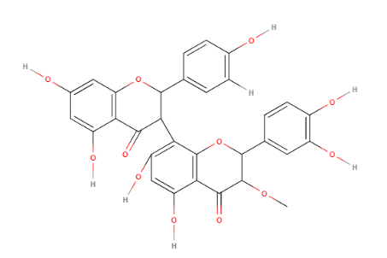 | 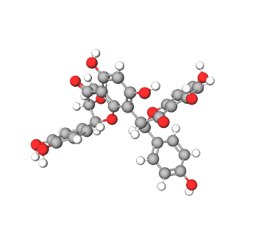
DS03 | 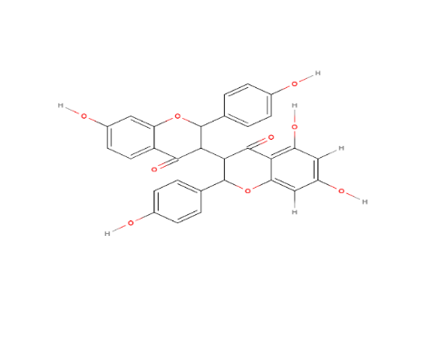 | 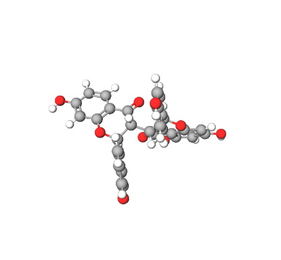

Table2 : Interactions of investigated drugs with catalase

 |  | Molecular Docking scores |  | Type of interaction
Protein | Ligand | MolDock Score (Kcal/mol) | ReRank Score  (Kcal/mol) | Hydrogen bonds | Steric bonds
 | DS03 | -120,039 | -103 ,754 | - | 1 interaction: Val (448)
1DGF | OBIII | -83,525 | -65,6647 | 3 interactions:  1 with His (364), 2 with Leu (366) and 1 with Arg (365 ;68) | 3 interactions :  2 with His (364) and, 1 with Leu (366)
 | Baicalin | -74,1781 | -82,3413 | 2 interactions : 1 with Leu (366) and Arg (365) | 3 interactions:  1 with Gly (367) and 2 with His (364)

Table3: Interactions of investigated drugs with superoxide dismutase
 |  | Molecular Docking scores |  | Type of interaction
Protein | Ligand | MolDock Score (Kcal/mol) | ReRank Score (Kcal/mol) | Hydrogen bonds | Steric bonds
 | DS03 | -106,044 | -83,5244 | 3 interactions :  1 with Arg (141), Asn (51) et Val (7) | 6 interactions:  3 with Lys (9) ,1 with Cys (55), 1 with Gly (54)and 1 with Thr (52)
2SOD | OBIII | -89,9878 | -67,4299 | 1 interaction:  Ala (87) | 4 interactions:  1 with Asp (88), 2 with Ala (87) and 1 with Glu (38)
 | Baicalin | -84,8274 | -79,8709 | 4 interactions :  3 with Lys (9) and 1 with Gly (10) | 5 interactions :  2 with Gly (10) and 3 with Lys (9)

Table4 : Interactions of investigated drugs with Nitric Oxide synthetase

 |  | Molecular Docking scores |  | Type of interaction
Protein | Ligand | MolDock Score (Kcal/mol) | ReRank Score (Kcal/mol) | Hydrogen bonds | Steric bonds
 | DS03 | -81,8817 | -57,6702 | 2 interactions : 1 with Tyr (367) and Arg (375) | 3 interactions : 1 avec Val (346), 1 avec Tyr (341) et 1 avec Trp (340)
2NOS | OBIII | -65,4659 | -39,1393 | 3 interactions :  1 with Gln (486), 1 with HEM_901 and1 with IMD_902 | 5 interactions :  1 with Glu (371), 1 with Arg (260), 2 with Tyr (485) and 1 with Asn (348)
 | Baicalin | -79,3878 | -68,3457 | - | -

Table5 : Interactions of investigated drugs with human amyloid beta protein

 |  | Molecular Docking scores |  | Type of interaction
Protein | Ligand | MolDock Score (Kcal/mol) | ReRank Score (Kcal/mol) | Hydrogen bonds | Steric bonds
 | DS03 | -343,166 | -23,9181 | 1 interaction with Lys (160) | 21 interactions : 5 with Leu (34), 6 with Val (240), 1 with Met (35), 7 with Phe (20), 1 with Lys (16) and 2 with Ile (31)
1IYT | OBIII | -313,603 | -76,4009 | 2 interactions :  1 with Gln (15) and 1 with Lys (16) | 22 interactions : 9 with Phe (19*7 ; 20*2), 10 with Lys (16), 1 with Val (12) and 3 with Gln (15)
 | Baicaline | -314,534 | -62,7358 | 2 interactions with Lys (16) | 19 interactions :  7 with Phe (20*4 ;19*3), 3 with Gln (15) and 9 with Lys (16)

Table 6: Interactions of investigated drugs with human acetylcholine esterase

 |  | Molecular Docking scores |  | Type of interaction
Protein | Ligand | MollDock Score (Kcal/mol) | ReRank Score (Kcal/mol) | Hydrogen bonds | Steric bonds
 | DS03 | -42,5411 | 141,384 | 7 interactions :  1 with Ser (287), 1 with Trp (82), 1 with Thr (120), 1 with Pro (285), 1 with THA_701 and 2 with Asn (83 ; 68) | 18 interactions :  1 with Ser (287), 1 with Gln (119), 6 with Gly (116*5 ;117), 7 with Thr (120), 1 with Asn (68), 1 with Ile (69) and 1 with Asp (70)
4DBS | OBIII | -4,41982 | 382,031 | 3 interactions :  1 with Ser (79), 1 with Trp (82) and 1 with THA_701 | 27 interactions : 1 with Asp (70), 3 with Asn (83), 1 with Glu (80), 6 with Ser (79*3 ; 198*3), 1 with Phe (329), 1 with Ala (199), 8 with Gly (117*2 ;121 ;116*5) and 6 with Thr (120)
 | Baicalin | -117,849 | -104,732 | - | -

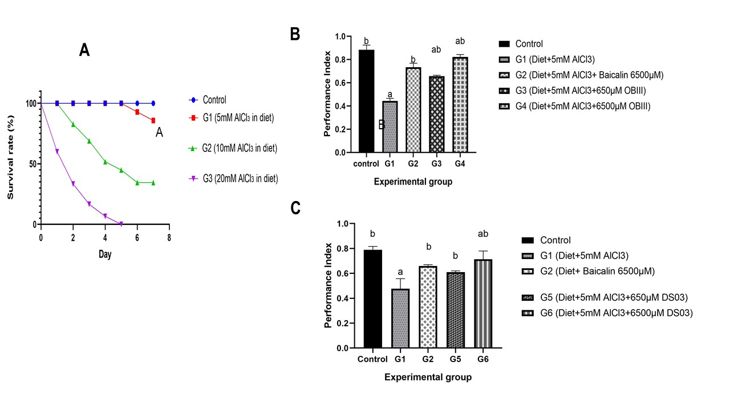
Figure 1: Concentration of AlCl3 inducing Alzheimer’s Disease symptoms (A) and effects of OBIII (B) and DSO3 (C) on Drosophila mobility

Each bar represents the mean ± MSE, n=3.
Control: normal control fed a standard diet without AlCl3; G1: group fed a diet supplemented with 5 mM AlCl3 for 7 days; G2: group fed a diet
supplemented with 10 mM AlCl3 for 7 days; G3: group fed a diet supplemented with 20 mM AlCl3 for 7 days.

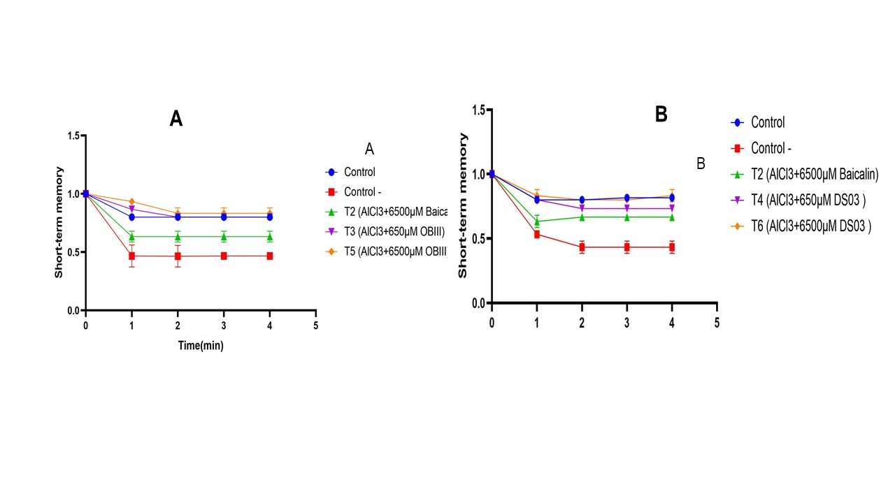

Figure 2: Effects on short-term memory in Drosophila of compounds (A) OBIII and (B) DS03
Each bar represents the mean ± MSE, n=3; # p <0.05: significant difference compared with T1.
T0: normal control fed a standard diet without AlCl3; T1 with 5mM AlCl3: negative control group fed a diet supplemented with 5mM AlCl3; T2: positive control group fed a diet supplemented with 5mM AlCl3 for 3 days then 650mM baicalin for 4 days; T3: positive control group fed a diet supplemented with 5mM AlCl3 for 3 days then 6500mM baicalin for 4 days; T4: group fed 5mM AlCl3 for 3 days, then 6500mM OBIII for 4 days; T5: positive control group fed 5mM AlCl3 for 3 days, then 6500mM OBIII for 4 days; T6: group supplemented with 5mM AlCl3 for 3 days, followed by 6500mM DS03 for 4 days; T7: positive control group supplemented with 5mM AlCl3 for 3 days, followed by 6500mM DS03 for 4 days.
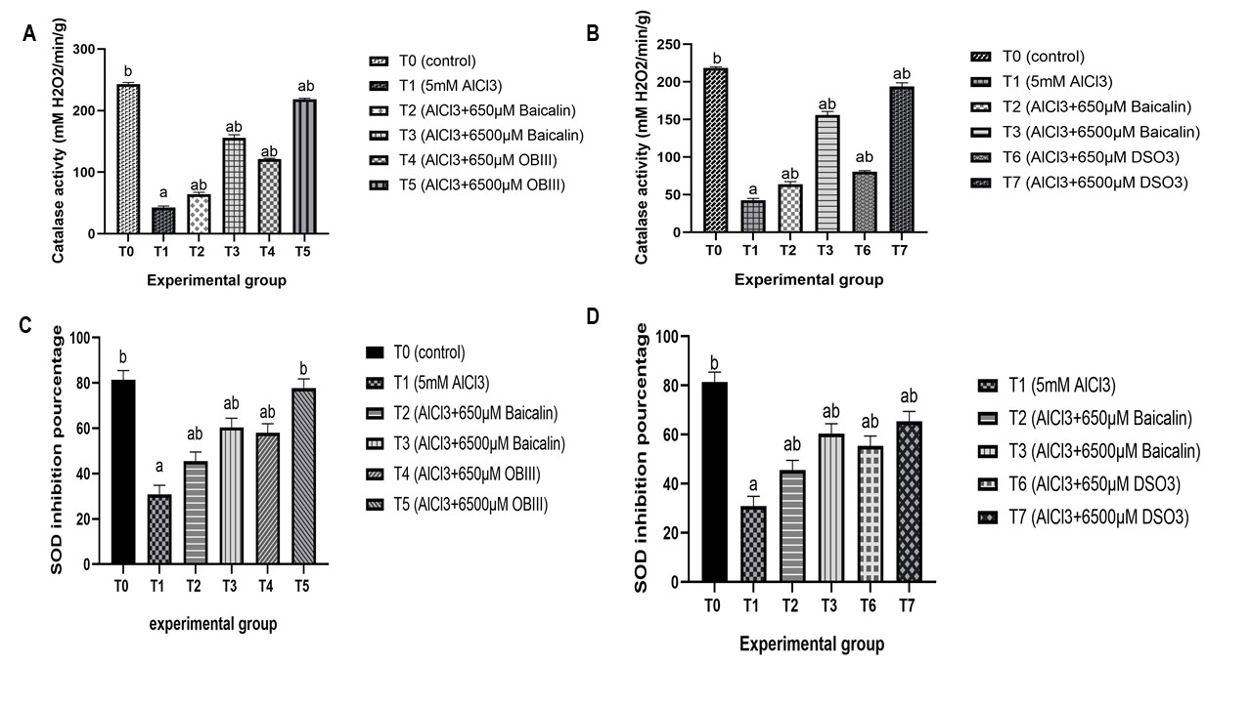

Figure 3: Effect of biflavonoids OBIII and DS03 on oxidative stress parameters (catalase and superoxide dismutase activity) in Drosophila
Each bar represents the mean ± MSE, n=3; # p <0.05: significant difference compared with T1.T0: normal control fed a standard diet without AlCl3; T1 with 5mM AlCl3: negative control group fed a diet supplemented with 5mM AlCl3; T2 positive control group fed a diet supplemented with 5mM AlCl3 for 3 days then 650 mM baicalin for 4 days; T3: positive control group fed a diet supplemented with 5mM AlCl3 for 3 days then 6500 mM baicalin for 4 days; T4: group fed 5mM AlCl3 for 3 days, then 6500 mM OBIII for 4 days;
T5: positive control group fed 5mM AlCl3 for 3 days, then 6500mM OBIII for 4 days; T6: group supplemented with 5mM AlCl3 for 3 days, followed by 6500mM DS03 for 4 days; T7: positive control group supplemented with 5mM AlCl3 for 3 days, followed by 6500 mM DS03 for 4 days.

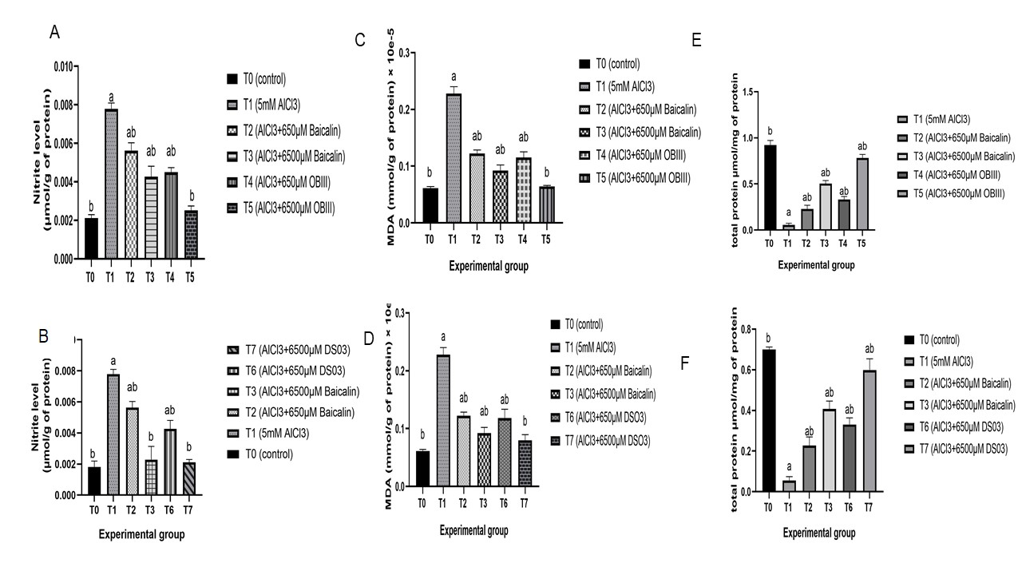

Figure 4: Effect of OBIII and DS03 biflavonoids on inflammatory parameters (NO level, MDA and total proteins level) in Drosophila
Each bar represents the mean ± MSE, n=3; # p <0.05: significant difference compared with T1.
T0: normal control fed a standard diet without AlCl3; T1 with 5mM AlCl3: negative control group fed a diet supplemented with 5mM AlCl3; T2:positive control group fed a diet supplemented with 5mM AlCl3 for 3 days then 650mM baicalin for 4 days; T3: positive control group fed a diet supplemented with 5mM AlCl3 for 3 days then 6500mM baicalin for 4 days; T4: group fed 5mM AlCl3 for 3 days, then 6500mM OBIII for 4 days;T5: positive control group fed 5mM AlCl3 for 3 days, then 6500mM OBIII for 4 days; T6: group supplemented with 5mM AlCl3 for 3 days, followed by 6500mM DS03 for 4 days; T7: positive control group supplemented with 5mM AlCl3 for 3 days, followed by 6500mM DS03 for 4 days.

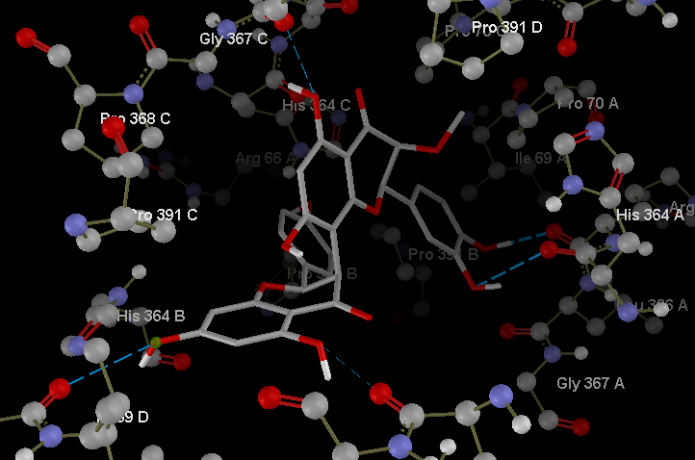
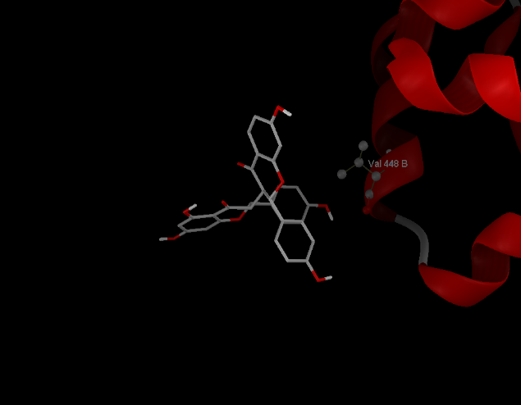
Interactions between catalase with OBIII and DS03

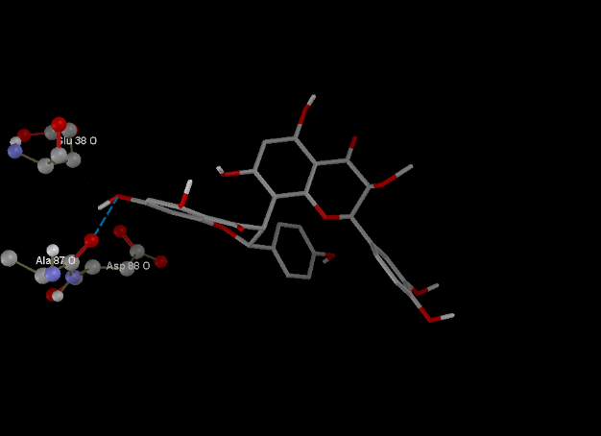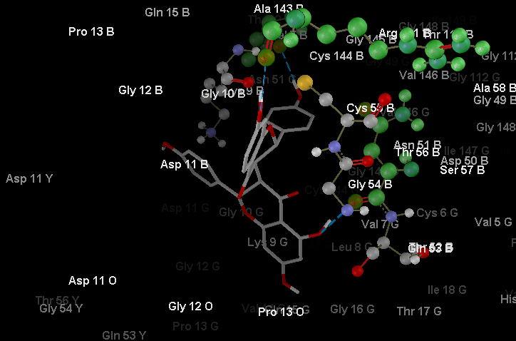
Interactions between human SOD with OBIII and DS03
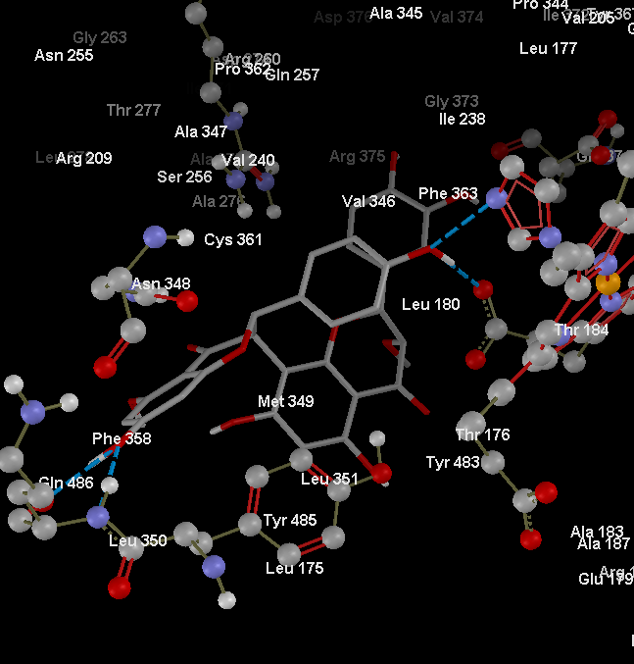
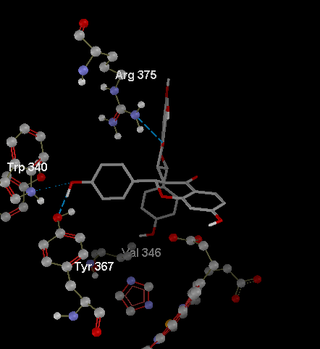
Interactions between human nitrite shynthetase with OBIII and DS03
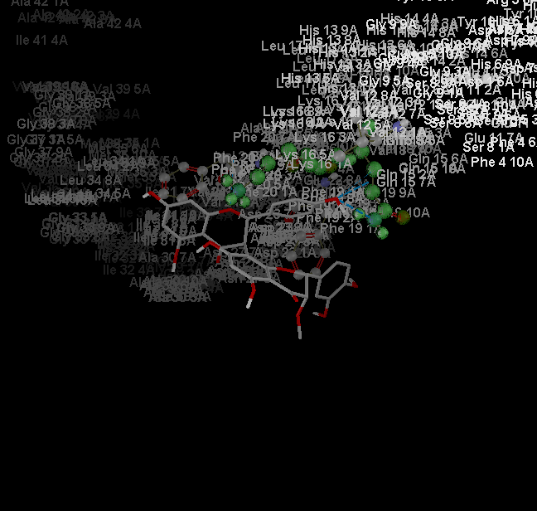
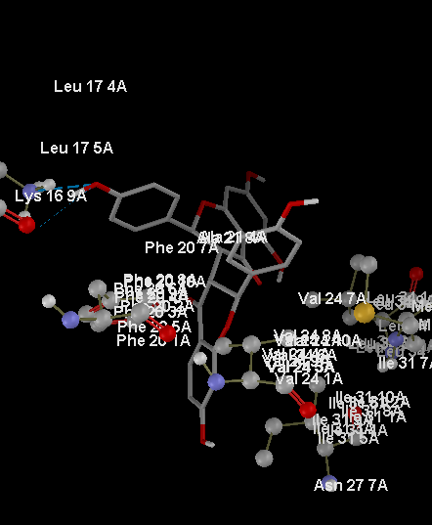
Interactions between human amyloid beta protein with OBIII and DS03
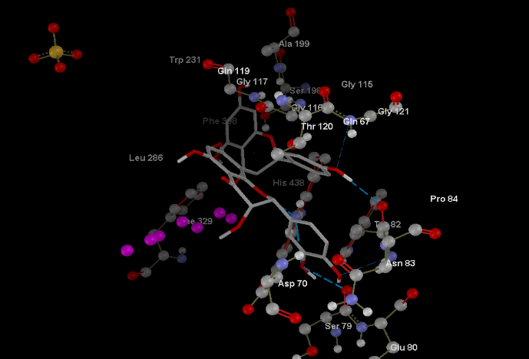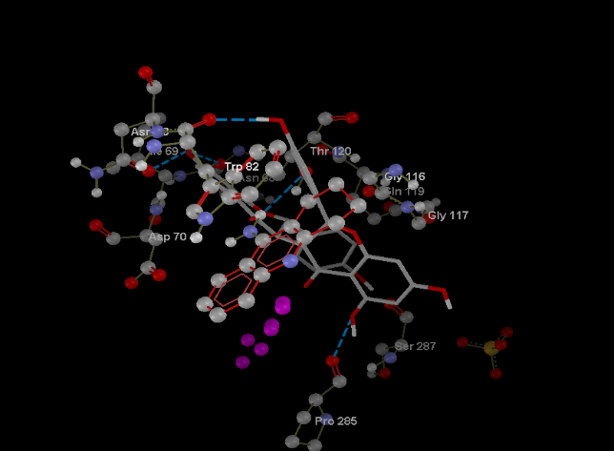
Figure 5: Molecular docking of OBIII and DS03 biflavonoids on some important parameters involves in Alzheimer’s disease

Interactions between human acetylcholine esterase with OBIII and DS03

REFERENCES

Abolaji, A. O., Fasae, K. D., Iwezor, C. E., Aschner, M., & Farombi, E. O. (2020). Curcumin attenuates copper-induced oxidative stress and neurotoxicity in Drosophila melanogaster. Toxicol Rep, 7, 261-268. https://doi.org/10.1016/j.toxrep.2020.01.015
Aycan, N., Akduman, H., Dilli, D., Soysal, C., Akduman, F., Fettah, N. D., Kaya, B., Oguz, B., & Ege, S. (2025). Comparison of oxidative stress markers in umbilical cord blood of vaginal and cesarean babies. Ir J Med Sci. https://doi.org/10.1007/s11845-025-04031-1
Baumber, J., & Ball, B. A. (2005). Determination of glutathione peroxidase and superoxide dismutase-like activities in equine spermatozoa, seminal plasma, and reproductive tissues. Am J Vet Res, 66(8), 1415-1419. https://doi.org/10.2460/ajvr.2005.66.1415
Bitencourt-Ferreira, G., & de Azevedo, W. F., Jr. (2019). Molegro Virtual Docker for Docking. Methods Mol Biol, 2053, 149-167. https://doi.org/10.1007/978-1-4939-9752-7_10
Bornemann, E. A., Kamma, H. K., Alabbas, M., Elashahab, M., Abid, N., Manaye, S., Cheran, K., Murthy, C., Giva, S., & Penumetcha, S. S. (2025). The Effect of Chronic Inflammation and Oxidative Stress on Alzheimer's Disease Progression: A Systematic Review. Cureus, 17(5), e84057. https://doi.org/10.7759/cureus.84057
Bouleau, S., & Tricoire, H. (2015). Drosophila models of Alzheimer's disease: advances, limits, and perspectives. J Alzheimers Dis, 45(4), 1015-1038. https://doi.org/10.3233/JAD-142802
Chen, C., Li, X., Gao, P., Tu, Y., Zhao, M., Li, J., Zhang, S., & Liang, H. (2015). Baicalin attenuates alzheimer-like pathological changes and memory deficits induced by amyloid beta1-42 protein. Metab Brain Dis, 30(2), 537-544. https://doi.org/10.1007/s11011-014-9601-9
Chen, D., Guo, Z., Yao, L., Sun, Y., Dian, Y., Zhao, D., Ke, Y., Zeng, F., Zhang, C., Deng, G., & Li, L. (2025). Targeting oxidative stress-mediated regulated cell death as a vulnerability in cancer. Redox Biol, 84, 103686. https://doi.org/10.1016/j.redox.2025.103686
Chowdhury, M. R., & Vijaykumar, S. D. (2025). A systems biology approach reveals dual neurotherapeutic mechanisms of Dioscorea bulbifera in Alzheimer's disease via estrogen signaling and cholinergic modulation. Inflammopharmacology. https://doi.org/10.1007/s10787-025-01872-1
Drachman, D. A. (2003). Preventing and treating Alzheimer's disease: strategies and prospects. Expert Rev Neurother, 3(5), 565-569. https://doi.org/10.1586/14737175.3.5.565
Eratne, D., Loi, S. M., Farrand, S., Kelso, W., Velakoulis, D., & Looi, J. C. (2018). Alzheimer's disease: clinical update on epidemiology, pathophysiology and diagnosis. Australas Psychiatry, 26(4), 347-357. https://doi.org/10.1177/1039856218762308
Fermor, B., Weinberg, J. B., Pisetsky, D. S., Misukonis, M. A., Banes, A. J., & Guilak, F. (2001). The effects of static and intermittent compression on nitric oxide production in articular cartilage explants. J Orthop Res, 19(4), 729-737. https://doi.org/10.1016/S0736-0266(00)00049-8
Gornall, A. G., Bardawill, C. J., & David, M. M. (1949). Determination of serum proteins by means of the biuret reaction. J Biol Chem, 177(2), 751-766. https://www.ncbi.nlm.nih.gov/pubmed/18110453
Guerchet, M., Mbelesso, P., Ndamba-Bandzouzi, B., Pilleron, S., Desormais, I., Lacroix, P., Aboyans, V., Jesus, P., Desport, J. C., Tchalla, A. E., Marin, B., Lambert, J. C., Clement, J. P., Dartigues, J. F., Preux, P. M., & Group, E. (2016). Erratum to: Epidemiology of dementia in Central Africa (EPIDEMCA): protocol for a multicentre population-based study in rural and urban areas of the Central African Republic and the Republic of Congo. Springerplus, 5, 562. https://doi.org/10.1186/s40064-016-2094-8
Haddadi, M., Jahromi, S. R., Sagar, B. K., Patil, R. K., Shivanandappa, T., & Ramesh, S. R. (2014). Brain aging, memory impairment and oxidative stress: a study in Drosophila melanogaster. Behav Brain Res, 259, 60-69. https://doi.org/10.1016/j.bbr.2013.10.036
Hira, S., Saleem, U., Anwar, F., Raza, Z., Rehman, A. U., & Ahmad, B. (2020). In Silico Study and Pharmacological Evaluation of Eplerinone as an Anti-Alzheimer's Drug in STZ-Induced Alzheimer's Disease Model. ACS Omega, 5(23), 13973-13983. https://doi.org/10.1021/acsomega.0c01381
Jack, C. R., Jr., Knopman, D. S., Jagust, W. J., Petersen, R. C., Weiner, M. W., Aisen, P. S., Shaw, L. M., Vemuri, P., Wiste, H. J., Weigand, S. D., Lesnick, T. G., Pankratz, V. S., Donohue, M. C., & Trojanowski, J. Q. (2013). Tracking pathophysiological processes in Alzheimer's disease: an updated hypothetical model of dynamic biomarkers. Lancet Neurol, 12(2), 207-216. https://doi.org/10.1016/S1474-4422(12)70291-0
Jeibmann, A., & Paulus, W. (2009). Drosophila melanogaster as a model organism of brain diseases. Int J Mol Sci, 10(2), 407-440. https://doi.org/10.3390/ijms10020407
Jones, K. C., & Bennett, B. G. (1986). Exposure of man to environmental aluminium--an exposure commitment assessment. Sci Total Environ, 52(1-2), 65-82. https://doi.org/10.1016/0048-9697(86)90105-1
Kumar, V., & Gill, K. D. (2009). Aluminium neurotoxicity: neurobehavioural and oxidative aspects. Arch Toxicol, 83(11), 965-978. https://doi.org/10.1007/s00204-009-0455-6
Lee, D., Clark, E. D., Antonsdottir, I. M., & Porsteinsson, A. P. (2023). A 2023 update on the advancements in the treatment of agitation in Alzheimer's disease. Expert Opin Pharmacother, 24(6), 691-703. https://doi.org/10.1080/14656566.2023.2195539
Moloney, A., Sattelle, D. B., Lomas, D. A., & Crowther, D. C. (2010). Alzheimer's disease: insights from Drosophila melanogaster models. Trends Biochem Sci, 35(4), 228-235. https://doi.org/10.1016/j.tibs.2009.11.004
Nampoothiri, M., John, J., Kumar, N., Mudgal, J., Nampurath, G. K., & Chamallamudi, M. R. (2015). Modulatory role of simvastatin against aluminium chloride-induced behavioural and biochemical changes in rats. Behav Neurol, 2015, 210169. https://doi.org/10.1155/2015/210169
Njamnshi, A. K., Djientcheu Vde, P., Fonsah, J. Y., Yepnjio, F. N., Njamnshi, D. M., & Muna, W. E. (2008). The International HIV Dementia Scale is a useful screening tool for HIV-associated dementia/cognitive impairment in HIV-infected adults in Yaounde-Cameroon. J Acquir Immune Defic Syndr, 49(4), 393-397. https://doi.org/10.1097/qai.0b013e318183a9df
Owald, D., & Waddell, S. (2015). Olfactory learning skews mushroom body output pathways to steer behavioral choice in Drosophila. Curr Opin Neurobiol, 35, 178-184. https://doi.org/10.1016/j.conb.2015.10.002
Owona, B. A., Mary, A., Messi, A. N., Ravichandran, K. A., Mbing, J. N., Pegnyemb, E., Moundipa, P. F., & Heneka, M. T. (2025). Biflavonoid Methylchamaejasmin and Khaya grandifoliola Extract Inhibit NLRP3 Inflammasome in THP-1 Cell Model of Neuroinflammation. Mol Neurobiol, 62(2), 1605-1619. https://doi.org/10.1007/s12035-024-04365-4
Rasool, M., Malik, A., Waquar, S., Tul-Ain, Q., Jafar, T. H., Rasool, R., Kalsoom, A., Ghafoor, M. A., Sehgal, S. A., Gauthaman, K., Naseer, M. I., Al-Qahtani, M. H., & Pushparaj, P. N. (2018). In-Silico Characterization and in-Vivo Validation of Albiziasaponin-A, Iso-Orientin, and Salvadorin Using a Rat Model of Alzheimer's Disease. Front Pharmacol, 9, 730. https://doi.org/10.3389/fphar.2018.00730
Singh, S. K., Srivastav, S., Castellani, R. J., Plascencia-Villa, G., & Perry, G. (2019). Neuroprotective and Antioxidant Effect of Ginkgo biloba Extract Against AD and Other Neurological Disorders. Neurotherapeutics, 16(3), 666-674. https://doi.org/10.1007/s13311-019-00767-8
Singh, Y. P., Kumar, N., Priya, K., Chauhan, B. S., Shankar, G., Kumar, S., Singh, G. K., Srikrishna, S., Garg, P., Singh, G., Rai, G., & Modi, G. (2022). Exploration of Neuroprotective Properties of a Naturally Inspired Multifunctional Molecule (F24) against Oxidative Stress and Amyloid beta Induced Neurotoxicity in Alzheimer's Disease Models. ACS Chem Neurosci, 13(1), 27-42. https://doi.org/10.1021/acschemneuro.1c00443
Sinha, A. K. (1972). Colorimetric assay of catalase. Anal Biochem, 47(2), 389-394. https://doi.org/10.1016/0003-2697(72)90132-7
Sowndhararajan, K., Deepa, P., Kim, M., Park, S. J., & Kim, S. (2018). Neuroprotective and Cognitive Enhancement Potentials of Baicalin: A Review. Brain Sci, 8(6). https://doi.org/10.3390/brainsci8060104
Thapa, A., & Chi, E. Y. (2015). Biflavonoids as Potential Small Molecule Therapeutics for Alzheimer's Disease. Adv Exp Med Biol, 863, 55-77. https://doi.org/10.1007/978-3-319-18365-7_3
Villemagne, V. L., Burnham, S., Bourgeat, P., Brown, B., Ellis, K. A., Salvado, O., Szoeke, C., Macaulay, S. L., Martins, R., Maruff, P., Ames, D., Rowe, C. C., Masters, C. L., Australian Imaging, B., & Lifestyle Research, G. (2013). Amyloid beta deposition, neurodegeneration, and cognitive decline in sporadic Alzheimer's disease: a prospective cohort study. Lancet Neurol, 12(4), 357-367. https://doi.org/10.1016/S1474-4422(13)70044-9
Wilbur, K. M., Bernheim, F., & Shapiro, O. W. (1949). The thiobarbituric acid reagent as a test for the oxidation of unsaturated fatty acids by various agents. Arch Biochem, 24(2), 305-313. https://www.ncbi.nlm.nih.gov/pubmed/15405719
Xie, L., Zhu, Q., & Lu, J. (2022). Can We Use Ginkgo biloba Extract to Treat Alzheimer's Disease? Lessons from Preclinical and Clinical Studies. Cells, 11(3). https://doi.org/10.3390/cells11030479

