***Original Research Article***

**Hepatoprotective Effects and** **Ameliorative Potential of Solanum nigrum Leaf Extract on Biochemical and Histological Alterations in CCl4-Induced Liver Injury in Rats**

**Abstract**

Hepatotoxicity, characterized by liver dysfunction or damage caused by excessive drug or xenobiotic exposure, remains a significant health concern. This study aimed to assess the hepatoprotective effects and ameliorative potential of the aqueous leaf extract of Solanum nigrum against carbon tetrachloride (CCl4)-induced liver toxicity in rats. Thirty male albino rats were divided into six groups (five rats each): a normal control group, a hepatotoxic control group receiving only CCl4, and four treatment groups. The hepatotoxic groups were administered a single dose of 1.5 ml/kg body weight of CCl4 intraperitoneally. Treatment groups received CCl4 alongside either 200 mg/kg silymarin (standard drug), or 50 mg/kg, 100 mg/kg, or 200 mg/kg of Solanum nigrum aqueous leaf extract orally for 14 days. Liver function markers and antioxidant parameters—including reduced glutathione (GSH), superoxide dismutase (SOD), and catalase (CAT)—were evaluated. CCl4 administration significantly elevated liver enzyme levels and decreased antioxidant enzyme activities compared to controls. However, treatment with Solanum nigrum extract significantly lowered liver enzymes and improved antioxidant status (P < 0.05) relative to the untreated hepatotoxic group. Histological analysis revealed that CCl4 caused severe liver damage, including disrupted cellular architecture, portal vein congestion, inflammatory infiltration, hemorrhage, and necrosis. Conversely, treatment with the extract restored normal liver histology. The extract restored liver function indices and antioxidant enzyme levels towards normal, comparable to the effect of silymarin, indicating that S. nigrum could serve as an effective natural hepatoprotective agent. These findings demonstrate that the aqueous leaf extract of Solanum nigrum effectively protects against CCl4-induced liver damage and mitigates its adverse effects in albino rats.

**Keywords:** **S*olanum nigrum,* carbon tetrachloride, Hepatoprotective, Biochemical Markers**

**Introduction**

“The liver is an organ in the upper abdomen that aids in digestion and removes waste products and worn-out cells from the blood. It is a vital organ present in vertebrates and some other animals, which has a wide range of functions, including detoxification and protein synthesis. The liver is our greatest chemical factory; it builds complex molecules from simple substances absorbed from the digestive tract, it neutralizes toxins, and it manufactures bile, which aids fat digestion and removes toxins through the bowels” (Maton *et al.,*1993). “But the ability of the liver to perform these functions is then compromised by numerous substances we are exposed to daily; these substances include certain medicinal agents, which, when taken in overdoses and sometimes when introduced within therapeutic ranges, injure the organ” (Gagliano *et al.,* 2007).

“Liver disease is a worldwide problem. Conventional drugs used in the treatment of liver diseases are sometimes inadequate and can have serious adverse effects. Therefore, it is necessary to search for alternative drugs for the treatment of liver disease to replace currently used drugs of doubtful efficacy and safety” (Ozbek *et al*., 2004). “In the absence of reliable liver-protective drugs in allopathic medical practices, herbs play a role in the management of various liver disorders. This, however, has drawn a lot of interest and attention to the curative claims and norms of medicinal plants and other sources all over the world, especially in underdeveloped countries in Africa and some parts of Asia” (Gagliano *et al*., 2007).

“Medicinal plants have been used by humans for centuries in folklore medicine” (Sermakkani, 2012). “*Solanum nigrum* is an important plant in traditional medicine, which belongs to the family of Solanaceae. It is used in hepatitis, fever, dysentery, and stomach complaints” (Jain *et al*., 2011). The juice of the plant is used for ulcers and other skin diseases. The fruits are used as a laxative, appetite stimulant, and for treating asthma and "excessive thirst". Traditionally, the plant is used to treat tuberculosis (Zakaria *et al.,* 2006). This study was designed to investigate the hepatoprotective effect of the aqueous bark extract of *Solanum nigrum* on the Carbon tetrachloride-induced liver damage.

**Materials and Methods**

**Collection of Sample**

Plant materials, *Solanum nigrum*, leaves were collected from the nearby farm around the hostels at Federal Polytechnic Ede, Nigeria, in the month of May 2022, air-dried in the laboratory, pulverized, and then stored in an airtight container.

**Reagents and Chemicals**

All chemicals and all other reagents were of analytical grade.

**Preparation Extracts**

*Solanum nigrum* leaves were washed with sterile water and allowed to drain and air-dry for 23 days at room temperature. The air-dried samples were ground to a fine powder using a blender. 500g of the sample was soaked in 1.5L of ethanol for three days. This was filtered and later air-dried to obtain the extract powder. The extract was kept in the freezer at 4 0C for further studies.

**Animals Protocol**

30 Wistar albino rats weighing 150g – 170g were obtained from the animal house at The Federal Polytechnic, Ado Ekiti, Ekiti State, housed in clean wire meshed cages under standard conditions, temperature (24 ± 1 °C), relative humidity, and 12 / 12-hour light and dark cycle. They were allowed to have free access to food (commercial pelletized diet from Vital Feed Mill) and drinking water *ad libitum* daily. The rat beddings were changed and replaced every day throughout the experimental period.

**Experimental Design**

30 male Wistar albino rats were randomly divided into six groups (I-VI) of five animals in each group.

**Animal Treatment**

The animal treatment is shown in the table below

**Table 1:** Animal Treatment

|  |  |
| --- | --- |
| **Groups** | **Treatment** |
| Group 1: Normal control (NC) | Distilled water only for 14 days |
| Group 2: Induced control (IC) | 1.5ml/kg bw CCl4 alone for a single administration |
| Group 3 | 3ml/kg bw CCl4+ 200mg/kg Silymarin for 14 days |
| Group 4 | 3ml/kg bw CCl4+ 50 mg/kg *Solanum nigrum* leaf extract for 14 days |
| Group 5 | 3ml/kg bw CCl4+ 100mg/kg *Solanum nigrum* leaf extract for 14 days |
| Group 6 | 3ml/kg bw CCl4+ 200 mg/kg *Solanum nigrum* leaf extract for 14 days |

**Dissection of Rats**

The rats were dissected, and a portion of blood was collected into plain bottles for the determination of biochemical parameters.

**Preparation of Serum**

Serum was prepared by centrifugation at 3000 rpm for 15 min at 25⁰C. The clear supernatant was collected and used for the estimation of serum biochemical parameters.

**Preparation of Homogenates**

The liver was excised using scissors and forceps. It was washed in buffer solution, blotted with filter paper, and weighed. They were then chopped into bits and homogenized in ten volumes of the homogenizing phosphate buffer (pH 7.4) using a Teflon homogenizer. The resulting homogenates were centrifuged at 3000 rpm at 4°C for 30 minutes. The supernatant obtained was collected and stored under 40C °C and then used for biochemical analyses.

**Antioxidant Assay**

**Determination of Catalase Activity**

This experiment was carried out using the method described by Sinha (1972).

**Determination of Superoxide Dismutase (SOD) Activity**

The level of SOD activity was determined by the method of Misra and Fridovich (1972).

**Determination of Reduced Glutathione (GSH) Level**

The method of Beutler *et al.* (1963) was followed in estimating the level of reduced glutathione (GSH).

**Determination of Total Protein (TP) in Serum**

The Biuret method described by Weichselbaum (1995) was employed in the determination of total protein in the serum using commercially available kits (Randox Laboratories, UK).

**Liver Function Indices**

**Assay of Aspartate Aminotransferase (AST) Activity**

AST activity was determined following the principle described by Reitman and Frankel (1957).

**Assay of Alanine Aminotransferase (ALT) Activity**

The principle described by Reitman and Frankel (1957) was followed in the assay of ALT using a commercially available assay kit (Randox Laboratories, UK) according to the instructions of the manufacturer.

**Assay of Alkaline Phosphatase (ALP) Activity**

Assay of serum ALP was based on the method of Englehardt *et al*. (1970) using commercial assay kits (Randox Laboratories, UK) according to the instructions of the manufacturer.

**Assay of Albumin (ALB) Activity**

Albumin activity was determined following the principle described by Grant *et al* 1987.

**Assay of Bilirubin (BIL)**

Bilirubin activity was determined following the principle described by Jendrassik and Grof 1938 and modified by Sherlock 1951.

**Principle**

Colorimetric method based on that described by Jendrassik and Grof (1938). Direct (conjugated) bilirubin reacts with diazotised sulphanilic acid in an alkaline medium to form a blue coloured complex. Total bilirubin is determined in the presence of caffeine, which releases albumin-bound bilirubin by the reaction with diazotized sulphalinic acid.

**Procedure**

200µl of diluted sample , Reagent 1(Sulphalinic acid), R2 (Nitrite) and R3 (Caffeine) were mixed and allowed to stand 10min at 20oC-25 oC. Then 200 µl Reagent R4 (tartarate) was mixed and allowed to stand for 5-30 min at 20oC-25 oC . The absorbance of the sample against the sample blank was read at 578nm.

Total Bilirubin (mg/dl) = 10.8 x ATB

**Statistical Analysis**

All values are expressed as mean ± SD. Statistical evaluation was done using One-Way Analysis of Variance (ANOVA) followed by Duncan's Multiple Range Test (DMRT) by using SPSS 11.09 for windows (Anthony and Richard, 2006). The significance level was set at p < 0.05.

**Results and Discussion**

**Table 2. Serum Biomarkers**

|  |  |  |  |  |  |  |
| --- | --- | --- | --- | --- | --- | --- |
| **Conc./ Parameters** | **ALP(mg/dl)** | **ALT(U/L)** | **AST(U/L)** | **CK(U/I)** | **ALB(mg/dl)** | **BIL(mg/dl)** |
| 1 | 38.10±3.05d | 52.39±2.17e | 20.19±1.06 e | 18.30±1.03e | 42.60±1.04a | 65.92 ±1.29e |
| 2 | 65.96±1.68a | 85.72±2.02a | 44.60±1.33a | 32.06±0.64a | 24.66±0.59e | 106.21±2.06a |
| 3 | 37.02±1.19e | 54.33±1.28d | 22.31±0.72d | 19.63+0.77d | 40.53+0.60b | 71.53±1.60d |
| 4 | 54.35±2.14b | 65.32±1.14b | 36.27±1.30b | 25.52±2.18b | 29.08±1.31d | 90.46±1.44b |
| 5 | 45.41±1.87c | 58.63 ± 2.09c | 28.50±1.12c | 23.75±0.78c | 34.22±0.58c | 81.27±2.11c |
| 6 | 45.41±1.87c | 58.63 ± 2.09c | 28.50±1.12c | 23.75±0.78c | 34.22±0.58c | 81.27±2.11c |

Values are expressed as mean ± standard deviation (n=5). Values with the different superscript(s) in a column are significantly different (P<0.05).

**Key:**

ALP = Alkaline phosphatase

ALT = Alanine amino transferase

AST = Aspartate amino transferase

CK = Creatinine kinase

ALB = Albumin

BIL = Bilirubin

A=control, B=3ml/kg bw CCl4 alone, C= 3ml/kg bw CCl4 + 200mg/kg silymarin, D=3ml/kg bw CCl4 + 50mg/kg *S. nig*, E=3ml/kg bw CCl4 + 100mg/kg, F=3ml/kg bw CCl4 + 200mg/kg

**Table 3. Liver biomarkers**

|  |  |  |  |  |  |  |
| --- | --- | --- | --- | --- | --- | --- |
| **Conc.** | **ALP(mg/dl)** | **ALT(U/L)** | **AST(U/L)** | **GGT(mg/dl)** | **ALB(mg/dl)** | **BIL(mg/dl)** |
| 1 | 56.73 ±1.55f | 87.66 ± 2.13f | 65.54±1.29f | 7.22±0.20e | 51.35±2.06a | 28.32 ± 1.67f |
| 2 | 91.60±1.69a | 130.94±3.43a | 102.63±3.08a | 10.09±0.42a | 24.75±0.83f | 52.14± 1.80a |
| 3 | 58.87+2.04e | 90.20+2.10d | 68.40+1.39e | 7.45+0.38d | 47.28±1.48b | 30.73+1.23e |
| 4 | 78.08±3.19b | 113.27±3.00b | 85.10±2.27b | 9.80±0.52b | 28.68±0.87e | 43.29±2.07b |
| 5 | 67.24±2.40c | 95.23±2.17c | 79.68±2.05c | 8.34±0.63c | 36.73±1.20d | 37.20±1.36c |
| 6 | 61.31±1.31d | 88.52±2.04e | 71.29±1.55d | 7.75±0.56d | 46.84±1.43c | 31.49±1.27d |

Values are expressed as mean ± standard deviation (n=5). Values with the different superscript(s) in a column are significantly different (P<0.05).

**Key:**

ALP = Alkaline phosphatase

ALT = Alanine amino transferase

AST = Aspartate amino transferase

GGT = Gamma glutamyl transferase

ALB = Albumin

BIL = Bilirubin

A=control, B=3ml/kg bw CCl4 alone, C= 3ml/kg bw CCl4 + 200mg/kg silymarin, D=3ml/kg bw CCl4 + 50mg/kg *S. nig*, E=3ml/kg bw CCl4 + 100mg/kg, F=3ml/kg bw CCl4 + 200mg/kg

**Table 4. Serum Antioxidant Biomarkers**

|  |  |  |  |  |  |
| --- | --- | --- | --- | --- | --- |
| **Group** | **SOD**  Activity  (U/mg protein) | **CAT**  Activity  (µmol/min/mg-protein) | **GPx** mg/100 mg tissue | **GSH**  Concentration  (mmole/min/mg-protein) | **TP**  (mg protein/ml serum) |
| 1 | 6.56±0.23e | 5.46±0.17e | 13.58±0.20e | 7.24±0.13f | 5.46±0.11e |
| 2 | 3.85±0.19a | 3.22±0.19a | 9.12±0.15a | 4.82±0.09a | 1.67±0.04a |
| 3 | 6.71±0.12d | 4.97±0.11c | 12.44+0.22c | 7.09±0.18e | 4.76±0.13a |
| 4 | 4.26±0.10b | 3.72±0.10ab | 10.02±0.16b | 5.21±0.10b | 2.08±0.08b |
| 5 | 5.14±0.15c | 4.23±0.13b | 12.32±0.19c | 5.96±0.15c | 4.13±0.12c |
| 6 | 5.88±0.14c | 5.07±0.10d | 13.08±0.10d | 6.83±0.20d | 4.58±0.10d |

**Table 5. Liver Antioxidant Biomarkers**

|  |  |  |  |  |  |
| --- | --- | --- | --- | --- | --- |
| **Group** | **SOD**  Activity  (U/mg protein) | **CAT** Activity  (µmol/min/mg-protein) | **GPx**  mg/deciliter | **GSH**  Concentration  (mmole/min/mg-protein) | **TP**  (mg protein/ml serum) |
| 1 | 6.34±0.14f | 9.47±0.18e | 18. 17±0.21f | 5.75±0.10e | 3.98 ± 0.14d |
| 2 | 4.08±0.20a | 5.22±0.12a | 12.58±0.14a | 2.09±0.07a | 1.07 ±0.01a |
| 3 | 6.27±0.32e | 10.31±0.10f | 16.45+0.44d | 5.16±0.12d | 3.69± 0.15c |
| 4 | 4.85±0.25b | 7.50±0.21b | 14.11±1.16b | 3.64±0.19b | 2.62 ± 0.11 b |
| 5 | 5.47±0.10c | 7.88±0.11c | 15.82±0.36c | 4.93±0.20c | 3.81 ± 0.10 cd |
| 6 | 6.05±0.14d | 9.15±0.13d | 17.31±0.29e | 4.97±0.17c | 4.05 ± 0.18 e |

**GROUP 1**

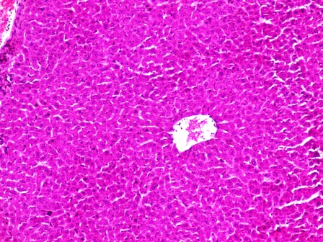 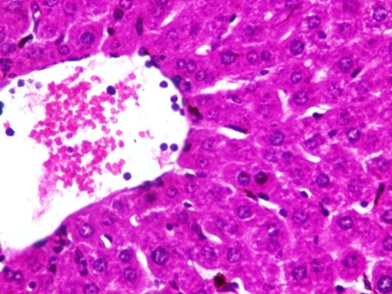

X100 X400

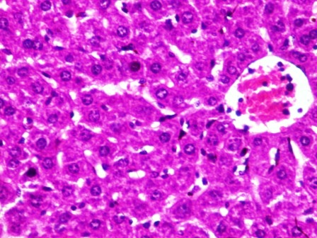 X400

**Figure 1.**

Photomicrograph of a liver section stained by Haematoxylin and Eosin showing normal central venules without congestion (white arrow) , the morphology of the hepatocytes appear normal (blue arrow), the sinusoids appear normal and not infiltrated (slender arrow),no pathological lesion seen.

**GROUP 2**

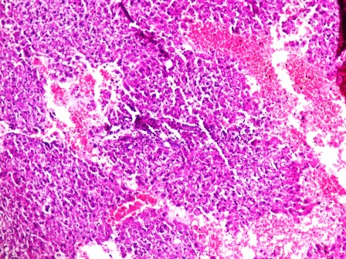 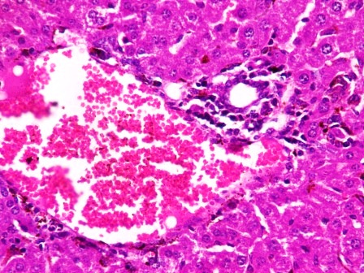

X100 X100

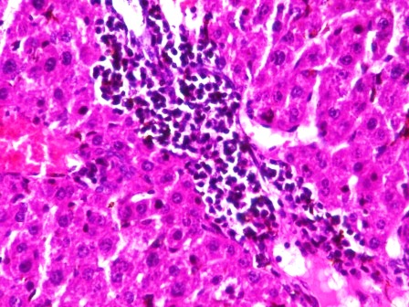 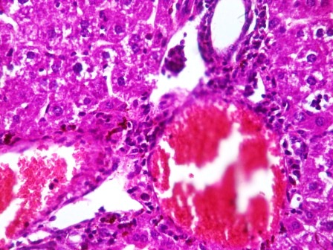

X400 X400

**Figure 2.**

Photomicrograph of a liver section stained by Haematoxylin and Eosin showing poor architecture, there is moderate to severe congesteion of the portal vein (white arrow) as well as severe peri portal infiltration of inflammatory cells(black arrow) , the liver parenchyma also show area with destroyed liver plates with severe hemorrhage and necrosis (green arrow,)the morphology of the hepatocytes some degenerated liver cells(blue arrow),the liver parenchyma also show focal area of moderate aggregate of inflammatory cells , the sinusoids appear normal and not infiltrated (slender arrow),

**GROUP 3**

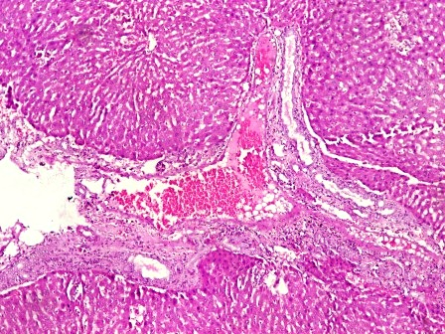 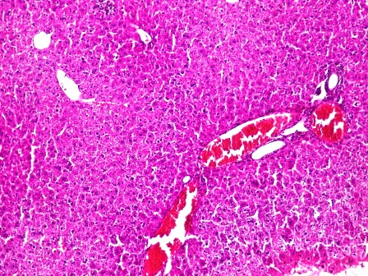

X100 X100

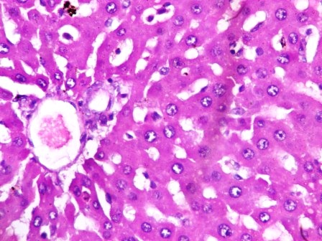 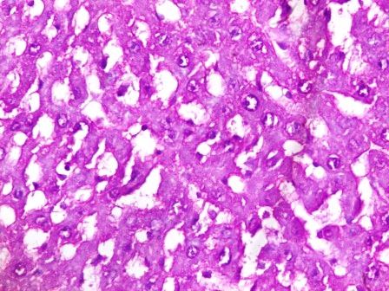

X400 X400

**Figure 3.**

Photomicrograph of a liver section stained by Haematoxylin and Eosin showing normal central venules (white arrow) and portal tract with mildly congested portal vein (black arrow), the morphology of the hepatocytes appear normal (blue arrow), the sinusoids appear normal and not infiltrated (slender arrow)

**GROUP 4**

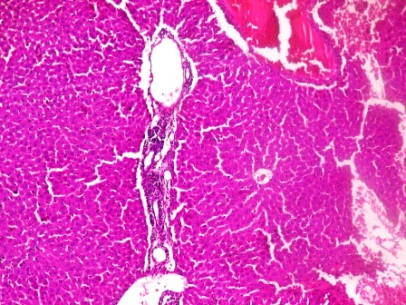 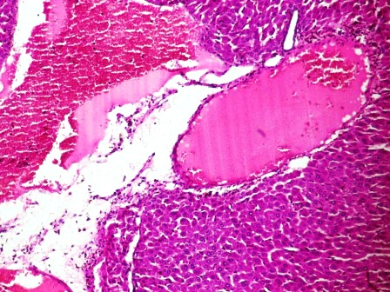

X100 X100

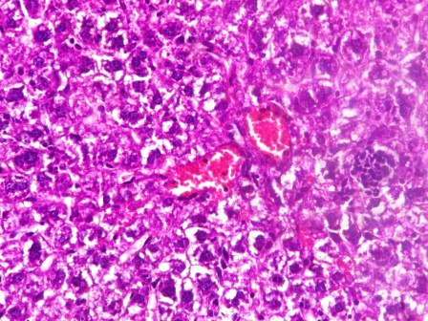 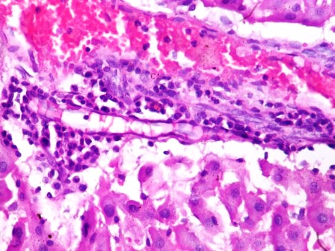

X400 X400

**Figure 4**

Photomicrograph of a liver section stained by Haematoxylin and Eosin showing poor architecture, there is moderate to severe congesteion of the portal vein (white arrow) as well as severe peri portal infiltration of inflammatory cells(black arrow) , the morphology of the hepatocytes show some degenerated liver cells (green arrrow) and other nomal liver cells (blue arrow), the sinusoids appear normal and not infiltrated (slender arrow),

**GROUP 5**

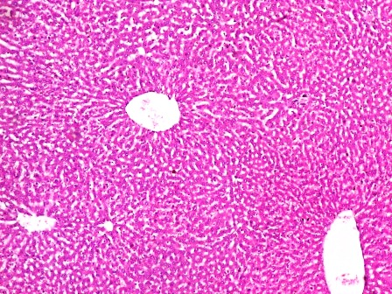 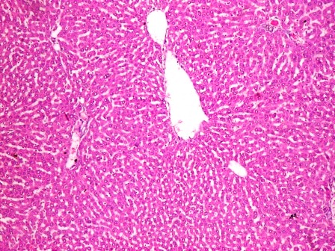

X100 X100

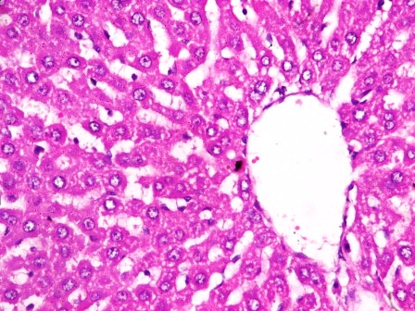 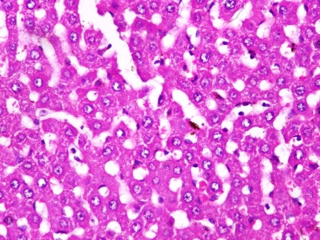

X400 X400

**Figure 5.**

Photomicrograph of a liver section stained by Haematoxylin and Eosin showing normal central venules and portal tract without congestion (white arrow) , the morphology of the hepatocytes appear normal (blue arrow), the sinusoids appear normal and not infiltrated (slender arrow),no pathological lesion seen.

**GROUP 6**

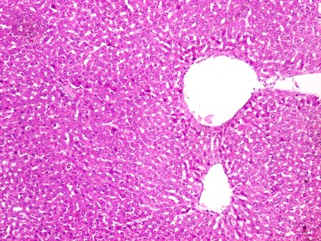 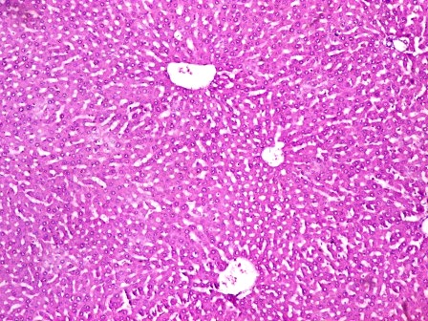

X100 X100

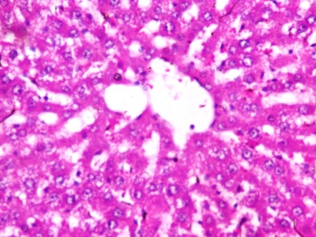 

X400 X400

**Figure 6.**

Photomicrograph of a liver section stained by Haematoxylin and Eosin showing normal central venules and portal tract without congestion (white arrow) , the morphology of the hepatocytes appear normal (blue arrow), the sinusoids appear normal and not infiltrated (slender arrow),no pathological lesion seen.

Carbon tetrachloride-induced hepatic injury is commonly used as an experimental method for the study of hepatoprotective effects of medicinal plants and drugs (Ugwu and Suru, 2021). Drug-induced liver injury (DILI) is a common condition that can be triggered by nearly all categories of medications. Most instances of mild DILI improve following the cessation of the drug (Roy *et al.,* 2024). When there is hepatopathy, these enzymes leak into the bloodstream in conformity with the extent of liver damage (Kalas *et al*., 2021).

The results from Table 2 demonstrate significant variations in liver biomarker profiles across experimental groups subjected to different treatments. The induced control group (Group 2: CCl4 only) recorded the highest levels of ALP, ALT, AST, GGT, and bilirubin, and the lowest albumin, all significantly different from the normal control group (Group 1) at p<0.05. This reflects acute hepatic injury characterized by membrane leakage, enzyme outflow, and impaired protein synthesis, corroborating findings from prior studies that describe CCl4-induced hepatotoxicity as a robust model for liver damage (Pradeep *et al*., 2017; Lee *et al*., 2012).

Silymarin (Group 3), a known hepatoprotective agent, significantly ameliorated these elevations, restoring ALP, ALT, AST, GGT, and bilirubin levels close to normal and improving albumin—a pattern consistent with its documented antioxidant and membrane-stabilizing effects (Abenavoli *et al*., 2010). Similarly, Solanum nigrum leaf extract showed a dose-dependent hepatoprotective effect: higher doses (Groups 5 and 6) offered greater normalization of biomarker levels compared to the lowest dose (Group 4); Group 6 (200mg/kg) particularly approached the efficacy of silymarin, aligning with literature that ascribes Solanum nigrum's efficacy to its polyphenolic content and radical scavenging capacity (Donatus *et al*., 2017; Wang *et al*., 2020).

Statistically, each parameter in Groups 3, 5, and 6 differed significantly (p<0.05) from the injured control (Group 2) and each other, as indicated by distinct superscripts in each column. This affirms the beneficial impact of silymarin and Solanum nigrum at moderate and high doses in ameliorating transaminase and bilirubin elevation and boosting albumin synthesis, further confirming liver protection.

In Table 3, the examination of serum biomarker results among groups 1 to 6 reveals clear and statistically significant variations (p<0.05) in the levels of ALP, ALT, AST, CK, ALB, and BIL, as shown by the different superscript letters for each parameter column. Group 2 (induced control, CCl4 alone) consistently showed the highest concentrations of biomarkers indicating liver and muscle damage, particularly ALP (65.96±1.68 mg/dl), ALT (85.72±2.02 U/L), AST (44.60±1.33 U/L), CK (32.06±0.64 U/I), and BIL (106.21±2.06 mg/dl), while having the lowest albumin level (24.66±0.59 mg/dl) in comparison to the other groups. Statistically, these figures are significantly different from those observed in the normal control (group 1) and the treatment groups (3–6), as demonstrated by the pattern of superscripts.

Group 1 (normal control) exhibited the lowest values for biomarkers and the highest albumin concentration (42.60±1.04 mg/dl), highlighting the integrity of the liver and muscles. Group 3 (CCl4 + silymarin) displayed a recovery effect, with enzyme and bilirubin levels nearing those of the control, while albumin remained elevated (40.53±0.60 mg/dl), indicating the hepatoprotective effects of silymarin, which is the standard synthetic drug used. Groups 4–6, which were administered increasing doses of Solanum nigrum extract, showed a dose-dependent response, where the higher doses (100 and 200 mg/kg) resulted in biomarker values approaching normal levels more so than the 50 mg/kg dose, yet still did not reach the same levels as seen with silymarin. Importantly, groups 5 and 6 had indistinguishable values, which may suggest a maximum effect at the higher doses of the extract. This observation shows that the more effective doses were at 100mg/kg and 200mg/kg.

From a scientific perspective, these observations confirm that CCl4 causes significant toxicity in the liver and muscles, indicated by increased levels of transaminases (ALT, AST), ALP, CK, and bilirubin, along with reduced albumin production, which aligns with the mechanisms underlying liver cell damage and impaired protein creation. The groups receiving treatment, especially those administered silymarin and higher doses of S. nigrum, showed notable improvements in these outcomes, implying that both substances may aid in liver recovery through antioxidant or cytoprotective actions, a phenomenon that has been well-established in previous studies (Yoon *et al*., 2016).

Previous research also supports these outcomes. For instance, Amat *et al*. (2018) reported similar enzyme normalization with Solanum nigrum in animal models of hepatotoxicity, while silymarin’s protective action is well-documented in both preclinical and clinical settings (Loguercio & Festi, 2011). This comparative alignment strengthens the clinical relevance and reproducibility of the present findings.

Examination of the photomicrograph slides of liver sections from groups 1–6 reveals clear differences in histological architecture corresponding to normalcy, injury, and response to treatment. Comparing the findings from the photomicrograph analysis to the broader literature, normal liver histology is universally characterized by intact hepatic plates, healthy sinusoidal spaces, and the absence of pathological lesions. CCl4-induced liver injury consistently produces centrilobular necrosis, ballooning hepatocytes, and prominent infiltration of inflammatory cells—histological hallmarks described in both animal and human studies. (Lin, *et al*., 2008). Interventions such as silymarin and Solanum nigrum lead to marked histological recovery, confirming their protective roles against hepatotoxic insults, a result echoed in multiple peer-reviewed investigations.

**Conclusion**

In summary, CCl4 exposure induces significant hepatic dysfunction as reflected by elevated ALP, ALT, AST, GGT, and bilirubin and reduced albumin, which are all mitigated by both silymarin and Solanum nigrum extracts in a dose-dependent manner. The hepatoprotective potential of Solanum nigrum, particularly at 100–200mg/kg, is comparable to standard silymarin therapy and aligns with the scientific consensus on antioxidant-driven cytoprotection in experimental hepatotoxicity. The photomicrograph analysis confirms that group 1 has normal liver histology, group 2 shows pronounced injury consistent with CCl4 toxicity, and groups 3–6, particularly those treated with higher doses of silymarin or Solanum nigrum, demonstrate substantial histological restoration.These findings are consistent with previous works on antioxidant therapy in experimental hepatotoxicity and suggest that Solanum nigrum, like silymarin, could be leveraged as an effective natural liver protector

**Ethical Approval**

Animal Ethic committee approval has been collected and preserved by the author(s)

Disclaimer (Artificial intelligence)

Author(s) hereby declare that NO generative AI technologies such as Large Language Models (ChatGPT, COPILOT, etc.) and text-to-image generators have been used during the writing or editing of this manuscript.

**References**

Abenavoli, L., Capasso, R., Milic, N., & Capasso, F. (2010). Milk thistle in liver diseases: Past, present, future. Phytotherapy Research, 24(10), 1423–1432. <https://doi.org/10.1002/ptr.3207>

Amat, N., Upur, H., Blaschek, W., & Efferth, T. (2018). Protective effect of a traditional Uighur medicine against CCl4–induced hepatic injury in rats. Evidence-Based Complementary and Alternative Medicine, 2018, 1–9. <https://doi.org/10.1155/2018/7615706>

Beutler, E., Duron, O., & Kelly, B. M. (1963). Improved method for determination of blood glutathione.

Carbon tetrachloride-induced toxicity: a review. *Egyptian Liver Journal*, *11*(1), 88.

Donatus, E. O., Okogun, J. I., & Adesogan, E. K. (2017). Antioxidant and hepatoprotective potentials of Solanum nigrum aqueous leaf extract. Journal of Ethnopharmacology, 208, 88–98. <https://doi.org/10.1016/j.jep.2017.06.010>

Englehardt A.*.,* Aerztl Labor. (1970): 16 42.

Gagliano, N., F. Grizzi and G. Annoni, 2007. Mechanism of aging and liver functions. *Digest. Dis. Sci.,* 25:118-123

Grant G. H (1987: Amino acids and proteins; fundamentals of clinical chemistry. Tietz N.W. editor, third Edition, W. B Saunders company Philadelphia USA pg 382-329.

Guerra Ruiz, A. R., Crespo, J., López Martínez, R. M., Iruzubieta, P., Casals Mercadal, G., Lalana Garcés, M., and Morales Ruiz, M. (2021). Measurement and clinical usefulness of bilirubin in liver disease. *Advances in Laboratory Medicine/Avances en Medicina de Laboratorio*, *2*(3), 352-361.

Hansen, T. W., Wong, R. J., & Stevenson, D. K. (2020). Molecular physiology and pathophysiology of bilirubin handling by the blood, liver, intestine, and brain in the newborn. *Physiological reviews*, *100*(3), 1291-1346.

Harris, E. H. (2005): Elevated liver function tests in type 2 diabetes. Clinical Diabetes, 23(3), 115–119.

Hellman, S., & Weichselbaum, R. R. (1995). Oligometastases. Journal of clinical oncology : official journal of the American Society of Clinical Oncology, 13(1), 8–10. <https://doi.org/10.1200/JCO.1995.13.1.8>

Himi, H. Z., Rahman, M., Hasan, S. A., Cruze, L. R. M. D., Ishraat , S. T., & Chowdhury , M. M. (2024). An Evaluation of Hepato-protective Activity of Ethanolic Extract of Solanum nigrum with Varying Doses on CCL4 Induced Hepatic Injured Rat. Asian Journal of Advanced Research and Reports, 18(4), 75–80. https://doi.org/10.9734/ajarr/2024/v18i4625

Jain, R., Sharma, A., Gupta, S., Sarethy, I. P., & Gabrani, R. (2011). Solanum nigrum: current perspectives on therapeutic properties. Altern Med Rev, 16(1), 78-85.

Jendrassik*, L. and* Grof*, P.* (1938): Simplified Photometric Methods for the Determination of Bilirubin. *Biochemical Journal*, 297; 81-89.

Jomova K., Raptova R., Alomar S.Y., Alwasel S.H., Nepovimova E., Kuca K., Valko M. (2023) Reactive oxygen species, toxicity, oxidative stress, and antioxidants: chronic diseases and aging. Arch. Toxicol.;97(10):2499–2574.

Kabbashi A.S., Eltawaty S.A., Ismail A.M., Elshikh A.A., Alrasheid A.A., Elmahi R.A., Koko W.S., Osman E.E. (2024) Ethanolic extract of Mangifera indica protects against CCl4-induced hepatotoxicity via antioxidant capabilities in Albino rats. J. Toxicol.;2024:5539386.

Kalas, M. A., Chavez, L., Leon, M., Taweesedt, P. T., and Surani, S. (2021). Abnormal liver enzymes: A review for clinicians. *World journal of hepatology*, *13*(11), 1688.

Kumari, K., Pahuja, S. K., & Kumar, S. (2023). An evolution of bilirubin physiology and analysis. *Current Signal Transduction Therapy*, *18*(2), 1-13.

Lee, K. J., Choi, J. H., Hwang, Y. P., Chung, Y. C., Jeong, H. G. (2012). Protective effect of silymarin against CCl4-induced acute liver injury in mice. Arch Pharm Res, 35(1), 107–117. <https://doi.org/10.1007/s12272-012-0112-4>

Lin, H.-M., et al. (2008). Hepatoprotective effects of Solanum nigrum Linn extract against CCl4. Chem Biol Interact, 171(3), 283-293.

Loguercio, C., & Festi, D. (2011). Silybin and the liver: From basic research to clinical practice. World Journal of Gastroenterology, 17(18), 2288–2301. <https://doi.org/10.3748/wjg.v17.i18.2288>

Mani R.K., Paramashree J., Bharathi D., Ahmed S. (2022) The traditional and pharmacological properties of Solanum nigrum: a review. Int. J. Toxicol.

Mansoor S., Ali Wani O., Lone J.K., Manhas S., Kour N., Alam P., Ahmad A., Ahmad P. (2022) Reactive oxygen species in plants: from source to sink. Antioxidants. 2022;11:225.

Marzinke, M. A., & Dufour, D. R. (2020). Laboratory diagnosis of liver disease. In *Contemporary Practice in Clinical Chemistry* (pp. 545-559). Academic Press.

Maton, A., H. Jean, C. W. McLaughlin, M.Q. Warner, D. Lattart and J. D. Wright, (1993): Human Biology and Health. Eaglewood Cliffs, New Jersey, Prentice Hall, USA.

Melaram R. (2021) Environmental risk factors implicated in liver disease: a mini-review. Front. Public Health. 9:1–7.

Onyango, C. M., Ontita, E. G., Onwong’a, R. N., Desterio, N., & Gapusi, J. R. (2016). Status and Production Practices of Vegetable African Nightshade (Solanum nigrum L.) in Selected Communities of Kenya. Journal of Experimental Agriculture International, 13(3), 1–12. https://doi.org/10.9734/AJEA/2016/27363

Ozbek, H. S., I. Ugras, I. U. Bayram and E. Erdogan, (2004): Hepatoprotective effect Foeniculum vulgare essential oil: A carbon tetrachloride induced liver fibrosis model in rats. *Scand. J. Anim. Sci*., 31: 9-17.

Palsamy P, Sivakumar S, Subramanian S. (2010): Resveratrol attenuates hyperglycemia-mediated oxidative stress, proinflammatory cytokines and protects hepatocytes ultrastructure in streptozotocin-nicotinamide-induced experimental diabetic rats. *Chem Biol Interact*. 86:200–10.

Perspectives on Therapeutic Properties. *Alternative Medicine Review, LLC*.; 16(1):78-85.

Pradeep, K., Mohan, C. V., & Gobianand, K. (2017). Silymarin modulates the oxidative stress and antioxidant status in rats exposed to CCl4 toxicity. Chemico-Biological Interactions, 165(2), 160–166. <https://doi.org/10.1016/j.cbi.2007.05.006>

Ramírez-Mejía, M. M., Castillo-Castañeda, S. M., Pal, S. C., Qi, X., & Méndez-Sánchez, N. (2024). The multifaceted role of bilirubin in liver disease: a literature review. *Journal of Clinical and Translational Hepatology*, *12*(11), 939.

Rawal, R., Kharangarh, P. R., Dawra, S., Tomar, M., Gupta, V., & Pundir, C. S. (2020). A comprehensive review of bilirubin determination methods with special emphasis on biosensors. *Process biochemistry*, *89*, 165-174.

Reitman S. and Frankel S, (1957): *Amer. J. Clin. Path*.,28:56.

Roy, S., Shah, Z., & Chakraborthy, G. S. (2024). A brief overview of drug-induced liver damage. *The Egyptian Journal of Internal Medicine,* 36(1), 56.

Sermakkani, M., & Thangapandian, V. (2012). GC-MS analysis of Cassia italica leaf methanol extract. Asian J Pharm Clin Res, 5(2), 90-94.

Sinha, A. K. (1972): Colorimetric assay of catalase. *Journal of Analytical Biochemistry*; **47**:389

Supraja, G., Maheswari, K. C., Pamarthy, D., & Saritha, K. V. R. (2022). Phytochemicals for hepatocellular carcinoma therapy: from in vitro to clinic. Theranostics and Precision Medicine for the Management of Hepatocellular Carcinoma, Volume 3, 109-132.Ugwu, C. E., and Suru, S. M. (2021). Medicinal plants with hepatoprotective potentials against

Uka, E., Etim, O. E., Effiong, A. O., & Jacobs, I. E. (2020). Phytochemicals, acute toxicity and in-vitro antioxidant activity of ethanol extract of Sphenocentrum jollyanum leaves. Journal of Drugs and Pharmaceutical Science, 4(2), 10-20.

Wang, Y., He, Y., Wang, X., Jia, Y., & He, C. (2020). Hepatoprotective effect of Solanum nigrum Linn extract against CCl4-induced liver injury in rats. Biotechnology and Applied Biochemistry, 67(2), 205–212. <https://doi.org/10.1002/bab.1828>

Wei Y, Chen P, de Bruyn MD, Zhang W, Bremer E, and Helfrich W. (2010): Carbon monoxide-releasing molecule-2 (CORM-2) attenuates acute hepatic ischemia reperfusion injury in rats. *BMC Gastroenterol*.;10:42.

Yoon, E., Babar, A., Choudhary, M., Kutner, M., & Pyrsopoulos, N. (2016). Acetaminophen-induced hepatotoxicity: a comprehensive update. Journal of Clinical and Translational Hepatology, 4(2), 131-142.

Zakaria, Z. A., Gopalan, H. K., Zainal, H., Mohd Pojan, N. H., Morsid, N. A., Aris, A., & Sulaiman, M. R. (2006). Antinociceptive, anti-inflammatory and antipyretic effects of Solanum nigrum chloroform extract in animal models. Yakugaku zasshi : Journal of the Pharmaceutical Society of Japan, 126(11), 1171–1178. <https://doi.org/10.1248/yakushi.126.1171>

Zakaria, Z. A., Gopalan, H. K., Zainal, H., Pojan, N. H. M., Morsid, N. A., Aris, A., & Sulaiman, M. R. (2006). Antinociceptive, anti-inflammatory and antipyretic effects of Solanum nigrum chloroform extract in animal models. Yakugaku zasshi, 126(11), 1171-1178.

Zhang, Y., Luan, H., & Song, P. (2025). Bilirubin metabolism and its application in disease prevention: mechanisms and research advances. *Inflammation Research*, *74*(1), 81.