Short Research Article

Determining Latent Anisotropy Inherent in the Two-way Propagation of Light in Vacuum: A Conceptual Approach

.

ABSTRACT

Aims: The propagational velocity of light in vacuo is generally assumed to be isotropic; i.e., its recessional velocity is assumed to be identical with its return speed back to the observer. This article presents a novel conceptual approach to this fundamental yet unresolved issue in physics: Is light propagation isotropic? The synchronization of mutually-distant time clocks has long been the bane of speed of light measurements. If such synchronization can be achieved at large, i.e., astronomical, scales, it can lay the foundation for methods to directly measure the one-way speed of light, a feat which has never been definitively accomplished. Building upon this basis, any potential latent anisotropy which may be inherent in the propagation of light can be investigated, both terrestrially and between the Earth and Moon or other planetary bodies.

Methodology: We propose methods whereby mutually distant atomic clocks are positioned on the Earth and the Moon. The clocks are devised to receive a set of signals transmitted from a man-made satellite or probe positioned at great mutual distance to the clocks and outside the ecliptic plane. The satellite emits electromagnetic timing signals (RF/laser); these signals serve as remote common external events to the atomic clocks. The clocks set themselves simultaneously to these signals, and are thereby synchronized by the same distantly-sourced external event(s).

Conclusion: Many novel and technically intricate speed of light measurement methodologies have been devised to measure, directly or indirectly, the speed of light between two points, with varying degrees of accuracy and reliability. However, none has yet shown promise to scale to astronomical distances. Such measurements performed at an interplanetary scale could help confirm or overturn the assumption of isotropic light propagation. The conceptual approaches presented herein provide pathways to one-way measurement. This paradigm scales beyond the terrestrial to interplanetary applications, thus enabling large-scale anisotropy investigations to be conducted.

Keywords: Speed of light measurement; anisotropy; atomic clocks; satellites

1. INTRODUCTION

Since the time of the original Michelson-Morley speed of light experiments (Morley et. al., 1887), “the speed of light, c, has been measured many times to an increasingly high degree of accuracy. The value of c is now defined to be a universal constant, and was set canonically in 1983 to have a fixed, standard value: exactly 299,792,458.000 meters per second” (NIST, 2022; Gibbs et. al., 1997).

However, this value of c represents only the closed-path or “round-trip” speed. To investigate if light propagation is anisotropic, i.e., varies according to direction, the measurement of the one-way speed of light in varying directions is required.

Remote speed of light experiments have been limited by the common technical difficulty of accurately synchronizing the participating atomic clocks, and in the determination of one-way vs. round-trip light times (Dai et. al., 2020; Giorgetta et. al. 2013; Ho, 2009). Despite such difficulties, there is much current activity in this and related fields.

1.1 SURVEY OF RECENT EXPERIMENTS

A satellite-based frequency transfer method, (Satellite Einstein Synchronization and Ranging, or SESAR), was recently introduced (Yan, 2024) with the goal of having multiple sites set to a common reference frequency. So far, this method is limited to a 10 km range. A related approach is through the use of satellite-based entangled photons (Halfar et. al., 2023) to perform clock synchronization among numerous ground stations.

Optical lattice clocks also show great promise in providing an absolute timekeeping reference (NIST, 2024; Takamoto, 2005). Quantum technology, too, is being utilized for this and related time synchronization purposes (Picciariello, et. al. 2024; Dai, 2020). The Picciariello study, in particular, was successful in utilizing precise timing facilities more than 900 km apart.

Recent optical cavity tests have been conducted (Zhang, et. al., 2021; Sanjuan, 2019) to determine if hypothetical violations of Lorentz invariance can be used for frequency stabilization across widely distributed geographic sites.

Such approaches underscore the need for high-precision, reliable, long-range timing synchronization, especially for terrestrial and near-Earth-orbit applications. However, extension of these approaches to interplanetary scales looms as the next major step forward.

2. SYNCHRONIZATION AND ANISOTROPY

The one-way speed of light, measured from point A to point B (and optionally, but separately, from point B back to point A), has been exceedingly difficult to determine reliably (Herrmann et. al., 2009; Finklestein et al., 2009; Iyer et. al., 2010; Nissim-Sabat, 1982; Cooke et. al., 1968). Since interplanetary space is neither a uniform medium nor a true vacuum, it presents numerous factors that can influence the propagation of light, the primary of which are gravitational time dilation and various relativistic effects (Bailey, 1977; Shapiro, 1964).

An even more fundamental obstacle to such measurement has been in synchronizing two (or potentially more) mutually distant atomic clocks. Atomic clocks can be paired and synchronized locally as a set, but should one of the set of clocks be translated in space or time – even minutely – the synchronization between them is lost (Hsu et. al., 2001; Mansouri et. al., 1977; Feenberg, 1979; Zhang, 1997).

To this end, we propose a conceptual methodology whereby mutually distant atomic clocks may be accurately synchronized. Once remote clock synchronization has been established, it follows that the one-way speed of light may then be measured. This provides a basis for the detection of latent anisotropy which may be inherent in the propagation of light.

3. SYNCHRONIZATION CONVENTION

In his 1905 paper, “On the Electrodynamics of Moving Bodies,” Albert Einstein’s second postulate, together with his synchronization convention (Einsteinª, 1905), established the underlying assumptions for synchronizing clocks within a common reference frame:

We have not defined a common “time” for A and B, for the latter cannot be defined at all unless we establish by definition that the “time” required by light to travel from A to B equals the “time” it requires to travel from B to A.

Thus, within a common reference frame, the speed of light in one direction is defined to be equal to its speed in the opposite direction. Additionally, “in the postulated case of propagational anisotropy wherein the speed of light would vary directionally, the effects of time dilation in accordance with Lorentz invariance would vary likewise, perfectly masking any clock desynchronization” (Terrell, 1959; Einstein^{b}, 1905), making the direct measurement of the one-way speed of light elusive at best.

4. SYNCHRONIZATION PARADIGM

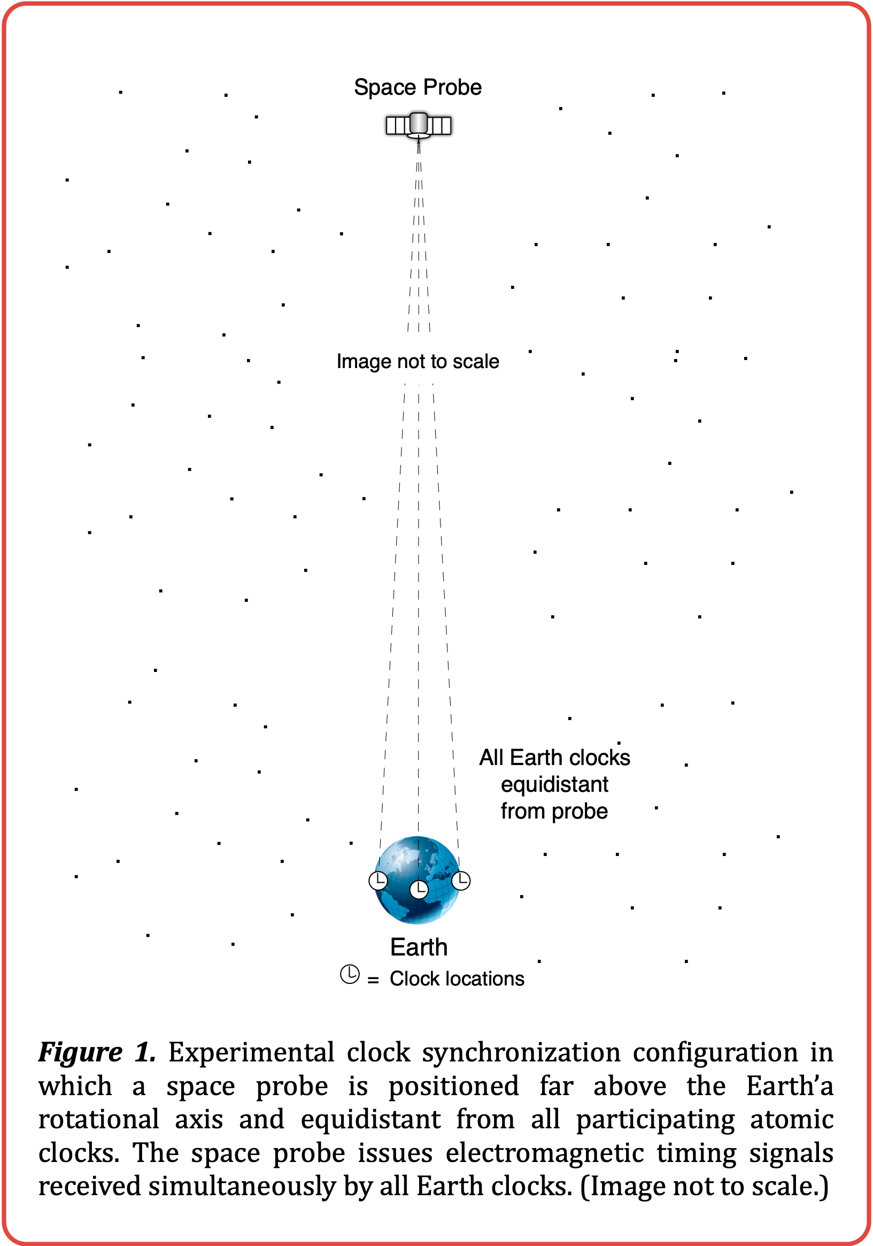
The inability to directly synchronize multiple atomic clocks at arbitrarily great distances is a problem that heretofore has not availed itself of an immediate solution.

4.1 SYNCHRONIZATION TO AN EVENT

The proposed clock synchronization scheme postulates the possibility of synchronizing two or more mutually distant clocks by an entirely different method: through correlation to a system-external entity, i.e., a “common external event.”

For our purposes, the participating atomic clocks we wish to use in these experiments must all be identical and contain embedded computer circuitry to set themselves to a requested time upon receipt of an information-laden electromagnetic command signal. The yet-unsynchronized clocks may be distributed about the Earth or elsewhere (refer to the anisotropy experiments of §5 and §6).

4.2 TIMING GROUND TRUTH

To synchronize our clocks, we utilize a remote common external event, equidistant from all participating clocks, which will serve as our timing “ground truth.” Such an event could be chosen to be any suitably located ongoing celestial event, such as a pulsar or supernova.
However, to have configurational control over the experiments, we have chosen to position an electromagnetic signal-emitting space probe at an arbitrarily great distance from the Earth. The maneuverable probe is positioned so that it is equidistant from all participating Earth clocks (refer to Figure 1).

The Earth clocks, having identical distances, within experimental error, from the distant space probe, simultaneously receive the same electromagnetic command signals transmitted by the probe.

The purpose of a typical signal is to command all participating clocks to immediately set themselves to a specified arbitrary time, e.g., “SET CLOCK TO 0:00:00.000000”. Once the identical clocks have received such a signal, they set themselves en masse to the same time simultaneously, after which they can be considered to be mutually synchronized with an assumed degree of accuracy.

This scheme can be extended to any number of participating clocks provided they are all identical and situated equidistant from the space probe. The SET probe signal may be retransmitted periodically for the purposes of experiment reset, and for assessing the bounds of error and time drift in the clocks (refer to §6.1).

With the establishment of this experimental configuration, one-way and round-trip speed of light experiments may then be run amongst any of the synchronized clocks, regardless of location.

5. ANISOTROPY EXPERIMENT 𝛼

In §4 we established the fundamentals of our external event-based clock synchronization paradigm. For our first conceptual experiment, we build on that foundation, and extend it.

First, we place one high-precision atomic clock on the Earth and another on the Moon, yet unsynchronized. We employ the basic clock synchronization scheme described in §4, but here the space probe is positioned at an arbitrarily far distance from the Earth-Moon system and outside the ecliptic plane, perpendicular to and centered upon the imaginary line that can be drawn between the two clocks (refer to Figure 2).

By choosing the Earth and Moon as platforms for this experiment we can obtain a large-scale and easily measurable time delay since the average round-trip light time between the Earth and the Moon, ∆t_{RT}, is approximately 2.56444 seconds (Battat et. al., 2009):

$$Δt_{RT}=\frac{2d_{EM}}{c}=\frac{2(384,399,000m)}{299,792,458m/s}$$

$$≈2(1.28222s)=2.56444s$$

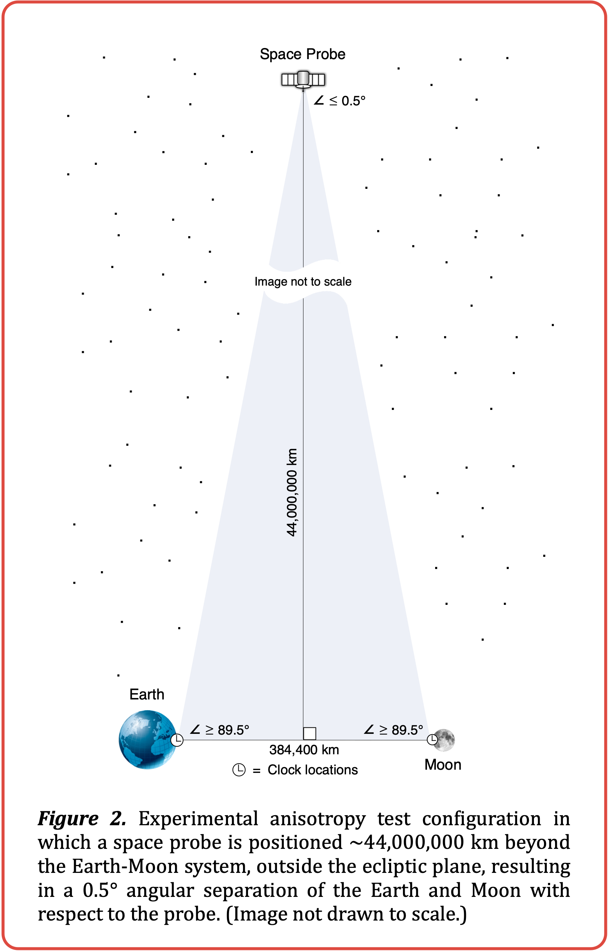
where d_{EM} is the average distance from the Earth to the Moon. (A larger time delay between clocks can be obtained by utilizing a more distant celestial body, such as Mars, or even a man-made satellite, but with additional experimental limitations.)

As before, the Earth and Moon clocks become mutually synchronized upon receipt of a SET command from the space probe, wherein both clocks immediately set themselves to the prescribed time.

Once this is accomplished, the Moon clock then sends an electromagnetic message to the Earth clock, containing its local timestamp of transmission of the message, t_{MT}. The Earth clock then timestamps its reception of the Moon clock’s message, t_{MR}. Subtracting the Moon clock’s transmission timestamp from the Earth clock’s reception timestamp gives ∆t_{ME}, the one-way light time from the Moon to the Earth:

$Δt_{ME}=t_{MR}-t_{MT}$

The Earth clock proceeds to determine the current round-trip light time between the Earth and the Moon, ∆t_{RT}, by sending a laser pulse to one of the laser retroreflectors deployed on the surface of the Moon by the Apollo and Lunokhod missions (Pavlov et. al., 2016; Dickey, 2014).

For the speed of light to be considered isotropic, ∆t_{ME}, the Earth clock’s local time of receipt of the Moon clock’s message, minus the Moon clock’s local time of transmission, should be equal to half of ∆t_{RT}, the measured round-trip light time, to a high degree of precision:

$Δt_{MR}=\frac{{∆t}_{RT}}{2}$

Note that lack of deviation from this result in practice would provide no evidence of measurable anisotropy in the speed of light on the tested path(s) between the Earth and the Moon.

6. ANISOTROPY EXPERIMENT 𝜷

As a more elaborate experiment to investigate any potential latent anisotropy, we again synchronize the Earth and Moon clocks as above, but in a more intricate manner.

As before, the Earth clock determines the current round-trip light time between the Earth and the Moon, ∆t_{RT}, by sending a laser pulse to one of the lunar laser retroreflectors deployed on the Moon. Then it sends this information, plus its local timestamp, to the Moon clock via an electromagnetic signal.

In accordance with the synchronization convention, the Moon clock sets itself to the Earth clock’s timestamp plus half of the just-measured round-trip light time between the Earth and the Moon. The Moon clock then sends a return acknowledgement to Earth, again via an electromagnetic signal, communicating its newly-set local timestamp information.

At this point it is assumed by convention (Einstein^{b}, 1905) that both Earth and Moon clocks are “synchronized” with each other in the traditional sense. Thus, if light propagation is isotropic for this path between the Earth and the Moon and back, the two clocks are synchronized by definition. This is a tentative assumption, and the object of our investigation.

Once the space probe is suitably positioned (as in the anisotropic experiment of §5), it thereafter issues randomly-timed electromagnetic SET signals — timing strobes — toward the Earth-Moon system.

6.1 ASSESSING EXPERIMENTAL ERROR

To build confidence in the reliability of this manner of synchronization, it is necessary to quantify the level of error and drift inherent in the scheme. This can be achieved over time by basing numerous back-to-back tests upon the prior synchronization as a new time baseline.

Specifically, the Earth and Moon clocks set themselves to the time value contained in the latest SET command from the space probe, and the Moon clock informs the Earth clock of its timestamp of receipt of each probe signal.

This is repeated with the clocks running on each previously “synchronized” timestamp. The Earth and Moon clocks will then be shown to have received the probe’s signals within a specified ∆ of time, determined by comparing the signal receipt timestamps of the two synchronized clocks. Repeating this process will reveal the drift level and error bounds inherent in this scheme. In this way the baseline accuracy of the synchronization can be determined for reliability purposes.

The varied timing approaches mentioned in §1 report a wide range of timing precision values. The SESAR experiment (Yan et. al., 2024) claims a timing precision of 18.06 ps over a 10 km baseline. The quantum-secured time transfer method (Picciariello et. al., 2024) performed with a timing precision ranging from -2.6 to +1.0 ns/day. It is unknown how well the proposed scheme will perform, as there are numerous implementation issues that must be taken into consideration to bound the drift and error to the desired level (refer to §8).

The propagation of light can be considered isotropic in the directions measured if the times at which the Earth clock has recorded seeing the probe’s timing strobes match the times at which the Moon clock has recorded seeing them, within a predetermined delta time.

The propagation of light can be considered anisotropic in the directions measured if the recorded timing strobe reception times differ consistently and repeatedly by greater than a predetermined delta time. In such case, we can conclude that the speed of light is anisotropic in the directions measured by an amount proportional to the difference between the Earth and Moon timing strobe reception times. This consistent, significant time differential can then be used to calculate the one-way speed of light in each direction, from EARTH→MOON and MOON→EARTH (refer to §7).

7. ANISOTROPIC VELOCITY CALCULATION

Consider the hypothetical case in which we compare the Earth and Moon clock timestamp logs and discover that the Earth clock consistently records each received timing strobe one second ahead of the Moon clock.

Since each timing strobe sent by the space probe arrives at the Earth and Moon clocks simultaneously, this implies that the clocks are “synchronized” one second apart, i.e., the Earth clock time is set one second ahead of the Moon clock time. This is indicative of a directional anisotropy along the paths between the Earth and the Moon.

Utilizing the synchronization convention, the isotropic one-way light times EARTH→MOON and MOON→EARTH are equal:

$Δt_{EM}=Δt_{ME}=\frac{Δt_{RT}}{2}=\frac{2.56444s}{2}=1.28222s$

where t_{EM} is the isotropic one-way light time EARTH→MOON, t_{ME} is the isotropic one-way light time MOON→EARTH, and t_{RT} is the round-trip light time EARTH→MOON→EARTH, measured to be 2.56444 seconds in the lunar ranging experiment, above.

But based on the timestamp logs, the one-way light time ∆t_{EM} is shown to be one second longer, or 2.28222 seconds. Since the round-trip light time ∆t_{RT} is 2.56444 seconds, the return trip, ∆t_{ME}, is:

$Δt_{ME}=Δt_{RT}-Δt_{EM}=2.56444s-2.28222s=0.28222s$

This is depicted in with greater detail the spacetime diagram of Fig. 3.

From this we can derive c_{EM}, the approximate one-way speed of light, in meters/second, in the EARTH→MOON direction, based on the measured anisotropy:

$c_{EM}=\frac{d_{EM}}{Δt_{EM}}=\frac{384,400,000m}{2.28222s}≈168,432,491m/s$

where d_{EM} is the current distance from the Earth to the Moon, in meters, and ∆t_{EM} is the amount of time, in seconds, light requires to travel from the Earth to the Moon.

Next we derive c_{ME}, the approximate one-way speed of light, in meters/second, in the MOON→EARTH direction, based on the measured anisotropy:

$c_{ME}=\frac{d_{ME}}{Δt_{ME}}=\frac{384,400,000m}{0.28222s}≈1,372,057,969m/s$

where d_{ME} is the current distance from the Moon to the Earth, in meters, and ∆t_{ME} is the amount of time, in seconds, light requires to travel from the Moon to the Earth, not considering relativistic effects.

8. DISCUSSION

The proposed schemes described herein represent conceptual methods of synchronizing mutually distant atomic clocks, and by extension, of enabling one-way speed of light measurement, and thereby the determination of whether the speed of light is isotropic or anisotropic in the directions tested.

However, there are numerous practical implementation aspects which must be considered for these schemes to be effective.

8.1 IDENTICAL ATOMIC CLOCKS

As noted in §4.1, the accuracy of the synchronization can be affected by the degree to which the atomic clocks involved in the synchronization are “identical,” as they must operate and set themselves according to electronic signals at exactly the same rate. However, any such operational differential may be determined and compensated for beforehand.

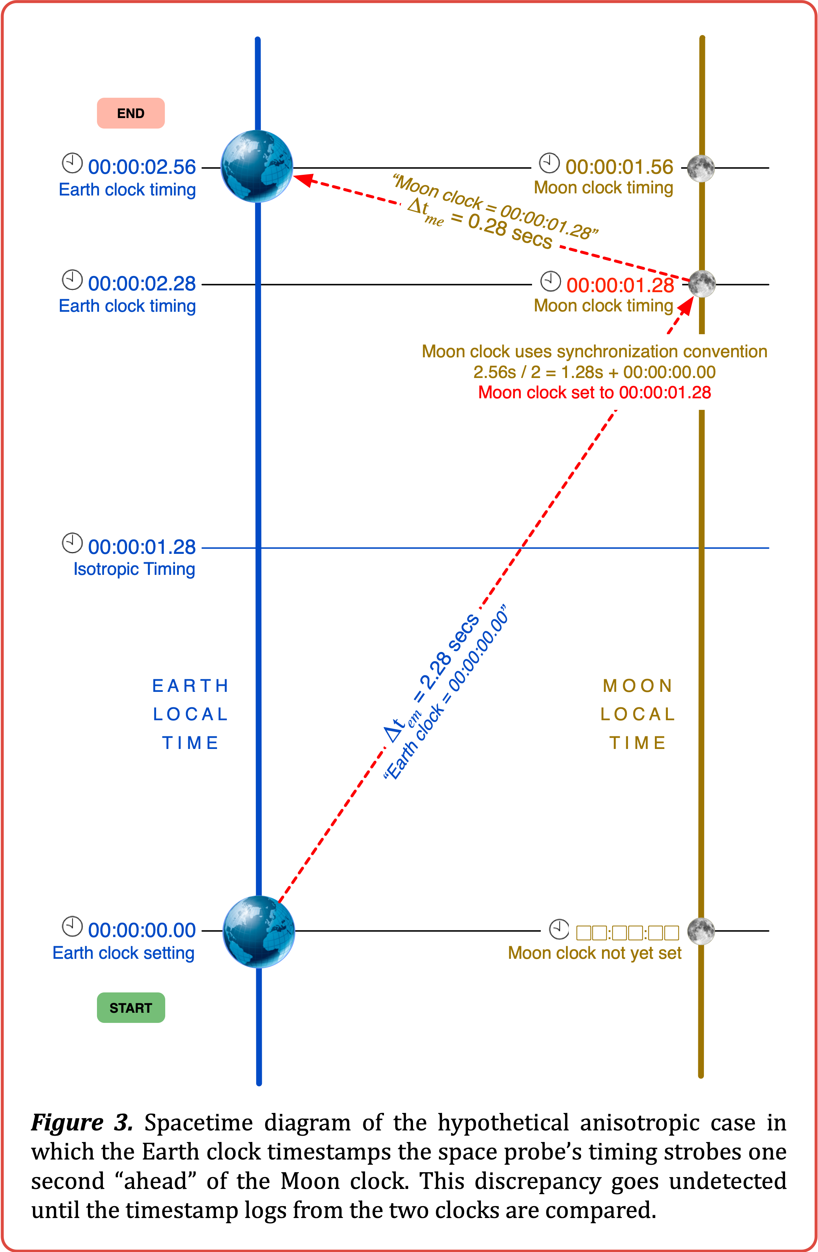
8.2 IDENTICAL ATOMIC CLOCK DISTANCES

To aid in the accuracy of the experiments, the space probe’s signals should ideally travel identical distances to the atomic clocks. For these experiments, the accuracy will depend on how closely maintained the probe’s position is in this regard to the position of the clocks.

8.3 SPACE PROBE MANEUVERABILITY

For Earth-Moon anisotropy experiment 𝜷, the probe’s maneuverability limitations and the Moon’s orbital geometry must be taken into consideration, as these may limit the window of investigational opportunity to certain times and/or phases of the lunar cycle. An inevitable small distance discrepancy can be factored into the calculations without invalidating the experiment. Additionally, a second probe may also be positioned similarly on the opposite side of the ecliptic plane in order to corroborate the experimental findings derived from the first probe.

8.4 SPACE PROBE MUTUAL DISTANCE

Also, since the space probe cannot be positioned at an infinite distance away from the clocks, there will always be a non-zero angular distance between them with respect to the probe. The arrangements diagrammed in Figures 1 and 2 depict an isosceles triangle having the space probe at the apex, with the angle between the clocks kept to a minimum by increasing the distance of the probe from the clocks as much as is practicable. It is unknown how much this residual angular distance may influence the results, as it is unknown how much, if at all, any potential anisotropy of light velocity might vary by angle. This aspect can be investigated by conducting additional experiments, each having varying degrees of angular distance between the clocks, as would occur naturally over the course of time when using the Earth-Moon system as the chosen experimental platform.

8.5 TIME-VARIANT VELOCITY COMPONENT

Another issue when using a remote planetary body such as the Moon or Mars in this manner is that there will necessarily be a non-zero, time-variant velocity component between the remote body and the Earth that must be taken into consideration. Note that this and other orbital characteristics are already factored into the lunar laser retroreflector round-trip light time measurement algorithms (Pavlov et. al., 2016). The influence this has on the results can also be investigated by conducting numerous additional experiments, each under varying conditions.

8.6 GEOGRAPHICAL PLACEMENT OF CLOCKS

Additionally, it must be considered what effect the geographic placement of the Earth and Moon clocks may have. Due to the effect of synchronous rotation, the Moon rotates at the same rate as its orbital motion. This allows the Moon clock to be placed at any convenient site on the Earth-facing side. By placing the clocks at their respective planetary equators, we find that the Moon’s “ground speed” at its sublunar (normal) point across the surface of the Earth is approximately 1627 km/hr, or 452 m/s (Pegrume, 2024). Thus, in the 2.56444 seconds it takes to conduct the lunar laser ranging experiment, the current sublunar point on Earth has traveled nearly 1.16 kilometers from its previous location. This is an additional aspect to the velocity component consideration, above.

9. CONCLUSIONS

The accurate synchronization of remote atomic clocks is a sine qua non for any speed of light measurement. The methods described herein posit a conceptual but practicable pathway to achieve such mutual synchronization.

Once all participating clocks are synchronized (as per §4), even if all subsequent measurement efforts show an isotropic propagation of light, and even if the correlated Earth and Moon clock timestamp logs of common external events (space probe signals) agree consistently to an arbitrarily high degree, this is support for but not de facto demonstration of universal isotropy.

It may happen that the velocity of light is isotropic in certain “preferred” round-trip directions and anisotropic in others, or in certain regions of the universe and not in others. Discovery of even local inherent anisotropy would challenge the cosmological principle, the prevailing notion of an isotropic universe (Keel, 2007; Eisele et. al., 2009), with far-reaching ramifications.

DISCLAIMER (AI)

Author(s) hereby declare that no generative AI technologies, such as Large Language Models, etc. were used in the preparation or writing of this manuscript.

COMPETING INTERESTS DISCLAIMER

Author(s) have declared that they have no known competing financial interests OR non-financial interests OR personal relationships that could have appeared to influence the work reported in this paper.

REFERENCES

Bailey, H. (1977). Measurements of relativistic time dilatation for positive and negative muons in a circular orbit. Nature 268 (5618): 301–305.

Battat, J. B., Murphy, T. W., Adelberger, E. G. (2009). The Apache Point Observatory Lunar Laser-ranging Operation (APOLLO): Two Years of Millimeter-Precision Measurements of the Earth-Moon Range. Astronomical Society of the Pacific121 (875):29–40.

Cooke, J., Martin, M., McCartney, H., Wilf, B. (1968). Direct determination of the speed of light as a general physics laboratory experiment. American Journal of Physics. 36 (9): 847.

Dai, H., Shen, Q., Wang, CZ. et al. (2020). Towards satellite-based quantum-secure time transfer. Nat. Phys. 16, 848–852. https://doi.org/10.1038/s41567-020-0892-y

Dickey, J. O. (2014). Lunar laser ranging: A continuing legacy of the Apollo program.
https://trs.jpl.nasa.gov/bitstream/2014/32452/1/94-0193.pdf

Einsteinª, A. (1905). On the electrodynamics of moving bodies. Fourmilab. https://www.fourmilab.ch/etexts
/einstein/specrel/www

Einstein^{b}, A. (1905). Zur Elektrodynamik bewegter Körper. Annalen der Physik. 322 (10): 891–921.

Eisele, C., Nevsky, A. Y., Schiller, S. (2009). Laboratory test of the isotropy of light propagation at the 10¹⁷ level. Physical Review Letters, 25 Aug 2009, 103(9):090401.

Feenberg, E. (1979) Distant synchrony and the one-way velocity of light. Foundations of Physics 9 329.

Finkelstein, J. (2009). Comment on “A one-way speed of light experiment by E. D. Greaves, A. Michel Rodriguez, and J. Ruiz Camacho”. American Journal of Physics.

Gibbs, P. (1997). How is the speed of light measured? The Physics and Relativity FAQ.

Giorgetta, F. R. et al. (2013). Optical two-way time and frequency transfer over free space. Nat. Photon. 7, 434–438.

Haldar, S., Agullo, I., Brady, A. J., Lamas-Linares, A., Proctor, W. C., Troupe, J. E. (2023). Towards global time distribution via satellite-based sources of entangled photons. Phys. Rev. A 107, 022615. DOI: 10.1103/PhysRevA.107.022615

Herrmann, S., Senger, A., Möhle, K., Nagel, M., Kovalchuk, E. V., Peters, A. (2009). Rotating optical cavity experiment testing lorentz invariance at the 10-17 level. Physical Review D. 80 (100): 105011.

Ho, C., Lamas-Linares, A., Kurtsiefer, C. (2009). Clock synchronization by remote detection of correlated photon pairs. N. J. Phys. 11, 045011.

Hsu, J. P., Zhang, Y. Z. (2001). Lorentz and Poincaré invariance. Advanced Series on Theoretical Physical Science. Vol. 8. World Scientific.

Iyer, C., Prabhu, G. M. (2010). A constructive formulation of the one-way speed of light. American Journal of Physics. 78, 195.

Keel, W. C. (2007), The road to galaxy formation (2nd ed.). Springer-Praxis. ISBN 978-3-540-72534-3.

Mansouri, R. M., Sexl, R. U. (1977). A test theory of special relativity: I. Simultaneity and clock synchronization. General Relativity and Gravitation, 8 497.

Morley, E., Michelson, A. A. (1887). On the relative motion of the earth and the luminiferous ether. American Journal of Science 34 333.

National Institute of Standards and Technology (2024) Optical Clocks: The Future of Time. https://www.nist.gov/atomic-clocks/optical-clocks-future-time

National Institute of Standards and Technology (2022). Codata value: Speed of light in vacuum. The NIST reference on constants, units, and uncertainty. https://physics.nist.gov/cgi-bin/cuu/Value?c.

Nissim-Sabat, C. (1982). Can one measure the one-way speed of light?, American Journal of Physics. 50, 533.

Pavlov, D. A., Williams, J. G., Suvorkin, V. V. (2016). Determining parameters of moon’s orbital and rotational motion from LLR observations using GRAIL and IERS-recommended models. Celestial Mechanics and Dynamical Astronomy. 126 (1): 61–88.

Pegrume, K. D. (2024). Moon ground speed calculation. https://wolframcloud.com/obj/kpegrume/Published/MoonGroundSpeed.nb

Picciariello, F., Vedovato, F., Orsucci, D. et al. (2024). Quantum-secured time transfer between precise timing facilities: a field trial with simulated satellite links. GPS Solut 28, 48.
https://doi.org/10.1007/s10291-023-01580-9

Sanjuan, J.; Abich, K.; Gohlke, M.; Resch, A.; Schuldt, T.; Wegehaupt, T.; et. al. (2019). Opt Express 2019 Dec 9;27(25):36206-36220.
doi: 10.1364/OE.27.036206. PMID: 31873404

Shapiro, I. (1964). Fourth test of general relativity. Physical Review Letters, 13.

Takamoto, M.; Hong, F.; Higashi, R.; Katori, H. (2005). "An optical lattice clock". Nature. 435 (7040): 321–324. doi:10.1038/nature03541. ISSN 1476-4687. PMID 15902252.

Terrell, J. (1959). The invisibility of the Lorentz contraction. Physical Review 116(4):1041-1045.

Yan, C., Tang, X., Meng, L., Sun, H., He, Y., Liu, R. (2024). A novel satellite frequency transfer method using Einstein synchronization and ranging (SESAR) for advanced real-time coordinated universal time (UTC) generation. Aerospace Science and Technology. Vol. 158, 109870.

Zhang, T., Bi, J., Zhi, Y., Peng, J. Li, L. Chen, L. (2021). Test of Lorentz invariance using rotating ultra-stable optical cavities. Phys. Let. A, Vol. 416 127666. https://doi.org/10.1016/j.physleta.2021.127666

Zhang, Y. Z. (1997). Special relativity and its experimental foundations. Advanced Series on Theoretical Physical Science. Vol. 4. World Scientific.

_______________________________________

_________________________________________________________________________________

