Evaluation of PBAT-Starch Nanoclay Composite Films for Quality Retention of Toast During Storage
Abstract
Aims: This study aimed to develop and evaluate nanoclay-reinforced PBAT-starch biodegradable films for toast packaging, with a focus on quality retention and sustainability during storage.
Study design: An experimental design was adopted with four film formulations: T0 (PBAT-only), T1 (PBAT:Starch 95:5), T2 (90:10), and T3 (85:15), each reinforced with 3% nanoclay.
Place and Duration of Study: The research was carried out in the Department of Processing and Food Engineering, SHUATS, Prayagraj, India, over a three-month experimental period.
Methodology: Films were synthesized and characterized for mechanical, chemical, microbiological, and migration properties. Toast samples were packaged in these films and stored at ambient conditions for three months. Quality parameters including moisture retention, peroxide and acid values, microbial counts, and texture were periodically evaluated.
Results: In films with starch and nanoclay, all parameters showed better preservation. Over a three-month period, T3 demonstrated the best results, with lower AV (0.88 mg KOH/g fat vs. 1.16 in T0), lower PV (6.00 meq O₂/kg vs. 8.33 in T0), less microbial growth (TPC 5.9×10³ CFU/g and YMC 4.9×10² CFU/g vs. 8.1×10³ and 7.8×10² CFU/g in T0, respectively), and better texture retention (3.13 kg vs. 2.75 kg in control).
Conclusion: Nanoclay-reinforced PBAT-starch films, particularly T3, demonstrated strong potential for eco-friendly packaging of baked products. Their application can contribute to extending shelf life while reducing environmental stress caused by synthetic plastics.
Keywords: Nanoclay, biodegradable packaging, shelf life, migration, lipid oxidation, texture analysis, biopolymer film

Introduction
The increasing demand for environmentally friendly and sustainable packaging has led to a great deal of research into biodegradable substitutes for traditional polymers derived from petroleum (Hou et al., 2024). In recent years, biodegradable polymers and composites have been extensively investigated as alternatives to synthetic plastics for food packaging. In particular, the incorporation of natural additives has been shown to improve both functional and active packaging properties (Atarés and Chiralt, 2016). Because of its biodegradability, flexibility, and compatibility with starch and nanofillers, poly (butylene adipate-co-terephthalate) (PBAT) has stood out among other polymers as a promising candidate (Roy et al., 2024).
The mechanical and barrier qualities required for food packaging, particularly for products that are sensitive to fat and moisture, such as bread and baked goods, may be insufficient for PBAT alone. Researchers have looked into using modified starch and nanoclay to improve the functional performance of PBAT-based films (Trajkovska Petkoska et al., 2021). These materials aid in better food preservation, decreased oxygen and moisture permeability, and increased structural integrity (Venkatesan et al., 2025).
A naturally occurring, plentiful, and renewable polysaccharide, starch has exceptional film-forming and biodegradable properties (Gupta et al., 2022). By adding mechanical strength when crosslinked or plasticized, its incorporation into PBAT enhances the hydrophilicity and cost-effectiveness of the film (H.-H. Wang et al., 2023). In a similar manner, nanoclay, usually montmorillonite, serves as a reinforcement filler by enhancing mechanical robustness and thermal stability while forming a convoluted channel for the passage of gases and moisture. In actual food storage situations, its synergistic action with starch improves the performance of composite films (Nath et al., 2022).
Toast is a baked good, it is quite vulnerable to lipid oxidation and texture changes while being stored. One of the most important sensory and quality factors that degrades over time as a result of moisture gain or loss is hardness. Maintaining this textural quality over time is crucial for customer appeal, as toast typically has a hardness of 2.0 to 8.0 kg (Bhise and Kaur, 2014). In this situation, texture analysis is a crucial instrument for evaluating how well biodegradable sheets maintain the integrity of the product (Perera et al., 2023).
This work examines the possibility of using nanoclay-reinforced PBAT-starch films to increase toasts shelf life by thoroughly assessing their mechanical, chemical, microbiological, and migratory qualities. The film’s ability to preserve toast quality over a three-month period was methodically investigated.
Materials and Methods
TGP Chemical Industry Pvt. Ltd. (Satara, Maharashtra, India) supplied the poly (butylene adipate-co-terephthalate) (PBAT), while Loba Chemie Pvt. Ltd. (Mumbai, India) supplied the modified potato starch (MPS), nanoclay, and 99% pure glycerol. Four composite film compositions T₀ (PBAT alone), T₁ (95:5 PBAT: MPS), T₂ (90:10), and T₃ (85:15) were produced using consistent applications of 30% glycerol and 3% nanoclay.
The blending process was carried out using a co-rotating twin screw extruder (Make: RKP Drives India Pvt. Ltd., Model: 16.5/7.5/1.0) at barrel temperatures between 70°C and 150°C and a screw speed of 240 rpm. Following pelletization, the extrudates were stored in an airtight container (Model: SKJ2-350B, Make: KBM Extrusion Pvt. Ltd.).
The film was developed using a blown film extruder (Model: NE GIAR, Make: Rashisons International FZE) at temperatures ranging from 130°C to 160°C. The resulting films were stored in desiccators for further analysis after cooling and conditioning.
AOAC Method 925.10 (AOAC International, 2016a) was used to measure the moisture content, and the samples were oven-dried at 105°C until they attained a constant weight. The moisture loss indicates how much water was held in the toast during storage.
The peroxide value (PV) was determined using the iodometric titration method, as outlined by the Association of Official Analytical Chemists (AOAC International, 2016b). In accordance with AOAC Official Method 965.33, the technique measures the hydroperoxides generated in the initial phases of lipid oxidation using milliequivalents of oxygen per kilogram of extracted fat (meq O₂/kg fat).
The acid value (AV) of the fat extracted from the toast matrix was calculated by titrating a standardized potassium hydroxide (KOH) solution to assess the amount of free fatty acids present. AOAC Official Method 940.28 (AOAC International, 2016c) was used to compute and report this as mg KOH/g fat.
The overall migration (OM) from the biodegradable films into food simulants was measured using food simulants (10% ethanol, 3% acetic acid) in accordance with European Union Regulation EU 10/2011 and IS 9845:1998. The migration values were expressed as mg/dm² of the contact surface area, per the European Commission, (2011) and the Bureau of Indian Standards (BIS), (1998).
The texture (hardness) of the toast was tested using a texture analyzer (TA. XT Plus, Stable Micro Systems) in compression mode. A cylindrical probe was used to measure the maximum force (kg) required to shatter the toast at a test speed of 1.0 mm/s. The study was conducted using AACC Method 74-09 (American Association of Cereal Chemists, 2000).
The total plate count (TPC) was determined using the pour plate technique on plate count agar (PCA), which was cultured for 48 hours at 37°C in compliance with ISO 4833-1:2013. After counting the colonies, the results were expressed as colony forming units per gram (CFU/g) (International Organization for Standardization (ISO), 2013).
The plates were placed on potato dextrose agar (PDA), acidified with tartaric acid to a pH of 3.5, and cultured for five days at 25°C to assess the amount of mold and yeast. The results were reported as CFU/g, and the enumeration was carried out in accordance with ISO 21527-1:2008 (International Organization for Standardization (ISO), 2008).
Results and Discussion
Moisture content
The amount of moisture in toast has a significant impact on its quality and shelf life while it is being stored (Marianelli et al., 2025). The moisture content of all treatments increased during the course of the three-month storage period, as seen in Table 1 and Figure 1. All samples began with a constant moisture content of 2.60%. The treated samples T₁, T₂, and T₃ displayed marginally higher values of 5.20%, 5.47%, and 5.65%, respectively, as compared to the control sample (T₀) packaged with pure PBAT, which reached 5.00% by the third month.
The penetration of ambient moisture through the packaging films is responsible for the steady rise in moisture content observed in all treatments. The PBAT-only film (T₀) showed comparatively lower moisture uptake than the starch-containing films (T₁– T₃). This could be because starch is naturally hydrophilic and affects the film matrix (Agarwal, 2021). Further evidence that larger starch loading may jeopardize the water barrier ability of PBAT films, even in the presence of nanoclay, comes from the fact that T₃ had the highest moisture.
The layered silicate structure of nanoclay makes water molecules travel in a circuitous path, it probably helped reduce moisture penetration when added at a constant 3% in all treatments (Müller et al., 2011). Nevertheless, at greater concentrations, the overall effect of the hydrophilicity of starch seemed to overwhelm the barrier improvement of the nanoclay. These results are in accordance with previous studies that found that adding starch to biodegradable films increased moisture absorption during storage because of its polar functional groups and affinity for water molecules (X. Wang et al., 2021).
Table 1. Moisture content (%) of toast packaged in pbat-based composite films over 3 months storage
Treatments | Moisture Content (%)
Treatments | Month
Treatments | 0 | 1 | 2 | 3
T₀ | 2.60 | 3.07 | 4.80 | 5.00
T₁ | 2.60 | 3.38 | 5.00 | 5.20
T₂ | 2.60 | 3.55 | 5.20 | 5.47
T₃ | 2.60 | 3.71 | 5.40 | 5.65
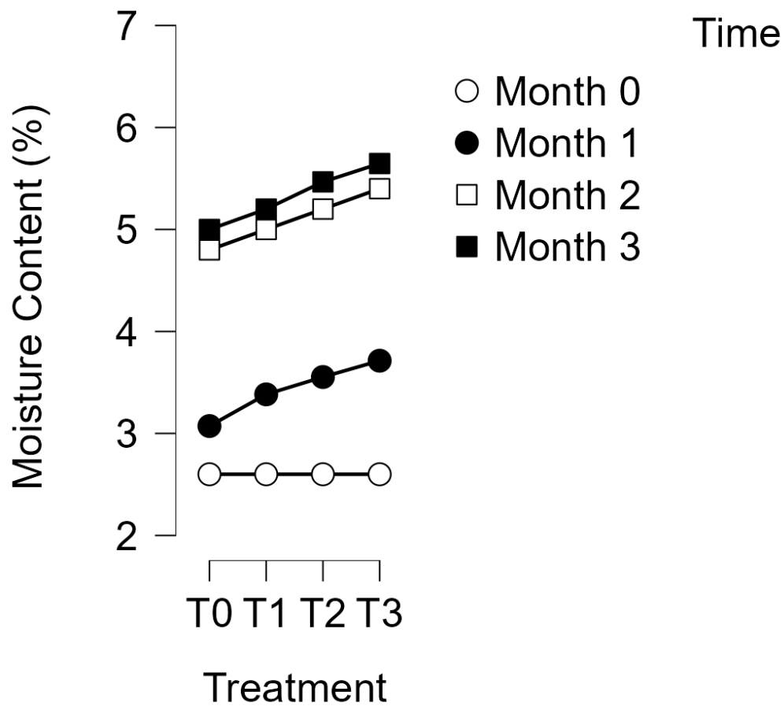
Figure 1 Moisture Content of Toast in Biodegradable Films Over 3 Months
Peroxide value (PV)
Peroxide value (PV) is a key measure of lipid oxidation in packaged foods, especially toast and other foods high in fat. PV rose for all treatments during the three-month storage period, as shown in Table 2 and Figure 2, suggesting gradual oxidative degradation. Nonetheless, the degree of oxidation differed greatly according on the type of packaging.
The uniform PV of 1.40 meq O₂/kg at the start of all treatments at month 0 confirmed that the initial oxidation was minimal. Using solely PBAT film, the control sample (T₀) had the greatest PV (8.33 meq O₂/kg) by month 3, indicating that there was little protection against oxygen penetration. T₁, T₂, and T₃, on the other hand composite films that contained 3% nanoclay and starch exhibited relatively lower PVs of 7.13, 6.27, and 6.00 meq O₂/kg, respectively.
The barrier-enhancing effect of nanoclay, which creates a convoluted channel for oxygen passage through the film matrix, slows down oxidative reactions and is responsible for the decreased PV in nanoclay-reinforced films (Jung et al., 2021). Higher starch concentrations in combination with nanoclay may help create a more cohesive film structure with better barrier functionality, as seen by the improved performance of T₂ and T₃.
These outcomes are in line with other research that found that nanocomposite films in baked goods that were stored exhibited decreased oxygen permeability and postponed lipid oxidation (San et al., 2022). A higher starch content (15%) may work in concert with nanoclay to provide a more compact matrix, further reducing oxidative breakdown, as suggested by the somewhat reduced PV in T₃ as opposed to T₂.
Table 2. Peroxide Value (meq O₂/kg) of Toast Packaged in PBAT-Based Composite Films During 3 Months Storage
Treatments | Peroxide Value (meq O₂/kg)
Treatments | Month
Treatments | 0 | 1 | 2 | 3
T₀ | 1.40 | 3.98 | 6.20 | 8.33
T₁ | 1.40 | 3.72 | 5.40 | 7.13
T₂ | 1.40 | 3.05 | 5.17 | 6.27
T₃ | 1.40 | 2.90 | 5.02 | 6.00

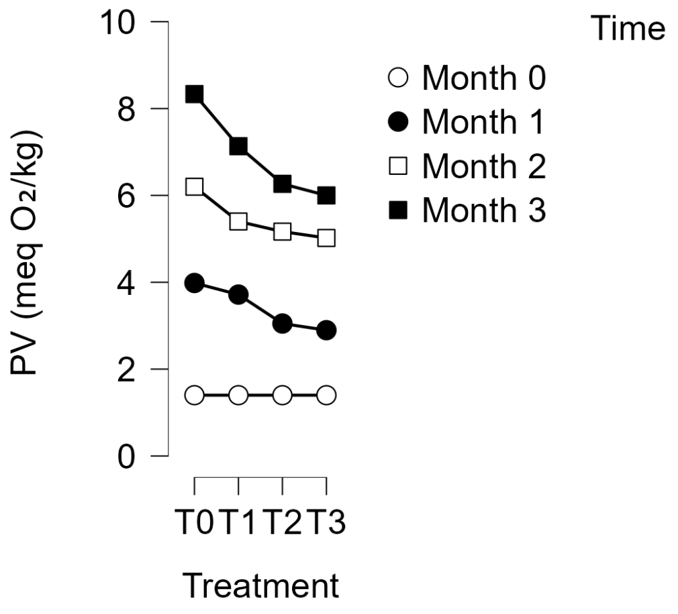
Figure 2 Peroxide value of toast in biodegradable films over 3 months
Acid value (AV)
The amount of free fatty acids (FFA) produced from triglycerides as a result of lipid degradation is reflected in the acid value (AV), a crucial measure of hydrolytic rancidity. Over the course of the three-month storage period, AV increased gradually in all treatments, as indicated in Table 3 and Figure 3, though at varying rates based on the packaging formulation. At month 0, the acid value of all samples was 0.40 mg KOH/g fat, indicating little lipid hydrolysis at first. The T₀, which used simply PBAT as the packaging medium, had the highest AV at the end of the storage period (1.16 mg KOH/g fat). This implies that PBAT by itself might provide only a limited level of defense against oxygen and moisture intrusion, which would speed up hydrolytic reactions.
The final AV values of 1.10, 1.00, and 0.88 mg KOH/g fat, respectively, showed that the composite films with starch and nanoclay (T₁, T₂, and T₃) had better oxidative and hydrolytic stability. Interestingly, T₃ showed the lowest AV despite having the greatest starch content (15%). According to this, using starch and nanoclay together enhances the films barrier qualities by limiting the entry of water molecules that encourage hydrolysis (Mujtaba et al., 2022).
The tortuous path of nanoclays lamellar structure restricts the diffusion of moisture, whereas starch increases the density of the film matrix, resulting in decreased permeability (Adak et al., 2025). By delaying hydrolysis, these interactions increase the packed products oxidative stability. Cheng et al., (2024) published similar findings, indicating decreased acid values in meals packed with biodegradable films reinforced with nanoclays.
Table 3. Acid Value (mg KOH/g fat) of Toast Packaged in PBAT-Based Composite Films During 3 Months of Storage
Treatments | Acid Value (mg KOH/g fat)
Treatments | Month
Treatments | 0 | 1 | 2 | 3
T₀ | 0.40 | 0.70 | 0.89 | 1.16
T₁ | 0.40 | 0.66 | 0.84 | 1.10
T₂ | 0.40 | 0.58 | 0.77 | 1.00
T₃ | 0.40 | 0.51 | 0.68 | 0.88
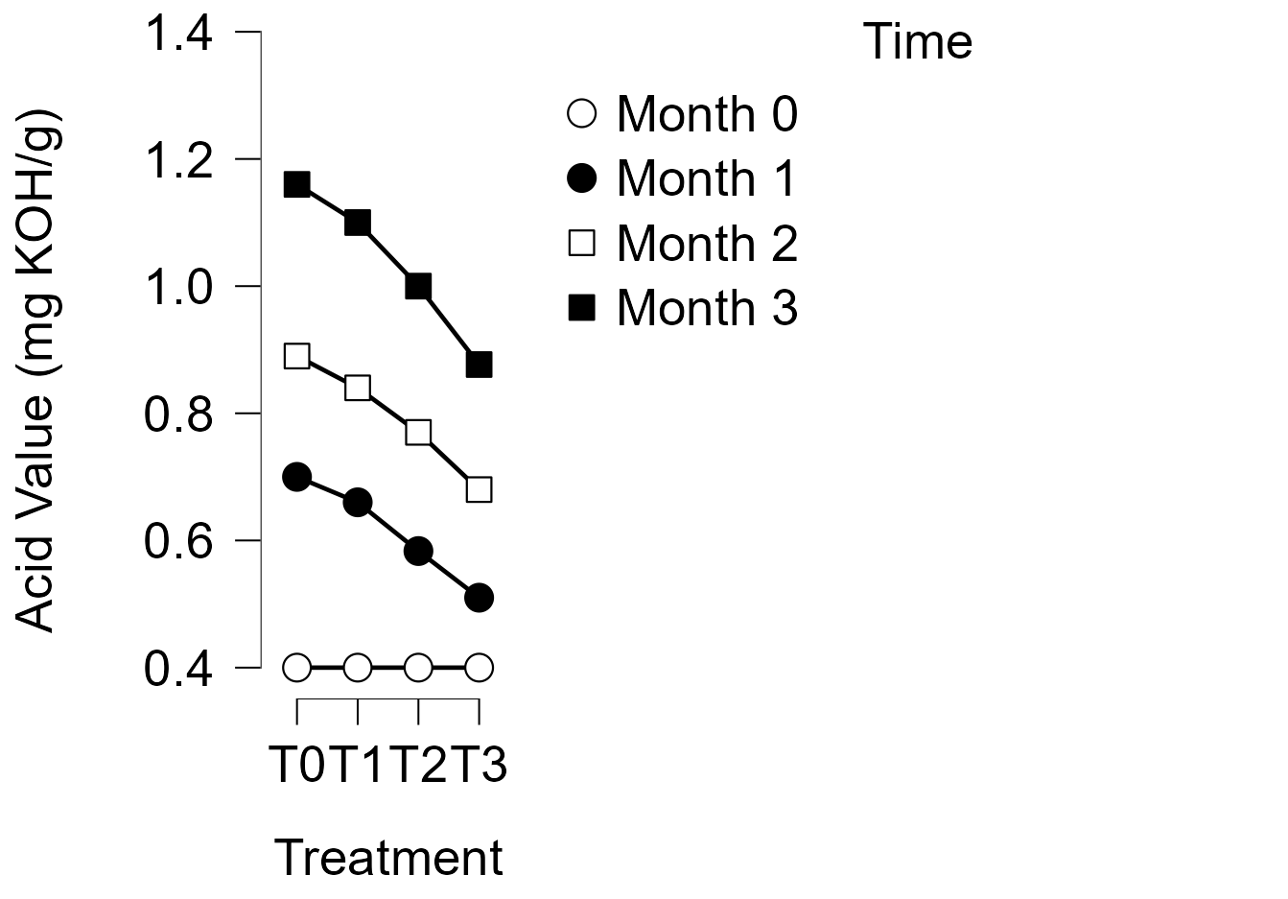
Figure 3 Acid value of toast in biodegradable films over 3 months

Overall migration
A crucial safety metric, especially for biodegradable packaging materials, is overall migration (OM), which is the total amount of non-volatile compounds that can move from packaging material into food. The overall migration limit for materials that come into contact with food is 10 mg/dm2, as per Indian Standard IS 9845:1998 and European Regulation EU 10/2011. All film samples, as indicated in Table 4, stayed under this regulation limit for the duration of the three-month storage period, proving their appropriateness for use in food packaging. Nonetheless, there were significant variations between the therapies. The highest OM values were seen in the PBAT-only film (T₀), which rose from 1.90 mg/dm² at month one to 6.20 mg/dm² by month three. The addition of starch and nanoclay, on the other hand, considerably decreased the amount of migration; T₃ (15% starch + 3% nanoclay) had the lowest OM values (1.27 to 5.04 mg/dm²).
The barrier-enhancing properties of nanoclay, which provide a convoluted channel that limits the diffusion of migratory chemicals through the film matrix, are responsible for this decrease in OM (Fahmy et al., 2020). Furthermore, starch improves hydrogen bonding and the films compactness, both of which reduce migration rates (Fatima et al., 2024).
The better performance of T₃ implies that a larger starch content works in concert with nanoclay to build a denser polymeric network, which lowers the mobility of potentially migrating additives or residues. Oliver-Ortega et al., (2021) found diminished migration values in nanocomposite biodegradable films, exhibiting similar patterns.
Table 4. Overall Migration (mg/dm²) from PBAT-Based Composite Films Used in Toast Packaging During Storage
Treatments | Overall Migration (mg/dm²)
Treatments | Month
Treatments | 1 | 2 | 3
T₀ | 1.90 | 4.00 | 6.20
T₁ | 1.80 | 3.70 | 5.40
T₂ | 1.50 | 3.23 | 5.16
T₃ | 1.27 | 2.98 | 5.04
Texture
The duration of three months of storage, the texture analysis of toast samples was carried out in terms of hardness; the findings are compiled in Table 5. The inclusion of starch and nanoclay increased the toasts initial firmness, as seen by the hardness of the samples throughout the first month, which ranged from 7.16 kg in the control sample (T₀) to 8.13 kg in T₃. In comparison to the control, treatments T₁ and T₂ also had greater hardness values, weighing 8.04 kg and 7.46 kg, respectively. All treatments showed a decrease in hardness by the second month. While T₁, T₂, and T₃ displayed hardness values of 6.58 kg, 6.11 kg, and 6.72 kg, respectively, T₀ fell to 5.30 kg. This decrease is explained by the toasts texture being softer due to moisture absorption during storage. However, as evidenced by their somewhat higher hardness, the films supplemented with starch and nanoclay showed superior resistance to moisture-induced softening.
The pattern of diminishing texture persisted in the third month, when T₀ dropped even further to 2.75 kg. T₁ and T₂ observed values of 2.88 kg, 2.77 kg, and 3.13 kg, respectively, in contrast. The synergistic effect of 15% starch and 3% nanoclay in the film matrix may have contributed to T₃ s improved capacity to keep texture, as it continuously maintained the maximum hardness throughout the storage time.
These findings demonstrate that adding starch and nanoclay to PBAT films improves packaging performance by postponing the toasts texture degradation. According to earlier research, biopolymer-based nanocomposite films have enhanced mechanical strength and barrier qualities, which help to better preserve food texture (Gao et al., 2022). All of the samples stayed within the allowed range of toast hardness, which is typically between 2.0 kg to 8.0 kg based on industry norms (Kinner et al., 2021). T₃, on the other hand, demonstrated the best textural stability, which makes it a viable option for commercial biodegradable packaging uses.
Table 5. Texture (Hardness) of Toast Samples During 3-Month Storage
Treatments | Texture (Hardness) (Kg)
Treatments | Month
Treatments | 1 | 2 | 3
T₀ | 7.16 | 5.30 | 2.75
T₁ | 8.04 | 6.58 | 2.88
T₂ | 7.46 | 6.11 | 2.77
T₃ | 8.13 | 6.72 | 3.13
Total Plate Count (TPC)
A crucial microbiological metric for assessing the overall hygienic conditions and microbial load in food items is the total plate count (TPC). Moisture migration and exposure to the environment during storage frequently result in an increase in TPC. A strong initial microbiological quality was indicated by the first TPC of 1.5×10³ CFU/g for all toast samples in the current study. Microbial counts, however, gradually rose in all treatments over the course of the three-month storage period (Table 6). At the conclusion of the second month, TPC varied between 5.9×10³ CFU/g (T₃) and 8.1×10³ CFU/g (T₀). The TNTC (Too Numerous To Count) level, which denotes microbial deterioration, was attained by all samples at month three. The content of the packaging, however, had a substantial impact on the rate of microbial development.
The maximum microbial proliferation was seen in T₀ (PBAT alone), suggesting inadequate oxygen and moisture barriers that potentially promote microbial development. The slowest rate of microbial growth, however, was shown in T₃ (PBAT + 15% starch + 3% nanoclay), which was followed by T₂ and T₁. The enhanced barrier qualities provided by the nanoclay and starch, which decreased moisture permeability and minimized microbial contamination, are responsible for the decreased microbial growth in T₃.
The formation of a tortuous channel that impedes the transfer of oxygen and moisture, nanoclay suppresses microbial activity and helps to maintain microbial stability (Mukherjee et al., 2022). Moreover, starch delays microbial growth by strengthening the film matrixs structural integrity and indirectly affecting the water activity surrounding the food (Liu et al., 2022). A lot of research has been done on using antimicrobial packaging solutions to increase the shelf life of baked goods. According to X. Wang et al., (2021), PBAT-based composites might prolong microbial lag phases due to their decreased permeability, even if they are not intrinsically antibacterial.
Table 6. Total Plate Count (CFU/g) in Toast Packed with PBAT-Based Composite Films During Storage
Treatments | Total Plate Count (CFU/g)
Treatments | Month
Treatments | 0 | 1 | 2 | 3
T₀ | 1.5×10³ | 6.1×10³ | 8.1×10³ | TNTC
T₁ | 1.5×10³ | 5.6×10³ | 7.6×10³ | TNTC
T₂ | 1.5×10³ | 5.2×10³ | 6.8×10³ | TNTC
T₃ | 1.5×10³ | 4.8×10³ | 5.9×10³ | TNTC
TNTC = Too Numerous To Count (≥10⁴ CFU/g)
Yeast and Mold Count (YMC)
A major sign of fungal spoiling in baked goods is the formation of yeast and mold, which is usually made worse by high moisture content and extended storage. The initial yeast and mold count for all treatments was 90 CFU/g, as shown in Table 7, and it gradually rose over the course of storage. At 4.7×10² CFU/g at month one and 7.8×10² CFU/g by month two, the PBAT-only film (T₀) showed the maximum fungal proliferation. By month three, TNTC (Too Numerous To Count) was evident, suggesting obvious spoiling.
In contrast, films with increased starch and a constant nanoclay content showed slower fungal growth with time. The lowest number of yeast and mold was found in the T₃ treatment, which reached 1.9×10² CFU/g at month 1 and 4.9×10² CFU/g at month 2. According to this pattern, which is consistent with findings from other criteria, the inclusion of starch and nanoclay greatly enhances the films barrier qualities, postponing fungal contamination (Lemos et al., 2025).
The improving the films impermeability to oxygen and moisture, which are necessary for fungal growth, nanoclay indirectly confers antimicrobial properties. Furthermore, a major component of fungal control, the combination of starch and nanoclay probably results in increased film matrix density, which lowers water activity surrounding the packaged toast (Zahra Afsharian, 2019). These outcomes are in accordance with Bajpai et al., (2018) research, which found that fungal spoiling of baked goods can be postponed by using biodegradable sheets that contain nanomaterials.
Table 7. Yeast and Mold Count (CFU/g) in Toast Packed with PBAT-Based Composite Films During Storage
Treatments | Yeast and Mold Count (CFU/g)
Treatments | Month
Treatments | 0 | 1 | 2 | 3
T₀ | 90.00 | 4.7×10² | 7.8×10² | TNTC
T₁ | 90.00 | 3.7×10² | 6.4×10² | TNTC
T₂ | 90.00 | 2.3×10² | 5.4×10² | TNTC
T₃ | 90.00 | 1.9×10² | 4.9×10² | TNTC
TNTC = Too Numerous To Count (≥10³ CFU/g)
Conclusion
The PBAT-starch-nanoclay composite films were effectively created and assessed in this work as biodegradable toast packaging materials. The functional performance of the films was considerably impacted by the addition of starch (5–15%) and a consistent 3% nanoclay. The T₃ film (PBAT:Starch 85:15 with nanoclay) showed the highest toast quality preservation over a three-month storage period out of all the treatments. It demonstrated restricted moisture absorption, improved texture retention (3.13 kg), the least increase in peroxide and acid values, and efficient microbial load reduction. These findings demonstrate the T3 film’s potential as an environmentally friendly substitute for traditional plastic packaging. According to the results, PBAT-starch-nanoclay coatings can successfully prolong the shelf life of baked goods like toast while preserving their texture and sensory qualities. Future studies could evaluate the effectiveness of PBAT-starch-nanoclay films with other perishable food items and investigate their scalability for industrial packaging applications.
Declaration of conflicting interests
“The authors declare no potential conflicts of interest with respect to research, authorship and/or publication of this article.”
Funding
“This research was supported by the Chhatrapati Shahu Maharaj National Research Fellowship (CSMNRF) 2023, awarded by the SARTHI Fellowship, Maharashtra Government. The authors acknowledge the financial assistance provided for conducting this study.”

COMPETING INTERESTS DISCLAIMER:
The authors declare that there are no competing financial, non-financial, or personal interests related to this work. The fellowship received by the corresponding author was solely for academic support and had no influence on the study design, data collection, analysis, or interpretation of results.
Disclaimer (Artificial intelligence)
The authors hereby declare that no generative AI technologies, such as Large Language Models (ChatGPT, COPILOT, etc.) or text-to-image generators, were used during the writing, editing, or preparation of this manuscript. All content, analysis, and interpretations were performed solely by the authors.
References
Adak, B., Baidya, S., & Teramoto, Y. (2025). Biopolymers and their nanocomposites coated paper-based high barrier and sustainable food packaging materials. Carbohydrate Polymers, 367, 123966. https://doi.org/10.1016/j.carbpol.2025.123966
Agarwal, S. (2021). Major factors affecting the characteristics of starch based biopolymer films. European Polymer Journal, 160, 110788. https://doi.org/10.1016/j.eurpolymj.2021.110788
American Association of Cereal Chemists. (2000). Approved Methods of the American Association of Cereal Chemists (10th ed.). AACC International.
AOAC International. (2016a). Official Methods of Analysis of AOAC International (20th ed.). AOAC International.
AOAC International. (2016b). Official Methods of Analysis of AOAC International (20th ed.). AOAC International.
AOAC International. (2016c). Official Methods of Analysis of AOAC International (20th ed.). AOAC International.
Atarés, L., & Chiralt, A. (2016). Essential oils as additives in biodegradable films and coatings for active food packaging. Trends in Food Science & Technology, 48, 51–62. https://doi.org/10.1016/j.tifs.2015.12.001
Bajpai, V. K., Kamle, M., Shukla, S., Mahato, D. K., Chandra, P., Hwang, S. K., Kumar, P., Huh, Y. S., & Han, Y.-K. (2018). Prospects of using nanotechnology for food preservation, safety, and security. Journal of Food and Drug Analysis, 26(4), 1201–1214. https://doi.org/10.1016/j.jfda.2018.06.011
Bhise, S., & Kaur, A. (2014). Baking quality, sensory properties and shelf life of bread with polyols. Journal of Food Science and Technology, 51(9), 2054–2061. https://doi.org/10.1007/s13197-014-1256-3
Bureau of Indian Standards (BIS). (1998). Indian Standard IS 9845:1998 – Migration of Constituents of Plastics into Food.
Cheng, J., Gao, R., Zhu, Y., & Lin, Q. (2024). Applications of biodegradable materials in food packaging: A review. Alexandria Engineering Journal, 91, 70–83. https://doi.org/10.1016/j.aej.2024.01.080
European Commission. (2011). Commission Regulation (EU) No 10/2011 on plastic materials and articles intended to come into contact with food.
Fahmy, H. M., Salah Eldin, R. E., Abu Serea, E. S., Gomaa, N. M., AboElmagd, G. M., Salem, S. A., Elsayed, Z. A., Edrees, A., Shams-Eldin, E., & Shalan, A. E. (2020). Advances in nanotechnology and antibacterial properties of biodegradable food packaging materials. RSC Advances, 10(35), 20467–20484. https://doi.org/10.1039/D0RA02922J
Fatima, S., Khan, M. R., Ahmad, I., & Sadiq, M. B. (2024). Recent advances in modified starch based biodegradable food packaging: A review. Heliyon, 10(6), e27453. https://doi.org/10.1016/j.heliyon.2024.e27453
Gao, S., Zhai, X., Wang, W., Zhang, R., Hou, H., & Lim, L.-T. (2022). Material properties and antimicrobial activities of starch/PBAT composite films incorporated with ε-polylysine hydrochloride prepared by extrusion blowing. Food Packaging and Shelf Life, 32, 100831. https://doi.org/10.1016/j.fpsl.2022.100831
Gupta, V., Biswas, D., & Roy, S. (2022). A Comprehensive Review of Biodegradable Polymer-Based Films and Coatings and Their Food Packaging Applications. Materials, 15(17), 5899. https://doi.org/10.3390/ma15175899
Hou, T., Sana, S. S., Riahi, Z., Kim, J. T., Bharathi, A., Kim, S.-C., & Roy, S. (2024). Fabrication of nanoceria and metakaolin activated poly (butylene adipate-co-terephthalate)-based composite for active food packaging applications. Food Bioscience, 61, 104900. https://doi.org/10.1016/j.fbio.2024.104900
International Organization for Standardization (ISO). (2008). ISO 21527-1:2008 – Microbiology of food and animal feeding stuffs – Horizontal method for the enumeration of yeasts and moulds – Part 1: Colony count technique in products with water activity greater than 0.95.
International Organization for Standardization (ISO). (2013). ISO 4833-1:2013 – Microbiology of the food chain – Horizontal method for the enumeration of microorganisms – Part 1: Colony count at 30°C by the pour plate technique.
Jung, B.-N., Jung, H.-W., Kang, D.-H., Kim, G.-H., & Shim, J.-K. (2021). A Study on the Oxygen Permeability Behavior of Nanoclay in a Polypropylene/Nanoclay Nanocomposite by Biaxial Stretching. Polymers, 13(16), 2760. https://doi.org/10.3390/polym13162760
Kinner, M., Rüegg, R., Weber, C. A., Buchli, J., Durrer, L., & Müller, N. (2021). Impact of selected baking and vacuum cooling parameters on the quality of toast bread. Journal of Food Science and Technology, 58(12), 4578–4586. https://doi.org/10.1007/s13197-020-04945-x
Lemos, G. S., Vitoria, J. S., Fonseca, L. M., Pires, J. B., Silva, F. T. da, Siebeneichler, T. J., Pacheco, C. de O., Gandra, E. A., & Zavareze, E. da R. (2025). Active food packages for cake conservation: Antifungal potential of bean starch biodegradable films with orange peel essential oil. International Journal of Biological Macromolecules, 310, 143441. https://doi.org/10.1016/j.ijbiomac.2025.143441
Liu, D., Zhao, P., Chen, J., Yan, Y., & Wu, Z. (2022). Recent Advances and Applications in Starch for Intelligent Active Food Packaging: A Review. Foods, 11(18), 2879. https://doi.org/10.3390/foods11182879
Marianelli, A., Casu Pereira de Sousa, B. A., Macaluso, M., Pieracci, Y., Palla, F., Verdini, P. G., Guidi, E., Coltelli, M. B., & Zinnai, A. (2025). Analysis and evaluation of compostable and conventional films for packaging bakery goods in modified atmospheres with the use of Microcontroller Unit (MCU) and digital sensors. Food Packaging and Shelf Life, 48, 101459. https://doi.org/10.1016/j.fpsl.2025.101459
Mujtaba, M., Lipponen, J., Ojanen, M., Puttonen, S., & Vaittinen, H. (2022). Trends and challenges in the development of bio-based barrier coating materials for paper/cardboard food packaging; a review. Science of The Total Environment, 851, 158328. https://doi.org/10.1016/j.scitotenv.2022.158328
Mukherjee, S., Sarkar, B., Aralappanavar, V. K., Mukhopadhyay, R., Basak, B. B., Srivastava, P., Marchut-Mikołajczyk, O., Bhatnagar, A., Semple, K. T., & Bolan, N. (2022). Biochar-microorganism interactions for organic pollutant remediation: Challenges and perspectives. Environmental Pollution, 308, 119609. https://doi.org/10.1016/j.envpol.2022.119609
Müller, C. M. O., Laurindo, J. B., & Yamashita, F. (2011). Effect of nanoclay incorporation method on mechanical and water vapor barrier properties of starch-based films. Industrial Crops and Products, 33(3), 605–610. https://doi.org/10.1016/j.indcrop.2010.12.021
Nath, D., R, S., Pal, K., & Sarkar, P. (2022). Nanoclay-based active food packaging systems: A review. Food Packaging and Shelf Life, 31, 100803. https://doi.org/10.1016/j.fpsl.2021.100803
Oliver-Ortega, H., Vandemoortele, V., Bala, A., Julian, F., Méndez, J. A., & Espinach, F. X. (2021). Nanoclay Effect into the Biodegradation and Processability of Poly(lactic acid) Nanocomposites for Food Packaging. Polymers, 13(16), 2741. https://doi.org/10.3390/polym13162741
Perera, K. Y., Jaiswal, A. K., & Jaiswal, S. (2023). Biopolymer-Based Sustainable Food Packaging Materials: Challenges, Solutions, and Applications. Foods, 12(12), 2422. https://doi.org/10.3390/foods12122422
Roy, S., Ghosh, T., Zhang, W., & Rhim, J.-W. (2024). Recent progress in PBAT-based films and food packaging applications: A mini-review. Food Chemistry, 437, 137822. https://doi.org/10.1016/j.foodchem.2023.137822
San, H., Laorenza, Y., Behzadfar, E., Sonchaeng, U., Wadaugsorn, K., Sodsai, J., Kaewpetch, T., Promhuad, K., Srisa, A., Wongphan, P., & Harnkarnsujarit, N. (2022). Functional Polymer and Packaging Technology for Bakery Products. Polymers, 14(18), 3793. https://doi.org/10.3390/polym14183793
Trajkovska Petkoska, A., Daniloski, D., D’Cunha, N. M., Naumovski, N., & Broach, A. T. (2021). Edible packaging: Sustainable solutions and novel trends in food packaging. Food Research International, 140, 109981. https://doi.org/10.1016/j.foodres.2020.109981
Venkatesan, R., Mayakrishnan, V., Alrashed, M. M., & Kim, S. (2025). Recent Advances in <scp>PBAT</scp> (Nano) Composite Materials for Food Packaging: A Comprehensive Review. Journal of Applied Polymer Science, 142(28). https://doi.org/10.1002/app.57163
Wang, H.-H., Zhou, S.-J., Xiong, S.-J., Liu, Q., Tian, H., Yu, S., & Yuan, T.-Q. (2023). High-performance thermoplastic starch/poly(butylene adipate-co-terephthalate) blends through synergistic plasticization of epoxidized soybean oil and glycerol. International Journal of Biological Macromolecules, 242, 124716. https://doi.org/10.1016/j.ijbiomac.2023.124716
Wang, X., Cui, L., Fan, S., Li, X., & Liu, Y. (2021). Biodegradable Poly(butylene adipate-co-terephthalate) Antibacterial Nanocomposites Reinforced with MgO Nanoparticles. Polymers, 13(4), 507. https://doi.org/10.3390/polym13040507
Zahra Afsharian, K. K.-D. (2019). Application of nanoclays in food packaging. Biointerface Research in Applied Chemistry, 10(1), 4790–4802. https://doi.org/10.33263/BRIAC101.790802

