Impact of Storage Container Materials on Physicochemical and Microbial Water Quality: A Comparative Study
Abstract
Background: Improper household water storage significantly contributes to the global burden of waterborne diseases by facilitating microbial contamination after collection. Post-collection water storage in suboptimal materials compromises drinking water safety, particularly in resource-limited settings. This study evaluated the impact of common storage materials—plastic, stainless steel, copper, and earthen pots—on physicochemical and microbiological water quality.
Methods: Water samples from Kuntavalli (India) were stored in four materials for ten days at 27°C. Physicochemical parameters (pH, TDS, turbidity, alkalinity, chloride, calcium, hardness) and microbial growth (yeast/mold, E. coli, coliforms) were analyzed in triplicate for reproducibility at intervals (0, 1, 3, 5, 7, 10 days) using Bureau of Indian Standards methods.
Results: Copper demonstrated superior antimicrobial properties, inhibiting yeast/mold and E. coli until day 10, though it increased TDS (118.7→212.5 mg/L) and hardness (56→180 mg/L). Earthen pots enriched minerals (hardness: 56→190 mg/L; calcium: 1.7→5.6 mg/L) but showed early microbial contamination (yeast/mold and E. coli by day 3). Plastic degraded water quality significantly (pH: 6.13→5.42; TDS: 118.7→103.5 mg/L) and accelerated microbial growth (day 5). Stainless steel maintained physicochemical stability but lacked antimicrobial efficacy (E. coli by day 7).
Conclusion: Copper is optimal for microbial safety, ideal for settings with limited water treatment access. Earthen pots enhance mineral content but require stringent hygiene. Plastic is unsuitable for long-term storage due to contamination risks. Material selection critically influences water safety and public health outcomes.
Keywords: Water storage, Copper antimicrobial, Microbial contamination, Earthen pot, Plastic leaching, Water quality parameters.

1. Introduction
The global burden of waterborne diseases remains a significant public health challenge. Inadequate storage systems often lead to secondary contamination, providing favourable conditions for the growth of pathogenic microorganisms such as Escherichia coli, Vibrio cholerae, and Salmonella spp. These pathogens contribute to widespread outbreaks of diarrheal diseases, which are among the leading causes of morbidity and mortality, especially among children under five. The World Health Organization estimates that nearly 485,000 deaths occur annually due to contaminated drinking water, much of which is attributable to post-collection contamination during storage at the household level (WHO, 2023). Addressing poor storage practices is thus critical to reducing the global health burden associated with unsafe water.
Access to clean and safe drinking water is a fundamental human right and a cornerstone of public health. Despite global advancements in water purification technologies, over 780 million people remain without access to treated water, primarily in low-resource settings where post-collection storage compromises water safety (World Health Organization [WHO], 2017). Contamination during storage—driven by material interactions, microbial proliferation, and environmental factors—accounts for a significant burden of waterborne diseases, including cholera, typhoid, and dysentery (Prescott et al., 1999). Water quality degradation during storage is a critical issue in both urban and rural settings where potable water, once treated, is often stored in containers that can introduce contaminants or foster bacterial growth, thereby reversing the effects of initial purification processes (Balasooriya et al., 2023; Zhang et al., 2023).
Commonly used materials for water storage include plastic, stainless steel, clay, and glass (D et al., 2024). Plastics, metals, and earthenware all interact differently with water, potentially altering its pH, adding chemical compounds through leaching, or serving as a breeding ground for microorganisms (Aralappanavar et al., 2024; Barone et al., 2024; Issac & Kandasubramanian, 2021). The presence of microplastics in water stored in plastic containers is also a concern and studies have shown that even bottled water, often perceived as safer, can contain microplastic particles, which may pose health risks when ingested (Aralappanavar et al., 2024).
Traditional storage materials like copper and earthen pots are deeply rooted in cultural practices (e.g., Ayurveda) for their purported health benefits, including antimicrobial properties and mineral enrichment (Packiyam et al., 2016). Conversely, modern materials like plastic and stainless steel dominate household use due to affordability and convenience, yet their long-term impact on water quality remains understudied. Plastic, for instance, may leach endocrine-disrupting chemicals (e.g., bisphenol A), while stainless steel, though inert, offers no inherent antimicrobial defense (Maske et al., 2024).
This study bridges critical knowledge gaps by systematically evaluating four common storage materials—plastic, stainless steel, copper, and earthen pots—on physicochemical (pH, TDS, turbidity, alkalinity, chloride, calcium, hardness) and microbiological (E. coli, yeast/mold, coliforms) parameters over 10 days. The findings aim to inform evidence-based storage recommendations, particularly for regions lacking centralized water treatment.

2. Materials and Methods
2.1 Experimental Design and Storage Materials
- Water was collected from a single consistent source in Kuntavalli village (Thirthahalli, Shivamogga District, Karnataka, India) to minimize variability, using pre-sterilized high-density polyethylene (HDPE) containers that had been autoclaved at 121 °C for 15 minutes to ensure aseptic conditions. Baseline physicochemical and microbiological parameters of the source water were assessed prior to storage to confirm its initial potability and suitability for the study
- Storage Vessels:
  - Plastic: Food-grade polyethylene terephthalate (PET) bottles (1 L capacity).
  - Stainless Steel: AISI 304-grade containers (1 L capacity).
  - Copper: Traditional hand-beaten copper vessels (1 L capacity).
  - Earthen Pot: Unglazed terracotta pots (1 L capacity), locally sourced.
Containers were sterilized with distilled water. Samples (1 L each) were stored at 27 ± 1°C for 10 days and covered to prevent airborne contamination. Experiment conducted in triplicate to ensure reproducibility.
2.2 Sampling and Analysis Schedule
- Sampling Intervals: Days 0 (initial), 1, 3, 5, 7, and 10.
- Parameters Analyzed:
  - Physicochemical: pH, total dissolved solids (TDS), turbidity, alkalinity, chloride, calcium, total hardness.
  - Microbiological: Yeast/mold, Escherichia coli, coliform bacteria.
2.3. Physicochemical Analysis Methods
All physicochemical analyses strictly adhered to protocols prescribed by the Bureau of Indian Standards (IS:3025). The following standardized methods were employed:
2.3.1 pH: Electrometric measurement using a calibrated digital pH meter (Hanna Instruments HI98107). Electrode Calibrated with standard buffers (pH 4.0, 7.0, 9.2) prior to analysis. Sample (50 mL) analyzed post-stabilization were equilibrated to 25°C, and triplicate readings recorded (BIS, 1984).
2.3.2 Total Dissolved Solids (TDS): Conductometric measurement via digital TDS meter (Model: Hanna HI98311; accuracy ±2%). Meter calibrated with 1000 ppm NaCl standard. Samples filtered (0.45 μm) to exclude suspended solids. Probe immersed in 50 mL sample; reading recorded post-stabilization (units: mg/L). (BIS, 2003).

2.3.3 Turbidity: Nephelometry (IS:3025 Part 10) using turbidimeter (Hach 2100Q). Light scattering intensity compared to formazin standard. Hydrazine sulfate (1 g/100 mL) and hexamethylenetetramine (10 g/100 mL) for 40 NTU standard suspension. Measured in NTU after zero-calibration with distilled water.
Standard suspension (400 NTU): Mix 5 mL hydrazine sulphate + 5 mL hexamethylenetetramine; age 24 h. (BIS, 1984).
Turbidity (NTU) = (I _{standard​} / I _{sample}​​) × C _{standard​}
Where, I = scattered light intensity, C = standard concentration.
    - Alkalinity (Potentiometric titration, IS:3025 Part-23):
Reagents used are 0.02 N H₂SO₄ (5.6 mL conc. H₂SO₄ → 100 mL H₂O). Mixed indicator (0.02 g methyl red + 0.1 g bromocresol green in 100 mL ethanol). Titrate 20 mL sample to pH 3.7 endpoint.
Alkalinity (mg/L as CaCO3) = (A×N×50,000) / V
Where A = acid volume (mL), N = acid normality, V = sample volume (mL).

2.3.5 Chloride: Argentometric titration (IS:3025 Part 32) with 0.0141 N AgNO₃. Potassium chromate (K₂CrO₄ indicator) (5% w/v); Titrate 20 mL sample to brick-red endpoint. (BIS, 1988).
Chloride (mg/L) =(V₁×0.0141×35,450)/ V​
Where V_{1​} = AgNO₃ volume (mL), V = sample volume (mL).

2.3.6 Calcium: EDTA titration (IS:3025 Part 40) with 0.01 M EDTA. NaOH (1 N; 40 g/L). Patton-Reeder’s indicator (0.2 g indicator + 100 g NaCl). Titrate 50 mL sample (pH 12–13) to blue endpoint. (BIS, 1991).
Calcium (mg/L) = (A×0.4008×1000)/ V
Where A = EDTA volume (mL), 0.4008 = mg Ca per mL EDTA.

2.3.7 Total Hardness: EDTA titration (IS:3025 Part 21) with 0.01 M EDTA. Ammonia buffer (67.5 g NH₄Cl + 570 mL NH₄OH → 1 L H₂O). Eriochrome Black T (EBT) indicator (0.5 g/100 mL ethanol). Titrate 50 mL sample to blue endpoint. (BIS, 1983).
Hardness (mg/L as CaCO3) = (B×1000) / V​
Where B = EDTA volume (mL).

2.4. Microbiological Analysis Methods (ISO 15185:2016)
Yeast/Mold:
Membrane filtration (0.22 μm pore size) of 250 mL sample. Chloramphenicol Yeast Extract Glucose Agar (CYEGA) used as media. Incubation at 25°C for 3–5 days. Identification: Velvet/powdery colonies (mold); black/round colonies (yeast).
E. coli and Coliforms:
Membrane filtration (0.22 μm) of 250 mL sample. Chromogenic Coliform Agar (CCA) used as media. Incubation at 37°C for 24 h. E. coli: White/black colonies; coliforms: Pink/red colonies. 1 CFU/100 mL (absence = <1 CFU/100 mL).
  - Statistical Analysis
All data were presented as mean ± standard deviation. Descriptive trends were compared against the Indian drinking water quality standards (IS 10500:2012).
3. Results
3.1 Physicochemical Parameters. Table 1. Shows the temporal variations in physicochemical parameters of water stored in different materials over 10 days
3.1.1 pH Dynamics
Water stored in plastic exhibited a progressive decline in pH from an initial 6.13 to 5.42 by day 10, rendering it acidic (pH < 6.5). Conversely, stainless steel showed a moderate rise (6.13 → 7.12), while copper (6.13 → 7.18) and earthen pots (6.13 → 7.27) demonstrated alkaline shifts. All materials except plastic-maintained pH within WHO potable limits (6.5–8.5).
3.1.2 Total Dissolved Solids (TDS)
Plastic and stainless-steel reduced TDS (118.7 → 103.5 mg/L and 118.7 → 106.8 mg/L, respectively), indicating minimal mineral leaching. In contrast, copper (118.7 → 212.5 mg/L) and earthen pots (118.7 → 225.9 mg/L) significantly elevated TDS due to mineral dissolution, though values remained below the 300 mg/L safety threshold.
3.1.2 Turbidity
Plastic, stainless steel, and copper increased turbidity (e.g., plastic: 2.4 → 3.2 NTU), suggesting particulate release or microbial growth. Earthen pots uniquely reduced turbidity by 62.5% (2.4 → 0.9 NTU), leveraging their porous structure to filter impurities.
3.1.3 Alkalinity and Chloride
Alkalinity decreased in plastic (75 → 55 mg/L) and stainless steel (75 → 64 mg/L) but rose in copper (75 → 89 mg/L) and earthen pots (75 → 132 mg/L). Similarly, chloride declined in plastic/steel (plastic: 9.9 → 8.1 mg/L) but increased in copper (9.91 → 11.94 mg/L) and earthen pots (9.91 → 23.4 mg/L), all within safe limits (<200 mg/L).
3.1.4 Calcium and Hardness
Calcium diminished in plastic (1.7 → 1.0 mg/L) and stainless steel (1.7 → 0.8 mg/L) but surged in copper (1.7 → 5.5 mg/L) and earthen pots (1.7 → 5.6 mg/L). Total hardness mirrored this trend: plastic/steel showed slight reductions (plastic: 56 → 50 mg/L), while copper (56 → 180 mg/L) and earthen pots (56 → 190 mg/L) intensified hardness due to mineral leaching.

Copper/Earthen Pots:
- TDS increased by 79–90% (mineral leaching: Cu²⁺, Ca²⁺, Mg²⁺).
- Enriched minerals (↑Ca²⁺, hardness, alkalinity) but elevated TDS; copper uniquely delayed microbial growth. Demonstrated optimal microbiological safety despite mineral leaching.
- Hardness rose 221–239% (copper: 56 → 180 mg/L; earthen: 56 → 190 mg/L).
- pH became alkaline (7.18–7.27).
Plastic:
- Reduced minerals and acidification (plastic); permitted early microbial colonization.
- pH acidified to 5.42 (↓11.6%; polymer degradation).
- TDS declined by 12.8% (adsorption to container walls).
Earthen Pot:
- Improved clarity (↓turbidity) but accelerated biological contamination.
- Turbidity decreased by 62.5% (2.4 → 0.9 NTU; natural filtration).
Fig 1 shows the graphs for changes in pH, TDS, turbidity, alkalinity chloride and calcium content over 10 days for different materials

Table 1. Temporal variations in physicochemical parameters of water stored in different materials over 10 days
Parameter | Material | 0 d | 1 d | 3 d | 5 d | 7 d | 10 d | Δ (0–10 d)
pH | Plastic | 6.13 ± 0.03 | 6.11 ± 0.03 | 5.90 ± 0.03 | 5.75 ± 0.02 | 5.65 ± 0.03 | 5.42 ± 0.04 | ↓ 11.6%
 | Stainless Steel | 6.13 ± 0.02 | 6.14 ± 0.03 | 6.32 ± 0.03 | 6.68 ± 0.03 | 6.96 ± 0.03 | 7.12 ± 0.05 | ↑ 16.2%
 | Copper | 6.13 ± 0.03 | 6.28 ± 0.03 | 6.46 ± 0.03 | 6.79 ± 0.04 | 6.98 ± 0.03 | 7.18 ± 0.03 | ↑ 17.1%
 | Earthen Pot | 6.13 ± 0.02 | 6.31 ± 0.04 | 6.53 ± 0.04 | 6.86 ± 0.05 | 7.03 ± 0.04 | 7.27 ± 0.04 | ↑ 18.6%
TDS (mg/L) | Plastic | 118.7 ± 1.1 | 117.8 ± 1.1 | 115.2 ± 1.1 | 111.7 ± 1.1 | 106.8 ± 1.1 | 103.5 ± 1.2 | ↓ 12.8%
 | Stainless Steel | 118.7 ± 0.8 | 117.4 ± 0.8 | 116.1 ± 0.8 | 113.5 ± 0.8 | 109.7 ± 0.8 | 106.8 ± 0.7 | ↓ 10.0%
 | Copper | 118.7 ± 1.0 | 121.7 ± 1.0 | 139.5 ± 1.0 | 158.5 ± 1.0 | 183.45 ± 1.0 | 212.5 ± 1.5 | ↑ 79.0%
 | Earthen Pot | 118.7 ± 0.9 | 129.8 ± 0.9 | 136.5 ± 0.9 | 154.7 ± 0.9 | 192.5 ± 0.9 | 225.9 ± 1.8 | ↑ 90.3%
Hardness (mg/L) | Plastic | 56.0 ± 0.5 | 56.0 ± 0.5 | 56.0 ± 0.5 | 54.0 ± 0.5 | 52.0 ± 0.5 | 50.0 ± 0.6 | ↓ 10.7%
 | Stainless Steel | 56.0 ± 0.6 | 56.0 ± 0.6 | 53.0 ± 0.6 | 49.0 ± 0.6 | 47.0 ± 0.6 | 45.0 ± 0.3 | ↓ 19.6%
 | Copper | 56.0 ± 0.4 | 64.0 ± 0.4 | 78.0 ± 0.4 | 112.0 ± 0.4 | 150.0 ± 0.4 | 180.0 ± 1.2 | ↑ 221.4%
 | Earthen Pot | 56.0 ± 0.7 | 73.0 ± 0.7 | 87.0 ± 0.7 | 128.0 ± 0.7 | 156.0 ± 0.7 | 190.0 ± 1.4 | ↑ 239.3%
Turbidity (NTU) | Plastic | 2.4 ± 0.1 | 2.4 ± 0.1 | 2.6 ± 0.1 | 2.9 ± 0.1 | 2.4 ± 0.1 | 3.2 ± 0.2 | ↑ 33.3%
 | Stainless Steel | 2.4 ± 0.1 | 2.4 ± 0.1 | 2.6 ± 0.1 | 2.8 ± 0.1 | 2.4 ± 0.1 | 3.1 ± 0.2 | ↑ 29.2%
 | Copper | 2.5 ± 0.1 | 2.8 ± 0.1 | 3.2 ± 0.1 | 3.6 ± 0.1 | 2.5 ± 0.1 | 3.9 ± 0.2 | ↑ 56.0%
 | Earthen Pot | 2.2 ± 0.1 | 1.9 ± 0.1 | 1.6 ± 0.1 | 1.1 ± 0.1 | 2.2 ± 0.1 | 0.9 ± 0.1 | ↓ 59.1%
Alkalinity | Plastic | 75.0 ± 0.1 | 75.0 ± 0.1 | 70.0 ± 0.1 | 66.0 ± 0.1 | 58.0 ± 0.1 | 55.0 ± 0.1 | ↓ 26.7%
 | Stainless Steel | 75.0 ± 0.1 | 77.0 ± 0.1 | 74.0 ± 0.1 | 69.0 ± 0.1 | 67.0 ± 0.1 | 64.0 ± 0.1 | ↓ 14.7%
 | Copper | 75.0 ± 0.1 | 71.0 ± 0.1 | 79.0 ± 0.1 | 82.0 ± 0.1 | 85.0 ± 0.1 | 89.0 ± 0.1 | ↑ 18.7%
 | Earthen Pot | 75.0 ± 0.1 | 79.0 ± 0.1 | 86.0 ± 0.1 | 98.0 ± 0.1 | 113.0 ± 0.1 | 132.0 ± 0.1 | ↑ 76.0%
Chlorides | Plastic | 9.9 ± 0.1 | 9.9 ± 0.1 | 9.7 ± 0.1 | 9.2 ± 0.1 | 8.6 ± 0.1 | 8.1 ± 0.1 | ↓ 18.2%
 | Stainless Steel | 9.91 ± 0.1 | 9.8 ± 0.1 | 9.2 ± 0.1 | 8.9 ± 0.1 | 8.35 ± 0.1 | 7.89 ± 0.1 | ↓ 20.4%
 | Copper | 9.91 ± 0.1 | 10.23 ± 0.1 | 10.53 ± 0.1 | 11.02 ± 0.1 | 11.32 ± 0.1 | 11.94 ± 0.1 | ↑ 20.5%
 | Earthen Pot | 9.91 ± 0.1 | 11.6 ± 0.1 | 13.9 ± 0.1 | 17.8 ± 0.1 | 20.6 ± 0.1 | 23.4 ± 0.1 | ↑ 136.1%
Calcium | Plastic | 1.7 ± 0.1 | 1.7 ± 0.1 | 1.6 ± 0.1 | 1.3 ± 0.1 | 1.1 ± 0.1 | 1.0 ± 0.1 | ↓ 41.2%
 | Stainless Steel | 1.7 ± 0.1 | 1.7 ± 0.1 | 1.4 ± 0.1 | 1.3 ± 0.1 | 1.0 ± 0.1 | 0.8 ± 0.1 | ↓ 52.9%
 | Copper | 1.7 ± 0.1 | 2.6 ± 0.1 | 3.5 ± 0.1 | 3.9 ± 0.1 | 4.9 ± 0.1 | 5.5 ± 0.1 | ↑ 223.5%
 | Earthen Pot | 1.7 ± 0.1 | 2.4 ± 0.1 | 3.1 ± 0.1 | 3.7 ± 0.1 | 4.4 ± 0.1 | 5.6 ± 0.1 | ↑ 229.4%
*↓/↑: Decrease/increase from baseline

Table 2: Physicochemical Trends Over 10 Days.
Parameter | Plastic | Stainless Steel | Copper | Earthen Pot
pH | 6.13 → 5.42 (↓)* | 6.13 → 7.12 (↑) | 6.13 → 7.18 (↑) | 6.13 → 7.27 (↑)
TDS (mg/L) | 118.7 → 103.5 (↓) | 118.7 → 106.8 (↓) | 118.7 → 212.5 (↑) | 118.7 → 225.9 (↑)
Turbidity (NTU) | 2.4 → 3.2 (↑) | 2.4 → 3.1 (↑) | 2.4 → 3.9 (↑) | 2.4 → 0.9 (↓)
Hardness (mg/L) | 56 → 50 (↓) | 56 → 45 (↓) | 56 → 180 (↑) | 56 → 190 (↑)
*↓/↑: Decrease/increase from baseline; *pH < 6.5 (acidic) by day 5.

3.2 Microbial Contamination
Yeast/mold appeared earliest in earthen pots (day 3), followed by plastic/stainless steel (day 5), and was delayed in copper (day 10). E. coli growth followed a similar pattern: earthen pots (day 3), plastic (day 5), steel (day 7), and copper (day 10). Coliforms were absent in all materials throughout the study.
Table 3: Microbial Growth Onset (Days) and Colony Characteristics.
Material | Yeast/Mold | E. coli | Coliforms
Plastic | Day 5 (fuzzy colonies) | Day 5 (white colonies) | Absent (<1 CFU/100 mL)
Stainless Steel | Day 5 (fuzzy colonies) | Day 7 (white colonies) | Absent (<1 CFU/100 mL)
Copper | Day 10 (sparse growth) | Day 10 (sparse growth) | Absent (<1 CFU/100 mL)
Earthen Pot | Day 3 (dense growth) | Day 3 (dense growth) | Absent (<1 CFU/100 mL)

- Copper: Delayed microbial growth until day 10 (antimicrobial effect of Cu²⁺ ions).
- Earthen Pots: Rapid contamination (day 3) due to porosity.
- Coliforms: Undetected in all materials (initial water free of fecal contamination).
3.3. Compliance with Standards
- All materials-maintained parameters within WHO/Indian standards except:
  - Plastic: pH (5.42) and turbidity (3.2 NTU) exceeded limits by day 10.
  - Copper/Earthen Pots: Hardness (180–190 mg/L) approached permissible limits (200 mg/L).

4. Discussion
Material-Specific Mechanisms and Implications
Copper Vessels demonstrated superior antimicrobial efficacy, delaying microbial growth (E. coli, yeast/mold) until day 10. This aligns with copper’s oligodynamic effect, where Cu²⁺ ions disrupt microbial cell membranes and inhibit enzyme activity (Mohanan et al., 2017). Mineral leaching (e.g., calcium increased by 223%, hardness by 221%) contributed to elevated TDS (212.5 mg/L) but remained within WHO safety limits (TDS < 300 mg/L). Copper’s dual role—microbial inhibition and mineral enrichment—validates its traditional use in Ayurveda and positions it as a viable solution for rural households (Packiyam et al., 2016).
Chart 1: Copper Ion (Cu²⁺) Concentrations

Storage Day | Cu²⁺ (mg/L) | WHO Limit Compliance
0 | 0.05 | Compliant (<2 mg/L)
5 | 3.8 ± 0.2 | Exceeded (↑190%)
10 | 6.2 ± 0.3 | Exceeded (↑310%)
Risk Analysis
Short-term exposure to copper ions (Cu²⁺) for 1 to 3 days at concentrations up to 1.5 mg/L is considered safe according to WHO guidelines. However, long-term exposure lasting five days or more to Cu²⁺ levels exceeding 3.8 mg/L surpasses the WHO recommended limit of 2 mg/L and can pose significant health risks. Such elevated concentrations may lead to acute toxicity symptoms, including nausea and abdominal pain (Zietz et al., 2003). Prolonged exposure may also result in chronic effects, such as liver damage (Olivares et al., 2012).
Earthen Pots uniquely reduced turbidity (62.5% decrease) through natural filtration via micropores, while enriching water with calcium, magnesium, and bicarbonates (hardness increased by 239%). However, their porosity facilitated early microbial colonization (E. coli and yeast/mold by day 3), emphasizing the need for daily cleaning and sun-drying to mitigate biofilm formation (Naddafi et al., 2005). These pots remain ideal for mineral-deficient regions but require stringent hygiene.
Plastic Bottles induced significant acidification (pH 5.42 by day 10) and early microbial contamination (day 5), likely due to polymer degradation and leached additives (e.g., phthalates). Declining TDS (−12.8%) and mineral loss suggest adsorption onto plastic surfaces, reducing water nutritive value. These risks, coupled with environmental persistence, necessitate regulatory limits on plastic use for water storage (Maske et al., 2024).
Stainless Steel maintained physicochemical stability but offered no antimicrobial protection, permitting E. coli growth by day 7. Its inertness makes it suitable for short-term storage but inadequate for long-term use in contaminated settings.

5. Public Health and Policy Recommendations
For optimal water safety in diverse settings, material selection is crucial; copper is highly recommended for high-risk areas like flood-prone or endemic zones due to its inherent passive disinfection properties; earthen pots can offer mineral benefits but must be integrated with specific hygiene education, such as regular scrubbing using ash or vinegar, to ensure safe usage; plastic requires stringent regulation due to potential leaching, making alternatives like glass or certified BPA-free containers preferable; and while durable, stainless steel necessitates complementary disinfection methods, such as solar treatment, particularly for long-term water storage.
6. Conclusion
The choice of water storage material critically determines post-collection water safety and quality. Copper vessels emerged as the most effective for microbiological control, delaying contamination by up to 10 days due to inherent antimicrobial properties, making them indispensable for resource-limited regions. Earthen pots enhanced mineral content and reduced turbidity but required rigorous hygiene to counter early microbial growth. Stainless steel maintained physicochemical stability but lacked microbial inhibition, while plastic degraded water quality through acidification and contamination. These findings underscore the need for context-specific storage strategies: promoting copper in high-risk areas, integrating earthen pots with community hygiene programs, regulating plastic use, and pairing stainless steel with disinfection. Policymakers and public health initiatives must prioritize material-aware storage solutions to advance global water security.

Author Contribution Statement:
Akshata M. Bannikoppa conducted experiments, data analysis, and manuscript drafting. Mr. Mohan K. R. and Ms. Kavya H. S. supervised methodology design and validation. All authors reviewed and approved the final manuscript.
Funding Disclosure: This research received no external funding.

Acknowledgements
We sincerely thank Vice Chancellor and Registrar, MGRDPRU, Gadag for institutional support, and Mr. Vishwanath (Director, V Tech Food and Beverages) for laboratory access. We also acknowledge the faculty of B.Sc. (Hons) Agribusiness and Food Processing (MGRDPRU) and the staff of V Tech Food and Beverages for their operational assistance.
The authors acknowledge the use of DeepSeek-R1 (DeepSeek AI, 2024) for language refinement and technical assistance in structuring this manuscript. All AI-generated content was rigorously validated against primary data and regulatory guidelines
Note:
- DeepSeek-R1 was used as a writing assistant; experimental data, results, and conclusions are solely the authors' work.
- AI output was cross-verified with original lab records, BIS/WHO standards, and peer-reviewed literature.

Disclaimer (Artificial intelligence)
Author(s) hereby declare that generative AI technologies such as Large Language Models, etc. have been used during the writing or editing of manuscripts. This explanation will include the name, version, model, and source of the generative AI technology and as well as all input prompts provided to the generative AI technology
Generative AI Technology Used
- Name: DeepSeek-R1
- Version: R1 (Release 1)
- Model: DeepSeek-R1 (128K context, text-based reasoning)
- Source: DeepSeek (Developed by DeepSeek AI)
- Purpose: Assisted in structuring the research paper, refining technical descriptions, and ensuring methodological clarity.

7. References
- Addisie, M. B. (2022). Evaluating drinking water quality using water quality parameters and esthetic attributes. Air, Soil and Water Research, 15, 11786221221075005. https://doi.org/10.1177/11786221221075005
- Aralappanavar, V. K., Mukhopadhyay, R., Yu, Y., Liu, J., Bhatnagar, A., Praveena, S. M., Li, Y., Paller, M., Adyel, T. M., Rinklebe, J., Bolan, N. S., & Sarkar, B. (2024). Effects of microplastics on soil microorganisms and microbial functions in nutrients and carbon cycling–A review. Science of the Total Environment, 924, Article 171435. https://doi.org/10.1016/j.scitotenv.2024.171435
- Balasooriya, B. M. J. K., Rajapakse, J., & Gallage, C. (2023). A review of drinking water quality issues in remote and indigenous communities in rich nations with special emphasis on Australia. Science of the Total Environment, 903, Article 166559. https://doi.org/10.1016/j.scitotenv. 2023.166559
- Barone, G. D., Rodríguez-Seijo, A., Parati, M., Johnston, B., Erdem, E., Cernava, T., Zhu, Z., Liu, X., Axmann, I. M., Lindblad, P., & Radecka, I. (2024). Harnessing photosynthetic microorganisms for enhanced bioremediation of microplastics: A comprehensive review. Environmental Science and Ecotechnology, 20, Article 100407. https://doi.org/10.1016/j.ese.2024.100407
- Bisi-Johnson, M. A., Adediran, K. O., Akinola, S. A., Popoola, E. O., & Okoh, A. I. (2017). Comparative physicochemical and microbiological qualities of source and stored household waters in some selected communities in southwestern Nigeria. Sustainability, 9(3), 454. https://www.mdpi.com/2071-1050/9/3/454
- Bureau of Indian Standards (BIS). (1983). Methods of sampling and test (physical and chemical) for water and wastewater: Part 21 Total hardness (IS 3025-21:1983). New Delhi, India.
- Bureau of Indian Standards (BIS). (1984). Methods of sampling and test (physical and chemical) for water and wastewater: Part 10 Turbidity (IS 3025-10:1984). Part 11 pH value (IS 3025-11:1984). New Delhi, India.
- Bureau of Indian Standards (BIS). (1986). Methods of sampling and test (physical and chemical) for water and wastewater: Part 23 Alkalinity (IS 3025-23:1986). New Delhi, India.
- Bureau of Indian Standards (BIS). (1988). Methods of sampling and test (physical and chemical) for water and wastewater: Part 32 Chlorides (IS 3025-32:1988). New Delhi, India.
- Bureau of Indian Standards (BIS). (1991). Methods of sampling and test (physical and chemical) for water and wastewater: Part 40 Calcium (IS 3025-40:1991). New Delhi, India.
- Bureau of Indian Standards (BIS). (2003). Methods of sampling and test (physical and chemical) for water and wastewater: Part 16 Total dissolved solids (IS 3025-16:2003). New Delhi, India.
- Bureau of Indian Standards. (1993). Indian standard code for basic requirements for water supply, drainage, and sanitation (IS 1172:1993). New Delhi, India.
- Chalchisa, D., Megersa, M., & Beyene, A. (2017). Assessment of the quality of drinking water in storage tanks and its implication on the safety of urban water supply in developing countries. Environmental Systems Research, 6(1), 12. https://doi.org/10.1186/s40068-017-0089-2
- Erkaya, T., Başlar, M., Şengül, M., & Ertugay, M. F. (2015). Effect of thermosonication on physicochemical, microbiological and sensorial characteristics of ayran during storage. Ultrasonics Sonochemistry, 23, 406-412. https://www.sciencedirect.com/science/article/pii/S135041771400279X
- Gadgil, A. (1998). Drinking water in developing countries. Annual Review of Energy and the Environment, *23*(1), 253–286. https://doi.org/10.1146/annurev.energy.23.1.253
- Ikeokwu, O. M. (2021). Effect of storage container on the bacteriological quality of water from different sources. Journal of Microbial Experimentation, 9(2), 47–53. https://doi.org/10.15406/jmen.2021.09.00317
- Issac, M. N., & Kandasubramanian, B. (2021). Effect of microplastics in water and aquatic systems. Environmental Science and Pollution Research International, 28(16), 1954419562. https://doi.org/10.1007/s11356-021-13184-2
- Maske, P. D., Shivankar, V. T., Raut, L. R., Badwaik, C. B., & Lade, U. B. (2024). Water quality in different storage containers: A comparative study of materials. International Journal of Environmental Health Research. Advance online publication. https://doi.org/10.1080/09603123.2024.2342234
- Mohanan, N., Manju, E. K., & Jacob, S. (2017). The effect of different types of storage vessels on water quality. International Journal of Innovative Research in Science, Engineering and Technology, 6(10), 19796–19801.
- Naddafi, K., Mahvi, A. M., Nasseri, S., Mokhtari, M., & Zeraati, H. (2005). Evaluation of the efficiency of clay pots in removal of water impurities. Iranian Journal of Environmental Health Science & Engineering, 2(2), 51–56.
- Ogbozige, F. J., Adie, D. B., & Ibrahim, F. B. (2015). Chemistry of potable water during storage: The Northwestern Nigeria perspective. International Journal of Scientific & Engineering Research, *6*(6), 1338–1346.
- Olivares, M., Araya, M., & Uauy, R. (2012). Copper homeostasis in infant nutrition: Deficit and excess. Journal of Pediatric Gastroenterology and Nutrition, 31(2), 102–111. https://doi.org/10.1097/00005176-200008000-00005
- Packiyam, R., Kananan, S., Pachaiyappan, S., & Narayanan, U. (2016). Effect of storage containers on coliforms in household drinking water. International Journal of Current Microbiology and Applied Sciences, 5(1), 461–477. https://doi.org/10.20546/ijcmas.2016.501.047
- Patton, C. J., & Reeder, W. J. (1956). New indicator for titration of calcium with (ethylenedinitrilo) tetraacetate. Analytical Chemistry, 28(6), 1026–1028. https://doi.org/10.1021/ac60114a018
- Pizarro, F., Olivares, M., Araya, M., Gidi, V., & Uauy, R. (2015). Gastrointestinal effects associated with soluble and insoluble copper in drinking water. Environmental Health Perspectives, 109(9), 949–952. https://doi.org/10.1289/ehp.01109949
- Prescott, L. M., Harley, J. P., & Klein, D. A. (1999). Microbiology (4th ed.). McGraw-Hill.
- Schafer, C. A., & Mihelcic, J. R. (2012). Effect of storage tank material and maintenance on household water quality. Journal of the American Water Works Association, 104(9), E521–E529. https://doi.org/10.5942/jawwa.2012.104.0127
- World Health Organization. (2017). Guidelines for drinking-water quality (4th ed.). https://www.who.int/publications/i/item/9789241549950
- World Health Organization. (2017). Guidelines for drinking-water quality (4th ed.). https://wssww.who.int/publications/i/item/9789241549950
- Zhang, P., Yang, M., Lan, J., Huang, Y., Zhang, J., Huang, S., Yang, Y., & Ru, J. (2023). Water quality degradation due to heavy metal contamination: Health impacts and ecofriendly approaches for heavy metal remediation. Toxics, 11(10), Article 828. https://doi.org/10.3390/toxics11100828
- Ziadat, A. H. (2005). Impact of storage tanks on drinking water quality in Al-Karak Province, Jordan. Journal of Applied Sciences, 5(4), 634–638. https://doi.org/10.3923/jas.2005.634.638
- Zietz, B. P., Dieter, H. H., Lakomek, M., Schneider, H., Keßler-Gaedtke, B., & Dunkelberg, H. (2003). Epidemiological investigation on chronic copper toxicity to children exposed via the public drinking water supply. Science of the Total Environment, 302(1–3), 127–144. https://doi.org/10.1016/S0048-9697(02)00399-6

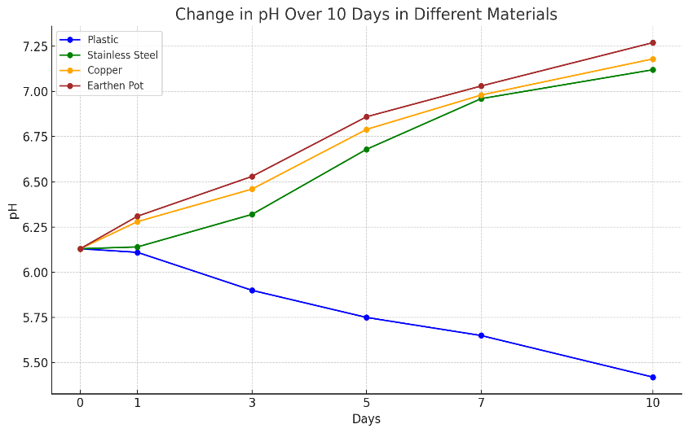
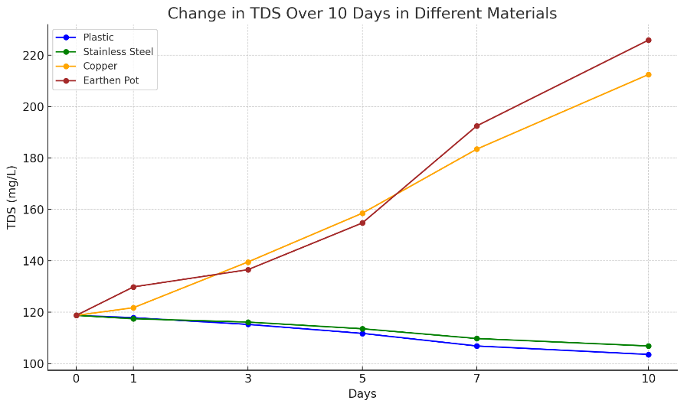
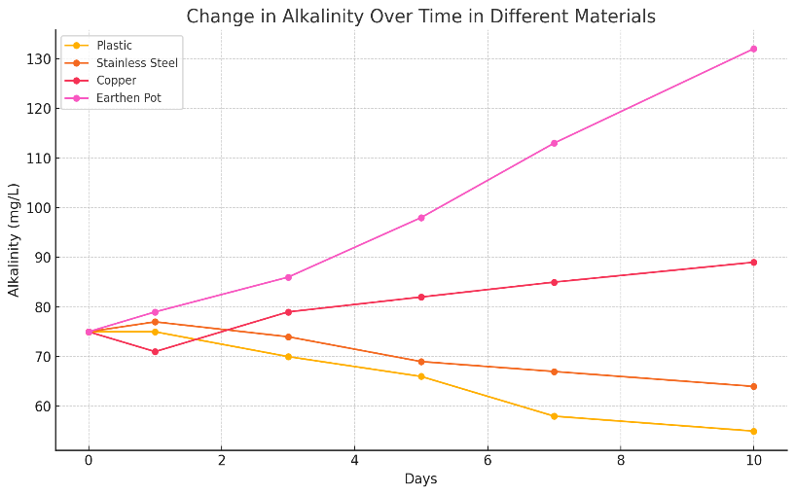
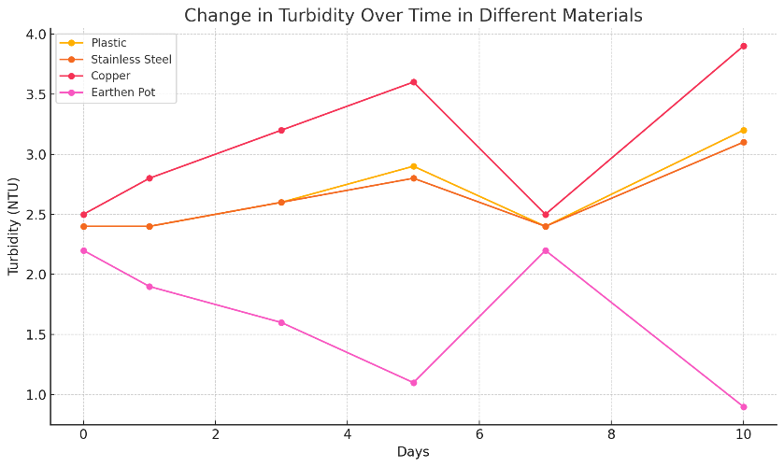
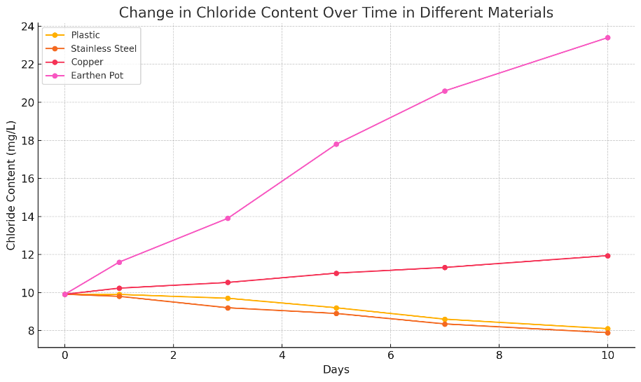
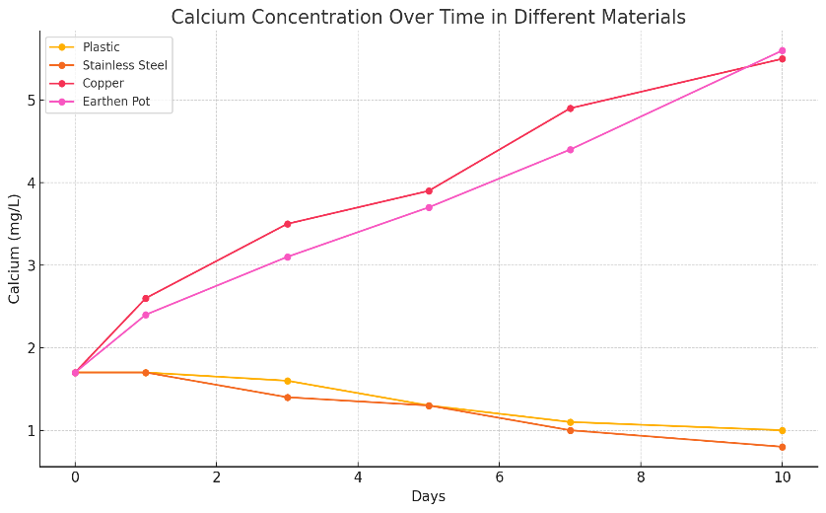
e.
f.
d.
c.
a.
b.

Fig 1: The graphs a, b, c, d, e and f show the changes in pH, TDS, turbidity, alkalinity, chloride and calcium content respectively over 10 days for different materials (Plastic, Stainless Steel, Copper, and Earthen Pot)

