Performance Evaluation of the Batch-Type Multigrain Puffing-cum-Popping Machine For the Production of Puffed Soynuts

Abstract
Soynuts are a nutritious and tasty snack made by puffing soybeans. The puffing of soynuts was carried out in a batch-type semiautomatic multigrain puffing cum popping machine designed and developed by the Department of Agricultural Process Engineering, CAET, VNMKV, Parbhani. This machine works on the High Temperature Short Time (HTST) principle. The present study highlights about performance evaluation of the batch-type multigrain puffing-cum-popping machine for the production of puffed soynuts. In this investigation, a bulk sample of 50 kg each of soybean and sorghum grains was procured from the Seed Processing Centre, VNMKV Parbhani and the groundnut and maize were procured from the local market of Parbhani (MS). The table salt was used as a heating medium for puffing of soy nuts. The grain-to-salt ratio of 1:4 was kept constant in the puffing pan for the production of puffed soy nuts. The sample size was taken as 1 kg during the experimental trial. Soybean was dipped in hot water at 100 ⁰C for 3 min and then surface dried for 3 hours. Pretreated soybeans were then fed to the machine for puffing. The optimization of the machine parameters for the production of puffed soynuts contained three independent variables: puffing temperature (°C), stirrer speed (RPM), and puffing time (min), assessed at three levels of 140, 150,160 °C; 35, 40, 45 RPM; 4, 5, 6 minutes respectively was carried out using Box-Behnken Design (BBD). The dependent variables, viz. puffing yield, expansion ratio, bulk density, colour, hardness and crispness were determined. The experimental data were analysed using Response Surface Methodology (RSM) to determine the optimal values of process and product quality parameters. The optimal condition of the machine parameters for production of puffed soynuts was found as a puffing temperature of 150 °C, stirrer speed of 40 rpm and puffing time of 5 minutes in a batch-type multigrain puffing cum popping machine. The puffing efficiency and capacity of developed puffing cum popping machine for puffed soynuts was 97.24 % and 80 kg/day. The developed batch-type semiautomatic puffing-cum-popping machine has proven to be well-suited for the production of puffed soynuts at small-scale industries.

Keywords: Soynuts, Box-Behnken Design (BBD), Optimisation, Multigrain puffing machine.
___________________________________________________________________________
Introduction:
Soybean [Glycine max (L)] is one of the oldest principal food crops and has paramount importance in the Indian agricultural and oil industry. Soybean is recognised for its value in enhancing and protecting health. It plays an important role in maintaining balanced dietary nutrients for human health. The soybean protein content is a quantitative trait mainly controlled by gene additive effects and is usually negatively correlated with agronomic traits such as the oil content and yield (Guo et al.,2022; Zhang et al.,2022). Soybean has tremendous potential to be transformed into a number of traditional local foods. Different products can be prepared from soybeans, such as soymilk and soy-paneer (dairy analogues), soy flour, soy bakery products, soynuts, etc (Kumari et al., 2025). Consumption of soy products is reported to be beneficial to prevent kidney disease, heart disease, diabetes, obesity, high blood cholesterol and cancer (Bolla, 2015). It has a good balance of the essential amino acids, making it a good supplement for cereals that can be used to improve the diet of millions of people, especially the poor and low-income earners in developing countries, because it produces the greatest amount of protein used as food by humans. It is a high-quality protein with a protein digestibility-corrected amino acid score (PDCAAS) of 1.00, which is close to some of the proteins from animal sources, such as meat and dairy (Qin et al.,2022). Puffing of soybeans consists of hydrothermal treatment as it involves the release or expansion of vapour inside the grains, while it is subjected to intensive heating for a short time. Puffing has also been used to deactivate anti-nutritional components in soybeans and to give characteristic flavour, colour and enhance nutrients, mineral availability to final products of puffed soy nuts. Thus, consumption of puffed soy nuts provides all the nutrients available in a whole soybean. Therefore, for identification of a suitable variety of soybean, the physical properties, texture characteristics, colour and Organoleptic properties of raw soybean and puffed soy nuts from four different varieties were analysed (Othzes et al., 2022). The present study highlights about performance evaluation of the batch-type multigrain puffing-cum-popping machine for the production of puffed soynuts.

Materials and Methods:
In this investigation, a bulk sample of 50 kg each of soybean and sorghum grains was procured from the Seed Processing Centre, VNMKV Parbhani and the groundnut and maize were procured from the local market of Parbhani (MS). The table salt was used as the heating medium (Jadhav, 2018) for puffing and popping the selected grains.
The various apparatus and equipment required for the quality evaluation of puffs/pops from selected grains were measuring cylinders, sieve, beakers, heat sealing machine, texture analyzer (TAXT plus), stopwatch, digital Hunter colour meter (Color Flex EZ), digital vernier caliper, electronic weighing balance, hot air oven, and multi grain puffing cum popping machine.
A multigrain puffing cum popping machine was designed and developed at the Department of Agricultural Process Engineering at the College of Agricultural Engineering, Parbhani.
Production of soynuts from soybean was carried out by varying different process variables: puffing temperature (°C), speed (rpm) and puffing time (min). The levels of process variables for the production of soybean puffs were determined based on the results of preliminary trials and literature review. The experimental design was formulated after the selection of the ranges.
Table 1. Experimental plans for the production of puffed soynuts by varying three process parameters
Sr. No. | Independent parameters | Levels | Dependent parameters
1. | Puffing Temperature (°C) | 140, 150, 160 °C | - Puffing efficiency (Puffing yield)  - Expansion ratio  - Bulk density  - Colour  - Hardness  - Crispness
2. | Speed (RPM) | 35, 40, 45 RPM
3. | Puffing Time (min) | 4, 5, 6 min
 | Total experiments =17

Seventeen experiments were performed to study the the performance evaluation of puffing cum popping machine and optimization of machine parameters and process parameters for production of soynuts according to a Box Behnken Design (BBD) with three process variables puffing temperature (°C), Speed (RPM) and puffing time for three levels of each variable. The effect of these three process variables on puffing efficiency (puffing yield) and on puffed soynuts quality, as expansion ratio, bulk density, colour, hardness and crispness, was studied for the production of puffed soynuts.
The process flowchart for the production of puffed soy nuts is given below

Soybeans

Soaking in hot water
(3 min, 100 ºC)

Surface drying (3 h)

Puffing – Temperature: 140, 150, 160 ºC
Stirrer speed: 35, 40, 45 RPM
Puffing time: 4, 5, 6 min
Grain:Salt (1:4)

Puffed soynuts
Fig 1: Process flowchart for the production of puffed soy nuts
The details of the standard runs of process variables with responses used in the experiments were presented in Table 2
Table 2: Standard runs of process variables for the production of puffed soy nuts
Sr. No | Coded value |  |  | Puffing temperature (˚C) | Stirrer speed (RPM) | Puffing time (min)
Sr. No | S₁ | S₂ | S₃ | Puffing temperature (˚C) | Stirrer speed (RPM) | Puffing time (min)
1 | -1 | -1 | 0 | 140 | 35 | 5
2 | 1 | -1 | 0 | 160 | 35 | 5
3 | -1 | 1 | 0 | 140 | 45 | 5
4 | 1 | 1 | 0 | 160 | 45 | 5
5 | -1 | 0 | -1 | 140 | 40 | 4
6 | 1 | 0 | -1 | 160 | 40 | 4
7 | -1 | 0 | 1 | 140 | 40 | 6
8 | 1 | 0 | 1 | 160 | 40 | 6
9 | 0 | -1 | -1 | 150 | 35 | 4
10 | 0 | 1 | -1 | 150 | 45 | 4
11 | 0 | -1 | 1 | 150 | 35 | 6
12 | 0 | 1 | 1 | 150 | 45 | 6
13 | 0 | 0 | 0 | 150 | 40 | 5
14 | 0 | 0 | 0 | 150 | 40 | 5
15 | 0 | 0 | 0 | 150 | 40 | 5
16 | 0 | 0 | 0 | 150 | 40 | 5
17 | 0 | 0 | 0 | 150 | 40 | 5

Where, S₁ = Puffing temperature (˚C), S₂ = Stirrer speed (RPM), S₃ = Puffing time (min)
    - Quality evaluation of selected grains puffs/pops prepared within the experimental range
The puffing /popping efficiency, expansion ratio, bulk density, colour (L value), hardness and crispness of puffed/popped products viz. puffed soynuts, puffed peanuts, sorghum pops, and popcorns of selected grains were determined.
3.3.7.1 Puffing/popping efficiency (Puffing/popping Yield, %):
Puffing/popping efficiency was determined for the selected puffed/popped grains in terms of popping yield (%). It is the ratio of the total weight of the popped sample to the sum of the total weight of popped and unpopped grains (Jadhav, 2018).
Puffing/popping efficiency was calculated by using the following formula,

$$Puffing/popping efficiency \left(\%\right)= \frac{Weight of Popped grains}{Weight of popped grains+Weight of unpopped grains }X 100$$
      - Expansion ratio:
The expansion ratio was calculated for the popped and unpopped grains. It is the ratio of the total popped volume (cm³) to the volume of raw kernels (Nakade, 2019).
Expansion ratio was calculated by using the following formula

$$Expansion Ratio=\frac{Total popped volume (ml)}{Volume of raw grains (ml)}$$

      - Bulk density:
Bulk density is the density of a material when packed or stacked in bulk. It was determined by placing each sorghum-popped product into a 1000 ml graduated cylinder. The volume and weight of the selected grains popped and unpopped grain products were recorded to determine the bulk density as the weight of selected grains popped products per volume occupied by selected grain popped/puffed products (Jadhav, 2018).
Bulk density was calculated by using the following formula

$$Bulk Density (g/cm3)=\frac{Mass of millet puff or pop sample (g)}{Volume of millet puff or pop ample (cm3)}$$
3.3.7.4 Color
The Colour (L value) of the samples was determined using a Hunter Lab colourimeter. All colour measurements were conducted after two days of the popping experiment (Jadhav, 2018). The colour of the selected popped grain products was measured using a Hunter Labcolourimeter (Plate 4.1). Before testing the sample, the instrument was calibrated using standard black and white tiles supplied with the instrument. Colour readings are expressed in terms of the L value. The L value represents the light-dark spectrum with a range of 0 (black) to 100 (white). It was observed that there was not much variation in the ‘a’ and ‘b’ values with changes in the process parameters. Therefore, only the L-value (lightness of colour or brightness of the product) was considered in the present investigation. The mean of the three replicates was used for each experimental sample.
3.3.7.5 Textural properties (Hardness and Crispiness):
The textural properties (Hardness and Crispiness) of the selected popped grain samples were evaluated using a texture analyser TA.XT. Plus Texture Analyser, Stable Micro System, UK (plate 4.2). A texture analyser with a 50 kg load cell was used to determine the hardness and crispiness of the sorghum pops. For the measurement of crispness, a macro was developed that counts the number of major peaks represented in the force-time deformation curve during compression (Nath and Chattopadhyay, 2007).
The hardness value was considered the mean peak compression force (Bourne, 2002), and crispiness was measured in terms of a major positive number of peaks (Khodke, 2002) with the setting of the texture analyser (Table 3).
Table 3: Setting of TA.XT PLUS for the production of puffed soynuts, puffed peanuts, puffs, sorghum pops and popcorns
Particulars | Settings for soy nuts and peanuts | Settings for pops of sorghum and maize
Mode | Measure force in compression | Measure force in compression
Option | Return to start | Return to start
Pre-test speed | 0.5 mm/sec | 1 mm/sec
Test speed | 0.1 mm/sec | 1 mm/sec
Post Test speed | 1.0 mm/s | 10.0 mm/s
Distance | N A | N A
Data acquisition rate | 400 pps | 400 pps
Strain | 50 % | 50 %
Testing force | 0.05 N | 0.05 N
Cylindrical probe | P75 | P35
Tare mode | Auto | Auto
(Bourne, 2002; Nakade, 2019; Nilza, 2022: Gosavi, 2022)

3.4 Optimization of process parameters for selected grains puffs/pops
Optimisation of process parameters was carried out to obtain the maximum puffing/popping yield, expansion ratio, optimal values of bulk density, hardness, colour and crispiness using Design Expert software (Version 8.0.6). Response surface graphs were generated to examine the effects of process parameters on the response variables. Response Surface Methodology (RSM) is a systematic and efficient approach for investigating the interaction effects of various parameters by following the path of steepest ascent and identifying a stationary point. Analysis of variance (ANOVA) is necessary to assess the significance and adequacy of the mathematical models proposed by RSM. With accurate models, different combinations of factors can lead to a desired response, which is visually represented in three-dimensional surface plots.
3.4.1 Effect of process parameters on quality characteristics of prepared from different grains
Response Surface Methodology (RSM) was used to find the effect of three process parameters puffing temperature, speed of the stirrer, and puffing time on the quality characteristics of prepared soybean puffs and the effect of two process parameters, puffing/popping temperature and speed of the stirrer, on the quality characteristics of prepared peanut puffs, sorghum pops, and popcorn. Make a separate statement, RSM was applied to experimental data using a commercial statistical package (Design Expert version 8.0.6 Stat Ease, Minneapolis, USA) to generate response surface plots and optimise process variables. The effects of process parameters viz. puffing temperature (S1), speed of the stirrer (S2) and puffing time (S3) with three levels on the quality characteristics of the puffed soynuts quality were analysed by conducting experiments using the Box Behnken. The effects of process parameters such as puffing/popping temperature (P₁/J₁/M₁) and stirrer speed (P₂/J₂/M₂) on the quality characteristics of peanut puffs, sorghum pops, and popcorn were analysed by conducting experiments using the Central Composite Rotatable Design (CCRD). The levels of the process parameters were based on the results of preliminary studies. Nonlinear regression equations were developed between the coded values of the independent variables (viz., P1, P2 and P3) and the dependent variables. A second-order polynomial equation of the following form was assumed to relate response Y and factors as follows:
$${{Y=β}_{0}+∑}_{j=1}^{k}β_{i}P_{j}+∑_{j=1}^{k}β_{jj}P_{j}^{2}+∑_{j=1}^{k}β_{ii}P_{i}^{2}+∑_{j=2}^{k}β_{ij}P_{i}P_{j}+ϵ$$
where,
Y = predicted response,
β0 = a constant,
βi = linear coefficient,
βii = squared coefficient,
βij = interaction coefficient,
Pi and Pj =the independent variables
𝜀= noise or error
3.4.2 Development of the model
Second-order quadratic models were utilised to establish correlations among the independent process parameters. The coefficients of the second-order polynomial for each term in the equation were derived through multiple regression analysis using Design Expert software (Version 8.0.6). The software fitted the experimental data to compute response models, and their regression coefficients were determined. The statistical significance of the terms and coefficients in the regression equation was assessed via analysis of variance (ANOVA) for each response. The statistical significance of all terms in the polynomial was evaluated by calculating the F-value. Complete second-order quadratic models were employed to fit the data, and the model's adequacy was tested by considering R² (the coefficient of multiple determination, which measures the amount of variation around the mean explained by the model). Data pertaining to various quality characteristics, such as puffing/popping efficiency, expansion ratio, bulk density, textural property (hardness and crispiness) and colour (L value), were tabulated and statistical analysis was conducted by subjecting the data to two-way analyses of variance.
3.4.3 Numerical optimisation
In numerical optimisation, simultaneous optimisation of multiple responses is achieved by setting specific goals for each variable and response. In the process of optimising multiple responses and identifying a solution, these goals were integrated into a comprehensive composite function known as the desirability function (Montgomery, 2004). The desirability function serves as an objective function, representing a desirable range from zero to one for each response. Numerical optimisation aims to identify the point that maximises the desirability function. The characteristics of a goal can be modified by adjusting its weight or importance. The puffing/popping yield, expansion ratio, bulk density, colour, hardness, and crispiness of the selected grains were evaluated based on the determined values of commercially and widely accepted samples of the selected grains.
3.4.4 Graphical optimisation
Graphical optimisation was conducted by superimposing contour plots for all responses concerning the process variables. In this optimisation, all responses are superimposed to identify the optimal intersection zone for superior product quality, where the point of maximum desirability function, as determined by numerical optimisation, is located. The superimposed contours of all responses for the specified process parameters and their interaction zones delineate the ranges of the process variables. The optimal combinations of response and process variables were derived by averaging these variable ranges.
3.4.5 Validation of the developed models
The study identified the optimal conditions for processing selected puffed or popped grains, focusing on key quality characteristics. The predicted optimal response values for parameters such as puffing/popping efficiency, expansion ratio, bulk density, colour, hardness and crispiness were validated against the values obtained from grain puffs/pops prepared under these optimal processing conditions.

Results and Discussions:
Soybean MAUS 612 variety was used to prepare puffed soy nuts by varying the puffing temperature (S₁) of the heating media, stirrer speed (S₂) for uniform and continuous mixing of the mixture of soybean grains with salt and puffing time (S₃) of the soybean grain. The effect of process parameters viz. puffing temperature (S₁), stirrer speed (S₂) and puffing time (S₃) on puffed soynuts quality was analysed by conducting seventeen experiments using the Box Behnken Design (BBD). The experimental data were analysed by applying Response Surface Methodology (RSM) using Design Expert 8.0.6. Quadratic models were developed using response surface methodology (RSM) to study the synergy between the process parameters and responses in terms of puffing efficiency, expansion ratio, bulk density, colour (L value), hardness and crispness. The optimised model for each response variable was verified for its significance by analysis of variance (ANOVA) at a 5 % level of significance (p<0.05) using Design Expert 8.0.6 software. To visualise the combined effect of the two variables on the puffing efficiency, expansion ratio, bulk density, colour, hardness, and crispness, response surface and contour plots were generated for the fitted model as a function of the two variables while keeping the other variable constant. The details of the process variables and responses used in the experiments are presented in Table 4.
Table 4: Quality characteristics of puffed soy nuts by varying process parameters
Treatment |  |  |  | Quality characteristics
Treatment | S₁ | S₂ | S₃ | Puffing efficiency  (%) | Expansion ratio | Bulk density  (kg/m³) | Colour (L value) | Hard-ness  (N) | Crispness  ( number of +ve peaks )
1 | -1 | -1 | 0 | 82.05 | 1.18 | 635.58 | 54.20 | 62.82 | 17
2 | 1 | -1 | 0 | 81.45 | 1.14 | 705.88 | 47.76 | 69.69 | 16
3 | -1 | 1 | 0 | 73.19 | 1.08 | 632.62 | 56.75 | 92.57 | 10
4 | 1 | 1 | 0 | 87.87 | 1.19 | 679.86 | 53.98 | 57.13 | 18
5 | -1 | 0 | -1 | 68.18 | 1.09 | 637.00 | 57.40 | 92.08 | 10
6 | 1 | 0 | -1 | 89.05 | 1.16 | 688.50 | 54.10 | 48.05 | 19
7 | -1 | 0 | 1 | 81.38 | 1.10 | 638.02 | 54.68 | 74.83 | 15
8 | 1 | 0 | 1 | 74.43 | 1.12 | 689.72 | 47.52 | 90.86 | 10
9 | 0 | -1 | -1 | 96.59 | 1.23 | 609.19 | 54.69 | 42.56 | 20
10 | 0 | 1 | -1 | 82.58 | 1.10 | 604.08 | 56.20 | 81.05 | 14
11 | 0 | -1 | 1 | 81.51 | 1.12 | 628.77 | 48.86 | 72.65 | 15
12 | 0 | 1 | 1 | 88.12 | 1.17 | 610.15 | 54.48 | 52.89 | 17
13 | 0 | 0 | 0 | 96.06 | 1.24 | 607.69 | 55.63 | 46.37 | 23
14 | 0 | 0 | 0 | 98.41 | 1.23 | 604.84 | 55.67 | 37.98 | 24
15 | 0 | 0 | 0 | 97.17 | 1.24 | 601.82 | 54.93 | 41.26 | 23
16 | 0 | 0 | 0 | 96.56 | 1.23 | 603.71 | 54.91 | 43.99 | 22
17 | 0 | 0 | 0 | 98.00 | 1.24 | 602.84 | 55.24 | 43.28 | 23
S₁ = Puffing temperature, S₂ = Stirrer speed and S₃ = Puffing time
4.3.1 Effect of process parameters on puffing efficiency for the production of puffed soy nuts
The puffing efficiency of puffed soy nuts is the ratio of the weight of puffed grains to the weight of the total (puffed plus unpuffed) grain. The computed values for the puffing efficiency of puffed soy nuts prepared with different combinations of process parameters are presented in Table 4. The puffing efficiency for puffed soy nuts ranged from 68.18 % to 98.41 % within the combination of variables studied. The relationship between the puffing efficiency of puffed soynuts was obtained using the following process parameters, viz: puffing temperature (S₁), stirrer speed (S₂) and puffing time (S₃).
The regression equation (4.1) represents a second-order polynomial model describing the effect of the process variables, puffing temperature (S₁), stirrer speed (S₂) and puffing time (S₃) on the puffing efficiency for the production of puffed soynuts.
PE (%) = - 3003.23 + 38.33 S₁ - 5.39 S₂ + 126.31 S₃ + 0.08 S₁S₂ - 0.69 S₁S₃ + 1.04 S₂S₃ - 0.13 S₁² - 0.14 S₂² - 6.46 S₃²
(R²=0.989) …… (4.1)
Where,
S₁ = Puffing temperature, S₂ = Stirrer speed and S₃= Puffing time
The coefficient of determination (R² = 0.989) suggested that the model explained 98.97% of the variability in puffing efficiency, indicating an excellent fit to the experimental data. The magnitude of the coefficient of the linear term showed that puffing time (S₃) had the most prominent effect on puffing efficiency, followed by puffing temperature (S₁) and stirrer speed (S₂). The positive coefficients in the case of the first-order term of puffing temperature (S₁) and puffing time (S₃) indicated that these process parameters have a significant direct influence on increasing the puffing efficiency. Whereas the negative coefficients of stirrer speed (S₂) and their quadratic terms suggest that an increase in stirrer speed has a detrimental effect on puffing efficiency. Add linear terms. Add Interaction terms. The presence of quadratic terms (S₁², S₂², S₃²) suggests that the effect of each parameter is nonlinear, implying that beyond a certain level, increasing these parameters could lead to diminishing returns or even negative effects on puffing efficiency.
Table 5: Analysis of variance (ANOVA) for process parameters showing the effect on puffing efficiency for puffed soy nuts
Source | Sum of Squares | df | Mean Square | F-value | p-value
Model | 1448.18 | 9 | 160.91 | 74.54 | < 0.0001*
(S₁): Puffing temperature | 98.03 | 1 | 98.03 | 45.41 | 0.0003*
(S₂): Stirrer speed | 12.13 | 1 | 12.13 | 5.62 | 0.0496*
(S₃): Puffing time | 15.02 | 1 | 15.02 | 6.96 | 0.0336*
S₁S₂ | 58.36 | 1 | 58.36 | 27.03 | 0.0013*
S₁S₃ | 193.39 | 1 | 193.39 | 89.58 | < 0.0001*
S₂S₃ | 106.24 | 1 | 106.24 | 49.21 | 0.0002*
S₁² | 659.98 | 1 | 659.98 | 305.72 | < 0.0001*
S₂² | 54.01 | 1 | 54.01 | 25.02 | 0.0016*
S₃² | 175.75 | 1 | 175.75 | 81.41 | < 0.0001*
Residual | 15.11 | 7 | 2.16
Lack of Fit | 11.3 | 3 | 3.77 | 3.95^{NS} | 0.109
Pure Error | 3.82 | 4 | 0.95
Cor Total | 1463.29 | 16
R-Squared | 0.9897
Adj R-Squared | 0.9764
Pred R-Squared | 0.8724
Std. Dev. | 1.47
Mean | 86.62
C.V. % | 1.7
*Significant at 5 % level NS- Non significant
From Table 5, a p-value less than 0.05 indicates that the model terms are significant. The Model F-value of 74.54 implies that the model for puffing efficiency is significant (p < 0.0001). The comparative effect of each parameter on puffing efficiency for puffed soy nuts was observed by the F-values in the ANOVA (Table 5). The lack of fit F-value is not significant for the model obtained. In this case, the coefficients of the linear terms of S₁, S₂, S₃ and the quadratic terms of S₁², S₂², S₃² and the interaction terms S₁S₂, S₂S₃, S₁S₃ are significant model terms at the 5% level of significance. Moreover, the predicted R² of 0.8724 was in reasonable agreement with the adjusted R² of 0.9764, that is, the difference was less than 0.2. This revealed that the non-significant terms were not included in the model. Therefore, this model can be used to navigate the design space.
The 3D surface plots in Figs. 2 through 4.3 illustrate the interaction effects of the independent variables puffing temperature (S₁), stirrer speed (S₂) and puffing time (S₃) on puffing efficiency for puffed soynuts. These response surface methodology (RSM) plots are instrumental in visualising the nonlinear effects and optimal processing conditions for maximising yield. Response surface analysis confirmed that the puffing process exhibited nonlinear behaviour, with distinct optima for each parameter. It was observed from these figures that the puffing efficiency for puffed soynuts increased with increasing puffing temperature (S₁) up to 150 ºC, stirrer speed (S₂) up to 40 rpm, and puffing time (S₃) at 5 min and the puffing efficiency of puffed soynuts decreased at higher levels of these process parameters.

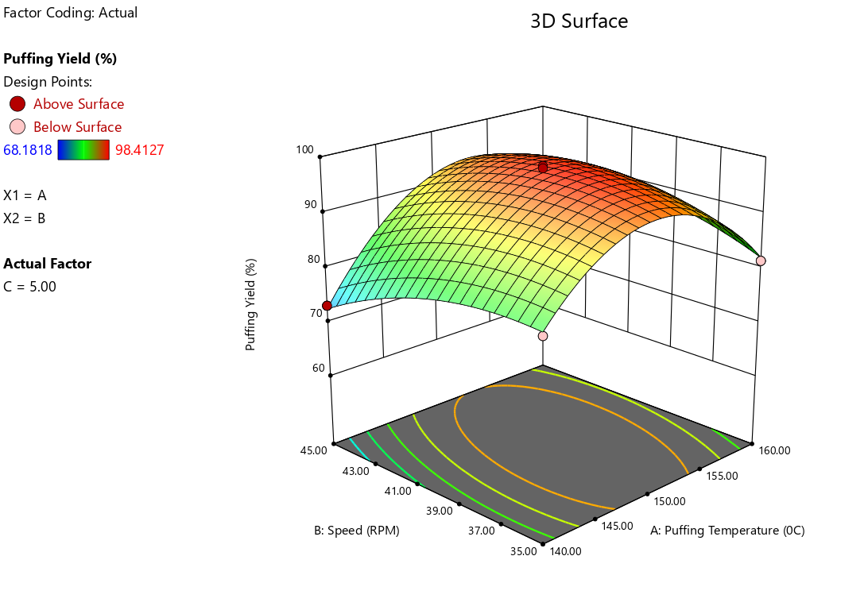
Fig. 2: Effect of puffing temperature and stirrer speed on puffing efficiency of puffed soynuts at constant puffing time

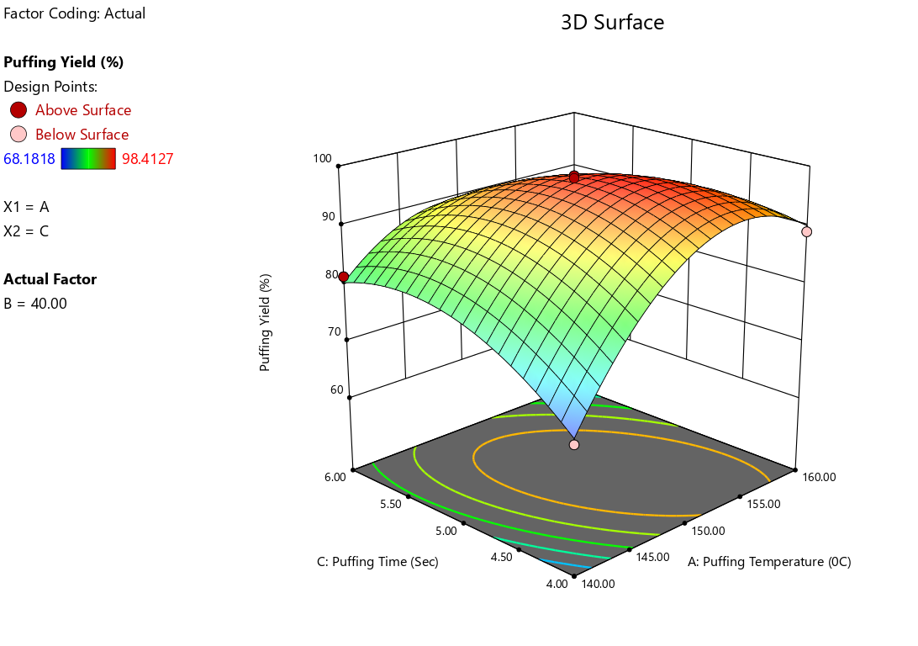
Fig. 3: Effect of puffing temperature and puffing time on puffing efficiency of puffed soynuts at constant stirrer speed
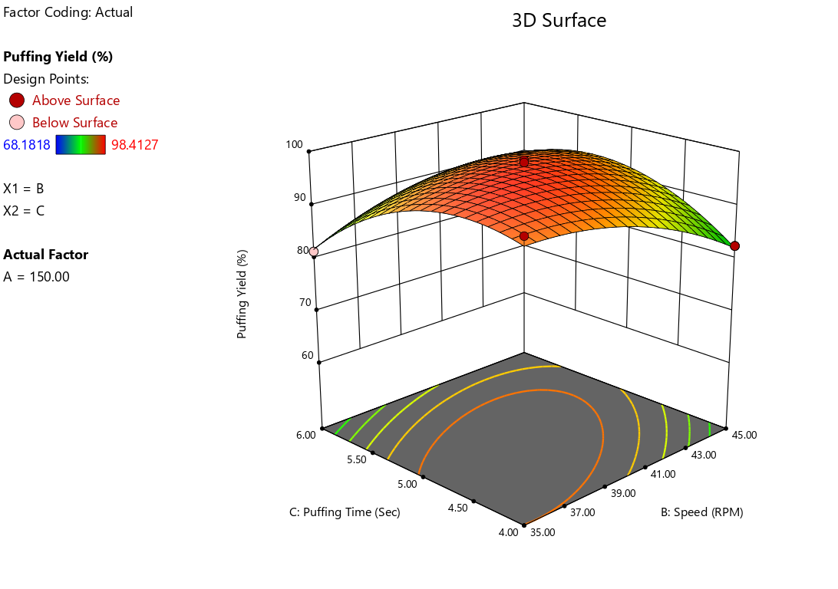
Fig. 4: Effect of stirrer speed and puffing time on puffing efficiency of puffed soynuts of at a constant puffing temperature

4.3.2 Effect of process parameter on expansion ratio (ER) for the production of puffed soynuts
The expansion ratio is the ratio of the total puffed volume (cm³) to the volume of the raw kernels. From Table 5, it is observed that the expansion ratio ranged from 1.076 to 1.238. The effects of three independent variables, S₁ (puffing temperature), S₂ (stirrer speed) and S₃ (puffing time), on the expansion ratio of puffed soy nuts were analysed. By applying multiple regression analysis to the experimental results, a second-order polynomial equation was established to estimate the relationship between the expansion ratio and the independent variables S₁, S₂ and S₃ during puffing of soynuts, as given in the following equation:
ER = -10.46 + 0.17 S₁ - 0.08 S₂ + 0.34 S₃ + 7.57 E-004 S₁S₂ - 1.14 E-003 S₁S₃ + 9.01 E-003 S₂S₃ - 6.28 E-004 S₁² - 1.02 E-003 S₂² - 0.06 S₃³
(R² =0.996)…….. (4.2)
Where,
S₁ = Puffing temperature, S₂ = Stirrer speed and S₃= Puffing time
The above equation represents a mathematical model for ER as a function of three variables S₁, S₂ and S₃. ER is the dependent variable, meaning that its value depends on the values of S₁, S₂ and S₃. The positive influence of S₁ and S₃ suggests that these factors contribute to increasing the ER, and the negative impact of S₂ implies that higher values of S₂ reduce the ER. Furthermore, the coefficient of the linear term effect of puffing time exhibited the most significant effect on the expansion ratio, followed by puffing temperature and stirrer speed. The quadratic coefficients show that the variables have nonlinear effects on ER. The interaction effects highlight the importance of combined factors rather than just their individual contributions. The presence of quadratic terms suggests a nonlinear relationship that is essential for optimising the levels of S₁, S₂ and S₃ to achieve the desired ER.
Table 6: Analysis of variance (ANOVA) for process parameters showing the effect on expansion ratio of puffed soynuts
Source | Sum of Squares | df | Mean Square | F-value | p-value
Model | 0.055 | 9 | 6.14E-03 | 208.69 | < 0.0001*
(S₁): puffing temperature | 2.68E-03 | 1 | 2.68E-03 | 90.96 | < 0.0001*
(S₂): stirrer speed | 2.63E-03 | 1 | 2.63E-03 | 89.42 | < 0.0001*
(S₃): puffing time | 8.51E-04 | 1 | 8.51E-04 | 28.91 | 0.001*
S₁S₂ | 5.73E-03 | 1 | 5.73E-03 | 194.54 | < 0.0001*
S₁S₃ | 5.19E-04 | 1 | 5.19E-04 | 17.63 | 0.004*
S₂S₃ | 8.11E-03 | 1 | 8.11E-03 | 275.56 | < 0.0001*
S₁² | 0.017 | 1 | 0.017 | 563.92 | < 0.0001*
S₂² | 2.73E-03 | 1 | 2.73E-03 | 92.77 | < 0.0001*
S₃² | 0.012 | 1 | 0.012 | 416.46 | < 0.0001*
Residual | 2.06E-04 | 7 | 2.94E-05
Lack of Fit | 1.45E-04 | 3 | 4.83E-05 | 3.17 ^{NS} | 0.1473
Pure Error | 6.11E-05 | 4 | 1.53E-05
Cor Total | 0.055 | 16
R-Squared | 0.9963
Adj R-Squared | 0.9915
Pred R-Squared | 0.9565
Std. Dev. | 5.43E-03
Mean | 1.17
C.V. % | 0.46
*Significant at 5 % level NS- Non significant
Where,
expansion ratio, puffing temperature (ºC), stirrer speed (rpm), puffing time (min).
Analysis of variables (Table 6) was performed to evaluate the statistical significance and reliability of the model. Moreover, the linear, interaction term, and quadratic coefficients showed significant effects (p < 0.05) on the expansion ratio of puffed soynuts. The significant p-value of the model and its F-value are 208.69, indicating the adequacy of the model and implying that the model is significant. There was only a lack of fit, and the F value was not significant for the model that could be used to navigate the design space. The coefficient of determination (R² = 0.996) indicates that the model fits the data very well, as it is close to 1, indicating that the equation explains 99.63% of the variation in ER. The predicted R² value of 0.956 was in reasonable agreement with the adjusted R² value of 0.991.

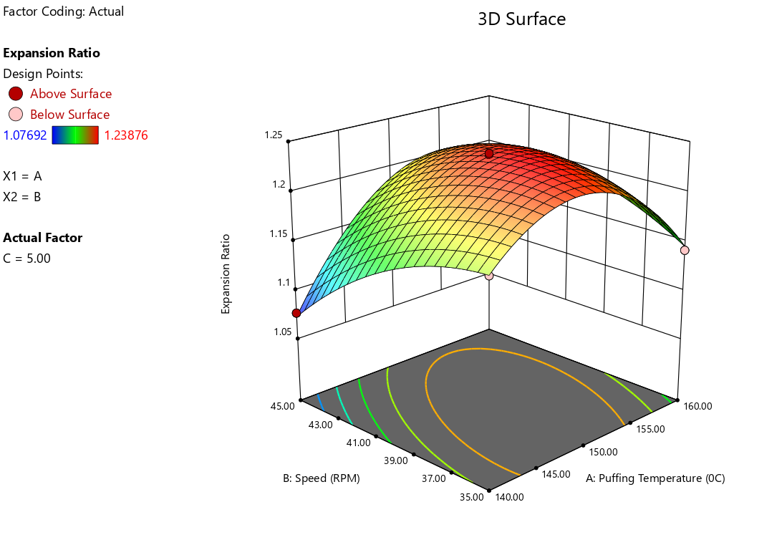
Fig. 5: Effect of puffing temperature and stirrer speed on expansion ratio of puffed soynuts at constant puffing time

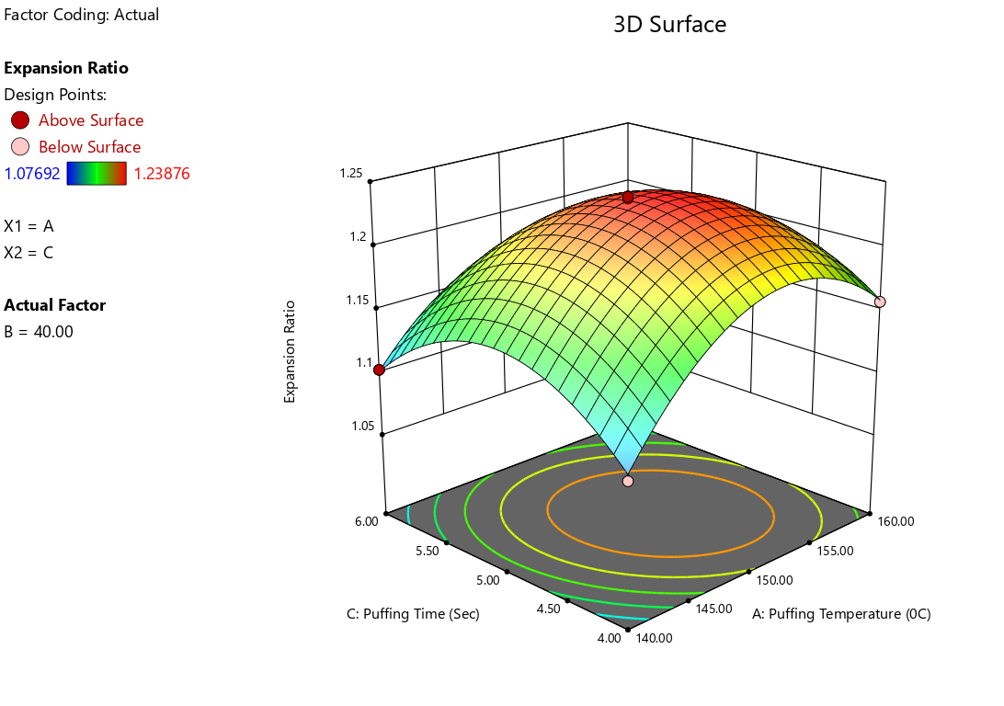
Fig. 6: Effect of puffing temperature and puffing time on expansion ratio of puffed soynuts at constant stirrer speed

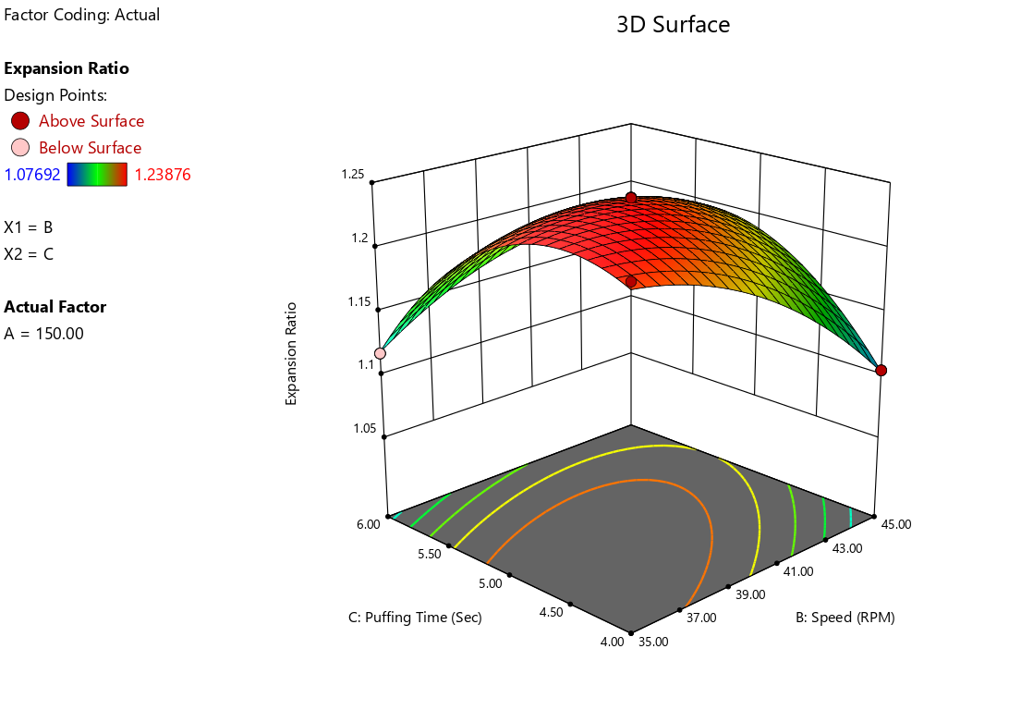
Fig. 7: Effect of stirrer speed and puffing time on expansion ratio of puffed soynuts at constant puffing temperature
To visualise the combined effect of two process parameters (variables) on expansion ratio, the response surface graphs were generated as a function of two variables while keeping the other variable at its central values. Graphical representations of the regression equation are shown through a three-dimensional (3D) response surface plot. As shown in Figs. 5, 6 and 7, it is clear that the expansion ratio of puffed soynuts increased with increasing puffing temperature (S₁) up to 150 °C, stirrer speed (S₂) up to 40 rpm and puffing time (S₃) at 5 min, respectively. Further, the expansion ratio of puffed soy nuts decreased at higher levels of these process parameters. The maximum expansion ratio of puffed soynuts was found at the optimum level of process variables, that is, S₁ (150 °C) puffing temperature, S₂ (40 rpm) stirrer speed, and S₃ (5 min) puffing time.

4.3.3 Effect of process parameter on bulk density (BD) for the production of puffed soynuts
The bulk density of puffed soynuts is the ratio of the weight of puffed soynuts to their volume of puffed soynuts. The bulk density of the design matrix and the response values obtained for the combination of the three factors at the three levels are given in Table 3. The responses were analysed using coded machines to evaluate the significant effects of three factors: puffing temperature (S₁) of puffed soynuts, stirrer speed (S₂) and puffing time (S₃) of puffed soynuts. The higher the expansion volume of puffed soynuts, the lower the bulk density of puffed soynuts. Bulk density values for puffed soynuts ranged from 601.82 to 705.88 kg/m³, as shown in Table 3. The regression equation for bulk density is as follows:

BD (Kg/m³) =12126.94 - 157.00 S₁ + 4.88 S₂ + 13.76 S₃ - 0.12 S₁S₂ - 5.28 E003 S₁S₃ - 0.68 S₂S₃ + 0.55 S₁² + 0.18 S₂² + 4.35 S₃²
(R²=0.994) …..(4.3)
Where,
S₁ = Puffing temperature, S₂ = Stirrer speed and S₃= Puffing time
The given regression equation (4.3) models bulk density (BD) in kg/m³ as a function of three independent variables S₁, S₂ and S₃. This model incorporates linear, interactive, and quadratic terms, making it a second-order polynomial regression model. The significant negative linear effect of S₁ suggests that BD decreases with increasing S₁, but the positive quadratic term indicates that beyond a certain threshold, BD might start increasing. The positive contributions of S₂ and S₃ suggest that higher values of these parameters generally enhance the BD. The interaction effects are negative, which means that increasing the two variables together does not necessarily yield an additive or synergistic improvement in BD. The three linear parameters were significant, of which the puffing temperature was the most influential parameter on bulk density, followed by puffing time and stirrer speed.

Table 7: Analysis of variance (ANOVA) for process parameters showing the effect on bulk density of puffed soynuts
Source | Sum of Squares | df | Mean Square | F-value | P-value
Model | 19829.09 | 9 | 2203.23 | 130.72 | < 0.0001*
(S₁): Puffing temperature | 6090.6 | 1 | 6090.6 | 361.35 | < 0.0001*
(S₂): Stirrer speed | 347.42 | 1 | 347.42 | 20.61 | 0.0027*
(S₃): Puffing time | 97.32 | 1 | 97.32 | 5.77 | 0.0473*
S₁S₂ | 132.87 | 1 | 132.87 | 7.88 | 0.0262*
S₁S₃ | 0.011 | 1 | 0.011 | 6.60E-04 | 0.9802
S₂S₃ | 45.63 | 1 | 45.63 | 2.71 | 0.1439
S₁² | 12636.36 | 1 | 12636.36 | 749.71 | < 0.0001*
S₂² | 86.06 | 1 | 86.06 | 5.11 | 0.0584
S₃² | 79.61 | 1 | 79.61 | 4.72 | 0.0663
Residual | 117.98 | 7 | 16.85
Lack of Fit | 97.65 | 3 | 32.55 | 6.4 ^{NS} | 0.0524
Pure Error | 20.33 | 4 | 5.08
Cor Total | 19947.07 | 16
R-Squared | 0.9941
Adj R-Squared | 0.9865
Pred R-Squared | 0.9201
Std. Dev. | 4.11
Mean | 634.13
C.V. % | 0.65
*Significant at 5 % level NS- Non significant
Where, bulk density (kg/m³), puffing temperature (ºC), stirrer speed (rpm) and puffing time (min).
Table 7 shows that all linear terms, interaction terms S₁S₂ and quadratic term S₁² are significant at (P < 0.05) level of significance. The linear model was found to fit well for the data, and the model F value of 130.72 implies that the model is significant. The lack-of-fit test was not significant, and the predicted R² value was compatible with the adjusted R² value. The coefficient of determination (R² = 0.994) indicated that the model explained 99.41% of the variability in BD, suggesting an excellent fit.

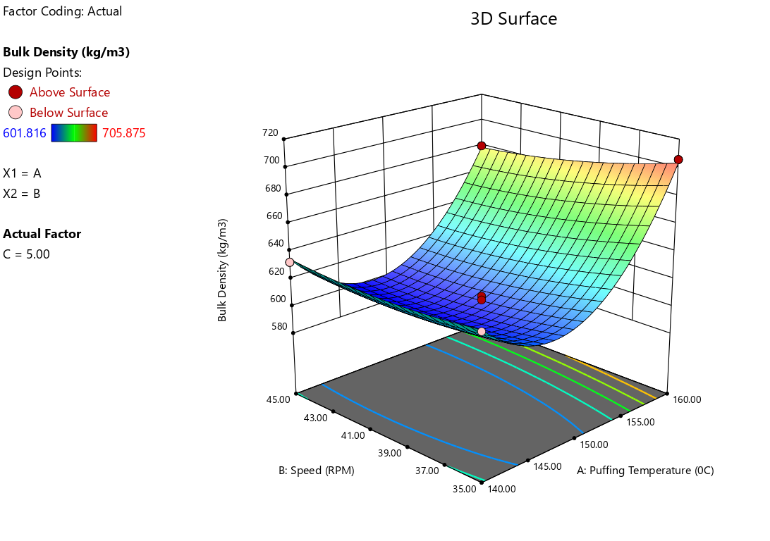
Fig. 8: Effect of puffing temperature and stirrer speed on bulk density of puffed soynuts at constant puffing time

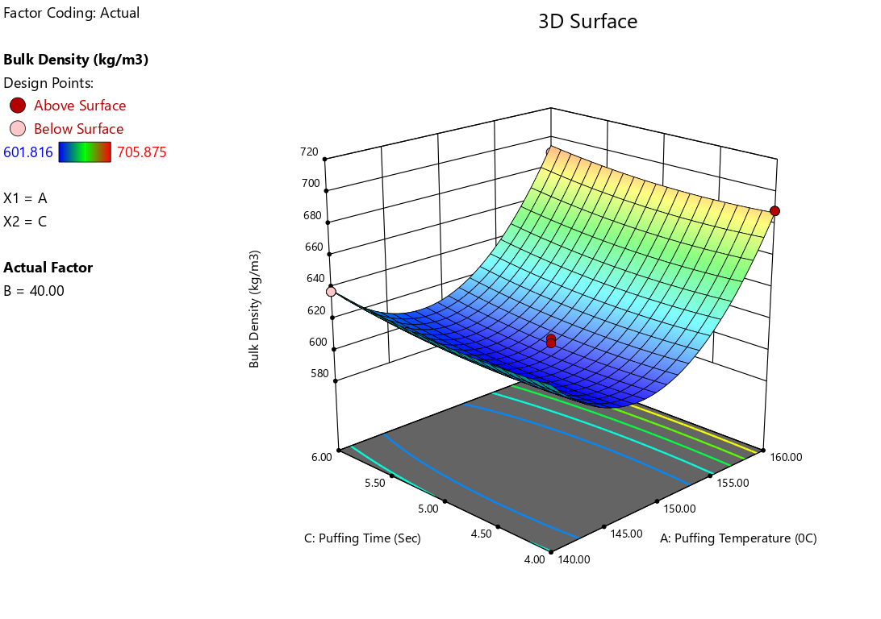
Fig. 9: Effect of puffing temperature and puffing time on bulk density of puffed soynuts at constant stirrer speed
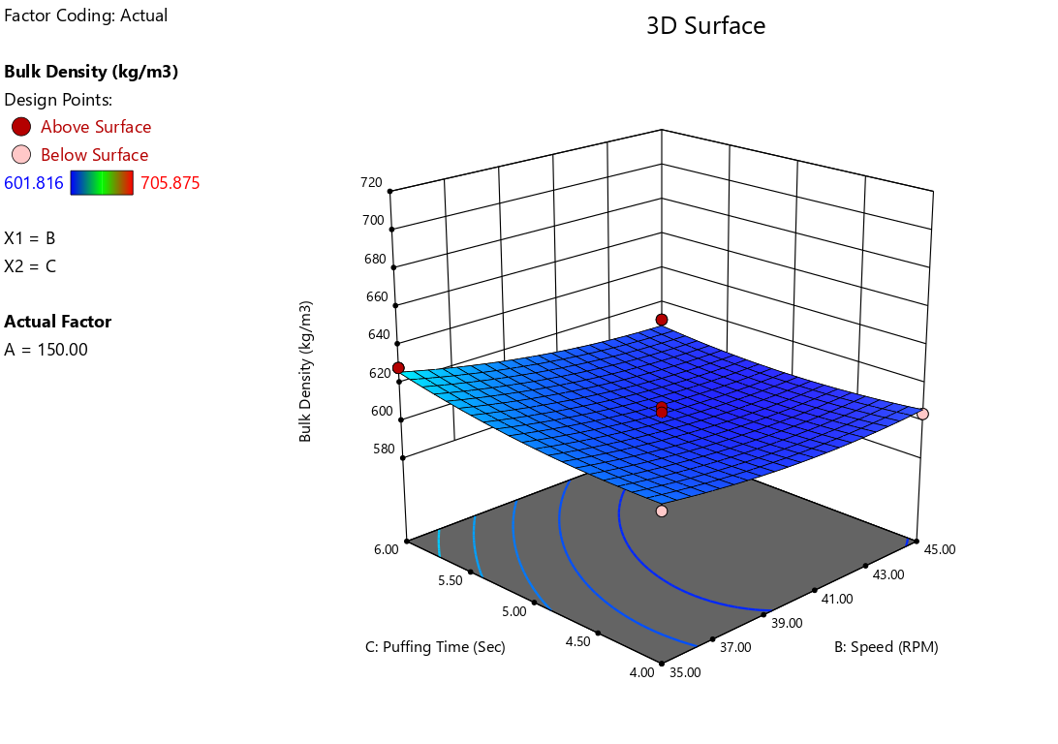

Fig. 10: Effect of stirrer speed and puffing time on bulk density of puffed soynuts at constant puffing temperature
As shown in Figs. 8, 9 and 10, it is clear that the bulk density of puffed soynuts decreases with increasing puffing temperature (S₁) up to 150 °C, stirrer speed (S₂) up to 40 rpm and puffing time (S₃) at 5 min, their bulk density value of puffed soybean increased at higher levels of these process parameters. The optimum bulk density of puffed soynuts was found at the following optimum process variables: S₁ (150°C) puffing temperature, S₂ (40 rpm) stirrer speed and S₃ (5 min) puffing time.
It was visually observed that the soybean grains were not properly puffed at lower temperatures, 140°C, which may be because the pressure inside the kernel was low, resulting in a less expanded structure and ultimately decreasing the bulk density of puffed soy nuts. Similar results were obtained by Subramani et al. (2020), Jadhav (2018), and Khedekar (2013) for soybean puff.
4.3.4 Effect of process parameter on colour for the production of puffed soynuts:
The colour of puffed soy nuts was determined using a Colour Flex Hunter Lab Colourimeter in terms of L value. The colour (L value) indicates the lightness of the puffed soy nuts. The lightness value indicates a measure of colour on the light-dark axis, which in turn denotes that the puffed soy nuts turned dark at reduced L value. The data recorded for the average colour of the puffed soynuts after each set of experiments with replications are shown in Table 3, and it ranged between 47.52 to 57.40 within the combinations of variables studied.
By applying multiple regression analysis to the experimental data, a second-order polynomial equation was established to estimate the relation between the response (colour L value) and independent variables (S₁, S₂ and S₃) during puffing, which is given by the following equation:
Colour, L value = -167.33 + 2.86 S₁ - 0.23 S₂ + 11.48 S₃ + 0.02 S₁S₂ - 0.10 S₁S₃ + 0.21 S₂S₃ - 0.01 S₁² - 0.039 S₂² - 0.73 S₃²
(R²= 0.989) ……. (4.4)
Where,
S₁ = Puffing temperature, S₂ = Stirrer speed and S₃= Puffing time
The above regression equation highlights the individual effect of process parameters on the L value of puffed soynuts, which likely represents a measure of brightness or lightness in a puffing process as a function of three independent variables. The coefficients of the regression equation with a positive sign for puffing temperature and puffing time indicate a synergistic effect, whereas the negative sign for the coefficient of stirrer speed represents an antagonistic effect on the colour response. The magnitude of the coefficient of linear terms of the model revealed that puffing time was the most influential process variable, followed by puffing temperature and stirrer speed.

Table 8: Analysis of variance (ANOVA) for process parameters showing the effect on colour L value of puffed soynuts
Source | Sum of Squares | df | Mean Square | F-value | p-value
Model | 139.7 | 9 | 15.52 | 74.94 | < 0.0001*
(S₁):Puffing temperature | 48.36 | 1 | 48.36 | 233.5 | < 0.0001*
(S₂): Stirrer speed | 31.6 | 1 | 31.6 | 152.57 | < 0.0001*
(S₃): Puffing time | 35.49 | 1 | 35.49 | 171.35 | < 0.0001*
S₁S₂ | 3.37 | 1 | 3.37 | 16.26 | 0.005*
S₁S₃ | 3.72 | 1 | 3.72 | 17.98 | 0.0038*
S₂S₃ | 4.22 | 1 | 4.22 | 20.39 | 0.0027*
S₁² | 5.26 | 1 | 5.26 | 25.41 | 0.0015*
S₂² | 4.09 | 1 | 4.09 | 19.74 | 0.003*
S₃² | 2.26 | 1 | 2.26 | 10.92 | 0.013*
Residual | 1.45 | 7 | 0.21
Lack of Fit | 0.91 | 3 | 0.3 | 2.28 ^{NS} | 0.2217
Pure Error | 0.54 | 4 | 0.13
Cor Total | 141.15 | 16
R-Squared | 0.9897
Adj R-Squared | 0.9765
Pred R-Squared | 0.8904
Std. Dev. | 0.46
Mean | 53.94
C.V. % | 0.84
*Significant at 5 % level NS- Non significant
Where, colour L value, puffing temperature (ºC), stirrer speed (rpm), puffing time (min)
Whether a quadratic model is significant or not could be determined through ANOVA as seen in Table 8. ANOVA shows that quadratic regression model (Eq.4.4) was highly significant. The colour F- value for model is 74.94 and it is insignificant as p-value < 0.0001..The model adequacy was further confirmed by a satisfactory value of

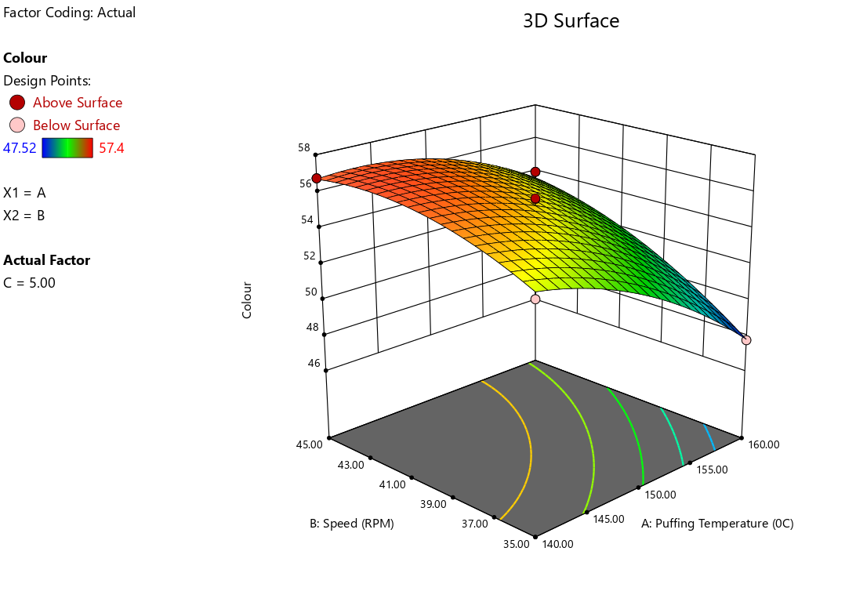
Fig. 11: Effect of puffing temperature and stirrer speed on colour L value of puffed soynuts at constant puffing time
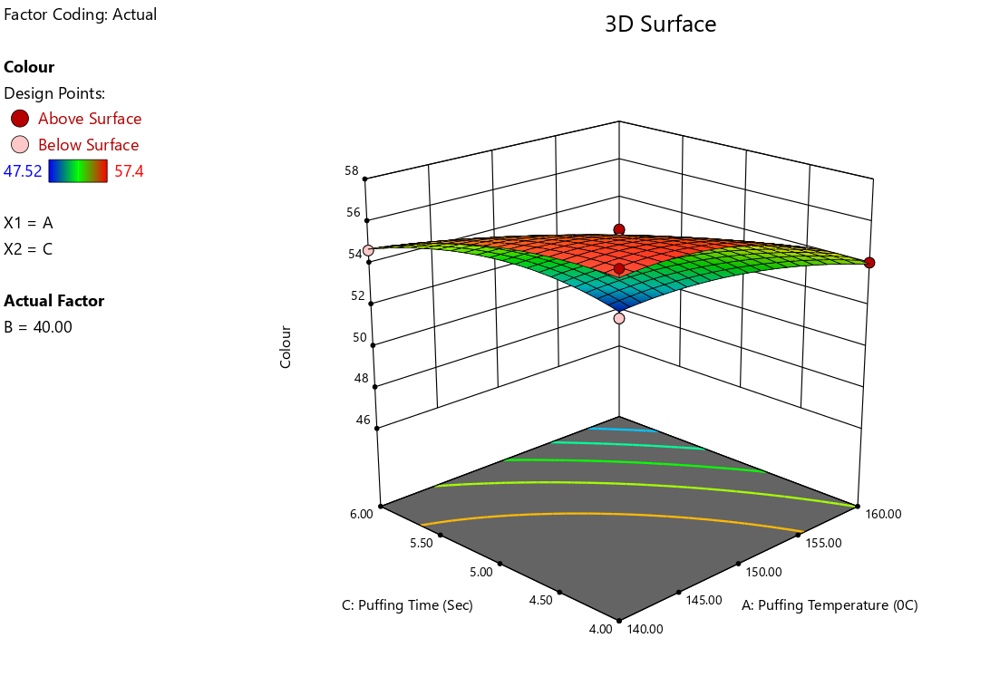
Fig. 12: Effect of puffing temperature and puffing time on colour L value of puffed soynuts at constant stirrer speed

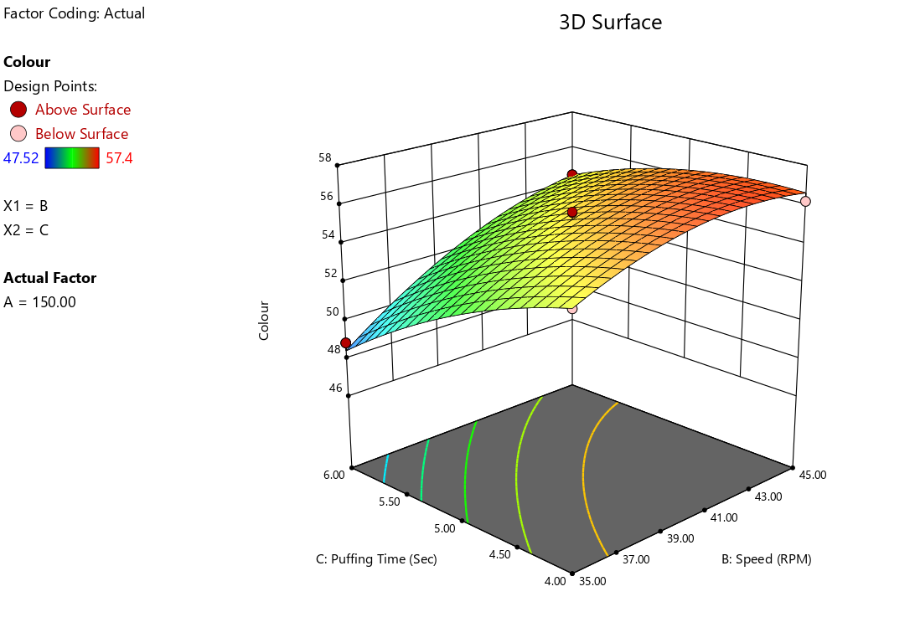
Fig. 13: Effect of stirrer speed and puffing time on colour L value of puffed soynuts at constant puffing temperature
, the determination coefficient R², which was calculated to be 0.989, demonstrating strong predictive capability. The value suggests that the model could predict 98.97 % of the variability in the response. It is adequate for this regression model within the range of experimental variables. The value of the F test for lack of fit is 2.28, which implies that there is a non-significant lack of fit at (P < 0.05) significance level and the model is acceptable.
The response surfaces and contour plots for L* value of RTE puffed soynuts were generated for the fitted model as a function of two variables while keeping the third variable at its central value, which was presented in Figs. 11,12,13. These figures exhibited that, colour value of puffed soybean increased with increase in puffing temperature (S₁) of raw soybean up to 150 ºC, stirrer speed (S₂) up to 40 rpm and puffing time (S₃) at 5 min, further colour value of puffed soynuts decreased at higher levels of these process parameters. As puffing temperature increased from 140 ºC to 150 ºC, the colour value of puffed soynuts increased up to 150 ºC, and further it decreased and puffed soynuts became darker with the increase in puffing temperature up to 160 ºC. As per visual observations, at 140 ºC puffing temperature, soybean grains were not properly puffed; however, at 160 ºC puffing temperature, soybean grains were almost spot burned and were not acceptable in terms of colour L value. Kahgyoglu and Kaya (2006) also stated that denaturation of protein inside the grain particles after puffing may be the factor contributing to the overall decrease in L value of RTE puffed soy nuts. Puffing time (S₃) and puffing temperature (S₁) a key factors influencing brightness, but excessive temperatures may have diminishing returns; it's possibly due to due to thermal degradation. Stirrer speed (S₂) has a small negative impact on brightness, suggesting that too much agitation might cause darkening, possibly due to oxidation or uneven processing. Thus, L value is an adequate parameter for monitoring the colour change and thus for controlling the puffing of puffed products (Ozdemir and Devres, 2000).
4.3.5 Effect of process parameters on hardness for the production of puffed soy nuts
Hardness is defined as the force required to compress a substance to a given deformation or penetration and is designated as soft, hard or firm. The hardness value was considered as the mean peak compression force. Hardness of the puffed soy nuts was measured for different combinations of process parameters by using TA.XT-2 Texture Analyser as per the experimental design and presented in Table 3. Hardness value of puffed soynuts varied between 37.98 to 92.57 N within the combination of variables studied.
The quadratic equation describing the effect of the process parameters on the hardness of puffed soynuts in terms of actual level of variables is given as:
HRD (N) = 4873.20 - 62.97 S₁ + 25.10 S₂ - 233.36 S₃ - 0.21 S₁S₂ + 1.50 S₁S₃ - 2.91 S₂S₃ + 0.21 S₁² + 0.28 S₂² + 12.81 S₃²
(R²= 0.981) ……. (4.5)
Where,
S₁ = Puffing temperature, S₂ = Stirrer speed and S₃= Puffing time
The above equation presents the regression coefficients (linear, interactive and quadratic) pertaining to process variables along with their respective level of significance. The positive sign of the linear coefficient indicated that, with an increased level of stirrer speed, there was an increase in the hardness value, while the negative sign of the linear coefficient indicated that the hardness value of puffed soynuts decreased with an increase in puffing temperature and puffing time. From the above equation, it is clear that the puffing time was the most influential parameter on the hardness value of puffed soynuts, followed by puffing temperature and stirrer speed.
Table 9: Analysis of variance (ANOVA) for process parameters showing the effect on hardness of puffed soy nuts
Source | Sum of Squares | df | Mean Square | F-value | p-value
Model | 5867.83 | 9 | 651.98 | 41.52 | < 0.0001*
(S₁): Puffing temperature | 400.02 | 1 | 400.02 | 25.47 | 0.0015*
(S₂): Stirrer speed | 161.3 | 1 | 161.3 | 10.27 | 0.015*
(S₃): Puffing time | 94.45 | 1 | 94.45 | 6.01 | 0.044*
S₁S₂ | 447.53 | 1 | 447.53 | 28.5 | 0.0011*
S₁S₃ | 901.8 | 1 | 901.8 | 57.42 | 0.0001*
S₂S₃ | 848.32 | 1 | 848.32 | 54.02 | 0.0002*
S₁² | 1869.62 | 1 | 1869.62 | 119.05 | < 0.0001*
S₂² | 200.76 | 1 | 200.76 | 12.78 | 0.009*
S₃² | 690.68 | 1 | 690.68 | 43.98 | 0.0003*
Residual | 109.93 | 7 | 15.7
Lack of Fit | 70.15 | 3 | 23.38 | 2.35 ^{NS} | 0.2136
Pure Error | 39.78 | 4 | 9.95
Cor Total | 5977.76 | 16
R-Squared | 0.9816
Adj R-Squared | 0.9580
Pred R-Squared | 0.8018
Std. Dev. | 3.96
Mean | 61.77
C.V. % | 6.42
*Significant at 5 % level NS- Non significant
Where,
hardness (N), puffing temperature (ºC), stirrer speed (rpm), puffing time (min).
From Table 9 model F value of 41.52 implies that the model is significant (p-value < 0.0001). The lack of fit F value (2.35) was non-significant for the model as the p-value was 0.2136. Moreover, the predicted coefficient of determination of 0.8018 was in reasonable agreement with the adjusted coefficient of determination of 0.9580; i.e., the difference is less than 0.2. Therefore, this model could be used to navigate the design space.

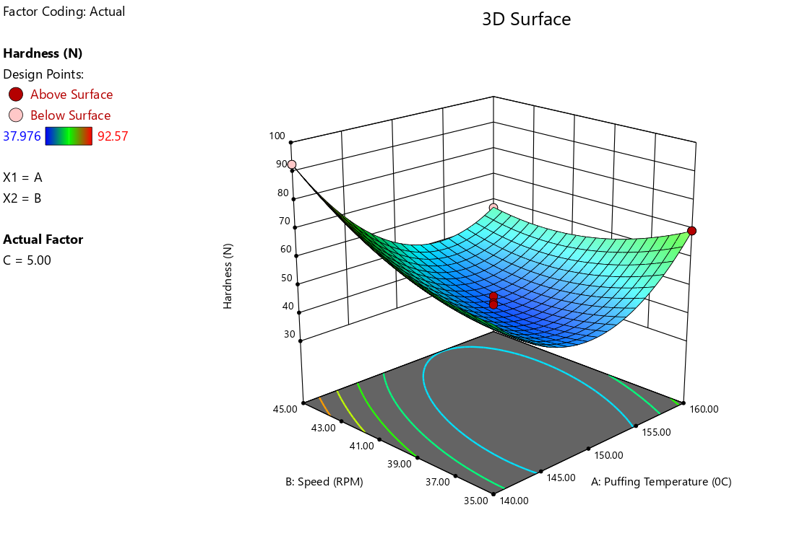
Fig. 14: Effect of puffing temperature and stirrer speed on hardness value of puffed soynuts at constant puffing time

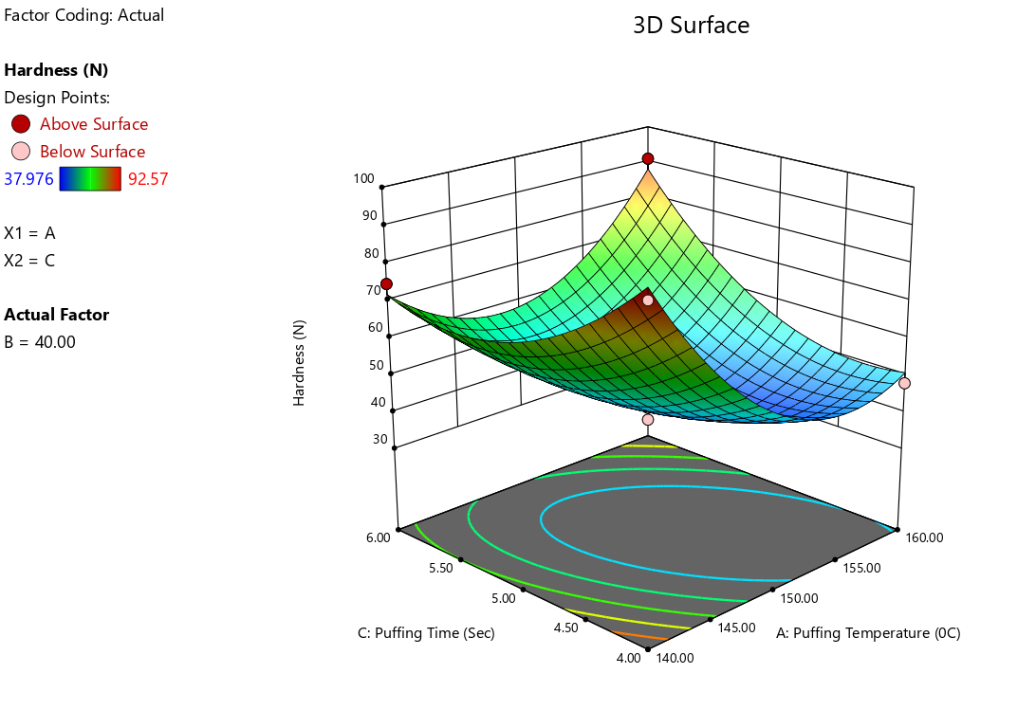
Fig. 15: Effect of Puffing temperature and puffing time on hardness value of puffed soynuts at constant stirrer speed

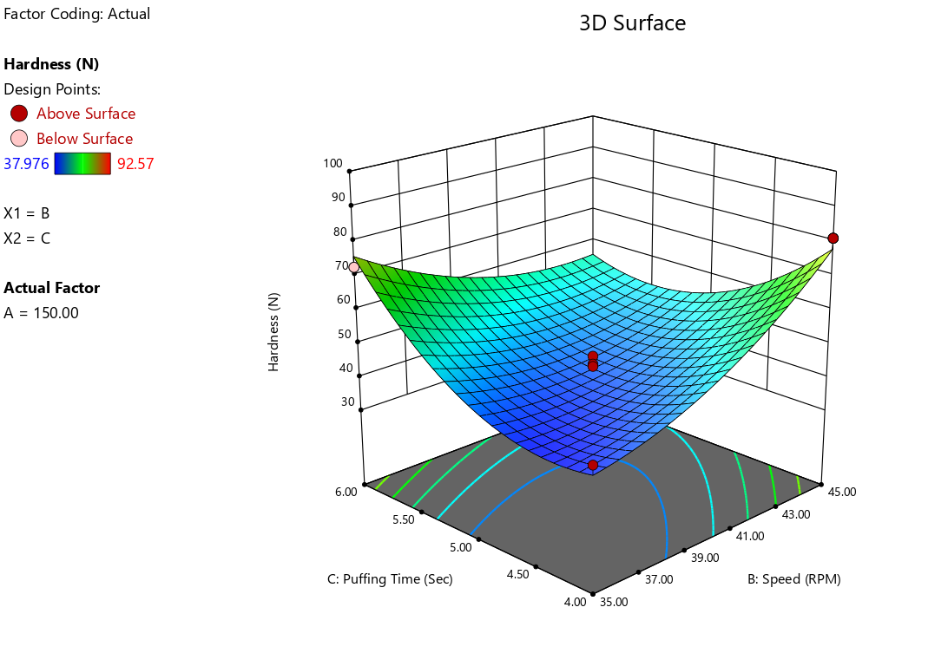
Fig. 16: Effect of stirrer speed and puffing time on hardness value of puffed soynuts at constant puffing temperature
To visualise the combined effect of two variables on hardness, the response surface contour plots (Figs. 14 through 16) were generated for the fitted model as a function of two variables while keeping the other variable at a constant value. It was observed that the hardness of puffed soynuts decreased with an increase in puffing temperature of (S₁) up to 150 ºC, stirrer speed (S₂) up to 40 rpm, and puffing time (S₃) up to 5 min. Further hardness of puffed soy nuts increased at high levels of these process parameters. This may be due to the loss and gain in moisture content and exposure to lower temperatures during puffing, causing the more hard texture, toughness and higher temperature brittleness. Similar results were observed in the case of roasted soy nuts quoted by Deshmukh (2016).
4.3.6 Effect of process parameter on crispness for the production of puffed soynuts:
The crispness of the puffed soy nuts were measured for different combinations of process parameters by using TA.XT-2 Texture Analyser as per the experimental design and presented in Table 3. The experimental values of crispness were in the range of 10 to 24 within the combinations of variables studied. The second-order polynomial equation illustrated the relationship of the three variables, which was established to explain crispness in equation 4.6.
CSP (number of +ve peaks) = -1361.88 + 16.21 S₁ - 1.38 S₂ + 77 S₃ + 0.05 S₁S₂ - 0.35 S₁S₃ + 0.4 S₂S₃ - 0.054 S₁² - 0.10 S₂² - 4.13 S₃²
(R²=0.989) ……... (5.6)
Where, S₁ = Puffing temperature, S₂ = Stirrer speed and S₃= Puffing time
All linear terms, interaction terms and quadratic terms are significant in the above equation. The negative sign of the linear regression coefficient viz stirrer speed, revealed that with the increase in these process parameters, the crispness value. The positive sign of the linear regression coefficient of puffing temperature and puffing time revealed that with an increase in these process parameters increase the crispness value. The effect of puffing time on crispness value is the most influential factor, followed by puffing temperature and stirrer speed.

Table 10: Analysis of variance (ANOVA) for process parameters showing the effect on crispness of puffed soynuts
Source | Sum of Squares | df | Mean Square | F-value | P-value
Model | 354.37 | 9 | 39.37 | 73.5 | < 0.0001*
(S₁): Puffing temperature | 15.13 | 1 | 15.13 | 28.23 | 0.0011*
(S₂): Stirrer speed | 10.13 | 1 | 10.13 | 18.9 | 0.0034*
(S₃): Puffing time | 4.5 | 1 | 4.5 | 8.4 | 0.023*
S₁S₂ | 20.25 | 1 | 20.25 | 37.8 | 0.0005*
S₁S₃ | 49 | 1 | 49 | 91.47 | < 0.0001*
S₂S₃ | 16 | 1 | 16 | 29.87 | 0.0009*
S₁² | 121.64 | 1 | 121.64 | 227.07 | < 0.0001*
S₂² | 23.75 | 1 | 23.75 | 44.33 | 0.0003*
S₃² | 71.64 | 1 | 71.64 | 133.74 | < 0.0001*
Residual | 3.75 | 7 | 0.54
Lack of Fit | 1.75 | 3 | 0.58 | 1.17 ^{NS} | 0.4262
Pure Error | 2 | 4 | 0.5
Cor Total | 358.12 | 16
R-Squared | 0.9895
Adj R-Squared | 0.9761
Pred R-Squared | 0.9131
Std. Dev. | 0.73
Mean | 17.41
C.V. % | 4.2
*Significant at 5 % level NS- Non significant
Where,
crispness (number of +ve peaks), puffing temperature (ºC), stirrer speed (rpm), puffing time (min).
Table 10 shows that all linear terms, interaction terms S₁S₂ and quadratic term S₁² are significant at (p < 0.05) level of significance. The linear model was found to fit well for the data, and the model F value of 73.50 implies that the model is significant. Lack of fit test was not significant as the p-value exceeds the 5 % level of significance. The lack of fit of the model was not significant, which indicates that the model was correlated well with the measured data. The R² value was calculated by a least squares technique and found to be 0.9895, showing a good fit of the model to the data. Moreover, the predicted R² of 0.9131 was in reasonable agreement with the adjusted R² of 0.9761; i.e. the difference is less than 0.2. This revealed that the non-significant terms have not been included in the model. Therefore, this model could be used to navigate the design space.

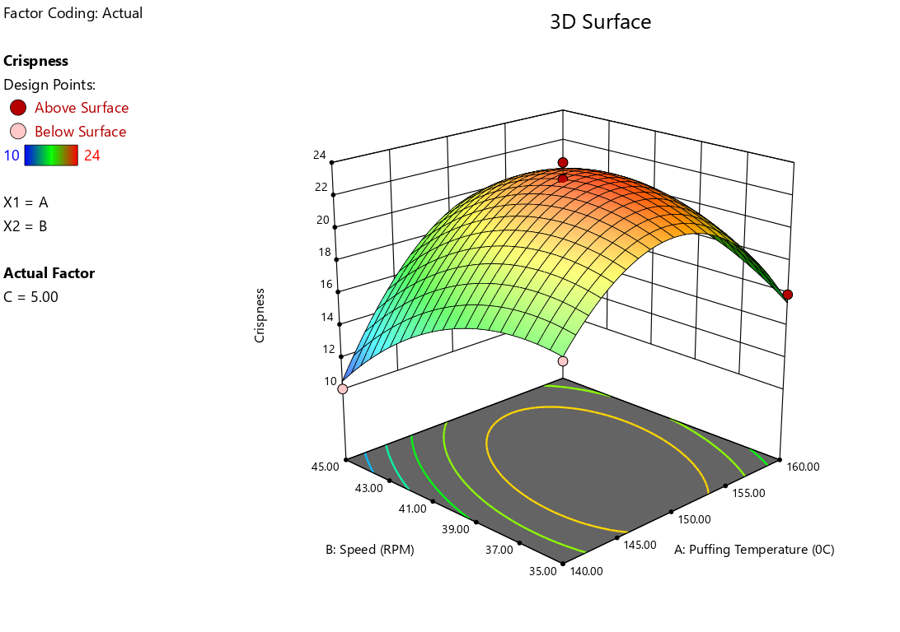
Fig. 17: Effect of puffing temperature and stirrer speed on crispness value of puffed soynuts at constant puffing time

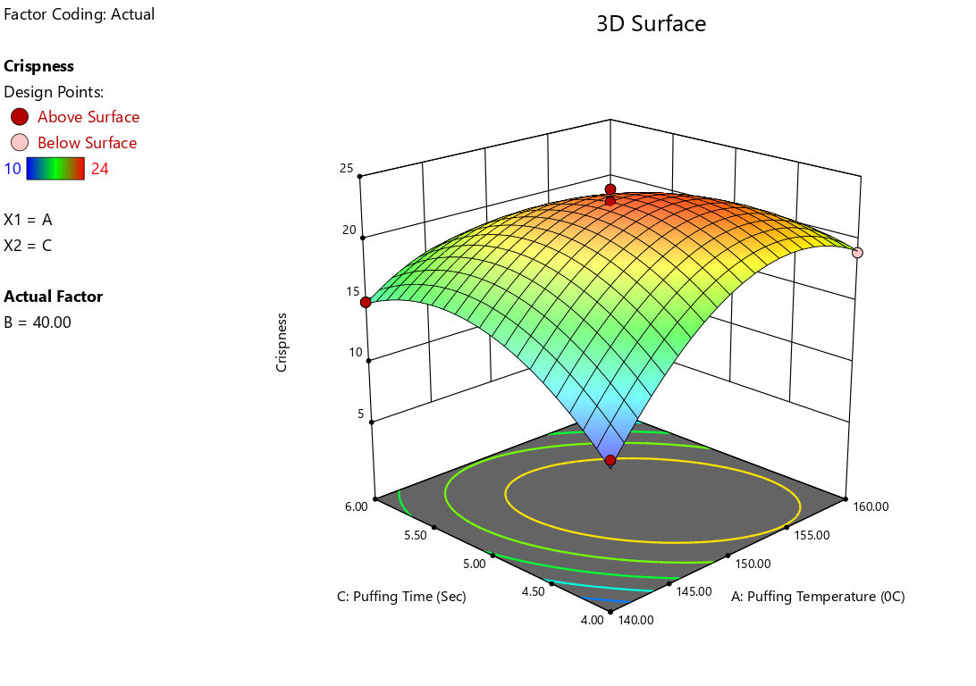
Fig. 18: Effect of puffing temperature and puffing time on crispness value of puffed soynuts at constant stirrer speed

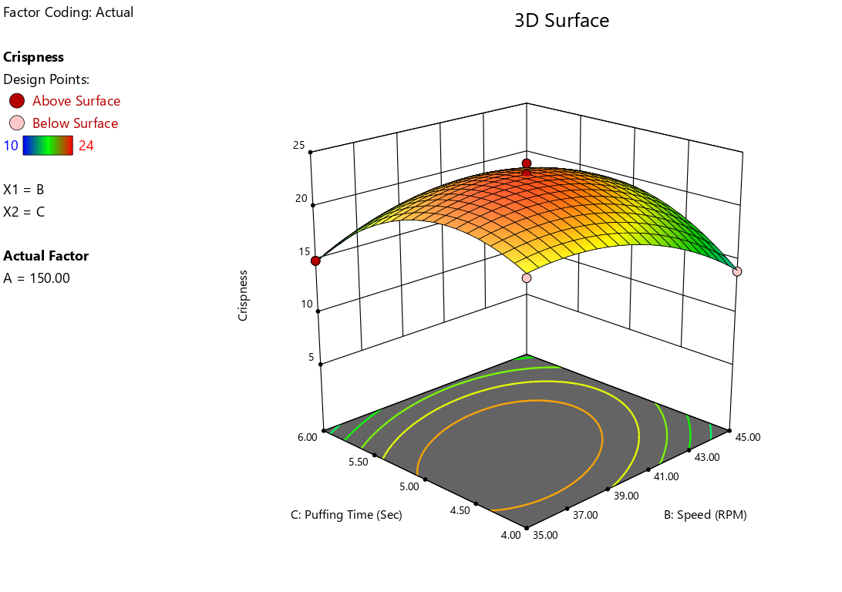

Fig. 19: Effect of stirrer speed and puffing time on crispness value of puffed soy nuts at constant puffing temperature
The response surface and contour plots as shown in Figs. 17,18,19 were generated for the fitted model (Eq. 4.6) as a function of two variables while keeping one variable at a constant value. It was noted that the crispness of puffed soynuts was increased with an increase in puffing temperature of (S₁) up to 150 ºC, stirrer speed (S₂) up to 40 rpm and puffing time 5 min. Further crispness of puffed soy nuts decreases at higher levels of these process parameters.
It was visually observed that, at higher puffing temperature of 160 ºC, crispness values of puffed soy nuts were decreased. This may be due to the fact that, at higher levels of puffing temperature up to 160 ºC, soynuts get over-burned and burned and resulting a brittle texture, thereby reducing the crispness value of RTE puffed soynuts. Similar results were observed by Jadhav (2018) for the crispiness value of puffed soy nuts.
4.3.7 Optimisation and validation of process parameters for the production of puffed soynuts
Optimisation of process parameters was done using Design Expert 8.0.6 software. The optimisation of process parameters such as puffing temperature, stirrer speed and puffing time was necessary to obtain better quality of puffed soynuts. Optimisation of process parameters for puffed soynuts was performed on the basis of its quality characteristics, such that good quality puffed soynuts should have maximum puffing efficiency, expansion ratio and optimum range in hardness, colour L value, bulk density and crispness.
Table 11: Constraints of process parameters for the production of puffed soy nuts
Independent variable | Goal | Lower limit | Upper limit
Puffing temperature (ºC) | in range | 140 | 160
Stirrer speed (rpm) | in range | 35 | 45
Puffing time (min) | in range | 4 | 6
Puffing efficiency (%) | Maximum | 68.18 | 98.41
Expansion ratio | Maximum | 1.07 | 1.24
Bulk density (Kg/m³) | in range | 601.81 | 705.88
Colour L value | in range | 47.52 | 57.40
Hardness (N) | in range | 37.98 | 41
Crispness (number of +ve peaks) | in range | 22 | 24

The constraints (Lower limit, upper limit and target value) given in Table 11 were used to find out the range of optimum values of process variables S₁ (Puffing temperature), S₂ (Stirrer speed) and S₃ (Puffing time).
4.3.8 Numerical optimisation for the production of puffed soynuts
Numerical optimisation was carried out by putting the values of independent variables within the experimental range and by setting desirable goals for each response (Table 11). The simultaneous optimisation of the multiple responses was carried out, and it gives optimum conditions of process parameters with the predicted values of responses. For more precise values of the responses, a solution having maximum desirability (1.00) was selected (Appendix B).
The optimum values of process variables obtained by numerical optimisation are as follows:
Puffing temperature (ºC): 151.84 ≈ 150
Stirrer speed (rpm) : 38.45 ≈ 40
Puffing time (min) : 4.67 ≈ 5
4.3.9 Graphical optimisation for the production of puffed soy nuts
The graphical optimisation was carried out by superimposition of contours to find the range of process parameters in which the values of responses given by numerical optimisation were obtained. It is evident from Fig. 20 (a b and c) that the predicted values of all responses lie well within the optimum intersection zone of process parameters; regions that do not fit the optimisation criteria are shaded grey and the maximum desirability function point is presented in the yellow zone. The superimposed contours of all responses for puffing temperature (ºC) vs stirrer speed (rpm) is shown in Fig.20 (a); puffing temperature (ºC) vs puffing time (min) is shown in Fig20 (b) and puffing time (min) vs stirrer speed (rpm)is shown in Fig.20(c).
The superimposed contours of all responses is shown in Fig.20 (a) for puffing temperature (ºC) vs stirrer speed (rpm); in Fig. 20 (b) puffing temperature (ºC) vs puffing time (min) and in Fig. 20 (c) puffing time (min) vs stirrer speed (rpm).
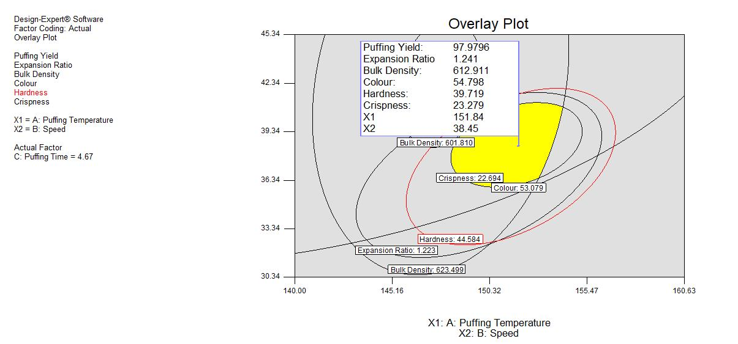
(a)
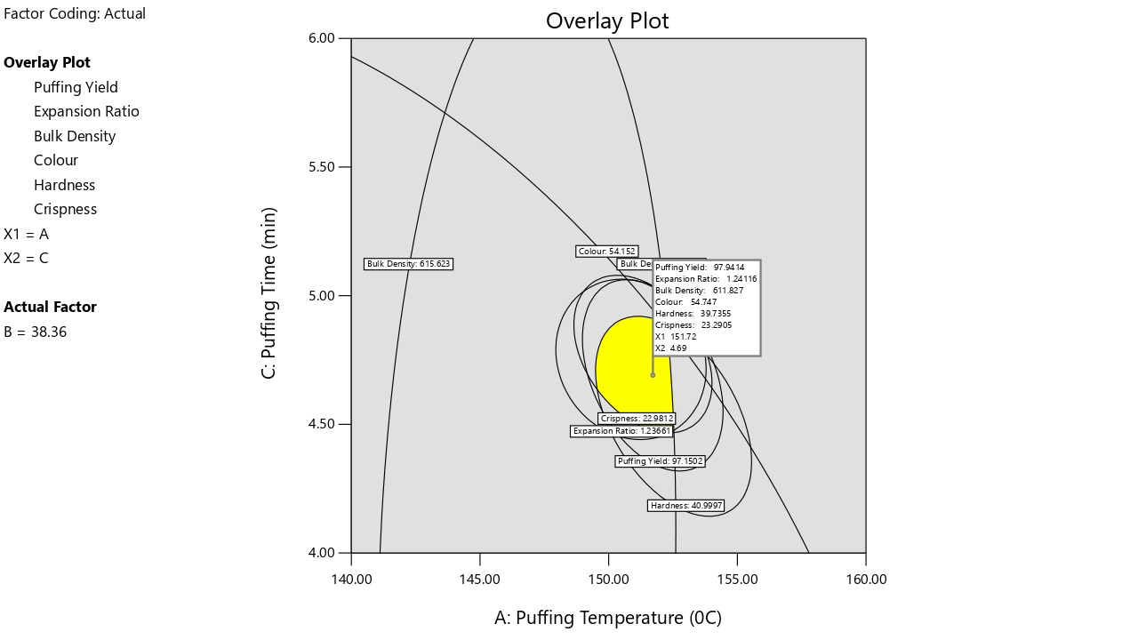
(b)
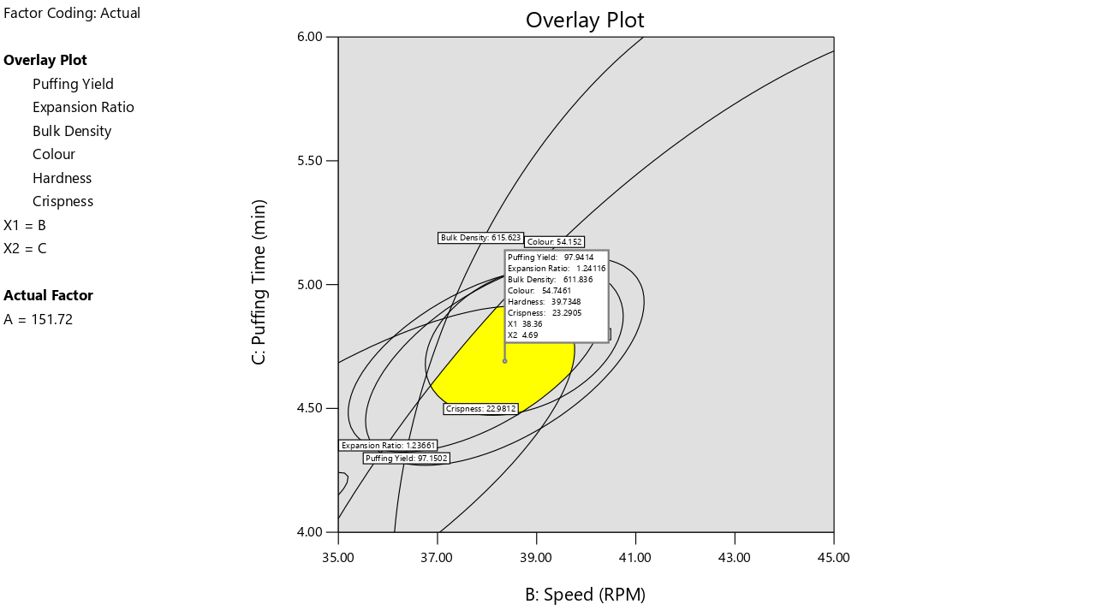(c)
Fig. 20 (a, b and c): Overlay plot showing predicted value of quality characteristics of puffed soynuts
The optimum values of responses obtained by graphical optimization as follows:
Puffing efficiency (%) : 97.97
Expansion ratio : 1.24
Bulk density (kg/m³) : 612.91
Colour L value : 54.79
Hardness (N) : 39.71
Crispness (number of +ve peaks) : 23.27

4.3.10 Validation of the model for the production of puffed soynuts:
The predicted optimum values of responses viz., puffing efficiency, expansion ratio, bulk density, colour L value, hardness and crispness were verified by preparing the puffed soynuts using the combination of optimum condition of process variables i.e. 150 °C puffing temperature (S₁), 40 rpm of stirrer speed (S₂) and 5 min of puffing time (S₃). Table 12 shows the predicted and experimental values of puffed soybean for puffing yield (%), expansion ratio, bulk density (kg/m³ ), colour L value (Lightness), hardness (N) and crispness (number of +ve peaks).

Table 12: Predicted and experimental values of responses for the production of puffed soynuts
Responses | Predicted values | Experimental values | CV (%)
Puffing efficiency (%) | 98.46 | 97.24 | 0.88
Expansion ratio | 1.148 | 1.171 | 1.403
Bulk density (kg/m³) | 601.91 | 604.18 | 0.27
Colour L value | 55.27 | 54.36 | 1.17
Hardness (N) | 42.54 | 41.75 | 1.32
Crispness (number of +ve peaks) | 23.20 | 22.40 | 2.48

From Table 12, it was observed that experimental values and predicted values are very close. The values predicted by the equation of puffing efficiency (%) (Eq.4.1), expansion ratio (Eq 4.2), bulk density (kg/m³) (Eq.4.3), colour (L value) (Eq.4.4), hardness (N) (Eq.4.5) and crispness (number of +ve peaks) (Eq.4.6) were 98.46, 1.148, 601.91, 55.27, 42.54 and 23.20, respectively. As a general rule, the coefficient of variation (CV) should not be greater than 10%. In this study, the coefficients of variation were less than 10% for all the responses, which indicates better precision and reliability of the experiments carried out. There was no significant difference between the experimental and predicted values of quality characteristics as indicated by lower values of CV. This indicated the suitability of the corresponding models. Therefore, it could be concluded from the discussion that the model developed for the puffing efficiency, expansion ratio, bulk density (kg/m³), colour (L value), hardness (N), and crispness (number of +ve peaks) was adequate to assess the quality of the puffed soynuts.
4.3.11 Standardised flowchart for the production of puffed soy nuts

Soybean (1 Kg)

Cleaning

(1:3 Grain to water ratio)
(Soaking Time 3 min)

Soaking in hot water (100 ºC)

Draining

Surface Drying, 3h

Heating media - Table salt
Grain: Table salt -1:4
Puffing temperature – 150 ºC Stirrer speed - 40 rpm
Puffing time - 5 min
Puffing

Puffed soynuts (925 g)
Fig. 21: Process flow chart for production of puffed soy nuts prepared from soybean
In Fig. 21 process flow chart for the production of puffed soynuts prepared from soybean on batch batch-type semiautomatic multigrain puffing-cum-popping machine is given. The standard process for the production of puffed soy nuts was adopted as per Nilza (2022). The puffing efficiency for the production of puffed soynuts of this design and developed batch type semiautomatic multigrain puffing-cum-popping machine was found as 98 %. The output quantity of puffed soy nuts was obtained as 925 g per kg raw soybean.
Conclusions:
The optimised values of the process parameters for the production of puffed soynuts on the design and developed batch-type semi-automatic puffing-cum-popping machine obtained were puffing temperature (S₁) 150 ºC, stirrer speed (S₂) 40 rpm and puffing time 5 min. The quantity of puffed soy nuts was obtained as 925 g per kg raw soybean. The optimum values of responses obtained by graphical optimisation were 97.97 % puffing efficiency (%), 1.24 expansion ratio, 612.91 kg/m³ bulk density, 54.79 colour L value, 39.71 N hardness and 23.27 (number of +ve peaks) crispness. The developed batch-type semiautomatic puffing-cum-popping machine has proven to be well-suited for the production of puffed soynuts at small-scale industries, had a puffing capacity of 80 kg/day.

Disclaimer (Artificial intelligence)
Option 1:
Author(s) hereby declare that NO generative AI technologies such as Large Language Models (ChatGPT, COPILOT, etc.) and text-to-image generators have been used during the writing or editing of this manuscript.
Option 2:
Author(s) hereby declare that generative AI technologies such as Large Language Models, etc. have been used during the writing or editing of manuscripts. This explanation will include the name, version, model, and source of the generative AI technology and as well as all input prompts provided to the generative AI technology
Details of the AI usage are given below:
1.
2.
3.

References:
Addesso,K., Dzurenko,T.E., Moisey,M.J., Levine,H., Slade,L. and Manns,J.M. (1995). Production of chip-like starch based snacks. US Patent, 93-5791819930507.
Ali,N.(2003).Soybean production and utilization in India status, prospects and strategy. Proceedings of ISPUC-IV Bhopal, India,1-6.
Anjitha, P. K., Baskaran, N., Venkatachalapathy, N. & Tito, Anand. (2021). Nutritional changes of sorghum after popping by a developed infrared assisted hot air popping . Int. J.Curr. Microbiol. App.Sci. 10(01), 3620-3627.
. (1),111-119
Dixit, A.K., Antony, J.I.X., Sharma, N. K. and Tiwari, R.K. (2011). Soybean constituents and their functional benefits. Opportmachiney, Challenge and Scope of Natural Products in Medicinal Chemistry, ISBN: 978-81-308-0448-4:367-383.
Donkeun, Park. & Joseph, M.A. (2000). Color, texture and sensory evaluation of selected hybrids of popped popcorn. Journal of Food Quality. 24(6), 563-574.
Ernoult,V., Moraru,C. I. and Kokoni, J. L. (2002). Influence of fat on
chemical, nutritional, optical, physical, rheological and textural attributes. Asian Journal of Chemistry, 29(6):1380-1392.
Lai, H.M. and Cheng, H. H. (2004). Properties of pre-gelatinized rice flour made by hot air or gun puffing. International Journal of Food Science & Technology, 39: 201-212.
Lee, E. Y., Lim, K., Lim, J. K. and Lim, S. T. (2000). Effect of gelatinization and moisture content of extruded starch pellets on morphology and physical properties of microwave expanded products. Cereal Chemistry,77 (6):769-773.
Lewis, K.,Lorenz, K. and Tribelhorn, R. (1992). Puffing quality of experimental varieties of proso millets (Panicummiliaceum). Cereal Chemistry, 69(4):359-365.
Liu, C., Zheng, X., Jia, S., Ding, N. and Gao, X. (2009). Comparative experiment on hot-air and microwave-vacuum drying and puffing of blue honey suckles nack. International Journal of Food Engineering, 5(4):1–11.
Llopart, E.E. & Drago, S. R. (2016). Physicochemical properties of sorghum and technological aptitude for popping. Nutritional changes after popping. LWT Food Science and Technology. 71: 316-322.
Luh, B.S. (1991). Breakfast rice cereals and baby foods, Chapter-8, Rice: Utilization (2ndedn.), AVI pub, USA, 2: 180-184.
Maisont, S. and Narkrugsa, W. (2010). Effects of salt, moisture content and microwave power on puffing qualities of puffed rice. Kasetsart Journal Natural Science, 44(2): 251-261.
Mandhare, L.L., More, D.R. and Nagulwar. (2020). Effect of popping methods on popping characteristics of quinoa seed. Journal of Pharmacognosy and Phytochemistry. 9(5), 1943-1945.
Marihonappanavara, N.,
puffed Ready-To-Eat (RTE) potato snacks: process parameter optimization. Journal of Food Engineering, 80: 770-780.
Nath, A. and Chattopadhyay, P. K. (2007a). Quality attributes of high temperature short time air puffed Ready-To-Eat potato snacks. International Journal of Food Properties, 10: 113-125.
Nath, A. and Chattopadhyay, P. K. (2008). Effect of process and soy flour concentration on quality attributes and micro-structural changes in RTE potato-soy snack using High Temperature Short Time air puffing. Journal of Food Engineering, 41:707-715.
Nath, A., Chattopadhyay, P. K. and Majumdar, G.C. (2012). Optimization of HTST process parameters for production of Ready-To-Eat potato-soy snack. Journal of Food Science Technology,49(4):427-438.
Pardeshi, I. L. (2009). Development of cereal based Ready To Eat snack foods. An unpublished Ph.D thesis submitted to Agricultural and Food Engineering Department, Indian Institute of Technology, Kharagpur (W.B.) - 721302, India.
Piotr, Z., Marek, M., Katarzyna, M., Arkadiusz, R. and Henryk (2006). Effect of temperature on the physical, functional and mechanical characteristics of hot air puffed amaranth seeds. Journal of Food Engineering, 76:469-476.
Pradeep, P. M., Dharmaraj, U., Rao, S.B., Senthil, A., Vijayalakshmi, N. S., Malleshi N. G. & Singh V. (2013). Formulation and nutritional evaluation of multigrain ready-to-eat snack mix from minor cereals. Journal of Food Science and Technology. 51(12), 3812-20.
Journal of Current Research and Academic Review, 2(1):164-170.
Singh, J. and Singh, N. (1999). Effect of different ingredients and microwave power on popping on popping characteristics of popcorn. Journal of Food
Solanki, C., Indore, N., Saha, D., and Kudos, S.K.(2018). Effect of popping methods on popping characteristics of amaranth grain. International Journal of Chemical Studies, 6(2): 2779-2782.
Soponronnarit, S., Swasdisevi, T., Wetchacama, S. and Wutiwiwatchai, W. (2001) Fluidised bed drying of soybeans. Journal Stored Products Research,37:133-151.
Subramani, D., Tamilselvan, S., Murugesan, M. & Shivaswamy, M. S. (2020). Optimization of sand puffing characteristics of quinoa using response surface methodology. Current Research in Nutrition and Food Science Journal. 8(2), 496-503.
Swarnakar, A.K., Srivastav, p.p. & Das, S.K. (2020). Optimization of pressure parboiling conditions and pre-conditioned moisture content of brown rice for microwave puffing and its comparison with hot sand bed puffing. International Journal of Food Studies. 9, 11-16.
Sweley, J. C., Rose, D. J. & Jackson, D. S. (2013). Quality traits and popping performance considerations for popcorn (Zea Mays Everta). Food reviews international. 29(2), 157-177.
Sweley,J.C., Meyer,M.C. and Rose,D.J. (2012). Effects of hybrid, environment, oil addition and microwave wattage on popped popcorn morphology. Journal of Cereal Science, 56: 276-281.
Tasie, M. M. & Gebreyes, B. G. (2020). Characterization of nutritional, antinutritional, and mineral contents of thirty-five sorghum varieties grown in Ethiopia. International Journal of Food Science, 2020.
Tavakoli,H., Rajabipour,A. and Mohtasebi,S.S. (2009). Moisture dependent some engineering properties of soybean grains. Agricultural Engineering International: the CIGR journal. Manuscript No.1110:9:1-14.
Tavanandi, H. A., Das, A. K., Venkateshmurthy, K. & Raghavarao, K. S. M. S. (2021). Design and development of a for continuous popping and puffing of grains. Journal of Food Science and Technology, 58 (5), 1703-1714.
Tunick, M. H., Onwulata, C. I., Thomas, A. E., Phillips, J. G., Mukhopadhyay, S., Sheen, S. & Cooke, P. H. (2013). Critical evaluation of crispy and crunchy textures: A review. International Journal of Food Properties. 16(5), 949-963.
Varela, G., Bender, A. E. and Morton, I. D. (1988). Frying of Foods Principles, Changes, New Approaches. Chichester, UK: Ellis Horwood.
Varnalis, A.L., Brennan, J.G. and Dougall, D.B. (2001). A proposed mechanism of high-temperature puffing of potato. Part-I. The influence of blanching and drying conditions on the volume of puffed cubes. Journal of Food Engineering,48(4):361-367.
Venkatesh, V. C., Goh, T. N., Wong, K. H. and Lim, M. J. (1989). An empirical study of parameters in abrasive jet machining. International Journal of Mechanical Tools Manufacture,29: 471.
Wiriyaum, S., Soponronnarit, S. and Prachayawarakorn, S. (2004). Comparative study of heating processes for full-fat soybeans. Journal of Food Engineering, 65:371-382.
Youn, K. S. and Chung, H. S. (2012). Optimization of the roasting temperature and time for preparation of coffee-like maize beverage using the response surface methodology LWT-Food Science and Technology, 46:305-310.
Bolla, K. N. (2015). Soybean consumption and health benefits. Int. J. Sci. Technol. Res, 4(7), 4.
Nilza Othzes, Smita Khodke and Madhuri Gajabe. Identification of variety of soybean for the production of quality puffed soynuts. The Pharma Innovation Journal. 2022; 11(12S): 1192-1197.
Kumari, S., Dambale, A. S., Samantara, R., Jincy, M., & Bains, G. (2025). Introduction, history, geographical distribution, importance, and uses of soybean (Glycine max L.). In Soybean Production Technology: Physiology, Production and Processing (pp. 1-17). Singapore: Springer Nature Singapore.
Guo, B., Sun, L., Jiang, S., Ren, H., Sun, R., Wei, Z., ... & Qiu, L. J. (2022). Soybean genetic resources contributing to sustainable protein production. Theoretical and Applied Genetics, 135(11), 4095-4121.
Zhang, M., Liu, S., Wang, Z., Yuan, Y., Zhang, Z., Liang, Q., ... & Tian, Z. (2022). Progress in soybean functional genomics over the past decade. Plant Biotechnology Journal, 20(2), 256-282.

Qin, P., Wang, T., & Luo, Y. (2022). A review on plant-based proteins from soybean: Health benefits and soy product development. Journal of Agriculture and Food Research, 7, 100265.

