# FORMULATION AND EVALUATION OF NUTRI-BAR INCORPORATING MILLET

**ABSTRACT**

This study set out to create and test a millet-based Nutri bar that includes ragi (finger millet) along with other nutrient-rich ingredients like wheat, jaggery, peanuts, oats, chia seeds, flaxseeds, and figs. Five different Nutri bars were made by changing the amount of ragi to wheat flour (0–100%) and checking their acceptability and nutritional content. A 9-point scale was used to measure taste and a detailed food analysis. The T3 mix (75% ragi, 25% wheat) turned out to have a high score of 7.8 for overall liking. When looking at the nutrients, T3 had a higher nutrient composition than the control (100% wheat) with more protein (24.25%) fibre (16.88%), and key minerals like calcium (142.4%), iron (2.67%), and potassium (124%). It also had many more vitamins B9, B6 A, E, and K. Adding ragi made the bar work better for the body helping digestion keeping blood sugar steady, and lowering the chance of long-term health problems. On top of that, T3 had less fat (14.7%) and carbs (51.1%) than the control making it a healthier snack choice. This research highlights the potential use of such bars to combat lifestyle diseases and improve the overall well-being of an individual. This study shows that millet-based nutri-bars could be a handy, nutrient-rich food option. They meet the growing need for wholesome, easy-to-eat snacks and help bring back old-school millets into today's diets.

***KEYWORDS* –** Millet nutri bar, sensory evaluation, nutritional composition, proximate analysis

# INTRODUCTION

The historical development of snack bars indicates a shift from historical medical foods to functional modern foods. For several years now, there has been a substantial interest in fast food and snack food production, due to changes in people’s lifestyles. Consumers have the tendency to look for easily prepared food, such as snacks, which are defined as alternatives to quick meals with or without substantial nutritional value (Constantin & Istrati, 2018; Boukid et al., 2022). Numerous types of energy bars have been developed and are referred by different names such as protein bars, cereal bars, snack bars, diet bars, granola bars, neutraceutical bars, health bars, whole food bars, fibre bars and so on(Ananthan et al., 2021; Serna-Saldivar, 2022). "Pastéli," made of sesame, nuts and honey eaten by the ancient Greeks, is said to be the "first-ever energy bar formulated." It was valued primarily because its various components allegedly contained healing powers. This observation illustrates this early understanding of food as more than mere fuel. The modern snack bar went through a clear episodes of development, initiated by the introduction of "Space Food Sticks in the 1960s. Space Food Sticks were developed by NASA and Pillsbury for astronauts as a lightweight and nutritionally complete food that could sustain astronauts through extended missions. This phase of awareness highlighted the functional nature of these products as they were designed to reach a specific purpose in the diet. At a later point in time, the emphasis turned to athletes with the introduction of the "Power Bar" in 1986. The "Power Bar" is a snack bar developed by a marathon runner and nutritionist intended for the purpose of improving athletic performance, the first mass-market snack bar. This shift also illustrates the growing recognition of the significance of nutrition to physical performance and overall well-being. (Gill et al., 2022).

Portion control is very important for being a healthy weight. Not only is being a healthy weight important for disease prevention (heart disease, diabetes, certain cancers) and other health concerns but also a balanced table is essential. To promote the metabolism, and decrease the risk of nutritional deficiency and chronic disease, it is important to drink enough water, limit processed foods, sugar, and toxic fats, and eat whole, unprocessed foods. In addition, healthy people often eat with natural body rhythms, in general; frequent meal timing and organized eating, for example, will improve digestion and fullness. Overall, nutrition supports mental, emotional, and physical health, so that people can live active and rewarding lives.

As lifestyle diseases continue to rise, it becomes increasingly apparent that a range of nutrient-dense foods, that have health benefits as well as convenience, is required. Most conventional snack foods contain extremely high levels of refined sugars, and unhealthy fats which have led to a wide variety of metabolic diseases being diagnosed. Therefore, the development of functional foods, based on natural and wholesome ingredients, provides a great opportunity for 'on-the-go' applicability. A ragi (finger millet) based nutribar that is carefully formulated with a range of nutrient-dense ingredients, such as ragi, wheat, jaggery, peanuts, oats, chia seeds, flaxseeds, and figs provides a practical solution for enhancing and maintaining well-being whilst controlling blood glucose levels. When these nutrient-dense ingredients are combined together a highly nutritious millet-based nutribar can potentially be enjoyed and used as a functional food with the aim of maintaining general well-being.

Amongst the oldest of millets from India is the finger millet or ragi (2300 BC). Finger millet has the highest content of potassium (408 mg%) and calcium (344 mg%) in any cereal or millet. It has higher nutritional fiber, minerals, and amino acids containing sulfur compared to white rice, which is today's primary staple in India. Current studies indicate that urban Indians eat

fewer millets in general, even though finger millet has a high nutritional value. Milling, malting, fermentation, popping, and decortication are the processes employed to process finger millet. Finger millet is also being utilized to produce pasta, vermicilli, noodles, Indian sweet (halwa) blends, papads, soups, and baked foods. Antiulcerative, blood-glucose-lowering, cholesterol-reducing, wound-healing, and other activities of finger millet were demonstrated through in vitro as well as in vivo (animal) tests. (S. Shobana et al, 2013).

One of the greatest advantages of wheat is its high fibre content. Fibre aids digestion and supports a healthy gut by helping avoid constipation and promoting healthy microbiota. In particular, whole wheat lowers cholesterol, prevents the risk of type 2 diabetes, and promotes a healthy heart by regulating blood sugar levels. Wheat is also a good source of plant-based protein, which makes it an important source of protein for vegetarians and vegans. Wheat also contains antioxidants and phytonutrients that help reduce inflammatory processes and prevent chronic diseases, such as cancer. Furthermore, wheat is practical and economical since it is so versatile in food processing, such that it could be developed into diverse simple meals, ranging from bread, pasta, cereals, and baked items. Millions of farmers derive their livelihood from farming wheat, and the crop itself contributes significantly to the global economy. Wheat is an important crop that fosters economic stability throughout the world and promotes health.(Yadav and Pawan ,2011).

Flaxseed is rich in soluble dietary fibre, phytoestrogenic lignans, and polyunsaturated fatty acids (PUFAs) and has numerous health benefits. Flaxseed is rich in omega-3 fatty acids, which reduce blood cholesterol and are heart-friendly. Flax protein possesses high digestibility and high biological value; its fibre also acts to normalize blood sugar and support gut health. Flaxseed is essentially as nutritionally dense in comparison to most cereal grains, as it contains B vitamins and minerals in substantial micronutrient amounts. Additionally, it contains gamma-tocopherol, a potent antioxidant form of vitamin E, as well as secoisolariciresinol diglucoside, a lignan form with powerful estrogen-modulating and antioxidant effects. ( Martinchik et al,2012) Chia seeds are hyper-functional food and multifaceted nutrients, including omega-3 fatty acids, dietary fibre, and plant proteins. Chia provides heart health benefits, helps maintain weight, and promotes plant-based diets for vegans and vegetarians. In addition to protein, quality sources of dietary calcium and minerals such as magnesium, phosphorus, and potassium. Chia seeds are rich in antioxidants which can reduce the likelihood of developing chronic diseases. ( Marevci et al,2019).

Jaggery, an ancient unrefined palm sugar sweetener, is a healthier option for refined sugar because it is rich in minerals and nutrients. Jaggery has been consumed in Indian food, Ayurveda, and traditional medicine for over three thousand years. Its health benefits are improved digestion, prevention of anaemia, and enhanced immunity. Jaggery is a winter sweetener, it aids in weight management and detoxification and prevents infection. Jaggery is also good for diabetics because it has a lower glycemic index. Jaggery is a great addition to the daily diet and adds flavour and well-being. (Hipara P et al , 2020). Peanuts are a legume crop and one of the world's leading crops, with Asia producing most of them. Peanuts contain fats, proteins, carbohydrates, vitamins, minerals, and phytochemicals, which qualify them as a high-energy food. Peanuts are eaten across the globe because of their flavour and nutritional benefits. Peanuts fight hunger in developing nations and correlate with low diabetes rates, cardiovascular heart disease, gallstones, and heart disease. Peanuts in developed nations raise allergy risk through their consumption.( Bonku. R and Yu.J, 2020) Peanuts are a good addition to this Nutri- bar since they are an excellent source of plant protein and healthy fats. Peanuts contribute significantly to the bar's ability to satisfy hunger and provide sustained energy, containing approximately 25 grams of protein per 100 grams. (USDA, 2021).

Native to the Middle East and Southwest Asia, figs are a shrub or tree that has been a mainstay of the Mediterranean diet for 6,000 years. The flavonoids, phenolic acids, carotenoids, and tocopherols found in figs are highly bioactive and have been used for thousands of years in medicine. Vitamins, minerals, proteins, carbs, and dietary fibre are all abundant in figs. Compared to fresh figs, dry figs contain more organic acids and sugars, which can have health benefits like reducing inflammation, regulating immunity, enhancing calcium absorption, and preventing blood clots. .( Sandhu A.K et al, 2023). Since ancient times, oats have been mostly grown in North America and Europe—and have been consumed by both humans and animals. Among their many health advantages is the prevention of non-communicable diseases like obesity and diabetes. The high fibre content of oats promotes cardiovascular health and blood sugar regulation. Public health can benefit from encouraging oat consumption and raising awareness of their nutritional benefits. Important minerals and bioactive substances can be found in whole-grain oats. Baby food, oat milk, drinks, breakfast cereals, and biscuits are just a few of the foods that contain oats. (Varma P et al ,2016). This study focuses on the formulation and evaluation of a nutri-bar incorporating millet, aiming to assess its nutritional value and potential benefits.

# METHODOLOGY

## Procurement of raw material

## The raw materials for preparing the bar were sourced from a local market in Mohali, Punjab,

## and used for the study.

## Standardisation of the Millet Bar

To ensure proper formulation of bar production. a detailed process was established, this process focused on standardizing ingredients, quantities, preparation stages and sensory characteristics. A “standard recipe” was developed to ensure that the proportions, mixing ratios and formulation method consistently produced Millet Bar of the highest quality.

In the initial phase of standardization, a standard Millet Bar recipe using ragi flour was prepared according to a detailed procedure. To determine the best Bar in terms of taste and nutritional value, different ingredient combinations were tested by incorporating ragi flour, wheat flour, jaggery, chia seed, flaxseed, peanut, oats, fig and poppy seed in various ratios. These variations were compared against a control sample, which consisted solely of wheat flour and other ingredients, serving as the baseline for evaluation.

The formulation of Bar resulted in five different samples, four of which consisted of different ratios of ragi flour, wheat flour and other ingredients, while the control sample only consisted of wheat flour and other ingredients. All five formulations, along with a control sample underwent sensory testing to identify the most preferred Bar formulation.

All five combinations were evaluated to identify the bar that offered the best balance of flavour and nutritional value. The objective was to identify the most preferable recipe from among the tested samples, the samples were denoted as T0,T1,T2,T3,T4.

## Different treatments in preparation of Millet Bar

Table 1 provides the formulation for the samples which investigated the different Bar recipes using ragi flour.

|  |  |  |  |  |  |
| --- | --- | --- | --- | --- | --- |
| **INGREDIENTS** | **T0**  **(CONTROL)** | **T1** | **T2** | **T3** | **T4** |
| Wheat flour (g) | 100 | 75 | 50 | 25 | - |
| Ragi flour (g) | - | 25 | 50 | 75 | 100 |
| Fig (g) | 10 | 10 | 10 | 10 | 10 |
| Flaxseed (g) | 4 | 4 | 4 | 4 | 4 |

|  |  |  |  |  |  |
| --- | --- | --- | --- | --- | --- |
| Chiaseed (g) | 6 | 6 | 6 | 6 | 6 |
| Peanuts (g) | 15 | 15 | 15 | 15 | 15 |
| Oats (g) | 10 | 10 | 10 | 10 | 10 |
| Poppy seed(g) | 5 | 5 | 5 | 5 | 5 |
| Jaggery (g) | 50 | 50 | 50 | 50 | 50 |

## Processing of Millet Bar

* **Steaming**

The ragi flour was steamed in a steamer for at least 2 hours or until steamed well.

## Soaking

Fig was soaked overnight and then ground in a grinder by adding a little water until you got a smooth and fine paste. Oats were soaked in hot water before the preparation of the bar and the ground in a grinder until smooth and fine paste.

## Roasting and grinded

the roasting of chia seed, flaxseed, peanut and wheat flour was done according to the ratio and chia seed and flaxseed were ground, the peanut was hand pounded and the wheat flour was roasted and kept aside separately.

## Making of the Bar

Once the ragi is steamed well, then strain the ragi with a strainer so that no lumps will be used. Heat a pan in medium flame the dry roast wheat in the required amount of ratio, after dry roasting it for 10 minutes keep it aside then dry roast the steamed ragi along with the chia seed and flaxseed roasted powder then keep it aside separately. In medium flame heat the pan and heat the jaggery until it's melted, then add the fig paste and keep stirring it continuously, then add the dry roasted wheat flour and ragi mixture in it. Mix the ingredients well until they all get bound together, then transfer them to a plate. Add the oats paste to the mixture and knead them until they are able to hold a shape. Then give them a bar shape or any other suitable shape and keep it in the refrigerator for 10-15 minutes until the bar is ready.

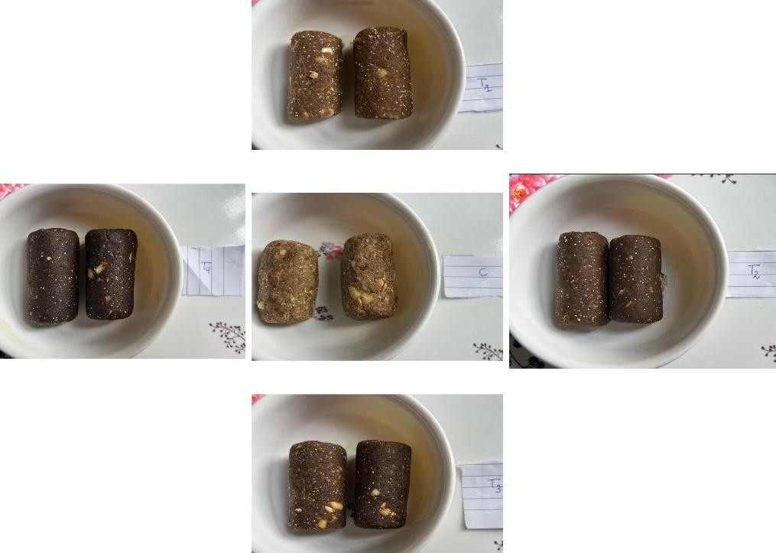

**Fig 1.** Control and value-added millet Nutri bars

## Sensory Evaluation of the Nutri Bars

For the evaluation 09-point hedonic scale was used for sensory evaluation using six different parameters which are colour, appearance, texture, flavour, taste and overall acceptability. A panel of 10 expert members performed the sensory evaluation and the bar with high acceptability was further analysed for nutritional evaluation.

## Nutritional composition analysis of the Bars

**Proximate analysis**

The proximate analysis test is done by FSSAI cereal and products, Kjeldahl method, anthrone and difference method, soxhlet extraction and spectrometry

## Mineral content analysis

The spectrometry method is used for the mineral content analysis.

## Vitamin content analysis

The chromatography method is used for the vitamin content analysis.

## Statistical Analysis

The result data was gathered and evaluated using statistical techniques like descriptive statistics like mean and standard deviation, they were calculated and analyzed using a way ANOVA test.

# RESULT AND DISCUSSION

## Sensory evaluation

The sensory evaluation was performed using a 9-point hedonic scale, the prepared samples were control sample ( with 100% wheat ), T1(with 75%wheat and 25%ragi flour ), T2 (with 50% wheat and 50% ragi ), T3 (with 75% ragi and 25% wheat ) and T4 ( with 100% ragi). Among the four prepared samples, T3 had the most overall acceptability of 7.8 which is the most liked and acceptable sample.

**Table 2**: statistical sensory evaluation table

|  |  |  |  |  |  |  |
| --- | --- | --- | --- | --- | --- | --- |
| S.NO | COLOR | APPEARANCE | TASTE | FLAVOR | TEXTURE | OVERALL ACCEPTABILITY |
| T0 | 8.6±0.15 | 8.9±0.16 | 8.8±0.15 | 8.7±0.21 | 8.5±0.25 | 8.6±0.15 |
| T1 | 7.1±0.27 | 7.1±0.31 | 6.7±0.42 | 6.8±0.38 | 6.7±0.42 | 7.2±0.29 |
| T2 | 7.2±0.24 | 7.6±0.30 | 7.7±0.36 | 7.6±0.42 | 7.4±0.40 | 7.4±0.30 |
| T3 | 7.7±0.36 | 7.7±0.33 | 7.9±0.23 | 7.9±0.31 | 7.5±0.37 | 7.8±0.35 |
| T4 | 7.3±0.44 | 7.8±0.41 | 7.8±0.41 | 7.7±0.47 | 7.2±0.29 | 7.6±0.37 |

This table shows that the control sample (T0) and the T3 sample were liked extremely while the other samples like T1, T2 and T4 were liked moderately.

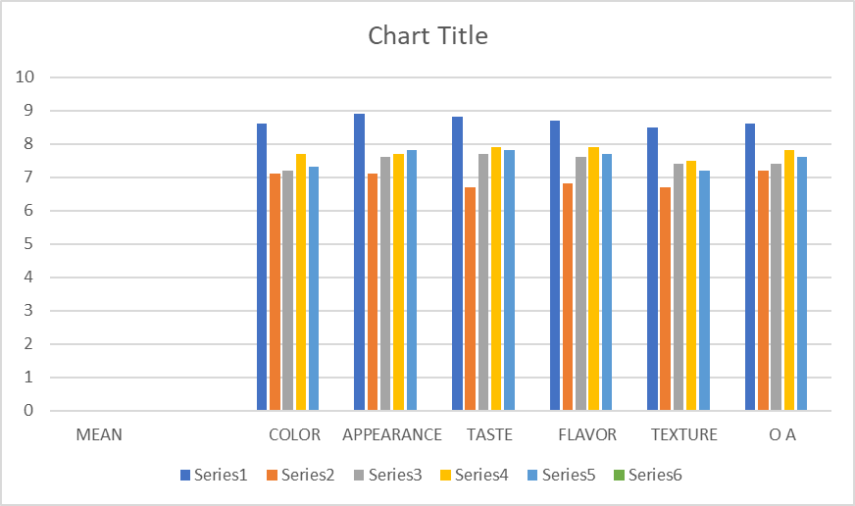

**Fig 2** Mean score of sensory evaluation of the control sample and the millet-incorporated Nutri bar.

**Table 3:** Nutritional composition of control and T3 sample

|  |  |  |
| --- | --- | --- |
| NUTRIENTS | CONTROL (T0) | T3 |
| MOISTURE | 5.72 | 4.16 |
| ASH | 1.61 | 3.52 |
| PROTEIN | 13.92 | 24.25 |
| CARBOHYDRATE | 54.3 | 51.1 |
| FAT | 18.6 | 14.7 |
| FIBER | 6.97 | 16.88 |
| ZINC | 1.94 | 4.77 |
| CALCIUM | 98.2 | 142.4 |
| IRON | 0.47 | 2.67 |
| MANGANESE | 1.01 | 5.02 |
| POTASSIUM | 16 | 124 |
| VITAMINS B9 | 0.5 | 9.5 |
| VITAMIN B6 | 1.42 | 11.81 |
| VITAMIN A | 0.7 | 72 |
| VITAMIN E | 11.4 | 42.1 |
| VITAMIN K | NA | 24.1 |

# NUTRITIONAL ANALYSIS PROCEDURE OF NUTRI BAR

Moisture content in the control sample (T0) with 100% wheat flour and other incorporated products was 5.72% while the T3 sample with 75% ragi, 25% wheat and other products was 4.16%. The moisture content in the control sample is higher than in the T3 sample. Ash content in the control sample (T0) with 100% wheat flour and other incorporated products was 1.61% while the sample T3 with 75% ragi and 25% wheat and other products was 3.52%. The ash content in the T3 sample is higher than the control sample. Protein content in the control sample (T0) with 100% wheat flour and other incorporated products was 13.92% while the T3 sample with 75% ragi and 25% wheat and other products was 24.25 %. The protein content is higher in the T3 sample than in the control sample. The carbohydrate content in the control sample (T0) with 100% wheat flour and other incorporated products was 54.3% while the T3 sample with 75% ragi and 25% wheat and other incorporated products was 51.1% . The carbohydrate content is higher in the control sample than the T3 sample. Fat content in control sample (T0) with 100% wheat flour and other incorporated products was 18.6% while the T3 sample with 75% ragi and 25% wheat and other incorporated products was 14.7% . The fat content is higher in the control sample than the T3 sample. Fibre content in control sample (T0) with 100% wheat flour and other incorporated products was 6.97% while the T3 sample with 75% ragi and 25% wheat and other incorporated products was 16.88%. The fibre content is higher in the T3 sample than the control sample. Zinc content in the control sample (T0) with 100% wheat flour and other incorporated products was 1.94% while the T3 sample with 75% ragi and 25% wheat and other incorporated products was 4.77%. The zinc content is higher in the T3 sample than the control sample. Calcium content in the control sample (T0) with 100% wheat flour and other incorporated products was 98.2% while the T3 sample with 75% ragi and 25% wheat and other incorporated products was 142.4%. The calcium content is higher in the T3 sample than in the control sample. Iron content in the control sample (T0) with 100% wheat flour and other incorporated products was 0.47% while the T3 sample with 75% ragi and 25% wheat and other incorporated products was 2.67% . The iron content is higher in the T3 sample than the control sample. Manganese content in the control sample (T0) with 100% wheat flour and other incorporated products was 1.01% while the T3 sample with 75% ragi and 25% wheat and other incorporated products was 5.02%. The manganese content is higher in the T3 sample than the control sample. The potassium content in the control sample (T0) with 100% wheat flour and other incorporated products was 16% while the T3 sample with 75% ragi and 25% wheat and other incorporated products was 124%. The potassium content is higher in the T3 sample than in the control sample. Vitamin B9 content in the control sample (T0) with 100% wheat flour and other incorporated products was 0.5% while the T3 sample with 75% ragi and 25% wheat and other incorporated products was 9.5%. The vitamin B9 content is higher in the T3 sample than in the control sample. Vitamin B6 content in the control sample (T0) with 100% wheat flour and other incorporated products was 1.42% while the T3 sample with 75% ragi and 25% wheat and other incorporated products was 11.81%. The vitamin B6 content is higher in the T3 sample than in the control sample. Vitamin A content in the control sample (T0) with 100% wheat flour and other incorporated products was 0.7% while the T3 sample with 75% ragi and 25% wheat and other incorporated products was 72% . The vitamin A content is higher in the T3 sample than in the control sample. Vitamin E content in the control sample (T0) with 100% wheat flour and other incorporated products was 11.4% while the T3 sample with 75% ragi and 25% wheat and other incorporated products was 42.1%. The vitamin E content is higher in the T3 sample than in the control sample. Vitamin K content in the control sample (T0) with 100% wheat flour and other incorporated products was not found while the T3 sample with 75% ragi and 25% wheat and other incorporated products was 24.1%. The vitamin K content is higher in the T3 sample than in the control sample.

# CONCLUSION

In this research, a millet-incorporated Nutri-bar was created and tested. The Nutri-bar was made from millet ragi (finger millet), along with other nutritious ingredients like wheat, jaggery, peanuts, oats, chia seeds, flaxseeds, and figs. A 9-point sensory evaluation scale was used to check the most acceptable sample. The T3 sample, with 75% ragi and 25% wheat, came out on top scoring 7.8 for overall likeability. When looking at the nutrient composition, T3 had a higher nutrient composition than the control (100% wheat) in key areas. It had more protein (24.25%) fiber (16.88%), and important minerals like calcium (142.4%) iron (2.67%), and potassium (124%). T3 also packed more vitamins, including B9, B6, A, E, and K showing it's much more nutritious. Adding ragi flour made the bar better in ways that could boost health. It might help digestion, keep blood sugar steady, and lower the chances of long-term health problems. T3 also had less fat (14.7%) and carbs (51.1%) than the control making it a healthier snack choice. This study shows that millet-based nutri-bars could be a handy, nutrient-rich food option. They meet the growing need for wholesome, easy-to-eat snacks and help bring back old-school millets into today's diets.

# REFERENCES

1. Gill, A., Meena, G., & Singh, A. (2022). Snack bars as functional foods: A review. 1324–1331. Review of literature
2. Shobana, S., Krishnaswamy, K., Sudha, V., Malleshi, N., Anjana, R., Palaniappan, L., & Mohan, V. (2013). Finger millet (Ragi, Eleusine coracana L.). Advances in Food and Nutrition Research, 1-39. https://doi.org/10.1016/b978-0-12-410540-9.00001-6
3. Yadav, Pawan. (2011). Nutritional Contents and Medicinal Properties of Wheat: A Review. Life Sciences and Medicine Research.
4. Martinchik AN, Baturin AK, Zubtsov VV, Molofeev VIu.(2012) [Nutritional value and functional properties of flaxseed]. Vopr Pitan ;81(3):4-10.
5. Knez Marevci, Masa & Ivanovski, Maja & Cor, Darija & Knez, Željko. (2019). Chia Seeds (Salvia Hispanica L.): An Overview—Phytochemical Profile, Isolation Methods, and Application. Molecules. 25. 10.
6. Hirpara, Parth & Thakare, Nitin & Kele, Vijay & Patel, Dhruvin. (2020). Jaggery: A natural sweetener. Journal of Pharmacognosy and Phytochemistry. 9. 3145-3148.
7. Bonku, R., & Yu, J. (2020). Health aspects of peanuts as an outcome of its chemical composition. Food Science and Human Wellness, 9(1), 21–30.
8. USDA. (2021). FoodData Central. United States Department of Agriculture.
9. Sandhu, Amandeep & Islam, Maria & Edirisinghe, Indika & Burton-Freeman, Britt. (2023). Phytochemical Composition and Health Benefits of Figs (Fresh and Dried): A Review of Literature from 2000 to 2022. Nutrients. 15. 2623.
10. Varma P, Bhankharia H, Bhatia S. Oats: A multi-functional grain. J Clin Prev Cardiol 2016;5:9-17
11. Constantin, O. E., & Istrati, D. I. (2018). Functional properties of snack bars. In Functional foods. IntechOpen. DOI: 10.5772/intechopen.81020
12. Boukid, F., Klerks, M., Pellegrini, N., Fogliano, V., Sanchez-Siles, L., Roman, S., & Vittadini, E. (2022). Current and emerging trends in cereal snack bars: implications for new product development. International Journal of Food Sciences and Nutrition, 73(5), 610-629.
13. Ananthan, P., Sharma, G. K., & Semwal, A. D. (2021). Energy bars: A perfect choice of nutrition to all. In Advances in Processing Technology (pp. 309-332). CRC Press.
14. Serna-Saldivar, S. O. (2022). Overview and State-of-the-Art of the Snack Food Industry. In Snack Foods (pp. 1-24). CRC Press.