Original Research Article
Crystallographic and Computational Insights into Hydrogen Bonding in Diisopropylammonium Hydrogenophthalate

Abstract :
Hydrogen bonds of the type A–H⋯A′, where A and A′ represent electronegative atoms, have attracted considerable attention in recent years due to their crucial role in stabilizing molecular systems. The combination of experimental characteristics and sophisticated quantum chemical calculations provides solid confirmation of the structural and electronic properties of the new molecules. In this context, diisopropylammonium hydrogenophthalate was synthesized and experimentally characterized, then studied by quantum chemistry in order to optimize its geometry and evaluate hydrogen-bonding interactions. X-ray diffraction analysis revealed the formation of parallel zigzag chains, stabilized by N–H···O hydrogen bonds between the diisopropylammonium cation and the hydrogenophthalate anion. Another intramolecular O–H···O hydrogen bond was also identified within the anion. From a theoretical perspective, the Mulliken charges, spectroscopic vibrations, and various global descriptors of the compound were studied using different basis sets within the DFT/B3LYP framework. The calculated vibrational frequencies were used to simulate infrared spectra for all basis sets considered. All these results confirm that diisopropylammonium hydrogenophthalate exists in the form of a salt, stabilized by a hydrogen bond between the cation and the anion. Finally, the frontier orbital energies (HOMO and LUMO), the energy gap, and global descriptors were determined in order to predict the reactivity of the compound. These findings provide a detailed understanding of how hydrogen bonding influences phthalate-based molecular crystals. They also highlight their potential for molecular electronics, advancing scientific knowledge.
Keywords: diisopropylammonium hydrogen phthalate; DFT ; Mulliken charges ; hydrogen bond ; infrared ;

1. Introduction
The examination of hydrogen bonding between a cation and an anion has attracted considerable attention because it strongly influences the stability, solubility, and physicochemical properties of the system (Dong et al. 2016; M. Li et al. 2024). Thus, the study of this hydrogen bond is crucial, as it plays a key role in chemistry (Peng et al. 2025), biology (García-Laiton et al. 2025), and materials science (L. Chen et al. 2025; Faye et al. 2024, 2025; Han et al. 2025). Many experimental and theoretical research works have been carried out. Experimentally, numerous studies on the synthesis and characterization of these compounds have been conducted using X-ray diffraction (Seye et al. 2018c) (Seye et al. 2018a, 2019a). All of these works confirm the existence of a hydrogen bond between a cation and an anion. However, some detailed structural and electronic properties cannot be determined solely by experimental methods. This justifies the use of theory to complement the experimental results. Accordingly, many theoretical studies have been devoted to this type of hydrogen bond (Ji et al. 2025; Shen et al. 2025; Žabka and Šebesta 2015). These calculations generally show that hydrogen bond lengths are shorter than 3 Å, which validates the theoretical approach since these values fall within the characteristic range of hydrogen bond interactions (Dieng et al. 2025; Strate et al. 2025). Among theoretical methods, DFT is widely used, particularly because it allows easy determination of global descriptors such as electronegativity (Kaya 2025), electronic chemical potential (Iram et al. 2025), hardness (Devar et al. 2025), etc. Recently, Lo et al. (Lo et al. 2025a) demonstrated for the first time, using DFT, the self-doping and electropolymerization of 4-amino-3-hydroxy naphthalene sulfonic acid (AHNSA). The hybrid B3LYP functional was used to calculate the structural, electrical, topological, and vibrational properties of this molecule. Other studies have focused on the structural determination of phthalate derivatives by DFT (Y. Chen et al. 2018a; Wang et al. 2023a, 2023b). For example, dimethyl phthalate has been studied by correlating experimental techniques with DFT investigations (Y. Chen et al. 2018b). In addition, phthalate esters have been prepared for the experimental determination of physicochemical parameters such as rate constants and half-lives.
Despite these methodological advances, some molecules, such as diisopropylammonium hydrogenophthalate, have not yet been the subject of any detailed study combining experimental data and theoretical analysis. To our knowledge, no study has been reported in the literature concerning the determination of geometric parameters and the spectroscopic analysis of diisopropylammonium hydrogen phthalate. Moreover, the Mulliken population, frontier molecular orbitals, and global descriptors of this compound have not yet been determined. The study of hydrogen-bonding interactions in diisopropylammonium hydrogenophthalate, a compound with potential relevance to energy-related applications. By combining experimental characterization with advanced quantum chemical calculations, the work offers a robust validation of structural and electronic properties. The insights gained into the role of N–H···O and O–H···O hydrogen bonds in stabilizing molecular assemblies contribute significantly to the broader understanding of hydrogen-bonded crystal systems. Furthermore, the prediction of reactivity through frontier orbital analysis and global descriptors opens new avenues for the design and application of phthalate-based materials in science and technology.
In this article, the compound, diisopropylammonium hydrogenophthalate, was synthesized, and its powder X-ray diffraction (XRD) data were recorded. Subsequently, density functional theory (DFT) calculations were performed using the B3LYP functional with three basis sets: 6-311++G(d,p), 6-311++G(d,p), and 6-311++G(d,p). The work focuses on investigating hydrogen-bonding interactions in diisopropylammonium hydrogenophthalate, a compound with potential relevance to energy-related applications. By combining experimental characterization with advanced quantum chemical calculations, the work offers a robust validation of structural and electronic properties. The insights gained into the role of N–H···O and O–H···O hydrogen bonds in stabilizing molecular assemblies contribute significantly to the broader understanding of hydrogen-bonded crystal systems. Furthermore, Mulliken atomic charges analysis, the prediction of reactivity through frontier orbital analysis and global descriptors opens new avenues for the design and application of phthalate-based materials in science and technology.
2. Experimental details
2.1. Synthesis of the compound
Diisopropylammonium hydrogenophthalate was obtained from the partial neutralization of phthalic acid (Ph(COH)₂; 5 g, 3 mmol) with diisopropylamine (iPr₂NH, 3.05 g, 3 mmol) in ethanol (50 mL) (Scheme 1). The clear mixture was stirred for two hours. Crystals suitable for X-ray diffraction analysis were obtained after one week of slow evaporation at room temperature. A crystal with dimensions 0.40 × 0.40 × 0.40 mm was used for data collection. The structure was solved and refined using standard programs (Seye et al. 2018a).

Scheme 1: Synthesis procedure of diisopropylammonium hydrogenophthalate

2.2 X-ray and IR spectra
2.3. Computational details
All quantum chemistry calculations were performed using the Becke-3-Lee-Yang-Parr (B3LYP) method with the Gaussian 16 software (Dieng et al. 2025). The structures were fully optimized using the 6-311++G(d,p), 6-311++G(d,p), and 6-311++G(d,p) basis sets. This method has been shown to provide sufficiently reliable results for both the geometry and energy of compounds involving hydrogen bonding (L. Li et al. 2015a; Tanak 2011). The optimized molecular structure was then used for vibrational frequency calculations at the DFT level.
3. Results and discussion
3.1 X-ray powder diffraction analysis
With the parameters a = 8.160(3), b = 14.876(5), and c = 12.549(5), diisopropylammonium hydrogenophthalate crystallizes in a monoclinic system with space group P21/c. One hydrogenophthalate anion and one diisopropylammonium cation constitute the asymmetric unit (Fig. 1). N-H-O hydrogen bonds bind the anions and cations together. The cation's C-C and C-N bonds resemble those seen in compounds that include the diisopropylammonium cation.
(Lo et al. 2024; Seye et al. 2024). The C-C and C-O bonds of the hydrogenophthalate anion are close to the published values for salts containing this anion (Seye et al. 2018c). In the overall structure, the acidic anions, hydrogenophthalate, are linked to the cations via N-H…O hydrogen bonds (Fig. 1), giving rise to zigzag chains parallel to [010] (Figs. 2 and 3), in which cations and anions alternate. Weak intermolecular hydrogen bonds C-H…O, contribute to the phthalate/phthalate and phthalate/cation interactions (Figs. 2, 3). All oxygen atoms are involved in at least two interactions, C-H…O and N-H…O hydrogen bonds, leading to a 3D architecture.

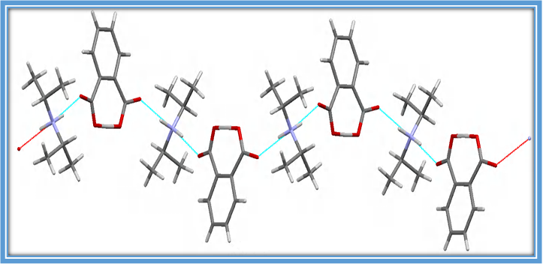
Figure 1 : Zigzag chains of alternating cations and anions connected by hydrogen bonds (N- H··O)
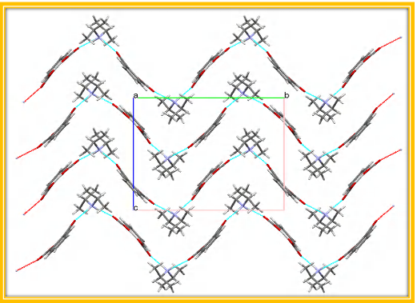
Figure 2: Hydrogen bonds (N-H…O) along the a-axis.
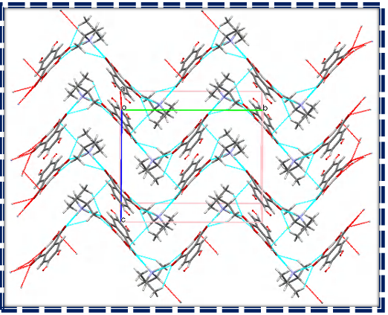
Figure 3 : Layered architecture formed by hydrogen bonds (C-H…O, N-H…O) approximately along the a-axis.
3.2 Geometrical structure
Figure 4, illustrating the optimized structure of the studied molecule, was calculated using density functional theory (DFT) with the above-mentioned basis sets. As shown by this optimized structure, the diisopropylammonium hydrogenophthalate molecule consists of a diisopropylammonium cation and a hydrogenophthalate anion connected by a hydrogen bond (N27–H18···O17). An intramolecular hydrogen bond (O16–H14···O13) is also observed within the anion. These hydrogen-bond interactions help stabilize the molecule by placing it in a minimum energy state. Moreover, the optimized geometry can be confirmed as an energy minimum by the absence of imaginary wavenumbers.
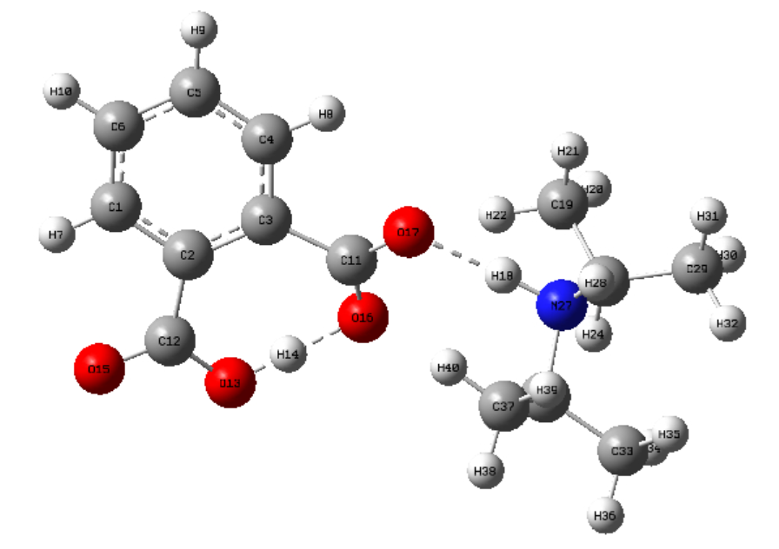
Figure 4: The optimized molecular structure of diisopropylammonium hydrogénophtalate calculated using DFT/B3LYP method.
3.3 Hydrogen bonding
The presence of the intermolecular hydrogen bond (N27–H18···O17) between the hydrogenophthalate anion and the diisopropylammonium cation ensures a strong interaction between these two ions, leading to the formation of diisopropylammonium hydrogen phthalate. This compound also exhibits an intramolecular hydrogen bond (O16–H14···O13). Both bonds together stabilize the molecule, as illustrated in its optimized structure (Fig. 4). The geometric parameters (bond lengths and angles) were determined using the B3LYP method with the various basis sets employed in this work. All obtained values are listed in Table 1. For the intermolecular hydrogen bond H18···O17, the calculated bond lengths are 1.681 Å, 1.682 Å, and 1.653 Å for the 6-311++G(d,p), 6-311+G(d,p), and 6-311G(d,p) basis sets, respectively, compared to the experimental value of 1.820 Å. Regarding the intramolecular hydrogen bond H14···O13, the corresponding values are 1.047 Å, 1.048 Å, and 1.039 Å for the same basis sets, whereas the experimental measurement is 1.190 Å. All these bond lengths fall within the characteristic range of hydrogen-bond interactions, namely below 3.0 Å (Seye et al. 2018b, 2019b). The theoretical values of the N27–H18···O17 bond angle are 174.93°, 174.95°, and 173.18° for the 6-311++G(d,p), 6-311+G(d,p), and 6-311G(d,p) basis sets, respectively, while the experimental angle is 166°. Similarly, for the O16–H14···O13 bond angle, the values are 171.21°, 171.39°, and 172.06° for the same basis sets. The experimental value for this bond angle is 173°. These experimental angle measurements confirm the presence of a hydrogen bond, in agreement with reported data for sulfonate groups (Lo et al. 2025a).
Table 1. Bond length and bond angle
 | Experimental | Theoretical
 | Experimental | B3LYP/6-311++G(d,p) | B3LYP/6-311+G(d,p) | B3LYP/6-311G(d,p)
Bonds lengths (Å)
H18···O17 | 1.820 | 1.681 | 1.682 | 1.653
H14···O13 | 1.190 | 1.047 | 1.048 | 1.039
Bonds angles (⁰ )
N27–H18···O17 | 166 | 174.93 | 174.95 | 173.18
O16–H14···O13 | 173 | 171.21 | 171.39 | 172.06

3.4 Mulliken population analysis
The electronic charges of atoms play a decisive role in bond formation and in the conformation of molecules (Krishne et al. 2025; L. Li et al. 2015b). In this work, the values of these atomic charges were obtained through Mulliken population analysis, performed using the B3LYP hybrid functional. The Mulliken atomic charges calculated for the diisopropylammonium hydrogenophthalate compound are presented in Table 2. The O13, O17, and N27 atoms, whose electronegativity is higher than that of hydrogen, exhibit negative theoretical Mulliken atomic charges, whereas the H14 and H18 atoms possess positive Mulliken charges. These results thus confirm the formation of the hydrogen bonds H18···O17 and H14···O13.
Table 2. Mulliken atomic charge
 | Theoretical
Atoms | B3LYP/6-311++G(d,p) | B3LYP/6-311+G(d,p) | B3LYP/6-311G(d,p)
017 | -0.321 | -0.321 | -0.503
H18 | 0.430 | 0.430 | 0.333
N27 | -0.169 | -0.169 | -0.346
O13 | -0.407 | -0.407 | -0.373
H14 | 0.451 | 0,451 | 0.288
O16 | -0.397 | -0.397 | -0.507

3.5 Vibrational analysis

Figure 5 displays the computed FTIR spectrum of diisopropylammonium hydrogenphthalate at the B3LYP level. Proton vibrations in the N–H···O and O–H···O hydrogen bonds, as well as internal vibrations of the diisopropylammonium cations and hydrogenphthalate anions, are the source of the bands seen in the measured range between 4000 and 100 cm⁻¹. Lattice vibrations are the source of the infrared spectra's bands below 100 cm⁻¹ (Arjunan et al. 2013). In this work, the vibrational assignments of the observed bands were carried out based on DFT calculations, which serve as a preliminary source for discussion, and also by comparison with previously reported theoretical studies on similar compounds. The FTIR spectra obtained with B3LYP/311++G(d,p), B3LYP/6-311+G(d,p), and B3LYP/6-311+G(d,p) are very similar, indicating the accuracy of the molecular structure.
3.5.1 Vibration of Diisopropylammonium
The experimental frequencies of the asymmetric N-H stretching vibrations in the complex are observed at 3459 and 3351 cm⁻¹ with the B3LYP/311++G(d,p) and B3LYP/311G(d,p) basis sets, respectively. The bands at 2752 and 2668 cm⁻¹ are attributed to the N-H bond stretching vibration. The C-N stretching bands of the side chain are assigned at 1547 and 1577 cm⁻¹ in the IR spectra using B3LYP/311++G(d,p) and B3LYP/311G(d,p), respectively. The C-C stretching mode is observed at 1543 and 1577 cm⁻¹ in the IR spectra of the B3LYP/311++G(d,p) and B3LYP/311G(d,p) basis sets, respectively. The alkyl C-H stretching mode is observed between 2752 and 3119 cm⁻¹. The modes observed between 1000 and 1200 cm⁻¹ in the IR spectra are attributed to in-plane C-H bending.
3.5.2 Vibrations of the Hydrogenophthalate Anion
Phthalic acid takes on a planar shape in the present complex and has carboxyl groups in both COOH and COO⁻ states at the same time. The asymmetric stretching vibrations of the COO group are linked to the IR peaks at 1543 and 1577 cm⁻¹, whereas the symmetric stretching vibrations of the COO⁻ group seen in the hydrogenophthalate anion are linked to the peaks at 1376 and 1392 cm⁻¹. The peaks at 1728 and 1761 cm⁻¹ in the infrared spectrum correspond to the in-plane bending vibrations of the C=O group. The O–H stretching of the carboxylic acid group is shown by the band in the current complex's infrared spectrum at 2263 and 2382 cm⁻¹ for B3LYP/311++G(d,p) and B3LYP/311G(d,p), respectively. In the infrared spectra, the C–H stretching mode of the phenyl group is observed around 1319 and 3138 cm⁻¹. These results are consistent with those reported in the literature (Dieng et al. 2025).
Figure 5 : Infrared spectra of diisopropylammonium hydrogenophthalate theoretically calculated using the B3LYP basis sets : a) B3LYP/311+G(d,p), b) B3LYP/6-311++G(d,p), c) B3LYP/311G(d,p).
3.6 Chemical reactivity
Quantum chemistry methods are highly effective for studying the electrochemical behavior and molecular structures of compounds (Camacho-Mendoza et al. 2015; Daoui et al. 2021). In this work, the frontier molecular orbitals (FMOs) were determined to better understand the electronic and optical properties of this compound. The highest occupied molecular orbital (HOMO) and the lowest unoccupied molecular orbital (LUMO) act as electron donor and electron acceptor, respectively (Daoui et al. 2021). The energy difference (Egap) between the LUMO and HOMO is an important factor in determining the electrical properties of a molecule (Edache et al. 2024a). This energy gap plays a significant role in the chemical and spectroscopic characteristics of the molecule and serves as an essential indicator of its electronic conductivity (Piasecki et al. 2016). The HOMO and LUMO energies of the diisopropylammonium hydrogenophthalate molecule, as well as the energy gap between HOMO and LUMO, are presented in Table 3. The smaller this energy gap (Egap), the more polarizable the compound is, with higher chemical reactivity and lower kinetic stability (Basha et al. 2024). The Egap values obtained for diisopropylammonium hydrogenophthalate are 4.0406 eV, 4.0409 eV, and 4.0972 eV for the B3LYP/6-311++G(d,p), B3LYP/6-311+G(d,p), and B3LYP/6-311G(d,p) basis sets, respectively. For diisopropylammonium phenylsulfonate, the values are 4.09 eV, 4.04 eV, and 4.040 eV (Lo et al. 2025b) using the same basis sets. These results indicate that both compounds exhibit relatively comparable electronic stability. Figure 6 illustrates the HOMO–LUMO transition. It can be observed that, in the HOMO diagram, the electrons are exclusively localized in the diisopropylammonium group region, whereas in the LUMO, they are distributed between both the diisopropylammonium group and the hydrogenophthalate anion.
3.6 Global Descriptors
Global descriptors allow the identification of the most reactive sites in a system and, consequently, the evaluation of a compound’s inhibitory effectiveness (Damous et al. 2021). Among these reactivity descriptors are hardness (η), electronegativity (χ), chemical potential (μ), and the electrophilicity index (ω). They are determined using the following equations (Edache et al. 2024b; Lo et al. 2025b) :

E_{gap} = E_{LUMO} - E_{HOMO} (1)
$η= E_{LUMO} -\frac{E_{HOMO}}{2}$ (2)
$χ= {-E}_{HOMO}-\frac{E_{LUMO}}{2}$ (3)
$μ= - χ$ (4)
$ω= \frac{μ^{2}}{2 η}$ (5)
A low value of the energy gap (Egap) indicates high chemical reactivity, whereas a high value corresponds to lower reactivity (Ai et al. 2025; Lo et al. 2025b). Therefore, this parameter serves as an essential indicator of a compound’s stability and reactivity. In the case of diisopropylammonium hydrogen phthalate, calculations show that it exhibits greater stability with the 6-311G(d,p) basis set, while it is more reactive with the 6-311++G(d,p) and 6-311+G(d,p) basis sets. Using the B3LYP/6-311G(d,p) method, this compound has the highest hardness, signifying increased stability. Conversely, the lowest hardness values are obtained with the 6-311++G(d,p) and 6-311+G(d,p) basis sets, confirming higher chemical reactivity under these conditions. These two basis sets also exhibit the highest electronegativity values, reinforcing the compound’s tendency to react more readily. Furthermore, Table 3 highlights that the 6-311++G(d,p) and 6-311+G(d,p) basis sets confer the highest electronegativity and the greatest electrophilicity index to the compound, reflecting an enhanced ability to accept electrons. The dipole moments obtained for the compound are 17.8450, 17.8350, and 16.5775 Debye with the 6-311++G(d,p), 6-311+G(d,p), and 6-311G(d,p) basis sets, respectively. These results indicate that the compound exhibits greater stability when described with the 6-311++G(d,p) and 6-311+G(d,p) basis sets.
Table 3: Global chemical reactivity indices of diisopropylammonium hydrogénophtalate
 | B3LYP/6-311++G(d,p) | B3LYP/6-311+G(d,p) | B3LYP/6-311G(d,p)
E_{HOMO} (eV) | -6,1046 | -6,1062 | -6,0382
E_{LUMO} (eV) | -2,0640 | -2,0653 | -1,9410
Dipole moment (debye) | 17.8450 | 17.8350 | 16.5775
Energy gap (Egap) (eV) | 4,0406 | 4,0409 | 4,0972
$η$(eV) | 0,9883 | 0,9878 | 1,0781
$χ$(eV) | 7,1366 | 7,1389 | 7,0087
$μ$(eV) | -7,1366 | -7,1389 | -7,0087
$ω$(eV) | 25 | 25 | 22

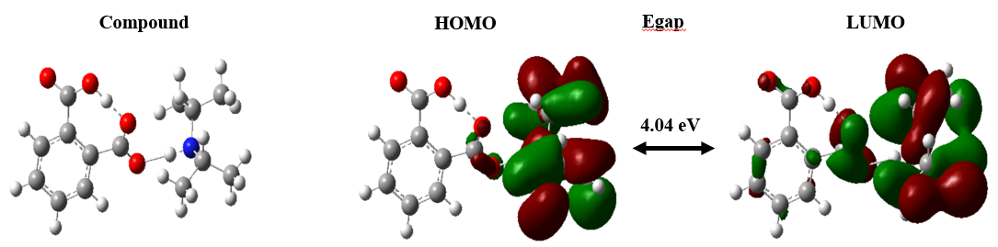 Figure 6: Schematic representation of HOMO and LUMO molecular orbitals of diisopropylammonium hydrogénophtalate at the B3LYP/6-311++G(d,p)
4. Conclusion
In this work, we performed calculations on the geometric parameters, vibrational frequencies, and molecular orbital energies of diisopropylammonium hydrogenophthalate using the DFT method with the 6-311G(d,p), 6-311+G(d,p), and 6-311++G(d,p) basis sets. The configuration of this molecule allowed us to study the effect of hydrogen bonding on vibrational frequencies, leading to a more accurate spectral assignment. The hydrogen bond lengths, confirmed by both experimental and theoretical results (using the hybrid B3LYP functional), indicate the presence of both intermolecular and intramolecular hydrogen bonds within the diisopropylammonium hydrogenophthalate molecule. Indeed, all hydrogen bond lengths are less than 3 Å. Furthermore, the calculated geometric parameters (bond lengths and angles) show good agreement with experimental values. The studied infrared spectra revealed the presence of hydrogenophthalate and diisopropylammonium groups, thus confirming the formation of the crystalline molecule. The theoretical Mulliken atomic charges indicate that the most electronegative atom involved in the hydrogen bond carries a negative charge, whereas the hydrogen atoms, being electropositive, carry a positive charge. This result confirms the formation of the hydrogen bond. The energies of the HOMO and LUMO, as well as their energy gap, were also determined; the magnitude of this gap reflects the stability of the compound. In addition, the calculated global chemical reactivity indices support this stability, showing that diisopropylammonium hydrogenophthalate exhibits low chemical reactivity. Further complementary research is currently underway in this field.

Disclaimer (Artificial intelligence)
Option 1:
Author(s) hereby declare that NO generative AI technologies such as Large Language Models (ChatGPT, COPILOT, etc.) and text-to-image generators have been used during the writing or editing of this manuscript.
DATA AVAILABILITY STATEMENT
We declare that all data are available in the manuscript file.
ACKNOWLEDGEMENT
The authors thank Prof. Tore BRINCK, from the Department of Chemistry, CBH, KTH Royal Institute of Technology, SE-100 44 Stockholm, Sweden
COMPETING INTERESTS
Authors have declared that no competing interests exist.

REFERENCE
Ai, H., Li, Q., Xu, Q., Li, X., Li, D., & Wu, Q. (2025). Halogen substitution for fine-tuning the energy gap and intermolecular interactions of dinuclear iron(III) half schiff base complexes: experimental and theoretical investigation. Journal of Molecular Structure, 1348, 143508. https://doi.org/10.1016/j.molstruc.2025.143508
Arjunan, V., Kalaivani, M., Marchewka, M. K., & Mohan, S. (2013). Structural and vibrational spectral investigations of melaminium maleate monohydrate by FTIR, FT-Raman and quantum chemical calculations. Spectrochimica Acta Part A: Molecular and Biomolecular Spectroscopy, 107, 90–101. https://doi.org/10.1016/j.saa.2013.01.040
Basha, A. A., Kubaib, A., & Azam, M. (2024). Exploring the antiviral potency of γ-FP and PA compounds: Electronic characterization, non-covalent interaction analysis and docking profiling with emphasis on QTAIM aspects. Computational and Theoretical Chemistry, 1231, 114412. https://doi.org/10.1016/j.comptc.2023.114412
Camacho-Mendoza, R. L., Gutiérrez-Moreno, E., Guzmán-Percástegui, E., Aquino-Torres, E., Cruz-Borbolla, J., Rodríguez-Ávila, J. A., et al. (2015). Density Functional Theory and Electrochemical Studies: Structure–Efficiency Relationship on Corrosion Inhibition. Journal of Chemical Information and Modeling, 55(11), 2391–2402. https://doi.org/10.1021/acs.jcim.5b00385
Chen, L., Pan, J., Wang, T., Xia, W., He, J., & Zhang, K. (2025). 1D Magnetic Nickel‐Carbon Matrix Nanotube Composites Derived from Hydrogen‐Bonded Organic Frameworks and Metal–Organic Frameworks for Electromagnetic Wave Absorption. Advanced Functional Materials, 35(3), 2409432. https://doi.org/10.1002/adfm.202409432
Chen, Y., Zhang, H., Zhou, W., Deng, C., & Liao, J. (2018a). The solvent effects on dimethyl phthalate investigated by FTIR characterization, solvent parameter correlation and DFT computation. Spectrochimica Acta Part A: Molecular and Biomolecular Spectroscopy, 199, 412–420. https://doi.org/10.1016/j.saa.2018.03.051
Chen, Y., Zhang, H., Zhou, W., Deng, C., & Liao, J. (2018b). The solvent effects on dimethyl phthalate investigated by FTIR characterization, solvent parameter correlation and DFT computation. Spectrochimica Acta Part A: Molecular and Biomolecular Spectroscopy, 199, 412–420. https://doi.org/10.1016/j.saa.2018.03.051
Damous, M., Allal, H., Belhocine, Y., Maza, S., & Merazig, H. (2021). Quantum chemical exploration on the inhibition performance of indole and some of its derivatives against copper corrosion. Journal of Molecular Liquids, 340, 117136. https://doi.org/10.1016/j.molliq.2021.117136
Daoui, S., Baydere, C., Akman, F., Kalai, F. E., Mahi, L., Dege, N., et al. (2021). Synthesis, X-ray crystallography, vibrational spectroscopy, thermal and DFT studies of (E)-6-(4-methylstyryl)-4,5-dihydropyridazin-3(2H)-one. Journal of Molecular Structure, 1225, 129180. https://doi.org/10.1016/j.molstruc.2020.129180
Devar, S., More, S., Patil, O., S M, B., G Y, N., & Hanagodimath, S. M. (2025). Synthesis, Spectroscopic, DFT Calculation and Molecular Docking Studies of Indole Derivative. Journal of Fluorescence. https://doi.org/10.1007/s10895-025-04301-2
Dieng, M., Diop, C. A. B., Seye, D., Diaw, M., Faye, D., Ngom, A., et al. (2025). Harnessing Weak and Hydrogen Bonding Interactions for Tailored Crystal Formation: A Case Study of Diisopropylammonium Phenylsulfonate. International Research Journal of Pure and Applied Chemistry, 26(4), 160–173. https://doi.org/10.9734/irjpac/2025/v26i4938
Dong, K., Zhang, S., & Wang, J. (2016). Understanding the hydrogen bonds in ionic liquids and their roles in properties and reactions. Chemical Communications, 52(41), 6744–6764. https://doi.org/10.1039/C5CC10120D
Edache, E. I., Uzairu, A., Mamza, P. A., Shallangwa, G. A., & Ibrahim, M. T. (2024a). DFT studies on structure, electronics, bonding nature, NBO analysis, thermodynamic properties, molecular docking, and MM-GBSA evaluation of 4-methyl-3-[2-(4-nitrophenyl)-1,3-dioxo-2,3-dihydro-1H-isoindole-5-amido]benzoic acid: a potent inhibitor of Graves’ disease. Journal of Umm Al-Qura University for Applied Sciences, 10(4), 652–670. https://doi.org/10.1007/s43994-024-00132-2
Edache, E. I., Uzairu, A., Mamza, P. A., Shallangwa, G. A., & Ibrahim, M. T. (2024b). DFT studies on structure, electronics, bonding nature, NBO analysis, thermodynamic properties, molecular docking, and MM-GBSA evaluation of 4-methyl-3-[2-(4-nitrophenyl)-1,3-dioxo-2,3-dihydro-1H-isoindole-5-amido]benzoic acid: a potent inhibitor of Graves’ disease. Journal of Umm Al-Qura University for Applied Sciences, 10(4), 652–670. https://doi.org/10.1007/s43994-024-00132-2
Faye, D., Lo, M., Seye, D., Diop, C. A. B., Diop, M. G., Ngom, A., et al. (2025). Silver Nanoparticles Supported by Carbon Nanotubes Functionalized with 1,2,3-Benzenetricarboxylic Acid: Spectroscopic Analysis and Electrochemical Capacitance. Journal of Inorganic and Organometallic Polymers and Materials. https://doi.org/10.1007/s10904-025-03782-9
Faye, D., Lo, M., Seye, D., Diop, C. A. B., Sall, M. L., Diop, M. G., et al. (2024). Synergistic Effect of Copper oxide Nanoparticles and Diazonium-Modified Carbon Nanotubes for Colorimetric Detection of Dimethoate Residues in Food Products. Chemistry Africa, 7(10), 5317–5328. https://doi.org/10.1007/s42250-024-01102-1
García-Laiton, G., López, F. A. Z., Shakerzadeh, E., & Chigo-Anota, E. (2025). Role of homonuclear B–B/N–N bonds in DNA nucleobases adsorption on boron nitride fullerenes: Biosensor and drug transport implications. Computational and Theoretical Chemistry, 1248, 115188. https://doi.org/10.1016/j.comptc.2025.115188
Han, K., Tan, C., Feng, S., Zhang, Q., Qiao, X., Zhong, Z., et al. (2025). Robust π‐Conjugated Hydrogen‐Bonded Organic Framework Nanowires Enable Stable and Fast Potassium Storage. Advanced Functional Materials, 35(1), 2407452. https://doi.org/10.1002/adfm.202407452
Iram, N., Sharma, R., Ahmad, J., Kumar, A., Kumar, A., Almutairi, F. N., & Alturaifi, H. A. (2025). A DFT Manifestation of the physical, thermodynamic and thermoelectric properties in Sn-based halide perovskites. Inorganic Chemistry Communications, 172, 113573. https://doi.org/10.1016/j.inoche.2024.113573
Ji, C., Zeng, F., Xu, W., Zhu, M., Yu, H., Yang, H., & Peng, Z. (2025). Hydrogen Bond‐Mediated Self‐Assembly of Carbon Dots Enabling Precise Tuning of Particle and Cluster Luminescence for Advanced Optoelectronic Applications. Advanced Materials, 37(4), 2414450. https://doi.org/10.1002/adma.202414450
Kaya, S. (2025). Conceptual density functional theory–based applications in extraction studies. In Green Analytical Chemistry (pp. 43–58). Elsevier. https://doi.org/10.1016/B978-0-443-16122-3.00003-2
Krishne, D. H., Sharma, K., Reddy, A. J., & Hadagalli, M. D. (2025). DFT and TD-DFT/CPCM analysis and pharmacokinetic evaluation of 6-fluoro-4-hydroxy-2-methylquinoline: spectroscopic, HOMO-LUMO, MEP, NLO, NBO, and docking insights with human serum albumin. International Journal of Modelling and Simulation, 1–16. https://doi.org/10.1080/02286203.2025.2493666
Li, L., Wu, C., Wang, Z., Zhao, L., Li, Z., Sun, C., & Sun, T. (2015a). Density functional theory (DFT) and natural bond orbital (NBO) study of vibrational spectra and intramolecular hydrogen bond interaction of l-ornithine–l-aspartate. Spectrochimica Acta Part A: Molecular and Biomolecular Spectroscopy, 136, 338–346. https://doi.org/10.1016/j.saa.2014.08.153
Li, L., Wu, C., Wang, Z., Zhao, L., Li, Z., Sun, C., & Sun, T. (2015b). Density functional theory (DFT) and natural bond orbital (NBO) study of vibrational spectra and intramolecular hydrogen bond interaction of l-ornithine–l-aspartate. Spectrochimica Acta Part A: Molecular and Biomolecular Spectroscopy, 136, 338–346. https://doi.org/10.1016/j.saa.2014.08.153
Li, M., Wang, X., Meng, J., Zuo, C., Wu, B., Li, C., et al. (2024). Comprehensive Understandings of Hydrogen Bond Chemistry in Aqueous Batteries. Advanced Materials, 36(3), 2308628. https://doi.org/10.1002/adma.202308628
Lo, M., Dieng, M., Seye, D., Faye, D., Diop, C. A. B., Ngom, A., et al. (2025a). Electropolymerization by self-doping of 4-amino-3-hydroxynaphthalene sulfonic acid: spectroscopy characterization and DFT for growth mechanism. Journal of Molecular Structure, 1346, 143136. https://doi.org/10.1016/j.molstruc.2025.143136
Lo, M., Dieng, M., Seye, D., Faye, D., Diop, C. A. B., Ngom, A., et al. (2025b). Electropolymerization by self-doping of 4-amino-3-hydroxynaphthalene sulfonic acid: spectroscopy characterization and DFT for growth mechanism. Journal of Molecular Structure, 1346, 143136. https://doi.org/10.1016/j.molstruc.2025.143136
Lo, M., Faye, D., Seye, D., Dieng, M., Sall, M. L., Thiaré, D. D., et al. (2024). A Novel Method for Combination of Ionic Conductivity and pH-metry Methods for the Determination of the Aqueous Solubility of a New Diisopropylammonium Hydrogenmaleate Crystalline Molecule. International Research Journal of Pure and Applied Chemistry, 25(6), 12–27. https://doi.org/10.9734/irjpac/2024/v25i6882
Peng, Z., Tang, L., Li, S., Tan, L., & Chen, Y. (2025). Strong Replaces Weak: Hydrogen Bond‐Anchored Electrolyte Enabling Ultra‐Stable and Wide‐Temperature Aqueous Zinc‐Ion Capacitors. Angewandte Chemie International Edition, 64(6), e202418242. https://doi.org/10.1002/anie.202418242
Piasecki, M., Myronchuk, G. L., Zamurueva, O. V., Khyzhun, O. Y., Parasyuk, O. V., Fedorchuk, A. O., et al. (2016). Huge operation by energy gap of novel narrow band gap Tl _{1− x} In _{1− x} B _{x} Se₂ (B = Si, Ge): DFT, x-ray emission and photoconductivity studies. Materials Research Express, 3(2), 025902. https://doi.org/10.1088/2053-1591/3/2/025902
Seye, D., Diop, C. A. K., Diop, L., & Geiger, D. K. (2018a). Diisopropylammonium benzenesulfonate. IUCrData, 3(6), x180876. https://doi.org/10.1107/S2414314618008763
Seye, D., Diop, C. A. K., Diop, L., & Geiger, D. K. (2018b). Diisopropylammonium benzenesulfonate. IUCrData, 3(6), x180876. https://doi.org/10.1107/S2414314618008763
Seye, D., Diop, L., Diop, C. A. K., & Geiger, D. K. (2018c). Diisopropylammonium hydrogen phthalate. IUCrData, 3(5), x180704. https://doi.org/10.1107/S2414314618007046
Seye, D., Faye, D., Lo, M., Diop, C. A. B., Dieng, M., Diop, C. A. K., & Fall, M. (2024). Varied Analysis of Acid Dissociation Constants by Cyclic Voltammetry and UV-Visible to Determine the Aqueous Solubility of a New Diisopropylammonium Phenylsulfonate Molecule. Chemical Science International Journal, 33(6), 225–240. https://doi.org/10.9734/CSJI/2024/v33i6940
Seye, D., Toure, A., Lo, M., Abdoul Khadir Diop, C., Diop, L., & Geiger, D. (2019a). Crystal Structure of Diisopropylammonium Hydrogen Maleate. Science Journal of Chemistry, 7(6), 110. https://doi.org/10.11648/j.sjc.2019070612
Seye, D., Toure, A., Lo, M., Abdoul Khadir Diop, C., Diop, L., & Geiger, D. (2019b). Crystal Structure of Diisopropylammonium Hydrogen Maleate. Science Journal of Chemistry, 7(6), 110. https://doi.org/10.11648/j.sjc.2019070612
Shen, Z., Liu, C., Zhou, Y., Zhao, J., & Chen, J. (2025). Computational investigation about photo-induced hydrogen bonding interactions and excited state double proton transfer behaviors for alkali substituted BPOH compounds. Chemical Physics Letters, 868, 142021. https://doi.org/10.1016/j.cplett.2025.142021
Strate, A., Paschek, D., & Ludwig, R. (2025). Hydrogen-Bonding Motifs in Hydroxy-Functionalized Ionic Liquids. Annual Review of Physical Chemistry, 76(1), 589–614. https://doi.org/10.1146/annurev-physchem-082423-020307
Tanak, H. (2011). Crystal Structure, Spectroscopy, and Quantum Chemical Studies of ( E )-2-[(2-Chlorophenyl)iminomethyl]-4-trifluoromethoxyphenol. The Journal of Physical Chemistry A, 115(47), 13865–13876. https://doi.org/10.1021/jp205788b
Wang, Y., Sun, Y., Wang, R., Gao, M., Xin, Y., Zhang, G., et al. (2023a). Activation of peroxymonosulfate with cobalt embedded in layered δ-MnO2 for degradation of dimethyl phthalate: Mechanisms, degradation pathway, and DFT calculation. Journal of Hazardous Materials, 451, 130901. https://doi.org/10.1016/j.jhazmat.2023.130901
Wang, Y., Sun, Y., Wang, R., Gao, M., Xin, Y., Zhang, G., et al. (2023b). Activation of peroxymonosulfate with cobalt embedded in layered δ-MnO2 for degradation of dimethyl phthalate: Mechanisms, degradation pathway, and DFT calculation. Journal of Hazardous Materials, 451, 130901. https://doi.org/10.1016/j.jhazmat.2023.130901
Žabka, M., & Šebesta, R. (2015). Experimental and Theoretical Studies in Hydrogen-Bonding Organocatalysis. Molecules, 20(9), 15500–15524. https://doi.org/10.3390/molecules200915500

