The scientific and technological contribution of African FabLabs: innovations, impacts and perspectives

.
ABSTRACT
This study examines the scientific and technological contribution of African within the context of local development. Through a mixed approach combining literature review, questionnaire surveys and semi-structured interviews, it analyzes the activities of FabLabs located in sub-Saharan Africa (Madagascar, DRC, Togo, Burkina Faso) between 2018 and 2025. The results reveal a diversity of equipment (3D printers, CNC, electronic tools), software (Fusion 360, KiCad , Arduino) and innovative projects in the fields of energy, health, agriculture and education. Initiatives such as SolarFocus, Plastikôo or W.Afate illustrate a frugal and sustainable approach, based on recycling and adaptation to local resources. In parallel, several FabLabs have produced scientific publications on educational commons, digital inclusion and low -tech models. Despite structural constraints (limited access to electricity, precarious funding, weak institutional recognition), these FabLabs promote technical skills acquisition, professional integration, and social innovation. Their pedagogical model, based on practice and interdisciplinarity, offers an alternative to traditional education systems. To strengthen their impact, the study recommends the creation of a pan-African network, integration into public policies, and the development of South-South partnerships positioning FabLabs as catalysts of technological sovereignty and community resilience.

Keywords: African FabLabs , frugal innovation, developed technologies, local development

Introduction
FabLabs are proliferating around the world as creative production spaces that combine art, science, and engineering. They provide opportunities to explore ideas, acquire technical skills, and design innovative solutions locally [ 1] . In Africa, these spaces are emerging as dynamic places for prototyping, training, and innovation [2] .
While African FabLabs have been the subject of research on their entrepreneurial or social functions [3] , their role in scientific and technological production adapted to local contexts remains little studied. However, in environments constrained by limited resources, they nevertheless constitute potential catalysts for frugal innovation and skills development.
This article aims to analyze the contribution of African FabLabs to local scientific and technological development, beyond their economic or social missions. The aim is to assess their ability to produce knowledge, strengthen the scientific skills of communities, and address local challenges through appropriate technological solutions.
To do this, the study uses a mixed approach combining a literature review [4], [5] a questionnaire survey of FabLabs in sub-Saharan Africa, and semi-directive interviews with their managers and project leaders. This methodology aims to cross-reference the perceptions of the actors with empirical data on the activities, infrastructures and impacts of these innovation laboratories [6] .
According to United Nations projections, around 230 million jobs in Africa will require digital skills by 2030. Yet, only 9% of young people aged 15 to 24 have basic computer skills. At the same time, less than half of African schools are connected to the Internet, and investments in research and development remain marginal (0.6% of GDP on average). These figures highlight the urgency of alternative structures such as FabLabs to address these structural deficiencies in technological education and digital inclusion [7], [8], [9] .
The FabLabs selected for this study were selected based on several criteria: a clear commitment to technical or scientific innovation activities; a location in low- or middle-income countries; accessibility to the public, particularly to students, young entrepreneurs, and inventors; as well as a diversity of interventions covering areas such as energy, health, agriculture, and education. In addition, the FabLabs had to be active at the time of the survey and have a minimal online presence (website or social media), allowing access to basic information about their projects.

State of the art: African FabLabs in the global technological landscape
FabLabs originated at the Massachusetts Institute of Technology (MIT) as part of the interdisciplinary CBA (Center for Bits and Atoms) laboratory founded in 2001 under the direction of Neil Gershenfeld, a physicist and computer scientist [4] and quickly spread throughout the world as open spaces for creation, innovation and creativity [5] .
Created in the early 2000, FabLabs allow students to master the use of different control machines digital available in the Center of Bits laboratory and Atoms. In 2012, the Fab Lab concept, first supported by MIT and partly funded by the NSF, particularly in the countries of the South, became independent and developed internationally, independently of MIT. In 2024, we have FabLabs.io which is the official platform of the global Fab Lab community developed since 2014, connecting nearly 1000 Fab Labs in more than 75 countries [6] .
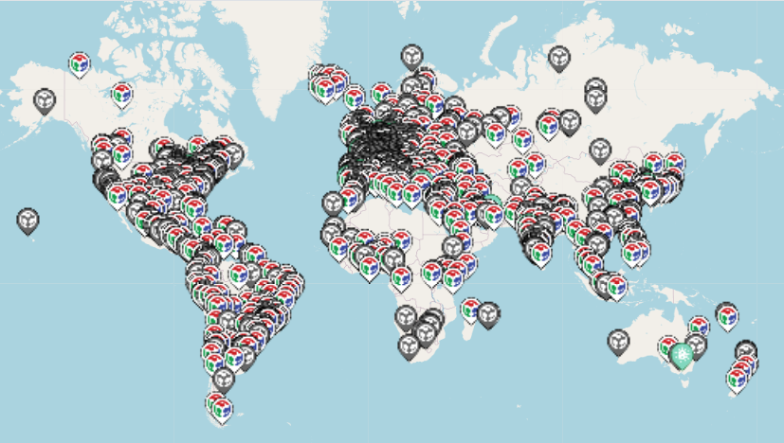
Figure 1 : Geolocation map of fabs networked labs [6]
FabLabs have also developed rapidly in Africa, particularly in West Africa. In Africa, their growth responds to various motivations: preservation of traditional know-how (e.g. Wɔɛlab , Studio Wudé ), [2] response to community needs (e.g. DefKo Ak Niep in Dakar, APM-Spacecraft in Ghana), or institutions seeking to offer spaces for innovation (e.g. Polylab at the University of Thiès) [10] .
African Fab Labs emphasize community service over financial goals. They promote knowledge sharing by offering free activities for the general public, particularly young people and women.
In 2020, Isabelle Liotard analyzed FabLabs in French-speaking Africa and highlighted their particularities. Unlike Western FabLabs, these spaces are often hybrid places integrating artisan workshops, incubators, and training adapted to local realities [3] .The author emphasizes the importance of frugal innovation and recycling to compensate for the lack of technological and financial resources [11] .
To further the analysis of African FabLabs , three theoretical concepts can be used. Social innovation refers to new solutions to needs that are poorly or insufficiently met by the market or public policies , often involving user participation, interdisciplinary collaboration and the creation of collective value [12] . African FabLabs respond to this logic by proposing co-constructed, frugal and inclusive solutions, particularly in the fields of education, health and energy. The concept of appropriate technology, defined by Schumacher in the 1970s , promotes simple, inexpensive tools based on local resources. The low -tech approach of many African FabLabs is part of this logic, by promoting recycling, self-production and technological sovereignty on a small scale [13] . Finally, frugal innovation, or Jugaad, is based on the design of robust and inexpensive solutions in a context of scarcity. Waste-based projects illustrate this local ingenuity. These three notions allow us to better understand the singularity and scope of African FabLabs [14] .

Technologies and innovations developed in African FabLabs

The equipment, software and technologies used
Following the surveys conducted, we can see that African Fab Labs offer a diversity of equipment, software, and technologies, allowing users to develop advanced technical skills in various fields, ranging from digital manufacturing to robotics. These tools play a key role in local scientific and technological innovation, and their availability varies depending on the resources and model of each Fab Lab.

Equipment available in FabLabs
The equipment available in African Fab Labs is primarily dedicated to digital manufacturing and rapid prototyping, allowing users to design and produce small-scale objects and prototypes. The tools common to most Fab Labs are:
- 3D printers: Used for the manufacture of plastic prototypes, they are available in almost all FabLabs, with the notable exception of WoeLab in Lomé which does not have one.
- Laser cutters: These machines allow for precise cutting of materials such as wood, plastic, and metal. They are present in all the FabLabs studied.
- CNC Milling Machines: These numerically controlled machines are used for milling hard materials such as metal or wood. They are available in Antananarivo, Bukavu, and Ouagadougou.
- Electronics: These devices include oscilloscopes, soldering irons, and other tools for electronics and robotics, facilitating the development of projects in these fields. They are present in almost all the FabLabs studied.
- Specific equipment: Some FabLabs, such as those in Bukavu, are equipped with plastic crushers and extruders, allowing plastic materials to be recycled for the manufacture of new products. These tools contribute to sustainability by reducing dependence on imported materials.
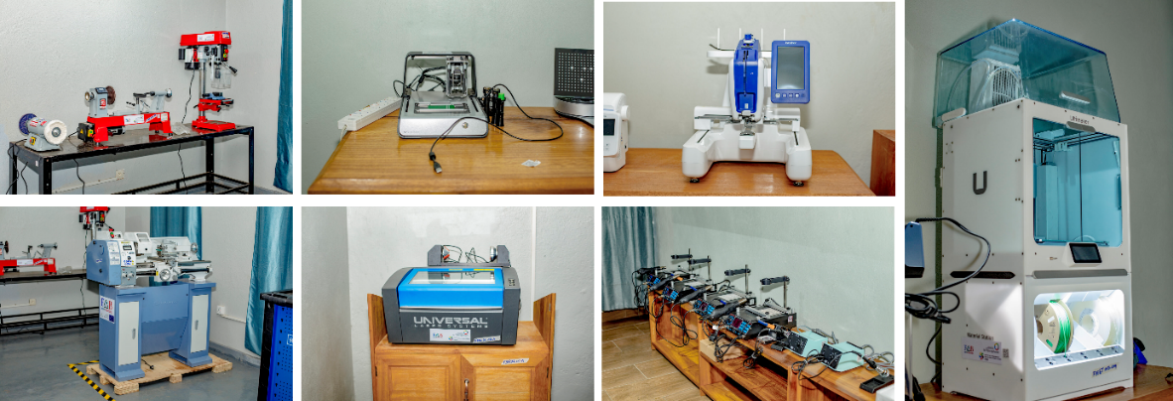
Figure 2 : Some equipment used in the FabLab EcoDéchets [15]
In addition, specialized equipment such as digital embroidery machines, metal lathes, tools for wood and metalwork, and PCB (printed circuit board) printers are available in certain FabLabs, particularly in Bukavu and Ouagadougou, strengthening the capacity of FabLabs to work on high-precision projects and to diversify their service offering.

Software and technology used in FabLabs
To complement the wealth of equipment, a wide range of software and technologies is used to design, model, and program projects. Here are some of the technologies used in the African FabLabs studied:
- Fusion 360, SolidWorks, FreeCAD: These CAD (Computer-Aided Design) software programs are used for 3D modeling and the design of mechanical or electronic prototypes. They allow users to create designs before physical fabrication, a crucial step in digital manufacturing.
- KiCad, Eagle: These software programs are specifically used for PCB design and electronic design management. They are essential in robotics and electronics projects, present in all Fab Labs.
- MATLAB, LabVIEW: Widely used tools for robotics, automation, and embedded systems projects. These software programs allow users to create algorithms and program complex systems.
- Arduino, Raspberry Pi: These tools are commonly used for developing IoT (Internet of Things) and robotics projects. They are accessible to users of all skill levels and allow for projects ranging from simple programming to the design of more advanced electronic devices.
- Scratch, Arduino IDE / C++: These programming languages and environments are used to introduce young people and beginners to programming and electronic manufacturing. They facilitate learning the basics of electronics and programming, essential for many projects within FabLabs.
These software technologies offer a range of tools tailored to the needs of rapid prototyping, programming, and product design for users, whether they are students, researchers, artisans, or entrepreneurs. They enable Fab Labs to support a wide range of projects, from robotics to the manufacturing of IoT devices, including the creation of connected products and the design of renewable energy solutions.

Challenges and limitations of the equipment, software and technologies used
Despite this wealth of equipment, software, and technology, some challenges remain. Access to certain equipment remains limited, particularly in Fab Labs that lack funding or suitable infrastructure. For example, in Lomé, equipment is less diverse, which can limit the types of projects users can undertake. Furthermore, unstable internet access in some Fab Labs (such as Antananarivo and Bukavu) complicates remote collaboration and access to online resources or cloud services for managing collaborative projects.
In terms of software, although quality tools are used, limited access to paid licenses or specific versions can be an obstacle for some Fab Labs. Furthermore, the lack of ongoing training on the optimal use of this software could hinder the full exploitation of these tools' potential.

Areas of intervention of FabLabs and innovative projects
Despite these challenges related to equipment, software, and infrastructure, African FabLabs stand out for the richness and relevance of their projects, geared toward the essential needs of local communities. Although diverse in their operations and locations, they share a common vocation: to offer innovative, accessible solutions adapted to local challenges. Their fields of action cover energy, health, agriculture, education, and more broadly, economic inclusion. FabLabs representative of this dynamic are presented below: FabLab EcoDéchets UEA (DRC), WoeLab (Togo), WAKATLAB (Burkina Faso), and Orange Solidarity FabLabs (Madagascar).

FabLab EcoDéchets UEA (Bukavu, DRC)
Located in Bukavu, in the east of the Democratic Republic of Congo, the EcoDéchets FabLab is the first of its kind in this region. It is supported by the Evangelical University in Africa (UEA) and was created thanks to the support of the Institute of Francophonie for Sustainable Development (IFDD), as part of the Environmental Technologies and Innovations Deployment Project (PDTIE). This FabLab specializes in the recovery of waste through digital technologies, with an approach strongly oriented towards the self-employment of young people and women [15] .

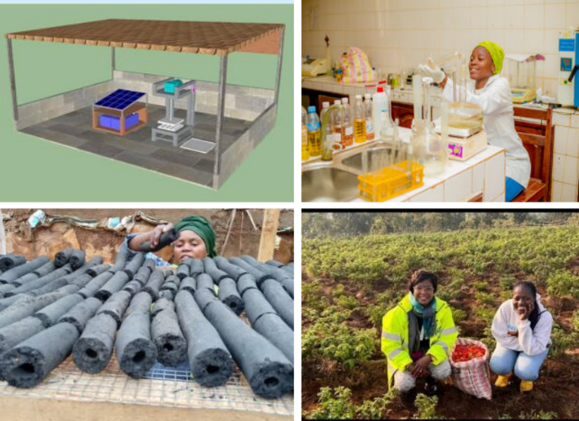
Figure 3 : FabLab Ecodéches ’ current projects [16]
Its areas of intervention include energy, environmental health, urban agriculture, and economic inclusion. Among its flagship projects is the transformation of plastic waste into laboratory equipment or utility objects via 3D printing, enabling both recycling and access to low-cost equipment. The FabLab has also developed prototypes of smart composters for urban agriculture and ecological sanitation devices, designed to combat waterborne diseases in underserved neighborhoods. These projects embody a successful synergy between technological innovation, environmental sustainability, and local social impact [15], [16] .

WoeLab (Lomé, Togo)
WoeLab , founded in 2012 in Lomé by Togolese architect and anthropologist Sénamé Koffi Agbodjinou , is an emblematic example of an African FabLab committed to social, technological and urban innovation. It embodies an inclusive vision of digital technology, adapted to local realities, and is part of several key areas of intervention.

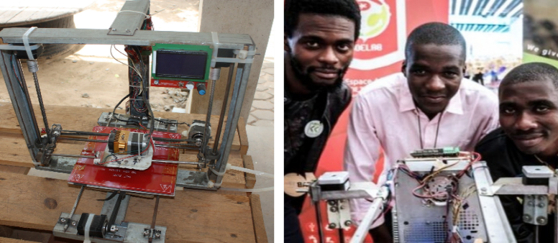
Figure 4 : W.Afate , first African 3D printer [17]
WoeLab distinguished itself by the creation of W.Afate , designed from locally recovered electronic waste. This project illustrates a " low - high tech" approach that values available resources while meeting local needs for affordable and sustainable technology [18] .
Through the HubCité program, WoeLab promotes a participatory urban planning model where residents are actors in the transformation of their urban environment. This initiative aims to create African “smart cities” based on collaboration, local innovation and open source culture [19] . As an incubation space, WoeLab supports innovative projects solving several urban problems such as waste management ( SCoPE ), food and energy resources ( Urbanattic ) and digital currency ( Sys'Woe ) [17] . It provides an environment conducive to the creation of technological solutions adapted to local challenges, thus promoting the emergence of an inclusive digital economy.

WAKATLAB (Ouagadougou, Burkina Faso)
Based in Ouagadougou, WAKATLAB is a collaborative space dedicated to digital manufacturing, prototyping, social innovation and youth support. This FabLab is distinguished by its community roots and pragmatic approach, which aims to design technical solutions that directly meet local needs, particularly in the health and entrepreneurship sectors.
For example, it contributed to the design of low-cost medical devices during COVID-19 with the DCLIC project: It helps fight the spread of the virus. Its mobile application, for example, allows body temperature to be determined by analyzing a photo taken with a smartphone. The project leaders are working in particular on a respirator made in Burkina and visors to protect healthcare personnel [20] .
CarrOps program, funded by the Embassy of the Kingdom of the Netherlands, aims to strengthen the social and economic integration of rural youth in Burkina Faso. Among the key actors, WAKATLAB plays a central role in the implementation of technological and digital training components. Through sustainable digital service centers located in 50 rural communes, WAKATLAB contributes to the creation of physical and virtual spaces where young people can develop their entrepreneurial, professional and social skills [21] .

Orange's Solidarity FabLabs (Madagascar)
The Solidarity FabLabs located in Madagascar operate in key areas of sustainable development, with innovative projects geared towards solving local problems. The cross-disciplinary approach adopted by these digital manufacturing laboratories promotes the convergence of engineering sciences and social innovation. Four FabLabs from Orange's Solidarity FabLabs were identified in this study: the Orange Digital Center FabLab in Antananarivo, the Mamiratra FabLab (managed by SOS Children's Village), the Ankatso University FabLab and the i- Votika FabLab in Antsirabe [22] .

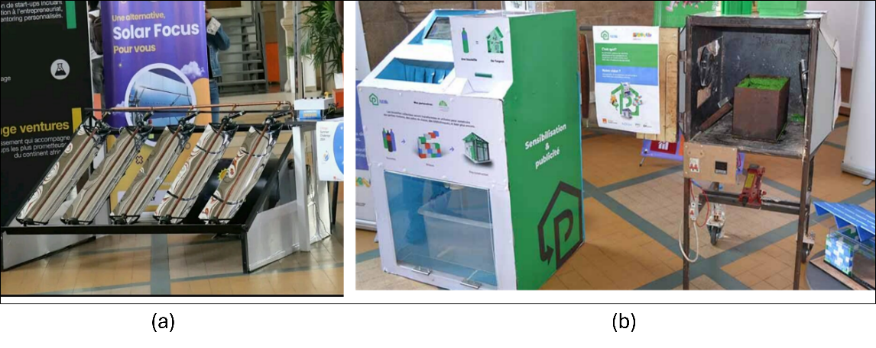
Figure 5 : the project developed in 2024: (a) SolarFocus and (b) Plastikôo

In the energy sector, several initiatives illustrate a desire for energy autonomy and technological adaptation. The FabLab Orange Digital Center has developed the Solar Focus project, a solar energy production device based on flexible glass panels, designed to meet the needs of non-electrified areas [23] . And also the SPARE project, a plug-and- play system that allows real-time monitoring of electricity and hybrid consumption, identification of waste and remote control of domestic appliances [23] . In terms of health, the projects focus on prevention, hygiene and population autonomy. The FabLab of Ankatso has developed the Rano'O project , which aims to purify water for school and community use, while integrating hygiene awareness campaigns for schools in Madagascar to encourage students to wash their hands [24] . Finally, the socio-economic impact WITH The Plastikôo project , incubated at the FabLab Orange, transforms plastic waste into building bricks, combining an ecological approach, professional integration and a response to housing needs [23] .
These projects show that FabLabs are not limited to prototyping sites, but act as catalysts for social and technical innovation, responding to the challenges of resilience, inclusion and sustainability in the Malagasy context.

The scientific and technological contributions of African FabLabs
In addition to the concrete technological initiatives developed within FabLabs , it is relevant to examine their contributions to scientific production. This section presents, on the one hand, some emblematic technological achievements, and on the other hand, the scientific publications resulting from or carried out by these FabLabs .

Table 1 : Examples of technological productions from African FabLabs
FabLab | Location | Areas of intervention | Key Projects / Achievements
UEA EcoWaste FabLab | Bukavu, DRC | Energy, environmental health, urban agriculture, economic inclusion | Transformation of plastic waste into equipment via 3D printing; smart composters; ecological sanitation devices
WoeLab | Lomé, Togo | Social innovation, technology, urban planning, digital inclusion | W.Afate ( low -tech 3D printer made from electronic waste); HubCité participatory urban planning ; waste management, digital currency
WAKATLAB | Ouagadougou, Burkina Faso | Digital manufacturing, social innovation, health, entrepreneurship | DCLIC mobile application (temperature measurement via photo); local respirator; protective visors; CarrOps program for rural integration
Orange Solidarity FabLabs | Madagascar (Antananarivo, Antsirabe, Ankatso) | Energy, health, social innovation | SolarFocus Project (flexible solar panels); SPARE (electricity consumption monitoring); Rano'O (water purification and awareness raising); Plastikôo (recycled plastic bricks)

Table 1 highlights the diversity and richness of technological productions from several African FabLabs . These initiatives illustrate how FabLabs , by relying on digital manufacturing technologies and a community approach, respond to local needs in health, environment, energy and education. Each FabLab adapts its projects to the social and economic realities of its context, proving their capacity to be catalysts for inclusive and sustainable innovation.

Table 2 : Examples of scientific productions from African FabLabs
Year | Publication title | Main objective | Methodology | FabLabs studied | Scientific contribution
2020 | FabLabs, workshops in the heart of the city: the specificities of places in French-speaking Africa [3] | Identify the specificities of African FabLabs in urban environments | Qualitative survey (interviews with FabManagers ) | Blolab , Woelab , Donilab , Ouagalab , Babylab , SahelFabLab , Ker Thiossane | Analysis of social dynamics, digital inclusion, territorial anchoring
2020 | FabLabs in Africa: digital innovation at the service of a sustainable city? [25] | Exploring the role of FabLabs in building frugal and sustainable cities | Field studies, critical approach to the smart city model | Woelab , Ouagalab , Defko Ak Niep , BabyLab | Positioning FabLabs as citizen and low -tech alternatives
2018 | From informational commons to educational commons: FabLabs in French-speaking Africa [26] | Analyzing FabLabs as producers of educational commons | Theoretical analysis (commons theory) and case studies | Blolab , Donilab , Ouagalab , ReFFAO | Conceptualization of FabLabs as spaces for shared educational innovation
2018 | FabLabs in Africa: a utopia tested by local realities [27] | Questioning the tensions between the ideals of the maker movement and African realities | Autoethnographic testimony, participant observation | Various African FabLabs (notably via Afropixel in Dakar) | Critical reflection on the adaptation of the FabLab model to African contexts

These various publications show that African FabLabs are not only places of manufacturing or technological innovation with a practical aim, but that they also generate active scientific reflection. Indeed, through the observation of their local dynamics, their collaborative practices and their anchoring in social and territorial issues, several researchers have produced scientific works that contribute to the knowledge of FabLabs in Africa. Thus, FabLabs such as Woelab , Blolab or Ouagalab also become objects of study, even research partners, demonstrating their capacity to fuel academic debates on educational commons, low -tech models, digital inclusion or even urban sustainability. This confirms that African FabLabs , in addition to their social and economic impact, play a growing role in the production of contextualized scientific knowledge.

Technical challenges and solutions
However, beyond this scientific and reflective contribution, African FabLabs remain confronted with technical constraints which influence their daily functioning and their capacity for action. Their responses to questionnaires and studies show that they face a series of specific technical challenges that limit their effectiveness and long-term development. These challenges vary depending on available resources, local infrastructure, and socioeconomic conditions. Nevertheless, numerous initiatives are being implemented to address them, seeking to strengthen the autonomy and sustainability of these spaces. Here is an analysis of the main technical challenges faced by African FabLabs, as well as the solutions being considered.

Limited access to electronic components and materials
One of the major obstacles faced by African FabLabs is limited access to electronic components and materials needed for manufacturing. FabLabs located in remote or less developed regions, such as FabLab Orange Digital Center in Madagascar or FabLab Ecodéchets UEA in the DRC, often struggle to obtain spare parts, electronic components, or materials specific to digital manufacturing. This shortage sometimes prevents prototyping or technology development projects from running smoothly.
To overcome this problem, some FabLabs are turning to local sourcing and using recycled or local materials, thereby reducing their dependence on foreign suppliers. For example, FabLab Ecodéchets UEA uses a plastic shredder and a plastic extruder to manufacture parts from plastic waste, helping to reduce procurement costs while having a positive environmental impact. This approach also supports local initiatives and encourages recycling.

Machine maintenance and lack of advanced training
Another major technical challenge is machine maintenance. FabLab equipment, such as 3D printers, CNC milling machines, and laser cutters, requires regular maintenance to function properly. However, African FabLabs, especially those without qualified maintenance personnel, often find themselves with non-functional equipment for extended periods. Furthermore, the lack of advanced training in some FabLabs limits their members' ability to fully utilize the available tools.
To address this issue, partnerships with local universities or specialized maintenance organizations are underway to train FabLab members in equipment management and maintenance. Additionally, some FabLabs are offering continuing education sessions on advanced technical aspects, such as manufacturing software optimization or machine repair. For example, WoeLab in Togo offers basic training in programming and digital manufacturing, but could expand these courses to include more advanced skills in machine maintenance and improvement.

Access to digital infrastructure and lack of knowledge sharing
Access to digital infrastructure and the lack of knowledge sharing between different African FabLabs also represent significant obstacles. Although FabLabs are spaces for collaboration, many challenges remain regarding the sharing of knowledge, skills, and resources between FabLabs on the continent. Unstable internet connectivity and the lack of collaborative platforms between FabLabs reduce their ability to exchange information or projects, thus limiting the potential for regional innovation.
To address this, several FabLabs are considering creating stronger collaborative networks and establishing shared digital platforms that would facilitate communication between African FabLabs and with international partners. For example, FabLab Ecodéchets UEA and FabLab Orange Digital Center have expressed their desire to strengthen local and international partnerships to pool resources and know-how. In addition, accelerating online training and creating a shared database of tools and methods would allow for better dissemination of technical knowledge and encourage collaborations between FabLabs .

Access to electricity and energy management
Access to electricity remains one of the biggest challenges for many FabLabs, particularly in rural areas or countries with less stable energy infrastructure. FabLabs like WoeLab in Togo and FabLab Orange Digital Center in Madagascar frequently report power outages that affect production and training. These outages sometimes prevent long-term projects from being carried out and increase operational costs due to the need to rely on alternative energy sources.
The transition to solar energy is emerging as an increasingly popular solution. FabLab Ecodéchets UEA in the DRC and WakatLab in Burkina Faso are already installing solar systems to reduce their dependence on the electricity grid. In addition, energy management and consumption monitoring systems are beginning to be integrated to optimize the use of available resources.

Financing and economic viability
Funding remains a recurring challenge for many FabLabs, which often rely on external grants or one-off funding to operate. This dependency makes it difficult to implement long-term sustainable projects. FabLabs such as WakatLab in Burkina Faso and FabLab Ecodéchets UEA in the DRC struggle to ensure stable financial autonomy.
To address this challenge, some FabLabs are seeking to diversify their funding sources by developing services such as on-demand manufacturing or technical training. Creating public-private partnerships and exploring collaborative business models could also provide solutions to make these spaces more financially self-sufficient.

The impact of FabLabs on professional integration and local innovation
Despite persistent technical challenges and the solutions implemented to address them, African FabLabs play a key role in local development. These spaces offer unique opportunities for acquiring practical and technical skills, promoting participants' autonomy and promoting their expertise. Thus, their contribution is not limited to technological innovation but also extends to professional integration and the creation of projects that meet the needs and challenges of local communities.

Acquisition of technical skills
The FabLabs studied offer a wide range of technical training, focusing on digital manufacturing, electronics, and programming. Tools such as 3D printers, CNC milling machines, Arduino, Raspberry Pi, and software such as Fusion 360, Python, and SolidWorks are used in all labs.
Pedagogy is often based on a practical approach (“learning by doing”), where participants learn by designing and prototyping concrete objects or systems.
Specific modules are offered on:
- Digital manufacturing,
- Renewable energy systems,
- Prototyping,
- Robotics and IoT.
These technical skills make it possible to fill the gaps left by traditional education, by training more operational profiles, adapted to local realities.

Effect on employment and entrepreneurship
African FabLabs are playing a growing role in the professional integration of young people, offering technical training geared towards market needs (digital manufacturing, prototyping, electronics, programming). However, their impact varies from one structure to another, depending on their capacity, equipment, and level of partnership with local businesses or institutions.

Table 3 : Impact of FabLabs on professional integration and entrepreneurship
FabLab | Country | Estimated annual professional integration | Startups created
FabLab Orange Digital Center | Madagascar | Less than 10 people | Not specified
UEA Eco-Waste FabLab | DRC (Bukavu) | Between 10 and 30 people | 3
WoeLab | Togo (Lomé) | About 10 to 30 people | 6
WakatLab | Burkina Faso | More than 50 people | About 10

- WakatLab (Burkina Faso) stands out for its high employment rate, with more than 50 young people trained each year finding employment or starting their own businesses. It is also the most active FabLab in terms of startup creation, with around ten entrepreneurial projects incubated.
- WoeLab (Togo) and FabLab Ecodéchets (DRC) also show solid results, with between 10 and 30 beneficiaries professionally integrated per year, and several startups launched (6 for WoeLab, 3 for the FabLab of Bukavu).
- FabLab Orange Digital Center (Madagascar) , more recent and smaller, still has a limited impact, with fewer than 10 young people integrated each year and no start-up creations recorded yet.
In summary, professional integration and entrepreneurship are two major contributions of African FabLabs, although their performance depends on structural factors such as access to financing, the quality of training offered, and the level of collaboration with local partners.

Comparison with other educational models
This ability to train and professionally integrate participants translates concretely into an innovative educational approach, where FabLabs stand out as alternatives to traditional schools, centered on practice, interdisciplinarity and frugal innovation. Unlike traditional technical education, which is often theoretical and disconnected from local needs, FabLabs enable rapid and targeted training, access to modern technological tools, and the creation of local solutions that address real-world challenges.
Synergies are possible with universities, as is already the case at FabLab Écodéchets (linked to the University of Bukavu), which would benefit from being systematized to pool educational resources.

Sustainability and viability of African FabLabs
Although African FabLabs have a significant impact on skills development and local innovation, their sustainability remains a key issue. Their operation depends largely on external funding, which limits their autonomy and hinders their ability to develop sustainably. Examining existing business models thus highlights the constraints and opportunities related to the viability of these spaces.

Existing economic models
Analysis of African FabLabs reveals a heavy reliance on external funding, which limits their ability to develop independently. None of the FabLabs studied achieve financial self-sufficiency. Their main sources of income include:
- Grants from NGOs or international organizations, such as for the UEA Ecodéchets FabLab .
- Personal or associative funding, as in the case of WoeLab , supported by an NGO and its founder.
- Services, such as training and prototype manufacturing, operated by FabLab Orange Digital Center and WakatLab to generate partial income.

Table 4 : Economic models of the FabLabs studied
FabLab | Country | Sources of funding | Financial Self-sufficiency
FabLab Orange Digital Center | Madagascar | Services (manufacturing, training), partnerships with companies | No
UEA Eco-Waste FabLab | DRC (Bukavu) | Grants from an international organization (NGO), equipment financed | No
WoeLab | Togo (Lomé) | Personal funding from the founder, support from the NGO L'Africaine d'Architecture | No
WakatLab | Burkina Faso | Calls for projects, services (training, manufacturing) | No

However, these sources remain fragile and irregular, and academic or institutional partnerships are still underdeveloped. This economic precariousness represents a structural obstacle to the consolidation of FabLabs, despite their obvious social and technological impact on local communities.

Environmental impact and sustainable solutions
In a context marked by limited resources and increasing pressure to adopt environmentally responsible practices, some African FabLabs stand out for their integration of approaches geared towards environmental sustainability. Two notable examples are the FabLab Écodéchets UEA (DRC) and the WoeLab (Togo), which illustrate a systemic approach to eco-design and resource circularity.
Recycling plastic and electronic waste is a central part of their operations. The UEA FabLab, for example, has a shredder and a plastic extruder, allowing them to transform plastic waste into filament for 3D printing. In addition, the WoeLab has developed digital equipment from recovered electronic components, as part of a technological reclamation approach.
Furthermore, these FabLabs promote the design of low-tech machines using local or second-hand materials, illustrating a technological adaptation to local constraints while reducing the ecological footprint of the equipment. The use of recycled materials is common in several projects carried out by these FabLabs, particularly in the fields of 3D printing, the manufacture of street furniture, and low-cost electronic devices. These practices are part of a circular economy approach, aimed at extending the life cycle of materials and limiting the need to import components.
Thus, these initiatives demonstrate that African FabLabs can constitute experimental laboratories in ecotechnology, by integrating sustainable development strategies adapted to their socio-economic environments.

Comparison with other FabLabs in emerging countries
Comparing African FabLabs with those in other emerging countries helps us better understand their sustainability challenges. This perspective highlights alternative economic models and resilience strategies that can strengthen their autonomy and sustainability.

Examples of inspiring international FabLabs
In several emerging countries, FabLabs have developed original models combining technological innovation, local roots and economic viability.
There is FabLab Lima which is recognized as the first FabLab in Latin America, having played a central role in the rise of the FabLab movement in the region. Founded in 2010, it hosted the FAB7 international conference in 2011, marking a significant milestone for the FabLab community in Latin America and highlights the collaboration with local artisans and the integration of digital fabrication into traditional craft practices [28] . In addition, FabLab Lima was a key player in the creation of the Fab network Lat , which aims to promote collaboration between Latin American FabLabs , and FabLab Kids, aimed at introducing young people to digital manufacturing technologies [29] .

Good practices to adapt in Africa
Despite the wealth of African initiatives, certain good practices observed elsewhere remain little adopted and would offer an important lever to strengthen the impact of African FabLabs :
- Revaluation of local crafts through digital co-design
- Integration of digital manufacturing into certified technical or secondary courses, to systematize skills development.
- Use of local crowdfunding platforms to support projects from FabLabs .
- Cross-residencies between FabLabs , art schools, engineering schools and agricultural cooperatives, in order to stimulate interdisciplinary innovation.
- Structured partnerships with SMEs to offer technical services and generate stable income.
Adopting these adapted models could enable African FabLabs to go beyond their role as prototyping centers to become pillars of local social and economic innovation.

Discussion and recommendation

Discussion
The development of African FabLabs can be illuminated by several theoretical frameworks from the sociology of technology and innovation. The Social Construction of Technology (SCOT) approach, proposed by Bijker and Pinch in 1984, highlights that technologies are never neutral: they are shaped by social groups, their needs, constraints and representations [30] . In African FabLabs , technical devices are not simply imported or standardized but result from co-construction processes between users and their environment. They reflect local realities – social, economic and cultural – and thus produce forms of contextualized technology. This reading is complemented by the theory of user innovation, developed by von Hippel in 2005, according to which end users can be the true innovators [31] . In African FabLabs, the logic of Do It Yourself and co-creation allows students, artisans, and young entrepreneurs to design solutions adapted to their daily needs. These actors are not simply beneficiaries, but active designers of relevant technologies. Finally, Schumacher's 1973 thinking on appropriate technology finds a direct echo in the low -tech approach of many FabLabs [13] . The use of recycled materials, the search for simplicity, reparability and suitability to local contexts illustrate a desire to promote technology on a human scale, resilient and accessible. Thus, these spaces do not just manufacture objects: they participate in the transformation of territories by articulating innovation, autonomy and inclusion.
Despite the wealth of information presented, certain limitations remain, notably the absence of detailed quantitative data and in-depth statistical analyses, the lack of a critical review of projects that did not succeed, and the overall generality of the recommendations provided. These limitations can be partly explained by the limited availability of data and the exploration nature of the research. Future, more targeted and longitudinal studies are planned to address these gaps, incorporate a more robust statistical methodology, systematically document the factors behind project failures, and develop precise operational plans to enhance the impact and sustainability of African FabLab initiatives.

Recommendations for the development of African FabLabs
In order to strengthen their sustainability and impact, several avenues should be considered:
- Strengthening institutional support: The involvement of States, local authorities and universities is crucial to ensure a stable legal, financial and logistical framework, in particular through the provision of premises, recurring subsidies and support mechanisms for local innovation.
- Structuring a pan-African FabLabs network: A collaborative network would make it possible to pool technical and educational resources, share best practices, and co-develop energy or software solutions adapted to African contexts.
- low -tech and local approaches: By integrating recycled materials and technologies adapted to the economic and environmental realities of the regions, FabLabs can offer sustainable alternatives to imported manufacturing models.
- Developing South-South partnerships: Drawing on the experience of FabLabs located in Latin America or Asia, Africa can benefit from skills transfers on key themes such as low-cost IoT, smart agriculture or the manufacturing of low-cost medical devices.
These recommendations aim to make African FabLabs not only manufacturing spaces, but also catalysts for technological sovereignty, inclusive economic development and community resilience.

Conclusion
FabLabs are now establishing themselves as local innovation hubs, capable of filling structural gaps in training, technological equipment, and sustainable development. Their contribution goes beyond simple prototyping: they play a vital role in acquiring practical skills, stimulating local entrepreneurship, and spreading a culture of inclusive innovation.
In a context where only 9% of young Africans have basic digital skills and where less than half of schools are connected to the Internet, these spaces represent a concrete response to major educational and socio-economic challenges. However, their ability to be part of a dynamic of sustainable innovation remains highly dependent on several factors: irregular access to electricity, precarious equipment, scarcity of recurring funding, and weak institutional recognition.
Our analysis shows that, although fragmented, these FabLabs demonstrate technological and social ingenuity through frugal innovation, recycling, and community dynamics. To strengthen their impact, it is essential to create a structured pan-African network, better integrate them into education systems, and support them through ambitious public policies.
Inspired by experiences in Latin America, African FabLabs can also leverage interdisciplinary co-design models, cross-residencies, and crowdfunding to broaden their scope. Supported by institutions such as UNESCO, UNIDO, and the OECD, they have the potential to become major vectors of technological sovereignty and local resilience on the continent.

Disclaimer (Artificial intelligence)
Author(s) hereby declare that generative AI technologies such as Large Language Models, etc. have been used during the writing or editing of manuscripts. This explanation will include the name, version, model, and source of the generative AI technology and as well as all input prompts provided to the generative AI technology

Details of the AI usage are given below:
- ChatGPT (OpenAI), GPT-4 version, accessed via the official platform (chat.openai.com).
- Purpose of use: language editing and text reformulation.
- The use was limited, ethical, and strictly focused on improving the writing quality without generating scientific content or data.

COMPETING INTERESTS DISCLAIMER:
Authors have declared that they have no known competing financial interests OR non-financial interests OR personal relationships that could have appeared to influence the work reported in this paper.

REFERENCES
[1] K. Sheridan, E. R. Halverson, B. Litts, L. Brahms, L. Jacobs-Priebe, and T. Owens, “Learning in the Making: A Comparative Case Study of Three Makerspaces,” Accessed: May 12, 2025. [Online]. Available at: https://dx.doi.org/10.17763/haer.84.4.brr34733723j648u
[2] Fiorenza Gamba, Sandro Cattacin, and Nerea Viana Alzola, City and creativity . in Chora. Seismo. [Online]. Available at: https://d1wqtxts1xzle7.cloudfront.net/103254435/Gamba_Cattacin_VianaAlzola_2023-libre.pdf
[3] I. Liotard, “FabLabs, workshops in the heart of the city : the specificities of places in French-speaking Africa ” , Innovations , vol. 61, no. 1 , pp. 117-139 , Jan. 2020, doi: 10.3917/inno.pr2.0073.
[4] Fabien Eychenne, “Fab Labs Overview – Fing”. Accessed: October 15, 2024. [Online]. Available at: https://fing.org/publications/fab-labs-overview.html
[5] J.-M. Galan and F. Musiani, “Creating a FabLab at the university : human and institutional issues: » , Sociol. Prat. , vol. No. 38, no. 1 , p. 35 ‑ 48, March 2019, doi: 10.3917/sopr.038.0035.
[6] “About | FabLabs,” FabLabs.io - The Fab Lab Network. Accessed: May 6, 2025. [Online]. Available at: https://www.FabLabs.io/about
[7] IIPE-UNESCO Dakar, “Digital Transformation of TVET and Skills Development Systems in Africa : state of play and perspectives | International Institute for Educational Planning » . Accessed : July 1, 2025. [Online]. Available at: https://www.iiep.unesco.org/en/publication/digital-transformation-of-leftp-and-competence-development-systems-in-africa-state
[8] “Development Dialogue on Digital Transformation and Artificial Intelligence”, UNIDO. Accessed: July 1, 2025. [Online]. Available at: https://www.unido.org/news/development-dialogue-digital-transformation-and-artificial-intelligence
[9] African Union Commission and OECD, African Development Dynamics 2024: Skills, Jobs and Productivity . in African Development Dynamics. OECD, 2024. doi: 10.1787/b25ee3a9-fr.
[10] IIPE-UNESCO Dakar, “West Africa : FabLabs promoting “ Low Tech ” and “ commons ” are developing | », TV5MONDE . Consulted on : May 6, 2025. [Online]. Available at: https://information.tv5monde.com/international/afrique-de-louest-les-FabLabs-promoteurs-des-low-tech-et-des-communs-se-developpent
[11] “Woelab, the 2.0 neighborhood house of the Togolese at the service of the Lomé of tomorrow”, Economie Afrique. Accessed: May 6, 2025. [Online]. Available at: https://economie-afrique.com/entreprises/woelab-maison-quartier-2-0-togolais-lome/
[12] Geoff Mulgan, Simon Tucker, Rushanara Ali, et Ben Sanders, “(PDF) Social Innovation: What It Is, Why It Matters and How It Can Be Accelerated” , ResearchGate . Accessed: July 1, 2025. [Online]. Available at: https://www.researchgate.net/publication/277873357_Social_Innovation_What_It_Is_Why_It_Matters_and_How_It_Can_Be_Accelerated?utm_source=chatgpt.com
[13] EF Schumacher, Small is beautiful; economics as if people mattered . New York: Harper & Row, 1973. [Online]. Available at: https://catalog.princeton.edu/catalog/9912181363506421
[14] N. Radjou, JC Prabhu, and S. Ahuja, Jugaad innovation: think frugal, be flexible, generate breakthrough growth , 1st ed. San Francisco: Jossey-Bass, 2012. Accessed: July 1, 2025. [Online]. Available at: https://library.usi.edu/record/462080
[15] “Home - FabLabecodechetsuea”. Accessed: May 4, 2025. [Online]. Available at: https://FabLabecodechetsuea.org/fr/
[16] “Events - FabLabecodechetsuea” Vardenafil: A Comprehensive Guide to Understanding its Uses, Effects, and Innovations, Accessed: May 12, 2025. [Online]. Available at: https://FabLabecodechetsuea.org/fr/events-2/

[17] M. Koba, Au Togo, WoeLab sert de tremplin aux jeunes innovateurs[In Togo, WoeLab serves as a springboard for young innovators] Accessed: May 6, 2025. [Online]. Available at: https://www.wearetech.africa/fr/fils/tech-stars/au-togo-woelab-sert-de-tremplin-aux-jeunes-innovateurs
[18] Rémy Nsabimana, “Woelab, the laboratory that recycles electronic waste”, BBC News Africa. Accessed: May 6, 2025. [Online]. Available at: https://www.bbc.com/afrique/monde-38577228

[19] Rémy Nsabimana, Un Togolais veut créer des villes intelligentes
[A Togolese wants to create smart cities], Urbanisme Francophonie. Accessed: May 6, 2025. [Online]. Available at: https://www.urbanisme-francophonie.org/ressource-doc/un-togolais-veut-creer-des-villes-intelligentes/
[20] S. Tobias, “Burkina Faso unites its initiatives in the face of Covid-19”, CIOMAG. Accessed: May 6, 2025. [Online]. Available at: https://cio-mag.com/le-burkina-faso-federe-ses-initiatives-face-au-covid-19/
[21] “WAKATLAB”. Accessed: May 6, 2025. [Online]. Available at: https://wakatlab.org/
[22] “FabLab solidaire”, Orange Madagascar. Accessed: May 6, 2025. [Online]. Available at: https://www.orange.mg/fr/FabLab-solidaire.html
[23] “Orange Summer Challenge 2024 : " Plastik ô o » wins the national prize in Madagascar » , Orange actu Madagascar. Accessed : May 4, 2025. [Online]. Available at: https://actu.orange.mg/orange-summer-challenge-2024-plastikoo-remporte-le-prix-national-a-madagascar/
[24] “Challenge “I Make 4 my City” | Orange Engage for Change - Madagascar”. Accessed: May 4, 2025. [Online]. Available at: https://engageforchange.orange.com/country/mg/programs/1e09cfeb-7509-4528-b8bf-14460c643b65
[25] C. Armelle and L. Martin, “FabLabs in Africa : digital innovation at the service of a sustainable city ? » , M é tropolitiques. Accessed : July 18, 2025. [Online]. Available at: https://metropolitiques.eu/Les-FabLabs-en-Afrique-l-innovation-numerique-au-service-d-une-ville-durable.html
[26] S. Leyronas, I. Liotard, and G. Prié, “From informational commons to educational commons : FabLabs in French-speaking Africa. » , May 2018. Accessed : July 18, 2025. [Online]. Available at: https://hal.science/hal-03407669

[27] M. N. Thomas Hervé, Les Fablabs en Afrique : une utopie à l’épreuve des réalités locales [FabLabs in Africa : a utopia tested by local realities] | Open AIR » . Accessed : July 18 , 2025. [Online]. Available at: https://openair.africa/les-FabLabs-en-afrique-une-utopie-a-lepreuve-des-realites-locales/
[28] Fabien Eychenne, “In Lima, FabLabs are Peru,” Makery. Accessed: May 6, 2025. [Online]. Available at: https://www.makery.info/2015/10/30/in-lima-FabLabs-are-peru/
[29] “FabLab Lima,” Maker Tour. Accessed: May 6, 2025. [Online]. Available at: https://www.makertour.fr/en/workshops/FabLab-lima#topics
[30] TJ Pinch and WE Bijker, “The Social Construction of Facts and Artefacts: or How the Sociology of Science and the Sociology of Technology might Benefit Each Other,” Soc. Stud. Sci. , flight. 14, no . 3, p. 399 - 441, August 1984 , doi: 10.1177/030631284014003004.
[31] V. Hippel and E. A, “Democratizing Innovation”, Prof. Von Hippel, 2005, Accessed: July 1, 2025. [Online]. Available at: https://dspace.mit.edu/handle/1721.1/118153

