Thermal and Energy Performance Analysis of Solar Dryers with Adobe Walls: An Experimental Study in Semi-Arid Regions

Abstract
This study evaluates a greenhouse-type solar dryer with adobe walls, a natural material known for its thermal inertia, aimed at improving the drying of agricultural products in tropical regions. By using local materials, the system reduces costs and environmental impact while enhancing energy efficiency. Experimental observations demonstrate the dryer’s ability to maintain stable internal temperatures above ambient levels, even during sunless periods, highlighting the thermal inertia of adobe. The findings confirm that adobe-based dryers provide a sustainable, low-cost alternative to conventional systems and support their broader adoption in rural areas. The results also suggest potential for further optimization and scaling using other natural materials.
Keywords: Solar dryer, Adobe walls, Thermal performance, Energy efficiency, Sustainable materials, Agricultural product drying, Greenhouse-type dryer
1. Introduction
For rural communities in tropical and subtropical regions, the search for sustainable and efficient solutions for preserving agricultural production remains a major challenge. Indeed, the drying of food products—particularly fruits, vegetables, and grains—is a traditional yet essential technique to minimize post-harvest losses, ensure food safety, and maintain product quality. However, while commonly used, open sun-drying methods present several drawbacks, including susceptibility to weather conditions, contamination, and product degradation (Indiarto et al., 2020).
In this context, solar dryers emerge as a promising alternative. These systems enable faster and more controlled drying while utilizing solar energy (Singh & Gaur, 2024). Among emerging technologies, greenhouse dryers that incorporate local materials such as adobe (banco) have attracted increasing interest due to their low cost, minimal environmental impact, and suitability for rural community needs (Venkateswarlu et al., 1989; Barpatra Gohain & Dutta, 2025).
Numerous scientific studies have investigated solar drying systems, typically categorized into three types: direct, indirect, and hybrid dryers (Fernandes & Tavares, 2024). Direct dryers, such as greenhouse dryers, capture solar heat through a transparent surface to warm the air and dry the products (Razack, 2021). Indirect dryers use a heat exchanger to transfer heat to a separate drying chamber. Hybrid systems combine both solar and auxiliary energy sources to enhance efficiency (Fudholi et al., 2010).
Adobe, a traditional building material made from raw earth, is widely recognized for its thermal properties and availability. Its ability to regulate temperature and humidity makes it a material of choice for designing solar dryers in hot climates (Parra-Saldivar et al., 2006). Recent studies have shown that adobe structures can maintain stable internal temperatures, thereby reducing thermal fluctuations that may compromise drying quality (Touati et al., 2023; Bailly et al., 2024; Heracleous et al., 2023).
However, the specific application of adobe in greenhouse dryer design remains underexplored. There is a pressing need to deepen understanding of the performance of such systems, particularly in terms of energy efficiency, drying quality, and long-term durability (Ntwali et al., 2021; Rahman et al., 2025; Andharia et al., 2024).
The objective of this study is to design, implement, and evaluate a greenhouse solar dryer equipped with adobe walls. Specifically, this research aims to (i) analyze the dryer’s ability to maintain optimal drying conditions by measuring temperature stability, airflow distribution, and internal relative humidity; (ii) compare the performance with conventional solar dryers using quantitative thermal and drying efficiency indicators; and (iii) examine the technical and economic feasibility for large-scale adoption by local communities by assessing construction costs, energy savings, and operational efficiency.
This study thus seeks to provide practical and sustainable solutions for improving agricultural drying conditions while promoting the use of local, environmentally friendly materials.
2. Design and Experimentation of the Adobe Greenhouse Solar Dryer
2.1 Schematic and Description of the Dryer
The experimental solar dryer was designed and constructed using locally available building materials. The prototype dryer has a parallelepiped shape with dimensions of 1.5 m in length, 1 m in width, and 1 m in height, giving it a total internal volume of 1.5 m³. The roof of the dryer is made of 5 mm thick glass and is inclined at an angle of 15° with respect to the horizontal plane, as illustrated in Figures 1 and 2.
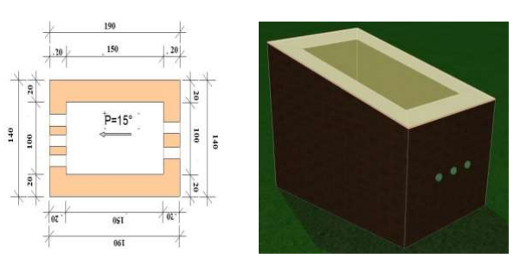
Figure 1: dryer plan Figure 2: Banco dryer

2.2 Fabrication of Adobe Bricks
“Banco,” or raw earth, is one of the oldest construction composites known. It is primarily composed of earth mixed with water and often supplemented with straw. To produce prismatic bricks, the earth is molded while in a plastic state and manually compacted to expel air trapped within its pores. Once compacted, the bricks can be immediately demolded.
The bricks are left to dry in the sun for several days. As soon as they can be handled without deformation, they are set upright on their edges to ensure uniform drying on both bearing and laying surfaces. Although the mechanical strength of adobe may be lower than that of industrially manufactured bricks, it is generally sufficient for human use.
When properly constructed and maintained, buildings made from adobe or rammed earth can last over a century in good condition. In theory, earthen structures can last indefinitely if given regular and appropriate maintenance (Barkeshli, 2022).
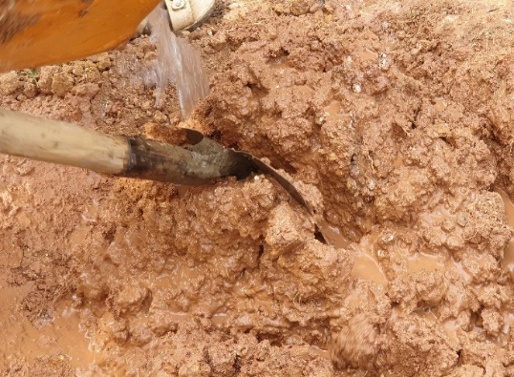 | 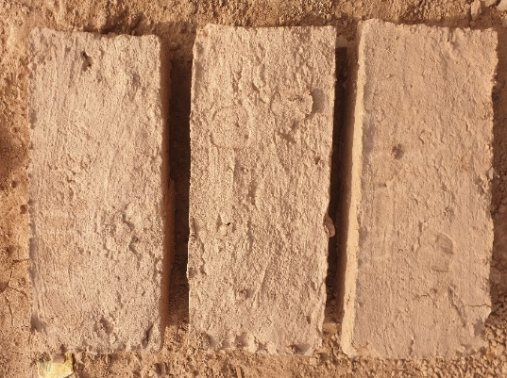
Figure 3: Adobe brick fabrication
2.3 Thermo-physical characterization of adobe brick
The thermo-physical properties of material are essential parameters for modeling heat transfer in complex systems. These properties serve as critical input data for predicting the thermal performance of a system. In this study, the intrinsic thermo-physical properties of the materials were experimentally determined using a KD2-Pro device (Figure 3).
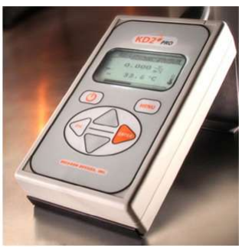
Figure 4: KD2 Pro device
2.4 Construction of the Dryer
After drying, the adobe bricks are assembled using a very stiff earthen mortar. This is the fastest construction technique involving raw earth. Moreover, the fabrication of adobe bricks requires very few tools—only a wooden (or metal) mold is needed to shape the parallelepiped bricks. As such, it is a highly cost-effective method, well suited to the needs of developing countries.
To build the prototype’s walls, the adobe bricks are stacked, and clay is used as a binding agent. The prototype dryer was constructed following this same approach. Additionally, once the main structural work was completed, the dryer was finished by applying a layer of the same earth used for the bricks to both the interior and exterior surfaces of the walls (Figure 5).
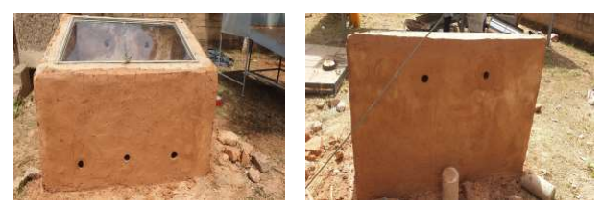
Figure 5: Solar dryer constructed with adobe bricks
2.5 Determination of Key Parameters in the Experimental Prototype
2.5.1 Temperature and Relative Humidity Measurements
To measure temperature, J-type thermocouples (Fe–CuNi pair) were used. These sensors operate over a temperature range of −200 °C to 870 °C and are known for their good resistance to high temperatures, with an accuracy of ±0.1% °C. The thermocouples were connected to a 10-channel digital data logger (midi LOGGER GL200A, GRAPHTEC brand), which offers a measurement precision of ±0.8% (Figure 6(a)). Temperature data were recorded every 10 minutes during the experiments. Ambient relative humidity at the experimental site was measured using a Velleman DVM171THT hygrometer (Figure 6(b)) at 30-minute intervals.
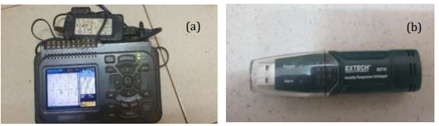
Figure 6: Measuring devices: (a) Midi LOGGER GL 200 A digital data logger; (b) Velleman DVM171THT hygrometer
2.5.2 Solar Radiation Measurement
Solar radiation was measured using an SR03-type pyranometer from Hukseflux (Figure 7), with an accuracy of 3.5%. This pyranometer was installed at the experimental site to record solar irradiance, which was logged using a GRAPHTEC-brand data recorder.
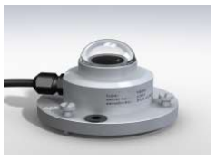
Figure 7: SR03 pyranometer (Hukselflux).
3. Data Acquisition Protocol for the Dryer Study
Figure 7 illustrates the data acquisition system used to monitor temperature variations within the experimental solar dryer. The instrumentation relies on multiple temperature sensors positioned at strategic locations inside the dryer; all connected to a data logger (Midi LOGGER GL 200A) that records the measurements in real time.
3. 1. Data Acquisition System
The system consists of:
- Temperature sensors (thermocouples or PT100 probes) placed at different heights and locations inside the dryer.
- A data logger (Midi LOGGER GL 200A), which automatically collects and stores the measured temperature data.
- A natural ventilation system, illustrated by arrows indicating airflow within the dryer.
3.2. Sensor Placement and Measured Data
The numbered sensors shown in the schematic allow thermal monitoring of several key zones of the dryer:
- Inlet air temperature: Measures the temperature of the ambient air before it enters the dryer.
- Interior wall temperatures (South, North, East, and West): T_{ps,i ;} T_{pn,i ;} T_{pe, i ;} T_{po,i}​; these indicate the influence of solar radiation absorbed and transferred to the drying air.
- Internal air temperature (Tai): Indicates thermal stratification and heat distribution within the drying chamber.
- Lower floor temperature (T_{plt}): Analyzes heat accumulation at the base of the dryer.
- Glass temperature (Tv): Evaluates solar capture efficiency and heat losses through the transparent cover.
- Inlet/outlet airflow: Monitors the movement and effectiveness of the drying air in extracting moisture.
3.3 Data Analysis and Interpretation
The recordings from the Midi LOGGER GL 200A yield time-resolved temperature curves at various points within the dryer. This enables analysis of:
- The thermal capacity and inertia of the dryer.
- Drying efficiency, particularly the temperature difference between drying air and ambient air.
- The impact of weather conditions (e.g., cloud cover, solar irradiance) on dryer performance.
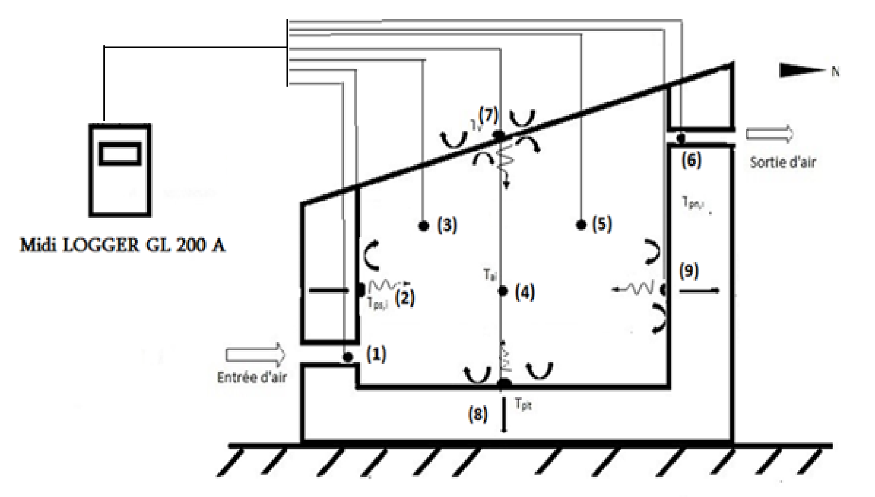
Figure 8: Descriptive diagram of the measurements
4. Results and Discussion
4.1 Thermo-Physical Properties of Adobe Bricks
The following table presents the thermal properties of three adobe brick samples (Test 1, Test 2, and Test 3) measured under similar temperature conditions (ranging between 29.06 °C and 29.46 °C) (Bailou et al. 2025). A detailed and structured analysis of the results is given below:
Thermal Conductivity
- Test 1: 0.428 ± 0.029 W/m·K
- Test 2: 0.352 ± 0.037 W/m·K
- Test 3: 0.570 ± 0.025 W/m·K
Thermal conductivity varies significantly among the samples. Test 3 shows the highest value (0.570 W/m·K), indicating a greater ability to conduct heat. This may be attributed to differences in material density or composition. In contrast, Test 2 exhibits the lowest conductivity (0.352 W/m·K), making it more thermally insulating. The average thermal conductivity across the three samples is 0.45 ± 0.030 W/m·K.
Volumetric Heat Capacity (C)
- Test 1: 1.885 ± 0.020 MJ/m³·K
- Test 2: 1.626 ± 0.030 MJ/m³·K
- Test 3: 2.270 ± 0.028 MJ/m³·K
Test 3 exhibited the highest volumetric heat capacity (2.270 MJ/m³·K), reflecting a greater ability to store thermal energy. In contrast, Test 2 showed the lowest value (1.626 MJ/m³·K), suggesting a reduced heat storage capacity. Taking these variations into account, the average value was determined to be 1.927 ± 0.028 MJ/m³·K.
Specific Heat Capacity (Cp)
- Test 1: 1.0296 ± 0.011 kJ/kg·K
- Test 2: 1.0069 ± 0.028 kJ/kg·K
- Test 3: 1.4149 ± 0.016 kJ/kg·K
Test 3 also showed the highest specific heat capacity (1.4149 kJ/kg·K), which is consistent with its higher volumetric heat capacity. This indicates that the material can store more thermal energy per unit mass.
Thermal Effusivity (E)
- Test 1: 898.209 ± 8.20 J·s ^{1/2} m⁻²·K⁻¹
- Test 2: 756.53 ± 7.57 J·s ^{1/2} m⁻²·K⁻¹
- Test 3: 1137.4 ± 10.10 J·s ^{1/2} m⁻²·K⁻¹
Test 3 exhibited the highest thermal effusivity (1137.4 J·s ^{1/2} m⁻²·K⁻¹), indicating a better ability to exchange heat with its surroundings. Conversely, Test 2 had the lowest effusivity (756.53 J·s ^{1/2} m⁻²·K⁻¹), which may be advantageous in applications requiring reduced thermal transfer. The average value was calculated to be 931.20 ± 8.71 J·s ^{1/2} m⁻²·K⁻¹
Thermal Diffusivity (α)
- Test 1: 2.270 × 10⁻⁷ ± 0.015 m²/s
- Test 2: 2.160 × 10⁻⁷ ± 0.023 m²/s
- Test 3: 2.313 × 10⁻⁷ ± 0.023 m²/s
Thermal diffusivity was slightly higher in Test 3 (2.313 × 10⁻⁷ m²/s), indicating a faster heat transfer rate within the material. Test 2 exhibited the lowest diffusivity (2.160 × 10⁻⁷ m²/s), suggesting higher thermal inertia. The average value obtained was 2.248 × 10⁻⁷ ± 0.020 m²/s.
In summary, the observed differences between samples can be attributed to variations in material composition (such as air pockets due to manual compaction), as well as differences in brick density, porosity, and experimental conditions. The experimental results presented in Table 1 fall within the ranges reported in the literature for adobe bricks (Ngaram, 2020; Lertwattanaruk et al.; Morsy, 2022). The reported values for thermal conductivity and other thermal properties are consistent with the typical characteristics of materials used in sustainable construction.

Table 1: Results of measurements of thermophysical parameters of adobe brick samples using the KD2 Pro thermal properties analyzer (Bailou et al. 2025).
Adobe brick smples | Temperatures  (ºC) | Thermal conductivity  (W.m⁻³.K⁻¹) |  | Volumetrie heat  capacity  C(MJ.m⁻³.K⁻¹) |  | Specific Heat Cp(Kj.kg⁻¹K⁻¹) |  | Thermal effusivity  E(J.s^{-1/2}.m⁻².K⁻¹) |  | Thermal diffusivity  (10⁻⁷.m².s⁻¹)
Adobe brick smples | Temperatures  (ºC) |  | Average | C | Average | Cp | Average | E | Average |  | Average
Test 1 | 29,46 | 0,428 ± 0,029 | 0,45  ±  0,030 | 1,885±  0,020 | 1,927  ±  0,028 | 1,0296  ±  0,011 | 1,1485  ±  0,015 | 898,2093±8,20 | 931,2089  ±  8,71 | 2,270±  0,015 |  | 2,313±  0,023
Test 2 | 29,34 | 0,352 ± 0,037 | 0,45  ±  0,030 | 1,626±  0,034 | 1,927  ±  0,028 | 1,0069  ±  0,018 | 1,1485  ±  0,015 | 756,5395 ± 7,57 | 931,2089  ±  8,71 | 2,160±  0,030 |  | 2,313±  0,023
Test 3 | 29,06 | 0,570 ± 0,025 | 0,45  ±  0,030 | 2,270±  0,028 | 1,927  ±  0,028 | 1,4149  ±  0,016 | 1,1485  ±  0,015 | 1137,497  ±  10,37 | 931,2089  ±  8,71 | 2,251±  0,025 |  | 2,313±  0,023
Table 2: Results of experimental measurements on adobe brick samples (Bailou et al. (2025)).
Adobe brick samples | Dimensions |  |  | Mass  M (kg) | Density  ρ (kg.m³)
 | Length L (m) | Width l (m) | Thickness e (m) | Mass  M (kg) | Density  ρ (kg.m³)
Test 1 | 0,376 | 0,188 | 0,085 | 11 | 1830,745
Test 2 | 0,377 | 0,191 | 0,095 | 11,05 | 1615,34
Test 3 | 0,373 | 0,188 | 0,096 | 10,8 | 1604,301
Average | 0,375 | 0,189 | 0,092 | 10,95 | 1677,828

4.2. Temporal evolution of Global Solar Radiation and Ambient Temperature
The figure 9 shows the simultaneous variation of global solar radiation (in W/m²) and ambient temperature (in °C) over four consecutive days starting from January 21, 2019, at the experimental site.
The daily profile of global solar radiation follows a typical bell-shaped curve. Each day begins with zero irradiation before 7 a.m., followed by a rapid increase until reaching a peak between 11 a.m. and 1 p.m. This maximum, reaching approximately 900 W/m², indicates strong and consistent direct sunlight. After this peak, radiation gradually decreases to return to near-zero values around 6 p.m., marking sunset. This consistent pattern over the four days highlights stable weather conditions, likely characterized by clear skies and minimal cloud cover.
Ambient temperature follows a similar trend, with a temporal lag due to the thermal inertia of air and surrounding materials. Minimum temperatures are recorded in the early morning, around 17 to 20 °C, and gradually increase under solar heating. Maximum temperatures, ranging from 35 to 38 °C, are reached between 1 p.m. and 3 p.m. This is followed by a gradual decline, returning to early morning levels during the night.
The joint analysis of both variables reveals a strong correlation between solar radiation and air temperature. The absence of major day-to-day fluctuations suggests stable climatic conditions, typical of a Sahelian dry season, with consistent solar irradiance favorable for solar drying processes.
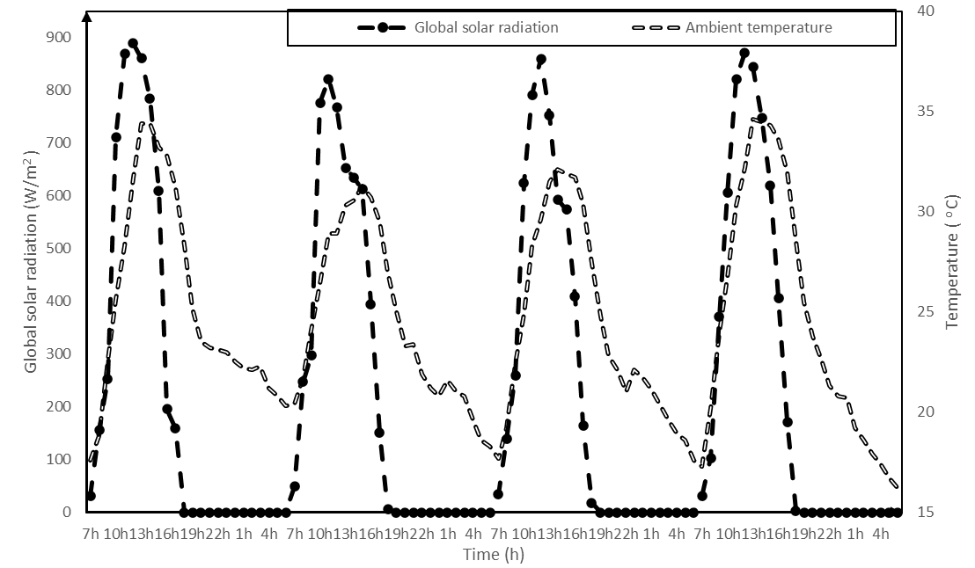
Figure 9: Temporal evolution of Global Solar Radiation and Ambient Temperature
4.3 Temporal Evolution of Ambient Temperature and Relative Humidity
The temporal evolution of the measurements reveals a pronounced diurnal variation in both ambient temperature and relative humidity (figure 10). The temperature exhibits a profile typical of regions under strong solar influence, with minima recorded during the late night (16–18 °C between 05:00 and 07:00), followed by a rapid increase after sunrise, reaching peak values between 30 °C and 35 °C, generally observed between 12:00 and 15:00, and then gradually decreasing in the late afternoon to reach 22–25 °C in the evening.
Relative humidity, on the other hand, follows an inverse trend, with maximum values occurring at night and in the early morning (20–28 %), reflecting more humid air under cooler conditions, and minimum values during midday (5–9 %) when temperature is highest. This inverse relationship reflects a clear negative correlation between the two parameters: rising temperature reduces relative humidity, and vice versa. This phenomenon is explained by the hygrometric properties of air: with an almost constant absolute water vapor content throughout the day, warmer air can hold more water vapor before reaching saturation, which results in a relative decrease in humidity as temperature increases.

Figure 10: Temporal Evolution of Ambient Temperature and Relative Humidity

4.4. Temporal evolution of wall and floor temperatures in the dryer
Figure 11 illustrates the temperature evolution of the interior surfaces of the dryer (North, South, East, and West walls, as well as the lower floor) along with the ambient temperature over four consecutive days, starting from January 21, 2019.
A clear correlation is observed between temperature variations and the daily solar radiation pattern. Temperatures on all surfaces increase progressively in the morning, reaching their peaks between 1 p.m. and 2 p.m., followed by a gradual decrease in the late afternoon and nighttime hours. This cyclic pattern repeats consistently over the four days, reflecting stable and sunny climatic conditions.
Notable differences between wall surfaces are evident. Despite receiving strong external solar radiation, the South wall exhibits lower temperatures compared to other interior walls, possibly due to higher thermal dissipation or greater thermal inertia of its construction material. In contrast, the East and West walls reach higher peak temperatures, attributed to direct solar exposure in the morning (East wall) and afternoon (West wall).
The lower floor consistently shows the highest temperatures among all measured surfaces, exceeding 55 °C during peak hours, indicating a strong capacity for absorbing and storing heat. During nighttime, all surface temperatures decrease slowly, suggesting gradual heat release by the materials, contributing to the thermal regulation of the system.
These experimental observations confirm the key role of thermal inertia in maintaining internal temperature stability within the dryer. This helps reduce thermal fluctuations between day and night and enhances overall drying performance by sustaining favorable thermal conditions even during periods of low solar input.
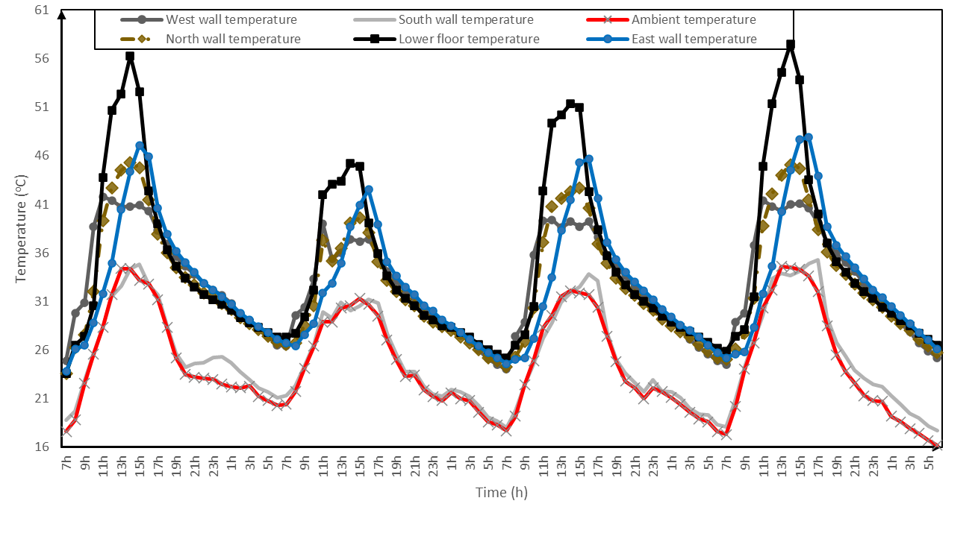
Figure 11: Temporal evolution of wall and floor temperatures in the dryer

4.5. Temperature Profiles of Drying and Ambient Air During Four Days of Dryer Operation
Figure 12 presents the temperature profiles of the drying air measured at two distinct points along the horizontal plane: 10 cm and 90 cm from the air inlet (located on the South wall side), and at a height of 45 cm above the lower floor, over a four-day period (from January 21 to January 25, 2019).
For both measurement points, the temperature peaks recorded at 90 cm from the inlet are consistently higher than those at 10 cm, regardless of the day. This can be explained by the fact that the air is always less heated at the inlet than at the outlet of the dryer. As air moves through the system, it gains thermal energy, resulting in higher temperatures farther from the entrance.
At any given time during the day, the internal air temperature within the drying unit is always higher than the ambient air temperature, with a temperature difference of approximately 6 °C even during periods without sunshine. This temperature gap indicates that the dryer, due to its thermal inertia, retains heat and thus prevents rapid cooling of the interior. As a result, drying continues effectively even in the absence of direct solar radiation.

Figure 12: Evolution of drying air and ambient temperatures on a horizontal plane
4.6. Temperature Profiles of Drying Air, Lower Floor, and Ambient Air Over Four Days of Dryer Operation
Figure 13 shows the temperature evolution of the drying air measured at two specific points within the dryer: at the level of the lower floor and 90 cm above it, over a four-day period (from January 21 to January 25, 2019). Throughout the experimental period, the temperatures recorded at the lower floor are consistently higher than those measured at 90 cm height. This difference is due to the fact that the lower floor directly receives solar radiation, while the drying air is mainly heated by convection as it comes into contact with the dryer walls.
All the curves follow a similar trend, displaying clearly defined temperature peaks. At all times, the temperature inside the dryer remains higher than the ambient air temperature, with a difference of approximately 6 °C during periods without sunlight. This observation confirms the trends previously noted in Figure 13 and highlights the thermal inertia of the dryer, which stores heat during the day and slows down cooling at night.
The maximum temperature of the lower floor reaches 56 °C, underscoring its crucial role in heat accumulation. However, a temperature drop is observed on the second day, which can be attributed to the passage of a cloud cover that temporarily reduced the intensity of solar radiation.

Figure 13: Temperature Profiles of Drying Air, Lower Floor, and Ambient Air Over Four Days of Dryer Operation
5. Conclusion
The study conducted on the thermal properties of adobe bricks and their application in the design of solar dryers highlights several key findings. Experimental results reveal significant variability in thermal properties among the brick samples. Thermal conductivity ranges from 0.352 to 0.570 W/m·K, reflecting differences in the density or composition of the bricks. These values fall within the ranges reported in the literature, indicating that these materials are suitable for applications requiring moderate thermal insulation.
The volumetric and specific heat capacities demonstrate that the bricks can store a considerable amount of thermal energy, particularly the sample with the highest values. Thermal effusivity and diffusivity confirm that these materials have a moderate ability to interact with external heat fluxes while maintaining a beneficial level of thermal inertia.
The results obtained are consistent with those reported in other studies (Ngaram, 2020; Lertwattanaruk et al., 2022). The adobe bricks studied exhibit characteristics typical of materials used in sustainable construction, particularly due to their ability to regulate temperature and provide thermal comfort.
Bricks with low thermal conductivity are ideal for applications requiring enhanced thermal insulation, such as walls of solar dryers or dwellings in hot climates. The use of adobe walls in the solar dryer prototype contributed to maintaining a stable internal temperature despite fluctuations in solar radiation. This stability is crucial to ensure uniform drying and to preserve the quality of agricultural products.

References
- Andharia, J. K., Markam, B., Patel, J., & Maiti, S. (2024). Study of a mixed-mode solar dryer integrated with photovoltaic powered dehumidifier. Solar Energy, 273, 112505.
- Araya-Letelier, G., Antico, F. C., Burbano-Garcia, C., & Concha-Riedel, J. (2021). Influence of agricultural waste additives on the performance of adobe bricks. Construction and Building Materials, 291, 123290. https://doi.org/10.1016/j.conbuildmat.2021.123290
- Bailly, G. C., El Mendili, Y., Konin, A., & Khoury, E. (2024). Advancing earth-based construction: A comprehensive review of stabilization and reinforcement techniques for adobe and compressed earth blocks. Eng, 5(2), 750-783.
- Bailou, O., Tubreoumya, G. C., Ouedraogo, E., Tiendrebeogo, E. S., Sanfo, S., Dissa, A. O., & Bere, A. (2025). Theoretical and experimental study of the temperature profile of a greenhouse dryer with walls made of adobe bricks. JP Journal of Heat and Mass Transfer, 38(4), 523–547. https://doi.org/10.17654/0973576325026
- Barkeshli, M., & Mangeli, M. (2022). Restoration and conservation of the adobe structures as sustainable material. UCSI University & Urmia University. Retrieved from
- Barpatra Gohain, R. J., & Dutta, P. P. (2025). Advancements in sustainable hybrid drying systems: A comprehensive review of technologies on experimental and numerical modeling techniques. Drying Technology, 1-25.
- Fernandes, L., & Tavares, P. B. (2024, January). A review on solar drying devices: Heat transfer, air movement and type of chambers. Solar, 4(1), 15-42.
- Fudholi, A., Sopian, K., Ruslan, M. H., Alghoul, M. A., & Sulaiman, M. Y. (2010). Review of solar dryers for agricultural and marine products. Renewable and Sustainable Energy Reviews, 14(1), 1–30. https://doi.org/10.1016/j.rser.2009.07.032
- Heracleous, C., Panagiotou, R., Ioannou, I., Michael, A., & Philokyprou, M. (2023, June). Hygrothermal performance of adobe structures. In IOP Conference Series: Earth and Environmental Science (Vol. 1196, No. 1, p. 012059). IOP Publishing.
- Indiarto, R., Izzati, A. N., & Djali, M. (2020). Post-harvest handling technologies of tropical fruits: A review. International Journal of Emerging Trends in Engineering Research, 8(7), 3951–3957. https://doi.org/10.30534/ijeter/2020/165872020
- Lertwattanaruk, P., Chindaprasirt, P., & Rattanasak, U. (2018). Effect of oil palm fiber content on the physical and mechanical properties of oil palm fiber reinforced cementitious composites. Construction and Building Materials, 162, 719–726. https://doi.org/10.1016/j.conbuildmat.2017.12.118
- Millogo, Y., Morel, J.-C., Aubert, J.-E., & Ghavami, K. (2014). Experimental analysis of pressed adobe blocks reinforced with Hibiscus cannabinus fibers. Construction and Building Materials, 52, 71–78. https://doi.org/10.1016/j.conbuildmat.2013.10.094
- Morsy, M. S. (2022). Experimental investigation of thermal and mechanical properties of adobe bricks. Renewable Materials Journal, 8(2), 95–107. https://doi.org/10.1080/21663831.2022.2042474
- Ngaram, I. (2020). Effects of moisture content on thermal properties of adobe bricks as a sustainable building material. American Journal of Applied Sciences, 17(1), 50–55. https://doi.org/10.3844/ajassp.2020.50.55
- Ntwali, J., Schock, S., Romuli, S., Kiria Chege, C. G., Banadda, N., Aseru, G., & Müller, J. (2021). Performance evaluation of an inflatable solar dryer for maize and the effect on product quality compared with direct sun drying. Applied Sciences, 11(15), 7074. https://doi.org/10.3390/app11157074
- Parra-Saldivar, M. L., & Batty, W. (2006). Thermal behaviour of adobe constructions. Building and Environment, 41, 1892–1900. https://doi.org/10.1016/j.buildenv.2005.07.021
- Rahman, M. A., Hasnain, S. M., Paramasivam, P., Zairov, R., & Ayanie, A. G. (2025). Solar drying for domestic and industrial applications: A comprehensive review of innovations and efficiency enhancements. Global Challenges, 9(2), 2400301.
- Singh, P., & Gaur, M. K. (2024). Review on development, recent advancement and applications of various types of solar dryers. Energy Sources, Part A: Recovery, Utilization, and Environmental Effects, 46(1), 14471-14491.
- Touati, K., Benzaama, M.-H., El Mendili, Y., Le Guern, M., Streiff, F., & Goodhew, S. (2023). Hygrothermal and economic analysis of an earth-based building using in situ investigations and artificial neural network modeling for Normandy’s climate conditions. Sustainability, 15(13985). https://doi.org/10.3390/su151813985
- Razak, A. A., et al. (2021). Recent advances in solar drying systems: A review. International Journal of Engineering Technology and Sciences, 8(1), 1–13.
- Venkateswarlu, K., & Kota Reddy, S. V. (2024). Recent trends on energy-efficient solar dryers for food and agricultural products drying: a review. Waste Disposal & Sustainable Energy, 6, 335–353. https://doi.org/10.1007/s42768-024-00193-3

