**Anthropocene Societal-Fluviology Distractions Using Geomatics, the Barakar River Sub-Basin, India**

**Abstract**

The Barkar River Basin (BKRB) is a sub-basin of the Damodar River, draining from an area of 7026 Km2 in the states of Jharkhand and West Bengal in India has a rich geological history late Quaternary period (47KYBP). Floods were outweighing the economics of the floodplain cushions. Presently, the BKRB has two multipurpose dams in the BKRB at Tilaiya and Maithon. The sub-basin is apocalyptic after the constitution of the Damodar Valley Corporation (DVC) in the 1950s during the pre-Anthropocene Epoch.

The Socio-economic activities of Homosapiens in BKRB have historical significance of the past. The integrated study of the traditional topographic survey has been conducted by using Q-GIS/RS methodologies**.** The Global Positioning System (GPS, Garmin), Landsat imageries, Google Earth Pro, ArcGIS 10.8, and Google Earth Engine (GEE) tools are employed to make various basic characteristic maps. The indices, like Normalised Difference vegetation Index (NDVI), moisture index (NDMI), Built-in index (NDBI), Waterbody NDWI Index, have been made and analysed. The prehistoric human existence in the BKRB has been reported through proxies during post Last Glacial maximum activities 17k YBP. The study reveals that BKRB running through dilapidated health stemming from sand and coal mining, soil erosion, and land degradation, impacting socio-economic health, morphology, and yield. The basin's unique topography, geology, lithology, and morphology, like wide, shallow meandering channels, rocky beds, and sharp valleys, exacerbated problems. Reconstruction of the BKRB shall address the morphology and socioeconomic issues, and shall solve the SDGs such as SDG 6, SDG 15, SDG 2, SDG 13, and SDG 17.

**Key Words: Environment, Runoff, Sediment, Slope, River morphology, Socio-economics**

**Introduction:**

The multipurpose hydroelectric projects during the mid-19th century were used as a non-renewable source of energy, neglecting their environmental impacts, climate change effects and the societal economic status. The process of sediment transport and impact on the fluvial regime through the drainage channels of a small or a large basin have effects on the morphology, demography, environment, expansion of riparian ecosystems and the anthropogenic stresses, (Ghosh et al, 2022,[1] Wang et al, 2023[2], Chua et al, 2024[3], Jadav et al., 2024[4], Anggraheni et al, 2025[5], Mishra et al, 2025[6])’

The Anthropocene is an epoch that refers to the influence of activities of Homosapiens on the Earth's systems. Though it is not officially recognised by the International Union of Geological Sciences (IUGS), but well accepted by scientists and geologists that humans have dominated over Hydro-Geo-Bio spheres from about the 1950s (Mishra et al, 2017[7])

Over the period, the soil erosion in the upper catchment area has led to huge sedimentation in the reservoirs of Damodar Valley Corporation (DVC), reducing its storage volume by about 40%. This depletion in storage has tightened the utilisation of the reservoir’s water allotment and flood moderating quantity, and has forced us to think of alternatives. The DVC basin managers have pointed towards the shortfall of land acquisition, and leaving aside three dams out of eight dams, have constrained the basin managers of the Barakar valley. Without implementation of corrective measures, the Damodar valley shall reiterate its old name “the sorrow of Bengal” (Haque et al, 2022[8]; Das GK., 2023[9]; Dasgupta et al, 2024[10]; Mishra et al, 2025[11]). The Usri, Barkar, Sali, Nunia and Kasai are the sub-sub tributaries of the Damodar River. (Biswas et al, 2021[12)

Present research intends to address the real-world problems addressing the present-day climate change, River health and environmental challenges of the Barakar River (BKR), a seasonal river in the tropics with a fluctuating regime. The search investigates the morphometry, hydrology, socioeconomics, and environmental impact on the environmental flow of Barakar River basin (BKRB), a tributary to Damodar River Basin (DRB), the sorrow of WB. The Damodar Valley Corporation (DVC), a corporate institution constituted in the 1950s to address the flood havoc in BKRB (Baral et al, 2025)[13]. The BKRB is a mature dying river whose erosion is balanced by upliftment (Kumar et al., 2024[14])

The interventions as hydraulic structures of the Barakar River were constructed during pre-independence India. At that time, the pre-visibility studies like environmental Impact Analysis, climate and risk assessment, land use planning, community participation and engagement, seismic risk analysis, and sediment management were not conducted. (Biswas et al, 2016[15], Almaliki et al., 2023[15], Mishra et al., 2023[16]). Moreover, the DVC Hydel-projects over BKR (Tilaiya and Maithon Dams), proposed initially in the 1950s, were incomplete due to land acquisition problems and even one dam was not started at the Balpahari Dam site in Jharkhand, that have caused insufficient flood moderation, power generation and irrigation water (Mishra et al, 2025[06])

**Study area:** The Barakar River (BKR), a major tributary of the Damodar River, originating from the Hazaribagh plateau, Jharkhand. The BKRB) runs between 230 45’N to 24̊ 20’N lat. and 85̊0 8’E to 87̊ 00’E long for a length of 256km. The principal portion (≈ 225 km) runs along the wide, shallow and partly steep narrow valleys within rapids. The section of the Barakar River has a width between 235m to 415 m and depth between 3.7 to 5.5 m and runs in a west-to-east direction with a gradient of 0.00035. Emerging from the Chot Nagpur plateau, flowing for about 256 km, debouches in the Damodar River, a tributary of the Hugli River at Dishergarh near Asansol in Bardhaman district, with a drainage area is 6159 Km2. The Barker River (BKR) has two principal tributaries, Usri (left embankment) and Barsotti at the right embankment (Sinha et al, 2020[18]). The river Barakar drains from a catchment of around 23371 km2. Area passing through the states of Jharkhand and West Bengal of India (World Bank Report 2020[19])

. 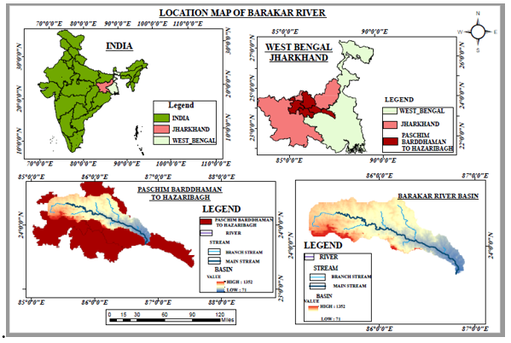

Fig 1: The index map of the BKR, a tributary of the Damodar River

Then the Barakar River (BR) flows east through the alluvial plains up to Barsul (Bardhaman). Later, it takes a southerly turn up to Chachai joins the Hugli. The present study envisions the quantitative valuation of flood risk, exposure, devastation and the cause, impacts and flood control techniques needed in the Barakar River (BR) Subbasin Mishra et al., 2024[20]. (Fig. 1).

A large number of research studies have been conducted in electronic media about the DVC Projects, but the Geology, geomorphology, hydrology, lithology and hydro-morphology investigations of major sub-systems discussion are meagre, which is the research gap which needs to be addressed.

**Objective of the Work**

The present investigation analyses the contribution of the deteriorated Barakar drainage system and reports:

1. The geo-hydro-morphologic search of the Barakar sub-basin of the Damodar River basin.
2. The physical characteristics of the Sub-basin using GIS/RS technology.
3. The impact of environmental flow interventions on the geomorphology of the sub-basin.
4. The socio-economic sample survey of the people of the subbasin has been done.

The socioeconomics of the two villages, Barakar and Kulti villages, were surveyed for the socio-economic status keeping in par with urbanisation, industrialisation, education, etc in the BKRB.

**Methodology:**

The pluvial floods in the BKRB are caused by heavy precipitation, tropical cyclones of BoB, and riverbank erosions, being influenced by climate change, sedimented old dams and their mismanagement. The rivers and reservoirs, and drainage channels are sources that increase the risk of flooding. From the viewpoints of hazards, vulnerability, exposure, and capacity (United Nations Office for Disaster Risk Reduction (UNISDR), Gayen et al, 2022[21]) risk of flood can be assessed.

The study of the Barakar river basin has been attempted in two ways, i.e. studying the basin by traditional topographic survey techniques and the other is by using Q-GIS/RS methodologies**.** The Global Positioning System (GPS, Garmin), Landsat imagery, Google Earth Pro, ArcGIS 10.8, and Google Earth Engine (GEE) tools are employed to make various maps of the BKRB’s various images. RS-derived indices, such as the Normalised Difference vegetation Index (NDVI), moisture index (NDMI), Built-in index (NDBI) and Waterbody NDWI Index **(**Dutta et al, 2025[22]**)**

Data collection for image formation uses toposheet Nos 72H/(7, 8, 11, 12, 15, and 16), 72L (4, 8, and 12), 73I (5,19, 10, 13, and 14) of 1:50,000 scale is downloaded from the Nakshe website of the Survey of India (SOI). These SOI Topo sheets are georeferenced and mosaicked using ArcGIS 10.5 software, ground control points (GCPs) and Universal Transverse Mercator (UTM) projection and WGS84 datum. The slope, aspect, etc. of the study area is premeditated pixel-by-pixel within a moving 3×3 window. The other GIS maps are generated from DEM maps.

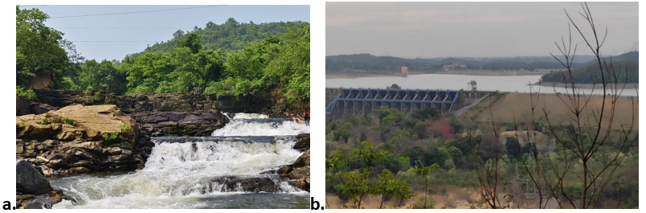

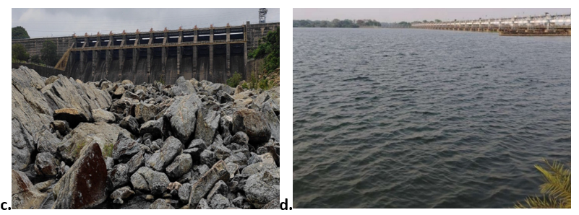

**Figure 2 (a-d) Maithon water fall, Kalyaneshwari, Asansol; (b) Maithon Dam aerial view; ( c) Downstream of Maithon Dam of Barkar River; (d) Maithon Reservoir near Barkar Village**

**Topography:** The BKR drains into the Damodar River running for a length of 256km after the Maithon dam and enters W.B., and runs along the border to Bankura and Burdwan with a widest stretch of about 2500m. Later flowing for 80km in the Burdwan district. It bifurcates, and one portion joins the Hooghly River near Shyampur, and the other dwindles and drains to the Rupnarayan River. The principal flow of the Damodar River Basin (DRB) and BKRB drains from a 23370.98 km2 area of Jharkhand and West Bengal states, where the Barakar River sub-basin shares 7026Km2. The BKR Sub-Basin has two principal feeder-basins- basins, i.e. Usri and Barsotti, Fig. 2 (a-d).

**Geology and lithology** The BKRB is formed over rocks of the Precambrian period, sediments of Permian age and Gondwana origin. The stratigraphy is called Permian Barkar formation, which includes coal-bearing strata of the Asansol area with alternate shales or siltstones, comprising finer-grained sediments. The lithology of bed rocks in the Chot Nagpur plateau has jointed gneiss that has strikes without cracks that disavow sinuosity in flow. The upper reaches of the BKR offer erratic erosivity, favouring the formation of bars and incised channels of mixed bed rocks with alluvial deposits. In levies and embankments.. The river, on average, has stable banks, straight reaches of flow with narrow sinuous bends, and a non-avulsive stable bank (Chakravarty et al, 2003[23]. Khan et al, 2012[24],

The sedimentary section (ash bed) from Barakar archaeological site (23°44′45′′N; 86°48′20′′E) on the west bank indicates about occurrence of microlithic industry and can be included in the apocalyptic Quaternary super-volcanic events in the Youngest Toba Tuff (YTT, 74 ka ago) period, which affected the climate and human occupancy during 17k years before present during post-LGM period. (Hota et al, 2012[25], Mukhopadhata S., 2023[26], Kumar et al, 2024[27])

**The fluvial morphology:**

When running in the Chot Nagpur plateau, the BKR has features like bedrock and gravel mixed, flowing either as a sinuous and braided channel in the upper/lower region, respectively (Table 1).

Table 1: The poisoning of the two dams, Maithon and Tilaiya, over the Barkha River in Jharkhand

|  |  |  |  |  |  |  |  |  |  |
| --- | --- | --- | --- | --- | --- | --- | --- | --- | --- |
| Reser-voir | River | Long. | Lat. | MDDL | FRL | FRL pond area | Reser-voir Capacity | Year of work | gross capacity loss |
|  | Name | 0E | 0N | (m) | (m) | Km2 | M Cum | years | M Cum |
| Maithon | Barakar | 86.8E | 23.78N | 132.56 | 146.31 | 107.16 | 1348.8 | 70 | 264 |
| Tilaiya | Barkar | 85.52E | 24.32N | 363.32 | 368.8 | 38.44 | 671.66 | 72 | 120.9 |

Source: The compendium on sedimentation, CWC 2020[28], jain et al., 2025[29]

**Climate and hydrology:**

The BKRB is influenced by the Indian summer monsoon climate with dry winter and wet summer. It enjoys a monsoon climate. The major climate of BKRB is dry winter (March to June) and (July to October). November to February are the cold months. A large share of rainfall is received (80 to 90%) during the monsoon season (Biswas et al. 2015[30]). The ephemeral river has scant flow even during the rainy season due to the upper reaches of the dams, and flow is continuous after the last Dam, Maithon. The annual rainfall in the area is 127 mm. The BKRB comprises conglomerate sandstone (coarse and felspathic), shales, and irregular thin coal seams (Dasgupta et al., 2024[31]).

**Hydraulic Interventions:** The BKRB is housed in the Western Fringe of the Lower Ganga Basin in India, covering the states of Jharkhand and West Bengal.The river emerges from the Padma Village in Jharkhand and receives many drainage channels of the Chot Nagpur Plateau and joins the Damodar River near Dishergarh in Bardhaman district, WB.The Tilaiya and Maithon dams are the two major hydrological interventions to the flow of the River Barakar. The other three are Panchet, Konar and Tenugarh on the Damodar and Konar rivers control the flow of the DRB. The upstream (U/S) erosion has lost its storage capacity of the Tilaiya and Maithon reservoirs, encroaching on the design space created for dead, live and flood storage. Initially, the land acquisition was not done in the reservoir rim of Tilaiya for 5m and Maithon reservoir for 10m (Banerjee et al, 20213[5], Mishra et al, 2024[32])

**a.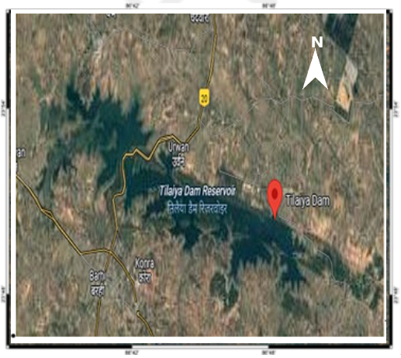b.**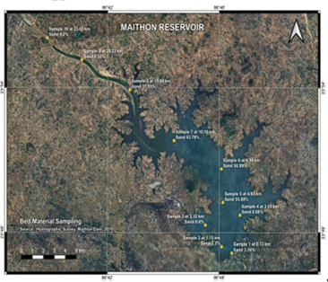

**Fig 3 (a-b) : (a) The Tilaiya dam, (b). The Maithon dam, Jharkhand, over the Barakar River.**

**(Source: Google Earth)**

**The Hydraulics anomaly in BKRB:**

The rainfall and runoff in BKRB contribute the lion’s share of DVC reservoir’s multifaceted utilities and flood moderation in the lower Damodar River basin due to the release of erratic discharge. At the basin catchment of the Maithon Reservoir, there is an increasing trend in rainfall and a delayed time lag to achieve the peak. It may be due to the initial impounding of the reservoir to abide by the reservoir operation table. As a result, the annual minimum discharge is reducing and the hydel power generation with the dwindling inflow regime and flood pattern. (Biswas et al, 2022[33] ) Fig 4 (a-d)

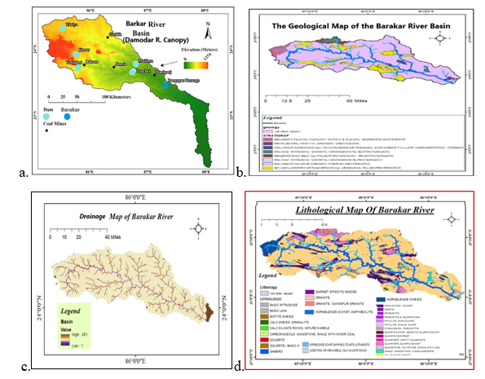

**Fig 4(a-d): (a)The Basin map of BKRB within the DRB, (b) The geological map of BKRB, (c) drainage map of BKRB, (d) Lithological map of BKRB; (Source modified: Prefeasibility Report Jujuti Sand Mine On Damodar River Raja Ghosh, and Biswas and Pani 2016)**

**The Salient features of Hydraulic structures:** As per the basin river’s anastomosis, the parent tributary to the Damodar River is the Barkar River. In the pre-independence period, for flood control, hydropower, water supply, etc., the Barkar River sub-valley was intervened by two dams, Tilaiya and Maithon were constructed upstream of the Durgapur barrage were constructed whose salient features are in Table 2.

Table 2: The housing, hydrology, hydraulic, and hydropower structures of Tilaiya & Maithon Dam over BKR.

|  |  |  |  |  |  |
| --- | --- | --- | --- | --- | --- |
| Dam | Maithon | Tilaiya | Dam | Maithon | Tilaiya |
| Location | Dhanbad; | Koderma/  Hazaribagh /Jam tara | Type of Dam | Earthen dam | Straight conc.  gravity |
| State | Jharkhand | Jharkhand | U/ sluice  type/ No/Size | Vertical Lift/5nos/ 1.73x 3.05m | Modified Butterfly/2no/  1.1x1.66m |
| Latitude | Lat. 23° 785 N | Lat.23.678N | Type of turbine | Francis Hor. shaft | Vert shaft  Francis |
| Longitude | Long.86°88.1E | Long 86.746E | Minim Discharge | 20Cumec idle PH | Not known |
| Catchment | 6294Km2 | 984 Km2 | DSL | 90MCum | 40.31MCM |
| Av R/F / Year | 1140mm | 1120mm | DSL above MSL | 132.59m | 119.48m |
| Yearly Av. Runoff | 2700MCM | 4539MCM | Work flood Level | 150.88(m) ≥ MSL | 132.59≥ MSL |
| Year of erection | 1951-1957 | 21st Feb 1953 | Flood Storage | 326MCum | 592MCum |
| Over River | Barkar R. fall | Barkar R. | Installed capacity | (2X20)+(23.2) W | 2X40MW |
| Reservoir area | 65Km2 | 36 Km2 | Spillway | Ogee Type | Ogee Type |
| Type of Dam | Composite | Straight Concrete Gravity Dam | Gate type | Tainter | Tainter |
| length/overflow | 4426.76/155m | 365.76/155.45m | Crest gate | 12Nos | 15Nos |
| Ht./Energyhead | 50m/38.71m | 30.18 | gate No/size | 12.19 X 12.5m | 12.19X 12.5m |
| Purpose of the dam | FC/60MWHP. | FC; 2x40MW | *Dams/Hydraulic machine* | | |
| Power-House | UG type | D/S based | PH Crest gate | 15No | 14No |
| Type of Dam | Earthen dam | Earthen Dam | No of Turbines | Three | Two |
| Type of gate | Tainter | Tainter |  |  |  |
| HP: Hydropower; UG: Underground; MCM: million cubic meters; MW: Megawatt HP: hydro power ; DSL:;(Dead storage Volume); PH: Power House; | | | | | |

**Floods in the Damodar Valley (DV)**: The WB has recorded historical high floods above 15000 Cumec in the Damodar River were in 1730, 1823, 1848, 1856, 1882, 1890, 1898, 1901, 1905, 1907, 1913, 1916,1923, 1935, and 1943. The post-construction period floods in the Damodar valley are in the years 1956, 1965, 1971, 1978, 1987, 1994, 2002, 2000, 2008, 2015, 2021, 2024, where the shattering historical floods were in 1943, 1978 and 2000. The flood in 1943 led to serious public resentment against the British Government over the diversion of the flood by the Eden canal, <https://dvc.gov>. In/cms-web/details-pages/13. The flood occurs in the BKRB when the flood volume exceeds Durgapur Barrage above about 19049cumec in the d/s (Fig. 5 (a-b).

**Sedimentation:**

Both the environmental flow interventions in the Barakar system, i.e. Tilaiya and Maithon dams, share water with the Damodar Valley flow. Since its commissioning, from 1950’s has been suffering from large sedimentation, leading to depletion of its storage capacity. The rate of sedimentation has exceeded the design flow with deposits affecting flood routing, irrigation, hydropower generation, etc., Table 3.

Table 3: The sedimentation status from the first impounding rate in Tilaiya and Maithon Dams

|  |  |  |  |  |  |  |  |  |
| --- | --- | --- | --- | --- | --- | --- | --- | --- |
| Name of Dam/  Barrage | Catch-ment  area | Commission year | Last Survey | First gross storage | T. loss gross storage | Gross storage | gross storage (Av. ) | Av. actual silting  rate |
| Pondage | Km2 | year | Year | MCum | MCum | % loss | % loss | TCM/km2/yr. |
| Maithon | 6294 | 1955 | 1994 | 1348.8 | 264.04 | 19.58 | 0.91 | 1.08 |
| Tilaiya | 984.2 | 1953 | 1997 | 335.83 | 120.92 | 36.01 | 0.76 | 2.79 |

Source: The compendium on sedimentation of reservoirs, CWC, Sedimentation Compendium, 2020

The average rate of sedimentation is lower in the Mithon reservoir than in Tilaiya reservoir, whose catchment basins are in different geological strata. The design storage was not achieved due to land acquisition issues. To achieve the full benefits, it is required to raise the height of the dam and store more water to save the downstream stakeholders from flooding. The proposed Belpahari dam near Koderma should be constructed on a priority basis to augment storage volume in the BKR sub-basin.

**Sediment accumulation in Maithon and Tilaiya**

Major sediment imported from the upstream catchment of Barakar depends upon (a) Reservoir surface area, (b) Reservoir shape, (c ) distance from the dam,(d) reservoir depth, ( e) slope and structure of side hillocks in the mountainous range. Major short time for sediment distribution of both the dams in Barakar basin depends on slope/soil of catchment, Stream-flow, the sediment load, Particle size of the sediment, trap efficiency, Reservoir operation rule, trap efficiency and faulty management in dam operation, etc., Table 4.

Table 4: The comparison of reservoir characteristics of Tilaiya and Mithon dams. In BKRB

|  |  |  |  |  |  |  |  |
| --- | --- | --- | --- | --- | --- | --- | --- |
| Name of Dam/ | Bed Level area | >FRL | Commission Capacity | Capacity in 2019 | Gross storage | gross storage (Av. ) | Av. actual silting rate |
| Pondage | Sq. Km | (m) | MCum | MCum | % loss | % loss | TCM/km2/yr. |
| Maithon | 103.63 | 150.88 | 1196 | 845 | 19.58 | 0.91 | 1.08 |
| Tilaiya | 345.95 | 372.47 | 551 | 377 | 36.01 | 0.76 | 2.79 |
| Reservoir | Zone | Reservoir level (m) | Commission Capacity (MCM) | Capacity 2019 (MCM) | Capacity Loss (MCM) | Loss of capacity (%) | Commissioning storage(MCM) |
| Maithon | Dead zone | 103.6-132.59 | 207 | 90 | 117 | 57% | 3268MCM |
| Live zone | 132.60-146.30 | 607 | 430 | 178 | 29% |
| Flood storage | 146.31-150.88 | 382 | 326 | 57 | 15% |
| Tilaya | Dead zone | 345.95-363.32 | 141 | 40 | 100 | 71% | 7009MCM |
| Live zone | 363.33-368.81 | 195 | 111 | 84 | 43% |
| Flood storage | 368.82-372.47 | 215 | 226 | -11 | -5% |

**Source:** Choudhury D. SDM, DVC, 2024[35]

The sediment deposition occurs slowly, upper reservoir zones where the inflow river debouches into the reservoir, and they are coarse and of high particle size. The dead storage zone receives smaller-sized particles slowly. The trap efficiency of the reservoirs varied in the course of time and the shape, size and depth of the reservoirs, Fig. 5 (a-d).

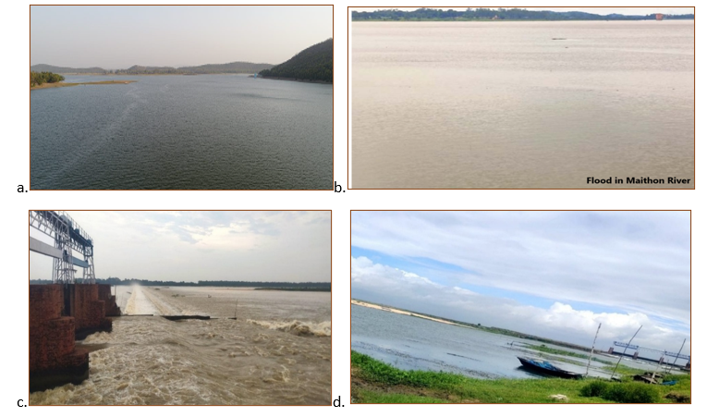

**Fig 5(a-d): (a)The confluence points of the Barakar and Maithon R. (b) The Maithon R. flood near Barakar village 2025 (c) The Rondiha dam flood 2025 (d) The Barakar river**

**Topographic features:**

The topographic physical appearance of the BKRB can be reflected by the slope, aspect, relief, hill shade, soil, geology and geomorphology maps, etc. Map architects used various techniques for generating landscape imageries and analysing them for geographic, topographic, relief, geomorphologic and hydrologic research **(**Umrigar et al, 2015[368]; Renu et al., 2025[37]; Jhariya et al., 2025[38])**.** The Barakar River emerges from Padmapur, in high-level areas of the Chhota Nagpur plateau. The river is as if stretched out and meticulously resembles a rift valley stream whose evolutionary phase is incomplete(Das et al, 2024[39]).The GIS/RS technique can be used in watersheds with accuracy, flexibility, and hydrology and hydraulics research without duplication and superimposition against procedures in vogue.

**Geological Formation and stratigraphic analysis**,

The BKRB formation is connected to the Vindhyan and Gondwana Super Group belonging to the Palaeozoic era and Chot Nagpur Gneiss and Granophyre with the capping of laterite at some places (Biswas, 2016). This Barakar formation of the Gondwana Super Group is made up of coarse, soft, and white to fawn coloured massive sandstone, shale with coal seams as bed grit with conglomerate and a bed of shale. The BKRB area is less populated due to hilly terrain, mining area (Coal at Srirampur, Raniganj and Giridihi; IISCO and DSP steel mines. The mining areas have raised the economy of the people of the basin. Fig 6 (a-d)

**Soil of BKRB:**

The long-term soil erosion and retrospective soil loss affect the management of resources linked to land-use, anthropogenic activities, and water resources management. The BKRB is housed in the mining area of Bihar and West Bengal.

a.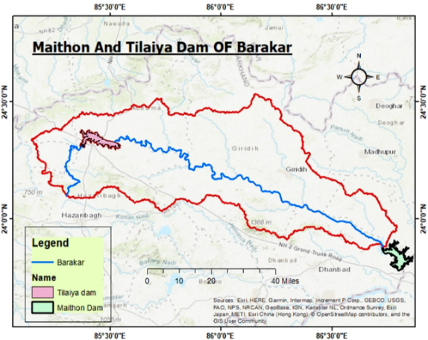b.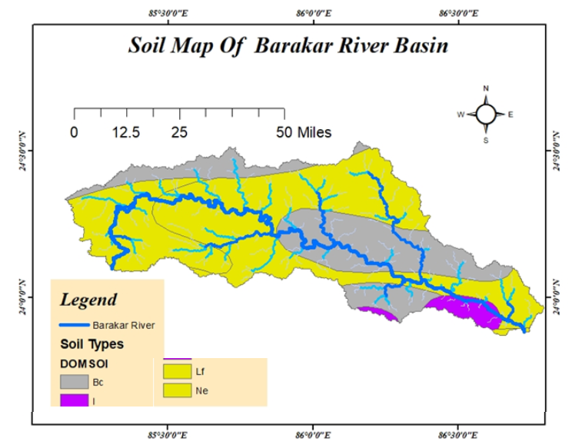

c.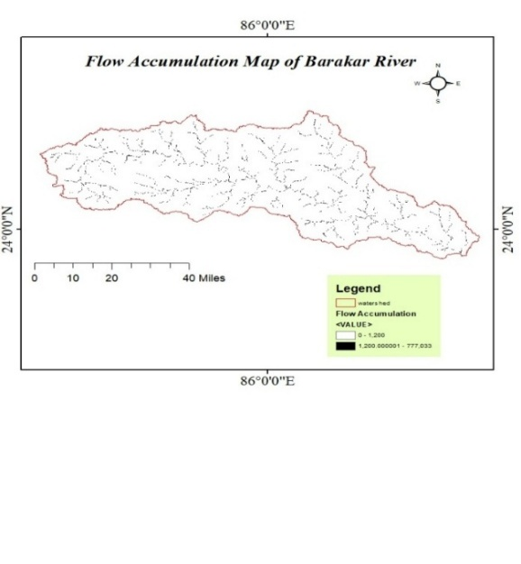 d..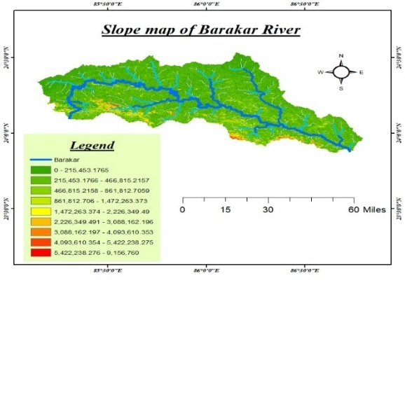

**Fig 6(a-d) : (a) the positioning of Dams in BKRB, (b) the soil map, (c ) the flow accumulation map, (d) slope GIS maps of the BKRB.**

The mean soil loss in the Damodar River Basin has decreased from 12.86 t ha⁻ 1 yr⁻ 1 in 2017 to 12.06 t ha⁻ 1 yr⁻ 1 in 2024. The present study identifies areas affected by prominent soil loss (>20 t ha¹¹ yr¹¹⁻ 1 ) covering 36.47% of the total area in 2017, mostly concentrated on the northwestern and central region of the entire basin with extensive mining activities, which slightly declined to 35.07% in 2024, Fig. 7 (a-d).

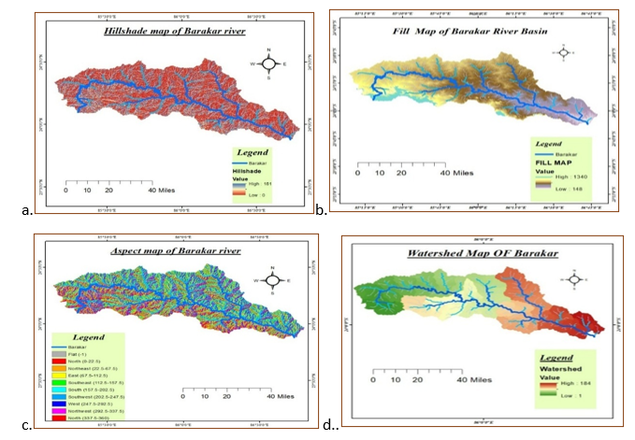

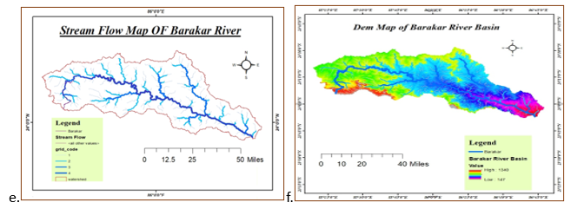

Fig 7(a-f): Different GIS maps (a) Hill shade (b). Fill in map (c). Aspect map (d), Watershed map (e ), Stream order and (f) The DEM map of the Barakar sub-basin, a part of the Damodar Basin

The Hill-shade map of the BKRB depicts the effect of solar radiation, which highlights topographies like ridges and valleys of the basin that helping in knowing drainage designs and morphology by getting the shape/direction of slopes. Basin fill talks about the sediments that are accumulated in a gorge or low-lying areas, probably resulting from tectonic or erosional processes. The aspect map indicates the slope orientations of a location and the hydrological and morphological features of the basin. It depicts the major soil erosion, drainage patterns, etc. The eastward slopes get more sun rays with varied moisture than the west / southwest slope. The BKRB’s aspect map tells about slope steepness, drainage pattern, elevation, soil type, and rainfall data indicate the high, medium and low risk zones of soil erosion. The sedimentation pattern shows that it compels action for soil conservation measures.

**Various indices in BKRB**

Many normalised differential indices resulting from RS data on analysis tell about the basin features. They are used to know about the basin’s health, like vegetative cover (NDVI), water bodies (NDWI), built-up areas (NDBI), and moisture pattern (NDMI), etc. (Table 5)

**Table 5: The indices derived from the RS date and their details used for BKRB**

|  |  |  |  |  |
| --- | --- | --- | --- | --- |
| The indices | The full form | The equations used | The spectral band used | Interpretations of values |
| NDVI | Normalised Difference Vegetation Index | (NIR - Red) / (NIR + Red) | NIR near-infrared Red = Red band.  SWIR shortwave infrared.  Green: green spectral band | High: dense, well-vegetated; Low: sparse vegetation |
| NDBI | Normalised Difference Built-up Index | (SWIR - NIR) / (SWIR + NIR). | High: Urban areas  Low: other than settlements |
| NDWI | Normalised Difference Water Index | (Green - NIR) / (Green + NIR) or (NIR - SWIR) / (NIR + SWIR) | High= presence of water; Low+ land or vegetation |
| NWMI | Normalised Difference Moisture Index | (NIR - SWIR) / (NIR + SWIR) | Highly damp, low moisture /dry stress condition |

The NDVI monitors the drought conditions of a basin to assess agricultural yield, Anthropogenic stresses on forests or vegetation. The BKRB sub-basin has anthropogenically stressed, more human settlements, Mining areas and less dense forests except some patches near Koderma Hills.

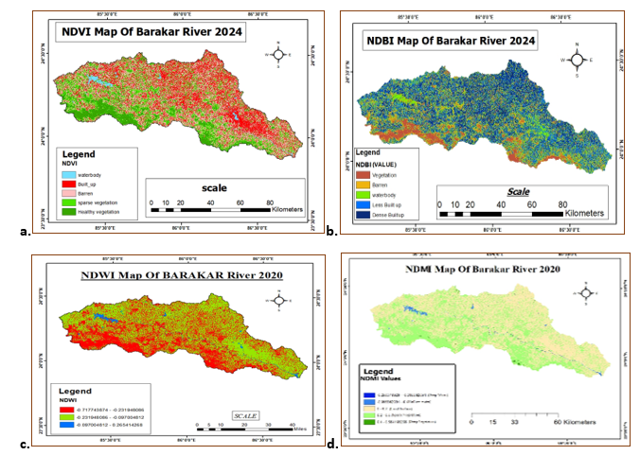

**Fig 8 (a-d): Various basin characteristics maps of National Differential Indices (a) vegetation, (b)Built-up, (c) water and moisture GIS map of the Barakar River Basin.**

The NDBI value of a basin is used for urban planning and also provides knowledge about the impact of land cover and Urbanisation in a basin on the ecosystem and the environment. The NWDI map indicates the drought impacts on Ecosystem health, vegetation of the basin and is used to map water levels, presence of inundation and water logging in the basin.

**Land use and Land cover:**

The NDVI map generation is an innovative and usable technique used for spatial change detection of the physical features that are related to Photosynthetically Active Radiation (PAR. The vegetation index indicates numerically that it uses the visible and near-infrared bands of the electromagnetic spectrum (EMS).

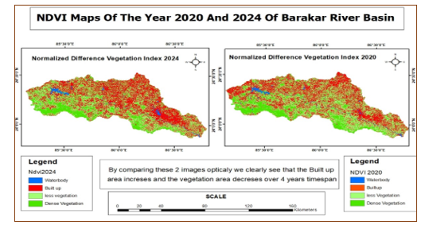

FIG 9. NDVI maps of Barakar River Basin during 2020 and 2024

The NDVI images were created between 2020 to 2024. It is observed that the vegetation changes have shown a negative value with a rise in built-up areas within the mentioned period.

**The Environmental Impact Analysis:**

During the inception of hydraulic interventions in the 1950’s the Environmental Impact assessment due to the interventional dams, the Tilaiya and the Mithon, was not conducted along with the long-term impact of the partly collected reservoirs. In the long run, the multi-faceted utilities were reduced, and the basin has deteriorated as of this date. It is pertinent that the environmental studies along with socioeconomic survey of the large sub-basin of the Damodar basin is warranted alongwith the Socio economic growth of the inreasing demography which can help the basin managers to plan for future complementary economic advance, preservation of ecosystem, environmental risk, and societal security, according to environmental and social impact assessment (ESIA) guidelines stipulated by Government of India (GOI). Two sample villages were considered for the socio-economic aspect. They are Barakar and Kulti, shown in Google Maps in the figure.

**Village 1: Barakar (Near Asansol sub-division Headquarters)**

* Coordinate: Latitude: 23.73° N. ; Longitude: 86.85° E.
* Municipal corporation: Asansol Municipal Corporation
* Total Population: About 79,891(Projected till 2020)
* Total No. of Family: approximately 2450 households(HH)

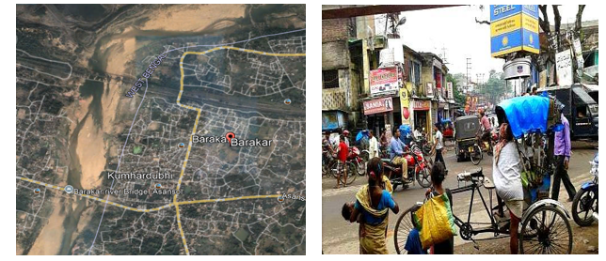

Fig 10 (a-b): (a)Google image of Barakar village (b). Barakar Market, Begunia More

**Sex/Caste Composition:**

Table 6: The sex wise status of the villagers of Barakar, in Barakar Sub-basin

|  |  |  |  |  |
| --- | --- | --- | --- | --- |
| Total Population | Male (No) | Female (No) | SC (No) | ST (No) |
| 79891 | 41,210 | 38,681 | 99 | nil |

As estimated from the local people, various wage-earning persons with variable income are of various professions. They are Cultivators as land owners: 9.44%; Agricultural Labourers: 21%; Industrial Workers: 2.48% and other workers with varying professions, including service holders, were 67.08%. The sex wise data and educational status in BKR are in Tables 6 and 7.

Table 7: Educational status of the people as literacy rate, sex wise.

|  |  |  |  |
| --- | --- | --- | --- |
| Category | Average literacy rate | Male literacy rate | Female literacy rate |
| Total population (%) | 63.64(%) | 73.45(%) | 52.08(%) |
| Urban area | 0 | 0 | 0 |
| Rural area (%) | 63.64(%) | 73.45(%) | 52.08(%) |

**The various utilities provided by the government to villagers:**

1. **Schools:** Barakar Adarsha Vidyalaya (HS), Marwari Vidyalaya HS, Little Angels School, Barakar Muslim Fp School, Barakar Mother Mary School, Kids Garden School and Kids Point Nursery School.
2. **Health Care Units:** Barakar Primary Health Centre
3. **Police Station**: Barakar Police Post (Barakar PP)
4. Ferry Ghat: Barakar Ferry Ghat

The ponds in the village of Barkar are Ambagaon Pond and Ram Golam Singh Pond. Barakar is known for the ancient Begunia Temple Complex, dating back to the 8th-9th century. These Shiva temples are influenced by the architecture of Jains and Vaishnavas. Barakar has a history of floods, with major events recorded in 1913 and 1946. Dams like Tilaiya and Maithon have helped with flood control. The area's landscape includes undulating land and scattered hills. People are well educated, and the village is modernised with all facilities of health, communication, education and WASH for all. However, the women's communities are less developed, and they mostly take part in household work, but they are away from the MMST or SSG or Nari Shakti mission, etc.

V**illage 2 : Kulti village(Near Asansol Sub division)**

1. Coordinate: Latitude: 86.8399° E Longitude: 23.7300° N
2. Municipality: Asansol Municipal Corporation, Neamatpur, Kulti Office
3. Total Population: 2025 Estimate: 456,000 according to https://www.census2011.co.in/data/town/801670-kulti-west-bengal.html
4. Total No. of households: 3839
5. Landless households, mainly income from manual casual labour: 2429, (Socio Economic and Caste Census (SECC);https://share.google/VDaX9ItUvUxLgzHwd )
6. Males: 163,193 (52%) Females: 150,616 (48%).(Sex Ratio: 923 females per 1000 males. )
7. Underprivileged people with caste: Scheduled cast: 69,292; Scheduled Tribe: 13,610
8. Income levels of various groups of workers of Kulti village:
9. Average Starting Salary: ~₹20,000 per month
10. Managerial Positions (Average Annual Salary): ₹3,63,966
11. Delivery Drivers (Potential Monthly Earnings): Up to ₹30,000 - ₹35,000 + incentives)
12. Security Guards (Monthly Salary Range): ₹13,300 - ₹15,500
13. Part-time Café Helper (Monthly Pay): ₹3,000 - ₹5,000

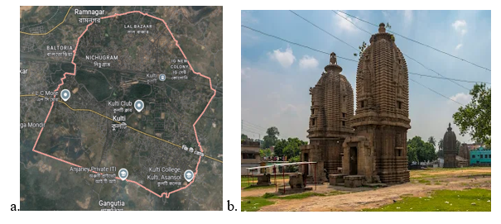

**Fig 11(a-b): (a) Kulti in Google map, (b) 17th century old temple of lord shiva**

**3. Source of income:**

1. **Agriculture:** Kult’s economy relies heavily on agriculture for both income and employment generation.
2. **Industry:** The Steel Authority of India's IISCO (Indian Iron and Steel Company Ltd) steel-making plant plays a significant role in Kult’s economy. Kulti has also been identified as a developing hub for industries like real estate, coal, pipe manufacturing, and garments.
3. **Other**: Services Sector: While considered smaller than agriculture and industry, the service sector plays a crucial role in Kulti's local economic development. This can encompass various services like those provided by finance companies offering loans and investment products,
4. **Real Estate**: Kult’s proximity to Asansol and growing infrastructure present opportunities for commercial real estate investment in areas like Ushagram and Morgenthau, potentially generating rental income.
5. **Literacy rate :**
6. Total Literates: 209952 (88.72% of the population over 6 years).
7. Literacy Rate: 75.41%, lower than the state average of 76.26%.
8. Male Literates: 120000.
9. Female Literates: 89952.
10. Male Literacy Rate: 82.85%.
11. Female Literacy Rate: 67.34%
12. **Public amenities:** 
    * + 1. **Public School**: The state government-funded Public schools are Priyadarshini Public School, Kulti Public School.
        2. **English Medium schools**: New Wonderland Eng Medium School, De Cosy School, St. Christopher's Mission School.
        3. **Higher Secondary Schools:** Kendwa High School, Parbelia Colliery Bangla Higher Secondary School, Sodepur Colliery High School.
        4. **WBCHSE Schools:** Narsamuda Jana Kalyan Samity High School, Aryakanya Kanya Vidyalaya HS, Bali Tora High School.
13. **Health care units:**
    1. **Hospitals and Nursing Homes:** Shri Hospital, Kamala Nursing Home, Kulti Seva Sadan Hospital.
    2. **Public Hospitals**: Reza Clinic & Nursing Home, S.D. Hospital.
    3. **Polyclinics:** Tirupati Medical Centre, S.S. Health Care, Sanjeevani Polyclinic & Diagnostic Centre.
14. **Police Station:** Kulti police station under located on Kulti Station Road, Post Kulti, West Bengal. It's part of the Asansol-Durgapur Police Commissionerate.
15. **Years of Flood:** 1978,1984,1991, 2000
16. **Geomorphology:** Kulti, in West Bengal, India, features undulating lateritic soil. This area lies between the Damodar and Ajay Rivers. It is part of the Gondwana sedimentation, where rocks were deposited in a faulted basin during the Archean period. The Gondwana formations contain coal seams, which have supported mining. The landscape includes faults and intrusions of igneous rocks, such as the Salma dolerite dyke. The lateritic soil, formed on older rocks and early Quaternary sediments, is prone to erosion from rainfall and human activities. Fluvial processes from the Damodar and Ajay Rivers, along with weathering, erosion, mining, and climate, further shape the terrain. Kuti’s geomorphology results from its geological history, river activity, weathering, and human impacts like mining.
17. **Kulti as a tourist place:** The Economy of the people of Kulti depends mainly on agriculture. The various tourist hubs are a) Gandhi Statue. Court, Asansol (b) Maithon, Memorial Pillar at Hadla Kalyane Shwari.(c) Maithon Waterfall. (d) Dihika Sunset Point. ( e) Satabdi Park. (f) Budha More, etc, have escalated the socio-economic status of people of BKRB.
18. **Industrial Impact:** The economy of the people of Asansol is shared with Kulti is a part, relies on the steel and coal industries, along with railways and trade

**Result and Discussion:**

The climate change scenarios of the BKRB basin reveal that the annual flood and peak flow discharges have been reducing gradually over time for the last two to three decades. The dwindling of the flow patterns is due to the spatial climatic changes, anthropogenic interventions in the catchment, sedimentation in the reservoirs, new dams and barrages, revised reservoir operation rules, and even the need to fix a new zero elevation for the reservoirs, the Maithon or Tilaiya or both.

Numerous hydraulics regulating structures, including dams, weirs, spillways, power house structures, head/ cross/ tail regulators, sluices, outlet gates, tailrace structures and canals have been harshly damaged. It is high time to renovate them.

The design of the basin management was proposed for eight dams having a flood storage volume of 3.58 BCM. The dams at Bal Pahari, Bokaro and Bermo are yet to be constructed. The inadequate storage capacity cannot accommodate the peak flood release. It is observed that any flood >19049 Cumec discharged D/S of Durgapur Barrage causes a flood in the flood plains of Damodar-Barkar basin, depending debouching condition at Harinkhola estuary.

The causes of the flood in the Damodar River may be attributed to enormous discharge from the Barkar basin and continuous monsoon rainfall. The silting/sedimentation in dams/barrages of the 1950s, along with river beds and canals, inappropriate flood routing, and sometimes faulty reservoir operation implementation, causes floods. This establishes that the flood in BKRB is anthropogenic (Ghosh et al. 2023[40]).

Nonachievement of the designed flood storage due to inadequate land acquisition that has depleted the flood canopy of the old reservoir built up during the 1950s. The river bed mining has changed the flow pattern of the BKR.

The designed sedimentation rate is less than the actual sedimentation, which has reduced the utility storage volume of the reservoirs. The Tilaiya dam has a higher rate of sedimentation, which has turned out to be dysfunctional over time. The NDBI map tells that one of the prime regions of sedimentation is due to anthropogenic intervention on the soil, mining discharges and vegetation over the period.

The BKRB, a sub-basin of the DRB, is segmented into upper and lower reaches are wide, fan-shaped, with a steep hill slope, whereas the Lower Barkar Basin in West Bengal is narrow, flatter and elongated. India’s summer monsoon rainfall (ISMR) fills the lower reaches of the BKRB first, and later the upper reaches in Jharkhand with heavy precipitation. The runoff from BKRB cannot smoothly discharge, which causes flooding and waterlogging in the lower BKRB regularly.

The trap efficiency is the ratio between the total sediment deposited in the reservoir/ total sediment flowing in the river. The trap efficiency in the case of Tilaiya reservoir has approached the value since its commissioning in 1953. The Tilaiya reservoir is no longer able to store water and has gradually ceased to fill the Tilaiya dam.

The BKRB is presently emerging as a more stable topography and is at a mature stage. The careful basin management stresses upon to alleviate erosion, control sediment loading and more water storage. This can enlighten us to the geomorphological evolution of the BKRB.

Attaining Sustainable Development Goals to rejuvenate a deteriorated basin like BKRB shall be considered. **SDG 6**: Need improved water management should stress upon achieving sustainable water supply, safe drinking water (SDG 6.1) and sanitation and hygiene ( SDG 6.2).

ii. **SDG 2:** The basin BKRB needs to support sustainable agriculture, favouring food security and reducing water scarcity.

ii. **SDG 15**: stress upon the life on land, which includes focusing on ecosystem protection and sustainable land management (SDG 15.3).

iii. **SDG 13:** (Climate action)The climate action has surged the resilience measures like floods, droughts, water bodies diminution and an increase in greenhouse gas emission (GHG) as per IPCC reports, which need to be ameliorated.

**SDG 17: (**partnership for the goals**)** This SDG is for basin health through participatory stakeholder engagement in the developmental work of the BKR basin.

**Recommendations**

To assist the conservation efforts needs prioritisation management of urban and mining wastes is needed. The greenery should be encouraged, MSMEs to be implemented particularly among the women group, and Strict compliance with establishing an effluent treatment plant should be ensured with strict compliance (Mishra et al, 2024[41]).

1. Land acquisition up to Maximum water levels in Maithon & Tilaiya reservoirs to utilise the total flood storage already developed under 1st phase of construction. No significant steps have been taken yet.
2. The drainage channels of BKRB need desedimentation, interconnection, repair, construction and renovation of embankments to be taken up early. The non-structural actions like flood zoning, flood proofing events, rehabilitation events, appropriate flood fighting phases, disaster readiness and response scheduling, etc., are taken up at the government level, but are inadequate.
3. Augmentation for improved flood amelioration and fulfilling the deficiencies caused by less land acquisition and construction of the Belpahari dam is to be taken immediately, DVC report 2020.[42]
4. Upgrading the systems, such as real-time data collection, flood forecasting and pre- and post-flood programmes, along with implementation of judicious reservoir operation rules, basin planning, decision-making by developing flood forecasting, basin management, Real Time Data Acquisition System (RTDAS) and Real Time Decision Support System (RTDSS) efficient Basin management is possible, (Panda et al, 2020[43], Mishra et al., 2025[44])
5. Rehabilitation, repair & improvement of all dams in BKRB concerning electro-mechanical parts such as crest gates, intake gates, gantry crane, under sluice gates, etc., are necessary for efficient operation. All the activities are in progress, but to be completed soon. The Operation & Maintenance (O&M) manuals and Emergency Action Plan (EAP) for each dam are to be prepared.
6. Rationalisation of the use of water and its Allocation must be reviewed in the present and future set-up of demands. Along with the allocation of water to newly developed industries.
7. To know the actual water demand, use in industries & urban areas should be reviewed regularly and advised for recycling of water at various steps. Mishra et al, 2024 [45].
8. In the Barakar tributary it was proposed three dams but only two (Tilaiya and Maithon). The third dam at Belpahari has yet to be commissioned since the 1950s. The proposed dam at Bal Pahari is to meet the present demand of the basin.
9. The Barakar River has lost its natural flow pattern due to climate change, except during the monsoon period, when it is transformed into a narrow drainage channel in summer. However, the fast anthropogenic interferences like denudation, urbanisation, industrialisation, mining activities within the river bed and mines area of the catchment have increased the sediment loading in the intervened area. The indiscriminate dumping of municipal solid and liquid wastes primarily from the Asansol city (IISCO, or Bengal Paper Mill), along with coal/sand mining, is degrading the environmental health of the river and the sub-basin (Chaudhury et al, 2024[35]). Women's empowerment must be prioritised to be part of the right trajectory. (Mishra et al, 2024[45]).
10. The Maithon upper catchment is flat and comprises five sub-basins. The repair, renovations and construction of Balpahari and land acquisition of the left-out area and impounding the reservoir shall augment the storage capacity and resolve the crisis of flood and the hydel energy. The river beds and embankments, along with watershed management, need re-sectioning and excavation. Barrages and check dams may be constructed to minimise sedimentation and augment irrigation (Panda et al, 2020).

**Conclusion:**

The geo-hydro-morphological status associated with the health of the river Barkar has deteriorated as of this date. The post-independence interventions on the hydraulics and corresponding land-use changes in its flood cushion have invited severe societal and economic stress on the ecology and the people of the sub-basin. The societal cum gender development is essential for equity, modernity, inclusiveness and transparency through community participatory management. The women in the valley are neglected and socially have less importance. Mobilising and establishing systems to augment the social status by enhancing safety, security, and empowerment of women and girl children are essential. By providing wide-ranging support and services, to achieves the social development objectives of the project and works closely with Nari Shakti Mission, Rupashree Prakalpa, Lakshmir Bhandar, [Sabla](https://www.google.com/search?rlz=1C1UEAD_enIN1085IN1085&cs=0&sca_esv=7bb187fa02092698&sxsrf=AE3TifM3wHhYBybjX9NlriHOFX_coZiuIg%3A1754294893426&q=SABLA&sa=X&ved=2ahUKEwiDlZvf2fCOAxXszqACHfsjA3UQxccNegQIERAB&mstk=AUtExfBheAzPBZD1W5SaGzlkIVAVrDH_7YVgDb88IeQpcDWs6mU6PtJKXwO2sbtEKxvtRCEnXNFJmnUQcseWGjijVePv-pTnxdrNB503X-USuU9bI2b33evjmUnwgtwQ0xCYlGEjarrNZXZ1XFBRMhqIjjjXrd-pfqNjRFt61nAz_Q_sRs3-Tk8Vm5ZWRb2waMyUGSirTKD-9Keg5SIxZmkgJMP5qdqFcC5aCDadvM6TmLvr5oFjcOnK04JgVFCQZOdihEj4YtqWxMFb4Uz0xo5X-XQ2&csui=3)**Scheme, Child Protection Committees (CPC), and MSME are some** of the prime organisations that ensure social safeguards to womenfolk. The pre-requisites of EIA/EMP and societal empowerment are the Environment and Social Management Framework (ESMF) / or Environment and Social Impact Assessment (ESIA).

Abidance to the present research shall through insights that will offshoot new initiatives in mitigating the areas of catastrophe risk saving, sustainable growth, reasonable resilience-building and surging societal economics of the BKRB confirming to SDG - 6 (Clean Water and Sanitation), SDG 15 (Life on Land), SDG- 2 (Zero Hunger), SDG 13 (Climate Action), and SDG 17 (Partnerships for the Goals)

Disclaimer (Artificial intelligence)

Author(s) hereby declare that **NO** generative AI technologies such as Large Language Models (ChatGPT, COPILOT, etc.) and text-to-image generators have been used during the writing or editing of this manuscript.

COMPETING INTERESTS DISCLAIMER:

Authors have declared that they have no known competing financial interests OR non-financial interests, OR personal relationships that could have appeared to influence the work reported in this paper.

**REFERENCE:**

1. Ghosh S., Hoque Md. M., Saha U. D., Islam A. (2022). Assessment of dam-induced changes in eco-geo-morphological behaviour and fluvial functionality in the Damodar River, West Bengal, India. AQUA - Water Infrastr., Ecosystems and Soc. 71 (6): 722–750, https://doi.org/10.2166/aqua.2022.003
2. Wang, S.; Wang, X. Changes of water and sediment processes in the Yellow River and their responses to ecological protection during the last six decades. Water 2023, 15, 2285
3. Chua, S.D.X.; Yang, Y.; Kondolf, G.M.; Oeurng, C.; Sok, T.; Zhang, S.; Xixi, L. Can restoring water and sediment fluxes across a mega-dam cascade alleviate a sinking river delta? Sci. Adv. 2024, 10, eadn9731
4. Jadhav, H.; Kandekar, A.M.; Das, S. Climatic and Anthropogenic Influences on Long-Term Discharge and Sediment Load Changes in the Second-Largest Peninsular Indian Catchment. Water 2024, 16, 3648. https://doi.org/10.3390/w16243648
5. Anggraheni, E.; Hamdany, A.H.; Maricar, F.; Andika, N.; Sisinggih, D.; Tanlie, F.S.; Respati, F.A.R. Hydrological Response of Land Use and Climate Change Impact on Sediment Rate in Upper Citarum Watershed. Fluids 2025, 10, 36. https://doi.org/10.3390/fluids10020036
6. Mishra SP., Padhi S., Manna SJ., Mandol I. and Mondal T. (Mar. 2025). Fluvio-geomorpho logic Analysis of Lower Ajoy River, West Bengal, India. CJAST, 44(4):66-90, DOI: 10.9734/cjast/2025/v44i44516
7. Mishra SP., 2017, The apocalyptic Anthropocene epoch and its management in India, Int. Jour. Adv. Research, Vol. 5(3), pp. 645-663; DOI: 10.21474/IJAR01/3555
8. Hoque MM., Islam A, Ghosh S. (2022) Environmental flow in the context of dams and development with special reference to the Damodar Valley Project, India: a review. Sustainable Water Resources Management 8(3), DOI: 10.1007/s40899-022-00646-9
9. Das GK. (2023). Environmental Deterioration of Damodar River, West Bengal. 2023. Indian Science Cruiser 37(2):47-57, DOI: 10.24906/isc/2023/v37/i2/223480
10. Dasgupta, M., & Das, S. (2024). Extreme Flood Flow Routing for Panchet and Maithan Reservoirs of India Using Modified Puls Technique. Water, 16(5), 663. <https://doi.org/10.3390/w16050663>
11. Mishra SP., Roy R., Mishra S., (2025). Cataclysmic Morpho Dynamics of the Lower Damodar River Basin, India. J. of Geog. Env. and Earth Sci. Int. 29(05):140-165. DOI: 10.9734/jgeesi/2025/v29i5899.
12. Biswas SS, Pani P (2021) Changes in the hydrological regime and channel morphology as the effects of dams and bridges in the Barakar River, India. Env. Earth Sci 80(5). https://doi.org/10.1007/s12665-021-09490-0
13. Baral M., Chakraborty A., Mukherjee, K, Bhadra T., Das P, Sarkar R.,(2025). A comprehensive flood risk mapping in the Gangetic interfluvial flood plain region. Discov Geosci 3, 45, doi.org/10.1007/s44288-025-00142-5
14. Kumar P, Vishwanath BC, Hanjagi AD, Mahalingam B, Singh Rathore M. (2024). Geomorphological Assessment of the Barakar River Basin: A Hypsometric and Morphometric Approach Using GIS. Geographical Analysis. 13(2): 1-9. https://doi.org/ 10.53989/bu.ga.v13i2.208
15. Biswas SS. (2016). Hydrological Changes of the Barakar River, India. Conference: 9th International Geographical Union (IGU) Conference,
16. Almalki, R., Khaki, M., Saco, P. M., & Rodriguez, J. F. (2023). The Impact of Dam Construction on Downstream Vegetation Area in Dry Areas Using Satellite Remote Sensing: A Case Study. Remote Sensing, 15(21), 5252. https://doi.org/10.3390/rs15215252
17. Mishra SP., Chakraborty T., Barik KK., (2023). Geomorphologic changes and ethnobotany losses of the Indian Sundarbans in Anthropocene. Current J. of Applied Science and Technology, 42(41), 28-47
18. Sinha S., Rai VK., (2020). Topographical Characteristics of Lower Barakar Basin: A Geospatial Approach. NGJI, NGSI-BHU, 66 (1 ),1-8
19. The World Bank project (2020). Environmental and social impact assessment (ESIA) report (Including ESMP). West Bengal Major Irrigation and Flood Management Project (WBMIFMP), SPMU- WB MIFMP, Irrigation & Waterways Directorate, p 1-249, GoWB. https://wbiwd.gov.in/uploads /Revised Final_ ESIA_with_ESMP_WBMIFMP
20. Mishra SP., Bauri B., 2024, Geo-sustainability Challenges and Remediation Strategies: A GIS-based Assessment of Sripur Coalmine Areas, West Bengal, India. September 2024Advances in Research 25(5):97-119, DOI: 10.9734/air/2024/v25i51142
21. Gayen, S., Villalta, I. V., & Haque, S. M. (2022). Flood Risk Assessment and Its Mapping in Purba Medinipur District, West Bengal, India. Water, 14(7), 1049. https://doi.org/10.3390/w14071049
22. Dutta A., Karmakar S., Das, S., Banerjee, M., Ray, R., Hasher, F. F. B., Mishra, V. N., & Zhran, M.(2025). Modelling the River Health and Environmental Scenario of the Decaying Saraswati River, West Bengal, India, Using Advanced RS and GIS. Water, 17(7), 965. https://doi.org/10.3390/w17070965
23. Chakraborty, C., Ghosh, S.K., Chakraborty, T. (2003). Depositional Record of Tidal-Flat Sedimentation in the Permian Coal Measures of Central India: Barakar Formation, Mohpani Coalfield, Satpura Gondwana Basin. Gondwana Research,6(4), 817-827, <https://doi.org/10.1016/S1342-937X(05)71027-3>
24. Khan, Z.A., Tewari, R.C. (2012). Principal component analysis of lithologic variables in Early Permian Barakar coal measures, western Singrauli Gondwana sub-basin of central India. J Geol Soc India 79, 404–410, <https://doi.org/10.1007/s12594-012-0061-8>
25. Hota, R., Adhikari, P., Mohanty, A. and Maejima, W. (2012) Cyclic Sedimentation of the Barakar Formation, Singrauli Coalfield, India: Statistical Assessment from Borehole Logs. Open Journal of Geology, 2, 1-13. doi: 10.4236/ojg.2012.21001.
26. Mukhopadhyay S., Roy B., Sangode SJ., Jaiswal MK., Dutta S. (2023). Late Quaternary sediments from Barakar-Damodar Basin, Eastern India, include the 74 ka Toba ash and a 17 ka microlith toolkit. J. of Asian Earth Sci.: (9), 100135, https://doi.org/10.1016/ j.jaesx.2022.100135
27. Kumar P, Vishwanath BC, Hanjagi AD, Mahalingam B, Singh Rathore M. (2024). Geomorphological Assessment of the Barakar River Basin: A Hypsometric and Morphometric Approach Using GIS. Geographical Analysis. 13(2): 1-9. <https://doi.org/10.53989/bu.ga.v13i2.208>
28. Central Water Commission (2020).Compendium on Sedimentation of Reservoirs in India. Wate shed & Reservoir Sedimentation, Directorate Environment Management Organisation, Water Planning and Projects Wing, CWC.1-460.
29. Jain, S. K. (2025). Sedimentation management in reservoirs with particular reference to a medium height Indian dam (Maithon). *ISH Journal of Hydraulic Engineering*, *31*(2), 361–367. <https://doi.org/10.1080/09715010.2025.2462074>
30. Biswas, S.S., Pani, P., 2015, Estimation of soil erosion using RUSLE and GIS techniques: a case study of Barakar River basin, Jharkhand, Modelling Earth Systems and Env., 1(4), 42
31. Dasgupta, M., & Das, S. (2024). Extreme Flood Flow Routing for Panchet and Maithan Reservoirs of India Using Modified Puls Technique. Water, 16(5), 663. <https://doi.org/10.3390/w16050663>
32. Banerjee SB. (2021). Damodar basin water management system - A review on critical issues and performance. ICOLD Symposium on Sustainable Development of Dams and River Basins, 24th - 27th February, 1-8, 2021, New Delhi
33. Mishra, S.P., Acharya, B. (2024). Environmental Health Impact Assessments and Eco-Modernity of Sukinda Chromite Ultramafic Belt, India”. Journal of Scientific Res. and Reports 30 (11):1157-81.https://doi.org/10.9734/jsrr/2024/v30i112643.
34. Biswas SS., Pani P. (2022). Changes of flow regime in response to river interventions in the Barakar River, India. Ch-5. Book “ Springer Nature Switzerland AG 2022; P. K. Shit et al. (eds.), Drainage Basin Dynamics, Geography of the Physical Env., https://doi.org/10.1007/978-3-030-79634-1_5 6
35. Chaudhuri D. (2024). Reservoir Sediment Deposition & Distribution - A State of the Art PPT. By.SGM, Dam Safety, Damodar Valley Corporation, [https://iitr.ac.in/Careers/static /ICED /Specialist_Lectures/Reservoir_Sediment_distribution-R2_DC.pdf](https://iitr.ac.in/Careers/static%20/ICED%20/Specialist_Lectures/Reservoir_Sediment_distribution-R2_DC.pdf)
36. Umrigar, J., Mehta, D. J., Caloiero, T., Azamathulla, H. M., & Kumar, V. (2023). A comparative study of the provision of environmental flows in the Tapi River. Earth, 4(3), 570-583.
37. Renu, S., Reddy, BSN. , Sreelekshmi, SS., Lekshmi, V. S. , Pramada, K., Sridhar. V . (2025).. Hydrologic and Hydraulic Modelling for Flood Risk Assessment: A Case Study of Periyar River Basin, Kerala, India. Climate 13 (6), 129. https://doi.org/10.3390/cli13060129
38. Jhariya, D.; Shrivastav, M.; Deshpande, R.D.; Padhya, V. (2025). Hydrological Dynamics of Raipur, Chhattisgarh in India: Surface–Groundwater Interaction Amidst Urbanisation. Water 2025, 17, 930. https://doi.org/10.3390/w17070930
39. Das S., Roy S., Chatterjee J.,… Sengupta, S. (2024). Identifying Topographic Disequilibrium Conditions and their Lithological and Tectonic Implications in a Rifted River Basin of Eastern India: Insights from DEM-derived Longitudinal Profiles and their Derivatives, J. of Earth System Sci. 134(1); DOI: 10.1007 /s12040-024-02492-z
40. Ghosh, S., Kundu, S., (2023). Flood Risk Assessment and Numerical Modelling of Flood Simulation in the Damodar River Basin, Eastern India, Floods in the Ganga–Brahmaputra–Meghna Delta, 10.1007/978-3-031-21086-0_13, (303-349).
41. Mishra S.P., Mishra D.P., Mohapatra S., 2024. Women Empowerment Gaining Right Trajectory: A Perspective from MSME, Odisha, India. Journal of Economics, Management and Trade, 30(3),10-29, 2024; DOI: 10.9734/JEMT/2024/v30i31196
42. Damodar Valley Report (2020). Sedimentation Survey Report of Tilaiya Reservoir under NHP. Hydraulic Data Division, P.O.- Maithon, Dist-Dhanbad, Jharkhand.
43. Panda S. R.; Barik K. K.; Mishra SP., (2020). Watershed Management of Joda-Barbil Mining Area, Odisha, India: A Geospatial Approach, CJAST, 39(31): 105-115,
44. Mishra, SP., Mondal, A., Mondal, T. 2025. “Unveiling Societal Hydro-Morphology of the Lower Kopai River, West Bengal, India”. Asian Journal of Environment & Ecology 24 (7):244-62.https://doi.org/10.9734/ajee/2025/v24i7766
45. Mishra SP., Mishra DP., Mishra S., ( 2024). Anthropocene response to the hydrodynamics of Chilika Lagoon, India. Computer Research and Development 24(7), 397 -422.