THEME : INFLUENCE OF A GREEN ROOF ON THERMAL COMFORT IN HOUSING IN SAHEL ZONE

ABSTRACT
The concern for improving comfort in housing has led man to focus on temperature, which primarily influences thermal comfort inside the building. In a building, all walls are likely to receive and transfer heat, but the roof contributes significantly to heat exchange more than other walls. In this article, we will focus on the effect of green roofs on thermal comfort in housing. We conducted a study simulating the temperatures of housing with a green roof, a slab, and one with sheet metal using COMSOL 5.3 software. The results of this study indicated an indoor temperature of around 27°C for the green roof. This temperature is consistent with that considered for thermal comfort in hot and dry climates. The indoor temperature of the housing with a slab is 34°C, while that of the housing with sheet metal is 35°C. The temperature difference from thermal comfort is +7°C for the flat roof and +8°C for the metal roof. The simulation results obtained show that the temperature inside the green roof is lower compared to the other types of roofs. The green roof better ensures good thermal comfort for the occupant.
Keywords: green roofs, thermal comfort, biodiversity.

INTRODUCTION
Nowadays, Sahelian countries are subjected to a phenomenon of climate change due to rising temperatures. Construction materials and building roofs heat up quickly because of intense solar irradiation. In Burkina Faso, solar radiation is very significant; "the potential solar energy per km2 is estimated at 1500GWh" /year under the assumption of a production of about 4 to 6 kWh/m²/day. This solar radiation affects the roofs of buildings, which absorb more than 40% of energy consumption and influences thermal comfort inside homes. Thermal comfort is defined as the sensation of satisfaction of the body in relation to the thermal environment. It depends on several parameters including metabolism, ambient temperature, air humidity, and clothing conditions. In hot and dry countries like Burkina Faso, the comfort zone is defined within a temperature range of 20 to 27°C. The pursuit of thermal comfort presents a major challenge in hot and dry climates where the human body cannot withstand intense heat. It quickly dehydrates due to lack of water for proper functioning, causing fatalities. Mechanisms need to be sought to protect it. According to the Mali Actu newspaper from April 30, 2019, "more than 550 people died due to the heat" in 2019. In Burkina Faso in April 2024, there is an increase in the number of deaths due to high temperatures according to the report from the "Burkinabé Society of Public Health (SOBUSAP) on May 6, 2024." It is in this context that we focused on the issue of high temperatures in housing by studying the modeling of indoor temperatures in buildings with green roofs to appreciate its effect on the thermal comfort.
In this work, we first demonstrated based on the results of the bibliographic study of certain authors from tropical countries that green roofs provide thermal insulation. They reduce overheating and decrease the need for air conditioning. Vegetalization of roofs lowers the air temperature inside the building by 7°C for a substrate thickness of 70 cm. The green roof helps to reduce thermal flux inside the room and improves its sound performance by 15 to 20 dB, depending on whether the substrate of the green roof is dry or water-saturated. Then we compared the results to the values of interior temperatures of the slab roof and the corrugated steel roof. Finally, we demonstrated the effect of the green roof in improving thermal comfort in housing and in recovering vegetation cover.
- Presentation of Physical Model
In the present physical model, for the same solar irradiation, we observe that the flux that passes through the roof is small compared to that which passes through the bare slab. The green roof reduces the heat that passes through it into the interior of the building. We can hypothesize that the green roof could improve thermal comfort in the habitat. Figure 1 shows the effect of reducing the heat entering the building provided by a green terrace roof (GTR) compared to a bare terrace roof (BTR).
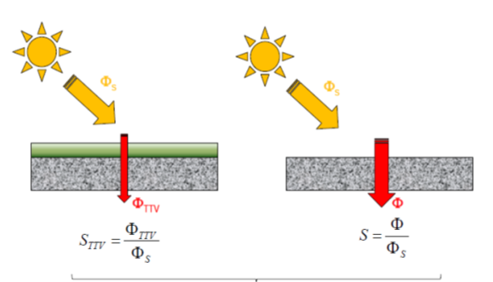
Figure1 : Reduction of heat penetrating into the building provided by the green roof.
  - Definition of thermal comfort.
Thermal comfort is defined according to the climatic context. Thermal comfort refers to an area studied and defined within a temperature range called the thermal comfort zone. This comfort zone is obtained from the thermal comfort diagram according to the climatic context; hot or humid tropical climate.
    - Thermal comfort in a hot and dry climate context
In the context of a hot and dry climate, the thermal comfort zone is defined within a temperature range of 20 to 27°C [8] based on the thermal comfort diagram known as the CARRIER diagram. Figure 2 shows the CARRIER thermal comfort diagram.
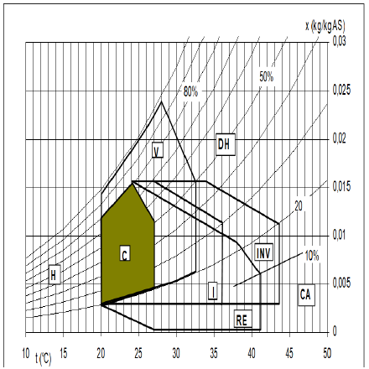
Figure 2: CARRIER thermal comfort diagram

    - Thermal comfort in a tropical and humid climate context
Thermal comfort is an important parameter in air-conditioned buildings due to its impact on the quality of indoor environments, health, and productivity depending on the climatic context. The results of these studies showed ambient temperatures in humid tropical climates of around 24.24°C in Yaoundé and 26.10°C in Douala. In the humid tropical context, the thermal comfort zone is defined within a range of 15 to 25°C according to R. Fauconnier's wet bulb diagram, 1992 (figure 3).
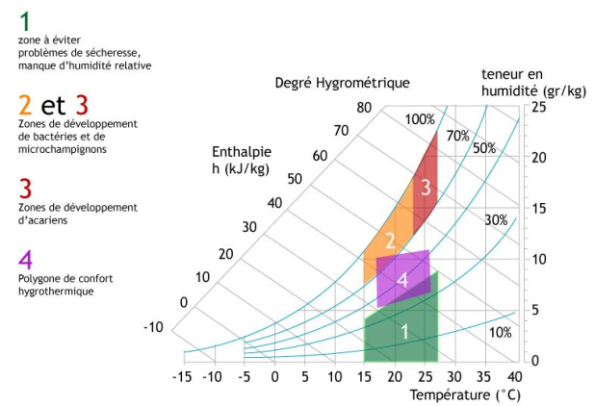
Moisture content(gr/Kg)
hygrothermal degree
Enthalpy h(kJ/Kg)
hygrothermal comfort polygons
Développement zones of mites
Areas of development of bacteria and microfungi
1-area to avoid Problem of dryness Lack of relative humidity
Figure 3: wet diagram by R. Fauconnier 1992
From these two types of diagrams, we notice that the more the climatic context changes, the more the comfort zone of thermal comfort varies. In our study, we will focus on the hot and dry climatic context.
  - Modeling of the system
We are going to model the temperatures of habitable cells with planted roofs, in slab, in sheet metal. Then we will compare their thermal comfort temperature to that of the thermal comfort diagram according to CARRIER in order to assess the effect of the green roof on thermal comfort in housing. The prototype diagram of the habitable cell with a green roof is shown in figure 4. Figure 5 explains the different thermal exchange phenomena produced between the green roof and the atmosphere.
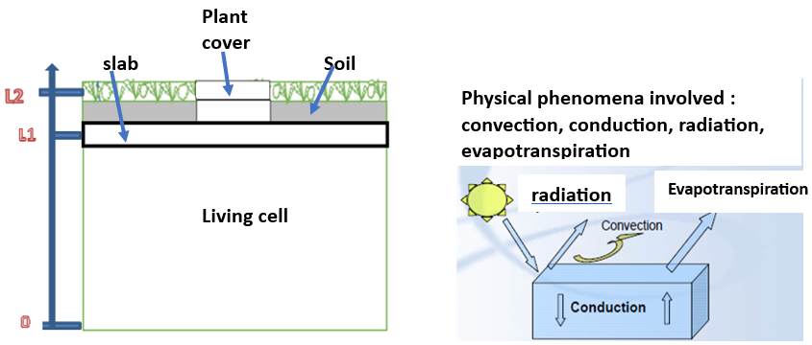
Figure 4 : Diagram of the living cell prototype with green roof
Figure 5 : heat transfer phenomena of green roofs

1.2.1.Boundary conditions
The boundary conditions are defined as follows:
z=0 ; $ϕ_{0}(t)=alfa.Pw(t)+h\left(T(t)-{T(t)}_{sheet}\right)-{\dot{m}}_{e}.Lv$ (1)
z=L1 : T2(L1,t)=T3(L1,t) (2)
z=L2 ; T3(L2,t)=T4(L2,t) (3)
These equations are introduced into a calculation program using the finite element method of Comsol software.
1.2.2. Modeling hypotheses
We assumed that the different types of heat transfers occur as follows: - conduction takes place between the roof, the floor, and the slab; - convection occurs from the inside of the room to the outside (roof); - radiation manifests inside the rooms through the absorption of materials; - evapotranspiration proceeds by gaining energy to release the amount of water stored in the rooftops.
2- Heat transfer equations
2.1- At the level of the vegetation cover and the soil
We use here the hypothesis that transfers are predominant along the z-axis. The vegetation cover and the soil are modeled in a porous medium interacting with air. A phenomenon of evapotranspiration thus simplifies a convective exchange between the leaves and the atmosphere. The results of the modeling allowed us to derive the convective exchange equation defined by equation (4):
$${\left(ρCp\right)}_{eff}\frac{∂T_{2}}{∂t}+ρCp.\vec{V}.\vec{∇T_{2}}-λΔT_{2}=alfa.Pw+h\left(T-Tshettv\right)-{\dot{m}}_{e}.Lv (4)$$
${with : \left(ρCp\right)}_{eff}=θ_{p}ρ_{p}C_{p,p}+\left(1-θ\right).Cp$ (5)
$λ_{eff}=θ_{p}λ_{p}+\left(1-θ\right).λ$ (6)
With :
Pw= solar power received on the roof ;
alfa= solar fraction intercepted ;
${\dot{m}}_{e}$=0.2083[kg/h] mean evapotranspiration ;
$θ_{p}$=porosity ;
$C_{p,p}$=specific heat of water ;
Cp=specific heat of dry soil .
2.2- At the level of the concrete slab
The concrete slab is governed by the classic heat transfer equation in a solid defined by equation (7).
${\left(ρCp\right)}_{concrete}\left( \frac{∂T_{3}}{∂t}+\vec{V}.\vec{∇T_{3}}\right)=+λ_{concrete}ΔT_{3}$ (7)
With:
$Cp:$ specific heat of concrete
$λ_{concrete}$: thermal conductivity of concrete
2.3- Regarding the air volume of the isolated habitable cell
Within the confines of the habitable cell, the movement of the air volume is characterized by a thermal exchange defined by equation (8).
${\left(ρCp\right)}_{air}\left( \frac{∂T_{4}}{∂t}+\vec{V}.\vec{∇T_{4}}\right)=+λ_{air}ΔT_{4 }$(8)

3-Results and Discussions
The aim of the simulation is to determine the variation of solar radiation from 7 a.m. to 5 p.m. over the course of the day on May 23, 2019. This variation in radiation allows us to determine the thermal flux inside the room. The greater the radiation, the larger the flux. The increase in the internal temperature of the building depends on the conductivities of the different roofing materials and those of the building's envelope. We have considered the thermal conductivities of the following types of roofing materials:
- reinforced concrete slab(𝜆_{concrete})=1,5 W/m.K;
- aluminum (λa) = 235 W/m.K;
-zinc (λZ) = 116 W/m.K;
-plant fibers (λf) = (0.03 to 0.1) W/m.K.
We note that the thermal conductivity of plant fiber is very low compared to other materials. When a material has low thermal conductivity, its thermal resistance (R/h = e/λ) is high and the heat flow passing through it is low. We conclude that plant fiber allows thermal flow to pass through it with difficulty due to its low thermal conductivity compared to other types of materials. For the purpose of our research, we will study the evolution of temperature for each type of roof in the room based on solar radiation. Figure 6 shows the variation of solar radiation on May 23, 2019.
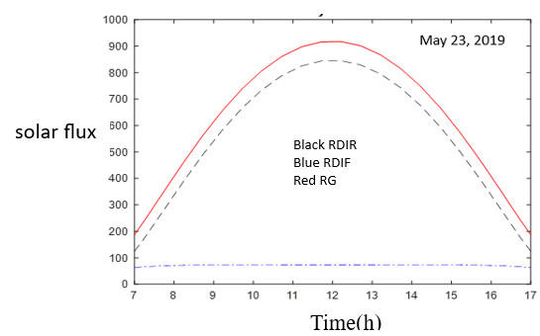
Figure 6: variation of solar radiation for the day of May 23, 2019

3.1- Evolution of the temperature in the green roof and in the insulated room.
The simulation using Comsol software allowed us to graphically represent the temperature variation curves (figure 6); the red curve represents the evolution of the slab temperature, the blue curve shows the evolution of the ambient temperature, and the green curve illustrates the evolution of the internal temperature of the room. Under the influence of solar radiation, the slab temperature reaches 31.5°C in 24 hours. The temperature of the room is 27.85°C and the ambient air temperature is 27°C. This temperature corresponds to the average air temperature inside the habitat, which is 27°C. It is consistent with a sense of thermal comfort in the context of hot and dry regions [10]. The presence of plant cover helps to reduce the temperature that reaches the surface of the slab. Consequently, the temperature inside the room and the ambient temperature gradually decreased. Figure 7 shows the perspective view of the green roof. Figure 8 shows the temperature evolution profile in the green slab and in the insulated room.
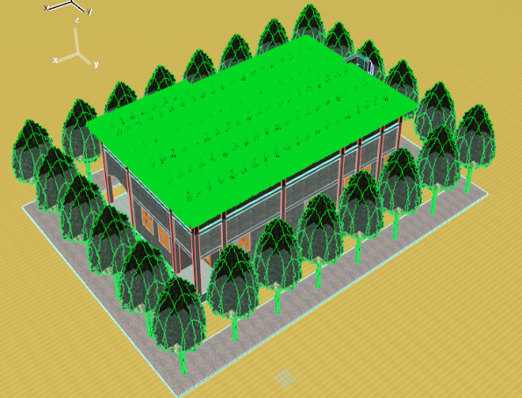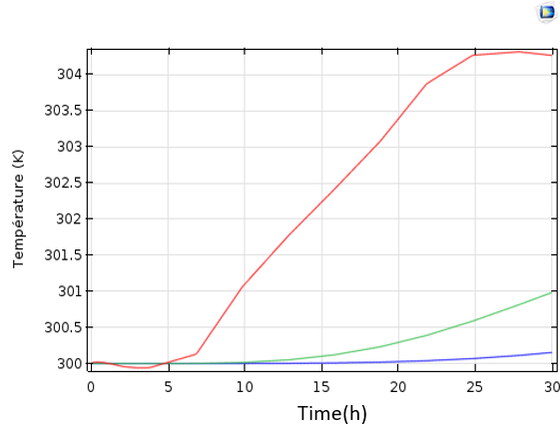
Figure 7: Perspective view of the green roof
Figure 8 : temperature profile in the green slab and in the insulated room

The evolution of the temperatures of the different environments (ambient temperature, room temperature, slab temperature, plant layer temperature) is represented in figure 9.
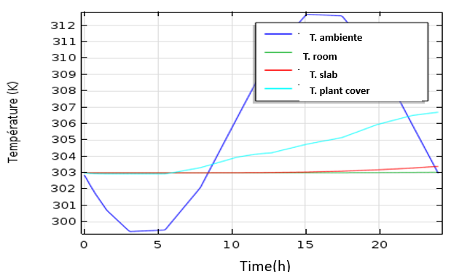
Figure 9: Scatter plot of temperatures
3.2- Evolution of the temperature in the bare slab and in the room
For the case of the bare slab, its temperature rises to 52°C in 18 hours, compared to an ambient temperature of around 29.5°C. The temperature of the slab decreases to 49°C in 24 hours, while the ambient temperature rises to 34°C compared to 27°C, which is the comfort temperature in the context of hot and dry countries, resulting in a difference of +7°C [10]. This temperature is significantly higher than that of the green roof, which is 27°C. We can note that the bare slab allows more thermal flux to pass through compared to the green flat roof. It ensures less thermal comfort for the occupant in the habitat compared to the green roof. Figure 10 shows the perspective view of the flat roof. Figure 11 shows the temperature evolution profile in the flat roof and in the room.
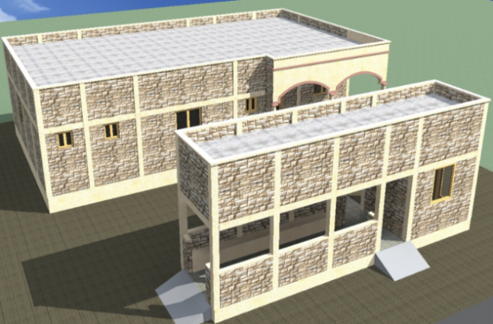
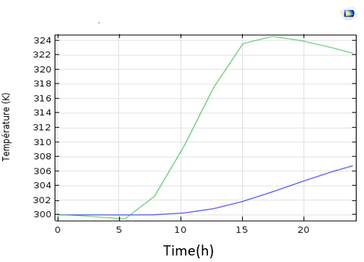
Figure 11: Temperature profile for the bare slab roof and the room
Figure 10: Perspective view of the bare slab roof

3.3- Evolution of temperature in the sheet and in the part
In the case of the sheet metal, its temperature rises to 56°C in 18 hours, compared to an ambient temperature of around 31°C. The temperature of the sheet metal decreases to 49°C in 24 hours, while the ambient temperature rises to 35°C compared to 27°C, which is the comfort temperature in the context of hot and dry countries, resulting in a difference of +8°C [10]. This temperature is significantly higher than that of the bare slab roof, which is 34°C. We can conclude that the sheet metal allows more thermal flux to pass through compared to the bare slab roof. The sheet metal roof does not ensure thermal comfort for the occupant compared to the slab one.
Figure 11 shows the perspective of the metal roof. Figure 12 shows the profile of the temperature evolution in the metal and in the room.
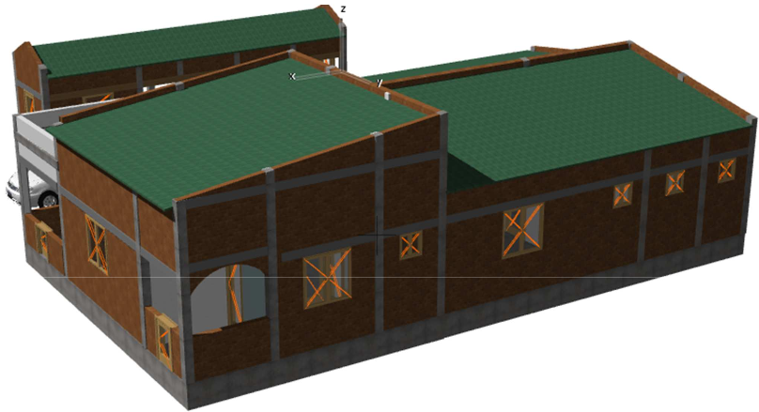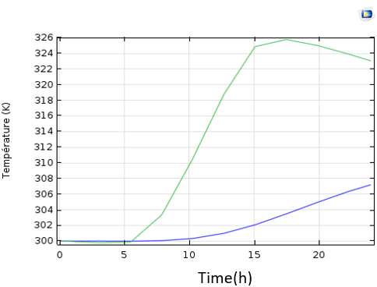
Figure 11: Perspective view of the sheet metal roof
Figure12: Temperature profile in the sheet and in the room

Referring to the principle of heat exchange, the higher the internal temperature of a space, the greater the thermal flow within that space and vice versa. The results of the modeling with the Comsol software allow us to conclude that among these three types of roofs, the green roof guarantees good thermal comfort compared to the other types of roofs (slab, sheet). Therefore, we can deduce that the green roof improves thermal comfort for the occupants in the habitat.
4. Advantages and disadvantages of green roofs
Building a structure primarily involves destroying the environment and consequently creating a break in ecological and faunal continuities. Burkina Faso, a Sahelian country, given its ecological poverty, should be an example in biodiversity preservation. Therefore, we must find other mechanisms to recover the environment. Greening rooftops could be the solution to redevelop biodiversity (providing suitable habitats and refuges for many bird species on rooftops) in order to restore ecological corridors in the Sahel. Green roofs can host numerous species of insects and invertebrates, thus helping to minimize the loss of biodiversity. They are places of new natural balances where endangered plant species can even be introduced, along with their associated faunal groups.
- On a technical level
- Green roofs provide good waterproof protection thanks to the impermeability of materials that resist solar thermal radiation and ultraviolet (UV) rays, which are responsible for about 5% of the aging of roof membranes. They reduce the air conditioning needs of buildings, thereby contributing to energy savings.• Green roofs help combat thermal shock and reduce mechanical stress. They promote good sound insulation by absorbing sound waves and decreasing urban environmental noise. According to the Scientific and Technical Center for Building (STB), a 12 cm substrate can reduce airborne noise by nearly 40 dB.• Promoting the construction of green roofs in the context of hot and dry climates could be a response to several targets of the High Environmental Quality approach:
- Harmonious relationship between buildings and their immediate environment. The development of green spaces through green roofs contributes to a quality landscape and the integration of the building into its environment.- Green roofs help to preserve resources such as water (rainwater retention, low water demand) and energy (thermal insulation).- Green roofs allow for the retention of rainwater, an alternative method for collecting rainwater for domestic use. Moreover, the retention of rainwater by green roofs results in a reduction of the flows that need to be managed by drainage systems.
- an ecological and health interest
The evapotranspiration generated by green roofs will promote air humidity and the formation of dew, which will be essential for the settling of dust and pollen suspended in the air. The green roof provides a significant supply of oxygen in cities while filtering many atmospheric pollutants such as sulfur dioxide or nitrogen oxide. It improves the sanitary quality of the air due to its capacity to absorb CO2 and the supply of O2 from the air through the phenomenon of photosynthesis. A green roof with an area of 1.5 m2 meets the oxygen needs of an adult human. Figure 13 shows the production and absorption of (CO2, O2) by humans and plants.
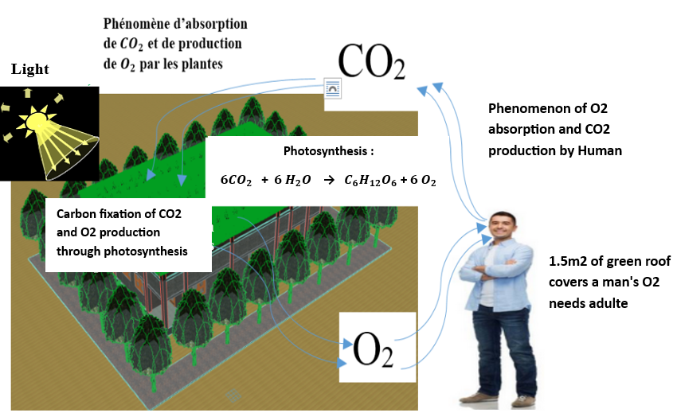
Figure 13: Production and absorption of (CO2, O2) by humans and plants.
It should be noted that the greening of roofs in hot and dry climates could result in the inconvenience of non-compliance with maintenance rules due to lack of water. Hence the need to install solar pumps powered by supercapacitors to regulate the pumping system during disruptions in solar radiation [1].
CONCLUSION
We note that green roofs provide better thermal comfort in housing than other types of roofs. They help preserve biodiversity and ecological continuity. From a high environmental quality perspective, green roofs help maintain freshness in the building's surroundings. They contribute to the phenomenon of photosynthesis through significant oxygen production for respiration. Not to mention that from an economic standpoint, green roofs reduce energy expenses and maintenance costs of waterproofing systems. They offer many advantages, and their maintenance can be a source of employment for young people. Hence, the need to promote the construction of green roofs to support biodiversity balance in the Sahelian zone.

Bibliographic References:

[1] SORE Saidou, ILBOUDO Paul, MOGMENGA Latifatou, NIKIEMA Oumane,
BATHIEBO Dieudonné Joseph, and KAM Sié ; « Experimental Study of the Compensation of the Variability of Solar Pumping Power Over the Sun without Storage using Supercapacitors in the Context of Burkina Faso » Physical Science International Journal, Article no.PSIJ.137818 ;

[2] Paul Ilboudo*, Boubacar Soro, Dieudonné Dabilgou, Boureima Kaboré, Jean Marie Compaoré,Sié Kam*, Dieudonné Joseph Bathiebo ; « Experimental Study of the Evolution of Temperatures in Pavement Structures andInfluence of Traffic on the RN1 in Burkina Faso in a Hot and Dry Climate » Open Journal of Civil Engineering, 2023, 13ISSN Online : 2164-3172-ISSN Print: 2164-3164 ;

[3] Yezouma COULBALY, ” Climat et confort thermique in Sud sciences et technologiques, N° 002 ([11/01/2018]) Economies d'énergie dans le bâtiment et dans l'entreprise ‘’du 30 avril 2019 ; Fondation 2iE 2010)

[4] Ky, J. B., Tissologo, M., Ouedraogo, S., Nikiema, O., & Ouattara, F. (2023). Comparative study of electricity production cost of energy mix of Burkina Faso. International Journal of Trend in Scientific Research and Development (IJTSRD), 29–36.
[5] Yann DUSZA, “ Toitures végétalisées et services écosystémiques : favoriser la multifonctionnalité via les interactions sols-plantes et la diversité végétale”. Ecologie, Environnement. Université Pierre et Marie Curie- Paris VI, 2017. Français. NNT: 2017PA066033. tel-01587757.
[6] Ouédraogo A.A., Berthier E., Ramier D., Tan Y., Gromaire M., “ Evapotran spiration d’une toiture végétalisée expérimentale : observations et modélisation” JDHU 2022 ;
[7] Aurélien Jean, Frédéric Miranville. “Toitures végétalisées : Présentation du concept et bénéfices pour l’île de La Réunion”. 2011. hal-01165874v4 ;
[8] Benjamin KIEMA, Ousmane COULIBALY, « Etude des diagrammes de confort thermique et des Degrés Jours de Refroidissement (DJR) des dix stations synoptiques du Burkina Faso » 30 juillet 2023 ;

[9] A. Kemajou, A. Tseuyep et N.E. Egbewatt, « Le confort thermique en climat tropical humide vers un réaménagement des normes ergonomiques » (reçu le 03 Novembre 2011- accepté le 29 Septembre 2012.

[10] OUEDRAOGO Issaka, $≪$Mmodélisation et optimisation d’une toiture bioclimatique pour la climatisation passive d’un habitat type du BURKINA FASO$≫$P.24-Coopération Institutionnelle Universités Francophones de Belgique (C.U.D/C.I.U.F), 09 Avril 2009.

