Original Research Article

Enhancing Learning in Robotics Teleoperation: Understanding Competence through
Eye Fixation Data

.
ABSTRACT

Aims: A previous study, addressing the analysis of the work activity of a pilot teleoperating a ground robot out-of-sight, led to the hypothesis that the time taken to gather information on the control screens could be correlated with the pilots’ level of skills. This study has made it possible to analyze this hypothesis.
Study design: The study was longitudinal. The activity of the participants was analyzed individually.
Place and Duration of Study: Robotic Accident Response Group, Groupe d'intervention en cas d'accident robotique (INTRA Group, France), between 2021 and 2025.
Methodology: Each participant had to perform the same standard robotic teleoperation activity, equipped with an eye-tracking system in order to characterize the pilot's intake of information during the activity. Performance levels were also measured. The standard robotic teleoperation activity consisted of carrying a cylindrical container using the gripper of the robot’s arm whilst moving through a maze, placing the container on the ground halfway, pick up a ring with the gripper, drop the ring into the container, and then pick the container back up to exit the maze.
Results: The data was used to construct an index of competence for each pilot. The consistency of this index of competence with observations made elsewhere has made it possible to validate a scale of competence ($τ_{k}$=.89, p<.005). The construction of a mathematical function involving the pilots’ maximum fixation time and the reference fixation time x_{ref}, along with the pilot's fixation time dispersion coefficient c_{d} was correlated with the index of competence (r=.89, p<.001).
Conclusion: The study made it possible to measure a pilot's competence in teleoperation based on performance indicators and mastery of the equipment. A model has been proposed to explain how the fixation time during information acquisition on screens correlates with the pilot's competence. The acquisition times for information by a pilot are reduced with the increase in competence and the dispersion of these acquisition times tighten. Thus, training must promote quick scrutiny of all screens: this helps the pilot to get more information about the environment and to build a better mental 3D representation of the robot in the environment.

Keywords: competence; eye-tracking; fixation; performance; robotics; teleoperation; training.

Symbol Quantity Units
c_{d} dispersion coefficient none
i_{c} index of competence
f mathematical function
fq frequency occurrences/minute
k number of classes none
M mean value
N number of points none
p significativity none
p_{i} proportion %
r correlation coefficient none
SD standard deviation
x_{i} value of a fixation time ms
x_{max} value of the extremum
of the distribution of a fixation times ms
x_{ref} reference fixation time ms
$τ_{k}$ Kendall coefficient none

Table 1:
1. INTRODUCTION

  - Context and aims
The mission of the Robotic Accident Response Group, Groupe d'intervention en cas d'accident robotique (INTRA Group, France), is to use robots instead of humans in nuclear accidents. It was set up after the Chernobyl accident by the stakeholders in the French nuclear industry (Fauquet-Alekhine & Bleuze, 2023, 2024a). With this in mind, two major aspects are essential to meet this need: the maintenance of a fleet of ground and aerial drones for intervention and the ability of pilots to be able to remotely operate the machines in hostile environment. The training and retraining of pilots is therefore a major component of the performance of the response teams: teleoperation of robots requires the pilot to control the robot out-of-sight using only information provided on the control panel screens from the robot onboard cameras. From this information, the pilot must build a mental 3D representation of the robot in its environment.

A previous study addressing pilot training (Fauquet-Alekhine & Bleuze, 2024b) was conducted using an eye-tracking device to access what makes pilots competent within the framework of a subjective evidence based ethnography (SEBE) approach. This is a first-person approach that captures the pilot's activity on video and to re-discuss and reenact it in an analysis involving the SPEAC model (the Square of PErceived ACtion model) described in detail by Fauquet-Alekhine (2016, 2020). This is a “process tracing” approach that is perfectly explained in the Cognitive Task Analysis paradigm (CTA) (see Tofel-Grehl & Feldon, 2013; Wei & Salvendy, 2004). The previous study (Fauquet-Alekhine & Bleuze, 2024b) has made it possible to access elements defining pilot's competence, and in particular tacit knowledge that is difficult to access without implementing a SEBE-type method. The study also led to the hypothesis that there could be a difference in the time taken to gather information on a screen depending on whether the pilot was a novice or experienced. The pilots operating out-of-sight mainly use feedback videos from robots onboard cameras. This specificity regarding information capture from screens has already been highlighted in studies related to aviation (Ziv, 2016] and in Space Telerobotic Training (Guo et al., 2022) for example.

The purpose of the present study was to conduct an investigation campaign on a series of pilots teleoperating out-of-sight a ground robot during a standard activity. The study was conducted between 2021 and 2025. The objective of the study was to analyze the extent to which the time to acquire information could or could not be associated with the pilot's skills or performance. No studies are available in the literature on this topic.

  - Performance and competence
As the objective of the study is to analyze the relationship between the pilot's information gathering time in teleoperation with the pilot's performance or skills, it is necessary to define what characterizes the pilot's performance and skills beforehand.

The levels of competence and performance are closely linked: Woodruffe (1991) defines occupational competence as aspects of the job which an individual can perform, with competence referring to a person’s behavior and underpinning competent performance.

Performance in ground-based robotic teleoperation on nuclear accident has been defined by the INTRA group Referent Trainer for several decades according to several criteria:
- Time criterion: for a given activity, performance is better if the objective is achieved in a minimum of time.
- Quality criterion: the activity is carried out with minimal equipment degradation (i.e. degradation of the robot or degradation of the surrounding equipment). This is quantified by counting the number of collisions between the robot and the environment or the number of falls (e.g. falling down the stairs). For a pilot to be considered successful, these counts must be 0.
- Efficiency criterion: for the standard activity of picking up a ring with the robot's gripper, placing it in a container and removing the container, the number of attempts to pick up the ring (if it falls) and the number of attempts to place it in the container (if it is set aside or falls) are performance indicators; The number of attempts to pick up the container which may also fall is also a performance indicator. These indicators assess the pilot's ability in remote operation; they must be equal to 0 for a successful pilot. However, they are included in the criterion of the total time it takes to carry out the activity; the analysis from the previous study (Fauquet-Alekhine & Bleuze, 2024b) showed that incorporating these indicators is unnecessary as they tend to increase the time taken to complete the activity and therefore, they are inherently integrated into the total time criterion.
The performance criteria chosen are therefore the overall time criterion necessary for the pilot to complete the entire activity (which includes the efficiency criterion) and the quality criterion.

Competence is more difficult to characterize objectively. The effectiveness criterion mentioned above is an indicator of competence since it partly reflects the pilot's ability to perform the activity correctly. However, competence is most often assessed subjectively based on observables that are assessed by a professional (e.g. the Robotic Referent Trainer of the INTRA group) during the execution of the activity. For instance, in ground-based robotic teleoperation with manipulation of the robot's articulated arm, one of the observable factor is the fluidity of the robot's movement and of the movement of the arm during manipulations. This type of observable is difficult to quantify and does not allow for the computational analysis which would be necessary for exploring correlations with other quantities, such as the pilot's information gathering time (fixation time).

Considering the definition of "competence" in the literature, several can guide the selection of quantifiable criteria to assess competence. Fauquet-Alekhine (2020:13) suggested “to consider competencies as an overall concept designating knowledge, know-how and skills where knowledge is a prerequisite to know-how and skills. Skills develop from know-how in action with experience, where “experience” means being exposed to situations several times and at a certain frequency (it is quite different to perform a task once every ten years or ten times in one year). Having skills is therefore possessing know-how that has been put into action several times (in the event of the situation).” A high level of competence is often unconscious: Rasmussen (1983) defined skill-based behaviour as “highly integrated patterns of behaviour”, related to “sensory-motor performance during acts” following intention and occurring without conscious control. To illustrate this, let us consider an apprentice novice at the steer-wheel of a car for the first driving lesson: the novice will take a significant amount of time to perform various operations necessary for driving and will spend considerable time gathering information, especially by visually confirming the correct placement for hands or feet relative to the desired action (e.g. shifting the gear lever from neutral to first gear). In contrast, the experienced driver, who has been driving almost daily for the past 10 years, no longer pays attention to these gestures. Instead, the driver focuses more on the road through the windshield, with little attention paid to vehicle’s control.

The KKHS model (Knowledge – Know-How – Skills model) proposed by Fauquet-Alekhine (2020) explains that the development of skills is based on the repeated and frequent application of know-how, and that maintaining the level of competence implies that this implementation is continued over time in a repeated and frequent manner. Thus, in the example of the experienced driver above, the small number of switches from the windshield (to obtain information about the road) to the control devices and the dashboard of the car, reflects the repeated and frequent application of Know-How (KH): the number of switches "windshield" versus "dashboard or driving devices" serves as an indicator of the competence through mastery of the equipment.
On this basis and by analogy, an objective and quantifiable indicator of competence in robotic teleoperation is the number of gaze switches made by the pilot between the control screens and the control panel. This indicator reports on the pilot's mastery of the equipment. As with the car driver, a competent pilot does not look at the control panel much and focuses on the information on the control screens which correspond to the information taken in the direction of the "road".

In summary, the criteria used in this study to characterize the pilot's level of competence is the combination the duration of the activity, the number of collisions, and the number of switches of the pilot's gaze between the control screens and the control panel.

2. material and methods
  - Participants
Between 2021 and 2025, INTRA group pilots were invited to carry out a standard activity while being equipped with an eye-tracking device.

During the study period, some pilots started the experiment as novices and repeated it a few months later as an experienced pilot: meanwhile the pilot was trained and working with robots. The experiment also involved external pilots who are full-time employees in a parent company of the INTRA group, who have undergone the same initial training as the group's full-time pilots, and who undergo a one-week refresher course each year. Thus, although the staff of the INTRA group only has 9 pilots, this has made it possible to obtain 13 measurement cases overall.

  - The standard activity
In order to be able to compare the data collected from one pilot to another, it was necessary to observe a single activity. This activity had to be carried out by experienced pilots as well as novice pilots. This activity also had to integrate variable difficulties, the mastery of which evolves according to the training of pilots. The activity therefore included movement as well as the manipulation of objects using the robot's articulated arm. The details of the activity are as follows and are fully detailed in Fauquet-Alekhine & Bleuze (2024b).

The pilot had to teleoperate a robot, a tracked ground machine equipped with an articulated arm. The teleoperation consisted of moving through a maze. The aim was to increase the use of the screens by the pilot when avoiding the walls and thus produce eye-tracking data. The pilot had to carry a cylindrical container with the gripper of the robot arm. Halfway through the maze, the container had to be put on the ground, and a ring had to be picked up with the gripper, then dropped into the container, then the container had to be picked up to get out of the maze. This activity was carried out on a full-scale simulator in order to reduce the risks associated with the safety of people or the safety of equipment. The duration of the activity was about 10 to 20 minutes. The activity had to be completed in a minimum time.

  - Data acquisition
The system used to capture the first-person video recording of the activity is composed of spectacles with adapted glasses correction to the user, with a wide-angle camera mounted on the glasses stem, detectors on the glasses frame to capture and record the pupils’ movement, a wire between one spectacles stem and a smartphone for recording. The whole equipment is provided by Pupil Lab. The data collected was analyzed by a posttreatment software that locates the points of fixation of the person's gaze on the video (see the equipment at https://pupil-labs.com/products/invisible). This allows to access the characteristics associated with the pilots' fixation time during the work activity.

The data that was measured by the video processing software is as follows:
- activity duration (min): time needed to complete the entire standard activity.
- handling duration (min): time needed to complete the handling portion of the standard activity.
- proportion of handling duration within total duration.
- total fixation duration (s): sum of all fixation times over the total duration of the activity.
- number of fixations.

Additionally, the eye-tracking video analysis made it possible to access the frequency of switching between the screens and the control panel (PCL) for each of the participants:
- number of switches screens-PCL.

This data was supplemented with sociodemographic and physiological data collected by questionnaire: age of the pilot, experience (number of years spent in the position), ophthalmological correction. The gender of the pilot was not taken into account because the population was entirely male.

3. results and discussion

3.1 Sociodemographic and physiological characteristics of participants

The average age of the participants was M_{a}=45.56 (SD_{a}=7.61), with all participants older than 34 years old. This is due to recruitment constraints which require selection among staff from the parent companies (Electricité de France, Commissariat à l’Energie Atomique, Orano), staff who had to work for several years in their parent company before being able to apply to the INTRA group.

The pilots' experience expressed in terms of the number of years spent in the position varies from 0.5 to 18 years, with an average M_{e}=4.8 (SD_{e}=4.5). However, it should be noted that the experience thus considered is not equivalent for a full-time pilot and for an external pilot: in fact, a full-time pilot as well as an external pilot undergoes a refresher course in training once a year, but the full-time pilot is invited to pilot during exercises several times a year while the external pilot is invited to this type of training only once a year. As a result, 7 years of experience for a full-time pilot is not associated with the same level of competence as 7 years of experience for an external pilot. The impact of this difference will be discussed below.

Among all the pilots, 3 participants required ophthalmological correction. The eye-tracking device allows this type of correction to be integrated. This was only necessary for 2 pilots.

  - Data analysis
The data that was calculated are as follows:
- proportion of fixation duration to the total activity duration (%): this represents the percentage of time spent fixating with the eyes over the total duration of the activity.
- average fixation duration (ms): average duration of all gaze fixation times over the total duration of the activity.
- fixation peak average range (step 60ms): median value of the interval that includes the extremum of the dispersion diagram of the fixation times for intervals of 60ms.
- proportion of fixation peak class within total (number of occurrences): number of fixation times within the interval that shows an extremum on the dispersion diagram of fixation time for intervals of 60ms.
- proportion of fixation peak class within total (%): proportion of fixation time in the interval showing an extremum on the dispersion diagram of the fixation time for intervals of 60ms relative to the total number of fixation.
- frequency switches screens-PCL (occ/min): ratio of the number of switches from the screen to the control panel to the total activity time.
- frequency of fixation points within total duration (occ/min) or saccade: ratio of total fixations to total activity time.

The results show that there is a correlation between the total time of completion of the activity and the handling time: r=.94 (p<.0001) (Fig.1). This significant correlation is logical: a pilot that moves more slowly manipulates more slowly; what is noteworthy is the proportionality: the manipulation represents on average about M=66% (N=13, SD=7%) of the total time for this activity.
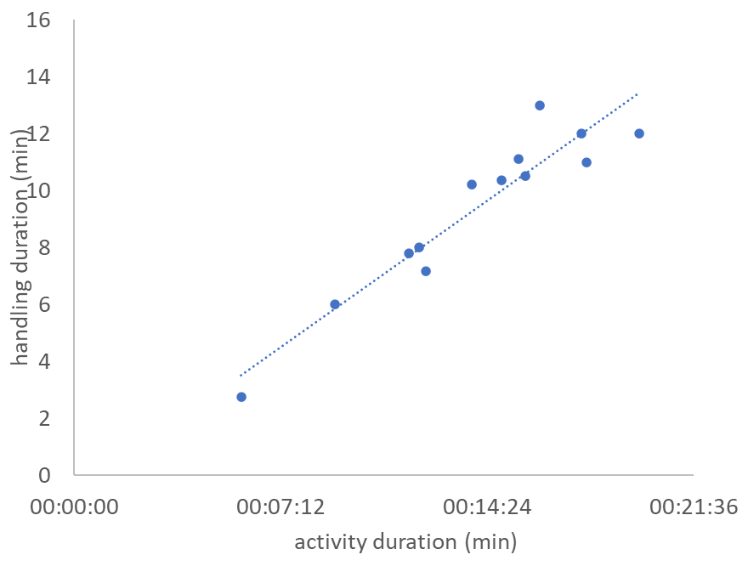
Fig. 1. activity duration (time required to complete the entire standard activity) versus handling duration (r=.94, p<.0001)

The mastery of the equipment by the pilot (of which the chosen indicator is frequency of switches screen - PCL) does not show correlation with performance (total time to complete the activity) when all pilots are considered (r=.24, p>.4, Fig.2).

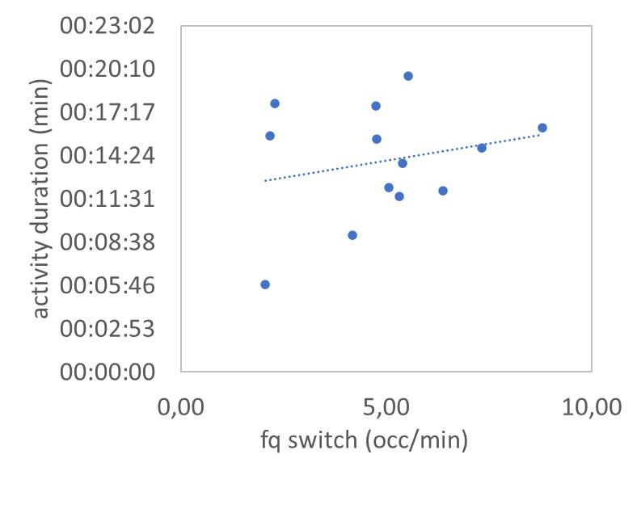
Fig.2. combination of performance and mastery of the equipment (represented by the frequency of switches between PCL and control screens) for all pilots (r=.24, p>.4)

However, when pilots whose completion time is greater than 17 min (external and novice pilots) are not selected, the mastery of the equipment on the equipment consistently correlates with performance: r=.82 (p<.007) (Fig.3): a high frequency (low expertise on the equipment) is associated with a low performance (long time of activity).

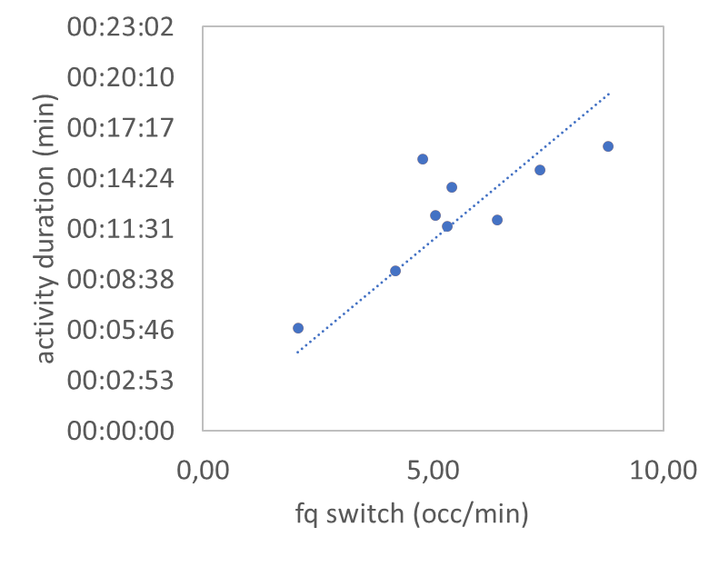
Fig.3. combination of performance and expertise on the equipment (represented by the frequency of switches between PCL and control screens for pilots except novices and external (r=.82, p<.007)

The fact that frequency correlates with activity duration for pilots, except novices and external pilots, suggests that the mastery of the equipment is not sufficiently elaborated or maintained. The KH are not enough robust and structured to produce the expected performance.

Fig. 3 shows an affine line on which the orthogonal projection of the data points can be associated with an index of competence. On this line, the distance from the origin to the projection of the point is calculated, allowing each point to be associated with a value. Thus, each pilot (i.e. each point on the graph) has an i_{c} on this scale that provides an objective ranking of pilots according to this competence. This value has the disadvantage of being higher the less competent the pilots. In order to remedy this disadvantage, the inverse of this distance is taken as the index of competence for each of the pilots. These indices of competence are used in the following to study the possible relationship between the time it takes to take information and the pilots' competence.

  - Characterization of fixation times
When all pilots are considered, the total fixation time is proportional to the total time of the activity (r=.89, p<.002) which is logical: for a given pilot, an extension of the duration of activity implies an extension of the fixation time since s/he is supposed to spend more time getting information. A similar trend is observed for the total number of fixations with the total time of the activity (r=.80, p<.01).
However, fixation patterns are not uniform across pilots. Figs. 4 a & b illustrate the dispersion diagram of fixation times for 2 pilots in a) one at the lower end of the competence scale, and b) one on the higher end, thus performing better. The fixation times are divided into 60ms classes, a value obtained by applying Sturges' rule (Sturges, 1926) given in eq. 1: on average, the analyzed activity is covered by 2000 fixation points, which leads to 12 classes. However, fixation durations exceeding 750ms account for less than 10% of all points, supporting the choice of 60ms interval for the distribution.

Sturges' rule:

$k= 1+ \frac{10}{3} \left\{\log_{10}\left(N\right)\right\}$ (1)

where:
k : number of classes
N : total number of points to be distributed over k classes.

The fixation time distributions by 60ms-classes show different extrema and dispersions (Fig. 4 a & b).

a 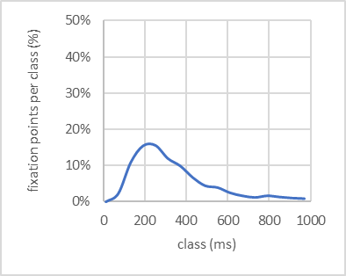 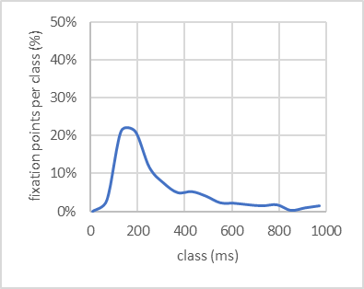b
Fig.4 a & b Dispersion diagram for a) a novice pilot, and b) an experience pilot

Concerning the extrema: the extremum of the less competent pilot (Fig.4a) corresponds to a higher class (220ms) value than that of the more competent pilot (160ms) (Fig.4b): this indicates that the less competent pilot requires longer fixation time to process information compared to the more competent pilot.

Regarding the shape of the distributions: the distribution is more spread out for the pilot with the lower competence index (Fig.4a) than for the pilot with a high competence index (Fig.4b).
Ziv (2016) found that expert airline pilots had more fixations on different instruments and shorter fixation time when compared to novices.

The analysis of these curves for all pilots confirms this difference: a less competent pilot has a higher fixation peak with a broader distribution than a more competent pilot.

Based on these observations, fixation times per pilot can be characterized by the value of the extremum x_{max} of the distribution and by a dispersion coefficient c_{d} calculated on the basis of the formulation of the dispersion coefficient of a statistical distribution as follows:

$c_{d} = \frac{1}{x_{max}} {\left[\frac{\sum_{i}{p_{i}{\left(x_{i}-x_{max}\right)}^{2}}}{N}\right]}^{1/2}$ (2)

where:
$c_{d}$: dispersion coefficient of the fixation time distribution
$x_{max}$: value of the extremum of the distribution
$x_{i}$: median value of a class i of distribution fixation points
$p_{i}$: proportion of the class i relative to the distribution (number of fixation times in the class relative to the total number of fixation points)
$N$: total number of points

  - Competencies and fixation time
The objective of the study being to analyze the extent to which the time to acquire information could or could not be associated with the pilot's skills or performance, the question arises as to whether the maximum fixation time is associated with competencies or not. There is no significant correlation between the maximum fixation time and the index of competence. The same lack of correlation is observed when maximum fixation time is replaced by the distribution coefficient.

However, the combination of the maximum fixation time with the dispersion coefficient could be correlated with the index of competence given the previous remarks regarding the characterization of fixation point distributions.
Furthermore, it was remarked above that the fixation times differ between a pilot with a high level of competence and a pilot with a low level: the least competent have a higher maximum value of fixation time than the most competent pilots.
Therefore, the further a pilot's maximum fixation time deviates from the reference fixation time calculated from an average of the maximum fixation times of the best pilots, the lower the pilot’s competence. Arbitrarily, this reference time x_{ref} is calculated as the average of the maximum fixation times of the top 3 pilots: x_{ref}=140ms.
On the basis of these observations and considerations, a mathematical function f is constructed using the absolute value of the difference between a pilot's maximum fixation time and the reference fixation time x_{ref}, along with the pilot's fixation time dispersion coefficient c_{d}. Seeking a function that correlates with the index of competence leads to the following formulation:

$f=abs\left(x_{max}- x_{ref}\right) {i_{d}}^{0.5}$ (3)

The result of the modeling of the index of competence from the peak fixation and the dispersion of the fixation times is presented in Fig.5, with a correlation coefficient r=.89 (p<.001). The ranking of pilots based on calculations of the index of competence has been compared to the ranking by the Referent Trainer on the basis of training data and evaluations. The Kendall coefficient $τ_{k}$=.89 (p<.005) showing a good coherence.

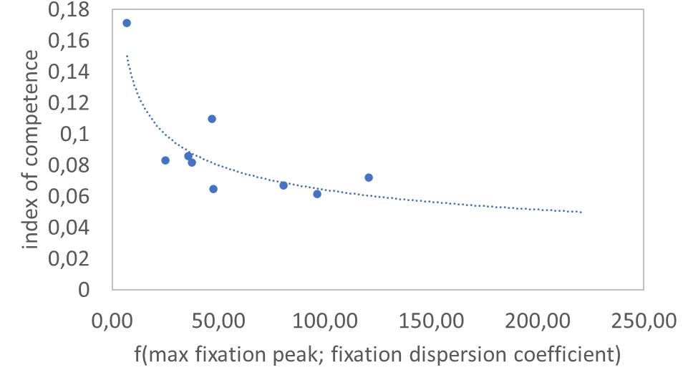
Fig.5. The modeling function f for the index of competence versus maximum fixation time and dispersion coefficient (r=.89, p<.001)

The interpretation of the results is as follows: when the gap between the fixation peak and the reference fixation peak increases, the index of competence decreases; similarly, when the dispersion of the fixation times increases, the index of competence also decreases.
This means that an efficient pilot must have a fixation time centered around 140ms and with minimum deviation from this value. In terms of training, pilots need to extract information within consistently short fixation duration, and this as frequently as possible. One of the training instructions used to achieve this goal is to encourage the pilots to scan the screens as frequently as possible in order to gather the maximum amount of relevant information. This information is unconsciously integrated and combined by the pilot during teleoperation.

One element may explain the wide dispersion of fixation times for pilots with a low index of competence. The plot of the fixation frequency throughout the activity as a function of the dispersion coefficient (Fig.6) shows that a high dispersion coefficient is associated with a low frequency r=.81 (p<.008): the indicators show that the most effective pilots extract information more frequently and in a shorter duration. Qualitative analysis of the video recordings suggests that these pilots tend to scan the full set of the screens. From a training perspective, this leads to encouraging pilots to avoid focusing on one or two screens; On the contrary, they should actively scan across all available screens as much as possible.

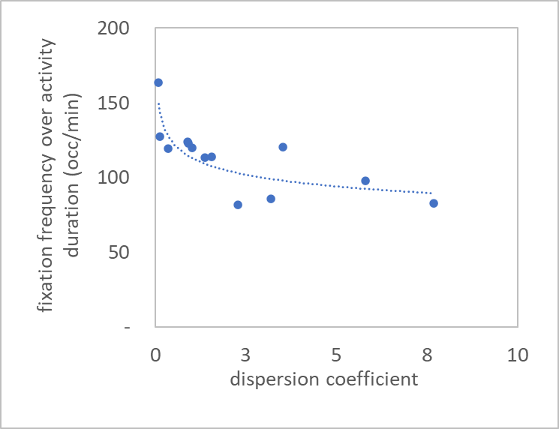
Fig.6. Fixation frequency versus dispersion coefficient (r=.81, p<.008)

The implication in terms of training is as follows: pilots must learn to capture information over a short time (since most of them have a longer fixation time than the reference), and this as often as possible. It can be hypothesized that a shorter fixation time allows the pilot to grasp more information during the activity, provided that gaze scans all the screens at a sufficient frequency: pilots with a high index of competence have a higher frequency than others. One of the instructions given by the trainer in order to achieve this result may be to ask the pilot in training to scan the screens as much as possible to capture as much different information as possible or update it frequently. In this way, the pilot learns to enter more information and is forced to reduce fixing times. The information acquired in this way is integrated and combined by the pilot during his teleoperation activity. This multi-camera set of information allows the pilot to build the 3D mental representation of the robot in its environment in a more efficient way.

  - Cognitive abilities, personality, or training
The question may arise as to whether these results are associated with the cognitive abilities of each of the pilots or whether they are due to the effect of training. It is obvious that cognitive abilities necessarily come into play (e.g. Cardenas et al., 2024; Pan et al., 2016, 2021).
Personality may also come into play. Pan et al. (2016), studying extravehicular astronaut’ activities, found that participants with lower neuroticism showed better task and safety performance and imagery subjects showed higher task and safety performance than verbal subjects.

However, the study included two pilots who completed the experimental test twice, several months apart, the first time as a novice and the second time as experienced pilot. Regarding their index of competence, it increased by 48%. Regarding the maximum fixation time, deviation from the reference time decreases by 50%. As for the dispersion index, it stagnated for one pilot and decreased by 45% for the other. These comparative results show a clear improvement. This proves the positive effect of the training on the improvement of the index of competence and of fixation time characteristics according to the model proposed and formalized by eq. 3.

A discussion with the Referent Trainer helped clarify how such improvements are achieved. The trainer explains that during training, if a pilot tends to focus on a single screen, they are reminded of the importance of using all on-board cameras, particularly during robotic arm manipulation.
The robot is equipped with a camera on the arm and two lateral cameras. The trainer therefore asks the pilot to reposition the lateral cameras because the novice pilot tends to focus on the use of the arm-mounted camera. In doing so, the pilot broadens his spectrum of screen analysis since he is required to use the information from the screens associated with the cameras he repositions. As a result, the pilot gathers information from three screens instead of one.

This may help to refocus its maximum fixation time around the optimal fixation time while reducing the dispersion of fixation times.

  - Effect of the number of years of experience, age, ophthalmological correction
Neither the maximum fixation time, nor the performance, nor the skill, nor the index of competence are correlated with the age of the pilot or experience. The few pilots with ophthalmological corrections did not present any particularities compared to their colleagues.

4. Conclusion

The study made it possible to measure a pilot's competence in teleoperation out-of-sight based on performance indicators and mastery of the equipment.
A model has been proposed to explain how the fixation time during information acquisition on screens correlates with the pilot's competence. This mathematical function involves the pilots’ maximum fixation time and the reference fixation time x_{ref}, along with the pilot's fixation time dispersion coefficient c_{d} and is correlated with the pilots’ index of competence i_{c} (r=.89, p<.001).
In conclusion, as a pilot's competence increases, information acquisition times decrease and the variability in these times becomes more constrained. Training should therefore emphasize efficient and thorough monitoring of all displays.
From a training perspective, the implications are as follows:
- Information must be taken from as many screens as possible,
- The time it takes to gather information on a screen (fixation time) must be around 160ms,
- Overall, the fixation times should be grouped around 160ms (the distribution of fixation times must be reduced),
- By following these instructions, the pilot learns to catch information more quickly, to make the information intake more exhaustive since the gaze travels through more screens, to update information more frequently since shorter times allow a higher frequency of switching from one screen to another, which results in better performance by helping the pilot to build a 3D mental representation of the robot in its environment in a more efficient way,
- The instructions already implemented by the Robotics Training Referent, which consist of avoiding focusing on one or two screens and browsing all the screens as much as possible, contribute to achieving these objectives and, as the measurements show, contribute to improving the performance of the pilots.
From a research perspective, the models and methods proposed in the present study might be profitably applied in other teleoperation domains such as mini-invasive surgery or air traffic control. The parameters identified in the present study might also be combined with other metrics used elsewhere such as gaze entropy or pupil diameter identified as the most reliable and sensitive measures of workload (Upasani et al. 2024).

Consent
Each participant has co-signed with the supervisor of the experiments an informed consent explaining the aim of the study, the participants profile expected, the procedure and duration of the experiment, the equipment used and how, the benefits and the risks for the participants and what was made to reduce the risks, the debriefing following the activity, and recalled the volunteer character of the participation as well as the participants’ right to leave as they wanted. The informed consent was written according to the British Psychological Society Guidelines for Minimal Standards of Ethical Approval in Psychological Research.

Ethical approval
All authors hereby declare that the design of the study was examined and approved by the Committee for Ethics, Standards and Protection of the INTRA group, approval number #CESP/PHFA/100, and have therefore been performed in accordance with the ethical standards laid down in the 1964 Declaration of Helsinki.

COMPETING INTERESTS DISCLAIMER:
The author has declared that he has no known competing financial interests OR non-financial interests OR personal relationships that could have appeared to influence the work reported in this paper.
Disclaimer (Artificial intelligence)

The author hereby declares that NO generative AI technologies such as Large Language Models (ChatGPT, COPILOT, etc.) and text-to-image generators have been used during the writing or editing of this manuscript.

References

Cardenas, J. J. G., Hei, X., & Tapus, A. (2024, October). Exploring Cognitive Load Dynamics in Human-Machine Interaction for Teleoperation: A User-Centric Perspective on Remote Operation System Design. In 2024 IEEE/RSJ International Conference on Intelligent Robots and Systems (IROS) (pp. 12204-12211). IEEE.

Fauquet-Alekhine, P. (2016). Subjective ethnographic protocol for work activity analysis and occupational training improvement. British Journal of Applied Science and Technology, 12(5), 1-16.

Fauquet-Alekhine, P. (2020). Knowledge Management in High Risk Industries: Coping with Skills Drain. Berlin: Springer Nature.

Fauquet-Alekhine, P., & Bleuze, J. (2023, July). Robot-Assisted Nuclear Disaster Response: determinants of performance. In 2023 3rd International Conference on Electrical, Computer, Communications and Mechatronics Engineering (ICECCME) (pp. 1-12). IEEE.

Fauquet-Alekhine, Ph., & Bleuze, J., (2024a). Determinants of Performance for Robotics Teleoperated Activities: from Emergency Response to Decommissioning. Journal of Robotics and Mechatronics, 36(1), 139-147.

Fauquet-Alekhine, Ph., & Bleuze, J., (2024b). Improving Learning in Robotics Teleoperation: Contribution of Eye-tracking in Digital Ethnography. Current Journal of Applied Science and Technology, 43(7), 128-139.

Guo, Y., Freer, D., Deligianni, F., & Yang, G. Z. (2021). Eye-tracking for performance evaluation and workload estimation in space telerobotic training. IEEE Transactions on Human-Machine Systems, 52(1), 1-11.

Pan, D., Zhang, Y., Li, Z., & Tian, Z. (2016). Association of individual characteristics with teleoperation performance. Aerospace Medicine and Human Performance, 87(9), 772-780.

Pan, D., Zhang, Y., Li, Z., & Tian, Z. (2021). Effects of cognitive characteristics and information format on teleoperation performance: A cognitive fit perspective. International Journal of Industrial Ergonomics, 84, 103157.

Rasmussen, J. (1983). Skills, roles, and knowledge: signals, signs, and symbols, and other distinctions in human performance models. IEEE Transaction on Systems, Man, and Cybernetics SMC, 13(3), 257-266.

Sturges, H. A. (1926). The choice of a class interval. Journal of the American statistical association, 21(153), 65-66.

Tofel-Grehl, C., & Feldon, D. F. (2013). Cognitive Task Analysis-Based Training: A Meta-Analysis of Studies. Journal of Cognitive Engineering and Decision Making, 7(3), 293-304.
Wei, J., & Salvendy, G. (2004). The cognitive task analysis methods for job and task design: review and reappraisal. Behaviour & Information Technology, 23(4), 273-299.

Upasani, S., Srinivasan, D., Zhu, Q., Du, J., & Leonessa, A. (2024). Eye-tracking in physical human–robot interaction: Mental workload and performance prediction. Human factors, 66(8), 2104-2119.

Woodruffe, C. (1991). Competent by any other name. Personnel Management, September, 30-33.

Ziv, G. (2016). Gaze behavior and visual attention: A review of eye tracking studies in aviation. The International Journal of Aviation Psychology, 26(3-4), 75-104.

