APPLICATION OF MACHINE LEARNING FOR RADIO REFRACTIVITY PREDICTION ACROSS CLIMATIC ZONES IN WEST AFRICA

This research explores the use of machine learning (ML) models to predict surface radio refractivity in diverse climatic zones across West Africa. We evaluated three machine learning approaches for predicting surface radio refractivity across West Africa’s diverse climates, using data from five locations: Niamey, Bamako, Monrovia and Jos. Models used including ; LightGBM, Random Forest, and Long Short-Term Memory (LSTM) trained on ERA5 reanalysis atmospheric dataset, optimized through grid search and early stopping to improve predictive accuracy. Result showed LightGBM performed best overall (MAE: 35.014, MSE:1918.844), though Random forest achieved slightly lower in some regions but struggle with overall accuracy ( MAE: 113.457, MSE : 59707.833). The analysis reveal wind speed and solar radiation as the key predictive factors across different climate zone. These models offer practical improvements over traditional methods for radio wave propagation, forecasting particularly valuable for telecommunication planning in regions with limited observational data.
Abstract
Keywords: Machine learning, Radio refractivity, Atmospheric prediction, ERA5, West Africa, LightGBM, Random Forest, LSTM

INTRODUCTION
The accurate prediction of atmospheric conditions is crucial for various applications, including meteorology, aviation, and telecommunications. Radio refractivity is a crucial aspect of atmospheric characteristic that significantly affects radio wave propagation, particularly for telecommunications and radar systems. Surface refractivity (N) depends on meteorological factors such as temperature, pressure, and humidity. In regions like West Africa, characterized by diverse climatic zones, from arid regions in the north to humid tropical areas in the south, accurate prediction of surface refractivity is essential for optimizing radio frequency applications.
Traditional methods for predicting radio refractivity often rely on empirical models that may not adequately account for the complexities of atmospheric behavior. In recent years, machine learning (ML) techniques have emerged as powerful alternatives, offering the ability to model nonlinear relationships and capture intricate patterns within atmospheric data. The primary aim of this research is to explore and compare different machine learning models for predicting surface refractivity. The models analyzed in this study include LightGBM, Random Forest, and Long Short-Term Memory (LSTM). Each model was trained and optimized using data from ERA5 reanalysis, a widely used global atmospheric dataset. Through a comprehensive analysis that includes metrics such as Mean Absolute Error (MAE) and Mean Squared Error (MSE), this study seeks to provide insights into model performance across various locations; Niamey, Bamako, Monrovia, Darker, and Jos, and different seasonal conditions representing a broad spectrum of climatic zones. The findings will contribute to a better understanding of how machine learning can enhance

refractivity predictions and improve the reliability of wireless communication systems in challenging atmospheric environments.
Objectives
- Compare the performance of machine learning models (LightGBM, Random Forest, LSTM) in predicting surface refractivity.
- Identify the most effective model for predicting surface refractivity in different climatic zones and seasons.
- Determine the most important predictors influencing refractivity in West Africa.

LITERATURE REVIEW
Machine learning models have shown promising results in meteorological applications such as temperature forecasting, humidity estimation, and rainfall prediction. These models excel at capturing complex non-linear relationships between atmospheric variables, which is critical in accurately predicting radio refractivity.
Several studies have applied ML techniques for atmospheric refractivity prediction in various regions. For instance, Haji-Aghajany et al. (2024) used Support Vector Machines (SVM) and Artificial Neural Networks (ANNs) to predict refractivity, another method, which is Downscaling techniques have been widely used to improve regional climate predictions, especially in diverse climatic zones like West Africa (Wilby & Dawson, 2013), noting substantial improvements in accuracy compared to traditional models. However, their work focused on relatively homogeneous climatic conditions, leaving a gap in understanding how ML models perform across varied climates such as those in West Africa. In addition, models like LSTM, which are well-suited for time-series data, have shown effectiveness in predicting atmospheric variables that exhibit seasonal variations (Kumar et al., 2019). Yet, there remains limited research on applying these advanced

ML models specifically for surface refractivity prediction in diverse climates. This paper aims to fill this gap by analyzing multiple ML models and their performance across West Africa’s distinct climatic zones.

METHODOLOGY
  - Study Locations: This study focuses on five key locations across West Africa, selected to represent a diverse range of climatic conditions, as shown in Table 1. These regions exhibit significant variations in temperature, humidity, and seasonal patterns, all of which are expected to influence surface refractivity. Each of these locations represents a distinct climatic zone with unique atmospheric dynamics.
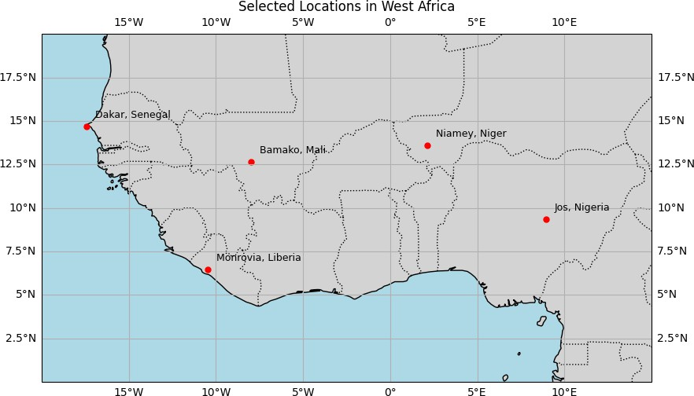
Figure 1: Map showing the selected study locations across West Africa, each representing distinct climatic zones.
Table 1: Selected study locations in West Africa

City | Country | Climate Zone
Niamey | Niger | Sahel
Bamako | Mali | Sudano-Sahelian
Monrovia | Liberia | Tropical Rainforest

Dakar | Senegal | Tropical Savanna
Jos | Nigeria | Tropical Wet and Dry
  - Data Collection and Preprocessing: Data for surface refractivity prediction were derived from the ERA5 reanalysis dataset provided by the European Centre for Medium- Range Weather Forecasts (ECMWF). ERA5 offers high-resolution global atmospheric data, including surface temperature, pressure, and relative humidity, critical inputs for calculating surface refractivity (Dee et al., 2011). The equation used for calculating surface

refractivity (N) is given as: 𝑁 = 77.6 × 𝑃
𝑇
+ 3.73 × 10⁵ × 𝑒
𝑇2

Where: - P is the atmospheric pressure (hPa)

- T is the temperature (K)
- e is the water vapor pressure (hPa)

Data preprocessing involved extracting relevant atmospheric parameters from ERA5, including surface temperature, pressure, and humidity, at a daily time resolution. The data was further aggregated to compute seasonal averages to analyze the performance of models across different seasons.
    - Atmospheric Predictors: In this study, four key atmospheric predictors were used to model surface refractivity:
- Potential Evaporation (m): This predictor represents the amount of water that could evaporate under given atmospheric conditions, contributing to variations in humidity, which directly affects radio refractivity. Higher evaporation rates typically reduce humidity and refractivity (Pan et al., 2020).
- Surface Net Solar Radiation (Jm⁻²): Solar radiation influences surface temperature and atmospheric density, which are critical to refractivity. Increased solar radiation

heats the surface, altering the temperature profile and subsequently affecting refractivity levels (Wilby & Dawson, 2013).
- Wind Speed (ms⁻¹): Wind speed plays a role in transporting heat and moisture across regions, influencing both temperature and humidity. Variations in wind speed can lead to localized changes in atmospheric refractivity (Meenal et al., 2021).
- Precipitation (mm): Precipitation affects the amount of water vapor in the atmosphere, directly impacting refractivity. Higher precipitation increases humidity, which generally leads to an increase in refractivity values due to the presence of more moisture in the air (Livieratos & Cottis, 2019).
These predictors were derived from the ERA5 reanalysis dataset and were essential in training the machine learning models used to predict surface refractivity across different climatic zones.
  - Machine Learning Models: Three machine learning models were employed to predict surface refractivity based on atmospheric predictors such as variables like potential evaporation, surface net solar radiation, wind speed, and precipitation.
- LightGBM: A gradient boosting framework known for its fast-training speed and efficiency in handling large datasets. It builds decision trees in a sequential manner, optimizing for performance through boosting.
- Random Forest: An ensemble learning method that builds multiple decision trees and aggregates their outputs to improve prediction accuracy. Random Forest is particularly robust to overfitting and handles nonlinear relationships well.
- LSTM (Long Short-Term Memory): A type of recurrent neural network (RNN) architecture designed to capture sequential dependencies in data. LSTM is well-suited

for time-series forecasting, making it ideal for modelling refractivity over time as it accounts for historical atmospheric trends.
    - Model Training and Optimization: To optimize model performance, hyperparameter tuning was conducted using grid search, a method proven effective in machine learning studies (Bergstra et al., 2011). A range of parameters was explored:
      - LightGBM: Learning rate, number of boosting iterations, and maximum tree depth.

      - Random Forest: Number of trees, maximum depth, and minimum samples split.

      - LSTM: Number of hidden layers, number of LSTM units, learning rate, and sequence length.
Early stopping was applied during model training to prevent overfitting by halting training once the model's performance stopped improving on validation data. Cross-validation was also employed to ensure that the models generalized well to unseen data.
The models were trained and validated on 80% of the dataset, while the remaining 20% was used for testing. To evaluate model performance across different locations and seasons, the dataset was stratified based on these variables during the splitting process.
  - Evaluation Metrics: The performance of the machine learning models was assessed using the following metrics:
- Mean Absolute Error (MAE): Measures the average magnitude of the errors between predicted and actual values, providing a simple interpretation of model accuracy.
- Root Mean Square Error (RMSE): A more sensitive metric to large errors, highlighting significant deviations between predicted and actual refractivity.

- R-squared (R²): Indicates the proportion of variance in the actual values that is predictable from the independent variables, with higher values representing better model fit.
These metrics were computed for each location and season, enabling a comprehensive comparison of model performance across the different climatic zones. Box plots and error distributions were used to visualize the error spread across different locations and models, providing insights into model robustness and generalization across varying atmospheric conditions.

RESULTS AND DISCUSSION
The analysis of machine learning models (LightGBM, Random Forest, and LSTM) for predicting surface radio refractivity across five diverse climatic zones as shown in figure 1 for West Africa, using atmospheric data, yielded insightful findings regarding model performance and the influence of atmospheric parameters. Key metrics like Mean Squared Error (MSE) and Mean Absolute Error (MAE) were employed to evaluate the model predictions, demonstrating varying degrees of accuracy, with clear differences in performance across regions and seasons.
  - Model Performance Across Locations and Climatic Zones: The comparison of MSE and MAE across different locations highlights the geographical challenges faced by each model:
- Monrovia: LightGBM and Random Forest tended to overestimate refractivity, with predicted values above actual measurements. LSTM provided closer estimates but still underestimated refractivity by a significant margin.
- Niamey: All models struggled to accurately predict refractivity in this region, with Random Forest showing slightly better accuracy. This suggests that additional

meteorological factors not fully captured by the models may be at play, such as localized temperature or pressure fluctuations.
- Jos: LSTM was the most accurate in this region, reflecting its ability to capture sequential dependencies in the data, while LightGBM and Random Forest underestimated refractivity due to the complex topographical effects of this region.
- Dakar: All models exhibited significant challenges here, with consistent underestimation of refractivity, indicating the need for more robust data on oceanic influences and humidity to improve model performance.
- Bamako (Semi-Arid zone): LightGBM performed relatively well, but all models showed higher errors compared to other regions, likely due to the semi-arid conditions and fluctuating humidity levels. Random Forest struggled the most, suggesting that models might need to incorporate additional predictors for arid regions.
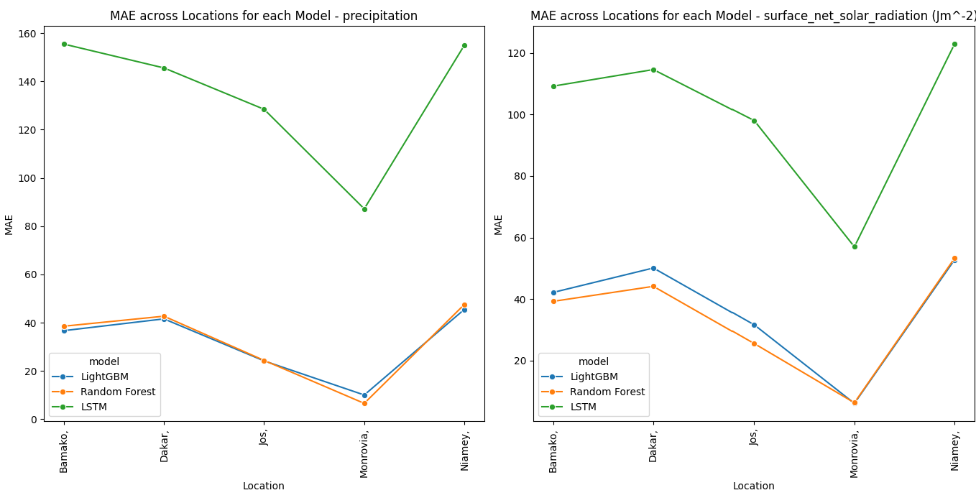

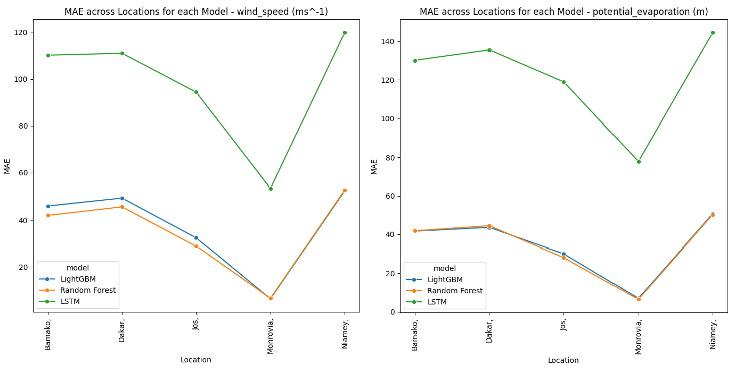
Figure 2. Mean Absolute Error (MAE) and Mean Squared Error (MSE) comparisons across locations for LightGBM, Random Forest, and LSTM models The results, as depicted in the figure depicting MAE and MSE across Locations and the figure 3 showing the box plot, show that LightGBM consistently performed better across most locations, particularly in Niamey (Tropical Savannah) and Bamako (Hot Semi-Arid), regions characterized by relatively stable atmospheric conditions. LightGBM's ability to handle large datasets and efficiently learn from them enabled it to capture the relationships between atmospheric parameters and surface refractivity more effectively. In contrast, Random Forest struggled with the higher variability in data from complex climatic regions, such as Monrovia (Tropical Rainforest), where humidity and temperature
fluctuations are more pronounced.

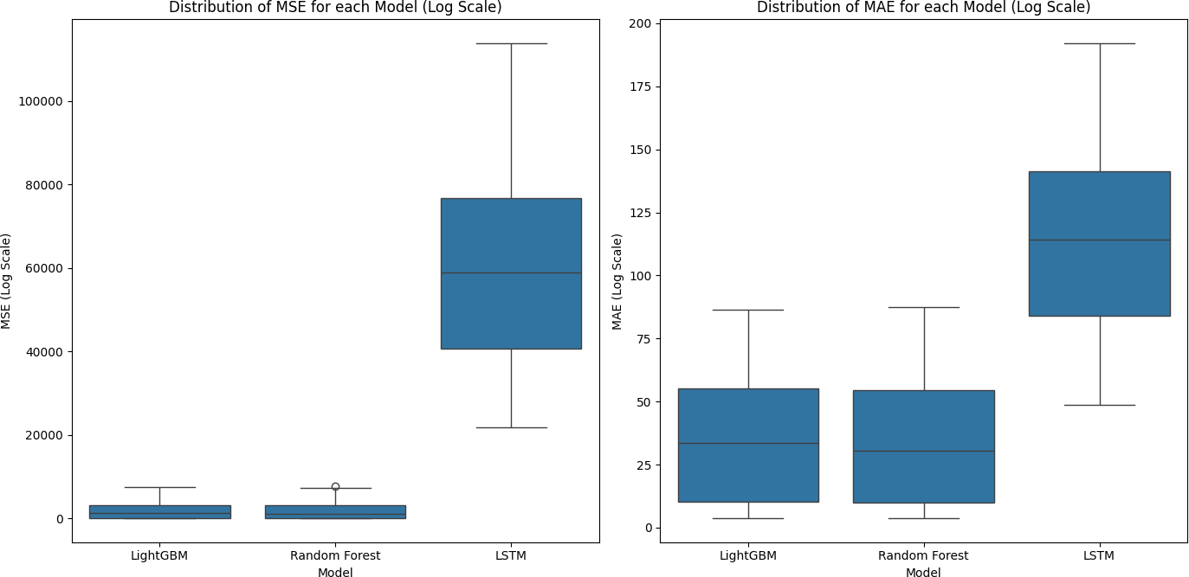

Figure 3. Box plot visualizing the error distributions (MSE and MAE) for LightGBM, Random Forest, and LSTM across different locations
Figure 2 shows the MSE and MAE across locations for each model, with LightGBM consistently outperforming the others in Niamey and Bamako. In contrast, Figure 3 illustrates the box plot for error distributions, where LSTM shows a marked improvement in regions with seasonal variability, such as Monrovia and Dakar. However, LSTM's overall predictive accuracy was slightly lower than LightGBM due to the complexity and variability in training this type of model, particularly in handling non-stationary data without large-scale temporal patterns.
  - Seasonal Variation and Model Response: The MSE and MAE across Months chart in figure 4, highlights significant seasonal variation in model performance, particularly during the rainy season, when atmospheric parameters such as humidity and temperature fluctuate rapidly. During the dry season, when atmospheric conditions are more stable, all models demonstrated improved accuracy, though LightGBM maintained the lowest error rates overall. During the rainy season, LSTM showed improvements, likely due to its

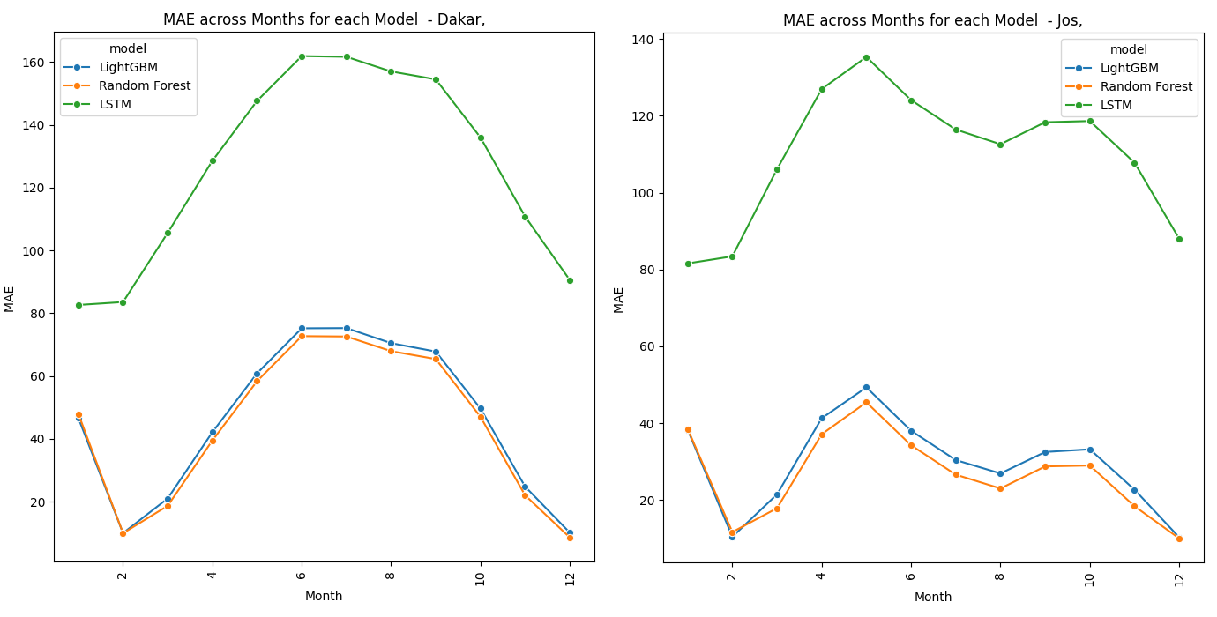
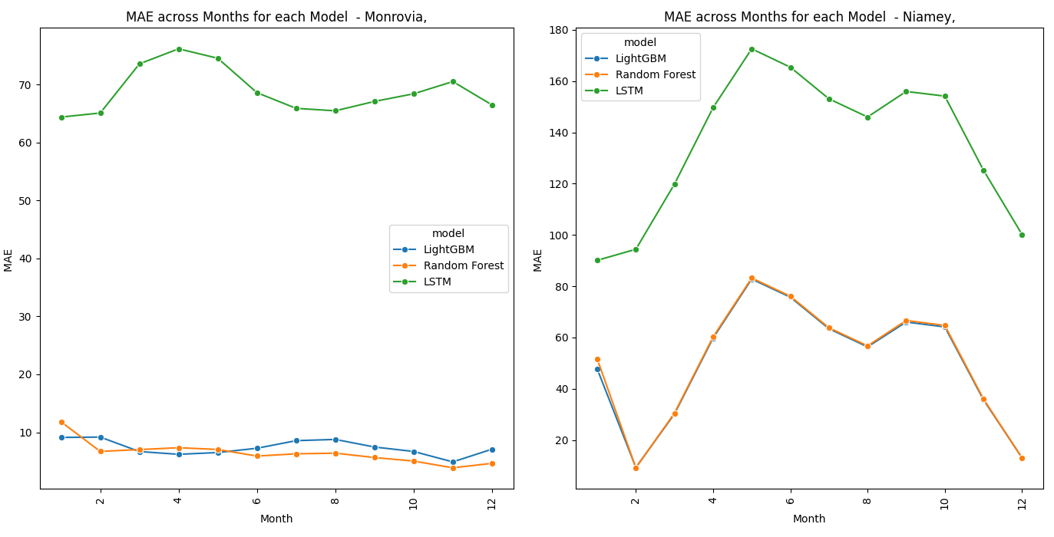
ability to process sequential data and capture short-term temporal dependencies. However, Random Forest exhibited the most significant drop in performance during periods of high variability, likely due to its inherent inability to manage the non-linearities in rapidly changing atmospheric conditions as effectively as LightGBM and LSTM.

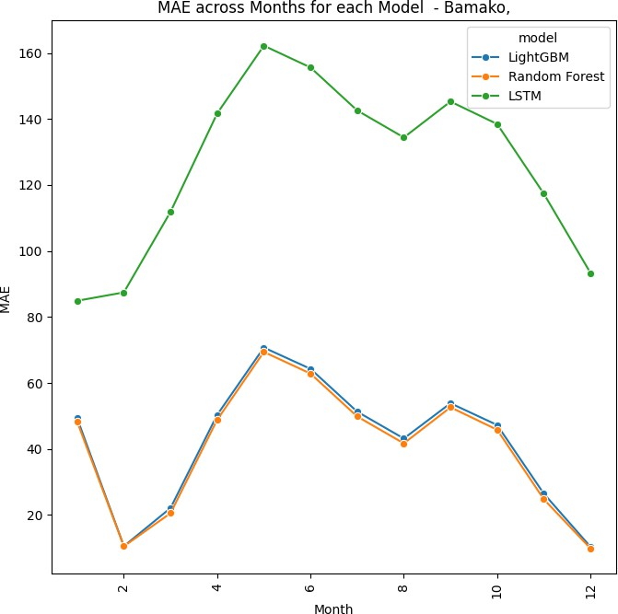

Figure 4. Mean Absolute Error (MAE) comparisons for each location across different months, showing seasonal variation in model performance
  - Importance of Predictors: Figure 5 uses a heatmap to depict the correlation between atmospheric predictors and model outputs. This heatmaps of normalized Mean Squared Error (MSE) and Mean Absolute Error (MAE) reveal the significance of atmospheric predictors in refractivity modeling. Precipitation and potential evaporation emerge as the most impactful variables, particularly for the LSTM model, which exhibits the highest error rates for these predictors. This suggests that LSTM struggles to capture the rapid variability associated with these factors. In contrast, LightGBM and Random Forest models show significantly lower errors (MSE: ~0.02), demonstrating superior performance in managing these parameters. Whereas, when ranking across board as shown in table 2, the atmospheric parameters, wind speed emerges as the most influential or stable predictor, with the lowest average errors, followed closely by surface net solar radiation. Surprisingly, precipitation, despite its high MSE and MAE values in the LSTM model, ranked as the least significant predictor across all models. This outcome likely arises from the high temporal and spatial variability of precipitation, which introduces greater noise into the prediction models.

Precipitation's non-linear relationship with refractivity, combined with rapid changes during wet seasons, can challenge models like LSTM, which depend on sequential patterns. In contrast, more stable predictors, such as wind speed and solar radiation, contribute to better model performance due to their relatively steady and predictable influence on atmospheric refractivity. Potential evaporation ranks third, with moderate MSE and MAE scores, indicating its intermediate role in refractivity changes.
Table 2: Atmospheric Parameter Ranking Table

Atmospheric Parameter | MSE Mean | MAE Mean | MSE Rank | MAE Rank
Windspeed | 17990.018 | 56.738 | 1 | 1
Surface Net Solar Radiation | 18440.322 | 56.855 | 2 | 2
Potential Evaporation | 22744.379 | 63.417 | 3 | 3
Precipitation | 25427.392 | 65.960 | 4 | 4
Overall, Surface net solar radiation and wind speed contribute moderately to model performance. LSTM has higher error rates, indicating difficulty in capturing the temporal influence of these factors, whereas LightGBM and Random Forest maintain low error levels across all predictors.

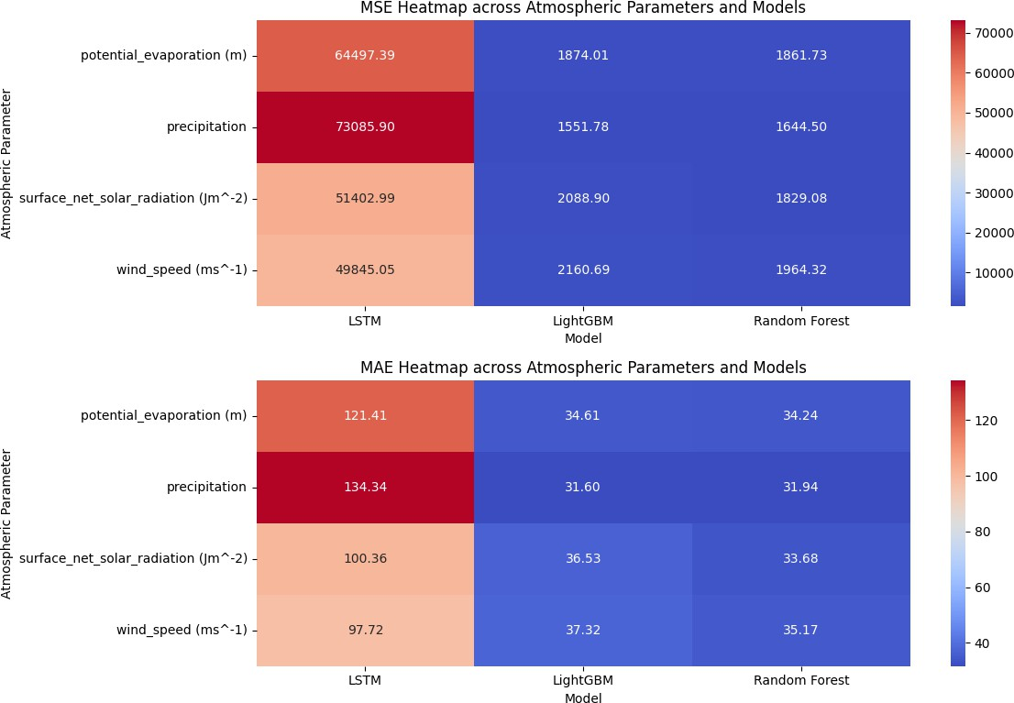

Figure 5. Heatmap illustrating the correlation between atmospheric predictors (e.g., wind speed) and model performance (LightGBM, Random Forest, LSTM)
  - Model Comparison and Implications: The box plot in figure 3 comparing MSE and MAE across models highlights LightGBM’s superior performance in minimizing errors, followed closely by Random Forest, with LSTM trailing behind.
The overall ranking of the models, shown in Table 3, indicates that Random Forest had the lowest MSE and MAE overall, performing particularly well in regions with moderate climatic variability, such as Niamey and Bamako. However, LightGBM emerged as the most reliable model across diverse climatic zones, especially in areas with extreme weather conditions, where its robustness in handling large, complex datasets gave it an edge. This makes LightGBM the more consistent model for broader applications, while Random Forest shows strong performance in more stable conditions. This is likely due to its gradient boosting framework, which excels in handling structured datasets with various

interdependencies between predictors. LSTM performed well in regions and seasons where temporal patterns were more pronounced, suggesting that its sequential architecture may be more appropriate for specific use cases involving highly seasonal or time- dependent refractivity predictions.
Table 3: Model Ranking

Model | MSE Mean | MAE Mean | MSE Rank | MAE Rank
Random Forest | 1824.906 | 33.757 | 1 | 1
LightGBM | 1918.844 | 35.014 | 2 | 2
LSTM | 59707.833 | 113.457 | 3 | 3
  - Implications for Radio Refractivity Prediction and Wireless Communication Systems: This study’s findings have important implications for enhancing radio refractivity predictions, particularly in West Africa’s diverse climatic zones. Accurate refractivity predictions are crucial for optimizing wireless communication systems, minimizing signal degradation, and improving network reliability.
    - Tropical and Coastal Zones: The high variability of atmospheric conditions, particularly due to humidity and oceanic influences, suggests that more complex models or additional predictors may be needed to accurately capture these fluctuations. LightGBM performs well, but enhancements through sequential data or additional humidity-related predictors could improve accuracy.
    - Highland and Semi-Arid Zones: Models that incorporate sequential data, like LSTM, may be better suited for highland and semi-arid zones, where temporal variations in wind speed and solar radiation are key refractivity drivers. While LSTM

underperformed overall, its potential for handling time-dependent data makes it valuable in these specific zones.
    - Practical Implications:
LightGBM’s superior performance highlights its potential for improving network reliability and reducing signal degradation across West Africa. By providing more accurate refractivity predictions, telecommunication companies can better anticipate signal disruptions during extreme weather conditions, particularly in coastal regions like Dakar where oceanic influences and high humidity impact signal strength. Furthermore, the deployment of machine learning models like LightGBM could reduce operational costs by enabling more efficient network designs that account for atmospheric variability, leading to enhanced service quality in rural and high-demand urban areas, making it a viable model for deployment in communication systems across the region.

CONCLUSION
This study demonstrates the potential of machine learning models for predicting surface refractivity in West Africa. Among the models tested, LightGBM consistently delivered the most accurate predictions, particularly in arid and semi-arid regions. LSTM showed promise in areas with high seasonal variability, while Random Forest performed well but lagged behind in overall predictive accuracy.
Key findings indicate that:

- LightGBM is the most reliable model for surface refractivity predictions, especially in less extreme climatic conditions.
- LSTM has potential for regions with significant seasonal changes due to its ability to handle sequential data.

- Random Forest showed strong performance but exhibited a higher tendency toward overfitting.
These results suggest promising future directions for enhancing refractivity predictions. Potential improvements could include integrating additional atmospheric predictors, real- time data, and using hybrid or ensemble models that combine the strengths of LightGBM and LSTM for regions with complex climate patterns. Fine-tuning model hyperparameters for specific climatic zones could further improve accuracy.
In summary, LightGBM stands out as the most promising model for refractivity prediction in West Africa, offering significant improvements over traditional methods.
- LIMITATIONS

Several constraints should be acknowledged in this study. The ERA5 reanalysis data has a spatial resolution of approximately 31 km, potentially missing localized atmospheric phenomena that affect refractivity, particularly in coastal and mountainous regions like Jos. Our models were developed specifically for West African climatic conditions and may require retraining for other regions with different atmospheric dynamics and seasonal patterns.The ERA5 dataset carries inherent biases from sparse observational networks, especially in remote areas of our study region. Additionally, using daily averaged data may not capture short-term atmospheric variations crucial for real-time applications, such as sudden weather events that can significantly impact radio propagation.
- FUTURE WORK

Future research will focus on expanding model applications to other regions, particularly East Africa and similar climate zones, to assess generalizability and determine regional customization requirements. Integration with real-time weather station data represents a priority for improving prediction accuracy during rapidly changing atmospheric conditions. We plan to develop hybrid ensemble approaches combining LightGBM and LSTM strengths, potentially switching between models based on atmospheric stability conditions. Collaboration with telecommunications operators across Africa will enable operational testing and model refinement in real-world environments, ultimately working toward a continental-scale prediction system for practical engineering applications.

Disclaimer (Artificial intelligence)
Option 1:
Author(s) hereby declare that NO generative AI technologies such as Large Language Models (ChatGPT, COPILOT, etc.) and text-to-image generators have been used during the writing or editing of this manuscript.
Option 2:
Author(s) hereby declare that generative AI technologies such as Large Language Models, etc. have been used during the writing or editing of manuscripts. This explanation will include the name, version, model, and source of the generative AI technology and as well as all input prompts provided to the generative AI technology
Details of the AI usage are given below:
1.
2.
3.

REFERENCES
- Bergstra, J., Bardenet, R., Bengio, Y., & Kégl, B. (2011). Algorithms for hyper-parameter optimization. Advances in Neural Information Processing Systems, 24, 2546-2554.
- Meenal, R. M. P. A., Michael, P. A., Pamela, D., & Rajasekaran, E. (2021). Weather prediction using random forest machine learning model. Indonesian Journal of Electrical Engineering and Computer Science, 22(2), 1208-1215.
- Breiman, L. (2001). Random forests. Machine Learning, 45(1), 5-32. https://doi.org/10.1023/A:1010933404324
- Dee, D. P., Uppala, S. M., Simmons, A. J., et al. (2011). The ERA-Interim reanalysis: Configuration and performance of the data assimilation system. Quarterly Journal of the Royal Meteorological Society, 137(656), 553-597. https://doi.org/10.1002/qj.828
- ECMWF. (2020). ERA5 reanalysis dataset. European Centre for Medium-Range Weather Forecasts. https://www.ecmwf.int/en/forecasts/datasets/reanalysis- datasets/era5
- Pan, S., Pan, N., Tian, H., Friedlingstein, P., Sitch, S., Shi, H., ... & Running, S. W. (2020). Evaluation of global terrestrial evapotranspiration using state-of-the-art approaches in remote sensing, machine learning and land surface modeling. Hydrology and earth system sciences, 24(3), 1485-1509.
- Livieratos, S. N., & Cottis, P. G. (2019). Rain attenuation along terrestrial millimeter wave links: A new prediction method based on supervised machine learning. IEEE Access, 7, 138745-138756.
- Hochreiter, S., & Schmidhuber, J. (1997). Long short-term memory. Neural Computation, 9(8), 1735-1780. https://doi.org/10.1162/neco.1997.9.8.1735

- Haji-Aghajany, S., Rohm, W., Kryza, M., & Smolak, K. (2024). Machine learning-based wet refractivity prediction through GNSS troposphere tomography for ensemble troposphere conditions forecasting. IEEE Transactions on Geoscience and Remote Sensing, 62, 1-18.
- Ke, G., Meng, Q., Finley, T., Wang, T., Chen, W., Ma, W., Ye, Q., & Liu, T. Y. (2017).
- LightGBM: A highly efficient gradient boosting decision tree. Advances in Neural Information Processing Systems, 30, 3146-3154. https://papers.nips.cc/paper/6907- lightgbm-a-highly-efficient-gradient-boosting-decision-tree
- Liaw, A., & Wiener, M. (2002). Classification and regression by Random Forest. R News, 2(3), 18-22. https://CRAN.R-project.org/doc/Rnews/
- International Journal of Forecasting, 36(3), 1261-1270. https://doi.org/10.1016/j.ijforecast.2019.11.002
- Kumar, A., Ramsankaran, R. A. A. J., Brocca, L., & Munoz-Arriola, F. (2019). A machine learning approach for improving near-real-time satellite-based rainfall estimates by integrating soil moisture. Remote Sensing, 11(19), 2221.
- Wilby, R. L., & Dawson, C. W. (2013). The statistical downscaling model: Insights from one decade of application. International Journal of Climatology, 33(7), 1707-1719. https://doi.org/10.1002/joc.3544

APPENDIX
The following appendix provides detailed comparisons of model performance and predictions, supplementing the findings discussed in the main text. These results offer further insights into model accuracy across different climatic zones and over time.

Appendix Figure A1: Model Performance with respect to each predictor (a) LightGBM (b) RandomForest (c) LSTM

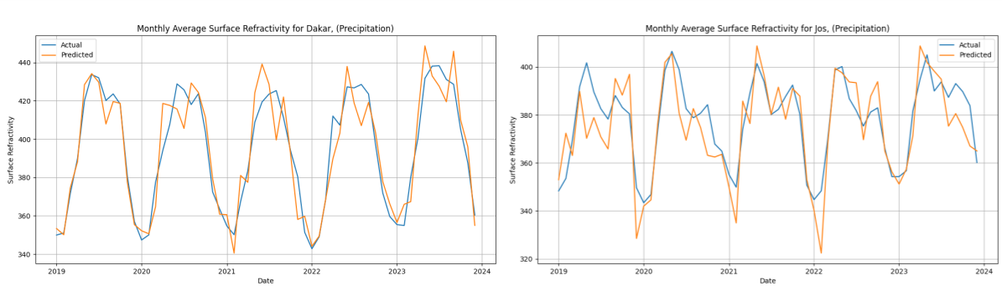
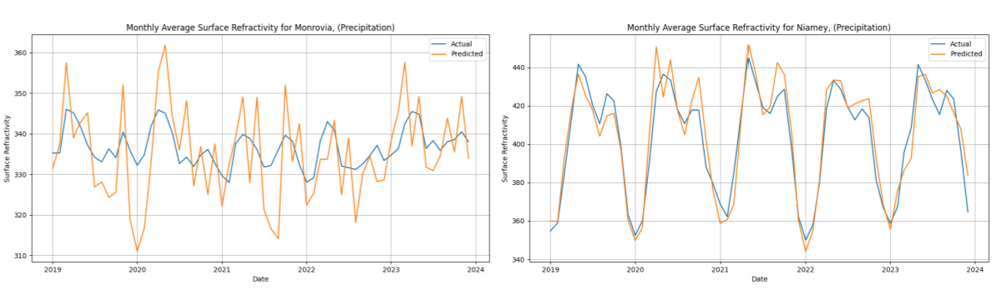

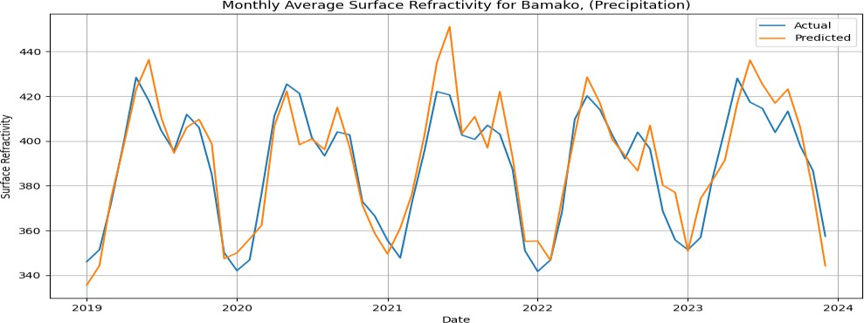
Appendix Figure A2: LightGBM Prediction vs Actual values Appendix Table A1: Table Showing LightGBM Prediction vs Actual values
YEAR | SURFACE  REFRACTIVITY | PREDICTED  SURF | LOCATION | ZONE
2019 | 337.8905 | 335.7131 | Monrovia, | Tropical Rainforest
2020 | 336.8705 | 336.1424 | Monrovia, | Tropical Rainforest
2021 | 335.0587 | 333.2645 | Monrovia, | Tropical Rainforest
2022 | 334.3544 | 330.2382 | Monrovia, | Tropical Rainforest
2023 | 339.1473 | 340.562 | Monrovia, | Tropical Rainforest
2019 | 402.6694 | 400.3903 | Niamey, | Tropical Savannah
2020 | 402.7075 | 407.3609 | Niamey, | Tropical Savannah

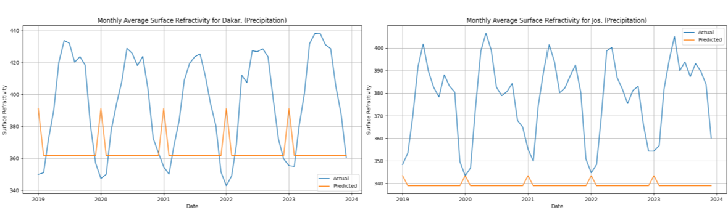
2021 | 404.9511 | 405.8499 | Niamey, | Tropical Savannah
2022 | 398.5185 | 402.0268 | Niamey, | Tropical Savannah
2023 | 404.9335 | 405.9945 | Niamey, | Tropical Savannah
2019 | 389.2038 | 390.0405 | Bamako, | Hot Semi-Arid
2020 | 388.7995 | 386.3005 | Bamako, | Hot Semi-Arid
2021 | 388.9961 | 396.5275 | Bamako, | Hot Semi-Arid
2022 | 385.1957 | 389.4236 | Bamako, | Hot Semi-Arid
2023 | 393.0877 | 395.4774 | Bamako, | Hot Semi-Arid
2019 | 395.9212 | 395.053 | Dakar, | Coastal
2020 | 392.829 | 394.2528 | Dakar, | Coastal
2021 | 389.4156 | 390.6169 | Dakar, | Coastal
2022 | 393.081 | 390.6349 | Dakar, | Coastal
2023 | 401.2491 | 403.2687 | Dakar, | Coastal
2019 | 376.4732 | 372.5792 | Jos, | Highland
2020 | 377.3313 | 372.3295 | Jos, | Highland
2021 | 378.2501 | 378.1415 | Jos, | Highland
2022 | 374.3321 | 374.2502 | Jos, | Highland
2023 | 382.6947 | 378.9572 | Jos, | Highland

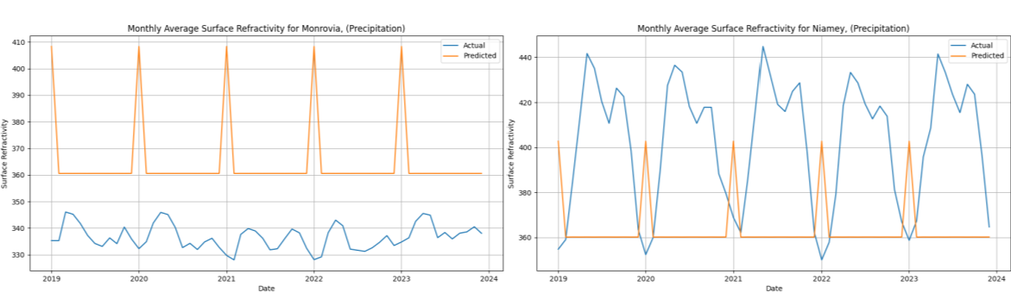

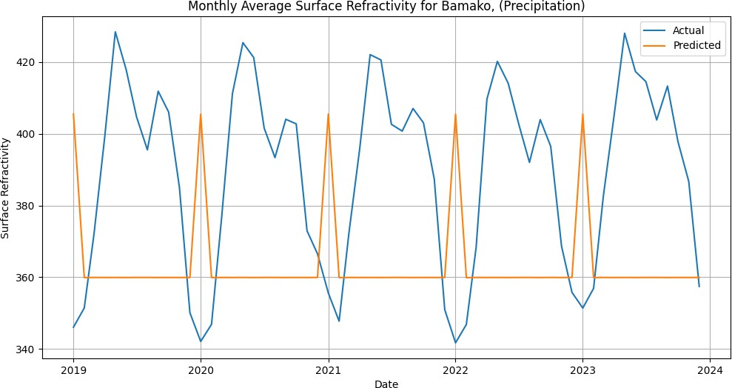

Appendix Figure A3: Random Forest Prediction vs Actual values

Appendix Table A2: Table Showing RandomForest Prediction vs Actual values

YEAR | SURFACE  REFRACTIVITY | PREDICTED  SURF | LOCATION | ZONE
2019 | 337.8905 | 364.6313 | Monrovia, | Tropical Rainforest
2020 | 336.8705 | 364.6207 | Monrovia, | Tropical Rainforest

2021 | 335.0587 | 364.6313 | Monrovia, | Tropical Rainforest
2022 | 334.3544 | 364.6313 | Monrovia, | Tropical Rainforest
2023 | 339.1473 | 364.6313 | Monrovia, | Tropical Rainforest
2019 | 402.6694 | 363.8152 | Niamey, | Tropical Savannah
2020 | 402.7075 | 363.8066 | Niamey, | Tropical Savannah
2021 | 404.9511 | 363.8152 | Niamey, | Tropical Savannah
2022 | 398.5185 | 363.8152 | Niamey, | Tropical Savannah
2023 | 404.9335 | 363.8152 | Niamey, | Tropical Savannah
2019 | 389.2038 | 363.791 | Bamako, | Hot Semi-Arid
2020 | 388.7995 | 363.7817 | Bamako, | Hot Semi-Arid
2021 | 388.9961 | 363.791 | Bamako, | Hot Semi-Arid
2022 | 385.1957 | 363.791 | Bamako, | Hot Semi-Arid
2023 | 393.0877 | 363.791 | Bamako, | Hot Semi-Arid
2019 | 395.9212 | 364.1814 | Dakar, | Coastal
2020 | 392.829 | 364.176 | Dakar, | Coastal
2021 | 389.4156 | 364.1814 | Dakar, | Coastal
2022 | 393.081 | 364.1814 | Dakar, | Coastal
2023 | 401.2491 | 364.1814 | Dakar, | Coastal
2019 | 376.4732 | 339.2992 | Jos, | Highland
2020 | 377.3313 | 339.2983 | Jos, | Highland
2021 | 378.2501 | 339.2992 | Jos, | Highland
2022 | 374.3321 | 339.2992 | Jos, | Highland
2023 | 382.6947 | 339.2992 | Jos, | Highland

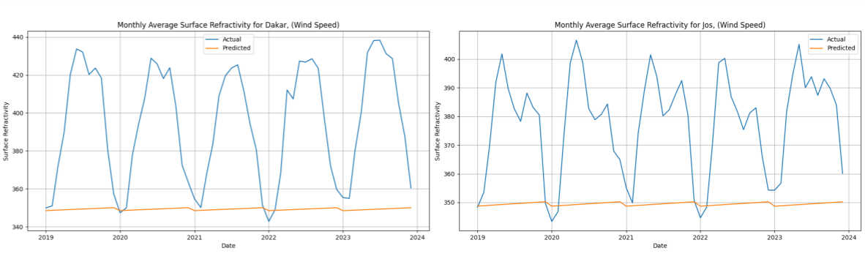

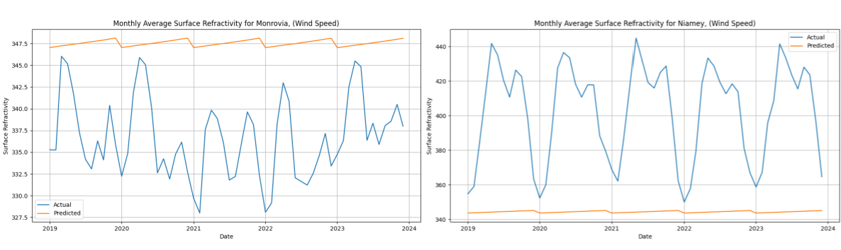

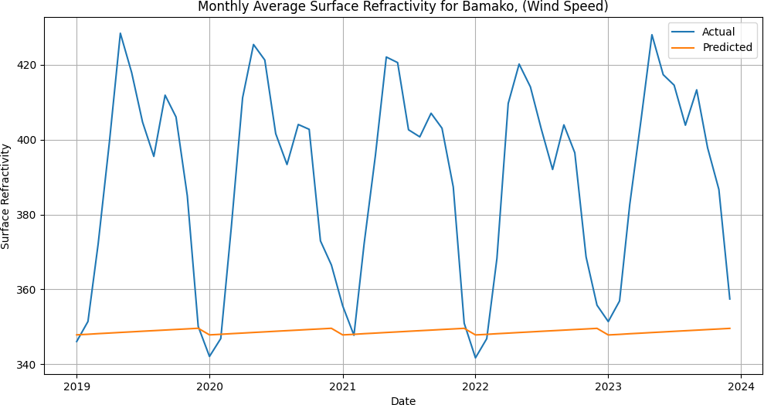

Appendix Figure A4: LSTM Prediction vs Actual values

Appendix Table A3: Table Showing LSTM Prediction vs Actual values

YEAR | SURFACE  REFRACTIVITY | PREDICTED  SURF | LOCATION | ZONE
2019 | 337.8905 | 347.5713 | Monrovia, | Tropical Rainforest
2020 | 336.8705 | 347.5685 | Monrovia, | Tropical Rainforest

2021 | 335.0587 | 347.5628 | Monrovia, | Tropical Rainforest
2022 | 334.3544 | 347.5555 | Monrovia, | Tropical Rainforest
2023 | 339.1473 | 347.5492 | Monrovia, | Tropical Rainforest
2019 | 402.6694 | 344.4465 | Niamey, | Tropical Savannah
2020 | 402.7075 | 344.4373 | Niamey, | Tropical Savannah
2021 | 404.9511 | 344.4315 | Niamey, | Tropical Savannah
2022 | 398.5185 | 344.4238 | Niamey, | Tropical Savannah
2023 | 404.9335 | 344.4161 | Niamey, | Tropical Savannah
2019 | 389.2038 | 348.7311 | Bamako, | Hot Semi-Arid
2020 | 388.7995 | 348.7225 | Bamako, | Hot Semi-Arid
2021 | 388.9961 | 348.7174 | Bamako, | Hot Semi-Arid
2022 | 385.1957 | 348.7104 | Bamako, | Hot Semi-Arid
2023 | 393.0877 | 348.7036 | Bamako, | Hot Semi-Arid
2019 | 395.9212 | 349.2865 | Dakar, | Coastal
2020 | 392.829 | 349.2761 | Dakar, | Coastal
2021 | 389.4156 | 349.2694 | Dakar, | Coastal
2022 | 393.081 | 349.2608 | Dakar, | Coastal
2023 | 401.2491 | 349.2522 | Dakar, | Coastal
2019 | 376.4732 | 349.4831 | Jos, | Highland
2020 | 377.3313 | 349.4727 | Jos, | Highland
2021 | 378.2501 | 349.4655 | Jos, | Highland
2022 | 374.3321 | 349.4564 | Jos, | Highland
2023 | 382.6947 | 349.4475 | Jos, | Highland

