**Ionospheric electron density perturbations during geomagnetic storm period February 25, 2014 to March 3, 2014 over Koudougou station in the solar cycle 24**

**ABSTRACT**

In this study, we analyzed electron density disturbances in the ionosphere during the period from February 25, 2014, to March 3, 2014. This period is in the solar maximum phase of Solar Cycle 24. Solar flares are classified using the letters A, B, C, M and X depending on their X-ray peak flux in the wavelength range from 0.1 to 0.8 nm. X class flares are major events with very intense luminosity and a large amount of X-ray flux in the order of . M class flares are less bright with X-flux greater than; C class flares are less bright than M class with X-flux greater than.During this time, a total of 77 solar flares occurred, among them 61 were of class C, 6 of class M, and one belongs to class X. The results show that the class X solar flare triggered a coronal mass ejection (CME). In order to interpret these events, we used interplanetary solar wind data and geomagnetic indices. These Satellite data and SYM-H (Symmetric-Horizontal index) indices, which at times reached -100 nT and beyond, were observed and analyzed. Significant Bz values found were 20 nT, -20 nT and -50 nT. These parameters are available at [www.omniweb.gsfc.nasa.gov/form/omni_in.html](http://www.omniweb.gsfc.nasa.gov/form/omni_in.html). Furthermore, this study strongly suggests that solar flares and coronal mass ejections have a major impact on electron density and Total Electron Content (TEC) in the ionosphere and influence the origin of geomagnetic storms. TEC and RINEX data were obtained from the Koudougou Ionosonde station (Burkina Faso) during solar cycle 24. Specifically, the coronal mass ejections (CME) of February 25, 2014, had a significant geo-effective impact between February 27 and 28, leading to a geomagnetic storm whose intensity ranged from moderate to strong, causing ionospheric disturbances. The geomagnetic storm significantly disrupted the ionosphere, resulting in an increase in TEC and disturbances on Global Positioning System (GPS) and High Frequency (HF) radio signals.

**Keywords:** solar flares, solar cycle, coronal mass ejections, ionosphere and electron density, Bz, SYM-H, and TEC.

1. **INTRODUCTION**

The Sun, the star at the heart of our solar system, is an immense sphere of plasma in constant activity. Its complex magnetic field generates various energetic phenomena that influence Earth's space environment. Among these phenomena, three play a key role in the interaction between the Sun and Earth: solar wind, solar flares, and coronal mass ejections. These phenomena particularly interact with the ionosphere, a layer of the atmosphere located between 60 and 1,000 km in altitude, rich in ionized particles. It was discovered in 1901 by G. Marconi during a transatlantic radio transmission (Younas, et al., 2021). These solar manifestations are potential sources of geomagnetic storms, which are disturbances in Earth's magnetosphere resulting from solar activity (Sawadogo, et al., 2022). The solar wind is a continuous flow of charged particles (electrons, protons) emitted by the solar corona (Al-Feadh and Al-Ramdhan, 2019; Sawadogo, et al., 2019). It shapes the heliosphere, influences polar auroras, and can disrupt terrestrial technological systems when it intensifies. Additionally, solar flares are sudden explosions that release a large amount of electromagnetic energy. They are classified according to their intensity (A, B, C, M, and X classes) (Grodji, et al., 2021; Jiang, et al., 2024) and can impact radio communications and orbiting satellites. Solar flares are classified according to their X-ray intensity measured in the 1 to 8 Ångström (0.1 to 0.8 nm) wavelength band by satellites such as GOES (Geostationary Operational Environmental Satellite). Thus, Class A (Intensity < 10⁻⁷ W/m²); Class B (Intensity from 10⁻⁷ to 10⁻⁶ W/m²); Class C (Intensity from 10⁻⁶ to 10⁻⁵ W/m²); Class M (Intensity from 10⁻⁵ to 10⁻⁴ W/m²) and Class X (Intensity > 10⁻⁴ W/m²). Moreover, coronal mass ejections are massive expulsions of plasma and magnetic fields from the solar corona (Wang and Sheeley, Jr., 2015). When a CME is directed toward Earth, it can cause geomagnetic storms, disrupting power grids and GPS systems. It can also generate polar auroras at mid and high latitudes as well as disturbances in HF radio communications. Solar flares can influence the Bz component of the magnetic field through several mechanisms: solar-wind interaction, modifications of electric fields, and geomagnetic storms. When a solar flare occurs, it releases a burst of energy and charged particles into space. The interplanetary magnetic field (IMF) is the solar magnetic field carried outward by the solar wind into the heliosphere. It is driven by the highly conductive plasma of the solar wind and plays an important role in geomagnetic activity (Dungey, 1961; Gonzalez and Tsurutani, 1987; Zerbo, et al., 2013; Koala, et al., 2022).This solar wind can interact with Earth's magnetic field, particularly affecting the Bz component of the interplanetary magnetic field. A southward-directed Bz (negative values) can enhance geomagnetic activity by allowing more solar wind particles to penetrate the magnetosphere (Zhang, et al., 2004;Chakrabarty, et al., 2013 ). The SYM-H index is a geomagnetic index that reflects the intensity of magnetic storms. It is crucial for assessing overall geomagnetic activity during solar events (Younas, et al., 2021). When the lower limit of SYM-H reaches -46 nT, it can improve storm detection, highlighting its importance in understanding geomagnetic activity (Davoudifar, et al., 2021).

The objective of this study is to determine the effect of solar flares accompanied by coronal mass ejections on the ionosphere. Thus, we selected data from February 25 to March 4, 2014, on solar flares that occurred during this period, which belongs to the solar maximum of Solar Cycle 24. We will examine solar wind parameters such as solar wind speed, proton density, dynamic pressure, the SYM-H geomagnetic index, and the Bz component of the interplanetary magnetic field. In the following sections, we will present the data and methods used for analysis. Then, we will discuss the obtained results. Finally, the discussion and conclusion will be addressed.

1. **MATERIALS AND METHODS**

The geomagnetic field is measured using various parameters, such as the aa, Ap, and Dst indices, which are used to monitor and assess geomagnetic activity(Kilcik, et al., 2011).In this study, we used the SYM-H index, which is an important indicator for researchers studying the relationship between magnetic activity and ionospheric phenomena. It provides information on how disturbances can influence plasma drifts and the generation of irregularities (Bhattacharyya et al., 2002). Another parameter we used is the Bz component of the interplanetary magnetic field. According to studies by Dungey (1961) and Gonzalez et al. (1994), strong magnetic reconnection occurs when Bz is oriented southward, creating an opening in the magnetosphere that allows solar wind particles to penetrate. Additionally, proton density was also considered, as it reflects the concentration of particles in the solar wind flow. The density of slow solar wind is generally higher than that of fast solar wind, which leads to particle acceleration in fast wind streams ( Sanchez‐Diaz, et al., 2016; Réville, et al., 2020; Griton, et al., 2021). Slow solar wind indicates higher density (typically 5-10 protons/cm³) whereas fast solar wind indicates lower density (typically <5 protons/cm³). Furthermore, solar wind dynamic pressure was also one of the parameters used. High dynamic pressure can compress the Earth's magnetosphere, increasing the risk of geomagnetic storms, especially when the solar wind is fast. Dynamic pressure is calculated based on the density and velocity of the solar wind. It represents the force exerted by the moving solar wind and is measured in nanopascals (nPa). Solar wind speed represents how quickly charged particles are ejected from the Sun into interplanetary space. It is generally measured in kilometers per second (km/s) and is one of the parameters we studied. Solar wind speed varies depending on solar activity and the source on the Sun. On average, it ranges from 300 to 400 km/s during periods of low activity (slow solar wind) and can reach 700 km/s or more during solar eruptions and in fast solar wind from coronal holes. Solar wind speed directly influences the pressure exerted on Earth's magnetosphere, determining the geoeffectiveness of solar disturbances. These parameters are available at [www.omniweb.gsfc.nasa.gov/form/omni_in.html](http://WWW.omniweb.gsfc.nasa.gov/form/omni_in.html). Another key parameter in our study is the Total Electron Content (TEC). TEC quantifies the total number of electrons in a vertical column between a GPS satellite and a receiver, expressed in TEC units (TECU), where 1 TECU is equal to electrons per square meter. The ionospheric Total Electron Content (TEC) is a widely used parameter in studies of Earth's near-space plasma environment. The scientific use of TEC began early in the artificial satellite era, and among its many contributions are fundamental discoveries on how the ionosphere responds to geomagnetic storms (Mendillo, 2006). A strong ionospheric disturbance is characterized by abnormal variations in TEC. Typical TEC disturbance thresholds are:

Normal TEC is from 5 to 20 TECU (average values depending on region and local time), Low to moderate disturbance from 20 to 30 TECU, moderate disturbance from 30 to 50 TECU; Strong disturbance superior to 50 (>50 TECU: sudden increase or decrease in TEC) and Severe ionospheric storms increases superior to 100 (>100 TECU) or drastic decreases may indicate significant ionospheric disturbances. TEC and RINEX data were obtained from the Koudougou Ionosonde station (Burkina Faso) during solar cycle 24. The event of February 25, 2014, was selected from the CME Flare Catalog via <https://cdaw.gsfc.nasa.gov/CME_list/>, which provides information on solar flares associated with halo coronal mass ejections (CMEs).The table below presents the data for the event of February 25, 2014.

***Table 1. Event of February 25, 2014, from the CME Halo Flare Catalog***

|  |  |  |  |  |  |  |  |  |
| --- | --- | --- | --- | --- | --- | --- | --- | --- |
| First C2 Appearance (UT) | | Apparent (km/s) | Space (km/s) | Acceleration (m/s2) | MPA [deg] | Source location | X-ray importance | Flare onset |
| [25/02/2014](https://cdaw.gsfc.nasa.gov/movie/make_javamovie.php?stime=20140224_2338&etime=20140225_0310&img1=lasc2rdf&title=20140225.012550.p073g;V=2147km/s) | [01:25:50](http://cdaw.gsfc.nasa.gov/CME_list/UNIVERSAL/2014_02/yht/20140225.012550.w360h.v2147.p073g.yht) | [2147](http://cdaw.gsfc.nasa.gov/CME_list/UNIVERSAL/2014_02/htpng/20140225.012550.p073g.htp.html) | 2153 | -158.1 | 73 | S12E82 | X4.9 | 00:39 |

In this table we have firstly, CME Appearance (First C2 Appearance), where the date and time are recorded (Date: 25/02/2014 and Time: 01:25:50 UT). These data indicate the moment when the CME was first detected by the SOHO/LASCO C2 coronagraph. Secondly, CME Speed, which provides information on both the apparent and spatial (real) velocity (Apparent speed: 2147 km/s and Spatial (real) speed: 2153 km/s). These values show that the CME was extremely fast. A speed greater than 1000 km/s is typical of geoeffective events that can impact Earth's magnetosphere (Nigam, et al., 2017). Such a high speed can indicate a shock-type CME, which may cause significant ionospheric and geomagnetic disturbances. Then, CME Acceleration, which represents the acceleration value (Acceleration: -158.1 m/s²). This negative acceleration value means that the CME is slowing down as it propagates through interplanetary space. This deceleration is due to the resistance of the ambient solar wind, which is common for high-speed ejections (Jadeja, et al., 2008). Moreover, CME Position which provides the values of the maximum position angle (MPA) and the solar flare source location (MPA (Maximum Position Angle): 73°). Furthermore, Flare Source Location: S12E82, meaning 12° South and 82° East on the Sun.

These data show that the MPA falls between 60° and 120°, characteristic of a moderate-sized CME. The flare source is near the eastern limb of the Sun, meaning the CME is less likely to be directly Earth-directed (Gopalswamy, et al., 2000; Uwamahoro, et al., 2012). An event on the eastern limb of the Sun is often observed at a tangential angle, which can affect estimates of its speed and potential impact on Earth. We also have the "X-ray Importance" section provides information on the intensity of the X-ray flare (Class: X4.9). This indicates that the solar flare belongs to class X, which signifies an extremely intense flare (Grodji, et al., 2021).  
The X4.9 flare is a major eruption, likely to have caused HF radio disruptions, communication blackouts, and significant ionospheric ionization on Earth. Lastly, the "Flare Onset" section records the start time of the flare (00:39 UT, Universal Time). This time corresponds to the beginning of the X-ray flare associated with this CME. Generally, an intense X-class flare can precede a fast CME (Diakite, et al., 2024), and the data confirm that this is the case here.  
This fast CME, associated with an X4.9 flare, represents a major solar event of Solar Cycle 24. We also analyzed other solar flares that occurred between February 25 and March 4, 2014, using the data from https://www.st4aste-lab nagoya-u.ac.jp hinode_flare for a better interpretation of the results. Since the impact of a CME on Earth's atmosphere can be felt 1 to 5 days after its ejection, depending on its speed (Gopalswamy, et al., 2000, 2007; Shi, et al., 2015), we examined this period closely. Additionally, we used [www.solarmonitor.org](https://www.solarmonitor.org/), which provides images of the solar corona and in situ measurements of the solar wind, to analyze the solar corona's behavior between February 25 and March 4, 2014, in order to describe solar wind characteristics during this period.

1. **RESULTS AND DISCUSSION**

Every solar cycle consists of four phases: solar minimum, ascending phase, solar maximum, and descending phase(Krainev, 2004; Sawadogo, et al., 2024). The event of February 25, 2014, occurred during the solar maximum of solar Cycle 24. Table 1 provides information on the solar flare of February 25, 2014, accompanied by a coronal mass ejection . The potential impact of this event on the ionosphere is illustrated in Figure 1 as follows:

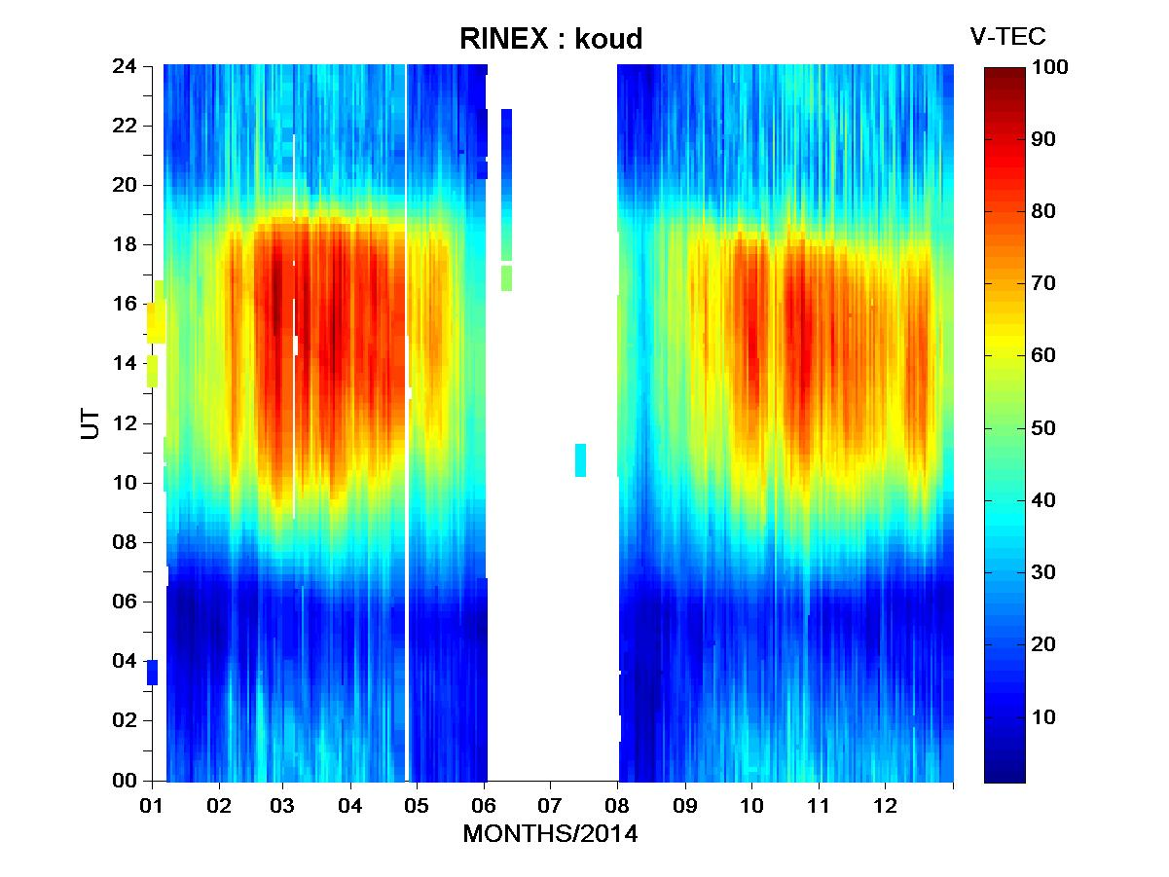

***Figure 1: RINEX Data from Koudougou (Burkina Faso) at the Solar Maximum of solar Cycle 24***

This figure represents a variation map of the Vertical Total Electron Content (V-TEC) as a function of Universal Time (UT) and the months of the year 2014 at the Koudougou station in Burkina Faso. The color scale on the right of Figure 1 indicates V-TEC values in Total Electron Content Units (TECU). The dark red to yellow indicates high V-TEC concentration (~70-100 TECU) whereas light blue to dark blue indicate low V-TEC concentration (~0-30 TECU). Additionally, two distinct periods show particularly high V-TEC values, which correspond approximately to the March-April and September-October equinoxes. During these periods, maximum V-TEC values occur between 12:00 and 20:00 UT. At night (around 00:00-06:00 UT), V-TEC values are lower (blue), which is consistent with the decrease in ionization after sunset. Since 2014 corresponds to the solar maximum phase of solar Cycle 24, it is characterized by increased ionospheric activity. The high daytime V-TEC values result from the increased ionization of the ionosphere due to solar radiation. The V-TEC maxima observed at the equinoxes are consistent with the seasonal effect of the ionosphere.  
In general, TEC is higher during equinoxes than solstices, as the alignment of Earth's magnetic field with the Sun allows for more efficient ionospheric heating. Discontinuities or white areas in the figure are due to missing data. Thus, Figure 1 highlights the dynamics of V-TEC in 2014, showing seasonal variations and daily fluctuations linked to the solar cycle and ionospheric conditions. The strong variability between 12:00 and 20:00 UT reflects maximum ionization due to solar exposure. High ionospheric activity is represented by the dark red and yellow areas, corresponding to high V-TEC values (~70-100 TECU). March 2014 is the month with the highest ionospheric activity. Thus, the maximum V-TEC intensity occurs between March 2 and March 5, with a strong concentration of dark red between 12:00 and 20:00 UT. Another significant increase is observed around March 15-18. Then, another period of high activity is visible in October-November 2014, but March remains the most pronounced. In fact, ionospheric activity is generally stronger during the March and September equinoxes, as solar irradiation is more intense and evenly distributed between hemispheres. This promotes increased ionization of the ionosphere, explaining why March exhibits high V-TEC values.

***Figure 2: TEC Evolution at the End of February***

Figure 2, illustrates the variation of Total Electron Content (TEC) over several days before and after the solar eruption (from February 23 to February 28), as a function of the hours of the day. The TEC follows a typical diurnal pattern, with a gradual increase starting at 06:00 UT. We have a peak between 12:00 and 15:00 UT and a decline in the evening from 18:00 UT onward. The minimum values are recorded between 00:00 and 06:00 UT (~20-40 TECU), while the maximum values range between 80 and 100 TECU around midday to 15:00 UT.

On February 28, 2014 (green curve), an anomaly is observed, with significantly higher TEC values compared to the other days. This day stands out, showing that a higher TEC starting as early as 08:00 UT and a peak exceeding 100 TECU, unlike the other days that exhibit slight fluctuations (~80 TECU on average). This TEC peak is linked to the maximum intensity of solar radiation and the solar eruption accompanied by coronal mass ejections that occurred during this period, directly affecting atmospheric ionization.

***Figure 3: TEC Evolution in Early March***

Figure 3, illustrates the variation of Total Electron Content (TEC) over several days before and after the solar eruption (March 1 to March 4, 2014), as a function of the hours of the day.

The TEC varies throughout the day, showing that a gradual increase in the morning, a peak between 12:00 and 15:00 UT and a decline in the evening. Minimum values are observed between midnight and 06:00 UT (~20-40 TECU), while maximum values reach approximately 100 TECU around midday. On March 1, 2014 (blue curve), the highest TEC values are recorded, especially between 10:00 and 16:00 UT. The following days show slightly lower values compared to March 1. Analysis of TEC variations from February 25 to March 4, 2014 show that during February 23-27 and March 1-4, the TEC follows a typical daily pattern, with a morning increase, a peak between 12:00 and 15:00 UT, and an evening decrease. The maximum values generally range between 80 and 100 TECU. On February 28, 2014, TEC values were significantly higher (above 100 TECU) and remained abnormally high between 08:00 and 18:00 UT. This suggests intense solar activity or a geomagnetic disturbance that impacted the ionosphere. Such a perturbation could have caused GPS positioning errors and Radio communication disruptions. TEC values on March 1 remained slightly elevated compared to the following days, indicating a possible residual effect of the February 28 disturbance. A return to normal after March 1 suggests a gradual recombination of electrons and the stabilization of ionospheric conditions.

Additionally, in Figure 4, we present the variations of certain solar wind parameters and the SYM-H indices in the following days to assess whether this eruption triggered a geomagnetic storm.

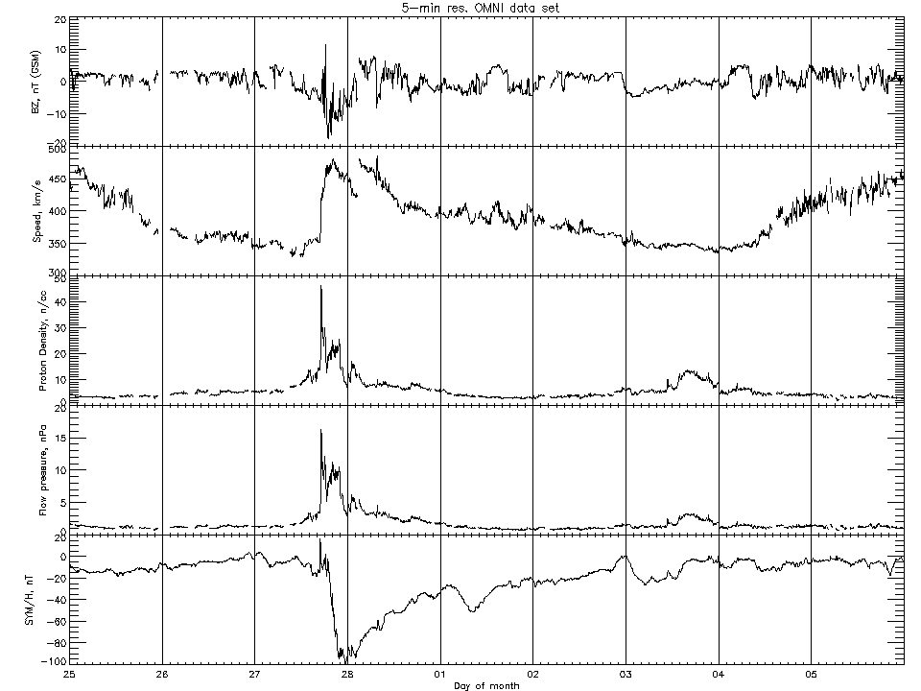

(a)

(b)

(c)

(d)

(e)

***Figure 4: Characteristics of the period from February 25 to March 5, 2014***

Figure 4 presents a set of OMNI data with a 5-minute resolution, including solar wind parameters such as: Solar wind speed (in km/s), Solar wind dynamic pressure (in nPa) , Proton density (in particles/cm³) and SYM-H index (in nT), which is an indicator of geomagnetic storms. The data spans several days, covering the period from February 25 to March 5, 2014. The first curve (Figure 4(a)) represents the variation of the Bz component of the Interplanetary Magnetic Field (IMF) (in nT, GSM). Bz oscillates around 0 nT but shows a sharp drop around February 27-28. This negative drop indicates a southward orientation of the IMF, which enhances coupling with Earth’s magnetosphere and can trigger a geomagnetic storm. After this disturbance, Bz returns to more stable values.

The second curve (Figure 4(b)) shows the variation of solar wind speed (in km/s): the solar wind speed increases significantly after February 27-28, rising from ~350 km/s to over 500 km/s. This increase suggests the arrival of a high-speed solar wind stream, typically associated with a Coronal Mass Ejection or a coronal hole.

The third curve (Figure 4(c)) represents the proton density (in particles/cm³). Before February 27-28, the density remains relatively low. After that, on February 27-28, a sudden surge occurs, reaching a peak of ~40 particles/cm³. This peak can be linked to the shock front of a CME, indicating strong interplanetary plasma compression before the arrival of the fast solar wind.

The fourth curve (Figure 4(d)) displays the solar wind dynamic pressure (in nPa). The pressure follows a similar trend as density and speed, showing a sharp increase around February 27-28. This strong compression of the magnetosphere could have triggered an intense geomagnetic response.

The fifth curve (Figure 4(e)) shows the variation of the SYM-H index (in nT), an indicator of geomagnetic storms. On February 28, SYM-H drops sharply below -80 nT, indicating a strong geomagnetic storm. This drop is characteristic of an intense magnetic storm, caused by the interaction between the CME and Earth's magnetosphere. Afterward, SYM-H gradually recovers, marking the end of the main phase of the storm and the beginning of the recovery phase.

The analysis of Figure 4 confirms that February 27-28 marks the arrival of a CME or an interplanetary shock, causing a strong disturbance which aligns with the TEC variations in Figure 2. In fact, in Figure 2, a severe ionospheric storm is observed between February 27 and 28, coinciding with the arrival of the CME triggered by the X4.9-class solar flare on February 25, 2014. Solar wind parameters (speed, density, pressure) exhibit a sudden impact, characteristic of a shock event. While Bz becomes negative, promoting magnetospheric coupling and triggering a geomagnetic storm, SYM-H drops significantly, confirming an intense geomagnetic storm. This event is classified as a severe geomagnetic storm, likely caused by a CME associated with a solar flare. This disturbance may have led to notable ionospheric effects, such as increased Total Electron Content (TEC) and disruptions in GPS and HF radio communications. Solar Flare occurrence during this period has been : 61 C-class flares, 6 M-class flares and 1 X-class flare.

Furthermore, Figure 5 presents an image of the solar corona from SolarMonitor.org, captured on February 25, 2014.

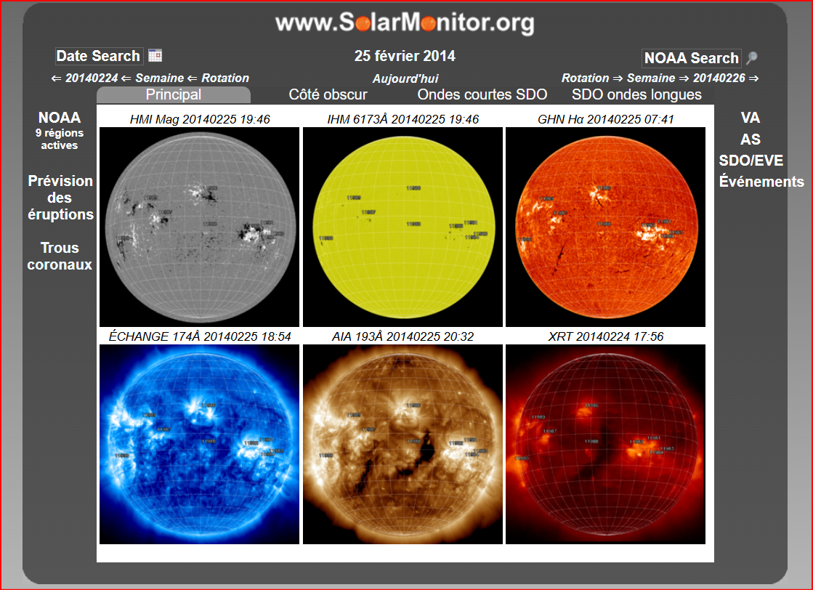

***Figure 5: Solar Corona from February 24 to 25, 2014***

Figure 5 presents different observations of the Sun on February 25, 2014, a date corresponding to an X4.9-class solar flare, as recorded in NOAA data. Several active regions are visible in Figure 5, some of which are associated with this eruption. A total of 9 active regions were identified on the solar disk. This image is composed of multiple solar observations at different wavelengths, providing a comprehensive view of solar activity. Firstly, we have HMI Magnetogram (Black and White Image, Top Left) which displays the solar magnetic field, where white and black areas indicate opposite polarities. They are Crucial for identifying active regions and their magnetic complexity. The region responsible for the X4.9 flare shows strong magnetic activity. Secondly, HMI 6173Å (Yellow Image, Top Center) that Captures the Sun in visible light, allowing the identification of sunspots which are indicators of intense magnetic activity. Then, GHN Hα (Red Image, Top Right) displays the Sun in Hydrogen-alpha (Hα), a wavelength that reveals chromosphere structures. It Highlights solar flares and active filaments. Several bright regions are visible, likely linked to solar eruptions. Moreover, AIA 174Å (Blue Image, Bottom Left) Captures the Sun in Extreme Ultraviolet (EUV, 174Å) and shows the solar corona, highlighting high-activity regions and coronal loops associated with active regions. Furthermore, AIA 193Å (Brown Image, Bottom Center) highlights the solar corona and coronal holes. Coronal holes (dark areas) are sources of high-speed solar wind, which can influence Earth's geomagnetic environment. Lastly XRT (Dark Red Image, Bottom Right) show an X-ray observation, revealing the hottest regions of the solar atmosphere. Several intense emission zones are visible, indicating high solar activity.

Figure 6 also provides an image of the solar corona in the days following the solar flare, specifically from March 3 to 5, 2014.

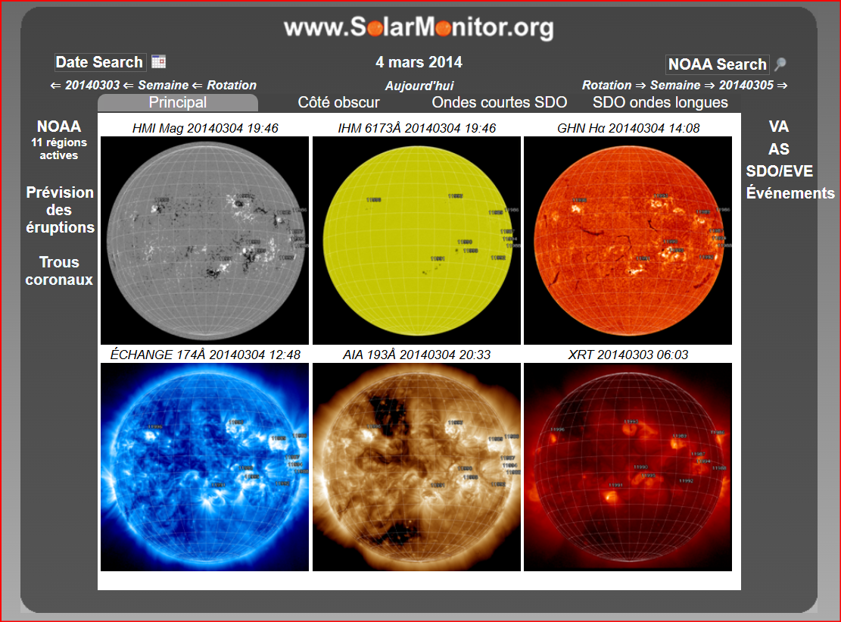

***Figure 6:* *Image of the Solar Corona from March 4, 2014***

On this date, 11 active regions were identified on the solar disk. This period comes shortly after the X4.9 solar flare on February 25, 2014, meaning the Sun was still in a phase of intense activity. Several active regions appear to evolve and interact, increasing the likelihood of further solar flares and coronal mass ejections. The presence of filaments and bright active areas suggests that a CME was associated with some of these eruptions.

From the analysis of Figures 5 and 6, there is a noticeable increase in the number of active regions (9 on February 25, 11 on March 4). The activity in X-rays and extreme UV appears to remain high. New coronal holes emerge, which could influence the solar wind in the following days. Therefore, solar activity on March 4, 2014, was particularly intense, with 11 active regions and bright zones in X-rays and EUV. From the analysis of Figures 4, 5, and 6, the characteristics of the solar wind from February 25 to March 4, 2014, show that on February 25, 2014, coronal holes (dark areas in the AIA 193Å image) were observed, indicating sources of fast solar wind. Several bright active regions in X-rays and UV (from the XRT and AIA 174Å images) suggest high solar activity and a potential for CMEs. The X4.9 flare on February 25 generated a significant CME. The solar wind from this eruption likely accelerated the CME to high speeds, with the apparent speed reaching 2147 km/s and the real space speed at 2153 km/s. the observations from March 4, 2014, highlight an increase in the number of coronal holes, indicating an increased release of fast solar wind. Several active regions remain clearly visible, maintaining a constant flow of solar activity and possible disturbances. The analysis of UV and X-ray images shows that the Sun remains highly dynamic, leading to a phase of energetic particle emission into interplanetary space.

Assuming the solar wind propagates radially, the second curve on Figure 4 shows that the solar wind speed increases after February 27-28, rising from about 350 km/s to more than 500 km/s. This increase suggests the arrival of a fast solar wind stream, typically associated with a coronal mass ejection or a coronal hole. The average distance between the Sun and the Earth is 1 AU = 150 million km. The propagation time is given by:



Thus, the propagation time to Earth is between 2.2 days and 5 days. The February 25, 2014 eruption (X4.9 class) generated a fast CME (~2153 km/s). Its arrival on Earth would have occurred approximately 1 to 2 days later, around February 27, 2014. The coronal holes visible in the March 4, 2014 coronal image are sources of fast solar wind (~600-800 km/s). The solar wind from these holes must have left the Sun around March 1 or 2, 2014, reaching Earth around March 3 or 4. These conditions indicate a disturbed solar environment and confirm the production of geomagnetic storms and interactions with the Earth's magnetosphere, as indicated by the variation of SYM-H in Figure 4, where we observe that SYM-H drops sharply below -80 nT on February 28, indicating a strong geomagnetic storm.

1. ***CONCLUSION***

The Sun, the primary source of energy for Earth, directly influences the Earth's atmosphere, particularly through solar wind, solar flares, and coronal mass ejections . The study of events from February 25 to March 4, 2014 shows that during this period, solar flares and a fast CME occurred. This period falls within the solar maximum of solar cycle 24. Among the solar flares produced, there were 61 class C, 6 class M, and 1 class X. The most powerful solar flare, X4.9, occurred at 00:39 UT on February 25, 2014, accompanied by a fast CME (2153 km/s). This CME was directed towards S12E82 with a MPA of 73°, meaning it was moderate, not directly aimed at Earth but still capable of causing secondary effects (shock waves, energetic particles). The negative acceleration (-158.1 m/s²) indicates a slowdown, suggesting that the CME may have interacted with the ambient solar wind. From February 27-28, 2014: The CME reaches Earth, causing an increase in solar wind density, high dynamic pressure, and a geomagnetic storm (SYM-H ≈ -100 nT). A significant variation in the magnetic field Bz (~ -20 nT) indicates possible magnetic reconnection. A sharp increase in proton density (> 40 particles/cm³) and dynamic pressure (> 15 nPa) is a sign of an interplanetary shock. The days February 23-27 and March 1-4 show a typical TEC evolution with a morning increase, a peak between 12:00 and 15:00, followed by a decrease in the evening, with maximum values generally ranging between 80 and 100 TECU. However, on February 28, TEC values were significantly higher (above 100 TECU) and remained abnormally high between 8:00 and 18:00. This suggests intense solar activity or a geomagnetic disturbance affecting the ionosphere. Such a disturbance could have caused GPS positioning errors and destabilized radio communications. A significant ionospheric disturbance likely occurred on February 28, 2014, with an abnormal increase in TEC. This disturbance was caused by the X4.9 solar flare. After this event, TEC showed a tendency to stabilize from March 1 to 4, 2014, although with slight variations. These interactions between solar activity and the ionosphere play a fundamental role in space weather, as when they reach Earth, they strongly ionize the upper layers of the ionosphere, causing disruptions in high-frequency radio communications and GPS anomalies. They can also cause significant fluctuations in the Earth's magnetic field, affecting satellites and electrical infrastructures. This requires continuous monitoring to anticipate their effects on terrestrial and space technologies.

Disclaimer (Artificial intelligence)

Option 1:

Author(s) hereby declare that NO generative AI technologies such as Large Language Models (ChatGPT, COPILOT, etc.) and text-to-image generators have been used during the writing or editing of this manuscript.

Option 2:

Author(s) hereby declare that generative AI technologies such as Large Language Models, etc. have been used during the writing or editing of manuscripts. This explanation will include the name, version, model, and source of the generative AI technology and as well as all input prompts provided to the generative AI technology

Details of the AI usage are given below:

1.

2.

3.

References:

Al-Feadh, D., Al-Ramdhan, W., 2019. Large Geomagnetic Storms Drives by Solar Wind in Solar Cycle 24. J. Phys. Conf. Ser. 1234, 012004. https://doi.org/10.1088/1742-6596/1234/1/012004

Bhattacharyya, A., Basu, S., Groves, K.M., Valladares, C.E., Sheehan, R., 2002. Effect of magnetic activity on the dynamics of equatorial *F* region irregularities. J. Geophys. Res. Space Phys. 107. https://doi.org/10.1029/2002JA009644

Chakrabarty, D., Bagiya, M.S., Thampi, S.V., Pathan, B.M., Sekar, R., 2013. Signatures of moderate (M-class) and low (C and B class) intensity solar flares on the equatorial electrojet current: Case studies. J. Atmospheric Sol.-Terr. Phys. 105–106, 170–180. https://doi.org/10.1016/j.jastp.2013.10.005

Davoudifar, P., Tabari, K.R., Shafigh, A.A.E., Ajabshirizadeh, A., Bagheri, Z., Akbarian Tork Abad, F., Shayan, M., 2021. Development of a local empirical model of ionospheric total electron content (TEC) and its application for studying solar-ionospheric effects. Sci. Rep. 11, 15070. https://doi.org/10.1038/s41598-021-93496-y

Diakite, Y., Zoundi, C., Kabore, M., Zerbo, J.L., 2024. Statistical Study of the Geoeffectivity of Halo Coronal Mass Ejections Associated with X-Class Flares during Solar Cycles 23 and 24. Open J. Appl. Sci. 14, 950–960. https://doi.org/10.4236/ojapps.2024.144062

Dungey, J.W., 1961. Interplanetary Magnetic Field and the Auroral Zones. Phys. Rev. Lett. 6, 47–48. https://doi.org/10.1103/PhysRevLett.6.47

Gonzalez, W.D., Tsurutani, B.T., 1987. Criteria of interplanetary parameters causing intense magnetic storms (Dst < −100 nT). Planet. Space Sci. 35, 1101–1109. https://doi.org/10.1016/0032-0633(87)90015-8

Gopalswamy, N., Lara, A., Lepping, R.P., Kaiser, M.L., Berdichevsky, D., St. Cyr, O.C., 2000. Interplanetary acceleration of coronal mass ejections. Geophys. Res. Lett. 27, 145–148. https://doi.org/10.1029/1999GL003639

Gopalswamy, N., Yashiro, S., Akiyama, S., 2007. Geoeffectiveness of halo coronal mass ejections. J. Geophys. Res. Space Phys. 112, 2006JA012149. https://doi.org/10.1029/2006JA012149

Griton, L., Rouillard, A.P., Poirier, N., Issautier, K., Moncuquet, M., Pinto, R., 2021. Source-dependent properties of two slow solar wind states. Astrophys. J. 910, 63. https://doi.org/10.3847/1538-4357/abe309

Grodji, O.D.F., Doumbia, V., Amaechi, P.O., Amory-Mazaudier, C., N’guessan, K., Diaby, K.A.A., Zie, T., Boka, K., 2021. A Study of Solar Flare Effects on the Geomagnetic Field Components during Solar Cycles 23 and 24. Atmosphere 13, 69. https://doi.org/10.3390/atmos13010069

Jadeja, A.K., Iyer, K.N., Vats, H.O., Manoharan, P.K., 2008. Geo-effectiveness of CMEs. J. Astrophys. Astron. 29, 287–291. https://doi.org/10.1007/s12036-008-0038-6

Jiang, H., Matsuura, R., Wang, J.T.L., 2024. Multiclass Classification of Solar Flares in Imbalanced Data Using Ensemble Learning and Sampling Methods. Int. FLAIRS Conf. Proc. 37. https://doi.org/10.32473/flairs.37.1.135365

Kilcik, A., Yurchyshyn, V.B., Abramenko, V., Goode, P.R., Gopalswamy, N., Ozguc, A., Rozelot, J.P., 2011. MAXIMUM CORONAL MASS EJECTION SPEED AS AN INDICATOR OF SOLAR AND GEOMAGNETIC ACTIVITIES. Astrophys. J. 727, 44. https://doi.org/10.1088/0004-637x/727/1/44

Koala, S., Sawadogo, Y., Zerbo, J.L., 2022. Solar wind and geomagnetic activity during two antagonist solar cycles: Comparative study between the solar cycles 23 and 24. Int. J. Phys. Sci. 17, 57–66. https://doi.org/10.5897/IJPS2022.4998

Krainev, M.B., 2004. Main phases of the solar cycle in the galactic cosmic ray intensity. Int. J. Geomagn. Aeron. 5, GI2004. https://doi.org/10.1029/2004GI000070

Mendillo, M., 2006. Storms in the ionosphere: Patterns and processes for total electron content. Rev. Geophys. 44, 2005RG000193. https://doi.org/10.1029/2005RG000193

Nigam, B., Singh, P.R., Chamadia, P.K., Saxena, A.K., Tiwari, C.M., 2017. Effect of Coronal Mass Ejection on Earth’s Magnetic Field during Ascending Phase of Solar Cycles 23-24. Int. J. Astron. Astrophys. 07, 213–220. https://doi.org/10.4236/ijaa.2017.73017

Réville, V., Velli, M., Rouillard, A., Lavraud, B., Tenerani, A., Shi, C., Strugarek, A., 2020. Tearing instability and periodic density perturbations in the slow solar wind. Astrophys. J. Lett. 895, L20. https://doi.org/10.3847/2041-8213/ab911d

Sanchez‐Diaz, E., Rouillard, A.P., Lavraud, B., Segura, K., Tao, C., Pinto, R., Sheeley, N.R., Plotnikov, I., 2016. The very slow solar wind: Properties, origin and variability. J. Geophys. Res. Space Phys. 121, 2830–2841. https://doi.org/10.1002/2016JA022433

Sawadogo, E.W., Zerbo, J.L., Mahamat, N.A., Ouattara, F., 2019. Diurnal variation of F2-layer critical frequency under solar activity recurrent conditions during solar cycles 21 and 22 at Ouagadougou Station: Prediction with IRI-2012. Sci Res Essays.

Sawadogo, S., Gnabahou, D.A., Pahima, T., Ouattara, F., 2024. Solar activity: Towards a standard classification of solar phases from cycle 1 to cycle 24. Adv. Space Res. 73, 1041–1049. https://doi.org/10.1016/j.asr.2023.11.011

Shi, T., Wang, Y., Wan, L., Cheng, X., Ding, M., Zhang, J., 2015. Predicting the Arrival Time of Coronal Mass Ejections with the Graduated Cylindrical Shell and Drag Force Model.

Uwamahoro, J., McKinnell, L.A., Habarulema, J.B., 2012. Estimating the geoeffectiveness of halo CMEs from associated solar and IP parameters using neural networks. Ann. Geophys. 30, 963–972. https://doi.org/10.5194/angeo-30-963-2012

Wang, Y.-M., Sheeley, Jr., N.R., 2015. CORONAL MASS EJECTIONS AND THE SOLAR CYCLE VARIATION OF THE SUN’S OPEN FLUX. Astrophys. J. 809, L24. https://doi.org/10.1088/2041-8205/809/2/L24

Younas, W., Amory‐Mazaudier, C., Khan, M., Le Huy, M., 2021. Magnetic Signatures of Ionospheric Disturbance Dynamo for CME and HSSWs Generated Storms. Space Weather 19, e2021SW002825. https://doi.org/10.1029/2021SW002825

Zerbo, J.-L., Amory-Mazaudier, C., Ouattara, F., 2013. Geomagnetism during solar cycle 23: Characteristics. J. Adv. Res. 4, 265–274. https://doi.org/10.1016/j.jare.2012.08.010

Zhang, J., Liemohn, M.W., Kozyra, J.U., Lynch, B.J., Zurbuchen, T.H., 2004. A statistical study of the geoeffectiveness of magnetic clouds during high solar activity years. J. Geophys. Res. Space Phys. 109, 2004JA010410. https://doi.org/10.1029/2004JA010410