Thrombolytic Therapy for Acute Mechanical Aortic Valve Thrombosis: A Case Report with Coronary Embolic Complication

Abstract
Background:
Prosthetic valve thrombosis (PVT) is a rare but life-threatening complication of mechanical heart valves, particularly in the setting of subtherapeutic anticoagulation. Obstructive PVT in the aortic position can result in acute heart failure and sudden cardiac death. While emergency surgery is the recommended treatment, thrombolytic therapy may be considered when surgical access is limited or contraindicated.
Case summary:
We report the case of a 69-year-old female with a mechanical aortic valve who presented with acute dyspnea and signs of cardiogenic shock following a 15-day interruption of vitamin K antagonist therapy. Transthoracic echocardiography revealed a severely elevated transaortic gradient, consistent with obstructive valve thrombosis. Due to the unavailability of emergency surgery, low-dose slow-infusion thrombolysis with tenecteplase was administered, resulting in rapid clinical and hemodynamic improvement. However, the patient developed a coronary embolism as a complication of thrombolysis, manifesting as anteroseptal ST-segment elevation and reduced left ventricular ejection fraction. Subsequent imaging confirmed restored prosthetic valve function.
Discussion:
This case illustrates the critical role of anticoagulation adherence in preventing mechanical valve thrombosis. Thrombolysis remains a life-saving alternative in emergency settings lacking surgical support, particularly when using slow-infusion protocols that optimize efficacy and reduce complications. Nonetheless, clinicians must remain vigilant for embolic events, including coronary embolism, which may present with atypical symptoms and contribute to myocardial dysfunction.
Conclusion:
In select patients with obstructive mechanical valve thrombosis and no access to surgery, thrombolysis is a viable option, but requires close monitoring for iatrogenic embolic complications. This case emphasizes the dual challenge of timely intervention and anticipation of thrombolysis-related risks.
Take-Home Message
Lifelong adherence to anticoagulation is essential in patients with mechanical heart valves to avoid thrombosis and life-threatening complications. Patient education and regular monitoring are key to prevention. Thrombolysis can be lifesaving despite the occurrence of a severe embolic complication, this highlights both the risks of this therapy and the necessity to proceed when urgent intervention is required.

Keywords:
Mechanical aortic valve, prosthetic valve thrombosis, thrombolysis, coronary embolism, anticoagulation, tenecteplase.

INTRODUCTION :
Prosthetic valve thrombosis (PVT) is a rare but potentially life-threatening complication of mechanical heart valves [1]. Despite advances in anticoagulation management, inadequate therapy or patient non-compliance can lead to valve obstruction, heart failure, or systemic embolization [2]. Early recognition and prompt treatment are essential to reduce morbidity and mortality.
Thrombolytic therapy has emerged as an alternative to urgent surgical intervention in selected patients with obstructive PVT, particularly when surgery is contraindicated, delayed, or unavailable [2]. While generally effective, thrombolysis carries risks of systemic embolization and bleeding [6], and in rare cases, coronary embolism [14].
We report the case of a 69-year-old female with mechanical aortic valve thrombosis treated with thrombolysis who developed a coronary embolic complication. This case highlights a rare but serious iatrogenic event, emphasizing the need for careful patient selection, monitoring, and adherence to anticoagulation to prevent life-threatening complications [17].
CASE REPORT
A 69-year-old female patient, with a known history of rheumatic aortic stenosis, underwent a mechanical aortic valve replacement in 2018. Postoperative follow-up was uneventful, and transthoracic echocardiography (TTE) consistently demonstrated a well-functioning prosthesis, with a mean transaortic gradient never exceeding 15 mmHg. The patient was compliant with her anticoagulation therapy, taking vitamin K antagonists (VKA) regularly, with appropriate INR monitoring during the follow-up period.
The patient also had a 3-year history of type 2 diabetes mellitus. Her preoperative coronary angiography, performed in 2018 prior to valve replacement, revealed no significant coronary artery disease. Following surgery, serial transthoracic echocardiograms (TTE) consistently confirmed appropriate prosthetic valve function, with a mean transaortic gradient remaining below 15 mmHg. She remained compliant with anticoagulation therapy using vitamin K antagonists (VKA), and no thromboembolic or hemorrhagic complications were previously reported.
However, the patient presented to the emergency department late at night with acute-onset dyspnea that had rapidly worsened over the previous hours, progressing to orthopnea and signs of cardiogenic shock. Upon admission, she was found to have hypotension with signs of low cardiac output (cold extremities, prolonged capillary refill time), bilateral pulmonary crackles reaching the apices, and a complete absence of the aortic prosthetic valve click on auscultation. Further investigation revealed that she had discontinued VKA therapy 15 days prior to admission, without medical supervision.
An urgent TTE revealed a markedly elevated transprosthetic aortic gradient of 73 mmHg. Although leaflet motion could not be clearly visualized in the emergent setting due to the patient's unstable condition, the clinical presentation and echocardiographic findings were highly suggestive of acute obstructive prosthetic valve thrombosis.
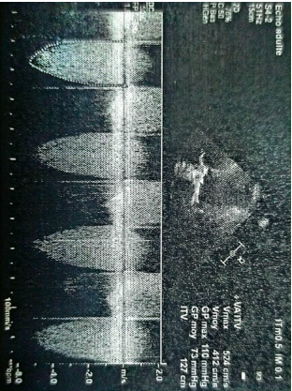
Figure 1 : Transthoracic echocardiographic image showing an increased transaortic gradient of 73 mmHg consistent with obstructive thrombosis of an aortic valve prosthesis.
According to European Society of Cardiology guidelines, emergency valve replacement surgery is the treatment of choice in such cases, with thrombolytic therapy reserved for situations where Intervention other than thrombolytic therapy was unavailable. Intravenous thrombolysis with tenecteplase (Metalyse) was initiated after contreindications were eliminated, alongside supportive medical therapy for cardiogenic shock, including non-invasive ventilation (CPAP), loop diuretics, and continuous cardiac and respiratory monitoring.
Within three hours of thrombolysis, the aortic valve click reappeared, accompanied by marked improvement in both hemodynamic and respiratory parameters. No neurological deficits suggestive of cerebral haemorragiae or embolism were observed post-thrombolysis. However, the patient developed left shoulder pain raising suspicion for atypical chest pain. Electrocardiography showed ST-segment elevation in the anteroseptal leads, consistent with acute coronary syndrome secondary to embolization. Coronary angiography was not performed due to the patient’s categorical refusal, despite thorough counseling about potential risks.
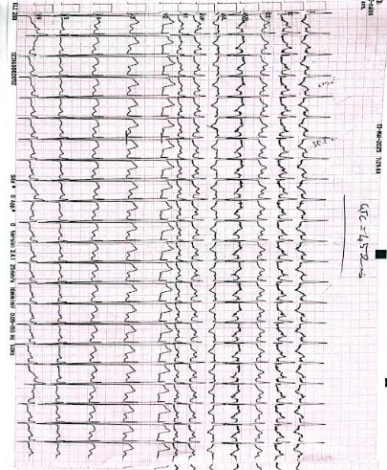
Figure 2 : ECG showing an embolic complication of thrombolysis consistent with a coronary embolism: ST-segment elevation in the antero-septo-apical leads with reciprocal changes in the inferior leads.
Subsequent echocardiographic evaluation demonstrated a reduction in left ventricular ejection fraction (LVEF) to 40%. The transprosthetic gradient had decreased significantly to 12 mmHg, and prosthetic leaflet mobility was restored. This was confirmed by both transesophageal echocardiography (TEE) and cinefluoroscopy. These findings indicated successful thrombolysis in resolving the obstructive prosthetic thrombosis
The STEMI was managed medically with a combination of oral anticoagulation (AVK), P2Y12 inhibitor therapy, and standard heart failure treatment. Follow-up demonstrated a favorable outcome: the patient remained asymptomatic, exercise tolerance was excellent, and echocardiography showed improvement in left ventricular ejection fraction by approximately 3–5% under medical therapy. No additional thromboembolic or hemorrhagic complications were observed.

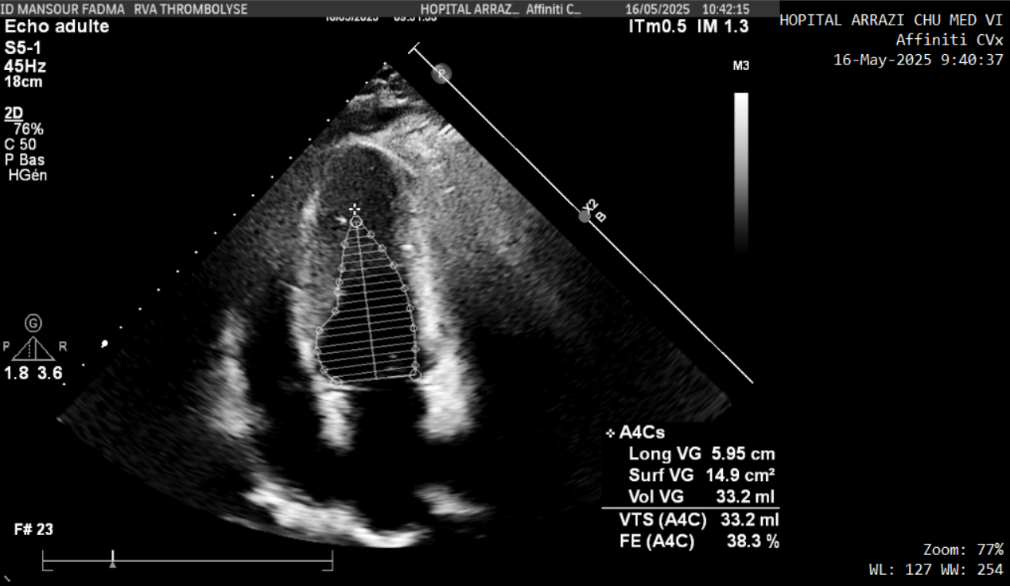
Figure 3 : Echocardiographic image showing impaired left ventricular ejection fraction of ischemic origin due to a coronary embolism.
DISCUSSION :
Prosthetic valve thrombosis (PVT) is a rare but life-threatening complication of mechanical heart valves, with obstructive forms representing a medical emergency due to the risk of acute heart failure, cardiogenic shock, and sudden cardiac death [2]. Although PVT is more common in the mitral position, mechanical aortic valve thrombosis, while less frequent, is associated with high mortality when left untreated [3]. Our case illustrates a classic presentation of obstructive aortic PVT in the setting of a 15-day interruption of vitamin K antagonist (VKA) therapy—currently identified as the most significant modifiable risk factor for thrombotic events in these patients [8].
Clinically, the abrupt onset of dyspnea, signs of low cardiac output, pulmonary edema, and the abolition of the prosthetic valve click were highly suggestive of a mechanical obstruction. Transthoracic echocardiography (TTE) confirmed the diagnosis through a markedly elevated transvalvular gradient. Although imaging of leaflet motion was suboptimal due to the patient’s hemodynamic instability, the combination of clinical and echocardiographic findings was sufficient to presume an obstructive thrombus [9]. Additional imaging modalities, such as transesophageal echocardiography (TEE) or multidetector computed tomography (MDCT), may be helpful to distinguish thrombus from pannus in less urgent cases [10].

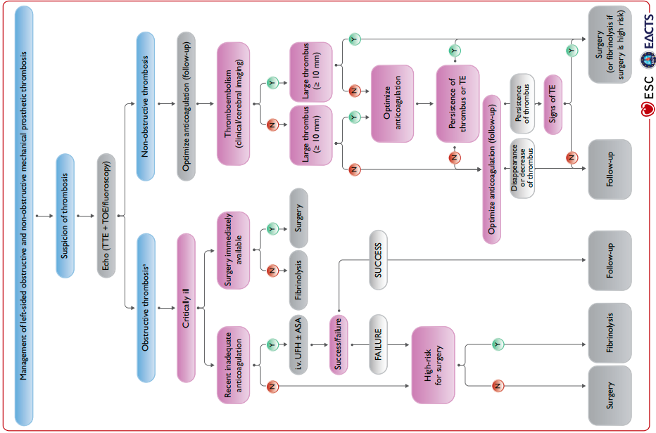
Figure 4 : Management of left-sided obstructive and non-obstructive mechanical prosthetic valve thrombosis according to the 2021 ESC guidelines.
Management of obstructive left-sided PVT remains challenging and time-sensitive. Emergency surgery is the treatment of choice in critically ill patients with NYHA class III–IV symptoms [11]. However, thrombolytic therapy is considered an acceptable alternative when surgery is contraindicated or not readily available. Recent data suggest that thrombolysis may be equally effective in select patients, with comparable survival rates to surgery when initiated early [12].
According to Guidelines for the management of valvular heart disease, the management of mechanical prosthetic valve thrombosis should be individualized based on hemodynamic stability, thrombus size, and surgical risk, with decisions guided by a multidisciplinary Heart Team.A recent systematic review and meta-analysis demonstrated that systemic thrombolysis was associated with a lower mortality rate (10.8 %) compared to surgical intervention (15.3 %), though thromboembolic complications were more frequent in the thrombolysis group [16].Case reports further support the feasibility of low-dose, ultraslow infusion thrombolysis—even in critical situations—such as a cardiac arrest due to mechanical aortic valve thrombosis successfully managed with t-PA, or in a younger patient with favorable outcome upon intravenous thrombolysis.In our case, the hemodynamic urgency and high surgical risk justified thrombolysis, despite the occurrence of an embolic complication.
Recent literature continues to underline the clinical diversity and therapeutic challenges of prosthetic valve thrombosis. An unusual case of massive aortic prosthetic valve thrombosis in a hypocoagulated patient was recently reported, further emphasizing the dramatic consequences of poor anticoagulation control. Moreover, comprehensive reviews highlight that the management of this condition requires careful evaluation of thrombus size, valve position, hemodynamic status, and surgical risk, with thrombolysis remaining a valuable option in selected patients [17].
In our case, the lack of immediate access to cardiac surgery justified the use of thrombolysis with tenecteplase after careful risk-benefit assessment. The patient showed rapid clinical improvement with normalization of the transvalvular gradient and reappearance of the prosthetic click. These findings support existing evidence demonstrating that low-dose, slow-infusion thrombolytic protocols can achieve high success rates while minimizing adverse events. The TROIA and PROMETEE trials previously highlighted the efficacy and safety of such regimens [7], and more recent reports have confirmed these outcomes across different clinical settings, including mechanical aortic valve thrombosis.
Despite the favorable response to thrombolysis, our patient experienced a rare but serious complication: coronary embolism, likely resulting from thrombus fragmentation. Although cerebrovascular events are the most frequently reported embolic complications, coronary artery embolism is increasingly recognized and may present atypically, as in our case with isolated shoulder pain. Diagnosis was established based on ST-segment elevation in the anterior leads and a marked rise in troponin levels, indicating embolic myocardial infarction. The resulting reduction in left ventricular ejection fraction to 40% further supported the presence of ischemic myocardial injury, a consequence documented in several reports of coronary embolism following thrombolysis [15].
As for the risk factors of PVT, it is primarily caused by inadequate anticoagulation, either due to subtherapeutic dosing, poor adherence, or fluctuations in INR levels, which promote thrombus formation on mechanical valves. Other contributing factors include atrial fibrillation, left ventricular dysfunction, hypercoagulable states, and valve-related issues such as high transvalvular gradients or stasis. Prevention of this life-threatening complication relies on strict anticoagulation management with regular INR monitoring, patient education on adherence, and optimization of modifiable risk factors such as heart failure or arrhythmias. Additionally, routine echocardiographic surveillance can facilitate early detection of valve obstruction, allowing timely intervention before severe hemodynamic compromise or embolic events occur.
This case highlights the diagnostic and therapeutic challenges of obstructive prosthetic valve thrombosis (PVT), a rare but life-threatening complication, particularly when affecting mechanical aortic valves. The abrupt clinical deterioration in our patient following anticoagulation discontinuation illustrates the critical importance of strict adherence to VKA therapy, which remains the cornerstone of prevention in patients with mechanical heart valves.
Although emergency surgical intervention is considered the gold standard in patients with obstructive PVT and hemodynamic instability, thrombolysis can serve as a life-saving alternative in centers without immediate surgical access [4]. In our case, thrombolytic therapy led to rapid hemodynamic improvement and full recovery of prosthetic valve function, supporting its utility in appropriately selected patients. This aligns with findings from large observational studies and trials, including TROIA and PROMETEE, which confirmed the effectiveness and relative safety of thrombolytic regimens when carefully administered [7].
However, this therapeutic approach is not without risk. Our patient developed a coronary embolism, a rare but serious complication of thrombolysis, which manifested atypically. Although stroke is the most frequently encountered embolic event, this case serves as a reminder that non-cerebral embolic complications, particularly coronary embolism, must also be actively monitored for following thrombolytic therapy [5].
The main contribution of our manuscript lies in highlighting coronary embolism as a rare and serious complication of thrombolytic therapy for prosthetic valve thrombosis. While PVT and its management are well established, the occurrence of coronary emboli post-thrombolysis is scarcely reported, making it a clinically significant event that requires awareness among cardiologists[15]. Our case provides detailed chronological documentation of this complication, from the onset of STEMI to its medical management and favorable follow-up, illustrating both the risks associated with thrombolysis and the potential for conservative management when invasive intervention is not feasible. By focusing on this iatrogenic complication, the manuscript emphasizes the importance of vigilance, early recognition, and individualized patient care, offering readers a practical lesson that extends beyond standard PVT management.
In summary, this case reinforces several essential clinical messages:
- Early recognition of prosthetic valve dysfunction in the emergency setting is vital.
- Thrombolysis remains a valid therapeutic option in resource-limited situations, when surgical delay may result in death [6].
- Close clinical and imaging follow-up is critical to confirm therapeutic success and detect possible complications.
- Most importantly, sustained patient education and anticoagulation adherence are paramount to preventing these catastrophic events [4].

CONCLUSION :
Coronary embolism is a rare but serious complication of thrombolytic therapy for prosthetic valve thrombosis, with potentially life-threatening consequences. This case highlights the need for vigilance during and after thrombolysis, careful patient selection, and thorough monitoring for early detection of embolic events. When invasive interventions such as coronary angiography are not feasible, medical management combining anticoagulation, antiplatelet therapy, and optimal heart failure treatment can lead to favorable outcomes. Clinicians should also emphasize strict adherence to anticoagulation and regular follow-up to prevent valve thrombosis and minimize the risk of such complications. Awareness of this iatrogenic risk and preparedness for its management are essential to improve patient safety and outcomes.

CONSENT
As per international standards or university standards, patient(s) written consent has been collected and preserved by the author(s).

DISCLAIMER (ARTIFICIAL INTELLIGENCE)
Author(s) hereby declare that NO generative AI technologies and text-to-image generators have been used during writing or editing of this manuscript.
References
- Lengyel M, Horstkotte D, Völler H, Mistiaen WP. Recommendations for the management of prosthetic valve thrombosis. Eur Heart J. 1997 Jan;18(1):132-8. doi:10.1093/oxfordjournals.eurheartj.a015174. PMID: 9043820.
- Roudaut R, Lafitte S, Roudaut MF, Courtault C, Perron JM, Jaïs C, Pillois X, Coste P, DeMaria A. Fibrinolysis of mechanical prosthetic valve thrombosis: a single-center study of 127 cases. J Am Coll Cardiol. 2003 Feb 19;41(4):653-8. doi:10.1016/S0735-1097(02)02872-3. PMID: 12598078.
- Barbetseas J, Nagueh SF, Pitsavos C, Toutouzas PK, Quiñones MA, Zoghbi WA. Differentiating thrombus from pannus formation in obstructed mechanical prosthetic valves: an echocardiographic and clinical study. Circulation. 1998;97(2):212-6. doi:10.1161/01.CIR.97.2.212. PMID: 9445162.
- Nishimura, R. A., Otto, C. M., Bonow, R. O., Carabello, B. A., Erwin, J. P., Fleisher, L. A., ... & Thompson, A. (2017). 2017 AHA/ACC focused update of the 2014 AHA/ACC guideline for the management of patients with valvular heart disease: a report of the American College of Cardiology/American Heart Association Task Force on Clinical Practice Guidelines. Journal of the American College of Cardiology, 70(2), 252-289.
- Roudaut, R., Serri, K., & Lafitte, S. (2007). Thrombosis of prosthetic heart valves: diagnosis and therapeutic considerations. Heart, 93(1), 137-142.
- Özkan, M., Gündüz, S., Biteker, M., Astarcioglu, M. A., Çevik, C., Kaynak, E., ... & Özdemir, N. (2013). Comparison of different TEE-guided thrombolytic regimens for prosthetic valve thrombosis: the TROIA trial. JACC: Cardiovascular Imaging, 6(2), 206-216.
- Gupta, D., Kothari, S. S., Bahl, V. K., Goswami, K. C., Talwar, K. K., Manchanda, S. C., & Venugopal, P. (2000). Thrombolytic therapy for prosthetic valve thrombosis: short-and long-term results. American heart journal, 140(6), 906-916.
- Druteikaitėa, K., Bėrontaitėa, S., Valterytėb, G., & Jaruševičiusb, G. (2023). Prosthetic valve thrombosis: literature review and two case reports. Cor Vasa, 65(1), 90-99.
- Bonnichsen, C. R., & Pellikka, P. A. (2015). Prosthetic valve thrombus versus pannus: progress with imaging. Circulation: Cardiovascular Imaging, 8(12), e004283.
- Carlson, S., Habib, G., Chen, T., Leipsic, J., Enriquez-Sarano, M., & Cavalcante, J. L. (2022). Multimodality imaging for prosthetic valves evaluation: Current understanding and future directions. Progress in Cardiovascular Diseases, 72, 66-77.
- Vahanian A, et al. 2021 ESC/EACTS Guidelines for the management of valvular heart disease. Eur Heart J. 2022;43(7):561–632.
- Chopard, R., Vidoni, C., Besutti, M., Ismail, M., Ecarnot, F., Favoulet, B., ... & Meneveau, N. (2024). Surgery Versus Thrombolytic Therapy for the Management of Left‐Sided Prosthetic Valve Thrombosis Without Hemodynamic Compromise: A Systematic Review and Meta‐Analysis. Journal of the American Heart Association, 13(19), e035143.
- Mandal, S., Rohita, D. K., Paudel, S., Stroia, A., & McClintic, B. (2022). Mechanical Aortic Valve Thrombosis Successfully Treated With Intravenous Thrombolytic Therapy: A Case Report. Cureus, 14(10).
- Karakoyun, S., Gürsoy, M. O., Kalçık, M., Yesin, M., & Özkan, M. (2014). A case series of prosthetic heart valve thrombosis-derived coronary embolism. Turk Kardiyol Dern Ars, 42(5), 467-471.
- Kus, M. K., Karaagac, A., Bozkurt, B., Ceylan, U. S., & Kaplan, M. (2024). Myocardial infarction due to coronary embolism after mechanical aortic valve replacement: a case report. Journal of Cardiothoracic Surgery, 19(1), 114.
- Chopard R, Vidoni C, Besutti M, Ismail M, Ecarnot F, et al. Surgery versus thrombolytic therapy for the management of left-sided prosthetic valve thrombosis without hemodynamic compromise: A systematic review and meta-analysis. J Am Heart Assoc. 2024;13(19):e035143.
- • Gündüz S, Kalçık M, Gürsoy MO, Güner A, Özkan M. Diagnosis, treatment & management of prosthetic valve thrombosis: the key considerations. Expert Rev Med Devices. 2020;17(3):209-21

