**Massive Pulmonary Embolism Revealing Right-Sided Infective Endocarditis Complicated by Intracerebral Hemorrhage in a Non-IV Drug User**

Abstract

Background: Right-sided infective endocarditis (RSIE) is typically associated with intravenous drug use or indwelling catheters. Its diagnosis in non-IV drug users is often delayed due to low clinical suspicion. The disease is often under-recognized in patients with atypical risk profiles, leading to delayed management and potentially severe complications.  
Case Presentation: We report a rare case of massive pulmonary embolism (PE) revealing tricuspid valve infective endocarditis in a 53-year-old woman with no history of intravenous drug use. The clinical course was complicated by intracerebral hemorrhage (ICH), resulting in death within five days. Despite early initiation of antibiotic therapy, the rapid progression of multi-organ failure and neurological deterioration precluded surgical intervention.  
Conclusion: This case underscores the importance of considering RSIE in patients without classical risk factors, particularly when septic pulmonary embolism and neurological complications are present. Clinicians should maintain a high index of suspicion and promptly perform echocardiography in atypical cases to avoid delayed diagnosis. Multimodal imaging and interdisciplinary management are crucial for optimal outcomes.

Keywords

Right-sided infective endocarditis, pulmonary embolism, intracerebral hemorrhage, tricuspid valve, Staphylococcus aureus, non-IV drug user

Introduction

Infective endocarditis (IE) is a life-threatening condition that typically affects the left side of the heart. Right-sided IE, particularly involving the tricuspid valve, represents 5–10% of all IE cases and is most commonly associated with intravenous drug use, pacemaker leads, or central venous catheters. However, RSIE may also occur in patients without these risk factors, especially those with skin or soft tissue infections. The clinical presentation can be nonspecific, and complications such as pulmonary embolism or neurological manifestations are frequently underdiagnosed.  
  
Early recognition of RSIE in non-classical presentations is critical, as delayed diagnosis is associated with increased morbidity and mortality. In such patients, the diagnosis is often made after the occurrence of severe complications, such as septic emboli or intracranial hemorrhage. Multidisciplinary evaluation, including imaging and microbiological assessment, plays a pivotal role in identifying these cases in time.  
  
We report a fatal case of RSIE revealed by massive pulmonary embolism and complicated by intracerebral hemorrhage in a diabetic woman without a history of intravenous drug use. This case illustrates the need for clinical vigilance, especially when embolic phenomena coexist with systemic inflammatory signs in patients without traditional IE risk factors.

Case Presentation

**A 53-year-old woman with a history of insulin-dependent diabetes mellitus, prior right foot amputation, and a recent gluteal abscess was admitted for progressive dyspnea over three weeks (NYHA Class III) and sudden-onset heaviness in the left upper limb for the past 24 hours. She denied any history of intravenous drug use, hemodialysis, or known valvular heart disease.  
On examination, her blood pressure was 102/66 mmHg, heart rate 98 bpm, temperature 37.2°C, and oxygen saturation 92%. Cardiopulmonary auscultation was unremarkable.  
Laboratory findings revealed severe microcytic anemia (hemoglobin 5 g/dL), leukocytosis (WBC 21,000/μL), thrombocytopenia (platelets 53,000/μL), and elevated C-reactive protein (CRP 256 mg/L). She also had hyperkalemia (potassium 8 mmol/L), with normal sodium (137 mmol/L) and chloride (97 mmol/L). Prothrombin time was reduced to 52%, while liver and thyroid function tests were within normal limits.  
Electrocardiography showed sinus tachycardia (96 bpm) without any conduction or repolarization abnormalities. Chest X-ray revealed right ventricular enlargement.  
Transthoracic echocardiography demonstrated two large, mobile vegetations on the atrial side of the tricuspid valve, dilated right heart chambers, preserved left ventricular function, moderate tricuspid regurgitation, and an estimated pulmonary artery systolic pressure of 52 mmHg.  
Two sets of blood cultures isolated methicillin-sensitive Staphylococcus aureus (MSSA). Brain and thoracic CT scans revealed acute intraparenchymal cerebral hemorrhage and massive pulmonary embolism involving the right upper lobar branch and bilateral distal branches.  
Despite supportive care and intravenous antibiotics, the patient’s condition deteriorated, and she died on the fifth day of hospitalization due to septic shock.]**

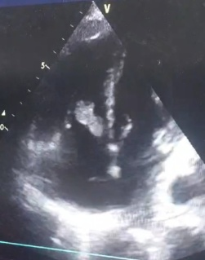

*Figure 1Transthoracic echocardiography showing large vegetations on the tricuspid valve.]*

*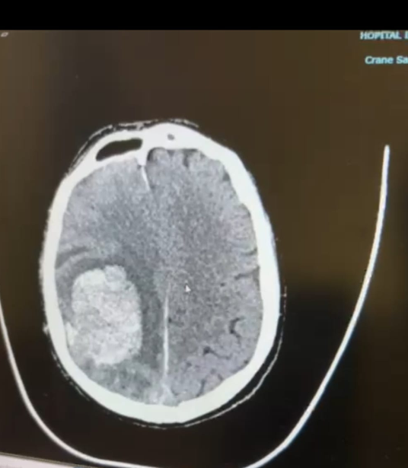Figure 2 CT scan showing acute intracerebral hemorrhage*

**Discussion:**

**This case illustrates several uncommon and severe aspects of right-sided infective endocarditis (RSIE). RSIE is most frequently encountered in young intravenous drug users, making our patient’s profile—an older diabetic woman without drug use—particularly atypical. While poorly controlled diabetes and a recent gluteal abscess were present, classical risk factors such as indwelling catheters or congenital heart disease were absent.  
Diagnosis of RSIE can be challenging due to its nonspecific presentation. Involvement of the tricuspid valve often lacks characteristic auscultatory findings such as murmurs and may remain undetected until complications arise. In this case, massive pulmonary embolism was the initial revealing feature. Embolization of septic thrombi or vegetations from the right heart to the pulmonary arteries can result in significant hypoxia and right ventricular strain. This pathophysiology was supported by thoracic CT findings demonstrating extensive pulmonary emboli.  
Neurological complications are seen in 10–35% of IE cases, and among these, intracranial hemorrhage accounts for approximately 12–30%. The mechanisms underlying cerebral hemorrhage in IE include rupture of mycotic aneurysms, hemorrhagic infarctions, or associated coagulopathy. In this patient, acute cerebral hemorrhage was a critical event that significantly worsened the prognosis.  
The combination of neurological injury and hemodynamic instability posed a major limitation to surgical intervention, despite the clear indication. Although timely administration of targeted antibiotic therapy remains the cornerstone of treatment, surgical management is warranted in selected cases with large vegetations or embolic complications. However, in this case, the extent of multi-organ failure restricted therapeutic options and contributed to the fatal outcome.**

**Conclusion :**

**Right-sided infective endocarditis remains a diagnostic and therapeutic challenge, particularly in patients without classical risk factors. This case highlights the need to maintain a high index of suspicion for RSIE in patients with septic pulmonary embolism and neurological symptoms, even in the absence of intravenous drug use. Early diagnosis through echocardiography and CT imaging, combined with aggressive medical or surgical management, may improve outcomes in selected cases.]**

**Consent**

As per international standards or university standards, patient(s) written consent has been collected and preserved by the author(s).

**Ethical Approval:**

As per international standards or university standards written ethical approval has been collected and preserved by the author(s).

Disclaimer (Artificial intelligence)

Option 1:

Author(s) hereby declare that NO generative AI technologies such as Large Language Models (ChatGPT, COPILOT, etc.) and text-to-image generators have been used during the writing or editing of this manuscript.

Option 2:

Author(s) hereby declare that generative AI technologies such as Large Language Models, etc. have been used during the writing or editing of manuscripts. This explanation will include the name, version, model, and source of the generative AI technology and as well as all input prompts provided to the generative AI technology

Details of the AI usage are given below:

1.

2.

3.

*References*

1. *Habib G, et al. 2015 ESC Guidelines for the management of infective endocarditis. Eur Heart J. 2015;36(44):3075–3128*
2. Nucifora, G., Badano, L., Hysko, F., Allocca, G., Gianfagna, P., & Fioretti, P. (2007). Pulmonary embolism and fever: when should right-sided infective endocarditis be considered?. Circulation, 115(6), e173-e176.
3. *Murdoch, D. R., Corey, G. R., Hoen, B., Miró, J. M., Fowler, V. G., Bayer, A. S., ... & International Collaboration on Endocarditis–Prospective Cohort Study (ICE-PCS) Investigators. (2009). Clinical presentation, etiology, and outcome of infective endocarditis in the 21st century: the International Collaboration on Endocarditis–Prospective Cohort Study. Archives of internal medicine, 169(5), 463-473.*
4. *Chahoud, J., Yakan, A. S., Saad, H., & Kanj, S. S. (2016). Right-sided infective endocarditis and pulmonary infiltrates: an update. Cardiology in review, 24(5), 230-237.*
5. *Shuang, L., Jiang, X., Yong, C., Jinghua, Y., Jianqun, Z., Xu, M., & Yinglong, L. (2014). Presenting features and clinical course of 34 patients with septic pulmonary embolism caused by right-sided infective endocarditis. Chinese Medical Journal, 127(15), 2735-2739.*
6. *Ge, W., Wu, B., Wang, Z., & Zhang, H. (2024). Right-sided infective endocarditis or thrombus? Report of two cases diagnosed by transthoracic echocardiography. Journal of Cardiothoracic Surgery, 19(1), 49.*
7. *Kang DH, et al. Early surgery vs conventional treatment for infective endocarditis. N Engl J Med. 2012;366(26):2466–2473.*
8. Shmueli, H., Thomas, F., Flint, N., Setia, G., Janjic, A., & Siegel, R. J. (2020). Right‐sided infective endocarditis 2020: challenges and updates in diagnosis and treatment. Journal of the American Heart Association, 9(15), e017293.
9. Ogata, T., Takahashi, S., Moriya, T., & Yamashita, T. (2025). Eventual resolution of pulmonary cavities following septic pulmonary embolism secondary to right-sided infective endocarditis. BMJ Case Reports CP, 18(8), e267535.
10. *García-Cabrera, E., Fernández-Hidalgo, N., Almirante, B., Ivanova-Georgieva, R., Noureddine, M., Plata, A., ... & González, A. D. A. (2013). Neurological complications of infective endocarditis: risk factors, outcome, and impact of cardiac surgery: a multicenter observational study. Circulation, 127(23), 2272-2284.*