**Enhancing Soybean Physiology Through Artificial Polyploidy Induction**

## Abstract

**Aims:** The present study aimed to investigate the in vitro induction of polyploidy in *Glycine max* (L.) Merr. (soybean) using colchicine, and to evaluate the subsequent effects on various morphological, physiological, and cytological characteristics, ultimately assessing its potential for crop improvement.

**Study design:** germinating soybean seeds were treated in vitro with varying concentrations of colchicine (0.03, 0.05, 0.08, 0.1%) for different durations (24 and 48 hours). Polyploidy induction was identified via applying different analyses including; morphological measurements, stomatal parameters, epidermal cell count, pollen grain size, chromosomal changes during metaphase and anaphase and genomic DNA optical density. The plant improvement was assessed by measuring the concentration of photosynthetic pigment, protein content, potassium and sodium ions ratio.

**Results:** treatment with 0.05% or 0.1% colchicine for 48 hours effectively induced polyploidy in soybean. Polyploid plants exhibited several desirable phenotypic changes, including darker and thicker leaves, increased plant height, and larger seeds with greater weights. Significant alterations were observed in stomata number, width, length, and index, as well as in epidermal cell count, although trichome numbers were unaffected. Cytological examination revealed increased cell size during metaphase and anaphase, larger pollen grains, higher genomic DNA optical density, and elevated concentrations of chlorophyll a, b, and carotenoids, along with increased protein content compared to diploid controls.

**Conclusion:** colchicine treatment can successfully induce polyploidy in *Glycine max*, leading to distinct morphological, physiological, and cytological alterations. The observed improvements in seed size, photosynthetic pigments, and protein content suggest that induced polyploidy holds significant promise for enhancing soybean characteristics.

***Keywords:*** polyploidy, colchicine, soybean, stomatal response, gigas, DNA content, morphological traits.

**Abbreviations:** FPP: first polyploidy, SPP: second polyploidy

**1. Introduction**

Polyploidy, the state of having more than two complete sets of chromosomes, is a fundamental process in plant evolution and a significant tool in plant breeding. Artificially induced polyploidy is a key strategy to enhance plant genetic makeup, leading to beneficial changes in morphological, anatomical, and physiological traits (Hannweg *et al.,* 2013; Huang *et al.,* 2014; Saeed *et al*., 2021). Over the past century, developing polyploid plant material has been a central goal in breeding programs due to the observed vigor and improved performance of polyploids over their diploid counterparts (Sattler *et al.,* 2016; Petr 2023). Polyploid plants often show increased tolerance to abiotic stresses like drought (Hannweg *et al.,* 2016; Venial et al., 2020) and exhibit enhanced morphological and yield-related traits, including greater plant height, larger storage organs, increased biomass, higher photosynthetic capacity, and larger reproductive structures (Urwin *et al.,* 2014). Polyploidy is commonly induced using mitotic spindle inhibitors such as colchicine and oryzalin. Colchicine is particularly effective and widely employed in plant systems Its mechanism involves disrupting spindle fiber formation during mitosis, preventing sister chromatid segregation and thereby leading to chromosome doubling (Urwin, 2014; Planchais *et al.,* 2000; Venial *et al*., 2020).

Within the Fabaceae family, the soybean (*Glycine max*) is an economically crucial flowering plant, serving as a major global source of protein and oil and contributing significantly to animal feed (Ekka and Lal, 2016; Krishnan, 2005; Garima *et al*., 2020, Kwadwo *et al.,* 2023). As a nitrogen-fixing crop, soybean is a staple food for over a billion people, especially in developing nations, and provides essential nutrients like phytoestrogens, amino acids, folates, and omega-3 fatty acids (Schmutz *et al.,* 2010; Garima *et al*., 2020, Kwadwo *et al.,* 2023). *Glycine max* is one of the most extensively cultivated crops globally and a significant agricultural commodity in international trade (AMIS, 2022). This research aims to produce more productive soybean plants via polyploidy tools.

**2. Material and methods**

**2.1 Seed treatment**

Twenty soybean seeds were disinfected, pre-soaked, and germinated on cotton for 4-7 days. Then, germinated seeds were treated with varying colchicine concentrations (0.0, 0.03, 0.05, 0.08 and to 0.1%) for 24 or 48 hours, thoroughly washed, and planted in a peat moss-sand mixture under controlled greenhouse conditions.

**2.2 Selection and Analysis of Putative Polyploid Plants**

Putative polyploid plants were identified and selected based on distinct morphological characteristics. These plants exhibited gigs feature, thicker and darker green leaves, and a noticeable delay in growth when compared to their diploid control counterparts.

**2.3 Analysis of Stomatal Behavior**

To analyze stomatal and epidermal cell density, clear nail polish impressions were made from the abaxial surface of three mature rosette leaves per treatment, examined under a light microscope, counting stomata and epidermal cells in three areas per patch to calculate the stomatal index using the formula:

s $tomatal index =\frac{total number of stomata per unite area}{No of stom per unite+ No of epidermal per unite area }× 100$

To analyze stomatal size and width, epidermal strips were taken from 3-5 leaves per treatment. Using an Olympus BX41 microscope with a digital camera, 40 stomata per treatment had their pore lengths and widths measured, totaling 120 measurements per group, following Colijn-Hooymans *et al.,* 1994.

**2.4 DNA Extraction from Soybean Leaves**

Genomic DNA was extracted from soybean leaves using a modified version of Edwards's buffer method that included sterilized sea sand for mechanical tissue disruption. DNA concentration was quantified by measuring optical density at 260 nm using spectrophotometry (Edwards *et al.,* 1991).

**2.5 Mitotic Index and Chromosome Number**

To determine the mitotic index (MI) and analyze chromosome numbers, secondary root tips from germinating seeds were treated with colchicine, collected, fixed in a solution of glacial acetic acid and alcohol for 24 hours. They were then hydrolyzed in HCl, stained with acetocarmine, squashed by coverslip on microscope slides. Three slides per treatment were analyzed, with five fields viewed per slide. MI was calculated using Grant's formula based on observations of 2,000 cells per slide, totaling 9,000 cells examined to assess colchicine’s effects on cell size, chromosome number, and MI (Grant 1982).

**2.6 Pollen Grain Size Measurement**

To examine pollen size with microscope, the glycerin jelly mounting method (Shaheen *et al.,* 2009) was used.

**2.7 Measurement of Photosynthetic Pigments**

Leaves were homogenized in 85% aqueous acetone at a ratio of 0.1 g fresh weight per 10 mL solvent. After centrifugation at 9,000 rpm and 5°C, the supernatant was analyzed using a spectrophotometer at different wavelengths, Arnon (1949). Pigment concentrations were calculated using standard formulas.

Chlorophyll a= (12.21*E633) – (2.81*E646)

Chlorophyll b= (20.13*E644) – (5.03*E663).

Carotenoids = (1000* E470 - 3.27*chl a - 104*chl b/229) (Wellborn *et al* 1984).

**2.8 Protein Extraction from Leaves**

Leaf tissue was ground into a powder with liquid nitrogen, and proteins were extracted using a buffer containing phosphoric acid, EDTA and β-mercaptoethanol. The mixture was centrifuged, the protein-containing supernatant was collected and stored at −80°C. Protein concentration was determined using the Bradford assay , with bovine serum albumin (BSA) as the standard, and absorbance measured at 595 nm (Bradford, 1976).

**2.9 Potassium and Sodium Ratio Measurement**

100 mg of leaf tissue was ground into a fine powder using liquid nitrogen, mixed with 1.5 mL of ultra-high purity water, allowed to defrost, transferred to new tubes, and heated at 95°C for one hour. After centrifugation to remove debris, K⁺ and Na⁺ concentrations in the supernatant were measured using flame photometry (Gaber *et al.,* 2009).

**2.10 Statistical Analysis**

The data were analyzed using two-way ANOVA, Statistical analysis was conducted with GenStat 7, and results were deemed significant when the Least Significant Difference (LSD) was below 0.05. Data are reported as mean ± SEM.

**3. Results**

**3.1** **Identification of polyploidy plant**

Colchicine treatments at 0.05% and 0.1% concentrations for 48 hours successfully induced polyploidy in soybean plants, producing first polyploids (FPP) and second polyploids (SPP), respectively. These treatments caused noticeable morphological and biological changes, enhancing plant traits. Importantly, seed germination remained high at 90% after seven days, indicating that the treatments effectively induced polyploidy without harming germination or causing adverse effects.

**3.1.2 Morphological characters**

Colchicine treatment of soybean seedlings for 48 hours induced polyploidy, marked by the visible "Gigas plant" trait as shown in figure 1. Polyploid plants were significantly shorter than controls; FPP: 21.75 cm, SPP: 20 cm vs. control: 33.5 cm (Figure 2), though stem diameter and branch count remained similar. Polyploid plants had darker green leaves and exhibited notable seed changes: seeds became larger and more spherical (FPP: 0.9 mm, SPP: 1.22 mm vs. control: 0.68 mm) as demonstrated in figure 3: A &B. Both dry and wet seed weights (Figure 4: A &B) increased significantly in polyploid groups, with SPP showing the highest increase.

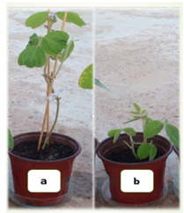

**Figure 1.** Images reflect different in plant height of control **(a)** and gagis polyploids plant **(b)**

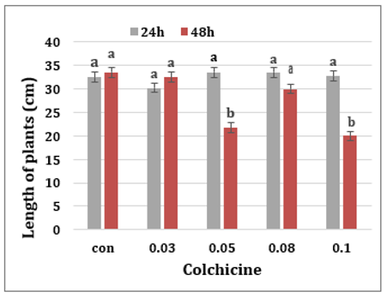

**Figure 2** The effect of selected doses of colchicine on the length of plants at 24 and 48hours (n= 5 readings). Error bars illustrate Stander Error. Significant differences at *P*˃0.05 demonstrated by lowercase letters.

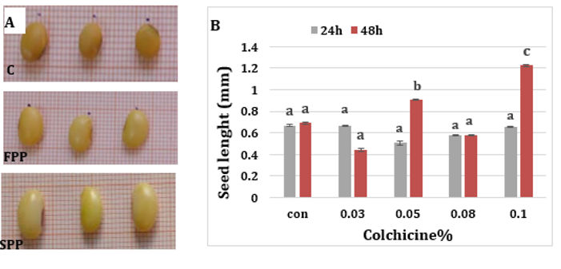

**Figure 3.** The effect of selected doses of colchicine on **(A)** the shape of soybean seeds. FPP seeds, SPP seeds and c their control. **(B)** seed length. (n= 5 readings). Error bars illustrate stander error. Significant differences at *P*˃0.05 demonstrated by lower case letters

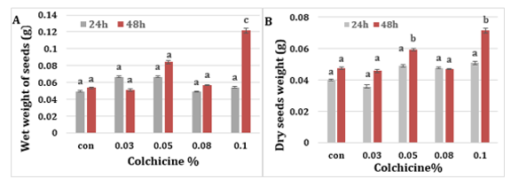

**Figure 4.** The effect of selected doses of colchicine on **(A)** seeds wet weight **(B)** seeds dry weight. (n= 5 readings). Error bars illustrate stander error. Significant differences at *P*˃0.05 demonstrated by lower case letters

**3.1.3 Stomatal, epidermal and trichome analysis**

Polyploids had larger but fewer stomata with average counts of 21 (FPP) and 24 (SPP) versus 44 in diploids (*P*<0.001, LSD=1.7). Stomatal length was significantly greater in polyploids (FPP: 23µm, SPP: 22µm vs. 17µm in controls; *P*<0.001 with LSD=0.2), as was stomatal width (both polyploids: 12µm vs. 7.8µm in controls; *P*<0.001 at LSD=0.12). Similarly, polyploid plants had fewer but larger epidermal cells (FPP: 96, SPP: 92 vs. 187 in controls; *P*<0.001, LSD=3.3). Despite fewer stomata, stomatal density was significantly higher in polyploid plants compared to diploids as illustrated in figure 5: A-F. Thorough examination of plants with multiple chromosomal sets reveled lack of variation in trichome characteristics where control had 43, FPP: 42 and SPP: 45. No differences were found in trichome density, length, or size and none of trichomes exhibited brunching.

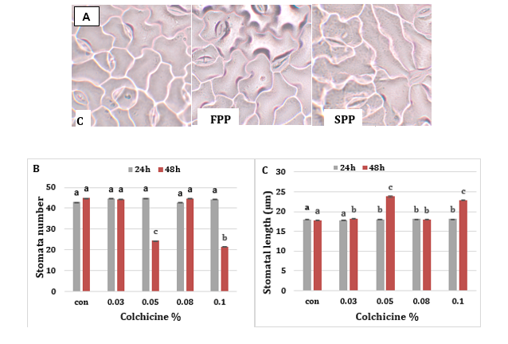

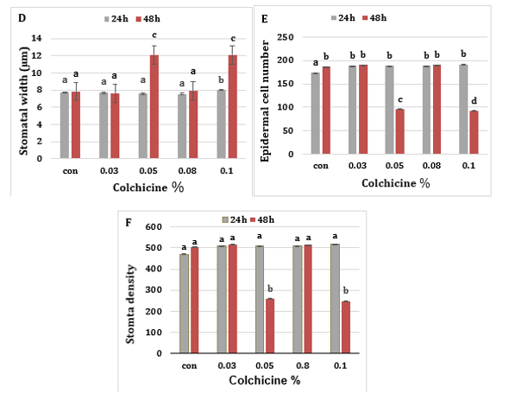

**Figure 5.** The effect of selected doses of colchicine on stomatal response; **(A)** images showing stomata and epidermis taken from the middle of fully extended leaves of control, FPP and SPP, **(B)** stomatal number **(C)** stomatal length **(D)** stomatal width **(E)** Epidermal cell number **(F)** stomatal density, (n= 5 readings). Error bars illustrate stander error. Significant differences at *P*˃0.05 demonstrated by lowercase letters

**3.1.4 pollen grain size**

The study found a positive correlation between pollen grain size and colchicine concentration. Figure 6: A and B show significant differences (*P*>0.001, LSD = 0.75) in pollen grain size between putative polyploids and their diploid counterparts. Specifically, the pollen grain diameter of both first polyploids (FPP) and second polyploids (SPP) increased to 25 µm, compared to the control group's pollen grains which measured 22 µm in diameter.

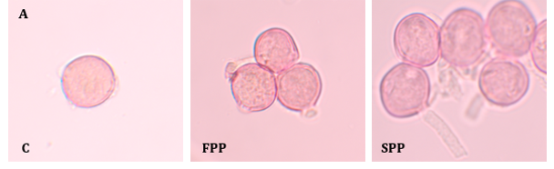

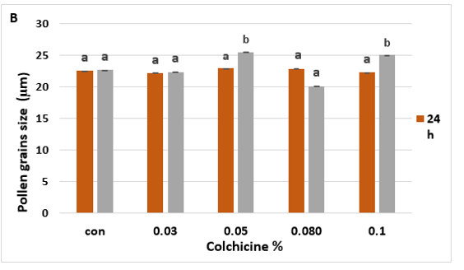

**Figure 6**. **(A)** Images showing the changes of pollen grain size of diploids, FPP and SPP. **(B)** The effect of selected doses of colchicine on pollen grain size (n= 5 readings). Error bars illustrate stander error. Significant differences at *P*˃0.05 demonstrated by lowercase letters

**3.1.5 Chromosome examination**

Initially, mitotic index (MI) studies were conducted to pinpoint the optimal colchicine doses and exposure times needed for chromosome doubling. When root tip cells were exposed to varying colchicine concentrations, significant changes were observed in the percentages of cells in metaphase and anaphase (Table 1). The study revealed that both first polyploids (FPP) and second polyploids (SPP) showed a significant increase (*P*<0.01, LSD = 17 for metaphase; *P*<0.01, LSD = 15 for anaphase) percentages compared to control groups. Conversely, there were no significant differences in the frequency of cells in prophase and telophase between diploid and polyploid cells. Additionally, enlarged cells were frequently observed in both FPP and SPP plants (Figure 7).

**Table 1** Number, phase index of the different stages of mitosis and interphase for the control and treated cells at different concentrations of colchicine treatments total dividing cells, PI: Prophase index, MI: Metaphase index, AI: Anaphase index, TI: Telophase index

|  |  |  |  |  |  |  |  |  |  |  |  |
| --- | --- | --- | --- | --- | --- | --- | --- | --- | --- | --- | --- |
|  | INT | PRO | MET | ANA | TEL | TOTAL | PI | MI | AI | TI | Mitotic index |
| Con 24 | **3890** | **1000** | **105** | **101** | **794** | **5890** | **50±9.6**a | **5.25±2.2a** | **5.05±1.8 a** | **39.7±3.9a** | **33.9a** |
| 1 | **3975** | **996** | **102** | **96** | **806** | **5975** | **49.8±31.1**a | **5.1±2.4a** | **4.8±0.5 a** | **40.3±18.9a** | **33.4a** |
| 2 | **3998** | **902** | **99** | **103** | **896** | **5998** | **45.1±7.5**a | **4.9±2.02a** | **5.1±2.02 a** | **44.1±8.4a** | **33.3a** |
| 3 | **3820** | **978** | **102** | **108** | **812** | **5820** | **48.9±7.5**a | **5.1±1.15a** | **5.4±2.02 a** | **40.6±10.2a** | **34.3a** |
| 4 | **4020** | **902** | **109** | **105** | **884** | **6020** | **45.1±0.1**a | **5.4±1.8a** | **5.2±0.8 a** | **44.2±16. a** | **33.2a** |
| Con 48 | **3993** | **960** | **103** | **98** | **839** | **5995** | **48±5.7**a | **5.1±1.6a** | **4.9±1.07 a** | **41.9±17.6a** | **33.3a** |
| 1 | **4018** | **988** | **91** | **99** | **822** | **6018** | **49.4±24.3**a | **4.5±0.09a** | **4.9±0.8 a** | **41.1±18.2**a | **33.3a** |
| 2 | **4021** | **870** | **157** | **176** | **797** | **6021** | **43.5±14.2**a | **7.8±0.6b** | **8.8±2.5b** | **39.8±9.4a** | **33.2a** |
| 3 | **3894** | **951** | **89** | **90** | **870** | **5894** | **47.5±4.9**a | **4.4±1.6a** | **4.5± 0 a** | **43.5±16.9a** | **33.9a** |
| 4 | **3981** | **925** | **173** | **162** | **740** | **5981** | **46.2±2.4**a | **8.6±2.2b** | **8.1±1.1b** | **37±13.4a** | **33.4a** |

* Small letters indicate statistical differences.

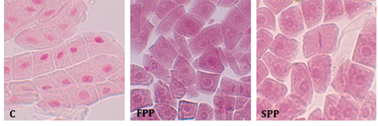

**Figure 7.** Images of mitotic cells taken from soybean root tips of control and polyploidy plants

**3.1.6 Molecular Confirmation of Polyploidy**

This study focused on DNA analysis of polyploids induced by 0.05% and 0.1% colchicine with 48-hour incubation, as these were the only treatments that successfully generated polyploids. To confirm the morphological and microscopic observations, genomic DNA was extracted from both polyploid and diploid leaves. DNA quantification via spectrophotometry at 260 nm revealed a significant increase in DNA content in polyploids, consistent with chromosome doubling. Diploid plants had an average of 42 ng of DNA, while first putative polyploid (FPP) plants showed 95 ng, and second putative polyploid (SPP) plants had 110 ng (Figure 8). These differences in mean DNA content were statistically significant (*P*<0.001, LSD = 19.9), confirming the successful induction of polyploidy.

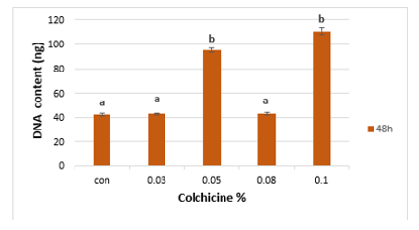

**Figure 8.** The effect of selected doses of colchicine on DNA content (n= 5 readings). Error bars illustrate stander error. Significant differences at *P*˃0.05 demonstrated by lowercase letters

**3.2 The assessment of improvement of polyploidy plants**

**3.2.1 Improved Photosynthetic Pigments in Polyploids**

This study investigated whether polyploid plants exhibit improvements in key physiological traits related to photosynthetic pigments. It found that polyploid soybeans showed significant increases at *P*< 0.003 with LSD=2.9 in chlorophyll a, chlorophyll b, and carotenoid content compared to diploid controls as demonstrated in figures 9 and 10 respectively. Chlorophyll a was significantly higher in FPP (11 mg/g) and SPP (9.8 mg/g) than in diploids (5.3 mg/g). Chlorophyll b levels were also elevated in FPP (5.4 mg/g) and SPP (5.9 mg/g) versus the control (2.02 mg/g). Additionally, carotenoid content was significantly greater in FPP at 865 mg/g and SPP at 719.6 mg/g compared to diploids at 532 mg/g (*P*<0.009, LSD=259.5).

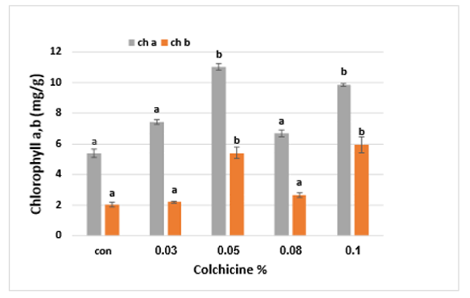

**Figure 9.** Illustrate the concentration of Chlorophyll a andb of soybeans after 48 hours of colchicine treatments (n= 5 readings). Error bars illustrate stander error. Significant differences at *P*˃0.05 demonstrated by lowercase letters

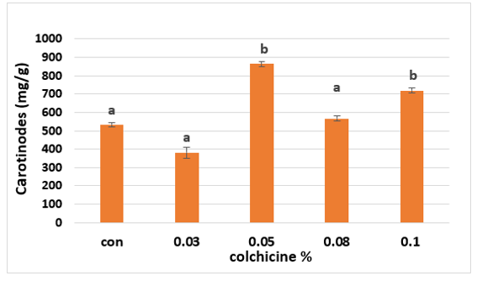

**Figure 10**. Illustrate the concentration of carotenoid of soybeans after 48 hours of colchicine treatments (n= 5 readings). Error bars illustrate stander error. Significant differences at *P*˃0.05 demonstrated by lowercase letters.

**3.2.2 Enhanced Total Protein in Polyploid Plants**

The study used the Bradford protein assay with a Bovine Serum Albumin (BSA) standard curve to measure total protein content. Results (Figure 11) showed that polyploid plants had significantly higher soluble protein levels than diploids (*p*<0.003) that averaged 17.7 µg/mL of protein, while polyploid plants treated with 0.05% colchicine for 48 hours reached 28.2 µg/mL, and those treated with 0.1% colchicine reached 23 µg/mL.

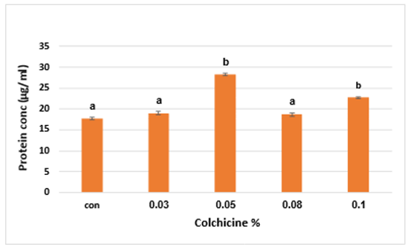

**Figure 11.** Illustrate total protein content in soybean plants subjected to varying concentrations of colchicine for 48 hours. n= 5 readings, Error bars represent the standard error, significant differences at *P*˃ significant differences at demonstrated by lowercase letters.

**3.2.3 Potassium (K) and Sodium (Na) ion ratios.**

Applying colchicine at 0.05% and 0.1% for 48 hours significantly increased both sodium (Na) and potassium (K) ion levels in soybeans as shown in figure 12. Sodium levels in first polyploids (FPP) rose to 46.5 ppm and in second polyploids (SPP) to 49.5 ppm, a substantial jump from the control's 12 ppm (*p*<0.001, LSD = 11.7). Similarly, potassium levels improved, with first polyploids reaching 99.0 ppm and second polyploids 100.5 ppm, both notably higher than the diploid control's 76.5 ppm (*p*<0.003, LSD = 12.1).

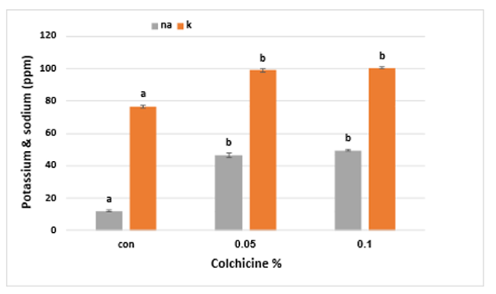

**Figure 12**. Illustrate sodium and potassium ion levels in soybean plants subjected to varying concentrations of colchicine for 48 hours. n= 5 readings, Error bars represent the standard error, significant differences at *P*˃0.05 demonstrated by lowercase letters.

**4. Discussion**

**4.1 Identification of polyploidy plants**

**4.1.1 Optimization of Colchicine Concentration and Incubation Time:** our research demonstrated that out of various concentrations and incubation periods, 0.05% and 0.1% colchicine concentrations applied for 48 hours yielded the most favorable results in soybean. This optimization is critical, as previous studies report a wide range of effective colchicine concentrations across different plant species (Castro *et al* 2018). It's also known that excessive concentrations can lead to plant malformations and reduced polyploid production (Pirkoohi *et al* 2011). Achieving chromosome doubling, which involves duplicating genetic content by disrupting cellular processes, requires a careful balance of concentration and exposure (Eng and Ho, 2019; Ascough *et al.,* 2008).

**4.1.2 Morpho-Cytological and Molecular Indicators of Polyploidy:** polyploid plants exhibit noticeable differences in external traits compared to their diploid counterparts, particularly in the size and shape of roots, stems, leaves, flowers, and fruits (Hannweg *et a*l. 2016). While morphological parameters are often initial indicators, they are not always entirely reliable. In our study, both FPP and SPP showed a "gigas" effect, meaning they were larger than their diploid relatives, with highly significant variations in length. This "gigas" effect, resulting from larger cell sizes and a reduced surface area to volume ratio, is a common consequence of polyploidization, leading to thicker stems and larger, darker green leaves (Prashant and Rakesh 2004). Regarding seed characteristics, FPP and SPP seeds were distinctly larger and different in shape from diploid seeds, accompanied by an increase in both dry and wet weight. These findings align with previous reports of colchicine-induced polyploidization leading to enhanced morphological traits (Martelotto *et al*., 2005; Shao *et al*., 2003).

**4.1.3 Microscopic examination of plant structures**: stomatal size, particularly stomata length, is a well-established indicator of ploidy levels. In our study, induced soybean polyploids showed a significant decrease in stomatal density and exhibited significantly longer stomata compared to diploids. These results are consistent with the general understanding that tetraploids have larger but fewer stomata than diploids (Huang *et al*., 2014; Miguel and Leonhardt, 2011; Heping *et al*., 2008; Gallone *et al*., 2014). Regarding pollen grains, polyploidy typically leads to larger blooms and pollen grains, with an increased pollen grain diameter being a notable physical characteristic. Our results showed clear size differences in pollen grains between polyploids and diploids, aligning with numerous comparative studies (Oliveira *et al.,* 2022).

**4.1.4 Direct Methods for Ploidy Confirmation:** while stomata analysis and pollen grain size are useful indirect methods for initial screening of polyploid plants, direct methods like chromosome counting and DNA content measurement are considered definitive. These direct methods are widely recognized as the most accurate and reliable for confirming polyploidization (Aina, *et a*l., 2012; Aleza *et a*l., 2012; Dhooghe *et al.,* 2011).Colchicine induces polyploidy by inhibiting microtubule development, which are crucial for chromosome segregation during cell division (Ade and Rai, 2010, El-Nashar and Ammar, 2016). By acting as a mitotic toxin, colchicine blocks chromosome segregation at metaphase, leading to a doubling of the chromosome number (Caperta *et al.,* 2006). Our observations revealed an increase in the number of cells in both metaphase and anaphase, consistent with colchicine's effect of halting chromatid separation (Ray *et al.,* 2012, Planchais *et al.,* 2000, Barman *et al.,* 2020). Understanding how nuclear volume is directly determined by changes in bulk DNA amount caused by polyploidy is crucial. Spectrophotometry, a precise method for estimating plant nuclear DNA, showed that the DNA content of the polyploids was double that of the diploids. Untreated plants had an average DNA content of 42 ng, while FPP and SPP plants exhibited 95 ng and 110 ng, respectively, confirming the successful induction of polyploidy. These findings are consistent with related research conducted by Colijn-Hooymans *et al.*, (1994).

**4.2 Enhancements in Polyploidy Plants**

**4.2.1 Increased Protein and Photosynthetic Pigment Content:** our study revealed a significant increase in protein concentration in polyploid soybeans, aligning with numerous studies demonstrating that chromosome doubling can lead to larger seeds and higher protein levels in various crops. For instance, tetraploid *Moringa oleifera Lam* (Zhang, J *et al.,* 2020) and *Pontianak taro tubers* showed enhanced protein content (Mahanta *et al*., 2023). This is likely due to the larger genomes of tetraploid plants, which are hypothesized to result in larger cells capable of holding more water and other metabolites, including proteins. Furthermore, polyploids exhibited higher levels of chlorophyll a and b, as well as carotenoids, leading to their observed darker green leaves. This indicates an increased photosynthetic capacity and activity, allowing for greater conversion of photosynthetic products. This finding is consistent with research showing that polyploid induction often results in higher chlorophyll content, enhancing photosynthetic ability and leading to greater yields than diploids. Increased carotenoid content also suggests enhanced transpiration and photosynthetic processes in tetraploid plants (Šmarda *et al*., 2018, De J *et al.,* 2016, Wee *et al*., 2021).

**4.2.2 Improved Ion Homeostasis and Stress Tolerance:** polyploid plants demonstrate improved resistance to biotic and abiotic stressors. Notably, polyploid plants exhibit a more balanced potassium-sodium (K+/Na+) homeostasis (Nieves-Cordones *et al.,* 2016; Isayenkov and Maathuis, 2019), which is critical for salinity tolerance (Wu *et al.,* 2018). Maintaining high K+ uptake and tissue concentration is crucial as K+ competes with Na+ for similar ion channels, transporters, and active sites, preventing Na+ accumulation and functional disruption. For example, polyploid *Arabidopsis* shows greater salinity tolerance due to increased K+ uptake and decreased Na+ buildup in leaves, an effect largely dependent on rootstock polyploidy rather than shoot cytotype (Chao *et al.,* 2013). This suggests that grafted crops using polyploid rootstocks could inherit this root-dependent trait. Other plants like hexaploid bread wheat (Yang *et al.,* 2014), *Ipomoea trifida* (Liu *et al*., 2019) and "Carrizo" citrange have also shown enhanced K+ retention under salt stress (Ruiz *et al.*, 2016). While the exact mechanism of this ploidy-driven differential cation regulation is still being investigated, these findings are consistent with our study's observation that polyploid induction increases potassium and sodium percentages,

**Conclusions:** in our *in vitro* study**,** identified effective colchicine concentrations (0.05 & 0.1%) and exposure time (48h) for generating polyploid plants. Found that measuring OD of total DNA content via spectrophotometry served as an easy and reliable way to identify these putative polyploids. Observable changes in polyploid plants, increased plant height, leaf thickness, and overall leaf size. Stomata length and width were increased in polyploid plants, while the stomata index (density) was decreased. Finally, by employing these diverse methods, we conclude that all of them can be successfully used to induce polyploidy plants, offering a wide array of benefits ranging from increased size and yield to enhanced stress tolerance and improved nutritional content.

Disclaimer (Artificial intelligence)

Author(s) hereby declare that NO generative AI technologies such as Large Language Models (ChatGPT, COPILOT, etc.) and text-to-image generators have been used during the writing or editing of this manuscript.

**References**

Ade, R., & Rai, M. K. (2010). Colchicine, Current Advances and Future Prospects. *Nusantara Bioscience*, *2*(2), 90-96.

Aina, O., Quesenberry, K., & Gallo, M. (2012). In vitro induction of tetraploids in Arachis paraguariensis. *Plant Cell, Tissue and Organ Culture*, *111*(2), 231–238.

Aleza, P., Juarez, J., Cuenca, J., Ollitrault, P., & Navarro, L. (2012). Extensive citrus triploid hybrid production by 2x × 4x sexual hybridizations and parent-effect on the length of the juvenile phase. *Plant Cell Reports*, *31*(9), 1723–1735.

AMIS. (2022). “Market Database.” Agricultural Market Information System. USDA.

Arnon, D. I. (1949). Copper Enzymes in Isolated Chloroplasts Polyphenol Oxidase In Beta Vulgaris. *Plant Physiol*, *24*, 1-15.

Ascough, G. D., Van Staden, J., & Erwin, J. E. (2008). Effectiveness of Colchicine and Oryzalin at Inducing Polyploidy In Watsonia Lepida N.E. Brown. *HortScience*, *43*(7), 2248-2251.

Barman, M., Singh, H. A., & Bhorali, J. (2020). Systemic Control of Cell Division and Endoreduplication by NAA and BAP by Modulating CDKs in Root Tip Cells of Allium cepa. *International Journal of Science and Research (IJSR)*, *9*(11), 160-164.

Bradford, M. M. (1976). A Rapid And Sensitive Method For The Quantitation Of Microgram Quantities Of Protein Utilizing The Principle Of Protein-Dye Binding. *Analytical Biochemistry*, *72*, 248-254.

Caperta, A. D., Delgado, M., Ressurreição, F., Meister, A., Jones, R. N., Viegas, W., & Houben, A. (2006). Colchicine-induced polyploidization depends on tubulin polymerization in c-metaphase cells. *Protoplasma*, *227*(2-4), 147–153.

Castro, M., Castro, S., & Loureiro, J. (2018). Production of Synthetic Tetraploids as a Tool for Polyploid Research. *Web Ecol*ogy, *18*, 129-41.

Chao, C. T., Li, Y. Y., & Tsai, P. P. (2013). Genomic insights into polyploid formation and evolution in plants. *Current Genomics*, *14*(4), 229–241.

Colijn-Hooymans, C., Hakkert, J., Jansen, J., & Custers, J. (1994). Competence For Regeneration Of Cucumber Cotyledons Is Restricted To Specific Developmental Stages. *Plant Cell, Tissue Organ Cult*, *39*, 211–217.

De J., D. S., Gomes, V., Da S., S. A., Aud, F., Santos-Serejo, J., & Oliveira, E. (2016). Inducing Autotetraploids In Cassava Using Oryzalin And Colchicine And Their In Vitro Morpho Physiological Effects. *Genetics and Molecular Research: Gmr*, *15*(2), Article ID gmr.15028456.

Dhooghe, E., Van Laere, K., Eeckhaut, T., Leus, L., & Van Huylenbroeck, J. (2011). Mitotic Chromosome Doubling Of Plant Tissues In Vitro. *Plant Cell, Tissue Organ Culture*, *104*, 359–373.

Edwards, K., Johnstone, C., & Thompson, C. (1991). A Simple And Rapid Method For The Preparation Of Plant Genomic Dna For Pcr Analysis. *Nucleic Acids Research*, *19*(6), 1349.

Ekka, N. P., & Lal, G. M. (2016). Study On Genetic Variability And Character Association In Soybean (Glycine Max L. Merrill) Germplasm At Vindhyan Zone Of Uttar Pradesh. *Agricultural Science Digest - A Research Journal*, *36*, 69-71.

El-Nashar, Y., & Ammar, M. (2016). Mutagenic Influences of Colchicine on Phenological and Molecular Diversity of Calendula Officinalis L. *Genetics and Molecular Research*, *15*(2), 1-15.

Eng, W.H., & Ho, W.S. (2019). Polyploidization Using Colchicine In Horticultural Plants: A Review. *Scientia Horticulturae*, *246*, 604-617.

Gaber, M. Abogadallaha, Mamdouh M. Seragb, & William Paul Quicka. (2009). Fine And Coarse Regulation Of Reactive Oxygen Species In The Salt Tolerant Mutants Of Barnyard Grass And Their Wild-Type Parents Under Salt. *Physiologia Plantarum*, *138*(2).

Gallone, A., Hunter, A., & Douglas, G. C. (2014). Polyploid Induction In Vitro Using Colchicine And Oryzalin On Hebe'Oratia Beauty': Production And Characterization Of The Vegetative Traits. *Scientia Horticulturae*, *179*, 59-66.

Grant, W. F. (1982). Chromosome Aberration Assays In Allium: A Report Of The Us Environmental Protection Agency Gene-Tox Program. *Mutation Research/Reviews in Genetic Toxicology*, *99*, 273-291.

Hannweg, K., Sippel, A., & Bertling, I. (2013). Ploidy stability and growth of micropropagated Carica papaya L. plants. *South African Journal of Botany*, *88*, 367-372.

Hannweg, K., Visser, G., De Jager, K., & Bertling, I. (2016). In Vitro-Induced Polyploidy and Its Effect on Horticultural Characteristics, Essential Oil Composition and Bioactivity of Tetradenia Riparia. *South African Journal of Botany*, *106*, 186–191.

Heping, H., Shanlin, G., Lanlan, C., & Xiaoke, J. (2008). In Vitro Induction and Identification of Autotetraploids of Dioscorea Zingiberensis. *In Vitro Cellular & Developmental Biology-Plant*, *44*, 448-455.

Huang, H., Gao, S., Wang, D., Huang, P., & Li, J. (2014). Autotetraploidy Induced In Nianmaohuangqin (Radix Scutellariae Viscidulae) With Colchicine In Vitro. *Journal Of Traditional Chinese Medicine*, *34*, 199-205.

Isayenkov, S. V., & Maathuis, F. J. M. (2019). Plant salinity stress: from sensing to adaptation. *Journal of Experimental Botany*, *70*(14), 3465–3469.

Krishnan, H. B. (2005). Soybean proteins: Processing and utilization. In J. N. Culver & R. B. Goldberg (Eds.), *Soybean: Genetics, biochemistry and molecular biology* (pp. 577–602). CABI Publishing.

Liu, X., Liu, Y., Zhao, W., Ji, M., Lin, J., Zhang, Q., & Yuan, L. (2019). Genome-wide identification and expression analysis of the WRKY gene family in Brassica napus under various abiotic stresses. *BMC Plant Biology*, *19*(1), 1-17.

Mahanta, S., Barooah, A., Choudhury, H., & Sarmah, D. (2023). Nutritional composition of taro (Colocasia esculenta L. Schott) landraces from Assam, India. *Journal of Food Science and Technology*, *60*(1), 183-192.

Martelotto, L. G., Pupilli, F., & Arcioni, S. (2005). A comprehensive analysis of gene expression alterations in a newly synthesized Paspalum notatum autotetraploid. *Plant Science*, *169*(2), 211–220.

Miguel, T. P., & Leonhardt, K. W. (2011). In Vitro Polyploid Induction Of Orchids Using Oryzalin. *Scientia Horticulturae*, *130*, 314-319.

Nieves-Cordones M, Al-Harbi AM, Santa-María GE, & Rubio F. (2016). Roles and transport of sodium and potassium in plants. *Plant and Cell Physiology*, *57*(5), 935–946.

Oliveira, W., Silva, J. L. S., Cruz-Neto, O., Oliveira, M. T. P., Fernandes De Albuquerque, I., Borges, L. A., & Lopes, A. V. (2022). Higher Frequency of Legitimate Pollinators and Fruit Set Of Autotetraploid Trees of Libidibia Ferrea (Leguminosae) Compared To Diploids In A Mixed Tropical Urban Population. *Journal of Plant Research*, *135*, 235-245.

Pirkoohi, M. H., Keyvanloo, M., & Hassanpur, M. (2011). Colchicine Induced Polyploidy In Mint By Seed Treatment. *International Journal of Agriculture and Crop Sciences*, *3*, 102-104.

Planchais, S., Glab, N., Inze, D., & Bergounioux, C. (2000). Chemical Inhibitors: A Tool for Plant Cell Cycle Studies. *FEBS Letters*, *476*, 78–83.

Joshi, P., & Verma, R. C. (2004). High Frequency Production Of Colchicine Induced Autotetraploids In Faba Bean (Vicia Faba L.). *Cytologia*, *69*(1), 81-88.

Ray, S., Koley, S., Das, K., & Chaudhuri, S. (2012). Metaphase arrest and delay in cell cycle kinetics of root apical meristems and mouse bone marrow cells treated with leaf aqueous extract of Clerodendrum viscosum Vent. *Asian Pacific Journal of Cancer Prevention*, *13*(8), 3843-3848.

Ruiz, J. M., Riquelme, A., Marín, L. M., Pérez-Alfocea, F., & Egea, I. (2016). Melatonin enhances the tolerance of tomato plants to drought stress by modulating photosynthesis and antioxidant defense. *Journal of Plant Physiology*, *205*, 78–85.

Saeed, M., Ahmad, T., & Iqbal, N. (2021). Induced Polyploidy: A Tool for Forage Species Improvement. *Agriculture*, *11*(3), 210.

Sattler, M. C., Carvalho, C. R., & Clarindo, W. R. (2016). The Polyploidy And Its Key Role In Plant Breeding. *Planta*, *243*(2), 281–296.

Schmutz, J., Cannon, S. B., Schlueter, J., et al. (2010). Genome Sequence Of The Palaeopolyploid Soybean. *Nature*, *463*, 178–183.

Shaheen, N., Khan, M. A., Yasmin, G., Hayat, M. Q., & Ali, S. (2009). Taxonomic Implication Of Palynological Characters In The Genus Malva L., Family Malvaceae From Pakistan. *American-Eurasian Journal of Agricultural & Environmental Sciences*, *6*, 716-722.

Shao, H. B., Liang, Z. S., Shao, M. A., & Wang, B. C. (2003). Changes of antioxidant enzymes under salt stress in Pennisetum glaucum. *Plant Science*, *165*(5), 1037–1044.

Šmarda, P., Horová, L., Knápek, O., Dieck, H., Dieck, M., Ražná, K., Hrubík, P., Orlóci, L., Papp, L., & Veselá, K. (2018). Multiple Haploids, Triploids, And Tetraploids Found In Modern-Day"Living Fossil"Ginkgo Biloba. *Horticulture Research*, *5*, 1-12.

Urwin, N. A. (2014). Generation and Characterisation Of Colchicine-Induced Polyploid Lavandula intermedia. *Euphytica*, *197*(3), 331–339.

Venial, L. R., Mendonça, M. A. C., Amaral-Silva, P. M., Canal, G. B., Passos, A. B. R. J., Ferreira, A., Soares, T. C. B., & Clarindo, W. R. (2020). Autotetraploid Coffea canephora and Auto-Alloctaploid Coffea arabica From In Vitro Chromosome Set Doubling: New Germplasms for Coffea. *Frontiers in Plant Science*, *11*, 154.

Wee, E., Ho, C. L., Sim, N. J. Y., Chee, C. J. Y., Li, S., Tong, Z., ... & Chew, J. (2021). Genome-wide identification of genes involved in salicylic acid biosynthesis and signaling in Tetrastigma leucostaphylum and expression analysis in response to Colletotrichum gloeosporioides infection. *Physiologia Plantarum*, *173*(2), 523–539.

Wellborn, A., & Lichtenhaler, H. (1984). Formulae program to ditermine total crotenoids A and chlorophyll and B lef extrcts in different solvents. In C. Sypesma (Ed.), *Advances In Photosynthesis Research* (Vol. II, pp. 9-12).

Wu, J., Zhang, X., Li, J., Yan, C., Shi, P., & Zhang, Y. (2018). Roles of plant miRNAs in abiotic stress responses. *Journal of Plant Physiology*, *229*, 168–176.

Yang, Z., Liu, S., Li, B., Chen, S., Wang, H., & Wang, Y. (2014). Variation in root system architecture of hexaploid wheat (*Triticum aestivum* L.) under different phosphorus supplies. *Journal of Plant Nutrition*, *37*(12), 2008-2023.

Zhang, J., Pian, R., Yang, E., Zhou, W., He, Q., & Chen, X. (2020). In Vitro Induction And Characterisation Of Tetraploid Drumstick Tree (Moringa Oleifera Lam.). *Open Life Sciences*, *15*, 840–847.