**KOLAVIRON MODULATES GLUCOSE METABOLISM-ASSOCIATED GENES IN STREPTOZOTOCIN-INDUCED DIABETIC WISTAR RATS**

**ABSTRACT**

**Background:** Despite advances in diabetic treatment, side effects of antidiabetic drugs, including hypoglycemia and allergic reactions, drive the search for safer natural alternatives. Kolaviron (KV), a biflavonoid complex from Garcinia kola, has demonstrated antihyperglycemic properties, but its molecular impact on glucose metabolism-related genes remains understudied. This study aims to evaluate the effects of KV on Aryl hydrocarbon receptor nuclear translocator-like protein 1 (ARNT), Rat Insulin-2 (RATINS), Glucose transport type 4 (GLUT-4), and Toll-like receptor type 4 (TLR-4) gene expressions in streptozotocin-induced diabetic Wistar rats. **Materials and Methods:** A total of 22 adult male and female Wistar rats weighing 200–250 g were divided into five groups. Diabetes was induced in 20 rats using 42 mg/kg streptozotocin (STZ). Animals were grouped into five: Group A (non-diabetic control, n=2), Group B (untreated diabetic, n=2), Group C (diabetic, metformin 100 mg/kg, n=6), Group D (diabetic, KV 100 mg/kg, n=6), and Group E (diabetic, KV 200 mg/kg, n=6). Treatments lasted three months. Blood glucose and HbA1c were assessed monthly. mRNA expression of target genes was evaluated by qPCR. Sequence variations were analyzed using Sanger sequencing. **Results:** KV at 100 and 200 mg/kg body weight significantly reduced blood glucose and HbA1c levels (P<0.001). There was a significant upregulation of ARNT, RATINS, GLUT-4, and TLR-4 in KV-treated groups, with minor fluctuations in some months. A silent A→G mutation was detected at amino acid 885 of TLR-4 without altering protein function. **Conclusion:** KV improved glycemic control and modulated key genes in glucose metabolism without inducing harmful mutations, supporting its potential as a natural antidiabetic agent.

**Keywords:** Diabetes, kolaviron, streptozotocin, ARNT, RATINS, GLUT-4, TLR-4.

**1. INTRODUCTION**

Medicinal plants have gained global interest as affordable and accessible treatments for chronic diseases, particularly diabetes mellitus [1]. Despite the availability of numerous standard drugs like insulin and oral hypoglycemic agents, issues like adverse effects, high cost, limited accessibility in low-resource settings, and the emergence of drug resistance highlight the urgent need for alternative remedies [2]. Many traditional medicinal plants have demonstrated promising antidiabetic properties, including antioxidant, hypoglycemic, and insulin-sensitizing effects, and continue to be investigated for their bioactive phytochemicals and mechanisms of action [3 and 4]. Consequently, integrating ethnomedicinal knowledge with modern scientific validation offers a sustainable pathway for developing safer, cost-effective treatments to manage and prevent diabetes and its complications.

*Garcinia kola*, commonly called bitter kola, is a plant native to West and Central Africa. Its biflavonoid extract, KV, has exhibited antioxidant, anti-inflammatory, and hypoglycemic properties in various *in vivo* and *in vitro* studies [5]. Previous studies primarily focused on its biochemical effects using ELISA and histology, but the genetic pathways involved remain scarcely understood [6].

Several genes regulate glucose metabolism, such as Aryl hydrocarbon receptor nuclear translocator (ARNT), which is essential for insulin signaling and glucose homeostasis [7]. RATINS (Rat Insulin-like gene) regulates pancreatic insulin synthesis [8], while the Glucose Transport type 4 genes (GLUT-4) facilitate insulin-stimulated glucose uptake [9]. Toll-like receptor type genes (TLR-4) are linked to inflammation-mediated insulin resistance [10]. Understanding kolaviron’s effect on these genes could broaden its therapeutic profile and elucidate the molecular pathways involved in its antidiabetic actions. Against this background, this study aimed to determine the effect of kolaviron on some genes associated with glucose metabolism in STZ-induced diabetic Wistar rats.

**2. MATERIALS AND METHODS**

**2.1 Plant Collection and Identification**

*Garcinia kola* seeds were purchased from a market in the city of Ilorin, Nigeria, and were authenticated at the Plant Biology Herbarium, University of Ilorin by Bolu Ajayi (voucher no: UILH/001/1217/2024).

**2.2 Plant Extraction Preparation**

Fresh *Garcinia kola* seeds were dried and pulverized, and about 100 g of the powder was defatted using petroleum ether. The ethanolic extraction was carried out at room temperature (18-22°C) as described by [11] using a Soxhlet apparatus (Infitek, SE-6P, China).

**2.3 Animal Housing**

The study was carried out at the University of Benin, Benin City, Nigeria. Thirty-two Wistar rats (10–15 weeks, ~230 g) were acclimatized for one week under standard laboratory conditions at the Animal House of the Department of Anatomy, University of Benin, Benin City. Food and water were provided ad libitum.

**2.4 Acute Toxicity (LD₅₀) Test**

Acute oral toxicity was assessed by administering single doses of 1,000–5,000 mg/kg KV as previously described by Locke’s method [12]. No mortality or behavioral changes were observed after 24–72 hours, confirming its safety. Behavioural toxicity signs and also mortality were closely monitored.

**2.5 Diabetes Induction**

Following overnight fasting, diabetes was induced using a single intraperitoneal dose of 42 mg/kg STZ in 0.1M citrate buffer (pH 4.5). Rats with fasting glucose ≥250 mg/dL after 72 hours were considered diabetic [13].

**2.6 Experimental Grouping and Treatment**

A total of 22 Wistar rats, consisting of 11 males and 11 females, were distributed into 5 groups in the test experiment of KV administration as follows in Table 1.

**Table 1: Abatement Administration in Relation to Duration**

Group Description No. of Rats Treatment

______________________________________________________________________________

A Non-diabetic control 2 1mL of distilled water with pelleted feed

B Diabetic, untreated 2 Nil with pelleted feed

C Diabetic + Metformin 6 100mg/kg of metformin with pelleted feed

D Diabetic + Kolaviron (Low dose) 6 100mg/kg of KV with pelleted feed

E Diabetic + Kolaviron (High dose) 6 200mg/kg of KV with pelleted feed

**___________________________________________________________________________**

Treatments were administered for three consecutive months.

**2.7 Sample Collection and Laboratory Analysis**

At each month’s end, blood was drawn via retro-orbital puncture after fasting. Glucose was measured using the glucose oxidase method [14]. HbA1c was quantified with the MISPA-i2 analyzer [15].

Liver, kidney, and pancreatic tissues were harvested post-mortem. RNA was extracted using Trizol (Invitrogen Life Technologies, Catalog # 15596-026), quantified using Nanodrop (ThermoFisher Scientific, Waltham, MA USA), and converted to cDNA using RevertAid Strand cDNA synthesis kit (ThermoFisher Scientific, Waltham, MA USA) . Quantitative PCR (qPCR) was performed using gene-specific primers (Table 2). β-actin served as the housekeeping gene. Gene expression was analyzed using the ΔΔCt method. Sanger sequencing analyzed mutations in the amplified genes [16, 17, and 18].

Table 2: Selected genes and their primer sequence

|  |  |  |
| --- | --- | --- |
| Gene | Forward Primer Sequence | Reverse Primer Sequence |

GLUT-4 CTACTCAGGGCTAACATCAGG ATAGACTCCAAACCCAACACC

TLR4 GCTTTAGAGGTTGCTGTTCTTATTC AGTGCTGAAAGTCCAGGTATTC

ARNTL-1 CACTACGAAGTCGATGGTTCAG CCTTCCAGGACATTGGCTAA

RATINS2 GGAGCGTGGATTCTTCTACAC CAGTGCCAAGGTCTGAAGG

β-ACTIN AGCCATGTACGTAGCCATCC ACCCTCATAGATGGGCACAG

All organs were examined for gross lesions. Tissues of interest were taken at necropsy, fixed in 10% buffered formalin saline (1 part of tissue to 10 parts of fixative), and then labelled. The tissues were dehydrated through ascending grades of alcohol, cleared in xylene, wax impregnated, and finally embedded in paraffin wax. They were sectioned at 5 µm using a rotary microtome and stained by Mayer’s haematoxylin and Eosin (H & E) method for microscopic assessment. Any evidence of histopathological changes was observed using a CX23 Olympus microscope.

**2.9 Statistical Analysis**

Data were expressed as mean ± SEM for six animals (n=6) in each treatment group. One-way ANOVA with Tukey’s post hoc test analyzed group differences. P-values < 0.05 were considered statistically significant. Genetic analysis was performed using BioEdit and MEGA 6.0.

**3.0 RESULTS**

**Effects on Blood Glucose and HbA1c**

KV significantly reduced fasting blood glucose and HbA1c in diabetic rats, similar to metformin. Diabetic rats (Group B) showed persistent hyperglycemia, confirming successful diabetes induction (Table 2).

**3.1 Gene Expression Findings in the Kidney, Liver, and Pancreas of STZ-Induced Diabetic Wistar Rats.**

Treatment of diabetic rats with 100 mg/kg body weight of metformin and 100 and 200 mg/kg body weight of KV throughout the three months of the study caused consistent upregulation of ARNT, RATINS, TLR-4, and GLUT-4 genes in the kidney of diabetic rats across all treated groups. Meanwhile, there were occasional exceptions: **TLR‑4** showed **downregulation** in the **first month**, and **GLUT‑4** was **downregulated** in the **second month**. **KV** at both dosages (100 and 200 mg/kg), produced a **greater gene expression effect** than metformin during the entire study period (Figure 1).

The same four genes in the liver of diabetic rats experienced remarkable **elevated expression** under treatment with 100 mg/kg of KV, eliciting more than 10-fold increases in nearly all target genes, outperforming metformin (Figure 2).

The administration of 100 and 200 mg/kg of kolaviron for three months enhanced the upregulation of all four genes in the pancreas of diabetic rats throughout the study. A**silent mutation** was identified at **position 885 of the TLR‑4** gene in KV-treated animals (Figures 3 and 4).

**3.2 Histological Observations**

The histopathological findings revealed that the treatment of diabetic groups with KV regardless of the dosage for three months did not elicit any adverse effect on the morphology of the liver, kidney and pancreatic tissues. Well preserved cellular architecture of these organs support the safety of KV (Figures 5, 6, and 7).

**4. DISCUSSION**

The synthesis and release of insulin by the Beta (β)-cells maintain glucose homeostasis and prevent metabolic diseases. Inflamed and stressed β-cells of the pancreas are functionally impaired and may not promptly respond to increased insulin demand in hyperglycemic conditions. This invariably worsens β-cell dysfunction, resulting in β-cell failure and the onset of type 2 diabetes mellitus [19].

Glycated haemoglobin (HbA1c) expresses the percentage of haemoglobin bound to glucose; this sensitive index measures the mean blood glucose level over 6–8 weeks (life span of red blood cells) and reflects glycemic control in patients [20]. Diabetes disrupts glucose homeostasis, leading to metabolic complications. Current medications, though effective, are often accompanied by side effects or are inaccessible in low-resource settings [2].

This study demonstrates that KV, a biflavonoid complex isolated from *Garcinia kola* seeds, significantly ameliorated hyperglycemia as evidenced by the remarkable reduction in blood glucose and HbA1c levels at both 100 and 200 mg/kg body weight doses of KV (P < 0.001). This finding is in tandem with the previous reports of Dogara et al. [21] and Ting-Dan et al. [22] that indicate hypoglycemic properties of KV in diabetic animal models. The reduction in HbA1c, which is an integrated marker of long-term glycemic control, suggests sustained glucose-lowering effects beyond acute glycemic fluctuations by the up-regulation influence of KV on the ARNT, RATINS, TLR4, and GLUT4 genes that are responsible for glucose homeostasis in the cells.

ARNT gene does play a role in glucose homeostasis by interacting with HIF-1α to regulate hypoxia-induced genes. This interaction is relevant to β-cell function and insulin secretion [23]. The upregulation of ARNT suggests that KV may aid the performance of β-cells and insulin synthesis under metabolic stress.

Similarly, increased expression of an insulin gene homolog called RATINS could indicate augmented pancreatic insulin production, complementing the ARNT effect. Although direct studies on the regulation of the insulin gene expression by KV are scarce, flavonoids are known to modulate β-cell gene transcription [24]. A significant finding is the upregulation of GLUT-4, the insulin-regulated glucose transporter gene; predominantly expressed in adipose tissue and skeletal muscle. GLUT-4 expression facilitates increased glucose uptake into peripheral tissues, thereby reducing circulating glucose levels [25].

Polyphenolic compounds, including those from the KV family, may activate Phosphatidylinositol 3-kinase/protein kinase B pathway (PI3K/Akt) that promote GLUT-4 gene transcription and translocation to the plasma membrane [25]. ARNT, a transcription factor in insulin gene regulation, and RATINS, an insulin precursor gene, were both upregulated, indicating enhanced insulin production thereby promoting glucose uptake into cells, particularly in muscle and fat tissues.

The upregulation of TLR-4 is particularly intriguing because it has dual roles in metabolic regulation and innate immunity. While TLR-4 activation is generally associated with pro-inflammatory responses and insulin resistance [26], a recent study suggests that certain contexts of mild TLR-4 activation may also promote tissue repair and modulate insulin sensitivity [28]. In this study, the significance of TLR-4 upregulation may be due to an immunomodulatory effect of KV that balances metabolic inflammation [10 and 26]. A silent A→G mutation at amino acid 885 of TLR-4 was detected in this study. It has been observed that silent mutations do not alter the encoded amino acid and thus typically do not affect protein function directly. However, research indicates they can influence mRNA stability, translational efficiency, or splicing in some contexts [27]. Since no functional alteration was observed, this mutation is likely a neutral polymorphism, although its long-term biological relevance warrants further study. Its occurrence without amino acid alteration suggests genomic safety of KV.

The mild fluctuations in gene expression levels observed across the treatment months may be reflective of adaptive responses to chronic KV exposure in this study. Bioactive plant compounds often exhibit varying pleiotropic effects with dosage and duration, as observed in other flavonoid studies [28].

Taken together, the present findings support multifaceted antidiabetic potential of KV, combining direct hypoglycemic effects with modulation of key genes regulating insulin secretion, glucose uptake, and innate immunity. The study reinforced the ethnomedicinal use of *Garcinia kola* in managing metabolic disorders. This supports its ethnomedicinal use as a viable alternative therapy, particularly in resource-limited regions [6].

Treatment of diabetic rats with KV has an ameliorative effect on all the organs, especially the liver and pancreas, where the activity of the GLUT-4 gene was upregulated throughout the whole three-month duration of the study. Furthermore, histopathological findings revealed that the administration of KV, regardless of dosage, did not elicit any adverse effect on the cellular architecture of the kidney, liver, and pancreas when compared with the non-diabetic Wistar rats (Figures 5-7). The antidiabetic and antihyperlipidemic properties of KV have been previously reported [20], which is consistent with the observed outcome of this study.

Comparatively, the efficacy of KV rivaled metformin, the standard antidiabetic drug. Future studies should delineate the precise molecular pathways involved, the role of gut microbiota, and the possible long-term safety implications of chronic TLR-4 modulation in KV metabolism.

**Table 3: Effect of KV on Glycaemic Biomarkers of STZ-Induced Diabetic Wistar rats for Three Months**

|  |  |  |  |  |  |  |  |  |  |  |  |  |  |
| --- | --- | --- | --- | --- | --- | --- | --- | --- | --- | --- | --- | --- | --- |
| Parameter | Non-diabetic  Control  **A** | | Untreated  Diabetic  **B** | | Metformin-  Treated  **C** | | KV  100 mg/kg  **D** | | KV  200 mg/kg  **E** | | | ***\*P-***  ***value*** | |
| Glucose | | 8.42±0.64 | | 20.76±8.72 | | 9.13±0.14 | | 9.87±0.21 | | 9.38±0.23 | <0.001 | |
| HbA1c | | 5.63±0.47 | | 6.43±0.66 | | 5.71±0.12 | | 5.83±0.09 | | 5.73±0.11 | <0.001 | |

*P-values were expressed as mean±SD for six animals (n=6) in each group after treatment with metformin (Group C) and kolaviron (Groups D and E), respectively, for three months.

**Figure 1: Dose-dependent effect of kolaviron on the expression of genes in the kidney of STZ-induced diabetic Wistar rats**

**Figure 2: Dose-dependent effect of kolaviron on the expressions of genes in the liver of STZ-induced diabetic Wistar rats**

**Figure 3:** **Dose-dependent effect of kolaviron on the expressions of genes in the pancreas of STZ-induced diabetic Wistar rats**

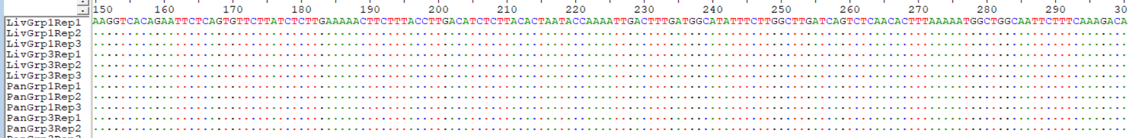 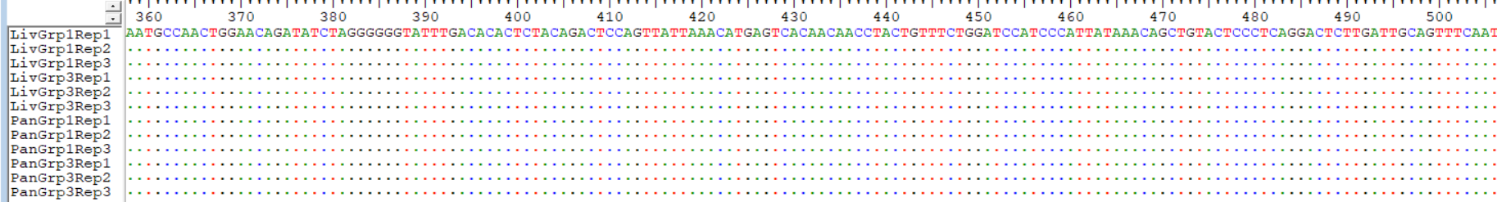 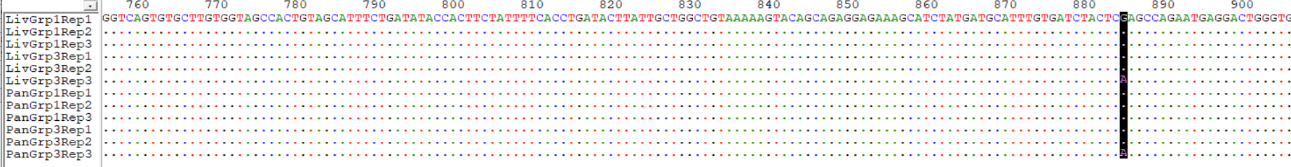

**Figure 4: Sequence Alignment Showing the Position of SNPs along the Amplified Toll-Like Receptor 4 (TLR4) Sequenced Fragment**

The SNP position is marked with a bolded color to indicate where the sample sequence deviates from the reference. Sequencing revealed a silent mutation in TLR-4, with a nucleotide substitution (A→G) at amino acid 885, changing AAA to AAG. This synonymous mutation did not alter lysine’s coding, indicating no functional impairment.

**Group A Group B Group C Group D Group E**

**(Control) (Untreated) (100 mg/kg Metformin) (100 mg/kg KV) (200 mg/kg KV)**

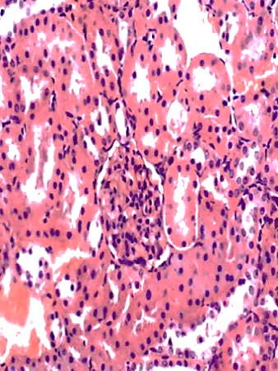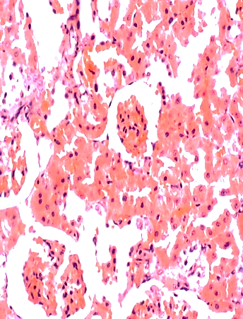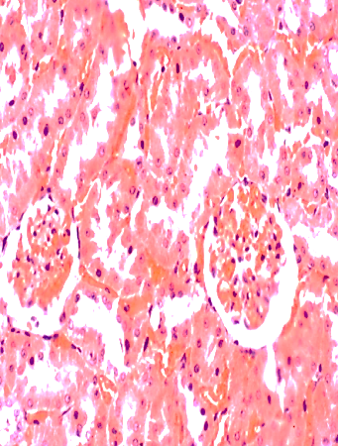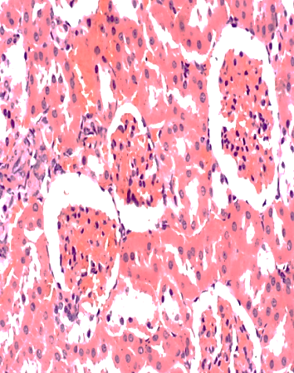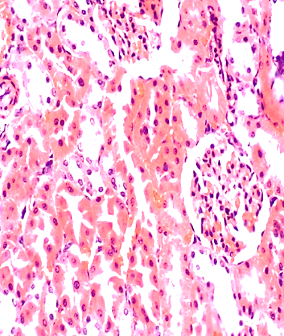

**KIDNEY X400 (H & E)**

**Figure 5: Dose-dependent effect of administration of metformin and KV on the kidney of diabetic Wistar rats**

**Group A Group B Group C Group D Group E**

**(Control) (Untreated) (100 mg/kg Metformin) (100 mg/kg KV) (200 mg/kg KV)**

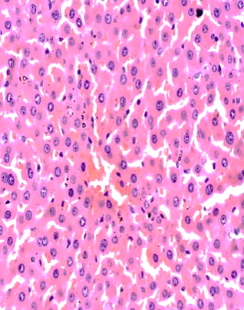 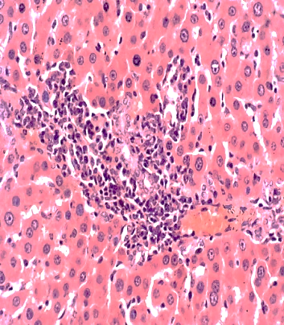 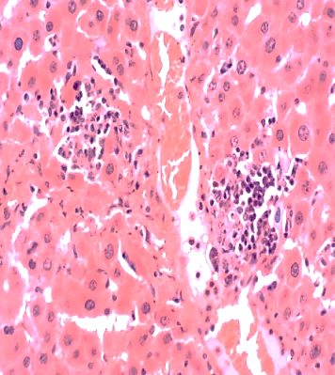 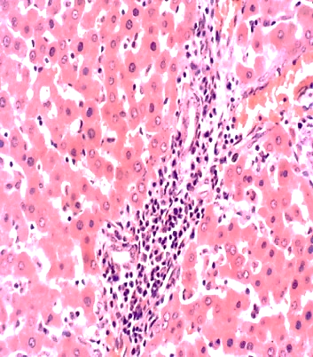 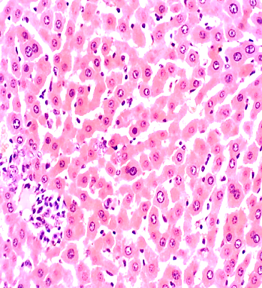

**LIVER X400 (H & E)**

**Figure 6: Dose-dependent effect of administration of metformin and KV on the liver of diabetic Wistar rats**

**Group A Group B Group C Group D Group E**

**(Control) (Untreated) (100 mg/kg Metformin) (100 mg/kg KV) (200 mg/kg KV)**

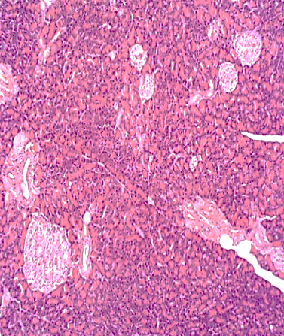 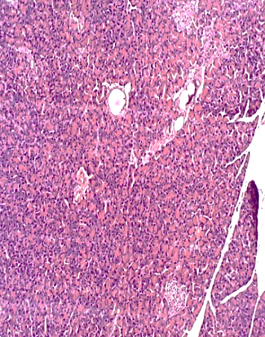 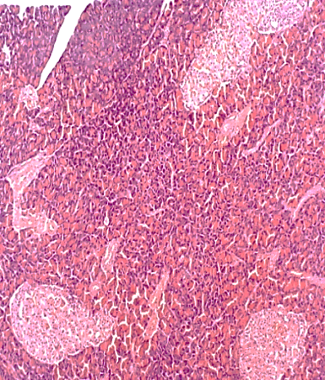 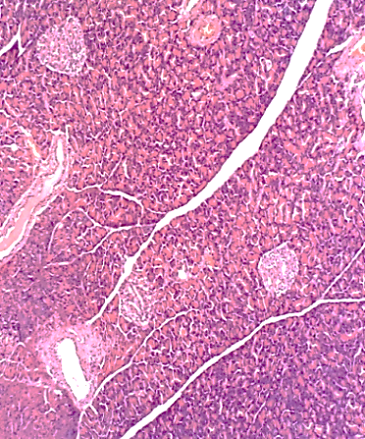 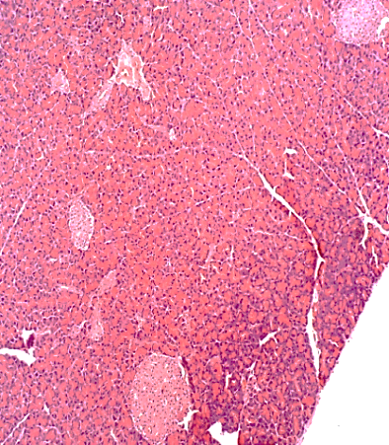

**PANCREAS X400 (H & E)**

**Figure 7: Dose-dependent effect of administration of metformin and KV on the Pancreas of diabetic Wistar rats**

Longitudinal sections of the kidney, liver, and pancreas following three months of treatment of diabetic groups C, D, and E with 100 mg/kg of metformin, and 100 mg/kg of KV, respectively, as compared with the non-diabetic control (1 mL of distilled water) and untreated diabetic group B. Sections show a well-preserved architecture of all three organs for the control group. Groups B, C, D, and E show varied histological changes from widening of the Bowman’s space (arrow) and mild distortion of the flattened squamous tubular epithelial cells lining the Bowman’s space of the kidney. Sections of the liver from Groups B, C, D, and E revealed hepatic tissue with preserved architecture composed of cords of normal hepatocytes (black arrow). The portal tracts showed mild to moderate inflammation (red arrow) with predominantly lymphocytes and histiocytes. Furthermore, groups B, C, D, and E showed pancreatic tissue characterized by preserved architecture with numerous small- to large-sized islets of Langerhans (arrows). There are no features of significant inflammation or damage seen as compared with the control. Magnification was set at x400.

**5. CONCLUSION**

Kolaviron significantly improved glycemic control and enhanced the expression of key genes involved in glucose metabolism in diabetic Wistar rats. Its safety profile was supported by the absence of toxic histological alterations and mutagenic effects. These results highlight the potential of kolaviron as a natural therapeutic agent for diabetes management. However, clinical trials in humans are essential to confirm its efficacy and safety. Additionally, the development of affordable kolaviron-based formulations and further research into its molecular mechanisms and long term effects are warranted.

Ethical Approval

The protocol for this study was approved by the Ministry of Agriculture and Natural Resources, Benin City, Edo State, Nigeria (Ref: V.1041/27).

Disclaimer (Artificial intelligence)

Option 1:

Author(s) hereby declare that NO generative AI technologies such as Large Language Models (ChatGPT, COPILOT, etc.) and text-to-image generators have been used during the writing or editing of this manuscript.

Option 2:

Author(s) hereby declare that generative AI technologies such as Large Language Models, etc. have been used during the writing or editing of manuscripts. This explanation will include the name, version, model, and source of the generative AI technology and as well as all input prompts provided to the generative AI technology

Details of the AI usage are given below:

1.

2.

3.

**REFERENCES**

1. [Yedjou](https://pubmed.ncbi.nlm.nih.gov/?term=%22Yedjou%20CG%22%5BAuthor%5D), C. G., [Grigsby](https://pubmed.ncbi.nlm.nih.gov/?term=%22Grigsby%20J%22%5BAuthor%5D), J., [Mbemi](https://pubmed.ncbi.nlm.nih.gov/?term=%22Mbemi%20A%22%5BAuthor%5D), A., Daryllynn, N., [Mildort](https://pubmed.ncbi.nlm.nih.gov/?term=%22Mildort%20B%22%5BAuthor%5D), B., [Latinwo](https://pubmed.ncbi.nlm.nih.gov/?term=%22Latinwo%20L%22%5BAuthor%5D), L., and

[Tchounwou](https://pubmed.ncbi.nlm.nih.gov/?term=%22Tchounwou%20PB%22%5BAuthor%5D), P. B. (2023). The Management of Diabetes Mellitus Using Medicinal Plants

and Vitamins. *International Journal of Molecular Sciences;* 24(10), 9085.

2. [Sugandh](https://pubmed.ncbi.nlm.nih.gov/?term=%22Sugandh%20FNU%22%5BAuthor%5D), F. N. U., [Chandio](https://pubmed.ncbi.nlm.nih.gov/?term=%22Chandio%20M%22%5BAuthor%5D), M., [Raveena](https://pubmed.ncbi.nlm.nih.gov/?term=%22Raveena%20FNU%22%5BAuthor%5D), F. N. U., [Lakshya, K.,](https://pubmed.ncbi.nlm.nih.gov/?term=%22Kumar%20L%22%5BAuthor%5D) [Karishma](https://pubmed.ncbi.nlm.nih.gov/?term=%22Karishma%20FNU%22%5BAuthor%5D), F. N. U.,

[Khuwaja](https://pubmed.ncbi.nlm.nih.gov/?term=%22Khuwaja%20S%22%5BAuthor%5D), S., [Unaib, A.](https://pubmed.ncbi.nlm.nih.gov/?term=%22Memon%20UA%22%5BAuthor%5D) M, [Karoona, B.](https://pubmed.ncbi.nlm.nih.gov/?term=%22Bai%20K%22%5BAuthor%5D), [Maham, K.](https://pubmed.ncbi.nlm.nih.gov/?term=%22Kashif%20M%22%5BAuthor%5D), [Giustino, V.](https://pubmed.ncbi.nlm.nih.gov/?term=%22Varrassi%20G%22%5BAuthor%5D), [Mahima, K.](https://pubmed.ncbi.nlm.nih.gov/?term=%22Khatri%20M%22%5BAuthor%5D), and [Satesh, K.](https://pubmed.ncbi.nlm.nih.gov/?term=%22Kumar%20S%22%5BAuthor%5D) (2023). Advances in the Management of Diabetes Mellitus: A Focus on Personalized Medicine. *Cureus;* 15(8):e43697. doi: [10.7759/cureus.43697](https://doi.org/10.7759/cureus.43697).

## 3. Sharanjeet, K., and Singh, S. (2025). The commercial availability of plant-based phytochemical components used in GLP-1 inhibition for the treatment of type-2 diabetes**.** [*Phytomedicine Plus*](https://www.sciencedirect.com/journal/phytomedicine-plus)***;***[5(3](https://www.sciencedirect.com/journal/phytomedicine-plus/vol/5/issue/3)), 100825.

4. American Diabetes Association. (2020). Standards of Medical Care in Diabetes. *Diabetes*

*Care,* 43(Supplement 1), S1–S212.

5. Tcheghebe, O. T., Signe, M., Seukep, A. M. and Tatong, F. N. (2016)/ Review on

Traditional uses, phytochemical and pharmacological profiles of *Garcinia kola* Heckel.

*Merit Research Journal of Medicine and Medical Sciences,* 4(11), 480-489.

6. Tauchen, J., Adela, F., Anna, M., Irena, V., Bohdan, L., and Olga, L. (2023). *Garcinia kola*: A Critical Review on Chemistry and Pharmacology of an Important West African Medicinal Plant. Phytochemistry Review. Nature Publishing Group. Page 1-47.

7. Lee, J., and Jaemin, L. (2022). Endoplasmic Reticulum (ER) Stress and its Role in

Pancreatic β-Cell Dysfunction and Senescence in Type 2 Diabetes. *International Journal*

*of Molecular Sciences,* 23(9), 4843.

8. Wataru, N., Hiroak, I., and Munkhtuya, T. (2022). Role of the Transcription Factor

MAFA in the Maintenance of Pancreatic β-cells. *International Journal of Molecular*

*Science,* 23(9), 4478-4480.

9. Al-Ishaq, R. K., Abotaleb, M, K., Kajo, K. and Büsselberg, D. (2019): Flavonoids and the

Anti-[diabetic Effects: Cellular Mechanisms and Effects to Improve Blood Sugar Levels.](https://pubmed.ncbi.nlm.nih.gov/31480505/)

*Biomolecules,*9(9), 430-432.

10. Sameer, A. S. and Saniya, N. (2021). Toll-Like Receptors (TLR): Structure, Functions,

Signaling and Role of their Polymorphisms in Colorectal Cancer Susceptibility. *Biomedical Research International,* 21**,** 1157023.

11. Airaodion, A. I., Elenjoku, J. A., Ngwogu, A. C., and Ngwogu, K. O. (2020). Ethanolic

Extract of Garcinia kola (Heckel) Seed Possesses Antiplasmodial Properties against

*Plasmodium berghei*. [*Asian Journal of Medical Principles and Clinical Practice;* 3(1), 33-39.](https://journalajmpcp.com/index.php/AJMPCP/index)

12. Sadiq, I. S., Abubakar, F. S., Hassan, H. A. and Ibrahim, M. (2020). Working with

Bioactive Substances from Medicinal Plants in Animals. *South Asian Journal of Natural*

*Products,* 3(2), 27 – 37.

13. Asghar, G. and Sajad, J. (2023). Streptozotocin as a Tool for Induction of Rat Models of

Diabetes: A Practical Guide. *EXCLI Journal of Experimental and Clinical Sciences,* 22,

274-279.

14. Trinder, P. (1969). Determination of Glucose in blood using Glucose Oxidase with an

alternative Oxygen Acceptor. *Annal of Clinical Biochemistry,* 6, 24-27.

15. Navin, K. S., Binod, K., Uma, S. S. and Ila, J. (2018). Role of Glycosylated Haemoglobin

(HbA1c) Estimation in cases of Gestational Diabetes. *IOSR Journal of Dental and*

*Medical Sciences,* 17(7), 1-3.

16. Al-Shaqha, M. K., Waleed, M., Nasir, S., Arezki, A., and Ahmad, A. C. (2015). Anti-

diabetic potential of Catharanthus roseus Linn. And its effect on the glucose transport

gene (GLUT-2 and GLUT-4) in Streptozotocin induced diabetic Wistar rats. *BMC*

*Complementary and Alternative Medicine,* 15, 379.

17. Artika, M. I., Yora, P. D., Ita, M. N., Josephine, E. S., and Ungke, A. (2022). Real-Time

Polymerase Chain Reaction: Current Techniques, Applications and Roles in COVID-19

Diagnosis. *Genes*, 13(12), 2387-2388.

18. Crossley, B.M., Bai, J., Glaser, A., Maes, R., Porter, E., Killian, M.L., Clement, T. and

Toohey-Kurth, K. (2020). Guidelines for Sanger Sequencing and Molecular Assay

Monitoring. *Journal of Veterinary Investigation:* Official Publication of the American

Association of Veterinary Laboratory Diagnosticians, Inc, 32(6), 767-775.

19. Dludla, P.V., Sihle, E.M., Ziqubu, K., Bongani, B.N., Sithandiwe, E.M., Sidney, H.,

Albert, K.B., Carmen, P., Andre, P.K. (2023). Pancreatic β-cell dysfuction in Type 2

Diabetes; Implications of Inflammation and Oxidative Stress. *World Journal of Diabetes;*

14(13), 130-146.

20. [Mawson, W., and](https://www1.racgp.org.au/ajgp/authors/mawson-wang)    Tien-Ming, H. (2021). HbA1c: More than just a number. *Australian*

*Journal of General Practice;* 50, (9), 03-21.

21. [Dogara](https://pubmed.ncbi.nlm.nih.gov/?term=%22Dogara%20AM%22%5BAuthor%5D), A. M., [Saber, W. H](https://pubmed.ncbi.nlm.nih.gov/?term=%22Hamad%20SW%22%5BAuthor%5D)., [Harmand, A. H.](https://pubmed.ncbi.nlm.nih.gov/?term=%22Hama%20HA%22%5BAuthor%5D), [Sarwan, W. B.](https://pubmed.ncbi.nlm.nih.gov/?term=%22Bradosty%20SW%22%5BAuthor%5D), [Soran, K.](https://pubmed.ncbi.nlm.nih.gov/?term=%22Kayfi%20S%22%5BAuthor%5D), [Sawsan, S. A.](https://pubmed.ncbi.nlm.nih.gov/?term=%22Al-Rawi%20SS%22%5BAuthor%5D), and [Lema](https://pubmed.ncbi.nlm.nih.gov/?term=%22Lema%20AA%22%5BAuthor%5D), A. A. (2022). Biological Evaluation of Garcinia kola Heckel**.** *Advances in Pharmacology and Pharmaceutical Sciences;* 3837965. doi: [10.1155/2022/3837965](https://doi.org/10.1155/2022/3837965).

22. [Ting-Dan, F.,](mailto:Ting-Dan,%20F.,) [Wen-Li, Z.](mailto:Wen-Li,%20Z.), and [Xin-An, H.](https://journals.sagepub.com/doi/10.1177/1934578X231224993#con10) (2024). Garcinia Biflavonoid 1 from *Garcinia*

*kola* Ameliorates Glycolipid Metabolism Disorder in Type 2 Diabetic db/db Mice. *Sage*

*Journals;* <https://doi.org/10.1177/1934578X231224993>.

23. [Sayed](https://cmbl.biomedcentral.com/articles/10.1186/s11658-022-00397-7#auth-Tahseen_S_-Sayed-Aff1), T. S., [Maayah](https://cmbl.biomedcentral.com/articles/10.1186/s11658-022-00397-7#auth-Zaid_H_-Maayah-Aff1), Z. H., [Zeidan](https://cmbl.biomedcentral.com/articles/10.1186/s11658-022-00397-7#auth-Heba_A_-Zeidan-Aff2), H. A., [Agouni](https://cmbl.biomedcentral.com/articles/10.1186/s11658-022-00397-7#auth-Abdelali-Agouni-Aff1), A., and [Hesham M. K.](https://cmbl.biomedcentral.com/articles/10.1186/s11658-022-00397-7#auth-Hesham_M_-Korashy-Aff1) (2020). Insight into the physiological and pathological roles of the aryl hydrocarbon receptor pathway in glucose homeostasis, insulin resistance, and diabetes development**.** [*Cellular & Molecular Biology Letters*](https://cmbl.biomedcentral.com/); 27, 103.

# 24. Harithpriya, K., Jayasuriya, R., Adhikari, T., Rai, A., and Ramkumar, K. M. (2023). Modulation of transcription factors by small molecules in β-cell development and differentiation. [*European Journal of Pharmacology*](https://www.sciencedirect.com/journal/european-journal-of-pharmacology)*;* 946, 175606.

**25.** [Chadt](https://link.springer.com/article/10.1007/s00424-020-02417-x#auth-Alexandra-Chadt-Aff1-Aff2), A., and [Al-Hasani](https://link.springer.com/article/10.1007/s00424-020-02417-x#auth-Hadi-Al_Hasani-Aff1-Aff2), H. (2020). Glucose transporters in adipose tissue, liver, and skeletal muscle in metabolic health and disease. *European Journal of Physiology;* 472, 1273-1298.

26. [Wang](https://pubmed.ncbi.nlm.nih.gov/?term=%22Wang%20Z%22%5BAuthor%5D), Z., [Xiaolin, N](https://pubmed.ncbi.nlm.nih.gov/?term=%22Ni%20X%22%5BAuthor%5D)., [Li, Z.](https://pubmed.ncbi.nlm.nih.gov/?term=%22Zhang%20L%22%5BAuthor%5D), [Liang, S.](https://pubmed.ncbi.nlm.nih.gov/?term=%22Sun%20L%22%5BAuthor%5D), [Xiaoquan, Z.](https://pubmed.ncbi.nlm.nih.gov/?term=%22Zhu%20X%22%5BAuthor%5D), [Qi, Z.](https://pubmed.ncbi.nlm.nih.gov/?term=%22Zhou%20Q%22%5BAuthor%5D), [Yang](https://pubmed.ncbi.nlm.nih.gov/?term=%22Yang%20Z%22%5BAuthor%5D), Z., and [Yuan](https://pubmed.ncbi.nlm.nih.gov/?term=%22Yuan%20H%22%5BAuthor%5D), H. (2020). Toll-Like Receptor 4 and Inflammatory Micro-Environment of Pancreatic Islets in Type-2 Diabetes Mellitus: A Therapeutic Perspective**.** *Diabetes, Metabolic Syndrome and Obesity;* 13, 4261–4272.

27. [Chie, K.](https://pubmed.ncbi.nlm.nih.gov/?term=%22Kikutake%20C%22%5BAuthor%5D), and [Mikita, S.](https://pubmed.ncbi.nlm.nih.gov/?term=%22Suyama%20M%22%5BAuthor%5D) (2023). Possible involvement of Silent Mutations in Cancer Pathogenesis and Evolution**.** *Scientific Reports;* 13, 7593.

28. Intharuksa, A., Kuljarusnont, S., Sasaki, Y., and Duangjai, T. (2023). Flavonoids and Other Polyphenols: Bioactive Molecules from Traditional Medicine Recipes/Medicinal Plants and Their Potential for Phytopharmaceutical and Medical Application. *Molecules;* 29, 23.