Influence of substrates, cultivation conditions and NPK in the production of teak seedlings Tectona grandis Linn.f., Verbenaceae from strains, Daloa (Haut Sassandra, Ivory Coast)
Abstract
This study aimed to evaluate the effectiveness of vegetative propagation of teak by stump, by examining the influence of the type of substrate, growing conditions, and NPK fertilizer supply on production. In this context marked by strong international demand for this forest species prized on the tropical wood market, whose multiple uses have led to the progressive depletion of natural stocks.
The experimental design was a three-factor split plot. The first factor (growth conditions) included two levels (outdoor and under firewood), the second factor (growth substrates) included two levels (decomposed coffee parchment and decomposed sawdust), and the third NPK factor with seven levels (0; 5; 10; 20, 30; 50; 100 g/L) with three replicates for each factor. The parameters evaluated included bud burst rate (Td), average plant height (H), average leaf number (NF), leaf area (SF), average tap length (Lp), and average root number (Nr).
The best bud break rate of 93.33% was recorded in the open air with sawdust at a dose of 5g/L.
In terms of average root number and tap length, the shaded area was found to be the best condition with the 50 g/L NPK dose with respectively19±11.41 roots and 12.87±3.51cm.
These results show that teak is well adapted to vegetative propagation by stump.

Keywords:teak, NPK (15 15 15), growth conditions, substrate, strain

Introduction
Teak is a highly prized forest species on the international tropical timber market due to its multiple uses. Its high international demand has led to the depletion of natural stocks (Koné et al., 2010). This has forced users to choose teak from plantations of various origins. In Côte d'Ivoire, teak plantations are established and managed by the Forest Development Company (SODEFOR). The latter plants hectares of teak each year. In 2020, the cumulative area reforested with teak exceeded 76,000 hectares.
In order to safeguard the species in many countries, reforestation using seedlings from seeds, cuttings or stumps is being undertaken. It has become the most cultivated tropical tree species in the world, with Côte d'Ivoire ranking first among African countries (Padré, 2002). For the production of seedlings, the use of seeds poses the problem of the non-reproducibility of the characteristics of the mother plant to the daughter plant (Paluku et al., 2018) and the loss of the germination power of the seeds in the case of conservation. As an alternative, vegetative propagation from cuttings, layering, grafting and in vitro culture are adopted (Paluku et al., 2018).
Previous research on several tropical tree species has highlighted a wide range of factors influencing the rooting of cuttings under various conditions. These factors include species genotype, substrate type, and climatic factors (Bellefontaine 2018).
This study aimed to evaluate vegetative propagation by strain. Specifically, the influence of substrate type (sawdust and decomposed coffee parchment), growth conditions (open air and shade) and different doses of NPK (15-15-15) on teak seedling production over time was evaluated.

1. Materials and methods
1.1. Materials
1.1.1. Study site
The study was carried out in the Haut-Sassandra region, in the center-west of Côte d'Ivoire, in Daloa (6°53'58''N North latitude and 6°26'32''W West longitude), which has an area of 15,205 km2 and an estimated population of 1,430,960 inhabitants (RGPH, 2014). Average temperatures range from 25°C to 28°C. The region is divided into four seasons: a major rainy season (April to mid-July); a minor dry season (mid-July to mid-September); a minor rainy season from mid-September to November; and the major dry season, from December to March (N'guessan et al., 2014). The edaphic heritage is of the ferralitic type. Rainfall decreased from 1868.5 mm in 1968 to an average of 1120.4 mm in 2005, and the region experienced a 40% decrease in rainfall (Ligban et al., 2009). The department is watered by the Sassandra River and its tributary, the "Lobo", whose branches, the Dé and the Gore, flood all localities (Sangaré et al., 2009). It is a humid tropical zone with dense forest vegetation that is declining due to the practice of extensive and shifting agriculture coupled with the anarchic exploitation of forest species (Sangaré et al., 2009). The experimental site is located in the Jean Lorougnon Guédé University, approximately 100 m from the university library (Figure 1).
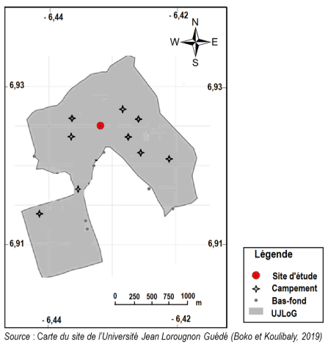

Figure 1:Location of the study site
1.1.2. Plant material
The biological material consists of teak stumps. To obtain these stumps, teak seedlings, approximately 12 months old, were dug up in the teak forest of the Vavoua Forest Management Company, in the Haut-Sassandra region. These seedlings were stripped of their leaves and secondary roots. The main root was cut approximately 5 cm from the crown. Stumps 15 to 20 cm long were selected for the study (Figure 2).
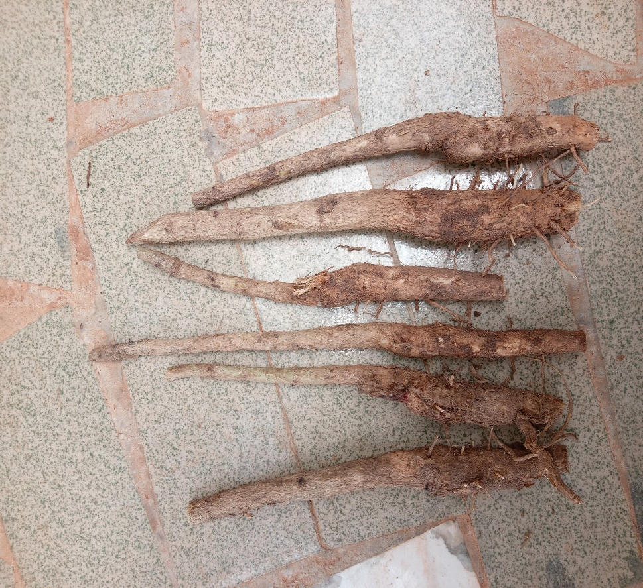
Figure 2: strains of Tectona grandis Linn. f. dressed
1.1.2. Materials and chemical substrates
The chemical material used is a 15-15-15 NPK fertilizer. This fertilizer was supplied by the company YARA-CI. The substrates used are decomposed sawdust (SBD) and decomposed coffee parchment (PCD). The sawdust was collected at the Société Générale du Bois Tropical (SGBT) in Daloa. The coffee parchment comes from a coffee hulling factory (UNICAFE) located in the Garage district.

1.2. Methods
1.2.1. Obtaining plants
The resulting teak stumps were placed vertically in perforated polystyrene bags, previously filled with 50 g of heat-sterilized substrate. The culture was then placed in the shade (SO) and in the open air (AL) according to a distribution scheme (Figure 3).

1.2.2. Treatment of strains with NPK
The study was carried out according to the method of Toukourou and Carsky (2001) and that of Lopez Zada et al. (1994) modified. Seven (7) NPK solutions were prepared (0, 5, 10, 20, 30, 50 and 100 g/L). Watering with the different concentrations was carried out once, after sowing. Each solution was applied at a rate of 10 ml per sachet and by watering at the collar.
1.2.3. Experimental design and treatments
The experimental design was a plot divided into three factors. The first factor (growing conditions) included two levels (outdoor and under a fire), the second factor (growing medium) included two levels (decomposed coffee parchment and decomposed sawdust) and the third factor corresponded to NPK doses (15-15-15) with seven levels (0, 5, 10, 20, 30, 50, 100 g/L) with three repetitions for each factor.
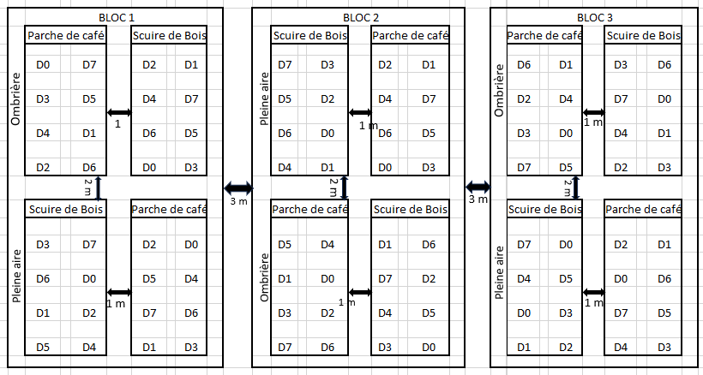
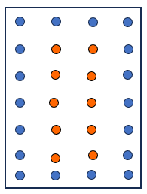
elementary plot

Border plants
Utilities for plants

Figure 3: Experimental design

1.2.3. Evaluation of agromorphological parameters

Table I: Methods for measuring agromorphological parameters of teak plants
Settings  growth | Evaluation method | Formulas
Average bud burst rate (Td) | The average bud burst rate (Td) is obtained by comparing the number of cuttings that have taken root with the number of cuttings transplanted (Nt) | $Td=\frac{Nr}{Nt}$ x100;Nr=numberof cuttings bearing buds  Nt = total number of cuttings transplanted
Average plant height (H) | Stem height was determined from the stem insertion point on the cutting or crown to the shoot apex using a tape measure. | $H=\frac{\sum{H_{i}}}{NP}$ ;Hi = height of each plant;  NP = total number of plants
Average number of leaves (NF) | The number of leaves per plant was assessed by manually counting open leaves. | $NF= \frac{\sum{{NF}_{i}}}{NP}$ ;NFi = number of leaves per plant  NP = total number of plants
Average leaf area (ALA) | Leaf area was determined by multiplying the length taken by measuring the main vein and the width taken at the middle of the leaf. | $SF= \frac{\sum{{SF}_{i}}}{NP}$ ;$SF$_{I} =leaf area per plant  NP = total number of plants
Average pivot length (Lp) | Root length was determined from the root insertion point on the cutting to the root apex using a tape measure. | $Lp =\frac{\sum{{Lr}_{i}}}{NP}$ ;LRI = average root length/plant  NP = total number of roots
Average number of roots (Nr) | The number of roots per plant was assessed by manually counting secondary roots. | $Nr= \frac{\sum{{Nr}_{i}}}{NP}$ ;NFi = number of roots per plant  NP = total number of plants

1.2.4. Statistical analysis of data
The data obtained were subjected to analysis of variance (ANOVA) with SPSS (Statistical Package for the Social Sciences) software version 11.5 at the 5% threshold. If P˂0.05, homogeneous groups were then determined by Fisher's LSD method. The results were expressed as mean ± standard deviation.
2. Results

2.1. Influence of the interaction of the studied factors on the bud burst rate of teak stumps treated with NPK (15, 15, 15)
The data in Table II show that the interaction of the studied factors influenced the budburst rate of the stumps and varied according to the growing conditions, substrates and treatments. The budburst rate of teak stumps increased gradually until reaching a maximum at the fourth week.
During the first week, the best bud burst rate of 66.67% was observed outdoors on SBD with 30 g/L NPK solution, while the lowest rate of 43.33% was recorded on PDC with 50 and 100 g/L NPK treatments. In the fourth week, the highest rate of 93.33% was recorded outdoors on SBD substrate with 5 g/L NPK treatment, while the lowest bud burst rate of 83.33% was observed with 100 g/L NPK treatment.
For plots with PCD as substrate, bud break also peaked during the fourth week, with the lowest rate (63.33%) for the control plot (0 g/L NPK) and the highest (90%) with the 10 g/L NPK treatment.
Under shade, the most significant rate of 66.67% was observed in the first week on the SDB substrate with the 10 g/L NPK treatment, and on the PDC with the control batch. From the fourth week, bud burst reached its maximum. The highest levels were recorded with the 5 and 10 g/L NPK treatments on SBD, and the lowest level was recorded on PDC with the 50 g/L treatment.

Table II:Effect of substrate, nursery and NPK concentration on the average budburst rate of teak stumps
Terms | Substrates | Treatments | Week 1 | Week 2 | Week 3 | Week 4
Open air | SBD | 0 g/L  5 g/L  10 g/L  20 g/L  30 g/L  50 g/L  100 g/L | 63.33±15.28abcd  53.33±23.10abcd  63.33±30.55abcd  63.33±32.15abcd  66.67±41.63abcd  50.00±26.46abc  60.00±45.83abcd | 86.67 ± 15.28 a.  73.33±23.09abc  76.67±23.09abc  76.67±20.82abc  76.67±32.15abc  60.00±30.00abc  60.00±30.00abc | 86.67±11.55cde  80.00±17.32bcde  80.00±17.32bcde  86.67±15.26cde  76.67±23.09 a  70.00±20.00abcde  76.67±32.15 BC. | 86.67±11.55ef  93.33 ± 5.77 °F  90.00±17.32ef  90.00±10.00ef  90.00±17.32ef  86.67±15.28ef  83.33±28.87def
Open air | LGD | 0 g/L  5 g/L  10 g/L  20 g/L  30 g/L  50 g/L  100 g/L | 53.33±11.55abcd  56.67±25.17abcd  46.67±25.17abc  56.67±20.82abcd  60.00±20.46abcd  43.33±20.82AB  43.33±41.63abc | 70.00±17.32abc  76.67±23.04abc  66.67±30.55abc  73.33±23.09abc  76.67±20.82abc  70.00±26.46abc  60.00±45.83abc | 86.67±11.55cde  86.67±15.28cde  73.33±25.17bde  76.67±20.82 a  80.00±20.00 a.  70.00±20.00abcde  70.00±36.06abcde | 63.33±46.19bcdef  80.00±14.14def  90.00±10.00ef  83.33±20.82def  86.67±15.28ef  80.00±10.00def  86.66±15.28ef
In the shade | SBD | 0 g/L  5 g/L  10 g/L  20 g/L  30 g/L  50 g/L  100 g/L | 60.00±51.96abcd  56.67±40.41abcd  66.67±49.33abcd  63.33±37.86abcd  43.33±15.28ab  62.50±22.17abcd  60.00±43.59abcd | 66.67±40.41abc  73.33±37.86abc  73.33±46.19abc  70.00±36.06abc  66.67±28.87abc  80.00 ± 26.46 a  53.33±37.86abc | 96.67±5.77e  76.67±32.15 a  76.67±40.41bcde  70.00±20.00abcde  70.00±10.00abcde  66.67±20.82abcde  53.33±15.28bcd | 83.33±11.55def  86.67±15.28ef  86.67±11.55ef  83.33±28.87def  76.67±11.55cdef  80.00±28.28bcdef  60.00±36.06abcde
 | LGD | 0 g/L  5 g/L  10 g/L  20 g/L  30 g/L  50 g/L  100 g/L | 66.67±49.33abcd  60.00±36.06abcd  53.33±23.04abcd 63.33±37.86abcd  50.00±36.06abc  55.00±35.36abcd  46.67±32.15abc | 76.67±40.41abc  66.67±41.63abc  56.67±32.15abc  50.00±30.00ab  63.33±20.82abc  63.33±25.17abc  53.33±37.86abcd | 83.33±28.87cde  83.33±28.87cde  60.00±26.46abc  53.33±25.17abcd  70.00±10.00abcde  66.67±20.82abcde  53.33±15.28bcd | 53.33±5.77abcd  46.67±11.55abc  60.00±20.00abcde  53.33±20.82abcd  46.67±20.82abc  30.00±10.00a  53.33±11.55abcd
 |  | p | 0.033 | 0.06 | 0.018 | 0.00
For each factor studied,means followed by the same letter in a given column do not differ statistically at the 5% threshold (LSD test). SBD: finely ground decomposed sawdust, PCD: decomposed coffee parchment

2.2. Influence of the interaction of the studied factors on the number of leaves of teak plants
The data in Table III show that the interaction of the studied factors influenced the average leaf number of teak plants, varying according to growth conditions, substrates, treatments, with a general increase in leaf number over time.
Outdoors, on the SBD substrate, the 50 g/L NPK treatment produced the highest average leaf number (9 ± 2.99 leaves), followed by the 30 g/L NPK treatment (8 ± 3.35 leaves), while the control plants recorded an average of 6 ± 2.13 leaves. On the PCD substrate, the maximum average leaf number was recorded for the control plants (9 ± 3.93 leaves), followed by the 50 g/L NPK-treated plants (8 ± 3.76 leaves).
In shade, plants on SBD substrate had more leaves than those on PCD substrate. The 10 g/L NPK treatment produced the highest average leaf number (9 ± 4.42 leaves), followed by the 20 g/L NPK treatment (8 ± 4.22 leaves), compared to the control plants (7 ± 3.74 leaves). The lowest average leaf number was observed with the 100 g/L NPK treatment (7 ± 3.44 leaves on SBD and 6 ± 1.96 on PCD).

Table III:Effect of substrate, nursery and NPK concentration on the average leaf number of teak seedlings
Terms | Substrates | Treatments | Week 4 | Week 6 | Week 8 | Week 10 | Week 12
Open air | SCB | 0 g/L  5 g/L  10 g/L  20 g/L  30 g/L  50 g/L  100 g/L | 5±1.35bcde  5±1.68 of  5±1.78bcde  5±1.99bcde  5±1.67bcde  5±2.01bcde  4±1.19abcd | 6±2.07bcde  6±1.98abcde  6±2.21bcde  6±2.62bcde  6±3.51cde  6±2.59bcde  5±1.66 from | 6±1.80 from  5±1.81 from  6±2.21abc  7±1.92bcdef  6±3.19abcdef  6±3.23abcdef  5±1.34a | 6±1.90abc  6±1.99abcd  6±2.21abcde  7±2.19abcdefghi  7±2.89abcdefgh  7±2.77bcdefghi  5±1.61a | 6±2.13abcd  7±4.28bcdefgh  8±4.80  7±3.79bcdefgh  8±3.35fghi  9±2.99 days  6±3.28defghi
Open air | PCD | 0 g/L  5 g/L  10 g/L  20 g/L  30 g/L  50 g/L  100 g/L | 5±1.87bcde  5±1.45bcde  5±1.76bcd  4±1.56abcd  5±1.62bcde  5±1.64bcde  4±1.39a | 6±2.45bcde  7±2.89 of  6±3.15cde  6±2.59bcde  6±2.11bcde  7±3.37e  6±2.80abcde | 7±2.38defg  8±2.49fg  7±2.99efg  7±2.81bcdef  7±2.70bcdef  8±3.18g  7±3.18cdefg | 8±2.56h  8±2.72gh  8±4.08fghi  7±3.04bcdefghi  7±3.58CFhUgh  9±3.89I 8±3.75Efghi | 9±3.93hi  6±2.00abc  6±2.08abcde  7±2.41bcdefGH  7±2.93abcdef  8±3.76  5±2.07a
In the shade | SCB | 0 g/L  5 g/L  10 g/L  20 g/L  30 g/L  50 g/L  100 g/L | 5±2.07bcde  6±1.72e  5±1.94bcde  6±1.68e  4±1.67abcd  5±1.46cde  5±1.44bcde | 5±1.76abc  6±2.41bcde  5±1.88abc  6±2.59abcde  5±1.31 from  6±2.55bcde  5±2.43 from | 7±2.55CDEF  7±2.92bcdef  6±2.06abcdef  6±2.56abcd  6±1.68abcd  7±3.05abcdef  6±2.83abcde | 6±3.14abcde  7±2.32ABCDEFGHI  6±2.71abcdefg  6±2.77abcdef  9±1.58abcd  7±3.06abcdefg  6±2.74 from | 7±3.74cdefghi  7±3.57bcdefGH  9±4.42Record  8±4.22fghi  8±4.60fghi  6±3.87 from
In the shade | PCD | 0 g/L  5 g/L  10 g/L  20 g/L  30 g/L  50 g/L  100 g/L | 4±1.30abcd  5±1.7abcd  5±1.38bcde  5±1.71bcde  5±1.74abcd  4±1.51a  4±1.65abc | 5±2.10 from  5±1.46 from  5±2.51abc  5±2.06abcd  6±2.13abcde  5±1.14 a  4±2.26a | 7±2.51bcdef  7±2.30abcdef  7±2.71CDEF  7±3.39defg  7±2.89cdefg  6±2.45abcdef  6±3.12abcdef | 7±2.25defghi  7±2.71abcdefghi  8±3.49  8±4.50ij  8±3.85  6±2.78 from  6±3.47abcde | 6±3.08abcde  7±1.66abcde  6±2.31abcde  6±2.83abcd  6±1.84abc  7±2.93abcde  6±1.96abcd
In the shade |  | p | 0.034 | 0.02 | 0.003 | 0.016 | 0.01
For each factor studied,means followed by the same letter in a given column do not differ statistically at the 5% threshold (LSD test). SBD: finely ground decomposed sawdust, PCD: decomposed coffee parchment

2.3. Influence of the interaction of the studied factors on the leaf surface
The interaction between the factors studied had a very significant impact on the average leaf area, with variations observed depending on the growing conditions, substrates, NPK treatments and the time of data collection. In all cases, the leaf area increased progressively to reach a peak at the twelfth week.
On both substrates (SBD and PCD) in the plots exposed to the open air, the different treatments influenced the leaf area. On SBD, plants from strains treated with the NPK solution (15-15-15) at a concentration of 30 g/L recorded the highest average leaf area (17.70±24.18 cm2). This leaf area gradually increased until reaching a maximum at the twelfth week (26.16±33.53 cm2). However, the 100 g/L concentration of NPK solution recorded the lowest leaf area observed (13.06±13.91 cm²) at the twelfth week. At PCD, strains treated with the 50 g/L NPK solution recorded the largest average leaf area (71.02±76.73 cm²) in the twelfth week.
In shaded plots, NPK treatments also had a significant effect on mean leaf area. The largest leaf areas were observed in the PCD plot, with the 100 g/L NPK treatment (41.93±66.35 cm²).

Table IV: Effect of substrate, nursery and NPK concentration on the average leaf area of teak seedlings
Terms | Substrates | Treatments | Week 4 | Week 6 | Week 8 | Week 10 | Week 12
Open air | SCB | 0 g/L  5 g/L  10 g/L  20 g/L  30 g/L  50 g/L  100 g/L | 13.76±16.82Defghi  13.93±15.68AB  10.52±12.79abcde  17.04±30.53Defghi  17.70±24.18hijkl  12.16±13.50bcdefg  7.47±7.17a | 16,040 ± 20.37 cdefg  14.03±16.43abcdef  10.67±12.12a  19.13±31.83jkl  21.87±30.86hijk  15.61±19.19cdefg  12.97±15.90abcde | 18.34±20.07abcd  14.89±15.76a  11.02±12.89a  22.37±33.74cdefg  21.60±29.21abcd  17.10±22.13abcd  12.69±13.38ab | 19.29±20.41abc  15.12±16.97abc  13.03±16.76abcdef  24.95±33.16cdefg  22.79±32.25cdefg  18.22±23.12abc  12.55±13.14ab | 20.22±21.78abc  16.29±16.33Ghijk  13.38±15.30a  27.97±37.76bcdef  26.16±33.53cdefgh  23.00±26.63abcde  13.06±13.91a
Open air | LGD | 0 g/L  5 g/L  10 g/L  20 g/L  30 g/L  50 g/L  100 g/L | 22.10±31.58l  15.82±17.87Ghijk  16.63±25.71ghijk  18.14±32.38efghij  15.21±19.29ghij  14.21±16.33EFGHI  8.14147±9.22abc | 20.31±28.98ghij  20.24±18.95ghij  26.02±41.46k  20.26±35.14kl  23.36±36.36jk  23.52±33.39JK  16.97±23.25Defghi | 37.98±54.41jkl  28.80±27.44fghi  30.78±39.22hij  35.83±49.08ijk  41.52±57.91kl  45.06±59.19l  37.36±50.83jkl | 38.15±27.56jkl  31.49±30.48fghij  36.31±53.45ijk  40.55±48.36ghij  50.81±68.35 m  66.06±64.39N  45.63±51.98lm | 61.02±92.90lm  32.72±37.88efghi  40.50±64.63ghij  42.28±51.91klm  55.60±75.30kl  71.02±76.73m  48.40±52.55jk
In the shade | SCB | 0 g/L  5 g/L  10 g/L  20 g/L  30 g/L  50 g/L  100 g/L | 16.24±24.16ghijk  13.51±23.14defgh  15.03±21.66fghij  15.55±21.93ghe  14.55±22.62fghi  18.28±24.65ijkl  7.62±8.48 from | 17.03±19.25defghi  22.43±33.21 ijk  19.30±25.38fghij  16.02±20.24a  16.55±20.72defgh  21.59±28.67hijk  14.98±15.18bcdefg | 19.79±25.55bcd  29.22±37.83ghi  21.97±26.43cdefg  20.21±28.22bcd  19.88±21.07bcd  25.76±33.54CDefG  19.20±25.04bcd | 20.70±34.34 BC Era  30.44±38.44cdefg  22.85±26.56abcde  20.83±28.41cde  19.96±20.52 from  26.41±34.63abcde  20.20±27.54bcd | 21.72±34.51abcd  32.49±40.13ghe  23.31±26.00cdef  22.43±27.75 ijk  21.62±25.79cdefg  27.83±40.69EFGH  22.64±28.90abcde
In the shade | PCD | 0 g/L  5 g/L  10 g/L  20 g/L  30 g/L  50 g/L  100 g/L | 7.19±10.14a  8.14±10.79abc  9.90±14.40abcde  9.66±11.72abcde  12.65±21.07cdefg  9.33±14.05abcd  8.13±15.71abc | 9.02±11.58a  10.79±15.67abc  15.16±22.18cdefg  11.73±11.47ABCD  14.12±18.75abcdef  13.83±18.55abcdef  9.54±14.62 from | 20.13±30.44bcd  18.10±28.22abcd  22.19±27.30cdefg  21.09±29.18cdef  17.15±21.14ABCD  24.28±29.00DefGH  22.41±35.21cdefg | 28.67±41.65defghi  24.47±32.51cdefg  29.41±37.78EFGHE  26.89±36.62cdefgh  34.97±43.05 hours  32.50±41.90ghe  30.26±43.40fghij | 30.97±43.13DefGH  29.26±35.52bcdef  33.49±42.25fghi  33.58±52.85fghi  41.16±58.25h  34.22±46.34fghi  41.93±66.35ij
In the shade |  | p | 0.00 | 0.00 | 0.00 | 0.00 | 0.00
For each factor studied,the means followed by the same letter in a given line do not differ statistically at the 5% threshold (LSD test). SBD: finely ground decomposed sawdust, PCD: decomposed coffee parchment

2.4. Influence of the interaction of the studied factors on the average length and the average number of roots three months after transplanting
Statistical analysis revealed that the interaction of the studied factors significantly influences the average length and the average number of roots of three-month-old teak seedlings (p = 0.00). These parameters vary depending on the growing conditions, substrates and treatments.
Outdoor treatments improved root length and number. Decomposed sawdust (DSD) was the ideal substrate, especially with 50 g/L NPK treatment for root length (12.67 ± 4.73 cm), compared to the control (10.32 ± 5.65 cm). The 30 g/L NPK treatment produced the highest mean root number (13 ± 8.38 cm).
Under shading, the treatments also had a positive effect. SBD produced the longest roots with the 20 g/L NPK treatment (12.87 ± 3.51 cm), followed by the 10 g/L NPK treatment (12.45 ± 4.45 cm), compared to the control batch of 11.75 ± 5.30 cm. The 100 g/L NPK treatment produced the shortest roots. The highest mean root count (19 ± 11.41 cm) was obtained with the 50 g/L NPK treatment on SBD.
To maximize root length and number, it is recommended to grow plants in the shade with SBD substrate, using 20 g/L NPK for length and 50 g/L NPK for root number.

Table V:Effect of substrate, nursery and NPK concentration onthe average length and number of roots of three-month-old teak seedlings.

Terms | Substrates | Treatments | Long R | Neither
Open air | SCB | 0  5  10  20  30  50  100 | 10.32±5.65cdef  11.83±5.30f  12.20±5.30f  11.83±4.95f  11.60±5.69ef  12.67±4.73f  11.16±5.20ef | 9±5.82abcd  9±5.26abcd  10±4.67abcd  9±5.28abc  13±8.38defghi  10±5.65abcde  10±3.83abcdef
Open air | PCD | 0  5  10  20  30  50  100 | 7.88±4.17abc  8.05±4.26abc  7.87±4.53abc  8.28±5.21abcd  8.16±4.39abcd  10.96±5.15ef  9.14±5.03bcde | 8±5.74 from  7±3.41a  7±3.10a  11±7.00bcdefg  7±5.09a  12±9.60bcdefgh  9±5.42abcd
In the shade | SCB | 0  5  10  20  30  50  100 | 11.75±5.30f  11.34±4.50ef  12.45±4.43f  12.87±3.51f  12.23±5.72f  12.12±5.83f  11.60±4.74ef | 16±9.87ij  14±8.96  14±9.26fghi  15±8.20 Record  16±10.21ij  19±11.41 days  15±9.41gi
In the shade | PCD | 0  5  10  20  30  50  100 | 8.31±5.08abcd  8.17±5.16abcd  6.04±3.74a  7.16±5.43a  8.12±4.73abc  8.08±6.19abc  10.70±5.85def | 13±9.55defghi  13±8.10cdefghi  8±5.85 from  11±7.04abcdef  11±6.44bcdef  13±7.94defghi  12±7.06bcdefgh
In the shade |  | p | 0.00 | 0.00
For each factor studied,means followed by the same letter in a given column do not differ statistically at the 5% threshold (LSD test). SBD: finely ground decomposed sawdust, PCD: decomposed coffee parchment; Long R: root length;Number R: number of roots.
3. Discussion

3.1. Influence of the interaction of the studied factors on the bud burst rate of teak stumps treated with NPK (15, 15, 15)
The results obtained in this study showed that the factors studied (conditions, substrates, treatments and time) influenced the parameters evaluated in teak plants. However, these parameters varied depending on the growth conditions, substrates used, treatments and time.
When treating the strains with NPK, the most significant bud burst rate of the experiment was recorded outdoors with SBD at 5 g/L. Under these conditions, the bud burst rate is estimated at 93.33% at the 4th week.Our results show that light intensity plays an important role in the bud break of cuttings. This confirms the idea that the action of light affects the speed of vegetative recovery of cuttings. However, in our case, low light intensity does not prevent the vegetative recovery of species grown in the shade where up to 86.67% of bud break rate was recorded at the fourth week. In other words, as demonstrated by Hartmann et al. (1997), in general, photosynthesis is not necessary for the rooting of cuttings because they can use their own reserves to ensure vegetative recovery. The bud break rate (86.67%) recorded under shade could be explained by the fact that the shade reduces the impact of solar rays on the strains and therefore their dehydration. The results obtained on cuttings exposed to the sun confirm the fact that teak is a heliophilous plant (N'Dabalishye, 1995).
SBD proved to be the best substrate, unlike decomposed coffee parchment. Our results are similar to thosed'Aka et al (2022),who also achieved a better germination rate of tomato seeds with sawdust. This substrate (PCD) is insufficiently ground and releases fewer nutrients.
Despite the effectiveness of the culture conditions, substrates, and treatments, some cuttings did not regenerate 28 days after transplanting. This phenomenon could be linked to an unfavorable microenvironmental effect. Several other parameters could explain this. In many cases, cuttings do not pass the healing phase, which does not favor the emission of their roots (Asseh et al., 2017). Healing is indeed a key stage of cuttings, influenced by several factors, including the hormonal balance between the auxin used and other plant hormones such as cytokines (Agbogan et al., 2014; Jaenicke and Benies, 2003).

3.2. Influence of the interaction of the studied factors on the number of leaves of teak plants
The interaction of the studied factors had a significant effect on the number of leaves of teak trees. Indeed, the results showed that the number of leaves varies according to the growing conditions, substrates, treatments and period. The highest number of leaves was recorded in the batch of plants exposed to the open air with SDB as substrate and treated with a 50 g/L solution. The number of leaves is then estimated at9±2.99 sheets.
The number of leaves in plants exposed to the sun could be explained by the action of light which promotes their development through photosynthetic activity. Our results are consistent with those of Asseh et al. (2017) who also obtained a large number of leaves of Thunbergia atacorensis in the shaded area only.The results prove that whatever the treatment applied to the stumps, the physiology of the teak plants was stimulated in the nursery.Our results are consistent with those of Tchaniley et al. (2020) on lettuce. In his article, the author highlights the effectiveness of different NPK-based treatments on the average number of leaves compared to control plots.

3.3. Influence of the interaction of the studied factors on the leaf surface
The results obtained show that the leaf surface of teak plants varies depending on growing conditions, treatments and substrates.
, the largest average leaf area was recorded in the open air at the PDC associated with the NPK-based solution with a concentration of 50g/L. Under these conditions, the average leaf area is estimated at 71.02±76.73cm² three months after transplanting.These results prove that the leaf area would be influenced by the mode of exposure to the sun. Indeed, plants in plots exposed to the sun have larger leaves than those in plots exposed to the shade. Our results are in agreement with those of Asseh et al., 2017 who obtained the same results under the same conditions with the cultivation of Thunbergia atacorensis. The large leaf area of plants exposed to the sun could be explained by the action of light which promotes their development thanks to increased photosynthetic activity. On the other hand, the small leaf area of teak trees in shaded plots could be one of the consequences of the etiolation phenomenon. Indeed, teak trees, exposed to the shade, can no longer ensure the growth and development of their leaves. Thus, this loss of capacity to regenerate their energy resources due to lack of light is accentuated and leads to the fall of leaf area. This result suggests that photosynthesis would be more important in the open air than in the shade. Yue and Margolis (1993) reported that shelter decreases light intensity (0-50 mμ mol.m-2 s-1) and therefore limits photosynthesis. On the contrary, for Langellier (2000), photosynthesis depends more on the quality (type of radiation) of light than on its quantity (light intensity).

3.4. Influence of the interaction of the studied factors on the average length and number of roots three months after transplantation
The average length and number of roots of three-month-old teak trees varied depending on the factors studied. Statistical analysis of the interaction of factors showed a significant effect on the average length and number of roots of three-month-old teak trees.When treating the stumps with NPK, the best results were observed in the shade, with SBD as the substrate. Regarding the treatments, the 20 g/L solution proved effective in terms of root length, and the teak trees treated with the 50 g/L solution recorded the highest number of roots. The values recorded at this level are:12.87±3.51 cm and 19.30±11.41 roots, respectively.These results are consistent with those of William (2003) who indicate that nitrogen stimulates aerial growth which also promotes root growth. This difference could also be explained by the amount of sunlight reaching the leaves. Our results show that low light intensity promotes root development. These results are contrary to those of Asseh et al. (2017) in Thunbergia atacorensis. For this author, low light intensity slows down the bud break of Thunbergia atacorensis cuttings exposed to shade, and therefore has an effect on rhizogenesis.
Conclusion
This work showed that teak offers good appreciation for vegetative propagation by cuttings (stump). Rooted cutting rates of more than 93.33% were even obtained. The rooting substrate, growing conditions, treatments and weather conditions significantly influenced the bud burst rate, leaf number, leaf area, taproot length and root number. Finely ground decomposed sawdust (SBD) was found to be the best substrate compared to decomposed coffee parchment. Open air was the best growing condition in terms of bud burst rate compared to shade. Regarding the bud burst rate, the treatment at a dose of 5 g/L was found to be the most effective. For other treatments, the dose of 50 g/L generally gave the best results. In general, the treatments had a positive effect on the measured parameters. Open air and SBD appear to be the ideal conditions for teak seedling production. In the long term, it is interesting to find an ideal balance between the two substrates.

Disclaimer (Artificial Intelligence)

The authors hereby declare that NO generative AI technologies such as large language models (ChatGPT, COPILOT, etc.) and text-to-image generators were used in the writing or editing of this manuscript.

REFERENCES
Agbogan, A., Bammite, D., Tozo, K., & Akpagana, K. (2014). Contribution to the multiplication, by seeds and by cuttings of stem and root segments, of three spontaneous fruit trees from the savannah region of Togo: Haematostaphis barteri hook. F., Lannea microcarpa Engl. & K. Krauss and sclerocarya birrea (A. Rich.) Hochst. Eur. Sci. J. ESJ 10, 195–211.
AKA BJ K, BOYE M. AD, N'Gonian KS, EBROTTIE KF, Germination and Growth Test of Tomato on Sawdust, Rice Bran and Rice Husk. IOSR Journal of Agriculture and Veterinary Science (IOSR-JAVS) e-ISSN: 2319-2380, p-ISSN: 2319-2372. Volume 15, Issue 8 Ser. I (August 2022), PP 46-56
Asseh EE, Ake-Assi E., Koffi KJ, Faustine KA, 2017
Domestication of Thunbergia atacorensis Akoegninou & Lisowski (Acanthaceae): effect of substrate type and lighting mode on the ability of cuttings to vegetatively restart and plant growth. European Scientific Journal, 13: 328-354.

Bellefontaine R, Meunier Q., Ichaou A., Morin A., Mapongmetsem PM, Belem B., Azihou F., Houngnon A., Abdourhamane H., (2018). Regeneration by seeds and by low-cost vegetative propagation (dissolvents and cuttings of root segments), CIRAD, 463p.
Daniel Cornu, M. Boulay. Vegetative propagation: horticultural techniques and in vitro culture.French Forestry Review, 1986, 38 (Special), pp.60-68.⟨10.4267/2042/25750⟩.⟨hal-03424780⟩
Hartmann, HT, Scholten, HJ, Kester, DE, Davies, FT, & Geneve, RL (1997). Plant propagation: principles and practices. Scientia Horticulturae, 70, 347-348.https://doi.org/10.1016/S0304-4238(97)00085-X
Jaenicke, H., & Benies, J. (2003). Vegetative propagation of woody plants in agroforestry. Training manual and bibliography. World Agrofor. Cent. ICRAF ISBN 92 9059 1501 KulGraphics Ltd Nairobi Kenya.
Kone KHC, Boraud NKM, Issali AE, Kamanzi AK (2010). Influence of planting method on survival and growth dynamics of teak stumps used in industrial reforestation in a dense semi-deciduous forest area of Ivory Coast. Journal of Applied Bioscience 32: 1956-1963 p.
Langellier B. 2000. Light and photosyn thèse.perso.orange.fr/bernard.langellier/ps/psswf.htm. 20/10/23
Ligban R., Gone LD, Kamagate B., Saley MB & Biemi J. (2009). Hydrogeochemical processes and origin of natural springs of the Carré de Daloa degree (Central-West Ivory Coast), International Journal of Biological and Chemical Sciences, 3:17 p.
Ndabalishye I. 1995. West African subsistence agriculture through the case of Côte d’Ivoire. Monograph IDESSA Bouaké. 371 p.
N'Guessan AH, N'Guessan KF, Kouassi KP, Kouamé NN & N'Guessan. PW (2014).
Population dynamics of the cocoa stem borer, Eulophonotus myrmeleon. Felder (Lepidoptera: Cossidae) in the Haut-Sassandra region of Côte d'Ivoire, Journal of Applied Biosciences, volume 83, 9 p.
Paluku et al., J. Appl. Biosci. 2018 Cola acuminata (P. Beauv.) Schott & Endl. cuttings: Influence of substrate, leaf length and surface area on rooting of cuttings in Kisangani, DR Congo, Journal of Applied Biosciences 123: 12354-12362p.
Sangaré A., Koffi E., Akamou F. & Fall CA (2009). State of plant genetic resources for food and agriculture. Ministry of Agriculture, Abidjan, Republic of Côte d'Ivoire, Second report, 65 p.
Schiembo PN, Newton AC, Leakey RRB, (1997b). Vegetative propagation of Ricinodendron heudelotii, a fruit tree from West Africa. Journal of Tropical Forest Science 9 (4): 514 – 525 p.
Toukourou AM and Carsky R, (2001). Cassava response to nitrogen, phosphorus and potassium in the arid lands of southern Benin. In Proceedings of the scientific workshop, 12-13 December 2001, 149-154 p.
White HKJ, (1991). Teak Forestry II. Teak Regeneration China/ESCAP/FAO Senior Regional Teak Research and Development Officer Guangzhou Hainnan. China. 37 p.
William G. Hopkins 2003, Plant Physiology, translation of the 2nd American edition by S. Rambour, scientific revision by Ch-M Evrard, De Boeck and Larcier sa,.
Yue D. and HA Margolis. 1993. Photosynthesis and dark respiration of black spruce cuttings during rooting in response to light and temperature. Can. Day. For. Res. 23:1150-1155.

