Spatial Characterization of Land Use, Geology, and Hydrology in the
Musi River Basin Using Remote Sensing and GIS
Abstract
The present study offers an integrated assessment of the physiographic, geological, and land surface characteristics of the Musi River Basin, a sub-catchment of the Krishna River located in Telangana, India. Using satellite imagery, GIS techniques, and Digital Elevation Models (DEM), along with the interpretation of topographic and thematic layers, including drainage, geology, land use/land cover (LULC), soil, and geomorphology, the study provides a comprehensive understanding of the basin’s physical environment. DEM analysis indicates a west-to-southeast flow regime with moderate to high relief in the upper and fringe zones, contributing to a dendritic to sub-dendritic drainage pattern. The geological framework is predominantly composed of Archaean granites, interspersed with localized quartzite and dolerite dykes, which subtly influence terrain morphology and hydrological flow paths. The drainage network exhibits moderate density and texture, reflecting a structurally stable landscape. LULC analysis reveals a dominance of agricultural land, open scrub, and rapidly expanding urban areas, highlighting increasing anthropogenic pressure on the natural environment. Soil types vary from deep black cotton soils in low-lying regions to gravelly red soils in uplands, with spatial distribution strongly correlated to geological and topographic settings. These variations significantly affect runoff dynamics, erosion potential, and groundwater recharge. Geomorphological features such as denudational hills, pediment plains, and buried pediments further modulate hydrological behavior and land degradation processes. This comprehensive spatial analysis, employing DEM-based landform characterization and thematic integration, emphasizes cropland dominance and the interrelationship between soil, geology, and terrain. The findings contribute valuable insights for sustainable watershed management, flood risk mitigation, soil conservation, and strategic land-use planning in the rapidly urbanizing Musi River Basin.
Keywords: Musi River Basin, Remote Sensing, Drainage Morphometry, Geomorphology, Land Use Land Cover (LULC), Soil Classification.
1. INTRODUCTION
Remote sensing is a valuable geospatial technology that enables the acquisition of data about Earth's surface without direct contact, utilizing airborne or satellite-based sensors to detect the interaction of electromagnetic energy with terrain features. This technology is increasingly recognized for its efficiency and cost-effectiveness in covering large geographic expanses with high precision, particularly in geological and environmental studies (Ezzati et al., 2014). Since the early 20th century, remote sensing has played a significant role in the exploration of land use and land cover dynamics (El Khidir & Babikir, 2013). Understanding land use and land cover (LULC) change is vital for managing and conserving natural resources. These changes are closely linked to both natural and anthropogenic influences, requiring continuous monitoring for sustainable development (Nagamani & Ramachandram, 2003). Land use patterns are shaped by several environmental factors such as soil properties, topography, vegetation, and climate. Furthermore, land acts as a critical and finite resource supporting multiple developmental functions including agriculture, forestry, industry, housing, energy production, water resource management, and ecological conservation (Uma Maheshwari et al., 2015; Udaya Laxmi et al., 2016; Linga Swamy et al., 2022; Priyanka et al., 2024).
In geomorphological studies, terrain characteristics offer essential clues about underlying geological structures. Rugged topographies comprising hills, ridges, and escarpments, often signal resistant lithologies such as granites, quartzites, and limestones, whereas gently sloping areas and basins generally point to weaker sedimentary sequences like shales or sandstones. Soil properties, including colour and texture, are also influenced by lithological variations. Similarly, vegetation patterns often correlate with subsurface geology, further aiding interpretation in remote sensing analyses. The relevance of terrain evaluation and geomorphological mapping extends beyond traditional geosciences. It intersects with hydrology, environmental planning, landscape ecology, and natural hazard assessment, thereby broadening its scope and significance in interdisciplinary research (Jancewicz et al., 2022; Ma and Zhao, 2022; Xiong et al., 2022). The distinction between land use and land cover is critical in such studies: while land cover refers to the physical surface features such as vegetation, water bodies, or bare soil, land use pertains to the human utilization of land for purposes such as agriculture, urban development, or conservation. Recognizing the need for high-resolution, multi-temporal, and multi-spectral data for effective resource management, this study utilizes IRS P6-LISS IV satellite imagery to assess the terrain characteristics of the Musi River basin in the north-central region of Telangana. The analysis focuses on key geospatial features including elevation, drainage patterns, soil distribution, land use and land cover classification, geomorphological attributes, and inferred geological formations and to emphasize the practical utility of the study for watershed and environmental planning. The study area map is depicted in Fig. 1, which highlights the location and spatial context of the basin.
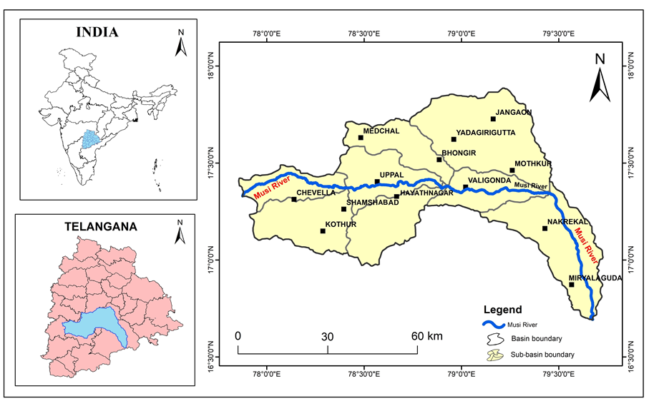
Fig.1. Location map of the Musi River basin with sub-basins area
2. MATERIALS AND METHODS
The present study focuses on the Musi River basin, a prominent tributary of the Krishna River, situated in the south-central region of Telangana State, India. Geographically, the basin extends from 16°40′00″ to 17°54′00″ N latitude and from 77°50′00″ to 79°45′00″ E longitude, encompassing an area of approximately 11,317.89 km² (Fig. 1). The river passes through Hyderabad, the capital city of Telangana, adding both geographical and socio-economic significance to the basin. The Musi River originates in the Anantagiri Hills near Vikarabad in the Ranga Reddy district, roughly 90 km west of Hyderabad, and traverses eastward across the state. It ultimately joins the Krishna River at Vadapally in the Nalgonda district, spanning a total length of approximately 240 km. To support this geospatial investigation, remote sensing data from IRS-P6 (RESOURCESAT-1) was employed.
For this study, IRS P6-LISS IV data provided by the National Remote Sensing Centre (NRSC), Hyderabad, was used (source: http://bhuvan.nrsc.gov.in). The LISS-IV sensor offers a spatial resolution of 5.8 meters and operates across three spectral bands are Band 2 (0.52–0.59 μm), Band 3 (0.62–0.68 μm), and Band 4 (0.77–0.86 μm). These spectral ranges are particularly effective for identifying regional geomorphological and geological features, aiding in the interpretation of lithology, drainage, and terrain morphology. Base data for this research included 1:50,000 scale topographic maps obtained from the Survey of India (SOI). These were integrated with satellite imagery for detailed terrain and thematic mapping (ArcGIS 10.7). Standard image preprocessing and enhancement techniques were employed to refine data accuracy and interpretability evaluated using confusion matrix and Kappa coefficient. These techniques included spectral enhancement, spatial filtering, histogram stretching, edge sharpening, and contrast adjustment, which are well-documented in remote sensing literature (Miller and Pearson, 1971; Castleman, 1978; Singer, 1980; Chavez et al., 1982; Price, 1995). Additional processing steps, such as data stratification, layer stacking, supervised classification using Maximum Likelihood algorithm, and refinement through iterative compositional analysis, were applied to enhance image clarity and improve mapping precision. The IRS-P6 Data User’s Manual (2003) served as a key reference for understanding sensor specifications and operational procedures during data handling and analysis. This integrated methodology allowed for the extraction of thematic information relevant to land use/land cover classification, geomorphology, and lithology hydrogeological interpretation of the Musi River basin.
3. RESULTS AND DISCUSSION
The Musi River basin was geo-referenced and digitally processed using IRS P6-LISS IV satellite imagery for a comprehensive assessment of its terrain elements, including topography, drainage, lithology, soil, geomorphological features and land use/land cover characteristics (Rao, 1995). Image interpretation techniques and visual analyses were employed to identify major physiographic variations and structural features within the basin. Discussion of how urban sprawl and terrain characteristics impact water flow and land use, and implications for future land use planning.
3.1. Topography
The basin exhibits distinct elevation gradients ranging from 41 meters to 730 meters above mean sea level (MSL). As depicted in Fig. 2, the western and northwestern zones, particularly near Chevella, Shadnagar, and Medchal, are characterized by elevated terrain and rugged hill ranges, with altitudes reaching over 700 meters (SRTM 30-meter resolution). These higher elevations correspond to resistant lithological formations, primarily composed of granitic and hard crystalline rocks. In contrast, the eastern and southeastern sectors, especially around Miryalaguda and Nakrekal, exhibit lower altitudes (below 250 meters) and relatively flat topography, indicating softer rock formations and alluvial deposits. The general slope of the basin follows an eastward gradient, directing surface runoff and river flow towards the Krishna River. The undulating nature of the landscape, coupled with dissected terrain in the upper catchments, influences drainage density and stream behavior. Stream order and drainage density were calculated to assess morphometric characteristics. The transition from steep hills in the west to gently sloping plains in the east signifies varied geomorphic processes at work.
These topographical features, along with lithological and geomorphological controls, are crucial in formulating geophysical or geochemical exploration strategies. Elevation zones provide insights into soil types, infiltration capacities, and groundwater recharge potential. Furthermore, terrain analysis supports hydrological modelling, land suitability classification, and infrastructure planning. The transport network in the basin is well-developed, with a mix of metalled and non-metalled roads, cart tracks, and footpaths. All major and minor settlements across the basin are interlinked through this road network, enhancing accessibility for field surveys and facilitating rural-urban connectivity.
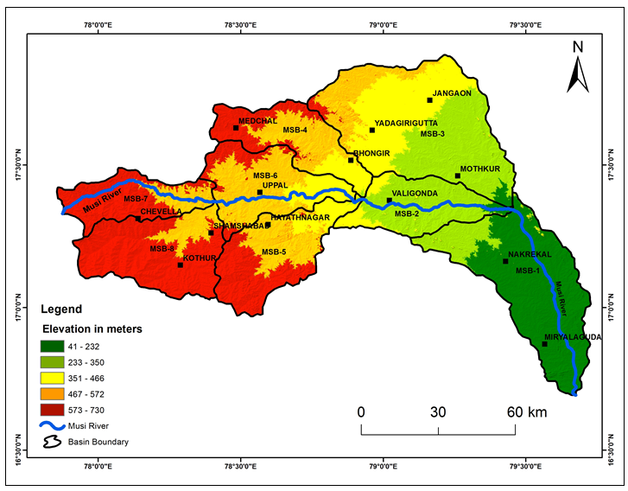
Fig 2. Digital elevation map of the study area Musi basin.
3.2. Lithological Analysis
The lithological diversity within the Musi River basin was interpreted using multispectral remote sensing techniques, particularly from IRS P6-LISS IV satellite imagery. The identification of geological formations was achieved by analysing the False Colour Composite (FCC) signatures across three spectral bands (B2: 0.52–0.59 µm, B3: 0.62–0.68 µm, and B4: 0.77–0.86 µm), alongside established band ratioing and enhancement techniques described by (Miller and Pearson, 1971; Singer, 1980; Price, 1995).
Remote sensing effectively delineated variations in lithology due to differences in spectral reflectance, grain size, and mineral composition. Topography also served as a geomorphic indicator for identifying lithological boundaries, as many rock units exhibit distinct surface expressions and erosion patterns (Fig. 3). The geological structure of the Musi River basin is primarily composed of Archean-age crystalline rocks, typical of the Eastern Dharwar Craton. According to Table 1, the dominant lithology is Leuco Granite, covering 8060.10 km², which accounts for 71.22% of the total basin area. This widespread occurrence indicates a stable continental crust and intrusive igneous activity during the late Archean.
Other significant lithological units include:
- Grey Biotite Granite (15.23%) and Pink Biotite Granite (1.00%)-exhibiting medium to coarse textures, often associated with rugged terrain in the north-central basin.
- Migmatite Gneiss (4.06%)-indicative of high-grade metamorphic processes, mainly found in localized patches.
- Basalt formations (6.86%)-part of the Deccan Traps in the western sector, suggesting volcanic activity from the Cretaceous–Paleogene era. These flows are mostly tholeiitic in nature.
- Laterites (0.87%)-weathered and iron-rich capping predominantly occurring on elevated plateaus and hilltops, representing secondary deposits of Cenozoic age.
- Sedimentary lithologies, although less extensive, are also present along the eastern fringe of the basin:
- Massive Limestone (0.17%), Quartzite (0.09%), and Shale (0.33%), representative of the Proterozoic Kurnool Group, are confined to structurally low-lying terrains and river-adjacent areas.
- Minor occurrences of Amphibolite (0.13%) and Banded Magnetite Quartzite (0.05%) reflect high-grade metamorphism and mineralization zones, offering potential for mineral exploration.
Structural features such as faults, dolerite dykes, and quartz veins/reefs are prominently mapped throughout the basin. These linear or curvilinear features represent zones of tectonic weakness and are crucial in influencing groundwater flow, recharge, and storage. Their alignment often controls the orientation of stream networks and can impact the permeability of the host rock formations, the lithological and structural analysis reveals a complex geological framework dominated by intrusive granitic rocks, volcanic flows, and minor sedimentary outcrops. This heterogeneity plays a pivotal role in shaping the hydrogeological potential, terrain morphology, and land use suitability across the Musi River basin.
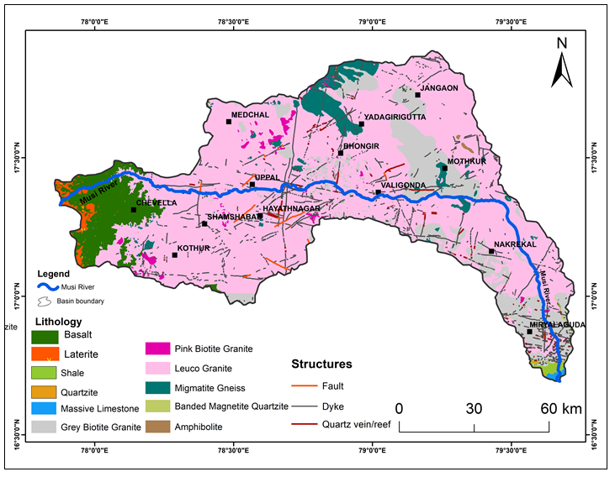
Fig 3. Lithological and structural map of the study area Musi basin.
Table 1. Spatial distribution of the lithological analysis
Lithology | Area in sq. km | Area in %
Amphibolite | 14.77 | 0.13%
Banded Magnetite Quartzite | 5.33 | 0.05%
Basalt | 776.54 | 6.86%
Grey Biotite Granite | 1723.86 | 15.23%
Laterite | 97.90 | 0.87%
Leuco Granite | 8060.10 | 71.22%
Massive Limestone | 19.16 | 0.17%
Migmatite Gneiss | 458.99 | 4.06%
Pink Biotite Granite | 113.59 | 1.00%
Quartzite | 10.56 | 0.09%
Shale | 37.09 | 0.33%
Grand Total | 11317.89 | 100 %

3.3. Drainage Pattern
The drainage pattern and texture observed in the imagery provide valuable insights into the underlying landforms and bedrock characteristics, and they also suggest the prevailing soil conditions and drainage efficiency (Thornbury, 1986). In the present study area, the drainage pattern is predominantly dendritic, indicating that the region is largely underlain by homogeneous lithological formations with minimal structural disturbances. This pattern is characterized by the irregular branching of tributaries joining main streams at acute angles, resembling the branches of a tree. However, in certain localized parts of the basin, particularly towards the eastern and northeastern sectors (e.g., around Bhongir, Jangaon, and Valigonda), slight angular deviations and tributary alignments suggest the presence of a sub-dendritic pattern, likely due to minor variations in lithology or structural influences such as joints or fractures. The general slope of the area trends towards the southeast, guiding the Musi River and its tributaries in that direction. Numerous small to medium-sized streams and streamlets dissect the terrain, further supporting the dendritic to sub-dendritic drainage classification. The flow direction of the Musi River is from west to southeast, consistent with the overall topographic gradient (Fig. 4).

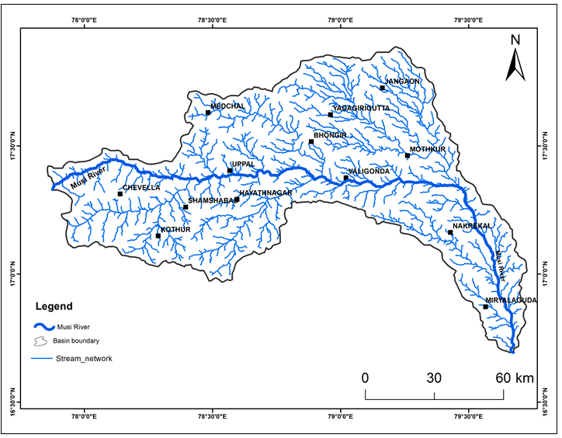
Fig 4. Drainage map of the study area Musi basin.
3.4. Geomorphological Features
The geomorphology of a river basin reflects the long-term interaction between tectonics, climate, lithology, and erosion processes. In the case of the Musi River basin, geomorphological analysis reveals a complex terrain shaped predominantly by fluvial activity and denudational processes over geological time (Aboyeji et al., 2012; Sharma and Yadav, 2020; Kumar and Hassan, 2021). The geomorphological map, prepared using high-resolution IRS satellite imagery, delineates various landform units that provide valuable insights into the basin’s surface and subsurface hydrological dynamics (Table 2). The dominant geomorphic unit in the basin is the Pediplain (54.42%), which represents a large, nearly level, gently undulating erosional surface formed by the coalescence of pediments. Pediplains are typically underlain by weathered and fractured rock material and exhibit moderate to high infiltration capacity, making them important zones for groundwater accumulation. These landforms are often favored for agriculture and habitation due to their relatively fertile soils and ease of accessibility. Following this, Pediments (35.53%) are the second most prominent geomorphic features. These are gently sloping bedrock surfaces located at the base of hills or uplands, formed due to sheet wash and weathering processes. Although less suitable for agriculture due to shallower soils, pediments offer moderate groundwater potential, especially when intersected by fractures or lineaments, enhancing secondary porosity. The presence of these features indicates active denudational processes and transitions between uplands and lowlands. Residual Hills (1.34%) are isolated hillocks or knobs of resistant rock that have withstood erosion, representing the remnants of a once-continuous upland. These features are of limited hydrological significance in terms of recharge but contribute to surface runoff and may control local drainage networks. Active Flood Plains (1.83%), though occupying a smaller portion of the basin, are critical from a hydrological perspective. These are low-lying flat terrains adjacent to the Musi River and its major tributaries, characterized by recent alluvial deposits. These areas are prone to seasonal flooding but are important recharge zones due to their loose sediments and high infiltration rates. They also support intensive agriculture due to the deposition of fertile silts and clays during monsoon floods.
The presence of Waterbodies including tanks, lakes, and river channels accounts for approximately 5.21% of the basin. These surface water reservoirs not only aid in irrigation and drinking water supply but also play a crucial role in groundwater recharge during post-monsoon seasons through percolation and seepage mechanisms. The Moderately Dissected Hills and Valleys (0.33%) and Low Dissected Hills and Valleys (0.12%) reflect rugged terrain formed by intense erosion and structural dissection. These areas typically exhibit steep slopes, limited soil cover, and low infiltration capacity, thereby acting as runoff-generating zones. While not ideal for agriculture or habitation, they play a role in controlling sediment transport and streamflow characteristics. Additional features include Dyke/Sill Ridges (0.52%), which are linear or arcuate resistant rock formations resulting from igneous intrusions. These features influence local drainage direction and may also create confined aquifers where groundwater can accumulate in fractured zones. Ridges (0.05%) and Channel Bars (0.08%) further add to the diversity of the terrain. Quarry areas (0.07%) represent anthropogenically modified zones, which, although limited in spatial extent, may alter local drainage and infiltration dynamics.
From a geomorphological standpoint, the overall drainage pattern of the Musi River basin is dendritic to sub-dendritic, suggesting a relatively uniform lithology with minimal structural control in certain parts, while other areas reflect influence from faults and lineaments. The Musi River flows in a west to southeast direction, collecting runoff from numerous small and medium-sized streams. The general slope of the land towards the southeast supports this drainage trend. Such a drainage configuration, combined with the terrain characteristics, enhances the basin’s surface and sub-surface water movement. The geomorphology of the Musi River basin reveals a predominantly erosional landscape dominated by pediplains and pediments, interspersed with flood plains, waterbodies, hills, and ridges. These features not only shape the hydrological regime but also influence land use, soil development, and groundwater recharge potential. An in-depth understanding of these landforms is essential for integrated water resource planning, groundwater prospecting, and sustainable management of the basin.
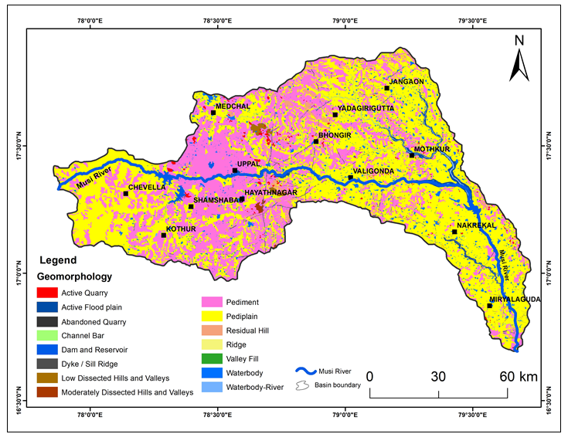
Fig 5. Geomorphology map of the study area Musi basin.

Table 2. Spatial distribution of the geomorphology features
Geomorphology Features | Area in sq. km | Area in %
Abandoned Quarry | 0.50 | 0.004%
Active Flood plain | 206.94 | 1.828%
Active Quarry | 74.34 | 0.657%
Channel Bar | 2.83 | 0.025%
Dam and Reservoir | 71.03 | 0.627%
Dyke / Sill Ridge | 58.58 | 0.518%
Low Dissected Hills and Valleys | 36.18 | 0.320%
Moderately Dissected Hills and Valleys | 12.83 | 0.113%
Pediment | 4021.06 | 35.528%
Pediplain | 6158.69 | 54.416%
Residual Hill | 151.08 | 1.335%
Ridge | 5.16 | 0.046%
Waterbody | 392.84 | 3.471%
Waterbody-River | 125.83 | 1.112%
Grand Total | 11317.89 | 100 %

3.5. Land Use/Land Cover (LULC)
Land use/land cover (LULC) refers to the human and natural activities on the Earth’s surface, and it is intricately linked with geomorphological and lithological characteristics of the region (Reddy et al., 2018; Varde et al., 2011; Das and Paul, 2023). LULC plays a critical role in hydrological processes such as infiltration, runoff, erosion, and evapotranspiration (Kumar et al., 2007; Smith, 2008; Roy et al., 2020; Chand et al., 2022), thereby directly influencing the recharge and availability of groundwater resources. The LULC map of the Musi River basin was prepared using LISS-IV IRS-P6 satellite imagery, employing techniques such as layer stacking and supervised classification through signature editing. The classified LULC of the Musi sub-basin (Fig. 6) reveals that crop land dominates the landscape, accounting for 61.80% of the total area (6994.91 sq. km). This extensive agricultural coverage indicates significant reliance on groundwater or surface water resources for irrigation. The next major category is scrub land, covering 18.04% (2041.71 sq. km), indicating semi-arid conditions or lands undergoing ecological transition (Table 3).
Urban and rural built-up areas collectively represent 6.59% (urban: 4.08%, rural: 2.51%), predominantly clustered around Hyderabad and its suburban sprawl like Uppal, Hayathnagar, and Shamshabad, reflecting increasing urbanization pressure in the central-western part of the basin. Barren rocky land accounts for 1.60%, generally associated with the rugged terrain and resistant lithologies, while mining and industrial zones occupy 1.51%, scattered near urban centers and transport corridors. Reservoirs and tanks form an important hydrological feature, covering 3.90%, playing a crucial role in surface water storage and groundwater recharge. Forests cover 2.72% of the basin, mainly in the northern and eastern regions, contributing to ecological stability. Other minor land cover classes include agriculture plantation (1.83%), river/stream/drain networks (1.24%), transportation (0.59%), canals (0.15%), and lakes/ponds (0.01%).
he spatial distribution and area statistics of each land cover class (Table 3) provide insights into land resource utilization and anthropogenic pressures. The LULC analysis of the Musi River basin reflects a typical rural-agricultural-urban transitional landscape, highlighting the need for sustainable land and water resource management strategies in this rapidly developing region.

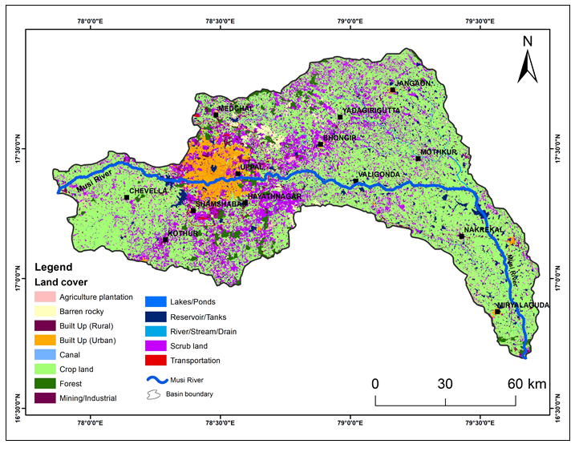
Fig 6. Land use land cover map of the study area Musi basin.
Table 3. Spatial distribution of land use-land cover
Land use and Land Cover type | Area in sq. km | Area in %
Agriculture plantation | 207.69 | 1.83%
Barren rocky | 181.38 | 1.60%
Built Up (Rural) | 284.48 | 2.51%
Built Up (Urban) | 462.17 | 4.08%
Canal | 17.26 | 0.15%
Crop land | 6994.96 | 61.80%
Forest | 308.13 | 2.72%
Lakes/Ponds | 0.62 | 0.01%
Mining/Industrial | 170.62 | 1.51%
Reservoir/Tanks | 441.46 | 3.90%
River/Stream/Drain | 140.61 | 1.24%
Scrub land | 2041.70 | 18.04%
Transportation | 66.81 | 0.59%
Grand Total | 11317.89 | 100 %

3.6. Soil Characteristics of the Musi Basin
The Musi River Basin exhibits a complex and varied distribution of soil types, shaped by its underlying geology, topography, and climatic influences. The soils are composed of mineral particles, organic matter, air, and water, with textures ranging from clayey to gravelly. This variability plays a critical role in determining the water retention, drainage capacity, fertility, and overall agricultural potential of different areas (Sarkar and Pal., 2019; Bhattacharya and Das, 2021). According to the soil classification and spatial distribution analysis (Fig. 7 and Table 4), the Loamy to gravelly clay deep dark reddish-brown soils constitute the most extensive soil type in the basin, covering approximately 23.67% of the total area. These soils are predominantly found in the northeastern, eastern, and central regions of the basin. Their well-drained structure and moderate fertility make them suitable for mixed dryland agriculture, especially in areas with moderate rainfall.
The Moderately deep calcareous black soils, which occupy about 21.98%, are largely located in the southern and southwestern zones. Rich in calcium carbonate, these soils exhibit moderate fertility and are particularly prone to cracking during dry spells, a characteristic feature of Vertisols. Nonetheless, they support a variety of rainfed and irrigated crops depending on the water availability. Soils classified as Loamy to clayey skeletal deep reddish-brown soils account for 21.58% of the basin and are generally distributed across plateau and highland regions. These soils are often shallow to moderately deep with a high proportion of coarse fragments, which limits their fertility. However, they play a critical role in regulating surface runoff and facilitating infiltration, particularly in forested slopes and rocky uplands.
Gravelly clayey moderately deep dark brown soils and Clayey moderately deep wet soils, covering 10.83% and 7.54% respectively, are dispersed across central and northern parts of the basin, including areas like Medchal, Uppal, and Hayathnagar. These soils show moderate permeability and adequate water-holding capacity, making them suitable for crops that do not require deep rooting zones. The Deep black clayey soils, occupying 6.90%, are mainly found in southwestern valleys and the fringes of hilly terrain. Known for their high fertility and moisture retention, these soils are well-suited for intensive agriculture, especially for cotton and cereals in valley bottoms. Shallow gravelly red soils account for 4.42% of the area and are typically located in upland and marginal areas, particularly in Medchal and Jangaon districts. These soils are thin, low in fertility, and prone to erosion, especially in areas with steep gradients and sparse vegetation.
In terms of non-agricultural land uses, settlements cover 2.12% of the total area, while water bodies occupy 0.95%, indicating limited but crucial land cover classes. Settlements are concentrated around urban centers, while water bodies reflect the presence of natural and man-made reservoirs and tanks crucial for irrigation and ecosystem services. The spatial distribution of these soil types indicates active erosional and denudational processes in certain upland and forested regions, leading to the formation of skeletal and shallow soil profiles. These areas often contribute significantly to groundwater recharge, especially where vegetation cover enhances infiltration. The Musi Basin's soil mosaic mirrors its geological heterogeneity and geomorphological complexity. This diversity necessitates region-specific soil conservation, agricultural planning, and watershed management strategies to ensure sustainable land use and long-term ecological balance.
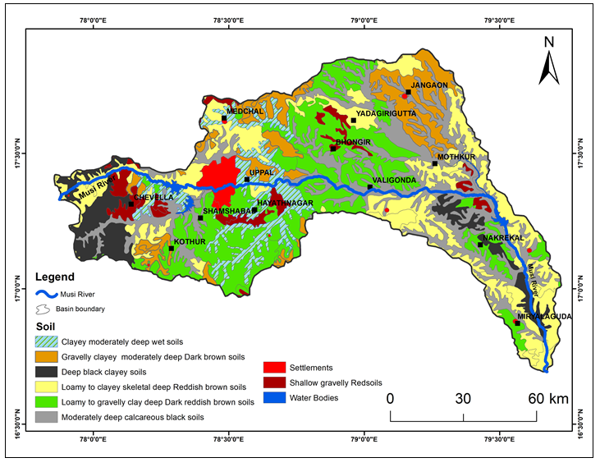
Fig 7. Soil map of the study area Musi basin.
Table 4. Spatial distribution of the soil types
Soil Type | Area in sq. km | Area in %
Clayey moderately deep wet soils | 852.97 | 7.54%
Gravelly clayey moderately deep dark brown soils | 1225.49 | 10.83%
Deep black clayey soils | 781.48 | 6.90%
Loamy to clayey skeletal deep Reddish brown soils | 2442.67 | 21.58%
Loamy to gravelly clay deep dark reddish-brown soils | 2678.92 | 23.67%
Moderately deep calcareous black soils | 2487.78 | 21.98%
Settlements | 240.48 | 2.12%
Shallow gravelly red soils | 500.02 | 4.42%
Water Bodies | 108.08 | 0.95%
Grand Total | 11317.89 | 100 %

4. DISCUSSION
The spatial integration of thematic layers across the Musi River Basin reveals a dynamic and environmentally sensitive landscape shaped by both natural processes and human activity. The digital elevation model (DEM) analysis delineates a clear elevation gradient sloping from west to southeast, dictating the basin’s hydrological response and stream flow direction. This topographic gradient, coupled with the dominance of Archaean crystalline rocks, has resulted in the development of a predominantly dendritic to sub-dendritic drainage pattern, indicating minimal structural disturbances and lithological homogeneity in large sections of the basin. However, occasional linear stream alignments hint at local structural influences, especially near dolerite intrusions. The drainage density and stream frequency reflect moderately dissected terrain, which is conducive to moderate surface runoff and seasonal groundwater recharge in low-lying zones. The geological framework of the area, primarily composed of granite and gneiss, has played a fundamental role in shaping the pediplains, buried pediments, and valley fills evident in the geomorphological classification. These landforms influence surface-water retention, infiltration, and erosion susceptibility.
Soil characteristics emerge as a critical factor in mediating the interactions between landform, hydrology, and land use. The soil distribution across the basin mirrors its geomorphic and geological context, reinforcing spatial patterns of land suitability, runoff potential, and erosion vulnerability. Deep clayey and calcareous black soils prevalent in the flatter terrains and valley fills offer high moisture retention, making them well-suited for agriculture and enhancing the basin’s role in food production. These soils also contribute significantly to groundwater recharge due to their relatively lower permeability, which promotes infiltration over quick surface runoff. In contrast, gravelly red soils dominating the upland and pediment zones are typically shallow, less fertile, and more prone to erosion. These characteristics limit their agricultural productivity and make them more susceptible to degradation under land-use pressure. Furthermore, soil depth, texture, and structure directly influence the basin’s hydrological pathways. For instance, in areas with compact or calcareous soils, surface runoff is more pronounced during monsoonal events, increasing the flood risk in downstream zones. Conversely, porous and well-structured soils in valley fills facilitate aquifer recharge, supporting sustainable water availability. Thus, soil functions not merely as a physical medium but as a dynamic component regulating hydrological connectivity, nutrient cycling, and land productivity.
The land use and land cover (LULC) patterns, characterized by widespread agriculture, open scrub, and growing urban footprints, suggest significant land modification, particularly in central and eastern parts of the basin. The increasing built-up area and conversion of natural landscapes into agricultural and settlement zones have implications for surface runoff, infiltration capacity, and flood risk. The synergy between soil type and land use decisions becomes evident here: for instance, urban expansion over high-infiltration soils can drastically reduce groundwater recharge potential, while cultivation on erosion-prone red soils without adequate conservation measures accelerates land degradation. Geomorphologically, the basin exhibits a mix of active and stable landforms, where high-relief denudational hills and pediment inselbergs are prone to erosion, and buried pediments and valley fills offer groundwater recharge potential. This integrated interpretation underscores the interdependence of topography, lithology, soil, and land use in governing the hydrological behavior, land degradation, and resource sustainability of the basin. The incorporation of detailed soil data thus provides a more holistic understanding of environmental processes, supporting targeted interventions for watershed management and sustainable land use planning.
5. CONCLUSIONS
The comprehensive interpretation of topographical, geological, drainage, soil, LULC, and geomorphological datasets of the Musi River Basin provides critical insights into its complex environmental dynamics. The basin’s physiography is fundamentally shaped by its underlying Archaean geology and moderate relief, which support a dendritic drainage network that governs water flow and sediment transport. Human-induced land use changes, particularly the expansion of agriculture and urban areas, are significantly altering the natural hydrological balance, leading to increased surface runoff, reduced infiltration, and heightened erosion risks.
Importantly, soil characteristics emerge as a key controlling factor within this integrated system. Variations in soil texture, depth, and fertility strongly influence surface-water retention, groundwater recharge potential, and susceptibility to erosion. Deep, fertile soils in low-lying areas promote sustainable agriculture and aquifer recharge, while shallow, gravelly, and erosion-prone soils in upland regions demand targeted conservation efforts to prevent land degradation. The coupling of soil and landform data thus allows for a nuanced identification of zones requiring focused soil and water conservation measures. The integration of multi-thematic data layers offers a robust framework for identifying priority areas for watershed management, soil conservation, and sustainable urban planning. This holistic approach is essential for maintaining the ecological balance and securing water and soil resources in rapidly changing peri-urban river basins like the Musi. Future management strategies must prioritize soil health and its role in hydrological processes to ensure long-term environmental resilience, resource sustainability, implications for watershed planning and recommend zoning for conservation in erosion-prone uplands, buffer zones near water bodies, and control of construction in high recharge areas.
DISCLAIMER (ARTIFICIAL INTELLIGENCE)
Author(s) hereby declares that NO generative AI technologies such as Large Language Models (ChatGPT, COPILOT, etc.) and text to image generators have been used during the writing or editing of this manuscript.
COMPETING INTERESTS
Authors have declared that no competing interests exist.
REFERENCES
Aboyeji, O. S., Mogaji, K. A., & Oyinloye, R. O. (2012). Structural Interpretation of Remotely Sensed Sets, It Hydrogeological Implication over Ile-Life and Environs. Ozen Journal of Applied Sciences, Vol. 5, pp.43-54.
Bhattacharya, T., & Das, A. (2021). Soil and landform analysis using terrain indices and GIS in semi-arid watershed of India. Arabian Journal of Geosciences, 14(4), 321. https://doi.org/10.1007/s12517-021-06516-3
Castleman, K.E. 1978. The gray level histogram, Digital Image Processing. Printice- Hall, Englewood Cliffs, New Jersey, Inc., pp. 68-84.
Chand, P., & Acharya, P. (2022). Long-term land use and land cover dynamics and its impact on water quality in a semi-arid watershed of India using remote sensing and GIS. Environmental Monitoring and Assessment, 194(3), 172. https://doi.org/10.1007/s10661-022-09875-w
Chavez, P.S. Jr., Berlin, G.L. and Sowers, L.B. 1982. Statistical method for selecting Landsat MSS ratios, Journal of Applied Photographic Engineering, Vol. 8(1), pp. 23-30.
Das, S., & Paul, S. (2023). Urban growth and its impact on hydrological response in the Eastern India river basin using remote sensing and SWAT. Water Resources Management, 37, 205–224. https://doi.org/10.1007/s11269-022-03323-3
El Khidir, S.O. and Babikir, I.A., 2013. Digital image processing and geospatial analysis of landsat 7 ETM+ for mineral exploration, Abidiya area, North Sudan. International Journal of Geomatics and Geosciences, 3(3), pp.645-658.
Ezzati, S.A., S.R. Mehrnia and K.S. Ajayebi (2014). Detection of hydrothermal potential zones using remote sensing satellite data in Ramand region, Qazvin Province, Iran journal of Tethys, Vol. 2 (2), pp. 93–100.
IRS P6 data user’s manual, IRS-P6/ NRSA/NDC/HB-10/03, 1/October-2003.
Jancewicz, K., R´o˙ zycka, M., Szymanowski, M., Kryza, M., Migo´n, P., 2022. Topographic Characteristics of Drainage Divides at the Mountain-Range Scale&mdash;A Review of DTM-Based Analytical Tools. ISPRS Int. J. Geo Inf. 11 (2), 116.
Kumar, P.K.D., Gopinath G. and Seralathan P. (2007) Application of remote sensing and GIS for the demarcation of groundwater potetential zones in a river basin of Kerala, southwest coast of India. International Journal of Remote Sensing, 28 (24) pp. 5583-5601.
Kumar, S., & Hassan, M. I. (2021). Assessment of geomorphological parameters for watershed prioritization using SRTM DEM in semi-arid regions. Applied Water Science, 11(3), 54. https://doi.org/10.1007/s13201-021-01344-3
Linga Swamy Jogu, Udaya Laxmi G, Naveen Kumar Gradas, and Vidyasagar Chary (2022) “Analysis of Terrain elements using IRS P6-LISS-IV image in parts of Nagarkurnool and Wanaparthy districts in Telangana State, India.” Indian Society of Applied Geochemists (ISAG)-Journal of Applied Geochemistry, ISSN (Print): 0972-1967 ISSN (Online): 2319-4316, Volume: 24, Issue: 4, PP.197-202.
Ma, D., Zhao, S., 2022. Quantitative Analysis of Land Subsidence and Its Effect on Vegetation in Xishan Coalfield of Shanxi Province. ISPRS Int. J. Geo Inf. 11 (3), 154.
Miller, L.D. and Pearson, R.L. 1971. Areal mapping program of the IBP grassland biome: Remote Sensing of the productivity of the shortgrass prairie as input into biosystem models, 7th Proceedings of International Symposium. Remote Sensnsing of Environment. Vol. 1, pp. 175–205.
Nagamani, K. and Ramachandran, S., 2003, December. Land use/land cover in Pondicherry using remote sensing and GIS. In Proceedings of the Third International Conference on Environment and Health, Chennai, India (pp. 15-17).
Price, J.C. 1995. Examples of high resolution visible to near infrared reflectance spectra and a standardized collection for remote sensing studies: International Journal of Remote Sensing, Vol. 16, pp. 993–1000.
Priyanka, T., B. Veeraiah, and Linga Swamy Jogu. 2024. “Terrain Analysis of Elements Using LISS-IV Satellite Image in Bhainsa Region, Northwestern Part of Nirmal District, Telangana State, India”. Asian Journal of Geographical Research 7 (2):107-22. https://doi.org/10.9734/ajgr/2024/v7i2235.
Rao, D.P. 1995. Remote Sensing for Earth Resources, AEG Publication.
Reddy, C. S., Jha, C. S., & Dadhwal, V. K. (2018). Assessment and monitoring of long-term forest cover changes in Western Ghats biodiversity hotspot using remote sensing data. Current Science, 114(1), 62–70. https://www.currentscience.ac.in/Volumes/114/01/0062.pdf
Roy, P. S., Joshi, P. K., Kale, M. P., Srivastava, V. K., Dwevidi, R. S., & Behera, M. D. (2020). National framework for land use/land cover classification in India using remote sensing. Journal of the Indian Society of Remote Sensing, 48(1), 1–12. https://doi.org/10.1007/s12524-019-01029-8
Sarkar, A., & Pal, S. C. (2019). Geospatial approach for soil erosion vulnerability assessment using RUSLE model in hilly terrain of India. Natural Hazards, 97, 1451–1472. https://doi.org/10.1007/s11069-019-03741-y
Sharma, M., & Yadav, A. (2020). Quantitative morphometric analysis of a river basin using GIS: A case study of Son basin, India. Modeling Earth Systems and Environment, 6(2), 1121–1131. https://doi.org/10.1007/s40808-020-00734-z
Singer, R.B. 1980. Near–infrared spectral reflectance of mineral mixtures, systematic combinations of pyroxenes, olivine and iron oxides, PSD Publications. No. 258, MIT, Cambridge, MA.
Smith, P. (2008). Land use change and soil organic carbon dynamics. Nutrient Cycling in Agroecosystems, 81(2), 169–178.
Thornbury, W.D. 1986. Principles of Geomorphology, 2nd Edition. Wiley Eastern Ltd.
Udaya Laxmi G., Narsimha,K., Linga Swamy Jogu, Telu Raju, Ramadass,G., 2016. IRS R2-LISS IV Satellite Image Analysis for Mapping Lithological, Geomorphological, Drainage and Structural Features Along the Kalwakurthy-Nalgonda-Huzurnagar Profile, Telangana State, India. Int. Journal of Research in Engineering and Technology (IJRET) Vol. 5 Issue-07, pp.129-137.
UmaMaheshwari R., Rajkumar R., Surendran A. and Krishnamoorthy B.S., 2015). Monitoring changes in land use/land cover using multi temporal/sensor satellite data: a case study in Palani. (IJRSR), 6(2), 2867- 2870.
Varde, A.M., Wath, P., Dongre, K.P., Khare, Y.D. and Khandare, H. (2011). Integrated approach using remote sensing and GIS for assessment of groundwater situation in parts of Chandrapur and Gadchiroli Districts of Maharastra, Journal of Indian Geophysics Union, v.15 (4), pp.195-206.
Xiong, L., Li, S., Tang, G. and Strobl, J., 2022. Geomorphometry and terrain analysis: Data, methods, platforms and applications. Earth-Science Reviews, 233, p.104191.

