Improving Seed Germination and Seedling Performance of Osyris lanceolata through Fruit Maturity indices, Seed Pretreatments, and Substrate Optimization

Abstract
Background and Aim: Osyris lanceolata (Hochst. &Steud) is an evergreen hemi-parasitic shrub or small tree of the Santalaceae family, valued for its fragrant heartwood and essential oils used in perfumery and traditional medicine. However, its propagation is limited due to poor seed germination and challenges in vegetative methods. This study aimed to evaluate the effects of different pre-sowing seed treatments, germination substrates, and fruit maturity stages on the germination and early growth performance of O. lanceolata from naturally growing populations in Tehri Garhwal, Uttarakhand.
Study Design: The study was conducted through two separate experimental setups using a completely randomized design (CRD) to evaluate the effects of fruit maturity stages, germination substrates, and various pre-sowing treatments on the seed germination and early growth of Osyris lanceolata. In the first experiment, conducted at the Forest Tree Seed Laboratory, ICFRE-FRI, seeds collected at three different maturity stages (green, light orange, and bright red) were subjected to mechanical scarification followed by soaking in boiling water for 12 hours. The seeds were then sown on two different substrates—sand and vermiculite—and incubated under controlled laboratory conditions at 25 ± 1 °C, >90% relative humidity, and a 24-hour photoperiod. Each treatment included four replicates of 20 seeds.The second experiment was carried out in the nursery of Jakh-Koti Botanical Park, Tehri, Uttarakhand where seeds were subjected to eight different pre-sowing treatments: T1 – Control, T2 – Mechanical scarification + 500 ppm GA₃ (24 h), T3 – Mechanical scarification + 1000 ppm GA₃ (24 h), T4 – 30% Hydrogen peroxide (24 h), T5 – 0.2% Potassium nitrate (24 h), T6 – 2% Thiourea (24 h), T7 – 20% Sulfuric acid (1 min), and T8 – Hot water (1 min). Each treatment included four replicates of 100 seeds. Across both experiments, germination performance was evaluated using key parameters: Germination Percentage (GP), Mean Germination Time (MGT), Germination Value (GV), Peak Value (PV), Germination Index (GI), Seedling Vigor Index (SVI), Sturdiness Quotient (SQ), Vigor Index (VI) and Quality Index (QI).

Results:In the laboratory experiment, substrate and fruit maturity stage had a significant impact on germination parameters. Seeds sown on vermiculite showed a significantly higher germination percentage (46.66 ± 7.63%) compared to those sown on sand (33.33 ± 7.63%). Pretreatment improved all germination parameters, while fruit maturity stage played a critical role. Seeds collected at the bright red maturity stage (moisture content: 52.62 ± 2.51%) recorded the highest germination percentage and germination value, along with a low mean germination time (MGT), indicating their physiological readiness for germination. In the nursery experiment, the highest germination percentage (66.66 ± 8.32%) was observed in T3 – Mechanical scarification followed by soaking in 1000 ppm GA₃ for 24 hours, which was significantly superior to all other treatments. This was followed by T2 (Mechanical scarification + 500 ppm GA₃; 49.33 ± 4.61%) and T7 (20% Sulphuric acid for 1 min; 41.33 ± 2.30%). The lowest germination percentages were recorded in T4 (30% Hydrogen peroxide; 18.66 ± 2.30%), T8 (Hot water; 18.66 ± 6.11%), and the untreated control T1 (13.33 ± 2.30%), with no significant differences among them. Among all treatments, T3 proved to be the most effective for enhancing seed germination.
Conclusion: The study highlights effective strategies for improving the germination and early growth of Osyris lanceolata. Vermiculite was identified as the optimal germination medium, while seeds collected at the bright red maturity stage (~52% moisture content) exhibited the highest germination performance, including superior germination percentage (GP), germination value (GV), and reduced mean germination time (MGT). Among pre-sowing treatments, mechanical scarification followed by soaking in 1000 ppm GA₃ for 24 hours (T3) resulted in the highest germination percentage and significantly enhanced seedling vigor. These findings provide valuable guidance for optimizing seed propagation and support the domestication and conservation of O. lanceolata.
Keywords: Maturity indices; seed germination, germination substrate, seed dormancy, growth performance.

Introduction
  - Osyris lanceolata:
Osyris lanceolata (commonly known as East African sandalwood) is an evergreen shrub or small tree belonging to the Santalaceae family (Teklehaimanot et al., 2003; Githae et al., 2011). Typically growing between 1 to 7 meters in height, it can reach up to 10 meters under optimal forest conditions (Beentje, 1994; Subasinghe, 2013). The species is highly valued for its aromatic yellowish-red heartwood, which yields essential oils used in perfumery, cosmetics, and traditional medicine (Mwang’ingo et al., 2007; Tshiisikhawe et al., 2012). Additionally, its roots are utilized in basketry, while the bark and roots provide a red dye for tanning (Mbuya et al., 1994). Medicinally, O. lanceolata has been employed to treat infections, diarrhea, and fertility-related issues (Tshisikhawe et al., 2012). Its evergreen nature and prolonged flowering period also make it an important forage species (Githae et al., 2011). However, the species faces significant challenges in natural regeneration due to limited seed production, low germination rates, and seed dormancy (Mwang’ingo et al., 2004; Kamondo et al., 2014). The seeds exhibit chemical dormancy and are recalcitrant, complicating both storage and germination processes. In India, speciesflowering between March-May (peak April) and fruiting September-October, producing 6-8 mm diameter drupes that transition from green to red deep at maturity.
1.2 Distribution
Osyris lanceolata has a pantropical distribution, occurring naturally across South Asia (India, Sri Lanka, Nepal, Bhutan), Southeast Asia (Myanmar, Thailand, Indo-China), China, Africa, and Southern Europe. In India, it is particularly found in the subtropical Himalayas, Northeast, Central, and Peninsular regions, with specific populations recorded in Himachal Pradesh, Andhra Pradesh, Goa, Kerala, and Tamil Nadu (Balakrishnan et al., 2012).It exhibits a highly scattered, patchy distribution across rocky slopes, dry woodlands, and montane areas up to 2,000 m elevation.
The national biodiversity assessment report from African countries listed the species as critically endangered, highly threatened or locally endangered due to overexploitation for medicine and oil extraction leading to habitat degradation, poor natural regeneration, and an increased risk of extinction. Seed dormancy and low viability associated with species cause challenges in nursery propagation, and vegetative propagation methods are also found to be not effective. The current study aimed to evaluate the effects of different pre-sowing seed treatments and germination substrates for developing effective ex situ conservation strategies for the species and to study the various fruit maturity stages on the germination and early growth performance for standardizing optimal harvesting stages.
- MATERIALS AND METHODS
  - Seed Collection
Seeds of Osyris lanceolata were collected from Tehri Forest Division-1, Uttarakhand, India, at GPS coordinates 30°28′03.60″N latitude and 78°26′23.41″E longitude, at an elevation of 1332 m. Seeds were collected from the subtropical pineforest where species grows in association with Pinus roxburghii, Quercus leucotrichophora, Anogeissus latifolia and Mallotus philippinensis. Laboratory germination trials were conducted at the Forest Tree Seed Laboratory, ICFRE-FRI, while nursery experiments were carried out at Jakh-Koti Botanical Park (30°24′18.4″N, 78°27′0.9″E; elevation 1100 m) near Tehri Lake.

2.1.1. Seed extraction and morphological studies in Osyris lanceolata
Mature Osyris lanceolata seeds, identified by their firm white endosperm, were hand-collected and processed within 48 hours. Pulp removal was done by rubbing fruits through a 4 mm wire mesh, followed by rinsing and manual maceration. A flotation test separated viable (sinking) from non-viable (floating) seeds. Shade-drying ensured moisture removal before sowing. Morphological parameters (length, width, color) and moisture content of fruits at green, intermediate, and ripened stages were recorded. Seed weight and count per kilogram were measured post-drying. Authenticated specimens were deposited at the Forest Research Institute, Dehradun (Herbarium ID: 173683).Both trials employed rigorous germination assessment protocols while differing in environmental conditions and treatment variables, collectively providing comprehensive insights into optimal germination strategies for O. lanceolata.

This study examined the effects of pre-sowing seed treatments on the germination and growth performance of Osyris lanceolata under incubator and nursery conditions. Germination was monitored daily, with key parameters recorded including Germination Percentage (GP), Mean Germination Time (MGT), Initial Germination Time (IGT; days until first radicle emergence)and final germination time (FGT; days until the last viable seed's radicle emergence). Additionally, other germination and seedling performance indices were assessed, such as Germination Value (GV), Peak Value (PV), Germination Index (GI), Seedling Vigor Index (SVI), Sturdiness Quotient (SQ), Vigor Index (VI) and Quality Index (QI). These parameters were evaluated to determine the influence of different treatments on seed germination efficiency and early seedling development.

- Germination Parameters

- Germination Percentage (GP):
GP = (Number of seeds germinated/Total number of seeds sown) × 100 (Maguire, 1962)

2. Growth Parameters
- Moisture Content (MC): MC (%) = [(Fw - Dw)/Fw] × 100
Where: Fw = Fresh weight (g) Dw = Dry weight after oven drying at 103°C for 17 hours(ISTA, 2007)

3. Germination Speed and Synchronization
- Mean Germination Time (MGT): MGT = Σ (F × x)/ΣF
Where: F = Number of seeds germinated on day x, x = Number of days from sowing (Ellis, R.H., & Roberts, E.H., 1981)
- Germination Index (GI): GI = Σ(G/T)
Where: G = Percentage of seeds germinated per day, T = Germination period (days) (Maguire, J.D. (1962)
- Germination Value (GV): GV = (ΣDGS/N) × (Final germination %/10)
Where: DGS = Daily germination speed, N = Number of days (Czabator, F.J., 1962)
- Peak Value (PV): Highest mean daily germination rate (Czabator, F.J., 1962)

4. Seedling Vigor and Quality Indices
- Vigor Index (VI):VI = GP × (Shoot length + Root length) (Abdul-Baki and Anderson, 1973)
- Seedling Vigor Index (SVI)SVI = Seedling height (cm) × GP (Abdul-Baki and Anderson, 1973)
- Sturdiness Quotient (SQ): SQ = Seedling height (cm)/Collar diameter (mm) (Thompson, 1985)
- Volume Index (VI): VI = [Diameter (mm)] ² × Height (cm) (Hatchell, 1985)
- Quality Index (QI): QI= [Total seedling dry weight (g)]/ [Height (cm) + Collar diameter (mm)] + [Shoot dry weight (g)/Root dry weight (g)] (Dickson, 1961)

  - Viability test
Seed viability was assessed using the tetrazolium test (Grabe 1970). Seeds were soaked in water for 24 hours, carefully cut along the margin, and immersed in 0.1% TTC solution for 16 hours at 25°C in darkness. Viable embryos stained pink confirming viability.

  - Seed Germination Experiment
The study examined the germination performance of Osyris lanceolata seeds through two distinct experimental setups. In the first trial (GT1-GT5), seeds were kept in a germinator (25±1°C temperature, >90% RH, 24hours photoperiod) using a completely randomized design with four replications of 20 seeds per treatment. Sand (control), sand with scarification and boiling water treatment for seeds at green, intermediate, and ripened stages and vermiculite for ripened seeds (Table 1). The second trial (T1-T8) investigated eight pre-sowing treatments in nursery conditions using root trainers with a Sand-Soil-FYM (1:2:1) medium, including cold water soak (control), gibberellic acid (500/1000 ppm), hydrogen peroxide, potassium nitrate, thiourea, sulfuric acid, and boiling water treatments, each with four replications of 25 seeds (Table 2).
Table 1: Experimental pre-sowing treatment details for Osyrislanceoalatain incubator

Treatment codes | Treatment details
T1 | Sand (control) Ripe fruit seed
T2 | Sand + seed scarification + boiling water (12hrs) Ripe fruit seed
T3 | Sand + seed scarification + boiling water (12hrs) Partially ripe fruit seed
T4 | Sand + seed scarification + boiling water (12hrs) Unripe fruit seed
T5 | Vermiculite + seed scarification + boiling water (12hrs) Ripe fruit seed

Table 2: Experimental pre-sowing treatment details for Osyrislanceoalatain nursery

Treatment codes | Treatment details
T1 | Control (Seeds are soaked in Cold water for 24 hrs)
T2 | Seed scarification + Gibberellic acid (Seeds are soaked in 500 ppm GA₃ for 24 hrs.)
T3 | Seed scarification + Gibberellic acid (Seeds are soaked in 1000 ppm GA₃ for 24 hrs.)
T4 | Seed scarification + 30% Hydrogen peroxide (Seed are soaked in H₂O₂ for 24 hrs.)
T5 | Seed scarification + 0.2% Potassium nitrate (Seed are soaked in KNO₃ for 24 hrs.)
T6 | Seed scarification + 2% Thiourea (Seed are soaked in Thiourea for 24 hrs.)
T7 | Seed scarification + 20% Sulfuric acid (Seed are soaked in H2SO4 for 1 minute)
T8 | Seed scarification + Boiling water (Seed are soaked in boiling water for 1 minute)

2.3 StatisticalAnalysis
Statistical analysis of germination data was performed with the SPSS16.0softwarepackage. The data was subjected to analysis of variance (ANOVA). Post Hoc Turkey LSD test was used to check the significance of treatments on GP, MGT, GV, PV, GI, SVI, SQ, VI and QI.

3.RESULTS

3.1 Maturity Indices at Various Stages of Fruit Growth
Fruit morphological and physiological traits exhibited significant variation across developmental stages (Table 3). At the green stage, fruits measured 5.81 ± 0.70 mm in length and 5.55 ± 0.26 mm in width with a moisture content of 56.37 ± 3.35%. The mean fruit count per kilogram was 5700yielding a 1000-fruit weight of 200–220 g. Fruit coloration (RHS 144A; RGB 111, 133, 36) corresponded to medium green. During the yellow to orange transition, fruit dimensions increased to 6.98 ± 0.90 mm (length) and 6.79 ± 0.61 mm (width) with moisture content declining to 48.74 ± 3.39%. The fruit count decreased to 4500 kg⁻¹, while 1000-fruit weight rose to 240–260 g. Coloration shifted to medium orange (RHS 125A; RGB 236, 103, 21). At the bright red stage (physiological maturity) fruits reached maximal size (8.27 ± 0.02 mm length; 8.05 ± 0.7 mm width) with 52.62 ± 2.51% moisture content. Fruit density further declined to 3700kg⁻¹, and 1000-fruit weight peaked at 290–310 g. The bright red color (RHS N34A; RGB 157, 19, 44) confirmed ripeness.

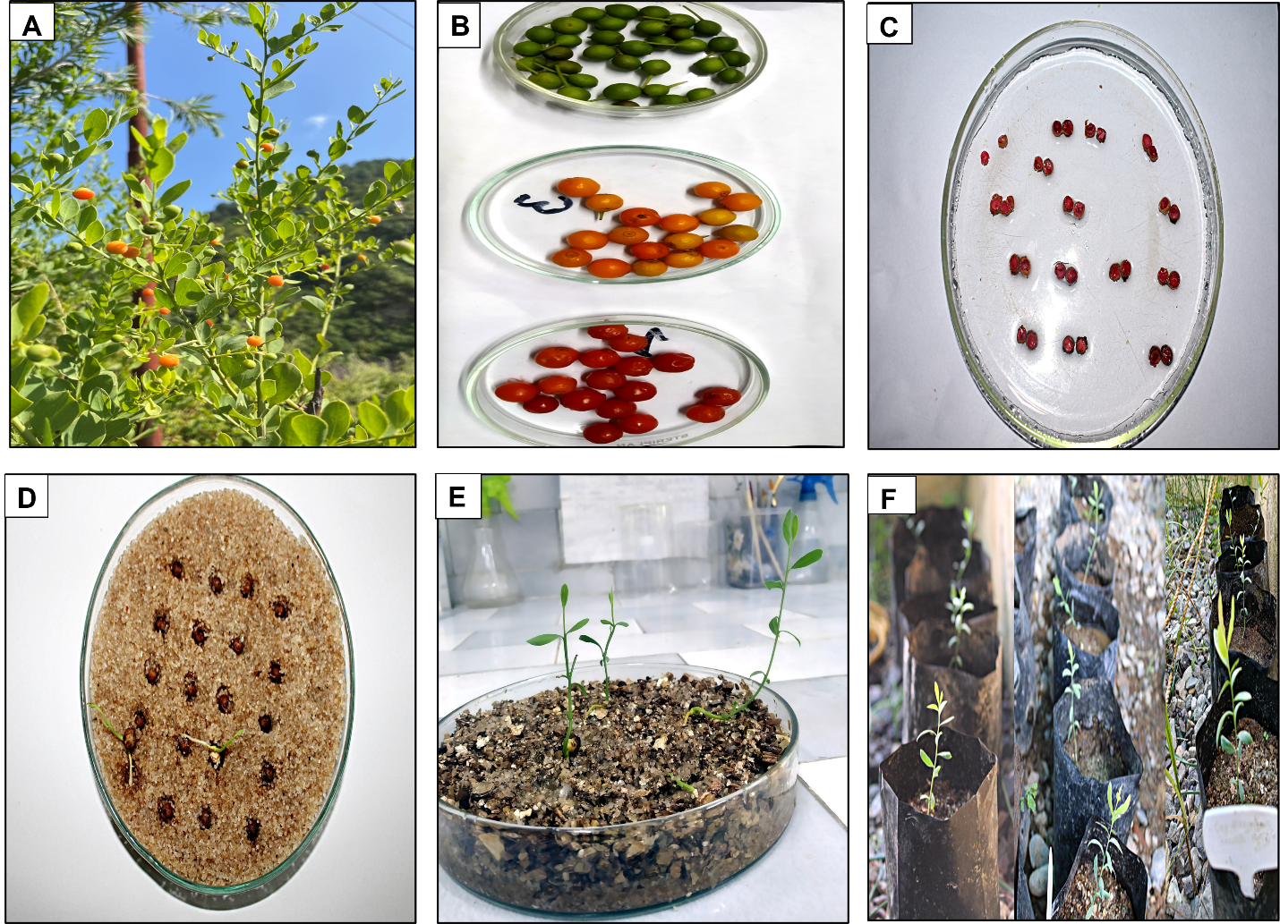
Fig. 1. Osyris lanceolata, A: Fruits, B1: Maturity stages, C: Seed viability test using Tetrazolium chloride, D, E: Seed germination in quartz sand and vermiculite respectively, F: Seedling growth after 60 days

Maturity Indices at Various Stages of Seed Growth
The study evaluated the physiological and morphological characteristics of Osyris lanceolata seeds across three distinct maturation stages. At the green stage, seeds exhibited high moisture content (42.25±7.81%) and low germination capacity (10±5.00%) with approximately 10,800 seeds per kilogram and displaying creamy white coloration (RHS NN155C) as per RHS colour chart. As seeds progressed to the yellow to orange stage, moisture content decreased to 38.75±3.37% and germination percentage improved to 18.33±2.88%accompanied by a reduced weight of 9600 seeds per kilogramand light brown pigmentation (RHS 165D) as per RHS colour chart. Mature seeds at the bright red stage demonstrated optimal physiological characteristics including the lowest moisture content (32.12±2.37%) highest germination percentage as33.33±7.63% in sand and 46.66±7.63% in vermiculite. At this stage weight reduced to 8,600 seeds per kilogram. These fully developed seeds shown medium brown coloration (RHS N167A) as per RHS colour chart and largest dimensions (7.16±0.36 mm length × 7.01±0.77 mm width). The study revealed a clear positive correlation between seed maturity and viabilitywith bright red stage fruits exhibiting significantly improved germination performance as evidenced by their highest germination value and lowest mean germination time compared to earlier developmental stages.

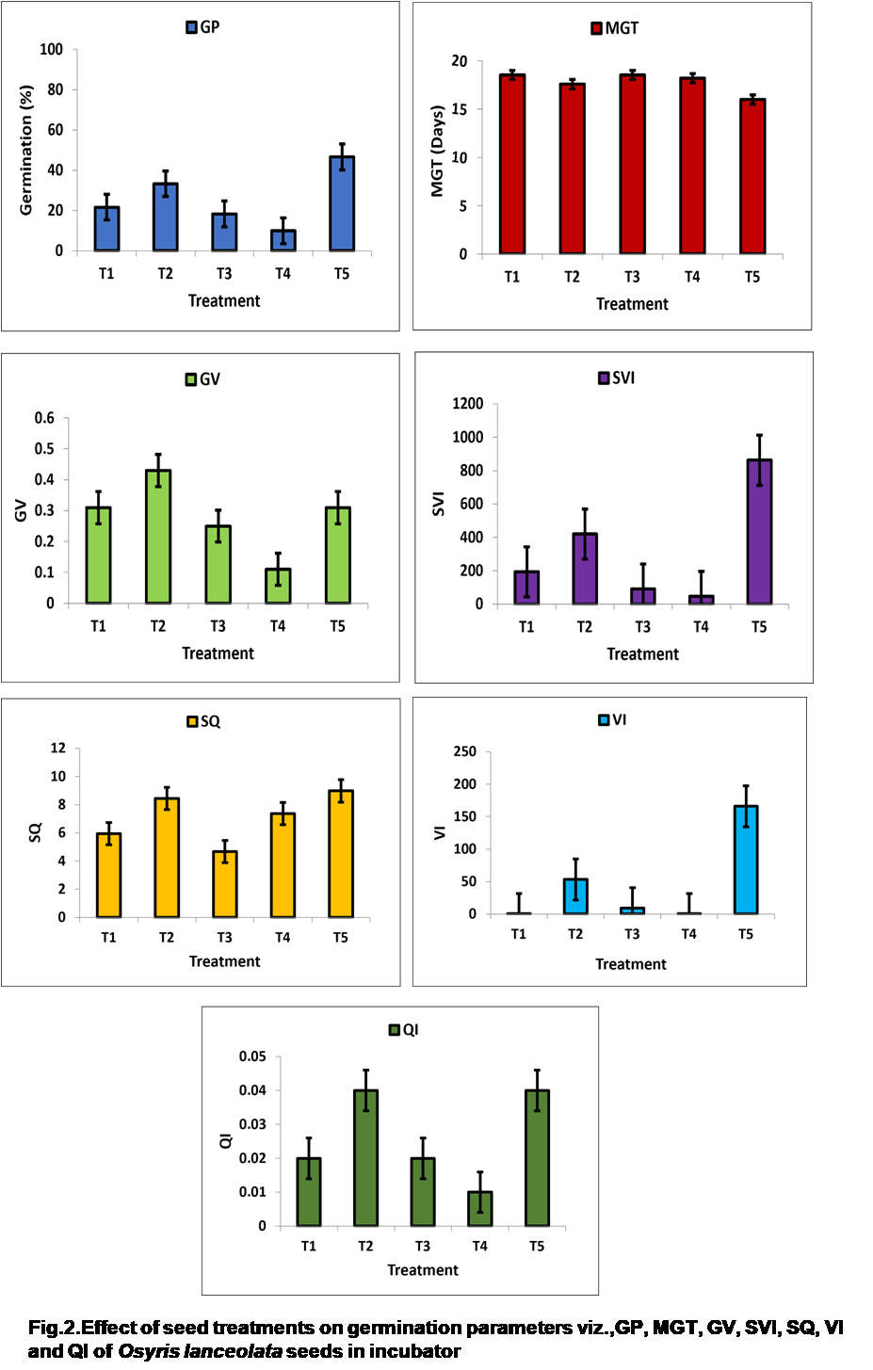

Table3.Fruit maturity indices at three stages of development in Osyris lanceolata

Maturity indices | Green stage | Yellow to orange stage | Bright red stage
Fruit parameters
Fruit moisture (%) | 56.37±3.35 | 48.74±3.39 | 52.62±2.51
Germination rate (%) | 10±5.00 | 18.33±2.88 | 46.66 ± 7.63
1000 fruit weight(gm) | 200-220 | 240-260 | 290-310
Total number of fruits/kilogram | 5700 | 4500 | 3700
RHS colour code | 144A (111, 133,36) | 125A (236, 103,21) | N34A (157, 19,44)
RHS colour | Medium green | Medium orange | Bright red
Fruit length | 5.81±0.70 | 6.98±0.90 | 8.27±0.02
Fruit width | 5.55±0.26 | 6.79±0.61 | 8.05±0.70

Table4.Seed maturity indices at three stages of development in Osyris lanceolata

Maturity indices | Green stage | Yellow to orange stage | Bright red stage
Seed parameters
Seed moisture (%) | 42.25±7.81 | 38.75±3.37 | 32.12±2.37
Germination rate (%) | 10±5.00 | 18.33±2.88 | 46.66 ± 7.63
Mean Germination Time(days) | 10±5 | 18.33±2.88 | 46.66±7.63
Germination Value | 0.11±0.05 | 0.25±0.14 | 0.31±0.08
1000 seed weight(gm) | 80-95 | 100-110 | 115-125
Total number of seeds/kilogram | 10,800 | 9,600 | 8,600
RHS colour code | NN155C (244, 242,239) | 165D (234, 187, 142) | N167A (173, 101,32)
RHS colour | Creamy white | Light brown | Medium brown
Seed length(mm) | 4.68±0.47 | 6.18±0.28 | 7.16±0.36
Seed width(mm) | 4.55±0.86 | 5.82±0.36 | 7.01±0.77

Table 5. Effect of seed treatment on germination parameters of Osyris lanceolata

Treatment | GP | MGT | GV | PV | GI | SVI | SQ | VI | QI
T1 | 21.66±  2.88 ^{ab} | 18.55±  0.66 ^{b} | 0.31±  0.16 ª | 0.71±  0.22 ª | 0.22±  0.03 ^{ab} | 193.5±  25.89 ^{ab} | 6.44±  1.05^{ab} | 0.13±  0.05 ª | 0.02±  0.004 ª
T2 | 33.33±  7.63^{bc} | 17.59±  1.30 ^{ab} | 0.43±  0.21 ª | 0.91±  0.39 ª | 0.38±  0.10 ^{b} | 420±  83.21 ^{b} | 5.94±  0.78^{ab} | 53.31±  6.58 ^{b} | 0.03±  0.030 ª
T3 | 18.33±  2.88 ^{ab} | 18.55±  0.66 ^{b} | 0.25±  0.14 ª | 0.64±  0.20 ª | 0.17±  0.05 ª | 91.16±  12.90 ª | 6.02±  0.52^{ab} | 9.18±  0.66 ^{ab} | 0.02±  0.01 ª
T4 | 10±5 ª | 18.22±  0.38 ^{b} | 0.11±  0.05 ª | 0.35±  0.11 ª | 0.08±  0.03 ª | 47.41±  18.65 ª | 7.73±  0.65^{ab} | 0.16±  0.001 ª | 0.01±  0.005 ª
T5 | 46.66±  7.63 ^{c} | 15.99±  0.57 ª | 0.31±  0.08 ª | 0.79±  0.09 ª | 0.57±  0.09 ª | 862.7±  195 ^{c} | 4.67±  0.92ª | 166±  39 ^{c} | 0.04±  0.006 ª
F value | 19.289 | 5.636 | 2.085 | 2.32 | 22.13 | 36.13 | 7.78 | 46.23 | 2.51
P | .000 | 0.012 | 0.158 | 0.12 | 0.00 | 0.00 | 0.00 | 0.00 | 0.10
Post Hoc Turkey LSD was used for testing the significance of GP, MGT, GV, PV, GI, SVI, SQ, VI and QIbetween treatments. P<0.05 statistically significant difference. The values with different superscript letters in a column are significantly different (p<0.05)

3.3 Effect of seed pretreatment on germination percentage
Germination performance of Osyris lanceolata seeds varied significantly (p < 0.05) across treatments and growth media (Figure 2). In sand substrate, scarification combined with 24-hour boiling water treatment (T2) yielded 33.33 ± 7.63%germination, representing a 54% increase over untreated controls (T1) 21.66 ± 2.88%. Notably, unripen-stage seeds subjected to identical pretreatment (GT4) showed reduced efficacy (10 ± 5%⁾, while vermiculite-grown ripe seeds (T5) demonstrated maximal germination (46.66 ± 7.63%)(Table 5).
3.4 MGT, IGT and FGT under Different Treatments
Control seeds (GT1: sand substrate) exhibiting delayed initiation (IGT = 14 days), prolonged completion (FGT = 25 days), suboptimal germination (21.66 ± 2.88%), and extended mean germination time (MGT = 18.55 ± 0.66days). (T2) showed improved performance, with accelerated initiation (IGT = 11 days; 21% reduction versus control), maintained completion time (FGT = 24 days), enhanced germination (33.33 ± 7.63%), and reduced MGT (17.59 ± 1.30days). Optimal results were observed in vermiculite substrate (GT5), demonstrating earliest initiation (IGT = 10 days; 29% improvement), compact completion (FGT = 22 days), highest germination (46.66 ± 7.63%), and shortest MGT (15.99 ± 0.57days). Developmental stage significantly influenced outcomes, as immature seeds (T4) displayed poorest performance, initiation (IGT = 17 days), lowest germination (10 ± 5%), and prolonged MGT (18.22 ± 0.38 days) highlighting the critical role of both seed maturity and treatment-media combinations in enhancing germination efficiency.

3.5 GV, PV and GI under different treatments
The study revealed significant variations in germination parameters across treatment groups (p<0.05). Germination value (GV) ranged from 0.11±0.05 to 0.43±0.21, with T2 showing the highest GV (0.43±0.21), followed by T5 with substrate vermiculite (0.31±0.08). Control (T1) (0.11±0.05) and other treatments (T3,T4) exhibited the lowest GV values. Peak value (PV) measurements demonstrated similar treatment effects, ranging from 0.35±0.11 to 0.91±0.39. T2 again showed superior performance (0.91±0.39), with T5 following closely (0.79±0.09). The poorest PV was recorded in T4 (0.35±0.11), preceded by T3 (0.64±0.20). Germination index (GI) results presented a distinct pattern, with values spanning 0.08±0.03 to 0.57±0.09. T5 treatment achieved the highest GI (0.57±0.09), indicating optimal germination synchronization, while T2 showed intermediate performance (0.38±0.10). The lowest GI values were observed in T4 (0.08±0.03) and T1 (0.22±0.03) (Table 5). These findings demonstrate treatment-specific effects on germination characteristics (T2) enhanced germination vigor (GV) and peak performance (PV), while in vermiculite (T5) improved germination synchronization (GI). Immature seeds (T4) consistently showed the poorest performance across all parameters.
3.6 SVI, SQ, VI and QI under different treatments
The study revealed significant treatment effects (p < 0.05) on seedling development parameters (Table 4). Seedling Vigor Index (SVI) showed remarkable variation 47.41 ± 18.65 to 862.7 ± 195, with T5 (vermiculite) demonstrating superior performance (862.7 ± 195), followed by T2 (420 ± 83.21). Control and other treatments (T1, T3, T4) exhibited substantially lower SVI values. Seedling Quality (SQ)derived from the experiments ranged from 4.67 ±0.92 to 8.92 ± 1.20 withT5 (vermiculite) demonstrating superior performance (8.92 ± 1.20), followed by T2 (8.44 ± 1.05). Control and other treatments (T1, T3, T4) exhibited substantially lower SQ values. The lowest SQ was recorded in T3 (4.67±0.92) and T1 (5.94±0.05). Vigor Index (VI) ranged from ranged from 0.13±0.05 to 166±39.Results confirmed the superiority of T5 (166 ± 39), with T2 showing intermediate values (53.31 ± 6.58). Minimal VI development was observed in T1 (0.13 ± 0.05) and T4 (0.16 ± 0.001). Quotient Index (QI) ranged from 0.01±0.005 to 0.04±0.006, while showing less variation, maintained the same performance hierarchy, with T5 (0.04 ± 0.006) outperforming T2 (0.03 ± 0.030) and other treatments (T3: 0.02 ± 0.01; T4: 0.01 ± 0.005) (Table 5).

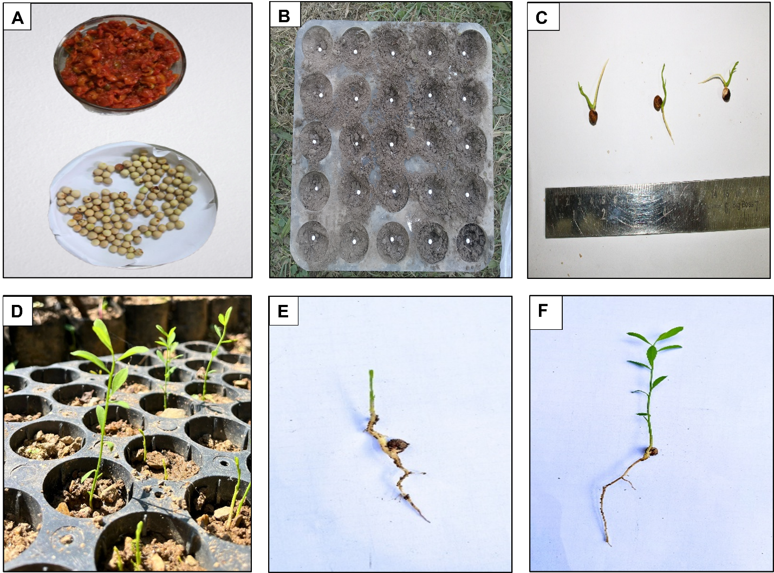
Fig. 3 Pre sowing treatments in seed germination of O. lanceolata (A) Depulping of mature fruit (B) Seed sown in root trainer (C) Measurement of emerged seedling with growth (D) Seedling growth after 30 days (E) Control F) Root and shoot length measurement by scale. Emerged seedling with growth in T₃ (Mechanical scarification + Gibberellic acid (Seeds are soaked in 1000 ppm GA₃ for 24 hrs.)

Table 6: Effect of pre sowing treatment on the initiation and final germination of seeds of O. lanceolata

Treatment codes  and details | Days to initiate germination | Days taken for final germination
T1 (Control) | 60.66±4.04 | 68.66±0.57
T2 (Mechanical scarification + GA3 500 ppm | 23±0 | 44.33±2.51
T3 (Mechanical scarification + GA3 1000 ppm) | 19±1 | 39.33±1.15
T4 (30% Hydrogen peroxide) | 34.33±2.51 | 51±1.73
T5 (0.2% Potassium nitrate) | 30±1 | 48.66±1.15
T6 (2% Thiourea) | 28±1 | 47.33±1.15
T7 (20% Sulphuric acid) | 26±1 | 46±0
T8 (Boiling water) | 36±1 | 49.66±2.30

Table 7: Effect of pre sowing treatment on germination and seedling growth of O. lanceolata

Treatments | Germination % | Shoot length  (cm) | Root length  (cm) | Vigor index | Number of leaves | Fresh weight  (gm) | Dry weight  (gm)
T1 | 13.33±  2.30 | 6.97±  0.31 | 2.54±  0.62 | 29.52±  4.50 | 3±1 | 0.68±  0.08 | 0.03±  0.01
T2 | 49.33±  4.61 | 13.94±  2.12 | 8.69±  0.47 | 226.91±  89.92 | 16±2 | 2.08±  0.29 | 0.11±  0.03
T3 | 66.66±  8.32 | 15.55±  3.32 | 10.07±  0.64 | 387.74±  41.55 | 18±2 | 4.60±  0.69 | 0.27±  0.07
T4 | 18.66±  2.30 | 9.15±  0.51 | 3.07±  0.19 | 40.12±  16 | 7±2 | 0.5±  0.22 | 0.07±  0.01
T5 | 21.33±  2.30 | 11.38±  1.20 | 7.03±  1.11 | 135.64±  101.57 | 10.33±1.52 | 0.42±  0.11 | 0.21±  0.01
T6 | 29.33±  2.30 | 10.15±  1.15 | 4.2±  0.42 | 73.10±  23.24 | 5.66±  1.52 | 2.05±  0.31 | 0.08±  0.02
T7 | 41.33±2.30 | 11.38±0.8 | 6.02±0.18 | 140±16 | 14±1 | 0.34±0.06 | 0.22±0.02
T8 | 18.66±6.11 | 7.85±1.05 | 5.03±0.20 | 24.71±4.45 | 3.66±1.15 | 0.54±0.06 | 0.05±0.01
Table 8. Effect of seed treatment on germination parameters of O. lanceolata in Nursery

Treatment | GP | MGT | GV | PV | GI | SVI | SQ | VI | QI
T1 | 13.33±2.30ª | 37.47±1.02^{b} | 0.65±0.13ª | 0.31±0.33 ª | 0.09±0.01 ª | 128.16±34.66 ª | 7.80±2.83 ^{ab} | 29.52±4.50 ª | 0.006±0.0008 ª
T2 | 49.33±4.61^{c} | 32.21±1.30ª | 5.85±1.60 ^{c} | 1.07±0.17 ^{d} | 0.41±0.06 ^{c} | 1117.3±160.91 ^{c} | 5.61±1.29 ^{ab} | 226.91±89.92 ^{b} | 0.03±0.004^{bc}
T3 | 66.66±8.32^{d} | 31.62±2.20ª | 9.34±0.69 ^{d} | 1.40±0.04 e | 0.58±0.11 ^{d} | 1705±305 ^{d} | 4.42±0.66 ª | 387.74±41.55 ^{c} | 0.05±0.08 ^{c}
T4 | 18.66±2.30^{b} | 38.33±1.66^{b} | 0.92±0.12ª | 0.40±0.15^{ab} | 0.11±0.01 ª | 228.07±28.38 ª | 6.98±1.08 ^{ab} | 40.12±16 ª | 0.01±0.004 ^{ab}
T5 | 21.33±2.30^{ab} | 39.26±0.46^{b} | 1.07±0.18ª | 0.52±0.06 ^{ab} | 0.13±0.01 ª | 392.4±43.69 ^{ab} | 7.70±2.83 ^{ab} | 135.64±101.57 ^{ab} | 0.02±0.004 ^{ab}
T6 | 29.33±2.30^{ab} | 38.10±0.77^{b} | 1.81±0.26 ^{ab} | 0.70±0.07^{bc} | 0.19±0.07 ^{ab} | 423±77 ^{ab} | 6.43±0.15 ^{ab} | 73.10±23.24 ª | 0.02±0.001 ^{ab}
T7 | 41.33±2.30^{bc} | 36.75±0.34^{b} | 3.58±0.33 ^{b} | 0.97±0.06 ^{cd} | 0.29±0.01^{bc} | 718±17.84^{b} | 6.13±0.13 ^{ab} | 140±16 ^{ab} | 0.03±0.003^{bc}
T8 | 18.66±6.11^{b} | 37.91±1.71^{b} | 0.95±0.33ª | 0.49±0.09 ^{ab} | 0.12±0.03 ª | 237±81 ª | 7.43±1.56 ^{ab} | 24.71±4.45 ª | 0.009±0.001 ª
F value | 28.151 | 14.087 | 68.268 | 37.626 | 38.174 | 52.134 | 2.398 | 17.492 | 12.283
P | <0.05 | <0.05 | <0.05 | <0.05 | <0.05 | <0.05 | <0.05 | <0.05 | <0.05

Post Hoc Turkey LSD was used for testing the significance of GP, MGT, GV, PV, GI, SVI, SQ, VI and QI between treatments. P<0.05 statistically significant difference. The values with different superscript letters in a column are significantly different (p<0.05)

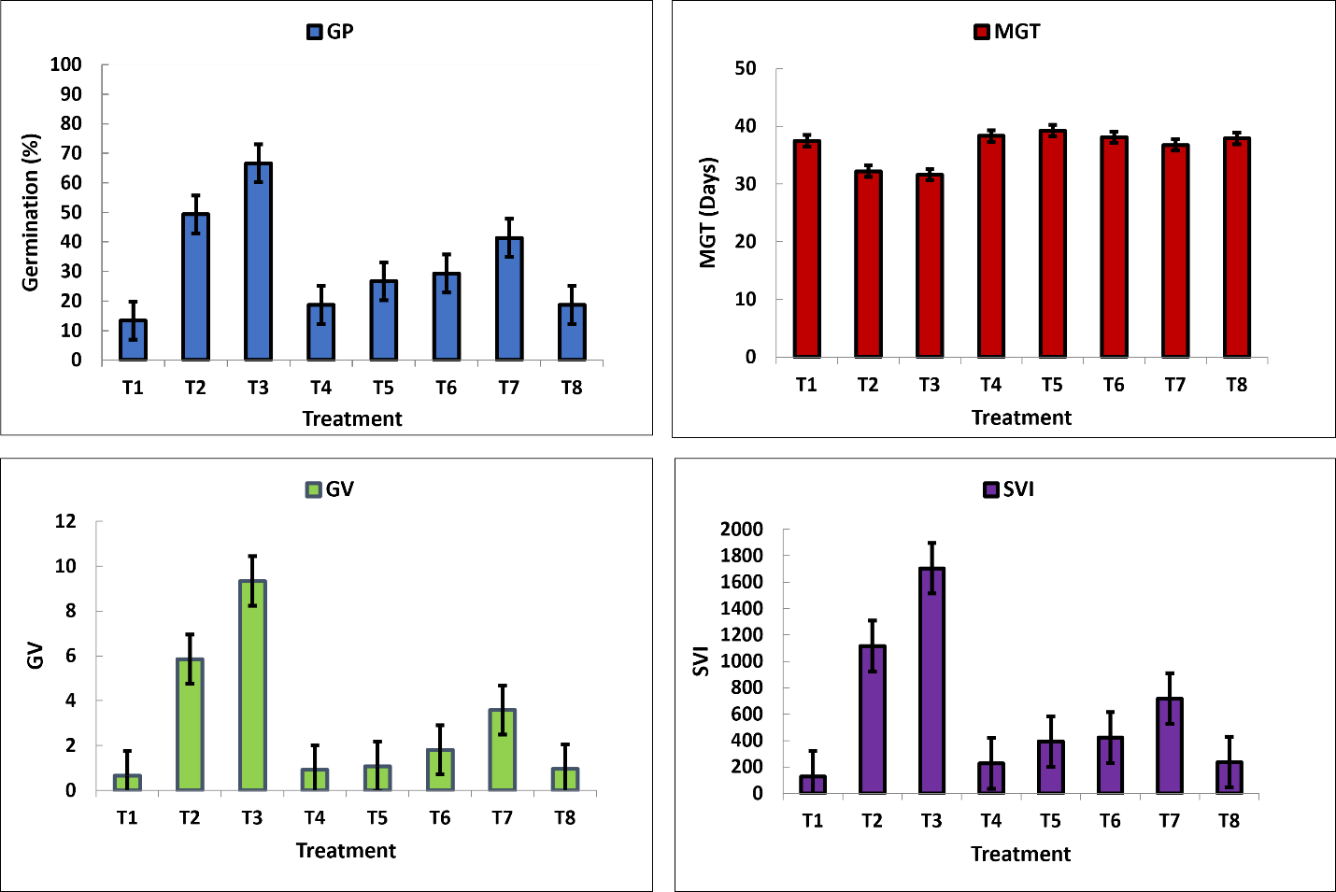

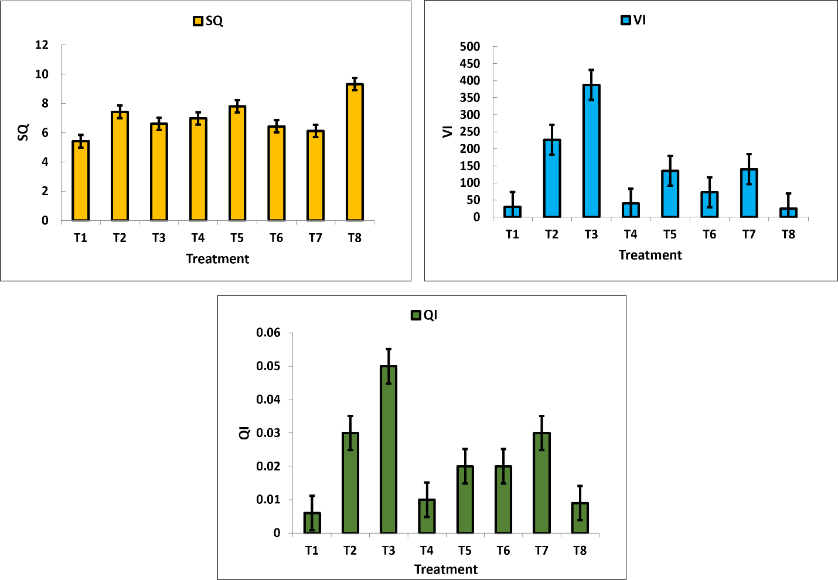

Fig.4. Effect of seed treatments on germination parameters viz., GP, MGT, GV, SVI, SQ, VI and QI of Osyris lanceolata seeds in nursery

3.1. Effect of seed pretreatment on germination percentage

The result obtained during the present course of investigation was carried out to visualize a significant influence of different pretreatment on seed germination. Among all seed pre-treatments, T3 (Mechanical Scarification + GA₃ 1000 ppm) demonstrated the earliest germination initiation (19±1days) and the highest germination percentage (66.66 ± 8.32%) significantly outperforming other treatments, while the control (T1) showed the slowest germination (60.66 ± 4.04 days) and the lowest germination rate (13.33 ± 2.30%),T2 (GA₃500 ppm) followed with moderate success (49.33 ± 4.61%) whereas T4 (H₂O₂ 30%) had poor germination (18.66 ± 2.30%) (Table 7&8). . These results indicate that mechanical scarification combined with gibberellic acid (1000 ppm) is the most effective pre-treatment for enhancing both germination speed and success in nursery conditions, while untreated seeds perform the worst.

3.2. MGT, IGTand FGT under Different Treatments
The control (T1) exhibited the slowest germination, initiating only on the 60th day and completing by the 68th day, with a low germination rate (13.33±2.30%) and a mean germination time (MGT) of 37.47±1.02 days. In contrast, T3 (Mechanical Scarification + GA₃ 1000 ppm) demonstrated the earliest germination initiation (19th day), fastest completion (40th day), highest germination rate (66.66±8.32%), and the shortest MGT (31.62±2.20days), making it the most effective treatment. T2 (GA₃500 ppm) followed closely, with germination starting on the 23rd day, ending on the 44th day, achieving a 49.33 ± 4.61% germination rate and an MGT of 32.21±1.30days.Among other treatments, T4 (H₂O₂ 30%) and T8 (Boiling Water) showed delayed germination initiation (34th and 36th day, respectively) and lower germination rates (18.66 ± 2.30% and 18.66 ± 6.11%), with MGTs of 38.33 ± 1.66 and 37.91±1.71days, respectively. T5 (KNO₃ 0.2%), T6 (Thiourea 2%), and T7 (H₂SO₄ 20%) exhibited intermediate performance, with germination starting between 26th–30th day, completing by 46th–48th day, and achieving 21.33 ± 2.30% to 41.33±2.30% germination rates, with MGTs ranging from 36.75 ± 0.34 to 39.26 ± 0.46 days.

3.3. GV, PV and GI under different treatments

The study revealed significant variations in germination parameters across treatments. Germination Value (GV) ranged from 0.65 ± 0.13to 9.34 ± 0.69. T3 (Mechanical Scarification + GA₃ 1000 ppm) showing the highest GV, followed by T2 (GA₃500 ppm) at 5.85 ± 1.60and lowest GV value was observed in T1, T4 andT8. The Peak Value (PV) derived from the experiments ranged from 0.31±0.33 to1.40±0.04 and followed a similar trend, with T3 recording the maximum (1.40 ± 0.04), T2 at 1.07 ± 0.17, and the lowest values in T1 (0.31 ± 0.33) and T4 (0.40 ± 0.15).Germination Index (GI) of the experiment ranged from 0.09±0.01 to 0.58±0.11. T3 again outperformed others (0.58 ± 0.11), trailed by T2 (0.41 ± 0.06), while T1 (0.09 ± 0.01) and T4 (0.11 ± 0.01) exhibited the poorest performance (Table 8).

3.4.SVI, SQ, VI and QI under different treatments
The SVI ranged from 128.16±34.66 to 1705±305. The highest SVI was observed in T3 (1705±305), followed by T2 (1117.3±160.91), while the lowest SVI was recorded in (128.16±34.66), followed by T4 (228.07±28.38). The SQ values ranged from 4.42±0.66 to 7.80±2.83. The highest SQ was recorded in T1 (7.80±2.83), followed by T5 (7.70±2.8) and T8 (7.43±1.56) whereas the lowest value was observed in T3 (4.42±0.66), followed by T2 (5.61±1.29) and T7(6.13±0.13). The VI ranged from 24.71±4.45to 387.74±41.55.The highest VI was found in T3 (387.74±41.55), followed by T2 (226.91±89.92), while the lowest VI was recorded in T8 (24.71±4.45), followed by T1 (29.52±4.50). The QI values ranged from 0.006±0.0008 to 0.05±0.08. The highest QI was observed in T3 (0.05±0.08), followed by T2 (0.03±0.030), whereas the lowest QI was recorded in T1 (0.006±0.0008) followed by T8 (0.009±0.001). Overall, T3 emerged as the most effective treatment for enhancing seedling vigor and growth, suggesting that these treatments could be prioritized for optimal seedling development. In contrast, T1 consistently underperformed across all indices, indicating its limited efficacy (Table 8).

4. DISCUSSION

4.1. Standardization of Maturity Indices of Osyris lanceolata in Incubator
The study successfully established maturity indices for Osyris lanceolata fruits under incubator conditions by classifying them into three developmental stages based on fruit color: green, yellow to orange, and bright red, using the RHS color chart (Table 3 & 4). Significant differences were observed in seed viability, moisture content, and germination performance across these stages. Seeds from the green stage had higher moisture content but lower germination rates. As the fruit matured, moisture content declined, while germination percentage and vigor increased. The bright red stage indicated physiological maturity, exhibiting the highest germination rate, improved germination value, and shorter mean germination time, confirming it as the ideal stage for seed collection. These results align with the general understanding that seed ripening involves key morphological, physiological, and chemical changes (Bonner, 1981). Additionally, fruit color change during ripening is associated with chlorophyll degradation and anthocyanin accumulation, resulting in red, blue, or purple hues (Lillo et al., 2008), further supporting the maturity classification.
Studies across diverse species confirm that color transition reliably signals seed maturity, correlating with optimal germination potential and biochemical readiness. In Azadirachta indica, yellow fruits exhibit higher germination than green due to complete lipid accumulation (Sivasamy, 1991), while Pinus merkusii brown cones contain fully mature seeds with maximum viability (Arisman& Powell, 1986). Similarly, Quercus spp. acorns show enhanced desiccation tolerance upon transitioning from green to brown (Bonner, 1976). For Santalaceae species, Santalum album purple-black fruits indicate peak viability 73.2% (Manomani et al.,2001). Harvesting at optimal mature stage ensures maximum seed quality, as immature seeds lack protective compounds (Harrington, 1970) and overmature ones are prone to fungal degradation (Srimathi&Nagaveni, 1995). These findings establish color as a universal, non-destructive maturity marker for optimal seed collection. Extensive research demonstrates that color transition reliably indicates seed maturity across diverse species. Comparative studies reveal dramatic germination differences between mature and immature seeds from 7% to 97% in Terminalia bellerica (Negi &Todaria, 1995).In Mallotusphilippenensis, fruit color transitions from reddish-green to dark red, while seeds change from whitish-yellow to black upon reaching maturity (Tewari et al., 2016). Similarly, in Prunus cerasoides, the shift in fruit color from dark green to pale red or red has been identified as a useful marker of seed maturity (Tewari et al., 2011). Seed maturity indices for Semecarpus anacardiumfound that fully ripened seeds collected from the ground exhibited significantly higher germination percentage, germination capacity, seedling vigor index, collar diameter, and seedling height, confirming the importance of maturity stage in determining seed quality and performance (Ratheish and Negi, 2020). In Ziziphus mauritiana, fruit maturity progresses from green to lime yellow, then to yellowish-green, optimal harvest stage is marked by an ovate shape and yellowish-green color, identified through physical, biochemical, and sensory attributes to ensure proper maturity for quality fruit (Singh & Deen, 2022). Litsea glutinosa fruits matured from green to dark blue stage germination percentage increased reaching 47%, this stage marks the optimal time for seed collection due to improved viability ( Thapliyal et al., 2024). These findings establish fruit/seed color-based harvesting as a universal, non-destructive method for obtaining high-quality seeds with improved germination and seedling performance.

4.2. Seed Germination Experiment

The germination trial conducted on Osyris lanceolata revealed statistically significant differences (P < 0.05) in germination response and seedling vigor as influenced by various seed pretreatments and substrate types. Analysis using Tukey’s LSD test (Table 5) indicated that the combination of mechanical scarification followed by boiling water treatment in sand (T2) substantially improved germination percentage (33.33 ± 7.63%) in comparison to the untreated control (21.66 ± 2.88%), corresponding to an enhancement of 54%. Notably, the best overall germination performance was observed under T5 treatment (vermiculate substrate), which achieved a germination rate of 46.66 ± 7.63%.
These outcomes underscore the importance of integrating effective seed pretreatments with optimal substrates to overcome dormancy in O. lanceolata, a species known for its complex seed physiology. Similar studies by Mwang'ingo et al. (2005) reported that the introduction of host plants like Brachytegia spiciformis, Rhus natalensis, and Casuarina equisetifolia promotes the early growth of O. lanceolata in terms of height, diameter, and overall root and shoot biomass. In the current study, vermiculite proved superior to sand due to its enhanced physicochemical characteristics, such as high water retention, optimal aeration, neutral pH, and abundance of essential minerals, especially magnesium and potassium. These properties created favorable microenvironments that facilitated moisture availability, nutrient uptake, and effective suppression of dormancy-inducing chemical inhibitors (Baskin & Baskin, 2004; Delouche, 1971). Further, T2 promoted faster and more synchronized germination, as reflected by elevated Germination Value (0.43 ± 0.21) and Peak Value (0.91 ± 0.39). However, T5 recorded the highest values in Germination Index (0.57 ± 0.09), Vigor Index (166 ± 39), and Seedling Vigor Index (862.7 ± 195), indicating stronger seedling establishment potential. In contrast, the control group (T1) exhibited a high sturdiness quotient (7.73 ± 0.65), signaling weak seedling structure and reduced suitability for transplantation (Thompson, 1985). These findings corroborate earlier studies that endorse vermiculite as an ideal germination medium for several woody and medicinal species (Gairola et al., 2011).
4.3. Seed Germination Experiment of Osyris lanceolata in Nursery
The germination experiment conducted in nursery conditions revealed statistically significant differences (p < 0.05) among treatments, indicating that successful dormancy-breaking methods for Osyris lanceolata must be aligned with the species’ specific seed physiology (Table 8). The highest germination percentage (66.66 ± 8.32%) and germination value (9.34 ± 0.69) were obtained with 1000 ppm gibberellic acid (GA₃) treatment (T3), corroborating earlier findings on GA₃'s role in overcoming physiological dormancy through activation of hydrolytic enzymes and cell elongation (Finch-Savage &Leubner-Metzger, 2006; Ali-Rachedi et al., 2004). This treatment effectively counteracts abscisic acid (ABA) inhibition and enhances α-amylase production, which mobilizes stored reserves and supports embryo development (Patel et al., 2019; Cadman et al., 2006).Sulfuric acid scarification (T7), while achieving a moderate germination rate (41.33 ± 2.30%) and germination value (3.58 ± 0.33), demonstrated superior seedling vigor as reflected in the sturdiness quotient (6.13 ± 0.13) and vigor index (140 ± 16). These results affirm its effectiveness in disrupting physical dormancy by weakening the seed coat, thus improving water permeability (Nikoleave, 1977; Levitt, 1974). However, this method poses a risk of embryo injury, limiting its practical application. The control group (T1), with only 13.33 ± 2.30% germination, highlights the strong dormancy traits present in O. lanceolata. Previous studies have reported that the impermeable seed coat inhibits water and oxygen exchange, reducing germination efficiency (Mwang'ingo et al., 2007). Mechanical scarification has emerged as the most effective physical method, yielding up to 66.5% germination, although it is labor-intensive. Hot water treatments produced lower germination (57.5%) and adversely impacted seedling vigor, while cold water treatments showed minimal improvement. The effectiveness of GA₃ is further supported by reports across multiple species. In sandalwood, pre-sowing treatments with GA₃ significantly improved germination (Palani et al., 1996), and in Albizia lebbeck and Gloriosa superba, germination rates of 56.55% were recorded at lower GA₃ concentrations (200 ppm), demonstrating its efficacy even at minimal doses (Muruganandam et al., 2019). Additionally, GA₃ has been widely recognized for enhancing seed viability and vigor in various forest and medicinal species (Polaiah et al., 2020).In conclusion, GA₃ at 1000 ppm is a highly effective treatment for breaking both physical and physiological dormancy in O. lanceolata, while sulfuric acid remains useful for seed coat modification. An integrated pretreatment approach is recommended for improving propagation and conservation outcomes.
5. Conclusion
This study successfully standardized fruit maturity indices and optimized seed germination protocols for Osyris lanceolata, a recalcitrant and ecologically significant species within the Santalaceae family. Fruit color transition particularly the bright red stage proved a reliable indicator of physiological maturity, associated with complete fatty acid accumulation, lignified seed coat, and enhanced seed viability. Incubator experiments identified T5 (boiling water scarification + vermiculite) as the most effective treatment, improving seedling vigor (SVI: 862.7, VI: 166) by enhancing moisture retention and cation exchange capacity (Mg²⁺/K⁺). In nursery conditions, mechanical scarification combined with GA₃ at 1000 ppm (T3) yielded the highest germination percentage (66.66%)a fivefold increase over controland reduced germination duration from 60 to 19 days. Vermiculite outperformed sand and traditional substrates due to its superior aeration and water-holding properties. Sulfuric acid and mechanical scarification were also effective in breaking physical dormancy, though with varying effects on seedling quality. These results confirm that integrated pretreatment protocols targeting both physical and physiological dormancy are critical for successful propagation. Optimal seed collection time was identified as mid-August, when fruits attain bright red coloration and peak viability, minimizing fungal infection risks. Adoption of vermiculite or perliteenriched media may further improve propagation efficiency for restoration and conservation efforts.
Future Recommendations
Future research should focus on mapping the distribution and identifying suitable habitats for Osyris lanceolata, a species classified as rare or threatened in several regions. Long-term field trials are essential to evaluate the performance of seedlings raised through different pretreatment methods. Molecular studies on dormancy-related gene expression and hormonal interactions could further clarify seed physiology. GA₃ at 1000 ppm significantly enhanced germination and seedling growth, making it a recommended pretreatment for producing quality planting material for large-scale propagation and conservation.
An integrated approach by incorporating the benefit of seed pretreatment and substratum along with the standardization of the most suitable host plant for the species during early growth could significantly improve the seed germination and seedling performance. Similarly the scope of Plant growth-promoting rhizobacteria PGPR based propagation methods should be examined for ecologically and economically important species.

DISCLAIMER (ARTIFICIAL INTELLIGENCE)
Author(s) hereby declare that NO generative AI technologies such as Large Language Models (ChatGPT, COPILOT, etc) and text-to-image generators have been used during writing or editing of this manuscript.

REFERENCES
Abdul-Baki, A. A., & Anderson, J. D. (1973). Vigor determination in soybean seed by multiple criteria. Crop Science, 13(6), 630–633.
Ali-Rachedi, S., Bouinot, D., Wagner, M. H., Bonnet, M., Sotta, B., Grappin, P., &Jullien, M. (2004). Changes in endogenous abscisic acid levels during dormancy release and maintenance of mature seeds: Studies with the Cape Verde Islands ecotype, the dormant model of Arabidopsis thaliana. Planta, 219(3), 479–488.
Arisman, H., & Powell, G. R. (1986). Effects of cone colour and seed-extraction methods on yield and quality of seeds of Pinus merkusiiin Indonesia. Seed Science and Technology, 14, 177–190.
Balakrishnan, N. P., Chakrabarty, T., Sanjappa, M., Lakshminarasimhan, P., & Singh, P. (2012). Flora of India (Vol. 23, pp. 193–194). Kolkata: Botanical Survey of India.
Baskin, C. C., & Baskin, J. M. (2000). Seeds: Ecology, biogeography, and evolution of dormancy and germination. Academic Press
Baskin, J. M., & Baskin, C. C. (2003). Classification, biogeography, and phylogenetic relationships of seed dormancy. In R. D. Smith, J. B. Dickie, S. H. Linington, H. W. Pritchard, & R. J. Probert (Eds.), Seed conservation: Turning science into practice (pp. 518–544). Kew Publishing.
Beentje, H. J. (1994). Kenya: Trees, shrubs and lianas. National Museums of Kenya.
Bonner, F. T. (1976). Maturation of Shumard and white oak acorns. Forest Science, 22(2), 149–154.
Bonner, F. T. (1981). Collection, conditioning and certification of forest tree seed. In P. K. Khosla (Ed.), Advances in Forest Genetics (pp. 59–78).
Cadman, C. S., Toorop, P. E., Hilhorst, H. W., & Finch-Savage, W. E. (2006). Gene expression profiles of ArabidopsisCvi seeds during dormancy cycling indicate a common underlying dormancy control mechanism. The Plant Journal, 46(5), 805–822.
Delouche, J. C. (1971). Determinants of seed quality. Proceedings of the Short Course for Seedsmen.
Dickson, A., Leaf, A. L., &Hosner, J. F. (1960). Quality appraisal of white spruce and white pine seedling stock in nurseries. The Forestry Chronicle, 36(1), 10–13.
Finch-Savage, W. E., &Leubner-Metzger, G. (2006). Seed dormancy and the control of germination. New Phytologist, 171(3), 501–523.
Gairola, K. C., Nautiyal, A. R., & Dwivedi, A. K. (2011). Effect of temperatures and germination media on seed germination of Jatropha curcas Linn. Advances in Bioresearch, 2(2), 66–71.
Githae, E. W., Gachene, C. K. K., &Odee, D. W. (2011). Implications of in situ conservation of indigenous species with special reference to Coffea arabica L. population in Mount Marsabit Forest, Kenya. Tropical and Subtropical Agroecosystems, 14, 715–722.
Grzybowski, C. R. D. S., Vieira, E. S. N., Michelon, T. B., &Panobianco, M. (2022). Germination test of Cordia trichotoma seeds: A forest species native to Brazil. Journal of Seed Science, 44, e202244006.
Harrington, J. F. (1970). Seed and pollen storage for conservation of plant gene resources. In Genetic resources in plants: Their exploration and conservation (Handbook No. 11). International Biological Programme.
ISTA International Seed Testing Association. (2007). International Rules for Seed Testing: Edition 2007: Adopted at the Ordinary Meeting 2006, Glattbrugg/Zurich, Switzerland, to Become Effective on 1st January 2007.
Levitt, J. (1974). Introduction to plant physiology (pp. 277–286). C.V. Mosby Company.
Maguire, J. D. (1962). Speed of germination—Aid in selection and evaluation for seedling emergence and vigor. Crop Science, 2(2), 176–177.
Manonmani, V., &Vanangamudi, K. (2001). Influence of degree of fruit maturity on seed germination, seedling vigour and storability of sandal (Santalum album). Journal of Tropical Forest Science, 415–422.
Mbuya, L. P., Msanga, H. P., Ruffo, C. K., Birnie, A., &Tegnass, B. (1994). Useful trees and shrubs of Tanzania. SIDA/RSCU.
Muruganandam, C., Mohideen, M. K., &Barathkumar, T. R. (2019). Studies on the effect of certain chemicals and bioregulators on germination and seedling growth in glory lily (Gloriosa superba L.). Plant Archives, 19(2).
Mwang’ingo, P. L., Teklehaimanot, Z., Hall, J. B., &Lulandala, L. L. L. (2003). African sandalwood (Osyris lanceolata): Resource assessment and quality variation among populations in Tanzania. Southern African Forestry Journal, 199(1), 77–88.
Mwang’ingo, P. L., Teklehaimanot, Z., Maliondo, S. M., &Msanga, H. P. (2004). Storage and presowing treatment of recalcitrant seeds of African sandalwood (Osyris lanceolata). Seed Science and Technology, 32(2), 547–560.
Mwang'ingo, P. L., Teklehaimanot, Z., Lulandala, L. L., & Mwihomeke, S. T. (2005). Host plants of Osyris lanceolata (African Sandalwood) and their influence on its early growth performance in Tanzania. Southern African Forestry Journal, 203(1), 55-65.

Mwang’ingo, P. L., Teklehaimanot, Z., Hall, J. B., &Zilihona, J. E. (2007). Sex distribution, reproductive biology and regeneration in the dioecious species Osyris lanceolata (African Sandalwood) in Tanzania. Tanzania Journal of Forestry and Nature Conservation, 76(1), 118–133.
Negi, A. K., &Todaria, N. P. (1995). Effect of seed maturity and development on germination of five species from Garhwal Himalaya, India. Journal of Tropical Forest Science, 8(2), 255–258.
Nikolaeva, M. G. (1977). Factors controlling the seed dormancy pattern. In A. A. Khan (Ed.), The physiology and biochemistry of seed dormancy and germination (pp. 51–74). North-Holland.
Palani M, Dasthagir MG, Kumaran K, Jerlin R. Effect of presowing treatments on growth attributes of Albizia lebbeck L Benth. Annals of Forestry. 1996; 4(1): 85-88.
Polaiah, A. C., Parthvee, R. D., Manjesh, G. N., et al. (2020). Effect of presowing seed treatments on seed germination and seedling growth of sandalwood (Santalum album L.). International Journal of Chemical Studies, 8, 1541–1545.
Ramakrishnan, H. B. (1988). Seed quality studies in Ailanthus (Ailanthus excelsaRoxb.) [Master’s thesis, Tamil Nadu Agricultural University].
Rathiesh, P., & Negi, A. K. (2020). Seed maturity indices of Semecarpus anacardium Linn under Garhwal Himalayan condition: A highly valuable medicinal tree. European Journal of Medicinal Plants, 31(2), 40–44.
Singh, V., & Deen, B. (2022). Determination of Maturity Indices for Harvesting of ber (Ziziphus mauritiana Lamk.). International Journal of Plant & Soil Science, 34(22), 77–84.
Simão, E., Nakamura, A. T., & Takaki, M. (2013). Germination of Styrax camporum Pohl. seeds in response to substrate types, moisture contents and the seed morphology. Anais da Academia Brasileira de Ciências, 85(1), 295–306.
Sivasamy, M. (1991). Net Reproductive Effort Seed Production, Spectrum And Quality Polymorphism As Influenced By Ecological Factors InAzardirachta Indica Adr. Juss, Derris Indica (L) AndAllanthus Excels Roxb. Seeds (Doctoral dissertation, Tamil Nadu Agricultural University; Coimbatore).
Srimathi, R. A., &Nagaveni, H. C. (1995). Sandal seeds: Viability, germination and storage. In R. A. Srimathi, H. D. Kulkarni, & K. R. Venkatesan (Eds.), Recent advances in research and management of sandal (Santalum album L.) in India (pp. 77–84).
Subasinghe, S. M. C. U. P. (2013). Sandalwood research: A global perspective. Journal of Tropical Forestry and Environment, 3(1), 1–8.
Tewari, A., Bhatt, J., Mittal, A., Singh, N., &Tamta, K. (2016). Regeneration issues and indicators of seed maturity in MallotusphillipensisMuel. Arg. in the tropical forests of Uttarakhand. Ecology, Environment & Conservation, 22, 251–257.
Tewari, B., Tewari, A., Shah, S., Pande, N., & Singh, R. P. (2011). Physical attributes as indicator of seed maturity and germination enhancement in Himalayan Wild Cherry (Prunus cerasoides D. Don.). New Forests, 41, 139–146.
Thapliyal, M., Namitha, N. K., Deepika, & Singh, G. (2024). Study on maturity indices and effect of growing substrates on seed germination of Litseaglutinosa. Annual Research & Review in Biology, 39(10), 17–27.
Thompson, B. E. (1985). Seedling morphological evaluation: What you can tell by looking. In Evaluating seedling quality: Principles, procedures, and predictive abilities of major tests (pp. 59–71).
Tshiisikhawe, M. P., Van Rooyen, M. W., & Bhat, R. B. (2012). An evaluation of the extent and threat of bark harvesting of medicinal plant species in the Venda Region, Limpopo Province, South Africa. International Journal of Experimental Botany, 81, 89–100. Retrieved from Google Scholar.

