Options for Effective Forest Management of the Oak Wilt Fungus (Bretziella fagacearum) in the Eastern United States

ABSTRACT

Oak wilt is a fungal related disease that is caused by the oak wilt fungus (Bretziella fagacearum [Bretz] Z.W. De Beer, S. Marincowitz, T.A. Duong, and M.J. Wingfield) which is an introduced vascular wilt fungus that mainly infects oak species (Quercus spp.). The purpose of this review paper is to provide an update on the environmental challenges that are contributing to the spread of oak wilt as well as providing an overview of the forest management options that are available to reduce its spread. This disease has killed millions of oaks in the Midwest and Texas and impacts forest health in the Eastern United States as well. As climate change shifts ranges northward, the distribution of oak wilt is predicted to spread north to Canada. Forest managers, landscapers, and researchers use various management techniques to mitigate the impacts the disease causes to economy, biodiversity, and aesthetics. Current management emphasizes removal of trees near or in the infection center to limit the overland mode of spread. To contain the underground mode of spread, root graft connections between oak trees needs to be severed. Monitoring is key to limiting the spread of oak wilt and will require a combination of remote sensing based technologies and nventory plot network for effective ground-truthing.

Keywords: Climate Change, Forest Decline, Forest Health, Forest Pathogen, Pest Management

1. INTRODUCTION

Oak forest types are diverse: the two major oak forest types in the eastern United States are oak-pine and oak-hickory. On the spectrum of shade tolerance, oak species (Quercus spp.) are typically moderately shade tolerant and as such are typically succeeded by more shade tolerant competitors in the absence of disturbance (Kabrick et al., 2008; Chhin, 2018). With the development of a large tap root, oak species are adapted to asexually sprout after fires (Johnson et al., 2002). Oak acorns are important for food during fall and spring. Deer, squirrels, and many insects rely on fruit, seedlings, buds, and foliage of oak species for food. Arboreal animals rely on white oak trees peeling bark for shelter, including the endangered Indiana bat (Myotis sodalis Miller & Allen). Oak forest associates like shagbark hickory (Carya ovata (Mill.) K. Koch) fill similar niches. Wildlife objectives may become more difficult to achieve if oak lost its dominance in these forest types.

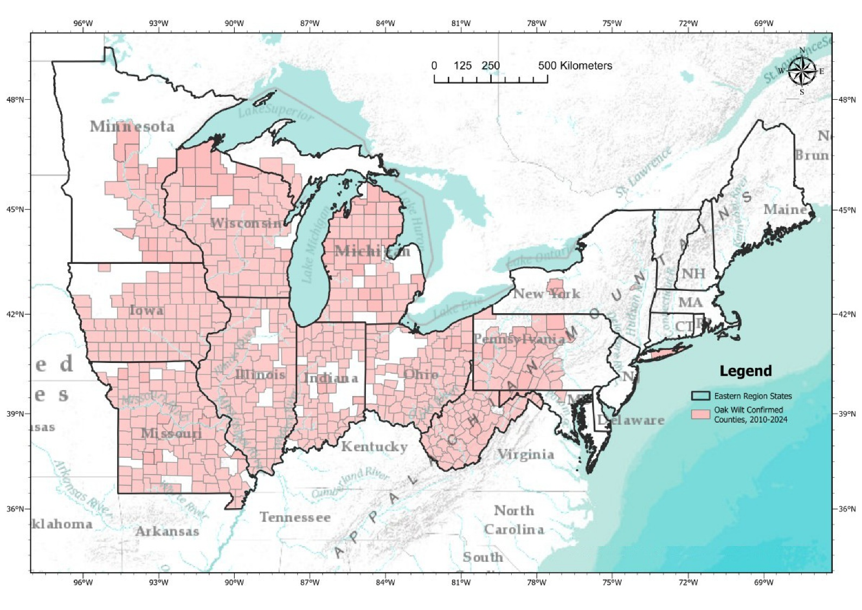
Fig. 1. The current distributional range of oak wilt in the eastern United States as of 2024. Map is adapted from the USDA Forest Service GIS data (USDA Forest Service 2021).

Healthy oak ecosystems provide many economic and ecological benefits and the presence of oak wilt can enact an economic toll. Northern red oak (Quercus rubra L.) is used commonly for flooring and furniture. White oak is the most valuable species in the eastern hardwood forests because there is a demand for barrel staves for whiskey and other distillery products. Veneer logs are a valuable export to the European Union (Bragard, et al., 2020). Trees becoming defective from wilt symptoms or mortality of immature trees represent a cost for landowners that invest in oak silviculture. Oaks are also widely planted as landscape trees, especially pin oak (Quercus palustris Muenchh.), which is susceptible to oak wilt. Landscape trees dying from oak wilt and having to be removed are an additional cost to landowners who value aesthetics and contribute to the overall economic toll that this fungus has afflicted (Haight, et al., 2011).

Oak wilt disease is caused by the oak wilt fungus (Bretziella fagacearum [Bretz] Z.W. De Beer, S. Marincowitz, T.A. Duong, and M.J. Wingfield; syn. Ceratocystis fagacearum) (Microascales: Ceratocystidaceae) (de Beer et al., 2017) is an important and problematic forest pathogen that was introduced into the United States but the origin of the fungus is unknown (Juzwik et al., 2008). Historically, in the United States, it was present in the Mississippi River Valley as early as the 1890s and became a national problem in the 1940s, though overshadowed by other devastating pathogens (i.e., chestnut blight and Dutch elm disease). The fungus spread to Texas and the Midwest in the 1960s. Oak wilt’s primary host are members of the genus Quercus. Chestnut species (i.e., Castanea spp.) is a secondary host genus. Oaks are keystone species in the Eastern United States, both ecologically and economically. Oak ecosystems extend from Canada to Texas and west to Minnesota and are associated with many forest types. The current (as of 2024) distributional range of the presence of oak wilt in the eastern United States is shown in Figure 1.

The purpose of this review paper is to provide an update on the environmental challenges that are contributing to the spread of oak wilt in the eastern United States and providing an overview of the forest management options that are available to reduce its spread. This review will also provide coverage of the economic impacts of oak wilt. Table 1 shows current research subjects associated with oak wilt from a popular database, Web of Science with a focus on articles published in 2010 and later. While there are a number of different subject topic categories, this review paper will focus on those in the forestry related topic category.

Table 1. Literature review summary of major subject categories (only top 10 are listed) associated with the study of oak wilt. Literature review was conducted using Web of Science (https://www.webofscience.com) for literature sources published in 2010 and later.

Category | Number of Publications | Percent of all Publications
Plant Sciences | 135 | 32%
Forestry | 103 | 24%
Entomology | 46 | 11%
Ecology | 32 | 7%
Mycology | 27 | 6%
Agronomy | 21 | 5%
Environmental Sciences | 13 | 3%
Microbiology | 13 | 3%
Materials Science Paper Wood | 12 | 3%
Biodiversity Conservation | 11 | 3%
 | 413

2. Biology of Bretziella fagacearum

B. fagacearum is a vascular wilt fungus, which infects the xylem vessels in the branches, trunks, and roots of trees (Juzwik et al. 2008). Vascular wilt fungi attack the conductive tissues in plant hosts, resulting in the formation of hyphal materials and mucilaginous gums, effectively blocking water and nutrient transport within the xylem (Wilson 2005). Wilting and mortality may begin within 2 months after infection in red oaks, whereas impacts from the disease may take many years for white oaks. Since white oaks have tyloses formation in the vessels they can severely limit the spread of the fungal hyphal materials (OBrien et al., 2011).

The fungus stains the vessels brown-black and as the tree dies the fungus forms a sterile pad of hyphae that separates the bark from the cambium. This pad has also been referred to as a pressure pad (Figure 2). From this gap the fungus begins fruiting and emits a fruity smell that attracts beetle vectors (Jagemann et al., 2018; DiGirolomo et al., 2020; McLaughlin et al., 2022). Beetles are poor vectors for transmitting the disease to healthy oaks, but wounds from wind breakage, logging damage, frost, animals, or pruning can facilitate transmission. Additionally, the fungus can be transmitted to adjacent oaks through root grafts (Bronson et al., 2023; Yang et al., 2024). Root grafts are the connection of root systems between individuals of the same species, directly exchanging water through xylem. This underground mode of spread occurs quickly and is the most efficient way of transmission.

A) B)

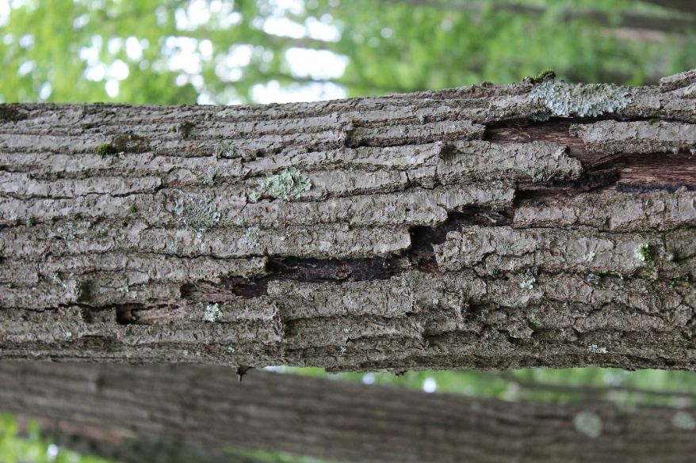

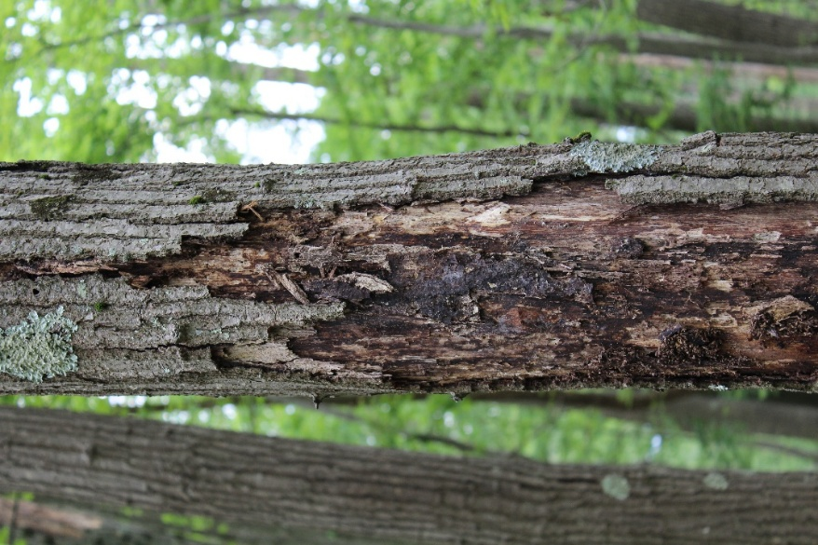

Fig. 2. A) Bark splitting in stem of red oak with signs of oak wilt underneath. B) Pressure pad directly underneath same region of stem shown previously in panel A). (All photos taken by Sophan Chhin at West Virginia University Research Forest, located just east of Morgantown, West Virginia, United States).

Symptoms of oak wilt include scattered dieback or limb mortality in white oaks and leaf scorching and complete mortality in red oaks (Yang & Juzwik, 2017). These symptoms are shared with a variety of pests and pathogens of oak, and reliable identification of oak wilt as a causal agent is difficult. Most often fungi are isolated from hosts or substrate and grown on agar plates in mycology labs. This method is less than ideal however, as poor sample quality may result in many fungi growing from the same sample. Additionally, oak wilt does not persist long in dead samples or samples not properly stored. A more reliable detection method is polymerase chain reaction (PCR) (Yang & Juzwik, 2017). PCR uses DNA primers to isolate oak wilt DNA in a sample. The DNA with the primer attached is then amplified and a probe is used to detect the oak wilt DNA by fluorescing. Nested PCR is a very accurate detection method.

Fungal detection in beetle vectors, and vector trapping are both important ways to monitor oak wilt (Jagemann et al., 2018; DiGirolomo et al., 2020; McLauglin et al., 2022). Long distance spread of oak wilt is reliant on sap beetles (Nitidulidae), which feed on the spore mats and carry the spores on their exoskeletons (DiGirolomo et al., 2020). The beetles spread the fungus to uninfected trees through wounds on branches or trunks that leak sap (DiGirolomo et al., 2020). The fungus inoculates the xylem as the beetle feeds and the infection spreads from the feeding location down to the trunk and roots (Obrien et al. 2011). Beetles are most active from April to mid-July (Jagemann et al., 2018) and many states warn against pruning during this time. Trapping of nitidulid beetles in areas near oak wilt centers is useful in anticipating the spread of oak wilt to the area (DiGirolomo et al., 2020). The most abundant species of nitidulid are Colopterus truncatus (Randall) and Carpophilus sayi (Parsons) (DiGirolomo et al., 2020). Multiple funnel traps baited with species specific pheromones are the most effective at capturing beetles (DiGirolomo et al., 2020). Testing samples for oak wilt can be done with PCR (Yang & Juzwik 2017; DiGirolomo et al., 2020).

3. Ecologic Impacts

Forests are not static systems and disturbances can elicit structural and functional changes. Invasive pests or pathogens cause species-specific stand replacing disturbance events that are detrimental to forest health. The worst-case scenario of oak wilt behavior is the exclusion or eradication of oak dominant forest types (Bragard, et al., 2020). The persistence of an infection center would show continual mortality and loss of dominance in the system. The ability of oak wilt to persist in the environment could lead to extended mortality and suppression of tree regeneration which is comparable to effects shown by fungi like chestnut blight (Cryphonectria parasitica (Murrill) M.E.Barr) and its impact on chestnut (Miller & Ivey, 2025). The loss of species diversity not only affects the economy but also species that rely on forests for habitat (Stewart et al. 2013). Birds that rely on oak forest types for breeding or post-breeding will have to relocate or use unfavorable habitat, which may contribute to population decrease from increased predation or reduced breeding success (Stewart et al., 2013).

Although limited, studies have shown no impacts of oak wilt infections on new oak reproduction. The oak wilt fungus relies heavily on transmission from infected root systems to healthy root systems, as seen from the behavior of an oak wilt infection centers (Meunier et al., 2019; Yang et al., 2024). Oak wilt does not persist in infected root systems for more than a couple years after harvest (Meunier et al., 2019). Therefore, seedlings are at low risk of infection because the fungus dies in the roots before oak seedling root systems form grafts with infected coppice individuals (Meunier et al., 2019).

Similarly, stump sprouting is a common mechanism to regenerate oaks following harvesting (Dey, 2014). A study in Wisconsin comparing oak sprouting of oak wilt infected areas and non-infected areas showed no difference in sprouting survival or size 12 years after harvesting (Meunier et al., 2019), which mimics similar assessments of Tyron et al. (1983 ) in West Virginia.

Additionally, risks of alternate host mortality is a concern. Oak wilt, while most impactful on its preferred host, will also infect Chinese chestnut (Castanea mollissima Blume) and American chestnut (Castanea dentata (Marsh.) Borkh.) (Miller & Ivey, 2025). Mortality in closely related chestnut hosts represents a form of collateral damage of mortality in red oaks, and infected chestnut trees can die as quickly as 2 weeks. The infections occur the same as in oaks: nitidulid beetles can spread spores to pruning wounds and hyphae spread through root grafts (McLaughlin et al. 2022; Yang et al., 2024). Oak wilt can spread easily through chestnut plantations, as many individuals are planted in close proximity, and form root grafts readily. This is a threat both to chestnut farmers and organizations attempting to breed blight resistant American chestnuts.

4. Current Management Practices

Forest management can have a variety of impacts on forest health and diversity, but managing against pathogens is particularly difficult. Pathogens may be present in the environment for a long time before symptoms appear. Detection of new infection centers is important to controlling their expansion. Monitoring the spread of beetle vectors is important, and knowing when they are active in the ecosystem is important for landscapers to know when it’s safe to prune. However, detecting, isolating, and removing infected trees is critical to stop the persistence and expansion of oak wilt.

A typical treatment to limit the spread of a pathogen is killing or harvesting trees that are infected or near an infection center. For larger infection areas, a sanitation harvest can be used to cover the timber value and reduce inoculum. For smaller areas, forest managers often use a stem girdling-herbicide combination to effectively kill the above and belowground structures of trees (Bronson et al. 2023). Treatments can be performed using a hypodermic hatchet or by hacking the trunk and spraying herbicide. Because oak wilt is persistent in the roots for some time, transmission is still possible after girdling. The herbicide treatment aims to kill the roots of infected oaks, but this may take up to 3 years, depending on the herbicide used. This makes stem girdling-herbicide combination not a fully effective treatment for an infection center.

Root graft severing aims to prevent the underground mode of transmission of oak wilt (Yang et al., 2024). Root grafts are locations where roots of two individuals of the same species fuse their root systems and exchange resources through the xylem. Because oak wilt infects the xylem of its hosts, the fungus can be transmitted from diseased to healthy individuals through grafts. Spread through root grafts occurs quickly, much faster than overland spread from beetle vectors, and can occur at any time of year. The underground spread characteristics of oak wilt form indicative infection centers, where the disease radiates from one host to adjacent hosts. Containment of these infection centers is an important technique to limit oak wilt spread. Containment is achieved by eliminating diseased trees, and isolating the infection center. Commercial harvests of diseased but merchantable individuals are often available. Logs with viable fungal mats should not be transported from the infection center. To contain the infection center, a trench digger or vibratory plow can be used to sever all root connections around the infection center, including a perimeter of asymptomatic trees adjacent to the infection center to prevent escape from the isolation zone through seemingly healthy trees (O’Brien et al., 2011). The most important part of infection center management is monitoring. Treated centers should be regularly monitored while symptoms are visible, and additional removals and isolations should be performed if any new infections occur. Cutting out infected areas not only promotes forest health through pathogen management but also promotes multiple age class development and diverse forest stand structure.

International phytosanitary regulations must be taken into consideration to ensure logs and lumber don’t spread the fungus outside its current range (Bragard et al., 2020). Concerns about the spread of oak wilt to Canada and Europe through oak log export have driven decision-makers in the EU to ban the import of oak logs with bark unless phytosanitary measures were performed. To successfully salvage value from oak wilt mortality, hardwood exporters must adhere to the relevant measures. The only measure available to exporters from the US is fumigation with methyl bromide. Decision IV/23 of the Montreal Protocol restricts the use of methyl bromide for fumigation, as it is classified as an ozone-depleting chemical. Research into finding alternative fumigants is developing. Two substitutes, ethanedinitrile (EDN) and sulfuryl fluoride (SF), have been tested with mixed results (Yang et al., 2023). EDN is soluble in water, which means its efficiency at fumigating large logs stored in wet conditions is poor. Sulfuryl fluoride has been used since 1990 but is not as effective as methyl bromide. More research into alternative fumigants will be necessary to minimize risk spread. Excluding log fumigation, there are various options to reduce risk as outlined by the European Food Safety Authority (Bragard et al. 2020; Table 2).

5. Future Management Strategy

The future behavior and range of oak wilt is predicted to change as the climate is modified by anthropogenic carbon emissions. Climatically sensitive distribution models of oak wilt indicate a northward expansion of oak wilt under future climate change (Pedlar et al., 2020). Concerns of the northward spread of oak wilt from the upper Midwest to southern Canada has amplified the importance of early detection of oak wilt (Gauthier et al., 2024). Oak wilt can spread north from either expanding infection centers, nitidulid beetles, or fungal mats transported in firewood. Detection of nitidulid beetles is particularly important, as infection centers are easily monitored and firewood transport across the Canadian border can be easily controlled with border security.

Monitoring is key to limiting the spread of oak wilt. Although potentially expensive, an array of beetle traps targeting areas with high oak populations can not only provide beetle population estimates, but newer molecular detection technologies allow for rapid determination of fungal presence on captured beetles or in wood samples (e.g., McLaughlin et al. 2022; Yang and Juzwik 2017). Positive detection of B. fagacearum in beetle vectors is very uncommon, but a detection in St. Clair, Canada, shows that monitoring of beetle vectors is important to quickly contain new infection centers (Gauthier et al., 2024). If southern Canadian oak forests are to persist in the long term, forest managers must be vigilant is management of oak wilt. Monitoring nitidulid range changes will continue being an important future tool in oak wilt management (McLaughlin et al., 2022).

Remote sensing is another tool that can enhance monitoring and detection efforts. Using remote sensing to detect changes in forest health or presence of oak wilt infections is far more affordable than annual field-based inventories and testing of symptomatic trees. Recent studies using spectral reflectance of forest canopies to detect changes in forest health have shown promising results (Sapes et al. 2022). Oak species reflect near-infrared and infrared light different from other trees and this difference can be detected by running aerial spectroradiometers and using classification algorithms to determine species. Likewise, the algorithms can also differentiate between red oaks and white oaks, and for red oaks the algorithm could detect whether the trees were classified as diseased (i.e., with oak wilt) and those without disease (Sapes et al. 2022).

Table 2. Current notable Risk Reduction Options (RRO) for Bretziella fagacearum. These options pertain to exported red and white oak veneer quality logs. RRO can be performed during pre-harvest (dark grey background and white text), during harvest operations (light grey background), or during processing and export (white background). Modified from Bragard et al. (2020).
Risk Reduction Option (RRO) | Description
Forest Certification | Certified forests are unsure that landowners practice good silviculture. Certified forests are more likely to be resilient against pathogen spread. These forests are also more likely to be in compliance with pest management standards.
Surveillance | Surveillance for oak wilt symptoms and signs means infection centers will be detected, and disease range will be more accurate.
Lab-based Confirmation | PCR and culture isolation can be used to detect the fungus from hosts currently outside the disease range.
Removal of Infected Trees | Cutting down infected trees and dryingdestroying the logs can dry and prevent the fruiting fungal mats from forming and spreading the disease.
Wound Painting | When pruning or wounding branches in oak wilt areas during high risk periods, painting wounds will seal them off from beetle vectors.
Root Graft Disruption | Destroying the grafts between healthy and infected trees can reduce transmission of the fungus through xylem, which aids in isolating infection centers.
Silviculture | Using silviculture to create conditions that are unfavorable to the fungus or preferable to host resilience can in turn limit mortality. Keeping forests diverse can limit transmission trough insect vectors and root grafts.
Marking Season | Only marking trees during periods when symptoms of infection are readily identified helps foresters recognize when an infection center is present.
Harvest Procedure | Limiting injuries to residual trees during harvest or prescribed cuts helps prevent transmission through sap beetle vectors.
Log Inspection | Phytosanitary inspection helps detect the fungus in logs before export, preventing spread from outside the host range.
Log Fumigation | Fumigation of logs before export helps ensure logs are disease free, especially if no visible signs of infection are present.
Inspect Imports | In areas outside of the disease range, inspecting imported logs for compliance with phytosanitary standards ensure the logs have been treated for the fungus.
Safe Transport | Transporting infected logs in sealed containers prevents spores or feeding beetles from escaping, in case phytosanitary standards have not been followed.
Safe Storage | Logs should be processed immediately after unloading, or stored under wet conditions, as the fungus is less viable when submerged or when boards are kiln dried.
Inspection of Nearby Stands | Regularly inspecting stands near to sawmills or known infection centers for presence of oak wilt.
Destroying Milling Byproducts | All sawdust and chips from milling infected logs are to be incinerated. Some mills use this residue to power their operations. Fumigated log residue does not need to be destroyed.
4. Conclusion

It would be prudent to continue researching this pathogen and how it interacts with its hosts and how it impacts forest productivity and biodiversity. Oak wilt will change in range soon as climate change continues to impact the ecosystems in North America. Potential introductions to Europe would be concerning. As oak wilt expands, new and potentially more disjunct populations of oak may be affected, which can affect genetic diversity. Prevention of spread and close monitoring are the best tools for limiting spread. Monitoring will require the use of advanced remote sensing technologies to manage the spread of oak wilt on a landscape scale. Removal of infection centers and good forest management can help mitigate the impacts on biodiversity and forest productivity. Investment in effective management of oak wilt will help ensure that the ecological and economic benefits provided by oak forests are safeguarded in a sustainable manner.

Disclaimer (Artificial intelligence)
Option 1:
Author(s) hereby declare that NO generative AI technologies such as Large Language Models (ChatGPT, COPILOT, etc.) and text-to-image generators have been used during the writing or editing of this manuscript.
Option 2:
Author(s) hereby declare that generative AI technologies such as Large Language Models, etc. have been used during the writing or editing of manuscripts. This explanation will include the name, version, model, and source of the generative AI technology and as well as all input prompts provided to the generative AI technology
Details of the AI usage are given below:
1.
2.
3.

References

Bragard, C., Dehnen-Schmutz, K., Di Serio, F., Jaques, M.-A., Miret, J., Justsen, A. F., . . . Gonthier, P. (2020). Commodity risk assessment of oak logs with bark from the US for the oak wilt pathogen Bretziella fagacearum under an integrated systems approach. European Food Safety Authority, 18(12): 6352. doi:10.2903/j.efsa.2020.6352
Bronson, D. R., Meunier, J., Pearson, T. R., & Scanlon, K. (2023). Evaluating effectiveness of girdle-herbicide containment of below-ground spread of oak wilt (Bretziella fagacearum). Forest Ecology and Management, 533, 2-8. doi:10.1016/j.foreco.2023.120816
Chhin, S. (2018). Managing red oak (Quercus rubra L.) reduces sensitivity to climatic stress. Journal of Forest and Environmental Science, 34, 338-351.
de Beer, Z.W., Marincowitz, S., Duong, T.A., & Wingfield, M.J. (2017). Bretziella, a new genus to accommodate the oak wilt fungus, Ceratocystis fagacearum (Microascales, Ascomycota). MycoKeys, 27, 1-19.
Dey, D. (2014) Sustaining oak forest in eastern North America: regeneration and recruitment, the pillars of sustainability. Forest Science, 60, 926-943.
DiGirolomo, M. F., Munck, I. A., Dodds, K. J., & Cancelliere, J. (2020). Sap beetles (Coleoptera: Nitidulidae) in oak forests of two northeastern states: A comparison of trapping methods and monitoring for phoretic fungi. Journal of Economic Entomology, 113(6), 2758–2771. doi:10.1093/jee/toaa195
Gauthier, M.-K., Bourgault, E., Potvin, A., Bilodeau, G. J., Gustavsson, S., & Reed, S. (2024). Biosurveillance of oak wilt disease in Canadian areas at risk. Canadian Journal of Plant Pathology, 46(1), 23-38. doi:10.1080/07060661.2023.2261890
Haight, R. G., Homans, F. R., Horie, T., Mehta, S. V., Smith, D. J., & Venette, R. C. (2011). Assessing the cost of an invasive forest pathogen: A case study with oak wilt. Environmental Management, 47, 506-517. doi:10.1007/s00267-011-9624-5
Jagemann, S. M., Juzwik, J., Tobin, P. C., & Raffa, K. F. (2018). Seasonal and regional distributions, degree-day models, and phoresy rates of the major sap beetle (Coleoptera:Nitidulidae) vectors of the oak wilt fungus, Bretziella fagacearum, in Wisconsin. Environmental Entomology, 47(5), 1152-1164. doi:10.1093/ee/nvy080
Johnson, P.S., Shifley, S.R., & Rogers, R. 2002. The ecology and silviculture of oaks. CABI Publishing, Oxon, UK.
Juzwik, J., Appel, D. N., MacDonald, W. L., & Burks, S. (2011). Challenges and cuccesses in managing oak wilt in the United States. Plant Disease, 888-900.
Juzwik, J., Harrington, T. C., MacDonald, W. L., & Appel, D. N. (2008). The origin of Ceratocystis fagacearum, the oak wilt fungus. Annual Review of Phytopathology, 46, 13-26. doi:10.1146/annurev.phyto.45.062806.094406
Kabrick, J.M., Zenner, E.K., Dey, D.C., Gwaze, D., & Jensen, R.G. (2008). Using ecological land types to examine landscape-scale oak regeneration dynamics. Forest Ecology and Management, 255, 3051-3062.
McLaughlin, K., Snover-Clift, K., Somers, L., Cancelliere, J., & Cole, R. (2022). Early detection of the oak wilt fungus (Bretziella fagacearum) using trapped nitidulid beetle vectors. Forest Pathology, 52(5), 1-7. doi:10.1111/efp.12767
Meunier, J., Bronson, D. R., Scanlon, K., & Gray, R. H. (2019). Effects of oak wilt (Bretziella fagacearum) on post harvest Quercus regeneration. Forest Ecology and Management, 432, 575-581. doi:10.1016/j.foreco.2018.09.056
Miller, A. C., & Ivey, M. L. (2025). The disease triangle of chestnut: A review of host, pathogen, and environmental interactions of chestnuts cultivated in the eastern United States. Plant Disease, 245-256.
OBrien, J.G., Mielke, M.E., Starkey, D., & Juzwik, J. (2011). How to identify, prevent, and control oak wilt. United States Department of Agriculture (USDA) Forest serive, Northeastern Area State & Private Forestry, NA-FR-01-11, Newtown Square, PA.
Pedlar, J.H., McKenney, D.W., Hope, E., Reed, S., & Sweeney. J. (2020). Assessing the climate suitability and potential economic impacts of oak wilt in Canada. Scientific Reports 10(1):19391. doi: 10.1038/s41598-020- 75549-w.
Sapes, G., Lapadat, C., Schweiger, A. K., Juzwik, J., Montgomery, R., Gholizadeh, H., . . . Cavender-Bares, J. (2022). Canopy spectral reflectance detects oak wilt at the landscape scale using phylogenetic discrimination. Remote Sensing of Environment, 273, 1-14. doi:10.1016/j.rse.2022.112961
Stewart, L. R., Morrison, M. L., Hutchinson, M. R., Appel, D. N., & Wilkins, R. N. (2013). Effects of a forest pathogen on habitat selection and quality for the endangered golden-cheeked warbler. The Wildlife Society, 38(2), 279-287.
Tyron, E.H., Martin, J.P., MacDonald, L. (1983) Natural regeneration in oak wilt centers. Forest Ecology and Management, 7(2), 149-155.
USDA Forest Service. (2021). Distribution of oak wilt over time. Available at: https://www.arcgis.com/home/item.html?id=436733e802864b52a804e4210518345e (Accessed 6 June 2025).
Wilson, A.D. (2005). Recent advances in the control of oak wilt in the United States. Plant Pathology Journal, 4(2): 177-191.
Yang, A., & Juzwik, J. (2017). Use of nested and real-time PCR for the detection of Ceratocystis fagacearum in the sapwood of diseased oak species in Minnesota. Plant Disease, 101, 480-486. doi:10.1094/PDIS-07-16-0990-RE
Yang, A., Haugen, L. M., Mausel, D. L., Lampereur, J., Stueck III, T., Montgomery, R. A., & Juzwik, J. (2024). Evaluation of the root rupture method for controlling belowground spread of the oak wilt pathogen (Bretziella fagacearum) in northeast Wisconsin, USA. Journal of Forestry, 122(3), 302-313. doi:10.1093/jofore/fvad055
Yang, A., Seabright, K., Garrison, T., Taylor, A., Myers, S., & Juzwik, J. (2023). Oak Wilt Fungus (Bretziella fagacearum) survival in logs following fumigation with ethanedinitrile. Forest Products Journal, 73(3), 260–266. doi:10.13073/FPJ-D-23-00016

