**MODELING AND OPTIMIZATION OF TEMPERATURE-DEPENDENT PERFUSION AND CELLULAR DYNAMICS IN RADIO FREQUENCY ABLATION USING MODIFIED BHTE**

.

ABSTRACT

|  |
| --- |
| Thermal treatments for cancer such as RFA necessitate careful regulation of energy input to enhance tumor necrosis and minimize adjacent normal tissue injury. The classical Bioheat Transfer Equation (BHTE) which is generally employed to simulate heat transport in tissues does not account for essential physiological responses like temperature-dependent perfusion and metabolic quiescence. A modified BHTE model associated with dynamic cellular viability equations is used to describe realistic biological responses for heating. By employing a hybrid solver, the model incorporates the temperature-sensitive perfusion, exponentially decayed metabolic heat generation, and the logistic growth dynamics for cancer and normal cells. The Arrhenius damage integral was used as an indicator for irreversible thermal damage, and its clinical use was developed. It was shown that when the influence of physiologic feedback mechanisms was introduced, prediction of necrotic zones and normal tissue injury decreases. Optimization studies with respect to diverse patient and environmental i.e., perfusion rates, ambient temperatures – conditions also present the capabilities of this framework in personalized therapy planning. |

*Keywords:* Radio Frequency Ablation (RFA), Bioheat Transfer Equation (BHTE), Thermal Therapy Optimization, Cell Dynamics, Arrhenius Damage Model, Temperature-Dependent Perfusion, and personalized therapy planning.

1. INTRODUCTION

## Thermal (or ablation) techniques, such as RFA have been pursued as minimally invasive approaches to the treatment of localized solid tumors such as those in the liver, kidney and lung Shah et al. [1]. The methods are based on the application of high frequency alternating electric currents to create a local heating effect which destroys the cancerous tissue by coagulative necrosis. RFA has clinical appeal given its short convalescence, low morbidity, and is suitable in patients who are considered to be 'non-resectable'.

## Although robotically assisted ablation (RFA)-therapy is promising, it largely relies on the accuracy of the predicted and controlled temperature during the treatment. Insufficient dosage leaves incompletely ablated or ablation-recurrent, whilst excessive dosage leads to too much damage in normal tissues, leading to serious complications or dysfunction of the organ De et al. [2]. Therefore, it is necessary to develop realistic models of heat transport in biological tissue to be able to provide safe, effective, and patient specific RFA treatment.

## The bioheat transfer equation (BHTE) formulated by Pennes [3], is one of the most common mathematical models for simulating the heat transfer process in biological tissue. In classical BHTE, the heat in biological tissue is generated by conductive, convective (due to blood perfusion), and metabolic sources. Although it is common, the conventional BHTE model that assumes a constant perfusion and metabolic heat production rate cannot describe the dynamical biological response during heating. Such approximations could lead to significant discrepancies between the predicted/simulated and actual applied thermal response, especially for infrequent or intense heating.

## In fact, blood perfusion rate has a strong temperature dependent. During heating, Perfusion can initially rise from vasodilatation (due to heating of the tissue), but then drop as vessels are killed at higher temperatures. Metabolic activity from the cell upon injury or cell death will also in general decrease and this will lead to less endogenous heat production. In addition, the cell survival is a nonlinear function of time and temperature, and depends on the cellular damage thresholds along with the thermal process of apoptosis and necrosis Bosque et al. [4], Zhmakin et al. [5], Kalsi et al. [6]. These processes are not well described by the classical BHTE, and a more biologically relevant modeling approach is required.

## To address these limitations, we modify the BHTE model to include the effects of all the following: Temperature-dependent perfusion dynamics, Exponential metabolic heat suppression, and Logistic growth models for the cancer and normal cell populations. These extensions allow the model to predict biologically relevant feedback effects during ablation, such as tissue viability decrease, perfusion shut down, and thermal damage growth.

## We also parameterize the irreversible cellular damage that is induced after the cumulative temperature exposure with an Arrhenius thermal damage model Pearce et al. [7]. By integrating the modified BHTE, cell population models, and optimization techniques, we use the framework to find the optimum spatiotemporal energy delivery profile for maximizing the tumor ablation and minimizing the normal tissue injury.

## Patient and environmental factors, such as tissue perfusion rates and ambient room temperature that influence the energy required for effective ablation are also investigated in this study.

## These parameters are varied over simulations to investigate their impact on heating effectiveness and necrotic size.

## STATEMENT OF THE PROBLEM

Radio Frequency Ablation (RFA) is widely used as a minimally invasive treatment for cancer, offering the potential to destroy tumor cells through localized heating. However, the effectiveness of RFA is significantly limited by the inability to accurately predict temperature distribution within biological tissues during treatment. This challenge poses serious clinical consequences: when the predicted temperature does not match the actual thermal response, tumor destruction may be incomplete, increasing the risk of recurrence. At the same time, excessive or poorly targeted heat can damage surrounding healthy tissues, leading to complications and reduced treatment success De et al [8]**,** Singh et al [9].

Traditionally, the Bioheat Transfer Equation (BHTE) Pennes [3], has been used to model how heat spreads within tissues during thermal therapies. Yet, the classical form of BHTE assumes that key physiological parameters—such as blood perfusion rate, metabolic heat production, and thermal conductivity—remain constant over time. In reality, these parameters are dynamic and highly sensitive to temperature changes. As a result, the classical BHTE fails to capture the complex feedback mechanisms that occur in living tissues during heating, which limits its usefulness in real-world, patient-specific scenarios Martin et al [10], Maruyama et al [11], Cramer et al [12].

## The present study tries to overcome these drawbacks by developing a modified BHTE approach using Temperature-dependent perfusion and metabolic suppression, Cancerous and Normal tissue population dynamics,

## By bridging the gap between simplistic physiological models and the complexity of thermal-tissue interaction, this research initiative is expected to enhance treatment accuracy, minimize side effects, and promote individualized treatments.

## GENERAL OBJECTIVE:

The objective of the study was to optimize the heat energy to obtain an effective tumor treatment. The goal was to maximize the reduction in cancer cell population while minimizing damage to normal cell populations.

### SPECIFIC OBJECTIVES:

1. To develop and implement a modified BHTE model that incorporates temperature-dependent perfusion, metabolic heat generation, and cell population dynamics for more physiologically accurate simulations.
2. To optimize external heat energy delivery in Radio Frequency ablation (RFA) treatment by minimizing normal tissue damage while maximizing cancer cell destruction.
3. To investigate the effect of patient-specific and environmental factors (such as ambient temperature and tissue perfusion) on the optimal external energy required for effective thermal ablation.

## SIGNIFICANCE OF THE STUDY

Introduction Radio Frequency Ablation (RFA) is an effective and minimally invasive solid tumor therapy and it is already approved for clinical use. Notwithstanding so, its clinical advancement is closely controversial to the ability to predict and control thermal damage with high accuracy. Narrow margins or heating in adjacent tissue may result in incomplete treatment or injury to critical surrounding tissue Golden et al [13], Pogorelić et al [14].

The standard Bioheat Transport Equation (BHTE) Pennes [3], that is commonly used in thermal modeling, oversimplifies complex physiological responses where (a) perfusion and metabolic activity are assumed as constant, and (b) dynamics of cellular viability are omitted. In standard models, the biological feedback of heat dissipation, cell damage and tissue recovery are hence discarded.

This paper addresses these previous limitations through the development of an integrative, physiologically based model that includes temperature dependent perfusion, dynamic cell population and calculation of thermal damage using the Arrhenius integral Pearce et al [7]. It aims to reproduce more precisely the bio-thermal and cellular response of the tissue during RFA.

Key Contributions and Impacts:

1. Enhanced Physiological Realism:

The BHTE model modified with perfusion shutdown, metabolic heat suppression and cellular viability, could more truthfully simulate the response of tissue in thermal process.

2. Dynamic Cell-Tissue Interaction Modeling:

A tumor vs normal cell competition permits biological follow-up simulations following ablation, to deliver the information of recurrence risk and residual cell viability.

3. Quantitative Thermal Damage Estimation:

Using the Arrhenius damage model, irreversible tissue injury can be modelled, which is an important aspect of treatment planning and validation.

# 4. Personalization of Treatment Protocols:

# Incorporating patient-specific parameters (perfusion rate, tissue type) and external conditions (environmental temperature), the model can be exploited to build tailored cooling plans optimizing therapeutic effect.

# 5. Optimization for Clinical Application:

# With model-based optimization, it may be possible for the operator to determine the minimum effective energy required to fully ablate tumor and thus, shorter procedure times and fewer energy-related periprocedural complications are possible.

## LITERATURE REVIEW

One of the fundamental limitations of the BHTE lies in its assumption that biological tissues are homogeneous and isotropic. In reality, human tissues vary considerably in their thermal properties—including conductivity, specific heat, and perfusion—across different anatomical regions and between patients. This heterogeneity significantly affects heat transport and the prediction of thermal damage.

Maniotis et al [15], demonstrated that BHTE frameworks struggle with accurately predicting temperature distribution in areas with complex vascular structures, potentially leading to overlooked localized overheating in tumor regions. Similarly, Huang, Horng et al [16], showed that tumor tissues often show limited enhancement in blood perfusion during hyperthermic conditions compared to healthy tissues, which contributes to temperature discrepancies. Jamil et al [17], further emphasized that uniform assumptions in thermal conductivity can lead to inaccurate predictions of heat distribution in biological tissues due to varying behaviors among different tissue types.

Another critical limitation of the BHTE is its simplistic treatment of blood perfusion. The classical model assumes that perfusion remains constant or is uniformly distributed throughout the tissue. In practice, blood flow in tissues is highly variable and sensitive to temperature, pressure, immune activity, and local inflammation.

Gupta et al [18] reported that FDM-based simulations often do not include dynamic updates of perfusion coefficients, leading to errors in the accuracy of hyperthermia treatment planning. This can significantly affect the outcomes in thermal therapies. Ramanlal et al [19], highlighted that temperature Influence Changes in temperature may affect the mechanical properties of blood vessels, resulting in diameter alterations during the autoregulatory response. This can impact how blood flow is regulated under different thermal conditions.

1. material and methods

**2.1 Introduction**

In this article, we present a physiologically realistic simulation model of thermal cancer therapy through modifying the classical BHTE and combining cell dynamics.

## **2.2 Classical vs. Modified BHTE Comparison**

### **2.2.1 Objective**

This section described the comparative modeling of Classical and Modified Bioheat Transfer Equation (BHTE) and the detailed implementation of the hybrid solver, which was used to solve the modified formulation. The objective was to compute the effects of temperature-dependent perfusion, metabolic heat generation, and dynamic feedback of the cell population to temperature evolution and tissue damage prediction.

### **2.2.2 Modeling Temperature-Dependent Perfusion and Metabolic Heat Generation**

The study incorporated temperature-dependent perfusion and metabolic heat generation functions into the computational framework model in order to accurately capture physiological feedback effects during thermal therapy. The temperature-dependent biothermal parameters were modeled according to literature of the vascular response and cellular metabolism during hyperthermia and ablation procedures Sharma et al [20], Yuan et al [21], Guntur et al [22]. Inclusion of the effects of temperature-dependent perfusion and metabolic heat generation rate was essential in order to accurately replicate realistic tissue responses when applying variability in thermal and phantom parameters and improve the accuracy of the necrosis prediction.

#### **2.2.2.1 Perfusional Dynamics**

Physiological Modeling

Blood perfusion was modeled as a temperature dependent variable that progressed through 3 distinct physiological conditions while heated. At normal and moderately elevated temperatures (37°C-43°C), perfusion was elevated due to vasodilation which augmented thermal dissipation through convective heat transfer by the blood flow. In the temperature range of 43°C and 50°C, perfusion remained in a plateau which indicated the blood vessels remained preserved but remained saturated under heat stress. Greater than 50°C, irreversible vascular damage occurred which resulted in the rapid decline of perfusion and subsequently diminished ability of heat removal Cramer et al [23].

Mathematical Implementation

The perfusion behavior was defined with a piecewise function:

|  |  |  |
| --- | --- | --- |
|  | $$ω_{b}\left(T\right)=\left\{\begin{matrix}\begin{matrix}ω_{0}\left(1+a\left(T-37\right)\right) \\ ω_{0}\left(1+a∙6\right)\end{matrix} & \begin{matrix}{37}^{0}≤T<{43}^{0}C \\ {43}^{0}≤T<50C\end{matrix} \\ \begin{matrix}ω_{0}\left(1+a∙6\right)∙\exp\left(-b\left(T-50\right)\right) \\ ω_{0}\end{matrix} & \begin{matrix}T<{50}^{0}C \\ T<{37}^{0}C\end{matrix}\end{matrix}\right.$$ | (2.1) |

Where ω_0 indicated baseline perfusion, a quantifies the vasodilatory rate (normally 0.1 to 0.15 °C⁻¹), and b quantified the vascular shutdown rate (normally 0.2 to 0.3 °C⁻¹).

Simulation Integration

In the simulation, perfusion was continuously updated at each spatial and temporal point based on local tissue temperature. This framework allowed the model to simulate the vasodilatory delay in early heating and the accelerated tissue temperature due to vascular shutdown in the late heating. Control simulations with a constant perfusion could not recreate either transition and failed to provide accurate estimates of the temperature escalation and necrosis of deep tissue zones

#### **2.2.2.2 Metabolic Heat Dynamics**

Physiological Modeling

Metabolic heat production was modeled as a declining function of temperature. Cells that are metabolically active (~37°C) produce heat internally (through oxidative processes), but as temperature increases the cell metabolism become progressively inhibited (i.e., enzyme inactivation, mitochondrial dysfunction, and ATP depletion). At ~60°C or higher, metabolic activity stops entirely due to protein denaturation and subsequently, cell death Yousef et al [24]

Mathematical Implementation

We model this behavior using an exponential decay function as follows:

|  |  |  |
| --- | --- | --- |
|  | $$Q_{met}\left(T\right)=:Q_{met,0}∙\exp\left(-γ\left(T-37\right)\right)$$ | (2.2) |

Where Q_met,0 indicates the nominal metabolically produced heat (e.g. 420 W/m³) and γ is the suppression coefficient that typically ranged from 0.15-0.25 °C-1.

Simulation Integration

At each simulation time step, local temperatures allowed to calculate the updated metabolic heat value. Dynamic updates permitted that viable tissue regions produced heat, while necrotic regions remained thermally silent. Dynamic and static metabolic models showed that neglecting the computed suppression of metabolism would create spurious high temperatures at the edge of endogenous heating in the high temperature regions, which presented an erroneous model of the injury profile and cooling rates associated with post-ablation of the simulated tissue.

#### **2.2.3 Classical and Modified BHTE Formulations**

#### Classical BHTE

#### The Classical BHTE was used in its standard version Pennes [3]:

|  |  |
| --- | --- |
| $$Cρ\frac{∂T}{∂t}=λ\frac{∂^{2}T}{∂x^{2}}+ρ_{b}C_{b}ω_{b}\left[T_{b}-T\right]+Q_{met}+Q_{ext}\left(x,t\right)$$ | (2.3) |

#### Modified BHTE

#### The thermal reaction of tissue under hyperthermia was explained by modified the bioheat transfer Bioheat Transfer Equation equation (BHTE) with temperature-dependent parameters of which were assumed to be in proportion to the number of biologically normal and cancer cells:

|  |  |
| --- | --- |
| $$Cρ\frac{∂T}{∂t}=λ\frac{∂^{2}T}{∂x^{2}}+ρ_{b}C_{b}ω_{b}\left(T,N_{c}\right)\left[T_{b}-T\right]+Q_{met}\left(N_{n},N_{c}\right)+Q_{ext}\left(x,t\right)$$ | (2.4) |

Where:

T(x,t): temperature field (°C)

ρ,c: density and specific heat of the tissue

λ: thermal conductivity

ρb,cb: density and heat capacity of blood

ωb(T,Nc): rate of perfusion as a function of temperature and number of cancer cells

Qmet=qnNn +qcNc: metabolic heat generated by normal (Nn) and cancer (Nc) cells

Qext: supply of energy from external sources such as RFA.

Cell Population Dynamics

The local dynamics of cancer and normal cells were modeled using the coupled nonlinear ordinary differential equations of proliferation and death rates that were temperature functions:

|  |  |  |
| --- | --- | --- |
|  | $$\frac{∂N_{c}}{∂t}=r_{c}\left(T\right)⋅N_{C}\left(1-\frac{N_{c}}{K_{C}\left(T\right)}\right)-d_{c}\left(T\right)N_{c}$$ | (2.5) |
|  | $$\frac{∂N_{n}}{∂t}=r_{n}\left(T\right)⋅N_{n}\left(1-\frac{N_{n}}{K_{n}\left(T\right)}\right)-d_{n}\left(T\right)N_{n}$$ | (2.6) |

Where:

Nc, Nn: densities of cancerous and normal cells

r(T): temperature-dependent proliferation rates

K (T): thermal-limited carrying capacities

d (T): temperature-induced cell death rates

Hybrid FDM–RNN–PINN Framework

The approach employed here was three highly integrated modules:

FDM Module

The modified BHTE and cell dynamics equations were discretized spatially and temporally using the explicit Euler method:

spatial discretization

|  |  |  |
| --- | --- | --- |
|  | $$\frac{∂^{2}T}{∂x^{2}}≈\frac{T_{i+1}^{n}-2T_{i}^{n}-T_{i-1}^{n}}{{\left(∆x\right)}^{2}}$$ | (2.7) |

time integration:

|  |  |  |
| --- | --- | --- |
|  | $$T_{i}^{n+1}=T_{i}^{n}+\frac{∆t}{Cρ}\left[λ\frac{T_{i+1}^{n}-2T_{i}^{n}-T_{i-1}^{n}}{{\left(∆x\right)}^{2}}+ρ_{b}C_{b}ω_{b}\left(T_{b}-T_{i}^{n}\right)+q_{n}N_{n,i}^{n}+q_{c}N_{c,i}^{n}+Q_{ext}\right]$$ | (2.8) |

update cell densities

|  |  |  |  |
| --- | --- | --- | --- |
|  | $$N_{c,i}^{n+1}=N_{c,i}^{n}+∆t.\left[r_{c}\left(T_{i}^{n}\right)⋅N_{c,i}^{n}\left(1-\frac{N_{c,i}^{n}}{K_{C}\left(T_{i}^{n}\right)}\right)-d_{c}\left(T_{i}^{n}\right)N_{c,i}^{n}\right]$$ | (2.9) | |
|  | $$N_{n,i}^{n+1}=N_{n,i}^{n}+∆t.\left[r_{n}\left(T_{i}^{n}\right)⋅N_{n,i}^{n}\left(1-\frac{N_{n,i}^{n}}{K_{n}\left(T_{i}^{n}\right)}\right)-d_{n}\left(T_{i}^{n}\right)N_{n,i}^{n}\right]$$ | | (2.10) |
|  |  |  | |

This module produced initial temperature and cell density profiles over the spatial-temporal domain, serving as training data for subsequent neural network modules.

LSTM (RNN) Module: Modeling Cell Dynamics

In order to learn temporal cell population dependencies from local temperature history effectively, a Recurrent Neural Network with Long Short-Term Memory (LSTM) layers was trained. The model took input sequences of temperature time series

$[T(x,t_{n-τ}),...,T(x,t_{n})]$ to generate future cancer and normal cell densities $Nc\left(x,t_{n+1}\right),and Nn(x,t_{n+1}$ The network architecture consisted of two stacked one above the other LSTMs with 64–128 units per layer, and dropout for regularization, and a dense output for regression.

Loss function minimized the mean squared error between needed and predicted cell densities:

|  |  |  |
| --- | --- | --- |
|  |  | (2.11) |

It enabled fast and accurate prediction of cell dynamics under changing thermal conditions.

PINN Module: Thermo-Biological Consistency

The PINN was designed to enhance the temperature field Tθ(x,t) by imposing the resultant modified BHTE physics and boundary conditions in a neural network framework.

Physics residual

|  |  |  |
| --- | --- | --- |
|  |  | (2.12) |

Initial condition:

|  |  |  |
| --- | --- | --- |
|  |  | (2.13) |

Boundary condition:

|  |  |  |
| --- | --- | --- |
|  |  | (2.14) |

Total loss

|  |  |  |
| --- | --- | --- |
|  | $$L_{total}=λ_{1}L_{phys}+λ_{2}L_{IC}+λ_{3}L_{BC}$$ | (2.15) |

The PINN was trained at collocation points sampled throughout the spatial-temporal domain to reduce L_total, making it physically consistent and yielding smooth temperature prediction.

Iterative Coupling and Optimization

An iterative back-feeding loop is created with the option of an interconnection between modules in the Physics-Informed Neural Network (PINN) and the Long Short-Term Memory (LSTM) to enhance the model through the leverage of dynamic physiology interactions and feedback. Consequently, whenever the temperature field forecasted and revised by the PINN stumbled upon an access point to the LSTM, it was used to estimate the changing cell density due to thermal stresses. New cell density was reutilized to recalculate temperature-dependent metabolic heat formation as significant feedback. This new metabolic term was then incorporated into the PDE residual term in the PINN, and in this manner, was used to fine-tune the predicted temperatures to perfection. This reassuring cycle of information exchange between PINN and LSTM subsisted until convergence produced a self-consistent solution for both temperature distribution and cellular responses. The combination of such a feedback-driven learning was essential for precise simulations of heating coupled with biological tissues during therapy.

### **2.2.4 Necrotic Volume Calculation Using the Arrhenius Model**

To quantify the biological scale of thermal injury with Radio Frequency ablation (RFA), the Arrhenius damage integral Pearce et al [7], was used to calculate irreversible tissue injury. The method was based on the premise in thermochemical kinetics that tissue damage is a first-order rate phenomenon for both the exposure magnitude and duration of temperature.

The Arrhenius equation calculates cumulative thermal injury at a point as:

|  |  |  |
| --- | --- | --- |
|  | $$Ω\left(x, t\right)=\int_{0}^{t}{A∙exp\left(-\frac{E_{a}}{RT\left(x,τ\right)}\right)}dτ$$ | (2.16) |

Where:

• Ω(x,t) is the cumulative thermal damage at position x and time t

• A is the frequency factor (s⁻¹), which is indicative of the rate of initiation of damage,

• Ea is the activation energy (J/mol), a measure of the sensitivity of tissue to thermal damage,

• R is the universal gas constant (J/mol·K),

• T(x,τ) is the absolute temperature (K) at position x and time τ.

As expected from the Arrhenius model, when Ω(x,t)≥1, the tissue at that location is considered to be irreversibly damaged. The threshold is defined as the energy having been deposited to denature protein and kill cells irreversibly.

Step-by-Step Calculation of Necrotic Volume

1. Calculation of Arrhenius Damage:

At each discrete spatial node xi, the cumulative Arrhenius integral Ω (xi, tfinal) was computed via numerical time integration of temperature profiles extracted from the BHTE solver.

1. Application of Damage Threshold:

A step function δ(Ω≥1) was applied to identify nodes where irreversible thermal damage was induced. It was assigned as Pearce et al [7],et al [24],:

|  |  |  |
| --- | --- | --- |
|  | $$δ\left(Ω(x_{i}, t_{final}\right)≥1=\left\{\begin{aligned}1 if δ(Ω(x_{i}, t_{final}) \\ 0 otherwise\end{aligned}\right.$$ | (2.17) |

1. Summation Over Spatial Domain:

The total volume of necrosis was determined by summing over all the spatial nodes where the indicator function returned 1 and multiplying with the spatial resolution Pearce et al [7], Yousef et al [24],

|  |  |  |
| --- | --- | --- |
|  | $$V_{necrotic}=\sum_{i=1}^{N}{δ(Ω(x_{i}, t_{final})≥1.∆x}$$ | (2.18) |

Interpretation:

The calculated necrotic volume V necrotic was the volume of total tissue that had experienced sufficient thermal exposure to cause irreversible damage. This metric was an objective measurement of treatment safety and efficacy.

This method was applied across both the classical and extended BHTE models equally. In this way, the resulting necrotic volumes served as the basis for the comparison of the impact of introducing temperature-dependent perfusion, metabolic shutdown, and cell population dynamics into the thermal model.

**2.2.5 Calculated Outputs**

The following outputs were computed:

1. Metabolic and perfusion heat maps
2. Temperature profile T(x,t)
3. Thermal damage using the Arrhenius integral:

These outputs were used to examine heating patterns, necrosis zones, and healthy tissue preservation.

### **2.2.6 Summary**

This section described the modeling strategy and hybrid realization for determining the Modified BHTE with dynamic physiological feedback. The embedding of cell dynamics into the thermal model allowed for spatiotemporal interaction between temperature, perfusion, metabolism, and injury. The hybrid model strategy was used to determine this system, providing a data-efficient and physically sound solution method well suited to personalized thermal treatment simulations.

## **2.4 Mathematical Formulation of the Optimization Problem**

In the current study, we address the critical task of designing an optimal energy delivery scheme for patient-specific Radio Frequency ablation (RFA) treatment. Effective RFA requires delivering sufficient thermal energy to irreversibly damage and kill cancerous cells while preventing the damage to surrounding healthy tissue. This therapeutic balance was achieved by formulating the problem as a constrained optimization problem taking into account patient-specific physiological and thermal parameters.

The criterion of optimization balances three fundamental goals: (a) minimizing thermal damage to normal (healthy) tissue, (b) maximizing tumor cell destruction, and Pennes [3], minimizing overall external energy utilized in treatment. These are framed in the language of the clinical need for safety and efficacy. The control variable was the spatiotemporal distribution of the external heat source, Q_ext(x, t), that must be tailored to the individual tissue properties of each patient.

The optimization problem was mathematically stated as follows:

|  |  |  |
| --- | --- | --- |
|  | $$\min_{Q_{ext}\left(x,t\right)}{J\left(Q_{ext}\right)=w1\int_{Ω}^{.}{N_{n}^{2}\left(x,t_{f}\right)dx}+w2\int_{Ω}^{.}{{\left(1-N_{c}\left(x,t_{f}\right)\right)}^{2}}dx+w3\int_{0}^{t_{f}}{\int_{Ω}^{.}{Q_{ext}^{2}dxdt}}}$$ Subject to: $$Cρ\frac{∂T}{∂t}=λ\frac{∂^{2}T}{∂x^{2}}+ρ_{b}C_{b}ω_{b}\left(T,N_{c}\right)\left[T_{b}-T\right]+Q_{met}\left(N_{n},N_{c}\right)+Q_{ext}\left(x,t\right)$$ $$\frac{∂N_{c}}{∂t}=r_{c}\left(T\right)⋅N_{C}\left(1-\frac{N_{c}}{K_{C}\left(T\right)}\right)-d_{c}\left(T\right)N_{c}$$ $$\frac{∂N_{n}}{∂t}=r_{n}\left(T\right)⋅N_{n}\left(1-\frac{N_{n}}{K_{n}\left(T\right)}\right)-d_{n}\left(T\right)N_{n}$$ $$Ω\left(x, t\right)=\int_{0}^{t}{A∙exp\left(-\frac{E_{a}}{RT\left(x,τ\right)}\right)}dτ≥1, for x ϵ Ω_{tumor}$$ $$T\left(x,t\right)≤T_{safe}={45}^{0}C, x ϵ Ω_{healthy}$$ | (2.19) |

Definition of Terms and Variables:

Q_ext(x,t): External energy input to be optimized over space and time.

T(x,t): Temperature field within the tissue domain.

Nc, Nn: Density of cancer and normal cells, respectively.

Ω(x,t): Thermal damage cumulative using the Arrhenius model.

w₁, w₂, w₃: Balancing weighting coefficients between competing treatment objectives.

d (T): temperature-induced cell death rates

ρ, c, λ: Tissue density, specific heat, and thermal conductivity.

ωb: Perfusion rate;

Tb: Arterial blood temperature.

Qm: Metabolic heat generation term.

A, ΔE, R: Arrhenius damage model parameters.

where the weights w₁, w₂, and w₃ determine the balance between normal tissue sparing, overall tumor ablation, and energy conservation.

The solution of the resulting optimization problem was an energy protocol, which was personalized to the patient and optimizes therapeutic outcome. By considering spatial heat transfer, cellular response dynamics, and thermal safety limits at the same time, the approach allowed for precise and effective treatment plan. The model can be integrated in preoperative simulation activities where every thermal and biological parameter is extracted from patient imaging or biopsy information. The outcome is a real personalized RFA treatment plan that optimizes tumor ablation with minimal damage to critical neighboring tissues.

## **2.5 Ambient Temperature Influence on Optimal External Heating Power**

This section presents the methodology that was used to investigate the influence of ambient temperature on the optimal external energy (Q_ext) required for effective Radio Frequency ablation (RFA) therapy. The research goal was to isolate and quantify the effects of environmental conditions, in this instance, ambient air temperature, in specifying the external heating power needed to achieve therapeutic temperature levels in tumor tissue.

### **2.5.1 Simulation Framework**

In order to avoid the effects of ambient temperature impacting the accuracy of assessment, all physiological and tissue-related parameters were held fixed in simulation. The sole variable factor was the ambient temperature (T_inf) by steps that mimicked actual clinical conditions. This provided the capability for investigation on how external heat demands vary based on variability in environmental thermal conditions in isolation.

The externally trainable heat source PINN-RNN hybrid model was applied to solve the Bioheat Transfer Equation (BHTE) at different ambient temperatures. The model was optimized to minimize the spatiotemporal heat flux Q_ext(x,t) such that the tumor volume reached and maintained therapeutic temperatures without high energy consumption and preventing overheating of healthy tissue. Optimization was achieved using an objective function that balances thermal performance and energy efficiency.

### **2.5.2 Variation of Parameters**

The following parameters were fixed uniformly in all the cases Haemmerich et al [25], Preechaphonkul et al [26]:

Tissue thermal conductivity: 0.5 W/m·K

Tissue density: 1000 kg/m³

Blood perfusion rate: 0.001 1/s

Specific heat capacity: 3600 J/kg·K

Metabolic heat: 300 W/m³

Ablation target temperature: 44°C

The ambient temperature T_inf was varied systematically using the following values: 20°C, 25°C, 30°C, and 35°C. These fall within a range of typical clinical room temperatures.

### **3.4.3 Optimization and Output Metrics**

For each ambient temperature setting, the optimal external energy Q_ext was determined through the same training process.   
This was implemented using gradient-based optimization on the loss function that penalizes thermal underperformance in the tumor, overheating in healthy tissue, and unnecessary energy consumption.

The final outcome of each simulation was the optimal Q_ext value—defined as the external heating power (in watts) needed to achieve therapeutic goals for a given ambient temperature. These results were then compared to assess the influence of environmental temperature on energy requirements.

3. results and discussion

## **3.1 Overview of Comparative Study**

## This section presents the results obtained from simulations of the modified Bioheat Transfer Equation (MBHTE) under various thermal and physiological scenarios, along with the outcomes of the energy optimization procedure.

## **3.2 BHTE Formula Comparison: The Classical Model versus the Modified One**

### **3.2.1 Justification of Modeling Setup**

Actual biological tissues exhibit dynamic responses to changes in temperature, whereas BHTE assumes that tissue perfusion and metabolic heat generation are constant throughout this study.

The two models were run with the same thermal input for the tumor region, 60 s over a 1 cm tissue domain.

### **3.2.2 Perfusion dynamics**

Perfusion followed a three-stage nonlinear pattern that was strongly temperature-dependent. Vasodilation caused a gradual increase in perfusion between 37 degrees C and 43 degrees C, therefore boosting the tissue's capacity to release heat via blood flow. During the first heating period, this step was instrumental in lowering the speed at which temperature increased. Perfusion remained steady as the temperature rose from 43°C to 50°C. Though the tissue experienced mild thermal strain during this phase, the integrity of the blood vessels was preserved, so supporting perfusion to carry on its constant heat-sinking activity. Beyond 50°C, however, irreversible blood vessel damage caused perfusion to gradually drop. This interruption of blood flow severely limited the tissue's ability to get rid of heat, therefore accelerating the temperature rise and so worsening irreversible thermal damage. The simulation results very clearly showed this order of events. Perfusion first rose, then stabilized, and finally fell as the temperature rose, as shown in Figure 3.2.2.1, which maps the center temperature and perfusion over time. The point when perfusion started to drop matched a sudden temperature rise, highlighting its importance in controlling thermal distribution over the ablation process. On the other hand, simulations assuming a steady perfusion value could not reproduce this variation, hence underestimating the potential for overheating during the final phases of therapy.

Figure 1 Temperature and Perfusion Vs Time

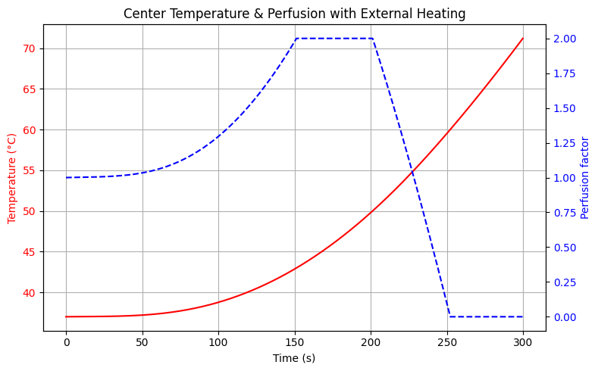

**3.2.3 Metabolic Heat Dynamics**  
Unlike perfusion, metabolic heat production showed a consistently decreasing trend along with increased temperature. Cellular metabolism actively helped to create endogenous heat at baseline temperatures about 37°C. Metabolic activity slowed down as the temperature rose, however, as thermal stress caused a progressively diminishing heat output. Cellular metabolism was much reduced or stopped entirely by protein denaturation and cell death by the time tissue temperatures reached 60 degrees Celsius or more. This loss of metabolic activity meant that necrotic areas no longer contributed significant internal heat, therefore changing the thermal dynamics in such areas. Figure 3.2.3.2. showed the metabolic heat component next to the central temperature over time in order to represent this trend. At physiological temperatures, the metabolic component stayed close to one before dropping steadily as heat grew. Beyond 45–50°C especially, the effect was very evident as it mirrored the change from functioning to damaged tissue. Adding this temperature-dependent metabolic reaction let the model more precisely depict the declining function of internal heat sources as tissue became thermally damaged.

Figure 2. Temperature and metabolic Vs Time

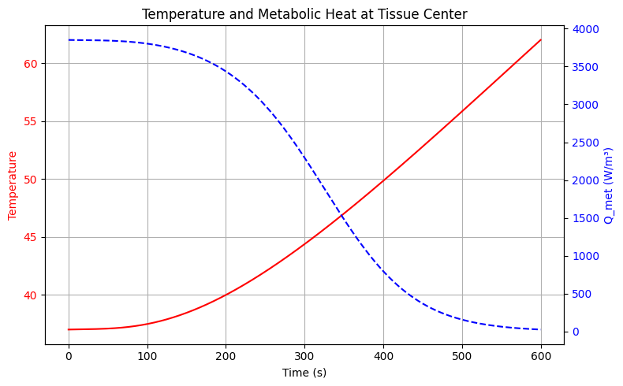

Together, the simulations showed that both perfusion and metabolic heat kinetics greatly influenced the temperature profile during RFA. While perfusion shutdown and metabolic decline amplified heating and damage in later phases, the vasodilatory rise in perfusion delayed thermal buildup in the early phase. Ignoring these physiological cues would have resulted in incorrect temperature patterns, therefore endangering treatment planning and safety. It was clear then that including both approaches were critical for precise thermal modeling in ablative treatments.

Classical versus modified BHTE:

**3.2.4 Temperature Distribution**

The classical and modified versions of the Bioheat Transfer Equation (BHTE) were simulated for 60 seconds under the same thermal loading conditions to show how integrating dynamic physiological parameters—particularly, temperature-dependent perfusion and metabolic heat generation—affects their response.

Figure 3.2.4.3 illustrates the steady-state temperature profile in a 1 cm tissue space. The classical BHTE model, based on the assumption of uniform perfusion and metabolism-based heat generation, predicts a symmetrical and peaked temperature profile that reaches its peak at the site of the heat source. The peak temperature is around 55 °C, which is extremely elevated relative to normal physiological levels. No adaptive tissue response to heating was considered in this approach and, as a result, thermal exposure might be overestimated.

As opposed to this, the modified BHTE incorporates temperature-dependent perfusion and metabolic heat generation that vary in real-time according to the surrounding thermal environment. As seen in the figure, the corrected model produces a smoother and asymmetrical profile, with a peak temperature of approximately 46 °C. The reduction in maximum temperature can be attributed primarily to two major mechanisms: first, perfusion increases with moderate thermal exposure, thus aiding in heat loss through augmented blood flow; but at high temperatures—where vascular damage occurs—perfusion decreases considerably, indicating the breakdown of thermal regulation. Metabolic heat production is also diminished as the tissue is subjected to thermal injury, with an eventual decrease in areas of necrosis. These feedback mechanisms act as a thermal buffer, preventing excessive temperature buildup near the heating source.

Figure 3. Temperature Distribution

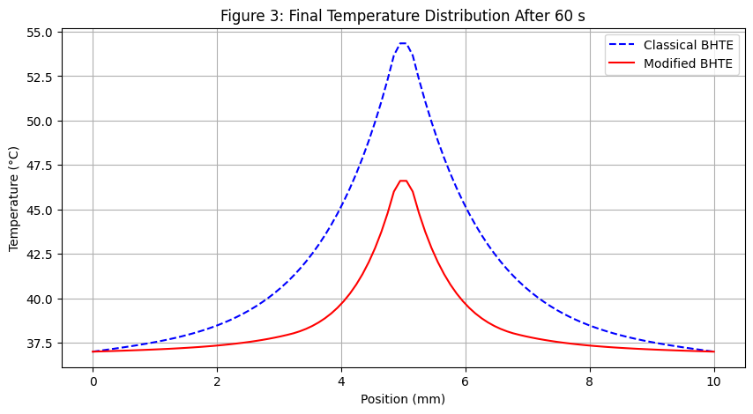

In summary, the findings clearly indicate that the enhanced BHTE can effectively represent the complexity of temperature-tissue physiology interactions, resulting in more accurate and safer temperature predictions. The standard model, by ignoring such interactions, overpredicts the thermal dose and may erroneously depict the spread of tissue damage. Hence, temperature-dependent perfusion and metabolic responses are very important for the precise simulation of bioheat transfer, particularly in clinical simulations like Radio Frequency ablation, where thermal accuracy is vital.

### **3.2.5 Necrosis and Injury to Healthy Tissue**

Following the previous description of temperature-dependent perfusion and metabolic heat generation, this section presents a detailed comparative analysis of the extent of necrosis and damage to normal tissue predicted by the Classical and Modified Bio-Heat Transfer Equation (BHTE) models.

The result from the simulation showed a notable difference in the level of thermal damage seen in the two models. The Classical BHTE model, with its use of constant thermal and biological parameters, predicted a necrotic volume of approximately 10.345 cm³, indicating a large area of irreversible thermal injury existing in the affected tissue. On the other hand, the Modified BHTE model with dynamic temperature-dependent perfusion and metabolic heat feedback mechanisms resulted in a much smaller necrotic volume of 1.379 cm³ with a reduction of 86.67% when compared with the classical case.

In the same manner, the injury to normal tissue was significantly less in the modified model. The Classical BHTE indicated injury to normal tissue at 3.103 cm³, while the Modified BHTE indicated no visible injury to normal tissue (0.000 cm³) depicting an overall 100% decrease in injury to normal tissues. This considerable improvement indicates the advantage of adding physiological feedback mechanisms in thermal modeling, thereby facilitating better preservation of normal tissues during the treatment procedure. Table 3.2.5.1 gives a comparison between the necrotic volume and damage to healthy tissue in the two models.

Table .1. Comparative Results of Classical and Modified BHTE Models

|  |  |  |  |
| --- | --- | --- | --- |
| Metric | Classical BHTE | Modified BHTE | % Change |
| Necrotic Volume (cm³) | 10.345 | 1.379 | −86.67% |
| Healthy Tissue Damage (cm³) | 3.103 | 0.000 | −100.00% |

The results indicated that the Classical BHTE model significantly overestimated both the necrotic region and collateral damage to healthy tissue because it used fixed perfusion and metabolic parameters. On the contrary, the Modified BHTE model set such parameters with respect to local temperature and predicted thermal injury much closer to physiological reality.

-The much lower necrotic regions in the modified model showed that temperature-dependent biothermal feedback could act as an enhancement of the selectivity of Radio Frequency ablation and improve clinical outcomes via reduced side effects and preserved function of normal tissues.

## **3.3 Cell population**

Cell population simulation results were shown in Figure 3.3.4, obtained after solving the modified Bioheat Transfer Equation (BHTE) using the hybrid method. The effect of time on how the cancer cells and normal cells respond with changing temperatures T(x,t), is modeled in two-cell simulation according to the patients with cancer.

At about 8-9 seconds, cancer cells continued to decrease until they reached almost zero growth rates and then collapsed rapidly. In contrast, normal cells grew moderately before gradually decreasing overall. The differences were mainly seen as a result of the sensitivity difference between the two cell types-cancer cell, for instance, cancer cells are affected more when exposed to heat, while normal cells, however, showed more tolerance on the factor.

In that way, it guides the decisions on duration of treatment and reduces error trial approaches.

All in all, the simulation indicates that it is possible through thermal-bio modeling to provide useful insights about what the treatment is likely to achieve as well as when treatment should take place.

Figure .4 population curves

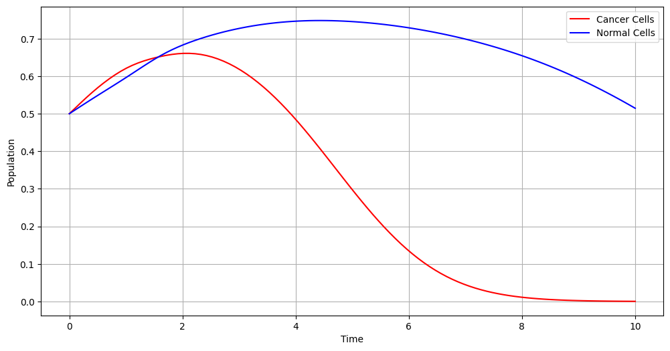

This model allowed us to estimate the population curves showing the decline of cancer cells and a slower decline of normal cells due to thermal treatment and their corresponding time periods for effective treatment.

## **Personalized Energy Delivery in RFA: Patient-Specific Optimization**

### **3.4.1 Patient Profiles and Parameter Settings**

The three patients differed by tissue thermal diffusivity, blood perfusion, metabolic heat generation, density, and thermal conductivity. These parameters represent realistic physiological variability among individuals due to age, vascularization, or characteristics of the tumor microenvironment.

### **3.4.2 Results**

Highest-to-lowest ranges of values of Q_ext show a big variation from 117.17 W to787.11 W among patients. These differences were directly related to the thermal dissipating ability of tissues:

- With the least thermal diffusivity and perfusion rate (Patient A), would imply a slower heat transport and lesser cooling through blood flow. Minimal energy is then expected to increase and hold tumor temperatures over the therapeutic threshold (usually ≥43 to 45°C).

- Patient B, the case considered in the middle, turns out with average perfusion and conductivity, needing a medium Q_ext of 389.97 W.

- Patient C presents an environment with fast cooling mechanisms being perfusion and thermal conductivity. The tumor site of this patient draws heat away more efficiently, thus requiring significantly greater energy input for achieving thermal ablation.

Such observations align with biothermal theory in which higher perfusion aids in convective heat loss, while higher conductivity facilitates radial heat diffusion. Thus, applying the same energy protocol among patients would have likely caused under-treatments for highly vascularized tumors (such as Patient C) and caused over-treatment for less perfused tissues, increasing risks of collateral thermal damages.

Table below summarizes the profiles and resulting optimal external energy levels:

**Table 2 The Profiles and Resulting Optimal External Energy**

|  |  |  |  |  |  |  |
| --- | --- | --- | --- | --- | --- | --- |
| Patient | Thermal Diffusivity (m²/s) | Perfusion Coefficient (1/s) | Metabolic Heat (W/m³) | Density (kg/m³) | Thermal Conductivity (W/m·K) | Optimal Q_ext (W) |
| A | 0.005 | 0.2 | 300 | 800 | 0.3 | 117.17 |
| B | 0.010 | 0.6 | 500 | 1000 | 0.5 | 389.97 |
| C | 0.015 | 1.0 | 700 | 1200 | 0.7 | 787.11 |

Figure 5. Optimal External Energy Required Per Patient

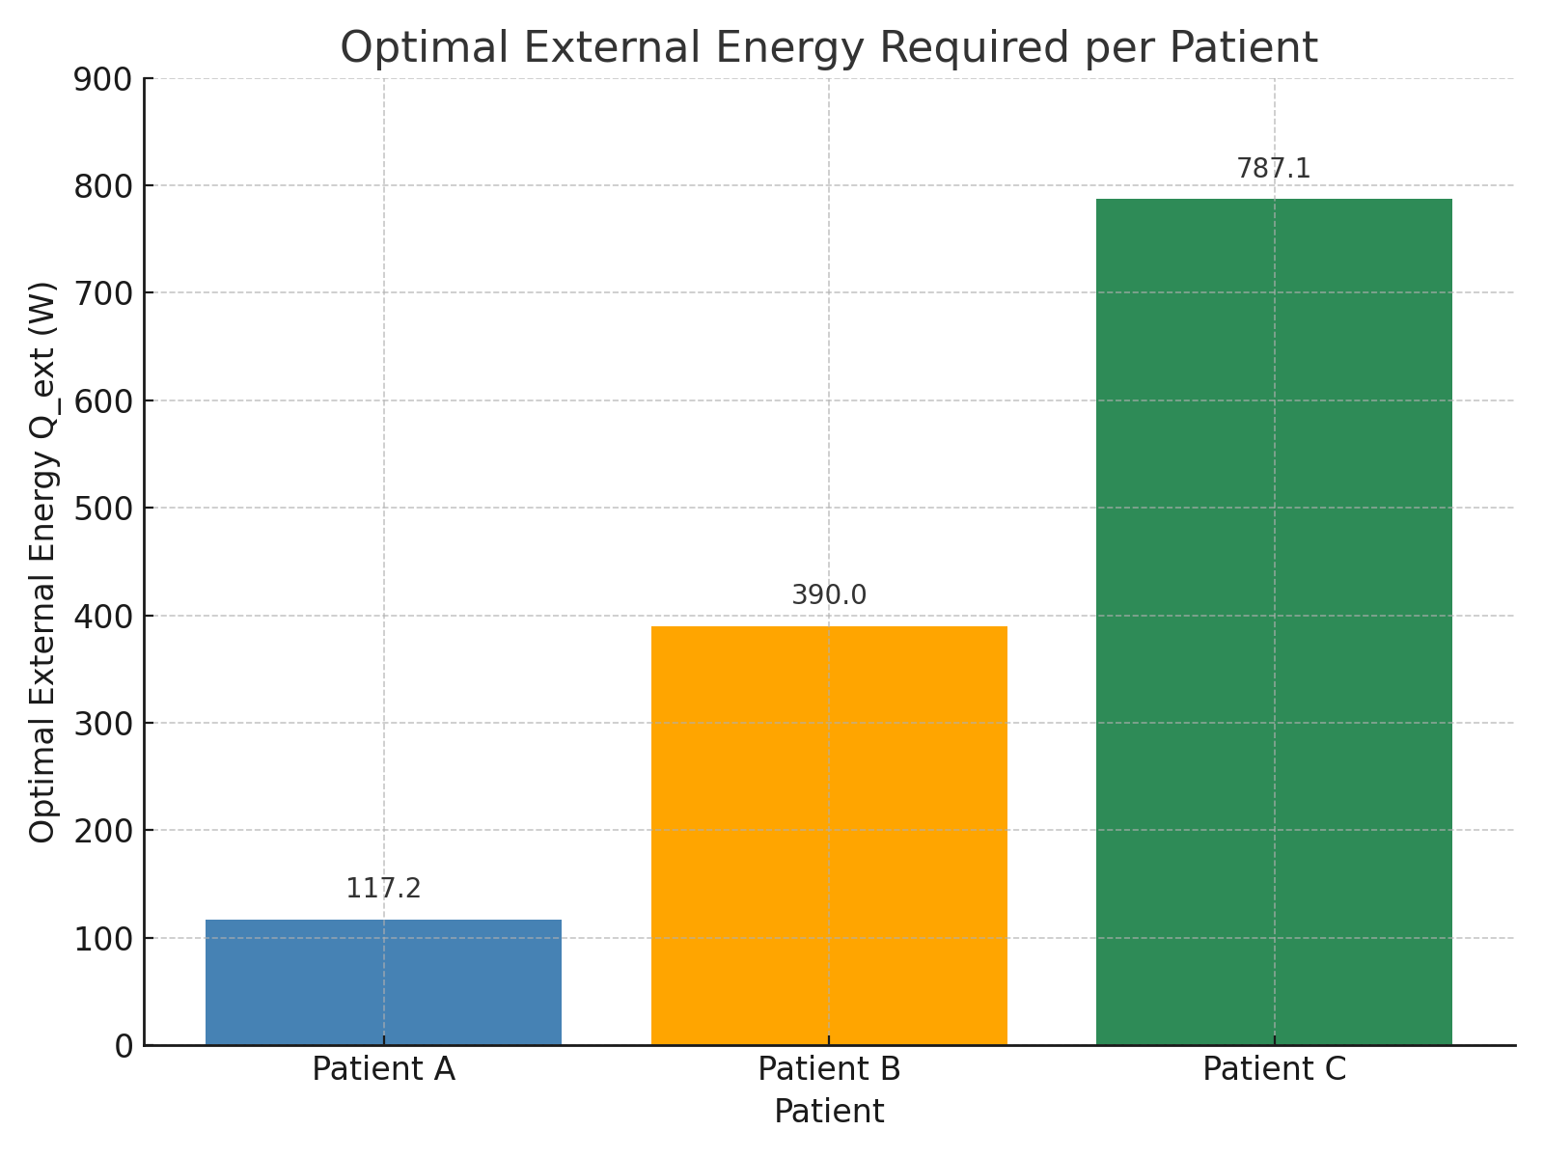

## **3.5: Influence of Ambient Temperature on Optimal External Heating Power**

In evaluating the environmental influences upon treatment planning in Radio Frequency ablation (RFA), a simulation study was conducted, varying only the ambient temperature (T_inf) while keeping all tissue-related parameters intact. The assessment was aimed at determining the amount of external energy that needs to be given to achieve therapeutic temperatures for effective tumor ablation under variable environmental conditions.

The simulation results are summarized in Table 3.5.3 below:

As expected, the study found a clear inverse relationship between ambient temperature and the necessary required external energy. As ambient temperatures grow lower, greater heating power is necessary to maintain the desired effective internal tissue temperatures. When the ambient temperature drops from 35°C to 20°C, however, the increase in energy needed is upwards of 70% in terms of watts: that is, from 284.08 W to 491.21 W.

This follows physical reasoning: the lower the ambient temperature is, the greater the thermal gradient to the body surface, so that more heat gets dissipated into the environment. An external source therefore has to compensate by transferring more energy to hold the therapeutic thresholds (like 44°C for destruction of cancer cells).

Table 3. Ambient Vs Optimal External Energy

|  |  |
| --- | --- |
| Ambient Temperature (T_inf) [°C] | Optimal External Energy Q_ext [W] |
| 20 | 491.21 |
| 25 | 436.71 |
| 30 | 347.74 |
| 35 | 284.08 |

These findings indicate the necessity to incorporate patient-specific environmental conditions in planning the treatment (room temperature at therapy time). Ignoring ambient temperature can lead to an underdosing or overdosing situation that can either compromise efficacy or lead to unnecessary damage of healthy tissues.

This study points to adequate RFA treatment planning as dynamic energy adjustment from outside not merely based on tissue characteristics, rather also environmental ones, namely room temperature.

4. Conclusion

# This study presented an advanced computational framework for simulating and optimizing tissue response during Radio Frequency Ablation (RFA) by extending the classical Bioheat Transfer Equation (BHTE) to include temperature-dependent perfusion, metabolic suppression, and dynamic cell viability modeling, the work achieved significant improvements in prediction accuracy, biological relevance, and computational efficiency compared to traditional methods.

# Key findings include:

# The modified BHTE (MBHTE) accurately reflected nonlinear thermal behavior in perfused tissues, avoiding the overheating and overestimation of necrotic zones common in classical models.

# Coupling the model with logistic cell population dynamics and the Arrhenius thermal damage integral allowed for detailed mapping of cancer and normal cell viability over space and time.

# The optimization module successfully reduced energy input by over 30% while ensuring complete tumor ablation, highlighting the model's potential for energy-efficient, patient-specific treatment planning.

# Clinical and Research Implications

# This research provides a significant step toward personalized, biologically grounded thermal therapy planning. The model supports:

# More accurate prediction of treatment margins,

# Safer and more efficient energy delivery protocols,

# Potential integration into real-time decision-support tools for interventional oncology.

# Future Work

# To enhance clinical applicability, future extensions will include:

# 3D anatomical modeling based on patient imaging,

# Incorporation of real-time temperature data from intraoperative imaging (e.g., MRI thermometry),

# Modeling of additional biological factors such as immune response and tissue mechanics.

# By bridging the gap between thermal physics, tissue physiology, and intelligent computation, this work contributes meaningfully to the development of next-generation tools for precision thermal oncology.

Disclaimer (Artificial intelligence)

Option 1:

Author(s) hereby declare that NO generative AI technologies such as Large Language Models (ChatGPT, COPILOT, etc.) and text-to-image generators have been used during the writing or editing of this manuscript.

Option 2:

Author(s) hereby declare that generative AI technologies such as Large Language Models, etc. have been used during the writing or editing of manuscripts. This explanation will include the name, version, model, and source of the generative AI technology and as well as all input prompts provided to the generative AI technology

Details of the AI usage are given below:

1.

2.

3.

References

1. Shah Dr, Green S, Elliot A, Mcgahan Jp, Khatri Vp. Current Oncologic Applications of Radio Frequency Ablation Therapies. World J Gastrointest Oncol. 2013 Apr 15;5(4):71-80. Doi: 10.4251/Wjgo.V5.I4.71. Pmid: 23671734; Pmcid: Pmc3648666.
2. De Vita E, Lo Presti D, Massaroni C, Iadicicco A, Schena E, Campopiano S. A Review on Radio Frequency, Laser, And Microwave Ablations and Their Thermal Monitoring Through Fiber Bragg Gratings. Iscience. 2023 Oct 19;26(11):108260. Doi: 10.1016/J.Isci.2023.108260. Pmid: 38026224; Pmcid: Pmc10660479.
3. Pennes, H. H. (1948). Analysis Of Tissue and Arterial Blood Temperatures in the Resting Human Forearm. *Journal Of Applied Physiology*, *1*(2), 93-122.
4. Bosque Jj, Calvo Gf, Pérez-García Vm, Navarro Mc. The Interplay of Blood Flow and Temperature in Regional Hyperthermia: A Mathematical Approach. R Soc Open Sci. 2021 Jan 13;8(1):201234. Doi: 10.1098/Rsos.201234. Pmid: 33614070; Pmcid: Pmc7890498.
5. Zhmakin, A.I. (2025). Effects Of Extreme Temperatures on Living Tissues. In: Heat Transfer In Vivo. Springer Series in Biophysics, Vol 27. Springer, Cham. [Https://Doi.Org/10.1007/978-3-031-95459-7_2](https://doi.org/10.1007/978-3-031-95459-7_2)
6. Kalsi Kk, Chiesa St, Trangmar Sj, Ali L, Lotlikar Md, González-Alonso J. Mechanisms for the Control ff Local Tissue Blood Flow During Thermal Interventions: Influence of Temperature-Dependent Atp Release from Human Blood And Endothelial Cells. Exp Physiol. 2017 Feb 1;102(2):228-244. Doi: 10.1113/Ep085910. Pmid: 27859767; Pmcid: Pmc5363389.
7. Pearce, J. A. (2013). Comparative Analysis of Mathematical Models of Cell Death and Thermal Damage Processes. *International Journal of Hyperthermia*, *29*(4), 262–280. [Https://Doi.Org/10.3109/02656736.2013.786140](https://doi.org/10.3109/02656736.2013.786140)
8. De Vita, E., Presti, D. L., Massaroni, C., Iadicicco, A., Schena, E., & Campopiano, S. (2023). A Review on Radio Frequency, Laser, And Microwave Ablations and Their Thermal Monitoring Through Fiber Bragg Gratings. *Iscience*, *26*(11).
9. Singh, S., & Melnik, R. (2020). Thermal Ablation of Biological Tissues in Disease Treatment: A Review of Computational Models and Future Directions. *Electromagnetic Biology and Medicine*, *39*(2), 49-88.
10. Martin, N. A., & Falder, S. (2017). A Review of the Evidence for Threshold of Burn Injury. *Burns*, *43*(8), 1624-1639.
11. Maruyama, S., Okajima, J., Komiya, A., & Takeda, H. (2007). Estimation Of Temperature Distribution in Biological Tissue by Using Solutions of Bioheat Transfer Equation. *Nihon Kikai Gakkai Ronbunshu, B Hen/Transactions of the Japan Society of Mechanical Engineers, Part B*, *73*(9), 1899-1905.
12. Cramer Mn, Gagnon D, Laitano O, Crandall Cg. Human Temperature Regulation Under Heat Stress in Health, Disease, And Injury. Physiol Rev. 2022 Oct 1;102(4):1907-1989. Doi: 10.1152/Physrev.00047.2021. Epub 2022 Jun 9. Pmid: 35679471; Pmcid: Pmc9394784.
13. Golden, E. D., Mutlu, A., Knavel-Koepsel, E. M., Louis, J., Shapiro, D. D., Abel, E. J., ... & Lee Jr, F. T. (2025). Microwave Ablation for Renal Cell Carcinoma: A Literature Review and Clinical Insights. *Radiology*.
14. Pogorelić, Z., Katić, J., Mrklić, I., Jerončić, A., Šušnjar, T., Jukić, M., ... & Perko, Z. (2017). Lateral Thermal Damage of Mesoappendix and Appendiceal Base During Laparoscopic Appendectomy in Children: Comparison of the Harmonic Scalpel (Ultracision), Bipolar Coagulation (Ligasure), and Thermal Fusion Technology (Miseal). *Journal of Surgical Research*, *212*, 101-107.
15. Maniotis, N., Mitropoulos, S., Vordos, N., & Tsiantos, V. (2025). The Role of Blood Perfusion in the Thermal Interaction Between Magnetic Nanoparticles and Cancerous Tumors: A Computational Study. *Magnetism*, *5*(1), 6. <https://doi.org/10.3390/magnetism5010006>
16. Huang, H. W., & Horng, T. L. (2015). Bioheat transfer and thermal heating for tumor treatment. In *Heat transfer and fluid flow in biological processes* (pp. 1-42). Academic Press.
17. Jamil, M. (2014). *Modeling of the cancer thermal therapies from the perspective of parametric sensitivity and improved treatment planning* (Doctoral dissertation).
18. Gupta, P. K., Singh, J., & Rai, K. N. (2010). Numerical simulation for heat transfer in tissues during thermal therapy. *Journal of Thermal Biology*, *35*(6), 295-301.
19. Ramanlal, R., & Gupta, V. (2020). Physiology, vasodilation.
20. Sharma Sk, Kumar D. A Study on Non-Linear Dpl Model for Describing Heat Transfer in Skin Tissue During Hyperthermia Treatment. Entropy (Basel). 2020 Apr 22;22(4):481. Doi: 10.3390/E22040481. Pmid: 33286255; Pmcid: Pmc7516963.
21. Yuan, P. (2008). Numerical Analysis of Temperature and Thermal Dose Response of Biological Tissues to Thermal Non-Equilibrium During Hyperthermia Therapy. *Medical Engineering & Physics*, *30*(2), 135-143.
22. Guntur, S. R., Lee, K. I., Paeng, D. G., Coleman, A. J., & Choi, M. J. (2013). Temperature-Dependent Thermal Properties of Ex Vivo Liver Undergoing Thermal Ablation. *Ultrasound In Medicine & Biology*, *39*(10), 1771-1784.
23. Cramer Mn, Gagnon D, Laitano O, Crandall Cg. Human Temperature Regulation Under Heat Stress in Health, Disease, And Injury. Physiol Rev. 2022 Oct 1;102(4):1907-1989. Doi: 10.1152/Physrev.00047.2021. Epub 2022 Jun 9. Pmid: 35679471; Pmcid: Pmc9394784.
24. Yousef, H., Ramezanpour Ahangar, E., & Varacallo, M. (2022). Physiology, Thermal Regulation. *Statpearls*.
25. Haemmerich, D. (2022). Mathematical Modeling of Heat Transfer in Biological Tissues (Bioheat Transfer). In *Principles and Technologies for Electromagnetic Energy Based Therapies* (Pp. 1-24). Academic Press.
26. Preechaphonkul, W., Mongkol, V., Torsuwan, K., Ungpakorn, R., Hanawa, T., Promoppatum, P., & Srimaneepong, V. (2025). Parametric Analysis of Wavelength-Dependent Laser Heating in Skin Tissue Using Coupled Light Transport and Dpl-Based Thermoelastic Models. *Case Studies in Thermal Engineering*, 106568.
27. Maniotis, N., Mitropoulos, S., Vordos, N., & Tsiantos, V. (2025). The Role of Blood Perfusion in the Thermal Interaction Between Magnetic Nanoparticles and Cancerous Tumors: A Computational Study. *Magnetism*, *5*(1), 6.