Cornual Ectopic Pregnancy Diagnosed in the First Trimester: A Case Report

Abstract
Cornual ectopic pregnancy is a rare and potentially life-threatening condition, accounting for only 2–4% of all ectopic pregnancies. Its diagnosis is often delayed due to non-specific symptoms and its deceptive sonographic appearance, which can mimic an intrauterine gestation. We report the case of a 37-year-old woman who presented at 9 weeks of amenorrhea with isolated pelvic pain. Transvaginal ultrasound revealed an empty uterine cavity and a gestational sac located in the left cornual region, surrounded by a thin myometrial mantle. The Serum β-hCG level was 4,343 IU/L. A diagnosis of unruptured cornual pregnancy was made. The patient underwent surgical management via laparotomy, consisting of cornual resection and ipsilateral salpingectomy, with a favourable postoperative course. This case highlights the importance of early transvaginal ultrasound evaluation, awareness of diagnostic criteria, and timely management to prevent catastrophic rupture. The diagnostic features, management options, and reproductive outcomes associated with this rare entity are also discussed.

Keywords
Cornual pregnancy, interstitial ectopic pregnancy, surgical management, transvaginal ultrasound, laparotomy

Introduction
“Cornual pregnancy, a rare subtype of ectopic pregnancy, occurs at the cornual or interstitial part of the uterus where the fallopian tube intersects with the uterine cavity” (Keikha et al., 2024). Ectopic pregnancies account for approximately 1–2% of all pregnancies, with cornual (also referred to as interstitial) pregnancies representing only 2–4% of these cases[1]. However, due to their rich myometrial blood supply and the capacity of the uterine wall to stretch, cornual pregnancies tend to present later and carry a sevenfold increased risk of rupture compared to other ectopic locations[2]. When rupture occurs, maternal mortality can be as high as 2.5%[3]. “Abnormal transport of the fertilised ovum is widely accepted as the possible mechanism, with other risk factors including in vitro fertilisation (IVF), uterine anomalies, previous ectopic pregnancies or pelvic surgeries, intrauterine device use, and chronic or acute inflammatory processes” (Lin et al., 2024; Dhanju et al., 2023)[17,18].
Despite advancements in imaging, early diagnosis remains challenging due to non-specific clinical signs and overlap with other intrauterine and tubal pathologies. Here, we present a case of a left cornual pregnancy diagnosed at 9 weeks, managed successfully with surgical resection.

Case Presentation
A 37-year-old gravida 4 para 1 woman with a history of one full-term vaginal delivery and two early miscarriages presented to the emergency department at approximately 9 weeks of amenorrhea with isolated pelvic pain. She had not undergone any prior ultrasonography during this pregnancy.
On clinical examination, she was hemodynamically stable, afebrile, with pelvic tenderness noted during deep palpation. No vaginal bleeding was observed. Bimanual examination revealed a globular, enlarged uterus tender to mobilisation without a detectable adnexal mass.
Transvaginal ultrasound showed an empty endometrial cavity and a 33 × 32 mm gestational sac implanted in the left cornual region. No embryo was visualised (Figure 1). The myometrial mantle was thin (approximately 3 mm) (Figure 2), with no free pelvic fluid. Serum β-hCG was 4,343 IU/L.
The diagnosis of a left cornual ectopic pregnancy was made. The patient underwent exploratory laparotomy, confirming an unruptured left cornual pregnancy (Figure 3). A left cornual resection and ipsilateral salpingectomy were performed. Hemostasis was achieved using U-shaped sutures, and the uterine wall was closed with absorbable sutures (Figure 4). The ovaries and right fallopian tube were normal.
The postoperative course was uneventful, and the patient was discharged on day 3.

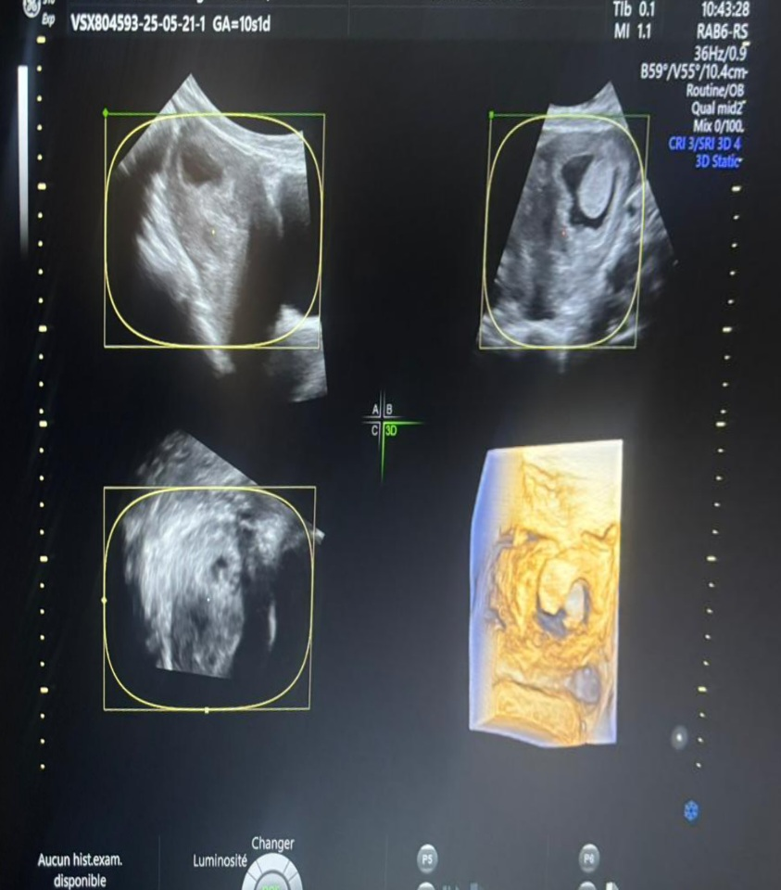
Figure 1. Transvaginal ultrasound and 3D reconstruction showing an eccentrically located gestational sac in the left cornual region. Note the empty central uterine cavity, thin surrounding myometrial mantle, and the lateral position of the sac, suggestive of an interstitial pregnancy.

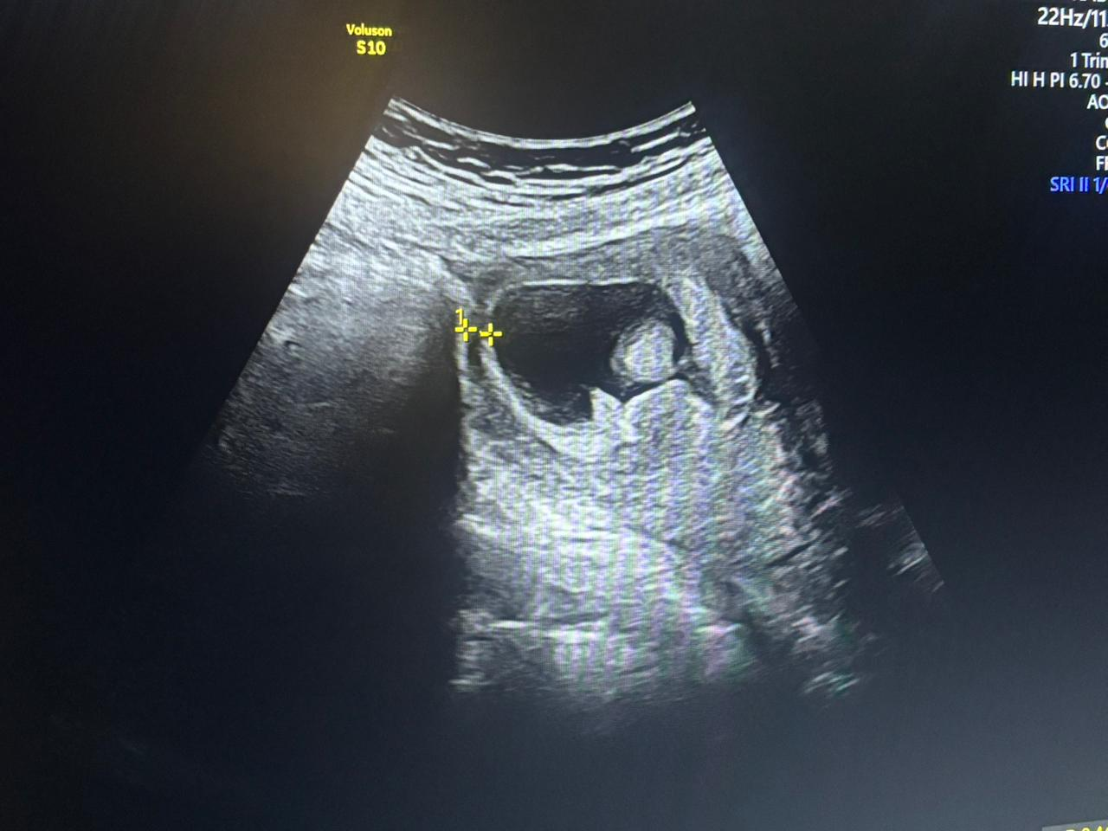
Figure 2. Transabdominal ultrasound showing an eccentrically located gestational sac with a thin surrounding myometrial mantle, consistent with an interstitial (cornual) pregnancy.
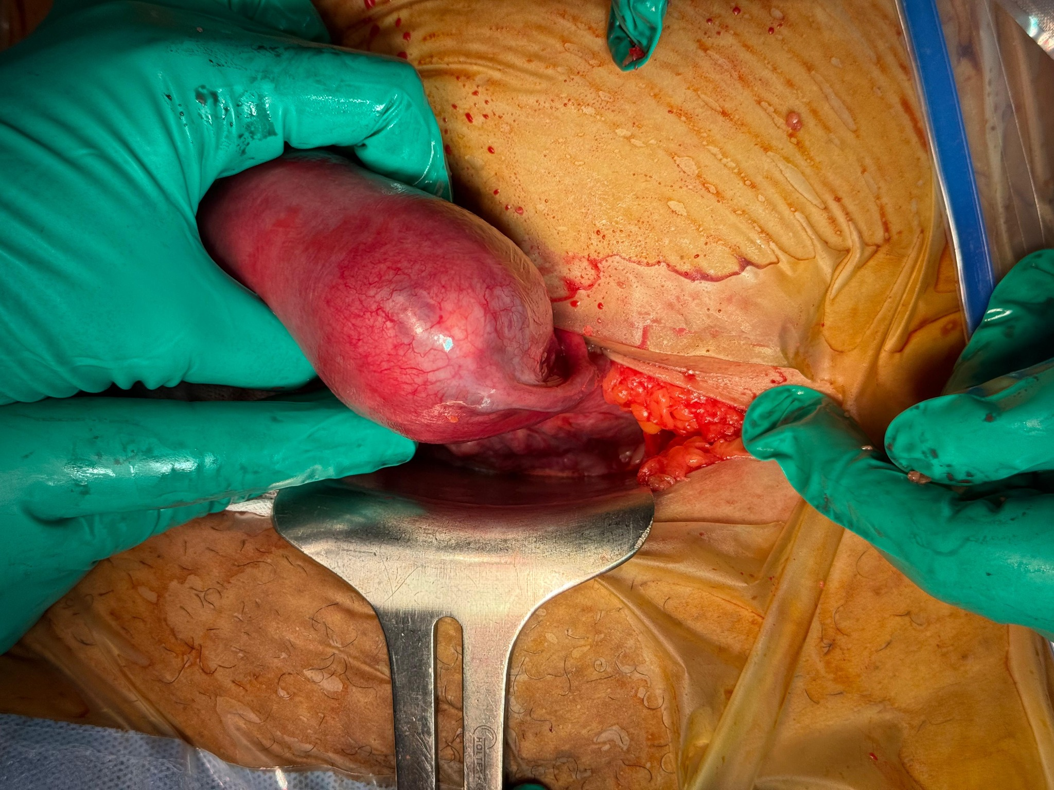
Figure 3. Intraoperative image showing a markedly distended left cornual region of the uterus, consistent with an unruptured cornual ectopic pregnancy. The cornual bulge is visualized through the laparotomy incision before resection.

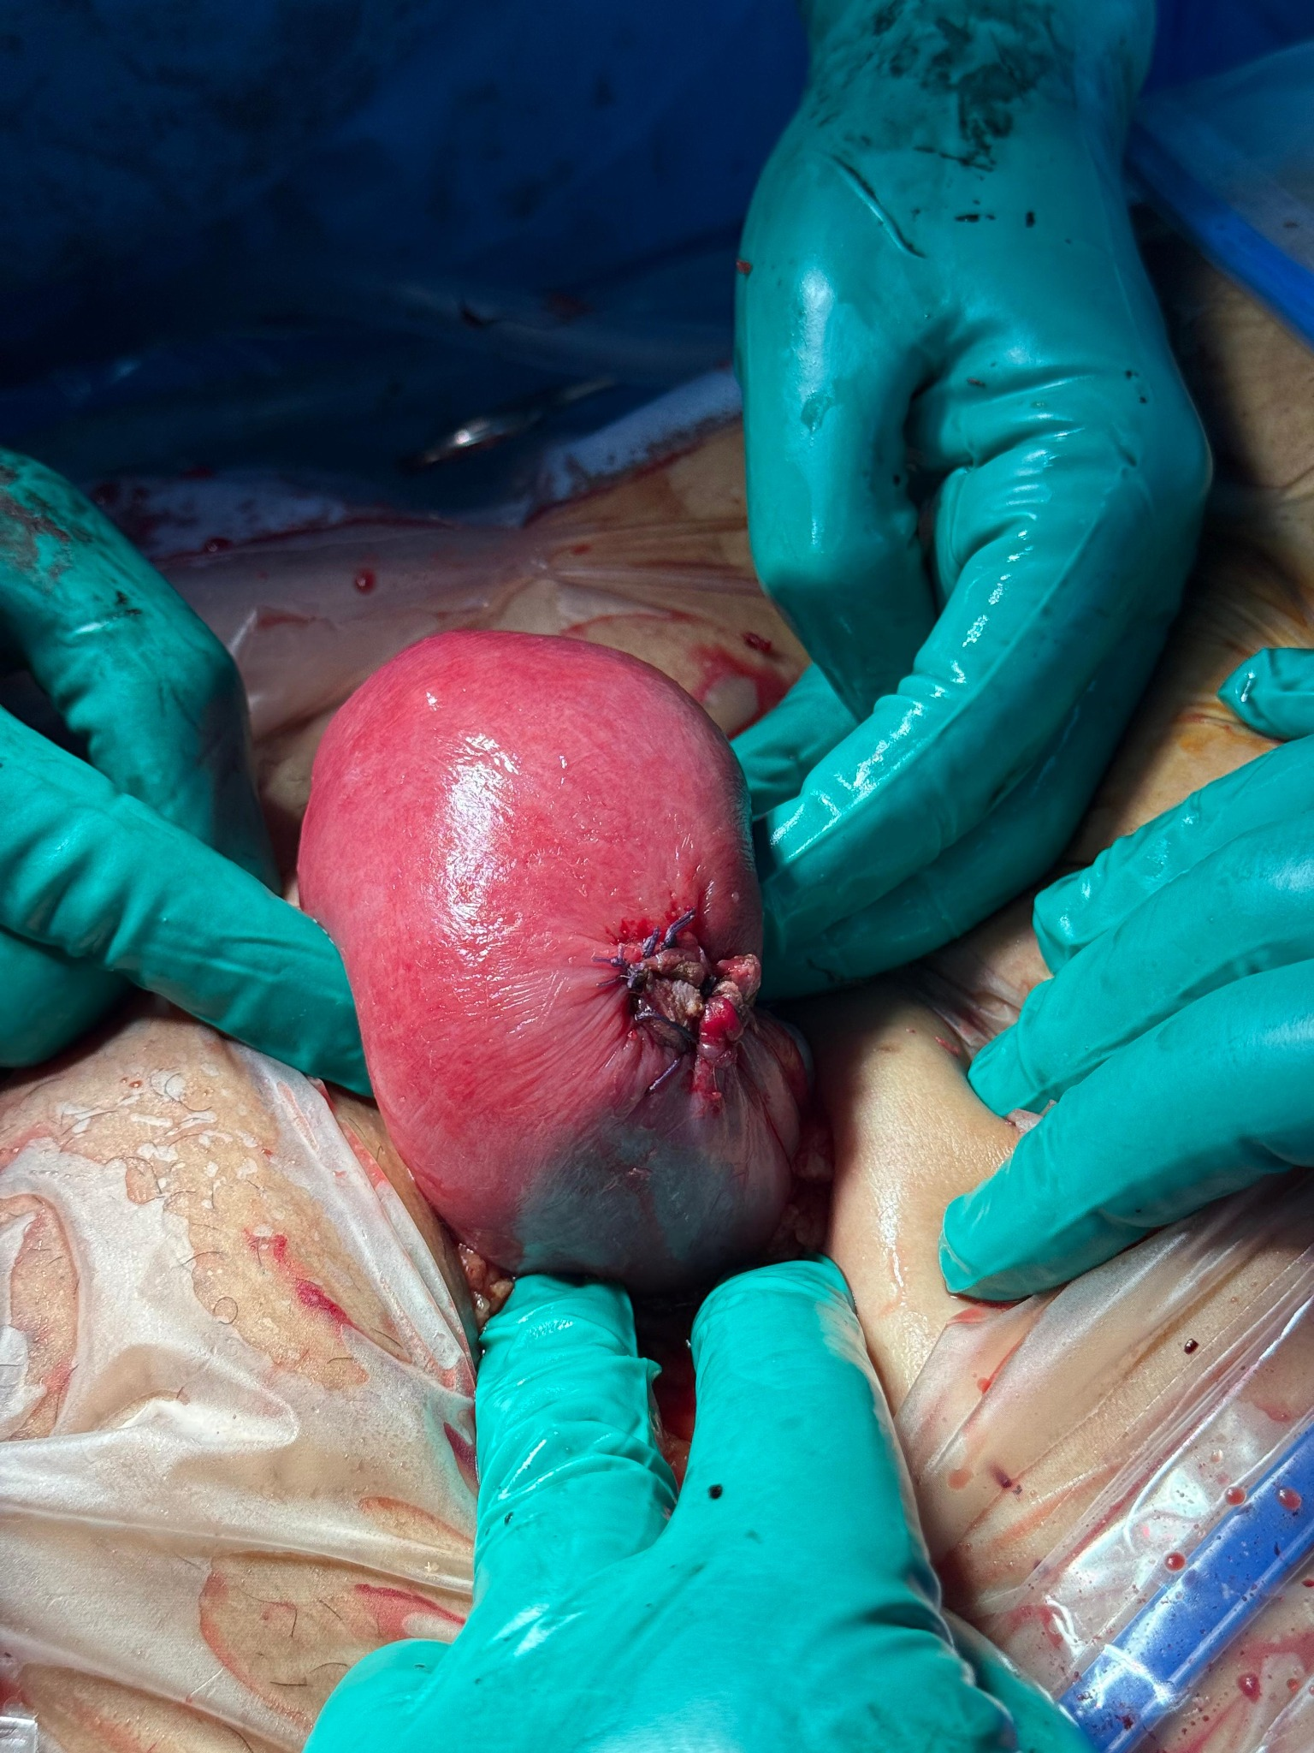
Figure 4. Postoperative view after cornual resection and hemostatic suturing. The resection site is visible on the left uterine cornua, showing a well-controlled surgical field with interrupted sutures ensuring uterine wall integrity.

Discussion
Cornual pregnancy is often confused with other forms of ectopic pregnancy. Technically, it refers to the implantation of a gestational sac in the interstitial portion of the fallopian tube, which traverses the muscular uterine wall[4]. It should be differentiated from angular pregnancies (within the endometrial cavity near the uterotubal junction) and rudimentary horn pregnancies, which occur in Müllerian anomalies[5].
Unicornuate uterus with a rudimentary horn is a congenital anomaly resulting from a defect in the development of one of the two Müllerian ducts that form the uterus. (Hegazy, 2014)
“The primary risk factors for ectopic pregnancy include chronic pelvic infections (often due to sexually transmitted infections), which may lead to adhesions and anatomical anomalies, previous ectopic pregnancy or tubal surgery, smoking, and intrauterine device use. However, in our case, none of these risk factors were identified”[6,7].
The clinical diagnosis is difficult due to: Later presentation, often beyond 8–9 weeks. Absence of early symptoms or misleading signs. Misinterpretation of the sac as intrauterine in early ultrasound. In our patient, acute-onset pelvic pain was the only clinical symptom, and there was no prior ultrasound.
Transvaginal sonography remains the most valuable tool. According to Timor-Tritsch et al.[10], three sonographic criteria are suggestive:
1. Empty uterine cavity.
2. Gestational sac located >1 cm from the most lateral edge of the uterine cavity.
3. Thin (<5 mm) myometrial layer surrounding the sac.
All three criteria were observed in our patient.
The use of 3D ultrasound and MRI can improve diagnostic accuracy[9], particularly in atypical or equivocal cases. Recent studies highlight the utility of 3D transvaginal ultrasound and colour Doppler, improving diagnostic accuracy up to 95%, particularly by identifying the interstitial line sign and a highly vascularized peripheral myometrium[10]. MRI has also proven valuable in complex or equivocal cases, especially to distinguish between angular and cornual pregnancies.
The treatment of interstitial pregnancies can be medical or surgical, depending on the clinical presentation and the patient's general condition.
Local methotrexate injection under ultrasound guidance has shown >85% success rates in selected cases (unruptured, sac <3.5 cm, β-hCG <5,000 IU/L). According to studies from Li et al. and Smorgick et al. Combination regimens (local + systemic intramuscular MTX) have further reduced failure rates to around 10% in comparison to 25% with systemic therapy alone[11,12]. In our case, the patient opted for surgery after declining medical treatment with methotrexate. Due to the unavailability of laparoscopy, a laparotomy was performed.
Surgical intervention remains the gold standard, especially in cases beyond 7 weeks or with high β-hCG levels. Techniques include cornual resection (via laparotomy or laparoscopy) and cornuostomy. Laparoscopic management, even in advanced cases, has shown favourable outcomes in recent studies[13], although it requires surgical expertise and hemodynamic stability. A multicenter study demonstrated that laparoscopy reduces operative time by 40% and shortens recovery. Moreover, a recent innovation recommends the use of purse-string sutures around the resection site, shown to reduce haemorrhage risk by 50%.
In terms of reproductive prognosis, a 2022 systematic review reports a 68% subsequent pregnancy rate after surgical management, with <1% risk of uterine rupture when proper monitoring is done[14,15]. The ESHRE guidelines suggest the following: Waiting at least 6 months before attempting a new pregnancy. Performing early ultrasound at 7–8 weeks with 3D assessment of scar thickness and planning a cesarean delivery if the myometrial layer is <5 mm or has abnormal angulation.

Conclusion
Cornual ectopic pregnancy is a rare but dangerous form of ectopic gestation. Early diagnosis through transvaginal ultrasound and prompt management are critical to avoid rupture and maternal morbidity. Surgical resection remains the mainstay in most cases, particularly after 8 weeks of gestation or in the presence of high β-hCG levels. This case underscores the importance of awareness and timely intervention.
Consent
As per international standards or university standards, Participants’ written consent has been collected and preserved by the author(s).

Disclaimer (Artificial intelligence)
Option 1:
Author(s) hereby declare that NO generative AI technologies such as Large Language Models (ChatGPT, manuscript.
Option 2:
Author(s) hereby declare that generative AI technologies such as Large Language Models, etc. have been used during the writing or editing of manuscripts. This explanation will include the name, version, model, and source of the generative AI technology and as well as all input prompts provided to the generative AI technology
Details of the AI usage are given below:
1.
2.
3.

References :

1. Di Tizio, L., Spina, M. R., Gustapane, S., D’Antonio, F., & Liberati, M. (2018). Interstitial pregnancy: from medical to surgical approach—report of three cases. Case reports in obstetrics and gynecology, 2018(1), 2815871.
2. Bouyer J, Coste J, Fernandez H, Pouly JL, Job-Spira N. Sites of ectopic pregnancy: a 10-year population-based study. Hum Reprod. 2002;17(12):3224–30. https://doi.org/10.1093/humrep/17.12.3224
3. Corioni S, Gallotta M, Sartori E, et al. Interstitial pregnancy treated with a single-dose of systemic methotrexate: a successful management. J Res Med Sci. 2015;20(3):312. https://doi.org/10.4103/1735-1995.163964
4. Gao MY, Zhu H, Zheng FY. Interstitial pregnancy after ipsilateral salpingectomy: analysis of 46 cases and a literature review. J Minim Invasive Gynecol. 2020;27(3):613–7. https://doi.org/10.1016/j.jmig.2019.04.029
5. Chao, A. S., Chang, Y. L., Yang, L. Y., Chao, A., Chang, W. Y., Su, S. Y., & Wang, C. J. (2018). Laparoscopic uterine surgery as a risk factor for uterine rupture during pregnancy. PLoS One, 13(5), e0197307.
6. Jayasinghe Y, Rane A, Stalewski H, Grover S. The presentation and early diagnosis of the rudimentary uterine horn. Obstet Gynecol. 2005;105(6):1456–67. https://doi.org/10.1097/01.AOG.0000161325.93355.56
7. Parker III, R. A., Yano, M., Tai, A. W., Friedman, M., Narra, V. R., & Menias, C. O. (2012). MR imaging findings of ectopic pregnancy: a pictorial review. Radiographics, 32(5), 1445-1460.
8. Hiersch, L., Krissi, H., Ashwal, E., From, A., Wiznitzer, A., & Peled, Y. (2014). Effectiveness of medical treatment with methotrexate for interstitial pregnancy. Australian and New Zealand Journal of Obstetrics and Gynaecology, 54(6), 576-580.
9. Moawad NS, Mahajan ST, Moniz MH, Taylor SE, Hurd WW. Current diagnosis and treatment of interstitial pregnancy. Am J Obstet Gynecol. 2010;202(1):15–29. https://doi.org/10.1016/j.ajog.2009.07.042
10. Timor-Tritsch IE, Monteagudo A, Matera C, Veit CR. Sonographic evolution of cornual pregnancies treated without surgery. Obstet Gynecol. 1992;79(6):1044–9.
11. Li, P., Tan, X., Chen, Y., Ge, Q., Zhou, H., Zhang, R., ... & Sun, D. (2023). Successful Ultrasound-Guided Methotrexate Intervention in the Treatment of Heterotopic Interstitial Pregnancy: A Case Report and Literature Review. Journal of Personalized Medicine, 13(2), 332.
12. Smorgick, N., Vaknin, Z., Pansky, M., Halperin, R., Herman, A., & Maymon, R. (2008). Combined local and systemic methotrexate treatment of viable ectopic pregnancy: outcomes of 31 cases. Journal of Clinical Ultrasound, 36(9), 545-550.
13. Soriano D, Vicus D, Mashiach R, et al. Laparoscopic treatment of cornual pregnancy: a series of 20 consecutive cases. Fertil Steril. 2008;90(3):839–43. https://doi.org/10.1016/j.fertnstert.2007.07.1397
14. Tulandi T, Al-Jaroudi D. Interstitial pregnancy: results generated from the Society of Reproductive Surgeons Registry. Obstet Gynecol. 2004;103(2):247–50. https://doi.org/10.1097/01.AOG.0000109423.48482.29
15. Ackerman TE, Levi CS, Dashefsky SM, Holt SC, Lindsay DJ. Interstitial line: sonographic finding in interstitial (cornual) ectopic pregnancy. Radiology. 1993;189(1):83–7. https://doi.org/10.1148/radiology.189.1.8372186
16. Keikha, F., Shbeeb, H., Homam, H., Nasiri Khormoji, N., & Nouri, M. (2024). Cornual Pregnancy as a Rare Entity of Ectopic Pregnancy After Assisted Reproductive Therapy‐Embryo Transfer (ART‐ET): A Case Report. Clinical Case Reports, 12(12), e9708.
17. Lin, X., Fu, Y., Lin, R., Cai, X., & Zhang, M. (2024). Successful delivery in a cornual pregnancy after expectant management with traditional Chinese medicine and low-molecular-weight heparin: A case report. Medicine, 103(45), e40446.
18. Dhanju, G., Goubran, A., Zimolag, L., Chartrand, R., Matthew, F., & Breddam, A. (2023). Distinguishing between cornual, angular and interstitial ectopic pregnancy: A case report and a brief literature review. Radiology Case Reports, 18(7), 2531-2544.
19. Hegazy A. (2014) Clinical embryology for medical students and postgraduate doctors. Lap Lambert Academic Publishing; ISBN: 978-3-659-54516-0

