Macronutrients fertility status of soil in the Nira command area of Baramati tehsil, Maharashtra, India

.ABSTRACT

The present investigation was undertaken to evaluate the chemical properties and nutrient status of soils in the Nira river command area. A total of 105 geo- referenced soil samples were collected across the region using a Global Positioning System (GPS). After collection, the samples were air-dried, ground and sieved (2 mm sieve) before analysis and analyzed using standard analytical methods.The results revealed that the soils were predominantly moderately alkaline, with pH values ranging from 7.99 to 8.83 with a mean of 8.25. Electrical conductivity (EC) ranged between 0.10 and 0.95 dS m⁻¹ with a mean of 0.53 dS m⁻¹, indicating that all soils were within the normal range for crop growth. Organic carbon content was generally low to moderate, varying from 0.22% to 0.97% with a mean of 0.54%. Calcium carbonate content ranged from 3% to 12.95% with a mean of 7.14%, showing moderate to very high accumulation in the soils. he analysis of available macronutrients revealed a significant deficiency in nitrogen, with values ranging from 57 to 196 kg ha⁻¹ and an average of 130 kg ha⁻¹. Phosphorus content exhibited considerable variability, ranging from 10.07 to 39.31 kg ha⁻¹ with a mean of 23 kg ha⁻¹, indicating a status that varied from low to very high. Potassium levels were also highly variable, spanning from 118.4 to 850 kg ha⁻¹ and averaged 437 kg ha⁻¹. Most of the samples fell into the very high category for potassium.

Keywords: Nira Command Area, Baramati Tehsil, Soil assessment, organic carbon, chemical properties.

1. INTRODUCTION

Maharashtra, the third-largest state of India, covers 307,713 km² and features diverse landscapes including the Deccan Plateau, Western Ghats, and Konkan coast. About 80% of its land (17.43 M ha) is under agriculture but only 17% (2.94 M ha) is irrigated making farming largely rainfall-dependent, with a cropping intensity of 127%. The soils are generally shallow and deficient in nitrogen, phosphorus, zinc and sulphur. Major crops include sugarcane, cotton, sorghum, pearl millet, soybean, chickpea, sunflower and safflower (Census & Economic Information Center data).

Baramati tehsil in eastern Pune district (18°3′–18°12′ N, 74°13′–74°30′ E; 538 m elevation) is bounded by the Nira and Karha rivers. Of its 138,200 ha area, 104,107 ha are cultivable with 39.9% irrigated mainly by the Nira–Karha scheme while 60.1% depends on rainfall (Khomane et al., 2021). The Nira command area was selected for study due to its agricultural significance. Soil chemical properties strongly influence nutrient retention, mineral content, organic matter and plant growth (Tale & Ingole, 2015).

Macronutrients are vital for crop growth. Primary nutrients (N, P, K) are applied during sowing or cultivation, while secondary nutrients (Ca, Mg, S) enhance crop quality (Johnson & Mirza, 2020). Nitrogen is essential for proteins, chlorophyll and photosynthesis; phosphorus promotes root development but excess can reduce Zn and Fe uptake; potassium contributes to overall plant vigor. Studies on Maharashtra’s swell-shrink soils showed low available nitrogen, low to medium phosphorus and high potassium levels (Patil & Sonar, 1994).

2. material and methods

2.1. General information of study area

The study was conducted during 2024 at the Division of Soil Science, Dr. Sharadchandra Pawar College of Agriculture, Baramati. The Nira command area, located in Baramati tehsil, Pune district, Maharashtra (18°–18.5°N, 74°–74.5°E), features a semi-arid climate with 550–600 mm annual rainfall, predominantly during the monsoon (June–September). The region’s alluvial plain, with clayey to loamy soils (Vertisols and medium black soils), supports diverse crops like sugarcane, maize, soybean and horticultural crops, irrigated primarily by the Nira Left Bank Canal.

2.2. Collection and analysis of soil sample

A total of 105 geo-referenced surface soil samples (0–22.5 cm) were collected from 15 villages using a stainless steel auger with GPS coordinates recorded at 1-km grid intervals. Location of study area given in fig no.1 and 2 from where samples were collected Chemical properties analyzed included pH (potentiometry), electrical conductivity (EC, conductometry), organic carbon (wet oxidation), CaCO₃ (acid neutralization), available nitrogen (alkaline permanganate), phosphorus (Olsen’s method), potassium (NH₄OAc extraction) by using. Standard methods Jackson, 1973; Walkley and Black, 1934; Subbiah and Asija, 1956; Watanabe and Olsen, 1965; Alison and Moodier, 1965.

2.3. Name of villages

1.Songaon | 8.Pandharwadi
2.Mekhali | 9.Late
3.Niravaghaj | 10.Korhale Khurd
4.Khandaj | 11.Sadobachi Wadi
5.Shiravali | 12.Hol
6.Sangavi | 13.Murum
7.Kambaleshwar | 14.Wanewadi  15. Nimbut

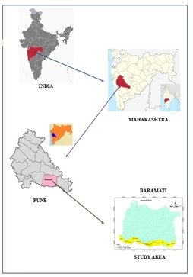
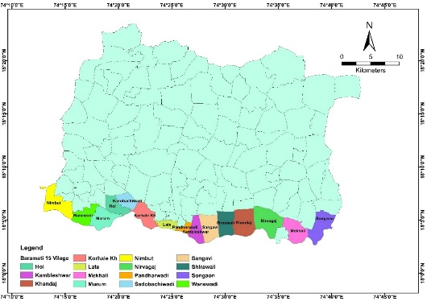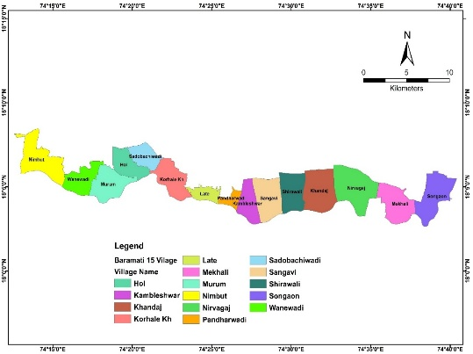
Fig. 1. Location map of Nira command area of Baramati tehsil

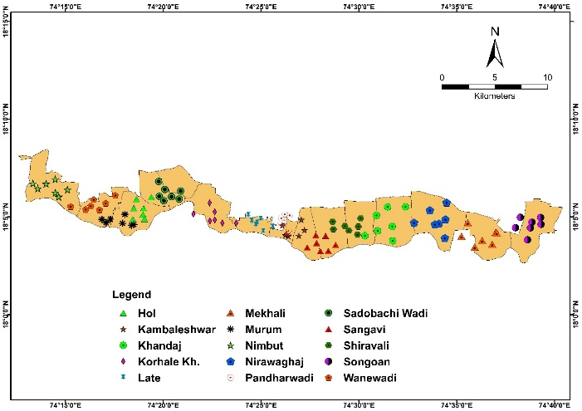
Fig. 2. Location map of sampling sites in Nira command area of Baramati tehsil

3.results and discussion

3.1 Soil Reaction (pH)
The data related to soil pH is presented in Table1 and illustrated in Figure no.3. In the Nira command area of Baramati tehsil, soil pH values ranged from 7.99 to 8.83 with an average of 8.25. A significant portion of the samples (85%) fell under the ‘moderately alkaline’ category, while the remaining (15%) were considered ‘slightly alkaline’. The lowest pH value of 7.99 was recorded in multiple samples from various villages, including Songaon , Mekhali , Shirawali (V5Ss3), Korhale Khurd and Nimbut while the highest pH value of 8.83 was observed in the sample from Sangavi.The alkaline nature of the soil can be attributed to the semi-arid climate of the study area, where the annual evaporation rate exceeds the rainfall. This imbalance reduces the chances of leaching, leading to the accumulation of soluble salts in the root zone of the soil. The similar results were recorded by Thale et al. (2020) in soils of Latur district of Maharashtra and Nagawade (2014) in the central farm of MPKV, Rahuri (M.S.).

3.2 Electrical Conductivity (EC)
The statistical information regarding soil electrical conductivity is presented in Table no.1 and illustrated in Figure no.3. The electrical conductivity of the soils ranged from 0.10 to 0.95 dSm⁻1, with an average value of 0.53 dSm⁻1. The minimum EC recorded was 0.10 dSm⁻1 at village sample Mekhali while the maximum was 0.95 dSm⁻¹ at Sangavi. 100% soil samples showed normal electrical conductivity, which can likely be attributed to the proper management of irrigation water. Satish et al. (2018) reported comparable results in soils of Brahmanakotkur watershed of Andhra Pradesh and Parhad et al. (2018) documented similar result in the soils of Sindkheda tehsil of Dhule (M.S.)

Fig.3. Soil pH and soil EC of Nira command area, Baramati tehsil.

3.3 Organic Carbon
The information related to organic carbon content in soils of the Nira command area of Baramati tehsil is shown in Table 1 and illustrated in Figure 4. The organic carbon values ranged from 0.22% to 0.97%, with an average of 0.54. According to the six-tier rating system, organic carbon levels were categorized as ‘low’ in (38%) of the samples, ‘moderate’ in (26%), ‘moderately high’ in (19%) and ‘high’ in (17%). The maximum organic carbon content of 0.97% was found in samples from Songaon , Nirawagaj and Pandharwadi while the minimum value of 0.22% was recorded at Hol.A wide range of organic carbon levels, from low to high, was observed in the soils, possibly due to the incorporation of organic residues. The considerable variation in organic carbon content could also be attributed to the high summer temperatures, which accelerate the decomposition of organic matter. Urade et al. (2019) observed similar findings in the soils of tamarind orchards located in Latur district and Salma et al. (2019) in the soils of Owk mandal (A.P.)
3.4 Calcium Carbonate
The data on calcium carbonate content is provided in Table 1 and illustrated in Figure 3. In the soils of the Nira command area of Baramati tehsil, calcium carbonate levels varied from 3% to 12.95%, with an average of 7.14%. Based on the analysis, the samples were classified as ‘moderate’ in (32%) of cases, ‘moderately high’ in (47%) and ‘very high’ in (21%). The lowest content of calcium carbonate content was 3 per cent Mekhali , Korhale khurd , Sadobachi Wadi and highest content was 12.95 per cent at village sample Pandharwadi .The semi-arid climate of the study area, characterized by low rainfall and a high evaporation rate, has contributed to increased accumulation and deposition of calcium carbonate, leading to elevated calcareousness in the soil. Similar results revealed by Ikhe et al. (2017) in the soil of soils in Buldhana district of Maharashtra and Surabhi et al. (2017) finding similar result in the soils of Shirol tehsil, Kolhapur district.
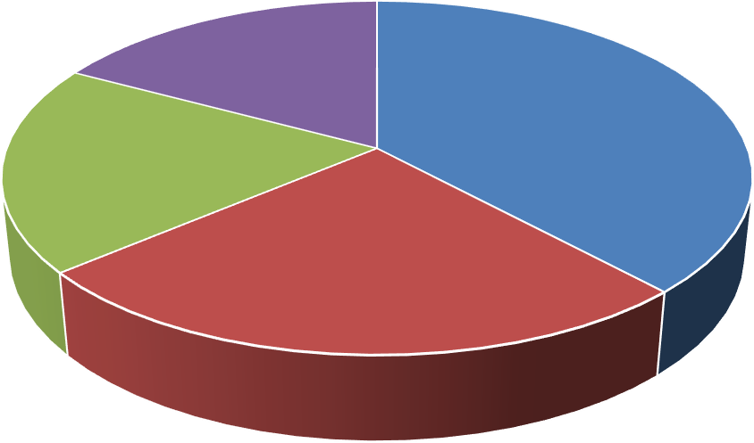
Organic Carbon
17%
38%
19%
26%
Low
Moderate
Moderately High
High
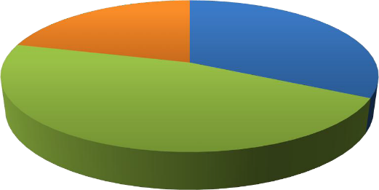
Calcium carbonate
21%
32%
47%
Moderate
Moderately High
Very High
Fig.4. Soil organic carbon and calcium carbonate of Nira command area of Baramati tehsil
Table 1. chemical properties status of soil in Nira command area of Baramati tehsil

Particulars | pH (1:2.5) | EC (1:2.5)  (dSm⁻¹) | Organic carbon  (%) | CaCO3  (%)
Mean | 8.25 | 0.53 | 0.54 | 7.14
Standard deviation | 0.24 | 0.23 | 0.22 | 3.00
Minimum | 7.99 | 0.10 | 0.22 | 3.00
Maximum | 8.83 | 0.95 | 0.97 | 12.95
CV % | 3.00 | 43.00 | 41.22 | 42.00
Category | Slightly  alkaline  (15) | Normal (100) | Low  (38) | Moderate  (32)
Category | Moderately  alkaline  (85) |  | Moderate  (26) | Moderately  high  (47)
Category |  |  | Moderately  high  (19) | Very  high  (21)
Category |  |  | High  (17)

3.5 Available Nitrogen

In the Nira command area, available nitrogen ranged from 57 to 196 kg ha⁻¹ with a mean of 130 kg ha⁻¹ as shown in table no.2 and fig no. 5. Based on the classification, 59% of samples were very low and 41% low in nitrogen. The minimum value (57 kg ha⁻¹) was observed at Hol, while the maximum (196 kg ha⁻¹) occurred at Nirawagaj. The generally low nitrogen status may be due to high temperatures in the semi-arid climate, which accelerate denitrification, along with variations in soil management practices such as fertilizer and manure application. Comparable deficiencies were also reported by Jangir et al. (2019) in Yavatmal district and Kachhiyapatel et al. (2022) in Narmada district soils.


Available Nitrogen
41%
59%
Very Low
Low
Fig.5. soil available nitrogen of Nira command area of Baramati tehsil

3.6 Available phosphorus

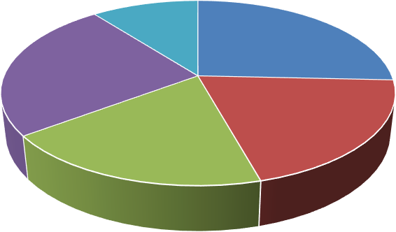
In the Nira command area, available phosphorus ranged from 10.07 to 39.31 kg ha⁻¹ with a mean of 23 kg ha⁻¹ as shown in table no.2 and fig no 6..The samples were classified as low (26%), moderate (20%), moderately high (19%), high (25%) and very high (10%). The minimum P (10.07 kg ha⁻¹) was observed at Pandharwadi, while the maximum (39.31 kg ha⁻¹) occurred at Sadobachi Wadi. The relatively higher P levels may be due to residual fertilizer use (DAP, SSP), organic matter, soil texture and low rainfall limiting leaching. Similar findings were reported by Patil et al. (2019) in Karnataka and Devdas & Srivastava (2021) in Chhattisgarh.
Available phosphorus
10%
26%
25%
20%
19%
Low
Moderately High Very High
Moderate High

Fig.6. Soil available phosphorus of ira command area of Baramati tehsil

3.7 Available Potassium

In the Nira command area, available potassium ranged from 118.4 to 850 kg ha⁻¹ with a mean of 437 kg ha⁻¹ as shown in table no.2 and fig no. 7.The samples were categorized as low (8%), moderate (9%), moderately high (11%), high (9%), and very high (63%). The lowest K (118.4 kg ha⁻¹) was recorded at Nirawagaj while the highest (850 kg ha⁻¹) was observed at Sadobachi Wadi. The predominance of very high potassium levels is likely due to mica- and feldspar-rich parent material. Comparable results were reported by Wagh et al. (2013) in soils of eastern Pune and Katkar et al. (2017) in Bhandara district, Maharashtra.

Available Potassium
8%
9%
63%
11%
9%
Low
Moderately High Very High
Moderate
High

Fig.7. Soil available potassium of Nira command area of Baramati tehsil

Table 2. Available macronutrients status of soil in Nira command area of Baramati tehsil

Particulars | Available macronutrients (kg ha-1)
 | N | P | K
Mean | 130 | 23 | 437
Standard deviation | 44.01 | 9.15 | 230
Minimum | 57 | 10.07 | 118.4
Maximum | 196 | 39.31 | 850
CV % | 34 | 40.50 | 53
Category | Very low (59) | Low  (26) | Low  (8)
Category | Low  (41) | Moderate  (20) | Moderate  (9)
Category |  | Moderately  high  (19) | Moderately  high  (11)
Category |  | High  (25) | High  (9)
Category |  | Very  high  (10) | Very  high  (63)

4. Conclusion

The study revealed that the soils are predominantly moderately alkaline with normal electrical conductivity, indicating suitability for crop growth. Organic carbon levels varied widely from low to high, reflecting differences in residue incorporation and decomposition rates, while calcium carbonate was moderately to very high due to the semi-arid climate, leading to calcareous conditions. Nutrient analysis showed that nitrogen was largely deficient, with most soils falling under very low to low categories, whereas phosphorus exhibited wide variability from low to very high depending on fertilizer use and management practices. In contrast, potassium levels were found to be consistently high to very high, attributed to the mineral composition of the parent material. Overall, while the soils are favorable in terms of salinity and potassium availability, their alkaline reaction, elevated calcium carbonate, and nitrogen deficiency highlight the need for balanced nutrient management, particularly through organic amendments and judicious fertilizer application, to sustain agricultural productivity in the region.

Disclaimer (Artificial intelligence)

Author(s) hereby declare that NO generative AI technologies such as Large Language Models (ChatGPT, COPILOT, etc.) and text-to-image generators have been used during the writing or editing of this manuscript.

References

Alison, L. E. and Moodier, C. D. (1965). Method of soil analysis, Part 2; Chemical and Microbiological Properties.
Devdas, D. and Srivastava, L. K. (2021). Soil fertility mapping by geographical information system in different blocks of Gariaband district, Chhattisgarh. Journal of Pharmacognosy and Phytochemistry, 10(2): 328-338.
Ikhe, U. D., Gabhane, V. V., Sonune, B. A. and Damre, P. R. (2017). Assessment of yield and quality of grapes on different soils in Buldhana district of Maharashtra. An International Quarterly Journal of Life Science, 12(1): 385-3.
Jackson, M. L. (1973). Soil Chemical Analysis - Advanced Course, 2nd Edn. Publ. by the author, University of Wisconsin, Madison, USA.
Jangir, A., Sharma, R. P., Tiwari, G., Vasu, D., Chattarji, S., Dash, B., Malav, L. C., Chandran, Singh, S. K. and Sheikh, S. (2019). Status of available major and micronutrients in soils of Kelapur block, Yavatmal district, Maharashtra. Journal of Soil and Water Conservation, 18(3): 241-245.
Johnson, V. J., Mirza, A. (2020). Role of macro and micronutrients in the growth and development of plants. International Journal of Current Microbiology and Applied Sciences, 9(11): 576-587.
Kachhiyapatel, K. A., Kumawat, L., Patel, K. H., Singh, N., Kotadiya, R. H., & Patel, P. H. (2022). Assessment of available macronutrient status and their correlation studies with important soil properties in soils of Narmada District. BFIJ, 14(1): 804-807.
Katkar, R. N., Lakhe, S. R., Kharche, V. K., Magare, P. N. and Laharia, G. S. (2017). Spatial variability of major and micronutrients in soils of Bhandara district, Maharashtra. Agropedology, 27(01): 56-62.
Khomane, S. L. (2021). Irrigation system in Baramati Tahsil. Anekant Journal of Humanities and Social Sciences, 4(1): 19-27.
Nagawade, S. G. (2014). GPS-GIS based soil fertility map of central farm of MPKV, Rahuri (M.S.). M.Sc. (Agri.) Thesis, Mahatma Phule Krishi Vidyapeeth, Rahuri.
Parhad, S. L., Kondvilkar, N. B., Khupse, S. M., Sale, R. B. and Patil, T. D. (2018). Management of soil quality through assessment of macro and secondary nutrients status of Sindkheda tehsil of Dhule district. International Journal of Chemical Studies, 26(3): 3098-3103.
Patil, P. L., Pawadshetti, D., Sunilkumar, K., Nagarahalli, R., Ramachandraiah, H. C., Kalappanawar, D. and Sanadi, U. S. (2019). Soil fertility mapping by GIS in Madhalli sub watershed under northern dry zone of Karnataka for site specific recommendations. Journal of Farm Science, 32(2): 167-176.
Patil, Y. M. and Sonar, K. R. (1994). Status of major and micronutrients in swell-shrink soils of Maharashtra. Journal of Maharashtra Agric. Uni., 19(2): 169-172.
Salma, D., Munaswamy, V., Giridhara, K., Sumathi, V. and Reddy, R. (2019). GPS and GIS based soil fertility maps and identification of soil related constraints for chickpea growing soils of Owk mandal, Kurnool district (A.P) India. International Journal of Current Microbiology and Applied Science, 8(6): 2319-7706.
Satish, S., Naidu, M. V. S. and Ramana, K. V. (2018). Soil fertility status in Brahmankotkur watershed of Andhra Pradesh for site specific recommendations. International Journal of Chemical Studies, 6(5): 2911-2915.
Subbaiah, B. V. and Asija, G. L. (1956). A rapid procedure for determination of available nitrogen in rice soils. Current Science, 25: 259-260.
Surabhi, H. K., Annapurna, M., Kondvilkar, N. B. and Pawar, R. B. (2017). Mapping of soil macro and secondary nutrients by GIS in Shirol tehsil of Kolhapur district (M.S.). Journal of Chemical Studies, 5(6): 892-896.
Tale, S. and Ingole, S. (2015). A review on role of physico-chemical properties in soil quality. Chemical Science Review Letters, 4(13): 57-66.
Thale, L. R., Vaidya, P. H., Shrivastav, A. S. & Sarda, D. A. (2020). Characterization, classification and soil site suitability of pomegranate (Punica granatum L.) growing soil of Latur district Maharashtra. Indian Journal of Current Science, 8(03): 2959-2964.
Urade, P. S., Jadhav, A. R. and Dheware, R. M. (2019). Studies on physico-chemical properties of tamarind orchards soils of Latur district. Journal of Pharmacognosy and Phytochemistry, 8(1): 2738-2740.
Wagh, G. S., Chavhan, D. M., & Sayyed, M. R. G. (2013). Physicochemical analysis of soils from eastern part of Pune city. Universal Journal of Environmental Research and Technology, 3(1): 93-99.
Walkley, A. J. and Black, A. I. (1934). Estimation of organic carbon by chromic acid titration method. Soil Science, 25: 255-259.
Watanabe, F. S. and Olsen, S. R. (1965). Test of ascorbic acid methods for phosphorus water and sodium bicarbonate extract of soil. Proceedings of Soil Science.

