Effects of graded dietary probiotic levels on growth performance and muscle protein content in juvenile golden trevally (Gnathanodon speciosus)

ABSTRACT

The golden trevally (Gnathanodon speciosus) is a favourable option for aquaculture due to its fast growth, valuable market value, and exceptional flavour. It is crucial to identify techniques for optimising production through growth enhancement in golden trevally aquaculture. This experiment aimed to assess the effect of grading levels of probiotic (0, 1, 2, 3, and 4 g kg ⁻¹) on the golden trevally, G. speciosus (initial weight 8.51 g ± 0.53). Each diet treatment had three replicates, and fed the fish over a duration of four weeks. The growth performance and protein and fat content in the muscle were evaluated. At the end of the experiment, the incorporation of probiotics into the golden trevally diet resulted in a statistically significant improvement in growth (P < 0.05). The survival rate of fish fed the probiotic diet was not statistically different from that of the control group. Furthermore, at the end of the experiment, the protein concentration was 20.30 to 21.15% in the flesh of golden trevally fed diet B2, B3 and B4, which was significantly increased in comparison to fish fed control diet (P < 0.05). In conclusion, nutritional treatment with probiotics trevally improves growth, survival, and body composition in juvenile golden fish. It is recommended to add 1 - 2 g of Bacillus kg⁻¹ diet of golden trevally to improved growth, survival and protein content. This trial represents the first investigation into the advantages of probiotics for golden trevally; however, researchers should undertake additional studies on physiological effects and stress resilience.

Keywords: Golden trevally, Gnathanodon speciosus, probiotic, growth performance, biometric index, protein content.

- INTRODUCTION

The aquaculture sector is essential for the future, as it provides sustenance for the rapidly expanding human population. This accounts for 51% of the global total, with a record 57% of production intended for human consumption . In the past, antibiotics have been used to treat diseases in aquaculture. However, “the dissemination of antibiotic residues in the marine environment has resulted in an increase in the rates of antibiotic resistance in aquatic bacteria and, more importantly, the transfer of this resistance to human pathogens” .

Common approaches for infection management involve the use of chemicals, such as antibiotics, which are linked to adverse environmental effects and the development of antibiotic resistance in both fish and people . Thus, urge research to find antibiotic replacement for aquaculture .

One of the promising methods of preventing the outbreak of disease is to enhance the immune system of fish by developing environmentally benign methods . Research showed that probiotics have emerged as viable and effective alternatives to reduce or eliminate antibiotic use and manage infections . Bacillus have garnered more interest owing to their production of non-toxic and non-pathogenic compounds as well as their sporulation capability, which confers protection under stressful conditions (heat, gastrointestinal tract) compared to other probiotics . In aquaculture, probiotics can be employed to improve water quality, strengthen immune function, improve nutrient utilisation, and enhance growth . Probiotic supplementation enhanced the growth of aquaculture animals, such as Nile tilapia (Oreochromis niloticus) , gilthead sea bream (Sparus aurata) , Mrigal (Cirrhinus mrigala) , tilapia (Oreochromis niloticus) , and hybrid sturgeon (Acipenser baerii ♀ Acipenser schrenkii ♂) .

“The golden trevally (Gnathanodon speciosus) inhabits tropical and subtropical areas of the Eastern Pacific, Western Indo-Pacific, and both the Eastern and Western Atlantic Oceans. Golden trevally functions as a food source and an ornamental animal. This species, whose spawning has been successfully stimulated in Vietnam, is a novel candidate for aquaculture. The commercial price of golden trevally is about 5.7 to 8 USD per kilogram. This fish are mainly served for local restaurants, and tourists prefer them for their outstanding taste and reasonable cost. Golden trevally is one of the large size belong to Carangidae” . The golden trevally is a critically important aquaculture species in Vietnam because of its rapid growth, considerable market value, exceptional taste, and current supply difficulties. This species encounters substantial obstacles in aquaculture settings due to environmental pressures, including issues like water contamination, elevated stocking density, and suboptimal water quality.

Several studies have investigated the benefits of probiotic Bacillus spp. on aquatic species; however, to our knowledge, no study has assessed the influence of Bacillus spp. on golden trevally. Thus, the aim of this study was to investigate the impact of Bacillus supplementation on growth performance, biometric indicators, and protein content in the golden trevally, Gnathanodon speciosus.

- MATERIALS AND METHODS

2.1. Design of the experiment

The objective of the experiment was to evaluate the growth performance and mortality of fish that were fed a probiotic-supplemented diet for a period of four weeks. Using a randomisation method, the four food treatments were assigned to three replicate containers, each of which contained 30 fish. Twelve containers were utilised to distribute 360 golden trevally.

2.2. Diet Formulation and Management

Probiotic (Sanolife® PRO-F, INVE, Belgium) was incorporated into a basal meal including 19.72 GE MJ/kg, 39.3% crude protein, and 8.71% fat at five distinct dosages (0, 1, 2, 3, and 4 g kg⁻¹). The following dietary therapies were implemented: B1, B2, B3, B4, and B5. On the initial day, each tank's experimental fish were administered 5% of their average body weight. The quantity of feed administered was subsequently checked and modified daily according to the volume of the remaining pellets. Approximately 30% of the water was replenished daily, and the residual feed and waste were disposed of. During the four-week trial, the fish were fed twice daily at 08:00 and 17:00. .

2.3. Juvenile Fish and Culture Tanks

The golden trevally, Gnathanodon speciosus, was obtained from an identical broodstock. Fish with an average starting wet weight of 8.51 g ± 0.53 were randomly assigned to composite tanks measuring 50 × 80 × 80 cm. Each tank was outfitted with a distinct recirculation system functioning at a flow rate of approximately 350 L min⁻¹.

2.4 Gathering Data and Sampling

At both the start and conclusion of the trial, the total length of each fish was measured and weighed individually. Upon the conclusion of the experiment, two fish were randomly chosen from each tank to analyse their muscle composition. Prior to any measurements or sampling, the fish were deprived of food for one day.

2.5 Chemical Analysis of Cultured Fish

Upon completion of the experiment, fish were gathered from each feeding regimen, and their muscles were stored at -20 °C for protein analysis. The amount of crude protein was assessed using a previously described method .

2.6 Calculation of Data

The following formulas were used to calculate the specific growth rate (SGR, % d⁻¹) and survival rate (SR) : SGR (% d⁻¹) = 100.(LnWt - LnWo)/days; SR (%) = 100.(Nt)/No. Where Wt and Wo were the fish's weights at the end and their respective commencement weights (in g), respectively. The coefficient of variation (CV, %) was determined in the following manner: CV is equivalent to (100 × S/M), where S represents the standard deviation and M represents the average weight of the fish. Viscerosomatic (VSI, %) and hepatosomatic index (HIS) calculations were as follows: VSI (%) = 100⋅viscera weight (g)/whole fish weight (g), where viscera refers to the stomach, liver, intestine, and adipose, and HIS (%) = 100⋅liver weight (g)/whole fish weight (g).

2.8 Statistical Assessment

ANOVA and Least Significant Difference (LSD) procedures were employed to analyse the growth, and body composition data of fish that were subjected to a variety of feeding procedures. Differences were accepted as significant when P < 0.05. Mean and Standard error (SEM) was used to represent the data. A non-parametric Kruskal-Wallis test was implemented to evaluate survival rates . All statistical analyses were conducted using SPSS 18 (IBM, Chicago, IL).

- RESULTS

3.1 Growth performance of golden trevally

The average weight of golden trevally did not differ significantly between administrations at the starting point of the experiment (ANOVA, P = 0.862).

Fig. 1. Specific growth rate (SGR % d⁻¹) (± SEM) of golden trevally fed different concentrations of probiotic. Distinct letters denote substantial disparities between treatments.

When dietary probiotic supplements were administered to golden trevally, there was a significant increase in the rate of fish. The growth rates varied from 2.21 to 2.72 percent each day, with a variety of values in between. The golden trevally received the most significant growth among the fish that were fed diet B3 (2 g kg⁻¹), followed by those that were fed diets B2 (1 g kg⁻¹), B4 (3 g kg⁻¹), and B5 (4 g kg⁻¹). However, when compared to one another, there was no discernible difference between these groups (P ≥ 0.287). According to the findings, it was observed that fish that were given the unsupplemented diet exhibited a significant decrease in growth when compared to fish that were provided with probiotic inclusion (P ≤ 0.036). (Fig. 1).

3.2 Biometric index of golden trevally fed different concentrations of probiotic

The biometric index of golden trevally fed diets containing probiotics as an additional ingredient is illustrated in Figure 2. The condition factor (CF) increased significantly in fish fed diets B2 (1 g kg⁻¹) and B3 (2 g kg⁻¹) (P ≤ 0.033). Fish fed diets B2 (1 g kg⁻¹) and B3 (2 g kg⁻¹) and those fed diets B4 (3 g kg⁻¹) and B5 (4 g kg⁻¹) exhibited a significant difference; however, this difference did not meet the criteria for statistical significance (P = 0.230). The fish that were administered B4 (3 g kg⁻¹) and B5 (4 g kg⁻¹) did not exhibit any significant differences in the condition factor (CF) when compared to those that were fed the basal diet (P = 0.220). (Fig. 2A).

Furthermore, the hepatosomatic index and viscera somatic index of golden trevally fed all levels of probiotic supplementation were considerably greater than those of golden trevally fed the control diets (P ≤ 0.031). However, there were no significant changes in the HIS and VSI in fish across the different probiotic supplementation groups (P ≥ 0.078). (Fig. 2 B & C).
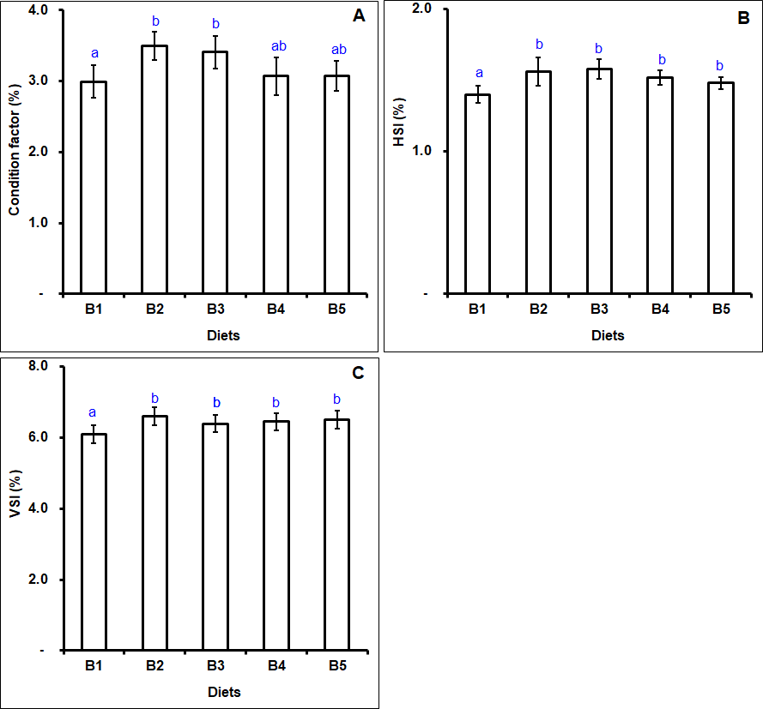
Fig. 2. Biometric index of golden trevally fed different levels of probiotic. Distinct letters denote substantial disparities between treatments.

3.3 Survival rate of golden trevally fed probiotic

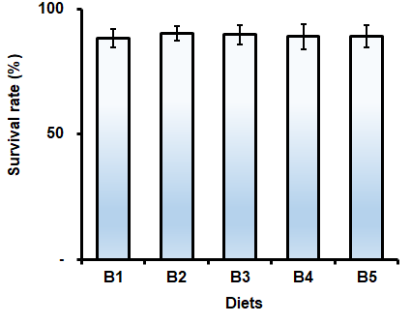
Fig. 3. Survival rate of golden trevally fed grading levels of Bacillus.

Fig. 3 shows the impact of dietary probiotics on the golden trevally's survival rate. The ultimate survival rate of golden trevally varied between 88.50 percent and 90.36 percent among the numerous treatments. The survival rate of fish that were fed diet B2 (1 g kg⁻¹) was the highest at 90.36%, followed by fish that were served diets B3 (2 g kg⁻¹) and B4 (3 g kg⁻¹), while the control diet had the lowest survival rate. However, probiotic administration did not significantly alter the survival rate of golden trevally (P = 0.075).

3.4. Variations in the size (CV, %) of golden trevally

Fig. 4. Coefficient of variations in weight (CV, %) of golden trevally fed different levels of probiotic. Distinct letters denote substantial disparities between treatments.

The coefficient of variation (CV, %) was employed to evaluate the heterogeneity of fish body weight. The results at the end of the experiment indicated that the fish receiving a control diet exhibited the highest coefficient of variation (CV, %) in body weight. As the intake of probiotic supplements increased, the coefficient of variation exhibited a declining trend. Compared to fish fed the control diet, a significant difference in CV value was observed in the B2 (1 g kg⁻¹) and B3 (2 g kg⁻¹) diets (P = 0.038). The CV values of fish fed diets B4 (3 g kg⁻¹) and B5 (4 g kg⁻¹) were lower than those of fish fed the control diet, but these differences were not statistically significant (P = 0.072). No significant differences in CV values were noted among the four groups of fish receiving any amount of probiotics (P = 0.092). Fig. 4.

3.6 Protein content in flesh of golden trevally
Fig. 5. Protein content in golden trevally subjected to dietary probiotic treatment. Distinct letters denote substantial disparities between treatments.

Diets supplemented with different levels of probiotics significantly influenced protein content (P ≤ 0.027). The protein content in the muscle of golden trevally ranged from 17.69% in the control diet group to 21.15% in the B3 (2 g kg⁻¹) group. Fish fed B3 had the highest protein content, followed by those fed B4 (3 g kg⁻¹) and B2 (1 g kg⁻¹), both of which were considerably greater than that in the control group (P ≤ 0.021). The protein content of fish fed B5 (4 g kg⁻¹) was greater than that of control fish, although the difference was not statistically significant. The protein content was not significantly different across fish subjected to different probiotic dietary doses (P = 0.351) (Fig. 5).

- DISCUSSION

This study is a fundamental and crucial examination of the effects of dietary probiotic Bacillus spp. on the growth and body composition of golden trevally. This research demonstrates that feeding Bacillus enhances the growth and survival of the golden trevally, Gnathanodon speciosus. Fish development improved with diets containing 1 - 4 g of Bacillus per kg.

Our findings support previous studies indicating that probiotics are crucial for the growth and survival of various fish species, including Nile tilapia (Oreochromis niloticus) , gilthead sea bream (Sparus aurata) , Cirrhinus mrigala , tilapia , hybrid sturgeon (Acipenser baerii ♀ Acipenser schrenkii ♂) , African catfish (Clarias gariepinus) , spinefoot rabbitfish (Siganus rivulatus) , Indian carp (Catla catla) , sea cucumber (Apostichopus japonicus) , Giant freshwater prawn (Macrobrachium rosenbergii) , and black tiger shrimp (Penaeus monodon) . Nevertheless, the growth performance of the young channel catfish, Ictalurus punctatus, was not enhanced by the addition of P. acidilactici or E. faecium to their diets . Similarly, the weight gain of juvenile rainbow trout, Oncorhynchus mykiss was not significantly influenced by diets containing Bacillus licheniformis and Bacillus subtilis .

Condition factors are critical indicators of health status . Additionally, the condition factor (CF) functions as an indicator for evaluating the alimentary condition, adult size, reproductive size, and nutritional status of fish . Regarding environmental factors , seasonal variations, and geographical regions , CF value is a tool for assessing the health and overall well-being of fish. The fish that were fed the control diet exhibited the lowest CF values in this study, whereas the fish that were fed 1 - 2 g of probiotic per kilogramme diet exhibited the highest CF values.

The biochemical composition of fish often dictates their nutritional status and health . Fish body composition is vital in aquaculture, as it affects food utilisation efficiency, survival rates, and growth . The current investigation revealed significant variations in the protein content of golden trevally fed dietary probiotics; however, a higher dosage of probiotic inclusion in the diet decreased protein levels in golden trevally, although these levels did not significantly differ from those in fish fed control diets. According to our findings, indicated that Mrigal (Cirrhinus mrigala) fed probiotics exhibited an increased protein content. Likewise, the protein content of Nile tilapia (Oreochromis niloticus) was augmented by probiotic supplementation . The improved growth, survival, and body composition of golden trevally in this study suggests the influence of probiotics on this species. Research has documented the advantages of utilising Bacillus to enhance the growth performance, survival, immunity, and disease resistance of aquatic organisms .

According to Hoseinifar et al. (2018), “probiotics administration enhance fish health and exert antioxidant effects through various mechanisms, including modulation of gut microbiota, production of antioxidant compounds, reduction of inflammation, enhancement of immune function, improvement of antioxidant enzyme activity, regulation of the gut barrier, detoxification of metabolic by-products, and increased nutrient absorption”. The role of Bacillus in aquaculture have been elucidated through several mechanisms, including competition with pathogenic bacteria for nutrients and adhesion sites , alteration of gut microflora , enhancement of enzymatic activity (Gupta et al., 2016), and improvement of water quality . This could be a reflection of the modulating effect of dietary Bacillus on the golden trevally's improved growth rate and body composition in this study.

5. CONCLUSION

Overall, the supplementation of juvenile golden trevally with dietary probiotics may enhance growth, survival, and body composition. The golden trevally, Gnathanatodon speciosus, exhibits enhanced growth performance and altered body composition due to the use of probiotics in their meals. The feed of golden trevally should be supplemented with 1 - 2 g kg⁻¹ of probiotic (Sanolife® PRO-F) to promote optimal growth. Moreover, additional research is essential to determine the probiotic concentration needed to trevally enhance the growth of golden trevally under diverse environmental circumstances and stressors, along with their physiology and immune defences at various life stages.

Disclaimer (Artificial intelligence)
Author(s) hereby declare that NO generative AI technologies such as Large Language Models (ChatGPT, COPILOT, etc.) and text-to-image generators have been used during the writing or editing of this manuscript.

REFERENCES

