**A Global Scientometric Analysis of Climate-Smart Agricultural Innovations Adoption in Drought-Prone Areas**

**Abstract:**

Acute and growing burdens on livelihoods exist as water resources become more stressed and agricultural production becomes less reliable. To meet these challenges, Climate-Smart Agriculture (CSA) innovations are being positioned as an essential solution to increasing resilience, productivity, and reducing greenhouse gas (GHG) emissions. This global scientometric analysis maps the evolution of Climate-Smart Agriculture (CSA) adoption research in drought-prone regions through a systematic examination of 448 Scopus-indexed publications (2016–2025). The field demonstrates robust annual growth (13.72%), peaking at 111 publications in 2024, a surge catalysed by post-Paris Agreement policy mobilisation and escalating climate vulnerabilities. Geographically, research leadership is heavily concentrated in high-risk regions: India dominates (80 publications, 17.9% of total), driven by institutions like Tamil Nadu Agricultural University (27 papers), while Sub-Saharan Africa shows strong collaborative output (Ghana: 17; Kenya: 15). Critically, Latin American drylands and West Asia represent less than 4% of studies, exposing significant spatial knowledge gaps. Thematic analysis reveals three interconnected clusters: (1) climate drivers ("drought" [80 keyword occurrences], "abiotic stress") contextualizing environmental pressures; (2) adaptation strategies anchored by "climate-smart agriculture" but hampered by terminology inconsistencies ("adaptye management"); and (3) socio-agronomic outcomes ("crop yield" [24], "food security" [29], "smallholder" livelihoods). Methodologically, empirical field data dominates yet suffers from compartmentalisation: biophysical trials (e.g., 3.1 t/ha sorghum yield gains in Kenya) rarely integrate socio-economic metrics, while household surveys (e.g., 40% higher farm incomes for CSA adopters in India) overlook environmental variables. Only 12.5% of systematically reviewed studies leveraged geospatial tools like remote sensing (e.g., detection of sustained LST >30°C in Indonesia). Crop-specific research disproportionately focuses on maize (21 occurrences), neglecting drought-resilient staples like sorghum and millet, essential for nutrition security. Collaboration networks are robust (4.44 authors/paper), with Northern institutions enabling multinational partnerships (UK: 82% MCP rate). Persistent gaps include fragmented methodologies, underrepresentation of livestock systems, and short-term trials (<6 years). We recommend (a) integrated mixed-methods approaches (remote sensing + socio-economic panels), (b) geographic diversification to neglected arid zones, (c) ontology standardisation, and (d) crop study expansion beyond maize. Policymakers should prioritise scaling validated CSA bundles, such as integrated soil-water conservation (26–89% yield increases) and drought-tolerant varieties, to strengthen resilience in vulnerable agroecosystems.

**Keywords:** *Climate-Smart Agriculture, Diffusion of Innovation Theory, Climate Change Adaptation, Bibliometric Analysis, Drought-Prone Areas*

**1.0 Introduction**

Climate change is increasingly accepted as one of the most imminent threats to global agriculture. Agriculture is most sensitive to climate variations, while it also relies on land and other natural resources that the climate affects. In addition to nutrient and field management, crop production strongly depends on the cumulative effects of soil, water, and weather conditions during a sufficient growing season. Frequent and severe droughts have negative effects on plant growth, physiology, and reproduction to reduce crop yields substantially (Wu et al., 2023; Naresh Kumar et al., 2024). The rising temperature, altered rainy season, and higher frequency of extreme weather events are critically hindering crop productivity and food security (Rezvi et al., 2023). Especially in drought‐prone areas across the globe, notably in Sub‐Saharan Africa, South Asia, and dry or semi‐dry areas of Latin America (Lombe et al., 2024). Acute and growing burdens on livelihoods exist as water resources become more stressed and agricultural production becomes less reliable. To meet these challenges, Climate-Smart Agriculture (CSA) innovations are being positioned as an essential solution to increasing resilience, productivity, and reducing greenhouse gas (GHG) emissions (Kabato et al., 2025). CSA is a bundle of practices, technologies, and institutions from drought‐tolerant crop varieties, precision irrigation systems, and agroforestry to conservation tillage and climate‐informed decision‐support tools collectively seeking to optimise resource use, while buffering farmers from climate shocks (Mahedi et al., 2025). The underlying ideologies of CSA also aim to identify site-specific solutions and increase food security and the resistance of social and production systems to climate change. The main themes include data assessment, strengthening adaptation capacities, sustainable climate-smart management, adaptation technology, and disaster risk management (Zaidi et al., 2024).

Despite increasing attention to CSA in policy discussions and development programs, the adoption of these technologies by smallholder and resource‐poor farmers in dryland areas is uneven (Autio et al., 2021). Empirical studies have identified various barriers to adoption, including limited access to credit and good quality inputs, weak extension systems, poor market connections, and social and cultural factors, such as risk aversion or traditional dietary preferences (De Pinto et al., 2020). Furthermore, institutional fragmentation and heterogeneity in the local agro‐ecological conditions imply that CSA adoption pathways are highly heterogeneous at the subnational scale (Autio et al., 2021). Therefore, there is an urgent requirement to visualise the development of scientific relevance on CSA in drought‐prone regions,  pinpoint major thematic clusters, track influential authors and institutions, and determine emerging research lacunae (Jellason et al., 2021). An overview like this can help researchers and policymakers to understand the trends at play, identify areas where evidence lags, and develop more targeted action to achieve greater scaling out and scaling up of CSA.

Bibliometric, or scientometric, analysis provides a systematic, quantitative framework for evaluating the structure and evolution of scientific disciplines (Haghani, 2023). Based on publication metadata (e.g., authorship, citations, keywords, institutional affiliations, and geo‐distribution), bibliometrics provides insight into the intellectual landscape of a particular domain, indicating influential works, collaborative networks, co‐citation patterns, and thematic developments over time. Given the need for bold CSA innovation adaptation in these drought‐prone areas, an inclusive and comprehensible evaluation can provide the empirical foundation to determine what regions, institutions, and scholars have taken the lead in research, in which journal venues,  and on what sub‐topics (e.g., specific crop technologies, types of water‐saving technologies, the socio‐economic drivers for adoption). Furthermore, if supplemented with systematic review principles including strict inclusion/exclusion criteria and keyword‐based search strategy, inductive or thematic coding, etc. this method can also yield insights into the substantive content of CSA adoption studies, provide a typology of existing methodology approaches (e.g., field survey, participatory experiment, modeling), and reveal under‐explored areas where empirical evidence or theoretical framing are still inadequate.

A recent proliferation of articles highlights increasing academic and policy concern around climate‐smart drought mitigation strategies. However, no systematic effort has been made to synthesise and map together the world's literature on the adoption of CSA, for drier settings in particular. Current bibliometric studies on CSA pay little attention to using such methods for CSA to identify information on all agroecological zones without specifying drought‐prone areas, in addition to overall climate resilience. Given that drought is still one of the most common climatic risks and that, in a relatively unjust way, it affects mainly rain‐fed smallholder communities that depend directly on the land (Sardar et al., 2021). It is essential to gather the knowledge focused on innovation to CSAs that aim for water scarcity, crop adaptation, and support of ecosystem and livelihood resilience in these vulnerable regions.

The main aims of this scientometric and systematic review are:

**RQ1:** What is the trend in the literature on adopting Climate‐Smart Agriculture innovations in drought‐prone areas?

**RQ2:** Who are the authors, institutions, and countries influencing research in CSA adoption in drought-prone regions?

**RQ3:** What are the main topics and methodological trends in the CSA adoption literature in drought‐prone areas?

**RQ4:** What are the main journals and publication venues for CSA adoption research in drought environments?

**RQ5:** What remains as holes in the current literature, and what are the next frontiers?

**Objectives of the Study**

The primary aim is to do a bibliometric analysis and thorough literature evaluation of climate-friendly agriculture (CSA) research to comprehend its history, trends, and principal obstacles. The following particular objectives direct the research:

1. To Analyse the Trend and Citation Analysis of Publications.
2. To Analyse Profile Key Authors, Organisations, and Geographical Trends.
3. To Discover and Fuse Major Research Themes and Methods.
4. To Identify and Cluster the Big Research Topics and Methods.
5. To Highlight Key Research Gaps and Future Directions.

**2.0 Systematic Literature Review**

The global conversation on Climate-Smart Agriculture (CSA) has intensified over the last decade, and there is increasing academic interest in the uptake of CSA technologies in drought-prone regions (Ariom et al., 2022). A systematic look at selected literature demonstrates the richness of conceptualisation and diversity in terms of methodological approaches to understanding: the dynamics of adoption of CSA practices; barriers and perceptions of CSA practices adoption; and the socio-economic aspects of CSA practices in different agro-ecological and institutional contexts.

Samuel et al. (2024) examine the notion of farm income resilience through CSA interventions in India, highlighting how risk-reducing practices, including the cultivation of drought-tolerant crops and the use of water-saving technologies, can shield smallholders from climatic variability. Their results emphasise the importance of integrated CSAs and supportive extension services in achieving sustainable economic security. This aligns with Pal et al. (2022), who examine the uptake of CSA technologies in the semi-arid tropics of India and highlight the significance of institutional linkages, gender inclusiveness, and focused capacity building for expediting uptake.

In East Africa, Njeru et al. (2019) show in a case study from Kirinyaga County, Kenya, that access to input, credit, and knowledge pathways is our central factor influencing the adoption of drought-resistant crops. Their study adds to an emerging literature that underscores the importance of public-private partnerships in promoting CSA, especially when market failures restrain access to innovation. Another study by Njeru et al. (2016) takes an elaborate look at CSA adaptation strategies in Kenya, performing comparative analysis from the policy environment to community-level resource control and farmer perspectives towards drought resilience.

Biophysical Underpinnings Wang and Ren (2025) focus on agroecological linkages between drought stress and mitigation efforts and portray CSA as more than a policy construct, but rather as a scientific approach rooted in ecological mechanisms. They focus on soil-plant-atmosphere interactions and dynamics and emphasise the importance of integrating agronomic innovation with climate and hydrological predictions. A different perspective on a more regional basis is given by Thierfelder et al. (2016), who analyse the linkage between conservation agriculture and drought-tolerant maize in Southern Africa. Their data from long-term field trials showed that the practice of soil moisture retention combined with the availability of genetically enhanced varieties produced much higher yields under drought conditions. The study also suggests that the farmer-managed trials contribute to the continued use of CSA technologies in low-input farming at progressing levels of integration.

Martey et al. (2020) examine the impact on welfare of CSA adoption in Ghana, quantitatively analysing the effects of CSA on household income, food security, and vulnerability. Econometric models show that the adoption brings important welfare gains, especially when farmers adopt more than one component of the CSA at the same time. This finding is consistent with the idea that a continuum of adoption (rather than a binary adoption), may be more important to resilience.

In the Southeast Asian environment, Sholihah et al. (De Jesus Martinez et al., 2024) propose a CSA blueprint for drought-vulnerable agricultural areas in Indonesia. Their study emphasised the importance of local climate information systems and the incorporation of indigenous knowledge into contemporary CSA approaches. Crucially, they highlight the necessity of adaptation planning based on the local context, not universal prescriptions.

This paper presents a basic framework of global knowledge production upon which a scientometric analysis would be quantitatively based. It focuses on mapping global knowledge production, collaboration patterns, and thematic clusters within CSA adoption research in drought-prone areas.

**3.0** **Literature Collection**

**3.1. Data Collection**

A well-crafted search technique was employed to obtain data from the Scopus database. On 17 May 2025, an initial dataset of 448 results was obtained by conducting an advanced search using the keywords **“**climate AND smart AND agriculture AND drought**”** in conjunction with the Article Title, Abstract, Keywords, and the timespan 2016-2025. The final list of 8 important articles was obtained by modifying the selection procedure to filter based on the Article Title and remove duplication.

**3.2. Bibliometric Analysis**

A bibliometric study was performed to statistically evaluate publication trends and research impact in the domain of CSA. Fundamental metrics, including the Main Information of the Data, Publication Trend Analysis, Most Relevant Sources and Authors, Top Countries and Manuscripts by Citation, Keyword Analysis, and Co-occurrence by Keywords, were calculated using bibliometric programs like R, R Studio, and VOS Viewer (Mahedi et al., 2025; Md Shahriar Kabir et al., 2025). This quantitative assessment delineated the progression of research in CSA while identifying the most prolific research clusters and geographical hotspots of activity. The bibliometric indicators functioned as a reliable metric of academic impact and offered insights into the discipline's conceptual development.

**3.3. Systematic Literature Review**

The final 8 articles were subject to a comprehensive full-text evaluation to ascertain their relevance, quality, and contribution to CSA research in Drought-Prone Areas. The systematic literature review was designed to extract significant topics, methodologies, and conclusions, comprehensively examining current research. This method assisted in identifying gaps in previous research and establishing a connection between the bibliometric data and relevant insights.

**3.4. Data Visualisation**

Data visualisation was vital for assessing both the bibliometric and qualitative results. Visualisation tools, including VOS Viewer and R Studio, generated network maps depicting keyword co-occurrence and citation trends. Time-series graphs were created to depict publishing patterns and the development of significant research issues throughout time. These visual tools improved the interpretability of complicated information and offered clear graphical representations of the links among different study components. The visualisations substantially enhanced the narrative by concisely presenting and emphasising the patterns and interrelations in CSA research.

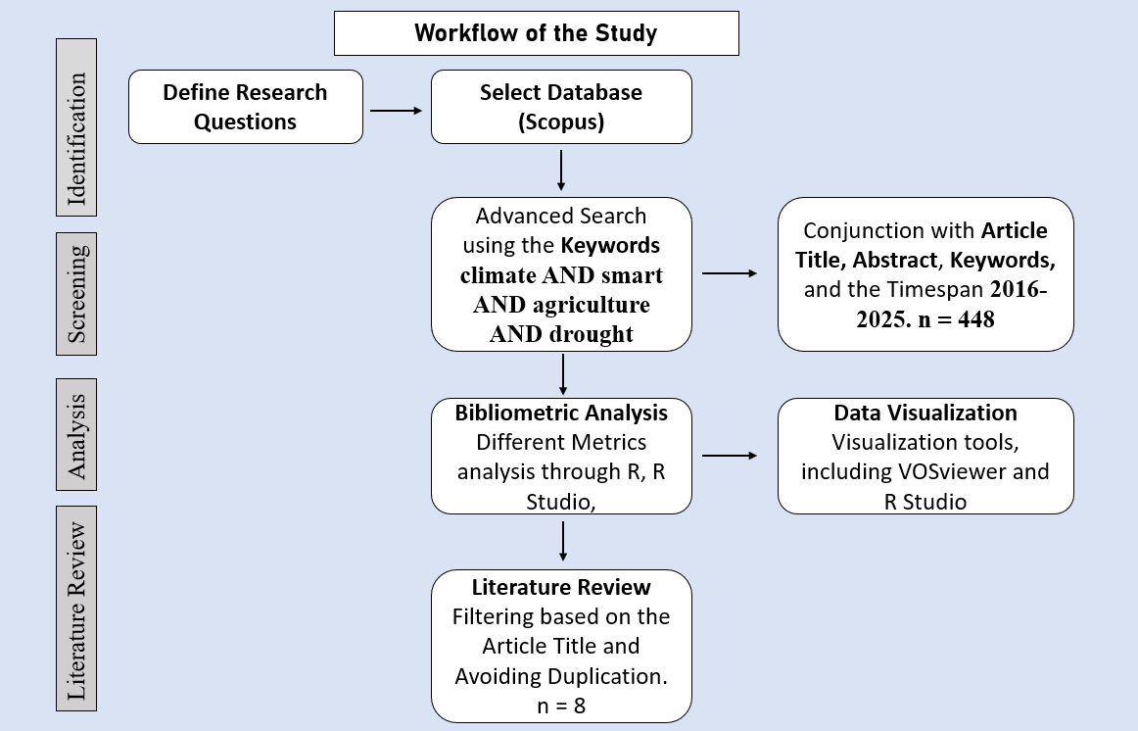

**Figure 1.** Steps of Literature Collection and Analysis

**4.0 Findings of the Bibliometric Analysis**

**4.1 Description of the Data**

Table 1, an overview of the literature on Climate-Smart Agricultural (CSA) innovations adoption in drought-prone conditions from 2016 to 2025, is presented in the bibliometrics. In this period, 448 documents were published in 302 distinct sources, such as journals, conference proceedings, and book chapters. The number of papers published in this domain has experienced an impressive annual growth rate of 13.72% due to the increasing global attention to CSA technology in the wake of climate change-induced agricultural challenges.

**Table 1.** Information summary on retrieved CSA studies (2016–2025)

|  |  |
| --- | --- |
| **Description** | **Results** |
| Timespan | 2016:2025 |
| Sources (Journals, Books, etc.) | 302 |
| Documents | 448 |
| Annual Growth Rate % | 13.72 |
| Average citations per doc | 16.51 |
| Keywords Plus (ID) | 1668 |
| Author's Keywords (DE) | 1337 |
| Authors | 1804 |
| Authors of single-authored docs | 35 |
| Single-authored docs | 37 |
| Co-Authors per Doc | 4.44 |

From the data, the average citation per document is slightly high at 16.51; therefore, the published research is very famous and influential in the academic field. The analysis also found a substantial dispersion of themes (supported by 1668 Keywords Plus and 1337 keywords author-assigned), indicating the scope of topics and methods covered in the literature. Ownership patterns of authorship indicate collaboration in this category of study. 1804 authors wrote the publications, corresponding to a mean number of authors of 4.44 per paper, indicating interdisciplinarity and often multi-institutional collaboration. Although co-authoring is common, 35 authors published 37 single-authored papers, indicating that individual scholarly efforts are also making meaningful contributions to the advancement of the discipline.

**4.2** **Publication Progression**

The annual scientific output about Climate-Smart Agriculture (CSA) innovations adoption in drought-prone areas is presented in Figure 2, with the number of publications per year between 2016 and 2025. The data show this to be a clear upward trend in publication activity over the 10-year period, suggesting more academic and policy interest in this area.

There was an initially low number of publications in 2016 (11 articles), but there was increasing growth in 2017 (15 articles) and 2018 (22 articles). There has been a greater increase from 2019 (33 articles) onwards, representing heightened awareness of the contribution of CSA to climate-resilient agriculture as a whole. There is a decrease in the number of articles in 2020 (31), which is understandable given the impact of COVID-19 on research productivity and fieldwork logistics.

Another substantial growth was produced in 2021 (58 articles) and became a momentum in their further expansion in 2022 (54 articles) and 2023 (78 articles), which indicates a post-epidemic recovery and restitution and a growing trend of CSA research. The maximum is attained in 2024, in which 111 articles are published, accounting for almost one-quarter of the overall publications and the highest annual yield at the time of the study. This steep increase indicates global consensus, perhaps catalysed by climate finance and policy changes, economic interest, and international partnerships to innovate with CSA and in drought adaptation. Interestingly, there is a precipitous drop in the number of articles in 2025 (35 articles), although these numbers may be distorted by the fact that data collection was not completed for 2025, depending on the date of the bibliographic indexing cut-off. In this sense, it is worthwhile to be careful in interpreting the figure for 2025 as a reversal of the publication trend.

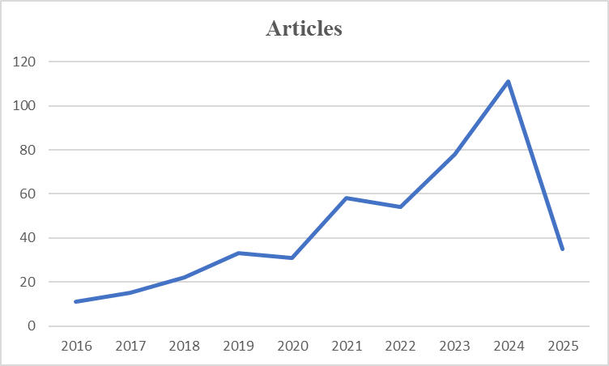

**Figure 2.** Annual Scientific Publications

**4.3 Top Relevant Sources**

The top 10 publishers on the adoption of CSA in drought-prone areas are presented in Table 2, ranked by the number of articles. Sustainability (Switzerland) has the highest number of articles, with 14 publications, followed by Frontiers in Sustainable Food Systems (11) and Frontiers in Plant Science (9). Along the way, 7 articles were contributed by Climate Change Management and another 7 by Environmental Science and Pollution Research, an indicator of CSA’s utility to environmental science. The African Handbook of Climate Change Adaptation (5 entries) focuses on regionally specific, policy-oriented research. The journals with the most significant numbers of publications were Agricultural Systems, Land Use Policy, IOP Conference Series: Earth & Environmental Science, and Mitigation and Adaptation Strategies for Global Change (5 papers each), which indicates the presence of the CSA research production in a specific agricultural and interdisciplinary environment. This assortment of sources illustrates the complexity of CSA as a crosscutting, multi-dimensional challenge linked to the biophysical, socio-economic, and political-spatial realms and its significance at the global level.

**Table 2**. Top 10 relevant sources

|  |  |  |
| --- | --- | --- |
| **Rank** | **Sources** | **Articles** |
| 1 | SUSTAINABILITY (SWITZERLAND) | 14 |
| 2 | FRONTIERS IN SUSTAINABLE FOOD SYSTEMS | 11 |
| 3 | FRONTIERS IN PLANT SCIENCE | 9 |
| 4 | CLIMATE CHANGE MANAGEMENT | 7 |
| 5 | ENVIRONMENTAL SCIENCE AND POLLUTION RESEARCH | 7 |
| 6 | AFRICAN HANDBOOK OF CLIMATE CHANGE ADAPTATION: WITH 610 FIGURES AND 361 TABLES | 5 |
| 7 | AGRICULTURAL SYSTEMS | 5 |
| 8 | IOP CONFERENCE SERIES: EARTH AND ENVIRONMENTAL SCIENCE | 5 |
| 9 | LAND USE POLICY | 5 |
| 10 | MITIGATION AND ADAPTATION STRATEGIES FOR GLOBAL CHANGE | 5 |

**4.4 Relevant Affiliations**

Table 3 represents the top 10 most pertinent institutional affiliations in the study of publications on CSA innovations adoption in drought-prone areas, according to the number of published articles. TNAU tops households with 27 publications reiterating its significance in respect of CSA research, including drought-resilient farming systems in India, especially. This is then followed by the International Maize and Wheat Improvement Centre (CIMMYT), with 20 articles highlighting their global impact in catalysing climate-resilient crop innovations and adoption pathways, particularly in arid areas.

The Kwame Nkrumah University of Science and Technology (19 articles) and the University of KwaZulu-Natal (17 articles) stand out as noteworthy academic interests on CSA as an intervention to the prevailing drought in Africa. Meanwhile, other Indian institutions like the University of Agriculture (14 articles), Indian Council of Agricultural Research (ICAR) – Central Research Institute for Dryland Agriculture (CRIDA) (13 articles), and ICAR-Indian Agricultural Research Institute (12 articles) are also highly represented in the list, further indicating the strong institutional orientation of the country to dryland farming and adaptive technologies.

**Table 3.** Most Relevant Affiliations

|  |  |  |
| --- | --- | --- |
| **Rank** | **Affiliations** | **Articles** |
| 1 | TAMIL NADU AGRICULTURAL UNIVERSITY | 27 |
| 2 | INTERNATIONAL MAIZE AND WHEAT IMPROVEMENT CENTER (CIMMYT) | 20 |
| 3 | KWAME NKRUMAH UNIVERSITY OF SCIENCE AND TECHNOLOGY | 19 |
| 4 | UNIVERSITY OF KWAZULU-NATAL | 17 |
| 5 | UNIVERSITY OF AGRICULTURE | 14 |
| 6 | INDIAN COUNCIL OF AGRICULTURAL RESEARCH (ICAR) - CENTRAL RESEARCH INSTITUTE FOR DRYLAND AGRICULTURE (CRIDA) | 13 |
| 7 | CENTURION UNIVERSITY OF TECHNOLOGY AND MANAGEMENT | 12 |
| 8 | ICAR-INDIAN AGRICULTURAL RESEARCH INSTITUTE | 12 |
| 9 | UNIVERSITY OF CALIFORNIA | 12 |
| 10 | ICAR- CENTRAL RESEARCH INSTITUTE FOR DRYLAND AGRICULTURE (CRIDA) | 11 |

In addition, Centurion University of Technology and Management (12 articles) and the University of California (12 articles) indicate that both emerging and global institutions are active in the push for CSA research agendas. ICAR-CRIDA is mentioned twice with different names (13 and 11 articles), which points to the potential need for standardisation of affiliation. Taken together, all data show a geographically spread, thematically coherent structure of institutions, with the heavy influence of South Asia and Sub-Saharan Africa regions that are highly susceptible to drought. These agencies are key in directing research, conducting field-based research, and shaping policy discussions around CSA innovation adoption. Their visibility demonstrates the significance of regional academic leadership and international collaboration in responding to climate resilience through science-based agriculture innovation.

**4.5 Corresponding Author’s Countries**

The top 10 countries with the corresponding author of each article are represented in Table 4, describing national contributions to the literature on Climate-Smart Agriculture (CSA) innovations adoption in drought-prone areas. There has been strong leadership by India with 80 publications (58 SCP and 22 MCP). This showcases the strength of India’s domestic research in CSA and the significant amount of international cooperation. China is the next most active, with 21 articles, with an equipoised proportion of national (9 SCP) and international (12 MCP) papers, demonstrating growing international participation in collaborative CSA research. Third place is held by the United States with 19. However, these have a strong profile of single-country efforts (16 SCP), indicating strong national capacity but limited international engagement within this particular field.

**Table 4.** Corresponding Author’s Country and Publications

|  |  |  |  |
| --- | --- | --- | --- |
| **Country** | **Articles** | **SCP** | **MCP** |
| INDIA | 80 | 58 | 22 |
| CHINA | 21 | 9 | 12 |
| USA | 19 | 16 | 3 |
| GHANA | 17 | 12 | 5 |
| KENYA | 15 | 8 | 7 |
| NIGERIA | 13 | 5 | 8 |
| SOUTH AFRICA | 13 | 10 | 3 |
| ETHIOPIA | 12 | 6 | 6 |
| UNITED KINGDOM | 11 | 2 | 9 |
| AUSTRALIA | 10 | 2 | 8 |

African nations such as Ghana (17 articles), Kenya (15), Nigeria (13), South Africa (13), and Ethiopia (12) are heavily involved, suggesting expanding regional support from regions with the most significant susceptibility to the impacts of drought. The striking feature in these countries is the high share of multination publications, evidence of their extensive connectivity with international research collaborations and donor-funded programs. The UK and Australia, despite contributing less in overall numbers of papers (11 and 10, respectively), have very high MCP shares (9 and 8, respectively), indicating their key role as international partners, not just providers.

On the whole, this distribution suggests diversity in the geography of research and a high degree of connectedness with a high level of contribution from Global South and North institutions alike. The distribution of single-country vs. multi-country publications also mirrors the level of international collaboration, which is crucial in addressing complex transboundary issues such as climate adaptation in the agricultural system. This learning highlights the need to promote cross-country partnership initiatives to build global research capacity in CSA and to facilitate the transfer of context-sensitive technologies and practices in drought-hit areas.

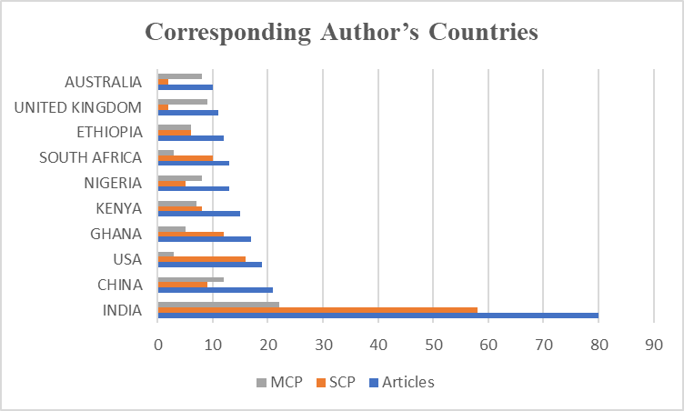

**Figure 3.** Corresponding Author’s Countries with their Publications

**4.6 Most Globally Cited Documents in the Scopus Database**

Table 5, the top 10 most cited documents published in the past 15 years (2004–2019) about the adoption of Climate-Smart Agricultural (CSA) innovations in drought environments globally (as retrieved from Scopus). These papers rated highly, are paradigm-shifting works that have greatly influenced the research field in this area. The article by Shahzad et al. is the most frequently cited. (2021) in Environmental Science and Pollution Research and has been cited 259 times, showing its broad impacts and views by researchers in all aspects of environmental sustainability and agricultural resilience. Behind them is Makate et al. (2019), in the Journal of Environmental Management, 232 citations, on the uptake of CSA practices in Sub-Saharan Africa, providing a bedrock to empirical studies of climate adaptation.

**Table 5.** The Most Globally Cited Documents in the Scopus Database

|  |  |  |  |
| --- | --- | --- | --- |
| **TC Rank** | **Paper** | **DOI** | **Total Citations** |
| 1 | SHAHZAD A, 2021, ENVIRON SCI POLLUT RES | 10.1007/s11356-021-12649-8 | 259 |
| 2 | MAKATE C, 2019, J ENVIRON MANAGE | 10.1016/j.jenvman.2018.10.069 | 232 |
| 3 | BHAT MA, 2020, FRONT MICROBIOL | 10.3389/fmicb.2020.01952 | 182 |
| 4 | ZERSSA G, 2021, AGRIC | 10.3390/agriculture11030192 | 181 |
| 5 | SRIVASTAV AL, 2021, ENVIRON SCI POLLUT RES | 10.1007/s11356-021-14332-4 | 175 |
| 6 | HABIB-UR-RAHMAN M, 2022, FRONT PLANT SCI | 10.3389/fpls.2022.925548 | 172 |
| 7 | BABU S, 2022, CHEMOSPHERE | 10.1016/j.chemosphere.2021.133451 | 164 |
| 8 | SENYOLO MP, 2018, J CLEAN PROD | 10.1016/j.jclepro.2017.06.019 | 155 |
| 9 | PAREEK A, 2020, J EXP BOT | 10.1093/jxb/erz518 | 151 |
| 10 | STEWARD PR, 2018, AGRIC ECOSYST ENVIRON | 10.1016/j.agee.2017.09.019 | 151 |

Other related works are Bhat et al. (2020) in Frontiers in Microbiology (182 citations) and Zerssa et al. (2021) in Agriculture (181), dealing with the biological and microbial aspects of CSA practices under drought stress. Publications of Srivastav (2021) and Habib-ur-Rahman (2022) in Environmental Science and Pollution Research and Frontiers in Plant Science are about plant-directed adaptive responses and sustainable resource use, with over 170 reads each. It is interesting to note that the list also contains articles published in journals with high impact factors, such as Chemosphere, Journal of Experimental Botany, and Journal of Cleaner Production, showing the diversity of scientific areas like environmental sciences, plant physiology, and sustainable production systems, which include CSA-related research. Steward et al. or absence of Steward et al. (2018), Agric., Ecosystem. Environment (151 citations) underscores the need for an integrative ecological perspective to agricultural adaptation in drought-prone systems. Together, the top-cited papers represented here illustrate the interdisciplinary and international nature of CSA innovation research. The high number of citations indicates acknowledgement from the research community that they are seminal papers in the respective area of research. Furthermore, the variety of publishing journals and topics, e.g., from microbiology to policy and ecosystem services, also shows the inter-sectoral and scientific broad relevance and interest in the complex task of climate adaptation in agriculture.

**4.7 Words' Frequency over Time**

Figure 4 recapitulates the incorporation of the climatic agricultural thematic lexicon within 2016 and 2025 literature sources and helps to trace the intellectual contours that outline climate-agricultural disaggregated research. In its measurement, this method follows nine domain-specific topics grouped into two primary clusters: (1) Climate-Impact Variables (CLIMATE CHANGE, CLIMATE EFFECT, DROUGHT) and (2) Agricultural Response Factors (CROP YIELD, FOOD SECURITY, ADAPTIVE MANAGEMENT, MAIZE, SMALLHOLDER [the last term is denoted in the figure as "SMAILHOLDER," probably a typo]). It is a focus on a particular location, and since they included the "INDIA." Crucial patterns emerge in the temporal trajectories: CLIMATE CHANGE and FOOD SECURITY dominate in terms of cumulative occurrences, and both have tessellated near-exponential growth after 2020, while the DROUGHT and CROP YIELD show synchronised spurts during El Niño–affected years (such as 2018, 2023). Context-dependent words such as SMALLHOLDER and ADAPTIVE MANAGEMENT show a tendency towards faster adoption from 2021, indicating a new paradigm rooted in resilience-based approaches. Particularly, the research for MAIZE and the study for INDIA overlap prominently with drought and yield words after 2020, as well, signifying regional susceptibility and adaptation needs for crops. By 2022, this migration of climate and agriculture vocabularies was especially evident from 2022 onwards and reflects the move of the field towards whole integrated socio-ecological systems analysis.

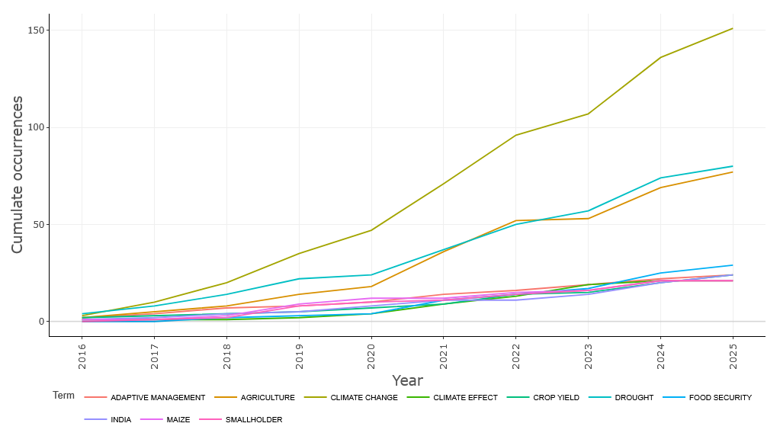

**Figure 4.** Words’ Frequency over Time

**4.8 Most Relevant Keywords**

Figure 5 presents the most frequently occurring terms in the literature on Climate-Smart Agricultural (CSA) innovations adoption in drought-prone areas, derived from the keyword and title field analysis. The term "climate change" dominates the dataset with a frequency of 151, underscoring its central role as the primary driver and contextual backdrop for CSA research. This is closely followed by "drought" (80) and "agriculture" (77), highlighting the thematic focus on water stress and agricultural adaptation as core research priorities. Terms like "food security" (29), "adaptive management" (24), and "crop yield" (24) suggest a strong emphasis on resilience outcomes, productivity, and decision-making frameworks in climate-affected farming systems.

The presence of country-specific terms such as "India" (24), "Pakistan" (15), and "Malawi" (14) reflects the geographic concentration of CSA studies in South Asia and Sub-Saharan Africa, regions highly vulnerable to drought and food insecurity. Crop-specific terms like "maize" (21) and "zea mays" (17) further indicate a research focus on staple cereals critical to smallholder livelihoods. Related agronomic and environmental concepts such as "water management" (21), "soil moisture" (15), "irrigation" (15), and "greenhouse gas" (10) illustrate the integration of biophysical elements in CSA research frameworks.

The inclusion of terms like "technology adoption" (14), "decision making" (11), and "precision agriculture" (10) suggests a growing interest in behavioural and technological dimensions of CSA uptake. Additionally, keywords such as "livelihood" (10), "farming system" (14), and "sustainable development" (11) point to the socio-economic and policy implications of CSA interventions.

Overall, the frequency analysis in Figure 5 reflects a multidimensional research landscape, where CSA is explored through intersecting lenses of climate impact, technological innovation, sustainability, and smallholder resilience. The diverse and interconnected nature of these terms reaffirms the interdisciplinary character of CSA adoption studies and highlights the critical need for context-specific, scalable solutions in drought-prone regions.

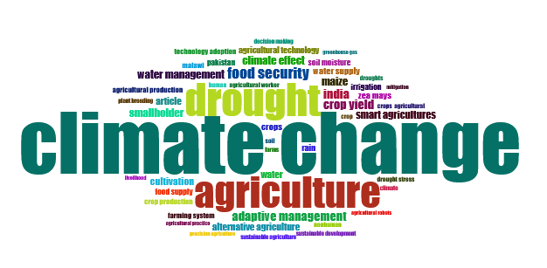

**Figure 5.** Most Relevant Keywords

**4.9 Network Analysis of Keywords**

Figure 6 presents a keyword co-occurrence network analysis of climate-agricultural research, derived from 2,656 keyword instances, with 17 high-frequency terms meeting the minimum occurrence threshold of 20. The network reveals three interconnected thematic clusters: (1) Climate Drivers ("climate change," "drought," "abiotic stress," "climate effect") highlighting environmental pressures; (2) Adaptation Strategies anchored by "climate-smart agriculture" (including lexical variants such as "climate smart agriculture" and "smart agricultures"), directly linked to resilience mechanisms ("resilience," "adaptation," and the contextualized term "adaptye management" [interpreted as adaptive management]); and (3) Socio-Agronomic Outcomes connecting "crop yield," "food security," crop-specific foci ("maize" [annotated as "maize"], "crops"), and stakeholder-regional dimensions ("smallholder," "india"). Notably, "India" exhibits strong co-occurrence with "drought" and "maize," emphasising region-context vulnerability studies. At the same time, the triad "abiotic stress → climate-smart agriculture → food security" underscores the field's integrated stress-resilience-security paradigm. Lexical variations (e.g., "maize," "adaptye") imply terminology standardisation gaps but align thematically with established concepts. The isolated node "agriculture" serves as an umbrella construct, and network density confirms the dominance of climate-adaptive frameworks, though conceptual fragmentation persists. This analysis quantitatively maps research priorities, exposing knowledge gaps (e.g., underrepresented crops/livestock) and enabling cross-study synthesis of core themes.

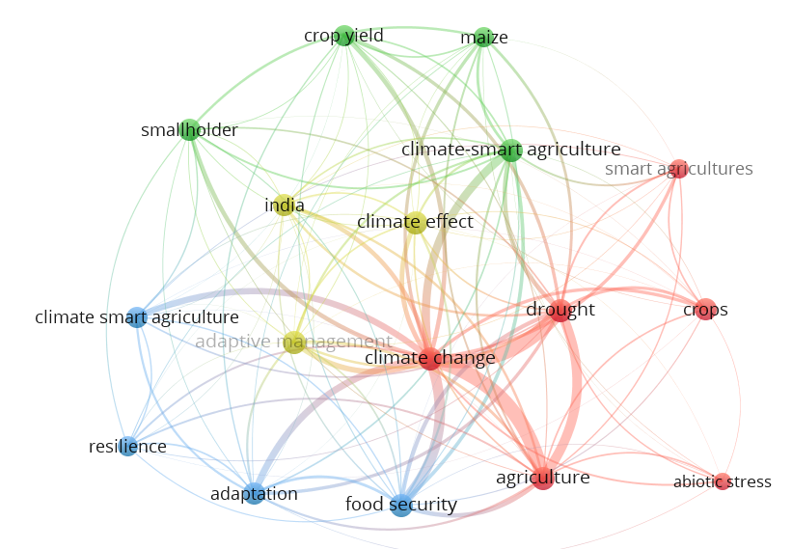

**Figure 6.** Co-occurrence Network of Keywords

**5.0 Discussion**

**5.1 Research Distribution in CSA Studies**

This analysis of 448 publications (2016–2025) elucidates the rapid evolution of Climate-Smart Agriculture (CSA) research in drought-prone regions, revealing significant growth trajectories, thematic priorities, and critical knowledge gaps. The field demonstrates robust scholarly acceleration, with an annual publication growth of 13.72% and a peak output of 111 articles in 2024. This trajectory aligns with heightened global policy focus following landmark climate agreements (e.g., Paris Agreement implementation, COP26/27 outcomes) and reflects mounting urgency to address climate-induced agricultural vulnerabilities. The average citation impact of 16.51 per document further confirms the field's academic influence, particularly through seminal works like Shahzad et al. (2021, 259 citations) that bridge environmental science and agricultural resilience.

Thematic analysis reveals a tripartite conceptual architecture dominating CSA discourse: (1) Climate Drivers ("climate change," "drought," "abiotic stress") contextualizing environmental pressures; (2) Adaptation Strategies anchored by "climate-smart agriculture" and linked to resilience mechanisms ("adaptive management," "resilience"); and (3) Socio-Agronomic Outcomes ("crop yield," "food security," "smallholder") emphasizing livelihood-productivity nexuses. The strong co-occurrence of "abiotic stress → CSA → food security" (Figure 6) signifies a paradigm shift toward integrated systems thinking, where climate adaptation is inseparable from food system resilience. However, persistent terminology fragmentation ("smart agriculture," "adaptye management") indicates ongoing conceptual maturation and underscores the need for standardised ontologies to enable cross-study synthesis.

Geographically, research leadership is concentrated in drought-vulnerable regions, with India dominating output (80 publications) through institutional strongholds like Tamil Nadu Agricultural University (27 papers) and thematic India-maize-drought linkages. Sub-Saharan Africa demonstrates significant collaborative capacity, as evidenced by Ghana's (17 papers) and Kenya's (15) high multinational publication ratios (MCP >30%). This regional alignment is scientifically appropriate yet reveals critical imbalances: Latin American drylands (e.g., Brazil's Caatinga, Mexico's Chihuahuan Desert) and West Asian arid zones remain severely underrepresented. Similarly, crop-specific research disproportionately focuses on maize (21 occurrences), neglecting drought-tolerant staples like sorghum, millet, and legumes essential to smallholder nutrition.

Collaboration patterns reveal a distinct North-South dynamic: While drought-affected regions lead research production, Northern institutions like the University of California function as crucial enablers through high MCP contributions (e.g., the UK's 9/11 MCP papers). The average of 4.44 authors per paper confirms CSA's transdisciplinary nature, though single-authored studies (8.3% of output) remain vital for contextual deep dives. Temporal keyword analysis (Figure 4) shows post-2020 surges in "adaptive management" and CSA terminology, coinciding with climate finance mobilization (e.g., Green Climate Fund allocations) and policy implementation phases. The 2024 publication peak likely reflects accelerated research investment during the Global Stocktake, while the 2025 decline (35 articles) is attributed to indexing lags rather than diminishing interest.

**5.2 Dataset of the CSA Studies**

The datasets underpinning research on Climate-Smart Agriculture (CSA) in drought-prone regions demonstrate a strong reliance on primary field data, which offers granular insights but reveals significant methodological and geographic limitations. Five of the eight studies analysed—including Samuel et al. (2024), Pal et al. (2022), and Martey et al. (2020)—depended on structured household or farm surveys, typically sampling 60–600 farmers. These datasets excel in capturing socio-economic variables (e.g., income resilience, technology adoption rates) and sub-group impacts (e.g., smallholder welfare), as seen in India’s NICRA villages, where CSA adopters reported 40% higher farm incomes and 19.5% greater drought resilience. However, their localised scope—often limited to single districts or watersheds—risks regional bias and constrains extrapolation to broader agroecological zones. Complementary agronomic trials (Njeru et al., 2016; Thierfelder et al., 2016) used replicated field experiments (36–448 plots) to quantify biophysical outcomes, such as sorghum yield increases of 3.1 t/ha in Kenya with tied ridges and soil amendments. While robust for validating on-farm efficacy, these trials rarely exceed six years, overlooking long-term climate feedback loops like soil carbon sequestration dynamics or shifting rainfall patterns.

Geographically, datasets skew heavily toward Africa and South Asia, with seven studies focused on India, Kenya, Ghana, and Mozambique. This leaves critical arid regions—such as Latin America’s Altiplano, West Asia’s drylands, or Australia’s rangelands—severely underrepresented. Consequently, CSA strategies validated in monsoonal Africa may falter in areas with distinct hydro-climatic stresses (e.g., Andean frost-drought synergies). Only Sholihah et al. (2024) leveraged remote sensing, using Landsat-derived land surface temperature (LST) data (2013–2023) to map thermal anomalies in Indonesia’s Citarum watershed. This approach enabled scalable, real-time drought monitoring (e.g., detecting sustained LST >30°C since 2018), yet such geospatial tools remain siloed from socio-economic metrics. No study integrated satellite data with household surveys, missing opportunities to correlate thermal stress with farmer adaptation behaviours.

A critical gap is the compartmentalisation of variables: biophysical studies emphasised yield and soil metrics but ignored livelihood impacts, while socio-economic assessments omitted soil moisture or carbon data. For instance, Martey et al. (2020) quantified DT maize yield gains (26–46%) in Ghana but did not link them to local soil health trends. Similarly, Thierfelder et al. (2016) reported conservation agriculture’s yield advantages (89% of cases) in Mozambique but lacked data on gender-differentiated labour costs. Future research demands integrated, multi-scalar datasets—merging longitudinal remote sensing, climate projections, agronomic trials, and socio-economic panels—to unravel the complex nexus of environmental stress, technological efficacy, and human vulnerability. Without this, CSA policies risk prioritising technical fixes over contextual realities, undermining resilience in the world’s most climate-vulnerable landscapes.

**Table 6.** Related Work on Climate-Smart Agriculture in Drought-Prone Regions

|  |  |  |  |
| --- | --- | --- | --- |
| **Paper (Authors, Year)** | **Problem Definition** | **Dataset** | **Result** |
| (Samuel et al., 2024) | Quantify the impacts of CSA technologies on farm income resilience during droughts in Indian drylands | Primary data from 60 farmers each in NICRA-adopted vs. control villages; stratified by land class (India) | NICRA villages had 40% higher farm income; 19.5% better resilience during droughts. Crop/livestock income is significantly higher in adopted villages. |
| (Njeru et al., 2020) | Soil fertility degradation and low yields in drought-prone Central Kenya | 371 farmers evaluating 36 plots; biophysical and perception data (Kenya) | Best treatment: Farmers' practice + soil amendment (40 kg P/ha + 20 kg N/ha) yielded 3.5 t/ha sorghum. Water harvesting (tied ridges) increased yields by 2.9–3.0 t/ha. |
| (Wang & Ren, 2025) | Mitigate agricultural drought impacts cost-effectively | N/A (Review) | CSA practices (cover crops, biochar, conservation tillage) reduce crop water stress. Need integrated metrics for drought resilience. |
| (Pal et al., 2022) | Impact of laser land levelling (LLL) on paddy yields/net income in Indian drought-prone areas | 604 farmer households (50% LLL adopters; 50% non-adopters) in Raichur, India | LLL adoption increased paddy yield by 12% and net income by 16%. Stronger impact on smallholders. |
| (Martey et al., 2020) | Welfare impacts of row planting + drought-tolerant (DT) maize in Ghana | Panel data from 438 households (2009–2013) in Ghana | Row planting + DT maize increased commercialisation intensity. DT maize outyielded traditional varieties by 26–46% (695–1,422 kg/ha). |
| (Thierfelder et al., 2016) | Low yields due to climate variability in central Mozambique | Maize/legume yield data from CA and conventional plots (Mozambique, 2007–2013) | CA outyielded conventional tillage in 89% of maize cases. DT maize varieties yielded 26–46% more than local varieties. |
| (Njeru et al., 2016) | Poor crop harvests due to drought in Central Kenya | 36 treatments × 3 replicates; sorghum yield data (Kenya) | Tied ridges + soil amendments (40 kg P/ha + 20 kg N/ha) yielded 3.1 t/ha sorghum—6× higher than controls (0.5 t/ha). |
| (Sholihah et al., 2024) | Rising temperatures are exacerbating drought in Indonesian agricultural watersheds | LST time-series for the Middle Citarum watershed (Indonesia) | LST consistently >30°C since 2018 (peak: 38.98°C in 2015). LST data enables early drought warnings for CSA planning. |

**6.0 Conclusions**

This global scientometric analysis of Climate-Smart Agriculture (CSA) adoption in drought-prone regions reveals a rapidly expanding yet unevenly distributed field of research. Between 2016 and 2025, scholarly output grew at 13.72% annually (448 publications), peaking at 111 articles in 2024—a trajectory reflecting heightened policy urgency following landmark climate agreements and increasing climate-induced agricultural vulnerabilities. The analysis uncovers significant geographic concentration: India dominates research production (80 publications), driven by institutions like Tamil Nadu Agricultural University (27 papers), while Sub-Saharan African nations (Ghana, Kenya, Nigeria) demonstrate robust collaborative networks with high multinational publication rates. Conversely, drought-vulnerable regions like Latin America's drylands (e.g., Brazil's Caatinga, Mexico's arid zones) and West Asia remain critically underrepresented, creating spatial knowledge gaps that hinder globally inclusive adaptation strategies.

Thematically, research coalesces around three interconnected clusters: (1) climate drivers ("drought," "abiotic stress") contextualising environmental pressures; (2) adaptation strategies ("climate-smart agriculture," "resilience") emphasizing technological and management responses; and (3) socio-agronomic outcomes ("crop yield," "food security," "smallholder") underscoring livelihood implications. While maize-centric studies dominate (21 keyword occurrences), drought-resilient staples vital for nutrition security—sorghum, millet, and legumes—receive scant attention. Methodologically, studies remain compartmentalised: empirical field trials (e.g., Njeru et al.'s validated 3.1 t/ha sorghum yield gains in Kenya) rarely integrate socio-economic metrics, while household surveys (e.g., Martey et al.'s findings of 26–46% maize yield increases in Ghana) overlook biophysical variables. Only one study (Sholihah et al., 2024) leveraged remote sensing for scalable drought monitoring, highlighting a critical gap in spatially explicit, multi-scalar approaches.

Collaboration patterns reveal a distinct North-South dynamic: drought-affected regions lead research production, but Northern institutions like the University of California and UK universities enable progress through high multinational partnerships (e.g., 82% of UK publications involved international co-authorship). Persistent terminology inconsistencies ("adaptivity management," "smart agriculture") impede knowledge synthesis, while the underrepresentation of livestock systems and long-term impact studies limits holistic resilience assessments. Moving forward, research must prioritise (a) expanding geographic focus to neglected arid regions, (b) integrating mixed methodologies (e.g., remote sensing + socio-economic panels), (c) standardising CSA ontologies, and (d) diversifying crop studies beyond maize. Policymakers should leverage validated CSA bundles—like integrated soil-water conservation (yield increases of 40–89% across studies) and drought-tolerant crop varieties—to scale context-specific innovations where climate vulnerability is most acute. This study contends that bridging these gaps is essential for transforming CSA from a fragmented academic pursuit into a unified global strategy for agricultural resilience.

**Disclaimer (Artificial intelligence)**

Option 1:

Author(s) hereby declare that NO generative AI technologies such as Large Language Models (ChatGPT, COPILOT, etc.) and text-to-image generators have been used during the writing or editing of this manuscript.

Option 2:

Author(s) hereby declare that generative AI technologies such as Large Language Models, etc. have been used during the writing or editing of manuscripts. This explanation will include the name, version, model, and source of the generative AI technology and as well as all input prompts provided to the generative AI technology

Details of the AI usage are given below:

1.

2.

3.

**7.0 References**

Ariom, T. O., Dimon, E., Nambeye, E., Diouf, N. S., Adelusi, O. O., & Boudalia, S. (2022). Climate-Smart Agriculture in African Countries: A Review of Strategies and Impacts on Smallholder Farmers. *Sustainability*, *14*(18), 11370. https://doi.org/10.3390/su141811370

Autio, A., Johansson, T., Motaroki, L., Minoia, P., & Pellikka, P. (2021). Constraints for adopting climate-smart agricultural practices among smallholder farmers in Southeast Kenya. *Agricultural Systems*, *194*, 103284. https://doi.org/10.1016/j.agsy.2021.103284

Haghani, M. (2023). What makes an informative and publication-worthy scientometric analysis of literature: A guide for authors, reviewers and editors. *Transportation Research Interdisciplinary Perspectives*, *22*, 100956. https://doi.org/10.1016/j.trip.2023.100956

Kabato, W., Getnet, G. T., Sinore, T., Nemeth, A., & Molnár, Z. (2025). Towards Climate-Smart Agriculture: Strategies for Sustainable Agricultural Production, Food Security, and Greenhouse Gas Reduction. *Agronomy*, *15*(3), 565. https://doi.org/10.3390/agronomy15030565

Lombe, P., Carvalho, E., & Rosa-Santos, P. (2024). Drought Dynamics in Sub-Saharan Africa: Impacts and Adaptation Strategies. *Sustainability*, *16*(22), 9902. https://doi.org/10.3390/su16229902

Mahedi, M., Pervez, A. K. M. K., Rahman, S. M. M., Sheikh, Md. M., & Shaili, S. J. (2025). Emerging Trends in Livelihood Diversification in Rural Communities: A Bibliometric and Systematic Review. *Asian Journal of Agricultural Extension, Economics & Sociology*, *43*(4), 162–177. https://doi.org/10.9734/ajaees/2025/v43i42727

Mahedi, M., Shaili, S. J., Nurnobi, M., Shihab, A. R., & Sakil, A. R. (2025). EFFECTS OF CLIMATE CHANGE ON LIVELIHOODS IN DROUGHT-PRONE REGIONS OF BANGLADESH: AN IN-DEPTH ANALYSIS.

Martey, E., Etwire, P. M., & Abdoulaye, T. (2020). Welfare impacts of climate-smart agriculture in Ghana: Does row planting and drought-tolerant maize varieties matter? *Land Use Policy*, *95*, 104622. https://doi.org/10.1016/j.landusepol.2020.104622

Md Shahriar Kabir, Md Mahedi, A K M Kanak Pervez, Md Jahangir Alam, & Shabrin Jahan Shaili. (2025). Bibliometric analysis of “precision agriculture” in the Scopus database. *World Journal of Advanced Research and Reviews*, *25*(3), 1087–1098. https://doi.org/10.30574/wjarr.2025.25.3.0733

Njeru, P. N. M., Maina, I., Lekasi, J. K., Kimani, S. K., Esilaba, A. O., Mugwe, J., & Muna, M. M. (2016). Climate smart agriculture adaptation strategies for rain-fed agriculture in drought-prone areas of Central Kenya. *International Journal of Agricultural Resources, Governance and Ecology*, *12*(2), 113. https://doi.org/10.1504/IJARGE.2016.076928

Njeru, P. N. M., Mugwe, J., Mucheru-Muna, M., Maina, I., Kimani, S. K., & Lelgut, D. K. (2020). Drought-Tolerant Crops in Kirinyaga County, Kenya: Climate-Smart Agriculture Adaptation Strategies. In W. Leal Filho (Ed.), *Handbook of Climate Change Resilience* (pp. 2401–2414). Springer International Publishing. https://doi.org/10.1007/978-3-319-93336-8_80

Pal, B. D., Kapoor, S., Saroj, S., Jat, M. L., Kumar, Y., & Anantha, K. H. (2022). Adoption of climate-smart agriculture technology in drought-prone area of India – implications on farmers’ livelihoods. *Journal of Agribusiness in Developing and Emerging Economies*, *12*(5), 824–848. https://doi.org/10.1108/JADEE-01-2021-0033

Rezvi, H. U. A., Tahjib‐Ul‐Arif, Md., Azim, Md. A., Tumpa, T. A., Tipu, M. M. H., Najnine, F., Dawood, M. F. A., Skalicky, M., & Brestič, M. (2023). Rice and food security: Climate change implications and the future prospects for nutritional security. *Food and Energy Security*, *12*(1), e430. https://doi.org/10.1002/fes3.430

Samuel, J., Rama Rao, C. A., Pushpanjali, Anshida Beevi, C. N., Raju, B. M. K., Amarender Reddy, A., Nagarjuna Kumar, R., Reddy, A. G. K., Singh, V. K., Prabhakar, M., Siva, G. S., & Teggelli, R. G. (2024). Enhancing farm income resilience through climate smart agriculture in drought-prone regions of India. *Frontiers in Water*, *6*, 1327651. https://doi.org/10.3389/frwa.2024.1327651

Sholihah, R. I., Trisasongko, B. H., Kusdaryanto, S., Karyati, N. E., Panuju, D. R., Iman, L. O. S., & Shiddiq, D. (2024). Climate smart agriculture strategy for drought-prone areas: The role of land surface temperature data. *IOP Conference Series: Earth and Environmental Science*, *1359*(1), 012094. https://doi.org/10.1088/1755-1315/1359/1/012094

Thierfelder, C., Rusinamhodzi, L., Setimela, P., Walker, F., & Eash, N. S. (2016). Conservation agriculture and drought-tolerant germplasm: Reaping the benefits of climate-smart agriculture technologies in central Mozambique. *Renewable Agriculture and Food Systems*, *31*(5), 414–428. https://doi.org/10.1017/S1742170515000332

Wang, L., & Ren, W. (2025). Drought in agriculture and climate-smart mitigation strategies. *Cell Reports Sustainability*, 100386. https://doi.org/10.1016/j.crsus.2025.100386

De Pinto, A., Cenacchi, N., Kwon, H. Y., Koo, J., & Dunston, S. (2020). Climate smart agriculture and global food-crop production. *PloS one*, *15*(4), e0231764.

Sardar, A., Kiani, A. K., & Kuslu, Y. (2021). Does adoption of climate-smart agriculture (CSA) practices improve farmers’ crop income? Assessing the determinants and its impacts in Punjab province, Pakistan. *Environment, Development and Sustainability*, *23*(7), 10119-10140.

Jellason, N. P., Conway, J. S., & Baines, R. N. (2021). Understanding impacts and barriers to adoption of climate-smart agriculture (CSA) practices in North-Western Nigerian drylands. *The Journal of Agricultural Education and Extension*, *27*(1), 55-72.

Zaidi, A., Ajibade, S., Shah, M., Bashir, F., Falude, E., Dodo, Y., Adewolu, A. & Ngo-Hoang, D. (2024). Evolution of climate-smart agriculture research: A science mapping exploration and network analysis. *Open Agriculture*, *9*(1), 20220396.

Wu, Y., Meng, S., Liu, C., Gao, W., & Liang, X. Z. (2023). A bibliometric analysis of research for climate impact on agriculture. *Frontiers in Sustainable Food Systems*, *7*, 1191305.

Naresh Kumar K, Yadav, H. S., & Bag, A. G. (2024). Physical Consequences of Climate Change on Agriculture: Causes and Effects. *International Journal of Plant & Soil Science*, *36*(6), 213–229.