Assessing the Effectiveness of Career Counselling on High School Students’ Career Choices: A Case Study from Barobaybay Academy, Northern Samar, Philippines

ABSTRACT

The transition from adolescence to adulthood is a pivotal stage, particularly when it comes to making significant career-related decisions. At Barobaybay Academy Mission School, students have access to various resources and support systems designed to guide them through this process. However, the effectiveness of the school's career counselling programs in shaping students' career choices remains uncertain. This study investigates the effectiveness of career counselling in shaping the career decisions of Junior and Senior High School students at Barobaybay Academy Mission School in Lavezares, Northern Samar, Philippines. Using a mixed-methods approach, data were gathered through survey questionnaires and open-ended responses from 144 students. Quantitative data were analysed using descriptive statistics, while qualitative responses underwent thematic analysis. Findings revealed that students agreed that counselling helped them understand their strengths and interests (WM = 3.65), clarify career goals (WM = 3.62), and match their strand to their desired career (WM = 3.64). Student also agreed that financial constraints influence their decision to stay (WM = 3.35). and that counselling helps them cope with strain limitation (WM = 3.19). However, the impact is hindered by limited awareness, irregular implementation, and a lack of access to guidance counsellors. Many students expressed neutral responses regarding their confidence in making career decisions and reported not actively engaging with counselling services. Economic factors, such as financial constraints and limited strand offerings, significantly influence student choices. The study recommends enhancing counsellor availability, extending services to all grade levels, increasing promotion and visibility of counselling programs, and involving parents in the process.

Keywords: Career Counselling, Career Decision-Making, Student Awareness, Guidance Services, Secondary Education, Barobaybay Academy

- INTRODUCTION
A career represents more than just a job or a paycheck—it is an ongoing journey filled with various activities. It begins with students’ education, which equips them with the skills needed to perform meaningful tasks in the future. This journey also encourages continuous learning and growth, allowing individuals to enhance their abilities, find purpose, and fulfill their potential.

Since a career spans a significant portion of a person’s life, it is essential for students to carefully consider their career choices and plan accordingly. In today’s rapidly evolving job market, career decisions play a crucial role in shaping their future. Therefore, making informed and thoughtful choices is not only important but also necessary, as it significantly impacts one’s life direction and overall fulfilment.

The transition from adolescence to adulthood is a pivotal stage, particularly when it comes to making significant career-related decisions. At Barobaybay Academy Mission School, students have access to various resources and support systems designed to guide them through this process. However, the effectiveness of the school's career counselling programs in shaping students' career choices remains uncertain. While there is anecdotal evidence highlighting the value of career counselling, there is a lack of substantial research evaluating its impact within the specific context of Barobaybay Academy. It is essential to identify areas where career counselling practices can be strengthened to better support students in their decision-making process. Without a comprehensive understanding of how these programs influence student outcomes, it becomes difficult to assess their effectiveness in helping students define clear career goals and feel adequately prepared for their chosen paths (Astuti et al., 2022). Although Barobaybay Academy offers career counselling services, there is still a gap in understanding the extent to which these programs influence students' career decisions.

The Philippines, with its robust economic growth and a thriving technology sector, presents young people with a multitude of opportunities. Yet, this abundance of choices can create a unique set of challenges. It’s difficult for students to navigate their own interests, skills, and aspirations when faced with such a vast landscape of career options. This is where the role of career counselling becomes essential.

Republic Act No. 11206, known as the “Secondary School Career Guidance and Counselling Act,” aims to institutionalise a career guidance and counselling program in all public and private secondary schools across the Philippines. Its primary objectives are to provide students with proper direction in pursuing tertiary education, equip them with the capability to make informed career decisions, and expose them to the relevant labour market. Career guidance describes a range of school-based interventions which seek to prepare young people for their transition to their post-secondary school lives and to empower them to be successful in their lives and careers (Wong et al., 2021). It is based on the premise that an increase in the quantity and quality of career guidance will lead to an increase in young people’s career readiness (Dodd et al., 2022).

Career guidance and counselling are crucial for Grade 7 to Grade 12 students at Barobaybay Academy Mission School as they prepare for their future careers. These services help students make informed decisions when selecting a senior high school strand that aligns with their intended college course, ensuring they are better prepared for their chosen career path. By receiving proper career counselling, students gain the necessary knowledge and support to explore various career options, empowering them to make confident and meaningful choices after junior high school. For young people in rural places that often have limited labour markets and opportunities, rational decisions must necessarily involve considering moving away to access a greater range of opportunities and improving one’s economic prospects (Alexander & Fuqua, 2024).

With rapid changes in the job market, technological advancements, and shifting educational trends, students face increasing pressure to choose the right career paths (Zafar, 2019). At Barobaybay Academy Mission School, career counselling services are available to help students navigate these challenges, but the extent to which these services influence students’ career decisions remains a topic of interest. This study seeks to evaluate the effectiveness of career counselling in Barobaybay Academy Mission School, identifying challenges and recommending improvements to ensure students receive proper guidance.
In support of this, various local and international studies affirm the significant role of counselling in student career development. Local research, such as that by Villanueva and Ramos (2023) and Santos and Dela Cruz (2019), provides strong contextual relevance by demonstrating how students in Northern Samar benefited from counselling services, particularly in terms of expanded career options and improved decision-making. These studies reflect similar socio-economic and educational conditions, offering valuable comparisons for Barobaybay Academy.

Meanwhile, international studies broaden the perspective by showcasing global best practices and reinforcing theoretical frameworks used in this research. For instance, studies in the United States, the United Kingdom, and Canada emphasise the importance of continuous, individualised, and even virtual counselling services in boosting students’ confidence, career clarity, and decision-making skills. Research by Howard and Walsh (2021), Perry et al. (2018), and Dixon and Dineen (2019) supports the theoretical underpinnings of this study—such as Holland’s Theory and Bandura’s Social Cognitive Theory—highlighting how effective counselling fosters career self-efficacy and alignment between personal attributes and career paths.
Collectively, these studies provide both a local foundation and international validation for investigating the effectiveness of career counselling. They support the rationale for evaluating and enhancing counselling programs at Barobaybay Academy Mission School to better equip students for informed, realistic, and fulfilling career choices.

- MATERIALS AND METHODOLOGY
Research Design
This study adopts a descriptive quantitative research design with qualitative elements. The quantitative component involves the use of structured survey questionnaires to gather numerical data on students' awareness, utilisation, and perceived effectiveness of career counselling services. The qualitative component consists of open-ended questions aimed at eliciting deeper insights into students' experiences, challenges, and suggestions regarding career counselling (Takona, 2024). This design is appropriate as it allows the researcher to describe the current condition of the career counselling program and its influence on students’ career choices without manipulating any variables.

Locale of the Study
This study was conducted at Barobaybay Academy Mission School (BAMS), located in Barangay Barobaybay, Lavezares, Northern Samar. Established on July 12, 1970, it was the first private secondary school in the municipality, founded by Brother Priest Rev. Tryphoon, Rev. Fr. John Garduce, OSB, and Sister Catalina Garduce. Upon their passing, the administration of the school was entrusted to the Missionary of the Child Jesus. BAMS was established to provide quality private secondary education to underprivileged youth in Barangay Barobaybay and neighbouring island barangays. Over the years, it has grown into a reputable institution, currently catering to both Junior and Senior High School students.

Population and Sampling
This study utilised the total population sampling method, a type of purposive sampling where the entire population that meets the criteria is included as respondents. The population consists of 144 Junior and Senior High School students enrolled at Barobaybay Academy Mission School (BAMS) in Lavezares, Northern Samar, during the school year 2024-2025. The distribution is in Figure 1.1:

Fig. 1- Enrollment Data

Research Variable

INPUT OUTPUT
Demographic Profile
Counselling Services
Challenges in Counselling

Career Counselling Program
Awareness and Utilization
Recommendations

Research Instrument
This study will use a researcher-made survey questionnaire. The research questionnaire was divided into five parts. The first part of the instrument is about the demographic profile, such as age, gender and grade level (Bihu, 2021). The second part is about career counselling and decision-making. The third part is about the awareness and utilisation of counselling services. The fourth part is about the strand limitation and the student's decision. The fifth part is about the preferences and suggestions on the career counselling program.
Validation of Instrument
To ensure validity and reliability, the instrument underwent:
Expert validation by education professionals.
Pilot testing among a small sample group (not included in final data analysis)
Revisions were made based on feedback before full deployment.
Data Gathering Procedure
To gather the necessary data, the researchers will ask permission from the principal and will give a letter to the respondents. The researcher will personally give the questionnaires to the respondents during School Year 2024-2025, and they will be collected after answering.
Scoping and Interpretation of Data
The scoring process and interpretation of the gathered data of information in this research study were based on the five-point Likert scale:
Chart 1: Scoring based on a five-point Likert scale
Scale | Weight | Descriptive Rating
5 | 4.21–5.00 | Strongly Agree
4 | 3.41–4.20 | Agree
3 | 2.61–3.40 | Neutral
2 | 1.81–2.60 | Disagree
1 | 1.00–1.80 | Strongly Disagree

Open-ended questions are also included to capture qualitative insights into the students' personal experiences with career counselling.

Statistical Treatment
The researcher will use descriptive Statistics to summarise the demographic profile of respondents and responses to Likert-scale items. Frequency and Percentage are used to describe the distribution of respondents according to age, gender, and grade level. Mean and Standard Deviation are used to measure the average response and variability of students' perceptions regarding: The impact of career counselling on their career decision-making, and their awareness and utilisation of counselling services. Weighted Mean will be used to interpret responses to Likert-scale items evaluating the Effectiveness of career counselling with the Level of awareness and usage (Scale: Strongly Agree = 5, Agree = 4, Neutral = 3, Disagree = 2, Strongly Disagree = 1).
Thematic Analysis for open-ended questions, responses will be analysed through coding and categorisation to identify common themes and patterns regarding: Challenges in the career counselling program, Recommendations for improving the services.
- RESULTS AND INTERPRETATION
Quantitative data were analysed using descriptive statistics such as frequency, percentage, weighted mean (WM), and standard deviation (SD) to describe respondents' demographics and perceptions. Thematic analysis was employed for open-ended qualitative responses to extract recurring themes from student preferences and suggestions.
- Demographic Profile of Respondent

Table 1: Demographic Profile in terms of Age
Age Range | Frequency | Percentage (%)
12-13 | 40 | 27.79
14-15 | 45 | 31.25
16-17 | 30 | 20.83
18-19 | 28 | 19.44
20-21 | 1 | 0.69
Total | 144 | 100%

Table 1 shows the Demographic profile of the respondents in terms of the age range of respondents ranges from 12 to 21. The majority fall within the 14–15 age group (31.25%), followed by 12–13 years old (27.79%). This indicates that most participants are early adolescents, which aligns with the Junior and Senior High School level composition of Barobaybay Academy Mission School.
Table 2: Demographic profile in terms of Gender
Gender | Frequency | Percentage (%)
Male | 68 | 47.22
Female | 76 | 52.78
Total | 144 | 100%

Table 2 shows in terms of gender distribution. Out of 144 students, 76 are female (52.78%) and 68 are Male (47.22%). This slight predominance of female students suggests a nearly balanced gender distribution among the respondents.
Table 3: Demographic profile in terms of Grade Level
Grade Level | Frequency | Percentage (%)
Grade 7 | 24 | 16.67
Grade 8 | 21 | 14.58
Grade 9 | 23 | 15.97
Grade 10 | 25 | 17.36
Grade 11 | 28 | 19.44
Grade 12 | 23 | 15.97
Total | 144 | 100%

Table 3 presents the demographic profile in terms of grade level. The largest group of respondents are from Grade 11 (19.44%), while Grade 8 has the fewest students (14.58%). This distribution supports the focus on both Junior and Senior High School Students and reflects a fairly even participation across grade levels.
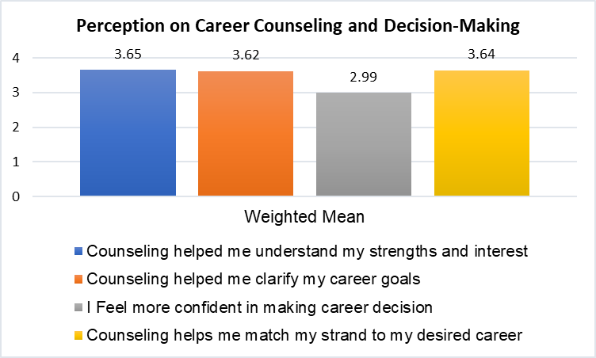Fig. 2 – Career Counselling and Decision Making
Figure 2 indicates that students agreed that counselling helped them understand their strengths and interests (WM = 3.65), clarify career goals (WM = 3.62), and match their strand to their desired career (WM = 3.64).
However, students felt neutral about gaining confidence in making career decisions (WM=2.99), indicating a gap where further intervention may be needed to boost decision-making skills.
The data shows that while career counselling has positively impacted self-awareness and career goal formation, there remains a need to strengthen students’ confidence in making final career decision.
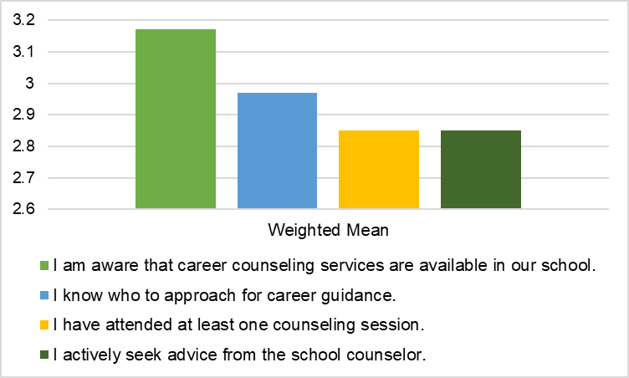
Fig. 3: Awareness and Utilisation of Counselling Services

In Figure 3, Respondents showed neutral responses regarding awareness and use of counselling services, with WM Scores ranging from 2.85 to 3.17.
Most students are not actively seeking counselling or aware of specific guidance personnel.
This means that there is a lack of strong awareness and engagement with the available counselling service. Greater promotion and visibility of counselling programs and personnel are needed.
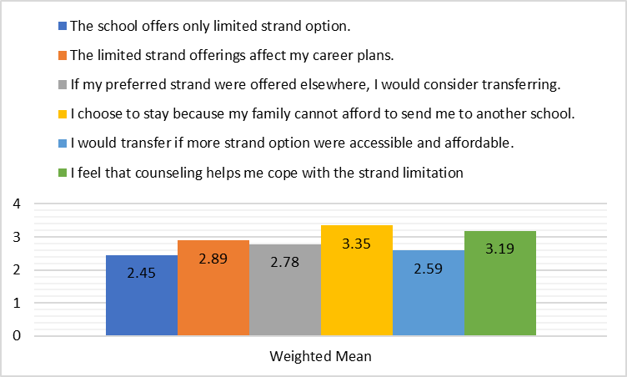
Fig. 4: Strand Limitation and Student Decisions
In Figure 4, presented that students disagree that the school offers limited strand options (WM = 2.45), suggesting relative satisfaction with current offerings.
However, responses were neutral on whether strand limitations affect career plans (WM = 2.89) and on their willingness to transfer if more options were available (WM = 2.78).
Student also agreed that financial constraints influence their decision to stay (WM = 3.35). and that counselling helps them cope with strand limitation (WM = 3.19).
This means that while strand availability may not be the main issue, economic factors play a significant role in students’ decisions. Counselling appears helpful in navigating these constraints.
- Preferences and Suggestions
Students were asked open-ended questions regarding their preferred strands, career aspirations, reasons for staying at Barobaybay Academy Mission School, and suggestions for improving the career counselling program. The researcher used Thematic Analysis.
Preferred Strand (Top Responses)
- Many students prefer GAS AND TVL, which are already available at the school.
- Other expressed interest in STEM, HUMSS, Sport, and Arts.
- A large number of students were undecided, indicating a need for enhanced guidance.
Preferred College Courses
- Most common responses: Criminology, Education, Business, Technology and Engineering.
- Notably, 15 students remained undecided, highlighting the importance of counselling.
Reasons for Staying at Barobaybay Academy Mission School
- Financial constraints and accessibility
- Scholarships
- Family influence
- School environment (Teachers, peers, class size)
Suggestion for Improving Counselling
- Wider access: Include parents at all levels, not just Grade 10 and 12.
- Consistency: Permanent presence of a Guidance Counsellor.
- Parental Involvement: Include parents in counselling decisions.
- Confidence-building and Career awareness program needed.
This area shows that students recognise the value of counselling but recommend systematic improvements to make it more accessible, inclusive and effective.

- DISCUSSION
This chapter presents a detailed interpretation of the study’s findings, focusing on how they address the central issue identified in the introduction—the gap between the availability of career counselling services and their actual effectiveness in shaping students’ career decisions at Barobaybay Academy Mission School.
In the Background of the Study, it was noted that while career counselling services exist in the school, there is limited empirical evidence assessing their real impact. Although the Philippine government mandates career guidance in all secondary schools under Republic Act No. 11206, the actual implementation and outcomes remain inconsistent across institutions. This study was conducted precisely to examine that implementation gap and to understand whether these services are truly influencing students’ career choices.
Bridging the Gap: What the Study Found
The results indicate that career counselling is moderately effective in helping students recognise their interests and make strand-related decisions. This is evident in the high weighted means for statements such as:
“Counselling helped me understand my strengths and interests” (WM = 3.65)
“Counselling helps me match my strand to my desired career” (WM = 3.64)
These findings suggest that when students do receive career counselling, it can positively impact their self-awareness and help align their academic track with future goals. This partially fulfils the expectations set forth by both national policy and global best practices, which argue that counselling fosters career readiness and informed decision-making.
However, the study also exposes a critical gap in actual engagement with counselling services. Students were neutral on whether counselling boosted their confidence in making career decisions (WM = 2.99), and similarly neutral in terms of awareness and utilisation, such as:
“I know who to approach for career guidance” (WM = 2.97)
“I have attended at least one counselling session” (WM = 2.85)
“I actively seek advice from the school counsellor” (WM = 2.85)
These neutral ratings reflect the core problem identified in the introduction—the existence of services without consistent implementation or student engagement. This disconnect may be due to the absence of a full-time guidance counsellor, limited promotion of services, or lack of integration within the school culture. Despite policies in place, the on-the-ground reality shows that students are not fully accessing or benefiting from these services, which significantly reduces their overall effectiveness.
The Role of External Constraints
Another key finding is the powerful role of socioeconomic limitations in student decision-making. Many students agreed that financial constraints influence their decision to stay at Barobaybay Academy, even if their preferred strand is unavailable (WM = 3.35). This highlights a structural barrier to effective career planning—students are often forced to choose practicality over preference, which counselling alone cannot resolve.
While students disagreed that the school’s strand limitations are a serious concern (WM = 2.45), they agreed that counselling helps them cope with these limitations (WM = 3.19). This demonstrates that although counselling may not remove barriers, it serves a valuable supportive function, helping students adjust expectations and find meaningful pathways within their constraints.
Undecided Students and Missed Opportunities
The presence of a significant number of undecided students regarding both strand selection and future careers further emphasises the need for more robust, consistent, and individualised counselling. Despite the availability of services, many students are still unclear about their academic and professional futures—a direct consequence of limited counselling exposure. This reveals that the current structure does not sufficiently prepare students for informed career planning.
Qualitative responses reinforced this by highlighting student desires for:
- Broader strand offerings (including STEM and HUMSS)
- More regular counselling sessions
- Greater parental involvement
- A more visible and active guidance presence
These findings support the assertion in the introduction that simply having a counselling program is not enough—it must be made accessible, engaging, and comprehensive to have a meaningful impact.
Relating Results to Theoretical and Contextual Foundations
The findings validate aspects of both Bandura’s Social Cognitive Theory and Holland’s Theory of Career Choice, as referenced in the introduction. Students’ decisions are clearly influenced by self-efficacy, environmental limitations, and social influences. Counselling can help improve self-awareness and decision-making, but without sufficient access or engagement, its theoretical benefits remain unrealised.
Moreover, local studies such as those by Villanueva & Ramos (2023) and Santos & Dela Cruz (2019)—which emphasised the importance of localised, sustained counselling—resonate with this study's results. International research by Howard & Walsh (2021) and Perry et al. (2018) also stresses that frequency, personalisation, and inclusivity are key to successful counselling programs, and these are precisely the elements that need improvement at Barobaybay Academy.
V. CONCLUSION
This study aimed to assess the effectiveness of counselling on student career choices at Barobaybay Academy Mission School in Lavezares, Northern Samar. Based on the results, it is concluded that career counselling has a moderately positive impact on students' ability to understand themselves, align academic strands with future careers, and adapt to limitations in strand availability.
Students acknowledged that counselling helps them identify their strengths and clarify goals, particularly in choosing strands aligned with their career interests. However, their neutral stance regarding confidence in career decision-making and their limited awareness and use of counselling services reveal critical gaps in implementation.
Furthermore, external factors—such as financial constraints, lack of school offerings, and family influence—exert a stronger impact on students’ educational choices than counselling does. Although counselling helps students cope with such barriers, its potential is not fully realised due to inconsistent access and limited outreach, especially in lower grade levels.
Overall, while the foundation of an effective career counselling program exists, its effectiveness is hindered by structural, economic, and programmatic challenges. Addressing these barriers is essential to transforming career guidance into a powerful tool for informed decision-making among students.
Implications
Based on the conclusions drawn, the following implications and recommended actions are presented:
1. Institutionalisation of Counselling Services
The school should ensure the permanent presence of a guidance counsellor who can provide consistent, ongoing support throughout the academic year.
2. Expansion of Counselling to All Grade Levels
Career guidance should not be limited to Grades 10 and 12. Early exposure to counselling in Grades 7 to 9 will help students develop long-term career awareness and readiness.
3. Increased Awareness and Utilisation
The school administration must intensify promotion of counselling services. Orientation sessions, classroom visits, and regular student engagement can help bridge the awareness gap.
4. Parental Involvement
Encouraging parental participation in career planning discussions will align school guidance with family support, particularly in households with limited financial flexibility.
5. Career Development Programs
Implement career fairs, seminars, and workshops to expose students to various career paths and industries. These programs will particularly benefit students who remain undecided about their future.
6. Addressing Socioeconomic Barriers
While beyond the full control of the school, efforts such as scholarship opportunities, partnerships with local industries, or career immersion programs can provide more tangible support and alternatives for students facing financial constraints.
7. Strand Offering Review
Although current offerings focus on GAS and TVL, periodic surveys should assess student demand for additional strands such as STEM, HUMSS, or Arts, which may guide future curriculum development.

CONSENT
All participants in this study were informed of the purpose, procedures, and voluntary nature of their involvement. Prior to the data collection, an approved written informed consent was obtained from the Office of the Principal.
The approval letter emphasised participants’ rights to confidentiality, anonymity, and the freedom to withdraw at any time without penalty. A copy of the signed approval letter is available and can be provided to the journal editorial board upon request.
ETHICAL APPROVAL
This study was conducted in accordance with ethical standards and institutional guidelines for research involving human participants. Prior to data collection, approval letter was obtained from the Office of the Principal of Barobaybay Academy-Mission School, Inc.
The research adhered to ethical principles outlined in the Declaration of Helsinki and ensured the protection of participants’ rights, including confidentiality, anonymity, and voluntary participation. All respondents were informed about the nature and purpose of the study, and approval letter to access to student’s and personnel participation was secured.

Disclaimer (Artificial intelligence)

Option 1:

Author(s) hereby declare that NO generative AI technologies such as Large Language Models (ChatGPT, COPILOT, etc.) and text-to-image generators have been used during the writing or editing of this manuscript.

Option 2:

Author(s) hereby declare that generative AI technologies such as Large Language Models, etc. have been used during the writing or editing of manuscripts. This explanation will include the name, version, model, and source of the generative AI technology and as well as all input prompts provided to the generative AI technology

Details of the AI usage are given below:
1.
2.
3.

References:
Jocelyn Pick, Career Guidance and assessment in the Philippines. https:// www.profileasiapacific.com

DepED access from https://jur.ph

Super, D. E. (1957). The psychology of careers. Harper & Row.

Holland, J. L. (1997). Making vocational choices: A theory of vocational personalities and work environments. Psychological Assessment Resources.

Bandura, A. (1968). Social foundation of thought and action: A social cognitive theory. Engwood Cliffs, NJ: Prentice-Hall.

Villanueva, M. S., & Ramos, E. T. (2023). The Role of Counseling in Improving Career Decision-Making Among High School Students. Northern Samar Journal of Educational Research, 9(1), 34-49.

Cruz, M. D., & Garcia, L. M. (2022). The Impact of Career Guidance on Senior High School Students’ Career Decision-Making. Journal of Philippine Education Research, 14(2), 45-58.

Reyes, C. A., & Bautista, F. M. (2020). The Effectiveness of Career Counseling in Enhancing Career Readiness among Senior High School Students. Philippine Journal of Guidance and Counseling, 8(1), 112-128.

Santos, R. T., & Dela Cruz, P. N. (2019). Career Counseling and Its Impact on Students’ Career Maturity in Private Schools. Philippine Journal of Educational Psychology, 5(3), 89-104.

Domingo, L. P. (2021). Influence of Career Counseling on the Career Preferences of Grade 12 Students. Journal of Philippine Educational Studies, 17(4), 67-82.

Howard, K. A., & Walsh, M. E. (2021). Virtual career counseling during COVID-19: Implications for high school student outcomes. Career Development Quarterly, 69(2), 134–149. https://doi.org/10.1002/cdq.12263

Perry, E., Deardon, L., & Morris, M. (2018). The long-term effects of career guidance interventions: Evidence from England. British Journal of Guidance & Counselling, 46(2), 219–231. https://doi.org/10.1080/03069885.2017.1346230

Dixon, K., & Dineen, M. (2019). The impact of individualized career counseling on adolescents' self-efficacy and decision-making. Canadian Journal of Career Development, 18(2), 45–52.

Fouad, N. A., & Bynner, J. (2017). Cultural considerations in career counseling for immigrant youth in Europe. International Journal for Educational and Vocational Guidance, 17(1), 5–20.

McMahon, M., Watson, M., & Bimrose, J. (2017). Telling stories of career development: A narrative approach to career counseling with high school students. Australian Journal of Career Development, 26(2), 62–70.
Alexander, R., & Fuqua, M. (2024). Ruraling career guidance research and practice: learning from rural perspectives. International Journal for Educational and Vocational Guidance, 1-18.

Dodd, V., Hanson, J., & Hooley, T. (2022). Increasing students’ career readiness through career guidance: measuring the impact with a validated measure. British Journal of Guidance & Counselling, 50(2), 260-272.

Wong, L. P., Yuen, M., & Chen, G. (2021). Career-related teacher support: A review of roles that teachers play in supporting students’ career planning. Journal of Psychologists and Counsellors in Schools, 31(1), 130-141.

Zafar, M. (2019). Career Guidance in Career Planning among Secondary School Students. Asian Journal of Education and Social Studies, 5(1), 1–8.

Astuti, B., Purwanta, E., Lestari, R., Bhakti, C. P., Anggela, E., & Herwin, H. (2022). The Effectiveness of Digital Module to Improve Career Planning of Junior High School Students. World Journal on Educational Technology: Current Issues, 14(3), 940-950.

Takona, J. P. (2024). Research design: qualitative, quantitative, and mixed methods approaches. Quality & Quantity, 58(1), 1011-1013.

Bihu, R. (2021). Questionnaire survey methodology in educational and social science studies. International Journal of Quantitative and Qualitative Research Methods, 9(3), 40-60.

