EXPLORING THE ENTREPRENEURIAL OPPORTUNITIES OF RECYCLED TEXTILES IN ADO EKITI

ABSTRACT
Recycling textile waste presents a double opportunity in addressing environmental concerns and unlocking new income-generating ventures. The increasing awareness of environmental sustainability and the drive towards sustainable practices has sparked a growing interest in exploring innovative solutions for reducing the waste that comes from the textile industry, used and discarded clothing. The market demand for eco-friendly and socially responsible products are growing rapidly, driving the need for innovative and sustainable materials that will divert from the usual filling of lands with textile waste. This study delves into the entrepreneurial opportunities presented by the recycling and repurposing of textile waste, aiming to shed light on the potential for sustainable business ventures and promoting environmental sustainability, job creation and economic development in Ado Ekiti. It also identifies potential ventures, and explores insights from successful initiatives across Nigeria.
Keywords: Recycling, Textiles waste, Entrepreneurial, Up-cycling, Opportunities

INTRODUCTION
The world has been facing a growing crisis in textile wastes due to global population growth and improved living conditions, combined with a decrease in the life cycles of textile products and once a product has been used for as long as possible and perhaps re-used by others, it should be recycled (Abrishami et al 2024). Textile recycling is one of the important aspects for reducing the massive waste problem generated by the fashion and textile industries. The escalating concerns surrounding the environmental impact of the textile and fashion industry have brought forth a pressing need for sustainable solutions. In recent years, the global fashion industry has undergone a transformative shift, spurred by a burgeoning awareness of environmental concerns and a growing emphasis on sustainable practices. As the world grapples with mounting waste and resource depletion, the spotlight has turned towards recycling and repurposing materials as a means to combat this global challenge. Among these solutions, recycled and repurposed textile materials have emerged as a promising avenue for entrepreneurs seeking to align profitability with environmental responsibility. Entrepreneurial opportunities are out there; individuals simply need to identify them (Mueller 2007). These opportunities may arise from some kind of environmental change, such as technological progress or by using market change, such as the departure of competitors. Entrepreneurship matters for developing countries because markets matter (Ács & Amorós 2008). According to Chidume 2021, Recycling is good business in any nation because individuals can earn money from wastes and also the environment will also be sanitised by reusing these waste products. Recycling serves individuals, communities and entire nations by benefiting personal well-being, societal health and national economies. Recycling according to Anqi (2022) is the process of collecting and converting resources into new goods that would otherwise be discarded as garbage. Recycling can provide individuals with gainful employment by collecting waste materials and transforming them into useful products for sale. This allows people to earn a living through recycling activities. When such ventures are established within communities, they can grow into businesses that create jobs for others, thereby contributing to national economic development. Through these processes, waste is effectively converted into wealth for the nation.
In Ado-Ekiti, textile wastes are part of solid wastes generated by every household. Okafor et al (2021) also stated that In Nigeria, textile waste is part of the solid wastes generated. Ado-Ekiti, an ancient city in Nigeria is located between latitudes 70 331 and 70 431 North of the equator and longitudes 50 071 and 50 221 East of the Greenwich meridian. The area spans approximately 5,888.9 km² and is bordered by Kwara State to the north, Kogi State to the east, Osun State to the west, and Ondo State to the south. It lies predominantly within an upland zone, rising over 250 meters above sea level, and is characterized by rocky outcrops. According to the 2006 Population Census (NBC 2007), Ado-Ekiti has a total population of 313,690, with rapid urbanization continuing to shape the region's growth.
Ogwueleka (2009), stated that the projected population as at 2017 using a growth rate of 2.5% stands at 411,553 and an increase in population will naturally lead to an increase in the amount of fabric waste generated.
Fabrics are one of the most important waste materials available in most societies in Nigeria (Chidume 2021). Clothing and textiles are essential part of everyday life and a key player in the global Economy. Rouch (2021) states that clothing represents more than 60 percent of the total textiles used and is expected to remain the largest application. Chen 2021 also opines that textiles are essential to humans in a variety of ways, especially clothing and the speed at which they end up in landfills is astonishing posing a severe risk to the environment, if the trend continues. The growth of the textile industry has led to a rise in textile waste. This waste is generally classified into two main categories: pre-consumer textile waste, which is generated during the production process and post-consumer textile waste, which arises after consumer use and before disposal. Most fabric wastes are not easily biodegradable and can remain on land for long periods, rendering such areas unsuitable for farming or other agricultural activities. However, a positive aspect of these wastes is that they can be repurposed into new products and used repeatedly until they reach a stage where natural biodegradation becomes possible. Apart from the environmental and ecological advantages which can be brought about by the re-use and recycling of textiles, there are many benefits of a socio-economic nature. Walter et al 2019 stated that the field of textiles is a consumption area which, along with food, housing and mobility, causes greatest environmental impacts and by means of re-use and recycling, some of these environmental impacts may be reduced.The exploration into the entrepreneurial opportunities in recycled textile materials in Ado-Ekiti aims to shed light on the potential for innovative businesses to thrive in this sustainable space. Textile recycling and entrepreneurship contribute to sustainable development by fostering innovation, waste reduction and economic empowerment. This synergy can create a sustainable business that will address the environmental challenges while promoting community sustenance.

INSIGHTS FROM SUCCESSFUL INITIATIVES ACROSS NIGERIA.
There are several successful initiatives across Nigeria that has highlighted the growing potential of textile recycling as both a sustainable and economically viable venture. These are;
- Planet 3R (Ibadan)
Planet 3R based in Ibadan Oyo State, founded by Adejoke Lasisi, is a social enterprise focused on transforming textile and plastic waste into eco-friendly products by applying the principles of Reduce, Reuse, and Recycle. Through creative weaving techniques, they repurpose waste materials into innovative, sustainable items aimed at protecting the environment, driven by the vision of a sustainable world free from textile and plastic waste, Planet 3R is committed to reducing landfill use by recycling discarded clothing and plastic materials. According to a report in 2024 by United Nation Development programme (UNDP) the company collects, sorts, cleans, and shreds plastic and textile waste to turn them into finished products. These finished products include fashion wear, home decor, shopping bags, school bags and accessories. PLANET 3R is a finalist of the EU-UNDP’s Growth Stage Impact Ventures (GSIV) in Nigeria.
Their initiative focuses on the empowerment of unemployed youths by training them on effective ways to earn income from recycling plastic and textile waste. PLANET 3R was founded in 2020 and currently employs a staff of 21 people, 90% of which are women with Over 20 tons of textile and plastic waste recycled per month and transformed into affordable eco-friendly products for low and middle-income earners. They also engage in grassroots and creative awareness programs geared towards achieving a clean environment.

FIG 1. SAMPLES OF THEIR PRODUCTS
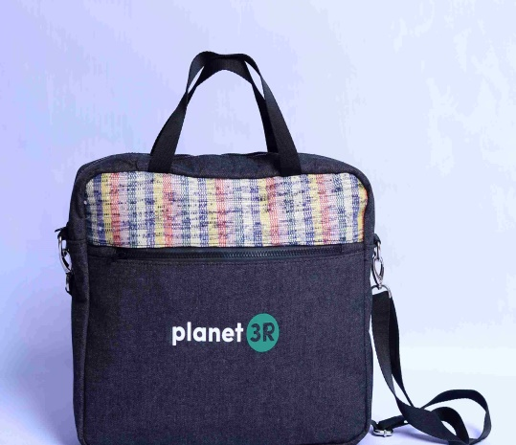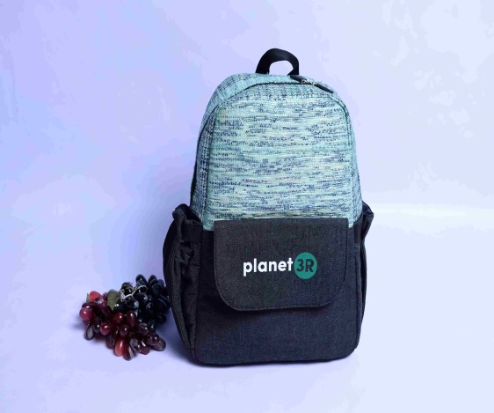
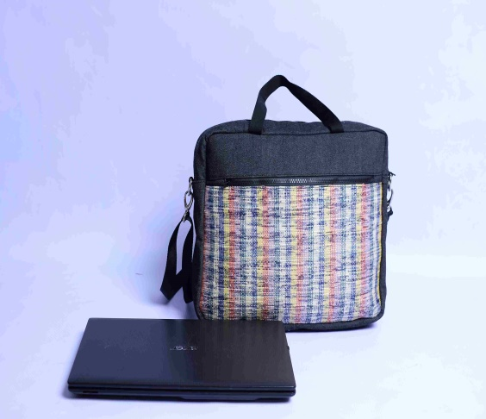
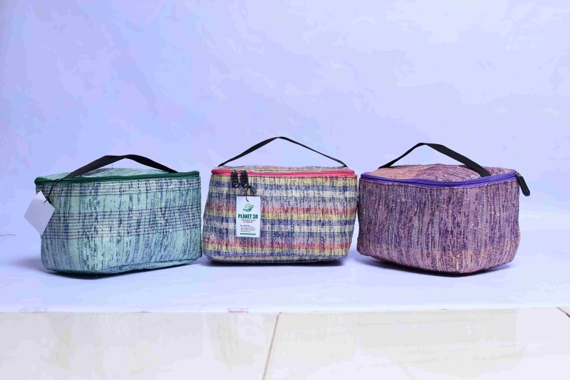
SOURCES: Planet3r.com

- Afthonia Textiles
Afthonia textiles whose vision and mission are facilitating a valuable ecosystem for textile waste and to show value in textile waste. According to their Instagram page, Afthonia are circular economy facilitators, helping individuals and organisations to enhance the principles of reducing, reusing, recycling and recovering resources to create a more sustainable future. They bring different players in the textile waste value chain together to create more value. We do this through advocacy, up cycling and recycling of textile waste. Afthonia is also a social enterprise committed to fostering environmental well-being, sustainability and improved livelihoods, with a strong focus on empowering women. Their mission centres on advocacy and the recycling and up-cycling of textile waste. They are deeply dedicated to supporting Sustainable Development Goals 12 and 13, which emphasize responsible consumption and production, along with urgent climate action. By turning waste into wonder, Afthonia textiles are helping build a circular economy that benefits both the planet and business.
The increasing demand for environmentally friendly practices and the decline in natural resources has highlighted the urgent need for alternative practices.
According to a blog titled turning textile waste to paper by Afthonia textiles in February 2025, it opined that the pulp and paper industry has spurred an interest in transforming waste materials into valuable goods, reducing textile waste and creating valuable resources. Shortage of forestry raw material resources has led the industry to investigate the pulping of non-wood material due to its cellulosic nature. Recovered textile scraps have been successfully converted into pulp slurry for moulded pulp and paper making applications thereby reducing textile waste and creating valuable resource. This sustainable approach addresses the growing problem of textile waste, keeping it out of landfills and giving it a second life as environmentally friendly paper pulp.

PROSPECTIVE BUSINESS APPROACHES IN ADO EKITI
- Up-cycling
According to Suman et al (2022), up-cycling is a creative project which definitely helps to reduce the textile and apparel waste and save natural resources. Up-cycling of apparel is also a physical process of reusing apparel waste by renovating and redesigning them with greater value as per latest fashion trend. Converting fabric scraps and rejects into bags, accessories, wall decorations, art works, furnishings using traditional or industrial loom, fashion accessories or home decoration items and sustainable gift items or corporate merchandise. This technique involves reusing existing materials—often considered waste—and transforming them into something new, without the need for significant spending on fresh resources. According to Kharadi (2023), the process of up-cycling has existed for centuries; the fashion industry is only now beginning to embrace it. The main goal of up-cycling, which is focused on sustainable consumerism, is to revitalize existing materials by arranging them differently and offering new uses for them while maintaining their original qualities as a key component of the process that adds value. Essentially, it gives old items a second life. The goal isn't just to enhance quality of life but also to imbue the resulting products with stronger environmental significance. At the same time, it adds aesthetic value to the creations. Designers are encouraged to use their creativity to develop new products while minimizing the use of resources.
Kharadi (2023), also opines that up-cycling, often referred to as creative reuse, is the process of repurposing leftovers, waste products, unnecessary items or unwanted items to make new materials or items that are thought to be of higher quality, such as items with artistic and environmental value. It is the process of taking something that is discarded and turning it into something more valuable. Therefore, up-cycling involves improving upon what is currently available. It has the potential to boost local economies and generate employment, especially within the craft and small business sectors by creating job opportunities and encouraging local entrepreneurship, it contributes positively to community development. It also focuses on re-evaluating and recombining to open the door for originality and value creation. As up-cycling enterprises grow, they help build a more diverse and resilient local economy.
Common Up-cycling practices
- Patchwork and Re-styling: Scrap fabrics, denim and Ankara materials are repurposed into blazers, bags, art works and accessories. According to Debbabi et al, 2014, patchwork is a larger design fabric constructed from pieces of fabric joined together by sewing. Paoletti & Jung (1987) also opined that patchworks are mostly used for quilts like blankets and also used for other clothing items such as bags, skirts, waistcoats and interior decorations like wall hangings and cushion cover. Patchwork and re-styling involve creatively combining or modifying scrap fabrics such as leftover denim, ankara and other textiles to produce new, functional or decorative items. These efforts reduce waste and create unique fashion pieces. Some designers and artisans in south western Nigeria including Ekiti are increasingly incorporating Aso-Oke and remnant scraps into creative patchwork garments and accessories. A creative construction using these pieces of fabrics into garments and accessories will help reduce dumping of these fabrics pieces into landfill (Sai et al, 2022).

Patchwork and Re-styling of Scrap fabrics, denim and Ankara materials
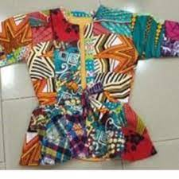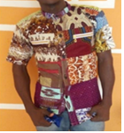
FIG 2 FIG 3
Source: Dzramedo et al 2023
FIG 4
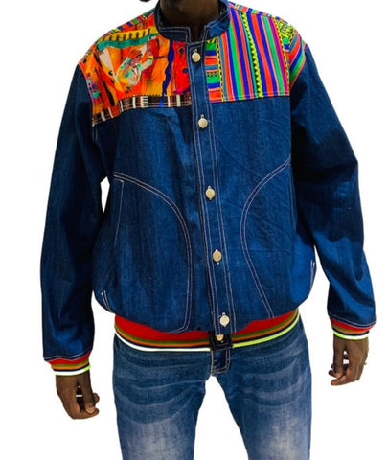
Source: finchitua.com

- Revival of Heritage Technique in Apparel
Heritage Techniques Revived: Traditional textiles like Aso-Oke and Adire are repurposed in modern designs, combining cultural preservation with sustainability. Cultural Sustainability Theory, proposed by David Throsby in 2001, emphasizes the importance of preserving, maintaining and passing down cultural traditions to future generations.

ASO-OKE PATCHES
FIG 5

Source: ozinna.com

FIG 6
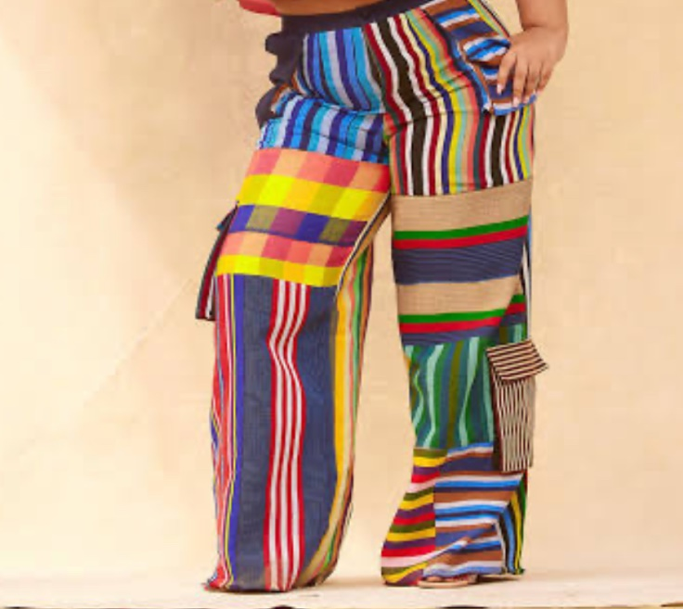
Source: Trax apparel

- Training & Vocational Skill Hubs
Training and vocational skill hubs play a vital role in supporting the development of a circular textile economy. These centres provide practical education and hands-on experience in areas such as textile sorting, repair, up-cycling, sustainable fashion design and recycling technologies. It also plays an important role in arming individuals with practical, market-relevant skills, particularly in underserved communities. These hubs provide training in areas such as crafts and sustainable production empowering participants, especially women and youth, to secure employment or start small businesses. By fostering local talent and entrepreneurship, they contribute to economic resilience and social development. Ado Ekiti has several vocational centres established by the government and individuals. Examples are Adire hub established by the wife of the Ekiti state governor, Dr. Olayemi Oyebanji in March, 2024 to boost youth empowerment. The initiative was designed in collaboration with State Ministry of Youth Development under Her Excellency’s pet project “Widows and Orphans Hope (WAOH) scheme to address unemployment challenges by offering comprehensive training programmes focused on the traditional craft adire dyeing and textile production. Another training and vocational skill hub is Afreeko founded by Mrs Celine Olusola Adesola which involves in creativity and entrepreneurship, youth and women empowerment, youth and art initiative and social enterprise. Tertiary institutions in the state also have entrepreneurship and vocational centres while secondary and primary schools are introduced to vocational skills.
Training and vocational hubs has also help with workforce development by equipping individuals with skills needed in textile reuse, repair, and recycling industries.

Economic and Environmental Impacts
Economic impact
Economic development involves change and the entrepreneur becomes the best agent for this change (Ács & Amorós 2008). The growing interest in textile reuse and recycling aligns with the rising emphasis on the circular economy concept in both international and national policies.
According to Khandzode and Rane (2024), the recycled materials can be used in a variety of industries, including automotive, furnishings, seafaring and/or insulation. For instance, they can be repurposed into products such as geo-fleece, carpet padding, car rear shelves, stuffed toys, shoe insoles, and various other items. Khandzode & Rane (2024) also stated that a portion of the trash generated by spinning and weaving can be sent to recycling facilities to go through a fibre recovery procedure and natural fibres like cotton or linen, recycled fibres are incorporated into the textile and apparel industries’ resource pools, enabling the creation of further value and job creation that is more employment opportunities, new business opportunities which encourages growth of sustainable fashion brands and circular economy start-ups.
- Reduced Waste Management Costs:
Diverting textiles from landfills significantly lowers the burden on municipal waste management systems. When textiles are recycled or reused instead of discarded, the volume of waste requiring collection, transportation, and landfill space is reduced. This leads to cost savings for local governments and contributes to more efficient and sustainable waste management practices

Environmental impact
When textiles are no longer needed, a large amount ends up in landfills. This not only takes up valuable space but also results in the release of harmful chemicals and greenhouse gases during decomposition especially in the case of synthetic materials, which break down very slowly. According to Abrishami et al (2024), the textile industry uses around 79 billion litres of water each year and nearly 20% of industrial water pollution stems from dyeing and finishing processes. This highlights the need to recognize that the practices adopted by industries and consumers who have adapted themselves to “fast fashion” trends in recent decades have not led to sustainable development in textile recycling. Textile reuse has gained popularity as an effective way to reduce the environmental impact of textile waste. It involves repurposing or adapting existing textiles instead of producing new ones. Reuse is generally considered more advantageous than recycling, particularly when the lifespan of reused items can be extended over a longer period. A fundamental shift in production and consumption patterns is essential. Recycling textiles offers a far more sustainable alternative to incineration or landfilling, both of which can harm the environment. According to start up tips posted by business ideas and plans for entrepreneurs in august 2023, statistics reveal that the textile industry is a major contributor to waste generation, with millions of tons of textiles discarded annually. By transforming waste materials into new textiles, recycling significantly reduces water consumption and generates fewer emissions compared to producing fabrics from raw materials. To achieve sustainability and reduce both environmental and financial harm, it is crucial to reform consumption habits within the textile sector and influence consumer behaviour through long-term strategies designed and implemented by international organizations.
The textile recycling industry in Nigeria and Africa plays a crucial role in tackling the rising issue of textile waste and its environmental consequences. As the global textile industry continues to grow, the demand for sustainable solutions becomes more urgent, positioning textile recycling as a promising and necessary path forward.

CONCLUSION
Recycled textile materials serves as a call to action for forward-thinking business leaders and aspiring entrepreneurs alike. Textile recycling has become a vital component of sustainable waste management, aiming to minimize environmental impacts while addressing socioeconomic challenges. The textile recycling industry in Nigeria and Africa has the potential to create a meaningful impact both regionally and internationally. By tackling the issue of textile waste, it can promote sustainable practices, drive economic development, and open up export opportunities. This aligns with the increasing global demand for eco-friendly and sustainable products. The exploration of entrepreneurial opportunities in recycled textile materials presents a promising path for sustainable development in Ado-Ekiti by establishing formal up-cycling centres, to collect, sort and creatively repurpose textile scraps locally. With growing observation of environmental issues and the increase in demand for eco-friendly products, the town holds a significant potential to become a hub for textile up-cycling and innovations. Repurposing these materials, entrepreneurs can not only divert significant volumes of waste from landfills but also contribute to the reduction of greenhouse gas emissions, water consumption, and energy use associated with conventional textile production. Engaging local designers and schools to run workshops using leftover textiles for crafts and fashion and by also harnessing local talent, creating more vocational training hubs and fostering small-scale enterprises, Ado-Ekiti can not only reduce textile waste but also stimulate economic growth, generate employment, and empower marginalized groups, particularly women and youth. Embracing this circular economy model will position the region as a leader in sustainable entrepreneurship and community-driven development.

COMPETING INTERESTS DISCLAIMER:
Authors have declared that they have no known competing financial interests OR non-financial interests OR personal relationships that could have appeared to influence the work reported in this paper.
Disclaimer (Artificial intelligence)
Option 1:
Author(s) hereby declare that NO generative AI technologies such as Large Language Models (ChatGPT, COPILOT, etc.) and text-to-image generators have been used during the writing or editing of this manuscript.
Option 2:
Author(s) hereby declare that generative AI technologies such as Large Language Models, etc. have been used during the writing or editing of manuscripts. This explanation will include the name, version, model, and source of the generative AI technology and as well as all input prompts provided to the generative AI technology

Details of the AI usage are given below:
1.
2.
3.
Reference Entry: OpenAI. (2023). ChatGPT (Mar 14 version) [Large language model]. https://chat.openai.com/chat. Accessed on 27th July, 2025 at 8.00am

REFERENCES

Ács ZJ, Amorós JE (2008) Entrepreneurship and competitiveness dynamics in Latin America. Small Business Economics 31(3): 305–322. https://www.jstor.org/stable/40650946

AfthoniaTextiles.ng 2023

Amita Khandzode, Nikhila Rane, 2024 Environmental and socioeconomic sustainability through textile recycling. JETIR April 2024, Volume 11, Issue 4 www.jetir.org (ISSN-2349-5162)

Awosusi, Ajoke Olukemi (2010) Assessment of Environmental Problems and Methods of Waste Management in Ado-Ekiti, Nigeria African Research Review Vol. 4(3b) July, 2010. Pp. 331-343

Eksginfo.ng/2024/03/03/ekiti-first-lady-to-launch-adire-ekiti-hub-to-boost-youth-empowerment

E. U. CHIDUME (2021) Recycling waste fabrics for interior designing: an entreprenuership venture to improve nigerian economy. Multidisciplinary Journal of Academic Excellence, Volume 21 No 1, August, 2021. ISSN 2141 – 3215

Chen, X., Memon, H. A., Wang, Y., Marriam, I., & Tebyetekerwa, M. (2021). Circular Economy and Sustainability of the Clothing and Textile Industry. Materials Circular Economy, 3(1), 12. https://doi.org/10.1007/s42824-021-00026-2

Chukwuebuka C. Okafor1,*, Christian N. Madu1,2, Charles C. Ajaero1, Juliet C. Ibekwe1 and Chinelo A. Nzekwe1(2021) Sustainable management of textile and clothing. AIMS Clean Technologies and Recycling Volume 1, Issue 1, 70–87. OI: 10.3934/ctr.2021004

Debbabi, F., Kordoghli, B. & Sahnoun, M. (2014). Valorization of Cutting Step Wastes
Creation of Patchwork Fabrics and Design of Patchwork Cloths. International Conference of Applied Research on Textile CITRAT-6. November 13-15, Hammamet, Tunisia.
Directive 2008/98/EC of the European Parliament and of the Council of 19 November 2008 on waste and repealing certain Directives (Text with EEA relevance) ELI: http://data.europa.eu/eli/dir/2008/98/oj

Dzramedo, Benard & Amenya, Anastasia & Deborah, Boye-Doe. (2023). Reconstructing Waste Fabric Pieces Into Fashionable Garments and Accessories for the Ghanaian Consumer. Fashion and Textiles Review. 4. 1-19. 10.35738/ftr.v4.2023.01.

Fashion.sustainability-directory.com/question/what-are-the-socio-economic-impacts-of-textile-waste-and-recycling. 2024

finchitua.com/collections/afro-retro

Hulbert, B., Gilmore, A., & Carson, D. (2013). Sources of opportunities used by growth minded owner managers of small and medium sized enterprises. International Business Review, 22(1), 293-303. https://doi.org/10.1016/j.ibusrev.2012.04.004

How To Start A Lucrative Textile Recycling Business In Nigeria and Africa: The Complete Guide: start up tips by business ideas and plans for entrepreneurs in august 2023. https://startuptipsdaily.com/textile-recycling-business-nigeria-africa-business-plan

Kharadi, Meeta. (2023). UPCYCLING IN FASHION AND TEXTILE. Book Chapter: Fashion Pedia.ISBN: 978-93-91903-68-8

Mueller, P. (2007). Exploiting entrepreneurial opportunities: The impact of entrepreneurship on growth. Small Business Economics, 28(4), 355-362.

Ogwueleka T. (2009):”Municipal solid Waste Characteristics and Management in Nigeria”.Iran Journal of Environmental Health, Science and Engineering, vol. 6, No 3, pp 173-180

Oni, Olayiwola, Toyin Omotoso, and Ayowole Alo. 2019. “An Integrated Approach to the Management of Municipal Solid Waste in a Typical City in Southwest Nigeria”. Journal of Engineering Research and Reports 7 (1):1-11. https://doi.org/10.9734/jerr/2019/v7i116961.

ozinna.com

Peter Davis Sumo, 2024. TEXTILE WASTE MANAGEMENT AND RECYCLING OPPORTUNITIES AND CHALLENGES FOR AFRICA: A MINIREVIEW. Holistic Approach Environ. 14(2024) 2, pp. 57 – 70. https://doi.org/10.33765/thate.14.2.3

Planet3r.com

Population Census 2006 (NBC, 2007)

Rouch, Duncan. (2021). Fashion and clothing textiles: how to reduce the environmental and social impacts.

Sai, A. O., Akorfi, M. & Acquaye, R. (2022). Fabric Waste Dimensions in Selected
Suburbs of Kumasi Metropolis –Ghana. Fashion and Textile Review, Vol. 1, No. 7, pp.
1-18

sdgprivatefinance.undp.org/leveraging-capital/sdg-investor-platform/business-case-studies/planet-3r-converts-textile

Shayan Abrishami, Armineh Shirali, Gulsah Ekin Kartal, Lisa Macintyre, Nicole Sharples, Omid Doustdar.2024. Textile Recycling and Recovery: An Eco-friendly Perspective on Textile and Garment Industries Challenges. Volume 94, Issue 23-24 https://doi.org/10.1177/00405175241247806

Suman Sodhi, Vivek Singh and Nisha Arya (2022). Upcycling: Innovative way of textile waste management. The Pharma Innovation Journal 2022; SP-11(3): 1247-1248

Traxapparelafrica.com

Throsby David. Economics and culture. Cambridge UP, 2001. https://doi.org/10.1017/CBO9781107590106

Udeani, N. A. (2017).Textile Waste Recycling: An Innovative Creativity for Entrepreneurial Sustainability in Nigeria. Tropical Built Environment Journal (TBEJ) Vol. 1. No.6, 2017

Walter Leal Filho, Dawn Ellams, Sara Han, David Tyler, Valérie Julie Boiten, Arminda Paço, Harri Moora, Abdul-Lateef Balogun, (2019). A review of the socio-economic advantages of textile recycling.. Journal of Cleaner Production,Volume 218,Pages 10-20, ISSN 0959-6526, https://doi.org/10.1016/j.jclepro.2019.01.210.(https://www.sciencedirect.com/science/article/pii/S0959652619302306)

Zhou, Anqi. (2022). The Origin, Process, and Advantages of Recycling and its Benefit to the Environment. BCP Business & Management. 34. 1424-1429. 10.54691/bcpbm.v34i.3194.

Fashion and clothing textiles:
how to reduce the environmental and social
impacts

Clarendon Policy & Strategy Group Working Paper Series
Working Paper No. 20, February 2021, updated 25 November 2024

