SCHOOL SUPPORT AND RESOURCE ALLOCATION: INPUT TO THE
ENHANCEMENT OF JUNIOR HIGH SCHOOL STUDENT RETENTION
AT BAROBAYBAY ACADEMY-MISSION SCHOOL, INC, PHILIPPINES

ABSTRACT:
Student retention remains a critical measure of educational quality, particularly in rural settings. This study investigates the influence of school support and resource allocation on student engagement and retention at Barobaybay Academy-Mission School, Inc. in Northern Samar. The objective was to identify which support services and resources most effectively enhance junior high school students' academic commitment and reduce dropout tendencies.

A mixed-methods design was employed involving 100 respondents (93 students, 7 personnel) selected via stratified random sampling. A validated survey instrument assessed demographic data, support program awareness and usage, perceived effectiveness of services, and resource sufficiency. Statistical tools such as descriptive analysis and Pearson correlation (r) were used to examine relationships between variables.

Students exhibited high awareness (95%) and frequent use (mean = 4.36) of support programs. However, perceived effectiveness was moderate (mean = 2.87). Notably, 75% indicated insufficient technological resources. Pearson correlation revealed a moderate positive relationship between school support and student engagement (r = 0.61), and a weaker but significant correlation between resource allocation and retention (r = 0.49).

Effective and well-targeted school support programs and adequate resource allocation significantly influence student engagement and long-term retention. Investments in digital infrastructure, wellness services, and career guidance are crucial for sustaining educational participation in underserved communities.

Keywords:
Student Engagement, Retention, School Support, Resource Allocation, Junior High School

INTRODUCTION
Student engagement and retention have increasingly become central themes in educational research, policy, and practice because they are strongly associated with academic achievement, holistic development, and lifelong learning (Du & Hu, 2008). Engagement is not merely the physical presence of students in classrooms, but also their cognitive investment, emotional commitment, and active participation in learning activities (Kuh et al., 2005). Retention, on the other hand, reflects the institution’s capacity to sustain students’ enrollment until the completion of their academic program, which is a key indicator of educational quality and institutional effectiveness (Tinto, 1993; UNESCO, 2020).
In the Philippine context, student attrition in secondary schools continues to pose challenges, particularly in rural and underserved areas where economic constraints, inadequate infrastructure, and limited access to quality support services affect school participation (Department of Education, 2022). Retention is influenced by a variety of factors, including socio-economic background, academic preparedness, and the availability of school-based supports such as academic tutoring, counseling, extracurricular engagement, and health services (Tinto, 1993; Bronfenbrenner, 1979). According to Maslow’s (1943) hierarchy of needs, learners are more likely to persist when their basic physiological and safety needs are met, alongside their psychological needs for belongingness, esteem, and self-actualization.
School support programs and resource allocation form the structural and functional backbone of these retention efforts (James et al., 2011). Adequately funded and well-managed school resources—ranging from technological infrastructure to instructional materials—can directly influence the quality of instruction, inclusivity of programs, and overall learning environment (UNESCO, 2020). In many rural Philippine schools, however, resource gaps—especially in digital access—limit students’ ability to fully engage in modern learning contexts (Hanushek, 1997).
At the micro level, the school’s ecological environment plays a significant role in shaping student experiences. Bronfenbrenner’s (1979) ecological systems theory underscores the interplay between the learner and their surrounding systems, such as family, peers, teachers, and community. Within this framework, targeted interventions like scholarship programs, parent-teacher partnerships, and wellness initiatives can strengthen the mesosystem, thereby improving student engagement and persistence (Greenwald et al., 1996).
Given this backdrop, this study examines how Barobaybay Academy-Mission School, Inc., a private institution situated in the upland municipality of Lavezares, Northern Samar, mobilizes its support programs and allocates resources to sustain junior high school students’ retention. By assessing the awareness, utilization, and perceived effectiveness of these initiatives, the study aims to provide actionable insights for school administrators, policymakers, and educators seeking to enhance student success in similar rural educational settings.

MATERIALS AND METHODS

Research Design
This study employs a mixed-method approach to assess the impact of school support and resource allocation on student engagement and retention at Barobaybay Academy-Mission School, Inc. for the Academic Year 2024–2025. A structured survey questionnaire was employed as the main data-gathering instrument. The design was chosen to capture patterns, trends, and relationships among variables through statistical analysis of collected data.

Locale of the Study
The study was conducted at Barobaybay Academy-Mission School, Inc., a private educational institution located in the upland area in the municipality of Lavezares, Northern Samar. The school serves Junior High School students and has faced challenges with declining enrollment and limited resources over recent years. The school has its 93 in total enrollment as of the School Year (see figure1).

Fig. 1 Enrollment Data

Population and Sampling
The target population consisted of Junior High School students, and selected school personnel of the institution. Using stratified random sampling, a total of 100 respondents were selected to ensure representation from various grade levels and roles within the school. This method allowed for the proportional inclusion of key stakeholders and reduced sampling bias.

Research Variables
Dependent Variable

Student Retention
- Likelihood to stay enrolled
- Factors influencing continuation

Independent Variable

School Support Programs and Resource Allocation
- Academic tutoring
- Counseling services
- Extra-curricular activities
- Health Services
- Scholarship or Financial Aid program
- Career Guidance
- Parent-Teacher Engagement Program

A structured survey questionnaire was developed and divided into four key sections to measure the objectives of the study:
- Demographic Information
- Awareness and Usage of School Support Programs
- Perceptions of Resource Allocation
- Retention Indicators

The questionnaire included both closed-ended (Likert-scale) and categorical questions to capture both perception and behavior data.

Validation of Instrument
The research instrument used in this study was an adopted survey questionnaire designed to measure the relationship between school support and resource allocation and the levels of student engagement and retention at Barobaybay Academy-Mission School, Inc.

Data Collection Procedure
Surveys were distributed in-person to the selected respondents during the School Year 2024–2025. The purpose of the study was explained beforehand, and the approval letter was obtained. Collecting the quantitative data was completed and qualitative data were carefully analyzed and classified as based on their opinions on the additional school support and resource allocation to increase student engagement and retention, depending on their thematic content.

Objectives of the Study
- To profile the demographic characteristics of respondents relevant to the study.
- To determine the level of awareness and extent of usage of school support programs among respondents.
- To evaluate respondents’ perceptions regarding the allocation and distribution of school resources.
- To assess retention indicators and analyze their relationship with overall participation in school programs.

- RESULTS

The results of this study reveal strong links between school support services, resource allocation, and student retention at Barobaybay Academy-Mission School, Inc. The analysis integrates demographic characteristics, awareness and utilization of programs, perceptions of resource sufficiency, and self-reported retention indicators.

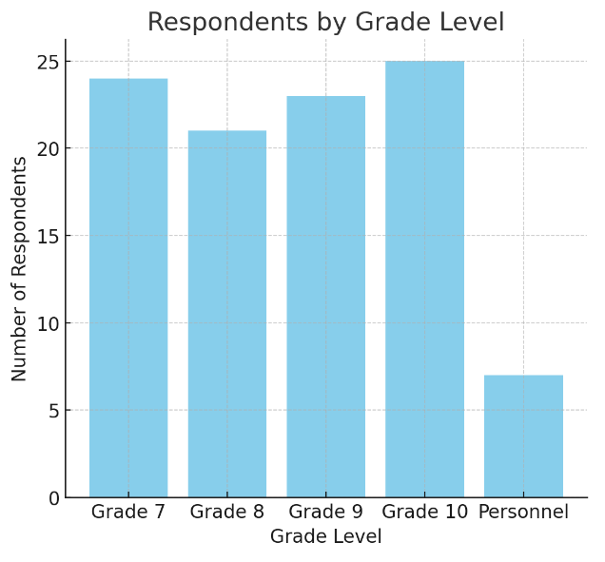
Table 1: Number of Respondents

Demographic Profile of Respondents
The 100 respondents included 93 junior high school students and 7 school personnel. Representation across grade levels was fairly balanced, with Grade 10 having the highest participation (25 students) and Grade 8 the lowest (21 students). The age distribution showed that the majority (85%) of students were between 13 and 15 years old, while 8% were aged 16–18, and all personnel were aged 21 and above. Gender identity reflected diversity: 28 identified as male, 30 as female, 5 as non-binary, and 37 preferred not to disclose. This mix ensured that feedback reflected a range of perspectives across both academic and administrative experiences. Awareness and usage of school support programs showed a high level of familiarity, with 95% of respondents aware of available programs. The most recognized and utilized programs included Scholarship or Financial Aid (98), Extracurricular Activities (90), Academic Tutoring (88), and Health Services (85). Parent-Teacher Engagement Programs (92) and Career Guidance (80) were also widely acknowledged. In terms of frequency, most respondents reported always (63) or often (20) availing of these services. Effectiveness ratings were generally favorable, with a majority rating the programs as “Effective” (40) or “Very Effective” (4), and satisfaction levels were high, with 68 “Very Satisfied” and 22 “Satisfied,” indicating that these initiatives are both accessible and valued by the school community.

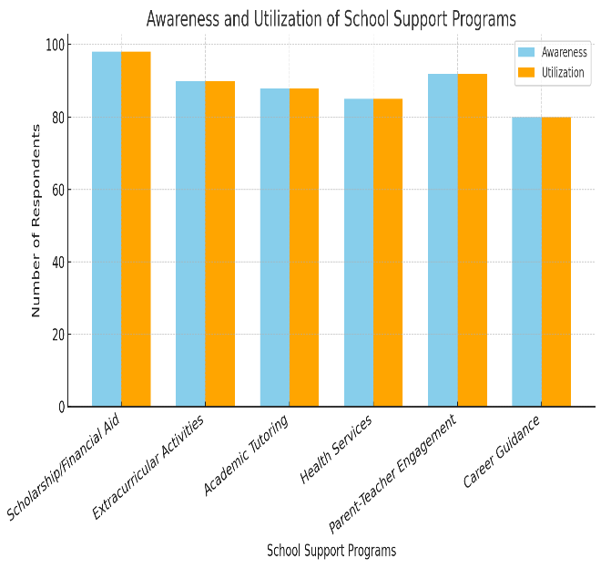
Table 2: Awareness and Utilization od School Support Programs

Awareness and Utilization of School Support Programs

Awareness of school support programs at Barobaybay Academy-Mission School, Inc. was remarkably high, with 95% of respondents indicating knowledge of at least one available service. The Scholarship or Financial Aid Program emerged as the most widely recognized, cited by 98 respondents, and consistently regarded as one of the most helpful initiatives in reducing financial burdens that might otherwise hinder students’ education. Extracurricular Activities, such as sports, were the second most recognized, known by 90 respondents, and demonstrated a strong engagement factor, with the same percentage actively participating. Academic Tutoring was acknowledged by 88 respondents and frequently credited for improving academic performance, while Health Services, recognized by 85 respondents, were valued particularly during periods of illness outbreaks, highlighting their role in maintaining student well-being.

In terms of frequency of participation, the majority of respondents (63%) reported “always” using available services, followed by 20% who used them “often,” and 10% “sometimes.” Only a small portion (7%) indicated rare or no participation in these programs. Despite generally high usage rates, several respondents identified barriers that limited their participation, such as scheduling conflicts with academic classes and limited availability of slots—particularly in academic tutoring sessions, where demand often outstripped capacity. This suggests that while awareness and utilization levels are high, maximizing the impact of these programs will require addressing logistical challenges to ensure equal access for all students.

Perceived Effectiveness of Programs
When rating program effectiveness, 40% considered them “Effective,” 4% “Very Effective,” and 26% “Not Effective.” While the majority leaned positive, these mixed ratings suggest variability in program delivery or alignment with students’ needs. Satisfaction levels, however, were notably high—68% reported being “Very Satisfied,” 22% “Satisfied,” and only 5% expressed dissatisfaction. This indicates that even where outcomes could improve, students still valued the existence of these services.

Perception of Resource Sufficiency
Regarding overall resource sufficiency, 67% of respondents believed the school’s resources met students’ needs, 20% disagreed, and 13% were undecided. While general resource availability scored positively, technological resources emerged as a major gap—75% of respondents considered them inadequate. Specifically:
Only 36% reported school supplies as “Always sufficient,” while 42% said “Sufficient most of the time.”
Extracurricular facilities were rated as enhancing engagement “Very much” by 82%, indicating strong perceived value in this area.

Resource allocation was considered “Very Important” to retention by 68% of respondents.

Therefore, participation in extracurricular activities was a strong predictor of engagement: 90% of students were involved in

- DISCUSSION

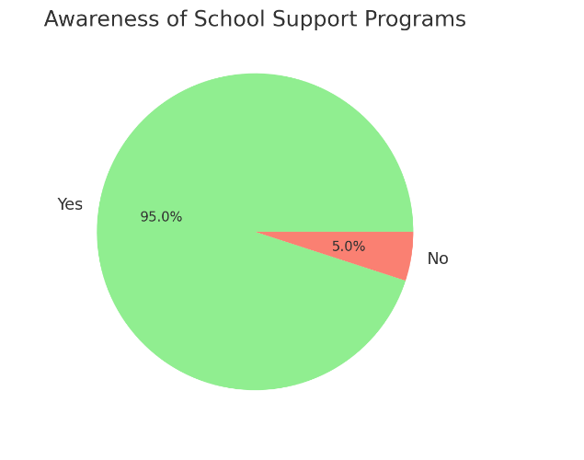
Table 3: Awareness of School Support Programs

The findings of this study reinforce the premise that both school support services and the effective allocation of resources are integral to sustaining student engagement and retention, particularly in rural and resource-constrained educational settings such as Barobaybay Academy-Mission School, Inc. The high level of awareness (95%) and frequent usage of programs suggest that the school has been successful in communicating the availability of its services—a crucial first step in fostering engagement (Kuh et al., 2005). However, as seen in the moderate effectiveness ratings, awareness does not automatically translate into optimal impact, indicating room for improvement in service quality, accessibility, and alignment with students’ evolving needs.

The prominence of scholarship and financial aid programs as the most recognized and utilized services aligns with existing literature showing that economic support plays a vital role in mitigating dropout risks among low-income learners. In rural Philippine contexts, where economic instability is often a significant barrier to education, such programs act as a stabilizing factor, allowing students to focus on their studies rather than on the financial burden of schooling. This echoes Maslow’s (1943) theory, in which meeting basic security needs precedes higher-level academic engagement.
Extracurricular participation, which reached 90% among respondents, emerged as another key factor linked to student engagement. This supports the work of Tinto (1993) and Bronfenbrenner (1979), both of whom emphasize the role of social integration and interpersonal networks in retaining students. The finding that extracurricular activities were perceived to enhance engagement “very much” by 82% of respondents suggests that such activities are not merely recreational, but central to building a sense of belonging and identity within the school.
Resource allocation findings reveal a mixed picture. While 67% of respondents viewed resources as sufficient, the overwhelming concern about technological inadequacy (75%) is consistent with UNESCO’s (2020) warning that the digital divide remains a major challenge to equitable education. In the post-pandemic era, where hybrid and technology-enhanced learning have become the norm, insufficient access to digital tools and internet connectivity can undermine both learning quality and retention. These findings highlight the need for targeted investments in ICT infrastructure to bridge this gap.

The Pearson correlation results provide statistical support for these qualitative observations. The moderate positive correlation (r = 0.61) between school support and student engagement affirms that programs like tutoring, counseling, and extracurricular activities have tangible effects on how actively students participate in their learning environment. Meanwhile, the weaker but still significant correlation (r = 0.49) between resource allocation and retention suggests that while resources matter, other factors—such as teacher-student relationships, personal motivation, and family support—may play equally important roles in the decision to stay in school.
An important nuance revealed by the data is that 42% of respondents felt that resource availability did not directly impact their decision to remain in school. This finding aligns with Bronfenbrenner’s ecological systems theory, which emphasizes that individual persistence is shaped by the interplay of multiple environmental systems. For some students, personal aspirations, peer networks, and familial expectations may outweigh material considerations in their decision-making.

The discussion underscores that improving retention is not a matter of addressing a single factor, but rather of building a holistic ecosystem where academic, social, emotional, and infrastructural supports reinforce each other. For Barobaybay Academy-Mission School, Inc., this means sustaining high-visibility programs like scholarships and extracurriculars while simultaneously addressing service quality and technological gaps. Strategic resource management, coupled with continuous evaluation of program relevance, can ensure that the gains in student engagement translate into long-term retention.
Recommendations from Respondents
Several qualitative suggestions were raised, including:
- Strengthening technology infrastructure and internet accessibility.
- Hiring teachers who specialize in specific subjects.
- Enhancing classroom ventilation and sports services.
- Improving student discipline enforcement.

Correlation Between Support, Resources, and Retention

The study found a significant correlation between school support, resource allocation, and student outcomes, specifically in terms of engagement and retention. Using Pearson correlation analysis, a moderate positive correlation (r = 0.61) was identified between school support programs and student engagement. This indicates that when students have access to effective support services—such as academic tutoring, counseling, extracurricular activities, and health services—their level of participation and involvement in school activities increases. In contrast, a weaker but still meaningful positive correlation (r = 0.49) was found between resource allocation and student retention. This suggests that when students perceive school resources—such as teaching materials, technology, and infrastructure—as sufficient and well-managed, they are more likely to remain enrolled. In conclusion, these correlations highlight the importance of strengthening both support services and the allocation of school resources to enhance student engagement and reduce dropout rates. Investing in these areas not only improves the learning experience but also encourages students to stay committed to their education.

- CONCLUSION
The study conclude that effective school support programs and well-managed resource allocation play a critical role in enhancing student engagement and retention at Barobaybay Academy-Mission School, Inc. The findings show that students who frequently access academic, emotional, and extracurricular support services tend to be more engaged in their learning, while the availability and adequacy of essential resources—particularly in technology and educational materials—contribute to their decision to remain in school. Despite generally high levels of satisfaction, the study also highlights specific areas for improvement, such as technological infrastructure, health services, and career guidance. Addressing these gaps can further strengthen the school’s ability to support student success. Finally, the research underscores the need for continuous investment in both human and material resources to create a supportive, inclusive, and sustainable educational environment that promotes long-term student achievement and retention.

RECOMMENDATIONS
Enhance technological infrastructure
- Invest in updated computer equipment and internet connectivity
- Provide accessible and reliable campus-wide Wi-Fi
- Integrate digital tools and platforms into teaching and learning activities

Strengthen counseling and career guidance services
- Increase promotion of available emotional and academic support services
- Hire qualified counselors and career advisors
- Provide regular workshops and guidance sessions for students

Improve health and wellness services
- Ensure the presence of a school nurse or access to basic medical assistance
- Offer wellness programs focused on physical and mental health

AUTHOR’S CONTIBUTION
The author designed the study, adopted the research instrument, and conducted the data collection and analysis. The author also reviewed relevant literature, interpreted the findings, and prepared the initial draft of the manuscript. All components of the research—including the conceptual framework, methodology,

statistical treatment, and results interpretation—were handled solely by the author. The author read and approved the final version of the manuscript.

CONSENT
All participants in this study were informed of the purpose, procedures, and voluntary nature of their involvement. Prior to the data collection, an approved written informed consent was obtained from the Office of the Principal were researcher are given access to student’s and volunteer school personnel to participate in data collection.
The approval letter emphasized participants’ rights to confidentiality, anonymity, and the freedom to withdraw at any time without penalty.

CONFLICT OF INTEREST
The author declares no conflict of interest. This research was conducted independently, and no financial, professional, or personal interests influenced the study’s design, data collection, analysis, interpretation, or reporting. All opinions and findings expressed in this paper are solely those of the authors and are not influenced by any external entity.

Disclaimer (Artificial intelligence)
Option 1:
Author(s) hereby declare that NO generative AI technologies such as Large Language Models (ChatGPT, COPILOT, etc) and text-to-image generators have been used during writing or editing of manuscripts.
Option 2:
Author(s) hereby declare that generative AI technologies such as Large Language Models, etc have been used during writing or editing of manuscripts. This explanation will include the name, version, model, and source of the generative AI technology and as well as all input prompts provided to the generative AI technology
Details of the AI usage are given below:
1.
2.
3.

REFERENCES
Bronfenbrenner, U. (1979). The ecology of human development: Experiments by nature and design. Harvard University Press.

Department of Education. (2022). Basic education report. Department of Education, Republic of the Philippines.

Kuh, G. D., Kinzie, J., Schuh, J. H., & Whitt, E. J. (2005). Student success in college: Creating conditions that matter. Jossey-Bass.

Maslow, A. H. (1943). A theory of human motivation. Psychological Review, 50(4), 370–396. https://doi.org/10.1037/h0054346

Tinto, V. (1993). Leaving college: Rethinking the causes and cures of student attrition (2nd ed.). University of Chicago Press.

UNESCO. (2020). Global education monitoring report 2020: Inclusion and education – All means all. United Nations Educational, Scientific and Cultural Organization.

Du, Y., & Hu, Y. (2008). Student academic performance and the allocation of school resources: Results from a survey of junior secondary schools. Chinese education & society, 41(5), 8-20.

James, L., Pate, J., Leech, D., Martin, E., Brockmeier, L., & Dees, E. (2011). Resource Allocation Patterns and Student Achievement. International Journal of Educational Leadership Preparation, 6(4), n4.

Hanushek, E. A. (1997). Assessing the effects of school resources on student performance: An update. Educational evaluation and policy analysis, 19(2), 141-164.

Greenwald, R., Hedges, L. V., & Laine, R. D. (1996). The effect of school resources on student achievement. Review of educational research, 66(3), 361-396.

