Original Research Article
Determination of Lethal Radiation and Ethyl Methane Sulphonate Doses for Mutagenesis in Green Gram (Vigna radiata (L.) Wilczek)

ABSTRACT

Green gram (Vigna radiata L.) is a nutritionally rich and versatile crop widely used for food and feed. However, its genetic improvement through conventional breeding is constrained by self-pollinating flowers and limited genetic diversity, making traditional methods inefficient for yield enhancement. Induced mutagenesis offers a viable alternative to create novel genetic variability. This study aimed to establish the mean lethal dose (LD₅₀) of ethyl methane sulphonate (EMS) and gamma irradiation in three green gram varieties (Shwe Toe-009, MAS-1, and Yezin-9). Nine EMS concentrations (0.00% [control], 0.05%, 0.10%, 0.15%, 0.20%, 0.25%, 0.30%, 0.35 % and 0.40%) and seven gamma radiation doses (0 Gy [control], 200 Gy, 400 Gy, 600 Gy, 800 Gy, 1000 Gy and 1200 Gy) were applied. Results showed a progressive decline in germination and survival percentages with increasing mutagen doses. Probit analysis revealed that EMS-treated samples exhibited similar LD₅₀ values across all varieties, reflecting its uniform biochemical mode of action (alkylation of DNA bases). Gamma-irradiated samples displayed genotype-dependent LD₅₀ values, attributable to varietal differences in seed morphology, antioxidant capacity, and DNA repair efficiency against radiation-induced chromosomal damage. The predicted LD₅₀ ranges were 400–650 Gy for gamma rays and 0.4% for EMS, providing optimal doses for balancing mutation induction with plant survival. These findings enable large-scale mutagenesis programs to generate diverse mutant populations for green gram improvement.

Keywords: Green gram; Gamma irradiation; Ethyl methane sulphonate (EMS); LD₅₀; Germination and survival percentage.

1. INTRODUCTION

Green gram (Vigna radiata (L.) R. Wilczek) (2n=2x=22) also known as mungbean is the second most important pulse crop in Myanmar, after black gram. It is a self-pollinated crop and is a leguminous crop that belongs to the family Facaceae and subfamily Papilionaceae. Due to their small genome size (579 Mb) (Thounaojam et al., 2024), short life cycle (about 80 days), and close genetic ties to other legumes (Kim et al., 2015), legume crops have a very low crop productivity rate when compared to cereals and offer enormous potential for genetic enhancement. With an average yield of 721 kg/ha, the global green gram area is approximately 7.3 million hectares and annual world production is 6 million tones. Other nations like China, Kenya, Thailand, Tanzania, and Indonesia also generate a significant amount of it (Nair & Schreinemachers, 2020).

In Myanmar, green gram is a popular pulse that is farmed in both the lower and central regions. It is mainly grown in Bago, Sagaing, Magway, Mandalay, Yangon, Ayeyarwaddy, Naypyitaw, Kayin and Mon. Green gram is a warm-season, short-duration crop cultivated during pre-monsoon, monsoon, and post-monsoon periods, fitting well into crop rotation with rice. The total sown area of pulses was 3952 ha, and the total sown areas and production of green gram were 1.15 million ha and 1.45 million tons in 2020-2021 (DOP, 2021). It can be used to make bean soup, rice vermicelli, and bean sprouts, among other things. Green grams are exported from Myanmar to China, India, and European countries.

Green grams have a narrow genetic base due to domestication bottlenecks, limiting natural diversity for breeding. Conventional green gram breeding programs, particularly hybridization, are a fundamental approach to developing new varieties and they do have limitations in producing diverse and high-yielding cultivars. These limitations include a reliance on traditional varieties with limited genetic diversity and challenges in efficiently incorporating desired traits. Conventional breeding methods are inefficient for boosting production in green gram because of their low genetic diversity. Production may be boosted by using more cutting-edge breeding methods or by employing mutation to improve the existing genotypes (Mir et al., 2020).

To overcome these limitations, mutation breeding offers a wide range of opportunities for genetic improvement in the agricultural sector, including the development of novel varieties that are resistant to biotic and abiotic stresses. Mutation breeding is an effective tool for raising agricultural production. Mutation breeding offers a faster route to developing improved varieties compared to traditional methods. It can induce a wide range of mutants in a relatively short time, allowing breeders to select for desired traits more quickly than waiting for natural mutants or relying on crosses.

Mutations may be brought on by different kinds of physical and chemical mutagens including gamma ray and ethyl methane sulphonate (EMS). The use of physical and chemical mutagens helps to improve many traits of agronomical importance in major crops including green gram to enhance the rate of genetic variability. In green gram breeding program, plant breeders use ethyl methane sulfonate (EMS) and gamma rays as mutagenic agents to induce genetic mutations for crop improvement. Gamma rays and EMS are commonly used mutagens in plant breeding programs, because these are known for their simple application, good penetration, reproducibility, high mutation frequency and less disposal problems (Chahal & Gossal, 2002). Ethyl methane sulphonate (EMS) causes point mutations, base substitutions and alter single genes by alkylating DNA, creating subtle but useful variations. Gamma rays induce chromosomal breaks, deletions, and rearrangements, leading to larger phenotypic changes (Pathak et al., 2023).

For effective mutation breeding, determining the optimal mutagen dose serves as the critical first phase. The success of mutation breeding relies on identifying mutagen doses that achieve target lethality in the M1 generation, ensuring high mutation rates, genetic variability, and adequate plant survival. Lethal doses are tested to determine the optimal radiation or chemical exposure level that induces mutations while minimizing plant mortality or damage. Specifically, the lethal dose at which 50% of the exposed population dies (LD₅₀) is a key indicator. Testing lethal doses helps breeders find a balance between inducing desirable genetic changes and maintaining a viable plant population (Ke et al., 2019; Vikhe & Nehul, 2020). The induction of mutation is to create genotypic and phenotypic variations, which are important for the selection of plants with desirable characteristics. Optimum potential of producing viable and useful mutants for genetic improvement of plant might be obtained at higher doses where half of the treated samples died (Álvarez-Holguín et al., 2019).

In Myanmar, three green gram genotypes, viz., Shwe Toe-009, MAS-1 and Yezin-9, is commercially and widely cultivated in the Sagaing, Magway, Bago, and Ayeyarwady Regions, as well as in the Yangon area. The current varieties are often outdated and lack the desired traits for optimal production, especially in the face of increasing climate variability. New green gram varieties are urgently needed to improve crop yields, enhance disease resistance, adapt to climate change, ultimately boost food security and farmers' incomes. The development of new varieties through mutation breeding requires identification of optimal lethal doses. Therefore, the current study was conducted to determine the mean lethal dose (LD₅₀) of ethyl methane sulphonate and gamma irradiation on green gram varieties.

2. material and methods

2.1 Plant Materials

The genetically pure seeds of three green gram varieties, ‘Shwe Toe-009’, ‘MAS-1’ and ‘Yezin-9’, used in this study were obtained from East West Seed Company Ltd. and the Department of Agricultural Research (DAR), Yangon, Myanmar.

2.2 Experimental Site and Duration

The experiments were carried out in April 2024 for lethal dose (LD₅₀) determination. Seeds of tested varieties are irradiated with 6 different doses of gamma rays at the Department of Atomic Energy (DAE) at Yangon in Myanmar and treated with eight different concentrations of ethyl methane sulphonate (EMS) at the laboratory of Department of Plant Breeding, Physiology and Ecology (BPE), Yezin Agricultural University (YAU), Naypyitaw in Myanmar.

2.3 Methods of Treatments

2.3.1 Gamma irradiation mutagenesis

The 100-uniform sized, dry seeds with 12 percent moisture of each green gram variety were exposed to gamma rays at 200 Gy, 400 Gy, 600 Gy, 800 Gy, 1000 Gy and 1200 Gy doses. The gamma radiation source was Cobalt-60 (Co-60), with a dose rate of 469 Gy/h, an exposure volume of 5000 cc, and irradiation was carried out in a Gamma Chamber 5000 located at the Department of Atomic Energy, Yangon, Myanmar. Non-irradiated dry seeds were used as control.

2.3.2 Ethyl methane sulphonate mutagenesis

The 100 genetically pure and uniform size seeds of each green gram variety were treated in different concentrations of EMS for 6 hours under room temperature. Prior to treatment of chemical mutagens, the seeds were presoaked in distilled water for 6 hours to allow an uptake of chemical mutagens (Singh, 2007). EMS solutions were prepared with different ranges of concentrations (0.05%, 0.10%, 0.15 %, 0.20 %, 0.25%, 0.30%, 0.35% and 0.40%). After treatment, seeds were thoroughly washed in running tap water for 1 hour to leach out the residual of chemicals. The 100 untreated seed stock as a control was soaked in distilled water.

2.4 Experimental Design and Data Collection

For gamma radiation, a two-factor experiment was laid down in randomized complete block design (RCBD) in split plot arrangement with three replications. Three green gram varieties such as Shwe Toe-009, MAS-1 and Yezin-9 were tested at main factors while doses of gamma radiation served as sub-factors. The same design and layout were used for ethyl methane sulphonate (EMS) treatments. The experiments were carried out at the laboratory of BPE, YAU in April 2024 to determine LD₅₀ for each variety. LD₅₀ values based on seed germination and plant survival were calculated to optimize different doses of gamma radiation and EMS. Based on gamma radiation and EMS mutagenesis, hundred seeds of each treatment along with untreated seeds as control were placed in petridishes over moistened germination paper under seed germinator at 25±1⁰C. The germination (%) of the untreated and treated seeds in petridishes were recorded to decide the effective doses of mutagens. The number of germinated seeds was counted from third to seventh days after testing. The induction of germination was interpreted as the appearance of a cotyledonary leaf.

The percentage of seed germination and survival were recorded for each treatment in each variety separately. The percentage of germination and survival were calculated using the following formulae suggested by (Olasupo et al., 2016).

$$\text{ Seed Germination (\%) = }\frac{\text{No. of Germinated Seeds }\left(\text{Normal Seedlings}\right)}{\text{No. of Seeds Kept for Germination}}\text{ ×100}$$

$$\text{ S}\text{urvival}\text{ (\%)}\text{ = }\frac{\text{No. of }\text{survival seedlings}}{\text{No. of }\text{germinated seeds}}\text{ ×100}$$

2.5 Statistical Analysis

The recorded data were subjected to analysis of variance using (STAR program version 2.0.1) software (https://bbi.irri.org/). When statistical differences were compared for all traits studied, the means of recorded data of each variety were compared based on the least significant difference (LSD0.05). Mean values of treated and non-treated populations were compared and linear regression calculations are performed using Microsoft Excel software.

To determine the optimal dose, the LD₅₀ value on M1 seeds was determined using Probit analysis based on the survival percentage (Postelnicu, 2011) and the regression correlation to find the effective dose (Awais et al., 2019). The LD₅₀ values of EMS and gamma radiation were obtained using Finney's method (Finney, 1971). With a few modifications to the log-doses, the following method was used to do the probit analysis. The Abbott's formula is used to determine the corrected mortality percentage.

Corrected mortality (%) =$\left\{\frac{\text{Observed Treatment Mortality }\left(\text{\%}\right)\text{– Control Mortality }\left(\text{\%}\right)}{\text{100 – Control Mortality }\left(\text{\%}\right)}\right\}\text{×100}$

3. results and discussion

3.1 Comparison of Mean Performances

Comparison of germination and survival response to EMS and gamma radiation mutagenesis in three green gram varieties are presented in Figure 1 and 2. Germination percentage and survival rate are critical indicators in plant mutagenesis studies, as they reflect the extent of genetic or physiological damage caused by EMS and gamma radiation exposure in seeds.

(a) (b)
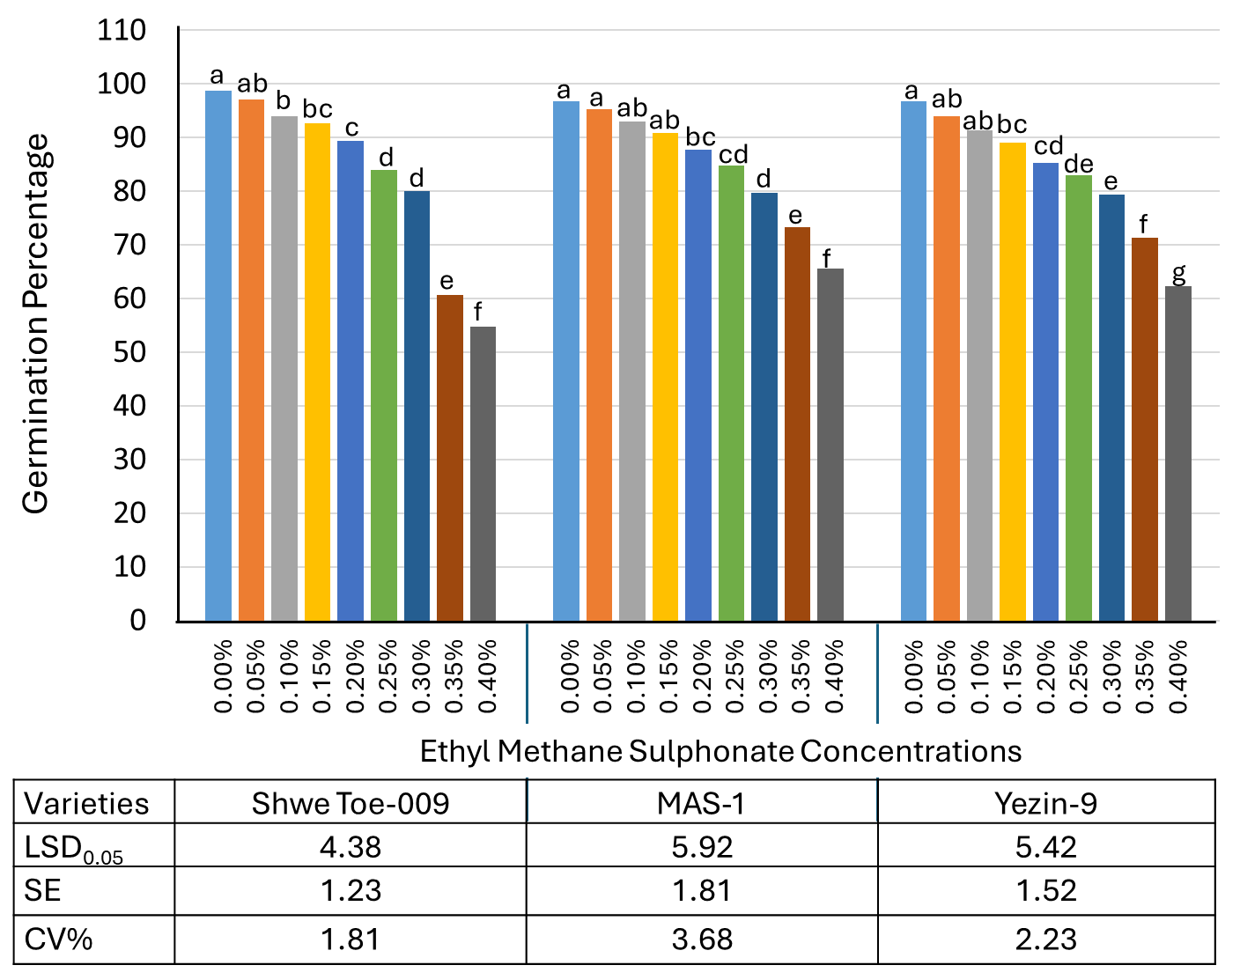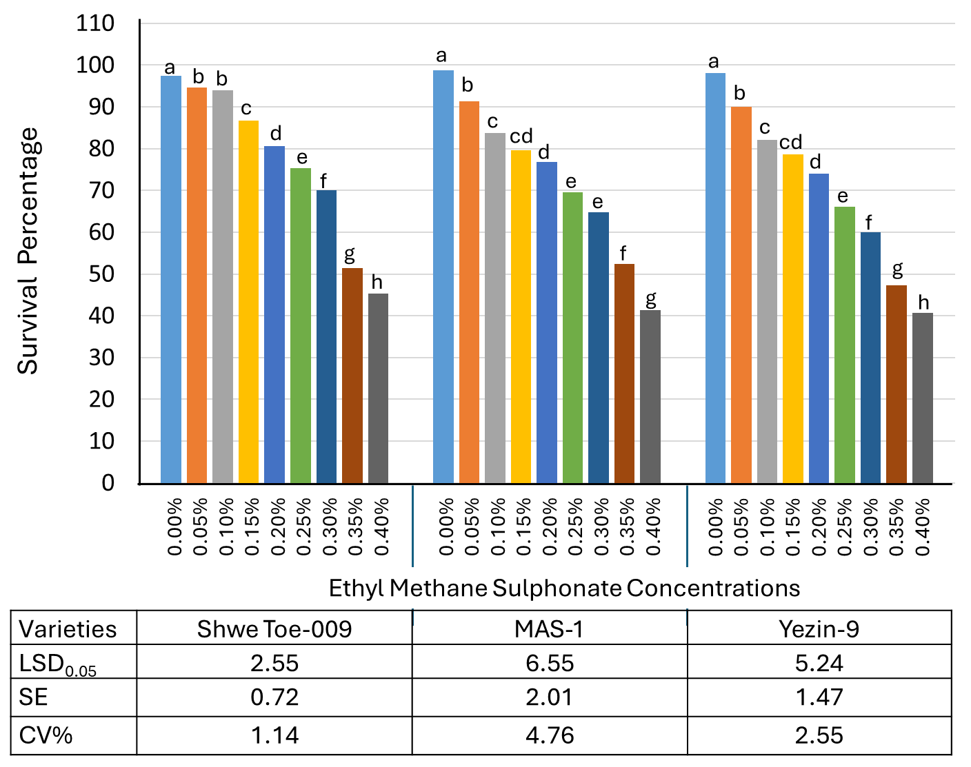

Fig. 1. Comparison of (a) germination and (b) survival response to EMS mutagenesis in three green gram varieties

In this study all the evaluated traits exhibited considerable variation across the varieties. For each variety, different letters indicated that the germination and survival percentages performed differently in the different doses of EMS and gamma radiation tested at least significant difference (LSD0.05). The germination and survival percentages decreased progressively with increasing EMS concentration (0.05% to 0.40%). At 0.40% EMS, all varieties showed significant sensitivity at 0.40% EMS, though with slight varietal differences. The germination dropped to 54.67-65.50% (vs. 96.67–98.67% in controls). For germination percentage, the two doses (0.35% and 0.40%) showed significant differences from other doses of EMS for all tested varieties. During the germination process, damage to the seeds during the meristematic region's cell division may be the cause of the effect on germination (Balai & Krishna, 2009; Kumar et al., 2010; Sagade & Apparao, 2011).

For survival percentage, three EMS concentrations (0.30%, 0.35% and 0.40%) revealed significant differences from others. Among the three green gram varieties, Shwe Toe-009 showed the lowest germination percentage while the lowest survival percentage was observed in Yezin-9. When the germination and survival percentages of gamma radiation (200 Gy to 1200 Gy) treated green gram varieties were compared with their control (0 Gy), the germination and survival percentages of the tested varieties decreased the increasing gamma radiation doses. The observed reduction in survival percentage following mutagenic treatments can be attributed to variations in cellular differentiation and embryonic development stages during exposure. These findings align with studies by Kusmiyati et al. (2018) in soybean which demonstrated that biological sensitivity to gamma radiation correlates with mutagen-induced disruptions in critical developmental processes. Such disruptions may include impaired cell division, elongation, biosynthesis, and hormonal regulation pathways, ultimately influencing survival rates. The lowest germination and survival percentages were observed in the highest dose of gamma radiation (1200 Gy) for all tested varieties. Consistent with the observed decline in germination percentage, this study also demonstrated a significant reduction in survival rates with increasing EMS concentrations and gamma-irradiation doses. Similar trends have been reported in cowpea (Horn et al., 2016), and pigeon pea (Ariraman et al., 2018). These studies collectively indicate that survival rates are high at low to intermediate mutagen doses but decline sharply at higher doses. The reduced survival percentage may result from gamma radiation's inhibitory effects on seed meristematic tissues, leading to chromosomal damage. This aligns with findings by Talebi et al. (2012), who attributed declining plant survivability to increased chromosomal aberrations at higher irradiation doses in rice. The findings indicate that green gram exhibits sensitivity to both gamma radiation and EMS, presenting a valuable opportunity to induce genetic variability for crop enhancement.

(a) (b)
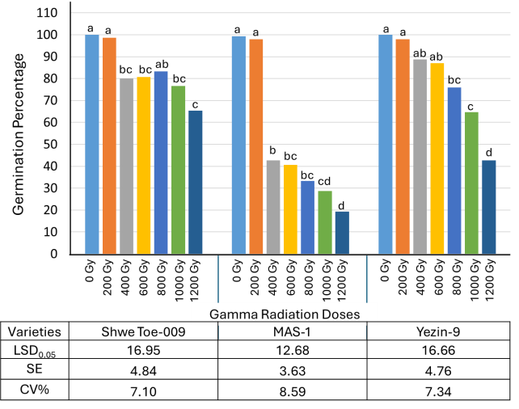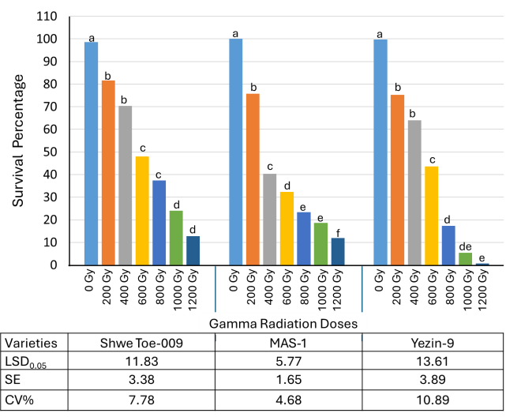

Fig. 2. Comparison of (a) germination and (b) survival response to gamma radiation mutagenesis in three green gram varieties

3.2 Determination of Lethal Doses

For successful induced mutagenesis in crops, establishing lethal dose values is essential, as these serve as critical reference points for determining optimal treatment doses in subsequent population studies. In the present study, lethal doses were determined with the help of probit analysis based on their survival rate of the seed after treatment with different doses/concentrations of gamma rays and EMS compared with untreated control (Table 1, 2 and 3). For Shwe Toe-009 variety, the probit curve analysis showed that the LD₅₀ value for EMS and Gamma rays were (0.38%) and (637.23 Gy), respectively (Table 1 and Figure 3). LD₅₀ values of EMS-treated and gamma-irradiated samples for green gram variety, MAS-1, were 0.39% and 414.88 Gy, respectively (Table 2 and Figure 4). LD₅₀ values of EMS-treated and gamma-irradiated Yezin-9 variety were 0.35% and 491.84 Gy respectively (Table 3 and Figure 5). The tested varieties showed similar LD₅₀ values when treated with EMS but displayed differing LD₅₀ responses to gamma radiation exposure. Among the three varieties, Shwe Toe-009 variety was the least sensitive to gamma irradiation followed by Yezin-9 and MAS-1. The observed difference in LD₅₀ patterns between EMS and gamma radiation treatments can be attributed to fundamental differences in their mutagenic mechanisms and biological interactions.

The differing LD₅₀ responses to gamma radiation versus EMS treatment in the tested varieties resulted from the distinct mechanisms of action of these mutagens and the varied genetic makeup of the plant varieties. EMS primarily induces point mutations by altering DNA bases, while gamma radiation causes more complex DNA damage, including deletions and chromosomal aberrations. This difference in damage type, coupled with inherent differences in DNA repair mechanisms and genetic backgrounds among the varieties, can lead to varying sensitivities to radiation. The chemical mutagen, EMS acts primarily by alkylating DNA bases, especially guanine, causing consistent point mutations across genotypes. It penetrates tissues uniformly, interacting similarly with cellular components regardless of variety. Its effects depend more on biochemical properties (e.g., DNA repair efficiency) that may be conserved across related varieties (Opoku Gyamfi et al., 2022).

Gamma radiation causes random DNA breaks, chromosomal aberrations, and oxidative damage via ionizing energy. Penetration and energy deposition may vary with tissue density, seed coat thickness, and moisture content. Indirect effects through radiolysis of water (free radical production) are influenced by cellular antioxidant capacity, which differs among varieties. Gamma radiation sensitivity is affected by physical barriers (e.g., seed coat thickness) that vary between varieties, while EMS diffusion is less impeded (Yasmin et al., 2020).

Table 1. Determination of the probit values for different doses of ethyl methane sulphonate and gamma radiation on green gram variety Shwe Toe-009

Conc./ Dose | Survival (%) | Survival over control (%) | Reduction over control (%) | Observed mortality (%) | Corrected mortality (%) | Log value of doses | Empirical probit value
Ethyl methane sulphonate (EMS)
0.00% | 97.33 | 100.00 | 0.00 | 2.67
0.05% | 94.67 | 97.26 | 2.74 | 5.33 | 2.74 | 1.70 | 3.08
0.10% | 94.00 | 96.58 | 3.42 | 6.00 | 3.42 | 2.00 | 3.19
0.15% | 86.67 | 89.04 | 10.96 | 13.33 | 10.96 | 2.18 | 3.77
0.20% | 80.67 | 82.88 | 17.12 | 19.33 | 17.12 | 2.30 | 4.05
0.25% | 75.33 | 77.40 | 22.60 | 24.67 | 22.60 | 2.40 | 4.25
0.30% | 70.00 | 71.92 | 28.08 | 30.00 | 28.08 | 2.48 | 4.42
0.35% | 51.33 | 52.74 | 47.26 | 48.67 | 47.26 | 2.54 | 4.92
0.40% | 45.33 | 46.58 | 53.42 | 54.67 | 53.42 | 2.60 | 5.08
Gamma radiation
0 Gy | 98.67 | 100.00 | 0.00 | 1.33
200 Gy | 81.67 | 82.77 | 17.23 | 18.33 | 17.23 | 2.30 | 4.05
400 Gy | 70.33 | 71.28 | 28.72 | 29.67 | 28.72 | 2.60 | 4.44
600 Gy | 48.00 | 48.65 | 51.35 | 52.00 | 51.35 | 2.78 | 5.03
800 Gy | 37.33 | 37.84 | 62.16 | 62.67 | 62.16 | 2.90 | 5.31
1000 Gy | 24.00 | 24.32 | 75.68 | 76.00 | 75.68 | 3.00 | 5.70
1200 Gy | 12.67 | 12.84 | 87.16 | 87.33 | 87.16 | 3.08 | 6.13

(a) (b)
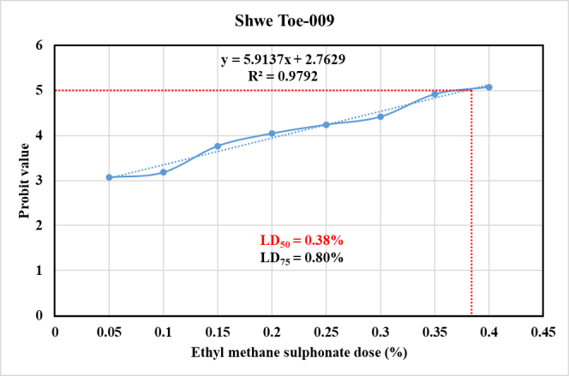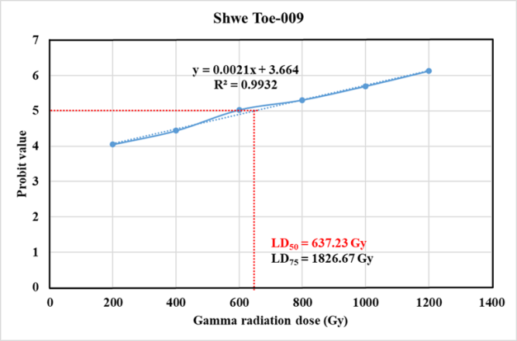

Fig. 3. Determination of the lethal doses of (a) ethyl methane sulphonate and (b) gamma radiation on green gram variety, Shwe Toe-009

Table 2. Determination of the probit values for different doses of ethyl methane sulphonate and gamma radiation on green gram variety MAS-1

Conc./ Dose | Survival (%) | Survival over control (%) | Reduction over control  (%) | Observed mortality (%) | Corrected mortality (%) | Log value of doses | Empirical probit value
Ethyl methane sulphonate (EMS)
0.00% | 99.33 | 100.00 | 0.00 | 0.67
0.05% | 92.67 | 93.29 | 6.72 | 7.33 | 6.71 | 1.70 | 3.50
0.10% | 85.33 | 85.91 | 14.09 | 14.67 | 14.09 | 2.00 | 3.92
0.15% | 80.67 | 81.21 | 18.79 | 19.33 | 18.79 | 2.18 | 4.10
0.20% | 79.33 | 79.87 | 20.13 | 20.67 | 20.13 | 2.30 | 4.16
0.25% | 73.33 | 73.83 | 26.14 | 26.67 | 26.17 | 2.40 | 4.36
0.30% | 69.33 | 69.80 | 30.20 | 30.67 | 30.20 | 2.47 | 4.48
0.35% | 57.33 | 57.72 | 42.28 | 42.67 | 42.28 | 2.54 | 4.80
0.40% | 42.00 | 42.28 | 57.72 | 58.00 | 57.72 | 2.60 | 5.19
Gamma radiation
0 Gy | 100 | 100 | 0 | 0
200 Gy | 75.67 | 75.67 | 24.33 | 24.33 | 24.33 | 2.30 | 4.29
400 Gy | 40.33 | 40.33 | 59.67 | 59.67 | 59.67 | 2.60 | 5.24
600 Gy | 32.33 | 32.33 | 67.67 | 67.67 | 67.67 | 2.781 | 5.45
800 Gy | 23.33 | 23.33 | 76.67 | 76.67 | 76.67 | 2.90 | 5.72
1000 Gy | 18.67 | 18.67 | 81.33 | 81.33 | 81.33 | 3.00 | 5.89
1200 Gy | 12.00 | 12.00 | 88.00 | 88.00 | 88.00 | 3.08 | 6.18

(a) (b)
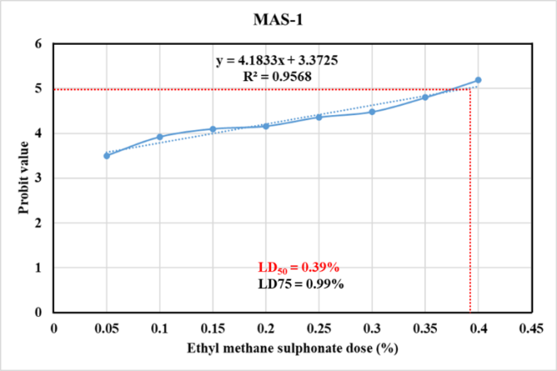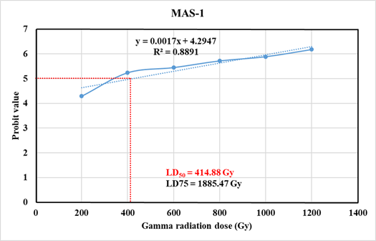

Fig. 4. Determination of the lethal doses of (a) ethyl methane sulphonate and (b) gamma radiation on green gram variety, MAS-1

Table 3. Determination of the probit values for different doses of ethyl methane sulphonate and gamma radiation on green gram variety, Yezin-9

Conc./ Dose | Survival (%) | Survival over control (%) | Reduction over control  (%) | Observed mortality (%) | Corrected mortality (%) | Log value of doses | Empirical probit value
Ethyl methane sulphonate (EMS)
0.00% | 98.00 | 100 | 0.00 | 2.00
0.05% | 90.00 | 91.84 | 8.16 | 10.00 | 8.16 | 1.70 | 3.59
0.10% | 82.00 | 83.67 | 16.33 | 18.00 | 16.33 | 2.00 | 4.02
0.15% | 78.67 | 80.27 | 19.73 | 21.33 | 19.73 | 2.18 | 4.15
0.20% | 74.00 | 75.51 | 24.49 | 26.00 | 24.49 | 2.30 | 4.31
0.25% | 66.00 | 67.35 | 32.65 | 34.00 | 32.65 | 2.40 | 4.55
0.30% | 60.00 | 61.22 | 38.78 | 40.00 | 38.78 | 2.48 | 4.71
0.35% | 48.67 | 49.66 | 50.34 | 51.33 | 50.34 | 2.54 | 5.01
0.40% | 40.67 | 41.50 | 58.50 | 59.33 | 58.50 | 2.60 | 5.21
Gamma radiation
0 Gy | 99.67 | 100 | 0.00 | 0.33
200 Gy | 75.33 | 75.59 | 24.41 | 24.67 | 24.41 | 2.30 | 4.31
400 Gy | 64.00 | 64.21 | 35.79 | 36.00 | 35.79 | 2.60 | 4.62
600 Gy | 43.67 | 43.81 | 56.19 | 56.33 | 56.19 | 2.78 | 5.15
800 Gy | 17.33 | 17.39 | 82.61 | 82.67 | 82.61 | 2.90 | 5.94
1000 Gy | 5.33 | 5.35 | 94.65 | 94.67 | 94.65 | 3.00 | 6.60
1200 Gy | 0.67 | 0.67 | 99.33 | 99.33 | 99.33 | 3.08 | 7.33

(a) (b)
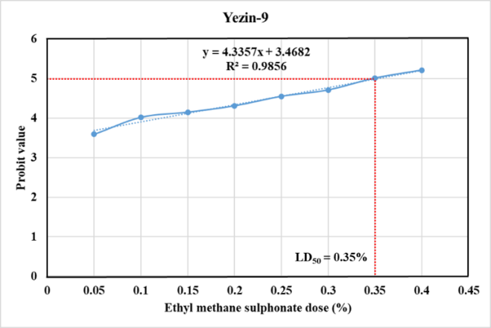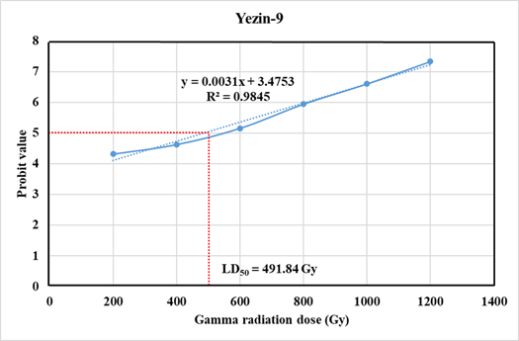

Fig. 5. Determination of the lethal doses of (a) ethyl methane sulphonate and (b) gamma radiation on green gram variety, Yezin-9

4. CONCLUSION

A given varieties’ level of response to a given mutagen varies from that of other genotypes due to the unique genetic composition of each genotype and the associated physiological and biochemical reactions. The statement is supported by the results of the present investigation, in which three different green gram varieties showed different LD₅₀ values for the chemical mutagen-ethyl methane sulphonate and physical mutagen-gamma ray. In order to establish the optimal mutagenic doses, the study assessed the LD₅₀ for ethyl methane sulphonate and gamma ray on three green gram varieties. For “Shwe Toe-009, MAS-1 and Yezin-9,” the LD₅₀ for ethyl methane sulphonate was determined to be 0.38%, 0.39% and 0.35% respectively. When treated with gamma ray, the LD₅₀ values for three genotypes were 637.23 Gy, 414.88 Gy and 491.84 Gy respectively. With varying dosages of EMS and gamma ray, several seedling parameters responded differently in tested varieties. The results showed that gamma ray at lower doses are more effective than EMS for obtaining the median lethal dose in three genotypes. In the present study, based on the germination and survival percentages, LD₅₀ doses for gamma irradiation and EMS have been predicted as 400-650 Gy and 0.40%. Lethal dose estimates serve as a foundation for efficient mutagenesis in green gram, enabling breeders to harness artificial mutations for crop improvement. By fine-tuning radiation and EMS treatments, researchers can develop high-yielding, stress-resistant green gram varieties to meet agricultural demands.

DISCLAIMER (ARTIFICIAL INTELLIGENCE)

Author(s) hereby declare that NO generative AI technologies such as Large Language Models (ChatGPT), manuscript.

REFERENCES

Álvarez-Holguín, A., Morales-Nieto, C. R., Avendaño-Arrazate, C. H., Corrales-Lerma, R., Villarreal-Guerrero, F., Santellano-Estrada, E., & Gómez-Simuta, Y. (2019). Mean lethal dose (LD 50) and growth reduction (GR 50) due to gamma radiation in Wilman lovegrass (Eragrostis superba). Revista mexicana de ciencias pecuarias, 10(1), 227-238.
Ariraman, M., Dhanavel, D., Seetharaman, N., Murugan, S., & Ramkumar, R. (2018). Regular article gamma radiation influences on growth, biochemical and yield characters of Cajanus cajan (L.) Millsp. J Plant Stress Physiol, 4, 38-40.
Awais, A., Nualsri, C., & Soonsuwon, W. (2019). Induced mutagenesis for creating variability in Thailand’s upland rice (cv. Dawk Pa-yawm and Dawk Kha 50) using ethyl methane sulphonate (EMS). Sarhad Journal of Agriculture, 35(1), 293-301.
Balai, O. P., & Krishna, K. R. (2009). Efficiency and effectiveness of chemical mutagens in mungbean. Journal of Food Legumes, 22(2), 105-108.
Chahal, G. S., & Gosal, S. S. (2002). Principles and procedures of plant breeding: biotechnological and conventional approaches. Alpha Science Int'l Ltd.
DOP (2021). Myanmar Agriculture Sector in Brief. Department of Planning. Ministry of Agriculture, Livestock and Irrigation.
Finney, D. J. (1971). A statistical treatment of the sigmoid response curve. Probit analysis. Cambridge University Press, London, 633.
Horn, L. N., Ghebrehiwot, H. M., & Shimelis, H. A. (2016). Selection of novel cowpea genotypes derived through gamma irradiation. Frontiers in Plant Science, 7, 262.
Ke, C., Guan, W., Bu, S., Li, X., Deng, Y., Wei, Z., ... & Zheng, Y. (2019). Determination of absorption dose in chemical mutagenesis in plants. PloS one, 14(1), e0210596.
Kim, S. K., Nair, R. M., Lee, J., & Lee, S. H. (2015). Genomic resources in mungbean for future breeding programs. Frontiers in plant science, 6, 626.
Kumar, A., Parmhansh, P., Mandal, R. K., & Prasad, R. (2010). Induced mutations in mungbean (Vigna radiata L. Wilczek). Indian Agriculturist, 54(3/4), 173-178.
Kusmiyati, F., Sas, M. G. A., & Herwibawa, B. (2018). Mutagenic effects of gamma rays on soybean (Glycine max L.) germination and seedlings. In IOP Conference Series: Earth and Environmental Science (Vol. 102, No. 1, p. 012059). IOP Publishing.
Mir, A. S., Maria, M., Muhammad, S., & Ali, S. M. (2020). Potential of mutation breeding to sustain food security. Genetic variation, 1-15.
Nair, R., & Schreinemachers, P. (2020). Global status and economic importance of mungbean. In The mungbean genome (pp. 1-8). Cham: Springer International Publishing.
Olasupo, F. O., Ilori, C. O., Forster, B. P., & Bado, S. (2016). Mutagenic effects of gamma radiation on eight accessions of Cowpea (Vigna unguiculata [L.] Walp.). American Journal of Plant Sciences, 7(02), 339-351.
Opoku Gyamfi, M., Eleblu, J. S. Y., Sarfoa, L. G., Asante, I. K., Opoku-Agyemang, F., & Danquah, E. Y. (2022). Induced variations of ethyl methane sulfonate mutagenized cowpea (Vigna unguiculata L. walp) plants. Frontiers in Plant Science, 13, 952247.
Pathak, R., Panchariya, P., Choudhary, M., Solanki, K., Rani, R., Kakani, R. K., & Kalia, R. K. (2023). Morphophysiological and molecular diversity in mung bean (Vigna radiata L.). Legumes: physiology and molecular biology of abiotic stress tolerance, 115-147.
Postelnicu, T. (2011). Probit analysis. Berlin Heidelberg: International Encyclopedia of Statistical Science Springer. doi:10.1007/978-3-642-04898-2461
Sagade, A. B., & Apparao, B. J. (2011). M1 generation studies in urdbean (Vigna mungo (L.) Hepper). Asian J. Exp. Biol. Sci, 2(2), 372-375.
Singh, A. K. (2007) Mutagenic effectiveness and efficiency of gamma rays and ethyl methane sulphonate in mungbean. Madras Agric. J., 94 (1-6): 7-13
Talebi, A. B., Talebi, A. B., & Shahrokhifar, B. (2012). Ethyl methane sulphonate (EMS) induced mutagenesis in Malaysian rice (cv. MR219) for lethal dose determination. American Journal of Plant Sciences, 3(12), 1661-1665.
Thounaojam, A. S., Patel, K. V., Solanki, R. U., Chaudhary, R. I., & Chavda, N. K. (2024). Response of gamma irradiation on germination and seedling growth of green gram var. GAM 8. Environment Conservation Journal, 25(1), 131-137.
Vikhe, A. C., & Nehul, J. N. (2020). Determination of LD₅₀ value of Vigna radiata (L.) Wilczek cultivar–Naval. Adv. in Zoology and Botany, 8(1), 6-11.
Yasmin, K., Arulbalachandran, D., Dilipan, E., & Vanmathi, S. (2020). Characterization of 60CO γ-ray induced pod trait of blackgram-A promising yield mutants. International journal of radiation biology, 96(7), 929-936.

