Original Research Article
Effect of Gamma Irradiation on Morphological Traits of Cassava (Manihot esculenta L. Crantz) Genotypes
ABSTRACT
Cassava (Manihot esculenta L. Crantz) is a perennial shrub characterized by outcrossing and a long breeding cycle, and significant inbreeding depression. Cultivated genotypes of cassava exhibit high heterozygosity; however, their reliance on vegetative propagation limits genetic diversity. To harness the inherent heterozygosity of cassava, the application of physical mutagens, specifically gamma irradiation, has been an effective method for generating novel genetic diversity, surpassing the slow and infrequent spontaneous mutation. The objective of the study was to create variation among candidate genotypes and determine the optimal doses for the effective mutagenic impact of gamma irradiation. Three cassava genotypes were exposed to gamma irradiation doses of: control (0), 15, 25, and 30 Gy. For seven months, we assessed the growth characteristics of cassava genotypes following gamma irradiation. Notably, the CAS-1 genotype showed a reduction in leaf lobes at 25 Gy. We successfully identified the LD₅₀ and GR₅₀ values for CAS-2 and CAS-3 genotypes at 23.62 Gy/23.05 Gy and 14.37 Gy/25.84 Gy, respectively; however, values for CAS-1 could not be determined due to suboptimal testing doses. Our analysis indicates optimal irradiation doses for CAS-2 and CAS-3 fall between 14 and 25 Gy. Additionally, a stimulating effect on sprout height was noted for CAS-2 at 15 Gy and CAS-1 at 30 Gy. Overall, while higher irradiation doses were detrimental to survivability in CAS-2 and CAS-3, CAS-1 demonstrated an increased survival rate. Our findings emphasize the importance of routine radiation sensitivity tests for all mutation breeding materials given the genetic variability.
Keywords: Manihot esculenta L. Crantz, Gamma irradiation, optimal dose, Radiation sensitivity test, Genotype
- INTRODUCTION
Cassava (Manihot esculenta L. Crantz) serves as a vital source of carbohydrates in sub-Saharan Africa and other tropical regions (Howeler et al., 2013), with Africa contributing over 50% of global production (FAO, 2025). Cassava is a member of the Euphorbiaceae family, primarily propagated vegetatively and demonstrates significant cross-pollination with high inbreeding. The species esculenta is the only cultivated variant among more than 90 species in its genus. It features diploid (2n = 36), triploid (3n = 54) and tetraploid (4n = 72) genomes with some triploid variants showing the most superior performance (Hahn et al., 1990). Cassava breeding faces challenges, including a lengthy vegetative phase and inbreeding depression due to its heterozygous nature, complicating the creation of inbred lines (Bizimana et al., 2024). Nonetheless, the genetic diversity of cassava can be improved through mutagenesis, which is crucial for enhancing genetic variability (Singh et al., 2023). Established mutation techniques, including the use of physical mutagens like gamma radiation, have been effective in increasing mutation rates and facilitating breeding efforts (Suprasanna and Nakagawa, 2011). The resultant mutants can be developed into new varieties or utilized in further breeding to enhance resource efficiency in germplasm development (Shu et al., 2011).
Gamma radiation and other physical mutagens have been pivotal in 90% of mutagenesis experiments with vegetatively propagated crops (Suprasanna and Nakagawa, 2011) resulting in the release of more than 700 mutant varieties (Mba and Shu, 2011). The properties of gamma radiation such as its short wavelength and strong penetration ability, enable it to induce mutations by altering DNA sequences in plant tissues, thereby enhancing the chances of beneficial mutations that can be inherited (FAO/IAEA, 2018). Gamma radiation is useful for vegetative propagules such as cassava stem cuttings (Baguma et al., 2021; Khumaida et al., 2015), not only fostering genetic diversity but also preserving desirable traits. Moreover, gamma irradiation is more efficient than conventional breeding methods expediting the breeding of root tubers such as cassava (Singh et al., 2023).
Gamma irradiation is species-specific, requiring careful optimization to minimize plant tissue damage while inducing effective mutations (Ghasemi-Soloklui et al., 2025; Sarri et al., 2024). Key metrics for evaluating sensitivity to gamma irradiation include lethal doses (e.g., LD₃₀, LD₅₀) and growth reduction (e.g., GR₃₀, GR₅₀) values, which determine optimal doses for mutation breeding (Ghasemi-Soloklui et al., 2025). Previous research has successfully utilized gamma irradiation in cassava breeding to achieve beneficial mutations such as improved disease resistance and enhanced tuber characteristics (Foster & Shu, 2011). Building on these findings, our study aimed to generate genetic variations in cassava genotypes, evaluating optimal gamma irradiation doses for the three candidate genotypes as part of our breeding initiative for cassava brown streak resistance.
- MATERIALS AND METHODS
  - Experimental Site and Plant Materials
The glasshouse experiment was conducted at the Department of Biotechnology, University of Eldoret, Kenya. The experimental site lies at an altitude of 2153 meters above sea level (masl) at a latitude of 0°34’ N and longitude 35°18’E with a mean temperature of 17.3°C and an annual average of rainfall of 2027 mm (https://en.climate-data.org/africa/kenya/uasin-gishu/eldoret-926351/).
The three candidate cassava genotypes, CAS-1, CAS-2, and CAS-3, used in the study, were part of the ongoing national performance trial of cassava genotypes conducted by the Department of Biotechnology's cassava breeding programme. The genotypes selected were based on validated desirable traits such as high yield and cooking quality (Kinyua et al., personal communication).
  - Gamma (γ) Rays Mutagenic Treatment of Cassava Cuttings/Stakes
We collected forty cassava cuttings/stakes, each bearing five nodes for the three genotypes at Koibatek Agricultural Training Centre (ATC), Eldama Ravine, Baringo County, Kenya and sent them for gamma irradiation at the Kenya Trypanosomiasis Research Institute (KETRI), Kikuyu, Kenya (Figure 1).
Bundles of cassava cuttings were subjected to acute gamma irradiation using a Cobalt-60 (⁶⁰Co) gamma source at a dose rate of 2 Gy/min for doses 0, 15, 25, and 30 Gray (Gy) for in vivo induction of mutation. After gamma irradiation, M1V1 cassava cuttings were carefully packaged and transported back to the University of Eldoret for planting.
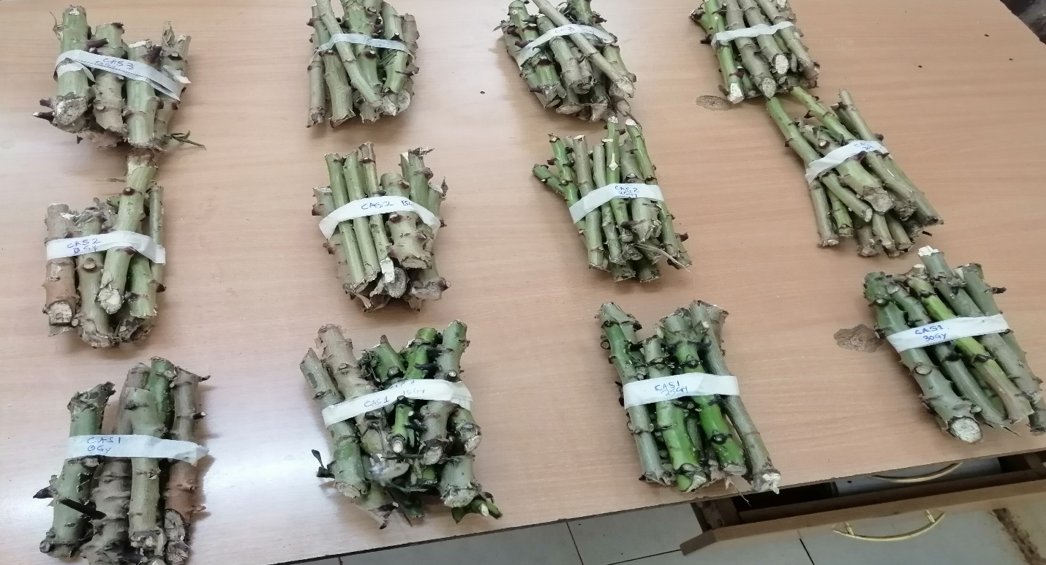
Fig. 1. Prepared cassava cuttings/stakes for the three candidate cassava genotypes with labels corresponding to the gamma irradiation dose treatment expected
2.3 Experimental Design and Greenhouse Regeneration of M1V1 Population
The M1V1 generation and unirradiated cassava cuttings/stakes were established as a 3 x 4 factorial experiment with three replicates, with the levels: CAS-1, CAS-2, CAS-3 and 0, 15, 25 and 30. All the cassava cuttings were planted in 17 cm by 12.5 cm pots in the glasshouse and managed for seven months.
  - Radiation Sensitivity Test - Data Collection and Analysis
    - Determination of the lethal dose at fifty per cent survival (LD₅₀) of cassava cuttings/stakes using survival percentage data
The number of surviving cassava cuttings at each dose for the three candidate cassava genotypes was recorded in Microsoft Excel until the seventh month. The percentage survival of cuttings at each dose was calculated and used to draw a combined line graph for the three cassava genotypes using the formula suggested by FAO/IAEA (2018).
Based on the survival percentage data and the combined line graph drawn using Microsoft Excel, the lethal dose at 50% survival (LD₅₀) for the seven-month-old M1V1 cassava plants was estimated by fitting a straight-line equation for the model, plotted using a simple linear regression approach (Rawat et al. 2024).
    - Determination of the fifty per cent growth reduction (GR₅₀) dose for the three cassava genotypes using cassava cuttings’ sprouting height recorded for 12 weeks
The data on the cassava cuttings sprout height at each dose for the three candidate cassava genotypes were recorded for 12 weeks and later processed in Microsoft Excel. The data processed were subjected to analysis of variance (ANOVA) at a 95% confidence interval, implemented in both Excel Analysis ToolPak and R programming. The mean separation was attempted using the least significant difference (LSD).
To determine the GR₅₀, we calculated the percentage (%) of the control over the mean cassava cuttings’ sprout height at each dose. This was used to draw a combined line graph for the three candidate cassava genotypes. The percentage (%) of the control over the mean cassava cuttings’ sprout height at each dose was calculated according to Mba et al. (2013) and Rawat et al. (2024).
    - Determination of the mean number of leaf lobes for each genotype for the respective gamma irradiation dose treatment
The data for the number of leaf lobes for the three genotypes were recorded at the sixth month according to the cassava descriptor by Fukuda et al. (2010) in MS Excel. We obtained the mean change in the frequency of the number of leaf lobes at each dose for the test genotypes and used it to draw a simple bar graph using MS Excel Analysis ToolPak to illustrate the change after gamma irradiation for 6 months of growth.
- RESULTS
3.1 Effect of gamma irradiation on the traits of cassava for the three candidate genotypes in the study
Gamma irradiation doses on each genotype were found to affect at least one of the measured traits even though the effect was statistically insignificant; for the CAS-1 genotype, sprout height trait decreased in doses 15 and 25 Gy and increased beyond the control at dose 30 Gy (Table 1, Table 2 and Figure 2). The percentage survival of cuttings decreased from 100% (0 Gy) to 54% (15 Gy) and again increased at doses of 25 and 30 Gy. The obvious impact of gamma irradiation on the CAS-1 genotype was the change in the number of leaf lobes from seven to five for the dose of 25 Gy (Table 2, Figure 3 and Figure 4). For the CAS-2 genotype, the measured parameters of the traits were negatively affected with the increase in gamma irradiation dose from 0 to 30 Gy (Table 2). According to survival percentage and number of leaf lobes traits, CAS-3 genotype was the most sensitive of the three genotypes to gamma irradiation treatment, able to tolerate only doses of 15 Gy and below. Conversely, the dose of 15 Gy showed stimulation in sprout height trait as compared to the control at a dose of 0 Gy (Table 1).
Table 1- Summary of ANOVA statistics for the three cassava candidate genotypes
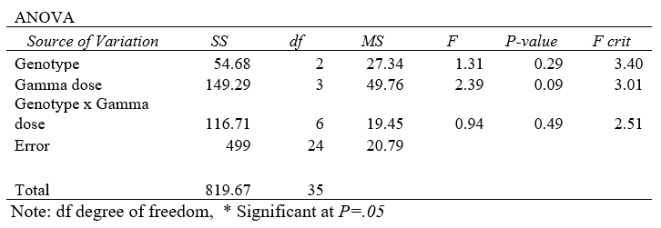
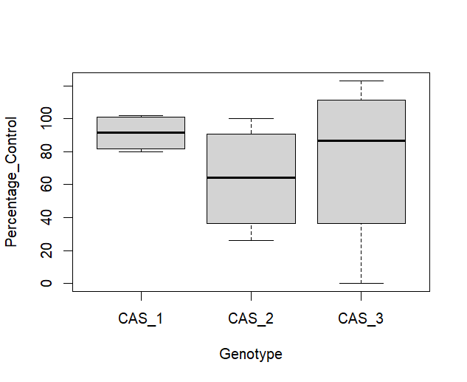
Fig. 2. Box plot for the three candidate cassava genotypes plotted using the sprout height data. The overlapping whiskers indicate no significant difference among the genotypes for per percentage control
Table 2 – A summary of the traits and observations in the study for the three cassava genotypes. The red font colour highlights the trend from dose 0 to 30 Gy
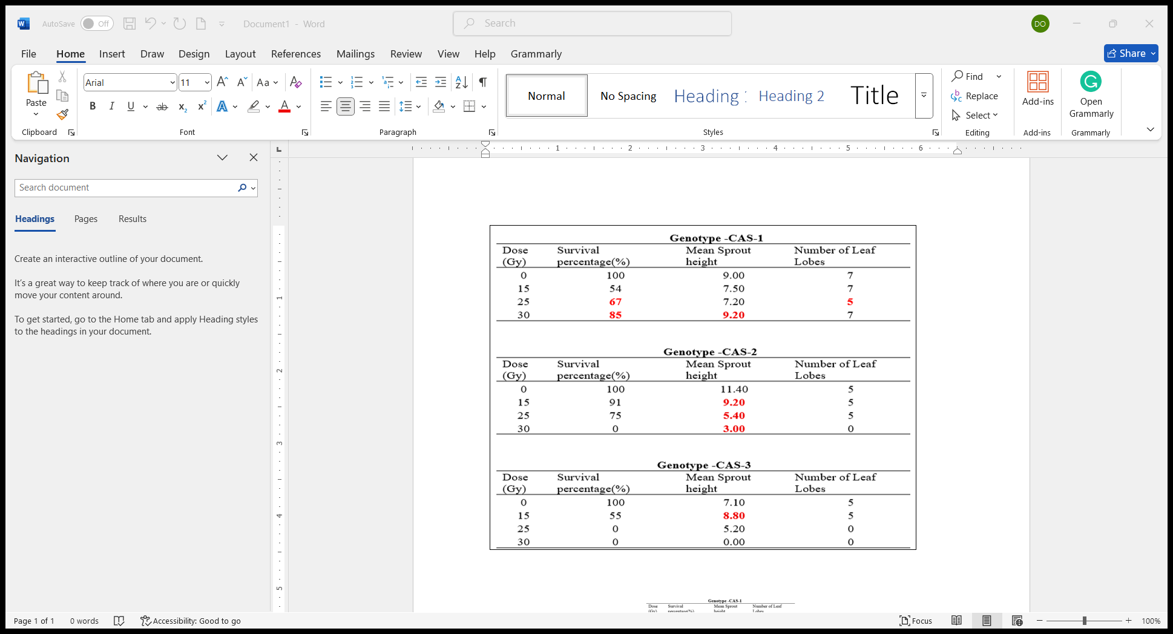

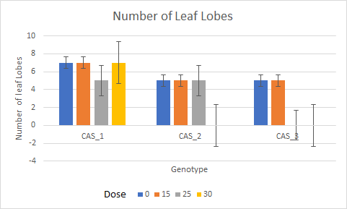
Fig. 3. A simple bar graph for the number of leaf lobes in each gamma-irradiated cassava candidate genotype with the corresponding dose treatment
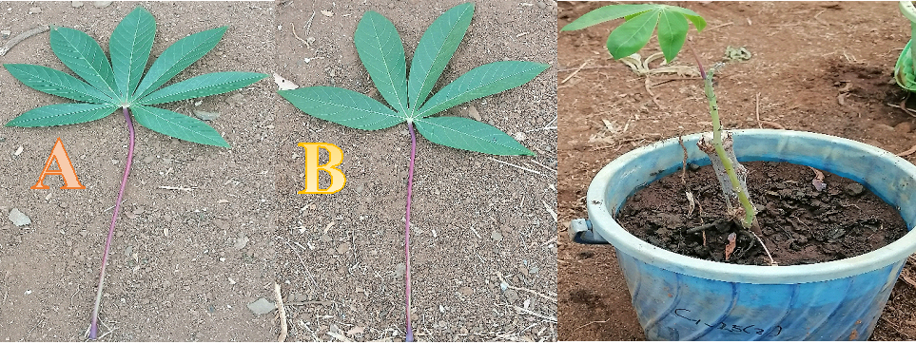
Fig. 4. Observed change in the number of leaf lobes in CAS-1, dose 25 Gy. A - CAS-1 parental genotype (unirradiated) leaf, while B – is gamma irradiated CAS-1, dose 25 Gy leaf at 6 months
3.2 The determination of the lethal dose at fifty per cent survival (LD₅₀) of cassava cuttings/stakes
To determine the optimal doses of gamma irradiation for effective mutation induction, an assessment of the gamma dose-cassava trait responsiveness must infer the genotype (s) radiation sensitivity. This inference could be made using either the cassava cuttings survival data or the cassava cuttings mortality data up to the time of harvesting. We used percentage (%) survival data collected for seven months to determine the optimal doses for the three cassava genotypes in the study. 50% survival chance following gamma irradiation (gamma rays dosage causing 50% mortality or damage, LD₅₀), we estimated LD₅₀ for CAS-2 as 23.62 Gy and 14.37 Gy for CAS-3. This was established more precisely using simple linear regression plots and the respective straight-line equations generated. It was impossible to estimate the LD₅₀ for the CAS-1 genotype based on the collected data; the mortality or survival percentages did not level off with increasing gamma irradiation dose. It was peculiar to see an increase in the rate of survival with an increase in gamma irradiation dose. Furthermore, we had little confidence in the attempt, given that the low coefficient of determination (R²) value of 0.1597, only 15.97% of the variation in per cent survival is explained by gamma doses (Figure 5).
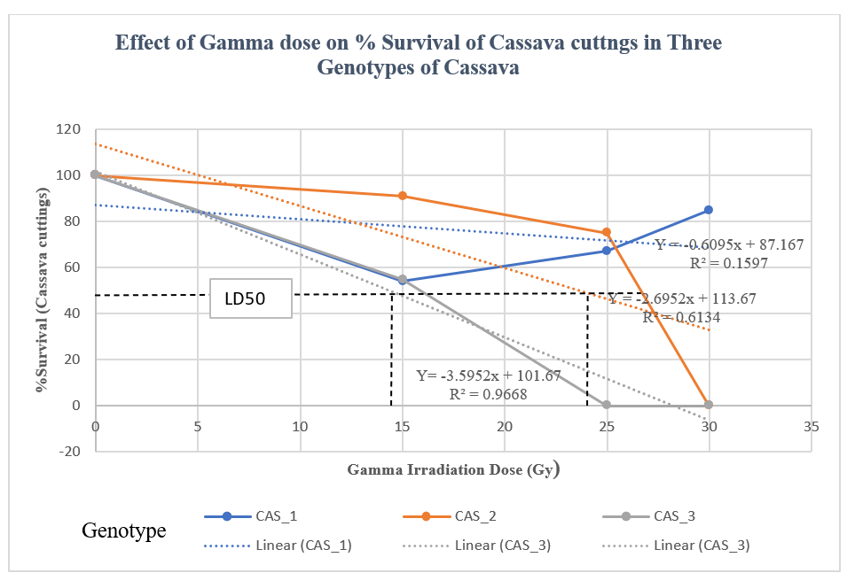
Fig. 5. Plotting the percentage survival of cassava cuttings against the gamma irradiation doses. The LD₅₀ line aids in the estimation of the respective LD₅₀ doses for the indicated cassava genotypes
3.3 Determination of the fifty per cent growth reduction (GR₅₀) dose for the three cassava genotypes using cassava cuttings’ sprouting height recorded for 12 weeks
The gamma irradiation dose that causes a 50% reduction in growth rate (GR₅₀) tends to infer a more subtle impact of the irradiation doses as compared to LD₅₀, which is more apparent, marked by the mortalities recorded in the same period. We inferred GR50 using sprout height data for CAS-2 and CAS-3 as 23.05 Gy and 25.84 Gy, respectively. We failed to estimate the GR₅₀ for the CAS-1 genotype because its sprout height data showed an increase in sprout height with gamma dose. The readings for the GR₅₀ values can be made using the simple regression plot and the straight-line equation for each genotype for the respective genotype plots (Figure 6).
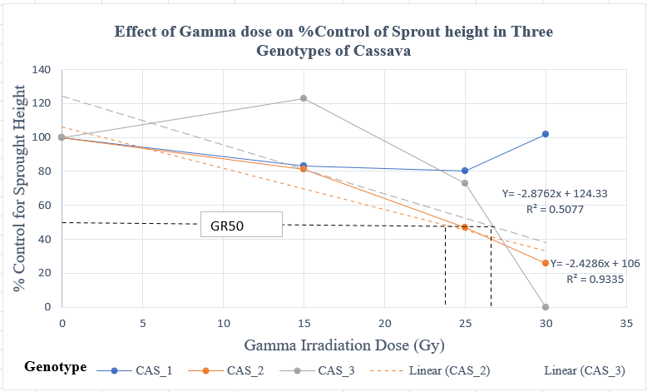
Fig. 6. A plot of the percentage (%) of the control sprout height against the gamma irradiation dose. The GR₅₀ values for the respective candidate cassava genotypes can be read off directly from the graph or calculated using the straight-line equations on the graph
- DISCUSSION
The present study determined the LD₅₀ for gamma irradiation in two cassava genotypes, CAS-2 and CAS-3, to be 23.62 Gy and 14.37 Gy, respectively. The GR₅₀ values for sprout height were found to be 23.05 Gy for CAS-2 and 25.84 Gy for CAS-3. The CAS-1 genotype exhibited significant tolerance to gamma irradiation at doses ≤30 Gy, preventing the calculation of LD₅₀ and GR₅₀ values for this genotype, which appeared to be less affected by the gamma irradiation compared to the others. Our LD₅₀ findings align more closely with those of Kangarasu et al. (2014) than with the higher values reported by Baguma et al. (2021). It is important to note that previous studies have encountered similar challenges in determining LD₅₀, especially in young or in vitro materials, for example lowest LD₅₀ value ever reported for cassava genotype was of 6 Gy (Ndofunsu et al., 2015), attributed to high sensitivity due to underdeveloped cell walls. Our results suggest an optimal gamma radiation dose range of 14 - 26 Gy for the effective induction of mutations in CAS-2 and CAS-3 consistent with prior research indicating a similar effective range of 20 - 30 Gy.
The study reaffirms previous findings regarding the high survivability of genotypes exposed to lower doses of gamma irradiation (Rawat et al., 2024; Ghasemi-Soloklui et al., 2025). It corroborates the unexpected observation made earlier that higher gamma doses can increase survivability, particularly noting the CAS-1 survival improvement at doses between 25 and 30 Gy (Kangarasu et al., 2014). Survival rates are influenced by the extent of chromosomal damage caused by irradiation (Suprasanna and Nakagawa, 2011). These findings suggest that lower dose rates of gamma irradiation effectively induce mutations with minimal damage. Therefore, lower dose rates are recommended to achieve effective gamma irradiation in vegetatively propagated crops, where mutants can become new varieties (Yamaguchi et al., 2008). Notably, low doses can stimulate growth in sprout height (Baguma et al., 2021) by activating stress response pathways (Mahure et al., 2010), enhancing antioxidant activities and mitigating oxidative damage. Moderate stress from low irradiation doses is noted to promote cell division and elongation in meristematic tissues (Hajizadeh et al., 2022). Conversely, high doses may generate excessive reactive oxygen species, leading to cellular damage and disrupting cellular structures and functions key to traits such as height (Lagoda, 2011). Additionally, a reduction in the number of leaf lobes in the CAS-1 genotype at 25 Gy was observed contrasting with other genotypes that exhibited consistent leaf lobe counts at different doses. The reduction in leaf lobe numbers due to gamma irradiation aligns with earlier findings of Baguma et al. (2021).
The statistical test on the traits of cassava genotypes given the two factors involved was insignificant. However, other studies have reported similar findings, up to half of the tested traits (Baguma et al., 2021; Sarri et al., 2024b). This study was limited by the three traits chosen due to the inability to conduct multivariate analysis to provide nuance among the study traits found in other studies (Ghasemi-Soloklui et al., 2025). Our study design could also have failed to factor in the nonuniformity in age for the material selected for gamma irradiation. Our findings confirm the invaluable need to conduct independent radiation sensitivity tests for every mutation breeding study, owing to genotypic and species differences. The GR₅₀ and LD₅₀ values can only be referenced, but not directly adopted, between studies. The findings offer us an opportunity to advance our cassava brown streak resistance breeding objectives.
- CONCLUSION
The study aimed to generate genetic variations in candidate cassava genotypes using cassava cuttings/stakes and to identify optimal gamma irradiation doses for mutation induction, focusing on traits relevant to cassava brown streak resistance. Three genotypes were exposed to gamma doses of 0, 15, 25 and 30 Gy, with evaluations of survival rates, leaf lobe variation, and sprout growth height. Key findings included lethal doses (LD₅₀) for CAS-2 and CAS-3 at 23.62 Gy and 14.37 Gy, respectively, and growth reduction (GR₅₀) values of 23.05 Gy and 25.84 Gy for sprout height in CAS-2 and CAS-3. CAS-1 showed the highest tolerance to irradiation, with significant effects observed at 25 Gy on leaf lobe count, although it was less affected in the other traits. The study suggests an optimal gamma radiation range of 14-26 Gy for effective mutation induction in CAS-2 and CAS-3 while maintaining acceptable growth levels. These insights emphasize the necessity of radiation sensitivity tests for genotypes or species in cassava breeding research.
ACKNOWLEDGEMENTS
This study was funded by the International Atomic Energy Agency (IAEA) through a grant to the University of Eldoret, Kenya, via Coordinated Research Projects (CRP) funding. The authors express gratitude to the KETRI staff for their technical assistance during the gamma irradiation process. Appreciations are extended to Mr Nathan Muasya and Miss Caroline Ndegwa for managing the M1V1 populations at the Department of Biotechnology greenhouses. Lastly, special thanks go to Mr Evans Ondati and the Koibatek Agricultural Training Centre management for maintaining the cassava genotypes used in the study.
DECLARATION OF COMPETING INTEREST
The authors declare no known competing financial interests or personal relationships that could have appeared to influence the work reported in this paper.
DATA AVAILABILITY STATEMENT
The original contributions presented in the current study are included in this journal article; we welcome further inquiries to be directed to the corresponding authors in this publication.
ETHICAL STATEMENT
Gamma irradiation exposure to cassava cuttings was conducted in a gamma chamber by a qualified and authorised person, as per the rules and regulations of KETRI in Kenya and the International Atomic Energy Agency (IAEA). We confirmed safe handling of the plant materials and that no non-target organisms were intentionally or unintentionally harmed in the course of this project. The authors adhered to all ethical issues in handling plant materials post-irradiation.
DISCLAIMER (ARTIFICIAL INTELLIGENCE)
The authors hereby declare that NO generative AI technologies such as Large Language Models (ChatGPT, COPILOT, Gemini, etc.) and text-to-image generators have been utilized in producing this manuscript.
REFERENCES
Baguma, J. K., Ogwok, E., Elegba, W., Sarkodie, A., Otu, S., Apio, H. B., Kawuki, R. S., Bua, A., Danso, K., & Alicai, T. (2021). Effects of gamma irradiation and ethyl methane sulphonate on morphometric traits and prevalence of common viral diseases and whiteflies in cassava. African Crop Science Journal, 29(3), 355–371. https://doi.org/10.4314/acsj.v29i3.3
Bizimana, J. P., Ngapout, Y., Nyirakanani, C., Shakir, S., Kanju, E., Legg, J. P., Rukundo, P., Shimelis, H., Nduwumuremyi, A., & Vanderschuren, H. (2024). Breeding strategies for mitigating cassava brown streak disease in Africa. Tropical Plants, 3(1), 0–0. https://doi.org/10.48130/tp-0024-0006
Climate Date (2025). Eldoret climate, Kenya. https://en.climate-data.org/africa/kenya/uasin-gishu/eldoret-926351/ [Accessed on 6th July 2025]
FAO/IAEA. (2018). Manual on mutation breeding - Spencer-Lopes M.M., Forster B.P., & L. Jankuloski, Eds.; Third edition. Food and Agriculture Organization of the United Nations. Rome, Italy. 301pp.
Food and Agriculture Organization of the United Nations (2025) – with major processing by Our World in Data. “Cassava production – FAO” [dataset]. Food and Agriculture Organization of the United Nations, “Production: Crops and livestock products” [original data]. Retrieved June 11, 2025, from https://ourworldindata.org/grapher/cassava-production
Foster B.P., & Shu Q. Y. (2011). Plant Mutagenesis in Crop Improvement: Basic Terms and Applications. In Shu Q.Y., Forster B.P., & Nakagawa H. (Eds.), Plant Mutation Breeding and Biotechnology: (pp. 12–23). Joint FAO/IAEA.
Fukuda, W. M. G., Guevara, C. L., Kawuki, R., & Ferguson, M. E. (2010). Selected morphological and agronomic descriptors for the characterisation of cassava. International Institute of Tropical Agriculture (IITA), Ibadan, Nigeria, 1–28.
Ghasemi-Soloklui, A. A., Kordrostami, M., & Jafari, M. (2025). Determination of optimal gamma radiation dose for mutation breeding in ’Sabz’ fig (Ficus carica L.) cuttings based on radiosensitivity and phenotypic changes. PLoS ONE, 20(1). https://doi.org/10.1371/journal.pone.0313017
Hahn, S. K., Bai, K. V., & Asiedu, R. (1990). Tetraploids, triploids, and 2n pollen from diploid interspecific crosses with cassava. Theor Appl Genet, 79, 433–439.
Hajizadeh, H. S., Mortazavi, S. N., Tohidi, F., Yildiz, H., Helvaci, M., Alas, T., & Okatan, V. (2022). Effect of mutation induced by gamma-irradiation in ornamental plant Lilium (Lilium longiflorum cv. tresor). Pakistan Journal of Botany, 54(1). https://doi.org/10.30848/pjb2022-1(23)
Howeler Reinhardt, Lutaladio NeBambi, & Graeme Thomas. (2013). Save and grow: Cassava (Gutierrez Diana, Ed.). FAO.
Kangarasu S., Ganeshram S, & A. John Joel. (2014). Determination of Lethal Dose for Gamma Rays and Ethyl Methane Sulphonate Induced Mutagenesis in Cassava (Manihot esculenta Crantz). International Journal of Scientific Research, 3(1).
Khumaida, N., Ardie, S., Dianasari, M., & Syukur, M. (2015). Cassava (Manihot Esculenta Crantz) Improvement through Gamma Irradiation. Procedia Food Science, 3, 27–34. https://doi.org/10.1016/j.profoo.2015.01.003
Lagoda P.J.L. (2011). Effects of Radiation on Living Cells and Plants. In Shu Q.Y, Forster B.P, & Nakagawa H. (Eds.), Plant Mutation Breeding and Biotechnology (pp. 123–134). Joint FAO/IAEA.
Mahure H.R., Choudhary M.L., Prasad K.V., & Singh S.K. (2010). Mutation in chrysanthemum through gamma irradiation. Indian J. Hort, 67, 356–358.
Mba, C. (2013). Induced mutations unleash the potential of plant genetic resources for food and agriculture. In Agronomy (Vol. 3, Issue 1, pp. 200–231). MDPI AG. https://doi.org/10.3390/agronomy3010200
Mba C., & Shu Q.Y. (2011). Gamma Irradiation. In Shu Q.Y, Forster B.P, & Nakagawa H. (Eds.), Plant Mutation Breeding and Biotechnology (pp. 91–98). Joint FAO/IAEA.
Ndofunsu Diamuini, Otono Bulubulu, Nakweti Kikakedimau, Mba Chikelu, & Till J. Bradley. (2015). In vitro gamma radiosensitivity test in Congolese cassava, Manihot esculenta Crantz accession. Academic Journal of Biotechnology, 1, 001–005. https://doi.org/DOI:10.15413/ajb.2014.0111
Rawat, A. S., Bhuj, B. D., Srivastava, R., Chand, S., Singh, N. K., Bisht, Y. S., Dasila, H., Bhatt, R., Perveen, K., & Bukhari, N. A. (2024). Determination of lethal and mutation induction doses of gamma rays for gladiolus (Gladiolus grandiflorus Hort.) genotypes. Heliyon, 10(17). https://doi.org/10.1016/j.heliyon.2024.e37387
Sarri, E., Samolada, S. M., Katsileros, A., Tomlekova, N., Abraham, E. M., & Tani, E. (2024b). Effect of γ-Irradiation on the Growth and Yield Response of Three Varieties of Pea (Pisum spp.). Agronomy, 14(8). https://doi.org/10.3390/agronomy14081695
Singh Asheesh, Singh Arti, Barb Jessica, Mahama A. Anthony, & Suza Walter. (2023). Genetic Variation and Germplasm Usage. In Suza W.P. & Lamkey K.R. (Eds.), Crop Improvement. Iowa State University Digital Press.
Suprasanna P., & Nakagawa H. (2011). Mutation Breeding of Vegetatively Propagated Crops. In Shu Q.Y., Forster B.P., & Nakagawa H. (Eds.), Plant Mutation Breeding and Biotechnology: (pp. 347–358). Joint FAO/IAEA.
Yamaguchi, H., Shimizu, A., Degi, K., & Morishita, T. (2008). Effects of dose and dose rate of gamma ray irradiation on mutation induction and nuclear DNA content in chrysanthemum. In Breeding Science (Vol. 58).

