Original Research Article

**Immunohistochemical Expression of Programmed Death Ligand 1(PD-L1) and Its Correlation with Clinicopathological Parameters in Breast Carcinoma**

|  |
| --- |
| **Aims:** Breast carcinoma (BC) is the leading cause of tumor burden, with an incidence of 11.8%. The programmed cell death protein 1(PD-1)/programmed death ligand 1 (PD-L1) pathway represents an adaptive immune resistance mechanism that tumor cells exert. Recent updates in the treatment modality of breast carcinoma indicate that the use of anti-PD-L1 therapy will help treat advanced breast carcinoma. This study aimed to evaluate the immunohistochemical (IHC) expression of the PD-L1 in breast carcinoma and to analyze the correlation between the PD-L1 and various clinicopathological factors.  **Study design:** A hospital-based cross-sectional study  **Place and Duration of Study:** Department of Pathology, BLDE(DU). Shri B.M. Patil Medical College, Hospital, and Research Center, Vijayapura. Between 1st May 2023 to 31st December 2024.  **Methodology:** The study was conducted on fifty invasive breast carcinoma cases. Tumor samples were assessed via routine microscopy and graded using the Bloom-Richardson system. IHC was performed for PD-L1 and estrogen receptor (ER), progesterone receptor (PR), and human epidermal growth factor receptor 2/neu (HER2/neu) status. PD-L1 scoring was performed using the combined positive score (CPS). PD-L1 expression was then correlated to clinicopathological factors including age, tumor size, histologic type and grade, lymph node status, and pTNM stage.  **Results:** PD-L1 expression was seen in 14 out of 50 cases (28.0%). Expression of PD-L1 showed a statistically significant correlation with HER2/Neu (p = 0.03). The expression of PD-L1 is not statistically significant with other clinicopathological parameters. Hence, PD-L1 may not be a robust prognostic marker based on current evidence.  **Conclusion:** Standardized PD-L1 immunohistochemistry reporting ensures reliable evaluation of breast carcinoma. Consistent and accurate PD-L1 assessment could significantly impact the application of novel targeted immunotherapies in treating breast carcinoma.  *Keywords: Breast carcinoma, PD-L1, Prognosis* |

ABSTRACT

1. INTRODUCTION

Breast carcinoma (BC) is the leading cause of tumor burden, with an incidence of 11.8%. The global burden of Breast cancer is expected to cross more than 20 lakhs by 2030 [1]. According to the WHO 2022 projections, in nations with a very high Human Development Index (HDI), about 1 in 12 women will receive a breast cancer diagnosis at some point in their lives, while approximately 1 in 71 will die from the disease [2]. The overall incidence and mortality of females diagnosed with breast cancer are highest in Asian countries like India and Pakistan [3]. Breast cancer is an intricate, multidimensional disease that is caused by a confluence of environmental, hormonal, and hereditary variables [4].Approximately half of the breast cancers develop in women over the age of 40 years. The notifiable risk factors that increase the risk are the increasing age of the patient, obesity, consumption of alcohol, family history, radiation exposure, and postmenopausal hormone therapy [5].Programmed Death-Ligand 1 (PD-L1) is an immunoregulatory protein that traverses the cell membrane. It binds to Programmed Cell Death-1 (PD-1) receptors present in diverse immune cells, including lymphocytes (T and B cells), natural killer (NK) cells, dendritic cells, and monocytes. In addition to causing T cell apoptosis, activation decreases T cell multiplication and T lymphocyte activity, decreases cytokine production, and induces antigenic tolerance [6]. These deactivated T cells in the tumor microenvironment aid in tumor progression [7]. PD-L1 is overexpressed in numerous malignancies like Lung, Urinary bladder, Colorectal, and renal malignancies. A worse prognosis is linked to increased PD-L1 expression [8]. One of the significant focuses of immune-oncology research is identifying the strategies to circumvent these tumor resistance pathways [9]. Immunotherapeutic approaches, especially immune checkpoint inhibitors (ICIs), have transformed oncology and have proven effective in managing various cancers [10]. Several PD-1/PD-L1 inhibitors have been created in recent decades to treat multiple types of cancer [11]. A global clinical trial has demonstrated that adding an anti-PD-L1 drug to nab-paclitaxel significantly enhances progression-free survival in patients with metastatic triple-negative breast cancer compared to treatment with nab-paclitaxel monotherapy alone [12,10]. In September 2014, the approval of Pembrolizumab for advanced melanoma paved the way for the broader clinical advancement of PD-1/PD-L1 inhibitors as anticancer therapies. The FDA has recently authorized these inhibitors as anticancer therapies for nine additional cancer types [13]. Recent years have seen the evolution of anti-PD-1/PD-L1 (Programmed Death-L1) medicines in breast cancer, mainly in the TNBC (triple negative subtype), with encouraging outcomes when administered either alone or in conjunction with conventional therapy [14]. Given that PD-L1 serves as a potential prognostic biomarker in various solid tumors, including breast cancer, its expression must be examined to assess its significance in targeted immunotherapy [15]. Although extensive research has been conducted, there is still a limited body of literature on PD-L1 expression in Indian breast carcinoma patients, with existing studies yielding inconsistent results [16].

The present study aims to evaluate the immunohistochemical expression of PD-L1 marker on carcinoma breast and to analyze the correlation between the expression of the PD-L1 marker with ER, PR, HER2/neu receptors, and with various clinicopathological factors, including age of the patient, tumor size, histologic type, histologic grade, lymph node status and pTNM staging.

2. material and methods

A hospital-based cross-sectional study was conducted on 50 mastectomy specimens collected at the Histopathology and Surgical Pathology Section of the Department of Pathology. The patient’s age, histological type, tumor size, lymph node status and histological grade were noted.

Exclusion criteria included breast biopsy, lumpectomy and improperly fixed specimens. Institutional ethical clearance was obtained for this study.

Four sections were prepared from each tissue block. For histopathological diagnosis, one tissue section was stained with hematoxylin and an eosin stain. Additional tissue sections were placed on a poly-L-lysine-coated slide and subjected to ER/PR/HER2/neu and PD-L1 immunohistochemistry. PD-L1 expression was then correlated to clinicopathological factors including age, tumor size, histologic type and grade, lymph node status, ER/PR/HER2/neu and pTNM stage.

A sample was deemed suitable for PD-L1 assessment if it contained at least 100 viable tumor cells. The scoring criteria for tumor cells included partial and complete membrane staining, while cytoplasmic staining was excluded as it was considered nonspecific. The scoring system was also extended to tumor-associated immune cells, including macrophages and infiltrating lymphocytes, that exhibited cytoplasmic or membrane staining. (Table 1)

**Table 1 - IHC Interpretation of PD-L1**

|  |  |
| --- | --- |
| **PD-L1** | **Combined Positive Score (CPS)** |
| Positive | Tumor cells- Complete or partial membrane staining is present in >10% of tumor cells.  Immune cell- Lymphocytes, macrophages exhibiting cytoplasmic or membrane staining. |
| Negative | Tumor cells- Complete or partial membrane staining is present in <10% of tumor cells.  Immune cell- Lymphocytes, macrophages exhibiting cytoplasmic or membrane staining. |

Specimens were classified as positive for PD-L1 expression, with a Combined Positive Score (CPS) of ≥10%, meaning a minimum 10% of viable tumor cells displayed membrane staining at any intensity, along with immune cells (lymphocytes and macrophages) showing membrane or cytoplasmic staining. Conversely, specimens were considered PD-L1 negative if the CPS was <10%, indicating that less than 10% of viable tumor cells exhibited membrane staining at any intensity [15].



For sample size calculation, the G\*Power version 3.1.9.4 tool was used. Data collection and analysis were conducted using Microsoft Excel and SPSS version 20. Results were presented as Mean (Median) ± Standard Deviation, along with counts, percentages, and visual diagrams for interpretation. The chi-square test was applied to evaluate associations between categorical variables. A *P* value < .05 was considered statistically significant.

3. results and discussion

results

**EXPRESSION OF PD-L1 IN THE STUDY POPULATION**

PD-L1 was identified by immunohistochemical (IHC) staining using a “Rabbit monoclonal antibody, Ventana SP263 Clone kit” with an FDA-approved automatic device (VENTANA BenchMark). PD-L1 expression was objectively evaluated by the Combined Positive Score (CPS). PD-L1 positivity (CPS >10%) was seen in 14 (28%) cases. PD-L1 was considered negative when CPS <10%. In this study, 36 (72%) cases were PD-L1 negative. ( Figure 1) ( Figure 2)

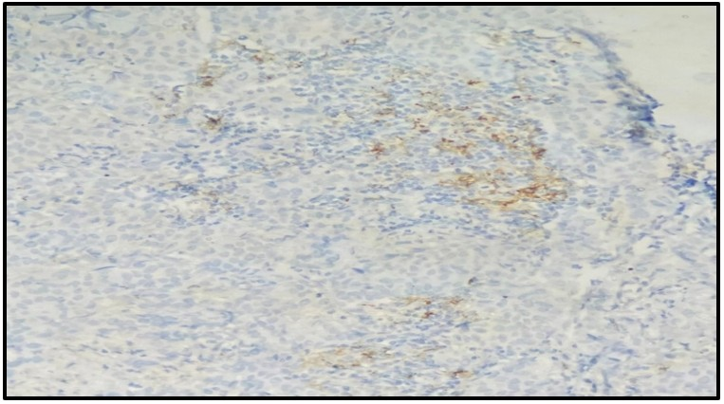

**Figure 1: Microphotograph of IHC marker PD-L1 showing membranous staining in tumor cells of invasive breast carcinoma NOS (100x)**

**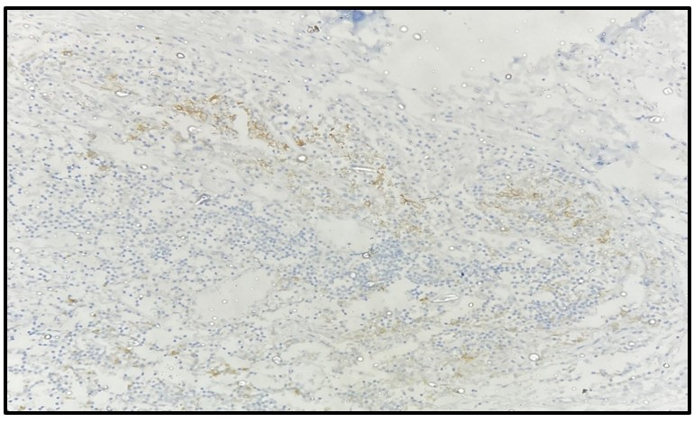**

**Figure 2: Microphotograph of IHC marker PD-L1 showing cytoplasmic and membranous staining in immune cells in invasive breast carcinoma NOS (100x)**

**CORRELATION BETWEEN PD-L1 EXPRESSION AND THE CLINICOPATHOLOGICAL PARAMETERS**

1. **AGE**

The patients with invasive breast cancer ranged in age from 30 to 80 years, and their mean age was 55.7 years. The highest number of PD-L1 positivity was observed in the study population of people over 50 years of age. The p-value is 0.27, which shows a statistically insignificant association between PD-L1 expression and the patient’s age.

1. **SIZE OF THE TUMOR**

The size of the tumor varied between 1 cm and 16 cm. In the majority of the cases tumor size was between 2-5cm (T2). Of the PD-L1 positive patients, 7 (50%) belong to the tumor size T2 group, 5 (35.7%) belong to the tumor size T1, and 02 (14.3%) belong to the tumor size T3.   
There is no statistically significant correlation between tumor growth and PD-L1 expression, as indicated by the p-value of 0.32. (Figure 3)

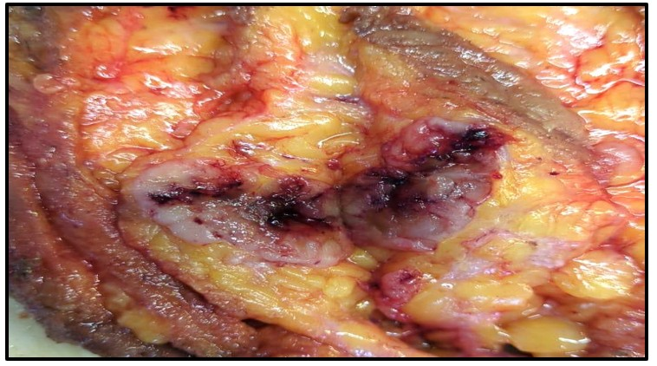

**Figure 3: Macrophotograph showing cut section of Invasive ductal carcinoma with tumor size 2x1.5 cm**

1. **HISTOLOGICAL TYPE**

Out of 50 cases studied, the maximum number of cases were Infiltrating ductal carcinoma NOS, i.e., 46 cases (92%), as shown in (Figure 4). One case (2%) was of Invasive lobular carcinoma, 1 case (2%) was invasive papillary carcinoma, 1 case (2%) was encapsulated papillary carcinoma, and 1 case (2%) was Mucinous carcinoma.13 (92.8%) of the 46 infiltrating ductal carcinoma-NOS cases had PD-L1 positivity. The p-value was 0.44, showing no statistically significant association with PD-L1 and histological type.

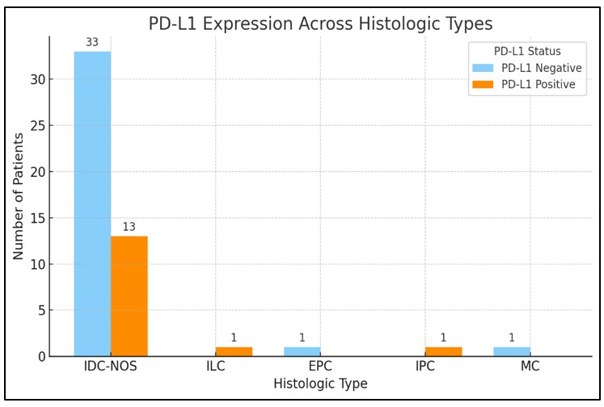

**Figure 4: Graphical representation of PD-L1 with histologic type**

1. **HISTOLOGICAL GRADE**

In the present study, 20 (40%) cases belonged to histological grade I, 23 (46%) cases belonged to histological grade II and 7(14%) cases were of grade III. Most cases in this study with positive PD-L1 expression were Grade I. The p-value was 0.534, which shows a statistically insignificant correlation. (Figure 5)

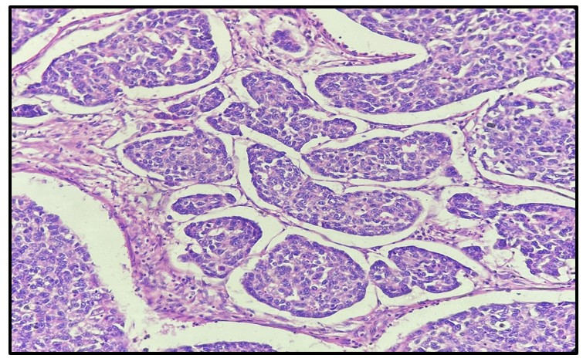

**Figure 5: Microphotograph of invasive breast carcinoma NOS- Grade 2. Tumor cells showing moderate Nuclear pleomorphism (H&E) (400x)**

1. **LYMPH NODE STATUS**

Lymph node metastasis was seen in 30(60%) of the 50 invasive breast cancer cases; of them, 8 (57.1%) had PD-L1 positive expression and 22 (61.1%) had PD-L1 negative expression. The p-value was 0.30, showing no statistical significance in comparing PD-L1 expression with lymph-node status.

1. **ESTROGEN RECEPTOR STATUS**

Among 50 cases of invasive breast carcinoma**,** 18 cases (36%) were ER-negative, and 32 cases (64%) were ER-positive. Six (42.9%) of the 18 ER-negative cases were PD-L1 positive. Eight (57.1%) of the 32 patients with positive ER expression had PD-L1 expression. A statistically insignificant association between the tumor’s ER status and PD-L1 expression was demonstrated by the p-value of 0.7

1. **PROGESTERONE RECEPTOR STATUS**

Among 50 cases of invasive breast carcinoma**,** 20 cases (40%) were PR-negative, and 30 cases (60%) were PR-positive. Seven (50%) of the 20 PR-negative cases were PD-L1 positive. Seven (50%) of the 30 individuals with positive PR expression also had PD-L1 positivity. A statistically insignificant association between the tumor’s PR status and PD-L1 expression was indicated by the p-value of 0.56.

1. **HER2/neu STATUS**

Of the 50 invasive breast cancer cases in the current study, 26 (52%) had HER2/neu negative results, and 24 (48%) had HER2/neu positive results. Four (28.6%) of the 26 HER2/neu negative cases were PD-L1 positive. Ten (71.4%) of the 24 individuals with positive HER2/neu expression also had PD-L1 positivity. PD-L1 expression and the tumor’s HER2/neu status were statistically significantly correlated, as indicated by the p-value of 0.03. (Figure 6)

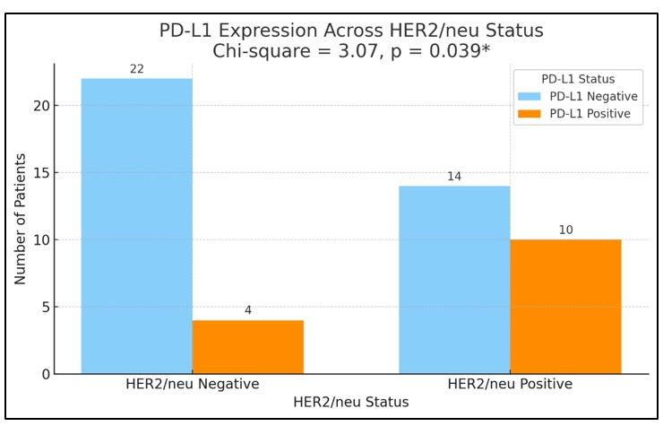

**Figure 6: Graphical representation of PD-L1 with HER2/neu receptor status**

Summary of PD-L1 expression and correlation with various clinicopathological parameters, such as the age of the patient, tumor size, histological type, histological grade, lymph node status, and ER/PR expression, as shown in (Table 2)*.*

**Table 2: Comparison of PD-L1 with various clinicopathological parameters**

|  |  |  |  |  |
| --- | --- | --- | --- | --- |
| **PARAMETERS** | **PD-L1 NEGATIVE**  **NO OF CASES(%)** | **PD-L1 POSITIVE**  **NO OF CASES(%)** | **CHI- SQUARE TEST** | **P VALUE** |
| **AGE** | | | | |
| <30 | 0 (0%) | 0 (0%) | 3.88 | 0.27 |
| 31-40 | 4 (11.3%) | 3 (21.4%) |
| 41-50 | 7 (19.4%) | 2 (14.2%) |
| 51-60 | 11 (30.5%) | 7  (50%) |
| >60 | 14 (38.8%) | 2 (14.2%) |
| **TUMOR SIZE** | | | | |
| T1 | 07 (19.4%) | 05 (35.7%) | 3.50 | 0.32 |
| T2 | 17 (47.2%) | 07 (50%) |
| T3 | 06 (16.7%) | 02 (14.3%) |
| T4 | 06 (16.7%) | 00  (0%) |
| **HISTOLOGICAL TYPE** | | | | |
| IDC-NOS | 33 (91.6%) | 13 (92.8%) | 3.74 | 0.44 |
| ILC | 00  (0%) | 1 (7.14%) |
| EPC | 01 (2.7%) | 00  (0%) |
| IPC | 01 (2.7%) | 00  (0%) |
| MC | 01 (2.7%) | 00  (0%) |
| **HISTOLOGICAL GRADE** | | | | |
| I | 14 (38.9%) | 06 (42.9%) | 1.25 | 0.53 |
| II | 18 (50%) | 05 (35.7%) |
| III | 4 (11.1%) | 03 (21.4%) |
| **LYMPH NODE STATUS** | | | | |
| Involved | 22 (61.1%) | 08 (57.1%) | 1.07 | 0.30 |
| Not involved | 14 (38.9%) | 06 (42.9%) |
| **ER STATUS** | | | | |
| Negative | 12 (33.3%) | 06 (42.9%) | 0.09 | 0.76 |
| Positive | 24 (66.7%) | 08 (57.1%) |
| **PR STATUS** | | | | |
| Negative | 13 (36.1%) | 07 (50%) | 0.35 | 0.56 |
| Positive | 23 (63.9%) | 07 (50%) |
| **HER 2 NEU** | | | | |
| Negative | 22 (61.1%) | 04 (28.6%) | 3.07 | **0.03\*** |
| Positive | 14 (38.9%) | 10 (71.4%) |

**DISCUSSION**

Breast cancer accounts for more than one million of the estimated 10 million neoplasms identified globally every year in both men and women, making it the most prevalent cause of cancer in females in both high and low resource settings [[22]](javascript:void(0)). Anti-PD-1/PD-L1 therapies function by disrupting the interaction between PD-1, an inhibitory receptor on T cells, and its ligand, PD-L1, expressed on tumor and immune cells. By blocking PD-1 or PD-L1, these therapies restore T-cell activity, enabling cytotoxic T lymphocytes to recognize and kill cancer cells. This reactivation of the immune response not only enhances the direct antitumor effects but also promotes immunologic memory, potentially preventing recurrence [23]. More excellent knowledge of the molecular causes of metastatic disease would have applications in the medical field of diagnosis, treatment, and prognosis because metastatic disease is the cause of mortality linked to breast cancer [[24]](javascript:void(0)). To create individualized care, a thorough search for potential disease markers is required, particularly for those having prognostic and therapeutic implications [[25]](javascript:void(0)) .

In the study we conducted, PD-L1 positivity was found in 28% of cases of breast carcinoma. PD-L1 expression ranges from 80%, 14.6%, 35.9%, 11%, 52.6%, and 37.5% respectively, in research by Gupta et al.[18], Punhani et al.[15], Gajaria et al.[6], Amin et al.[8], Dey et al.[17], and Lou J et al.[19].Different antibody clones and scoring systems may cause the difference in PD-L1 expression observed in different studies.

PD-L1 expression was higher in postmenopausal patients in this study, with a mean age of 55.7 years. The research done by Punhani et al., Dey et al., and Lou et al. yielded similar results.

The 10-year survival rate for women with tumors less than 1 cm and no lymph nodes is 90%; if the cancer is more significant than 2 cm, the 10-year survival rate is 77%. The highest number of cases in the studies by Punhani et al., Gajaria et al., Amin et al., and Lou J et al. belonged to size (T2) 2-5cm. However, this was not statistically significant. The current research found that 50% cases with PD-L1 positive belong to the tumor size T2 category. PD-L1 and tumor size did not significantly correlate in our investigation, as indicated by the p-value of 0.32. In studies by Gupta et al. and Dey et al., a significant correlation between PD-L1 and tumor size(T2) was found.

Most cases were Infiltrating Ductal carcinoma-NOS (46 out of 50 cases), but none of these types were statistically significant with PD-L1 expression. Punhani et al., Amin et al., and Dey et al. found that 94%, 84.4%, and 89.6% of cases were IDC-NOS, respectively, but there was no statistical significance between PD-L1 and histological type.

Grade 2 tumors accounted for the most significant fraction in the current study (46%). A study by Gupta et al. and Dey et al. found similar results. PD-L1 expression was observed to be linked with higher tumor grade, i.e., Grade 3, with a p-value <0.05 in the Punhani et al. and Amin et al. studies.

Approximately 10-20 % of women without axillary lymph node metastasis experience recurrence with distant metastasis [[20,21]](javascript:void(0)). In the current study, out of 30 lymph node metastasis cases, 08 cases (57.1%) showed PD-L1 positive expression, which meant there is no statistically significant correlation between PD-L1 and lymph node metastasis. Similar findings were noted in the studies performed by Punhani et al. and Dey et al.

PD-L1 and HER2/Neu positive status were statistically significant in the current study, with a p-value of 0.03. However, no statistical significance existed between PD-L1 and PR/ER status. Amin et al.’s study showed no statistical correlation between PD-L1 and ER expression, PR expression and HER2/neu expression in their research. In the study by Gupta et al., a statistical correlation was seen between PD-L1, ER-positive expression, and HER2/neu-negative expression.

4. Conclusion

Our research indicates that PD-L1 expression is linked to poor prognostic factors in breast cancer, particularly concerning HER2/neu status. This correlation implies that higher PD-L1 levels may signal a worse clinical outcome. However, we found no statistically significant associations with other prognostic and clinicopathological factors, such as ER/PR status, lymph node status, tumor size, histological type and histological grade, which limits its current use as a standalone prognostic marker. Nevertheless, PD-L1 expression holds promise as a novel biomarker. To harness its potential fully, standardization of immunohistochemical (IHC) reporting for PD-L1 is crucial to ensure consistency and reliability in breast cancer evaluations. Enhanced accuracy in PD-L1 assessment will be vital for the effective application of innovative targeted immunotherapies, ultimately improving therapeutic strategies and outcomes for patients with breast carcinoma.

Consent

All authors declare that written informed consent was obtained from the patient.

Ethical approval

As per international standards or university standards, written ethical approval has been collected and preserved by the authors.

Disclaimer (Artificial intelligence)

Option 1:

Author(s) hereby declare that NO generative AI technologies such as Large Language Models (ChatGPT, COPILOT, etc.) and text-to-image generators have been used during the writing or editing of this manuscript.

Option 2:

Author(s) hereby declare that generative AI technologies such as Large Language Models, etc. have been used during the writing or editing of manuscripts. This explanation will include the name, version, model, and source of the generative AI technology and as well as all input prompts provided to the generative AI technology

Details of the AI usage are given below:

1.

2.

3.

References

1. Mehrotra R, Yadav K. Breast cancer in India: present scenario and future challenges. World J Clin Oncol. 2022;3(3):209–218.
2. Sung H, Ferlay J, Siegel RL, Laversanne M, Soerjomataram I, Jemal A, Bray F. Global cancer statistics 2020: GLOBOCAN estimates of incidence and mortality worldwide for 36 cancers in 185 countries. CA Cancer J Clin. 2021;71(3):209–249.
3. Javaid QN, et al. Histopathological grading and staging of invasive ductal carcinoma in modified radical mastectomy specimens. Ann King Edward Med Univ. 2022;28:74 79.
4. Masood S. Breast cancer subtypes: morphologic and biologic characterization. Women’s Health (London). 2016;12(1):103–119.
5. Breast cancer; 26 March 2021. Available from: <https://www.who.int/news-room/fact-sheets/detail/breast-cancer>
6. Gajaria PK, Gupta MR, Patil A, Desai SB, Shet TM. Programmed cell death ligand-1 expression in triple-negative breast carcinoma and its prognostic significance in the Indian population. Indian J Pathol Microbiol. 2021;64(4):664–670.
7. Shi Y. Regulatory mechanisms of PD-L1 expression in cancer cells. Cancer Immunol Immunother. 2018;262:1–9. doi:10.1007/s00262-018-2226-9.
8. Amin NH, Abou-Bakr AA, Eissa S, Nassar HR, Eissa TS, Mohamed G. Expression of PD-L1 in early-stage invasive breast carcinoma and its relation to tumor-infiltrating lymphocytes. Asian Pac J Cancer Prev. 2022;23(3):1091–1102.
9. Topalian SL, Taube JM, Anders RA, Pardoll DM. Mechanism-driven biomarkers to guide immune checkpoint blockade in cancer therapy. Nat Rev Cancer. 2016;16:275–287. doi:10.1038/nrc.2016.36.
10. Erber R, Hartmann A. Understanding PD-L1 testing in breast cancer: a practical approach. Breast Care (Basel). 2020;15(5):481–490. doi:10.1159/000510812.
11. Shen X, Zhao B. Efficacy of PD-1 or PD-L1 inhibitors and PD-L1 expression status in cancer: meta-analysis. BMJ. 2018;362:k3529. doi:10.1136/bmj.k3529.
12. Schmid P, Adams S, Rugo HS, Schneeweiss A, Barrios CH, Iwata H, et al. Atezolizumab and nab-paclitaxel in advanced triple-negative breast cancer. N Engl J Med. 2018;379:2108–2121. doi:10.1056/NEJMoa1809615.
13. Gong J, Chehrazi-Raffle A, Reddi S, Salgia R. Development of PD-1 and PD-L1 inhibitors as a form of cancer immunotherapy: a comprehensive review of registration trials and future considerations. J Immunother Cancer. 2018;6(1):8. doi:10.1186/s40425-018-0316-z.
14. Planes-Laine G, Rochigneux P, Bertucci F, Chretien AS, Viens P, Sabatier R, et al. PD-1/PD-L1 targeting in breast cancer: the first clinical evidence is emerging. A literature review. Cancers (Basel). 2019;11(7):1033. doi:10.3390/cancers11071033.
15. Punhani P, Ahluwalia C. Expression of programmed death ligand 1 (PD-L1) in breast cancer patients in India and its correlation with prognostic parameters. Arch Breast Cancer. 2023;10(3):280–290. doi:10.32768/abc.2023103280-290.
16. Kim, H. M., Lee, J., & Koo, J. S. (2017). Clinicopathological and prognostic significance of programmed death ligand-1 expression in breast cancer: a meta-analysis. *BMC cancer*, *17*(1), 690.
17. Dey S, Rana S, Nandy S, Mondal M, Datta C. Clinicopathological and Prognostic Significance of PD-L1 Expression in Male and Female Breast Carcinoma Cases: A Cohort Study Clin of Diagn Res 2024; 18(10)
18. Gupta A, Chandra S, Chauhan N, Arora A. Study of PD-L1 Expression with Association of Pathological Factors and Molecular Subtypes in Breast Carcinoma. Journal of Laboratory Physician 2022; 14(04): 491-496.
19. Lou J, Zhou Y, Huang J, Qian X. Relationship Between PD-L1 Expression and Clinical Characteristics in Patients with Breast Invasive Ductal Carcinoma. Open Med (Wars). 2017 Sep 6;12:288-292. Doi: 10.1515/med-2017-0042.
20. Kumar V, Abbas AK, Aster JC: [Robbins and Cotran Pathologic Basis of Disease](https://scholar.google.com/scholar?q=intitle:Robbins%20and%20Cotran%20Pathologic%20Basis%20of%20Disease). Elsevier Health Sciences, Philadelphia, PA; 2014.
21. Rosai J: [Rosai and Ackerman’s Surgical Pathology](https://scholar.google.com/scholar?q=intitle:Rosai%20and%20Ackerman%E2%80%99s%20Surgical%20Pathology" \t "_blank). Elsevier Health Sciences, Philadelphia, PA; 2018.
22. Łukasiewicz S, Czeczelewski M, Forma A, Baj J, Sitarz R, Stanisławek A: [Breast cancer—epidemiology, risk factors, classification, prognostic markers, and current treatment strategies—an updated review](https://dx.doi.org/10.3390/cancers13174287). Cancers (Basel). 2021, 13:4287. [10.3390/cancers13174287](https://dx.doi.org/10.3390/cancers13174287)
23. Ajutor, L. J., Iyoyojie, B. A., Ugoagwu, K. U., Samuel, O. T., Adedayo, O. A., Oyedemi, D. T., ... & Adobor, C. A. (2025). Role of Immune Checkpoints (PD-1, PDL1 and CTLA-4) In Triple-Negative Breast Cancer and Therapeutic Implications. *International Research Journal of Oncology*, *8*(1), 8-20.
24. Kesse-Adu R, Shousha S: [Myoepithelial markers are expressed in at least 29% of oestrogen receptor negative invasive breast carcinoma](https://dx.doi.org/10.1038/modpathol.3800103). Mod Pathol. 2004, 17:646-52. [10.1038/modpathol.3800103](https://dx.doi.org/10.1038/modpathol.3800103)
25. Banin Hirata BK, Oda JM, Losi Guembarovski R, Ariza CB, Oliveira CE, Watanabe MA. Molecular markers for breast cancer: prediction of tumor behavior. Disease markers. 2014;(1):513158.