**Enhancing Maize Productivity and Nitrogen Uptake Through Integrated Application of Biogas Slurry and Chemical Fertilizers**

**Abstract**

With growing population exponentially, food demand also grows rapidly, leading to excessive dependence on chemical fertilizers to ensure food and nutritional security. But presently, serious issues related to long-term soil health, environmental sustainability, and fertilizer-use efficiency arise due to such a non-sustainable strategy. Combination of inorganic fertilizers with organic waste amendment, such as biogas slurry (BS), may present an economically viable strategy to reduce chemical inputs at the cost of no loss of yield. A field experiment was conducted on maize (Zea mays L., var. Pusa Jawahar) to ascertain the impact of biogas slurry (BS), which is a partial substitute for Urea-N, on growth and physiological parameters. T0 Absolute Control, T1: 100% Bio slurry (replacement of Urea-N) + P & K, T2: 75% BS + 25% RDF (recommended dose of fertilizers), T3: 50% BS + 50% RDF, T4: 25% BS + 75% RDF, T5: 100% RDF, T6-25% BS + 75% RDF + microbial consortium, and T7: 25% BS + 75% RDF + chelating agents were the eight treatments used. It was concluded in the study that the treatment T3 which incorporated 50% BS + 50% RDF mix, improved plant height, biomass growth and grain yield in comparison to the other treatments. Further, it is also being found that the T3 treatment not only improves physiological and yield parameters but also increases nutrient utilization efficiency and soil health.

**Key words:** Bio-slurry, Maize, Pusa Jawahar, Fertilizers use efficiency, Sustainable agriculture

1. **Introduction**

Bioslurry, a by-product of anaerobic digestion of organic waste for the production of combustible methane gas, is an important type of organic manure that can be applied in a semi-liquid form in to the field crops (Mofokenget. al 2020). Approximately 25-30% of the digested organic matter is transformed into biogas, while the rest is converted into bioslurry (Ekstrand et. al. 2022). Bioslurry has been reported to have no toxic or harmful effects on either soil or crops, with a higher nutrient quality than compost, manure and inorganic fertilizers. The concentrations of toxic heavy metals have been found to be very low compared to synthetic fertilizers. Bioslurry usually consists of about 93% water and 7% dry matter, of which 4.5% is organic matter and 2.5% inorganic matter (Kumar et al. 2015). However, Kırkpınar, F. (2021), mentioned that the composition of bioslurry depends on factors including the kind of organic material used, type of animal dung, age of animals, type of feed and feeding rate, amongst others. Its value as an organic fertilizer is dependent on nutrient content, ratio, and availability (Al-Zubaidi, J. 2021). Apart from bioslurry production, biogas production has many advantages, including resolving energy poverty issues, food insecurity and the disposal of organic waste. Soil microbial communities are important for the decomposition of a wide range of plant compounds by utilizing carbon (C) to synthesize their own biomass (Kallenbach et al. 2016). While the quality and value of organic fertilizers are often measured in terms of their contribution to nutrient supplies and soil fertility reported by Nagdev et al., (2022). Increased crop productivity in response to application of organic soil amendments has been attributed to greater nutrient availability and enriched soil microbial populations. The addition of fresh organic manure .to the soil has been found to stimulate growth and enhance the activity of previously dormant microorganisms, as they can now utilize the new substrate. Soil microbiological and biochemical properties including microbial biomass, community composition, enzymatic activity, and functional and structural diversity provide direct information on small changes in the soil ecosystem (Woźniak, M., 2025). These changes, due to agricultural practices, are specific to various microbial groups. Soil degradation has a negative impact on the ability of the soil to support ongoing food production and overall ecosystem resilience It is therefore important to critically study and understand factors or practices that affect soil stability and resilience to achieve sustainable development and long-term agricultural productivity (Bayata, A. 2024). Long-term maize monoculture can negatively impact soil properties and microbial communities. Studies have shown that agricultural practices influence soil bacterial diversity, composition, and function (Dube et al., 2019 & Wolińska et al., 2022). The timely detection of soil degradation can be enhanced a range of microbiological and molecular techniques are available to study changes in soil microbial populations.

Since nutrient cycling—particularly of carbon, nitrogen, and phosphorus—is a core soil function governed largely by microbial processes, microbial activity serves as a reliable proxy for evaluating soil health in response to agricultural practices. Therefore, a study was planned to evaluate the impact of biogas slurry application on the productivity of maize. This study supports the integration of organic and inorganic nutrient sources, particularly the use of bioslurry-based amendments, as a sustainable strategy for enhancing soil health and improving long-term maize productivity.

**Table 1 - Initial soil properties**

|  |  |  |  |
| --- | --- | --- | --- |
| **Parameter** | **15 cm** | **30 cm** | **45 cm** |
| **pH (1:2.5 soil:water)** | 7.95 | 7.98 | 8.0 |
| **Organic carbon (%)** | 0.43 | 0.42 | 0.40 |
| **Available Nitrogen (kg/ha)** | 220 | 218.5 | 216.3 |
| **Available posphorous (kg/ha)** | 38.9 | 37.12 | 35.5 |
| **Available potassium (kg/ha)** | 240 | 238.5 | 236.2 |
| **Water holding capacity (%)** | 40.5 | 39.12 | 37.25 |
| **Bulk density (g/cc)** | 1.88 | 1.89 | 1.91 |
| **EC ds/m** | 0.5 | 0.57 | 0.61 |

1. **Materials and methods** 
   1. **Design and Layout**

The field experiment was conducted at the Integrated Farming System (IFS) Model Field at IARI, Pusa Campus, New Delhi. The experiment was laid out in a Randomized Block Design (RBD) with eight treatments replicated four times. The crop was planted with a spacing of 60 cm between rows and 25 cm between plants.

* 1. **Fertilizer Application and Crop Management**

A field experiment was conducted on maize (Zea mays L., var. Pusa Jawahar) to ascertain the impact of biogas slurry (BS), which is a partial substitute for Urea-N, on growth and physiological parameters. Following treatments were taken. T0 Absolute Control, T1: 100% Bio slurry (replacement of Urea-N) + P & K, T2: 75% BS + 25% RDF (recommended dose of fertilizers), T3: 50% BS + 50% RDF, T4: 25% BS + 75% RDF, T5: 100% RDF, T6-25% BS + 75% RDF + microbial consortium, and T7: 25% BS + 75% RDF + chelating agents were the eight treatments used. To control weeds, the crop was sprayed with Atrazine at the rate of 1.5 kg in 800 liters of water per hectare at the pre-emergence stage, i.e., two days after sowing. Manual weeding was also performed using a khurpi, and plants were later earthed up with the help of a harrow. For the treatment T6 Microbial consotium of phosphate solubulizing bacteria (PSB) was applied @ 1kg/ha , For the treatment T7 chealating agent Zn-EDTA was applied @ 1kg /ha and the maize variety used was Pusa Jawahar.

* 1. **Observations and Measurements**

Plant height of the maize plants was measured using a measuring tape. The three best-performing plants in each treatment plot were selected, and the average plant height was recorded**.** Cob length was measured using a measuring scale. The best-performing plants from each treatment were selected, and the average cob length was calculated. The maximum cob diameter was recorded using a digital vernier caliper with a least count of 0.01 mm. The best-performing plants from each treatment were selected, and the average maximum cob diameter was computed**.**

* 1. **Analysis of Physiological parameter**

The number of leaves per plant was recorded as an important physio-morphological parameter. Observations were made from the pre-flowering stage to crop maturity by counting all fully expanded leaves. Whole plant samples were weighed at different crop growth stages to assess fresh biomass accumulation. Fresh weight was recorded in grams using a physical balance.The same plant samples were oven-dried and then weighed using an electrical balance to determine dry biomass. Dry weight was measured in grams.

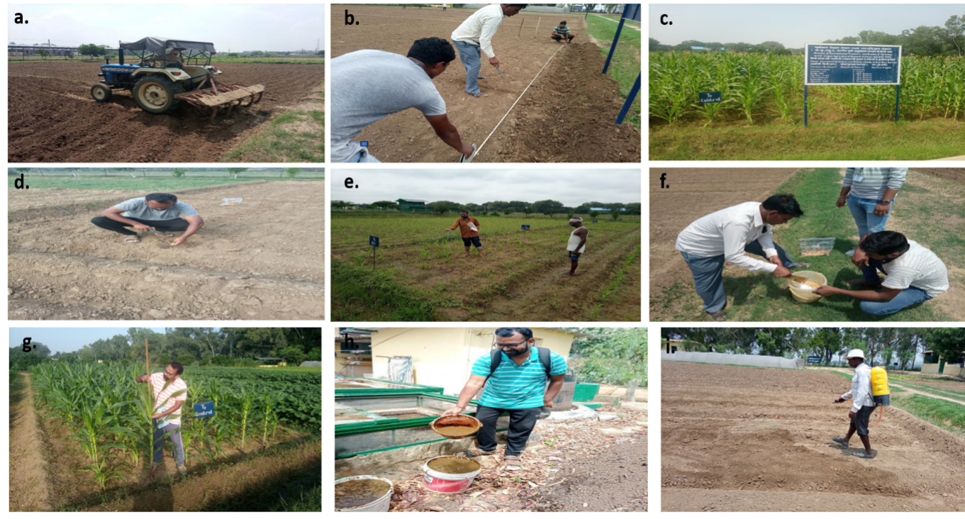

**PICTURE 1.** Field experimentation at IARI, Pusa: (a) Field preparation by tractor ploughing; (b) Marking and layout of experimental plots; (c) Prepared experimental field; (d) Sowing maize seeds; (e) Application of urea fertilizer; (f) Seed treatment with Bavistin (carbendazim, 2–3 g/kg seed); (g) Measurement of plant height; (h) Collection of biogas slurry from the biogas plant; (i) Atrazine application at the pre-emergence stage, two days after sowing. Each panel depicts a key stage of field management, input application, or data collection as performed in the study.

* 1. **Analysis of Yield Parameters**

The weight of individual cobs was measured using a physical balance and recorded in grams. Data were collected after complete development of the cob. Cob length was measured in centimeters using a meter scale at different crop growth stages by selecting representative plants from each treatment**.** Grain yield per plant was determined by threshing mature cob samples and weighing the grain using an electrical balance. The yield was noted in grams per plant.

**1.2 Nitrogen uptake in seed and Stover**

The digestion step aims to convert the nitrogen (N) in a biological sample into ammonium sulfate by adding an acid, typically sulfuric acid, and heating the mixture up to 373 °C, during which the carbon in the sample is oxidized and released as CO₂ and H₂O, while ammonium sulfate is formed. This process generally uses a Kjeldahl flask, a spherical glass container with a long neck. In the distillation stage, sodium hydroxide (NaOH) is added after the solution cools down, and the mixture is reheated to release ammonia gas from the ammonium sulfate; the ammonia is then condensed and captured in a receiving flask containing a solution such as boric acid (H₃BO₃). Finally, in the ammonium quantification step, since the nitrogen content of the original sample correlates with the amount of ammonia produced during distillation, titration is commonly employed to determine the ammonia concentration (Michalowski et al., 2013; Martin et al., 2017).

**1.3 Statistical Analysis**

Data on plant growth, yield, and yield-contributing characters were analyzed statistically using the analysis of variance (ANOVA) method suggested by Fisher (1937). The level of statistical significance was determined at p < 0.05 where applicable, to assess treatment differences.

1. **Results and Discussion**
   1. **Root length**

Considerable root length improvement was noted in treatments T3 to T6, with increments of 11–13% over two consecutive years (p < 0.05) relative to the control (T0) and lower substitution rates (T1 and T2), which had negligible effect (Figure 1). Combined use of biogas slurry (BS) and chemical fertilizers in these treatments possibly enhanced root growth through increased nutrient availability and rhizospheric activity. The availability of organic acids in bioslurry could have promoted the chelation of chemical fertilizer-derived micronutrient ions, enhancing their solubility and efficiency of uptake. This is consistent with previous research by Madhupriyaa et al., 2024, who indicated that soils amended with bioslurry have enhanced nutrient use efficiency as a result of biochemical interactions within the root zone. Additionally, the response in the second year was more significant, suggesting that soil microbial communities need time to develop and stabilize before having a dramatic influence on root architecture (Wright et al., 2019). These findings highlight the value of integrated nutrient management in supporting root system establishment and long-term soil sustainability. The combination of organic and inorganic sources of nutrients not only stimulated root growth but also indicates enhanced soil biological activity, which is key to nutrient cycling and sustainable crop production.

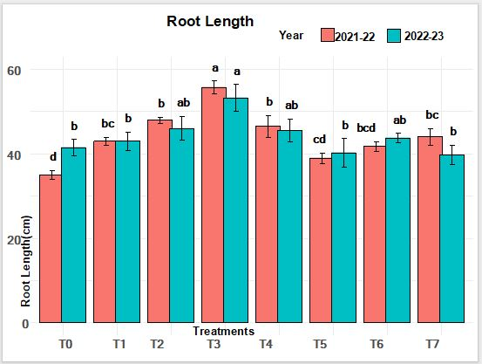

**Figure 1.**Root Length – Year wise Comparison

* 1. **Germination percentage (GP)**

As illustrated in Figure 2, in Year 2, Treatment T3 (50% BS + 50% RDF ) exhibited the greatest increase in germination percentage, improving by 14.47% ,T3 recorded the highest GP. T6, however, exhibited poor performance, decreasing by 2 % relative to T0 (p < 0.05). The consistent performance of T3 is indicative of consistent nutrient supply and drawdown. The beneficial performance of T3 might also be due to synergistic nutrient release and auxin production by bioslurry-associated microbes (Kumar et al., 2015 & Zhang et al., 2022). The poor GP in T7 points to possible fertilizer toxicity, likely due to the lack of bioslurry’s salinity stress mitigating chelating and buffering effects.

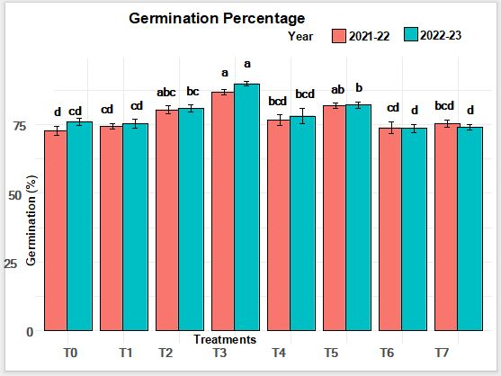

**Figure 2.** Germination Percentage- Year wise Comparison

* 1. **Cobs per plant**

Treatment T3 (biogas slurry combined with chemical fertilizer) achieved the maximum cob count of 2.2 ± 0.4 cobs per plant which is an 38% improvement over T0 (p < 0.05). On the other hand, T7 (high chemical input with chelating agents) performed the worst with 0.8 ± 0.1 cobs per plant, which is a 33% decline when compared to T0. Both T3 and T6 (CF + BS + microbial consortium) showed significant (p < 0.05) increases in cob count which demonstrates the benefits of integrated nutrient management (figure 3).The greater cob count in these treatments is likely due to a balanced supply of macro- and micro-nutrients, better nutrient-use efficiency, soil microbial activity (especially phosphorus solubilization and the mineralization of organic matter from bioslurry), and bioslurry's effects on soil structure and moisture retention. Khan et al. (2014) and Jatav et al. (2022) reported similar findings where they observed an increased cob yield of up to 78% from the combined application of chemical fertilizers and bioslurry.

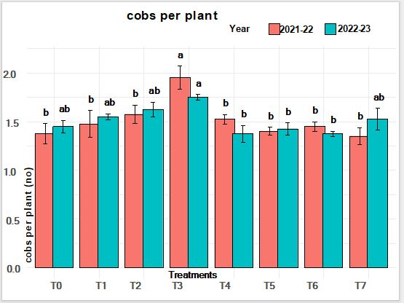

**Figure 3.** No of Cobs- Year wise comparison

* 1. **Plant height**

(Figure 4, 5, and 6) In Year 2 at 30 Days after Sowing (DAS), T3 achieved a height of 17.0 ± 0.9 cm, showing 21% growth compared to Year 1 and surpassing the control (T0) by a significant level (p < 0.05). T1 and T2 also shown growth (p < 0.05) but not as pronounced as T3. This pattern remained the same at 60 DAS. The growth tendency as previously mentioned can, in this instance, be connected to better nitrogen absorption, improved aggregation of the soil, and enhanced rhizospheric microbial activity as a result of applying biogas slurry (BS). By 90 DAS the height of the plants in Year 2 have increased significantly for many of the treatment. T3 reached 85 ± 5 cm in height marking a 21% increase from the previous year (p < 0.05). T3's continued growth dominance speaks to the advantages of proper nutrient allocation and balanced fertilization, confirmed by Wang et al. (2021) and Kumar et al. (2015).

This optimization shows that the combined use of chemical fertilizers and biogas slurry boost early and mid-season growth due to better nitrogen-use efficiency, step-wise nutrient supply, and active soil life. As noted by Kumar et al*.* (2021) and Wright et al. (2019), biogas slurry also improves soil structure, mineralization, and microbial colonization, which helps in better nutrient absorption.

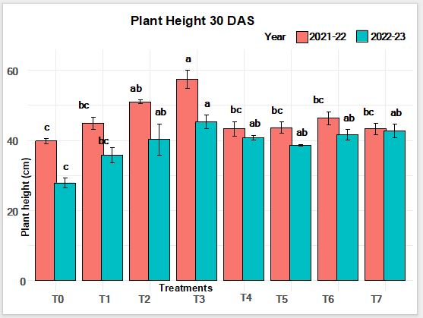

**FIGURE 4**. Plant Height 30 DAS (Days after sowing)- Year wise Comparison

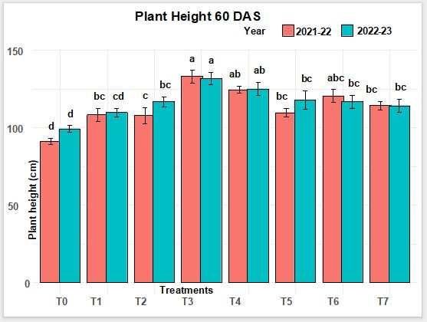

**FIGURE 5**: Plant Height 60 DAS (Days after sowing)- Year wise Comparison

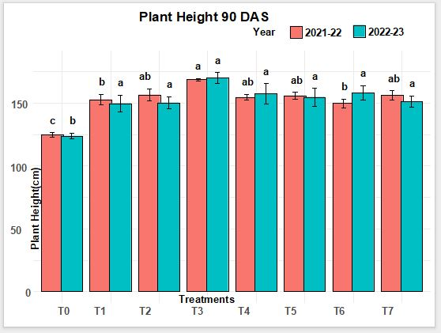

**FIGURE 6**: Plant height 90 DAS (Days after sowing)- Year wise comparison

* 1. **Grain yield**

The grain yield varied significantly across treatments, with T3 demonstrating the highest increase (49.06% ) over the control (T0) in both growing seasons, likely due to its optimized nitrogen application. In contrast, T7 and T6 showed marginal improvements (<15%), suggesting limited efficacy under experimental conditions. Seasonal analysis revealed that yields in 2022-23 were consistently higher, possibly attributable to favorable rainfall distribution. These findings underscore the potential of T3 as a sustainable practice for maize productivity enhancement. in the similar study it as be reported that Bioslurry application, particularly when combined with chemical fertilizers, has shown significant potential for enhancing grain yield and profitability in cereal crops. Studies on maize demonstrated that integrated use of biogas slurry and chemical fertilizers increased grain yield by 20-24% and improved economic returns compared to traditional practices. Similar benefits were observed when bioslurry was applied at 20t/ha, resulting in increased plant height, cob yield, grain yield, and nutrient uptake (A. Nasir et al., 2010, Malav et al.,2015, Khan et al.,2015).

* 1. **Cob Diameter**

The results demonstrate that all treatments led to an increase in maize cob diameter over the control (T0) across both years. The most significant enhancement was observed under **T3**, showing a 20–21% increase in cob diameter, followed closely by T4 and T5 with 15–16% gains. These results align with findings by (**Rani et al. 2019; Kienbaum et al., 2021)** who reported that integrated nutrient application enhances reproductive traits, including cob development, through improved nutrient availability and plant vigor These findings show the role of integrated nutrient strategies, particularly T3, in enhancing cob morphology a key yield component thereby contributing to overall productivity in maize cultivation (paul et al.,2023), similar results were found in Malav et al.,2015 50% bioslurry + 50 % RDF given good yield and soil amelioration .

* 1. **Cob weight**

Cob weight, a key yield attribute in maize, was positively influenced by all treatments compared to the control (T0) across both seasons. The **T3 treatment consistently recorded the highest cob weight**, with increases of **7.6% (2021–22)** and **6.3% (2022–23)** over T0, highlighting its superior role in promoting biomass partitioning to reproductive parts.This observation is in agreement with studies by **Sharma et al. (2020)** and **Meena et al. (2018)**, who reported enhanced cob development and grain filling under integrated nutrient management due to improved nutrient synchronization with crop demand. Treatments T4 and T5 also showed significant gains, confirming the efficacy of balanced fertilization in enhancing cob characteristics.

* 1. **Plant dry weight**

Plant dry weight, a proxy for overall biomass accumulation and growth vigor, significantly improved with all nutrient treatments compared to the control (T0). The T3 treatment consistently showed the highest dry matter production, with an increase of 12.7% in 2021–22 and 11.8% in 2022–23, indicating optimal nutrient availability and uptake dynamics. This is in line with findings by Yadav et al. (2017) and Choudhary et al. (2023), reported that integrated nutrient management (INM) enhances biomass accumulation by improving soil nutrient balance, microbial activity, and plant physiological efficiency. T4 and T5 treatments also exhibited substantial improvements (10%), suggesting that strategic nutrient combinations can effectively support vegetative growth and dry matter production.

|  |  |  |  |  |  |  |  |  |  |  |  |  |
| --- | --- | --- | --- | --- | --- | --- | --- | --- | --- | --- | --- | --- |
| **Treatment** | **Yield (kg/ha)** | | **Shoot biomass (kg/ha)** | | **cob length (cm)** | | **cobs per plant (number)** | | **cob weight (gm)** | | **cob diameter(cm)** | |
| Season | 2021-22 | 2022-23 | 2021-22 | 2022-23 | 2021-22 | 2022-23 | 2021-22 | 2022-23 | 2021-22 | 2022-23 | 2021-22 | 2022-23 |
| T0 | 3032.33c | 3215.21c | 3822c | 3958c | 17.18b | 16.96b | 1.33b | 1.43b | 263.04c | 269.67c | 40.66b | 39.42c |
| T1 | 4154b | 3570b | 4530.66b | 4771ab | 19.4a | 20.03a | 1.43b | 1.53b | 267.55b | 270.6b | 42.71ab | 41.91b |
| T2 | 3907b | 4001.66a | 4457.33b | 4625.3ab | 19.39a | 20.37a | 1.53b | 1.6b | 271.61b | 273.79b | 45.89ab | 43.47b |
| T3 | 4522.12a | 4426.53a | 5064.66a | 5321a | 20.8a | 21.24a | 2.03a | 1.76a | 283.32a | 285.86a | 51.99a | 51.59a |
| T4 | 4104b | 3902.33ab | 5036a | 5162a | 19.95a | 20.00 a | 1.5b | 1.3b | 278.75b | 283.63a | 49.18ab | 50.68a |
| T5 | 4123b | 3846.33ab | 5041.33a | 4979.66ab | 19.43a | 19.65a | 1.4b | 1.43b | 280.35a | 282.89a | 48.54ab | 50.37a |
| T6 | 3761bc | 3705.33b | 5088a | 4895ab | 18.64a | 18.64a | 1.46b | 1.36b | 276.28b | 279.33b | 46.85ab | 48.34b |
| T7 | 3783bc | 3594.33b | 5080a | 5121a | 19.22a | 19.22a | 1.36b | 1.6b | 278.89b | 281.33a | 45.36ab | 45.12b |

**Table 2 : Effect of Different Treatments (T0-T7) on Yield, Shoot Biomass, and Cob Characteristics of Maize during the (2021–22) and (2022–23) significant level (p < 0.05)**

* 1. **Nitrogen uptake seed**

**T3 (50% chemical fertilizer + 50% biogas slurry) consistently resulted in the greatest increase in nitrogen uptake over the control (T0), showing a 20.4% rise in 2021–22 and 15.4% in 2022–23, confirming it as the most effective treatment for enhancing N uptake. This finding aligns with research indicating that integrating biogas slurry with chemical fertilizers can improve nutrient availability and microbial activity, thereby increasing N uptake in maize (**Mdlambuzi et. al.,2021)**. Similar studies have shown that applying 15 tons/ha of pre-treated biogas slurry can maximize N uptake and allow a 30–50% reduction in synthetic fertilizer use without sacrificing biomass yield (**Liang et. al.,2023)**. Such integration not only meets crop nitrogen demands but also enhances soil health and reduces environmental reliance on chemical fertilizers, supporting the benefits of combined biogas slurry andfertilizer management systems in sustainable agriculture**

* 1. **Nitrogen uptake by Stover**

The consistently higher stover nitrogen uptake observed in all treatments compared to the control (T0), highlights the positive impact of nutrient supplementation on nitrogen assimilation in maize biomass. Treatment T3 (50% chemical fertilizer + 50% biogas slurry) exhibited the greatest enhancement, with a 12.9% increase in 2021–22 and 17.5% in 2022–23, confirming its effectiveness in promoting efficient nitrogen uptake and partitioning to the stover component. The superior performance of T3 can be attributed to the synergistic effects of chemical fertilizers and biogas slurry, which together improve soil nutrient availability, support microbial-mediated nutrient cycling, and enhance root nutrient absorption capacity. Biogas slurry, rich in organic nitrogen, amino acids, and microbial metabolites, likely contributed to the sustained release of nitrogen, synchronous with plant demand. This agrees with previous studies indicating that integrated nutrient management improves nitrogen-use efficiency and biomass accumulation (Dahunsi et al., 2017; Gunes et al., 2025). Furthermore, the notable increases in T4, T5, and T7—particularly in the second year—suggest a residual effect of biogas slurry in improving soil health over time. These gains underscore the long-term benefits of partially substituting inorganic fertilizers with organic amendments to enhance nitrogen recovery, minimize losses, and support sustainable soil fertility. Collectively, the results confirm the potential of integrated nutrient strategies, especially T3, in maximizing stover N uptake, thus enhancing overall plant nutrient efficiency and contributing to sustainable maize production systems.

* 1. **Plant fresh weight**

The fresh plant fresh weight of maize showed a consistent and notable improvement across all treatments compared to the control (T0), with the highest increase recorded in T3 and T4 treatments. In 2021–22, T3 improved plant fresh weight by approximately 14.3%, while T4 showed the highest increase in 2022–23 (14.8%).These gains reflect better vegetative growth and water content retention, essential for metabolic activity and biomass accumulation. These findings are in agreement with Khan et al. (2015) and Malav et al. (2015), who reported that the integration of organic manure with inorganic fertilizers significantly enhances higher fresh biomass in maize and similar cereal crops. The positive trend across T3 to T7 treatments suggests that integrated nutrient management not only supports optimal nutrient availability but also enhances soil structure and moisture holding capacity, both critical for fresh biomass accumulation. Such improvements in plant physiological parameters underscore the potential of integrated nutrient strategies for achieving higher productivity

**Table 3: Nitrogen Uptake and Plant Biomass of Maize under Different Treatments during (2021–22) and (2022–23) significant level (p < 0.05)**

|  |  |  |  |  |  |  |  |  |
| --- | --- | --- | --- | --- | --- | --- | --- | --- |
| Treatment | N uptake by seed (kg/ha) | | N uptake by stover (kg/ha) | | plant fresh weight (g) | | plant Dry weight (g) | |
| 2021-22 | 2022-23 | 2021-22 | 2022-23 | 2021-22 | 2022-23 | 2021-22 | 2022-23 |
| T0 | 26.68b | 24.65b | 61.85c | 63.11c | 623c | 641c | 141.66b | 145b |
| T1 | 28.83b | 26.9b | 63.5b | 67.39b | 683.33b | 708.66b | 148.16b | 150.49a |
| T2 | 29.58b | 27.82b | 66.47b | 71.19b | 708.66ab | 719.66b | 152.36a | 154.49a |
| T3 | 31.56a | 30.11a | 71.39a | 76.02a | 729.33a | 762.1a | 159.57a | 159.57a |
| T4 | 29.12b | 27.01b | 66.96b | 70.73b | 707.66ab | 737b | 156.29a | 158a |
| T5 | 28.40b | 26.52b | 68.38b | 71.84b | 718.33b | 743.66ab | 159.5a | 157.08a |
| T6 | 29.14b | 26.18b | 65.79b | 70.38b | 701.66b | 735.66b | 155a | 153.62a |
| T7 | 27.93b | 25.91b | 67.58b | 71.06b | 705b | 727.66b | 151.23a | 153.62a |

* 1. **Number of leaves 90 DAS**

Treatments T3, T4, and T5 showed the **highest percentage increase (up to 16%)** in leaf number over control (T0), suggesting a strong positive influence of the applied inputs. These findings are consistent with existing literature showing that optimized nutrient supply, bio-stimulants, or growth regulators can significantly boost vegetative growth in maize. Amanullah et al. (2009) reported that application of nitrogen and potassium increased the number of functional leaves per plant in maize by up to 12% over control plots. Shah et al. (2023) emphasized that the effectiveness of certain treatments (e.g., integrated nutrient management) on vegetative traits like leaf number remains stable across years, aligning with your results where T3–T5 consistently outperformed T0.

* 1. **Number of leaves after 60 days after sowing (DAS)**

Treatments **T3, T4, and especially T5** demonstrated the highest increase in leaf number at 60 DAS compared to the control (T0), with **T5 showing up to 38% improvement** in 2022–23. These results align well with published findings highlighting the effectiveness of nutrient and bio-stimulant interventions in promoting early-stage leaf development in maize. **Vegetative growth boosts from integrated nutrient management. Khan** et al. (2014) reported that integrated nutrient management in baby corn given better nitrogen uptake and balanced macro-micro nutrient availability. treatments that maintain similar vegetative benefits across years are desirable for sustainable maize cultivation.

* 1. **Number of leaves after 30 days after sowing (DAS)**

Treatments **T3 and T4** showed the highest leaf numbers, with up to a **25% increase** over the control (T0) in both years. Early leaf emergence is critical for light interception and dry matter accumulation, and the consistency across years highlights the **robustness of the treatment effect**. Zhang et al. (2016) emphasize that early leaf emergence in maize (by 30 DAS) is strongly influenced by nutrient availability and hormonal stimulation, contributing to final plant vigor and yield. **Nitrogen application at sowing and tillering** improves early leaf production significantly.**Ramesh et al. (2014)** showed that early application of bio-stimulants and foliar nutrients enhances vegetative traits by 15–35%.

**Table 4 Effect of Different Treatments on Leaf Development in Maize During (2021–22) and (2022–23) significant level (p < 0.05)**

|  |  |  |  |  |  |  |
| --- | --- | --- | --- | --- | --- | --- |
| Treatment | Leaves per plant 30 DAS | | Leaves per plant 60 DAS | | Leaves per plant 90 DAS | |
| 2021-22 | 2022-23 | 2021-22 | 2022-23 | 2021-22 | 2022-23 |
| T0 | 4.8c | 4.98c | 6.51b | 6.06b | 13.99b | 14.38c |
| T1 | 5.34ab | 5.84b | 8.27a | 7.92b | 14.77b | 15.37b |
| T2 | 5.45ab | 5.91b | 8.45a | 8.17ab | 14.93b | 15.66b |
| T3 | 6.04a | 6.19a | 8.96a | 9.62a | 15.5a | 17.22a |
| T4 | 6.22a | 6.12 a | 8.40 a | 8.22ab | 15.45a | 16.20 ab |
| T5 | 6.15a | 6.58a | 8.52a | 9.14a | 16.13a | 16.63ab |
| T6 | 5.63b | 5.63b | 8.23a | 8.06b | 15.19a | 15.46b |
| T7 | 5.2ab | 5.75b | 8.25a | 8.21b | 15.55a | 15.74b |

1. **Conclusion**

Biogas spent slurry was anaerobically digested with cow dung and paddy straw 3:1 ratio (30kg cow dung+10 kg paddy straw). The treatment T3 (50% N from bioslurry with 50 RDF) were performing better in crop yield and morphology. It is because of slow releasing N from the bioslurry. The chemical fertilizers (urea -N), generally stay for the short duration in the soil because of volatilization and denitrification. Hence, the mixture of organic and inorganic in 50% provided good results, due to slow release fertilizers and the crop was receiving constant supply of nutrients for better performance. Single application of bioslurry in T1 treatment, where 100% N from bioslurry given has not providing good yields but it had improved the soil health because of microbial act of organisms present in the bioslurry. Farmers can apply the bioslurry along with chemical fertilizers (50% Bioslurry + 50% RDF) which provides more crop yields and preserve the soil health also. A proper combination of bioslurry and chemical fertilizers were finalized for the maize after the 2 years of study. Bioslurry application also reduce the GHG (N2O) emission from the field as it reduces the chemical fertilizers application. Further, research are required to optimize the combination of bioslurry and chemical fertilizers for better yield and N2O mitigation in different crops which will ensure the agricultural and environmental sustainability.

Disclaimer (Artificial intelligence)

Option 1:

Author(s) hereby declare that NO generative AI technologies such as Large Language Models (ChatGPT, COPILOT, etc.) and text-to-image generators have been used during the writing or editing of this manuscript.

Option 2:

Author(s) hereby declare that generative AI technologies such as Large Language Models, etc. have been used during the writing or editing of manuscripts. This explanation will include the name, version, model, and source of the generative AI technology and as well as all input prompts provided to the generative AI technology

Details of the AI usage are given below:

1.

2.

3.

**References**

1. Abdul Nasir, A. N., Khan, F. H., Mahmood Riaz, M. R., & Khan, M. A. (2010). Comparitive study of biogas slurry with farmyard manure as fertilizer on maize crop. *Science international (Lahore)*,22 (4) 297-301.
2. Amanullah, H., Marwat, K. B., Shah, P., Maula, N., & Arifullah, S. (2009). Nitrogen levels and its time of application influence leaf area, height and biomass of maize planted at low and high density. *Pak. J. Bot*, *41*(2), 761-768.
3. Bayata, A. (2024). Soil Degradation: Contributing Factors and Extensive Impacts on Agricultural Practices and Ecological Systems-Systematic Review. *Journal of Agriculture and Environmental Sciences*, *13*, 16-34.
4. Choudhary, A. K., Rahi, S., & Kumar, A. (2023). Integrated nutrient management in vegetable crops. *Advances in Field Crop Production (Ed. Rana et al), Venus Publishers, ISBN*, (978-93), 83168-08.
5. Dahunsi, S. O., Oranusi, S., & Efeovbokhan, V. E. (2017). Pretreatment optimization, process control, mass and energy balances and economics of anaerobic co-digestion of Arachis hypogaea (Peanut) hull and poultry manure. *Bioresource Technology*, *241*, 454-464.
6. Dube, J. P., Valverde, A., Steyn, J. M., Cowan, D. A., & Van der Waals, J. E. (2019). Differences in bacterial diversity, composition and function due to long-term agriculture in soils in the eastern free State of South Africa. *Diversity*, *11*(4), 61.
7. Ekstrand, E. M., Björn, A., Karlsson, A., Schnürer, A., Kanders, L., Yekta, S. S., ... & Moestedt, J. (2022). Identifying targets for increased biogas production through chemical and organic matter characterization of digestate from full-scale biogas plants: what remains and why?. *Biotechnology for Biofuels and Bioproducts*, *15*(1), 16.
8. Fisher, R. A. (1937). The wave of advance of advantageous genes. *Annals of eugenics*, *7(4), 355-369.*
9. Gunes, A., Taskin, M. B., Sahin, O., Deniz Yagcioglu, K., Kadioglu, Y. K., Tugrul, M., ... & Eser, U. (2025). Transforming biomass energy waste into innovative fertilizer: impact of poultry litter incineration ash-based fertilizer on sugar beet nutrition, yield, and quality. *Sugar Tech, 27(2), 608-620.*
10. Holz, M., Zarebanadkouki, M., Benard, P., Hoffmann, M., & Dubbert, M. (2024). Root and rhizosphere traits for enhanced water and nutrients uptake efficiency in dynamic environments. *Frontiers in Plant Science, 15, 1383373.*
11. Jatav, S. S., Singh, S. K., Parihar, M., Alsuhaibani, A. M., Gaber, A., & Hossain, A. (2022). Application of sewage sludge in a rice (Oryza sativa L.)-wheat (Triticum aestivum L.) system influences the growth, yield, quality and heavy metals accumulation of rice and wheat in the northern Gangetic alluvial plain. *Life*, *12(4), 484*.

1. Khan, S. A., Malav, L. C., Kumar, Sandeep., Malav, M. K., & Gupta, Navindu (2015). Resource utilization of biogas slurry for better yield and nutritional quality of baby corn. *Advances in Environmental and Agricultural Science*, *32*, 382-394.
2. Kienbaum, L., Correa Abondano, M., Blas, R., & Schmid, K. (2021). DeepCob: precise and high-throughput analysis of maize cob geometry using deep learning with an application in genebank phenomics*. Plant Methods, 17(1), 91.*
3. Kienbaum, L., Correa Abondano, M., Blas, R., & Schmid, K. (2021). DeepCob: precise and high-throughput analysis of maize cob geometry using deep learning with an application in genebank phenomics. *Plant Methods*, *17*(1), 91.
4. Kırkpınar, F. (2021). Uses of bioslurry (biogas residue) as an inexpensive product for animal feed. In 4th International Students Science Congress Proceedings Book (p. 11).
5. Kumar, A., Garhwal, R. S., Prakash, R., Dhaliwal, S. S., Walia, S. S., Dubey, S. K., & Yadav, R. (2025). Impact of crop residue recycling and chemical fertilizers on soil health and nutrients uptake under different cropping systems–a scopus review. *Journal of Plant Nutrition*, 1-28.
6. Kumar, S., Malav, L. C., Malav, M. K., & Khan, S. A. (2015). Biogas slurry: source of nutrients for eco-friendly agriculture. International Journal of Extensive Research, 2(2), 42-46.
7. Liang, X., Wang, C., Wang, H., Yao, Z., Qiu, X., Wang, J., & He, W. (2023). Biogas slurry topdressing as replacement of chemical fertilizers reduces leaf senescence of maize by up-regulating tolerance mechanisms. *Journal of Environmental Management*, *344*, 118433.
8. Madhupriyaa, D., Baskar, M., Sherene Jenita Rajammal, T., Kuppusamy, S., Rathika, S., Umamaheswari, T., ... & Mohanapragash, A. G. (2024). Efficacy of chelated micronutrients in plant nutrition. *Communications in Soil Science and Plant Analysis*, *55*(22), 3609-3637.
9. Malav, L.C., Khan, S. A., Gupta, N., & Prasad, S. (2014). Resource utilization of biodigested slurry on the baby corn quality & production. [*Indo Global Journal of Pharmaceutical Sciences*](https://www.cabidigitallibrary.org/action/doSearch?do=Indo+Global+Journal+of+Pharmaceutical+Sciences)*,*Vol. 4, No. 3, 181
10. Malav, L. C., Khan, S. A., Gupta,N., Kumar, S., Bhattacharyya, R., & Malav, M. K. (2015). Effect of Biogas Slurry and Urea on Soil Health. *Journal of Agricultural Physics*, *15*(1), 55-62.
11. Malav, L. C., Khan, S. A., & Gupta, N. (2015). Impacts of biogas slurry application on soil environment, yield and nutritional quality of baby corn. *Society for Plant Research*, *74*, 194.
12. Mdlambuzi T, Muchaonyerwa P, Tsubo M, Moshia ME. Nitrogen fertiliser value of biogas slurry and cattle manure for maize (*Zea mays* L.) production. Heliyon. 2021 May 22;7(5):e07077. doi: 10.1016/j.heliyon.2021.e07077. PMID: 34095575; PMCID: PMC8166757.
13. Meena, R., Meena, S. C., Meena, S. N., & Jat, G. (2023). Effect of chemical nitrogen fertilizer and organic manure on yield attributes, productivity and profitability of maize (Zea mays L.) *Current Advances in Agriculture Science .15 (2)129-134 ,doi :10.5958/2394-4471.2023.00022.9.*
14. Nagdev, R., Khan, A. S., & Khan, S. A. (2022) Role of biogas slurry in soil health development.The Science World a monthly e magazine, 2(12), 2241-2244.
15. Patel, V., & Singh, B. V. (2022). Effect of need based nitrogen management on yield and quality of kharif maize (Zea mays L.) under central plain zone of UP. *Agricultural Res. J*, *10*, 45-53.
16. Paul, S. K., Ghosh, A., Rashid, M. H., Sarkar, S. K., Sarkar, M. A. R., Soufan, W., ... & El Sabagh, A. (2023). cob yield, nutritional quality and herbage productivity of baby corn as influenced by irrigation and integrated nutrient fertilization. *Applied Ecology & Environmental Research*, *21*(3).
17. Ramesh, R., & Ramprasad, E. (2014). Effect of plant growth regulators on morphological, physiological and biochemical parameters of soybean (Glycine max L. Merrill). In *Biotechnology and bioforensics: new trends* (pp. 61-71). Singapore: Springer Singapore.
18. Rani, N., Bamel, J. S., Garg, S., Shukla, A., Pathak, S. K., Singh, R. N., ... & Bamel, K. (2023). Linear mathematical models for yield estimation of baby corn (Zea mays L.). *Plant Science Today*, *11*(1), 166-75.
19. Shah, S. H., Islam, S., Alamri, S., Parrey, Z. A., Mohammad, F., & Kalaji, H. M. (2023). Plant growth regulators mediated changes in the growth, photosynthesis, nutrient acquisition and productivity of mustard. *Agriculture*, *13*(3), 570.
20. Sharma, N., Kumar, A., Farooq, F., MeCarty, J. S., Kumar, R., Sharma, V., ... & Mehta, S. (2024). Nutrient Management Strategies for Enhancing Maize Productivity in India: An Overview. *MAYDICA*, *67*(2).
21. Sharma, V., Singh, M. J., & Khokhar, A. K. (2020). Productivity, nutrient uptake and soil properties as influenced by integrated nutrient management in maize-wheat cropping system under rainfed conditions of sub-montane Punjab. *Agricultural Research Journal*, *57*(6).
22. Wang, J. L., Liu, K. L., Zhao, X. Q., Zhang, H. Q., Li, D., Li, J. J., & Shen, R. F. (2021). Balanced fertilization over four decades has sustained soil microbial communities and improved soil fertility and rice productivity in red paddy soil. *Science of the total environment*, *793, 148664.*
23. Wolińska, A., Kruczyńska, A., Podlewski, J., Słomczewski, A., Grządziel, J., Gałązka, A., & Kuźniar, A. (2022). Does the use of an intercropping mixture really improve the biology of monocultural soils?—A search for bacterial indicators of sensitivity and resistance to long-term maize monoculture. *Agronomy*, *12*(3), 613.
24. Woźniak, M., Liszewski, M., Jama-Rodzeńska, A., Gębarowska, E., Siebielec, S., Kaczmarek, A., ... & Bąbelewski, P. (2025). Effect of Paulownia and Buckwheat Intercropping on Soil Microbial Biodiversity, Dehydrogenase Activity, and Glomalin-Related Soil Protein. *Agronomy*, *15*(4), 888.
25. Wright, R. J., Gibson, M. I., & Christie-Oleza, J. A. (2019). Understanding microbial community dynamics to improve optimal microbiome selection*. Microbiome*, *7(1), 85.*
26. Yadav, M. R., Singh, M., Kumar, R., Kumar, D., Kumar Meena, R., Ram, H., & Makarana, G. (2022). Integrated nutrient management in maize-cowpea intercropping system is an attractive option to improve the fodder productivity and quality. *Communications in soil science and plant analysis*, *53*(22), 3045-3059.
27. Yadav, S., Lal, M., Naresh, R. K., Yadav, R. B., Yadav, A. K., Yadav, K. G., ... & Rajput, P. (2019). Effect of organic and inorganic nutrient sources on productivity, grain quality of rice and soil health in north-west IGP: A Review. *International Journal of Current Microbiology and Applied Sciences*, *8*(12), 2488-2514.
28. Zhang, Y., Li, C., Wang, Y., Hu, Y., Christie, P., Zhang, J., & Li, X. (2016). Maize yield and soil fertility with combined use of compost and inorganic fertilizers on a calcareous soil on the North China Plain. *Soil and Tillage Research*, *155*, 85-94.