Appendiceal Actinomycosis Revealed in the Postpartum Period: A Case Report and Literature Review
Abstract
Appendiceal actinomycosis is a rare form of chronic infection caused by Actinomyces israelii, a commensal bacterium of the digestive and female genital tracts. Its clinical presentation is often atypical and nonspecific, making the diagnosis difficult, usually established postoperatively. We report the case of a 35-year-old woman admitted on the 30th day postpartum with right iliac fossa pain evolving over several days, associated with fever. A history of prolonged intrauterine device (IUD) use was noted. Imaging revealed an appendiceal mass, prompting urgent surgical exploration. Histological analysis revealed sulfur granules and filamentous bacilli, consistent with appendiceal actinomycosis. The patient received prolonged antibiotic treatment with amoxicillin for twelve months, with a favorable outcome. This case highlights the importance of considering this diagnosis in cases of chronic abdominal pain, especially in postpartum women, and emphasizes the benefit of combined medical-surgical management in advanced forms.
Keywords
Actinomycosis, Antibiotic treatment, Postpartum, Subacute appendicitis, Surgery
Introduction
Acute appendicitis remains the leading cause of emergency abdominal surgery worldwide (1). However, non-acute forms, including subacute, chronic, or recurrent presentations, are largely underestimated (2).. Among the rare causes, appendiceal actinomycosis is a chronic granulomatous infection caused by anaerobic Gram-positive bacteria of the genus Actinomyces (3). Although it represents a small percentage of appendicitis cases, it is very rarely diagnosed preoperatively. Diagnosis remains challenging due to its insidious and nonspecific presentation (4). This case illustrates the diagnostic difficulty posed by actinomycosis, especially when it occurs in a postpartum context.
Case Report
A 35-year-old woman, smoker, primigravida, and primiparous, with no significant medical history, had used a copper IUD for five years prior to this pregnancy, which was carried to term without complications. She was admitted on postpartum day 30 for right iliac fossa pain evolving over eight days, associated with moderate fever (38.5 °C) and chills. The patient reported similar but less intense pain at 37 weeks of gestation, which worsened after delivery.
Clinical examination revealed a fixed, oblong, tender mass measuring approximately 5 x 5 cm in the right iliac fossa, with localized guarding but no generalized abdominal rigidity. Biological workup showed an inflammatory syndrome with leukocytosis of 16,200/mm³ and CRP at 257 mg/L. Contrast-enhanced abdominal CT scan revealed a well-limited 4 cm appendiceal mass, suggestive of an abscess, with fat stranding, without mesoappendiceal or periappendiceal tissue infiltration, no regional lymphadenopathy, and no signs of dissemination.
Surgical exploration via a Mac Burney incision revealed an ileocecal appendiceal inflammatory mass adherent to the abdominal wall (Fig 1). A pseudo-tumoral appendix measuring 3 cm with a distal citrine collection of 3 cm was identified. Ileocecal resection with ileocolic anastomosis was performed.
The postoperative course was uneventful under amoxicillin treatment, and the patient was discharged on day 12. Microbiological analysis of the collected fluid isolated Actinomyces israelii, sensitive to amoxicillin. Histopathological examination showed chronic fistulized appendicitis with transmural lymphoid infiltration and sulfur granules suggestive of actinomycosis; silver staining revealed black filamentous bacilli. Oral amoxicillin therapy was continued for 12 months without recurrence.
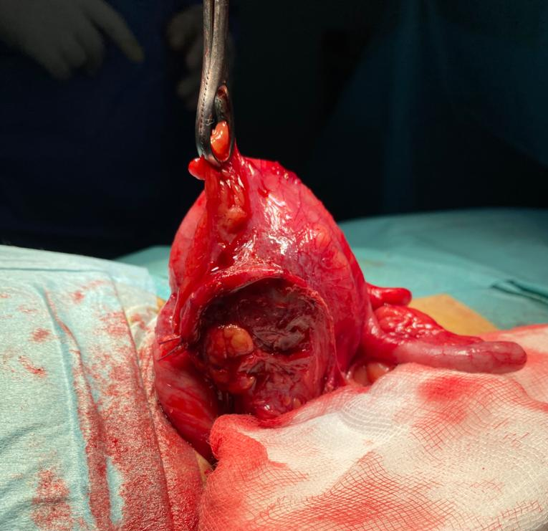
Fig 1: Intraoperative view showing a pseudotumoral appendix, thickened, sclerotic, and fistulized. The inflammatory and adherent appearance suggests a complicated chronic form of appendicitis.
Discussion
Actinomycosis is a rare chronic bacterial infection with slow progression, caused by Gram-positive, non-spore-forming anaerobic bacilli of the genus Actinomyces, which may appear as ramified filaments. The most frequently isolated species in humans is Actinomyces israelii. These bacteria are common commensals of the oropharynx, digestive tract, and female genital tract (5). Their pathogenic potential is low and generally requires mucosal disruption to invade tissues, as seen in appendicitis, diverticulitis, digestive perforation, prior abdominal surgery, foreign bodies, or digestive cancers (6).
Clinical Actinomycosis presents in three major clinical forms:
- Cervicofacial: 40–55% of cases
- Abdominopelvic: 20%
- Thoracic: 15% (7).
In the abdominal cavity, Actinomyces species colonize the right colon, especially stagnation-prone areas like the cecum, appendix, or diverticula (6). Infection can occur weeks or even years after a mucosal breach, explaining its insidious progression. In 75% of cases, perforated appendicitis is the trigger (8). However, as in our case, infection can also occur on non-perforated inflamed appendices (6).
Appendiceal actinomycosis is considered the most common form of abdominal actinomycosis. The infection often extends to the terminal ileum and abdominal wall. Symptoms are usually insidious and nonspecific, including recurrent abdominal pain and low-grade fever. Appendiceal actinomycosis represents only 0.02–0.06% of appendicitis cases, and fewer than 10% of them are diagnosed preoperatively (6). A thorough clinical examination may reveal localized tenderness or, more rarely, a palpable right iliac fossa mass. A history of similar symptoms weeks prior to consultation may suggest a previously unrecognized perforated appendicitis (9).
Due to its nonspecific presentation and resemblance to other digestive or gynecologic diseases, abdominal actinomycosis is rarely considered initially. It may mimic chronic appendicitis, Crohn's disease, intestinal tuberculosis, amebiasis, cecal carcinoma, diverticulitis, or tubo-ovarian abscess (10).
Some known risk factors should alert the clinician: history of abdominal surgery, inflammatory or neoplastic pathology, and especially prolonged use of intrauterine devices (IUD). This device is associated with an increased incidence of abdominopelvic actinomycosis in some studies (11), although the association remains debated in the literature. The IUD is not considered an established risk factor, but its presence may raise suspicion in a compatible clinical context (12).
Imaging, especially computed tomography (CT), remains nonspecific but may reveal large infiltrative solid masses with hypodense areas corresponding to collections, and invasion of adjacent tissues (3). In appendiceal actinomycosis, appendiceal wall thickening and periappendiceal inflammation may be observed, findings that also occur in acute appendicitis, making the diagnosis more challenging (13). Nevertheless, CT is useful for localizing infection, assessing extent, and monitoring treatment response.
Definitive diagnosis relies on histological identification of sulfur granules or isolation of the pathogen from surgical specimens, aspirates, or endoscopic biopsies (14). However, these samples are often superficial and of limited value (15). Sulfur granules, although highly suggestive, are not pathognomonic and can also be observed in nocardiosis, botryomycosis, or certain forms of aspergillosis (16). Culture of Actinomyces is difficult, requiring prolonged anaerobic incubation for at least seven days (17).
In practice, the diagnosis is often made postoperatively on histological examination of the surgical specimen (14). Identification of the organism or sulfur granules is usually sufficient, and antibiotic susceptibility testing is rarely necessary due to natural susceptibility to common antibiotics (17).
When diagnosed preoperatively, especially in chronic indolent forms, exclusive antibiotic therapy may be sufficient and avoid unnecessary surgery(18). CT helps monitor evolution in such cases(10).Conversely, when diagnosis is made postoperatively, additional antibiotic therapy is essential to eradicate the bacteria and prevent secondary dissemination, particularly in the right iliac fossa (19). Antibiotics should be initiated even in the absence of microbiological isolation if sulfur granules are observed histologically (10).
In complicated or advanced cases, a combined surgical and medical approach is recommended. This strategy limits the extent of resection and reduces postoperative complications. Pelvic or parietal abscesses may be drained percutaneously under ultrasound or CT guidance. Persistent fistulas may be managed later (19). Surgery plays both a diagnostic and therapeutic role, ensuring debridement of necrotic tissue and excision of fistulous tracts. It is also indicated in case of failure of medical therapy alone. Several recent studies have shown that surgery reduces the duration of antibiotic treatment (9). This combined approach achieves cure rates exceeding 90% (4).
Due to the frequent presence of dense, avascular fibrous tissue limiting antibiotic diffusion, prolonged treatment is usually necessary: six months for simple forms, up to twelve months in cases of peritoneal or mesenteric involvement or incomplete resection. Penicillin G or amoxicillin remains the first-line treatment. Alternatives in case of allergy include tetracyclines, clindamycin, erythromycin, cephalothin, or cefoxitin (19). Metronidazole is only partially active against Actinomyces. With appropriate treatment, the prognosis is excellent, with a cure rate above 90% (4).
Conclusion
This case illustrates the importance of considering appendiceal actinomycosis in the differential diagnosis of subacute or chronic appendicitis, especially in the presence of risk factors such as prolonged IUD use. In the context of atypical clinical presentation, histological and microbiological confirmation is essential. Treatment relies on a combined medical-surgical approach with prolonged antibiotic therapy, ensuring an excellent prognosis.
Patient Consent
Consent was obtained from the patient to publish the clinical details and the images included.
Conflict of interest statement
The authors declare that they have no conflict of interest regarding the publication of this case report.
They also confirm that they have no known competing financial interests, non-financial interests, or personal relationships that could have appeared to influence the work reported in this paper.
Editorial Assistance Note
Generative AI tools were used solely to improve the language of this manuscript. The authors are fully responsible for the content and accuracy of the work.
Disclaimer (Artificial intelligence)
Option 1:
Author(s) hereby declare that NO generative AI technologies such as Large Language Models (ChatGPT, COPILOT, etc.) and text-to-image generators have been used during the writing or editing of this manuscript.
Option 2:
Author(s) hereby declare that generative AI technologies such as Large Language Models, etc. have been used during the writing or editing of manuscripts. This explanation will include the name, version, model, and source of the generative AI technology and as well as all input prompts provided to the generative AI technology
Details of the AI usage are given below:
1.
2.
3.

References
1. Alvarez-Alvarez FA, Maciel-Gutierrez VM, Rocha-Muñoz AD, Lujan JH, Ploneda-Valencia CF. Diagnostic value of serum fibrinogen as a predictive factor for complicated appendicitis (perforated). A cross-sectional study. International Journal of Surgery. janv 2016;25:109.
2. Berk DR, Sylvester KG. Subacute appendicitis. Clin Pediatr (Phila). mai 2005;44(4):363‑5.
3. Wong VK, Turmezei TD, Weston VC. Actinomycosis. BMJ. 11 oct 2011;343:d6099.
4. Gómez-Torres GA, Ortega-Gárcia OS, Gutierrez-López EG, Carballido-Murguía CA, Flores-Rios JA, López-Lizarraga CR, et al. A rare case of subacute appendicitis, actinomycosis as the final pathology reports: A case report and literature review. International Journal of Surgery Case Reports. 1 janv 2017;36:46‑9.
5. Smego RA, Foglia G. Actinomycosis. Clinical Infectious Diseases. 1998;26(6):1255‑61.
6. Garner JP, Macdonald M, Kumar PK. Abdominal actinomycosis. Int J Surg. déc 2007;5(6):441‑8.
7. Bennhoff DF. Actinomycosis: diagnostic and therapeutic considerations and a review of 32 cases. Laryngoscope. sept 1984;94(9):1198‑217.
8. Deshmukh N, Heaney SJ. Actinomycosis at multiple colonic sites. Am J Gastroenterol. déc 1986;81(12):1212‑4.
9. Choi MM, Beak JH, Lee JN, Park S, Lee WS. Clinical Features of Abdominopelvic Actinomycosis: Report of Twenty Cases and Literature Review. Yonsei Med J. 19 août 2009;50(4):555‑9.
10. Lee SY, Kwon HJ, Cho JH, Oh JY, Nam KJ, Lee JH, et al. Actinomycosis of the appendix mimicking appendiceal tumor: A case report. World J Gastroenterol. 21 janv 2010;16(3):395‑7.
11. Peitsidis P, Papadimitriou C, Rodolakis A, Peitsidou A. Actinomycosis of the appendix and pelvis: a case report. J Reprod Med. sept 2008;53(9):711‑3.
12. Westhoff C. IUDs and colonization or infection with Actinomyces. Contraception. juin 2007;75(6 Suppl):S48-50.
13. Pickhardt PJ, Bhalla S. Unusual Nonneoplastic Peritoneal and Subperitoneal Conditions: CT Findings. RadioGraphics. mai 2005;25(3):719‑30.
14. Lisa-Gracia M, Martín-Rivas B, Pajarón-Guerrero M, Arnáiz-García A. Abdominal actinomycosis in the last 10 years and risk factors for appendiceal actinomycosis: review of the literature. Turk J Med Sci. 2017;47:98‑102.
15. Kim JB, Han DS, Lee HL, Kim JP, Sohn JH, Hahm JS. Diagnosis and partial treatment of actinomycosis by colonoscopic biopsy. Gastrointestinal Endoscopy. 1 juill 2004;60(1):162‑4.
16. Hawes AS, Whalen GF. Recurrent and chronic appendicitis: the other inflammatory conditions of the appendix. Am Surg. 1 mars 1994;60(3):217‑9.
17. Liu V, Val S, Kang K, Velcek F. Case report: actinomycosis of the appendix—an unusual cause of acute appendicitis in children. Journal of Pediatric Surgery. 1 oct 2010;45(10):2050‑2.
18. Valour F, Sénéchal A, Dupieux C, Karsenty J, Lustig S, Breton P, et al. Actinomycosis: etiology, clinical features, diagnosis, treatment, and management. Infection and Drug Resistance. 5 juill 2014;7:183‑97.
19. Habib E, Aoura T, Mekkaoui M, Elhadad A. Actinomycose de l’appendice. Présentation de deux observations. La Revue de Médecine Interne. 1 juill 2002;23(7):638‑41.

