Surgical and prognostic outcomes of radical nephrectomy with inferior vena cava thrombectomy in patients of renal cell carcinoma with level II inferior vena cava thrombus

Abstract
Background and Aim
Renal cell carcinoma (RCC) with inferior vena cava (IVC) tumor thrombus represents an advanced stage of disease and poses major surgical challenges. Level II thrombus can be managed surgically without cardiopulmonary bypass, but outcomes from low-resource centers remain underreported. This study aimed to evaluate surgical feasibility, perioperative safety, and medium-term survival outcomes of radical nephrectomy with IVC thrombectomy for Level II thrombus in a resource-limited tertiary care setting.
Methods
A prospective analysis was conducted on six patients with RCC and Mayo Clinic Level II IVC thrombus managed at our center. All underwent open radical nephrectomy with IVC thrombectomy through a Chevron incision. Preoperative data, intraoperative parameters (surgical time, IVC clamping time, blood transfusion needs), and postoperative complications (Clavien–Dindo classification) were recorded. Survival outcomes were assessed using Kaplan–Meier analysis over an 18-month follow-up.
Results
Mean surgical time was 320 minutes; mean IVC clamp time was 12.3 minutes. The average transfusion requirement was 2.6 units of whole blood. There was no perioperative mortality and only minor complications (Grade I–II). Median hospital stay was 8.5 days. Two deaths occurred at 5 and 7 months (metastatic disease). Kaplan–Meier survival was 83.3% at 5 months, 66.7% at 7 months, and remained stable through 18 months in the censored patients.

Conclusion
Radical nephrectomy with Level II IVC thrombectomy can be performed safely in resource-limited settings with experienced multidisciplinary teams, achieving zero perioperative mortality and durable medium-term survival in the majority of patients. These results provide valuable evidence to guide surgical decision-making and reinforce that high-quality outcomes are possible outside high-volume centers.
Keywords
Renal mass, Radical nephrectomy, IVC thrombectomy, Multidisciplinary care, Postoperative outcome

INTRODUCTION
Renal cell carcinoma (RCC) is a common malignancy of the kidney, accounting for approximately 90-95% of all kidney cancers. RCC often presents asymptomatically in its early stages, but as the disease progresses, it can manifest with a variety of symptoms, including hematuria, flank pain, and a palpable mass [1]. One of the critical complications of RCC is the development of a tumor thrombus that can extend into the renal vein and inferior vena cava (IVC), which significantly complicates the management and prognosis of the disease.
“The involvement of the IVC by a tumour thrombus occurs in approximately 4-10% of patients with RCC” [2]. The surgical management of RCC with IVC thrombus poses significant challenges due to the complexity of the procedure, the potential for major blood loss, and the need for extensive preoperative planning and intraoperative management. This study aims to detail the surgical approach, intraoperative findings, and prognostic outcomes of nephrectomy with IVC thrombectomy at Gauhati Medical College and Hospital, comparing these outcomes with existing literature.
The formation of a tumour thrombus occurs when cancer cells invade the venous system, leading to the development of a thrombus within the renal vein and extending into the IVC. The pathogenesis of tumour thrombus formation is multifactorial, involving direct invasion of cancer cells into the venous wall, endothelial cell activation, and a hypercoagulable state often seen in malignancy. These factors contribute to the adherence of tumour cells to the venous endothelium and subsequent thrombus formation. The presence of a tumour thrombus is associated with a worse prognosis, making surgical resection imperative for potential curative treatment.
The surgical management of RCC with IVC thrombus requires a multidisciplinary approach involving urologists, vascular surgeons, and anaesthesiologists. Preoperative imaging is crucial for delineating the extent of thrombus and planning the surgical approach. “Modalities such as magnetic resonance imaging (MRI), computed tomography (CT), and positron emission tomography (PET) scans are employed to assess the extent of the thrombus and its relationship with adjacent structures” [3].
“Nephrectomy with IVC thrombectomy is performed through an open laparotomy, allowing adequate exposure and control of the IVC. The surgical technique involves clamping the IVC above and below the thrombus, followed by cavotomy and thrombus extraction. In cases where the thrombus extends above the hepatic veins, more advanced techniques, such as the use of cardiopulmonary bypass, may be required” [4]. The goal of surgery is complete resection of the tumour and thrombus while minimizing perioperative complications.
Intraoperative management focuses on maintaining hemodynamic stability and minimizing blood loss. Intraoperative complications can include bleeding, injury to adjacent organs, and embolization of the thrombus. The classification of thrombus and its extension determines the surgical complexity and potential for complications.
The length of the cavotomy, need for vascular clamping, and use of Pringle manoeuvre are dictated by the thrombus's location and extent. The Pringle manoeuvre, involving clamping of the hepatic artery and portal vein, is sometimes employed to reduce blood flow and facilitate safer thrombus removal [5].
Postoperative care focuses on pain management, wound care, and monitoring for complications. Patients typically require intensive care unit (ICU) monitoring initially, with careful assessment of renal function and hemodynamic status. The use of anticoagulation therapy postoperatively is a critical aspect of care to prevent thrombus recurrence, although it must be balanced against the risk of bleeding [6].
The prognosis for patients undergoing nephrectomy with IVC thrombectomy depends on several factors, including the extent of the thrombus, presence of metastases, and histopathological characteristics of the tumour. Studies have shown that complete surgical resection of the tumour and thrombus can lead to improved survival rates, emphasizing the importance of meticulous surgical planning and execution [7].
Several studies have documented the outcomes of nephrectomy with IVC thrombectomy, providing a basis for comparison with the current case series. Blute et al. reported a series of patients undergoing this procedure and highlighted the importance of preoperative imaging and intraoperative management in achieving favourable outcomes [8]. Given the complexity and high risk associated with procedure, detailed case analyses can enhance understanding of best practices, improve intraoperative planning and optimize postoperative care.
Similarly, a study by Tilki et al. emphasized the role of histopathological analysis in determining prognosis, noting that the presence of tumour cells within the thrombus and adjacent adrenal gland are poor prognostic indicators [9]. In this study, we present our institutional experience to contribute to existing literature, aiming to improve patient prognosis and surgical success rates.
METHODOLOGY
The methodology for this case series on nephrectomy with IVC thrombectomy involved a retrospective review of patient records from the Department of Urology and Renal Transplantation at Gauhati Medical College and Hospital. The study aimed to analyse clinical outcomes, surgical techniques, and prognostic outcomes in patients who underwent nephrectomy with IVC thrombectomy.
Patients who underwent nephrectomy with IVC thrombectomy between January 2023 and July 2024 were included in the study. Data were collected from the hospital's electronic medical records and this case series includes 6 patients for whom demographic information, clinical presentation, preoperative workup, surgical details, intraoperative findings, postoperative course, histopathological findings and follow-up information were collected and analysed.
The Mayo Clinic RCC tumor thrombus (TT) classification guideline (MCTTCG) was used to classify these patients according to the extent of intravascular tumor extension (Table 1) [10].

Table 1: Mayo clinic RCC tumor thrombus classification guidelines*
Tumor thrombus level | Description
0 | Limited to the renal vein
I | Extends into the IVC, but < 2 cm above the renal vein
II | Extends into the IVC, > 2 cm above the renal vein but below hepatic veins
III | Extends above hepatic veins but below the diaphragm
IV | Extends above diaphragm
*The content of this table was extracted from the Mayo Clinic Tumor Thrombus Classification Guidelines and adapted for the article's use [10].

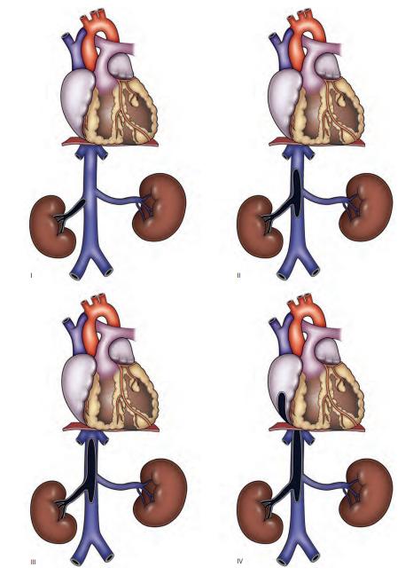
Figure1: (I to IV) Classification of venous tumor thrombus extension [11].

Patient selection:
The inclusion criteria were patients with renal tumours involving the IVC, confirmed by preoperative imaging, and who had undergone radical nephrectomy with IVC thrombectomy. Exclusion criteria included patients with incomplete medical records, those who did not undergo surgery, thrombus involving only the renal vein and extending above the hepatic veins. Patients with clinical evidence of thrombus extending above the hepatic veins are referred to other institutions for bypass.
All patients underwent a thorough preoperative evaluation, including blood tests (haemoglobin, platelets, renal function tests, liver function tests), imaging studies (CT/MRI) and where indicated, additional investigations such as PET-CT. The preoperative ASA (American Society of Anaesthesiologists) classification was recorded to assess the patient’s overall health status. The surgical approach involved radical nephrectomy with IVC thrombectomy under general anaesthesia. The type of incision, intraoperative findings, extent of thrombus, and techniques used for IVC management were meticulously documented. Parameters such as the use of IVC clamping and length of cavotomy, were recorded. Intraoperative data included the duration of surgery, transfusion requirements and the use of vasoactive agents. Postoperative management focused on monitoring for complications, classified using the Clavien-Dindo system. Hospital stay duration, renal function, and recovery status were tracked.
Adjuvant therapies, including chemotherapy, radiotherapy, and targeted therapies such as Pazopanib, were administered based on individual patient pathology and oncological recommendations. The follow-up protocol included periodic clinical evaluations, imaging studies, and laboratory tests to monitor for recurrence or metastasis and to assess disease-free survival and overall survival. Complications, recurrence, metastases, and cause of death, if applicable, were documented.
The collected data were analysed to evaluate the clinical outcomes, identify factors influencing prognosis. Descriptive statistics were used to summarize the patient demographics, clinical characteristics, and outcomes. Kaplan-Meier survival analysis was employed to estimate disease-free and overall survival rates. The findings aimed to enhance clinical practice and improve patient care in similar cases.
Surgical description:
All patients underwent preoperative evaluation to stage their disease and evaluated in the anesthetic pre-operative clinic to assess their perioperative risk. As soon as the TT is detected, intravenous low molecular weight heparin is started to all patients during preoperative period to prevent the risk of pulmonary embolism and venous thrombus embolization.
Our surgical technique involved a Chevron incision for abdominal access. The great vessels and the renal hilum are exposed. Out of our 6 cases, 4 were right RCC (figure 2. A-B) and 2 were left RCC (figure 3). For the right sided cases, the right colon and small bowel are mobilised, the Kocher maneuver is performed, and the right anterior space is developed, and the great vessels are exposed. The kidney is mobilised outside the renal fascia, and the ureter is divided. The IVC is carefully dissected to its bifurcation, ligating the right gonadal vein on its anterior surface.
Vascular control is obtained sequentially, first the right renal artery is identified in the inter-aortocaval region (Figure 4) and secured with a 0-silk ligature. Followed by which the infrarenal IVC, right renal vein and suprarenal IVC are identified and secured with vessel loop, and it is used as a rummel tourniquets(Figure 5). The IVC TT was identified and milked cephalad into the right renal vein. The Rumal tourniquets are applied and. A C-shaped satinsky vascular clamp is placed around the ostium of the right renal vein, partially occluding the IVC, ensuring that the thrombus is located within the jaws of the clamp before complete closure. The renal vein ostium is circumferentially excised, and the incision is extended superiorly on to the anterior surface of the IVC using Potts scissors (Figure 6). Thrombus is extracted by gentle downward traction on the renal vein and the TT and kidney are removed en bloc.
The IVC is flushed with heparinized saline solution and intima is inspected for signs of caval invasion. At least one- half of the width of IVC must be maintained for proper closure. The caval defect is closed with a running 4-0 Prolene suture (Figure 7). Before tying the knot, the infrarenal vascular loop is released and 5 to 10 ml of blood is allowed to seep from cavotomy to clear the IVC of air and debris. After tying the suture, the contralateral renal vascular loop is released, followed by the suprarenal IVC vascular loop. Out of 6 cases in 2 of cases there was involvement of the regional lymph nodes for which regional lymphadenectomy is performed. Followed by which a closed suction drain is kept, and the wound is irrigated, and the incision is closed.
Exposure for TT associated with a left sided tumour is more difficult because the IVC is best accessed from the right retroperitoneum. Therefore, both the right and the left colon are mobilised to get adequate exposure. The left colon is mobilised and the left anterior pararenal space is developed. The left renal artery is then identified and ligated near its origin close to the aorta. The adrenal, lumbar and gonadal branches of the left renal vein are ligated and divided. The steps to achieve proximal control of the IVC mirrored those described previously. The Rummel tourniquets are applied sequentially over the infrarenal IVC, right renal vein and suprarenal IVC. Similar procedure was repeated as describes previously for right RCC and TT and kidney are removed en bloc.
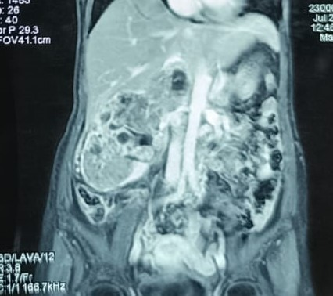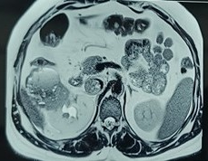
B
A
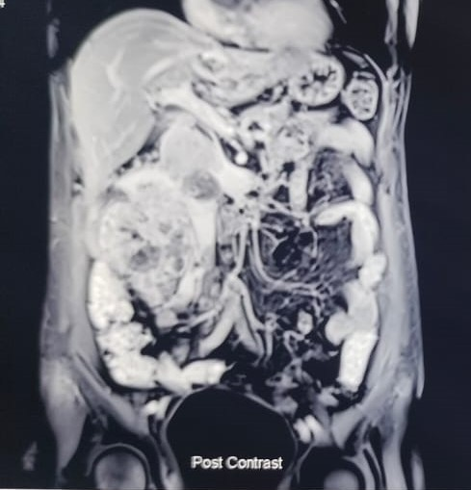
Figure 2 (A-C) Right RCC with level II IVC thrombus
C
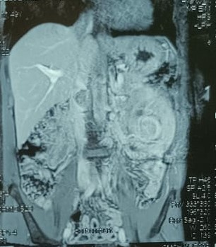
Figure 3. Left RCC with level II IVC thrombus

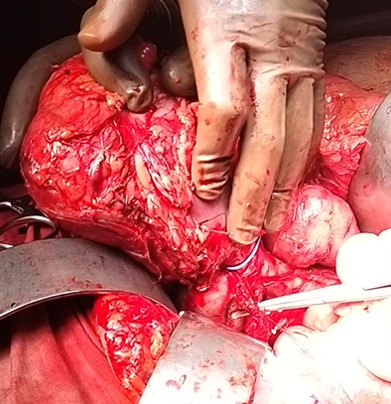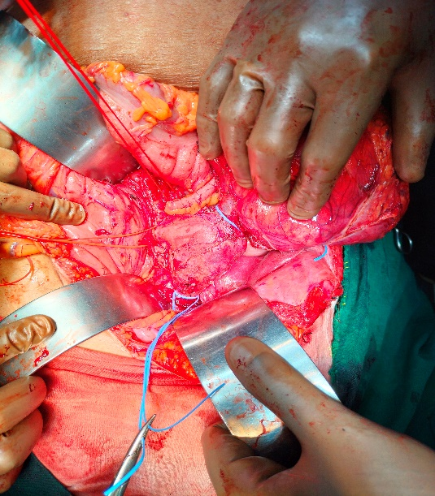
Figure 5. Rummel torniquets
Figure 4. Dissection of renal artery in interaortocaval region

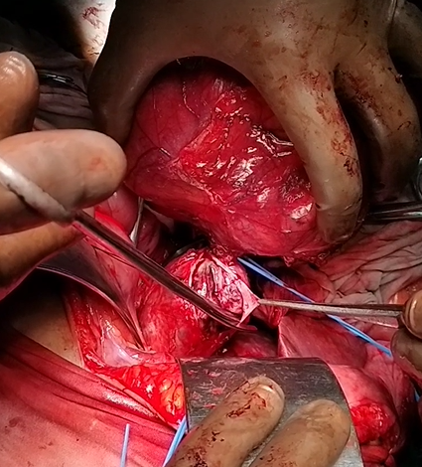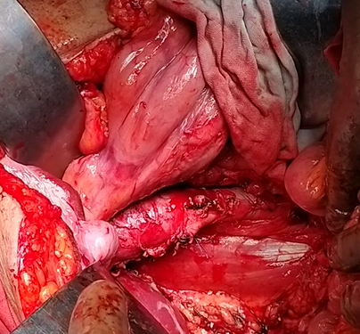
Figure 6. Cavotomy and extraction of the thrombus
Figure 7. IVC repair

STATISTICAL ANALYSIS
Central tendency measurements described the sample distribution. The mean was used to make assumptions about prevalent observations, while the median helped rule out potential outliers. Proportion analysis evaluated categorial data, including TT extension level and BMI variables. Patients were stratified by their BMI results: a BMI of 18.5-24.9 indicated a healthy weight, 25-29.9 indicated overweight, and above 30 indicated obesity.

RESULTS
The study analysed 6 patients: 66.6%(n=4) male and 33.3%(n=2) female. The mean and median age at the time of surgery were 55.83(±9.57) and 56 respectively. As seen in (table 2), 33.3%(n=2) patients were considered to have a healthy weight, and 66.6%(n=4) were either overweight or obese. The most prevalent comorbidities in our study were hypertension 66.6%(n=4) and type 2 diabetes mellitus 50%(n=3) and one patient had a history of tuberculosis. None of the patients from our study was associated with any family history of cancer. The most common presenting symptom were flank pain 50%(n=3), hematuria 16.6%(n=1) and Constitutional Syndrome 16.6%(n=1). One patient was asymptomatic. None of the patients from our study had lower limb edema, varicocele and pulmonary embolism. The mean preoperative calcium, hemoglobin, and platelet counts were 8.93(±0.47), 10.86(±2.14) and 254.3(±48.92) respectively. Two patients had hypocalcemia before surgery and four were anemic (66.6%). In all cases ultrasound was performed as the first diagnostic test followed by CT and MRI for confirmation and PET CT in two patients. In one patient, pulmonary, liver and regional lymph node metastasis detected before surgery. The tumour was located in the right kidney in 66.6%(n=4) and in the left kidney in 33.3%(n=2). The mean size of the tumour was 10.53.
The IVC clamping was done in all patients and the mean time was 12.3(±1.03). The mean surgical time for nephrectomy and thrombectomy was 320min (range 270-380). Transfusion volumes patient received were as follows: three patients received two units of whole blood, two patients received three units, and one patient received four units, and the mean transfusion of whole blood was 2.6 units. No intraoperative and postoperative complications were reported within this study. It is important to note that the estimated blood loss volume was not assessed for our patients in this study.
The histopathology reports of five patients showed diagnosis of clear cell RCC and one patient showed Ewing sarcoma. Tumour cells were present in caval thrombus of all patients. The adrenal gland showed no invasion in any cases. Distant metastasis was seen in one patient (16.6%). One of the patients had lymph nodes positive for malignancy. The mean duration of hospital stay was 8.5 (±1.87). The longest hospital stay was 12 days, while the shortest hospital stay was 7 days. Postoperative complications were minor in all patients (Clavien I in 5 and Clavein II in 1). Two patients died of metastatic disease at 5 and 6 months, 4 patients are treated to 18 months.

Table 2: Patient demographics
 | 1 | 2 | 3 | 4 | 5 | 6
Age | 65yr | 44yr | 47yr | 60yr | 52yr | 67yr
Sex | Female | Male | Male | Male | Male | Female
Symptoms | Flank pain | Asymptomatic | Flank pain | Constitutional Syndrome | Hematuria | Flank pain
Comorbidities | None | Hypertension  Diabetes mellitus II | Tuberculosis | Hypertension  Diabetes mellitus II | Hypertension  Diabetes mellitus II | Hypertension
Family history of cancer | No | No | No | No | No | No
BMI | 21.4 | 27.6 | 22.2 | 20.3 | 31.1 | 26.7
preoperative
ASA classification | I | II | I | I | II | I
Hb(g/dl) | 9.3 | 14 | 10.2 | 11.1 | 12.5 | 8.1
Platelet | 256000 | 310000 | 180000 | 231000 | 306000 | 243000
Calcium(mg/dl) | 8.7 | 9.4 | 9.1 | 9.3 | 9 | 8.1
Imaging studies | Ultrasound+CT+MRI | Ultrasound+CT+MRI | Ultrasound+CT+MRI | Ultrasound+CT+PET CT | Ultrasound+CT+MRI | Ultrasound+CT+MRI+PETCT
Size of tumor(cm) | 15.8 | 10.2 | 11.7 | 8.2 | 9.3 | 8
Tumor laterality | Right | Right | Left | Left | Right | Right
Preoperative TNM | T_{3b}N₀M_{x} | T_{3b}N₀M_{x} | T_{3b}N₀M_{x} | T_{3b}N₁M₀ | T_{3b}N₀M₁ | T_{3b}N₁M₁

Table 3: Intraoperative
 | 1 | 2 | 3 | 4 | 5 | 6
Surgical incision | Chevron | Chevron | Chevron | Chevron | Chevron | Chevron
Nephrectomy | Right | Right | Left | Left | Right | Right
Thrombus level | II | II | II | II | II | II
IVC clamping(min) | 12 | 12 | 11 | 12 | 13 | 14
Cavotomy length(cm) | 3 | 5 | 4 | 4 | 3 | 4
Blood transfusion | 2 | 2 | 3 | 4 | 3 | 2
Vasoactive agents | No | No | No | No | No | No
Surgical time(min) | 280 | 290 | 380 | 330 | 370 | 270

Table 4: Postoperative
 | 1 | 2 | 3 | 4 | 5 | 6
Complication (Clavien) | I | I | II | I | I | I
Hospital stays(days) | 7 | 8 | 9 | 7 | 12 | 8

Table 5: Histopathology
 | 1 | 2 | 3 | 4 | 5 | 6
Histological type | Clear cell | PNET(Ewing) | Clear cell | Clear cell | Clear cell | Clear cell
Fuhrman classification | 3 | - | 3 | 3 | 2 | 3
Tumor cells in thrombus | Yes | Yes | Yes | Yes | Yes | Yes
Tumor cells in adrenal gland | No | No | No | No | No | No
TNM classification | p T_{3a}N_{X} M_{x} | p T_{3a}N_{X} M_{x} | p T_{3a}N_{X}M_{x} | p T₄N₁M_{x} | p T_{3a}N_{X}M_{x} | p T_{3a}N₁M_{x}

Table 6: Follow up
 | 1 | 2 | 3 | 4 | 5 | 6
Adjuvant treatment | Pazopanib  (800mg/day) | CHOP/  RT(4500Gy) | Pazopanib  (800mg/day) | Pazopanib  (800mg/day) | Pazopanib  (800mg/day) | Pazopanib  (800mg/day)
Status | Living | Living | Living | Living | Deceased | Deceased
Cause of death | No | No | No | No | Metstasis in lung, liver | Metstasis in lung, liver
Survival(months) | 13 | 16 | 11 | 18 | 7 | 5

The Kaplan-Meier survival analysis of six patients with renal cell carcinoma and Level II IVC thrombus undergoing radical nephrectomy with thrombectomy demonstrates an initial survival rate of 83.3% at 5 months, which declines to 66.7% at 7 months due to two mortality events. Thereafter, survival stabilizes at 66.7% up to 18 months of follow-up among the remaining patients who were censored (fig 8). This curve highlights an early postoperative mortality risk followed by durable medium-term survival in the majority, underscoring that, even in resource-limited settings, this complex surgery can achieve meaningful survival outcomes with multidisciplinary management. This result supports the feasibility and potential benefit of surgical intervention for Level II IVC tumour thrombus in renal cell carcinoma.

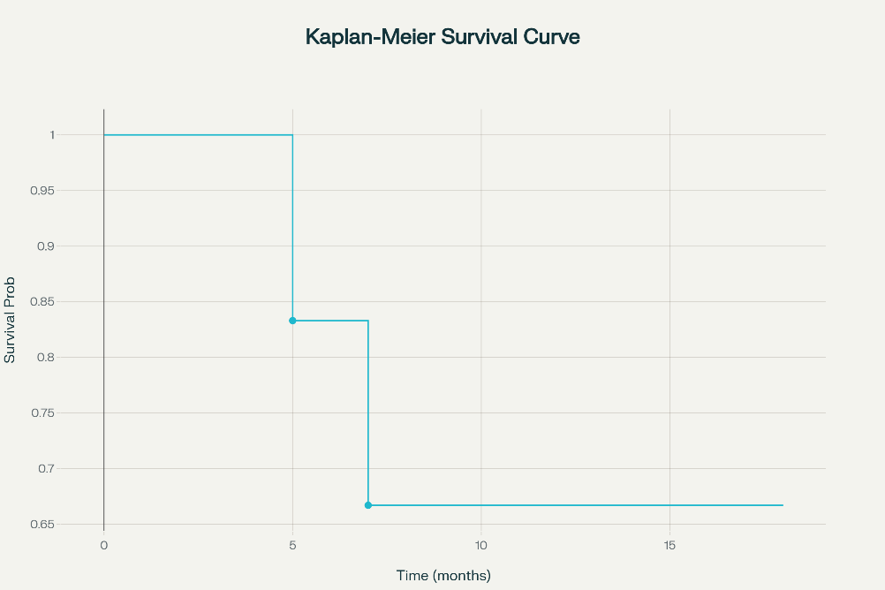
Fig 8: Kaplan-Meier survival analysis of treated patients

DISCUSSION
Radical nephrectomy with IVC thrombectomy is a complex procedure that requires an experienced, well trained and integrated operative team involving urological, cardiothoracic and if needed hepatobiliary surgeons. Recently, several series have reported “patients treated by laparoscopy or robotic surgery with results like those obtained by laparotomy” [12]. Level II thrombi are managedd by cavotomy without the need for a complete piggy-back, with clamping of IVC and contralateral renal vein followed by cavotomy and thrombectomy. Bypass techniques have not been used and patients with clinical evidence of supradiaphragmatic caval invasion or atrial involvement are referred to other institutions for bypass.
According to the literature, “the presentation of TT in RCC patients is variable; some remain asymptomatic, while others exhibit symptoms like varicocele, lower extremity swelling, cardiac dysfunction, pulmonary embolism, or Budd-Chiari Syndrome” [13]. In our patient cohort, none developed symptoms indicative of caval thrombus.
Hypertension, diabetes and obesity have been well associated with RCC. “Hypertension induces a state of chronic inflammation, promoting hypoxia-induced factor expression with subsequent cell growth dysregulation and angiogenesis. Additionally, hypertension is associated with increased formation of reactive oxygen species, which promotes tumor development and progression” [13]. Diabetes, on the other hand, have been associated with worse overall survival, cancer-specific survival, and recurrence-free survival[13]. “The mechanism by which obesity furthers tumorigenesis is thought to be due to excess adipose tissue, which promotes the secretion of adipokines, pro-inflammatory and pro-angiogenic factors, and serves as an energy reservoir for the tumor” [13]. In our patient cohort the prevalence of hypertension, diabetes and BMI >25 was 66.6%, 50% and 50% respectively.
It has been observed that “the higher the level of the thrombus, the greater the need for blood transfusion during surgery” [12]. Two American series report between 4.3 and 4.7 units of transfused packed red blood cells while the mean number of units transfused whole blood in our patients was 2.6. The reported average surgical time has been between 250 and 467 min while the mean was 320 min in our patients.
In a study conducted by Duty et al. on six patients with retroperitoneal tumors associated with an IVC invasion who underwent an IVC resection without reconstruction, the study showed that “the most frequent postoperative complications were pneumothorax, lower extremity compartment syndrome, right upper extremity brachial plexus stretch injury, respiratory failure, and atrial fibrillation” [14]. Baldrich et al. claimed that “reconstruction is not optional for malignant tumors because a replacement of the IVC with the help of various prosthetic grafts can help avoid several venous complications, and it can also improve the survival rate” [14].
The survival rate depends on the tumour behaviour and IVC invasion. RCC do not usually extend to IVC; and when they do, they often present as TT. The surgical en bloc resection of the primary tumour with thrombectomy by cavotomy without the need of IVC reconstruction was considered in our study due to potential improvement in the oncological prognosis. In our cohort study, we have observed the presence of tumor cells in all the caval thrombi but the absence of invasion in the caval wall and adrenal gland excised together with the renal tumor.
“Hemorrhage and PTE are serious complications associated with the higher level of cranial extension of the thrombus” [12]. Our patients have only presented minor complications (Clavien I or II) and the mean duration of hospital stay was 8.5. According to different series perioperative mortality was 3.5–6%[12] which was null in our study.
After surgery, “5-year survival is 15–20% with regional or distant metastases and only 4% with both types of metastases and in cases with no metastasis, survival reaches 60%” [12]. However, “even in patients with distant metastases, surgery is still indicated as it increases survival and improves quality of life. In patients with distant metastases, mean survival rates of 13 months and 2-year survivals of 26% have been reported” [12]. In our study distant metastasis was seen in 16.6% cases with mean survival time of 6 months.
Some studies showed that “targeted therapy can help metastatic RCC but do little on RCC with IVC tumour thrombus”[15]. “Tumour embolism in IVC may cause a release of more tumour cells from thrombus into circulation, leading to metastasis” [15]. “The CARMENA trial demonstrated that systemic treatment alone in the form of Sunitinib was not inferior to cytoreductive nephrectomy followed by Sunitinib for intermediate or poor risk metastatic RCC” [16]. Palumbo et al, reported “older (>71yrs) frail patients were more likely to experience higher rates of overall complications, failure to recover and in-hospital mortality following cytoreductive nephrectomy” [16]. In our study all 6 patients received post-operative targeted therapy. Future studies should focus on long-term outcomes and the impact of adjuvant therapies in improving survival rates.
There are several limitations of this cohort study. The study design, small sample size, particularly only 6 cases of level II and short follow up time which limit our generalizability. There is need to broader research, to better understand the factors influencing the RCC TT and long follow up to better understand the efficacy of nephrectomy with thrombectomy in the future.

CONCLUSION
We conclude that nephrectomy and thrombectomy have been proven to be safe, effective and may be curative technique of management of RCC TT in the absence of metastasis or may at least increase survival in presence of metastasis. The approach must be selected with consideration for the tumour anatomy on clinical staging and the surgeon’s experience. The findings demonstrated that with meticulous multidisciplinary care, standardized open surgical techniques, and careful patient selection, the procedure can be performed safely with zero perioperative mortality and manageable minor complications. Kaplan-Meier analysis showed meaningful medium-term survival despite early postoperative mortality in two patients. These results provide valuable real-world evidence supporting the feasibility and effectiveness of complex IVC tumor thrombectomy outside high-volume centers, offering important insights to guide surgical management and optimize outcomes in similar advanced RCC cases globally.
Consent
As per international standards or university standards, patient(s) written consent has been collected and preserved by the author(s).

Disclaimer (Artificial intelligence)
Authors hereby declare that No generative AI technologies such as Large Language Models (ChatGPT, COPILOT, etc.) and text-to-image generators have been used during the writing or editing of this manuscript.

References
- Krabbe LM, Bagrodia A, Margulis V, Wood CG. Surgical management of renal cell carcinoma. Semin Intervent Radiol. 2014 Mar;31(1):27-32. doi: 10.1055/s-0033-1363840. PMID: 24596437; PMCID: PMC3930656.
- Haddad AQ, Patil NK, Elfandy H, Gorin MA, Ball MW, Johnson MH, et al. The impact of venous tumor thrombus level on survival in patients undergoing nephrectomy and thrombectomy: a contemporary multicenter analysis. J Urol. 2017;197(4):918-924.
- Sankin A, Shah P, Kundu A, Verma S. Advances in imaging for renal cell carcinoma with venous thrombus. Urol Oncol. 2020;38(7):607-616.
- Haferkamp A, Bastian PJ, Jakobi H, Pritsch M, Pfitzenmaier J, Albers P, et al. Renal cell carcinoma with tumor thrombus extension into the vena cava: prospective long-term followup. J Urol. 2019;162(5):2017-2022.,
- Campbell SC, Novick AC, Belldegrun A, Blute ML, Chow GK, Derweesh IH, et al. Guideline for management of the clinical stage I renal mass. J Urol. 2017;182(4):1271-1279.
- Motzer RJ, Jonasch E, Agarwal N, Beard C, Bhayani S, Bolger GB, et al. NCCN guidelines insights: kidney cancer, version 1.2015. J Natl Compr Canc Netw. 2018;13(1):41-53.
- National Comprehensive Cancer Network (NCCN). NCCN Clinical Practice Guidelines in Oncology (NCCN Guidelines): Kidney Cancer. 2021. Available from: https://www.nccn.org/professionals/physician_gls/pdf/kidney.pdf
- Blute ML, Leibovich BC, Lohse CM, Cheville JC, Zincke H. The Mayo Clinic experience with surgical management, complications, and outcome for patients with renal cell carcinoma and venous tumor thrombus. BJU Int. 2017;99(5):769-775.
- Tilki D, Nguyen HG, Dall’Era MA, Bertini R, Carballido E, Chromecki T, et al. Impact of histologic subtype on cancer-specific survival in patients with renal cell carcinoma and tumor thrombus. Eur Urol. 2019;68(5):586-591.
- Blute ML, Leibovich BC, Lohse CM, Cheville JC, Zincke H: The Mayo Clinic experience with surgical management, complications and outcome for patients with renal cell carcinoma and venous tumour thrombus. BJU Int. 2004, 94:33-41. 10.1111/j.1464-410X.2004.04897.x
- Wang GJ, Carpenter JP, Fairman RM, et al. Single-center experience of caval thrombectomy in patients with renal cell carcinoma with tumor thrombus extension into the inferior vena cava. Vasc Endovasc Surg 42:335–40, 2008.
- C. Jiménez-Romero et al., “Treatment of Caval Vein Thrombosis Associated With Renal Tumors §,” 2017. [Online]. Available: www.elsevier.es/cirugia
- S. A. Bernaschina-Rivera et al., “Renal Cell Carcinoma With Tumor Thrombus: A Case Series in Puerto Rico,” Cureus, Apr. 2024, doi: 10.7759/cureus.58113.
- B. Moldovan et al., “Inferior Vena Cava (IVC) Resections without Reconstruction in Renal Tumors: Two Case Reports,” Diagnostics, vol. 13, no. 10, May 2023, doi: 10.3390/diagnostics13101759.
- S. Ma et al., “Case reports of robot-assisted laparoscopic radical nephrectomy and inferior vena cava tumor thrombectomy,” Medicine (United States), vol. 100, no. 33, Aug. 2021, doi: 10.1097/MD.0000000000026886.
- G. J. Nason, K. Ajib, G. H. Tan, D. T. S. Woon, G. T. Christakis, and R. K. Nam, “Radical nephrectomy with resection of vena cava thrombus using extracorporeal circulation and deep hypothermic circulatory arrest,” Canadian Urological Association Journal, vol. 15, no. 4, Sep. 2020, doi: 10.5489/CUAJ.6736.

