Case report
IRIDIAN AND CHORIORETINAL COLOBOMA:
A CASE REPORT

.
abstract :
Aims: To report an unusual bilateral presentation combining anterior and posterior segment colobomas with marked asymmetry in visual outcome, highlighting the importance of
detailed clinical and imaging assessment particularly when there is significant asymmetry in anatomical involvement and visual outcome.
Presentation of Case:
A 17-year-old female with no significant medical or familial history presented with decreased visual acuity in her right eye. Visual acuity was limited to counting fingers in the right eye and 20/20 in the left. Slit-lamp examination revealed an iris coloboma in the left eye. Fundus examination showed a large chorioretinal coloboma involving the optic disc and inferior retina in the right eye. A smaller, inferotemporal chorioretinal coloboma was also observed in the left eye, sparing the macula. Neurological and systemic evaluations were unremarkable.
Discussion:
This case illustrates the heterogeneity of colobomatous malformations in terms of anatomical presentation and visual prognosis. The presence of extensive posterior segment involvement in the right eye was associated with severe visual loss, while the functionally preserved left eye showed limited involvement. Multimodal imaging plays a key role in defining the extent of the lesions and ruling out associated anomalies or syndromic forms. The distribution of the lesions along the embryonic fissure supports their classification as typical colobomas.
Conclusion:
Colobomas can present with bilateral but asymmetrical involvement of ocular structures. Early diagnosis, comprehensive imaging, and long-term monitoring are essential to anticipate complications and guide visual rehabilitation. This case highlights the importance of individualized assessment in the management of congenital ocular malformations.

Keywords: Congenital coloboma, Chorioretinal anomaly,Optic disc involvement, Ocular imaging

1. INTRODUCTION

Congenital ocular colobomas are rare developmental anomalies that arise due to incomplete closure of the embryonic (fetal) fissure during the fifth to seventh weeks of gestation (Onwochei BC et al, 2000). This disruption in normal ocular morphogenesis results in a spectrum of structural defects, which may involve one or multiple ocular tissues depending on the extent and location of the closure failure (Chang L et al, 2006). Clinically, colobomas may present as isolated anterior segment anomalies such as iris colobomas, or may extend posteriorly to affect the optic nerve, choroid, and retina, potentially leading to significant visual impairment (Gregory-Evans K et al, 2004).
This case report a rare presentation of unilateral iris coloboma associated with a chorioretinal coloboma, highlighting the clinical features, multimodal imaging findings, and potential visual implications of this combined anomaly.

2. PRESENTATION OF CASE

A 17-year-old female patient with no significant medical history presented with vision problems in her right eye. The visual acuity in this eye was limited to counting fingers, while it was 20/20 in the left eye. The examination of the anterior segment revealed an iris coloboma in the left eye (Figure 1), while the right eye showed no iris coloboma or other anterior segment anomalies. Fundus examination identified a chorioretinal coloboma involving the optic disc and adjacent retina extending inferiorly in the right eye. In the left eye, the retina showed a chorioretinal coloboma below the inferior temporal arterial arcades (Figure 2). The general examination was unremarkable, including the neurological assessment.

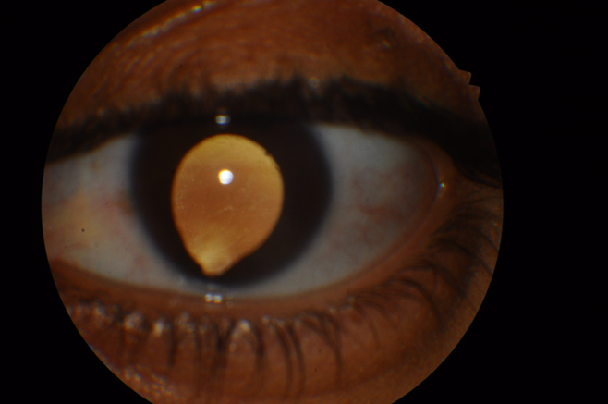

Fig. 1. Iridian coloboma in the left eye
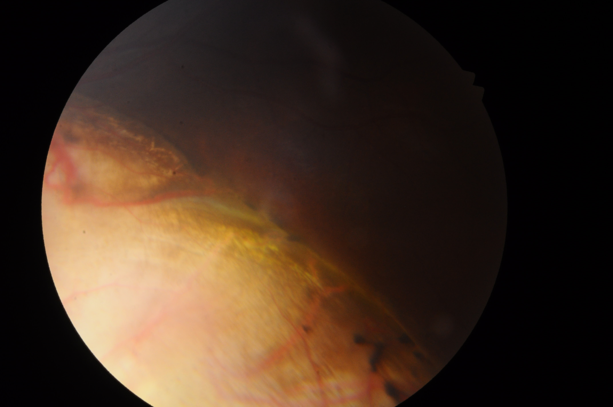

Fig. 2. Chorioretinal coloboma in the left eye

3. discussion

Colobomas are congenital malformations of the eye that arise due to incomplete closure of the fetal fissure during the early stages of ocular development (Onwochei BC et al, 2000). This defect can affect any ocular structure, including the iris, lens, retina, choroid, and optic nerve, with clinical manifestations varying widely depending on the site and extent of the anomaly. When the posterior segment is involved particularly the retina, choroid, and optic disc the risk of irreversible visual impairment and secondary complications such as retinal detachment increases significantly (Chang L et al, 2006).
In the present case, a 17-year-old female presented with markedly decreased vision in the right eye, while the left eye maintained normal visual acuity (10/10). Fundoscopic examination revealed a large chorioretinal coloboma in the right eye involving the optic disc and extending inferiorly, a typical distribution following the embryonic fissure pathway. Interestingly, the left eye, which was functionally intact, exhibited an iris coloboma and a small chorioretinal coloboma located below the inferior temporal arcades an uncommon finding in patients with preserved vision. The asymmetry between the two eyes in terms of both anatomical severity and functional impact is not rare in colobomatous cases and underscores the heterogeneity of this condition. Patel et al in their case series of atypical colobomas reports similarly demonstrated marked asymmetry unilateral iris coloboma versus contralateral chorioretinal coloboma underscoring how anatomical differences correlate with visual potential (Patel et al, 2021)
The marked asymmetry in our case: severe posterior segment involvement (counting fingers vision) in the right eye versus preserved 20/20 acuity in the left parallels observations by Uhumwangho & Jalali in their pediatric cohort. They reported that macular sparing, as seen in our patient’s left eye, is the strongest predictor of favorable visual outcomes, while optic disc involvement (present in our right eye) correlates with profound vision loss. This dichotomy underscores the importance of tailored assessments: while the left eye required only monitoring, the right eye necessitated low-vision rehabilitation and retinal detachment prophylaxis (Uhumwangho & Jalali, 2014)
Microphthalmia, frequently observed in extensive colobomas, was absent in our patient, as confirmed by both the clinical examination and normal globe size on imaging. Additionally, systemic and neurological assessments were unremarkable, suggesting an isolated, non-syndromic presentation. While several genetic syndromes such as CHARGE or COACH are known to include ocular colobomas within their spectrum, the absence of extraocular anomalies and the patient’s normal development make a syndromic association unlikely in this case (Brodsky MC, 2010).
Some posterior segment colobomas, particularly those involving the optic disc, may be misdiagnosed as other congenital optic disc anomalies such as morning glory disc anomaly or optic disc pit. However, the characteristic excavation, the presence of retinochoroidal tissue absence, and the inferonasal extension seen on fundus imaging support the diagnosis of typical chorioretinal coloboma (Shah et al 2024). In the left eye of our patient the preserved visual function despite the colobomatous defect suggests sparing of the macula and central visual pathways, a finding previously described in patients with peripherally located colobomas (Chang L et al, 2006).
Contemporary studies confirm that colobomas typically occur along the embryonic fissure meridian, with inferonasal localization being most characteristic of 'typical' colobomas (Azzam & Bordoni, 2023). In our case, both chorioretinal lesions followed this inferonasal or inferior-temporal distribution, reinforcing the embryological consistency of the presentation.
Imaging is recommended in cases of diagnostic uncertainty, especially in young children. Ocular ultrasound reveals a localized defect in the posterior wall and searches for associated ocular anomalies (such as cataracts) or complications (such as retinal detachment) (Shah et al 2024). Computed tomography and magnetic resonance imaging show a focal ectatic lesion postero-inferior-nasal to the ocular globe wall with clear liquid content (T1 hypointense, T2 hyperintense on MRI; hypodense on CT scan) (Morales-Cantón V et al 2020). These imaging modalities also help identify other associated orbital, cerebral, and ENT anomalies and rule out other differential diagnoses (Kaur S et al 2022).
As demonstrated by Barnard et al, ultra-widefield imaging is critical for delineating the full extent of chorioretinal involvement, particularly in asymmetric presentations like ours. Their work highlighted how advanced imaging can detect subtle bilateral colobomas missed on conventional examination a finding relevant to our patient, where the right eye’s extensive optic disc coloboma contrasted sharply with the left eye’s localized inferotemporal defect (Barnard et al, 2012).
4. Conclusion

Ocular coloboma is a developmental anomaly of the lens, iris, choroid, or retina that occurs around the sixth week of embryonic life. It results from a failure of closure of the embryonic fissure. The involvement can vary greatly, ranging from a simple inferior iridian notch to the absence of retinal tissue over a significant portion of the lower retina. It can also encompass the optic disc

CONSENT
All authors declare that ‘written informed consent was obtained from the patient for publication of this case report and accompanying images.
DATA AVAILABILITY
Not applicable
ETHICAL APPROVAL
As per international standards or university standards written ethical approval has been collected and preserved by the author(s).
Disclaimer (Artificial intelligence)
Author(s) hereby declare that NO generative AI technologies such as Large Language Models (ChatGPT, manuscript.

References

- Onwochei BC, Simon JW, Bateman JB, Couture KC, Mir E. Ocular colobomata. Surv Ophthalmol. 2000;45(3):175–194. doi:10.1016/S0039-6257(00)00148-3
- Chang L, Blain D, Bertuzzi S, Brooks BP. Uveal coloboma: clinical and basic science update. Curr Opin Ophthalmol. 2006;17(5):447–470. doi:10.1097/01.icu.0000233952.37325.b3

- Gregory-Evans K, Williams MJ, Halford S, Gregory-Evans CY. Ocular coloboma: a reassessment in the age of molecular neuroscience. J Med Genet. 2004;41(12):881–891. doi:10.1136/jmg.2004.024760
- Brodsky MC. Congenital optic disc anomalies. In: Pediatric Neuro-Ophthalmology. Springer; 2010. p. 59–75. doi:10.1007/978-1-4419-1106-7_5
- Azzam, D., & Bordoni, B. (2023). Embryology, optic fissure. In StatPearls [Internet]. StatPearls Publishing.
- Shah, S., da Cruz, N. F. S., Staropoli, P., Lopez-Font, F., Chang, T. C. P., & Berrocal, A. (2024). Non-nasal, atypical retinochoroidal coloboma in pediatric patients: Case series and review. American journal of ophthalmology case reports, 34, 102015.
- Barnard, s., shneor, e., brauner, j., millodot, m., & gordon-shaag, a. (2012). Bilateral chorioretinal coloboma discovered with ultra-wide field retinal imaging. Journal of optometry, 5(3), 150–154. Https://doi.org/10.1016/j.optom.2012.06.003
- Uhumwangho, o. M., & jalali, s. (2014). Chorioretinal coloboma in a paediatric population. Eye, 28(6), 728–733. Https://doi.org/10.1038/eye.2014.61

