***Case report***

Endogenous Endophthalmitis: an unusual presentation of Infective Endocarditis caused by *Streptococcus pseudoporcinus*

**ABSTRACT**

Endogenous endophthalmitis is an uncommon but severe intraocular infection that results from the hematogenous spread of microorganisms from a systemic focus. We report a rare case where endogenous endophthalmitis was the initial presentation of infective endocarditis caused by *Streptococcus pseudoporcinus*, an organism infrequently associated with invasive infections. This case highlights the importance of considering a systemic source when evaluating patients with endogenous endophthalmitis, especially in those with predisposing risk factors like diabetes.

**KEYWORDS**

Infective endocarditis; Endogenous endophthalmitis; *Streptococcus pseudoporcinus;* Ophthalmology; Infectious disease; Cardiovascular disease

**1. INTRODUCTION**

Endogenous endophthalmitis represent a minority of intraocular infections, most of which result from exogenous causes such as trauma, surgery, or direct inoculation. In endogenous cases, the infection arises via the bloodstream and is often linked to an undetected systemic illness like infective endocarditis (IE), liver abscesses, or urinary tract infections and accounts for 2% to 8% of all cases of endophthalmitis (1). It is associated with underlying medical conditions such as diabetes or cardiac diseases and malignancy in upto 90% of patients (1). Endophthalmitis can have a highly destructive impact on ocular tissues. The retina is especially vulnerable to the harmful effects of inflammation due to its limited capacity for regeneration. Consequently, damage may occur rapidly, necessitating timely and accurate diagnosis, as well as effective treatment, for better outcomes. A misdiagnosis at the outset (often as uveitis) can lead to delay in therapy. Literature suggests that diagnostic errors can affect as many as 25-33% of cases (2,3). About half of the reported endogenous endophthalmitis cases are caused by bacteria and half by fungi (4). In north America and Europe, the most frequently identified causative bacteria are S*taphylococcus aureus* and *Streptococcus pneumoniae*, while East Asia, *Klebsiella pneumoniae* is chiefly responsible (3). Among fungal etiologies, *Candida albicans* is the most common yeast and *Aspergillus* is the most common mold (5). Endogenous endophthalmitis has historically been rare; however, its incidence may have increased in the wake of COVID-19 pandemic due to immune dysregulation and widespread corticosteroid use (6,7).

Infective endocarditis refers to the inflammation of the endocardium, which is the inner lining of the heart, along with the valves that divide the four chambers of the heart. This condition is mainly caused by bacteria and presents a broad range of symptoms and complications. If not recognized and treated promptly, various complications can arise both within the heart and in other parts of the body. Infective Endocarditis can result in valvular destruction and perivalvular abscess formation which often can result in valvular dehiscence and acute heart failure. Friable infected tissue may disseminate hematogenously to further areas, causing bacterial seeding. A review of 72 cases of metastatic endophthalmitis revealed 10 cases to be secondary to endocarditis with majority of the cases involving both eyes (8). The vast majority of infectious endocarditis cases stem from gram-positive *Streptococci*, *Staphylococci* and *Enterococci* infections. Together, these three groups account for 80% to 90% of all cases, with *Staphylococcus aureus* specifically responsible for around 30% of cases in the developed world (9). Infectious endocarditis is a rare condition with an estimated yearly incidence of 3 to 10 cases per 100,000 people (10).

Streptococcus pseudoporcinus is a gram-positive, catalase-negative coccus that forms short chains and is distinguished by a prominent zone of beta-hemolysis (11). It was first considered to be *Streptococcus porcinus* based on phenotypic criteria; however, sequencing data differentiated it as a different, novel species, as it was dissimilar to other *Streptococcus* species by at least 2% (11). *Streptococcus pseudoporcinus’* role in invasive infections such as IE is extremely uncommon. While several streptococcal species such as Group B *streptococci* are documented culprits, a comprehensive literature review reveals that *Streptococcus pseudoporcinus* has not previously been identified in published cases as the cause of endogenous endophthalmitis whether in the context of bacteremia or endocarditis. To our knowledge, this report presents the first known instance of *Streptococcus pseudoporcinus* infective endocarditis manifesting with ocular involvement, thereby expanding the clinical spectrum of this emerging pathogen and highlighting the need to consider rare organism in patients with systemic risk factors and atypical presentations. A literature search reported only three cases of infective endocarditis caused by *Streptococcus pseudoporcinus* (12). Thus, this case report also adds to the limited existing literature on this organism.

**2. CASE PRESENTATION**

A 53-year-old woman with a background of type 2 diabetes mellitus and a history of carcinoma left breast treated with lumpectomy presented to the emergency department with complaints of high-grade fever and shortness of breath for four days. She also reported redness, pain, and reduced vision in the left eye over the past three days. There was no recent history of ocular trauma, surgery, or systemic infection known to the patient.

On examination, she was febrile. Ocular evaluation revealed conjunctival congestion, the pupillary reaction was slow but without a relative afferent pupillary defect, cells (4+) in the anterior chamber and a hypopyon occupying the anterior chamber of the left eye. There was markedly reduced visual acuity limited to perception of light. The right eye examination was unremarkable.

Blood tests showed leukocytosis and elevated inflammatory markers. Following ophthalmic evaluation, given the high concern for endogenous endophthalmitis (Figure 1a), she underwent an emergent vitreous tap and core vitrectomy with vitreous sample and culture. She received empirical intravitreal vancomycin and ceftazidime in the left eye as well as systemic intravenous Meropenem and Vancomycin. Blood cultures yielded *Streptococcus pseudoporcinus,* and antibiotics changed to ceftriaxone.

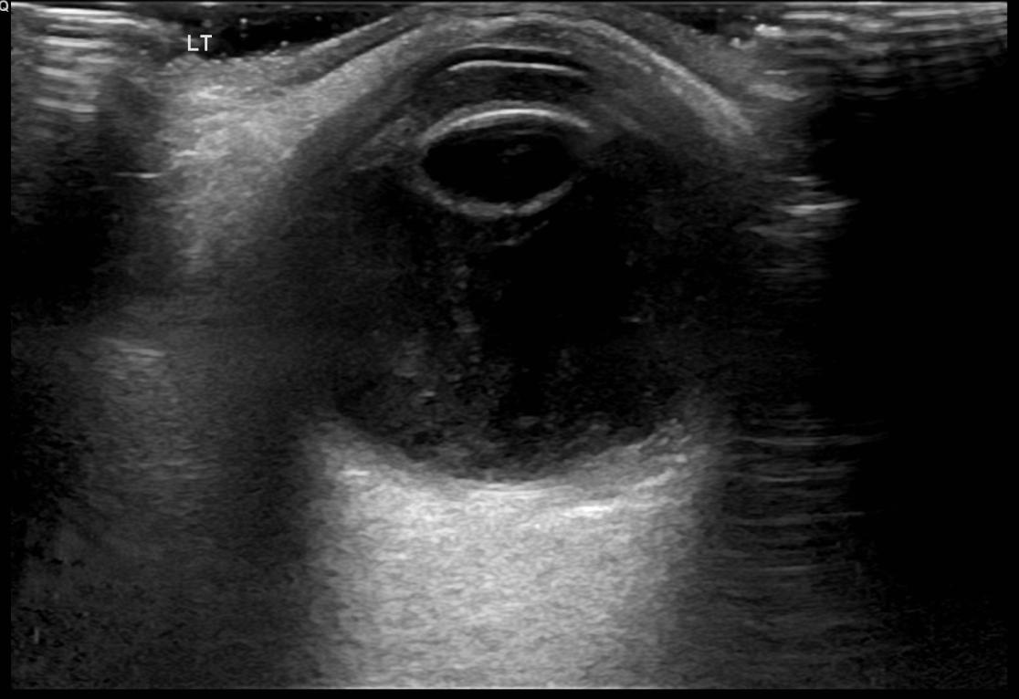

**Figure 1a.** Ultra sonography (USG) Left eye anterior chamber shows medium level echoes, vitreous shows thick membrane like echoes, chorio retinal layer- appears diffusely thickened with mildly increased vascularity, features suggestive of left eye endophthalmitis.

She underwent a transthoracic echocardiography, which showed mild mitral regurgitation, with no vegetation visualized. Considering the high suspicion for Infective Endocarditis, a transesophageal echo was done which showed vegetation measuring 1.0 x 0.6 cm on the posterior leaflet of the mitral valve, associated with moderate to severe mitral regurgitation (Figure 1b).

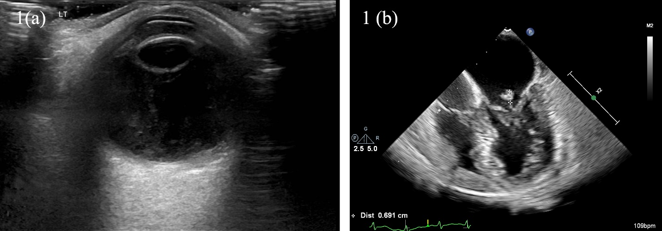

**Figure 1b.** Transesophageal echo showing vegetation measuring 1.0 x 0.6 cm on the posterior leaflet of the mitral valve.

Ceftriaxone continued for a duration of 4 weeks. On initiation of antibiotics her systemic symptoms resolved, and the inflammatory markers normalized. However, despite timely ophthalmic intervention, the visual outcome in the left eye remained poor, limited to light perception.

**3.DISCUSSION**

Endogenous endophthalmitis is a rare ocular manifestation of Infective Endocarditis with high mortality rates and poor visual prognosis that poses a difficult diagnostic challenge. Endogenous endophthalmitis often arises in patients with systemic comorbidities that predispose them to hematogenous spread of infection. Endogenous endophthalmitis requires a comprehensive assessment for an underlying systemic infection source, especially in individuals with risk factors like diabetes. This is illustrated in case series by Moutei et al. (13), which detailed two instances of endogenous endophthalmitis in diabetic patients with nephrological issues. Our patient shared a similar risk profile, emphasizing the necessity of maintaining a high index of suspicion of ocular involvement in bacteremic patients with uncontrolled diabetes.

Infective endocarditis remains an unusual but critical diagnostic scenario. In several published cases, patients with endophthalmitis and underlying risk factors were found to have vegetative cardiac lesions- sometimes detectable only by transesophageal echocardiography despite negative transthoracic studies (14,15). Rarely, endocarditis can present with extra cardiac manifestations such as infarcts or endophthalmitis as the first clue to systemic disease, underscoring the need for clinicians to pursue comprehensive investigations when eye findings are unexplained (14,15,16). This case underscores how an ocular presentation can be the first clue to an otherwise undiagnosed systemic illness like infective endocarditis.

*Streptococcus pseudoporcinus*, a close relative of *Streptococcus agalactiae*, has rarely been implicated in invasive human infections. In 2006, Streptococcus pseudoporcinus, a beta hemolytic streptococcus, was identified. It is mostly associated with genitourinary tract infection in women (11,17). While typically a commensal of the female genitourinary tract, *Streptococcus pseudoporcinus* has been implicated in a spectrum of invasive human infections – ranging from skin and soft tissue infection to invasive bacteremia and rarely infective endocarditis (18,19,20). Its isolation from blood culture in this case, along with clear echocardiographic evidence of mitral valve vegetation, strongly suggests its role as the causative pathogen in this patient’s endocarditis and secondary endogenous endophthalmitis. Increasing reports of *Streptococcus pseudoporcinus* causing serious and even fatal disseminated disease underscore the emerging importance of accurate species identifications and targeted therapy, especially when resistance patterns are atypical (21,22). A comprehensive PubMed search conducted through June 2025 did not yield any previously published case of endogenous endophthalmitis secondary to *Streptococcus pseudoporcinus*, either as an isolated ocular infection or in the context of infective endocarditis. To our knowledge, this is the first published case of *Streptococcus pseudoporcinus* infective endocarditis presenting initially with endogenous endophthalmitis.

Upon suspicion of endogenous endophthalmitis, treatment should begin even before getting confirmatory cultures. The mainstay of treatment involves intravitreal therapy, systemic antibiotics, and in some circumstances vitrectomy. Ceftazidime and vancomycin are the preferred intravitreal antibiotics for bacterial endogenous endophthalmitis. Ocular penetration and breadth of coverage, as defined by the presumed source of infection, are two crucial considerations for doctors when selecting systemic antibiotics (23).

**4. CONCLUSION**

Endogenous endophthalmitis can be the initial sign of occult infective endocarditis. *Streptococcus pseudoporcinus* is an unusual but emerging pathogen capable of causing serious invasive diseases. The importance of maintaining a high index of suspicion for infective endocarditis in patients presenting with endophthalmitis despite normal transthoracic echocardiography. A multidisciplinary approach involving ophthalmologists, infectious disease specialists, and cardiologists is essential for optimal management.

**CONSENT**

As per international standards or university standards, patient’s written consent has been collected and preserved by the authors(s).

**ABBREVIATIONS**

IE – Infective endocarditis

USG - Ultra sonography

**DISCLAIMER (ARTIFICIAL INTELLIGENCE)**

Author(s) hereby declares that NO generative AI technologies such as Large Language Models (ChatGPT, manuscript) have been used during the writing or editing of manuscripts.

**REFERENCES**

1. Okada AA, Johnson RP, Liles WC, D'Amico DJ, Baker AS. Endogenous bacterial endophthalmitis: report of a ten-year retrospective study. Ophthalmology. 1994;101(5):832–8.
2. Steeples LR, Jones NP. Staphylococcal endogenous endophthalmitis in association with pyogenic vertebral osteomyelitis. Eye (Lond). 2016;30(1):152–5.
3. Jackson TL, Paraskevopoulos T, Georgalas I. Systematic review of 342 cases of endogenous bacterial endophthalmitis. Surv Ophthalmol. 2014;59(6):627–35.
4. Binder MI, Chua J, Kaiser PK, Procop GW, Isada CM. Endogenous endophthalmitis: an 18-year review of culture-positive cases at a tertiary care center. Medicine (Baltimore). 2003;82(2):97–105.
5. Lingappan A, Wykoff CC, Albini TA, Miller D, Pathengay A, Davis JL, et al. Endogenous fungal endophthalmitis: causative organisms, management strategies, and visual acuity outcomes. Am J Ophthalmol. 2012;153(1):162–6. e1.
6. Lansbury L, Lim B, Baskaran V, Lim WS. Co-infections in people with COVID-19: a systematic review and meta-analysis. J Infect. 2020;81(2):266–75.
7. Manilika P, Maruthkar S, Daigavane S, Rahate N, Sarda P, Shukla S, et al. Endogenous endophthalmitis in COVID-19 patients. J Pharm Res Int. 2021;33(60B):51–7.
8. Greenwald MJ, Wohl LG, Sell CH. Metastatic bacterial endophthalmitis: a contemporary reappraisal. Surv Ophthalmol. 1986;31(2):81–101.
9. Barnett R. Infective endocarditis. Lancet. 2016;388(10050):1148.
10. Cahill TJ, Prendergast BD. Infective endocarditis. Lancet. 2016;387(10021):882–93.
11. Bekal S, Gaudreau C, Laurence RA, Simoneau E, Raynal L. *Streptococcus pseudoporcinus* sp. nov., a novel species isolated from the genitourinary tract of women. J Clin Microbiol. 2006;44(7):2584–6.
12. Birlutiu V, Birlutiu RM, Teodoru M, Catana AC, Stoica CI. Endocarditis with *Streptococcus pseudoporcinus* associated with mastocytosis and spondylodiscitis: a coincidental association? A case report. Trop Med Infect Dis. 2023;8(5):247.
13. Moutei H, Benaddou S, Bennis A, Chraibi F, Abdellaoui M, Benatiya I. Two endogenous endophthalmitis cases accompanying nephrological condition in diabetic patients. Asian J Med Health. 2024;22(11):20–8.
14. Villasmil RJ, Lattanzio N, Burns K, Alkayali T. More than meets the eye: infective endocarditis presenting as endogenous endophthalmitis. Cureus. 2021;13(4): e14745.
15. Abdulla MC. Infective endocarditis presenting as endogenous endophthalmitis and multiple cerebral infarcts. Indian J Cardiovasc Dis Women. 2024; 9:109–11.
16. Kim E, Park SW, Kwon HJ, Park BH, Byon I. Endogenous endophthalmitis and embolic retinopathy associated with infective endocarditis caused by *Staphylococcus aureus*. J Retin. 2023;8(1):62–6.
17. Stoner KA, Rabe LK, Austin MN, Meyn LA, Hillier SL. Incidence and epidemiology of *Streptococcus pseudoporcinus* in the genital tract. J Clin Microbiol. 2011;49(3):883–6.
18. Papapanagiotou M, Ioannou P, Alexakis K, Maraki S, Papadokostaki E, Kofteridis DP. *Streptococcus pseudoporcinus* bacteremia in a patient with skin and soft tissue infection: a case report and literature review. Infez Med. 2023;31(3):399–403.
19. Hai PD, Dung NM, Son PN, Phuong LL, Thuyet BT, Hoa LV. First report of infective endocarditis caused by *Streptococcus pseudoporcinus* in Vietnam. New Microbes New Infect. 2020; 34:100643.
20. Khan S, Wong TT, Prasad N, Lee B, Urban C, Segal-Maurer S, et al. *Streptococcus pseudoporcinus*: case reports and review of the literature. Case Rep Infect Dis. 2020; 2020:4135246.
21. Liatsos GD, Tsiriga A, Dourakis SP. Fatal *Streptococcus pseudoporcinus* disseminated infection in decompensated liver cirrhosis: a case report. J Med Case Rep. 2021; 15:240.
22. Soku YK, Etzioni AL, Mohamed A. Multidrug-resistant *Streptococcus pseudoporcinus* isolated from an infected surgical wound of a 9-year-old spayed female Great Dane dog: a case report. Front Vet Sci. 2023; 10:1139381.
23. Cornut PL, Chiquet C. Intravitreal injection of antibiotics in endophthalmitis. J Fr Ophtalmol. 2008;31(9):815–23.