Study of Platelet Count and Platelet Indices as Markers of Fibrosis in Nonalcoholic Fatty Liver Disease Patients

Abstract
Background: Platelet count and platelet indices are cheap, accurate and available methods to estimate fibrosis in Nonalcoholic fatty liver disease (NAFLD) patients. Aim: This work aims to study platelet count and platelet indices as markers of fibrosis in NAFLD patients. Methods: This cross-sectional study was carried out on 150 patients with NAFLD. Patients were divided into three equal groups according to ultrasonographic findings: Group 1: healthy volunteers as the control group, Group 2: patients with mild (grade I) or moderate (grade II) steatosis and Group 3: patients with severe (grade III) steatosis and possible fibrosis. Results: Fibrosis-4 index (FIB-4) showed significant positive correlations with aspartate aminotransferase to platelet ratio index (APRI), platelet count, several metabolic and liver function parameters, and a negative correlation with white blood cell (WBCs) and high-density lipoprotein (HDL). APRI correlated similarly, with added significance for DBP. Platelet count correlated positively with FIB-4, APRI, and metabolic markers, and negatively with HDL. Mean platelet volume (MPV) showed positive correlations with aspartate aminotransferase (AST), alanine aminotransferase (ALT), Haemoglobin (Hb), FBG, 2HPPG, and negative correlations with WBCs and cholesterol. Platelet Distribution Width (PDW) correlated positively with platelet indices, SBP, metabolic markers, and negatively with AST, ALT, and Hb. PCT showed positive correlations with platelet indices and metabolic markers. All showed non-significant correlations with remaining parameters. Conclusions: The study found a significant association between insulin resistance and the severity of NAFLD. Furthermore, the homeostasis model assessment for insulin resistance (HOMA-IR) was shown to predict fibrosis in NAFLD patients. Notably, the APRI was found to be a reliable non-invasive blood test for diagnosing fibrosis, particularly for ruling out advanced fibrosis due to its high negative predictive value.
Keywords: Platelet Count, Platelet Indices, Fibrosis, Nonalcoholic Fatty Liver

Introduction:

“Nonalcoholic fatty liver disease (NAFLD) is the leading cause of chronic liver disease worldwide, affecting 20-30% of the population in Western countries” ^{[1]}. It is a multifactorial metabolic disorder that was first described in 1980 ^{[37].}

“Egypt, a Middle East country with a population of nearly one hundred million, with 60% of them being younger than 30 years, is considered among the top ten countries in prevalence of obesity. Overall, the Middle East and North Africa (MENA) region has one of the highest NAFLD prevalence rates, which is estimated to affect 31.8% of all adults. Young adults are often overlooked as they are considered healthy; however, young adults with NAFLD can represent a major health problem with a significant burden on health care systems in the Middle East and North Africa” ^{[2]}.

“NAFLD is a spectrum ranging from simple steatosis with a favorable prognosis to nonalcoholic steatohepatitis (NASH), which may progress to cirrhosis and its complications” ^{[3]}. “Cirrhosis is defined as the histological development of regenerative nodules surrounded by fibrous bands in response to chronic liver injury, which leads to portal hypertension and other complications such as oesophagal varices (OV), ascites, spontaneous bacterial peritonitis or hepatorenal syndrome” [36].

“The hallmark of NAFLD is intrahepatic deposition of triglycerides, and the leading factors in this process are insulin resistance and energy imbalance. NAFLD is considered a hepatic manifestation of the metabolic syndrome” ^{[4]}.

“Thrombocytopenia is one of the most frequently identified hematologic problems in patients with chronic liver disease and cirrhosis” ^{[5]}.

“The role of platelet hemostasis is well known in the field of medical research. However, new roles are emerging recently due to innovations in automated complete blood count (CBC) analysers” ^{[6]}.

“Some of these roles are platelet roles in immunity and inflammation as well as thrombosis. Some of the fastest and simplest checks to validate platelet function are platelet indices” ^{[7]}.

“Platelet indices include platelet distribution width (PDW), mean platelet volume (MPV) and plateletcrit (PCT). The mean platelet volume (MPV) is said to be a useful index of platelet activation as it reflects the size of the platelet” ^{[8]}.

“Platelet crit (PCT) is the platelet count and platelet volume arithmetic product, which is positively associated with platelet reduction. And (PCT) at the same time suggests that platelets were extensively consumed. Mean platelet volume (MPV) is the measure of platelet volume. Bone marrow produces a large number of immature platelets, which are larger in volume than mature platelets, when platelets are consumed heavily” ^{[9]}.

“Therefore, both the newly formed platelets with large volume and mature platelets with limited volume are present concurrently in the blood at the same time, which leads to an increase in both MPV and PDW (coefficient of PLT variation) correspondingly” ^{[10]}.

“Several laboratory test Scores, and indices have been developed for noninvasive prediction of cirrhosis (F4) aspartate aminotransferase (AST) to platelet ratio aspartate aminotransferase to platelet ratio index (APRI), fibrosis-4 (FIB-4) are based on routine laboratory parameters and readily available in clinical practice WHO ranked these two scores as preferred noninvasive markers of fibrosis in resource limited countries” ^{[11]}.

“Sonographic evaluation (US) of hepatic steatosis is performed using five criteria: parenchymal brightness, liver to kidney contrast, deep beam attenuation, bright vessel walls, and gall bladder definition” ^{[12]}.
The aim of this work is to study platelet count and platelet indices as markers of fibrosis in NAFLD patients.
Patients and Methods:
This cross-sectional study was carried out on 150 patients with NAFLD, aged < 18 years, both sexes.
Exclusion criteria were patients severely affected by chronic extra hepatic disease, hepatocellular carcinoma, alcohol consumption of more than 20 g/day for women and less than 30 g/day foe men, metabolic causes of steatohepatitis including Wilson’s disease, hemochromatosis, viral hepatitis B or C, and autoimmune liver diseases, no recent use of medications such as glucocorticoids, estrogens, tamoxifen, or amiodarone that may cause fatty liver.
Patients were divided into three equal groups according to ultrasonographic findings: Group 1: healthy volunteers as control group, Group 2: with mild (grade I) or moderate (grade II) steatosis and Group 3: with severe (grade III) steatosis and possible fibrosis.
All patients were subjected to complete history taking, complete clinical examination, liver function tests, HCV antibodies and HBsAg, complete blood count with special focus on platelet count and platelet indices, serum creatinine, blood urea, total lipid profile, fasting and two hours post prandial blood glucose, calculation of FIB-4 (Age x AST)/ (Platelets x sqr (ALT)) ^{[13]}, APRI [(AST / upper normal limit AST) x 100]/ Platelets (109/L) ^{[14]}, (HOMA, IR) for each patient ^{[15]}, pelviabdominal ultrasonography and liver biopsy was not done due to its invasive nature.
The diagnosis of NAFLD was made according to US findings:
Grade I: increased hepatic echogenicity with visible periportal and diaphragmatic echogenicity.
Grade II: increased hepatic echogenicity with imperceptible periportal echogenicity, without obscuration of the diaphragm.
Grade III: increased hepatic echogenicity with imperceptible periportal echogenicity and obscuration of the diaphragm ^{[16]}.
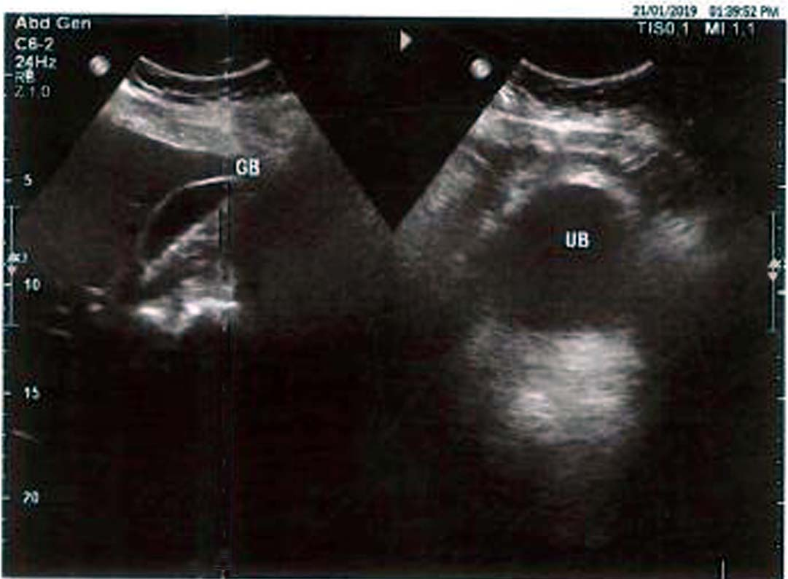 | 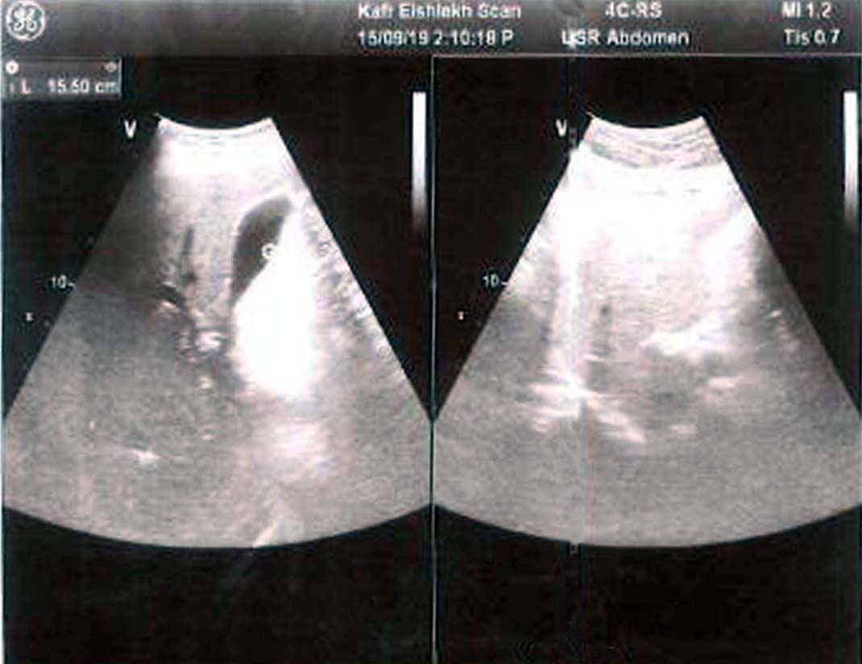
(A) | (B)
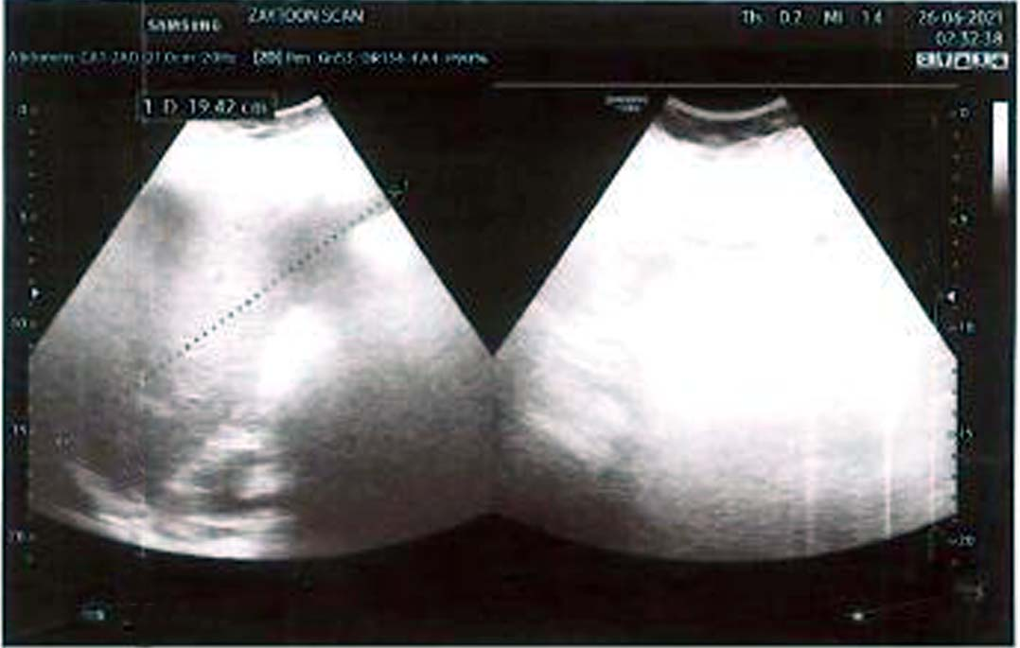 | 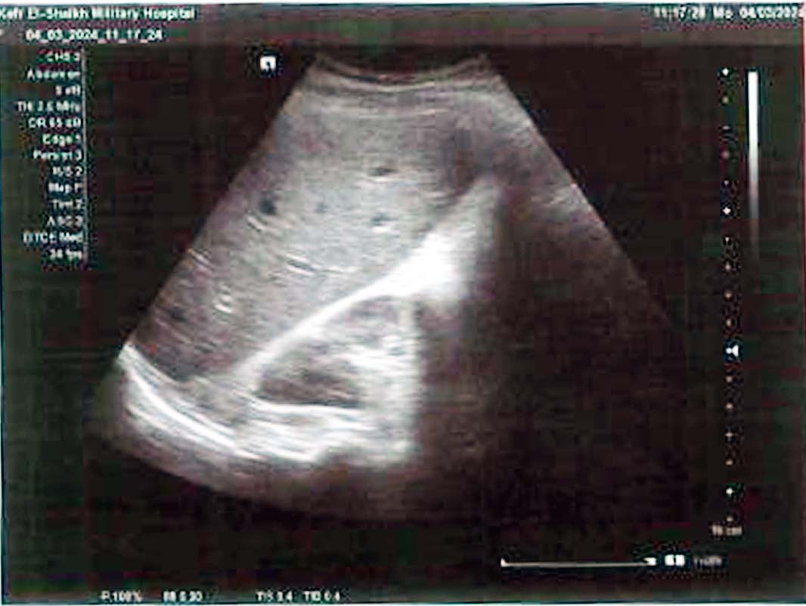
(C) | (D)
Figure1: (A) Mild fatty liver,(B) Moderate fatty liver , (C) Sever fatty liver and (D) Fatty liver with possible fibrosis
Statistical analysis
Statistical analysis was done by SPSS v26 (IBM Inc., Chicago, IL, USA). Quantitative variables were presented as mean and standard deviation (SD) and compared between the three groups utilising ANOVA (F) test with post hoc test (Tukey). Qualitative variables were presented as frequency and percentage and were analysed utilising the Chi-square test. A two-tailed P value < 0.05 was considered statistically significant.

Results:
Groups 2 and 3 had a significantly higher body weight, height, BMI, and waist circumference when compared to the control group 1. Table 1
Table 1: Distribution of the studied groups according to their sex, age, weight, height, BMI, and waist circumference
 |  | Group 1 | Group 2 |  |  | Group 3 |  | Total
Sex | Male | 29 (58%) | 25 (50%) |  |  | 23 (46%) |  | 77 (51.3%)
 | Female | 21 (42%) | 25 (50%) |  |  | 27 (54%) |  | 73 (48.7%)
Chi-square | X2 | 1.487
 | P | 0.474
 |  | Group 1 |  | Group 2 | Group 3 |  | F-test |  | p
Age (years) |  | 50.08 ± 11.72 |  | 46.84 ± 14.63 | 50.44 ± 7.15 |  | 1.465 |  | 0.234
 |  | P1=0.164, p2= 0.877p3=0.122
Weight (kg) |  | 59.68 ± 8.91 |  | 103.16 ± 20.87 | 107.64 ± 22.23 |  | 104.329 |  | 0.001*
 |  | P1=0.001*, p2= 0.001*p3=0.224
Height (cm) |  | 163.64 ± 8.47 |  | 176.32 ± 10.11 | 180.08 ± 5.71 |  | 53.878 |  | 0.001*
 |  | P1=0.001*, p2= 0.001*p3=0.025*
BMI |  | 22.19 ± 1.85 |  | 33.23 ± 6.07 | 32.97 ± 5.60 |  | 83.116 |  | 0.001*
 |  | P1=0.001*, p2= 0.001*p3=0.795*
Waist circumf. (cm) |  | 83.08 ± 14.94 |  | 123.00 ± 16.51 | 120.80 ± 16.52 |  | 98.244 |  | 0.001*
 |  | P1=0.001*, p2= 0.001* p3=0.493*
Data are presented as mean ± SD or frequency (%). BMI: Body mass index, F. test: Fisher exact test., P1: Comparison between Group 1 & Group 2, P2: Comparison between Group 1 & Group 3, P3: Comparison between Group 2 & Group 3, BMI: body mass index., Waist circumf.: waist circumference.
Groups 2 and 3 had significantly higher systolic blood pressure, diastolic blood pressure, aspartate aminotransferase, alanine aminotransferase, and total bilirubin when compared to control group 1 (control). While group 2 had higher direct bilirubin, white blood cells, platelet distribution width, and platelet count when compared to groups 3 and 1(control). While groups 2 and 3 had significantly lower albumin, platelets, and mean platelet volume when compared to the control group 1 (control). According to Hb, there was no statistically significant variability between all groups. Table 2
Table 2: Distribution of the studied groups according to their blood pressure and liver function tests and complete blood count.
Parameter | Group 1 |  | Group 2 |  | Group 3 | F | p
SBP (mm Hg) | 111.20 ± 6.89 |  | 120.80 ± 7.78 |  | 121.40 ± 9.09 | 25.758 | 0.001*
 | P1=0.001*, p2=0.001*, p3=0.707
DBP (mm Hg) | 76.40 ± 5.25 |  | 76.80 ± 5.51 |  | 79.40 ± 7.19 | 3.630 | 0.029*
 | P1=0.741, p2=0.014*, p3=0.033*
AST (U/L) | 27.96 ± 4.65 |  | 27.44 ± 6.16 |  | 33.96 ± 8.99 | 14.035 | 0.001*
 | P1=0.704, p2=0.001*, p3=0.001*
ALT (U/L) | 27.04 ± 5.34 |  | 29.08 ± 7.07 |  | 40.56 ± 8.73 | 51.526 | 0.001*
 | P1=0.158, p2=0.001*, p3=0.001*
Total Bilirubin (mg/dL) | 0.78 ± 0.16 |  | 0.91 ± 0.13 |  | 1.10 ± 0.22 | 43.582 | 0.001*
 | P1=0.001*, p2=0.001*, p3=0.001*
Direct Bilirubin (mg/dL) | 0.18 ± 0.06 |  | 0.28 ± 0.15 |  | 0.20 ± 0.06 | 14.412 | 0.001*
 | P1=0.001*, p2=0.407, p3=0.001*
Albumin (g/dL) | 4.21 ± 0.19 |  | 4.19 ± 0.29 |  | 4.06 ± 0.28 | 4.861 | 0.001*
 | P1=0.638*, p2=0.004*, p3=0.016*
Complete Blood Count.
Hb (g/dL) |  | 12.80 ± 0.76 |  | 12.56 ± 1.03 | 12.72 ± 1.41 | 0.643 | 0.527
 |  | P1=0.269, p2= 0.723, p3=0.451
WBCs (×10⁹/L) |  | 6.00 ± 1.04 |  | 6.58 ± 1.78 | 5.34 ± 1.09 | 10.637 | 0.001*
 |  | P1= 0.033*, p2= 0.015*, p3=0.001*
Platelets (×10⁹/L) |  | 268.04 ± 61.94 |  | 263.32 ± 41.46 | 213.12 ± 19.96 | 23.344 | 0.001*
 |  | P1= 0.597, p2= 0.001*, p3=0.001*
MPV (fL) |  | 11.15 ± 0.61 |  | 10.02 ± 1.30 | 10.82 ± 1.56 | 11.096 | 0.001*
 |  | P1= 0.001*, p2= 0.189, p3=0.001*
PDW (fL) |  | 15.32 ± 2.17 |  | 23.46 ± 10.83 | 14.34 ± 1.61 | 30.185 | 0.001*
 |  | P1= 0.001*, p2=0.446, p3=0.001*
PCT (%) |  | 3.00 ± 0.62 |  | 3.48 ± 1.37 | 3.11 ± 1.07 | 2.742 | 0.001*
 |  | P1= 0.027*, p2=0.613, p3=0.086
Data are presented as mean ± SD or frequency (%), F. test: Fisher exact test., P1: Comparison between Group 1 & Group 2, P2: Comparison between Group 1 & Group 3, P3: Comparison between Group 2 & Group 3, Waist circumf.: waist circumference, SBP: systolic blood pressure, DBP: diastolic blood pressure, AST: aspartate aminotransferase, ALT: alanine aminotransferase, HB: hemoglobin, WBCs: white blood cells, MPV: mean platelet volume, Fl: femto-liter, PDW: platelet distribution width, PCT: platelet crit.
Groups 2 and 3 had significantly higher creatinine, urea, cholesterol, triglycerides, fasting blood glucose, two hours postprandial glucose, fasting insulin, and homeostasis assessment model for insulin resistance when compared to control group 1 (control). While groups 2 and 3 had significantly lower high-density lipoproteins when compared to control group 1 (control). Table 3
Table 3: Distribution of the studied groups according to their kidney function tests, lipid profile, fasting and post prandial glucose, fasting insulin and HOMA-IR
 | Group 1 | Group 2 | Group 3 | F-test | p
Creatinine (mg/dL) | 0.97 ± 0.17 | 1.04 ± 0.20 | 1.14 ± 0.14 | 11.777 | 0.001*
 | P1= 0.038*, p2= 0.001*, p3=0.007*
Urea (mg/dL) | 22.68 ± 2.47 | 26.52 ± 3.12 | 25.68 ± 3.07 | 24.190 | 0.001*
 | P1= 0.001*, p2=0.001*, p3=0.150
Cholesterol (mg/dL) | 157.40 ± 18.04 | 224.92 ± 26.71 | 219.32 ± 17.48 | 156.631 | 0.001*
 | P1= 0.001*, p2=0.001*, p3=0.188
HDL (mg/dL) | 49.80 ± 3.25 | 43.92 ± 3.22 | 36.92 ± 2.02 | 249.803 | 0.001*
 | P1= 0.001*, p2=0.001*, p3=0.001*
Triglycerides (mg/dL) | 91.48 ± 29.89 | 168.68 ± 46.88 | 189.32 ± 28.48 | 102.233 | 0.001*
 | P1= 0.001*, p2=0.001*, p3=0.001*
FBG (mg/dL) | 110.08 ± 7.51 | 111.60 ± 13.93 | 122.16 ± 16.40 | 12.503 | 0.001*
 | P1=0.564, p2=0.001*, p3=0.001*
2HPPG (mg/dL) | 134.04 ± 8.26 | 152.96 ± 19.28 | 174.48 ± 29.51 | 46.842 | 0.001*
 | P1= 0.001*, p2=0.001*, p3=0.001*
F Insulin (µIU/mL) | 5.80 ± 2.23 | 9.06 ± 3.33 | 8.92 ± 0.95 | 29.983 | 0.001*
 | P1= 0.001*, p2=0.001*, p3=0.770
HOMA-IR | 1.42 ± 0.64 | 1.73 ± 0.69 | 2.38 ± 0.35 | 36.007 | 0.001*
 | P1= 0.008*, p2=0.001*, p3=0.001*
Data are presented as mean ± SD. F. test: Fisher exact test., P1: Comparison between Group 1 & Group 2, P2: Comparison between Group 1 & Group 3, P3: Comparison between Group 2 & Group 3, HDL: high density lipoprotein.FBG: fasting blood glucose, 2HPPG: two hours post prandial blood glucose, F insulin: fasting insulin, HOMA-IR: homeostasis model assessment for insulin for insulin resistance.
Groups 2 and 3 had significantly higher fibrosis-four index, aspartate aminotransferase to platelet ratio index, blood glucose and blood pressure when compared to group 1. Table 4
Table 4: Distribution of the studied groups according to fibrosis-4- (FIB-4) and aspartate aminotransferase to platelet ratio index (APRI), diabetes mellitus, viral hepatitis, hypertension and ultra-sonographic examination
 | Group 1 |  | Group 2 | Group 3 |  | F-test |  | p
FIB-4 | 1.02 ± 0.28 |  | 1.29 ± 0.42 | 1.71 ± 0.41 |  | 43.318 |  | 0.001*
 | P1= 0.001*, p2=0.001*, p3=0.001*
APRI | 0.23 ± 0.04 |  | 0.32 ± 0.09 | 0.43 ± 0.09 |  | 93.171 |  | 0.001*
 | P1= 0.001*, p2=0.001*, p3=0.001*
Diabetes mellitus, viral hepatitis, and hypertension. |  |  |  |  |  |  | X2 |  | P
DM | 0 (0%) | 14 (28%) |  |  | 17 (34%) |  | 36.705 |  | 0.001*
HTN | 0 (0%) | 6 (12%) |  |  | 8 (16%) |  | 8.187 |  | 0.017*
US exam
Normal | 50 (100%) | 0 (0%) |  |  | 0 (0%) |  | 292.101 |  | 0.001*
Mild | 0 (0%) | 29 (58%) |  |  | 0 (0%)
Moderate | 0 (0%) | 21 (42%) |  |  | 0 (0%)
Severe | 0 (0%) | 0 (0%) |  |  | 28 (56%)
Fibrosis | 0 (0%) | 0 (0%) |  |  | 22 (44%)
Data are presented as mean ± SD. F. test: Fisher exact test., P1: Comparison between Group 1 & Group 2, P2: Comparison between Group 1 & Group 3, P3: Comparison between Group 2 & Group 3, FIB-4: fibrosis-4 index, APRI: aspartate aminotransferase to platelet ratio index, χ² :Chi-squares, DM: diabetes mellitus, HTN: Elevated blood pressure, US: ultra-sonographic examination.
Area under the ROC curve was 0.895, with sensitivity 90% and specificity 86% with positive predictive value 87% and negative predictive value 90% with accuracy 88%. According to fibrosis-four index area under the ROC curve was 0.834, with sensitivity 86% and specificity 80% with positive predictive value 81% and negative predictive value 85% with accuracy 83%. According to platelets area under the ROC curve was 0.661, with sensitivity 74% and specificity 68% with positive predictive value 70% and negative predictive value 72% with accuracy 71%. According to mean platelet volume area under the ROC curve was 0.558 with sensitivity 68% and specificity 60% with positive predictive value 63% and negative predictive value 65% with accuracy 64%. According to platelet distribution width area under the ROC curve was 0.690, with sensitivity 72% and specificity 64% with positive predictive value 67% and negative predictive value 70% with accuracy 68%. According to the platelet crit area under the curve was 0.504, with sensitivity 60% and specificity 56% with positive predictive value 57% and negative predictive value 58% with accuracy 58%. Figure 2
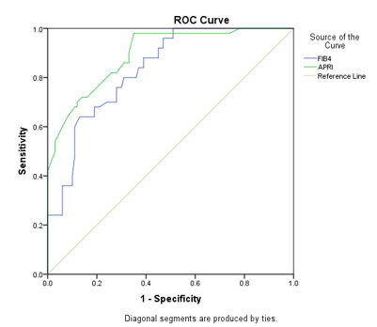 | 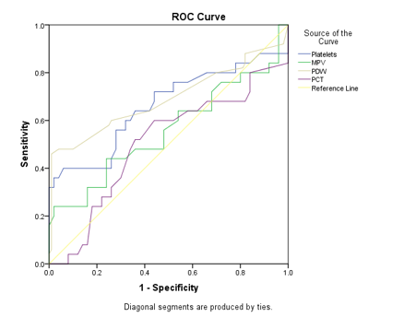
(A) | (B)

Figure 2: Receiver operating characteristic curve for the studied groups according to their (A) aspartate aminotransferase to platelet ratio and fibrosis-four indices and (B) their platelet count and platelet indices
According to the fibrosis-four index it showed a significant positive correlation with APRI, platelet count, age, SBP, AST, ALT, total bilirubin, creatinine, urea, cholesterol, triglycerides, FBG, 2HPPG, fasting insulin, HOMA-IR, weight, height, BMI, and waist circumference. On the other hand, it showed a significant negative correlation with WBCs and HDL. While it showed a non-significant correlation with the remaining parameters. According to APRI, it showed a positive significant correlation with FIB-4, platelet count, SBP, DBP, AST, ALT, total bilirubin, creatinine, urea, cholesterol, triglycerides, FBG, 2HPPG, fasting insulin, HOMA-IR, weight, height, BMI, and waist circumference. On the other hand, it showed significant negative correlation with WBCs and HDL. While it showed a non-significant correlation with the remaining parameters. According to platelet count, it showed a positive significant correlation with FIB-4, APRI, PDW, PCT, ALT, total bilirubin, creatinine, urea, cholesterol, triglycerides, FBG, 2HPPG, fasting insulin, HOM-IR, weight, height, and waist circumference. On the other hand, it showed significant negative correlation with HDL. While it showed a non-significant correlation with the remaining parameters. According to mean platelet volume, it showed a significant positive correlation with AST, ALT, Hb, FBG, 2HPPG. On the other hand, it showed significant negative correlation with WBCs and cholesterol. While it showed a non-significant correlation with the remaining parameters. According to platelet distribution width, it showed a significant positive correlation with platelet count, platelet crit, SBP, direct bilirubin, WBCs, urea, cholesterol, triglycerides, fasting insulin, and waist circumference. On the other hand, it showed significant negative correlation with AST, ALT, and Hb. While it showed a non-significant correlation with the remaining parameters. According to the platelet crit, it showed a positive significant correlation with platelet count, platelet distribution width, total bilirubin, direct bilirubin, creatinine, urea, cholesterol, triglycerides, 2HPPG, fasting insulin, and waist circumference. While it showed a non-significant correlation with the remaining parameters. Table 5
Table 5: Correlations between the platelet parameters, fibrosis-4, aspartate aminotransferase to platelet ratio indices and all other parameters done for the studied groups
 |  | FIB4 | APRI | Platelets | MPV | PDW | PCT
FIB4 | r |  | 0.540 | 0.293 | -0.009 | -0.067 | 0.127
 | P |  | 0.001* | 0.001* | 0.912 | 0.416 | 0.121
APRI | r | 0.540 |  | 0.342 | -0.099 | 0.029 | 0.131
 | P | 0.001* |  | 0.001* | 0.227 | 0.726 | 0.109
Platelets  ×10⁹/L | r | 0.293 | 0.342 |  | -0.032 | 0.212 | 0.503
 | P | 0.001* | 0.001* |  | 0.700 | 0.009* | 0.001*
MPV  fl | r | -0.009 | -0.099 | -0.032 |  | -0.117 | 0.105
 | P | 0.912 | 0.227 | 0.700 |  | 0.154 | 0.202
PDW  fl | r | -0.067 | 0.029 | 0.212 | -0.117 |  | 0.537
 | P | 0.416 | 0.726 | 0.009* | 0.154 |  | 0.001*
PCT  % | r | 0.127 | 0.131 | 0.503 | 0.105 | 0.537
 | P | 0.121 | 0.109 | 0.001* | 0.202 | 0.001*
Age  years | r | 0.175 | -0.010 | -0.132 | 0.019 | -0.147 | -0.046
 | P | 0.032* | 0.902 | 0.108 | 0.813 | 0.072 | 0.575
Systolic  Millimeter mercury | r | 0.233 | 0.367 | 0.103 | -0.142 | 0.211 | -0.046
 | P | 0.004* | 0.001* | 0.209 | 0.082 | 0.010* | 0.578
Diastolic  Millimeter mercury | r | 0.058 | 0.165 | -.017- | 0.093 | 0.113 | 0.146
 | P | 0.483 | 0.043* | 0.834 | 0.260 | 0.170 | 0.074
AST  U/L | r | 0.296 | 0.323 | 0.083 | 0.263 | -0.183 | -0.008
 | P | 0.001* | 0.001* | 0.311 | 0.001* | 0.025* | 0.923
ALT  U/L | r | 0.452 | 0.542 | 0.299 | 0.281 | -0.181 | 0.093
 | P | 0.001* | 0.001* | 0.001* | 0.001* | 0.027* | 0.259
Total bilirubin  mg/dL | r | 0.409 | 0.410 | 0.382 | -0.019 | -0.043 | 0.259
 | P | 0.001* | 0.001* | 0.001* | 0.820 | 0.605 | 0.001*
Direct bilirubin  mg/dL | r | 0.106 | 0.129 | 0.131 | -0.108 | 0.243 | 0.389
 | P | 0.196 | 0.117 | 0.110 | 0.189 | 0.003* | 0.001*
Albumin  g/L | r | 0.077 | 0.119 | 0.010 | 0.043 | -0.052 | -0.154
 | P | 0.349 | 0.147 | 0.902 | 0.602 | 0.528 | 0.060
Hb  g/L | r | -0.083 | 0.034 | -0.118 | 0.234 | -0.163 | -0.040
 | P | 0.313 | 0.677 | 0.151 | 0.004* | 0.047* | 0.624
WBCs  ×10⁹/L | r | -0.177 | -0.222 | -0.001 | -0.222 | 0.280 | 0.154
 | P | 0.031* | 0.006* | 0.986 | 0.006* | 0.001* | 0.059
Creatinine  mg/dL | r | 0.267 | 0.319 | 0.192 | -0.072 | 0.122 | 0.208
 | P | 0.001* | 0.001* | 0.018* | 0.384 | 0.138 | 0.011*
Urea  mg/dL | r | 0.211 | 0.266 | 0.304 | -0.105 | 0.239 | 0.199
 | P | 0.010* | 0.001* | 0.001* | 0.199 | 0.003* | 0.015*
Cholesterol  mg/dL | r | 0.388 | 0.531 | 0.545 | -0.235 | 0.325 | 0.329
 | P | 0.001* | 0.001* | 0.001* | 0.004* | 0.001* | 0.001*
HDL  mg/dL | r | -0.594 | -0.655 | -0.377 | 0.052 | 0.057 | -0.107
 | P | 0.001* | 0.001* | 0.001* | 0.526 | 0.489 | 0.194
Triglycerides  mg/dL | r | 0.391 | 0.534 | 0.465 | -0.094 | 0.218 | 0.276
 | P | 0.001* | 0.001* | 0.001* | 0.252 | 0.007* | 0.001*
FBG  mg/dL | r | 0.251 | 0.284 | 0.174 | 0.267 | 0.053 | 0.093
 | P | 0.002* | 0.001* | 0.033* | 0.001* | 0.518 | 0.257
2HPPG  mg/dL | r | 0.386 | 0.432 | 0.427 | 0.165 | 0.062 | 0.246
 | P | 0.001* | 0.001* | 0.001* | 0.044* | 0.454 | 0.002*
F insulin  µIU/mL | r | 0.232 | 0.407 | 0.367 | -0.051 | 0.526 | 0.347
 | P | 0.004* | 0.001* | 0.001* | 0.539 | 0.001* | 0.001*
HOMA-IR | r | 0.275 | 0.386 | 0.170 | -0.025 | -0.088 | -0.091
 | P | 0.001* | 0.001* | 0.038* | 0.766 | 0.284 | 0.267
Weight  kilograms | r | 0.451 | 0.500 | 0.466 | -0.013 | 0.074 | 0.146
 | P | 0.001* | 0.001* | 0.001* | 0.879 | 0.366 | 0.076
Height  centimeters | r | 0.392 | 0.464 | 0.375 | 0.056 | 0.040 | 0.172
 | P | 0.001* | 0.001* | 0.001* | 0.494 | 0.631 | 0.035
BMI | r | 0.408 | 0.442 | 0.438 | -0.088 | 0.116 | 0.109
 | P | 0.001* | 0.001* | 0.001* | 0.285 | 0.159 | 0.184
Waist  centimeters | r | 0.390 | 0.501 | 0.382 | -0.066 | 0.193 | 0.200
 | P | 0.001* | 0.001* | 0.001* | 0.420 | 0.018* | 0.014*
R: relation. P-value (P < 0.05) non-significant. P-value (P > 0.05) significant. P-value (P > 0.001) highly significant. FIB-4: Fibrosis-four index. APRI: Aspartate aminotransferase to platelet ratio index. MPV: Mean platelet volume. PDW: Platelet distribution width. PCT: Platelet crit. AST: Aspartate aminotransferase. ALT: Alanine aminotransferase. HB: Hemoglobin. WBCs: white blood cells. HDL: High density lipoprotein. FBG: Fasting blood glucose. 2HPPG: 2Hours post prandial glucose. F Insulin: Fasting Insulin. HOMA-IR: Homeostasis model assessment for insulin resistance. BMI: Body mass index.

Discussion
NAFLD, encompassing a spectrum of liver conditions in individuals with minimal to no alcohol consumption, is typified by excessive fat accumulation within hepatocytes. “NAFLD encompasses a spectrum of disorders ranging from simple steatosis to nonalcoholic steatohepatitis (NASH), the latter characterised by hepatic necro-inflammation and a propensity for rapid fibrotic progression, culminating in cirrhosis and hepatocellular carcinoma (HCC) ^{[17]}. The global prevalence of NAFLD is around 25%” ^{[18]}.
Our study revealed that FIB-4 and APRI were significantly higher in group 3 than in both groups and were significantly higher in group 2 than in controls.
In agreement with our result, Badawi et al. ^{[19]} performed a cross-sectional study on 116 NAFLD patients. They showed that FIB-4 was significantly higher in the advanced fibrosis group than the mild/moderate fibrosis group.
This is supported by Rigamonti et al. ^{[20]}, who showed that patients with NAFLD had significantly higher APRI than those without NAFLD.
The current study revealed that platelets can predict fibrosis with a sensitivity of 74% and specificity of 68% with a PPV 70% an an NPV 72% with an accuracy of 71%. MPV can predict fibrosis with a sensitivity 68% and specificity 60% with PPV 63% and NPV 65% with accuracy 64%. PDW can predict fibrosis with a sensitivity 72% and specificity 64% with PPV 67% and NPV 70% with an accuracy of 68%. PCT can predict fibrosis with a sensitivity 60% and specificity of 56% with PPV 57% and NPV 58% with an accuracy of 58%.
In the present study, there was a highly significant correlation between FIB-4 and APRI. There was a highly significant correlation between APRI and FIB-4 with platelets. There was a highly significant correlation between platelets and PDW and PCT.
“Higher PDW values are associated with a wider range of platelet size, which could result from platelet activation processes, platelet destruction mechanisms, or platelet consumption” ^{[21]}.
In the same line, Gadallah et al. ^{[17]} found that in NAFLD patients, PCT levels showed a significant positive correlation with platelet count.
On the other hand, Milovanovic et al. ^{[22]} reported that there was a statistically significant negative correlation between platelet count with APRI and FIB-4.
The current study revealed that there was a significant positive correlation between PDW and PCT. There was significant positive correlation between age and FIB-4. There was positive significant correlation between systolic blood pressure and FIB-4, APRI, and PDW. There was positive significant correlation between diastolic blood pressure and APRI.
However, Gadallah et al. ^{[17]} found that there was no significant correlation observed between PCT levels and PDW in NAFLD patients. This difference may be due to variations in study populations, disease severity, or differences in methodologies.
In contrast, Michalak et al. ^{[23]} showed that in NAFLD patients, there was a significant negative correlation between PDW and PCT
In this study, there was a positive significant correlation between ALT and FIB-4, and APRI, platelets, and MPV. While there was a significant negative correlation between ALT and PDW. There was a significant positive correlation between total bilirubin and FIB-4 and APRI, platelets and PCT. There was a significant positive correlation between direct bilirubin and PDW, and PCT.
This agreed with Rigamonti et al. ^{[20]}, who showed that APRI was correlated with total bilirubin in NAFLD patients.
In the same line, Aktas et al. ^{[24]} revealed that PDW was significantly and positively correlated with ALT levels in NAFLD patients.
There was a positive significant correlation between haemoglobin and MPV. There was a negative significant correlation between haemoglobin and PDW.
In this context, Harsha et al. ^{[25]} reported that there was a statistically significant positive correlation observed between MPV and HbA1C. Lippi et al. ^{[26]} reported that elevated MPV was significantly associated with higher HbA1c levels. Demirtas et al. ^{[27]} found that levels of PDW show a positive correlation with haemoglobin A1c.
However, Gadallah et al. ^{[17]} found that there was no significant correlation between MPV and haemoglobin, in NAFLD patients.
In the current study, there was a highly significant positive correlation between WBCs and PDW. There was significant negative correlation between WBCs and FIB-4, APRI, and MPV. There was positive significant correlation between creatinine and FIB-4, APRI, platelets, and PCT. There was a positive significant correlation between urea and FIB-4, APRI, platelets, PDW and PCT.
In the same line, Emre et al. ^{[28]} found that high WBC rates were accompanied by low MPV levels.
Hutapea et al. ^{[29]} showed a weak correlation between urea, creatinine, PDW, and PCT.
However, Gouda et al. ^{[30]} found that there is no statistically significant correlation between PCT and blood urea level. Small sample size may explain this difference.
There was a significant positive correlation between cholesterol and FIB-4, APRI, platelets, PDW and PCT. There was significant negative correlation between cholesterol and MPV. There was highly significant negative correlation between HDL and FIB-4, APRI, and platelets.
Plasma cholesterol levels appear to have a critical role in modulating platelet activity because hypercholesterolemia increases platelet activation more potently than hypertriglyceridemia ^{[31]}.
Alshuweishi et al. ^{[32]} revealed that all lipid parameters and ratios were significantly elevated in the highest APRI tertile.
This agreed with Rigamonti et al. ^{[20]}, who showed that APRI was correlated with HDL-C in NAFLD patients.
The current study revealed that there was a positive significant correlation between triglycerides and FIB-4, APRI, platelets, PDW and PCT. There was positive correlation between fasting blood glucose and FIB-4, APRI, platelets, PDW and MPV. There was a positive significant correlation between 2-h postprandial glucose and FIB-4, APRI, platelets, MPV, and PCT. There was positive significant correlation between fasting insulin and FIB-4, APRI, platelets, PDW and PCT.
This is supported by Alshuweishi et al.^{[32]} who revealed that the medians of APRI were significantly increased in subjects with high triglycerides.
This came in line with Kumar et al. ^{[33]}, who illustrated that PDW showed significant positive correlations with fasting blood sugar
According to our findings, there was a significant positive correlation between homeostasis model assessment for insulin resistance and FIB-4, APRI, and platelets. There was a positive, highly significant correlation between weight and FIB-4, APRI, and platelets. There was highly significant correlation between height and FIB-4, APRI, and platelets. There was highly significant correlation between BMI and FIB-4, APRI, and platelets. There was a positive significant correlation between waist circumference and FIB-4, APRI, platelets, PDW and PCT.
Supporting our findings, Mansour et al. ^{[34]} showed that there was a significant positive relationship between waist circumference and PDW% but a negative relationship with platelets.
This was confirmed by Correa et al. ^{[35]}, who demonstrated that FIB-4 was associated with the BMI and the homeostasis model assessment of insulin resistance index HOMA-IR.
Our study recommended that further studies on a larger number of patients are needed to evaluate the exact predictive role of platelet indices in NAFLD. Platelets may serve as a therapeutic target in the treatment of NAFLD.

Conclusions:
Platelet counting in NAFLD can be an indicator of NAFLD severity. Out of the three studied platelet indices, PDW had the highest AUC and could serve as a simple, cheap, bedside predictive test for NAFLD. There is an association between insulin resistance and NAFLD severity, and the homeostasis assessment model for insulin resistance can predict fibrosis in NAFLD patients. Fibrosis characteristics can be diagnosed simply and accurately by noninvasive blood tests. APRI is superior to other tests with a high negative predictive value for excluding advanced fibrosis.
Ethical approval and consent
The study was done from July 2021 to July 2024 after approval from the Ethical Committee of Tanta University, Tanta, Egypt. Informed written consent was obtained from relatives of the patients.
COMPETING INTERESTS DISCLAIMER:
Authors have declared that they have no known competing financial interests OR non-financial interests OR personal relationships that could have appeared to influence the work reported in this paper.

Disclaimer (Artificial intelligence)
Option 1:
Author(s) hereby declare that NO generative AI technologies such as Large Language Models (ChatGPT, manuscript.
Option 2:
Author(s) hereby declare that generative AI technologies such as Large Language Models, etc. have been used during the writing or editing of manuscripts. This explanation will include the name, version, model, and source of the generative AI technology and as well as all input prompts provided to the generative AI technology
Details of the AI usage are given below:
1.
2.
3.

References:
1. Teng ML, Ng CH, Huang DQ, Chan KE, Tan DJ, Lim WH, et al. Global incidence and prevalence of nonalcoholic fatty liver disease. Clin Mol Hepatol. 2023;29(1):32-42.
2. Tomah S, Hamdy O, Abuelmagd MM, Hassan AH, Alkhouri N, Al-Badri MR, et al. Prevalence of and risk factors for non-alcoholic fatty liver disease (NAFLD) and fibrosis among young adults in Egypt. BMJ Open Gastroenterol. 2021;8(1):30-44.
3. Basaranoglu M, Neuschwander-Tetri BA. Nonalcoholic Fatty Liver Disease: Clinical Features and Pathogenesis. Gastroenterol Hepatol (NY). 2006;2(4):282-91.
4. Ipsen DH, Lykkesfeldt J, Tveden-Nyborg P. Molecular mechanisms of hepatic lipid accumulation in non-alcoholic fatty liver disease. Cell Mol Life Sci. 2018;75(18):3313-27.
5. Desai S, Subramanian A. Thrombocytopenia in chronic liver disease: challenges and treatment strategies. Cureus. 2021;13(7):6-14.
6. Chaudhary PK, Kim S, Kim S. An insight into recent advances on platelet function in health and disease. Int J Mol Sci. 2022;23(11):10-6.
7. Zaid Y, Merhi Y. Implication of platelets in immuno-thrombosis and thrombo-inflammation. Front Cardiovasc Med. 2022;9(1):55-66.
8. Budak YU, Polat M, Huysal K. The use of platelet indices, plateletcrit, mean platelet volume and platelet distribution width in emergency non-traumatic abdominal surgery: a systematic review. Biochem Med (Zagreb). 2016;26(2):178-93.
9. Samuel D, Bhat AN, Prabhu VM. Platelet indices as predictive markers of prognosis in critically ill patients: A prospective study. Indian J Crit Care Med. 2020;24(9):817-22.
10. Takeuchi H, Abe M, Takumi Y, Hashimoto T, Kobayashi R, Osoegawa A, et al. The prognostic impact of the platelet distribution width-to-platelet count ratio in patients with breast cancer. PloS one. 2017;12(12):25-44.
11. Dong B, Chen Y, Lyu G, Yang X. Aspartate aminotransferase to platelet ratio index and fibrosis-4 index for detecting liver fibrosis in patients with autoimmune hepatitis: A meta-analysis. Front Immunol. 2022;13(1):55-60.
12. Filipović B, Marković O, Đurić V, Filipović B. Cognitive changes and brain volume reduction in patients with nonalcoholic fatty liver disease. Can J Gastroenterol Hepatol. 2018;12(1):15-22.
13. Åsberg A, Løfblad L, Hov GG, Mikkelsen G. Reference change values of FIB-4. Scand J Clin Lab Invest. 2023;83(6):394-6.
14. Abdelmonem M, Wasim H, Elhusseny A, Eldaly R, Saleh Abdelfattah M, Abdelmageed M. The role of aspartate aminotransferase-to-platelet ratio (apri) in the prediction of liver fibrosis in chronic hcv patients. Am J Clin Pathol. 2022;158(Supplement_1):S129-S30.
15. Reaven GM. What do we learn from measurements of HOMA-IR? Diabetologia. 2013;56(8):1867-8.
16. Bozic D, Podrug K, Mikolasevic I, Grgurevic I. Ultrasound methods for the assessment of liver steatosis: A critical appraisal. Diagnostics (Basel). 2022;12(10).
17. Gadallah A-NA-A, Elshayeb EI, Montaser BAE-M, Shaheen GAA-F, Abd El AEE-A, Mostafa A. Plateletcrit and mean platelet volume in the evaluation of liver cirrhosis and nonalcoholic fatty liver disease in egyptian patients. Surg Gastroenterol Oncol. 2024;29(2):105-9.
18. Wong WK, Chan WK. Nonalcoholic Fatty Liver Disease: A Global Perspective. Clin Ther. 2021;43(3):473-99.
19. Badawi R, Hussein BE-S, Watany MM, Elsabagh HM, Elkhalawany W. Fibrofast and fibrosis-4 versus fibroscan as indicators of hepatic fibrosis in non alcholic fatty liver disease patients: A cross-sectional study. Afr J Gastroenterol Hepatol. 2022;5(1):58-75.
20. Rigamonti AE, Bondesan A, Rondinelli E, Cella SG, Sartorio A. The role of aspartate transaminase to platelet ratio index (apri) for the prediction of non-alcoholic fatty liver disease (nafld) in severely obese children and adolescents. Metabolites. 2022;12(2):17-55.
21. Ligi D, Della Franca C, Notarte KI, Goldrich N, Kavteladze D, Henry BM, et al. Platelet distribution width (PDW) as a significant correlate of COVID-19 infection severity and mortality. Clin Chem Lab Med. 2024;62(3):385-95.
22. Milovanovic Alempijevic T, Stojkovic Lalosevic M, Dumic I, Jocic N, Pavlovic Markovic A, Dragasevic S, et al. Diagnostic accuracy of platelet count and platelet indices in noninvasive assessment of fibrosis in nonalcoholic fatty liver disease patients. Can J Gastroenterol Hepatol. 2017;2017(1):44-60.
23. Michalak A, Cichoż-Lach H, Guz M, Kozicka J, Cybulski M, Jeleniewicz W. Plateletcrit and mean platelet volume in the evaluation of alcoholic liver cirrhosis and nonalcoholic fatty liver disease patients. Biomed Res Int. 2021;11(1):20-44.
24. Aktas G, Duman TT, Kurtkulagi O, Tel BA, Bilgin S, Kahveci G. Liver steatosis is associated both with platelet distribution width, neutrophil/lymphocyte and monocyte/lymphocyte ratios. J Prim Health Care. 2020;10(4):1-4.
25. Harsha P, Tripati BK. A study on correlation of mean platelet volume with hba1c in type 2 diabetes mellitus. J Assoc Physicians India. 2023;71(1):1-9.
26. Lippi G, Salvagno GL, Nouvenne A, Meschi T, Borghi L, Targher G. The mean platelet volume is significantly associated with higher glycated hemoglobin in a large population of unselected outpatients. Prim Care Diabetes. 2015;9(3):226-30.
27. Demirtas L, Degirmenci H, Akbas EM, Ozcicek A, Timuroglu A, Gurel A, et al. Association of hematological indicies with diabetes, impaired glucose regulation and microvascular complications of diabetes. Int J Clin Exp Med. 2015;8(7):11420-7.
28. Emre AR, Yasar KA, Atakan Y, Orhan C, Murathan K. Relationship between white blood count to mean platelet volume ratio and clinical outcomes and severity of coronary artery disease in patients undergoing primary percutaneous coronary intervention. Cardiovasc Ther. 2020;5(1):55-66.
29. Hutapea RD, Widaningsih Y, Mangarengi F, Muhadi D. Analysis of urea, creatinine, and platelet indices in hypertensive patients. Indones J Med Lab Technol. 2021;27(2):117-21.
30. Gouda K, Saeed SA, Mohamed AY. The relationship between serum procalcitonin and dialysis adequacy in hemodialysis patients. Egypt J Hosp Med. 2021;85(2):3616-20.
31. Wang N, Tall AR. Cholesterol in platelet biogenesis and activation. Blood. 2016;127(16):1949-53.
32. Alshuweishi Y, Alfayez D, Almufarrih AA, Abudawood A, Alyami H, Alshuweishi FA, et al. Elevated alanine transaminase-to-platelet index (apri) is associated with obesity and distinct forms of dyslipidemia: A retrospective cross-sectional study. J Clin Med. 2024;13(18):10-6.
33. Kumar S, Reddy H, Acharya S, Parepalli A, Tawar D, Khan M, et al. Correlation between platelet metrics and cardiovascular risk in prediabetes with coronary artery disease: A two-year cross-sectional study. J King Saud Univ Sci. 2024;36(8):33-44.
34. Mansour SM, Badawi R, Soliman S, Negm MS, Elgebaly FA. The potential role of platelet indices and red cell distribution width in metabolic dysfunction-associated fatty liver disease. Afr J Gastroenterol Hepatol. 2024;7(1):48-63.
35. Correa Wengerkievicz Lopes A, Fragoso Perozo A, Fontes R, Serfaty F, Castelo M, Cunha M, et al. A-073 Is there a relationship of FIB 4 with weight and insulin resistance in subjects without type 2 diabetes and with normal transaminases? Clin Chem. 2024;70(1):15-22.
36. Soliman, A. M., Abd-Elsalam, S. M., ALBendary, A. S., & Sayed Negm, O. E. (2021). Immature Platelet Fraction as a Non-Invasive Marker for Esophageal Varices. Journal of Advances in Medicine and Medical Research, 33(3), 55–64. https://doi.org/10.9734/jammr/2021/v33i330821
37. Zarghamravanbakhsh, P., Frenkel, M., & Poretsky, L. (2021). Metabolic causes and consequences of nonalcoholic fatty liver disease (NAFLD). Metabolism open, 12, 100149.

