**ORIGINAL RESEARCH ARTICLE**

**Estimated Glomerular Filtration Rate and Its Clinical Correlates Among Outpatients in a Nigerian Teaching Hospital**

**Abstract**

**Background:** Chronic kidney disease is a growing public health concern, particularly in low- and middle-income countries like Nigeria. Early identification of individuals at risk through estimated glomerular filtration rate assessment is crucial for effective intervention.

**Objective:** To assess kidney function using eGFR and examine its associations with demographic, clinical, and anthropometric factors among adult outpatients in a tertiary hospital in Nigeria.

**Methods:** A hospital-based cross-sectional study was conducted among 213 adult patients attending the medical outpatient and nephrology clinics of the University of Benin Teaching Hospital. Participants were recruited consecutively and data were collected using structured interviews, standardized anthropometric measurements, and laboratory investigations.

Kidney function was assessed by estimating glomerular filtration rate (eGFR) using the CKD-EPI equation based on serum creatinine levels. Urinalysis with dipstick testing evaluated proteinuria and haematuria. Data analysis included descriptive statistics, independent t-tests, ANOVA, Pearson correlation, and multiple logistic regression to identify predictors of reduced kidney function, with significance set at P < .05

**Results:** Mean eGFR decreased significantly with advancing age (P < .01), with no significant difference observed between males and females. Participants presenting with haematuria had significantly lower eGFR values (P = .04). Although diabetes, hypertension, and proteinuria were linked to reduced eGFR, these associations did not reach statistical significance. Both waist–hip ratio and body mass index demonstrated significant negative correlations with eGFR (r = –0.203, P = .02 and r = –0.169, P = .049, respectively). On multivariate analysis, advancing age (P = .010) and presence of haematuria (P = .026) remained independent predictors of reduced kidney function, while gender, waist–hip ratio, and BMI were not statistically significant after adjustment.

**Conclusion:** Advancing age and haematuria independently predict reduced kidney function among adult outpatients at UBTH. Routine eGFR screening focusing on these risk factors can improve early detection of chronic kidney disease. Central obesity showed association on univariate analysis but was not an independent predictor.

***Keywords: Chronic kidney disease, eGFR, obesity, hypertension, GLOMERULAR FILTRATION RATE***

**Introduction**

Chronic kidney disease (CKD) has become a major global health concern, affecting approximately 850 million people worldwide, with increasing prevalence reported across both developed and developing countries.(Deng et al., 2025; Francis et al., 2024) The disease is characterized by a gradual loss of kidney function over time, often progressing silently until the late stages when complications such as end-stage renal disease (ESRD), cardiovascular disease, and death become imminent.(Vaidya & Aeddula, 2024) In many low- and middle-income countries (LMICs), including Nigeria, the burden of CKD is particularly alarming due to the dual challenges of underdiagnosis and limited access to renal replacement therapies such as dialysis and transplantation.(Adetunji & Fatokun, 2023; Stanifer et al., 2016)

The estimated glomerular filtration rate (eGFR), typically derived from serum creatinine levels, serves as a practical, non-invasive, and widely accepted index for assessing kidney function in population-based settings.(Provenzano et al., 2024) A reduced eGFR is not only indicative of impaired renal function but is also a strong independent predictor of cardiovascular events and all-cause mortality, therefore understanding the distribution of eGFR and its associated risk factors within local populations is critical for early detection, risk stratification, and the implementation of appropriate public health interventions.(Guo et al., 2018)

Multiple determinants influence kidney function, ranging from non-modifiable factors such as age, sex, and genetic predisposition to modifiable risk factors including hypertension, diabetes mellitus, obesity, and lifestyle-related metabolic disturbances. In sub-Saharan Africa, hypertension and diabetes, often undiagnosed or poorly controlled, remain the leading contributors to CKD, with significant overlap among individuals with concurrent cardiometabolic risk factors.(Kabinga et al., 2024) Anthropometric indices such as body mass index (BMI), waist circumference, and waist-to-hip ratio have also been linked to renal outcomes, as they reflect central adiposity, insulin resistance, and systemic inflammation, which may contribute to glomerular hyperfiltration and progressive renal injury.(Vela-Bernal et al., 2023)

In Nigeria, while studies on CKD have been conducted among specific patient groups such as diabetics and hypertensives, there remains a scarcity of data on kidney function and its determinants in broader adult populations, especially in community or outpatient settings. Given the increasing urbanization, dietary changes, and sedentary lifestyles among Nigerians, it is imperative to identify early indicators of renal dysfunction and the modifiable risk factors that drive its progression.

This study, therefore, aims to assess the pattern of kidney function, measured using eGFR, among adults in a Nigerian population and to identify the demographic, clinical, and anthropometric factors associated with impaired renal function. By generating context-specific evidence, the findings are expected to inform targeted screening, early preventive strategies, and policy development aimed at reducing the growing burden of kidney disease in Nigeria.

**METHODOLOGY**

**Study Area**

This study was conducted at the University of Benin Teaching Hospital (UBTH), a tertiary healthcare facility located in Benin City, Edo State, Nigeria. As one of the foremost referral centers in Southern Nigeria, UBTH provides a wide range of diagnostic and specialist services, including nephrology care, to a diverse patient population. The hospital's central role in managing both acute and chronic diseases makes it a suitable setting for evaluating kidney function and associated clinical parameters in an adult population.

**Study Design**

A hospital-based cross-sectional study was employed. Consecutive adult patients attending medical outpatient and nephrology clinics were recruited between July and September 2022. A total of 213 participants were enrolled using a convenience sampling technique, which may introduce selection bias. However, to mitigate information bias, standardized data collection tools were used, and interviewers were trained to ensure consistency during questionnaire administration, physical measurements, and laboratory evaluations.

**Study Population**

Inclusion criteria were adults aged 18 years and above who gave written informed consent. Patients with incomplete data or those with known chronic kidney disease on renal replacement therapy were excluded.

**Data Collection**

Demographic data, medical history (including hypertension and diabetes), and urinalysis findings (proteinuria, haematuria) were obtained. Anthropometric measurements were taken following standard protocols. Body mass index (BMI) was calculated as weight in kilograms divided by height in meters squared, and waist–hip ratio was derived from waist and hip circumferences. Random blood sugar levels were also measured.

Venous blood samples were collected for serum creatinine estimation, and the estimated glomerular filtration rate (eGFR) was calculated using the Chronic Kidney Disease Epidemiology Collaboration (CKD-EPI) equation, expressed in mL/min/1.73 m². eGFR was treated as a continuous variable for the correlation, and categorized into <60 mL/min/1.73 m² for reduced eGFR and ≥60 mL/min/1.73 m² for normal renal function.

**Data Analysis**

Data were analyzed using IBM SPSS version 27. Continuous variables were presented as means with standard deviations, and categorical variables as frequencies and percentages. Differences in mean eGFR across age groups, gender, and clinical subgroups (hypertension, diabetes, proteinuria, haematuria) were assessed using independent t-tests or one-way ANOVA as appropriate. Pearson’s correlation was used to evaluate relationships between continuous variables, including BMI, waist–hip ratio, random blood sugar, and eGFR. Multiple regression was done using variables which were significant from the prior tests to compute the model. A P-value less than 0.05 was considered statistically significant.

**RESULTS**

**Prevalence of reduced eGFR (Figure 1)**

Among the 213 participants, 69 (32.4%) had an estimated glomerular filtration rate (eGFR) < 60 mL/min/1.73 m², indicating impaired kidney function, while 144 (67.6%) had eGFR values ≥ 60 mL/min/1.73 m²,

**Association Between eGFR, Age, and Gender (Table 1 and Figure 2)**

The mean estimated glomerular filtration rate (eGFR) varied significantly across age groups. Participants aged ≤40 years had the highest mean eGFR (104.46 ± 30.1 mL/min/1.73 m²), followed by those aged 41–50 years (101.82 ± 30.2 mL/min/1.73 m²). A marked decline in eGFR was observed among individuals aged 51–60 years (85.97 ± 24.4 mL/min/1.73 m²) and those above 60 years (80.48 ± 21.4 mL/min/1.73 m²). This downward trend in kidney function with increasing age was statistically significant (F = 5.941, P < .01).

In contrast, no statistically significant difference in mean eGFR was observed between males and females. The mean eGFR among male participants was 95.26 ± 27.4 mL/min/1.73 m², compared to 95.58 ± 29.0 mL/min/1.73 m² in females (t = -0.116, P = .91),

**Correlation Between Key Clinical Parameters (Figure 3)**

Significant positive correlations were observed between waist–hip ratio and random blood sugar (r = 0.172, P = .02), as well as waist–hip ratio and body mass index (r = 0.269, P < .01). Waist–hip ratio also showed a significant negative correlation with estimated glomerular filtration rate (r = –0.203, P = .02). Similarly, estimated glomerular filtration rate was negatively correlated with body mass index (r = –0.169, P = 0.049). However, random blood sugar showed no statistically significant correlation with either estimated glomerular filtration rate (r = –0.162, P = 0.06) or body mass index (r = 0.034, P = .64).

**Association Between eGFR and Key Clinical Variables (Figure 4)**

Participants with a history of diabetes mellitus had a lower mean estimated glomerular filtration rate (83.43 ± 25.0 mL/min/1.73 m²) compared to those without diabetes (96.23 ± 29.2 mL/min/1.73 m²); however, this difference was not statistically significant (P = .26).

Those with a history of hypertension also had a lower mean estimated glomerular filtration rate (89.00 ± 21.6 mL/min/1.73 m²) than their normotensive counterparts (97.83 ± 3.9 mL/min/1.73 m²). This difference approached statistical significance (P = .07).

Participants with proteinuria had a slightly lower mean estimated glomerular filtration rate (86.63 ± 2.5 mL/min/1.73 m²) compared to those without proteinuria (96.13 ± 29.5 mL/min/1.73 m²), though this difference was not statistically significant (P = .37).

However, the presence of haematuria was significantly associated with lower kidney function. Participants with haematuria had a mean estimated glomerular filtration rate of 76.67 ± 21.0 mL/min/1.73 m² compared to 96.91 ± 29.1 mL/min/1.73 m² among those without haematuria (P = .04).

**Predictors of reduced estimated glomerular filtration rate (Table 2)**

Multivariate logistic regression analysis identified age (P = 0.010; OR = 0.915; 95% CI: 0.856–0.979) and haematuria (P = 0.026; OR = 8.272; 95% CI: 1.285–53.258) as significant predictors of reduced kidney function. Gender (P = 0.09), waist–hip ratio (P = 0.11), and BMI (P = 0.43) were not statistically significant in the model.

***Figure 1: eGFR distribution among respondents***

**Table 1: Distribution of eGFR among study participants**

|  |  |
| --- | --- |
| **Variable** | **Mean eGFR (mL/min/1.73 m²) ± S.D** |
| **Age** |  |
| ≤40 | 104.46 ± 30.1 |
| 41 – 50 | 101.82 ± 30.2 |
| 51 – 60 | 85.97 ± 24.4 |
| >60 | 80.48 ± 21.4 |
|  | **F = 5.941, P < .01** |
| Gender |  |
| Male | 95.26 ± 27.4 |
| Female | 95.58 ± 29.0 |
|  | **t = -0.116, P = .91** |

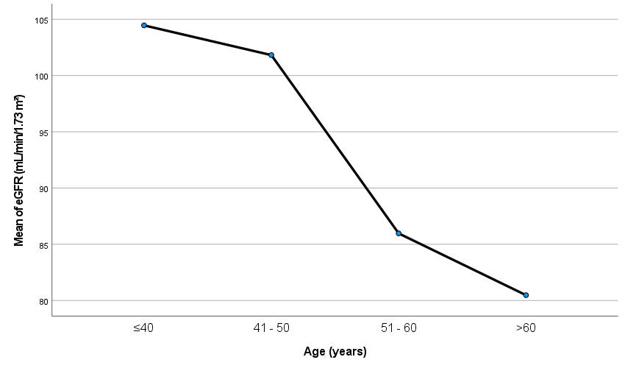

**Figure 2: Means plot showing eGFR across age groups**

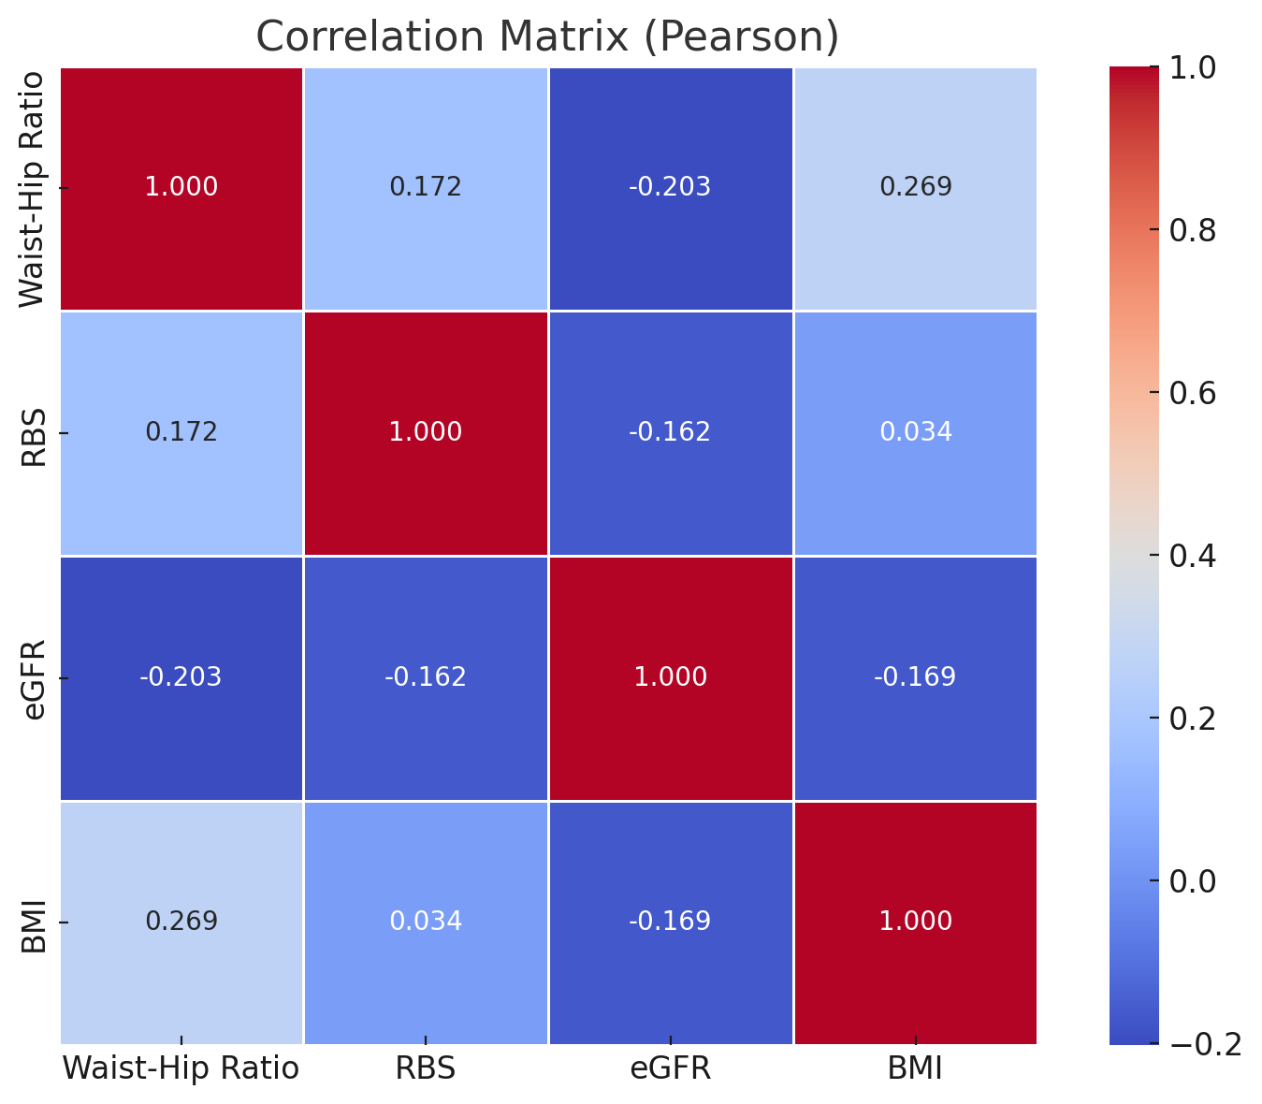

**Figure 3: Correlation matrix of clinical variables**

**Table 2: Multiple regression assessing predictors of reduced eGFR**

| **Variable** | **Odds Ratio** | **95% CI Lower** | **95% CI Upper** | **P-value** |
| --- | --- | --- | --- | --- |
| Age | 0.92 | 0.86 | 0.98 | .01 |
| Gender | 0.12 | 0.01 | 1.43 | .09 |
| Waist-Hip | 2.22 | 0.06 | 78.22 | .11 |
| Haematuria | 8.27 | 1.29 | 53.26 | .03 |
| BMI | 0.93 | 0.78 | 1.11 | .43 |

**Figure 4: Mean eGFR in relation to co-morbidities**

**DISCUSSION**

A key observation was the significant decline in kidney function with increasing age. The mean eGFR was highest among participants aged ≤40 years and declined progressively across older age groups, reaching the lowest value among those aged >60 years. This trend is consistent with existing literature, which identifies aging as a non-modifiable risk factor for reduced renal function due to nephron loss, decreased renal perfusion, and age-associated glomerulosclerosis.(Denic et al., 2016) In our study, this decline shows the need for routine renal function monitoring in older adults, even in the absence of overt disease.

Unlike age, gender did not demonstrate a significant association with eGFR, as both male and female participants had similar mean values. This aligns with previous studies that found negligible gender differences when eGFR is indexed to body surface area.(Ellam et al., 2013) However, other studies have reported gender variations in renal function, possibly influenced by hormonal, muscle mass, and dietary factors.(Fenton et al., 2018; Franco-Acevedo et al., 2021) The lack of difference in this cohort may reflect a relatively homogenous sample or the overriding influence of other risk factors.

Although participants with diabetes and hypertension had lower mean eGFR values compared to their non-diabetic and normotensive counterparts, these differences did not reach statistical significance. This is somewhat surprising given the well-established role of these conditions as major contributors to chronic kidney disease.(Akpor et al., 2022; Kabinga et al., 2024) One possible explanation is that many of the affected participants may have been receiving treatment, thereby mitigating further renal damage. Additionally, the cross-sectional design limits inference about duration or control status of these comorbidities, which are critical determinants of renal outcome.

Proteinuria, a marker of kidney damage, was not significantly associated with lower eGFR in this study. However, the presence of haematuria was significantly linked to reduced renal function. This suggests a possible underlying glomerular pathology in affected individuals, warranting further investigation. In resource-limited settings like Nigeria, routine urine dipstick testing can serve as a cost-effective tool for early detection of kidney injury.(Mmoh et al., 2022)

Anthropometric indices showed noteworthy associations. Waist–hip ratio correlated negatively with eGFR and positively with both random blood sugar and body mass index. Similarly, BMI also demonstrated a modest but statistically significant inverse correlation with eGFR (r = –0.169, p = .049). These findings are in keeping with the growing evidence that central obesity and metabolic syndrome contribute to renal dysfunction through pathways involving insulin resistance, inflammation, and glomerular hyperfiltration.(Bansal & Chonchol, 2025; Hall et al., 2020) Given the rising prevalence of obesity in Nigeria, these results highlight the importance of lifestyle interventions in kidney disease prevention.

Multivariate analysis demonstrated that advancing age and the presence of haematuria were independently associated with reduced kidney function among the study participants. The odds of reduced eGFR decreased by approximately 8.5% for each additional year of age (OR 0.92), highlighting age as a strong non-modifiable risk factor. Meanwhile, participants with haematuria had over eightfold increased odds of impaired renal function (OR 8.27), suggesting haematuria as a critical clinical marker warranting further investigation. Gender, waist–hip ratio, and BMI did not retain statistical significance in the adjusted model, indicating that while these factors showed some correlation on univariate analysis, their independent predictive value was limited within this cohort.

**Conclusion**

This study identified advancing age as the primary independent predictor of declining kidney function among adult outpatients at UBTH. Additionally, the presence of haematuria was significantly associated with impaired renal function, underscoring its clinical importance. Consequently, routine eGFR screening should be prioritized for older adults and patients presenting with haematuria to facilitate early detection of chronic kidney disease. Although central obesity showed an association with renal impairment in univariate analysis, it did not retain independent significance after multivariate adjustment.

**Limitations**

This study used a single eGFR measurement, which may over- or underestimate chronic kidney disease prevalence, as CKD diagnosis typically requires persistently reduced eGFR over at least three months. The single centre and use of convenience sampling may also limit generalizability of findings. Proteinuria and haematuria were assessed using dipstick tests without quantitative measures like albumin-to-creatinine or protein-to-creatinine ratios, limiting diagnostic accuracy. Clinical details regarding the duration, severity, and treatment adherence for diabetes and hypertension were not captured, which may affect kidney function outcomes. The extremely large odds ratio and wide confidence interval observed for waist–hip ratio may reflect model instability possibly due sample size limitations, and should be interpreted cautiously.

**Ethical Approval and consent**

Ethical approval was obtained from the Research and Ethics Committee of UBTH. Written informed consent was secured from all participants prior to data collection. Confidentiality and privacy were maintained throughout the study.

COMPETING INTERESTS DISCLAIMER:

Authors have declared that they have no known competing financial interests OR non-financial interests OR personal relationships that could have appeared to influence the work reported in this paper.

Disclaimer (Artificial intelligence)

Author(s) hereby declare that generative AI technologies such as Large Language Models, etc. have been used during the writing or editing of manuscripts. This explanation will include the name, version, model, and source of the generative AI technology and as well as all input prompts provided to the generative AI technology

Details of the AI usage are given below:

1. ChatGPT4 was used in the refinement of phrasing in the manuscript draft for improved clarity

**REFERENCES**

Adetunji, A. S., & Fatokun, T. S. (2023). CHALLENGES OF RENAL REPLACEMENT THERAPY IN NIGERIA: SOLUTIONS FROM MEDICAL STUDENTS’ PERSPECTIVES. *Annals of Ibadan Postgraduate Medicine*, *21*(2), 70. https://pmc.ncbi.nlm.nih.gov/articles/PMC10811714/

Akpor, O. A., Adeoye, A. O., Ibitoba, F. A., & Akpor, O. B. (2022). Prevalence of Chronic Kidney Disease Among Diabetes and Hypertensive Patients in a Teaching Hospital in Ekiti State, Southwest Nigeria. *The Open Public Health Journal*, *15*(1). https://doi.org/10.2174/18749445-V15-E221220-2022-99,

Bansal, A., & Chonchol, M. (2025). Metabolic dysfunction–associated kidney disease: pathogenesis and clinical manifestations. *Kidney International*, *108*(2), 194–200. https://doi.org/10.1016/J.KINT.2025.01.044

Deng, L., Guo, S., Liu, Y., Zhou, Y., Liu, Y., Zheng, X., Yu, X., & Shuai, P. (2025). Global, regional, and national burden of chronic kidney disease and its underlying etiologies from 1990 to 2021: a systematic analysis for the Global Burden of Disease Study 2021. *BMC Public Health*, *25*(1), 1–17. https://doi.org/10.1186/S12889-025-21851-Z/FIGURES/5

Denic, A., Glassock, R. J., & Rule, A. D. (2016). Structural and functional changes with the aging kidney. *Advances in Chronic Kidney Disease*, *23*(1), 19. https://doi.org/10.1053/J.ACKD.2015.08.004

Ellam, T., Fotheringham, J., & Kawar, B. (2013). Differential scaling of glomerular filtration rate and ingested metabolic burden: implications for gender differences in chronic kidney disease outcomes. *Nephrology Dialysis Transplantation*, *29*(6), 1186. https://doi.org/10.1093/NDT/GFT466

Fenton, A., Montgomery, E., Nightingale, P., Peters, A. M., Sheerin, N., Wroe, A. C., & Lipkin, G. W. (2018). Glomerular filtration rate: new age- and gender- specific reference ranges and thresholds for living kidney donation. *BMC Nephrology*, *19*(1), 336. https://doi.org/10.1186/S12882-018-1126-8

Francis, A., Harhay, M. N., Ong, A. C. M., Tummalapalli, S. L., Ortiz, A., Fogo, A. B., Fliser, D., Roy-Chaudhury, P., Fontana, M., Nangaku, M., Wanner, C., Malik, C., Hradsky, A., Adu, D., Bavanandan, S., Cusumano, A., Sola, L., Ulasi, I., & Jha, V. (2024). Chronic kidney disease and the global public health agenda: an international consensus. *Nature Reviews Nephrology 2024 20:7*, *20*(7), 473–485. https://doi.org/10.1038/s41581-024-00820-6

Franco-Acevedo, A., Echavarria, R., & Melo, Z. (2021). Sex Differences in Renal Function: Participation of Gonadal Hormones and Prolactin. *Endocrines 2021, Vol. 2, Pages 185-202*, *2*(3), 185–202. https://doi.org/10.3390/ENDOCRINES2030019

Guo, Y., Cui, L., Ye, P., Li, J., Wu, S., & Luo, Y. (2018). Change of Kidney Function Is Associated With All‐Cause Mortality and Cardiovascular Diseases: Results From the Kailuan Study. *Journal of the American Heart Association: Cardiovascular and Cerebrovascular Disease*, *7*(21), e010596. https://doi.org/10.1161/JAHA.118.010596

Hall, J. E., Mouton, A. J., Da Silva, A. A., Wang, Z., Li, X., & Do Carmo, J. M. (2020). Obesity, kidney dysfunction, and inflammation: interactions in hypertension. *Cardiovascular Research*, *117*(8), 1859. https://doi.org/10.1093/CVR/CVAA336

Kabinga, S. K., McLigeyo, S. O., Twahir, A., Ndungu, J. N., Wangombe, N. N., Nyarera, D. K., Ngaruiya, G. W., Chege, R. K., Ochieng, P. S., Ogutu, M. O., & Moturi, G. M. (2024). Risk factors for chronic kidney disease in the community: A decade of outreach in Kenya. *Clinical Epidemiology and Global Health*, *30*, 101823. https://doi.org/10.1016/J.CEGH.2024.101823

Mmoh, I. C., Ogbuagu, C. N., Modebe, I. A., Ogbuagu, E. N., Ogbuagu, C. M., Emelumadu, O. F., Okereke, U. C., Eleje, G. U., & Ekwunife, O. I. (2022). Dipstick urinalysis profile of an asymptomatic female group in south-east Nigeria. *SAGE Open Medicine*, *10*, 20503121221135576. https://doi.org/10.1177/20503121221135575

Provenzano, M., Hu, L., Abenavoli, C., Cianciolo, G., Coppolino, G., De Nicola, L., La Manna, G., Comai, G., & Baraldi, O. (2024). Estimated glomerular filtration rate in observational and interventional studies in chronic kidney disease. *Journal of Nephrology*, *37*(3), 573. https://doi.org/10.1007/S40620-024-01887-X

Stanifer, J. W., Muiru, A., Jafar, T. H., & Patel, U. D. (2016). Chronic kidney disease in low- and middle-income countries. *Nephrology Dialysis Transplantation*, *31*(6), 868. https://doi.org/10.1093/NDT/GFV466

Vaidya, S. R., & Aeddula, N. R. (2024). Chronic Kidney Disease. *The Scientific Basis of Urology, Second Edition*, 257–264. https://doi.org/10.51249/hs.v4i01.1865

Vela-Bernal, S., Facchetti, R., Dell’Oro, R., Quarti-Trevano, F., Lurbe, E., Mancia, G., & Grassi, G. (2023). Anthropometric Measures of Adiposity as Markers of Kidney Dysfunction: A Cross-Sectional Study. *High Blood Pressure & Cardiovascular Prevention*, *30*(5), 467. https://doi.org/10.1007/S40292-023-00600-6